- Describe functions of Statistics. Population: finite and infinite. Census method.
- Sampling: definition and its limits. Types of sampling and explain in details.
- What is Simple random sampling? Please explain in details.
- What is Stratified random sampling? Please explain in details.
- What is Systematic random sampling? Please explain in details.
- Collection of data. What are the main types of data (time series, spatial (cross-sectional) and Spacio-temporal data (panel data)). Please explain in details.
- Primary data: Please explain Direct personal interviews and indirect oral interviews in details.
- Primary data: Please explain Information from correspondents and Schedules sent through enumerators method in details.
- Primary data: Please explain Mailed questionnaire method. Characteristics of a good questionnaire in details.
- Secondary data: What are main sources, advantages and disadvantages?
- Classification. Please explain Chorological and geographical classification in details.
- Classification. Please explain Qualitative and quantitative classification in details.
- What is Tabulation?. What are the advantages and main elements of table?
- Compare discrete frequency distribution with continuous frequency distribution.
- Nature of class (limits, interval, size, range, mid-point, frequency).
- Main types of class intervals (inclusive, exclusive and open-end classes). Please explain each type of class in details.
- Please explain Percentage frequency table in details.
- Please explain Bivariate frequency distribution in details.
- What are One-dimensional diagrams and explain them with illustrations.
- What are Two-dimensional and three-dimensional diagrams and explain them with illustrations.
- Describe Histogram, Frequency Polygon and Frequency Curve.
- Describe Ogives and Lorenz curve.
- Please explain Discrete random variables and Discrete uniform distribution in details.
- Please explain Normal distribution in details.

- Calculate frequency and cumulative frequency for each interval.
Monthly wages |  | Number of workers | Percentage Frequency |  | Cumulative Percentage Frequency

- Description of Normal Distribution and its graph in detail. Why do we need normal distribution? Areas under normal distribution. Describe properties of Normal distribution. Please also briefly mention what tool we use to transform our data to be normally distributed.
- Arithmetic mean and weighted arithmetic mean: Definition, calculation methods, advantages and disadvantages
- Kinds of measures of dispersion. Characteristics of ideal measure of dispersion.
- Harmonic mean and geometric mean: Calculation, advantages and disadvantages.
- Skewness: Main types and their graphical representation. Please explain them in detail.
- Kurtosis: Main types and their graphical representation
- Description of Probability: Important points and main types.
- Standard deviation and coefficient of variation. Please explain in detail.
- Please describe and explain in detail measures of skewness.
- Please discuss what measures of dispersion are. Which one is preferable and why? (Give an answer to this question by comparing all measures of dispersion to one another).
- What are the types of Correlation? Please explain in details.
- Computation methods of correlation. Please explain in details.
- Please explain correlation with graphs in details.
- What are the merits and demerits of the correlation displayed by graphs?
- Please explain Normal distribution in details.
- What is Tabulation?. What are the advantages and main elements of table?
- Compare discrete frequency distribution with continuous frequency distribution.
- Classification. Please explain Qualitative and quantitative classification in details.
- Primary data: Please explain Mailed questionnaire method. Characteristics of a good questionnaire in details.
- Please explain Bivariate frequency distribution in details.
- Please calculate correlation based on the below given figures:
X | Y
- Arithmetic mean and weighted arithmetic mean: Definition, calculation methods, advantages and disadvantages
- Kinds of measures of dispersion. Characteristics of ideal measure of dispersion.
- Harmonic mean and geometric mean: Calculation, advantages and disadvantages.
- Main types of class intervals (inclusive, exclusive and open-end classes). Please explain each type of class in details.

Additional 25 statistical exercises. These exercises should not be distributed to the students. Only 50 questions are distributable to the students.

- Find the Quartile Deviation for the following data:
- Please calculate correlation based on the below given figures:
X | Y

- In a statistics class there are 18 juniors and 10 seniors; 4 of the seniors are females, and 14 of the juniors are males. If a student is selected at random, find the probability of selecting the following:
- A junior female
- A senior female

- Calculate range and its co efficient from the following distribution.
Size:
Number:

- Please calculate correlation based on the below given figures:
X | Y

- Calculate mean deviation from mean and median for the following data: also calculate co- efficients of M.D.

- Find the Quartile Deviation for the following data:

- Please calculate correlation based on the below given figures:
X | Y

- Calculate mean deviation from mean and median for the following data: also calculate co- efficients of M.D.

- Calculate the standard deviation from the following data:

- Please calculate correlation based on the below given figures:
X | Y

- Calculate Karl – Pearson’ s coefficient of skewness for the following data:

- Calculate the standard deviation from the following data:

- Please calculate correlation based on the below given figures:
X | Y

- Find the Quartile Deviation for the following data:

- Please calculate correlation based on the below given figures:
X | Y

- Find the Bowley’ s coefficient of skewness for the following series:

- Calculate the standard deviation from the following data:

- Find the Quartile Deviation for the following data:

- Please calculate correlation based on the below given figures:
X | Y

- Calculate range and its co efficient from the following distribution.
Size:
Number:

73
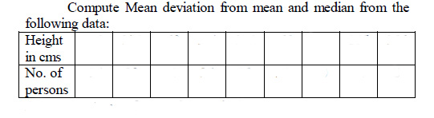

74
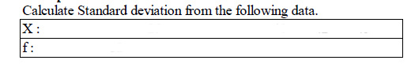

75
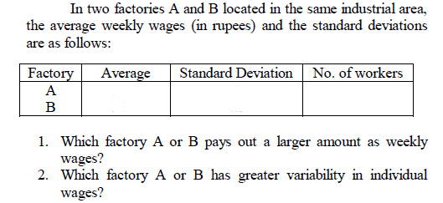

76
