International Currency-Credit Relations and Monetary Systems of the Foreign Countries

Exam Questions

- Explain the fundamentals of Gold Standard and why did the Gold Standard make sense?
- Explain the Bretton Wood System. What was the aim of this system and what accepted under the new agreement?
- Define the functions of the IMF and World Bank as the multinational institutions
- Define the differences between floating and fixed exchange rate systems
- Give the explanation about the features of currency, banking and foreign debt crisis
- Explain the Elasticities Approach
- What is the J-curve effect?
- Define an absorption instrument and an expenditure-switching instrument. Give an example of each and explain how it would be used to have the desired impact on the economy
- Explain what is "vehicle currency”. Why is the U.S. dollar considered a vehicle currency?
- Explain the purpose of the following figure from the text in the context of the interest rates on the dollar and the Japanese Yen between 1980 and 2010.
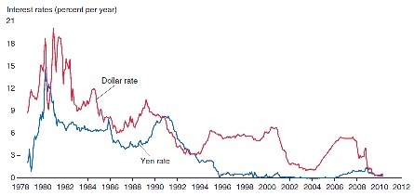
- Explain risk and liquidity of assets
- Explain why the interest parity condition must hold if the foreign exchange market is in equilibrium.
- Types of exchange rates and its impact on the foreign exchange market
- Please define and give an example of sterilized foreign exchange intervention
- A balance sheet for the central bank of Pecunia is shown below:
Central Bank Balance Sheet
Assets Liabilities
Foreign assets $0,000 Deposits held by private banks $000
Domestic assets $0,000 Currency in circulation $0,000

Please write the new balance sheet if the bank makes a sterilized transaction by selling $000 of foreign assets for domestic currency and then purchasing $000 of domestic assets by writing a check on itself

- If the central bank does not purchase foreign assets when output increases but instead holds the money stock constant, can it still keep the exchange rate fixed at 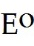? Please explain with the aid of a figure.
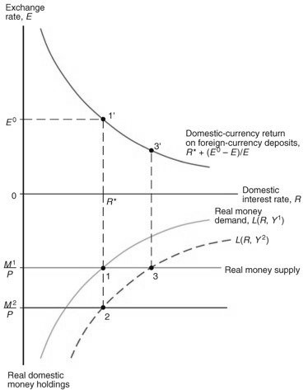
- Please discuss the difference between the terms devaluation and depreciation
- Use a figure to explain the potential effectiveness of fiscal policy to spur on the economy under a fixed exchange rate
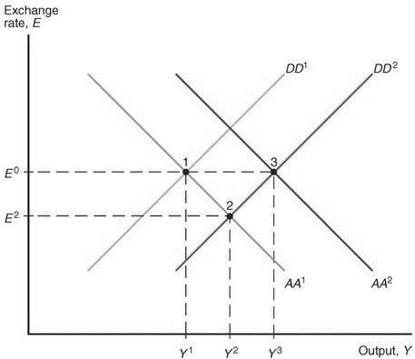
- Describe the effect of the 2008-2009 global financial crisis on the Swiss franc and the central bank's efforts to respond to the resulting problems
- Under the gold standard, if the dollar price of gold is pegged at $0 per ounce and the euro price of gold is pegged at 0 euro per ounce, what is the dollar/euro exchange rate?
- What are the main functions of money?
- What are the main factors that determine aggregate money demand?
- Explain the following figure

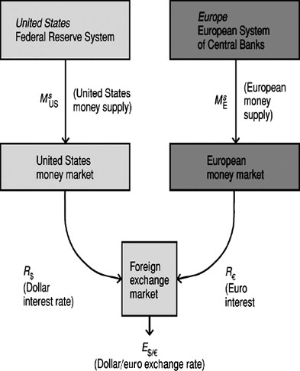

- Explain how the money markets of two countries are linked through the foreign exchange market
- Analyze the effects of an increase in the European money supply on the dollar/euro exchange rate
- Why is it useful to make a distinction between debt and equity instruments?
- Why is portfolio diversification so important in international trade?
- Describe the role of offshore banking and of offshore currency (eurocurrencies) trading
- Who is the Basel Committee? Discuss both their involvement in the Concordat as well the role of the Concordat in international banking
- Who are the main actors in the international capital market? Please explain the characteristics
- Explain what the four main categories of world economies are and give examples?
- Explain The Problem of “Original Sin”
- Describe the Structural Features of Developing Countries
- What are the alternative forms of financial inflow? Please give the characteristics
- Asian Financial Crisis. What were the consequences and specify the specifics.
- What factors lie behind capital inflows to the developing world?
- Does it appear that currency boards make low-inflation policies credible?
- Why does the Federal Reserve Bank of New York play a special role within the Federal Reserve System?
- Explain two concepts of central bank independence. Is the Fed politically independent? Why do economists think central bank independence is important?
- What is the theory of bureaucratic behavior and how can it be used to explain the behavior of the Federal Reserve?
- Explain the similarities and differences between the European System of Central Banks and the Federal Reserve System
- In what ways can the regional Federal Reserve banks influence the conduct of monetary policy?
- What are the functions of the Federal Reserve Banks? Please define all of them
- Explain the Fed's three tools of monetary policy and how each is used to change the money supply. Does each tool affect the monetary base or the money multiplier?
- Explain the figure according to the “Reserve Requirements”

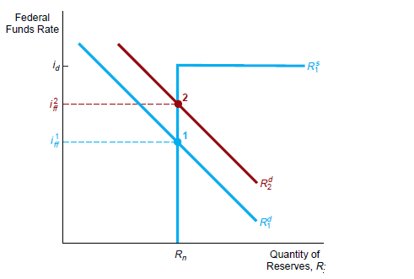
- Explain the Conventional Monetary Policy Tools of Federal Reserve Bank
- Open market operations have several advantages over the other tools of monetary policy. Please define them
- What are the main goals of the monetary policy and explain its importance.
- Advantages and disadvantages of the Inflation Targeting policy by the Central Banks
- How should central banks respond to asset-price bubbles?
- What is role of the “Taylor Rule”
- What were the lessons for Monetary Policy Strategy from the Global Financial Crisis?
- Explain the theory of optimum currency areas
- Draw the graph of the GG and LL schedules and explain the logic behind the slopes of each of the schedules
- What is one way to offset the economic stability loss due to fixed exchange rates?
- Is the EU an optimum currency area?
- During the 2009 euro crisis, a number of countries had private banks that had become too "big to save." Explain
- Explain the Keynesian theory of money demand. What motives did Keynes think determined money demand?
- Describe what the liquidity trap is. Explain how it can be problematic for monetary policymakers.
- What is the velocity of money?
- If the money supply is $000 and nominal income is $0,000, what is the velocity money is?
- If the money supply is $0 trillion and velocity is 0, then nominal GDP is?
- Explain the Law of One Price. Give an example
- Explain Purchasing Power Parity
- Discuss the relationship between PPP and the Law of One Price
- What is the Fisher Effect? Provide an example
- Suppose Russia's inflation rate is 000% over one year but the inflation rate in Switzerland is only 0%. According to relative PPP, what should happen over the year to the Swiss franc's exchange rate against the Russian ruble?
- Explain how expansionary and contractionary monetary policies affect aggregate demand through the exchange rate channel
- Define the concept of the real exchange rate and explain how it differs from the nominal exchange rate.
- Explain Tobin’s q theory
- Discuss three channels by which monetary policy affects stock prices and aggregate spending
- What are the pros and cons of monetary union? Describe each of them and provide one example.
- What are the advantages or disadvantages of a vehicle currency?
- When Could Using a Single Currency Pay Off?
- What is an exchange-rate target zone?

