Fakültə: Beynəlxalq İqtisadiyyat Məktəbi
Müəllim: Əli Rüstəmov
Fənn: İqtisadiyyatın tənzimlənməsi
- What is a market-clearing model? Is it possible in real life and why/why not?
- Please, build an economic model of supply and demand for oil products. Identify the endogenous and exogenous variables of the model.
- What are the main differences between GDP deflator and CPI?
- Assuming that base year is 2010, calculate the real GDP and the GDP deflator in 2015.
 | Year 2010 |  | Year 2015
Goods | Quantity | Price | Quantity | Price
Automobiles | 50 | 100 | 75 | 120
Bread | 70 | 120 | 60 | 200

- In 2014, Economically active population (in thsd. persons) in Azerbaijan was 4840,7 and employed people (in thsd. persons) was about 4602,9. What was the unemployment level in Azerbaijan in 2014?
- What is the introduction part of the empirical paper about?
- Please, explain the importance of conceptual framework part of the empirical paper. Give some examples, as well.
- What are the main purposes of applying econometric analysis?
- What kinds of economic datasets there are? Please, explain one of them on your answer.
- Please, identify the main differences between cross-sectional and time series data.
- Please, explain two major traditions of macroeconomics that aims to achieve the ‘major goals’ of economic policy. How were their concerns about government intervention in the economy?
- How would classical macroeconomics mechanism work at the period of the Great Depression? Please, also explain the need for new approach of macroeconomics.
- Please, explain the Keynesian approach of macroeconomics and its application in the macroeconomic events such as in the Great Depression.
- Please, clearly explain the major insights underlying new classical approach of macroeconomics.
- What are the central elements of ‘New Neoclassical Synthesis’?
- In a short-run aggregate production function, what is the main condition to maximize profits and why should it be satisfied?
- Please, explain the substitution and income effects of labour supply. Which one of these is assumed to be dominating another one in the classical model?
- What is the Say`s law about? Please, clarify your answer.
- What is the Cambridge cash-balance approach of the quantity theory of money?
- Please, explain the Fisher approach of the quantity theory of money.
- What is an IS curve of IS-LM Model for a closed economy?
- Please, explain the role of LM curve of IS-LM model for a closed economy.
- What is Pigou effect about? Please, give an example as well.
- Please, write down the limitations of the IS-LM model for an open economy.
- Please, give an explanation of what The Phillips Curve is.
- What are the major approaches on economic development of the classical post? Explain one of them in your answer.
- How many major approaches on economic development of the classical post exist? Explain the places of the developed and developing countries in those stages.
- What is the Harrod-Domar growth model about? Explain it clearly.
- Give the examples for both successful and failed attempt of Harrod-Domar growth model.
- What is the Solow growth model about? Explain it clearly.
- What differs the new classical economics from the monetarism?
- What is the partial equilibrium analysis about?
- What is the general equilibrium analysis about?
- What theories does the early new classical economics contain? Explain one of them in your answers.
- What is the rational expectations theory about? Explain both the weak and strong rational expectations theories as well.
- What are the main new classical achievements identified by Barro(1989)? Explain each of them clearly.
- What are the cyclical instabilities? List and explain the shocks to aggregate supply in your answer.
- What is the choice problem of economic agent about? Write down and explain the resource constraints of the agent.
- Please, explain the substitution and income effects in REBTC and give an example of that.
- Why do households being more willing to work when real wages are temporarily high and working fewer hours when real wages are temporarily low? Explain the cases that it would be.
- Explain the essential distinctions among the stages-of-growth theory of development, the structural-change models of Lewis and the theory of international dependence?
- Explain the meaning of dualism and dual societies.
- What is meant by the term neoclassical counterrevolution? What are its principal arguments, and how valid do you think they are? Explain your answer.
- Please, explain the O-ring model and give an example of O-ring production from everyday life?
- Please, explain the Big push model and what its main assumption are.
- What axioms should be rejected while modelling the Keynesian real world?
- What is the zero elasticity of productivity of money property about?
- What is the zero elasticity of substitution property about?
- How is decision making environments classified? Briefly explain each of those decision-making environments in your answer.
- Please, explain the Kreps`s approach to liquidity.
- Explain one of the six major functions of the financial sector in economy.
- What are the main two principal economic variables that monetary policy works on? Explain one of them in your answer clearly.
- What are the main aspects that most developing countries lack?
- Explain one of the five general functions of the central banks?
- Give an example for informal finance and explain it.
- What is the difference between economic globalization and trade protectionism?
- What is the export dependency? Give an example of countries experiencing it.
- Explain the commodity terms of trade in developing and developed countries.
- Explain the difference between comparative and absolute advantage in the economy and give an example while explaining it.
- What is the factor endowment theory about?
- What does the personal or size distribution of income state?
- List the methods of size distribution of income and explain one of them in your answer.
- Explain the relationship between Lorenz curve and Gini coefficient.
- What does the functional distribution of income state?
- What is total poverty gap (TPG)? How is it calculated?
- Describe briefly the essential assumptions and major features of the Todaro model of rural-urban migration.
- Distinguish between the urban formal and informal sectors, and discuss both the positive and the negative aspects of the informal urban labor market.
- What is an industrial district? How might governments of developing countries help them succeed?
- Explain clearly one of the key elements of the consensus of the comprehensive migration and employment strategy in your answer.
- What is urban giantism? Explain its causes in your answer as well.
- Explain the fluctuations of Azerbaijan`s share in non-oil world exports at the graph below.
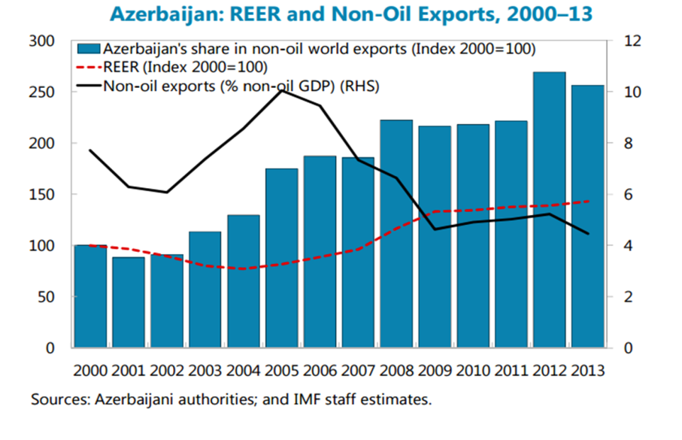
- What are the main reasons of the decrease in the industrial production of Azerbaijan at the early years of the independency?
- Describe the main problems of agriculture field in Azerbaijan and explain them.
- What are the general characterizations of the economic regions of Azerbaijan?
- Explain the global financial crisis commenced in 2008 and its impact on oil and non-oil sectors of Azerbaijan.

