AUDITING
Nijat Hajikhanov
1)
Sunrise Ltd has requested its auditor, Brown & Associates, to undertake the following engagement and report on the results of their work:
(a) Carry out whatever tests are deemed necessary to determine whether its annual general purpose financial report presents a true and fair view, and whether it has been prepared in accordance with Australian Accounting Standards.
REQUIRED
Identify whether the engagement is an audit, review or agreed -upon –procedures engagement and the level of assurance provided for each engagement.

2)
Sunrise Ltd has requested its auditor, Brown & Associates, to undertake the following engagement and report on the results of their work:
(a) Check whether the annual schedule of bonuses paid to senior management has been calculated correctly by checking the figures used in the calculations to the company's audited accounting records.
REQUIRED
Identify whether the engagement is an audit, review or agreed -upon –procedures engagement and the level of assurance provided for each engagement.

3)
Sunrise Ltd has requested its auditor, Brown & Associates, to undertake the following engagement and report on the results of their work:
(a) Carry out detailed analytical procedures and enquiries of management as to whether the half-yearly financial report lodged with ASIC presents a true and fair view, and whether it has been prepared in accordance with Australian Accounting Standards.
REQUIRED
Identify whether the engagement is an audit, review or agreed -upon –procedures engagement and the level of assurance provided for each engagement.

4)
Singh & Associates offer their clients a variety of audit and assurance services, including:
(a) analysis of financial transactions involving unauthorised transfers of cash between companies
(b) conformity of annual financial reports with applicable accounting standards
(c) reconstruction of incomplete accounting records to settle insurance claims
REQUIRED
For each of the services listed above, indicate the type of audit (financial report, compliance, performance, internal or forensic) performed

5)
Singh & Associates offer their clients a variety of audit and assurance services, including:
(a) checking adherence to legislative requirements
(b) review of half-yearly financial reports based on analytical procedures and enquiries of entity personnel
(c) assessment of energy usage patterns and recommendation of energy conservation opportunities.
REQUIRED
For each of the services listed above, indicate the type of audit (financial report, compliance, performance, internal or forensic) performed

6)
Jackie Kwan, a chartered accountant, is considering leaving her position at a major audit firm to join the staff of a small local accounting firm that provides accounting and tax advice and does the audits of self-managed superannuation funds.
REQUIRED
(a) Explain whether auditing standards are applied differently to auditors who work for a small local audit firm, as compared to those who work for a major audit firm.
(b) Explain whether the ethical rules are applied differently to members of the accounting bodies depending on the type of entity for whom they work.

7)
You have recently been appointed a manager at Buckley & Howard, a medium-sized audit firm, and put in sole charge of the professional practice area, including quality control. While going through the human resources (HR) files of Buckley & Howard's 60 employees, you note that salary reviews are infrequent. You are unable to find any policy on performance management systems and, while interviewing some of the employees, you note that this is the main reason for the firm's high staff turnover.
REQUIRED
Discuss whether Buckley & Howard complies with the relevant quality control requirements of ASQC 1 and APES 320. Justify your answer!

8)
You have recently been appointed a manager at Buckley & Howard, a medium-sized audit firm, and put in sole charge of the professional practice area, including quality control. The partners at Buckley & Howard have a policy of encouraging staff to improve their technical expertise and have discussed the possibility of introducing staff training, but have not been able to find the time to decide on the scope and content of the training. It is Buckley & Howard's policy to informally review a sample of audit engagements every five years, to ensure that they are conducting the engagements in a proper manner.
REQUIRED
Discuss whether Buckley & Howard complies with the relevant quality control requirements of ASQC 1 and APES 320. Justify your answer!

9)
You have been asked to prepare a report that analyses the potential acquisition of Staple Pty Ltd (Staple) by your audit client Hammer Ltd (Hammer). Prior to conducting your analysis, you decide to verify the accuracy and completeness of the cash flow statement provided by Staple for the year ended 30 June 2015. After reviewing a draft of your analysis, Hammer's Chief Financial Officer (CFO) has asked you to focus your attention on the sales and profitability of Staple and to avoid the distraction of cash flow reporting. He suggests that the acquisition will provide substantial future financial benefits to Hammer and that confusing the board with cash flow issues would not be helpful to the acquisition or to the likelihood of you being asked to undertake similar engagements in the future.
REQUIRED
Describe two threats to compliance with the fundamental principles that may exist as a result of your discussions with the CFO.

10)
You have been asked to prepare a report that analyses the potential acquisition of Staple Pty Ltd (Staple) by your audit client Hammer Ltd (Hammer). Prior to conducting your analysis, you decide to verify the accuracy and completeness of the cash flow statement provided by Staple for the year ended 30 June 2015. After reviewing a draft of your analysis, Hammer's Chief Financial Officer (CFO) has asked you to focus your attention on the sales and profitability of Staple and to avoid the distraction of cash flow reporting. He suggests that the acquisition will provide substantial future financial benefits to Hammer and that confusing the board with cash flow issues would not be helpful to the acquisition or to the likelihood of you being asked to undertake similar engagements in the future.
REQUIRED
Explain the fundamental principles at risk.

11)
You are the auditor of Enjoyment Ltd, a company involved in the entertainment industry. Borrowings are approaching maturity, with uncertain prospects of renewal or repayment due to poor performance, and there is excessive reliance on short- term borrowings to finance long. As a result, you have discussed with the directors the need to disclose this uncertainty, otherwise you will need to qualify the auditor's report on the basis of lack of disclosure. The company directors take exception to this view, because they intend to raise funds through a share issue within the next year and believe that such a disclosure would adversely affect the success of such a share issue. Rather than have a qualified auditor's report, the directors ask you to resign as auditor so that they can give the audit to another firm, Friendly Auditors & Associates, who will not qualify the auditor's report in the current year.
EQUIRED
Explain whether you are able to resign in these circumstances.

12)
Consider the following independent situation in relation to Dream Holidays Ltd (DH1), a major client of your audit firm, Accounting Associates.
(a) DH1 contributes around 10 per cent of the total audit fee revenue and 20 per cent of the non-audit fee revenue of Accounting Associates. DH1 has not paid any of its fees for the past two years, citing cash flow problems. The partners at Accounting Associates have been reluctant to put any pressure on DH1 for outstanding fees, as DH1 is a high-profile client that they wish to retain.
REQUIRED
For the above independent situation, identify any professional standards and regulatory requirements that have been breached, and recommend possible courses of action that Accounting Associates could take to rectify these breaches.

13)
Consider the following independent situation in relation to Dream Holidays Ltd (DH1), a major client of your audit firm, Accounting Associates.

(a) The partners at Accounting Associates frequently hire cars from DH1 to visit long-distance clients. DH1 gives alO per cent discount to its loyal customers, including Accounting Associates. Recently a tax partner at Accounting Associates, Rebecca Holmes, hired a fourwheel- drive from DH1 to go on a holiday with her family on the same terms as those offered to Accounting Associates.
REQUIRED
For the above independent situation, identify any professional standards and regulatory requirements that have been breached, and recommend possible courses of action that Accounting Associates could take to rectify these breaches.

14)
You are an audit manager with Clarke & Johnson (CJ). For the past three years CJ has been the auditor of Luxury Travel Holidays Ltd (LTH), a travel company. Geoff, the audit partner, has asked you to contact Chris, LTH's CEO, with a view to CJ being re-engaged as the auditor for the upcoming audit of the 30 June 2015 financial report. Geoff has also indicated that he intends to allocate Michael, a first – year accountant, and Annette, an accountant in CJ's tax advisory department, to the LTH audit for the first time. Geoff suggested that you discuss the audit with each of these staff, with a view to identifying any independence issues. You held talks with Chris and excerpts of conversation was as follows:
Conversation with Chris, excerpt
Chris stated: 'The board of directors were impressed with last year's audit and would like to propose reappointing CJ as the auditor of the 30 June 2015 financial report audit. The board would also like to invite Geoff to give a speech about LTH at the next travel agency seminar, to assist in promoting LTH's business to attract more investors. I understand that this is outside CJ's normal practice; however, the board expressed the view that it will be very difficult for LTH to continue any business engagements with CJ should Geoff refuse to provide such assistance.'
REQUIRED
(a) For each excerpt, identify and evaluate any threats in relation to auditor independence.
(b) Identify any safeguards to those threats identified above.

15)
You are an audit manager with Clarke & Johnson (CJ). For the past three years CJ has been the auditor of Luxury Travel Holidays Ltd (LTH), a travel company. Geoff, the audit partner, has asked you to contact Chris, LTH's CEO, with a view to CJ being re-engaged as the auditor for the upcoming audit of the 30 June 2015 financial report. Geoff has also indicated that he intends to allocate Michael, a first – year accountant, and Annette, an accountant in CJ's tax advisory department, to the LTH audit for the first time. Geoff suggested that you discuss the audit with each of these staff, with a view to identifying any independence issues. You held talks with Chris and excerpts of conversation was as follows:
Conversation with Chris, excerpt
Chris stated: 'To express our sincerity towards CJ and Geoff, and to maintain the good relationship in anticipation of another smooth audit for 2015, LTH would like to present a complimentary 14-day holiday package voucher for four people to the Greek isles for both Geoff's and your family. AU expenses, including accommodation and travelling costs, will be paid by LTH.'
REQUIRED
(a) For each excerpt, identify and evaluate any threats in relation to auditor independence.
(b) Identify any safeguards to those threats identified above.

16)
You are an audit manager with Clarke & Johnson (CJ). For the past three years CJ has been the auditor of Luxury Travel Holidays Ltd (LTH), a travel company. Geoff, the audit partner, has asked you to contact Chris, LTH's CEO, with a view to CJ being re-engaged as the auditor for the upcoming audit of the 30 June 2015 financial report. Geoff has also indicated that he intends to allocate Michael, a first – year accountant, and Annette, an accountant in CJ's tax advisory department, to the LTH audit for the first time. Geoff suggested that you discuss the audit with each of these staff, with a view to identifying any independence issues. You held talks with Michael and excerpts of conversation was as follows:
Excerpt from discussion with Michael
Michael stated: 'I am very excited to be part of the audit team. I believe that I will be a valuable asset to the team, as my dad is LTH's financial controller. He is responsible for the preparation of LTH's financial report.'
REQUIRED
(a) For each excerpt, identify and evaluate any threats in relation to auditor independence.
(b) Identify any safeguards to those threats identified above. LO 3.4

17)
You are an audit manager with Clarke & Johnson (CJ). For the past three years CJ has been the auditor of Luxury Travel Holidays Ltd (LTH), a travel company. Geoff, the audit partner, has asked you to contact Chris, LTH's CEO, with a view to CJ being re-engaged as the auditor for the upcoming audit of the 30 June 2015 financial report. Geoff has also indicated that he intends to allocate Michael, a first – year accountant, and Annette, an accountant in CJ's tax advisory department, to the LTH audit for the first time. Geoff suggested that you discuss the audit with each of these staff, with a view to identifying any independence issues. You held talks with Annette and excerpts of conversation was as follows:
Excerpt from discussion with Annette
Annette stated: 'I'm glad that I've been allocated to this year's LTH's audit team. It's going to be a very efficient audit this year! I was on a temporary assignment at LTH just a month ago, helping LTH with its tax calculations and preparing accounting entries that will be reflected in the 30 June 2015 financial report, so I don't think there will be much audit work required around the tax accounts. It will be great to catch up with everybody at LTH again, as they are so easy to work with.'
REQUIRED
(a) For each excerpt, identify and evaluate any threats in relation to auditor independence.
(b) Identify any safeguards to those threats identified above.

18)
You are currently planning the audit of Cheap Groceries Pty Ltd (Cheap Groceries), a large proprietary company that operates a small chain of supermarkets. You are in the process of gaining an understanding of Cheap Groceries' objectives and strategies and the related business risks. Competition in this business sector is intense, with major supermarket chains aggressively purchasing smaller rivals and discounting goods below cost in order to increase market share. In order to compete, Cheap Groceries has had to offer value-added services, such as free home delivery and loyalty rewards. While these strategies have helped to maintain its customer base, its gross margins have dropped by 10 per cent. In an effort to increase profits, Cheap Groceries has recently added higher margin products such as gourmet foods to its range. To date, these items have achieved only limited acceptance among its customers. AU of Cheap Groceries' premises are leased. Three of the leases are due to expire prior to the end of the current financial year. In two cases, the land on which the premises are situated has been rezoned as residential. Due to 'prior use' legislation, this does not prevent the premises from being used as a supermarket in the future. However, it does mean the land's value has increased and, on this basis, the lessor is demanding a 50 per cent increase in rent. Cheap Groceries is also experiencing difficulties with one of its major suppliers, which has withdrawn their volume rebates and reduced payment terms from 30 days to 14 days. Cheap Groceries has recently initiated legal action against a major supermarket chain for anticompetitive behaviour and predatory pricing.
REQUIRED
(a) Identify five business risks for Cheap Groceries that may lead to the risk of material misstatement in the financial report.

19) You are currently planning the audit of Cheap Groceries Pty Ltd (Cheap Groceries), a large proprietary company that operates a small chain of supermarkets. You are in the process of gaining an understanding of Cheap Groceries' objectives and strategies and the related business risks. Competition in this business sector is intense, with major supermarket chains aggressively purchasing smaller rivals and discounting goods below cost in order to increase market share. In order to compete, Cheap Groceries has had to offer value-added services, such as free home delivery and loyalty rewards. While these strategies have helped to maintain its customer base, its gross margins have dropped by 10 per cent. In an effort to increase profits, Cheap Groceries has recently added higher margin products such as gourmet foods to its range. To date, these items have achieved only limited acceptance among its customers. AU of Cheap Groceries' premises are leased. Three of the leases are due to expire prior to the end of the current financial year. In two cases, the land on which the premises are situated has been rezoned as residential. Due to 'prior use' legislation, this does not prevent the premises from being used as a supermarket in the future. However, it does mean the land's value has increased and, on this basis, the lessor is demanding a 50 per cent increase in rent. Cheap Groceries is also experiencing difficulties with one of its major suppliers, which has withdrawn their volume rebates and reduced payment terms from 30 days to 14 days. Cheap Groceries has recently initiated legal action against a major supermarket chain for anticompetitive behaviour and predatory pricing.
REQUIRED
(a) For each business risk identified, describe how it may lead to the risk of material misstatement in the financial report.

20)
You are responsible for preparing an audit strategy for the following independent situations:
(a) Since your last audit the client, Sleek Bicycles Ltd, has introduced a new computer system for inventory. Management has indicated that the main advantage of the new system over the old one is that it is capable of providing information on inventory levels and gross margins for both product line and geographical area.
REQUIRED
Outline how the information provided would affect your audit strategy in this case.

21)
You are responsible for preparing an audit strategy for the following independent situation:
(a) Your audit strategy for sales for Amazing Creations Ltd places substantial reliance on the system of internal control and the use of analytical procedures. Your testing of the internal control system for sales has found a significant number of instances where customers' credit ratings have not been checked and approval has not been sought when abnormally large discounts have been given. The sales manager states that these changes to control procedures have been the result of difficulties in maintaining past sales levels.
REQUIRED
Outline how the information provided would affect your audit strategy in this case.

22)
You are responsible for preparing an audit strategy for the following independent situation:
(a) Management of Blue Marine Ltd has recently introduced a new state of-the art plant and equipment register. AU plant and equipment is now barcoded, scanned and classified, with depreciation calculated automatically based on asset class. A big advantage of the new register is the variety of detailed reports it can produce, for example, depreciation by asset class, additions for the year and profit on disposal.
REQUIRED
Outline how the information provided would affect your audit strategy in this case.

23)
You are the auditor of Commercial Ovens Ltd, a manufacturer of large commercial ovens used in restaurants and you have performed a series of preliminary analytical procedures on the entity's financial report during the planning stages of the audit. These preliminary analytical procedures have produced the following results.
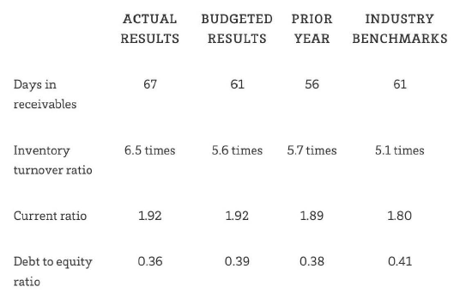
Discuss how the results of these preliminary analytical procedures may influence the planning of the audit of Commercial Ovens Ltd.

24)
Consider each of the following independent situation, which apply to ongoing audits of your clients for the year ending 30 June 2015.
(a) Snooze Ltd (Snooze) is a bed manufacturer. Although demand for Snooze's products has been steady, increasing costs have put significant pressure on gross margins, which have fallen from 30 per cent last year to 25 per cent this year, based on the latest management monthly accounts. Net profit before tax is a key measure used by monthly accounts. Net profit before tax is a key measure used by investors and Snooze has already had to revise down its profit forecast once in the current financial year.
REQUIRED
For the independent situation described above, outline the impact, if any, on inherent risk.

25)
Consider each of the following independent situation, which apply to ongoing audits of your clients for the year ending 30 June 2015.
(a) The CEO of Mountain Ltd (Mountain) issued a media statement on 1 August 2015, stating that Mountain had committed massive accounting fraud resulting in overstated profits and assets over the past five years.
REQUIRED
For the independent situation described above, outline the impact, if any, on inherent risk.

26) You are the audit senior on the audit of Cool Air Ltd (Cool Air) for the year ended 30 June 2015. Cool Air is an air-conditioning manufacturer. It has operational centres in all Australian capital cities. Each operational centre warehouses the equipment and spare parts and provides sales and maintenance services. Cool Air's head office is located in Melbourne where finance, IT and other corporate services are provided. On 1 January 2015, Cool Air switched over to a new automated customer invoicing system. The system, which was implemented by external specialists, replaced Cool Air's old invoicing system that was developed five years ago by Cool Air's own IT department. The external specialist implemented an off-the-shelf computer package based on discussions with the CEO, Terry Brown, as to the Cool Air's IT needs. As the new system is an off-the-shelf package and the staff all have plenty of IT experience, Terry does not believe that any additional training on the new system is necessary. He is relieved about this situation, as the staff are all under extreme time pressures and simply do not have the spare time available. It is now June 2015 and you are assessing the controls around the new customer invoicing system. You are aware that there have been two software upgrades to the system since it was implemented, all of which were undertaken by Cool Air's own IT department.
REQUIRED
In relation to Cool Air switching over to the new invoicing system in January 2015:
Identify two specific audit risks that could have potentially arisen from this event.

27) You are the audit senior on the audit of Cool Air Ltd (Cool Air) for the year ended 30 June 2015. Cool Air is an air-conditioning manufacturer. It has operational centres in all Australian capital cities. Each operational centre warehouses the equipment and spare parts and provides sales and maintenance services. Cool Air's head office is located in Melbourne where finance, IT and other corporate services are provided. On 1 January 2015, Cool Air switched over to a new automated customer invoicing system. The system, which was implemented by external specialists, replaced Cool Air's old invoicing system that was developed five years ago by Cool Air's own IT department. The external specialist implemented an off-the-shelf computer package based on discussions with the CEO, Terry Brown, as to the Cool Air's IT needs. As the new system is an off-the-shelf package and the staff all have plenty of IT experience, Terry does not believe that any additional training on the new system is necessary. He is relieved about this situation, as the staff are all under extreme time pressures and simply do not have the spare time available. It is now June 2015 and you are assessing the controls around the new customer invoicing system. You are aware that there have been two software upgrades to the system since it was implemented, all of which were undertaken by Cool Air's own IT department.
REQUIRED
In relation to Cool Air switching over to the new invoicing system in January 2015:
Describe two control activity those should have been in place to prevent the risk identified above from occurring.

28) You are the audit senior on the audit of Cool Air Ltd (Cool Air) for the year ended 30 June 2015. Cool Air is an air-conditioning manufacturer. It has operational centres in all Australian capital cities. Each operational centre warehouses the equipment and spare parts and provides sales and maintenance services. Cool Air's head office is located in Melbourne where finance, IT and other corporate services are provided. On 1 January 2015, Cool Air switched over to a new automated customer invoicing system. The system, which was implemented by external specialists, replaced Cool Air's old invoicing system that was developed five years ago by Cool Air's own IT department. The external specialist implemented an off-the-shelf computer package based on discussions with the CEO, Terry Brown, as to the Cool Air's IT needs. As the new system is an off-the-shelf package and the staff all have plenty of IT experience, Terry does not believe that any additional training on the new system is necessary. He is relieved about this situation, as the staff are all under extreme time pressures and simply do not have the spare time available. It is now June 2015 and you are assessing the controls around the new customer invoicing system. You are aware that there have been two software upgrades to the system since it was implemented, all of which were undertaken by Cool Air's own IT department.
In relation to Cool Air switching over to the new invoicing system in January 2015
REQUIRED
In relation to the computer software upgrades that Cool Air has undertaken since January 2015, identify one specific audit risk that could have potentially arisen from the software upgrades.

29) You are an audit senior at Swan & Associates and are part of the team auditing the sales and receivables areas of Renewable Energy Ltd (Renewable Energy), for the year ended 30 June 2015. You have been assigned the task of planning the audit and identifying the risks of material misstatement. Renewable Energy manufactures solar panels at its factory in Melbourne. Renewable Energy offers performance- related remuneration packages to its senior managers. While the base salary is relatively modest, there are substantial bonuses based on reported profit. Renewable Energy considered this approach to be appropriate, as it enables the company to attract suitably qualified management in the highly skilled and rapidly changing technological environment in which it operates. Renewable Energy has a large customer base located across Australia. All sales are on credit, with outstanding accounts due within 30 days. The balance of outstanding accounts at balance date is $50 million. Management has made a provision of $250 000 for doubtful debts, based on historical evidence. In recent months, the Australian dollar has depreciated 25 per cent against the US dollar, which has made some of Renewable Energy's inputs more expensive. Furthermore, rising interest rates in Australia are putting pressure on some of Renewable Energy's major customers. Consequently, the credit manager, who has recently joined Renewable Energy after many years in the construction industry, is closely monitoring receivables. Some of Renewable Energy's existing customers are considering purchasing lower-priced imported solar panels from one of Renewable Energy's major competitors.
REQUIRED
List five significant inherent risks that may require special audit consideration in the sales and receivables area. Explain your response.

30) You are an audit senior at Swan & Associates and are part of the team auditing the sales and receivables areas of Renewable Energy Ltd (Renewable Energy), for the year ended 30 June 2015. You have been assigned the task of planning the audit and identifying the risks of material misstatement. Renewable Energy manufactures solar panels at its factory in Melbourne. Renewable Energy offers performance- related remuneration packages to its senior managers. While the base salary is relatively modest, there are substantial bonuses based on reported profit. Renewable Energy considered this approach to be appropriate, as it enables the company to attract suitably qualified management in the highly skilled and rapidly changing technological environment in which it operates. Renewable Energy has a large customer base located across Australia. All sales are on credit, with outstanding accounts due within 30 days. The balance of outstanding accounts at balance date is $50 million. Management has made a provision of $250 000 for doubtful debts, based on historical evidence. In recent months, the Australian dollar has depreciated 25 per cent against the US dollar, which has made some of Renewable Energy's inputs more expensive. Furthermore, rising interest rates in Australia are putting pressure on some of Renewable Energy's major customers. Consequently, the credit manager, who has recently joined Renewable Energy after many years in the construction industry, is closely monitoring receivables. Some of Renewable Energy's existing customers are considering purchasing lower-priced imported solar panels from one of Renewable Energy's major competitors.
REQUIRED
Provide 5 key account balance and 5 assertion at risk of material misstatement.

31) You are a junior accountant working at Castle Chartered Accountants. You are instructed by your audit senior to identify related parties of its client Kimberley Ltd (Kimberley). Based on your current understanding of Kimberley, you have identified that the following may be related parties.
(a) The Kimberley Superannuation Fund, a fund that provides 'top-up' pensions for senior company employees
(b) Edward Black, Kimberley's agent in Thailand, who also controls a company that holds a 23 per cent share in Kimberley
REQUIRED
For each of the parties identified above, provide a brief explanation, with reference to the relevant standard(s), of whether you would undertake further investigation of the party as a possible 'related party' of Kimberley Ltd.

32) You are a junior accountant working at Castle Chartered Accountants. You are instructed by your audit senior to identify related parties of its client Kimberley Ltd (Kimberley). Based on your current understanding of Kimberley, you have identified that the following may be related parties.
(c) The Sentinel Insurance Company Inc., registered in the Canary Islands, which does all Kimberley's export insurance work; its ownership is not known
(d) Sally Pearson, a senior member of the management team of Kimberley
REQUIRED
For each of the parties identified above, provide a brief explanation, with reference to the relevant standard(s), of whether you would undertake further investigation of the party as a possible 'related party' of Kimberley Ltd.

33) You are a junior accountant working at Castle Chartered Accountants. You are instructed by your audit senior to identify related parties of its client Kimberley Ltd (Kimberley). Based on your current understanding of Kimberley, you have identified that the following may be related parties.
(e) CSG Pty Ltd, a firm that supplies about 65 per cent of Kimberley's raw material requirements and is owned by a cousin of Rob and Frank Black, Kimberley's controlling shareholders
(f) RFB Sales and Marketing Ltd, registered in Fiji, which is contracted to do all of Kimberley's export sales promotion and appoint agents who are paid on a commission basis; its ownership is not known
REQUIRED
For each of the parties identified above, provide a brief explanation, with reference to the relevant standard(s), of whether you would undertake further investigation of the party as a possible 'related party' of Kimberley Ltd.

34) Consider the following independent situations, each of which applies to an audit of a client entity for the year ending 30 June 2015:
-Easy Gardening Ltd is a garden tools manufacturer. When goods are received, the receiving department simply stamps 'order received' on its two copies of the purchase order, which then forms its receiving record. One copy of the receiving record is filed in the receiving department and the other is forwarded to the accounts payable department.
REQUIRED
For each of the above independent situations:
(a) explain the impact on control risk
(b) indicate the key account balance affected
(c) indicate the key audit assertions of interest to the auditor.

35) Consider the following independent situations, each of which applies to an audit of a client entity for the year ending 30 June 2015:
-Palm Grove Ltd failed to discover an employee fraud on a timely basis because bank reconciliations were not being reconciled on a monthly basis.
REQUIRED
For each of the above independent situations:
(a) explain the impact on control risk
(b) indicate the key account balance affected
(c) indicate the key audit assertions of interest to the auditor.

36) Consider the following independent situations, each of which applies to an audit of a client entity for the year ending 30 June 2015:
-Engineering Components Ltd is a large machinery spare parts manufacturer that transmits purchase orders electronically to its many suppliers. Each supplier electronically transmits an invoice, which is credited directly to the accounts payable file. The goods usually take one or two weeks to arrive. Once they have been received, a goods received note is raised and matched with the supplier's invoice, and payment is authorised.
REQUIRED
For each of the above independent situations:
(a) explain the impact on control risk
(b) indicate the key account balance affected
(c) indicate the key audit assertions of interest to the auditor.

37) Consider the following independent situations, each of which applies to an audit of a client entity for the year ending 30 June 2015:
-Tranquillity Ltd's credit officer, whose prime responsibility was setting and reviewing customers' credit limits, retired during the year. The position has remained unfilled for six months, as no suitably qualified and experienced replacement has yet been found.
REQUIRED
For each of the above independent situations:
(a) explain the impact on control risk
(b) indicate the key account balance affected
(c) indicate the key audit assertions of interest to the auditor.

38) You are the auditor of Cannon Pty Ltd (Cannon), and have made the following notes on Cannon's cash receipts procedures:
Cheques from customers are received by mail and from sales representatives, who may obtain the cheques directly from the customers. All cheques are to be then forwarded to the credit control clerk in the sales order department, who restrictively crosses the cheques so that they can only be banked into Cannon's bank account. She then enters the details of the cheque into the system via a terminal. She attempts to age the receipt from remittance advice details provided by the debtor, as attached to the cheque. If inadequate details are provided, she allocates the receipts to the oldest balance first. After all cheques have been processed, the credit control clerk prints the daily cash receipts report. This report details all cheques input into the system since the production of the previous report. She agrees all cheques to this report, prepares a bank deposit slip and banks the cheques. At the end of the day, the accounts receivable master file is updated with cash receipts data.
REQUIRED
(a) Identify any strengths in the internal controls described above.
(b) What will be your assessment of internal controls relating to Cannon's cash receipts system?

39) You are the auditor of Cannon Pty Ltd (Cannon), and have made the following notes on Cannon's cash receipts procedures:
Cheques from customers are received by mail and from sales representatives, who may obtain the cheques directly from the customers. All cheques are to be then forwarded to the credit control clerk in the sales order department, who restrictively crosses the cheques so that they can only be banked into Cannon's bank account. She then enters the details of the cheque into the system via a terminal. She attempts to age the receipt from remittance advice details provided by the debtor, as attached to the cheque. If inadequate details are provided, she allocates the receipts to the oldest balance first. After all cheques have been processed, the credit control clerk prints the daily cash receipts report. This report details all cheques input into the system since the production of the previous report. She agrees all cheques to this report, prepares a bank deposit slip and banks the cheques. At the end of the day, the accounts receivable master file is updated with cash receipts data.
REQUIRED
(a) Identify any weaknesses in the internal controls described above.
(b) Discuss the implications of each of the weaknesses you have identified.
(c) What will be your assessment of internal controls relating to Cannon's cash receipts system?

40) The following situations have occurred during the year at your audit client, Clean Energy Ltd, a large solar panel manufacturer:
(a) A data entry clerk incorrectly entered a customer payment as $575 instead of $5750.
(b) A computer operator on the night shift knew more about the company's computer system than anyone else. During a period of several months, he accessed the master payroll program, which was stored online, and increased his income tax withholding so that he would get a large refund when he filed his income tax return.
REQUIRED
Identify a control policy or procedure that would have prevented or detected each of the situations above.

41) Explain how management experience, knowledge and changes during the
period affect inherent risk at the financial report level.

42) Explain how unusual pressure on management affects inherent risk at the financial report level

43) Explain how Nature of the entity's business affects inherent risk at the financial report level

44) Explain how factors affecting the industry in which the entity operates affect inherent risk at the financial report level

45) What are the elements of fraud and give examples for each of them.

46) Explain fraud triangle based on example.

47) What are the broad categories of earnings management and give a description for them.

48) Explain why the auditor needs to be aware of the identity of related parties.

49) Identify test of controls for cash receipts.

50) How to do auditing for payroll and identify procedures.

51) MEDIUM Roger O'Brien is auditing the accounts receivable of Currency Ltd (Currency) for the year ended 30 June 2015. Currency's accounts receivable were recorded at $2 500 000 and comprised more than 2000 customer accounts. However, Currency's 10 largest customers' balances comprised a high percentage of the recorded accounts receivable (more than $750 000 or 30 per cent). As a result, Roger is considering using dollar-unit sampling. Based on prior audits and other judgments, Roger has established the following parameters:
Risk of incorrect acceptance 5%
Tolerable error $150 000
Expected error $50 000

REQUIRED
(a) Explain what factors Roger should consider in determining sample size, and how these factors would be assessed.

52 MEDIUM Roger O'Brien is auditing the accounts receivable of Currency Ltd (Currency) for the year ended 30 June 2015. Currency's accounts receivable were recorded at $2 500 000 and comprised more than 2000 customer accounts. However, Currency's 10 largest customers' balances comprised a high percentage of the recorded accounts receivable (more than $750 000 or 30 per cent). As a result, Roger is considering using dollar-unit sampling. Based on prior audits and other judgments, Roger has established the following parameters:
Risk of incorrect acceptance 5%
Tolerable error $150 000
Expected error $50 000

(b) Calculate the necessary sample size and sampling interval used by Roger in the audit of Currency.

53 You are reviewing your audit assistant's work for Lemon Pty Ltd (Lemon) for the year ended 30 June 2015, and note the following matters:
(i) Your audit assistant undertook a test of controls for 50 sales transactions. This test resulted in three errors. When planning the test, a tolerable error of 5 per cent had been established. The audit assistant's working papers noted that none of the errors found were material, either individually or in aggregate, and she therefore concluded that the controls were reliable.
REQUIRED
Comment on the appropriateness of your audit assistant's conclusions in each
of the above situations.

54 You have been assigned to the audit of Speciality Gifts Ltd for the year ended 30 June 2015. You have conducted audit procedures to test the following controls related to Speciality Gifts' revenue process.
1 Accounts receivable clerk compares quantity on sales invoice to shipping documents.
2 Sales manager approves prices on invoices.
3 Automated controls in processing sales to identify unusual sales amounts of greater than $10 000.
4 Credit manager approves write-offs of uncollectable accounts. You have decided to use a sampling approach based on the following judgments for each control:

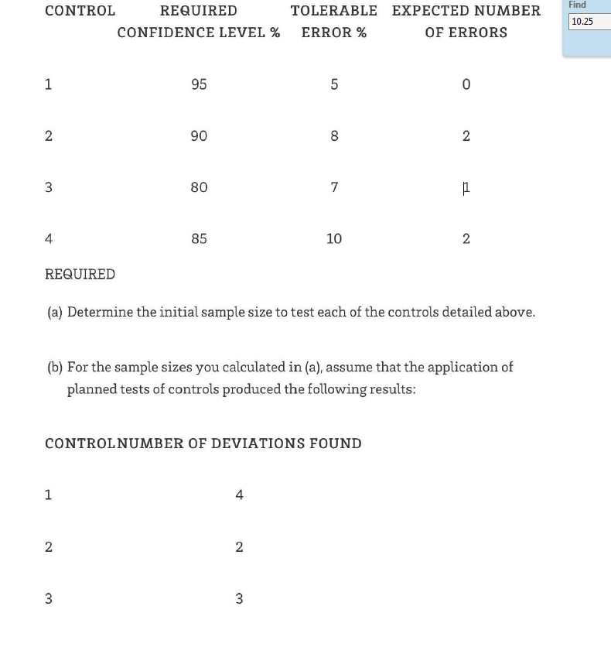

55 You have been assigned to the audit of Speciality Gifts Ltd for the year ended 30 June 2015. You have conducted audit procedures to test the following controls related to Speciality Gifts' revenue process.
1 Accounts receivable clerk compares quantity on sales invoice to shipping documents.
2 Sales manager approves prices on invoices.
3 Automated controls in processing sales to identify unusual sales amounts of greater than $10 000.
4 Credit manager approves write-offs of uncollectable accounts. You have decided to use a sampling approach based on the following judgments for each control:

56 You have been assigned to the audit of Speciality Gifts Ltd for the year ended 30 June 2015. You have conducted audit procedures to test the following controls related to Speciality Gifts' revenue process.
1 Accounts receivable clerk compares quantity on sales invoice to shipping documents.
2 Sales manager approves prices on invoices.
3 Automated controls in processing sales to identify unusual sales amounts of greater than $10 000.
4 Credit manager approves write-offs of uncollectable accounts. You have decided to use a sampling approach based on the following judgments for each control:

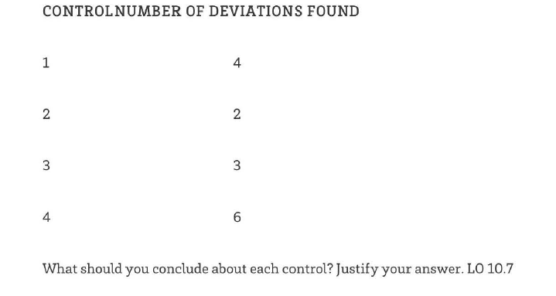

57 Listed below are the initial10 items from the accounts receivable population of Quality Meats Ltd:

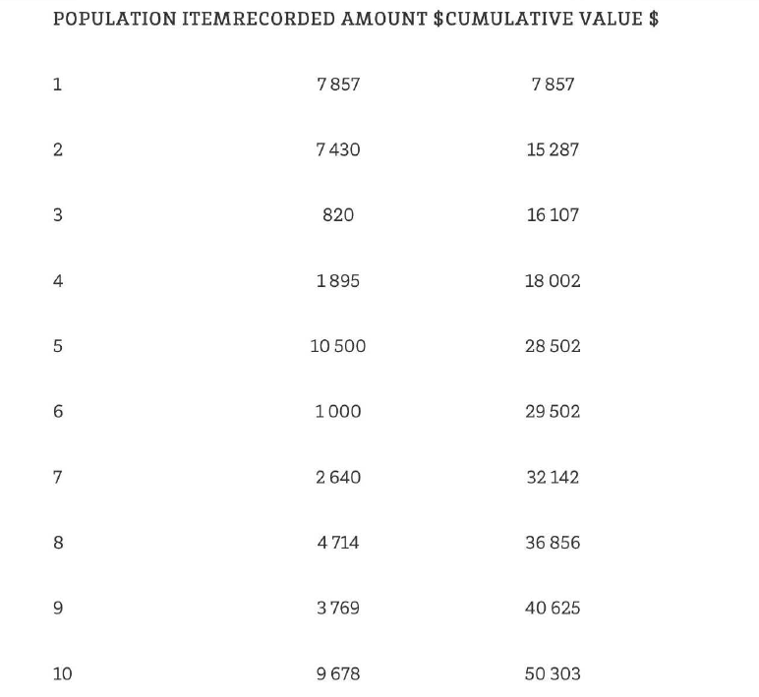
The total of the accounts receivable listing is $500 000, with more than 200 customers.

REQUIRED
(a) Explain whether you are more likely to be concerned with testing for overstatement or understatement for the accounts receivable account.

58 Listed below are the initial10 items from the accounts receivable population of Quality Meats Ltd:

The total of the accounts receivable listing is $500 000, with more than 200 customers.

REQUIRED
- Explain whether you are more likely to be concerned with testing for overstatement or understatement for the accounts receivable account.

59 Listed below are the initial10 items from the accounts receivable population of Quality Meats Ltd:

The total of the accounts receivable listing is $500 000, with more than 200 customers.

(b) It has been decided that dollar-unit sampling will be used, the sample size will be 25 and a random start of 8115 has been chosen. Determine which will be the second item to be selected.

60 Listed below are the initial10 items from the accounts receivable population of Quality Meats Ltd:

The total of the accounts receivable listing is $500 000, with more than 200 customers.

(c) You have undertaken your sampling plan of 25 items and your evaluation of errors reveals that the upper error limit exceeds the tolerable error. Identify the courses of action you have available.

61 Explain each of the factors that influence the sample size for substantive
testing.

62 For the upcoming audit of Franklin Ltd, you have planned the following audit procedures:
(i) Comparing payroll expense with the previous year and ensuring that major fluctuations are consistent with your knowledge of the business.
(ii) Checking the average cost prices of inventory items listed in the year-end inventory schedule to the detailed costing records.

63 For the upcoming audit of Franklin Ltd, you have planned the following audit procedures:
(iii) Vouching sales to the receipt book to ensure that details, in particular dollar amounts, are recorded correctly.
(iv) Scrutinising the repairs and maintenance account looking for items that should have been capitalized

64 Oriental Produce Ltd (Oriental Produce) has been operating for a number of years as a producer of canned vegetables. Oriental Produce imports most of its vegetables from Asia. AU overseas shipments to Oriental Produce are invoiced and require settlement in US dollars. Furthermore, Oriental Produce is required to pay for freight and insurance costs. The insurance covers the period from the day the goods are loaded onto the ship (i.e. Oriental Produce assumes ownership of the goods on the day the goods are loaded onto ships in the various Asian ports from where the produce is shipped) until the day they arrive in Oriental Produce's warehouses in Australia. AU shipments arrive in Australia within a 21-day period after loading onto a ship. AU overseas suppliers are settled 30 days after the date of shipment. Overseas suppliers now represent 65 per cent of accounts payable. Local and overseas suppliers are maintained in separate subsidiary ledgers within the accounting system. The audit partner has identified that accounts payable is at risk of
material misstatement.

REQUIRED
(a) Outline two key reasons why accounts payable is at risk of material
misstatement.

65 Oriental Produce Ltd (Oriental Produce) has been operating for a number of years as a producer of canned vegetables. Oriental Produce imports most of its vegetables from Asia. AU overseas shipments to Oriental Produce are invoiced and require settlement in US dollars. Furthermore, Oriental Produce is required to pay for freight and insurance costs. The insurance covers the period from the day the goods are loaded onto the ship (i.e. Oriental Produce assumes ownership of the goods on the day the goods are loaded onto ships in the various Asian ports from where the produce is shipped) until the day they arrive in Oriental Produce's warehouses in Australia. AU shipments arrive in Australia within a 21-day period after loading onto a ship. AU overseas suppliers are settled 30 days after the date of shipment. Overseas suppliers now represent 65 per cent of accounts payable. Local and overseas suppliers are maintained in separate subsidiary ledgers within the accounting system. The audit partner has identified that accounts payable is at risk of
material misstatement.

(b) For each why accounts payable is at risk of material misstatement identify and explain the assertion most at risk.

66 Oriental Produce Ltd (Oriental Produce) has been operating for a number of years as a producer of canned vegetables. Oriental Produce imports most of its vegetables from Asia. AU overseas shipments to Oriental Produce are invoiced and require settlement in US dollars. Furthermore, Oriental Produce is required to pay for freight and insurance costs. The insurance covers the period from the day the goods are loaded onto the ship (i.e. Oriental Produce assumes ownership of the goods on the day the goods are loaded onto ships in the various Asian ports from where the produce is shipped) until the day they arrive in Oriental Produce's warehouses in Australia. AU shipments arrive in Australia within a 21-day period after loading onto a ship. AU overseas suppliers are settled 30 days after the date of shipment. Overseas suppliers now represent 65 per cent of accounts payable. Local and overseas suppliers are maintained in separate subsidiary ledgers within the accounting system. The audit partner has identified that accounts payable is at risk of
material misstatement.

a) For each assertion at risk describe one substantive test of detail that is specifically responsive to the risk of material misstatement

67 You are a senior auditor with Tran & Associates and have been assigned to the audit of Beautiful Hair Ltd (Beautiful Hair). In early 2015, Beautiful Hair acquired a small manufacturer of highqualityn organic hair-styling products, Shimmer Pty Ltd (Shimmer). Beautiful Hair's management had identified that Shimmer's line of products would fit extremely well with the Beautiful Hair business, and organised funding for the acquisition from Regional Bank. Shimmer uses special formulas to create its products. Only the owner of Shimmer knows the secret ingredients for the formulas. These secret ingredients are apparently documented and held by Shimmer's solicitors. Beautiful Hair's management has been advised that the intellectual property related to the formulas has the potential to be both a material and valuable asset and has been recognised as an intangible asset arising from the acquisition in accordance with accounting standard AASB 3.
REQUIRED
(a) Identify and explain the two key assertions most at risk in relation to the intellectual property intangible asset.

68 Beautiful Hair Ltd (Beautiful Hair). In early 2015, Beautiful Hair acquired a small manufacturer of highqualityn organic hair-styling products, Shimmer Pty Ltd (Shimmer). Beautiful Hair's management had identified that Shimmer's line of products would fit extremely well with the Beautiful Hair business, and organised funding for the acquisition from Regional Bank. Shimmer uses special formulas to create its products. Only the owner of Shimmer knows the secret ingredients for the formulas. These secret ingredients are apparently documented and held by Shimmer's solicitors. Beautiful Hair's management has been advised that the intellectual property related to the formulas has the potential to be both a material and valuable asset and has been recognised as an intangible asset arising from the acquisition in accordance with accounting standard AASB 3.
REQUIRED
- Describe a substantive audit procedure to address the risks

69 You are conducting an audit of sales for Exclusive Gifts Ltd, a retail chain store with an integrated IT system in which computerized cash registers are integrated directly with accounts receivable, sales, perpetual inventory records and sales commission expense. At the time of sale, the sales clerks key-enter the following information directly into the cash register:
• store code number
• sales clerk number
• date of sale
• cash sale or credit sale
• customer account number for aU credit sales
• product number
• quantity sold
• unit selling price.
The total amount of the sale, including GST, is automatically calculated by the IT system and indicated on the cash register's visual display unit. The only printed information for cash sales is the cash register receipt, which is given to the customer. For credit sales, a credit slip is prepared, one copy is retained by the clerk, and these are submitted daily to the
accounting department. A summary of sales is printed out daily in the accounting department. The summary includes daily and monthly totals by sales clerks for each store, as well as totals for each of the 95 categories of inventory by store. Perpetual inventory and accounts receivable records are updated daily, but supporting records are limited primarily to machine –readable records.
REQUIRED
List five tests that could be conducted using generalised audit software

70 Your firm is approached to provide following service by some companies:
1. Preparation of tax return
2. Review half-year financial report
3

3. Audit and give your opinion on the effectiveness and efficiency of the company’s internal control
For each of the above services, comment on the type of the service and the level of assurance being provided.

71 Your firm is approached to provide following service by some companies:
4. Evaluate the purchasing procedure and provide a list of fact based on a list of management’s requirement
5. Help the company to prepare a new set of financial statements on cash basis.
6. Audit and prepare a report on the fairness of current asset only.

For each of the above services, comment on the type of the service and the level of assurance being provided.

72 You are the audit senior on the audit of Bright Glow Ltd (Bright Glow), an Australian listed company that specialises in the design and manufacture of skin- care products for distribution throughout Australia. It is now 4 August 2015 and you are finalising your audit of Bright Glow's financial report for the year ended 30 June 2015. The auditor's report and directors' declaration are due to be signed on 15 August 2015. As part of your completion procedures, you have noted the following material issues. On 27 June 2015, there was a fire in one of Bright Glow's Sydney warehouses that was used to stock its cosmetic products for the Sydney market. At the time of the fire, the products that were destroyed included aU of the forward sales orders for the month of July for Bright Glow's Sydney customers. Management orders for the month of July for Bright Glow's Sydney customers. Management
did not tell you about the fire when it occurred, but have included a note in the financial report about it. They noted significant damage to the building and to the stock on hand at the time of the fire. Despite this, no adjustment has been made to Bright Glow's 2015 financial report.

REQUIRED
- For the above events, identify and justify what action, if any, is most appropriate.

73 You are the audit senior on the audit of Bright Glow Ltd (Bright Glow), an Australian listed company that specialises in the design and manufacture of skin- care products for distribution throughout Australia. It is now 4 August 2015 and you are finalising your audit of Bright Glow's financial report for the year ended 30 June 2015. The auditor's report and directors' declaration are due to be signed on 15 August 2015. As part of your completion procedures, you have noted the following material issues. On 27 June 2015, there was a fire in one of Bright Glow's Sydney warehouses that was used to stock its cosmetic products for the Sydney market. At the time of the fire, the products that were destroyed included aU of the forward sales orders for the month of July for Bright Glow's Sydney customers. Management orders for the month of July for Bright Glow's Sydney customers. Management
did not tell you about the fire when it occurred, but have included a note in the financial report about it. They noted significant damage to the building and to the stock on hand at the time of the fire. Despite this, no adjustment has been made to Bright Glow's 2015 financial report.
REQUIRED
- Assuming the same facts as for (a), except that the fire occurred on 18 July 2015, identify and justify what action, if any, is most appropriate.

74 You are the audit senior on the audit of Bright Glow Ltd (Bright Glow), an Australian listed company that specialises in the design and manufacture of skin- care products for distribution throughout Australia. It is now 4 August 2015 and you are finalising your audit of Bright Glow's financial report for the year ended 30 June 2015. The auditor's report and directors' declaration are due to be signed on 15 August 2015. As part of your completion procedures, you have noted the following material issues. On 27 June 2015, there was a fire in one of Bright Glow's Sydney warehouses that was used to stock its cosmetic products for the Sydney market. At the time of the fire, the products that were destroyed included aU of the forward sales orders for the month of July for Bright Glow's Sydney customers. Management orders for the month of July for Bright Glow's Sydney customers. Management
did not tell you about the fire when it occurred, but have included a note in the financial report about it. They noted significant damage to the building and to the stock on hand at the time of the fire. Despite this, no adjustment has been made to Bright Glow's 2015 financial report.
REQUIRED
Assuming the same facts as for (a), except that the fire occurred on 17 August 2015, identify and justify what action, if any, is most appropriate.

75 Describe the types of modifications that can be made to the auditor's opinion in an independent auditor's report, and explain the circumstances under which each might be issued

