AZƏRBAYCAN DÖVLƏT İQTİSAD UNİVERSİTETİ
BEYNƏLXALQ İQTİSADİYYAT MƏKTƏBİ
BEYNƏLXALQ İQTİSADİYYAT (İNGİLİS DİLLİ) KAFEDRASI

Course: Money and Banking
Instructor: Rovshan Jamalov
Groups: 1027, 1028

1st mid-term exam questions - FOR “International Economics” chair office

FOR students

Chapter 1. Why Study Money, Banking, and Financial Markets?
- What is a stock? How do stocks affect the economy?
- What crucial role do financial intermediaries perform in an economy?
- What is the typical relationship among interest rates on three-month Treasury bills, long-term Treasury bonds, and Baa corporate bonds?

Chapter 2. An overview of Financial System
- Distinguish between a foreign bond and a Eurobond
- If you were going to get a loan to purchase a new car, which financial intermediary would you use: a credit union, a pension fund, or an investment bank?
- Because there is an imbalance of information in a lending situation, we must deal with the problems of adverse selection and moral hazard. Define these terms and explain how financial intermediaries can reduce these problems

Chapter 3. The essence and importance of money, monetary systems. What is money?
- Explain how cigarettes could be called "money" in prisoner-of-war camps of World War II.
- Which of the Federal Reserve’s measures of the monetary aggregates—M1 or M2—is composed of the most liquid assets? Which is the larger measure?
- Explain the functions of money
- If you use an online payment system such as PayPal to purchase goods or services on the Internet, does this affect the M1 money supply, the M2 money supply, both, or neither? Explain.

Chapter 4. The Meaning of Interest Rates
- Find the Present Value (PV)
- Find the Yield to Maturity (YTM) on a Simple Loan
- Find the YTM on a Perpetuity
- Find the YTM on a Discount Bond
- If interest rates decline, which would you rather be holding, long-term bonds or short-term bonds? Why? Which type of bond has the greater interest-rate risk?

Chapter 5. The Behavior of Interest rates. Lonable funds
- What is the impact on interest rates when the Federal Reserve decreases the money supply by selling bonds to the public?
- Use demand and supply analysis to explain why an expectation of Fed rate hikes would cause Treasury prices to fall. (draw the graph)
- Using the liquidity preference framework, what will happen to interest rates if the Fed increases the money supply?
- Using the liquidity preference framework, show what happens to interest rates during a business cycle recession (draw the graph)
- Why the quantity of loanable funds supplied or demanded is too small to affect the world real interest rate in the small open economy?

Chapter 6. An economic analysis of Financial Structure

- How does a mutual fund lower transactions costs through economies of scale?
- How does collateral help to reduce the adverse selection problem in credit market?
- How can asymmetric information problems lead to a bank panic?
- Why does the free-rider problem occur in the debt market?
- How does the free-rider problem aggravate adverse selection and moral hazard problems in financial markets?

Students II

Chapter 9. Banking and the Management of Financial Institutions
- How can specializing in lending help to reduce the adverse selection problem in lending?
- Your bank has the following balance sheet
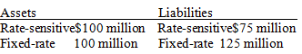
What would happen to bank profits if the interest rates in the economy go down? Is there
anything that you could do to keep your bank from being so vulnerable to interest rate
movements?
- Using T-accounts show what happens to reserves at Security National Bank if one individual deposits $1000 in cash into her checking account and another individual withdraws $750 in cash from her checking account
- “Bank managers should always seek the highest return possible on their assets.” Is this statement true, false, or uncertain? Explain your answer
- How will immediate affect a $5 million deposit outflow from a bank on its deposits and reserves?

Chapter 10. Banking Industry: Structure and Competition
- Why did the interest rate volatility of the 1970s spur financial innovation?
- What financial innovations helped banks to get around the bank branching restrictions of the McFadden Act?
- Discuss three ways in which U.S. banks can become involved in international banking
- Why does the United States operate under a dual banking system?
- How do sweep accounts and money market mutual funds allow banks to avoid reserve requirements?
- Unlike commercial banks, savings and loans, and mutual savings banks, credit unions did not have restrictions on setting up branches in other states. Why, then, are credit unions typically smaller than the other depository institutions?

Chapter 11. Central Banks and the Federal Reserve System
- Why does the Federal Reserve Bank of New York play a special role within the Federal Reserve System?
- Who are the voting members of the Federal Open Market Committee and why is this committee important? Where does the power lie within this committee?
- Explain two concepts of central bank independence. Is the Fed politically independent? Why do economists think central bank independence is important?
- Explain the similarities and differences between the European System of Central Banks and the Federal Reserve System

Chapter 14-23. The Money Supply Process and Aggregate Demand
- Explain two ways by which the Federal Reserve System can increase the monetary base. Why is the effect of Federal Reserve actions on bank reserves less exact than the effect on the monetary base?
- Explain two reasons why the Fed does not have complete control over the level of bank deposits and loans. Explain how a change in either factor affects the deposit expansion process
- Explain why the simple deposit multiplier overstates the true deposit multiplier
- The monetary base increased by 20% during the contraction of 1929-1933, but the money supply fell by 25%. Explain why this occurred. How can the money supply fall when the base increases?
- The Fed buys $100 million of bonds from the public and also lowers the required reserve ratio. What will happen to the money supply?
- Multiple deposit creation: problem
- Multiple deposit creation: problem
- Find the money multiplier
- Explain through the component parts of aggregate demand why the aggregate demand curve slopes down with respect to the inflation rate. Be sure to discuss two channels through which changes in inflation rates affect demand
- Using the aggregate demand-aggregate supply model, explain and demonstrate graphically the short-run and long-run effects of an increase in the money supply
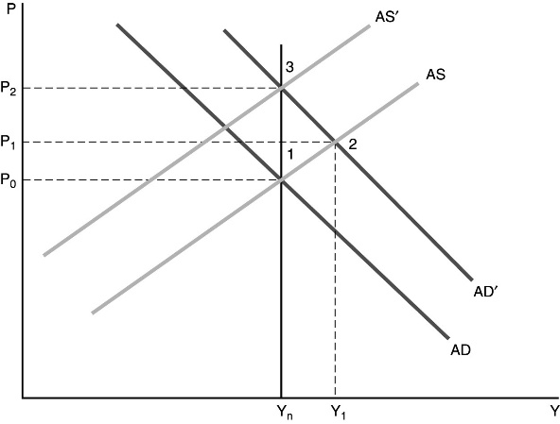

3rd mid-term questions - FOR “International Economics” chair office

Students
Chapter 12 Financial Crises

- Explain the Causes of the 2007-2009 Financial Crises
- Explain the all stages of financial crisis
- The Great Depression of 1930 and the financial crises of 2007–2009 have some similarities and some differences. Compare and contrast the two economic crises
- How did the global financial crisis promote a sovereign debt crisis in Europe?
- How can financial innovation lead to financial crises?

Chapter 15 Tools of Monetary Policy

- Explain the Fed's three tools of monetary policy and how each is used to change the money supply. Does each tool affect the monetary base or the money multiplier?
- Explain the Lender of Last Resort
- State whether the following statement is true or false AND explain why: "A decrease in the discount rate will always cause a decrease in the federal reserve funds rate."
- How Changes in the Tools of Monetary Policy Affect the Federal Funds Rate
- What are the disadvantages of using loans to financial institutions to prevent bank panics?

Chapter 16 The Conduct of Monetary Policy: Strategy and Tactics

- Explain the time-inconsistency problem. What is the likely outcome of discretionary policy? What are the solutions to the time-inconsistency problem?
- Explain what inflation targeting is. What are the advantages and disadvantages of this type of monetary policy strategy?
- Explain and demonstrate graphically how targeting nonborrowed reserves can result in federal funds rate instability.

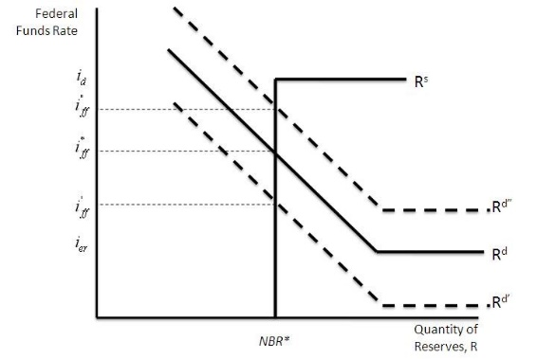
- What are the benefits of using a nominal anchor for the conduct of monetary policy?
- Explain The Fed’s “Just Do It” Monetary Policy Strategy

Chapter 17 The Foreign Exchange Market

- Explain the law of one price and the theory of purchasing power parity. Why doesn't purchasing power parity explain all exchange rate movements in the short run? What factors determine long-run exchange rates?
- Explain and show graphically the effect of an increase in the expected inflation rate on the equilibrium exchange rate, everything else held constant
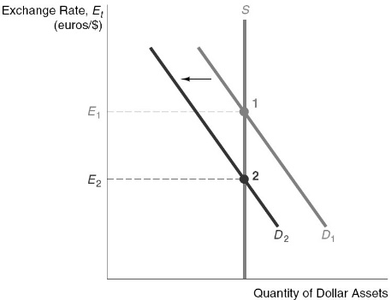
- Why Are Exchange Rates So Volatile?
- If the Indian government unexpectedly announces that it will be imposing higher tariffs on foreign goods one year from now, what will happen to the value of the Indian rupee today?
- If Mexicans go on a spending spree and buy twice as much French perfume and twice as many Japanese TVs, English sweaters, Swiss watches, and bottles of Italian wine, what will happen to the value of the Mexican peso?

Chapter 18 The International Financial System

- Assume that a fixed exchange rate is overvalued. Describe the situation of a speculative crisis against this currency. What can the central bank do to defend the currency? Why might the alternative of devaluation be preferable?
- Explain the 1992 crisis that led to the breakdown of the European Union's Exchange Rate Mechanism. What disadvantages of exchange-rate targeting were exhibited during this crisis?
- Explain the Bretton Woods System. Should the IMF Act as an International Lender of Last Resort?
- What are the key advantages of exchange-rate targetingas a monetary policy strategy?
- What are the advantages and disadvantages of currency boards and dollarization over a monetary policy that
uses only an exchange-rate target?

