AZƏRBAYCAN DÖVLƏT İQTİSAD UNİVERSİTETİ
BEYNƏLXALQ İQTİSADİYYAT MƏKTƏBİ
BEYNƏLXALQ İQTİSADİYYAT (İNGİLİS DİLLİ) KAFEDRASI

İMTAHAN SUALLARI

Chapter 1
- Why information management is so crucial?
- Distinguish the characteristics of data and information. How businesses use data and information to gain competitive advantage? Briefly talk about insights that can be driven from data and information.
- How data is organized to effectively support business processes
- Where is the information that makes businesses run? Distinguish centralized and decentralized information and briefly talk about the problems that may occur as a result of decentralized information system.
- Briefly talk about the three levels of decision making in business organizations. Outline some characteristics of information typically required for each three level of decision making.

Chapter 2
- Explain the concept of GDP and briefly talk about the different approaches for GDP calculation. And provide examples on excel as we did in class.
- Which different types of GDP do you know and how do they differ from each other? Provide practical examples.
- How do we take the effects of inflation out of GDP to compare economic well-being over time? Explain nominal and Real GDP and provide examples on excel.
- Draw an excel sheet with column and row and titles for the economy consisting of two goods. Place the ‘price’, ‘quantity’ and ‘total spending’ for 3 years. Calculate Nominal GDP in the terms of the excel formula for 3 years.
- Draw an excel sheet with column and row and titles for the economy consisting of two goods. Place the ‘price’, ‘quantity’ and ‘total spending’ for 3 years. Calculate Real GDP in the terms of the excel formula for 3 years.

Chapter 3
- Briefly talk about the concept of interest rates and explain how the interest rate affects the lending/borrowing decisions. Provide Excel examples.
- What factors affect the interest rates and how?
- Differentiate the real and nominal interest rates. And strengthen your answer with practical excel example.
- Differentiate the simple and compounding interest. Using an excel sheet explain them practically.
- Draw an excel sheet with column and row and titles and make a simple interest calculator for minimum three years as we did in the class. Show the excel formulas.

Chapter 4
- Explain the term of inflation and define the terms of “escalating inflation”, “disinflation” and “deflation”. Provide excel calculations for each.
- How is inflation measured? In a short excel sheet calculate the inflation rate.
- What creates inflation? Talk about supply shocks and demand shocks.
- What is the relationship between inflation and value of money? Provide excel example as we did in class.
- Draw the excel sheet with column and row and titles, place year 2011, 2012, 2013, 2014 inflation rates as %8, %7, %6, %5 respectively. What is the equivalent value of 1000 AZN at the beginning of 2011, at the end of 2014? Draw an excel sheet, place all variables, then evaluate with excel formula and calculate.

Chapter 5
- What is balance of payments? How are the transactions recorded? Give an example as we did on Excel in class.
- What different groups is balance of payments divided into? Show transactions referring to different groups using an example on Excel.
- Briefly explain the structure of balance of payments and Show transactions referring to different groups using an example on Excel.
- How is BoP analysed? What is the most valuable insight that we can understand after analysing BoP? Show your example on an excel sheet.
- How can we use balance of payments to understand the determinants of demand and supply of foreign currency? Show your example on an excel sheet.

Chapter 6
- Briefly explain the concept of portfolio management and explain how can portfolio structuring in Excel provide accuracy advantages?
- Briefly explain the concept of portfolio management and explain how can portfolio structuring in Excel provide time efficiency advantages?
- Create a model that an investor can use to structure a portfolio using the three-level approach as we practiced during seminar class. The user will input the total portfolio size as well as his allocations at the levels of asset class, categories within each asset class, and specific mutual funds within each category. The portfolio output should show the amount of money that will be invested in each mutual fund.
- Create a model where an investor decides the portfolio structure for the investment amount of $1,000,000.00. Think of yourself as an investor and create the categories and allocate funds to the categories using Excel. Briefly talk about your Excel experience and most importantly, why you prefer using Excel for this task.
- Think of yourself as an investor who has two portfolio choices to decide on. Create the portfolios on the Excel sheet below and assign rate of return for each of them and based on the return rate pick one portfolio and explain how Excel helped you in this particular task.

Chapter 7

- Briefly explain the concept of market equilibrium and talk about the advantages of excel for calculating equilibrium point.
- Is Excel time-efficient way of market equilibrium calculation? If yes, how?
- Once we set the table (among the cells of A3 and E5), which steps do we need to take to come up with the graph and formulas for supply price and demand price?

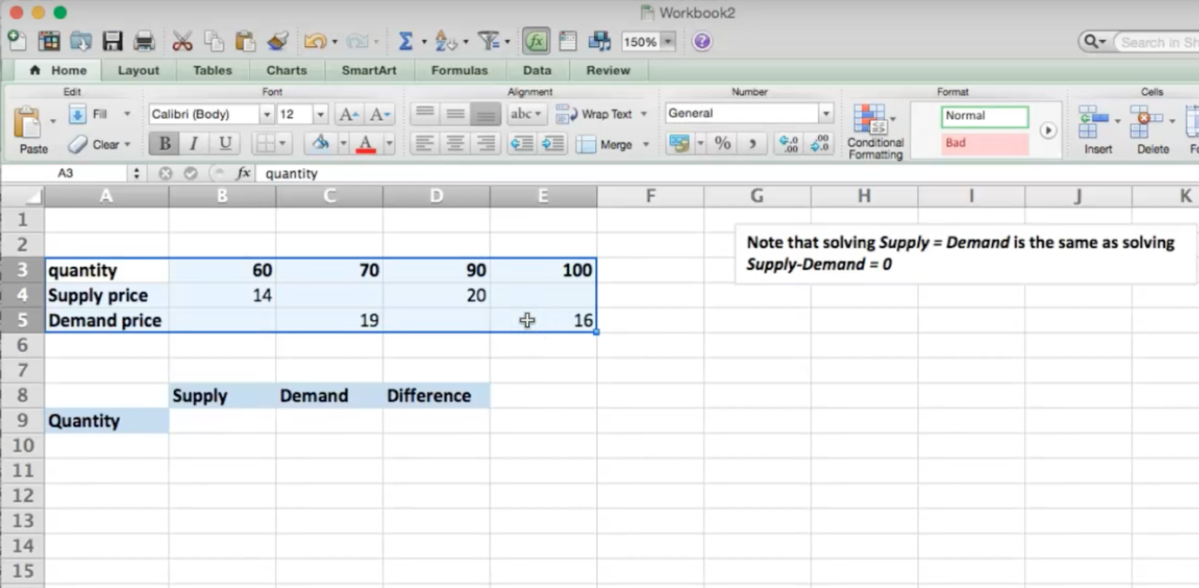

- Once we have got to this stage in our market equilibrium calculation on Excel, what is the next step we need to take? What is the main advantage of “Goal seek” function in Excel?

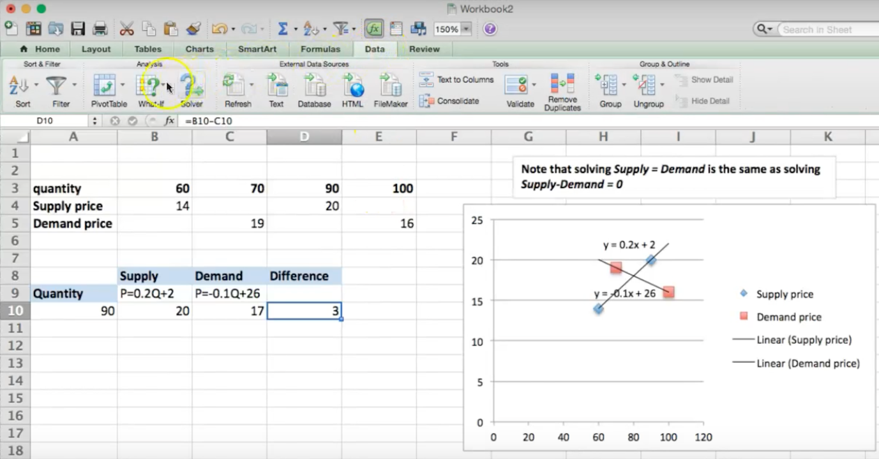

- Briefly explain the concepts of excess supply and excess demand, and logically describe how we can fix the quantities to get to market equilibrium using Excel.

Chapter 8

- Briefly explain the concept of big data and list some of the opportunities and challenges that it creates for businesses.
- How crucial is big data for modern business analytics?
- In our modern world how is big data created and processed? What is the most useful software to process big data?
- How crucial are governance and management for success of big data? What are the risks associated with failure governance and management of big data integration?
- In terms of data architecture, how big data should be integrated to the organization in order to gain maximum competitive advantage?

Chapter 9

- Analyze the below information given on Excel and briefly explain the terms of util, and utility. Describe how would Excel help economists with the below mentioned transactions.

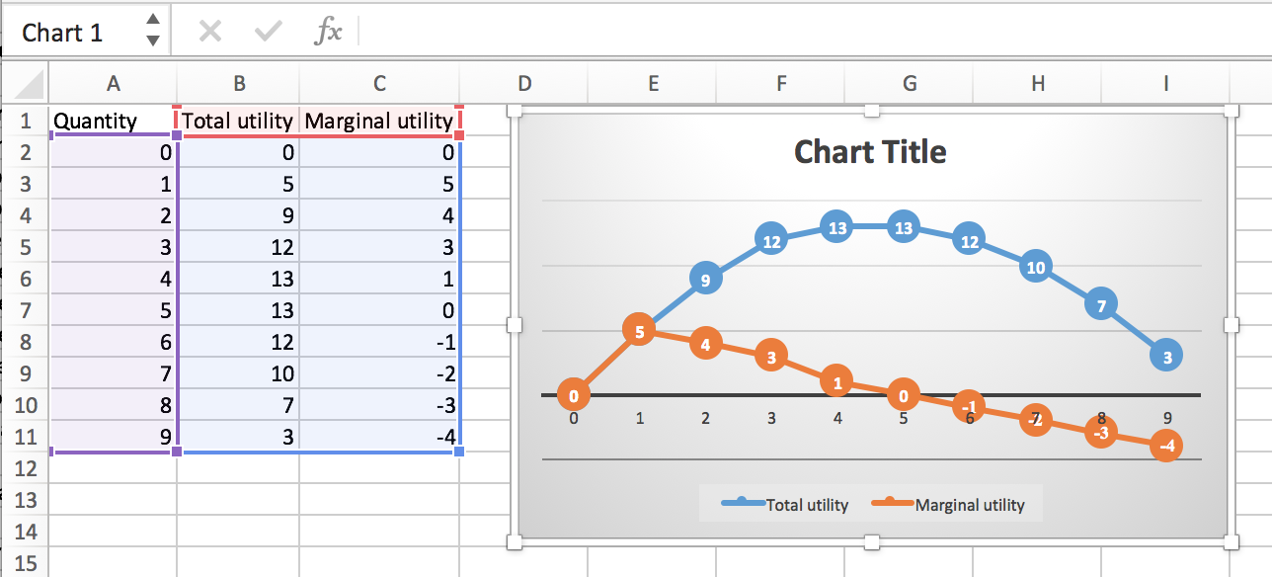

- Analyze the below information given on Excel and briefly explain the terms of total utility and marginal utility. Briefly talk about the diminishing marginal utility. Describe how would Excel help economists with the below mentioned transactions.

- Analyze the below information given on Excel and briefly explain the terms of cardinal utility and ordinal utility. Provide the distinction between those two concepts. Describe how would Excel help economists with the below mentioned transactions.

- Based on the concepts of marginal utility and total utility, explain how money and happiness are related. Support your answer graphically.
- Think of yourself as an economist who is supposed to measure the total utility, marginal, ordinal and cardinal utility of a particular product. How would you use Excel in this respect? What are the key competences of Excel for this particular task?

Chapter 10
- Briefly talk about the concept of utility maximization and explain who is considered to be a rational consumer.
- Briefly talk about the concept of utility maximization and explain how government warning affects consumers’ perception and how that changes consumers’ taste.
- “The conditions for marginal utility approach and indifference curve approach are equivalent and they give the same result.” If you agree with the statement provide the evidence for it.
- Suppose an individual has an income of $15 per time period, the price of good X is $1 and the price of good Y is also $1. That is, I = $15, PX = $1, and PY = $1.
Write the equation of the budget line of this individual in the form that indicates that the amount spent on good X plus the amount spent on good Y equals the individual’s income. How can you transfer the calculation of this task to Excel?

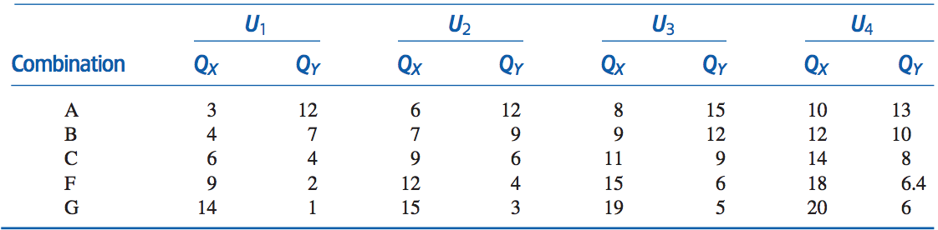

- Suppose an individual has an income of $15 per time period, the price of good X is $1 and the price of good Y is also $1. That is, I = $15, PX = $1, and PY = $1. Plot the budget line. How can you transfer the calculation of this task to Excel?

Chapter 11-12
- Briefly talk about blockchain and highlight the value proposition that is presented by that technology.
- Briefly talk about blockchain utilization and list the three levels of it. Talk about the the level of storage of digital records.
- Briefly talk about blockchain utilization and list the three levels of it. Talk about the the level of exchange of digital assets.
- Briefly talk about blockchain utilization and list the three levels of it. Talk about the the level of recordation and execution of smart contracts.
- Briefly talk about blockchain utilization and list the three levels of it. Talk about the classifications for blockchain implementation.
- How does blockchain work? Briefly explain the logic behind it and talk about the transactions in blockchain system.
- How does blockchain work? Briefly explain the logic behind it and talk about verification of transactions in blockchain system.
- How does blockchain work? Briefly explain the logic behind it and talk about the structure of blocks.
- How does blockchain work? Briefly explain the logic behind it and talk about the validation of blocks.
- How does blockchain work? Briefly explain the logic behind it and talk about blockchain mining.
- How does blockchain work? Briefly explain the logic behind it and talk about the importance of chain.
- How does blockchain work? Briefly explain the logic behind it and talk about the built-in defence in blockchain system.
- Talk about the importance of blockchain in digital age. List some of the key drivers of blockchain for a modern business.
- Talk about the importance of blockchain in digital age. List some of the key challenges of blockchain for a modern business.
- Talk about the importance of blockchain in digital age. List some of the potential solutions to challenges of blockchain for a modern business.
- How disruptive and innovative do you think is blockchain for digital age? What are the uses of technology in financial industry?
- How disruptive and innovative do you think is blockchain for digital age? What are the uses of technology in healthcare industry?
- How disruptive and innovative do you think is blockchain for digital age? What are the uses of technology in public sector?
- How disruptive and innovative do you think is blockchain for digital age? What are the uses of technology in energy industry?
- How disruptive and innovative do you think is blockchain for digital age? What are the uses of technology in media and telecom industry?
- How disruptive and innovative do you think is blockchain for digital age? What are the uses of technology in consumer and industrial products industry?
- Why should companies operating in financial sector consider adopting blockchain to their operations? What is the value driven out of that technology?
- Why should companies operating in non-financial sector consider adopting blockchain to their operations? What is the value driven out of that technology?
- Briefly talk about the importance of blockchain for remittances. Think of yourself as an immigrant who works abroad and periodically sends money to the family. How would blockchain help you in this matter?
- Compare two most popular methods of international financial transfers: via SWIFT and via blockchain. Which one would you prefer for your daily activities and why?

