- What is the difference between revenues and earnings? Describe and show as a sample.

What is the difference between expenses and payments?Describe and show as a sample.

What is the difference between revenues and receipts? Describe and show as a sample.

What is the statement of financial position?

What is the difference between the cash basis and the accrual basis of accounting?

What is the difference between adjusting entries and correcting entries?

What is a journal entry? (structure, items and etc.)

Describe and discuss the comparison of financial statements using debt ratio

Describe and discuss the comparison of financial statements using current ratio

Discuss and describe the preparation of income statement

Describe the preparation and analysis of income statement using margin ratios

Describe and discuss the calculation of COS(COGS), and inventory analysis

What is a general ledger account?(structure, items and etc.)

What is the double entry system?

What is historical cost?(the implmentation and show samples)

Describe the double entry system, T-accounts and their use in business purposes.

Describe the accounting, accounting process, its nature and basic accounting equation
- Describe the revenue recognition principle(the implmentation and show samples)
- Write on time period assumption (the implmentation and show samples)
- Write about matching principle (the implmentation and show samples)
- Describe and discuss assets, liabilities and equity, their structure, types and etc.
- (1) May 1 Owner invested $0 in the company.
(2) May 3 Borrowed $0 from a bank.
(3) May 6 Purchased $00 equipment in cash.
(4) May 8 Purchased $0 merchandise (0 units) on credit.
(5) May 15 Sold 0 units of merchandise at the price of $0.
Customer paid $0 in cash at the time of sale.
(6) May 25 Paid $0 salaries.
(7) May 26 Paid $0 rent.
Prepare T-account transactions and balance sheet.
- (1) May 1 Owner invested $00 in the company.
(2) May 3 Borrowed $00 from a bank.
(3) May 6 Purchased $00 equipment in cash.
(4) May 8 Purchased $00 merchandise (0 units) on credit.
(5) May 15 Sold 0 units of merchandise at the price of $00.
Customer paid $00 in cash at the time of sale.
(6) May 25 Paid $0 salaries.
(7) May 26 Paid $0 rent.
(8) May 27 Paid $0 utilities
Prepare T-account transactions and balance sheet.
- (1) May 1 Owner invested $0 in the company.
(2) May 3 Borrowed $0 from a bank.
(3) May 6 Purchased $0 equipment in cash.
(4) May 8 Purchased $00 merchandise on credit.
(5) May 15 Sold $00 of merchandise at the price of $00.
Customer paid $00 in cash at the time of sale.
(6) May 25 Paid $0 salaries.
(7) May 26 Paid $00 rent.
(8) May 27 Paid $0 utilities
Prepare T-account transactions and balance sheet.
- (1) May 1 Owner invested $00 in the company.
(2) May 3 Borrowed $00 from a bank.
(3) May 6 Purchased $00 equipment on credit.
(4) May 8 Purchased $00 merchandise in cash.
(5) May 15 Sold $0 of merchandise at the price of $00.
Customer paid $0 in cash at the time of sale.
(6) May 25 Paid $00 salaries.
(7) May 26 Paid $00 rent.
(8) May 27 Paid $0 utilities
Prepare T-account transactions and balance sheet.
26.What document summarizes the effects of all the entity’s transactions and adjustments throughout the period? Describe each item on it and write about relevant items.
27. What is the last major step in the accounting cycle? Describe each item on it and write about relevant items.
28. Which accounts do not get closed out? Describe each item on it and write about relevant items.
29. How the companies evaluate themselves? Which financial measures or ratios basically do they use? Write about them.
30. Data for the unadjusted trial balance of Mexican Riviera Tanning Salon at March 31,
2012, follow.
Cash  Equipment  Accumulate depreciation  Accounts payable  Supplies  Neeland, capital |  | Service revenue  Salary expense  Depreciation expense  Supplies expense  Neeland, drawing
Adjusting data for March 2012 are:
Accrued service revenue, $00.
Supplies used in operations, $00.
Accrued salary expense, $00.
Depreciation expense, $00.
Les Neeland, the owner, has received an offer to sell the company. He needs to know
the net income for the month covered by these data.
a. Prepare the worksheet for Mexican Riviera Tanning Salon.
b. How much was the net income/net loss for March?
C. Prepare balance sheet.

31. The trial balance of Telegraphic Link at November 30, follows:
Cash
Accounts receivable
Prepaid rent
Supplies
Equipment
Accumulated depreciation
Accounts payable
Salary payable
Thomas, capital
Thomas, drawing
Service revenue
Depreciation expense
Salary expense
Rent expense
Utilities expense
Supplies expense

Additional information at November 30, 2012:
Accrued service revenue, $0.
Depreciation, $0.
Accrued salary expense, $00.
Prepaid rent expired, $00.
Supplies used, $00
a) Complete Telegraphic Link’s worksheet for the month ended November 30, 2012.
b) How much was net income for November?
C) Prepare balance sheet

32. What are merchandising operations. Describe them and provide some examples.
33. Describe and write about The Operating Cycle of a Merchandising Business, provide samples.
34. Describe and write about perpetual inventory system, provide samples.
35. Describe and write about periodic inventory system, provide samples.
36. Describe and write about the accounting process for the perpetual inventory system, and provide samples.
37. Describe and write about the accounting process for the periodic inventory system, and provide samples.
38. Describe and write about the accounting process for purchase discounts, and provide samples.
39. Describe and write about the accounting process for purchase returns and allowances, and provide samples.
40. Describe and write about the accounting process for sales returns and allowances, and provide samples.
41. Describe and write about the accounting process for sales discounts, and provide samples
42. Describe and write about accounting ratios and their types.
43. Describe and write about adjusting process for the inventory based on physical count
44. Describe and write about closing process for the inventory based on physical count
45. Describe and write about Income Statement and it’s preparation.
46. Write about gross profit margin, it’s calculation methods and what it’s effects on.
47. Write about the inventory turnover, it’s calculations and what it’s effects on.
48. The company was established with authorized capital 00$, of which 000$ were in cash, 000$ was in Building, 000$ was in equipment. The company has employees with salary 000$. During the week the company acquired a car for company needs, by the price 000$ and paid in cash the full amount. Then it obtained office supplies from Intellect LLC by the price 0$, but paid 0% in cash. In order to get familiar to the publicity, the company arranged several interviews with one of the channels, and for this cause preliminary rented a room (which included snack and service) in PLAZA, and paid in advance in cash the amount 00$ for the whole month. The company was supplied with goods from Craft LLC by the price 00$, plus freight-in charges in the amount of 00$. During the check, there were found out that some goods are damaged, and some are provided incorrectly against the invoice. The damaged goods amounting to 00$ were returned to Craft LLC, and despite of fact that there was incorrectness in provision of some goods, the company considered them still eligible for sale, but claimed allowance for them in the amount of 00$. Craft LLC agrees and states that if our company makes the payment for the goods in 15 days, it will get an additional 10% discount on the price. Our company makes the payment during the discounting period. During the month company makes sales amounting to 00$ to Barnes LLC and send them invoice. During the transportation some of the goods were damaged and Barnes LLC returned to us 00$ worth of damaged goods that costed 00$, and paid in cash just 000$. Ending inventory at the end of the month was 00$. The utility expenses were 00$, commissions to staff were 10 000$. Al the expenses were paid out. Prepare relevant transactions, Balance and Income statement.
49. Describe and write about FIFO method and it’s calculation, provide samples.
50. Describe and write about LIFO and Average costing methods and their calculation, provide samples.

- Define internal control and it’s features
- List and describe the components of internal control and control procedures
- Explain control procedures unique to e-commerce
- Demonstrate the use of a bank account as a control device
- Identify ethical dilemmas in an internal control situation
- Describe and write about bank reconcilation process
- Describe and write about cash account reconciliation process
- Describe and write how the company can measure the cost of a plant asset
- Describe and write about capital expenditures
- Describe and write about the 3 main factors measuring the depreciation
- Describe and write about the depreciation methods (straight-line and reducing balance)
- Describe and write about the disposing of plant assets
- Write about contingent liabilities
- Describe and write about the payroll and payroll accounting
- Day 1. Established a company with authorized capital – 0 AZN. Day.2 Rented an office with monthly fee – 00 AZN.Day 3. Hired employees: Executive manager-00 AZN, 3 mid chain managers – each 00 AZN, 7 sales specialists – each 00 AZN, one warehouseman – 00 AZN. Day 5. Obtained a warehouse for keeping goods – 00 AZN. Day 8. Purchased 00 units of microprocessors by the price 0 AZN per unit.Day 10. Obtained a small truck for transportation needs – 00 AZN. Day 12. Purchased additionally 00 units of microprocessors by the price 00 AZN per unit and 00 video graphic adapters by the price 0 AZN per unit. Day 16. By the decision of procurement and sales departments additionally purchased 00 units of microprocessors by the price 0 AZN per unit and 00 video graphic adapters by the price 0 AZN. Day 20. The company realized 0 units of microprocessors and 00 units of video graphic adapters with 0% trade surcharge. Day 24. The company received bill for utilities – 00 AZN. Day 30. The company paid for all expenses including sales tax (0%). For purchase/selling operations use FIFO method. The terms of the problem: To prepare appropriate Profit and Loss Statement regarding above mentioned operations.To prepare appropriate Cash Flow Statement regarding above mentioned operations.To prepare appropriate Balance Sheet Statement regarding above mentioned operations.
- Given the data for the 1st month of NovKo ltd.:
A | L | E
Raw materials:  Production equipment:  Cash in bank:  Computers:  Accounts receivable: | Trade payables: | Authorized capital:  Net profit:
2nd month:
The salaries 00 (0% relate to admin personnel). Rental expenses – 00 for production area, 00 for the sales area. Utilities – 00 for sales area, 00 for production.
The company paid back 00 of payables, received back 0% of receivables. The depreciation for computers is 0 per month, for production equipment – 00 per month. Bought raw materials by the price 00. During the week 000 of raw materials were used in production. When the ready made production was ready, the company incurred packaging expenses -00, and transportation expenses – 00 on them. The good were transported to sales area and sold with 0% mark-up. Tax from sales – 0%. Prepare BS, IS, CFS
- Given an unadjusted trial balance for the company below:
Debit | Credit
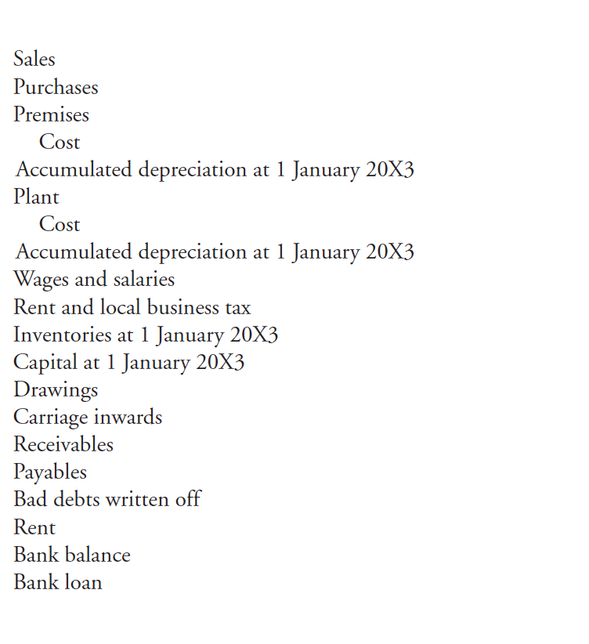

The following operations were incurred during the period:
1. Ending inventories is $00.
2. Accrued wages and salaries are $00.
3. Prepaid rent is $00.
4. Bank loan interest of 0% per annum is outstanding.
5. Allowance for receivables will be made as 0%.
6. Depreciation will be charged at 0 % of cost on premises, and at 0 %of cost on plant.
Required to prepare adjusted trial balance and reflect relevant journal entries of incurred operations.

- Given a trial balance for the company below. On its base calculate current ratio (1 point)
Debit | Credit
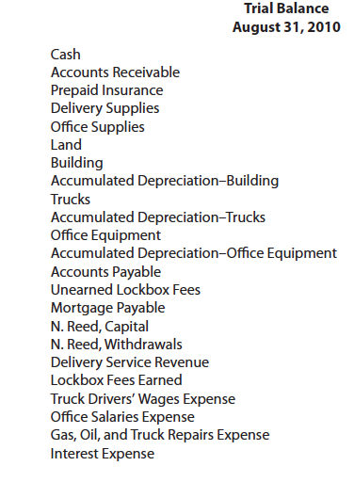

Assume that above trial balance is an unadjusted and incurred the following operations.
Expired insurance, $0. Inventory of unused delivery supplies, $0. Inventory of unused office supplies, $0. Estimated depreciation on the building, $00. Estimated depreciation on the trucks, $0. Estimated depreciation on the office equipment, $00. The company credits the lockbox fees of customers who pay in advance to the Unearned Lockbox Fees account. Of the amount credited to this account during the year, $0 had been earned by August 31. Lockbox fees earned but unrecorded and uncollected at the end of the accounting period, $0. Accrued but unpaid truck drivers’ wages at the end of the year, $0
Prepare adjusted trial balance and Income statement.

- Limitations of internal control – costs and benefits
- Describe and write about lump-sump purchase of assets.
- Describe and write about the 2 main controls over payroll.
- Below is given information on inflow and outflow of inventory on March:
Date | Unit | Unit cost ($) | Total cost ($)
2 Mar | 00 (i)* | 0 | 00
8 Mar | 0 (o)*
14 Mar | 00 (i) |  | 00
16 Mar | 0 (o)
18 Mar | 0 (i) |  | 0
26 Mar | 00 (i) |  | 0
30 Mar | 0 (o)
Note*: (i) means inflow(purchase), (o)-outflow(sales)
On the base of the above information calculate the COGS using the LIFO, FIFO, AVCO methods

- You have the following info
Debit | Credit
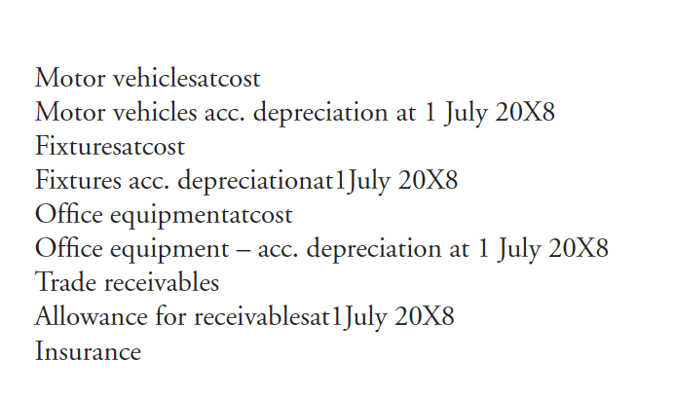
The following adjustments have not yet been made in the books:
(i) Motor vehicles are depreciated over 4 years on the straight-line basis. On 31 March 2009, a motor vehicle that had cost $000 on 1 July 2006 was disposed of for $00. It is the company’s policy to charge a full year’s depreciation in the year of purchase, and hence none in the year of disposal. No entries have been made for the disposal.
(ii) Fixtures are depreciated on the straight-line basis over 10 years, on an actual time basis
(i.e. from the date of acquisition). On 1 October 2008, fixtures were purchased for $00, which have not been entered in the books.
(iii) Office equipment is depreciated at 0 % per annum on the reducing-balance basis.
(iv) On 30 June 2009, it was decided to write off a bad debt of $000 and to make an allowance for receivables of 3% of the remaining receivables.
(v) The insurance figure above covers the period 1 July 2008 to 30 September 2009.
(vi) Sales representatives are paid commission, which amounts to 0 per cent of the previous month’s sales. The commission is due for payment on the 15th of the following month. During June 2009, sales amounted to $000.
Requirement:
- Prepare income statement for the year ended 30 June 2009
- Prepare journal entries and adjusted trial balance
- Compare FIFO,LIFO, AVCO methods, which one is more beneficial by the point of view for tax purposes and revenue purposes.

Above is given trial balance for the 30 March 2007
During 31 March 2007, the business made the following transactions.
(a) Bought materials for $00, half for cash and half on credit
(b) Made $0 sales, $00 of which was for credit
(c) Paid wages to shop assistants of $0 in cash
(d) Sales were 00$, 0% of them in cash
(e) trade payables decreased by 0%
(f) bought fixtures and furniture in credit amounting 0$

Requirement:
- Prepare income statement for the year ended 31 march 2007
- Prepare balance sheet for the year ended 31 march 2007

