COMPARİSON OF IAS 39 WİTH IFRS 9 AND TRANSİTİON PROCESS

University: Azerbaijan State University of Economics
Faculty: SABAH Center
Specialization: Finance
Author: Mirshahin Agayev
Supervisor: Agil Azizov

University of Economics
2019
Table of Contents

ACKNOWLEDGEMENTS 3
ABSTRACT 4
INTRODUCTION 5
  - Introduction 5
  - Problematic on Research and Methodology 6
  - Intellectual interest of the research and structure of the dissertation 7
CHAPTER 1: THEORETICAL BASE OF IAS 39 AND IFRS 9, COMPARISON OF THESE TWO STANDARDS 9
  - General information about IAS 39 and need for IFRS 9 9
  - Financial Instruments - IFRS 9 and its SWOT analysis 16
  - Transition Requirements of new standard and presentation 22
CHAPTER 2: METHODOLOGICAL BASE OF CLASSIFICATION AND MEASUREMENT UNDER NEW STANDARD 27
  - Classification under Amortized cost and Fait Value model 27
  - Debt instruments and Equity instruments at FVOCI 33
  - Measurement on Initial recognition and subsequent measurement 39
CHAPTER 3: ANALYSE THE RESULTS OF TRANSITION FROM IAS 39 TO IFRS 9 AND THE IMPAIRMENT MODEL 48
3.1. The Impairment Mode and Expected Credit Loss 48
3.2. Summary of changes after transition to new standard - IFRS 9 56
CONCLUSION 58
REFERENCES 61

ACKNOWLEDGEMENTS

It could be very difficult to research about this thesis without people who helped me to find reliable sources and choosing right way of research.
I want to express my profound and sincere gratefulness to my research Supervisor Azizov Agil because of stimulus, patience and incredible accumulation of knowledge.
As an Industry Specialist, I am very grateful to Kamran Asgarov- Senior Associate at PwC for his support during my research.

Mirshahin Agayev
Baku, May, 2019

ABSTRACT

The aim of this thesis is to deliver a comparative analyze for replaced standard IAS 39 and new standard IFRS 9- Financial Instruments. Financial Instruments is one of the most imperative objects for both FS-financial statements and stakeholders who are user of FS, at the same time it is used to measure and assess an organizations’ historical business performance, upcoming prospects and financial strength. Based on this reason, determination of fair measurement of Financial Instrument is one of the most considered accounting subjects by stockholders and supervisors. In spite of extensive belief, IFRS 9 influences more than just financial organizations. Any organization that has substantial alterations to its financial reporting as the consequence of this rule.
Most organizations will see some modification as a result of applying this new standard: At the end of the day, this standard makes a solitary model to measure and asses Financial instrument on timely basis and provide fair information to users of financial statements. It will deliver better reliability and comparability among industries and investment markets.
In conclusion, the effects of new standard can be as comprehensive as influencing business approaches, procedures, structures, panels, bookkeeping and discovery of financial statements. This thesis is going to analyze the potential influence of the new standard over Financial instruments and key distinctive from previous standard IAS39.

INTRODUCTION

Introduction
Accounting is a data framework that gives information about the database of the budgetary status of organizations because of the transactions made by the institutions and the origins of assets, what they use, the progressions that happen in these assets and convey this data to the appropriate people and institutions.
The accounting provides the reports of the information regarding to the financial position and sustainability of the entities. Several associations have taken an interest in the investigation to provide a similar language in global accounting practices. In contemporary monetary conditions the world over, financial bookkeeping and reporting give valuable data to leaders, speculators, providers, money related controllers and other monetary clients.
Therefore, as the business condition keeps on transforming, it spreads to accounting principles what oversee the reporting of the financial information.One of the important mechanisms that used in the operation of financial analysis are Accounting Standards. In an adjustted business condition , it is vital to check the usefulness and main functions of Accounting Standards.
It is necessary to use Accounting standards in the preparation if financial reports in order to show true position of the companies and in this way investors can easyly decide whether to invest or not. New accounting standars have issued in order to keep safety of investors and the safeguarding of information that illustrated in company’s financial statements.There were many standards about Financial Instruments which are very crucial in side of reporting and one of the difficult issue is to recognition and classification of financial instruments.
Recently, issues regarding to the classification of financial instruments as per accounting standards have fundamentally expanded. IFRS 9 is a new accounting standard about financial instruments which was developed in order to replace old standard that known as IAS 39 and the completion of new standard-IFRS 9 dated on 9 July 2014 by issuing latest standard that merges all requirement of financial instruments.

Research Problems and Methodology
Thesis is mainly based on the practical application of accounting standard after transition to IFRS 9 and building it as productive, because the aim of the making this research is to expose some practical facts.
As a consequence of this research, we have built up a two-way examination of the links between types of models to produce information and solution. Therefore, I research new IFRS rule so it is IFRS 9 financial instruments and their measurement. Then I have made research about SPPI test and Impairment Model which are key things in this standard, advantage and disadvantage of using new standard and main problems during application of IFRS 9. Documents used during the research consisted of articles that provided by Big4 companies, regulations, research reports of professionals in this field and sites specialized in accounting.
I have also also used the comparative method in order to clarify differences or similarities in the use of IFRS 9 and IAS 39. IFRS 9 is going to perform new requirements and rules compared to the standard that it will substituted (IAS 39).
The goal of this dissertation is to show the main requirements of IFRS 9, to compare its key distinctions and latest updates with existing IAS and accomplishing by the variety of sector institutions in identifying and adopting innovations.
Consequently, research have the following main objectives which will be explained in next paragraphs.
Objectives:
- Research and explanation of main requirements regarding to IFRS 9;
- Clarify key distinctions and new innovations brought by IFRS 9 in classification and measurement of financial instruments;
- Evaluation of the SPPI criteria under IFRS 9;
- Research and analyze of main changes that comes with Impairment Model

Intellectual interest of the research and structure of the dissertation
After publication of new standard in 2014, many articles and research have been published based on requirements of IFRS 9. Most of them stressed that the IFRS 9 is going be used not just in the accounting records, but will influence other range of the institution’s business model.

IFRS 9 mainly is efficacious for years beginning of January 2018, with earlier application allowed. But, based on decision that agreed by IASB in late 2016 is to provide option for application of new standard in institutions whose main actions are insurance related. Hence, they can delay adoption of IFRS 9 until 2021. Although the first adoption is 1 January 2018, there are still some indefiniteness as to how institutions will be affected by IFRS 9 in practice and what they have to do in a preparation of report under new standard.
Moreover, this research also objects to clarify whether the distinctions theoretically become clear for entities in certain industries compatible to the obstacles that these companies face in practice.
The structure of this thesis consist of three parts as follows:
- First part starts with theoretical base of two standards. After that, main requirement of new standard during transition is going to be discussed and SWOT analyze of IFRS 9 will be performed.
- Secondly, I am going to make research about classification and measurement of new standard IFRS 9 and SPPI (Solely Payment of Principals and Interest) criteria under new standard. This will be closed by analyzing of measurement on Initial recognition and the subsequent measurement.
- Third section is about results of transition from IAS 39 to IFRS 9 and the big changes come with Impairment Model.

CHAPTER 1. THEORETICAL BASE OF IAS 39 AND IFRS 9, COMPARISON OF THESE TWO STANDARDS.

In this part I am going to write general information regarding to each standard and specific thing that are coming with application of IFRS 9.

  - General information about IAS 39 and need for IFRS 9
In this part of first section I am going to write general information regarding IAS 39, different financial instruments under this standard and the importance of International standards. I will finish this part with short conclusion about IAS 39 and need for new standard – IFRS 9.
The companies which are under the interest of different stakeholders are trying to publish financial report that shows true position of the company. In a simple way, the goal of financial statements is to give the stakeholders who are outside the organization with data that may be valuable to perceive how well an organization is operating. Diverse clients have distinctive targets and may require various types of data, a few questions necessitate that you need more and more profound information, while other questions require just shallow data. That’s why demand for International Standard have been increased.
Diverse nations have distinctive accounting standards and there is a coordinated effort attempting to fit them with the goal that similarity ought to be improved by involvement of European Union (EU) and Boards which are main activities consist of International Accounting Standards (IAS). Harmonization implies that the nations are endeavouring to get diverse accounting guidelines to unite. A few nations have flexible adaptability of accounting standards, and this makes it troublesome for investors over the world to utilize financial related data in a choice situation. However even regardless of whether the harmonization and likeness are presented, there still contrasts among countries and these distinctions plays a vulnerable role for financial data.
The big need for International standard is about assessment of fair value for assets and liabilities. Assessing reasonable incentive (fair value) for assets and liabilities is very simple when they are effectively exchanged liquid markets. The issue turns out to be increasingly troublesome if dynamic markets don't exist. Specialists trust that extended reasonable esteem based financial reports may supply client’s helpful data, gave the reasonable fair value assessment.
IAS 39 is a standard, which gives bookkeeping principles to valuation and bookkeeping of monetary resources and liabilities and in certain respects the buy or clearance of non-money related things. This standard shows when the money related instruments ought to be taken up in its monetary record and how to assess them. It contains data on when they never again need to account the money related instrument in the balance sheet and how they are classified accurately. Financial instruments could be many things as interst rate swaps, UK treasure shares, equity (capital) swaps, debit/credit swaps, receivables, loan as a liability and other shares issued by different institutions. In nowadays there are even financial instruments that is aggravated and that implies for instance that an obligation security can contain both a value part and a risk part. In the course of recent years, the complexity has monetary instrument prompted challenges in measurement, classification, introducing and exposure these instruments in financial reports of an institutions. As indicated by an investigation the trouble with the present bookkeeping gauges is the decent variety of strategies displayed to esteem money related instruments. The grouping of the assets decides the essential estimation strategy reasonable esteem, amortized cost esteem, historical. The examination recommends that this valuation strategy causes superfluous unpredictability in money related instrument bookkeeping. The examination reason that an answer for the issue with characterization is understood is to utilize the reasonable incentive to quantify every money related instrument. The reasons for choosing the fair value in many financial instruments are that it could give more useful data for the stakeholder and other beneficiaries of financial statements. The fair value is a best method of measurement for assets and liabilities that are held-to-maturity (HTM) purposes. However, the fair value is an extremely unpredictable estimation.
IAS 39 tell regarding how to clarify a financial instrument. The organization's point of holding of the money related instrument assumes a major job in deciding in which class the instrument must be included. A budgetary instrument could be money, a value instrument of another element or an authoritative right, for example, the element gets money from different substances monetary assets for instance unique sorts of receivables.
It might likewise be an agreement that permits the organization changing assets or liabilities with another entity and that this gives a positive outcome. A case of such an instrument is distinctive kinds of swaps. It could likewise be a derivative that will be settled other than a fixed measure of money of the element's very own value instruments. Financial instruments can be grouped into three parts (Table1). A budgetary risk is an authoritative commitment given that it conveys money or other monetary advantage for the substance or it could be a trade budgetary instrument resource or obligation whit other venture element under possibly negative to the element. It could even be an agreement that might be settled in the element's very own value instrument on the off chance that it is a non-derivative for which the element is committed to convey a quantities of the element's own value. So as to know the distinction between money related instruments have a place with the organization's risk or value, there is a few conditions that must be met and they are: Instruments that legally binding commitment to convey money or other resource/obligation to another substance and an instrument which will be settled in the guarantors claim value for this situation it could be a derivative.
A financial instrument is any agreement that offers ascend to a financial asset of one company, and a financial risk or value instrument of another element. This implies things that will be settled through the receipt or conveyance of products or administrations are not financial instruments, nor ordinarily are charge assets and liabilities as these emerge through lawful as opposed to authoritative requirements.

Table1
Financial Instruments

Combinations
- Convertible debt
- Exchangeable debt
- Equity linked bonds
Primary
- Equity Instruments
- Bonds, loans, borrowings
- Receivables
- Deposits of Cash
Derivatives
- Forwards /Futures
- Financial Options
- Swaps
- Financial guarantees
- Letters of credit

As I mentioned before there are different types of financial instruments. Common fin instruments are shares, bonds, forwards and futures, swap and etc. A share is the point at which you have a possession enthusiasm for an organization that gives Interference in the organization. There are two sorts of shares and they are: Ordinary shares and preference shares. Preference shares, an offer in profits and during the liquidation process they have priority over different shares, for example, ordinary shares. A security is an obligation, as a rule more than quite a while promissory note confirming that the holder has loaned cash. A choice is an agreement between a purchaser and a dealer that gives the purchaser the right, yet not the commitment, to purchase or to sell a specific resource prior to the alternative's termination time, at a concurred cost. Choice is accessible in two variations call alternative and put choice. Futures contract, in account, alludes to an institutionalized contract to purchase or sell a predetermined ware of institutionalized quality at a specific date later on, at a market decided cost. A swap is a derivative in which two counterparty’s trades certain advantages of one gathering's money related instrument for those of the other party's budgetary instrument. For instance, two gatherings could change intrigue's instalment whit each other from variable to fixed rate.
“Incriminated complexity of accounting for financial tools is inherent due to the growing investors’ complexity and the extraordinary improvement of financial engineering”- by Maria Carmen Huain-2015

Financial assets are part of financial instruments and they are grouped into four sections as illustrated in Table 2.

Table 2

Reasonable estimation of these four resources there are two that should be esteemed to reasonable esteem and accounted really to the SFP (Statement of money related positions) and they are resources that are accounted clearly to Income articulation and monetary resources that are held for exchanging(trading). These are not held to development as they are interest in obligation instrument as obligation instrument (bond). Pay or misfortunes that are accomplished do to change in reasonable esteem should not to impact the salary explanation, the change should be accounted truly to the esteem if the monetary instrument has a spot with the class budgetary asset that is held for exchanging. Just pay or misfortunes that is recognized should be accounted honestly to Income articulation. In case pay is grabbed from a money related instrument and the change in esteem is on favourable position that has a spot with the class resources that is esteemed to reasonable esteem and is accounted direct to profit and disaster should be accounted genuinely to profit and mishap. This entire infers even a concealed advantage impact the advantage and hardship clarification if the favourable position is in the arrangement of monetary instrument that is esteemed to reasonable esteem genuinely through advantage and adversity. This is under the condition that the money related asset isn't a bit of a security and along these lines it is a bit of the association's framework for end of hazard or hazard the executives. According to the IAS 39, financial liabilities are summarized under two headlines.
- Financial liabilities assessed by FVTPL
- Financial liabilities which are not possible assess by Fair value through profit or loss (FVTPL)
First section is a one of the financial instruments which is held for trading and the aim is to achieve high level of profit. But in the second section, organizations’ financial liabilities as debt from banks and other kinds of loan can be categorized. In this section we can find biggest part of entities’ liability which are used through their lifetime. Although IAS 39 gives us many rules about the placement or measurement of financial instruments of the companies. There are still some weaknesses that should be improved based financial analysists’ decision. That’s why need for new standard IFRS 9 arises.
All affiliations that have money related instruments to be decided sheet need to displace the present IAS 39 with IFRS 9. The substitution essentially influences accounting itself, frames, works out, fundamental administration and in the end on budget summaries. This theory displays the connection between measures, its focal points and weaknesses, a sensible regard bookkeeping, hindrance of money related instruments and changes in fundamental authority in the affiliations.
“Reasonable value bookkeeping has been under deep inspection because of its alleged role in the financial crisis” by Vera Palea - Emerald Group Publishing Limited

  - Financial Instruments -IFRS 9 and its SWOT analysis
The IASB disseminated a last type of the all-inclusive money related declaring standard IFRS 9 Financial instruments in July 2014, which will supersede the present overall accounting standard IAS 39 – Financial instruments on first January 2018. All affiliations that have budgetary instruments in the declaration of monetary position need to replace the present IAS 39 with IFRS 9. The substitution fundamentally influences accounting itself, shapes, works out, essential authority and finally on budget reports. IFRS 9 presents accounting dependent on gauges, while IAS 39 relies upon standards, notwithstanding the way that these rules empower the chiefs to take progressively relentless and obvious decisions in a shaky area. Examination to the rules-based procedure fuses the manner in which that rules don't modify and are futile in a circumstance with imaginative trades, while investigation to the benchmarks subject to the guidelines approach join the nonappearance of operational course. With the introduction of rules reliant on measures, an examination across over affiliations is never again conceivable, in light of the way that standards require from the affiliations the confirmation of the assumptions and choices that are insisted and checked by the controllers and reviewers.
As per the many research ISA 39 is one the principle reason of monetary emergency in 2008, that is the reason the Board chosen to propose the advancement of the new standard for the money related instruments with the view to progress budgetary unfaltering quality, considering:

• The multifaceted idea of the current rule(standard) for budgetary instruments
• How much the budgetary instrument is at risk to reasonable esteem
• The methodology of affirmation and reasonable estimation of money related instruments.

Executive of IAS Board, in a discussion in January 2016 going before the European Parliament, raised that the best change getting from the substitution of the standard is a model of expected credit hardships that require a particular time of assertion of unavoidable disasters in financial synopses, especially in banks. Additionally, IFRS 9 improves the budgetary revealing, uncommonly in the field of responsibility instruments. Impedance of money related resources gets undeniable yet monster changes bookkeeping plans, which depend upon the model of future hardships, while assistants have a data into instruments with expanded credit danger.

As an insufficiency, we can raise the expenses caused at the time of execution, in any case Marshall watches that the central focuses outperform the expenses of use. A further block is the nonappearance of get together with US GAAP checks, yet the IASB trusts that necessities for attestation, portrayal, estimation and shut are the proportionate in EU and USA and that the European affiliations are not in a place of focused affront fundamentally on unequivocal models of deficiencies. IFRS 9 presents another bookkeeping inside the picked game plan of action and where resources are administered to make cash streams – by social event definitive cash streams, selling money related resources, or both. The arrangement of activity for administering fundamental commitment instruments is set up by the assignments in an affiliation that requirements to consider into the possibility of business:
• the manner in which the introduction of execution inside plan of action and the board of monetary resources and the introduction to the key administration staff
• Dangers that influence the execution of the plan of action and the manner by which those dangers are overseen
• The assurance of the compensation for officials

Examination between IAS 39 and IFRS 9 in the light of the motivation driving the standard was shown in table 3, the essential insistence, the estimation of the key game plans of the instruments, renaming of instruments, compensation and incapacity. We can reason that in starting insistence and in beginning estimation there are no complexities between the principles. The gathering of cash related instruments and its following estimation are the best changes in the substitution. IAS 39 has four classes of collection and three classes of estimation, while IFRS 9 has just three portrayals of estimation, which are besides the requests of course of action. IFRS 9 improves the game plan criteria of cash related tools (Instruments).
IASB presents a sensible regard estimation in IFRS 9. Sensible regard bookkeeping recommends that preferences and liabilities are regarded at sensible regard that exhibits their present an impetus at this moment. Sensible regard bookkeeping is depicted as the market-to-promote bookkeeping, as in the affirmation of the estimation of the record of sensible costs, which are given by the market.
IFRS 9 requests stipend against the amortized cost of budgetary resources held at amortized cost or FVOCI. The change in this recompense is represented in advantage and hardship. For most such resources, when the advantage is secured the incapacitation remittance is evaluated as the present estimation of credit disasters from default events foreseen all through the accompanying a year. The stipend remains subject to the typical disasters from defaults all through the accompanying a year with the exception of if there is an essential addition in credit hazard. If there is an imperative addition in credit hazard, the stipend is evaluated as the present estimation of all credit mishaps foreseen for the instrument over its full lifetime. If the credit chance recovers, the recompense can before long be obliged to the foreseen credit disasters all through the accompanying a year.
IFRS 9 needs a hindrance stipend in contradiction of the amortized expense of money related resources held at amortized cost or FVOCI. The adjustment in this stipend is accounted for in benefit and misfortune. For most such resources, when the advantage is gained the hindrance stipend is estimated as the current estimation of credit misfortunes from default occasions anticipated throughout the following a year. The remittance stays reliant on the normal misfortunes from evasions throughout the following a year except if there is a noteworthy increment in credit hazard. In the event that there is a huge increment in credit chance, the stipend is estimated as the current estimation of all credit misfortunes anticipated for the tool over its full lifetime.
The FVTOCI grouping is obligatory for certain obligation instrument resources except if the alternative to FVTPL ('the reasonable esteem choice') is taken. While for value ventures, the FVTOCI characterization is a race. The necessities for renaming additions or misfortunes perceived in other exhaustive pay (OCI) are distinctive for obligation and value speculations. For obligation instruments estimated at FVTOCI, intrigue salary (determined utilizing the powerful financing cost technique), remote money additions or misfortunes and debilitation increases or misfortunes are perceived straightforwardly in benefit or misfortune. The distinction between total reasonable esteem additions or misfortunes and the aggregate sums perceived in benefit or misfortune is perceived in OCI until derecognition, when the sums in OCI are renamed to benefit or misfortune.

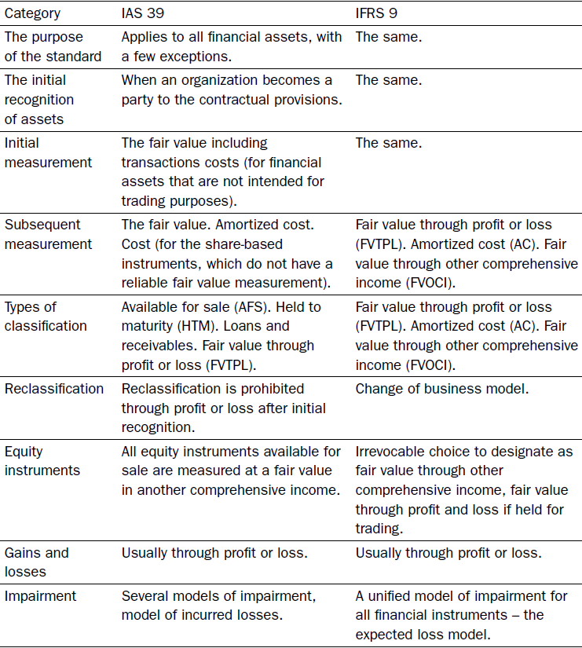
Table 3

In order to better understand IFRS 9 I have performed SWOT analyse which is going to illustrate strengths and weaknesses. SWOT analysis is a key arranging procedure used to support an individual or association recognize qualities, shortcomings, openings, and dangers identified with business rivalry or undertaking planning. It is expected to indicate the targets of the business adventure or venture and distinguish the interior and external components that are positive and ominous to accomplishing those destinations. Clients of a SWOT analysis regularly ask and answer inquiries to produce important data for every class to make the instrument helpful and recognize their upper hand. More information about SWOT analyse are provided in Table 4.
Table 4.
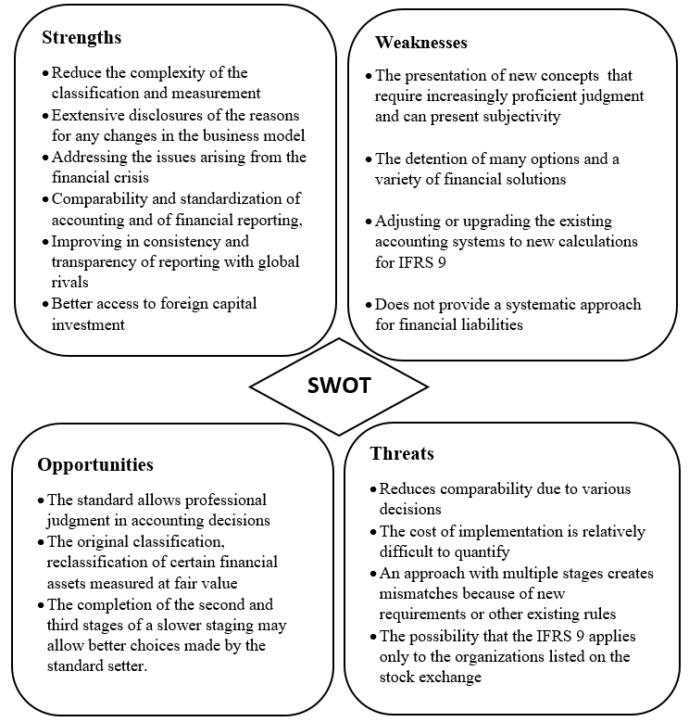

  - Transition Requirements of new standard and presentation
The date of introductory application (DIA) of IFRS 9 is the start of the detailing time frame when an element initially applies IFRS 9.
The general guideline out of the blue utilization of IFRS 9 is for review application as per IAS 8 Accounting Policies, Changes in Accounting Estimates and Errors, which is that the new prerequisites are connected as though those necessities had dependably been connected. Be that as it may, certain exceptions exist from the review application, being:
- An alternative not to repeat similar data with contrasts being recorded in opening held profit
- Prospective use of the fence bookkeeping prerequisites with restricted special cases.
- No utilization of IFRS 9 to monetary instruments that are derecognised before the DIA.
At its DIA, organization must evaluate based on the realities and conditions that exist at the DIA, regardless of whether a monetary resource meets the conditions for a characterization as at:
- Amortised costs
- Fair Value thought OCI for debt tools(instruments)
- FVOCI relating to equity tools
- Fair value thought profit loses

When the classification appraisal is made, that classification applies to the monetary resource reflectively (regardless of the element's plan of action in earlier revealing periods). The standard does not have any significant bearing to things that have just been derecognised at the date of initial application.
The below mentioned chart sets out the imaginable potential reclassifications from the IAS 39 classes to the IFRS 9 classifications for money related resources.

Chart 1
IAS 39 IFRS 9
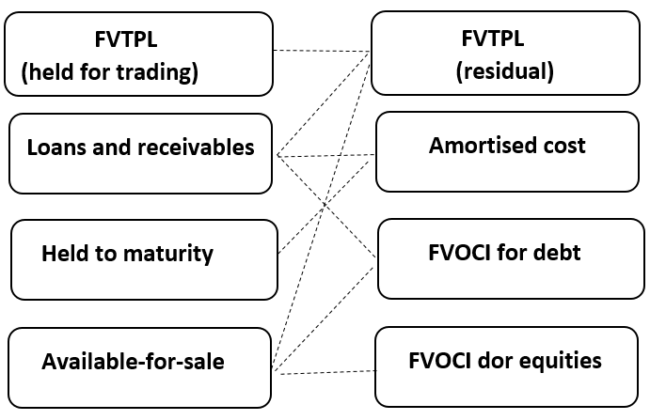

According to the research of Big10 Company –BDO, despite the fact that the classifications of IFRS 9 may seem like those of IAS 39, there are key contrasts. Under IAS 39, the accessible available to be purchased class (estimated at FVOCI with the exception of impairment and some remote trade contrasts) was a remaining classification to be utilized if a financial asset did not fall into any of the other three classifications; it was additionally discretionary except if a financial asset was required to be estimated at FVTPL. Conversely, the FVOCI class in IFRS 9 is for an unmistakably characterized gathering of financial assets and the residual classification is FVTPL.
In spite of the way that the standard is to be embraced reflectively as per IAS 8, a substance isn't required on initial application to repeat comparatives. Rather it is required to give the exposures.
The choice to assign financial assets or financial liabilities at Fair Value Thought Profit or losses is re-opened at the date of first adoption of IFRS 9 as per researchers. This passage expresses that such an assignment is made based on the actualities and conditions that exist at the date of initial application, and that this classification is connected reflectively. As noted in IFRS 9 this resignation is intended to enable elements to return to financial asset and financial liabilities assignments if doing as such disposes of or essentially diminishes bookkeeping confuse that would some way or another emerge from estimating the assets or liabilities or perceiving the increases and misfortunes on them on an alternate premise.
“Change will require solid governance and internal controls to give all stakeholders confidence in consequential financial information” by Arta Limani and Arian Meta 2017
The reasonable esteem alternative might be connected to individual financial assets and liabilities. Now and again, financial assets and liabilities might be assigned together if the joint assignment takes out or generously decreases an estimation mismatch (for instance, a financial asset that would somehow be estimated at FVOCI and a financial obligation that would some way or another be estimated at amortized cost).
Equity investment at FVOCI. At the DIA, an organization may assign an investment in a value instrument at FVOCI except if the venture is held for exchanging (trading). The decision is to be connected retrospectively. For unquoted value ventures estimated at expense under IAS 39, a company should decide the reasonable estimation of the value investment at the exact DIA. The distinction between the past residual amount and the reasonable esteem at the DIA is perceived (recognized) in opening retained income or different reserves (in the event that it is assigned at FVOCI).
In order to better understand the situation, I would like to provide practical example.
Suppose Company C buys an investment (equity) in an unlisted organization on 1 February 2014 for EUR100. As these instruments were not held for exchange it was recognized by company C as an accessible-for-sale financial resource (asset). In light of the fact that the investment did not have a quoted market cost in an active business sector and its fair value couldn't be consistently decided, the value venture was assessed at cost (less impairment) under IAS 39. On 31 December 2014 Company C recognized on their account an impairment loss of EUR50 in income statement. First adopting of IFRS 9 by the Entity C is dated on 31 December 2016. Entity C adopted IFRS 9 in the its annual financial reporting. It selects to appraise the equity securities at FVOCI. In line with the transition requirement of IFRS 9, Company C is not demand to restate relatives but is demand to deliver the disclosures which are set out in IFRS 7.
The reasonable value of the securities (its invest) on 1 January 2016 is determined to be EUR 65. However, value of this investment under requirement of IAS 39 at 31 December 2015 is EUR 50. The question is that “How Organization C may account or react for this investment on transition?”. The DIA of Company C is 1 January 2016. Entity B identifies the difference of EUR15 in its initial retained earnings or other assets reserves (in the case that it is nominated at FVOCI) at 1 January 2016. The EUR50 impairment loss initially recognised in income statement should be reclassified from retained earnings to Other Comprehensive Income after transition.
The main issue was mentioned on the Mojca Gornjak’s research, in spite of the likenesses in the classifications of estimating for financial instruments under a current and new standard, models are unique and this change emerges predominantly in the procedures of basic leadership inside the association. Every single financial instrument ought to be evaluated based on their cash flows as well as business model in which they are put.
Presentation. In a reasonable esteem hedge, the supporting instrument is estimated at reasonable esteem, with the segment of the hedged thing to which the supporting instrument relates likewise being estimated at reasonable incentive for the hazard being hedged. The addition or misfortune on the supporting instrument is perceived in income statement. The supporting increase or misfortune on the hedged items alters the conveying measure of the hedged thing (if relevant) and is perceived in benefit or misfortune (or other complete salary, if the supporting instrument hedges a value instrument that a substance has chosen to show changes of an interest in a value instrument in reasonable incentive in other far reaching pay)

CHAPTER 2. METHODOLOGICAL BASE OF CLASSIFICATION AND MEASUREMENT UNDER NEW STANDARD.

Under this section I will provide method of research and methodology of adoption IFRS 9. Method of my research paper is mainly based on practical examples and real application of new standard. As it is new standard that organizations are going to use, I have made research on this topic in order to show practical application. I have read many reports relating to Financial Instruments which are published Big4 and Big10 companies. Mainly, I have used inductive method of research during research process. It means that I have focus on qualitative features of Financial Instruments. But it is not only method that I used. Besides Inductive method I have also used deductive method during the analysis of measurement of Financial Instrument. The big change is ECL (expected credit loss model) and Impairment Model. In Azerbaijan many organizations and banks started application of IFRS 9, but big users of new standard are Banks as there are not many institutions which have different types of financial tools in their portfolio. That’s why mainly, I am going to focus on ECL and Impairment model as a result of analyse.

2.1 Classification under Amortised cost and Fait Value model.
Firstly, I have started by referring to IFRS practice which is published by BDO-Big 10 Company. IFRS 9 has presented various new measurement sections, while disposing of a portion of the past category under IAS 39. Under IFRS 9, monetary assets are classified under the classification one of the four sections: Figure 1

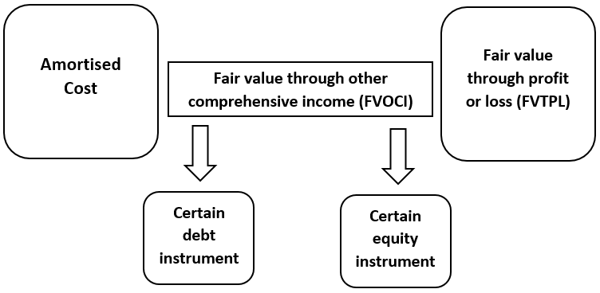
Figure 1

2.1 Classification under Amortised cost and Fait Value model
A money related resource is delegated in this way estimated at amortized cost under IFRS 9 in the event that it meets both of the accompanying standards:
- Hold to gather plan of action test (BMT - Business Model Test) – The benefit is held inside a plan of action whose goal is to hold the monetary resource so as to gather legally binding money streams.
- Exclusively instalments of key and premium (SPPI) authoritative income qualities test – The legally binding terms of the budgetary resource offer ascent to money streams that are SPPI on the key sum exceptional on a predetermined date.
Hold to collect business model. To fit the bill for amortized cost grouping, the money related resource must be in a hold to gather plan of action. That is, it must be in a plan of action in which the substance's goal is to hold the budgetary resource for gather the authoritative money streams from the monetary resource instead of with the end goal of pitching the advantage for understand a benefit or misfortune. For instance, exchange receivables held by an assembling element are probably going to fall inside the hold to gather plan of action if the exchange receivables don't contain a huge financing segment as per IFRS 15, as the assembling substance is probably going to have the expectation to gather the money streams from those exchange receivables. The hold to gather plan of action does not necessitate that monetary resources are constantly held until their development. A substance's plan of action can at present be to hold monetary resources for gather legally binding money streams, notwithstanding when offers of budgetary resources happen. There is a particular special case where money related resources are sold because of an expansion in the advantages' credit chance.
IFRS noticed that business, regardless of their recurrence and incentive because of an expansion in the benefits' credit hazard, are not conflicting with the hold to gather plan of action on the grounds that the credit nature of monetary resources is pertinent to the element's capacity to gather legally binding money streams. What's more, despite the fact that there is an assumption that the hold to gather prerequisites won't be met when there are deals that are more than rare or more than inconsequential it is important to think about why deals happened and whether they are 'one off'. Be that as it may, if in excess of a rare number of offers or a more than inconsequential estimation of offers is made out of a portfolio, the element ought to survey whether and how the deals are steady with the hold to gather objective. This appraisal ought to incorporate the reason(s) why the deals don't speak to an adjustment in the element's plan of action just as the normal recurrence of offers, and whether the benefits that are sold are held for an all-inclusive timeframe in respect to their legally binding developments.
“Letting for rare sales without co-operating the aptitude to extent financial assets at amortised cost under IFRS 9 is a key variance in contrast with the ‘held to maturity’ group under IAS 39.–BDO Partner -IFRS in practice 2018

The SPPI contractual cash flow characteristics test. The second condition for a money related advantage for fit the bill for amortized cost arrangement is that the budgetary resource must meet the SPPI authoritative income attributes test. Legally binding money streams are viewed as SPPI if the authoritative terms of the budgetary resource just offer ascent to money streams that are exclusively instalments of central and enthusiasm on the vital sum remarkable on indicated dates (for example the authoritative money streams are reliable with a fundamental loaning course of action). Primary is the reasonable estimation of the monetary resource at introductory acknowledgment, which might be unique in relation to the authoritatively expressed chief (for example a bond that is obtained or started at a higher cost than expected or rebate). While the thought for the time estimation of cash and credit hazard are normally the most noteworthy components of 'premium', IFRS 9 recognizes that it can likewise contain different components, for example, thought for liquidity chance, net revenue and administration or regulatory expenses. On the off chance that the loaning course of action incorporates a provision that repays the bank for these different components and they don't result in an adjustment in the idea of the loaning game plan (for example overall revenue is kept up) at that point the consideration of these components is steady with an ordinary loaning plan.
Modified time value of money. In some monetary resources in specific wards, the time estimation of cash component of premium might be changed in a manner that is defective. Instances of changes include:
- Instruments with variable loan costs where the recurrence of financing cost reset does not coordinate the tenor (or development) of the instrument, for example, instruments where intrigue is reset month to month to a quarterly rate. Certain Japanese government securities have a semi-yearly loan fee reset however the rate is dependably reset to a 10-year rate paying little heed to development (known as Japanese 10-year consistent development securities);
- Instruments with a variable loan fee however the variable intrigue is reset before the beginning of the intrigue time frame (for instance, two months prior so the rate at the date of reset isn't the present drifting rate, yet is rather the coasting rate two months prior).
Where the time esteem segment of the loan cost has been altered, (for example, for the instruments set out over), a further evaluation is required to decide if the time esteem part is fundamentally not quite the same as a benchmark instrument. The evaluation can be subjective or quantitative. It is important to decide how unique the authoritative undiscounted money streams are in examination with the undiscounted money streams that could emerge if the time estimation of cash component was not adjusted (benchmark money streams).
For instance, if the monetary resource under appraisal contains a variable loan fee that is reset each month to a one-year financing cost, the element would contrast that money related resource with a budgetary instrument with indistinguishable legally binding terms and the indistinguishable credit quality aside from the variable loan cost is reset month to month to a one-month loan cost. The correlation would consider the current distinction in rates, yet in addition the potential contrast emerging from conceivable future changes in loan fees. On the off chance that it is clear, with almost no investigation, that the legally binding (undiscounted) money streams on the monetary resource under the appraisal could (or proved unable) be altogether unique in relation to the (undiscounted) benchmark money streams, it isn't important to play out a point by point evaluation. The term 'altogether extraordinary' isn't characterized and no quantitative limit is given, yet by and by just a little variety would be allowed.
“The IASB replicates that these bases of bookkeeping are important only for “basic” or “simple” loans and receivables. More multifarious provisions must be measured at FVPL.”- PwC Partner IFRS9- Financial Instrument
Regulated interest rates. In certain wards, the legislature or an administrative specialist builds up loan costs. For instance, such government guideline of financing costs might be a piece of an expansive macroeconomic strategy or it might be acquainted with urge substances to put resources into a specific division of the economy. Under IFRS 9, a controlled loan cost might be utilized as an intermediary for the time estimation of cash component to apply the SPPI test if that managed financing cost furnishes thought that is comprehensively reliable with the progression of time and does not give introduction to dangers or unpredictability in the legally binding money streams that are conflicting with an essential loaning game plan.
Example: In order to better understand it, I am going to provide example.
Organization B loans Organization C $5 thousand at a secure interest rate. The advance is repayable in 5 ages. Organization C has the choice to pay the advance at any period at $5 thousand plus any accumulated interest plus a payment consequence fee of 3.5% which decreases by 1.5% for each whole period of one year throughout which the loan has been unresolved.
Does the credit meet the Solely PPI pledged cash flows typical test?
Yes. The prepayment alternative isn't dependent upon any future occasion
The prepayment punishment is viewed as sensible extra remuneration for early contract end.
Other provisions that change the timing or amount of cash flows. Other authoritative arrangements that change the planning or measure of money streams can at present meet the SPPI test if their impact is steady with the arrival of a fundamental loaning game plan.
For instance, an instrument with a loan fee that is reset to a higher rate if the indebted person misses a specific number of instalments can in any case meet the SPPI test as the subsequent change in the authoritative terms is probably going to speak to thought for the expansion in credit danger of the instrument. Different instruments where the premium instalment is connected to net obligation/profit before intrigue expense, deterioration and amortization (EBITDA) proportion are probably not going to meet the SPPI test, aside from in uncommon situations when an authentic connection can be made between the linkage include and the required SPPI highlights.
Other authoritative arrangements that change the planning or measure of money streams can at present meet the SPPI test if their impact is steady with the arrival of a fundamental loaning game plan.
For instance, an instrument with a loan fee that is reset to a higher rate if the indebted person misses a specific number of instalments can in any case meet the SPPI test as the subsequent change in the authoritative terms is probably going to speak to thought for the expansion in credit danger of the instrument. Different instruments where the premium instalment is connected to net obligation/profit before intrigue expense, deterioration and amortization (EBITDA) proportion are probably not going to meet the SPPI test, aside from in uncommon situations when an authentic connection can be made between the linkage include and the required SPPI highlights.
2.2 Debt instruments and Equity instruments at FVOCI

An obligation instrument is delegated in this manner estimated at reasonable incentive through other thorough pay (FVOCI) under IFRS 9 on the off chance that it meets both of the accompanying criteria:
- Hold to gather and sell plan of action test: The benefit is held inside a plan of action whose goal is accomplished by both holding the budgetary resource so as to gather legally binding money streams and selling the monetary resource
- SPPI legally binding income attributes test: The authoritative terms of the monetary resource give ascend on indicated dates to money streams that are exclusively instalments of central and enthusiasm on the primary sum exceptional.
Instances of money related instruments that might be characterized and represented at FVOCI under IFRS 9 include:
- Investments in government bonds where the speculation time frame is probably going to be shorter than development;
- Investments in corporate securities where the venture time frame is probably going to be shorter than development.
It is impossible that intercompany advances or exchange receivables would be arranged in the FVOCI classification.

Example: Company D vended one of its varied business processes and now has EUR20 billion of money. It consumes not yet originate another appropriate investment chance in which to capitalise its funds so it buys medium dated (4 years maturity) high quality management bonds in order to produce interest income. It is careful likely that appropriate asset opportunity will be originate before the maturity period, and in that case Company D will trade the promises and use the proceeds for the gaining of a business process. Then, Organization D tactics to hold the bonds to their pledged maturity.
Are the criteria for a hold to gather or hold to gather and sell plan of action met?
Answer: All things considered, the administration bonds would not meet the hold to gather plan of action test since all things considered, the bonds will be sold well before their legally binding development. In any case, all things considered, the venture would meet the hold to gather and sell plan of action test.
“Many investigation privileges that the reasonable value of the long-term resources has no effect and potentially is not confusing if the assets are in possession to the maturity” Mojca Gornjak-The Analyse of Replacaement-2017
Equity instruments. IFRS 9 needs that completely equity reserves to be assessed at reasonable value. The evasion approach is for all adjustments in reasonable incentive to be perceived in benefit or misfortune.
In any case, for value ventures that are neither held for exchanging nor unforeseen thought perceived by an acquirer in a commercial mix, substances can make an unalterable race at beginning acknowledgment to order the tools as at FVOCI, with every resulting change in reasonable esteem being perceived in other complete salary (OCI). This race is obtainable for each different venture.
In this new FVOCI group, reasonable esteem fluctuations are perceived in OCI while profits are perceived in benefit or misfortune (except if they plainly speak to a recuperation of part of the expense of the speculation). In spite of the fact that it may seem like the 'Available-for-Sale' group in IAS 39, note this is another estimation group which is unique. Specifically, under the new group, on transfer of the venture the combined change in reasonable esteem isn't reused to benefit or misfortune. Anyway, substances can exchange sums between stores inside value.
So as to rearrange the bookkeeping, IFRS 9 has killed the prerequisite to independently represent installed subsidiaries for money related resources. Rather, IFRS 9 expects elements to survey the half and half contract all in all for grouping. In the event that the terms of the crossover contract still meet the criteria for consequent estimation at amortized cost or FVOCI for obligation instruments then it is represented at amortized cost or FVOCI, else it is estimated at FVTPL. Nonetheless, the current necessities for implanted subordinates still apply to money related and different liabilities, and to contracts for resources that are not inside the extent of IFRS 9.
In order to see exact result of transition to IFRS 9 I am going to provide example and its answer under two options.
Example: Organization B makes investment to EUR 2000 convertible bonds that issued by Company C. The convertible bonds pay a 7% yearly coupon with a maturity of four years. Any time before its development, Organization B has the choice to change the bond into 2,000 shares of Company C.
The fair interest rate for a comparable instrument without the change highlight would be 8%.
IAS 39 IFRS 9
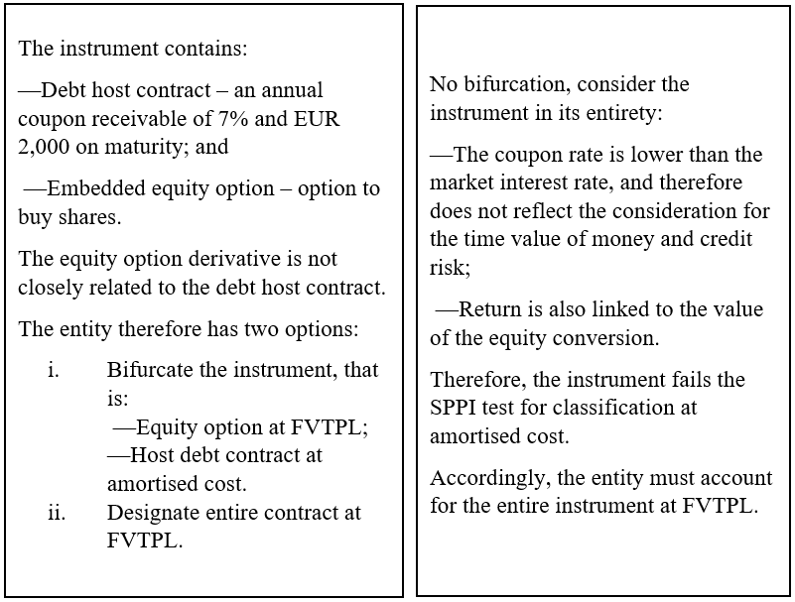

Financial Liabilities. The characterization and estimation of cash related liabilities as per IFRS 9 Financial tools remains generally unaltered from IAS 39 Financial tools: Recognition and Assessment.
Budgetary liabilities are delegated either:
– Financial obligations at amortized cost; or
– Financial obligations as at reasonable incentive through benefit or misfortune (FVTPL).
Money related obligations are estimated at amortized cost except if either:
– The budgetary obligation is detained for exchanging and is in this way necessary to be estimated at FVTPL (for example subordinates not assigned in a supporting relationship); or
– The substance chooses to quantify the monetary risk at FVTPL (utilizing the reasonable esteem choice).
As opposed to money related resources, the current necessities in IAS 39 for the division of inserted subsidiaries have been proceeded for monetary liabilities, implying that budgetary liabilities to be estimated at amortized cost would in any circumstance should be examined to decide if they contain any implanted subordinates that are demanded to be represented independently at FVTPL. Instances of monetary obligations that are probably going to be ordered and estimated at amortized cost and also at FVTPL comprise:

IFRS 9 demands an entity to perceive a budgetary resource or a money related risk in its announcement of monetary position when it moves toward becoming gathering to the legally binding arrangements of the instrument. At beginning acknowledgment, an entity estimates a money related resource or a budgetary obligation at its reasonable incentive give or take, on account of a monetary resource or a budgetary risk not at reasonable incentive through Income statement.

Amortised Cost FVTPL
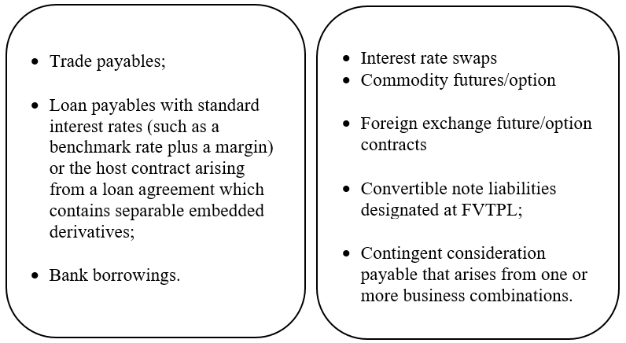

The main alteration under IFRS 9 for budgetary liabilities, in correlation with IAS 39, is for the introduction of changes in reasonable esteem emerging from changes in a substance's very own credit chance status for money related obligations that have been assigned as at FVTPL. This change is required for the most part to influence budgetary establishments however can likewise apply to elements that have gone into a half and half contract that contains an installed subordinate, for which the substance has chosen to quantify the whole contract at reasonable esteem. A methodology of estimating the whole instrument at reasonable esteem is regularly pursued since it disentangles future reasonable esteem computations and the bookkeeping prerequisites.
For instance, a substance issues a convertible note and has surveyed that the note contains an obligation have risk and an implanted subordinate obligation. Rather than independently representing the obligation have risk at amortized cost and the implanted subordinate risk at FVTPL, the guarantor chooses to represent the whole convertible note at FVTPL.

2.3 Measurement on Initial recognition and subsequent measurement
2.3.1 Measurement on initial recognition. The necessities for the underlying estimation of money related resources and obligations under IFRS 9 financial tools were conveyed forward from IAS 39 Financial Instruments: Recognition and Measurement. At beginning acknowledgment, a budgetary instrument is estimated at reasonable esteem including exchange costs except if the money related instrument is conveyed at FVTPL, in which case the exchange costs are quickly perceived in benefit or misfortune. The reasonable esteem is resolved as per IFRS 13 reasonable esteem estimation.
The best proof of reasonable incentive at beginning acknowledgment is typically the exchange cost, spoken to by the reasonable estimation of the thought given or got in return for the money related instrument. Any distinction between the reasonable esteem estimated by the element and the exchange cost is perceived:
- In Income statement, if the gauge is estimated by a cited cost in a functioning business sector or dependent on a valuation strategy that utilizes just information from noticeable markets; and
- Deferred as a change in accordance with the conveying measure of the monetary tool in every single other circumstance.
IFRS 9 incorporates a special case for the estimation on introductory acknowledgment of exchange receivables without a noteworthy financing part. These are required to be perceived at the exchange cost rather than reasonable esteem.
For exchange receivables with a huge financing part, any distinctions emerging between the measure of income perceived as per IFRS 15 – which is estimated at the exchange cost as per IFRS 15 - and the reasonable estimation of the exchange receivable is perceived as a cost in benefit or misfortune. The presence of a huge financing part is resolved as per the direction according to IFRS 15.
“In practice, short-term receivables and payables with no stated interest rate would continue to be measured at their invoiced amount. «by Anne Catherine Farley-BDO 2018 Financial Instruments
Exchange costs are steady costs that are legitimately inferable from the obtaining, issue or transfer of a budgetary instrument. Instances of exchange costs are: expenses and commissions paid to operators, counsellors, intermediaries and vendors; exacts by administrative offices and securities trades; exchange charges and obligations; credit appraisal expenses; enlistment charges and comparable expenses. Judgment might be required while applying the meaning of exchange costs by and by. Costs that don't qualify as exchange costs are obligation premiums or limits, financing costs, inside organization expenses and holding costs.
For every single money related instrument that are not estimated at FVTPL the treatment of exchange costs is made on an instrument by-instrument premise and either increment (monetary resource) or diminishing (budgetary obligation) the sum at first perceived in the fiscal summaries. All other exchange related costs that don't qualify as exchange costs are expensed as they are brought about.

2.3.2 Subsequent measurement.
After introductory acknowledgment, budgetary resources are either estimated at amortized cost or at reasonable esteem. Similarly, as with the underlying acknowledgment of money related instruments, the reasonable esteem is dictated by applying the direction set out in IFRS 13.
IFRS 9 expelled the special case from IAS 39 to record for certain value ventures at expense from IAS 39 and expects substances to gauge all value speculations at reasonable esteem. Notwithstanding, IFRS 9 expresses that in constrained conditions cost is a suitable gauge of reasonable esteem, which might be circumstances where:
- The most as of late accessible data isn't adequate to quantify the reasonable esteem; or
- There is a wide scope of conceivable reasonable esteem estimations and cost speaks to the best gauge inside that extend.
In any case, cost is never the best gauge for the reasonable estimation of cited value speculations. Besides it was noted by the IASB that cost could never apply to value speculations held by specific elements, for example, money related establishments and venture reserves.
In a noteworthy change from IAS 39 the new direction under IFRS 9 necessitates that when a substance assigns a monetary risk at FVTPL, the adjustments in reasonable esteem that identify with changes in the element's own credit status are ordinarily exhibited in other far reaching pay rather than benefit or misfortune. This is to wipe out the unreasonable impact that would some way or another emerge, that the more unfortunate the budgetary state of an element, the higher the rebate rate that will apply when estimating the reasonable estimation of its money related risk and the higher the related addition perceived in benefit or misfortune. This implies, under IFRS 9, elements will regularly need to decide the adjustment in reasonable estimation of the monetary risk overall, and after that play out a different computation to decide the adjustment in reasonable esteem that is owing to changes in their own credit status, and present those progressions in other complete pay (OCI). The rest of the changes in reasonable esteem will be exhibited in benefit or misfortune. The combined changes in reasonable esteem emerging from changes in a substance's own credit position that is perceived in OCI are not in this manner reused to benefit or misfortune when the money related obligation is derecognised. Be that as it may, IFRS 9 licenses substances to exchange the sum inside value after derecognition of the money related obligation.
In the event that the main noteworthy significant changes in economic situations are because of changes in a watched benchmark loan fee, the sum owing to changes in a substance's very own credit hazard can be evaluated utilizing the defaulting technique, which depends on the count of the money related tool's rate (IRR).

There are four steps.
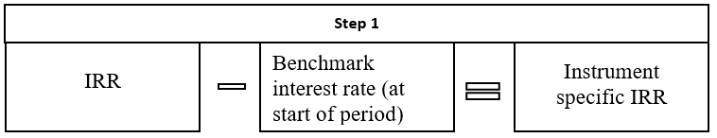
In the initial step, the element processes the obligation's IRR toward the beginning of the detailing time frame utilizing the reasonable estimation of the risk and the risk's legally binding money streams toward the beginning of the revealing time frame. It deducts from the IRR the watched benchmark loan fee toward the beginning of the period. The outcome is a tool explicit IRR edge.

In the second step, the organization determines the markdown rate, which is the entirety of the tool explicit IRR (calculated in Step 1) and the benchmark loan fee toward the finish of the revealing time frame, so as to compute the present estimation of the legally binding money streams.
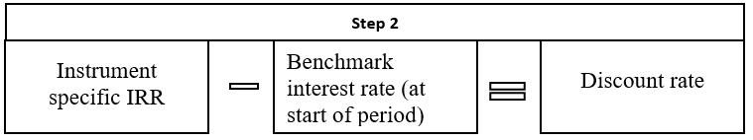

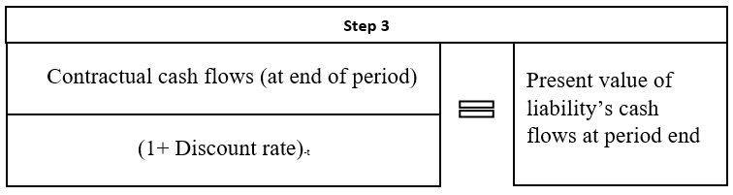
Thirdly, the element decides the current estimation of the legally binding money streams of the obligation at the end of the revealing time frame, utilizing the rebate rate determined in Step 2.

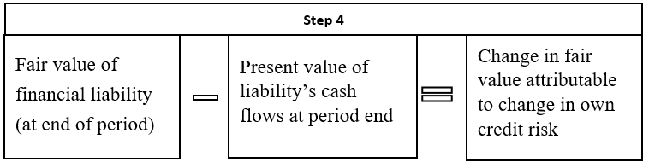
At long last, the substance deducts the present estimation of the obligation's money streams at the period end as decided under Step 3) from the reasonable estimation of the budgetary risk toward the finish of the detailing time frame. The outcome is the adjustment in the reasonable estimation of the money related obligation inferable from a substance's own credit chance.

Amortised cost measurement. The direction on amortized cost estimation and the compelling loan fee technique is to a great extent unaltered from IAS 39 and applies to:

- Financial resources and monetary obligations estimated at amortized cost; and
- Debt tool resources that are estimated at FVOCI.

The amortized cost estimation necessities apply to obligation tools estimated at FVOCI on the grounds that IFRS 9 necessitates that those obligation tools influence benefit or misfortune similarly as though they were estimated at amortized cost. Amortized cost is characterized in IFRS 9 as the sum at which the money related resource or budgetary risk is estimated at starting acknowledgment less primary reimbursements, give or take the combined amortization utilizing the powerful premium technique for any contrast between that underlying sum and the development sum and, for monetary resources, balanced for any misfortune recompense.
IFRS 9 needs that amortized expense is determined utilizing the compelling interest strategy, which designates intrigue pay and cost at a consistent rate over the term of the instrument. The powerful loan fee of a money related resource or monetary risk is determined at starting acknowledgment and is the rate that precisely limits the assessed future money courses through the normal existence of the budgetary resource or monetary obligation to the:
- Gross conveying sum of a money related resource; or
- Amortized cost of a monetary obligations.
At beginning acknowledgment, the amortized expense of a monetary resource or budgetary risk is typically equivalent to the reasonable estimation of the money related instrument balanced for the related exchange costs.
For the figuring of the powerful loan cost, an element assesses the normal money streams considering every authoritative term including any charges, exchange costs, and different premiums or limits. Obligation premiums or limits, financing costs or inside managerial or holding costs are not qualified exchange costs. Since exchange costs are incorporated as a feature of the underlying conveying measure of the money related instrument, the acknowledgment of these expenses in benefit or misfortune is spread over the term of the instrument through the utilization of the powerful premium strategy.
The assurance of the powerful loan cost depends on the evaluated money streams emerging from the advantage. Expected credit misfortunes are excluded as a major aspect of the money streams for the figuring of the viable financing cost technique. This is on the grounds that the gross conveying measure of a money related resource is balanced for a misfortune recompense, which isn't a piece of the powerful loan fee estimation.
Changes in the normal money streams will result in a recalculation of the gross conveying measure of a benefit and the amortized expense of a budgetary risk. The amended expected money streams are limited utilizing the first powerful financing cost of the instrument. Any distinction from the past sum is perceived in benefit or misfortune.

Modifications of financial assets and financial liabilities. For an adjustment that does not consequence in derecognition, the contrast between the current estimation of the changed money streams limited utilizing the first successful financing cost and the current estimation of the first money streams, is perceived in benefit or misfortune as an increase or misfortune from alteration. Expenses or charges in connection to the change of the budgetary resource are perceived as a major aspect of the conveying measure of the benefit and amortized over the rest of the term of the tool. A change of the first money related resource that outcomes in the derecognition of the monetary resource, requires the acknowledgment of another budgetary resource in accordance with the general prerequisites for the underlying acknowledgment (for example at reasonable incentive in addition to exchange costs). Be that as it may, IFRS 9 does exclude direction to figure out which expenses and charges might be qualified for capitalisation, as opposed to being sums which ought to be ascribed to the derecognition of the old obligation and in this way expensed right away.

The direction for the treatment of adjustments of budgetary liabilities that don't result in derecognition has changed from IAS 39 wherein an element could apply the strategy that if an alteration of a money related risk does not result in derecognition, changes in the legally binding money streams could be amortized over the rest of the term of the adjusted tool by recalculating the successful loan cost of the tool. Under IFRS 9 an addition or misfortune will be perceived in benefit or misfortune for the contrast between the first legally binding money streams and the altered money streams limited at the first powerful financing cost.
I am going to show face of FS relation to Liabilities before and after changes.
Example: Company An obtained $100 million. In this way, Company A has gone into an alteration game plan to reimburse some portion of the gliding rate credit and to adjust the terms of the extraordinary bit to be conveyed forward. In this situation Company A consents to pay $44 million at the season of the adjustment and $50 million later on dependent on the amended terms, as opposed to reimbursing $100 million later on dependent on the first terms. The development date of the current credit, and the bit to be conveyed forward, are the equivalent and the new advance is at an overhauled drifting rate. The legitimate expenses related with the change are $20,000.
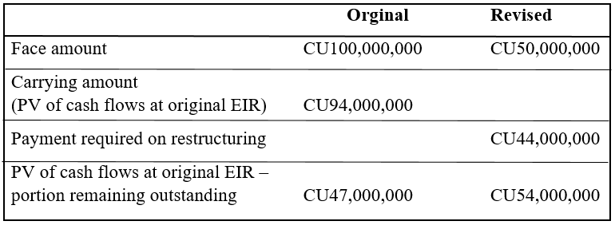

At the point when there is a halfway reimbursement questions frequently emerge about the 10% test – do you utilize the whole credit or just the sum that remaining parts extraordinary. Regardless of whether you take a gander at the rest of the credit or the whole advance will affect the end. As this precedent illustrates, if the appraisal was completed just for the rest of the credit it would be presumed that there is an extinguishment. In any case, if the appraisal was done for the whole credit it would be reasoned that the adjustment does not result in extinguishment, in view of the way that the distinction for the whole advance is under 10%.
As a conclusion to this part I would like mention that methodology about International standard have to be different from other research topics because of there are standardised rules which are remains same. Only and main thing during the research is careful analyse of replacement and showing examples. In the next section I am going to write about main result of research that makes IFRS 9 different from IAS 39.

CHAPTER 3. ANALYSE THE RESULTS OF TRANSITION FROM IAS 39 TO IFRS 9 AND THE IMPAIRMENT MODEL.

As a result of research, I would like to provide information that are used by organization during the application IFRS 9. Expected credit loss and Impairment model gives fair view about financial condition of Companies.

3.1 The Impairment Mode and Expected Credit Loss.
Impairment under IFRS 9 needs the utilization of a normal misfortune approach for the count of disability remittances. Not at all like its ancestor IAS 39, the criterion's centre rule as for hindrance is that debilitation arrangements are perceived before the misfortunes are really caused. The misfortunes are perceived through the entire existence of the money related instrument paying little heed to crumbling of credit nature of the budgetary instrument. Be that as it may, the crumbling of credit quality outcomes in change of methodology how and to what degree are the misfortunes determined.
New standard stipulates three methods (Table 5 and 6) in order to caring true calculation and assessment of Impairment.
- General methodology
- Streamlined methodology for exchange receivables, contract resources and rent receivables
- Approach for bought or began credit-disabled money related resources that are credit-impeded on beginning acknowledgment
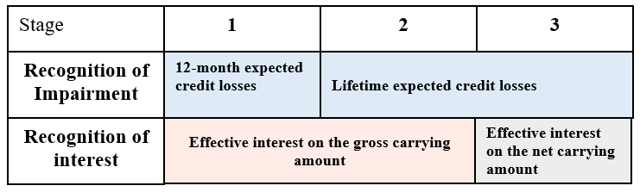
Table 5 – Three stages Model under new Standard

The core value of the normal credit misfortune (ECL) is to mirror the general example of crumbling or improvement in the credit nature of monetary tools. The measure of ECLs perceived as a misfortune recompense or arrangement relies upon the degree of credit disintegration since introductory acknowledgment. Under the over-all methodology, there are two estimation centres:
- 12-month ECLs that are going to apply to all things (from starting acknowledgment) insofar as there is no noteworthy decay in credit excellence.

- Lifetime ECLs that are going to apply when a huge increment in credit hazard has happened on a separate or aggregate premise.
In the event that money related resources become credit-weakened (Stage 3 look at Table 6) premium income would be determined by applying the successful loan fee (EIR) to the amortized cost (net of the hindrance stipend) as opposed to the gross conveying sum. Money related resources are surveyed as credit-weakened utilizing indistinguishable criteria from for the individual resource evaluation of debilitation under IAS 39.
The IASB portrayed its new weakness model as the "normal credit misfortune" model since this is the term utilized in insights to depict the weighted normal of results weighted by the likelihood of their event. Since the outcome is a normal, expected credit misfortunes are neither essentially "expected" nor "misfortunes", in any event as those terms are generally comprehended. Or maybe, they are a proportion of the benefit's credit hazard.
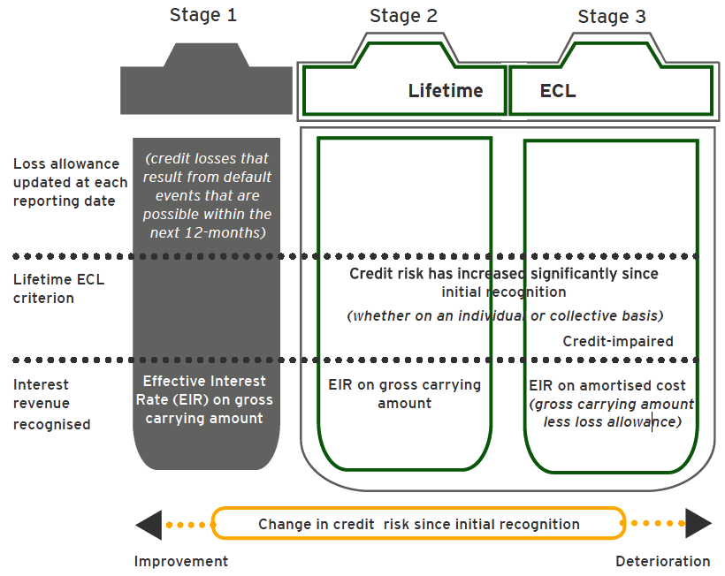
Table 6 – Three stages Model

Source: EY-Financial Instrument 2017
Anyway, as a down to earth convenient, a streamlined model applies for:
- Trade receivables or contract resources without a huge financing part.
- Other long-haul exchange receivables or contract resources with a noteworthy financing segment and rent receivables if the substance picks as its bookkeeping arrangement to quantify the misfortune recompense at a sum equivalent to lifetime anticipated credit loss.
In evaluating ECLs, organization must think about a scope of potential results and not the 'in all probability' result. The standard requires that at the very least, elements must consider the likelihood that:
- A credit misfortune happens; and
- No credit misfortune happens.

Expected credit losses. Expected credit misfortunes are determined by: (a) distinguishing situations in which an advance or receivable defaults; (b) evaluating the money deficit that would be brought about in every situation if a default were to occur; (c) duplicating that misfortune by the likelihood of the default occurring; and (d) summing the aftereffects of all such conceivable default occasions. Since each advance and receivable has probably some likelihood of defaulting later on, each advance or receivable has a normal acknowledge misfortune related for it—from the snapshot of its start or procurement. In a table 7 we can see Illustration of Expected credit loss.

Table 7- Simple Illustration of ECL
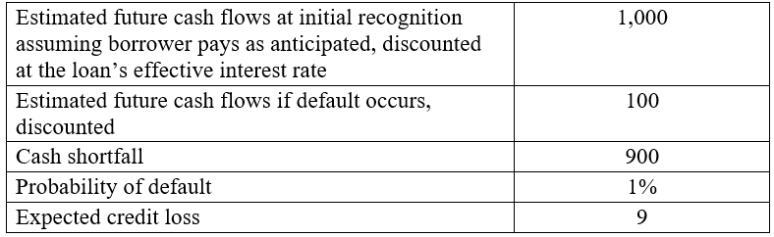

Under the General methodology, the standard recognizes following sorts of expected credit misfortunes:
a) Year expected credit misfortunes (12m ECL) – These misfortunes are perceived for money related tool, credit danger of which has not expanded fundamentally since beginning acknowledgment. For the reasons for these rules’ year ECL will be alluded to as Step 1 misfortunes and related exposures will be alluded to as Step 1 exposures;
b) Lifetime ECL (Step 2 ECL) – These misfortunes are perceived for resources credit danger of which has expanded essentially since starting acknowledgment. For the reasons for these rules’ lifetime ECL will be alluded to as Step 2 misfortunes and related exposures will be alluded to as Step 2 exposures;
c) Lifetime ECL (Losses for credit debilitated monetary resources/Step 3 ECL) – these speak to misfortunes for budgetary tool that are as of now credit weakened. The Standard does not unequivocally recognize these misfortunes from lifetime ECL at Step 2, anyway because of the reality these misfortunes are comparing to budgetary tool with credit weakness and their method for figuring contrasts from method for count of Step 2 lifetime ECL , with the end goal of these rules, these misfortunes will be alluded to as Step 3 misfortunes and related exposures will be alluded to as Step 3 exposures;
Individual vs. Collective assessment of impairment. Individual assessment (incl. scenario analysis) will be applied to all financial instruments, which is not reliable for collective assessment.
SA should define unambiguous criteria (for example, based on a threshold of significance, segment or impairment stage) to assign a financial instrument to an individual assessment. Such criteria should be formalized in the SA's internal documents and approved by the Supervisory board.
To incorporate forward-looking information into individual assessment of ECLs, the following principles should be applied:
- A few representative scenarios are modelled (e.g. a base scenario, an upside scenario and a downside scenario). Different numbers of scenarios may be appropriate depending on the facts and circumstances.
- The base scenario is consistent with relevant inputs to other estimates in the financial, budgets, strategic and capital plans, and other information used in managing and reporting by the SAs.
- SA calculates ECL for each selected scenario; Final ECL for financial instrument is assessed by taking the weighted average of the ECL determined for each of the multiple scenarios selected, weighted by probability of occurrence of each scenario.
In exceptional cases (such as the calculation of ECL for the segment “Private banking” and (subject to approval of Supervisory Board) if reliable justifications are available, the SA may apply the expert adjustments (overrides) to the ECL rates derived from the collective assessment.
“The expected loss approach defined by IFRS 9 replaced the incurred loss approach of the old accounting principle” by Aldo Letizia- 2019 Impact of IFRS 9
Collective assessment of impairment. ECL for money related Instruments characterized in Step 1 are estimated at a sum equivalent to the part of lifetime expected credit misfortunes that outcome from default occasion conceivable inside the following a year.
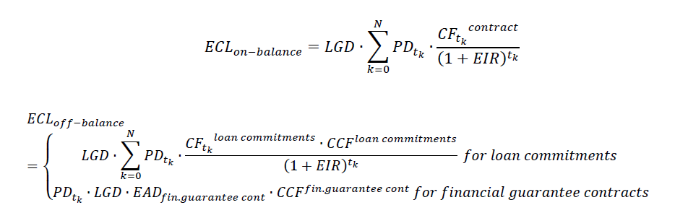
𝑬𝑪𝑳𝟏𝒔𝒕 𝒔𝒕𝒂𝒈𝒆= 𝐸𝐶𝐿𝑜𝑛−𝑏𝑎𝑙𝑎𝑛𝑐𝑒+𝐸𝐶𝐿𝑜𝑓𝑓−𝑏𝑎𝑙𝑎𝑛𝑐𝑒

Where:
𝐸𝐶𝐿𝑜𝑛−𝑏𝑎𝑙𝑎𝑛𝑐𝑒 – an assessment of predictable credit losses for SFP;
𝐸𝐶𝐿𝑜𝑓𝑓−𝑏𝑎𝑙𝑎𝑛𝑐𝑒 – estimation of predictable credit losses for off-SFP disclosures;
𝑡𝑘 – the period from the reporting time to the time of delivery of the k-th payment, in years;
𝑡0- the reporting date (t0 = 0)
“Under IFRS 9 lifetime expected misfortune is significant for advances where disintegration of credit quality was watched” by Bernd Engelmann
𝑃𝐷𝑡𝑘 – a gauge of the likelihood of evasion amid the historical from 𝑡0 to 𝑡𝑘; where 𝑡𝑘 is the period from the revealing time to the time of reception of the k-th instalment, in years, 𝑡0 is the detailing time (𝑡0= 0); if the timespan among 𝑡0 and 𝑡𝑘 is over 1 year, at that point the likelihood of default for a time of 1 year is utilized; on the off chance that k is under 1 year, at that point the estimation of the likelihood of default at the time 𝑡𝑘 is determined by insertion of the likelihood of default for 1 year; For on the whole surveyed cockeyed sheet exposures PD rates of the advances with the comparable attributes ought to be connected.
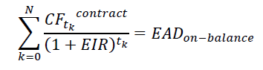
𝐶𝐹_{𝑡𝑘} ^{Contract} – on-balance legally binding income of the monetary tool, expected at time 𝑡𝑘. The measure of limited money streams is equivalent to the measure of cases subject to the danger of default on the parity resource.

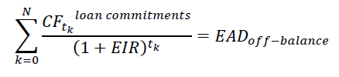
𝐶𝐹_{𝑡𝑘}^{𝑙𝑜𝑎𝑛 𝑐𝑜𝑚𝑚𝑖𝑡𝑚𝑒𝑛𝑡𝑠} – expected income from wobbly sheet exposures (for advance duties) of the money related instrument at time 𝑡𝑘. The measure of limited expected streams is equivalent to the measure of wobbly sheet presentation as of the detailing date:

𝐸𝐴𝐷_{𝑓𝑖𝑛.𝑔𝑢𝑎𝑟𝑎𝑛𝑡𝑒𝑒 𝑐𝑜𝑛𝑡} – the measure of shaky presentation for budgetary assurance gets
𝐶𝐶𝐹^{𝑙𝑜𝑎𝑛 𝑐𝑜𝑚𝑚𝑖𝑡𝑚𝑒𝑛𝑡𝑠} – the credit change factor connected to advance responsibilities;
𝐶𝐶𝐹^{𝑓𝑖𝑛𝑎𝑛𝑐𝑖𝑎𝑙 𝑔𝑢𝑎𝑟𝑎𝑛𝑡𝑒𝑒 𝑐𝑜𝑛𝑡𝑟𝑎𝑐𝑡𝑠} – credit transformation factor connected to money related assurance contracts;
𝐿𝐺𝐷 – the dimension of misfortunes when a budgetary instrument defaulted;
𝐸𝐼𝑅− is the effective interest rate.
𝑁 – number of instalments for the benefit after the time 𝑡0.
3.2 Summary of changes after transition to new standard - IFRS 9
Grouping decides how monetary resources are sorted and estimated in the fiscal summaries. Prerequisites for order and estimation are along these lines the establishment of the representing monetary tools.
The prerequisites for disability and fence bookkeeping are likewise founded on this grouping. Money related resources are ordered completely as opposed to being liable to complex bifurcation prerequisites. There is no partition of installed subordinates from monetary resources under IFRS 9.
The new standard viably sets out three noteworthy groupings; specifically, amortized cost (AC), reasonable incentive through benefit or misfortune (FVTPL) and reasonable incentive through other complete pay (FVOCI)
The common sense ramifications of these criteria are that, subject to an extraordinary FVOCI assignment alternative for interests in value tools, just credits, receivables, interests under water tools and other comparable resources can meet all requirements for estimation at Amortized Cost or FVOCI. The basic issues in these evaluations are whether:
- The goal of the substance's plan of action is to hold resources just to gather money streams, or to gather money streams and to sell ("the Business Model test"), and
- The legally binding money streams of a benefit offer ascent to instalments on determined times that are exclusively instalments of chief and premium ("SPPI") on the important sum remarkable ("the SPPI test").
Both of these tests must be met so as to represent a tool at Amortized Cost or FVOCI. In this production, when we discuss passing or meeting one of these tests, we mean the advantage can be estimated at Amortized Cost or FVOCI as fitting, accepting that the other test is met. When we discuss falling flat the test, we imply that the benefit must be estimated at FVPL.
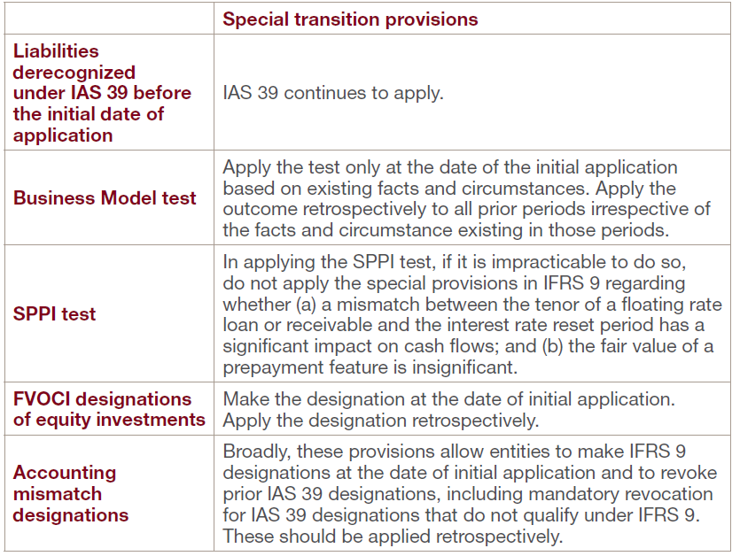
Table 8- Summary of special transition provisions

Source: PwC- Financial Instruments
IFRS 9 does not necessitate a substance to rehash earlier periods. Repetition is allowed, if and just on the off chance that, it is conceivable without the utilization of knowing the past and the repeated fiscal reports mirror the majority of the prerequisites of IFRS 9.
On the off chance that the company does not repeat earlier periods, any distinction between past conveying sums and those decided under IFRS 9 at the date of beginning application ought to be incorporated into opening held profit (or other identical part of value).
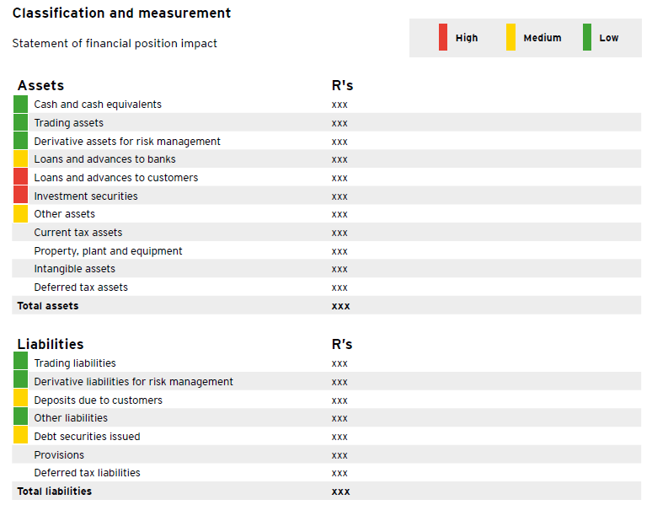
Table 9

We can trace line by line effect of adoption IFRS 9 from above mentioned Table 8. As I have written in the Impairment part, application of new standard mainly affects to Investment in securities and Debt securities.

Conclusion
The goal of this thesis is to making research about application of new standard and providing true information for the method used under IFRS 9. I have provided some examples regarding to adoption of new standard.
The main thing that analysed in this paper is method of measurement under both standard and their comparison based on practical application. The absence of prudence is the base for critique of the current rule of IAS 39 that is according to the insight that the IFRS permits better lending and loan extension, unrealized incomes and non-warranted additions and bonuses.
IFRS 9 is compulsory appropriate for stages start on or after 1 January 2018. IFRS 9 comprises overall requirement, which it ought to be useful retrospectively, though it also stipulates a sum of exclusions that I have written thought this thesis. Company may restate previous stages if it is conceivable without the usage of retrospection. Where previous stages are not repeated, any alteration between the prior stated carrying value and the new carrying amounts of budgetary resources and obligations at the start of the yearly reporting period ought to be documented in the introductory retained earnings of the yearly reporting stages when IFRS 9 is first adopted. Nevertheless, if an organization restates previous stages, the restated FSs must reflect all new requirements that are mentioned in IFRS 9.
The result of IFRS 9 is going to be measure on the evidences and conditions appropriate to each company. The kinds and intricacy of financial resources and financial obligations of the organization will influence this. The level of the provision of loan and the kinds of credits created and/or acquired is going to have an important influence on the intricacy of the impairment model.

In a below mentioned table, I have provided summary and conclusion for application of IFRS9. (See table 10)
Table 10- Decision Tree
FVOCI (Debt instruments)
Amortized cost
FVTPL
FVOCI (Equity instruments)
Has the entity elected the OCI option?

Is the asset an equity investment?
Is the business model’s objective to hold and collect contractual cash flows?
Are the assets
Contractual cash flows solely principal and Interest?
Is it held for trading?
Is the business model’s objective to hold and collect contractual cash flows?
No
No

Yes
No

Yes
No
No
No

Yes
Yes
No

Intention of business model was served principally by Investment in equity instrument, either FVTPL or FVOCI. At that time, the company must check whether the investment cares the obligation or surplus.
As I have mentioned above the big change that have been come with adoption of IFRS 9 is fair (reasonable) value accounting. Reasonable value bookkeeping ought to not only recognize the unrealized incomes but also must demand initial recognition of foreseeable losses. The reasonable value bookkeeping recognises fluctuations in the general credit risk experience and the variations in interest rates, that are one of the key risks which financial institutions are exposed.
References
Books and articles
- “Comparison of IAS 39 and IFRS9: The Analyse of Replacement” by Mojca Gornjak 2017
- “Financial Instruments-A summary of IFRS 9 and its effects” by Ernst&Young 2017
- “IFRS for corporates” by KPMG 2017
- “IFRS9, Financial instruments- Understanding the basics” by PricewaterhouseCoopers 2017
- “An Overview of IFRS 9 Financial Instruments vs. IAS 39 Financial Instruments: Recognition and Measurement” by Meyers Norris Penny LLP
- “Fair Value Accounting an Appropriate Measure of Today's Financial Instruments as more Firms Follow (IFRS)” by Loay Salem Al-Rahamneh 2018
- ” IASB's independence in the due process: an examination of interest groups’ influence on the development of IFRS 9” by Rajni Mala 2018
- “IFRS in Practice 2018-IFRS 9 Financial Instruments” by BDO LLP
- “Deliberative and comparative study of international ﬁnancial reporting standards IFRS 9” by Ghasmi, H. M 2016
- “ IFRS 9 Financial Instruments- Public Sector application guidelines” by HM Treasury 2017
Online sources
- https://onlinelibrary.wiley.com/doi/abs/10.1111/acfi.12280?af=R
- https://www.ifrs.org/issued-standards/list-of-standards/ifrs-9-financial-instruments/
- https://www.moodysanalytics.com/risk-perspectives-magazine/risk-data-management/regulatory-spotlight/ifrs-9-will-significantly-impact-banks-information
- https://www.accaglobal.com/hk/en/student/exam-support-resources/professional-exams-study-resources/strategic-business-reporting/technical-articles/ifrs-9.html
- https://www.ifrsbox.com/ifrs-9-financial-instruments/
- https://inform.pwc.com/?action=informContent&id=1432051608151978
- https://www.pwchk.com/en/services/audit-and-assurance/ifrs/financial-instruments-ifrs-9.html
- https://www2.deloitte.com/content/dam/Deloitte/ru/Documents/audit/ifrs-9-financial-instruments-en.pdf
- https://www.pkf.com/media/10034542/ifrs-9-financial-instruments-summary.pdf
- https://www.icaew.com/technical/financial-reporting/ifrs/ifrs-standards/ifrs-9-financial-instruments-replacement-of-ias-39/summary-and-timeline
- https://home.kpmg/xx/en/home/insights/2014/07/ith-2014-13.html

