The Ministry of Education of Azerbaijan Republic

Influence of word of mouth on online purchasing decision making

Elvar Abdullazada

UNEC SABAH
Azerbaijan State Economic University

JUNE 2019

ACKNOWLEDGEMENTS

First of all, I would like to thank my supervisor Ramil Jabbarov for his sincere care and sharing a lot of great information for me

I am also grateful to my family for their support and help.

And finally, I am extremely thankful to administration of UNEC 24/7 library for providing us with the good condition for preparing thesis.

ABSTRACT

As a result of the development of modern technologies, the Internet is expanding and has begun to build closer relations with consumers. Consumers see the WOMM as a source of information when buying. With the emergence of the Internet and the development of web-based technologies, consumers have begun to communicate with each other through social networks through online platforms. As a result of the development of the EWOM and businesses transmit information to consumers in a lower and faster way. The main purpose of the research is to create WOMM relations with people and to investigate how these relationships affect the online purchasing process. It's hard to build relationships with people, because each consumer's tastes are different. EWOM has a very important place here. This factor directly affects the consumers' online purchasing decisions and takes this factor into account when buying a consumer factor. Through EWOM, consumers communicate with each other, writes comments to social networks, communicates with each other over the Internet. In Azerbaijan, EWOM has not yet developed and is considered a new term. Today, one of the most important processes for businesses is to ensure that consumers are satisfied. Some businesses are using EWOM to attract consumers. Accordingly, it identifies the factors affecting the online purchasing process with consumers and applies marketing strategies accordingly. The main purpose of my survey is to measure the impact of online sharing on online purchasing decisions. In addition, there are other factors between demographic factors, respondents' attitudes towards online purchases, the attitude of respondents towards comments sent over the internet, and the choice of online purchases. In addition, the question of the level of trust of consumers in WOMM is examined.

Key words : WOMM , EWOM , online purchasing , relationship , comment

ABSTRACT (Azerbaijan)

Müasir texnologiyaların inkişafı nəticəsində internet üzərində əlaqələr daha da genişlənib və istehlakçılarla daha asan bir şəkildə əlaqələr qurulmağa başlanılıb. İstehlakçılar, alış həyata keçirən zaman WOMM u bir məlumat mənbəyi olaraq nəzərə alırlar. İnternetin ortaya çıxması və web-based texnologiyaların inkişafı ilə birlikdə online platformalar vasitəsilə istehlakçılar sosial şəbəkələr üzərindən bir-birləri ilə əlaqələr qurmağa başlamışdır. EWOM un inkişafı nəticəsində müəssisələr aşağı xərclərlə və daha sürətli bir şəkildə istehlakçılara rahat bir şəkildə informasiya çatdırırlar . Tədqiqatın əsas məqsədi insanlarla WOMM əlaqələrinin qurulmasıdır və bu əlaqələrin istehlakçının onlayn alış prosesinə necə təsir etməsini araşdırmaqdır. Hər bir istehlakçının zövqləri fərqli olduğuna görə insanlarla əlaqələrin qurulması çətin bir proses hesab olunur . .Burada EWOM -un çox önəmli bir rolu vardır . Bu amil istehlakçıların onlayn alış proseslərinə birbaşa olaraq təsir edir və istehlakçı alış qərarı qəbul edərkən bu amili nəzərə alınr. EWOM vasitəsi ilə istehlakçılar bir-biri ilə əlaqələr quurlar , sosial şəbəkələrdə rəylər yazırlar , internet üzərindən bi-birləri ilə ünsiyyətdə olurlar. Azərbaycanda EWOM elə də çox inkişaf etməmişdir və yeni yaranan bir termin hesab olunur . Hal-hazırda müəssisələr üçün ən vacib proseslərdən biri istehlakçıların məmnun və ya ya razı qalmasını təmin etməkdir . Bəzi müəssisələr istehlakçıları cəlb etmək üçün EWOM-dan istifadə edirlər. Burada , istehlakçılar arasında olan əlaqələr ilə onlayn alış prosesinə təsir edən amilləri müəyyənləşdirirlər və sonra marketinq strategiyaları həyata keçirirlər . Apardığım anket sorğusu əsas məqsədi İnternet üzərində yayılan əlaqələrin onlayn alış qərarlarına təsirini ölçməkdir. Həmçinin burada demoqrafik amillər , iştirak edən respondentlərin onlayn alışlara münasibəti , respondentlərin internet üzərindən yazılan şərhlərə münasibəti , hansı hallarda onlayn alış zamanı seçim arasında qaldıqları və digər amillər buraya aiddir .Həmçinin istehlakçılar qərar qəbul edən zaman WOMM amillərinə hansı səviyyədə etibar etdiyi məsələsi araşdırılıb.
Açar sözlər : WOMM,EWOM, Onlayn alış-veriş,əlaqələr, şərhlər

Table of Contents
1.INTRODUCTION & LITERATURE REVIEW 6
1.1 INTRODUCTION 6
1.2 LITERATURE REVIEW 9
1.2.1 WORD OF MOUTH 9
1.2.1.1 Traditional word of mouth 9
1.2.1.2 Classifications of word of mouth 12
1.2.1.3 Features of word of mouth 15
1.2.1.4 Communication of word of mouth 16
1.2.2 ELECTRONIC WORD OF MOUTH 17
1.2.2.1 Definition of electronic word of mouth 18
1.2.2.2 History of electronic word of mouth 19
1.2.2.3 Methods of electronic word of mouth 20
1.2.3 Marketing mix and consumer behavior 20
1.2.3.1 Online purchasing decision making 25
2.METHODOLOGY & RESULTS 26
2.1 METHODOLOGY 26
2.1.1 Electronic Word of Mouth IN AZERBAIJAN 26
2.1.2 Research problem 28
2.1.3 Data collection techniques 29
2.2 RESULTS 30
2.2.1 Survey questionnaires results 30
2.2.2 Face to face questionnaires results 45

3.CONCLUSION 50
4.REFERENCES 52
2.2.2 Appendix 55

1.INTRODUCTION & LITERATURE REVIEW
1.1 Introduction
As a result of increasing competition among enterprises, the number of products and brands in the market is increasing day by day and consumers are exposed to thousands of marketing messages every day. Consumers use marketing to market alternatives to select alternatives, reduce risk at the time of purchase, and get accurate information about the product. Communicating with consumers takes place more quickly than using traditional marketing methods ( Chevailer and Mayzlin , 2006 ) . As a result of the development of the Internet and the development of communication technologies, online purchasing is transferred to online marketing, where information and vision transfers is very important. EWOM marketing can be the fastest advantage of establishing relationships and establishing a cosmic relationship.
As a result of the development of the Internet and the development of communication technologies, online purchasing is transferred to online marketing, where information and vision transfers play an important role. EWOM marketing can be the fastest advantage of establishing relationships and establishing a good relationship. At the present, our world is changing so rapidly, and it causes several changes in society. These changes and developments that we face almost every day affects our behavior and forms a new lifestyle. It can also be observed in several marketing activities. Before, companies did not consider customers’ expectations and desires, and it is called manufactured oriented marketing. However, this concept is being replaced by another marketing approach which considers consumers’ satisfaction more deeply. Companies need to make more sales in order to gain more revenue. So, they need to keep hold more customers who improves sales, but it is not easy while there is an increasing competition among companies. The number of products and brands in the market is increasing, and consumers are getting thousands of marketing messages every day. Consumers use marketing to select alternatives, reduce risk at the time of purchase, and get accurate information about the product.
However, customer has a short time to choose from many types of similar products. WOMM is playing an effective method for this point. It is spreading so rapidly through the purchasers and gives significant data about items and administrations. Informal promoting is the point at which a purchaser's enthusiasm for an organization's item or administration is reflected in their day by day exchanges. If these dialogues are positive, then it provides consumer satisfaction and loyalty. In the case of negative dialogues, its effect can be worse, because of lack satisfaction consumer would want to share it with all. That is why it is necessary to prevent from these negative thoughts on time. This study demonstrates WOMM marketing impacts on consumer's online purchasing decision marketing.

The main purpose of my research is to investigate the effectiveness of EWOM’s impact in Azerbaijan. The main research object is linked to online purchases. EWOM is considered a new term in our country and the number of people using it is increasing day by day. EWOM is more effective than traditional marketing methods and has the ability to influence people faster. The age group using EWOM is considered younger. Because younger age groups are buying online making decision .
These are the basic research questions of the thesis :
- How do WOMM affect consumers' buy process?
- How does EWOM affect online purchase decisions?
- How do comments on social networks affect consumers?
- What type of product comments are you giving more importance?
- EWOM can be established more businesses are accessible to consumers at a faster and cheaper cost. Businesses will be able to measure consumers' reactions and behaviors by means of electronic mouths where businesses have a more effective marketing policy. (Goldsmith and Horowitz 2006).
Consumers divided five stages in the purchasing process:
• Consideration of the problem
• Information search
• Assess of alternatives
• Purchase decision
• Post-purchase behaviors (Kotler and Gary, 2006)
However, in accordance with the products consumed by consumers, each product has different consumer behavior. High-priced products are a complex structure that consumes more information and is more consumed by consumers, mostly because of people's lifestyle and social status. (Park, Lee and Han, 2007)
Today, social processes affect consumers' purchasing decisions. This situation causes significant changes in marketing activity. The concept of producer-oriented marketing is gradually replaced by expectations and satisfaction of consumers. Companies need new marketing methods to make more sales and get more consumers. In this situation, WOMM is an effective method. By helping customers expand their vord of mouth by spreading positive information about brands and products. As a result, consumer satisfaction is occured.

1.2 Literature Review
1.2.1 Word of Mouth
WOMM is widely used by companies, and this is because consumers pay more attention to people's opinions in their social environment, not just for any advertising. . The main factor in this process is how people think of the product and how the product is produced by the producer in the brain of the consumer. Today, people with strong connections use a WOMM more effectively than people in a different group. WOMM are essentially a process among consumers, consumers share their personal experiences.

1.2.1.1 Traditional WOMM
Since the early 1950s, WOMM began to be studied. Researchers have provided important information about how the WOMM affects consumer behavior. One of the first researchers in this field was Arndt (1967). WOMM has been described as "a process and a face-to-face meeting with a product, brand or service between the buyer and the seller" .
One of the studies on this subject was made by Katz and Lazarsfeld in 1955. Their famous "Personal Impact" book, WOMM, has created a new model. According to this research, the creation of word-of-mouth relationships has a very positive impact on consumers, even though this impact is 7 times higher than in newspapers and magazines. It was also found to be 2 times more effective than radio advertising. As a result of these studies, it was understood that communication by individuals was more effective than advertisements. Examples of such economists are Trusov, Bucklin and Pauwel, 2009.
In the early 1970's, a psychologist, George Silverman, created a group of "teleconference peer influence groups" to analyze the impact of Word of Mouth on consumer mind , examining the relationship between these groups with medical representatives and new pharmaceutical products. During the investigation, Silverman combined and examined some suspicions about a drug. Furthermore, as a result of the study, for example, if there is a positive opinion about one or several acquaintances about a drug, it has determined that the product will have a positive impact on the purchase. Any idea of the outside influences the purchasing power of the consumer and this can be positive or negative.
Traditional WOMM is divided into three sections:
1 – Interpersonal communication
2 – Commercial content
3 – Non – Commercially motivated communicators
The traditional WOMM is a common concept and is used in various communication relationships. In addition, the Word Keyword means setting up commercial relationships. These factors are mainly related to the establishment of communication process:
- Products, brands, market factors etc.
Although WOMM is assembled to commercial, the main transmitted message here is not for commercial purposes. WOMM is transmitted through verbal communication.
İn here, storytelling is very important. Storytelling means giving people information about a real event, making contact with WOMM. Customary WOMM assumes a substantial rol in oral tradition. In oral traditions, the WOMM is transmitted through generations and as time goes on, this process continues
Traditional WOMM , persons often use face-to-face relationships. There are different ways to influence this. Some companies use this method. It is considered to be an effective tool in some cases because it requires less cost compared to other methods. WOMM is not a reliable method. Because it is more likely to spread false and false information here. With this method it is possible to obtain consumers easily. Therefore, customers don't rely on the WOMM. A few firms give mistaken the WOMM through private people.Here, some businesses tend to say negative things about other products and create a situation where consumers reject the product.
At this time , some businesses are using the WOMM strategies. However, as a result of the development of technology, the use of WOMM has decreased since the creation of EWOM. Because people already have connections over the Internet. Consumers are basically considering their comfort. Also , WOMM is getting worse. In spite of the fact that the utilization of WOMM is decreased, a few organizations utilize this technique adequately.
Table 1.
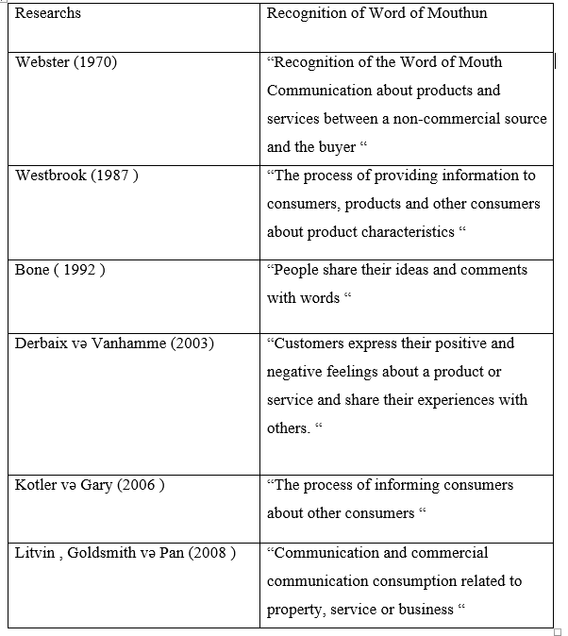

Word of Finger as a result of WOMM development began to spread through messages, e-mails and other means.

1.2.1.2 Classifications of WOMM
WOMM classifies positive and negative by researchers
Negative WOMM, disappointment among purchasers, negative perspectives about the item and individual objections are considered. (Audrain Pontevia and Kimmel 2008, Zeelenberg and Pieters, 2004). Consumers are not satisfied with this situation when they encounter low service levels. Negative ideas in the consumer's eyes cause the product or brand to abandon and desire to complain about the goods. Negative WOMM has a generally higher inclusivity than positive WOMM. Because people react more quickly to negative ideas about commodities. For example:
Picture 1.
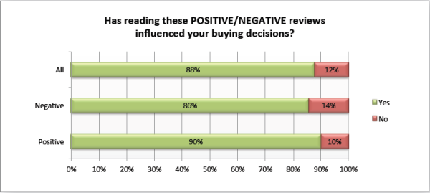
If the consumers are not satisfied with the product, they will refund the product or replace it with another alternative. In the following buy process, the shopper won't reuse a similar item. This process shapes ideas about the product in the consumer's eyes and can affect another people's mouthpiece. (Zeelenberg and Pieters, 2004).
In this situation, the consumer has the right to complain against the manufacturer, the company and the seller. The consumer should not want to have a negative opinion about the product, because the consumer will tell people in the social environment negative things about commodity and the incentive process will be faster. In addition, people often express negative opinions about the product on their online platforms, not on their social networks. (Zeelenberg and Pieters , 2004)
Consumer focuses that customers' negative perspectives are bound to give more understanding than positive thoughts (Cheung and Thadani, 2012). Donovan Mown and Chakraborty also stated that the negative word in 1999 was more effective than the Word of the Mouth. Based on the research, consumers who are satisfied with a product are informed about this product about 3 people on average, but if not satisfied, it means that 10 people are not satisfied with the product.
In a study by Sundaram, Mitra and Webster (1998), consumers are convinced not only that they are dissatisfied with the product, but also provide information about service levels, rude behaviour and other adverse conditions encountered in the procurement process. These factors accelerate the negative word of the mouth
Positive WOMM creates motivation for consumers and positively affects purchasing process. However, this process does not always work.
During WOMM process, consumers often use these six factors most often when reporting information:
- Social currency
- Trigger
- Emotion
- Public
- Practical Value
- Stories
The following is an indication of the effectiveness of the word mouth, and this once again shows how important it is to have a WOMM in the consumer's purchase process. WOMM has a great effect on other tools.

Picture 2 .
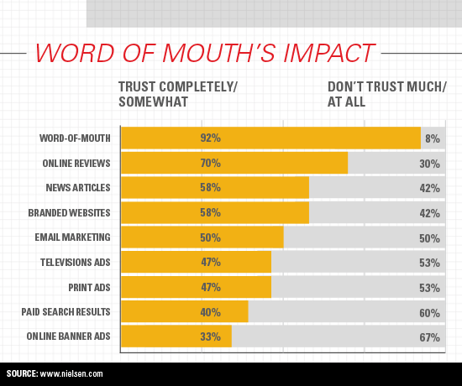

1.2.1.3 Features of WOMM
WOMM offer personal advice and advice, and the word for this features is divided into specific classes. Buttle (1998) divided the Word of Mouth into five categories. This refers to:
- Value factor - WOMM separates 2 different values of positive and negative. The positive effect is that consumers are satisfied with any product, goods and service in their mouth-to-mouth connections. On the contrary, in the case of a negative impact, consumers are dissatisfied and unsatisfied.
- Focus point - is the main target audience and the main activity of the word is that the main activity is widely considered to be consumers and also the environment which includes employees, social circles, competitors, suppliers.
- Time factor - consumers are considered as before and after buying product. Here's the WOMM that assumes the main role. Prior to purchasing the item, the purchaser audits the informal exchange and deals with the buying procedure with these components. Also, after receiving a consumer product, any idea about the product is formed in his eyes, which may be positive or negative.
- Demand factor - The product consumed during the purchase process can be consumed at the consumer 's request .In this case, consumers are trying to understand the WOMM factor, and vendors and managers play an active role in this process, bringing their ideas, ideas to consumers in the right shape.
- 5. Managing factor - here, in particular, spreading, managing, implementing WOMM among consumers, and other elements play an significant role here. Managers are responsible for managing the process
In addition to Buttleda, Endo and Noto (2003) investigate the nature of the WOMM in the analysis of the network and divide them into four groups, including the power of the connection, the security of the data source, and the value of the data.
- The Power of Relationships - As part of social life, people often come together and have strong relationships. Here, the confidence level of each information is one of the important factors that information can affect people.
- Safety of data source - this factor has a significant impact on the subject; Consumer consciousness increases the reliability of information and makes this information more reliable.
- Factor of data value - Here, mostly the interests of consumers are searched and strategies are applied to their areas of interest. It has been shown that people are more interested in new information and that this information has a positive impact on the product. Here, buyers use the verbal relation to purchase new items and play a functioning job in setting up the relationship.
- Distribution of information through network members - The keyword here is often used by the negative word, and such a tool is spreading very quickly. Negative words have a great impact on people. (Endo and Noto 2003). If the circle of interests is the same, then the WOMM spreads faster.
The word out of mouth is basically a positive and negative aspect of research and this emotional characteristics is very important .

1.2.1.4 Communication of WOMM
Today WOMM is item data that people transmit to different people. Since we get the word from individuals we know, WOMM will, in general, be more dependable and reliable than messages from progressively formal advertising channels. Also, in contrast to promoting, WOMM frequently accompanies social strain to adjust to these proposals. WOMM is particularly amazing when the customer is generally new to the item classification. And, unlike advertising, WOMM frequently accompanies social pressure to adjust to these suggestions. WOMM is particularly incredible when the customer is generally new to the item class. We frequently experience these circumstances on account of new items or those that are innovatively mind-boggling. One approach to lessen uncertainty about the shrewdness of a buy is to discuss it. Talking offers the customer a chance to produce supporting contentions for the buy and to gather support for this choice from others.

1.2.2 Electronic Word of Mouth
With the development of digital platforms, consumers can get the information they are interested in more quickly and accurately. Potential and realistic purchasing power can be influenced by other people's purchasing processes, giving positive or negative opinions about the product. At this time , EWOM marketing is a very efficient. Right now, EWOM showcasing is productive. A standout amongst the best approaches to elevate the item is to spread item product information to the Internet. (Silverman , 2007 ). The large use of the Internet as a result of technology development over the years has had a major impact on EWOM's expansion of online platforms.

1.2.2.1 Definition of EWOM
With the emergence and spread of the Internet, unlike traditional communication techniques, it began to find the communication between individuals on a digital platform. Web-based applications known as Web 2.0 have started to expand on online platforms. In this way, consumers share their ideas with other consumers and affect purchasing processes, and here come the words of Electronics. The Hootsuite Social Media Management Platform and the "Socialism" media agency report in 2017 show that the number of Internet users in the world has increased by 10% and around 50% of the world's population is around 3 billion 773 million in 2016. As an internet user. At the point when the Internet is broadly utilized by cell phones, individuals have started to invest much time in online life. There are similar platforms here. Those who have a high position in the media should not only have media owners and large companies but also the consumer role. There are cases where consumers have a say in certain situations. In about «mouth-to-mouth marketing" (Phelps, Levis, Mobilio, Perry and Raman, 2004). In other literature "online WOMM " (Duan, Gu and Vhinston, 2008). Also included in here Helme (2000). Although these names were different, they meant the same.
There are some advantages that EWOM has created, but relationships there may also cause disadvantages. This refers to:
- Although EWOM's rapid dissemination is preferred, for example, consumers may face certain risks as a result of rapid dissemination of any confidential information.
- - The confidentiality of some data during use of EWOM creates insecurity in the eyes of consumers.
- - The rapid dissemination of information slightly weakness the control factor and it is difficult to control the process.
- In addition, deliberate information is spread here and incorrect information is given here.

1.2.2.2 History of EWOM
Table 2 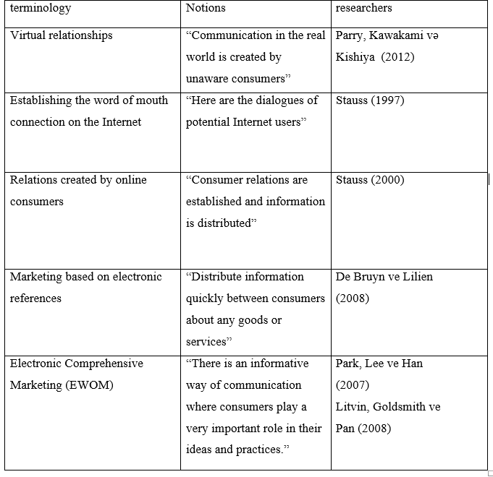

1.2.2.3 Methods of EWOM
When selling products with electronic words, consumers are informed about products and services. There are various electronic marketing methods to encourage consumers to buy the product. This belongs here. EWOM, buzz advertising, viral promoting is a standout amongst the most broadly utilized techniques (Czernowitz, 2007).
- The first of them EWOM marketing - EWOM is an online communication between consumers who never meet each other (Fong and Suzan, 2007).

1.2.3 Marketing Mix and Consumer Behavior
A standout amongst the most significant factors in executing online systems is to utilize the components of promoting blend accurately. Here, it is critical to utilize the components of promoting blend accurately.
Product methodology and customer conduct - One of the primary explanations behind item advancement and income age is to position the market. On the off chance that an element appropriately breaks down market fragments, it has a reasonable position in the market and positively affects the future execution of the business. The subsequent item is predominantly isolated into three sections: (Pride and Ferrell, 2000)

1 - The fundamental item is an item that the purchaser gets as the last item.

2 - Here the item is explicitly identified with the plan components.

3 - Here are the extra administrations advertised. This procedure is basically propelled by the buyer.

The key factor here is the thing that purchasers need to purchase and what items they like. Here the task ought not just to concern the physical properties of the item, yet in addition, give extra administrations. The endeavor must know how the shopper needs to purchase an item. Organizations that effectively break down these issues ought to think about various variables. Here are quality elements, security, showcase, and different elements.

Value system - According to business analysts, the value factor is available. As far as promoting, the principal issue that makers are keen on is the costs made by buyers.

Coming up next is the place the esteemed factor is huge:

• Estimation out of the cost

• The cost change factor

• Follow the frameworks of contenders and apply their expenses as demonstrated by their procedures.

• Establishing an enduring expense for things, by and large, market equality can be broken. The effect of the value factor on buyer conduct can be founded on these conditions:

• A decrease in costs for merchandise and enterprises

• because of value contrasts

• By expanding credit terms

• Making a value decrease for shoppers

The variables that are recorded here straightforwardly influence the shopper conduct.

Distribution strategies - Distribution methodologies assume a significant job in present-day economic situations. Because of the advancement of conveyance systems, undertakings have creation factors. Extraordinary merchants are attempting to keep up the harmony among makers and shoppers. The primary issue here is that the completed item ought to be conveyed to shoppers at the best time and in the prescribed procedures. The nature of the item is connected to the assembly room and circulation systems assume a significant job. The conveyance arranges right now assumes a significant job in connecting around the world. Since the items are conveyed to purchasers everywhere throughout the world securely through dispersion channels on the web. At whatever point a specific item advertising methodology is connected, deals guides explicit toward the item are distinguished.

Advancement technique - Including the item to planned purchasers in the market, upgrading deals and benefit, conveying item includes and different factors here. Here, producers provide consumers with information about their products and encourage them to buy them. Here are the advertising factors used. The main purpose of the advertisement is to deliver the product presentation accurately and accurately to consumers. Here, advertisement should encourage consumers to buy a product. Before buying the product, consumers must give full information about the product. This information must be accurate, so that it does not have any doubts in the eyes of the consumer.
There are some strategies when consumers decide. They follow the choices of other people and implement a product purchase process at a reasonable time. One of the biggest problems that businesses face is how the product creates an image in the eyes of consumers and how they react to their products. If the producer wants to carry out the purchase of the consumer should consider a number of factors. This refers to:
- Price, quality, product design, product benefits and other factors.
When consuming a crop, it does not matter only the price factor. During the online shopping, buyers attach importance to the product's price, appearance, design, quality, and other factors. The brand is very important to the image of the product during online shopping. Because the buyer sees the product for the first time and attaches importance to its appearance.

Consumer Behavior

- The field of purchaser conduct makes a great deal of progress: It is the investigation of the procedures included when people or gatherings select, buy, use, or discard items organizations, considerations, or experiences to satisfy needs and wants. Purchaser conduct is a procedure In its beginning periods of improvement, looks into alluded to the field as purchaser conduct :

This mirrored the accentuation around then (the 1970s ) on the cooperation among customers and makers at the season of procurement. The trade, an exchange in which at least two associations or individuals give and get something of significant worth, is a vital piece of advertising. Despite the fact that trade remains a significant piece of buyer conduct, the extended view stresses the whole utilization process, which incorporates the issues that impact the shopper previously, amid, and after a buy. A purchaser is an individual who distinguishes a need or want, makes a buy, and after that discards the item amid the three phases of the utilization procedure. Much of the time, be that as it may, various individuals assume a job in this succession of occasions.. In different cases, someone else may go about as an influencer when the person suggests certain items without really purchasing or utilizing them. A companion's frown when you take a stab at that some jeans might be more persuasive than anything your mom may state. At long last, purchasers may appear as associations or gatherings. One or a few people may choose items that many will use, as when an obtaining operator arranges an organization's office supplies. In other hierarchical circumstances, a huge gathering of individuals may settle on buy choices: for instance, organization bookkeepers, planners, engineers, deals staff, and others - every one of whom will have a state in the different phases of the utilization procedure. One significant kind of association is the family, in which distinctive relatives say something about items and administrations that all will utilize.
Consumers impact on marketing strategy - Why should directors, publicists, and other advertising experts try to find out about shopper conduct? Essentially, it's great business. The fundamental advertising idea that you ( ideally ) recall from your essential Marketing class expresses that associations exist to fulfill needs. Advertisers can fulfill these requirements just to the degree that they comprehend the general population or associations that will utilize the items and administrations they sell. That is the reason we consider buyer conduct.

1.2.3.1 Online purchasing decision making
What's the most widely recognized path for us to lead information to seek today? Google it, obviously. In spite of the fact that there are other web search tools out there, for example, Microsoft's Bing, Yahoo. Anyway as any individual who ever realizes the Web conveys colossal measures of item and retailer information in a flash. The most concerning issue Web surfers face nowadays is to limit their decisions, not to meet them up. In the internet, disentanglement is key. All things considered, the miserable the truth is that by and large we essentially don't look as much as we may. On the off chance that we Google a term a large portion of us are just prone to take a gander at an initial couple of results at the highest priority on the rundown.

For sure, that is one motivation behind why website improvement (SEO) is so significant today; this term alludes to the methodology organizations use to structure the substance of Web locales and presents on expanding the probability that their substance will show up when somebody scans for an important term. We will probably influence individuals to get to our substance. For instance. in the event that a lot of persuasive individuals share a section, the recipe will weight it more.

Would you be able to envision picking a café before you look at it on the web? Progressively a significant number of us depend on online reviews to guide us toward and far from explicit eateries, lodgings, motion pictures, articles of clothing, music, and pretty much everything else. We more often than not put a great deal of confidence in what individuals from our informal organizations suggest. Shockingly, client appraisals don't connect firmly to genuine item quality that target assessment administrations like Consumers Reports give. What's more, there's proof that portable audits might be less useful than work area surveys, notwithstanding when a similar commentator composes both. Comments posted are increasingly passionate and progressively negative.

2.METHODOLOGY & RESULTS
2.1 METHODOLOGY
As indicated by the examination, specialists isolate purchaser conduct into explicit classifications. The principal point of the examination is to research the impact of EWOM showcasing consequences for web-based buying basic leadership. Here, the consumers' enthusiasm for the item assumes a significant role. The proposition is the primary reason for estimating the impacts of EWOM with the level of items and examining the dimension of web-based obtaining conduct. At the point when customers get the item, we'll perceive how the electronic word functions.

2.1.1 EWOM in AZERBAIJAN
Likely, the quantity of web clients in Azerbaijan is around 8 million. Furthermore, most by far of clients are between the ages of 18-24. EWOM is viewed as another area in Azerbaijan and the most significant factor is the suppositions of individuals. The main purpose here is the means by which EWOM influences individuals' buying procedure, the dimension of buyer reaction to EWOM, and different elements.

The fundamental point here is to decide how powerful EWOM is in Azerbaijan. The job that EWOM plays in online buys, just as how it influences online buys and different elements. As per the study reactions, customers lean toward EWOM for web-based shopping. Since EWOM accelerates online buys and urges purchasers to buy the item. Regardless of the new advancement of web-based shopping in Azerbaijan, an ever increasing number of individuals use it. Contingent upon internet shopping, customers are isolated into explicit segments. For instance, a few clients just shop on the web. This can be explained by a few variables. For instance :

• price factor

• comfort factor

• operativeness factor and so forth.

These criteria are vital for members to lead focused on research :

• Be a functioning web client, know about electronic stages

• Using onlayn acquiring

• To have data about EWOM and WOMM for buyer

• the affectability of the buyer for item

• A positive or negative reaction by the client when acquiring an item

• How do the remarks distributed on the interpersonal organization influence the customer's obtaining procedure?

• The significance of individuals' effect on your internet shopping choices

• The significance of informal organization in the spread of EWOM

So as to achieve the point of the examination, a few inquiries show up. This has a place with them :

• How does electronic verbal impact the obtaining conduct of buyers?

• How does the electronic informal influence our buyer buying conduct in male and female people?

• How does the electronic verbal impact our purchaser obtaining conduct in training levels?

• What is the effect of electronic informal exchange amid shopper obtaining choices online items?

How does electronic informal correspondence influence the way of life of shoppers? What's more, and so on.

2.1.2 Research problem
The Internet assumes a significant role in online purchasing in the modern world. EWOM assumes a significant role here while web-based buying choice making. As an aftereffect of the advancement of the Internet, EWOM started to spread all the more broadly. Here's the manner by which individuals are making associations over the internet, how these connections influence buyers' buys, and how EWOM is powerful. The principal reason for the proposition was to discover which dimension of EWOM affects web-based obtaining in Azerbaijan. It is essential to gauge how much individuals utilize informal organizations for the duration of the day, regardless of whether they are fulfilled in the wake of accepting the item, and how they influence shoppers' effects on the item

Conventional and electronic correspondence in customer showcase is significant. Shoppers are called casual types of correspondence and are presently generally utilized on electronic stages. It is critical to set up electronic relations among purchasers to make clients progressively compelling, simpler and less expensive and direct marketing activities.
2.1.3 Data collection techniques
Deciding customer needs, providing good service, and achieving the advancement of the administration are among the most significant factors in here. Find how to make new thoughts, how customers see promoting messages, and how they utilize their compelling showcasing and correspondence techniques.

In this examination, an survey was utilized. The principle explanation behind this is the semi-organized meeting technique (interview method ) , which is the strategy for gathering information, to respond to questions. It is proposed to define the survey, to comprehend the subject inside and out, and to pass on the perspectives on members utilizing a semi-organized survey procedure.

The exploration was led in 2 directions. The first of these is the overviews covering people beyond 18 years old in Azerbaijan. For the most part statistic markers and the second piece of the job of EWOM in web-based buying, the dimension of effect, internet shopping, and different variables. It likewise analyzes the degree to which constructive or contrary feelings influence the procurement of individuals. Among the strategies utilized, the impact of Azerbaijani shopper conclusion on interpersonal organizations was contemplated.

The second strategy for the review was face to face. Right now, 50 members from 200 members were met and posed more inquiries about their dimension of WOMM and their responses to web-based obtaining choices. Because people are having a problem with the Internet and are afraid to purchase over the Internet. A couple of reasons are likewise included. As indicated by the confirmation, EWOM is definitely not a reliable strategy. Since individuals are having an issue with the Internet and are hesitant to buy over the Internet. This is on the grounds that bogus data can be spread over the Internet. Moreover, the demeanor of the old individuals to EWOM isn't clear. This sort of individuals, for the most part, favors WOMM, since discussions and discourse, all things considered, are more persuading than discussions over the Internet.

2.2 RESULTS
2.2.1 Survey questionnaires results

Survey questions incorporate the aftereffects of extra blend and extra assets, including predefined open inquiries and members' reactions.

The quantity of individuals who addressed the questionnaire is 200. The assessments of the respondents are opposing and everybody's genuine comments are mulled over here.
Buyer statistic indicators are as per the following:

Graph 1 .

As can be seen from Graph 1, 51% of respondents were ladies and 49% were men. The age factor assumes a significant job in online buys. Since purchasers take over the age factor when they item acquiring.
Graph 2 and Graph 3 .

Graph 2 shows the age of the respondents, and the graph 3 shows information on marital status. Most respondents from Figure 2 were between 21 and 25 years of age. As can be seen from Graph 3, most respondents were single people and they were 88%. Demographic factors play an important role here. Many of our surveys were based on the answers of the younger age group. Each age segment has different responses here. Online purchasing decisions from married and gay people are very different. Single people are making purchases more frequently compared to married people and are exposed to the WOMM effect more easily.

Graph 4 .

The other demographic results obtained as a result of the survey are the following: Graph 4 shows the level of education of respondents in the survey. According to the results of this survey, 77% of the respondents have bachelor's degree. Secondary education is 6% , also Master’s degree is 15 % .

Graph 5

The identification of this demographic indicator is therefore important to indicate which of the participants is included in the segment. According to Graph 5, most of the participants are students and constitute 60% of the total. Students are exposed to EWOM more quickly. They are also more involved in rapidly expanding bonds.
Graph 6 .
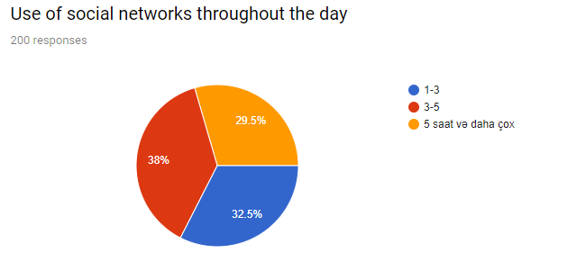

Here's how the daily use of respondents from the social network throughout the day. Social networks is important in developing and expanding EWOM. New relationships are established through social networks, people communicate with each other over the internet. Social networks have an important role in expanding these relationships. When people spend time on social networks, they are exposed to EWOM. Because here we read the comments of others and our thoughts about something may change. Social networks have a strong impact on online purchases.
Businesses that determine a marketing strategy attach great importance to social networking ads. Because it can directly affect the opinions of consumers. Popular social networks in our country are accepted as Facebook and Instagram. Businesses mostly use marketing strategies Facebook and Instagram and communicate with consumers.

Graph 7 .
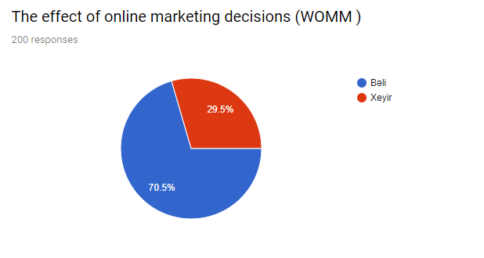
Graph 7 shows how WOMM affects online shopping and an substantial effect in purchasing decisions. As you can see from the results, 70.5% respondent say that WOMM worked and 29.5% of people say didn't work. This shows that WOMM has a significant impact on online shopping decisions in Azerbaijan. There are several factors that affect this. The use of social networks, online platforms and other factors can be demonstrated. As a percentage indicator, 29.5% of consumers say WOMM doesn't work and people like it don't pay much attention to their personal tastes.
Graph 8 .
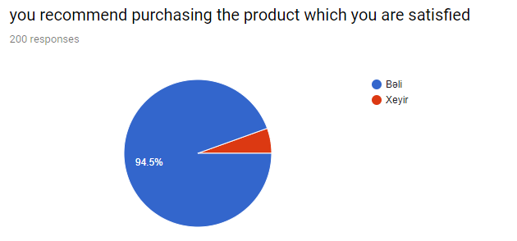
Graph 8 is the result of consumer satisfaction after buying product. 94.5 % Consumers recommend to information after buying product. 5.5% of the respondents did not comment on the product they were satisfied with. Consumers value not only the price, but also the service level and other factors when purchasing the product. The more useful the product, the more satisfied the consumer. After purchasing the product, it informs people about it, informs comments and other ways published on the social network. This process is related to the psychology of every consumer.

Graph 9 .
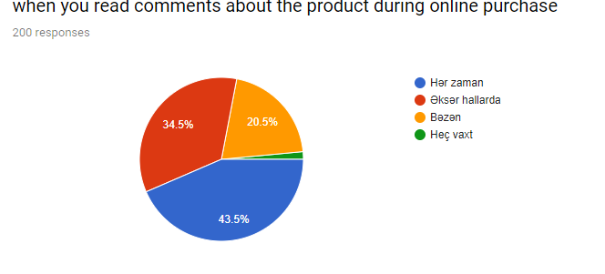
The analyse here is about the demonstrators that consumers look at when buying a product. The most important problem here is the comments written in the purchasing process. Positive or negative comments about the product creates doubts in the eyes of consumers and can change their opinions about the product. Some consumers only reads comments about the product. That is why people are hesitant. Based on the response of the questionnaire, 43.5% of the respondents always pay attention to the comments and 34.5% consider the comments written by the other people, but the latter makes the right choice.
As a percentage of interest, 20.5% of consumers are rarely affected by written comments and 1.5% of consumers do not think that comments are generally reliable. People do not consider this factor when buying online. Consumers commenting on the product think that this product is a reliable product if there are many positive comments about a product. While the comments posted on the Internet are convincing, they are not entirely reliable.

Graph 10 .
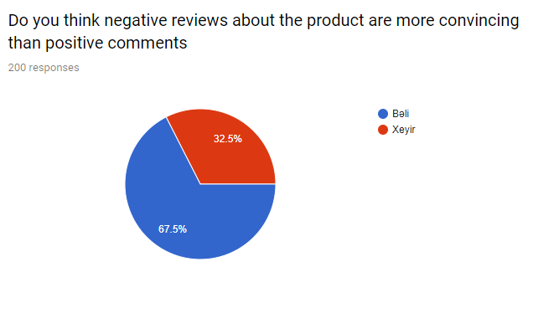
Graph 10 is mainly associated with negative or positive comment from consumers. After buying product, the consumer has a clear idea about the product. Here, positive and negative thoughts about the product may arise. In the next process, when the consumer is satisfied with the product, he expresses his positive opinions about the product. If you are not satisfied with the product, the level of customer satisfaction is low and there is a negative view of the product. As a result of my application, the negative impacts on the online purchasing process, according to the respondents' opinion. According to the survey, 67.5% of people say negative reviews have more impact on consumers than positive feedback. 32.5% do not agree with this idea. The negative feedback has a greater impact on the product than the positive comment.
Probably , a negative opinion about the product affects at least 10 people. Because, if a consumer expresses a negative opinion about a product, they think that there is a problem with the quality of the product or other features. Therefore, they consider this factor in the release of enterprises.

Graph 11 .
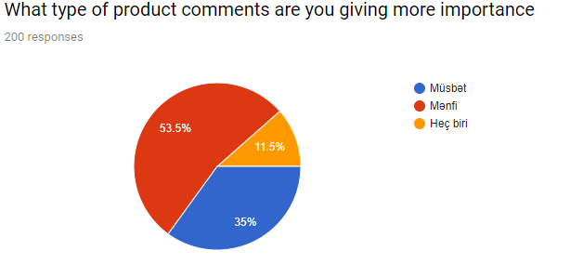

Here are some of the most important comments of consumers. According to the survey, 53.5% of consumers say negative reviews have a greater impact on online purchasing processes. 35% of the consumers do not receive positive or negative comment about the product and they realize the purchase process depending on their tastes.

Graph 12 .

According to Graph 12, the main purpose is to determine how effective EWOM is for consumers. This is the main purpose of evaluating the opinions of others before taking the product and measuring how people react to this idea. Of the 200 respondents, 9 are generally unhappy with the idea, while the other 14 do not agree. 49 respondents does not react to this idea, so they do not deal with positive or negative comment about the product. According to most respondents, taking advice from others is very important to them and they consider this factor when purchasing online. 90 people agree with the idea and 38 people fully support this idea and think that suggestions by the people play a very important role.
In the second part of the survey, it is important to determine how reliable the comment on the product in the social network is for the participants. Many respondents believe that the views expressed in the social network remain questionable about their reliability. Those who are completely satisfied with this idea and those who are not satisfied are very few. Most consumers do not trust the reliability of written comments and remain hesitant.
The third part of the survey shows how important the product evaluation is on the respondents. The majority of the respondents agree with the idea and their view, the evaluation of the websites plays an significant role in the procurement process. There is no difference in other categories. 49 of the participants are neutral and do not care.
The fourth part of the questionnaire generally refers to online assessments. Here are the opinions of those who consider the neutral and online evaluations.
Graph 13

Graph 13 aims to measure the impact of comments on online purchases. Overall, the main purpose here is to measure the effectiveness of product reviews on the product during online purchase. According to the survey, most of the participants remain neutral when comments on the product are positive or negative. Some, however, enjoy purchasing. If there is any disagreement between the comments on the product, consumers are hesitant and cannot know what to decide.
The survey determines that participants feel uncomfortable when reading online comments before online purchasing.

Graph 14 .

Based on Graph 14, it is aimed to measure the impact of people on online purchasing decisions. In general, online advertising has a role. At first, when the respondents were hesitant about buying, I asked a question about how much they valued comments. The reason for this is the choice of brand and other factors. If some participants choose between choosing the product, they choose the best one of the comments. However, the survey revealed that the majority of respondents did not consider this factor. This is because the consumer is less motivated by these products . Also, negative reviews about the product are more likely to convince consumers than positive comments.
I've also analyzed how our choice of products related to our products affects our online purchases. Most participants agree with this idea. If people around us buy and use the product we want to buy, it turns out that this will create a sense of satisfaction and that we can easily purchase our purchase process. Furthermore, most participants think that online shopping should be consulted or that other people should be consulted. This process helps to make the right choice. The product recommended by our friends creates satisfaction and we get a more comfortable way of getting the product. Consumers who consult people during the online shopping process have a positive impact on purchasing processes.

Graph 15 .
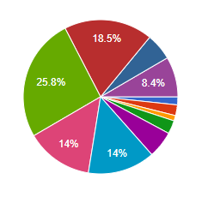
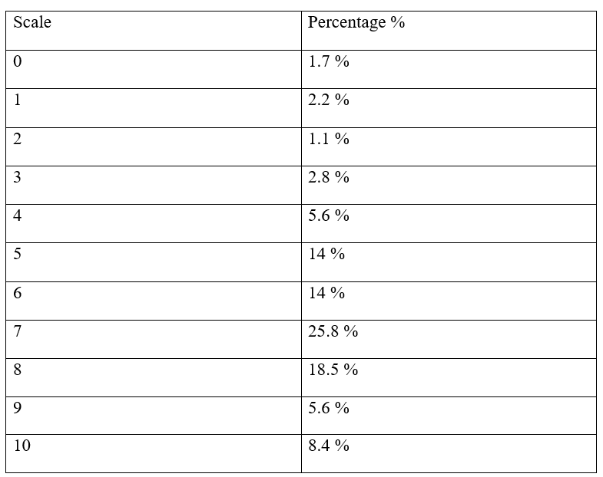

Here, according to the participants, EWOM is investigating the extent to which online purchases are affected. Communication over the Internet has a significant impact on online shopping. Here, EWOM is analyzed on a 10-point scale based on online purchases. . According to the survey, EWOM has a positive impact on online purchases. There are fewer participants who vote for 0, 1 and 2 points. They think EWOM has little or no impact on online shopping. Most of the respondents received 7 points on a 10-point scale. Survey respondents rated EWOM's online purchase value at 7 points. Honey scores of the participants could not choose between 7 and 8 points. Interest rates are as follows:% 25,8 and% 18,5 % .

As a result, people's attitude towards the Word of Mouth is not clear. Due to 5-10 points, participants remained in the elections and there is no indication that it is the best. Some participants say that scattered relationships are often wrong, while others help to buy an EWOM relations .
Therefore, the identification of these effects is considered a difficult process. People are eager to make EWOM online, but this is a direct result of the fact that this process is directly involved in online purchases. According to the survey, an impact on EWOM online purchases is partially affected. Because, in addition to the purchasing process, other factors also affect.

2.2.2 Face to face questionnaires results
As a result of my face to face research, I found that most of the positive words about any product were here. According to the survey, if at least 5 people make positive comments about a product, their brains create positive thoughts about the product. The most important advantage of communicating in the spoken language is the passage of feelings and emotions.Also , a participant said that the products purchased directly from the store were better quality than the products purchased online only. Therefore, some consumers do not support EWOM and face it. Consumers are experiencing a problem with the Internet. This is called - a safety.
According to another respondent , some delays and other problems arise in online purchases. This causes dissatisfaction among consumers. EWOM does not work and in such cases the customer will not be satisfied. Therefore, consumers do not prefer to shop online over the Internet. Consumer opinions are very different.
EWOM is capable of affecting more service networks. For example, a restaurant network can be seen here as an example. Restaurant networks are very sensitive to this process also, individuals people speak with one another by mouth-to-mouth conversation.
Also, one participant says that online shopping is very good. Because when we want, we can remove the product from the internet whenever we want. Here the consumer comfort factor stands out. 7/24 online shopping sites have been created for the convenience of consumers. Here consumers are making decisions about online purchases in certain categories and these sections are divided into several areas.
According to my research, consumers are shopping online for many custumers. Here the brand factor is very substantial. WOMM plays an significant role here. Consumers consider what they say about clothing products and spreads that directly affect the buying process. The biggest problem during online purchases here is the delays and problems that arise during deliveries. The timely arrival of the product and the sequence of other problems are included here. Also, in the order of the product, there may be problems with the order in terms of the size of the clothing.
As an a demographic statistics , people in the 35+ age group use fewer places than EWOM. As a result of the development of new modern technologies, EWOM develops every day and uses more of its younger generation.
According to the survey, the main problem in the overall spread of EWOM is the safety requirement. At present, EWOM in Azerbaijan has not shown much progress yet and is a new term. Therefore, businesses are trying to maximize the relationship of WOMM. Otherwise, it can seriously affect future business. Because if any problem arises, consumers will communicate with each other by word and they will have a negative image of the consumers in the enterprise.
The interview participants were selected according to criteria for providing information on the subject of the research.
As a result of the survey the consumer's opinions do not overlap with some surveys and there are some limitations.

Regression analysis
EWOM is a result of the importance of online purchasing in the first model. The main purpose of your mother's birth is to consider the ideas of people about this product and the relationships between these ideas and the importance of people's impact on online decision making before online purchasing product. Before buying the product, people's views on this product are taken into account. Some ideas are being said about whether people are persuaded. In addition, analysis of the importance given to people during online purchasing is taken into consideration. The result is that there is a meaningful relationship between people's views on this product and their impact on online shopping before purchasing this product. Also, according to the result, R square affects 0.79%. There was a significant relationship between the results in the analysis.

Model 1 .
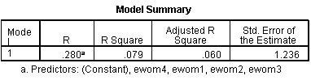
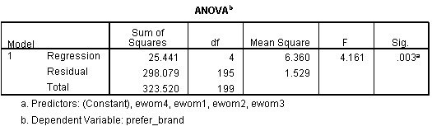
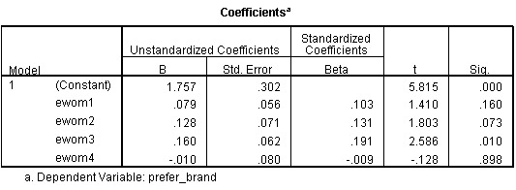

The model 2 is based on an analysis of how people around us are affected by online purchasing decision making. Here are four questions as an independent variable in EWOM. Another factor is that they are effective in online purchasing to get in touch with the surrounding people. The result of the analysis is shown below. As a result of the analysis, people around us have a direct impact on our online purchases. Because consumers are influenced by the ideas of people around them when buying the product and refusing the product. People around us can affect our purchasing decisions in a positive and negative manner.

Model 2
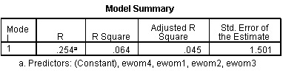
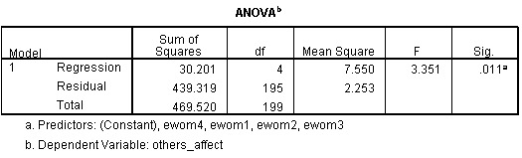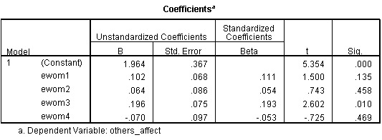

3.CONCLUSION
Nowadays, marketing has grown widely as a result of extensive technology development. This development has shown itself in the EWOM. Here's an example of how people connect over the Internet, a wider development of online platforms, increased information exchange, and other factors. One of the biggest advantages of creating EWOM was that it was faster and more operational. With the creation of EWOM, consumers became more accessible. Businesses can effectively apply their marketing strategies. As a result of the creation of EWOM, the essential of traditional marketing methods has been slightly reduced. Because consumers are already thinking about their comfort and have started to use EWOM techniques. Previously, it is intended for marketing, production and sale, but is now considered consumer expectations and satisfaction. EWOM has a great impact on this process. One of the most important goals of EWOM is to satisfy customers that their customers will be happy to inform people around and to express online products on the social network online. Prior to EWOM, traditional WOMM were created, and people expanded their relationship with real life. It also applies to face-to-face marketing. The most important problem here is to ensure that the consumer is satisfied with the product. As a result of the creation of EWOM, the demand for traditional marketing methods has been slightly reduced. Because consumers are already thinking about their comfort and have started to use EWOM techniques. Previously it is intended for marketing, production and sale, but is now considered consumer expectations and satisfaction. EWOM has a great impact on this process. One of the most important goals of EWOM is to satisfy customers that their customers will be happy to inform people around and to express online products on the social network online. Prior to EWOM, traditional WOMM were created, and people expanded their relationship with real life. It also applies to face-to-face marketing. The most important problem here is to ensure that the consumer is satisfied with the product. Online shopping sites are available 24/7, and the main problem here is that traffic is too much when the site is overloaded and freezing occurs. This factor is also a concern for consumers. However, online shopping for consumers is very important in terms of comfort. In addition, WOMM's comments on online purchases play a crucial role. These reviews are divided into two sections, both positive and negative. In the comments section widely used in social networks, consumers can comment on the product they want. Such comments have a serious impact on consumers' purchasing processes and cause doubts about their products. The main purpose of the study is to examine the extent to which EWOM is affected and how effective it is. To check the impact of online sharing on online shopping, I interviewed 200 people at the same time with 50 people. Active internet users in Azerbaijan are mostly 18-24 years old. At the same time, I found the participants' attitudes towards EWOM, how much they prefer online shopping, and how much they value product reviews on the social network. 77.5% of the respondents were mostly students. Online shopping also results in people spending more time on the social network. According to most participants, they spend about 3-5 hours in social networks throughout the day. In addition, according to the responses received, a very large percentage of consumers are satisfied with the product and are informed by friends and friends about this product. In addition, the respondents read their comments on the online purchases before buying a new product. According to another answer, one of the reasons for responding to consumers in the most effective way is the negative comments written about the product. This causes dissatisfaction and requires rejection of the product. When people's comments about their websites are taken into consideration, they have difficulty in choosing a brand, comments on social networking, and preferences among people around product preferences, and so on. Finally, in my opinion, WOMM factors play an important role in making online purchasing decisions and directly affect this process. I also think that comments on online purchase decisions play an important role, for example: I think the negative comments are more convincing than positive comments. Because I think the product is not good, so the consumer is not satisfied with the product. However, there may be explanatory comments during the comments, because the reason for these comments is that they want to influence the decision-making process of the consumer. I estimate the impact of EWOM on online purchase decisions by 8 points on a 10-point scale. Because EWOM has a significant impact on online purchase decisions, but this process is not fully accepted.

REFERENCES
1.Chevalier, J. A., & Mayzlin, D. (2006). The Effect of WOMM on Sales: Online Book Reviews. Journal of Marketing Research, 43
2. Philip Kotler, Gary Armstrong Principles of Marketing 14 th Edition 2011
- Goldsmith, Ronald E. (2006), "Electronic Word-of-Mouth," in Encyclopedia of E-Commerce, E-Government and
3.Mobile Commerce, Mehdi Khosrow-Pour, Ed., Hershey, PA: Idea Group Publishing, forthcoming.

4.Park DH, Lee J, Han I (2007). The Effect of On-line Consumer Reviews on Consumer Purchasing Intention: The Moderating Role of Involvement. Int. J. Electron. Commer. 11(4)
5.Katz, E., & Lazarsfeld, F. P. (1955). Personal influence; the part played by people in the flow of mass communications. Glencoe, IL: The Free Press
6.Pauwels, Koen (2004), “How Dynamic Consumer Response, Competitor Response, Company Support, and Company Inertia Shape Long-Term Marketing Effectiveness,” Marketing Science, 23 (4)
7. Journal of Economic Psychology 24(1):99-116 · February 2003
8. Litvin, S.W., Goldsmith, R.E. and Pan, B. (2008) Electronic Word-of-Mouth in Hospitality and Tourism Management. Tourism Management, 29.

9. Audrain – Ponteva, Anne-Françosie : Kimmel , Allan J. 2008 . Negative WOMM and redressstrategies

10. Journal of Business Research · April 2004
11. Article in Decision Support Systems 54(1):461–470 · December 2012
12. D.S. Sundaram, Kaushik Mitra, and Cynthia Webster (1998) ,"Word-Of-Mouth Communications: a Motivational Analysis", in NA - Advances in Consumer Research Volume 25, eds. Joseph W. Alba & J. Wesley Hutchinson, Provo, UT : Association for Consumer Research,
13. David Silverman (2006). Interpreting Qualitative Data: Methods for Analysing Talk, Text and Interaction (Third edition).
14. Duan, W., Gu, B., & Whinston, A. B. (2008). The dynamics of online word-of-mouth and product sales-An empirical investigation of the movie industry. Journal of Retailing,

15. A cross-cultural comparison of electronic word-of-mouth and country-of-origin effects
J Fong, S Burton
Journal of Business Research

16. Cheung C. M., Thadani D. R. (2012). The impact of electronic word-of-mouth communication: a literature analysis and integrative model. Decis. Support Syst.
17. Advances in Consumer Research Volume 28, 2001

18. David Godes and Dina Mayzlin
Marketing Science
Vol. 23, No. 4 (Fall, 2004)

19. Marketing concepts and strategies William Pride, O.C. Ferrell. [electronic resource]
20. International Journal of Research in Marketing 25(3):151-163 · September 2008

21. Do-Hyung Park, Jumin Lee and Ingoo Han
International Journal of Electronic Commerce
Vol. 11, No. 4 (Summer, 2007),

22. Phelps, J. E., Lewis, R., Mobilio, L., Perry, D., & Raman, N. (2004). Viral marketing or electronic word-of-mouth advertising: Examining consumer responses and motivations to pass along email. Journal of Advertising Research, 44(4)
23. Silverman, David (2005). Doing qualitative research: a practical handbook (2nd ed.). London: Sage.
24. W. Duan, B. Gu, A.B. Whinston, Informational cascades and software adoption on the Internet: an empirical investigation, forthcoming, MIS Quarterly (in press).
25. Westbrook, R. A. (1987). Product/consumption based affective responses and post-purchase processes. Journal of Marketing Research,
26. Zeelenberg, M., & Pieters, R. (2006). Feeling is for doing: A pragmatic approach to the study of emotions in economic behavior. In D. DeCremer, M. Zeelenberg & J. K. Murnighan (Eds.), Social psychology and economics
27. C. M. K. Cheung and D. R. Thadani, ―The impact of electronic wordof-mouth communication: A literature analysis and integrative model, ‖ Decision Support Systems, vol. 54, no. 1
28. Sundaram, D. S., Mitra, K., & Webster, C. (1998). Word-of-Mouth Communications: A Motivational Analysis. In J. W. Alba, & J. W. Hutchinson (Eds.), NA—Advances in Consumer Research (Vol. 25, pp. 527-531). Provo, UT: Association for Consumer Research.
29. Article in Journal of Product Innovation Management 29(6) · November 2012
30. Advances in consumer research. Association for Consumer Research (U.S.) 28 · May 2006
http://acrwebsite.org/volumes/8208/volumes/v25/NA-25
Appendix

- Cinsiniz
- Kişi
- Qadın
- Yaşınız
- 16-20
- 21-25
- 26-30
- 30-35
- Ailə vəziyyətiniz
- Evli
- Subay
- Dul
- Təhsil səviyyəniz
- Orta
- Bakalavr
- Magistr
- Doktorantura
- İşgüzar fəaliyyətiniz
- Dövlət sektoru
- Özəl sektor
- Biznes fəaliyyəti
- Freelancer
- Tələbə
- Təqaüdçü
- İşsiz
- Gün ərzində sosial şəbəkələrdən nə qədər istifadə edirsiniz ?
- 1-3 saat
- 3-5 saat
- 5+
- Ağızdan-ağıza yayılan marketinqin (WOMM) onlayn alış qərarlarınıza təsir edirmi ?
- Bəli
- Xeyr
- Digər
- Alıb razı qadığınız məhsulu digər insanlara tövsiyə edirsinizmi ?
- Bəli
- Xeyr
- Onlayn alış zamanı məhsul haqqında yazılan şərhləri oxuyursunuzmu ?
- Hər zaman
- Əksər hallarda
- Bəzən
- Heç vaxt
- Sizcə məhsul haqqınd yazılan mənfi rəylər müsbət rəylərə nisbətən daha inandırıcıdırmı ?
- Bəli
- Xeyr
- Məhsul haqqında yazılan hansı tip şərhlərə daha çox önəm verirsiniz ?
- Müsbət
- Mənfi
- Heç biri
- EWOM-un onlayn alışlarda əhəmiyyəti (Qəti razı deyiləm , razı deyiləm , nə razı nə də narazıyam , razıyam , tam razıyam )
- Məhsulu almamışdan əvvəl digər insanların bu məhsul haqqında fikirlərini nəzərə alıram
- Sosial şəbəkədə məhsul haqqında yazılan şərhlər etibarlı informasiya mənbəyidir
- Veb-saytlarda məhsul haqqında edilən dəyərləndirmələr onlayn alış prosesimə təsir edir
- Məhsul alışı zamanı yalnız onlayn dəyərləndirmələrə önəm verirəm
- İnternet üzərində insanlar tərəfindən yazılan şərhlərin onlayn alışlara təsiri (Qəti razı deyiləm , razı deyiləm , nə razı nə də narazıyam , razıyam , tam razıyam )
- Məhsul haqqında yazılan şərhlər müsbət olarsa , məmnuniyyətlə alış prosesini həyata keçirirəm
- Məhsul haqqında yazılan şərhlər arasında fikir ayrılığı olarsa , tərəddüd arasında qalıram
- Əgər onlayn alış etməzdən əvvəl şərhləri oxumasam , düzgün seçim edə bilmirəm
- Məhsul haqqında yazılan şərhlər , həmin məhsulun yaxşı və ya pis məhsul olmasının göstəricisidir
- Online alış veriş qərarlarınıza insanlar tərəfindən edilən təsirin əhəmiyyəti (Qəti razı deyiləm , razı deyiləm , nə razı nə də narazıyam , razıyam , tam razıyam )
- Alış zamanı brend seçimində tərəddüd edirəmsə , şərhlərin sayı daha çox olan brendi üstün tuturam
- Məhsul haqqında yazılan mənfi rəy müsbət rəyə nisbətən alış prosesimə daha çox təsir edir
- Ətrafımda olan insanların məhsul ilə bağlı etdiyi seçimlər onlayn alış prosesimə çox böyük təsir edir
- Onlayn məhsul aldığım zaman , hər zaman insanlarla məsləhətləşirəm
- Sizcə ağızdan-ağıza yayılan marketinq ( EWOM ) onlayn alışlara hansı səviyyədə təsir edir ?
0 – 10

