The Ministry of Education of Azerbaijan Republic

Positive and negative impacts of Lean Manufacturing on practice of Toyota Motor Company

Inji Allahverdiyeva

UNEC SABAH
Azerbaijan State University of Economics

JUNE 2019

Acknowledgements
The success of my thesis was mainly encouraged by various key actors. I offer my genuine appreciation for the learning and studying opportunities provided by my Dean, a Cand. of Econ., Assoc.Prof. Aida Aydin Guliyeva; Head of SABAH groups at Azerbaijan State University of Economics (UNEC). I extend my thankfulness towards Mr. Xalid Cavadov for heartening motivation, and also his assistance of data collection and seeking materials, which is used in my thesis. I would like to thank Mr. Agil Azizov for his help and some advice in completing my thesis.
I also wish to thank my family, especially my mother, later my closest friends, specially my best friend Aytaj, for their trust in huge support, encouragement, care and me.

Abstract
Lean manufacturing is a system that whole of companies continuously seek to maximize source utilization by minimizing the use of waste and improve operations and processes. Although the recognized power of lean system involves some complex and time-intensive procedures, it is the wide applicability to every activity industry. Likewise, this approach is based on the philosophy and methods of Lean systems and the nature of the industry. Accordingly, the value-added process is required to achieve this perfection of production system. This study describes the most considerable types of waste that caused in manufacturing. In addition, to identify some methods and how implementing of lean production, Just-in-time, Kanban, Kaizen, Total Quality Management (TQM), Value Stream Mapping, the 5S, Jidoka, Six-sigma are included. The study presents many benefits related with lean manufacturing. Lean manufacturing implementation shows to have many advantages such as reduction, or elimination of waste, financial benefits, reduced lead-time and low inventory levels to provide timely and superior quality production with lower costs and less effort.

Table of Contents

Acknowledgements 1
Abstract 2
1 Introduction 4
1.1 Background of the Study 4
1.2 Purpose of the Study 4
1.3 Research Questions 5
1.4 Significance of the Study 5
2 Literature Review 6
2.1 What is Lean Theory? 6
2.1.1 History of Lean System…………………………….....7
2.1.2 Principles of Lean System ..........................................12
2.2 What is Lean Manufacturing? …………………………18
2.2.1 Types of Waste ………………………………………22
2.2.2 Methods of Lean Manufacturing ............................29
2.3 Toyota Production System (TPS) …………………………..39
2.4 Lean Implementation………………………………………..43
2.4.1 Benefits of Lean System………………………………………….49
3 Methodology 55
4 Analysis and Discussion 56
5 Conclusion 59
6 Rereferences 60
7 APPENDİX......................................................................................63

- Introduction

  - Background of Study
Lean manufacturing is the most powerful system in the world. Many plants in the world have endeavoured to implement or adopt it in order to increase their productivity of company. This study addresses positive (benefits) and negative (obstacles) issues of the implementation of lean manufacturing concept to the continuous production/ process with a focus on Toyota Production System (TPS). Immediately following the success of lean system in Japan, other firms and sectors in the United States have copied this extraordinary system. Later on companies that are faced complexities and challenges accepted lean system implementation to systematically and continuously reply to these changes for advancing the quality and value of products and survive in the competitive and fluctuating market environment.
Nowadays, lean manufacturing concept has apply in many industries including automotive sector, healthcare, service provider and even military. Lean methods can be implemented in engineering, manufacturing, sales, planning, renovation, marketing, store, Research and Development (R&D) etc.

  - Purpose of the study
The purpose of the study is to research on the implementation of lean manufacturing and to examine the benefits and challenges of this system, considering that its creation comes from Toyota Motor Company. Moreover, it is to find the ways to become more productive for the company, using lean methods to provide that the production process be just in time and smooth, and to determine the effectiveness of the company's financial performance.

  - Research Questions
Factors driving the implementation of lean manufacturing are believed to focus on the customer satisfaction and to provide the continuous improvement of the organization to produce by eliminating waste and applying of different lean production methods and techniques. In addition, since there are long setup times characterized by high volume and low-range products, large non-flexible machines and the process industry, managers have hesitated to apply lean manufacturing methods and techniques to the continuous production process. The study will answer the following questions:
- Determination of the importance and framework structure of the lean manufacturing
- Identification and presentation of the most important determining factors for the implementation of lean manufacturing (including these influencing efficiency of implementation)
- What are the results and recognition of the experiences of the companies related to the implementation of the lean system

  - Significance of the Study
Lean system is a leading production approach in many industries of the economy, where the quality of the product is improved such a way increasing customer satisfaction, the level of inventory is reduced, the production cost is minimized by decreasing the low quality and the material cost. This system reveals systematically how lean manufacturing methods, when properly implemented, can benefit processing or operation by eliminating waste, better inventory control, better quality of goods and better overall financial and operational procedures in many industries of the economy. Because, today’s global competitive companies also need to seek more effective ways to obtain a competitive advantage. The study assumes that there are significant opportunities for productivity and improvement in the manufacturing process if lean methods are used.
- Literature Review
2.1 What is Lean Theory?
Lean theory is a manufacturing implementation that aims to minimize waste throughout all workflows and provide more value for consumers. According to theory, the use of resources that does not bring value to the customer is a goal of alter or elimination. Although it is difficult to answer this question, it is a logical idea to exist that a brief and pithy definition of a management approach as popular as Lean. Lean is a production process, however, it reflects more than production within an enterprise or company. "Lean" term refers to a set of actions or solutions to eliminate waste and non-value-added processes. Because mass production results in a lot of waste and value-free activity, the term interpretation of a new production system is a new system that focuses on reducing waste and maintaining value with working less by the Japanese. The Lean system systematically covers planning, management, and implementing activities to ensure overall co-operation. Lean philosophy has mainly been become to application in the Toyota and Toyota Production System, where the lean theory originated. At the same time, it has also been applied in areas where there is non-manufacturing. Essentially, the objectives behind the lean manufacturing system that has been implemented in Japan for a long time are the elimination of wastes, the reduction of costs and the empowerment of employees. In The Japanese approach, customers define the sale price of products. If the customer can access easily to more quality products and more services offered by the company, more customers will willing to pay for these products or services. The difference between the price of the product and its cost identify the benefit.
Lean manufacturing system is to obtain capital from waste, achieve more sales and to keep a competitive power in a progressive global market. The Toyota Production System has long been showing the basis of Lean manufacturing as a source of amazing performance as a system. The distinguishing practices of the system are generally introduced in the form of various lean techniques in manufacturing companies. In fact, GM, Ford and Chrysler have made major attempts to develop their production system such as Toyota. Organizations trying to adopt the system can be in different areas such as aviation, consumer products, metalworking and industrial products. A significant number of companies involved in manufacturing, service and the public sector have committed themselves to become Lean, some of the leading organizations of around the world. For more than twenty years, lean philosophy has been the business strategy that guarantees competitiveness and environmental friendliness by focusing on the disposal of non-value-added activities. This global partnership, it involves to assume that being lean is a noteworthy effort for organizations. Since resources and energy are limited, new sustainable methods of fabrication more with less should be created. The lean theory that Toyota offered at the beginning of the 20th century, consists of lean manufacturing, five basic principles and a number of practicable techniques. The concept of lean has shown significant impacts on productivity in various industries. The initiators of lean manufacturing have developed a number of techniques and tools that allow practitioners to regulate various problems and eliminate the wastes.
The word "Lean" was fundamentally described and first used by Womack, Jones and Roos in "The Machine that Changed the World" in the international bestseller. The Japanese production techniques based on the mass production system used in the automotive industry in North America and Europe were dubbed to "Lean manufacturing". These original Japanese techniques arose in Toyota Motor Company and were appreciated as Toyota Production System (TPS).
    - History of Lean System
The aspects of lean philosophy are well-defined by lean researchers. It is significant to look through the historical development of Lean concept to ensure in the connection between lean production and systems of measurement, and this is originated the roots of lean thinking. Lean concept has the extensive bibliographic materials which are available for investigate about the Lean Development.
Although the term "lean" has existed since the beginning of seventies, techniques of Lean as a tool can be reached far further up to the ideas generally developed by Frederick W. Taylor who is “The Father of Scientific Management”. In 1911, he published in a book called "The Principles of Scientific Management" his methods of implementing scientific analysis and testing to the production. Companies in Japanese made use of the notions in this book to recover their businesses after World War II. Because of it, after World War II, Japanese producers met a dilemma of deficit of financial, physical and human resources. The problems faced by Japanese manufacturers differed from their Western counterparts. These conditions led to the emergence of the “lean” production concept. All the roots of lean directed firstly to Henry Ford, who set up an impressive manufacturing system at the Highland Park production plant in 1913. In the impressive manufacturing system, a series of techniques and tools (standard work, assembly flow line and interchangeable parts) was implemented such as an integrated system that permitted the products to come out at higher speeds with very short flow periods and high consistence. Henry Ford passed from the craft production to mass production by designing mass production to meet the needs of society in the early 1900s. The key features of mass production were the development of sensitive machine tools and replacement parts. The studies of Frederick Taylor’s time and motion, combined with in line the division of labor into specialized talent groups had also led to massive productivity growth. The key point of such the time was the mass growth and movement in the USA. Most of people had needs low priced vehicles for a way to move and there was a huge market with unrestricted demands in the economy. Henry Ford accepted these restrictions and divided the assembly process into 30-second tasks, which were performed about a thousand times per day. In this situation, Henry Ford formed the Model T car by taking advantage of “Economies of Scale” for the masses. The mass production system developed by Ford has been characterized as the moving assembly line that was combined with interchangeable parts and time and motion studies. The cost of the Model T fell from $850 in 1908 to $290 in 1925 and 15 million dollars were incredibly sold.
Meanwhile, in Japan, the family of Toyoda (Toyoda who is a president of Toyota Motor Company) was making automatic weaving looms. Toyoda's inventions contained special mechanisms that automatically stopped a machine when a yarn had broken. Toyoda sold these patent rights to Platt Brothers in England for £ 100,000 and in 1930 spent this capital to build Toyota Motor Corporation. Toyota Motor Corporation has initially started to produce simple trucks and has fought for most of periods before World War II. Toyota Motor Company produced poor vehicles and was very little successful. World War II and its outcome caused Toyota to close the auto production to a near standstill, but to the USA brought about again a boom. The techniques of mass production developed by Henry Ford were spreading from USA to Europe. Henry Ford was a genuine genius of production and, in fact, he had revealed all the primary concepts of lean manufacturing in his early works (The "Today and Tomorrow" book, published in 1926). The popular River Rouge complex, which located Dearborn was arranged to provide material flow to finished vehicles, and Henry Ford pointed out that batch production, which has many inventories everywhere, is waste. Nevertheless, the batch production was implemented in the River Rouge and, despite the all waste, great demand and large production brought profit to Ford. He rearranged the production machines and maintained the assembly line concept, which in turn, it led to a sharp mistake, and so, “flow production” (it was termed by Ford in 1914) has become “mass production” by ignoring the demand of the final customer.
After the death of Henry Ford in 1947, American industries moved away from Ford's philosophy. In the industrialized world, while companies struggled to survive in the competitive market, companies in the US could sell all their products that they produced. Henry Ford II, who focused a great importance to finance and accounting, was not interested in the production side of work process like his father. Vehicles in the automobile market were becoming increasingly complex and the variety of vehicles was increasing at the demand of different buyers. Different models have slowed the flow of coordination of the production process, furthermore it was even more difficult to coordinate the flow of parts as the number of parts in a typical car increased. When product differentiation was being made, it was making more difficult to maintain manufacturing flowing in a systematized manner. As a result, Ford's hardship was the scheduling problems and inventory accumulation throughout manufacturing process. Although this system worked at incredible speeds, it was not flexible. Therefore, mass production approach was producing large inventories that caused wastage and hidden quality problems. Mass production was unable to ensure the flexibility exactly needed by production. The Model T cars were produced virtually unchanged for 19 years under this production system. There was not a need for other modifications or changing of structures, as only the same product was processed this work line. Increasing demand for a short product turnover and greater product diversity, likewise the changed market demands after World War II, showed to would not keep up Ford's production system ("Leanness") for long-term in the competitive market.
Kiichiro Toyoda who a member of Toyota's founding family and Taiichi Ohno who a leading production engineer of Toyota, visited Ford factories to research the assembly line and analyze their operations in production process, after WW II. Toyoda comprehended that the Japanese market was too weak and discontinuous to provide the great volume of production in the USA. A USA production line could produce 9,000 items per month, while Toyota could make only almost 900 items per month. Toyoda perceived that American automakers were out-producing Japanese counterparts at that time; in the mid-1940s, American companies performed ten times better than their counterparts in Japan. With a low volume, Toyota had to build more than one version on the same assembly line. With a few capital and facilities, Toyota had to be turned quickly production into cash, for attain the US; otherwise it would lose at the market. Toyoda considered they would have to change the approach toward mass production for adapting it to Japanese market. Toyota executives carefully read books of Henry Ford and tested responsive machine tools, the conveyer system and handloom production in economies of scale thinking. In contrast to the "Economies of scale" theory, they had to redesign production line for high quality, low cost, short delivery time and flexibility at the same time. They believed that they could perform Toyota into a competitive power in the automotive industry with some components in the Ford system, would adapt to their manufacturing process, and be more creative. Japanese leaders such as Toyoda Kiichiro, Shigeo Shingo and Taiichi Ohno have developed a creative, disciplined and process-oriented system known today as the Toyota Production System (TPS) or Lean Manufacturing (LM). Taylor and Gilbreth's work was influential on lean, with Ford's ideas being adopted by Toyota to start building the Toyota Production System (TPS), where Lean came from. Toyota has adopted these ideas and has combined the work of Deming, Shewhart and Juran to provide the participation of employees and to guide continuous improvement. With Taichii Ohno being defined as the biggest waste in the production of inventory by way of through overproduction, JIT principles were born, revealing that the customer wanted to keep the inventory waiting at any time without delay.
Toyoda appointed Taiichi Ohno (in Japanese: Ōno Taiichi), who a production manager, for find a way to catch up the West. Taiichi Ohno, who has been tasked in Toyota with developing a system that would improve productivity, is generally considered the main force behind this agreed upon system. Ohno, taking into account some ideas in Western production, and in particular Henry Ford's book “Today and Tomorrow", drew upon some analysis. Among companies, Toyota has attracted particular attention due to its performance in terms of applying the new techniques, developing the activities of automotive manufacturing process and then they renamed the Toyota Production System (TPS). Between 1952 and 1962, the Toyota Production System (TPS) was developed by Taiichi Ohno in the production department to achieve the above mentioned objectives. Henry Ford's moving assembly line, which provides continuous material flow, was formed the fundamental of the Toyota Production System. After some experiments, Toyota Production System was developed and purified between 1945 and 1970 and is still spreading to the world today. Companies operating in the world have begun to adopt these implementations in expectations of achieving the same results, and by TPS has become a model that has been called Lean manufacturing. The principal idea of this manufacturing system is to minimize the consumption of materials or sources that do not add the value to a product. US manufacturers came to understand that the traditional mass production concept should be adapted to new lean production ideas to compete in today's severely competition market. Because mass production has worked as a simple tool and a single model in high market demand. In this situation, it was possible to run individual production areas with the very fast and high volumes, but when products that are more complicated were produced, it was turning into a nightmare to assemble thousands of pieces at the right time.
TPS was noticed firstly in the Japanese industry and the spread of TPS began in Japan. American automakers recognized Japanese production in the late 1970s. At the Massachusetts Institute of Technology where was done a study that set of activities from mass production to lean manufacturing, as described in the book "The Machine That Changed the World" (Womack, Jones and Ross, 1990), US manufacturers changed their directions. The study emphasized the considerable achievement of Toyota at NUMMI (New United Motor Manufacturing Inc.) and revealed the huge gap in the automotive industries between the Japanese and Western. The new concept has been adopted in the United States because Japanese companies have produced, distributed products and developed with a system that covers a half or less human effort, area, capital investment, materials, tools, time and total expenditures.

2.1.2 Principles of Lean System
James Womack and Daniel Jones describe lean production as a five-stage process in "lean thinking" book: identifying customer value, defining value flow, set up it "flow", providing customer back by "pull system", striving for perfection. Being a lean organization requires a way of thinking that focuses on providing the flow of the product through processes that making added value, without interruption that is one-piece flow; it is a production system that pulls back from the customer request that is re-created only at the next operation, and a production culture in which everyone strives to develop continuously.
According to TPS, Womack and Jones's study have identified five fundamental principles for the roadmap becoming Lean, in “Lean Thinking”. It provides general information on all five principles.
- Identifying and specifying value from the customer’s perspective
- Identifying value stream
- Creating continuous flow
- Implement demand-driven systems: “pull, not push”
- Striving for perfection
The first principle is to define and specify the value created within the company, which requires the identification of the needs of customers and customers. Womack and Jones (2003) emphasize the ones that customers are willing to pay for a specific product or service. When the value is defined, all activities needed to create a product or to provide a service should be identified throughout the workstream through a method called Value Stream Mapping (VSM). A value stream covers all the procedures and steps that are required to produce a product or service at this time. In any production process, activities can be divided into three categories (Emiliani 1998, Liker 2003) :
1) These activities add value to the product or service;
2) These activities don't add value to a product or service nevertheless are needful;
3) These activities don't add value to any process and are not essential.
For instance, combining the two pipes with the weld (added value), inspecting welded seams (not added value but required) or reprocessing due to faulty welding seam (without added value and not required, Womack and Jones 2003). After the value stream is mapped and waste is known and eliminated (an unending method that must be recurrent continuously), the remaining added and presently necessary non-value extra method steps need to be set-up that they flow – allowing the least amount of work in process (WIP) and thus the shortest lead time possible. Womack and Jones's perspective (2003) this principle needs a special method of thinking joined must take the read purpose of the merchandize or service that's being processed to realize the value added (VA) and non-value added (NVA) times that occur during the entire process.
This different way of thinking is important as, traditionally, common sense may have suggested to group processes according to function so that they can be performed more efficiently (Womack and Jones 2003). However, such grouping results in the loss of overview method, and consequently to batch-processing. Batch-processing in turn leads to waiting time for individual products and the flow of the product is constantly interrupted (Womack and Jones 2003). Through flow, according to Womack and Jones (2003), most services or goods can be processed more efficiently and accurately with less WIP.
Since production flow has been created throughout the value stream, the time interval of the procedure from consumer order to delivery is dramatically reduced. However, if product or services area unit created while not existing demand, waste still happens. Without demand, product or services area unit pushed through the system and finished products inventory is formed. Finished products inventory doesn't add price and creates wide prices, so waste happens. For this reason, Lean's the fourth principle is to provide a pull system, that produces only goods or services that demanded by a consumer. In the optimal condition, period of production should be as short as that the certain production flow of a product or service can begin only a consumer order is accepted. In this case, no finished products inventory can exist (Womack and Jones 2003).
Finally, the fifth principle is a relentless push for perfection that triggers the process of continuous improvement of the current situation, one of the main elements of the Lean philosophy. Today, these five Lean principles outlined in above are widely recognized and implemented.
Liker’s 14 Principles
Another writer, Liker, who uses from the principles to explain the methods behind the Toyota Production System, revealed his work in a publication titled “The 14 Principles of the Toyota Way… (Liker 2003)”. He accepted the five principles set by Womack and Jones according to the principle of “…Constitute the Toyota Way (Liker, 2003)”, which defines the culture behind the Toyota Production System. Liker constructed 14 principles in four categories, is discussed in the following paragraphs.
Figure 1: Lean system as described by Liker in terms of 4 domains and 14 principles
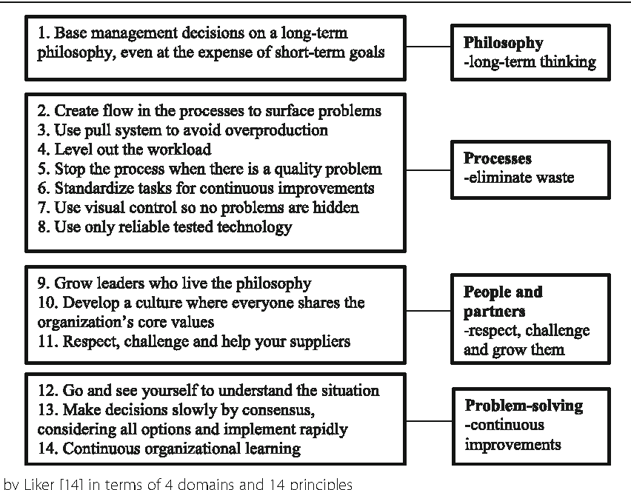
Source: Semantic Scholar
Liker's (2003) four categories are also called as the 4 P’s: 1) “Long-Term Philosophy” 2) “The Right Process will produce The Right Results” 3) “Add Value to Your Organization by Improving Your Employees and Partners” 4) “Continuous Root Problem Solving Continuous Organizational Learning”. Most Lean organizations focus on the second category, the process category (Liker 2003, Ohno 1988, Womack and Jones 1994). In addition, most of the five Lean principles created by Womack and Jones (2003) can be found in the second category of Liker ("The correct process will produce the correct result"). Companies that have successfully implemented the principles of the correct processes (Category 2) have streamed throughout their processes and pull systems have been set up to prevent overproduction. In addition, standardized work assignments have been created, the workload has been balanced, the need for continuous improvement, visualization is used to control the standards and to prevent problems from being concealed, reliable technology is in use, and lastly, the production line will be stopped at any time as soon as a problem happens, which cannot be solved without interrupting production.
The first category of Liker's the long-term philosophy is to perform all administrative decisions based on a long-term philosophy, even if it refers that short-term financial aims must be sacrificed. Liker (2003) proposes that the importance of finding a greater purpose than making money for the company. After a long-term philosophy is established, each function can be arranged with this general purpose, and all future principles are based on this philosophy (Liker 2003). Then, value can be created for customers, producers and the economy.
The importance of the Liker's third category emphasizes people, partners and employees of an company. Employees at Toyota Motor Company are considered to be the biggest assets of the company. Therefore, investing in the development of employees means investing in the future of the company. For this reason, Liker (2003) explains the development of people and teams who follow the long-term philosophy of the company with the principle of "Advance exceptional managers and teams that follow your philosophy of company". This principle underlines the importance of a general goal that all human development must be harmonized. Additionly, a company must understand the company philosophy and educate the leaders, and can teach the culture of company to others. This was described by the ninth principle of Liker (2003). Eleventh principle takes into account importance to the network of extended partners and suppliers, emphasizing the need to respect both of internal and external individuals. Principle eleven determines that partners and suppliers of their extensional work.
Fourth category of Liker (2003) is about the creation of a improved organization by continuously solving the root cause of the problems and the solution of continuous problems will create a continuous training for company. Rather than do theory based on what other people say or computer screen, going to the source of the problem and looking the problem personally is an important principle. This category is often mentioned as "genchi genbutsu". Once the root cause has been identified, a decision must be made on how to solve the problem. In thirteenth principle, Liker recommends that among all participants always try to achieve consensus. This approach called "nemawashi", can be time consuming process, but it can help to provide the solution rapidly after the consensus among participants has been established since all procedures were determined before the actual implementation started. Finally, the fourteenth principle of Liker's principles is to form a learning organization. For this, constant and standardized processes should be applied continuous development tools and Kaizen that is called continuous improvement processes. The frequent use of reflection meetings to define the lessons learned supports the target to grow a continuous learning organization.

Figure 2: A Model of Lean Systems
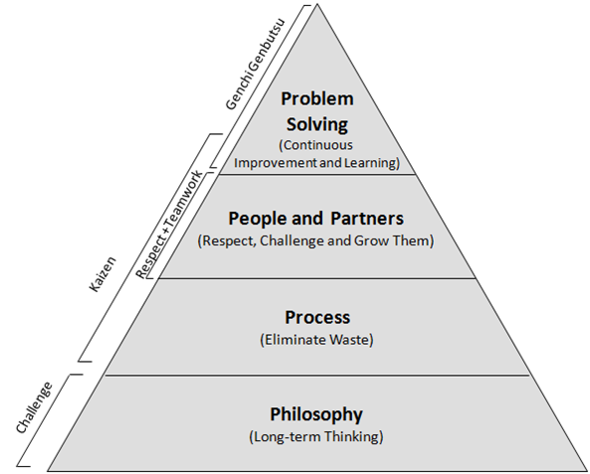
Source: alfraconsulting.eu
Both, Womack and Jones and Liker's studies of Toyota Production System and Lean concept emphasizes the importance of continuous improvement process as the basic philosophy that directs everything the organization does.
Lean principles and initiatives can provide considerable success when properly implemented and applied. Lean principles and initiatives are not limited to any particular industry. In fact that by taking into consideration the concept of production wastage, they really need to improve their processes to increase their competitiveness and thus all types of industries or institutions can benefit from the Lean principles.

2.2 What is Lean Manufacturing?
Lean manufacturing is the notion of eliminating as much wastage as possible throughout a production system. This can be happened through changes in the supply chain operations, during the production process or even when the product is distributed to a customer. As stated in Jacobs and Chase's Operations and Supply Chain Management, “Lean manufacturing is an integrated series of activities designed to make operations using minimum raw material stocks, work-in-process (WIP) and finished product inventories”. This system generates a just-in-time (JIT) production model. JIT is a system in which supplies get to the station house at which they are required in enough time which they are wanted, but not in so many time periods that they sit disused for a considerable length of time.
TPS is often follow interchangeably with the terms Lean Production and Lean Manufacturing. With regard to the technical problems of TPS and Lean, it is often used these terms instead of each other. This is called Lean, because ultimately the process can work:
• Use less material
• Less investment required
• Use less inventory
• Consume less space and
• Use fewer people
More importantly, TPS or another plant process is characterized by a stream and predictability that can significantly reduce the uncertainties and chaos of typical production facilities. Leaner is not only financially and physically, but also emotionally than other non-Lean capabilities. With great confidence, people work with greater peace than the easier and typical chaotic and the reactionary - they change the project on an hourly basis, and then they still work overtime and then still expedite all production facilities.
Because of providing Lean system, the production system continues to operate smoothly. Lean systems take advantage of a lean approach to define and eliminate waste. Knowing the purpose of the Lean system helps to understand what the Lean system is and why it develops. The main purpose of the Lean system is to create a zero-waste product, to produce a quality product for a short period and to guarantee the customer satisfaction. There are two objects while production system or business are used lean principles.
- Increase customer value
- Eliminate waste
The Lean System does not only increase productivity, but also eliminates negative effects that can occur in steps and is also the biggest factor that affects the customer. The main purpose of any Lean system is to be customer-oriented. So, lean means maximizing customer satisfaction by establishing a zero waste system. This process occurs more value for manufacturing too, because the company produces products that people need with fewer resources, and simply it is an aim for elimination. Every product produced by the company should create value, otherwise it will become a loss. From a customer perspective, that consumes a product or service, "value" is defined as any process or operation that the customer wants to pay. Mainly, it focuses on maintaining lean, less work-value. In any case, they begin with this question “What gives the company the highest value at the lowest cost?” when lean starts with the question “What ensures the consumer with the highest value at the lowest cost?". The customer will have a higher value standard because he / she makes a long-term investment in the product. It is the lean assumption that when the company accepts the standard of customer's value it will effort harder and work harder to improve product value and waste reduction. Lean production reflects a business model that specifies customers' expectations by providing quality products at the lowest cost when needed. If the customer does not want a product clearly, why should this product be produced? Hence, the question "Why" should be asked. A large number of lean practitioners, even without questioning why the process exists, jumps into one application of the principles to process; They usually make waste processes more efficient and improve even when a customer does something that he does not want.
Mass Production Thinking
Mass production could be a method of thinking that begins with the principle of economies of scale. With thinking that bigger production is better and manufacturing large batches of items or parts makes more productive use individually equipment than small parties with time-consuming conversions. The focus on process of mass manufacturing is individual productivity – effective utilize of individual machineries and individual operators.
In order to make the total system in Figure 2 more productive, the thinking of ​​mass production affects the efficiency of value-added operations or activities. According to the sample, the cycle time required to cut the steel can be reduced. It is in Figure 2 that the total benefit of decreasing the cycle time of activities that are value-added holds a small portion of the total lead-time, because the value-added time is a small part of the total delivery time.
Lean Thinking
Lean thinking based on value-added work stream and the effectiveness of the total system. If a part of the inventory stack is seated, this part is waste, and therefore the purpose is to ensure that the product flows and to add the maximum amount of value that can be obtained. The focus is on the general process and synchronizing operations, so that they are arranged and produced at a constant speed.
Lean manufacturing is a manufacturing philosophy that reduces the time between the client order and the product manufacture/cargo by eliminating materials of waste. Waste is something that does not contribute to converting a part into your client's requirements. The outcomes of the lean approach are visualized in Figure 3 below. Lean production, as in the traditional production approach, which is mass approach, will take some amount of waste from the value added activity that narrows it down, moreover, it reduces pure activities without added the value that have a major influence on lead-time.

Figure 3: Traditional vs Lean Approaches
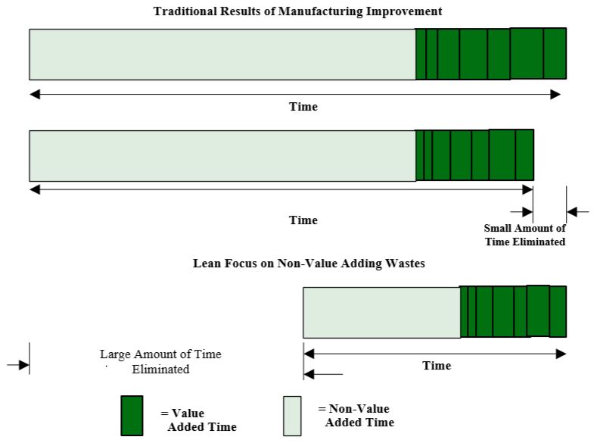
Source: Jeffrey K. Liker Thomas Lamb, A Guide to Lean shipbuilding, 2000
Lean Manufacturing System is becoming increasingly considerable issue for manufacturing corporations in developed countries, to find different ways to compete more effectively and efficiently against competition.

2.2.1 Types of Waste
What is waste?
“Waste ("muda" in Japanese) is anything other than the minimum amount of equipment, materials, parts, space, and worker's time, which are absolutely essential to add value to the product” – Shoichiro Toyoda, Founder Toyota
Eliminating the waste is one of the most important operation in Lean practice. The Lean Focus is to minimize lead-time by eliminating waste.
Waste in lean manufacturing is a concept that adds time and cost to a product over the preparing period but does not add any value to the product in terms of a customer's perspective. In production, manufacturing activities is generally the physical conversion of the items to meet customer expectations. The main goal is to turn materials into something that the customer wants and expectations. Figure 2 shows a simplified model of the steps needed to build a steel subassembly. Production activities add value or waste to the operation in the production process. Only these processes dyed in green add the value. By adding these values, the product transforms to a physical thing that the customer wants. The gray parts of activities are waste.
Figure 4: Elements of Product Leadtime
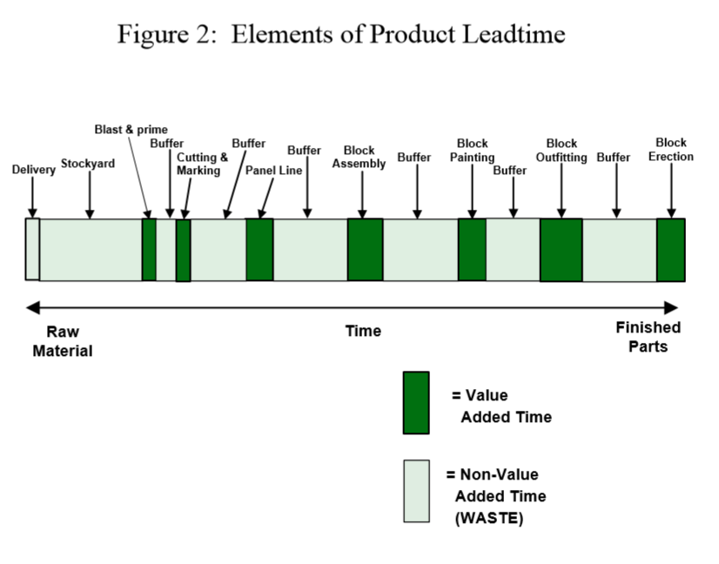
Source: Jeffrey K. Liker Thomas Lamb, A Guide to Lean shipbuilding, 2000
The waste known as Japanese is found in 3M method. 3Ms arrange and make a smooth workflow in the Lean production system. They - 3Ms are as follows:
MUDA = Non – Value – Added
MURA = Unevenness
MURI = Overburden
The term "waste" is characterized as Muda in Japan. Muda pays attention to the waste generated by activities or operations. The seven wastes are a tool for further categorizing “muda”. There are waste categories in the internal production. This conception originated in Toyota manufacturing. Taiichi Ohno who is a Chief Engineer of Toyota developed "The seven wastes" concept as the major of the Toyota Production System.
For waste disposal, this concept facilitates to understand just what kind of waste is and where it is occured. Although the products are different among firms, wastes are typical appeared that in manufacturing environments seems one another. Each waste in this concept, has a strategy to minimize or eliminate its impact on a factory, thereby increasing overall the performance of company and quality of goods and services.
Waste is generally defined as something that creates additional costs without adding value to product or service. In general, muda (or wastage) can be categorized in the follows groups:
Overproduction
Simply, overproduction is to produce large amounts of a product or its component, whereas this item is not actually needed. Overproduction is expensive to a manufacturing plant because it prevents the smooth material streams and accordingly reduces quality and efficiency. Nowadays in highly variable society, many products manufactured before being sold to a particular customer are worn out before the required time. It means that a very good product has been scrapped because it is not frequently used. Producing an item simply to hold a manufacturing source busy (this can be machine, station or both of them) is a condition that must be avoided. The Toyota Production System (TPS) is also known as Just in Time (JIT), because every product is made exactly as required. Overproduction process is drawn on as “Just in Condition.” This brings about extreme lead times, follow from in high storage expenditures, and complicates to identify defects. To prevent overproduction can be required turning off the tap, and this approach needs a lot of attention because the hidden problems of overproduction will be arisen (Romm 1994). The target of the concept is to plan and prepare only what must be immediately product that is wanted, transported sold and made better machinery changeover or design capability.
Waiting
Waiting, such as raw material holding, also result in insufficient capacity utilization and increased a lead-time. Component parts of products and preparing items process must be completed in order to pass to the stages during the time required by downstream sources. This process should be neither too quick, nor too late. When items are not operated or being moving, the waste of waiting happens. More than 90% of an existence of product in traditional production can be spent by waiting to be processed. Most of the delivery time of a product is about waiting in order to the next process; this delay is often because the material stream is not smoothly, the production processes are too long, and the distances between the operation stations are too massive. Goldratt (Theory of Restrictions) informed that an hour lost as a result of the bottleneck process was lost to the all firm's output for one hour and could never be recovered. Connecting a process consistently to the other can significantly reduce the waiting loss.
Transporting
The transporting process among the processes, is a process that does not add any value to the goods but causes a cost increase; 1) the product or parts for production is in the right stage at the right time and in the good state, 2) the product is in the incorrect place, and 3) the product is damaged in transition process and needs re-preparing. Two of three results are not beneficial, which leads to minimization of utilization. Transportation distances should be minimized to integrate the process as material handling is realized between all processes. Inordinate movement and utilization brings about damage and deteriorates quality of items. Material handlers should be used in the transport of materials, as a result another organizational outlay occurs that does not add any value to the consumer. Reducing transportation cost can be challenging because of the costs involved in transport and processes. Moreover, it is too difficult to assemble which operations should be side-by-side. Mapping workflows can facilitate to visualize and determine all processes.
Inappropriate / Incorrect Processing
Many organizations, often referred to "to use a sledgehammer for break the nut", apply expensive, high-precision tools instead of simpler equipment. This frequently results in insufficient plant scheme because the previous or subsequent processes are remote from each other. Additionally, excess worth utilization (provide more production by making minimum changes) is required to recover the great part of expenses of tools or machineries. Toyota Motor Company is reputed for its low cost automation; this is faultless maintained and often combined with old machines. To invest in a relatively small, more flexible tools; generate production cells; and the combination of steps can greatly minimize the waste of incorrect or inappropriate processing. A badly designed process causes in excess usage of manufacturing resources (operators and mechanisms). There is no perfect operation in production system. Improvements of process or operation are generally carried out practically with the new productivities included in the process. Continual improvement process is a critical side of Lean Production System.
Unnecessary / Excess Inventory
An inventory, commonly called as merchandise, refers to the goods and materials that an entity has in order to sell to customers in the near future. Inventory surplus reduces profitableness. It is not extraordinary for a producer keeps the product in the storage. Although this may be advantageous for both the customer and the supplier, the inventories that increase without system will prevent a smooth production. Work-in-Process (WIP) depends on directly the outcomes of wastes of waiting and overproduction. Excessive inventory can obstacle to uncover the facility floor issues that need to be detected and solved in terms of increasing operational performance. Excessive inventory extends lead times, occupies productive ground area, delays detection of consumer issues and prevents communication between procedures. By providing an uninterrupted flow between business centers, many producers were able to improve consumer service, and reduce inventories and related costs.
Unnecessary / Excessive Motion
This waste type is associated ergonomics and activities carried out by workers are considered as waste when they require long walks, searching vehicles or components and accessing parts to fulfill a task. There are also healthcare and safety issues that have become more of a problem for corporation in today's prudent society. Jobs that is overly motion must be analyzed and reformed to improve with the participation of facility personnel. There is no optimal time to make improvements. In any case, many processes perform below the preffered level of efficiency. Continuous Improvement is required for any firm or company to remain sustainable and competitive. Excessive motion or unnecessary handling is one of goals of waste disposal.
Defects
Quality in terms of both customer and manufacturing company is one of the preliminary targets and no one wants low quality, defective goods. At the same time, the reprocessing of the product increases the cost and may exceed the price of the product. If a process can be done as fast as possible, then the product can be accepted, without sacrificing product quality. The result is a tremendous cost for organizations that have a direct impact, re-processing or scrapping quality defects. Related costs involve quarantining, inspecting, re-planning, and loss of firm capacity. In many companies, the total expenditures of errors is usually a considerable percentage of the total production cost. Thanks to the deployment of Employees and Continual Process Improvement (CPI), many organizations are creating great opportunities to minimize errors in many plants.
In the latest edition of Lean Production called “Lean Thinking”, the waste from the Underutilization of Employees, such as the eighth waste of Ohno's original “7 wastes”, was added. Organizations should use their employees not only for their agile fingers and vigorous muscles, but also because they work with a free brain every day. By evaluating only the creativity of the employees, it can be stated that companies may eliminate the other 7 wastes and make a continual improvement with their performance.
It is obvious that wastages are always enemy of production system. Eliminating waste process should be an on-going activity that based regularly on improving an operation. Regular control of worker performance and production phases should be checked as possible as.
The second “M” is Mura means unevenness. Mura is a waste that arising from the imbalance in production of goods and services. Unevenness is an operation without level scheduling and irregularly managing work speed. It also occurs when standards are not present or are not monitored. A common sample is that, even if the customer doesn't demand, the companies increase production to reach their goals. These targets obligate the sales department to hurry to fulfill orders, and the shipping department creates loads while rushing to send products until the end of the month.
What was the result? Defective items are produced which they can not be determined into the loads due to the rush. Customers don't receive desirable products or services. The manufacturing floor struggles to fulfill large amount of orders and efforts slowly becomes failed. More interestingly, it generates the third waste - Muri (Overburden) that breaks the effort to eliminate Muda - the Seven Wastes. Unevenness can often be removed by managers, paying attention to level planning and working speed.
The final “M” is Muri means overburden. The third M of waste categories manifests itself as the result of excessively difficult tasks or operations or someone overloads workers. This can occur in the following situations:
- Lack of appropriate training
- The absence of standards as a sample
- Have wrong equipment for the jobs
When employees do not have the right tools for work, for example, things can become more difficult, take more time and damage the product. Such operations triples the time required to finish the task and needs the products to be re-preparing. Muri applies to various production and management activities. Instead of looking at the solution of problems, to blame someone for production issues can not provide improvement. This is reflected in the Non-Blaming Culture. It is not reasonable to blame the problems instead of alleviating them.
Non-Blaming Management establishes a culture where:
• Problems are understood as opportunities
• No problem making legitimate mistakes
• Problems arise due to increased confidence
• People don't cause problems - they are solvers
• Emphasis is put on solving problems instead of the question “who did the problem”

2.2.2 Methods of Lean Manufacturing
Lean philosophy focuses on the elimination of all types of waste in the workplace. Includes specific lean methods, just-in-time inventory production, Kanban planning systems, 5S workplace, Continuous improvement - Kaizen and others that are all "agile" development program methodologies. Many of these methods and concepts were leaded forward by Toyota, a car manufacturer based in the 1940s, and it later accepted as best practices in many sectors beyond automotive manufacturing (Brown 1999).
Lean manufacturing has been a symbol of efficiency and optimum performance since the 1980s, mainly in terms of its relationship with the automotive industry and Toyota. This system has been shown several times that large batches perform better than traditional production models. Literature also refers to Lean production, “Just-in-time” (JIT) or “cellular manufacturing” (CM) (Campell 1995). In the philosophy that they describe, these terms are the same meaning and these concepts are interchangeably: eliminating the waste, maximizing the efficiency, and continuously improvement.
The techniques to implement lean manufacturing
Just in time production and Kanban
JIT philosophy means that the right amount of goods is placed in the right place and that JIT exceeds the concept of stock reduction at the right time; it is an all-encompassing philosophy to eliminate waste, something that does not add value. A broad JIT vision - or lean manufacturing - lean systems - is something that covers the whole organization.
Just-in-time production (JIT) and a cellular production is closely associated, since the cellular manufacturing layout is often a prerequisite in order to achieve just-in-time production. JIT uses the cellular production scheme to minimize significantly inventory and work-in- process (WIP). JIT allows a company to produce any quantity of products that is customer-desired at any time. Through the mass production strategies, large amounts the same certain goods are produced and after then stored up until ordered by the buyer.
JIT methods step to maximize production, by spreading manufacturing procedures equally over time to support a smooth workflow between procedures. Changing the blend of products produced in a single line, sometimes likened to as "shish-kebab production," makes an effective way to produce the desired production mixture in a soft manner.
Kanban (Kan – card, ban – signal) means a Japanese term, literally meaning "signboard" or "billboard". Kanban is means of achieving Just-in-Time (JIT) Manufacturing. Kanban's roots can be followed back to the early days of Toyota in the late 1940s and in the early 1950s of the Total Production System (TPS). For the time of the global recession in the late 1970s, Kanban became popular in the United States when it was noteworthy for organizations to minimize waste and reduce costs.
The advantage of Kanban is to make visual indicators that enable workers covered in the manufacturing determine how many of a product is to be produced and when to move to a different product. This technique has a system of continuous supply of components and parts. Kanban enables workers to have: “What they need?”, “Where they need it?”, “When they need it?”
Kanban use as a basis the principles that have in the supermarket system. A supermarket should keep the product that wanted it customer on the shelves for the customer to buy the product. However, they do not allow too many inventory on the shelves. Racks must be re-stocked just before unloading. Therefore, the customer demand and the product quantity on the shelves must be overlapping in a supermarket.
Figure 5: Withdrawal Kanban
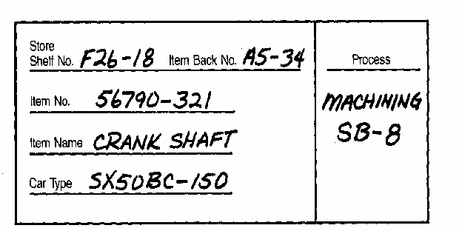
Source: Monden, Y., 1998 Toyota Production System – An Integrated Approach to Just-in-time

Figure 6: Production Kanban
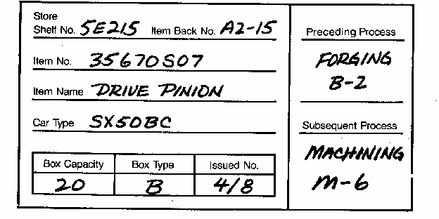
Source: Monden, Y., 1998 Toyota Production System – An Integrated Approach to Just-in-time
JIT often applies the using physical stock control tips (or kanban) to report the need to transport raw materials or can produce new parts of goods after the previous operation. In some situation, restricted amounts of reusable containers are applied as Kanban to ensure that only what requires producing. Many companies in their production system that implement lean practices also require suppliers to offer components of goods by use JIT. The company signals this operation by using a computer to supply its suppliers more of a certain component when needed. The result is a significant reduction of waste typically associated with redundant inventory, work-in-process (WIP) and overproduction.
Kaizen
Kaizen (Kai - continuous improvement, Zen - for the better) aims to eliminate waste (activities that add cost but do not add value) and this means to take it apart and put back together in a better way. This is then performed by standardization of this better way with other operations, by standardized work.
Kaizen or quick improvement procedures considered as "building blocks" of all lean manufacturing methods, focuses on the elimination of waste in the targeted process and activities of a production plant, increasing efficiency and achieving a continual improvement.
Lean manufacturing is based on kaizen idea - or continuous development. This philosophy leads to significant improvements with small and incremental changes that are routinely implemented and maintained for a long time. The Kaizen strategy aims to involve many employees at the company in their work to solve a problem or improve a process. The team uses analytics techniques such as value stream mapping and "5 whys" to rapidly eliminate waste in the production area in a targeted process and quickly identify opportunities. The team attempts to implement selected improvements quickly (usually within 72 hours of starting the kaizen activity), often focuses on solutions that do not spend large capital costs. Kaizen can be applied as an analytical method to implement many other lean practices, including transformations into cellular production and just-in-time production systems.
The 5S
Sort (SEIRI), the first S, focuses on removing unnecessary items at the workplace that are not necessary for current manufacturing operations. An effective visual method for identifying these useless materials is referred "red tagging", including the evaluation and proper handling of the necessity of each element in a work area. A red tag is labeled on all of items that are not necessary for operations or are not in the appropriate place or quantity. After the red label items are defined, these items are then carried to a central stock area for removal, recycling, or reassignment. Organizations frequently provide that reclassifying enables them to reclaim valued work areas and eliminating such things as broken components, scrap and surplus raw materials.
Set In Order (SEITON), Set in Order is based on forming effective and efficient storage methods to organize items to be smoothly to use and to label them so that they can simply be found and left. Set in Order can only be applied after the first column, Sort, has cleared the workspace of unnecessary items. Strategies for Effective Set Order include sticking labels and banners, outlining work areas and locations, and installing modular shelves and cabinets to paint floors, identify suitable storage locations and methods.
Shine (SEISO). Once the clutter blocking the workspaces is removed and be residuary items are organized, the next stage is to thoroughly clean the workspace. Daily follow-up cleaning is required to maintain this progress. A clean environment allows operating workers to notice equipment failures such as leakage, vibration, breaking things, and misalignment. If these changes are taken into account without supervision, failure of equipment and loss of production may result. Organizations typically identify Shine targets, tasks and assignments, techniques, and tools before they start the shine pillar.
Standardize (SEIKETSU). After applying the first three 5S, the next column is to standardize the best implementations in the workspace. Standardization, which is the protection method of the first three pillars, creates a coherent approach to tasks and procedures. The three operations in this process are to assign 5S (Sort, Set in Order, Shine) work responsibilities, integrate 5S tasks into regular work tasks, and control on 5S for maintenance. Some of the techniques used in the standardization of 5S procedures are: work cycle schedules, visual cues (e.g., signs, banners, screen score tables), the scheduling and check lists of the "five-minute" 5S periods. The second section of the Standardize is to prevent the accumulation of unnecessary items, to prevent the breakdown of procedures and to prevent the contamination of the equipment and materials.
Sustain (SEITSUKE). Sustain is the most difficult S to implement and achieve, making it the habit of maintaining the right procedures appropriately. Changing behavior may be difficult, and the trend often tends to return to the current situation and to the comfort area of the "old way" of operations. This S focuses on setting a new status quo and workplace organization standard. The implementations of the other pillar without the Sustain practice can not last long. Tools to maintain 5S include signs and banner, newsletters, pocket guides, team and management entries, performance reviews and departmental tours. Organizations typically aim to strengthen 5S messages in multiple formats until they are finished.
Jidoka
"Jidoka" in Japanese simply implies automation. At Toyota Company means that "by human touch automation". In 1902, Sakichi Toyoda designed the first automatic machine of the world that could be automatically stop if any of the yarns broke. This principle is a central method of Toyota Production System, which is designed to stop the problems immediately when they perceive a problem, and to draw attention to equipment and activities. The most visual manifestation of "by human touch automation" in which at the Altona plant is the Andon cord that is settled over the line. The existence of the Andon cord allows any staff member or employee to stop and intervene the production process if abnormalities happen. The Toyota Production System took over the principle of Henry Ford's separation of simple work and the deployment of these steps among employees at the operation. However, employees in the Toyota production system are responsible for their own work. They operate the workplaces through their teams. They define opportunities for achieving improvement and take the initiative to implement these developments in cooperation with administration.
Six Sigma
Sigma consists of several statistical methods used to sometimes systematically analyze processes to reduce process variations that to support and guide organizational continuous development activities. Six Sigma's a set of toolbox in the statistical control procedure and methodical techniques toolbox are applied by some businesses to evaluate quality of the process and wastage zones where other lean approaches can be implemented as solutions. Six Sigma is also encompassed to improve productivity and quality in lean implementation.
Motorola designed Six Sigma in the 1990s; this is the proven statistical techniques of quality control and analysis methods of data. Six Sigma term that is shown with a Greek alphabet (σ) is used to indicate variability. The level of sigma quality indicates how often defects can occur in procedures, portions or products. The Six Sigma quality level is equal to about 3.4 defects that are per million opportunities indicating high quality and variability of minimum process.
Six Sigma DMAIC that is a group of steps (Define, Measure, Analyze, Improve, and Control) is standardly aimed at applying the Six Sigma statistical tools and identifying the waste and vulnerabilities of processes. The Six Sigma DMAIC stages are as follows:
- Define. This stage aims to identify the objectives of the activities for project improvement and to detect the problems that need to be directed to reach a higher level of Sigma.
- Measure. At this stage, the purpose is to collect information about the targeted activities. Metrics are created and used to acquire basic information about process handling and to support identify problem assignment.
- Analyze. This stage refers with defining to the root of quality issues and their causes, and verifying these results by applying appropriate statistical techniques.
- Improve. Here are creative solutions - ways to make process or operation better, faster and or cheaper - the analyses was finding ways to solve problems identified in the analysis phase. Generally, other Lean practices, as cellular production, the 5S, mistake- proofing are detected as reasonable solutions. Statistical methods are re-used to evaluate improvements.
- Control. At this stage, it is planned to institutionalize the improved system by changing policies, approaches and other institution systems. The results of process performance are revised consistently to ensure increased productivity.
Some companies have preferred to integrate Kaizen (or continuous improvement) activities with Six Sigma methodologies. This generally leads to take advantage of statistical tools to help identify and measure improvements during and after the Kaizen process implementation.
Some lean researchers believe that Six Sigma methods applied in some organizations may be contrary to simple principles. In such conditions, Six Sigma professionals often referred to as "black belts", direct improvements to improve without actively covering employees affected by the development efforts. Lean experts often argue that the engagement and empowerment of employees is critical to developing a culture of waste disposal, which is the foundation of lean philosophy.
Six Sigma methods can be comparatively sophisticated and are used by large organizations and organizations that want to allocate resources and talents to develop the most commonly used Six Sigma statistical capabilities.

Total Productivity Maintenance (TPM)
Total Productivity Maintenance (TPM) (Soltero 2002) tries to involve all levels and functions of management system within an organization to increase the whole productivity of the production equipment. This implementation corrects current processes and equipment such a way reducing errors and accidents. Although the security departments are the center of traditional protective maintenance operations, the TPM tries to cover workers into overall departments from factory to top managers, to ensure that employees are able to operate efficiently.
The main objective of TPM is the training organized for employees to look after of active equipment and machines. TPM refers to the life cycle of the entire production system and establishes a solid, plant-based system to prevent accidents, errors and malfunctions. TPM is mainly focused on optimizing mechanism operation and minimizing machinery malfunctions and related waste management by efficiently managing equipment, preventing, correcting and maintenance, mistake-proofing equipment and providing safety and environmental issues. TPM mechanism focuses heavily on the mechanism work by optimizing the operation and managing the equipment efficiently, preventing, correcting and maintaining equipment, as well as safety and environmental problems as well as mistake-proofing equipment. This mechanism performs several activities such as malfunctions (protective maintenance), "mistake-proofing" machinery (or poka-yoke), to remove product defects and non-product mistakes or to simplify maintenance (corrective maintenance), to setup and design equipment that requires a little or no maintenance (maintenance protection), quick repair of equipment after malfunctions (breakdown maintenance).
Poka-yoke
In the context of lean manufacturing, the resistance to failure, known as poka-yoke (mistake- proofing), is the implementation of plain "fail-safing" machineries designed to operate errors impossible or leastways to identify and correct them. Poka-yoke technics are classified into two main categories: 1) prevention and 2) detection.
- A prevention device is a device that does not allow a machinery or machinery operator to form errors. For example, many cars have gearshift locks that get ahead of a driver from rolling backwards unless the feet are on the brake.
- A detection device informs about happened mistake to the operator when an error is made, the problem can quickly correct by user. For instance, in cars, a detection device could be a warning bell indicating that the keys had been left in the ignition by mistake.
Value Stream Mapping
Value stream mapping is a useful practice that can be applied in lean implementations to assess opportunities of procedures for development in lead-time. While value flow mapping is often linked with manufacturing, this method is implemented not only in logistics, but also supply chain management, service related sectors, health and product development.
In a standard form, Shigeo Shingo recommends that added the value is drawn in the middle of the maps, and that the steps without value added are represented in steps in perpendicular lines at the right corners to value flow. Thus, activities dissociate another kind of "waste" easily separated from the value flow in the center of attention. It refers the value stream as a process and activates non-value operations. The idea here is that the non-value-added steps are closely related to the step of preparing or cleaning up to the value-added process and to the person or mechanism / workstation implementing this value-added step. Therefore, while each perpendicular line is the “topic” of a person or workstation, the horizontal line expresses the "topic" of the product being formed.

Figure 7: A Simple Value Stream
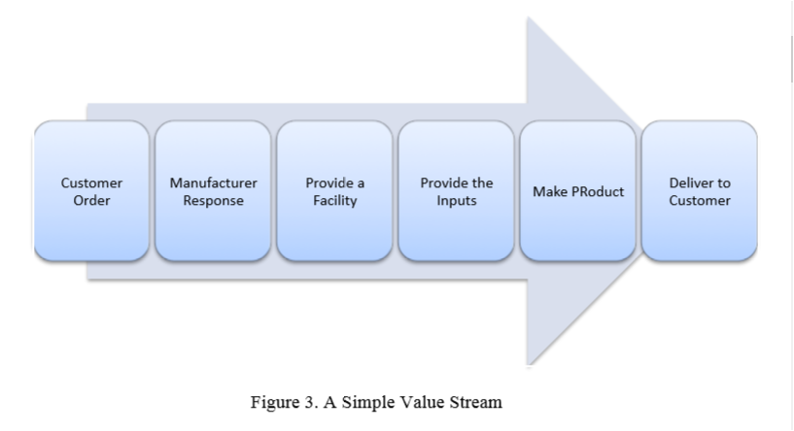
Source: Mert Baykut, Evaluation of Lean Systems in Rail Maintenance Operations, 2011
Value Stream is outlined as “the set of all the particular actions needed to bring a selected product through the 3 vital management tasks of any business: Problematic Solving, Data Management and Physical Transformation”. Value Stream Mapping (VSM) is that the method of mapping the fabric and knowledge flows needed to coordinate the activities performed by makers, suppliers and distributors to deliver product to customers. Initially a current state map was drawn from that the supply of waste known and its finds the chance for implementing numerous lean techniques.

2.3 The Toyota Production System (TPS)
Many of the concepts in Lean Manufacturing originate from the Toyota Production System (TPS) and have been implemented gradually throughout Toyota’s operations beginning in the 1950's. The key to success of Toyota is associated with the Toyota Production System. In the 1960’s and 1970’s this system was developed by Toyota's managers and is conceptualized several methods and techniques, each of which is essential to the structure of the all system, and principal to the general target – Lean manufacturing.
Toyota Production System (TPS) is a manufacturing system that aims to increase the efficiency in the production by eliminating waste. TPS was developed and made to operate, by Taiichi Ohno. When analyzing production issues in the internal environment of manufacturing, Ohno concluded that different types of waste are the major cause of low productivity and low efficiency.
TPS visualizes each element as a house where it plays a vital role for the entire organization. It was created to emphasize that analogy TPS (Lean system) can be successful only when applied as a single system. TPS concept is often referred to as Lean House or TPS House.
The TPS house, the Just-In-Time (JIT) column and Jidoka column that are built from two main columns, are critical for each element of this Lean house, but more importantly, these elements strengthen each other. Until the 1980’s Toyota had increasingly been recognized for the efficiency with it had applied Just-In-Time (JIT) production systems.
Figure 8: The TPS house
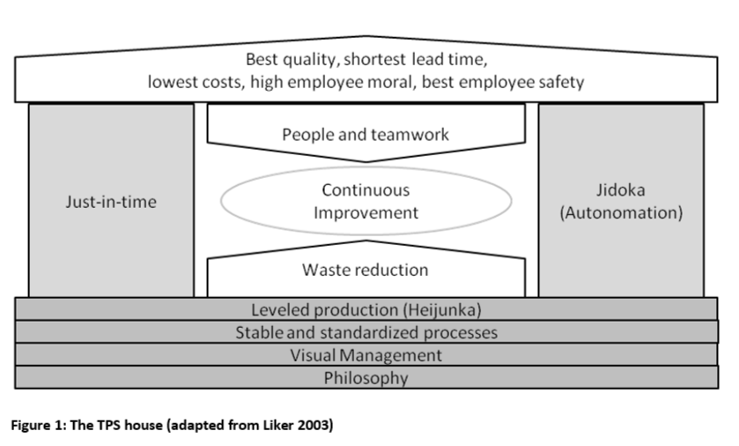
Source: Christian F. Fricke, Lean Management, 2010
As in the roof of Figure 1, the purpose of lean manufacturing is determined on the roof and the overall objective of TPS is to produce the best goods or services at the lowest prices and in the shortest possible time with highest safety and high level of morale. Toyota attaches great importance to the safety of their employees; this is based on another goal (Liker 2003). High morale of employees is essential to creating a positive and optimal work environment that will help to achieve their company goals. The roof of the TPS House is supported by two fundamental pillars: "Just-in-Time" on the left side and "Jidoka" or "Autonomation" on the right side.
Just-In-Time is a manufacturing philosophy that incorporates integrated a series of operations and procedures designed to maximize production volume using minimum inventories. JIT is a highly coordinated manufacturing system where goods move within the system and the services are run properly. JIT Functions are; zero inventory, zero lead-time, zero failure. Just-in-time production minimizes inventory by only processing the required amount of parts at a given time. Zero inventories are the theoretical objective and eliminate totally inventory costs. Nevertheless, obtaining zero inventory is hard or impossible.
Ohno expresses this while considering traditional mass production strategies that “…It is extremely difficult to apply just-in-time to the production plan of every process in an orderly way (1988)". It is time-consuming and cost-effective to show the actual requirements of the production plan by meticulously planning and continuously updating each process step. Computerized systems can perform this, but this still requires efforts, and operations must be made at the physical workplace. Ohno, after carefully reviewing, decided that computers would not synchronously work well with just-in time production systems (Ohno 1988). Determined to discover a better way to accomplish the just-in-time production process, Ohno was interested in production sequences (lines) in manufacturing. He comprehended that the previous process was only needed to manufacture the amount of pieces that the next operation would pull back. These analyzes caused to the formation of the kanban system. Unlike its competitors in the 1950s, Toyota did not use computers for planning, but applied simply Kanban that is the strikingly straightforward system for production control.
The second main pillar of the TPS is about Jidoka or Autonomation, a term that should not be confused with automation, which prevents a faulty part from moving to the next workstation and manages by separating human from the machine. An automatic machinery performs without human input when the start button is pressed and it automatically generates great part output. When these portions are not checked immediately for defects, large amounts of defective items can be produced without being noticed. Autonomous machines continuously detect errors that occur during inspection and automatically cease when non-compliance is detected and Toyota operates autonomous, non-automatic machines. Autonomation that prevents the manufacturing of these defective parts refers as “…Automation with a human touch (Ohno 1988)". Sakichi Toyoda has long ago used autonomation before the establishment of Toyota Production System and created a loom machine stopped immediately after the detection of abnormal conditions.
The foundation of the TPS (Lean) house, as visualized in Figure 8, consists of four necessary elements necessary to provide a stable foundation. The organization's “philosophy” is considered to be the most important component of the foundation as it maintains guidance on the way in which everyone in the organization leads to the direction of the organization and the strategy the organization wants to achieve its goals. Therefore, philosophy concept is situated at the very bottom of the TPS (Lean) house. The second basic element is defined as “visual management”. It shows that everything, which is being made within the organization needs to be visualized, thus the current condition of any operation or process becomes immediately clear and transparent. The third and fourth elements indicate that both the volume and the diversity level of the processes should be standardized, steady and reliable. The third and fourth elements in the TPS House are called Heijunka. The foundation of the house should be solid for pillars to remain constant therefore, the above mentioned processes and concepts are applied.
The center of the TPS is divided into 3 main elements: people and teamwork, continuous improvement and waste reduction in the system. People are at the center of the concept of TPS (Lean) house because they see wastage problems and solve these issues that lead to a continuous improvement of procedures. Taiichi Ohno takes the example of sports teams to understand how important team work is: for example, a football team may have players that play excellently individually, but without teamwork between individuals this team will never win. In addition, the elimination of waste, such as reducing inventory or minimizing faulty parts produced, is very important to immediately identify errors and solve problems in the production system. These process approaches require that the processes be at a high level, so the processes are not stopped frequently. Stability is achieved through sustainable development, an activity carried out by anyone who work for the organization or serve to the company.

2.4 Lean Implementation
As organizations are difficult to maintain profitable during terms of economic slowdown, many have adopted lean systems as a technique to increase competitiveness. As in many development programs, lean system practices have not been universally successful in their implementations and the literature examples of both the success of the lean systems and their failures are given.
The roots of lean generate from previous automotive production. The masters that prepared individual cars had a wide range of abilities and skills, but this process had implemented with lower productivity and at higher cost. Numerous manufacturing companies have implemented Lean that is its origins from the production of an automobile industry (Toyota Motor Company). Nowadays, all major automobile producers have developed their own manufacturing systems with similarities with Toyota Production System and Lean practice. For example, in its annual report for 2008, Volkswagen that Europe's largest carmaker, writes that it supposed to be improved a production system by focusing on procedures, standardization and work streams to improve the company's productivity through continual improvement and the elimination of wastages. Another example is the international corporation that Nissan and Renault. Renault has developed the Renault Production System (RPS) and their goals have been to use their best practices within the organization to eliminate waste and improve their performance throughout their processing.
Besides manufacturing industries, other industries also discovered the Lean concept and applied it. For example, the Virginia Mason Medical Center in Seattle, WA, built the Virginia Mason Production System (VMPS), a management system that targets zero defects by continually improving its procedures in healthcare sector. The VMPS is related to the Toyota Production System (TPS) and was completely integrated it until 2002 by Virginia Mason.
Another sample is Medical Centre that is called Flinders in Adelaide, Australia. The emergency department have to accept approximately 50,000 patients per year, and 40% of them need hospital admission. For a long time, the Flinders Medical Center has experienced increasing difficulties in providing adequate services for the serviced population (around 300.000), which has reached ultimately a point where maintenance safety is no longer fully achieved. After this period, the hospital committee decided to change the hospital culture by applying Lean principles and methods. By applying the principles of lean, the patients' processes mapped through the emergency service, which started with the arrival and ended their exits of the patients. Two main process flows have been established "Probably to go home" and "Probably to be hospitalized". Both the activities two-process streams are arranged separately with a group of nurses and doctors. If there is no threat to life, patients are seen in the order of arrival. These methods provided a "flow" to patient crowd, which reduced 48 minutes in the emergency room that the average time spent by a patient (13 percent reduction, Ben-Tovim et al. 2007). Additionally, the proportion of patients who waited until they were accepted by a doctor or a nurse and thus did not fulfill their care decreased by 50 percent. Following this immediate success in the implementation of Lean to the emergency department of the hospital, Lean effects were spread to the entire organization (Ben-Tovim et al. 2007).
Lockheed Martin Aeronautics Sector (LMAS), situated in Fort Worth, Texas, is the other industry that used Lean concept for improving company performance. In the late 1990s, LMAS launched the Lean initiative and focused initially on the store floor. Then, the company was faced with the necessity to severely reduce operating costs in order to improve its competitiveness, consumer satisfaction and increase the quality of products (Kandebo 1999). At the same time, British Aerospace that a strong rival of LMAS located in Great Britain, focused on restructuring all business areas and implementing Lean principles that provided it even more significant to develop operational performance of LMAS. Before initial improvements were made, the majority of organization's employees and management department went through an concentrated training process with regards to the Lean concept. For the overall success of Lean principles, it is important that Lean is supported by managers at all levels (Kandebo 1999). After the teaching and with the help of experienced consultants, production cell layouts were set up to manufacture items in one-piece flow setup, the business environment for employees has been developed to reduce the efforts required to fulfill a task. It was also scrutinized waste reduction concept. The results of changes in LMAS were appreciable: the need for space in cells decreased by 73 percent, distance of components carried reduced by 94 percent, work-in-process (WIP) was decreased by 99 percent, the direct labor required shrank by 45 percent, and occurred defects during the production process were reduced by 50 percent (Kandebo 1999). The company has saved several million dollars as a result of the Lean implementation.
In addition, after observing the success of Lean implementation in the shop floor at LMAS, Lean principles were expanded within all company areas. The results obtained from these efforts have led to major decreases in process times in general, especially through simplification of processes. For example, the drawing of a specific product to be revealed took about 64 days before Lean efforts. After implementation and evaluation process, the delivery time was minimized to 17 days mainly by reducing the signed parties and the reprocessing cycles. From participants perspective, it happened a change in the company culture that was significant for providing a sustainable, long-run, implementation of Lean idea.
The Starbucks Corp., headquartered in Seattle, WA, is recognized as its coffee shops around the world offering various kind of Italian mode espresso beverages, cakes and coffee-related products (Starbucks 2010). Starbucks Corp. decided to intend increasing the efficiency within company of service processes in order to increase the number of customers served, to reduce the chances of buyers leaving the shop due to long waiting periods (missed sales), or to provide the same number of customers with fewer employees. These aims also emerged due to the current economic decline and increasing competition from McDonalds Corp. and Dunkin’ Brands Inc. Starbucks Corp. has gathered a Lean team, which consists of 10 people for applying Lean methods and principles to support improving their service processes of single branches. Because of the analysis, it revealed 30 percent of the time of a barista was spent on his/her actions, such as walking, arriving, and bending while preparing coffee for the customer. A complete organizing of the process minimized the waste of motion. For example, different components such as syrups, flavorings and whipped cream have been displaced for better availability and accessibility. In addition, the process of drink preparation was redesigned in a workflow and the bottlenecks that shorten the lead-time time were eliminated. In addition to the other studies, the results of these efforts saved Starbucks's performance from a net cost of $ 6.7 million in the year before net earnings improvements of $ 151.5 million in the next year, while total operating costs decreased by $ 175 million (Jargon 2009).
The public sector also discovered Lean implementations to provide the efficiency of government procedures. In recent years, an increasing number of leaders who work in the public sector are interested in the methods and principles of Lean due to the efficiency and improvement goals announced for a large number of public organizations and institutions. In addition, the current economic decline led to a stagnate or shrink of tax revenues, so that operating costs reductions of government’s procedures become increasingly a major approach (Scorsone 2008). For instance, Grand Rapids city, MI, began Lean implementations in 2005 to support large amounts or increasing amount of jobs. A Lean Team consisting of employees led by the deputy director of the city and working in diversified functional areas was established. A high level of approval and commitment was made, and an external coach was appointed to get started the Grand Rapids city (Drickhamer 2008). After initial teachings concerning Lean issues, the teams began mapping value flows. The external coach trained employees to operate training and ateliers. Three value streams were initially defined and consisting of the material return operations, procurement procedures and engineering scheme process in the public library. Developments have led to significantly minimized lead times, reduced processing and other types of waste, and increased the provided quality levels.
The best effort to implement the principles of Lean, in 1998, had undertaken by Merillat Industries that in the wood industry which located in the United States and manufacture kitchen cabinets: In 2003, their production plant in Atkins, Virginia, awarded "The Shingo Price" for Excellence in Manufacturing. The Shingo Prize is an award that is given to companies that achieve world-class, excellent operations. During Lean experience of Merillat, the company minimized the total delivery time from five days to 17 hours, decreased in-process work by 80 percent, increased the quality of product by 66 percent, and done on-time 99.7 percent delivery.
It is not easy to implement and maintain Lean principles, in which companies try to provide principles of this concept and many companies and organizations have failed. Challenges and barriers come from a wide variety of sources, and identifying only the leaders of organizations enables them to overcome and achieve the performances of successful Lean practices.
Challenges and Obstacles in the Production Process
Although many companies and corporations tried to apply the principles of Lean, James P. Womack who the founder of the Lean Enterprise Institute and co-author of the books “The Machine that Changed the World" and “Lean Thinking", recently, instead of directing his concerns about the existing Lean movement to a Lean management, he expressed it was a “Tool Age”. Most institutions or organizations that apply Lean, these methods: kanban, kaizen, five reasons, 5S or others implement such as tools. This situation is understandable when it is considering the size and many dimensions of the tasks (Womack 2007). The Lean tools are suitable because they can be implemented in an isolated manner without being challenged by the organization itself. Nevertheless, according to Womack (Womack 2007), organizational culture needed to change for achieving the full potential of Lean implementation in the management within the organization (Womack 2007).
Liker (2003) actually mentioned a similar issue in his book “The Toyota Way”. He expresses that a comprehensive and successful lean configuration is more than just a few methods, techniques and initiatives. This is achieved through active participation by employees and by allowing operations to implementation of Lean in steady training and daily work. Furthermore, employees' training should not be limited to workshop staff only. On the contrary, leaders and managers in the entire company from all aspects should coach and training to all team members of their skills for providing a continuous improvement of company.
For example, Lockheed Martin Aeronautical Systems (LMAS) was a company that was trying to incorporate all members of team into Lean transformation efforts in the early stages. Senior staff members were unwilling to teach their lower-level employees. Consequently, the primary Lean effort was struggling. As a result, approximately 75 percent of the senior positions were replaced by managers who were willing and can teach their lower level of team members the proper use of Lean. After this restructuring, the training become a important part of the company being pushed into Lean concept. Selected senior executives presently serve as a coaching group to explain to other managers Lean. These activities and initiatives had a major impact on the organizational culture of the company.
Likewise, compared to other wood industries and other economic sectors, the US wood industry appears to be able to adopt Lean quickly and easily, although many of the problems of the wood industry can be improved by applying Lean.

2.4.1 Benefits of Lean System
Over many years, “lean” has been a hot issue among automotive manufacturers. In the industry, Toyota is known as a method it successfully uses to facilitate operations, reduce costs and optimize the quality of its products. The smooth of production system flow allows to the customer your product is on timely and accurate deliveries.
Why does company implement Lean?
You offer high quality products to your customer. On the other hand, you have noticed that while your costs are increasing, the quality of your parts begins to decline. You should look through closely the production process and consider the following issues:
- The time that it to install and alter to a new product line is increasing.
- Some workplaces are overloaded and others are inadequate, resulting in capability bottlenecks and insufficient workflow.
- Failure to plan the resulting problems leads to disruptive delivery schedule.
- More equipment and materials, in contrast shortage of capacity cause incomplete deliveries. When the product has in stock again, the same product must be sold to the consumer at a higher price.
- The overly complicated planning system slowed down the production process and led to a lot of paperwork.
- Quality is essential factor for customers. The number of customer feedback increases due to problems of quality.
These are familiar production problems and the standard answer is to detect and correct the production stage or procedure that causes the problem. However, if the problem arises not from a single stage, but from the way the stages work together? For instance, the shipping storage has the capacity to handle 3,000 portions per hour, but the plant floor could produce only 2,000 on a given day due to the material scarcity at the previous phases of the process. Forklift drivers are idle because of scheduling system is not elastic enough to appoint them to another mission during this time.
Although the product flow is a continuous process for the factory, the manufacturing process can not meet rapidly the variable customer demand day-by-day. This is the challenge of all manufacturing. Perhaps you were supplying your customer the green parts and when the same product was produced, the customer demanded the red parts in the middle of manufacture period. How would you provide the customer satisfaction in this situation? If you can not provide your customers with exactly what they need, they will be directed to other companies. This is an awful circumstance for the company.
Instead of focusing on a single production phase, it is possible to better deal with manufacturing problems by considering the flow of the product throughout the whole process. Solving problems covers smoothing the workflow and makes the process even more flexible. Focusing on the flow of product and process agility is basic to Lean. Lean includes all of these.
As a company is making efforts to reduce these wastes and provide for one-piece flow, many other advantages will follow. These benefits involve that improving quality and less defects, inventory reduction, fewer space required to create a product, development for overall production flexibility, recognition of future kaizen workplaces, providing a safer working environment and improving morale of employees. Each of these benefits are specified in more detail as follows:

Financial Benefits of Lean Manufacturing
The financial benefits of the implementation of lean production are extremely important, and everyone in the above-mentioned improvements will be affected in some way. In addition, they can return the required capital to the enterprise. If company reduces the amount of work in process (WIP) and the goods are held, it will automatically reduce the amount of money attached to that stock or minimize the borrowing from the bank. Increasing the productivity of the company allows producing more products for the same profit and increasing company profit. Reducing the necessity for things such as forklifts trucks and other equipment to move inventory also reduces expenditures. Reducing wastes and defects of the items immediately results in profit. The implementation of lean manufacturing has enormous financial benefits for the business, and if company wants to integrate it into the business culture, these benefits in the processes can be sustained. These advantages mean often more than what can be achieved with offshore (external outsourcing) and allows checking the quality of products or services.
Types of Waste
Lean principles operate to minimize all types of wastes from various sources, such as material errors, to employee ergonomics. It is easy to detect and correct many sources of wastage, for example, an unmanaged machine, it generates high quantity of defects. Other forms of wastage are environmental conditions that hinder workers' efforts. For instance, a better lighting can help to perform production issues by worker; carrying a file cabinet can eliminate a time-loss for an office worker.
Worker Satisfaction
The application of lean principles at work requires the involvement of entrance staff and participation of production team. They are usually in the best place to detect where wastage and inefficiency happens. Employees not only contribute as resources to the company, but employees also make sincere efforts to incorporate themselves in improvement processes. When they see that they pay attention to their suggestions and ideas, it is more likely that they will have an emotion of ownership and satisfaction with their contributions.
Safe working environment
Less stock means less confusion, and being lighted-up of the darkest places of the factory or plant, and the opportunity to better place equipment and devices. There are also fewer opportunities for unexpected motions, as production cells are occupied by a certain number of workers who know each of their repetitive assignments (as defined in standard jobs), which make the enhancement of the chances of an accident. When more production and batch production is eliminated, there is lower the opportunity to produce defects. Since the size of the party is only one, there will not be any inventory mountains to be counted, transported, stored and collected.
Implementing a one-piece stream requires each process to produce only what is required for the next process, but this sequence must be correctly followed one another; the transaction will eliminate the opportunity to pre-build. As a result, waste of inventories will not be permitted to increase. As inventory levels decrease, it will be easier to manage them and less space and labor force will be required. Additionally, the one-piece flow usually causes the machines to squeeze close manufacturing cells, so that a single technician can control a majority of pieces of equipment with minimal walking movement.
Competitive Advantage
Beyond lowering costs and increasing productivity, lean manufacturing techniques promote systems and develop abilities and skills with company personnel supporting changes created by new sales in the workplace. The space saved in storage can be used to cover new product queues. The same issue is true for timesaving. The staff can clutch new jobs and react quickly to changeovers in customer demand. Achieving jobs at fast, short intervals, without wasting and delivering on time, increases the competitive advantage among competitors.
New Inefficiencies
Lean methods can be overused. When efficiency and waste monitoring begin to affect the time spent for production, the solution changes to a problem. When lean principles are firstly implemented, it can expect a greater return since is ahead of this way. It is tempting to effort these principles and examine the worth of developments. If we refine the yield to 1,000 parts per hour in a section where we can supply only 500 parts from the previous phase, we have not improved our result.
Problems with JIT
JIT principles perform best with fixed system components. As the delivery times of raw and finished items are definite, the production components can be planned accordingly. Being extremely rigid according to the JIT planning causes it to be vulnerable to bottlenecks of the system. Supplier delivery problems can interrupt production stream of company by cutting raw materials. Maintenance necessities can reduce company output of production. Any restriction not taken into account in JIT scheduling potentially endangers the entire system. It may be difficult to balance error and system waste margin.
Worker Frustration
When a particular level of purification is achieved, the use of Lean methods for squeezing more economies from manufacturing can discourage employees, leave positive motivation, and shake the leadership. Adverse shift tendencies in previous developments may indicate the employee's resentment. Establishing a balance between stasis and continual improvement is a challenging task in any kind of lean environment. A small plant may be more prone to such a correction because of its less complexity system. The need be aware of how the changes involved affect the staff to measure how much they affect. Staff members will receive immediately a quick feedback about their work, as the one-piece stream results in identification of production problems and (hopefully) immediate resolution. This will provide more ownership to everyone in the field of production. Moreover, if they lead to problem solving attempts by focusing on procedures rather than on individuals, more confidence will be acquired to managers.
Additionally, the one-piece flow allows us to know that if a quality problem exists, the defect affects only that part (Linde 1995). Company does not need to isolate and test other parts or materials in the same manufacture run to determine whether they comply with quality standards. Certainly, if a defect is clutched in a one-piece flow condition, this case should not mean that plant has not performed appropriate corrective operations to provide that this problem will not be repeated. In this situation, the supervisor or manager should determine whether the standard operation has been followed and, if so, what changes should be made to the standard to guarantee that the problem will never occur again.
Figure 9: Benefits of creating flow
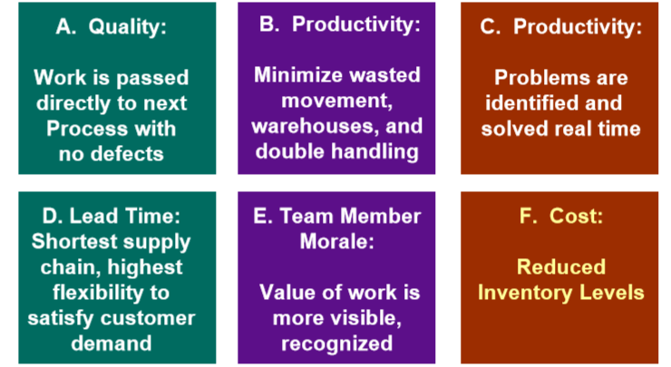
Source: Jeffrey K. Liker Thomas Lamb, A Guide to Lean shipbuilding, 2000

- Methodology
This study is based on The Balanced Scorecard, developed by Robert Kaplan and David Norton, is a highly effective management tool that is widely accepted and applied in the strategy of companies (Kaplan and Norton, 1992).
The BSC helps to overcome operational problems by measuring the current performance, report the most important strategic priorities and detecting "how is this performance achieved". Obviously, it is quite difficult to measure lean benefits and the BSC requires that different perspectives be included when defining appropriate measures. This is especially useful when attempting to evaluate Lean system. This evaluation plan is focused on the four perspectives of balanced scorecard.
- The Financial perspective
- The Customer perspective
- The Internal Process perspective
- The Learning and Growth perspective
Financial Perspective: The focus emphasis of this perspective may relate to the concept of reducing costs (waste is definitely a synonym of cost) - especially variable costs - throughout all production processes and also in the elimination of waste generated in support activities. It is mean that increased financial returns; the increased sales level that can make more profits, a decrease in stock size, higher return on sales, higher capital turnover (also higher return on assets (ROA)) and higher return on equity (ROE). To evaluate investments from this perspective, eliminating waste also means that the amount of capital required to implement a lean production system must be strictly taken into account together with the self-financing activities of the firm, which are managed or not shared by the firm.
Customer Perspective: This perspective measures to the concept of customer satisfaction - creating value for customers. The main objective is to provide customer loyalty and lifetime value. If defects and scrap in manufacturing processes are minimized, a maximized activity can be achieved, based on the value of the output transferred to customers and sold directly by the firm and it can provide an increasing in customer satisfaction by providing buyers with exactly what they need.
Internal Process Perspective: The focus of this perspective may be based on both “waste elimination” and “continuous improvement”. By implementing Lean methods and tools, the production time for internal processes, time wasting - delay time and all production processes by decreasing the stocks – can improve, and lower stocks can increase the capacity. In addition, companies should adopt standard production formulas for all suppliers and check the components supplied for deformations before installation.
Learning and Growth Perspective: This perspective can be concerned with the concept of continual improvement. The third category of the Lean model exactly covers these concepts. It shows increase the learning activities for all employees as well as increase overall labor productivity. Through direct improvement of labor productivity, the company can benefit from a declining manufacturing time and later increased production volumes in order to meet the possible increases in the demand for goods.

- Analysis and Discussion
Financial measures are a key resource of information; they provide feedback and information about past performance and may prevent a false presentation of future results. Kaplan and Norton (1992) identified that many organizations use three themes associated with financial measures to achieve their objectives: cost reduction, productivity improvement and asset utilization. These financial measures worked as part of the industrial mass production period and financial performance measurements show new value creation processes by specifying the developments in customer satisfaction and cycle time as a direct result of Lean implementation. Therewithal, a successful BSC identified processes that must be good for an organization in order to achieve financial and non-financial customer objectives. In order to determine the measures of measure and lag, these measures should take into account cause-effect relationships.

A rigorous study of Lean's impact on companies, and in particular its impact on performance, was conducted. Case study involving research are the Balanced Scorecard method; therefore, more qualitative data may include quantitative data (financial records, surveys) or a mixture of both. In the 1970s and 1980s, innovations in quality and just-in-time production by Japanese companies forced the leadership of the West in many important sectors. Then Lean manufacturing was spread, and accepted by companies. Therefore, I have investigated whether the Lean system will bring financial profitability to companies. To do this, I had to compare the data in the company before Lean system implementation with data of after implementing the Lean system. Data were obtained from S&P Capital IQ Platform. Five companies (Toyota, Ford, Nissan, Renault, Volkswagen) operating in the automobile sector were discussed. According to the when implement Lean manufacturing system in these companies, I selected the specific periods – before and after years, and calculated some indicators which show companies' profitability and improvement – Gross Margin, Ebitda Margin, Net Income Margin, Return on Asset, Return on Equity, Total Revenue. Gross Margin, Ebitda Margin, Net Income Margin measures the company's profitability and the growth over them indicates that the company is in good condition. Return on asset (ROA) shows how much profit the company earned from its assets. Return on equity (ROE) is the money invested by the company's shareholders and how many returns it has earned against the money invested by these shareholders. Total revenue is the revenue from the sale of the company.

Figure 10: Before Lean Manufacturing Implementation
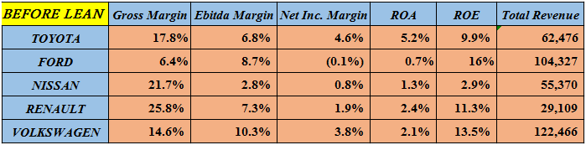
Source: Designed by the author

Figure 11: After Lean Manufacturing Implementation
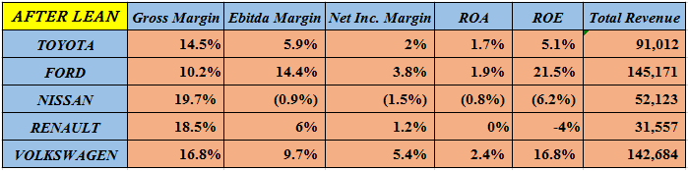
Source: Designed by the author

According to the results of calculations, the implementation of Lean Manufacturing in Ford and Volkswagen companies has led to both margins growth and total revenue growth. On the contrary, Nissan's profitability in the company decreased and total revenue declined. There was a slight increase in total revenues in Renault while a decrease in margins. Since the Toyota Production System (TPS) covers the 1960s and 1970s, I faced with the difficulty finding data in these dates and measured the effects of the Lean Manufacturing System on the initial and subsequent years. Although the company's profitability declines, the increase in the company's total revenue is reflected.
As we have seen above, although some companies have an increase, but some have diminished. The main reason for this is not related to the Lean system, but is linked to the factors that form in the market after the implementation of this system.

- Conclusion
I first specified the characteristics of this system, examined the evidence about how well the principles underlying the system have worked in practice, and finally discussed their potential implementations to strategy of companies.
In this study, I presented the most important aspects about lean manufacturing and the most common of waste in production activities. In the experience of Toyota Company, the application of Lean Manufacturing revealed many aspects. However, I also explained and described kinds of the benefits, which can help the company to become leaner. Mainly, the quality is a major focus in lean manufacturing, because poor quality management would result in many wastes such as scraps and rejects. Moreover, the lead-time will then shorten and increase productivity. Then with eliminating wastes production line be smoothly, as a result this process, defect products will be reduced and reach peak point that gain customer satisfaction. This all processes will be reflected as financial benefits in terms of companies. Therefore, before and after the lean system implementation, I researched how it affected the company's sales.
Lean systems, that is, the application of these saving production models is related to our production process. This system will reduce our costs, reduce our losses, increase product quality, and bring our product to the desired place more quickly. However, it does not mean that this system will affect the company's sales as well, because there are other factors in the market – there is competition in the market. With these applications, the company will go one-step ahead, but in the next steps, it will not be enough, where the company's market strategy plays a key role. The reason is that the lean system is the internal strategy of the company and it is different from the market strategy. In the early stages, we improve the internal process and maintain our production with perfect workflow, but this may not be sufficient because of the effects of external factors in the next set of steps. Moreover, Lean system does not cover all of the company's processes. Procurement, production, delivery - may not cover all our market procedures, and therefore these issues should be addressed in the future.
On the other hand, implementing Lean system may not give the same result for all companies. Lean is a complex system. Failures in implementation, inadequacies in the company and if it did not implement such as a complex system, failures are inevitable. At the same time, the production system should proper to approach companies as fundamental operations implementing Lean of manufacturing systems for correct procedures. This is one of the issues that should be addressed in terms of productivity in companies.
When I investigated this study, I realized that Lean was productive - focused on the company's internal production, not on external processes. I conclude that the Lean system can be modeled not only for the internal production process of the company, but also in the market system. It can be expanded by coverage and combined with a competitive strategy. Thus, I will try to explore the issues that I have mentioned above in the future.

- References
- Ben-Tovim, D.I., Bassham, J.E. and Bolch, D., 2007. Lean thinking across a hospital: redesigning care at the Flinders Medical Centre. Australian Health Review, 31(1), p.10.
- Brown, Howard and Timonthy Larson. "Making Business Intergration Work." Environmental Quality Management (Spring ) 3 (1999): 63-65.
- Campell, John Dixon. Strategies for Excellence in Maintenance Management. Portland: Productivity Press, 1995.
- Drickhamer, D., 2008. Using Lean Thinking to Reinvent City Government. Lean Enterprise Institute.
- Emiliani, M., 1998. Lean behaviors. Management Decision, 36(9), pp.615-631.
- Iloka Benneth Chiemelie Toyota Motors Corporation: An Overview of the Company's Strategic Management at
http://ilokabenneth.blogspot.com/2013/12/toyota-motors-corporation-overview-of.html
- Jargon, J., 2009. Latest Starbucks Buzzword: 'Lean' Japanese Techniques. The Wall Street Journal, p.A.1.
- Jeffrey K. Liker Thomas Lamb, A Guide to Lean shipbuilding, 2000
- Kandebo, S., 1999. Lean Thinking Spurs Culture Shift at LMAS. Aviation Week and Space Technology, 151(2), p.56.
- Kaplan, R.S. and Norton, D.P. (1992), “The balanced scorecard – measures that drive performance”, Harvard Business Review, Vol. 70, January/February.
- Liker, J.K., 2003. The Toyota Way 1st ed., New York: McGraw-Hill.
- Liker, J.K. (2004), The Toyota Way, McGraw-Hill, New York, NY.
- Liker, J.K. and Meier, D., 2007. Toyota talent: developing your people the Toyota way, McGraw- Hill Professional.
- Linde, Porter and Van Der. "Toward a New Conception of the Environment Competitiveness Relationship." Journal of Economic Perspectives 9 4 (1995): 97-118.
- Linker, K.J. (2004), The Toyota Way: 14 Management Principles from the World’s Greatest Manufacturers, McGraw-Hill, New York, NY.
- Maxwell, James, Sandra Rotheberg and B. Schenk. "Does Lean mean Green? The Implications of Lean Production for the Environmental Management." MIT Working Paper, 1993: 52-61.
- Mert Baykut, Evaluation of Lean Systems in Rail Maintenance Operations, 2011
- Monden, Y., 1998 Toyota Production System – An Integrated Approach to Just-in-time
- Ohno, T., 1988. Toyota Production System: Beyond Large-Scale Production 1st ed., Cambridge, MA: Productivity Press.
- Ohno, T. and Mito, S., 1988. Just-In-Time for Today and Tomorrow, Productivity Press.
- Pojasek, Robest B. Poka-Yoke and Zero Waste. New York: Winter , 1999.
- Romm, Joseph J. Lean and Clean Management: How to Boost Profits and Productivitiy by Reducing Pollution. New York: Kodansha International , 1994.
- Scorsone, E.A., 2008. New development: What are the challenges in transferring Lean thinking to government? Public Money and Management, 28(1), pp.61-64.
- Semantic Scholar
- Shoichiro Toyoda, Founder Toyota
- Soltero, Conrad, and Gregory Waldrip. "Using Kaizen to Reudce Waste and Prevent Pollution." Environmental Quality Management (Spring), 2002
- alfraconsulting.eu
- Starbucks, 2010. Company Overview. Starbucks Coffee Company. Available at: http://www.starbucks.com/aboutus/overview.asp [Accessed January 8, 2010].
- Toyota global (2011). Executives: names and positions. Available at http://www.toyota-global.com/company/profile/executives/
- Volkswagen AG, 2009. Annual Report 2008 - Production, Wolfsburg. Available at:http://annualreport2008.volkswagenag.com/managementreport/value- enhancingfactors/production.html [Accessed January 17, 2010].
- Womack, James P. and Daniel T. Jones. Lean Thinking: Banish Waste and Create Wealth in Your Corporation. New York: Simon & Schuster, 1996.
- Womack, J.P. and Jones, D.T., 2003. Lean Thinking: Banish Waste and Create Wealth in Your Corporation 1st ed., New York: Free Press.
- Womack, J.P., Jones, D.T. and Roos, D., 1990. The Machine That Changed the World: Based on the Massachusetts Institute of Technology 5-Million Dollar 5-Year Study on the Future of the Automobile, New York: Rawson Associates.
- Womack, J.P., 2007. Moving beyond the tool age [lean management]. Manufacturing Engineer, 86(1), pp.4-5.
- Womack, J.P. and Jones, D.T., 1994. From Lean Production to the Lean Enterprise. Harvard Business Review. Available at: http://hbr.org/product/from-lean-production-to-the- lean-enterprise/an/94211-PDF-ENG [Accessed August 16, 2010].

- APPENDİX
Appendix 1
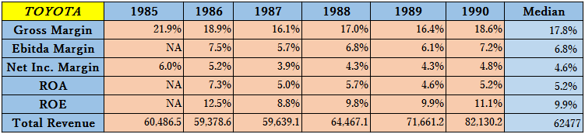
Appendix 2
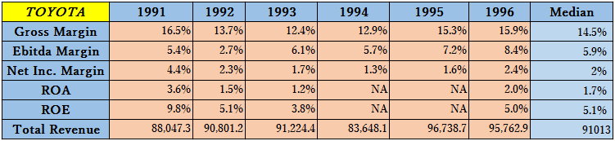
Appendix 3
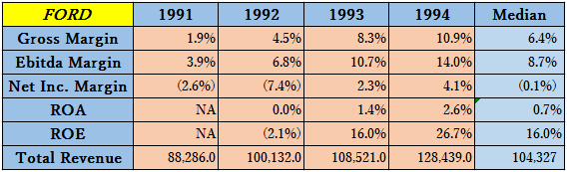

Appendix 4
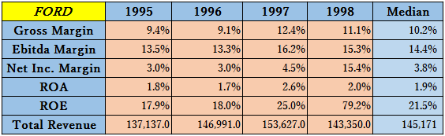
Appendix 5
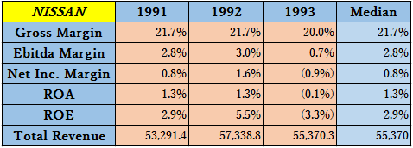
Appendix 6
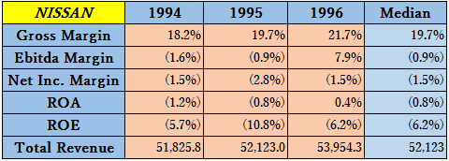
Appendix 7
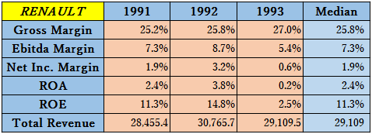

Appendix 8
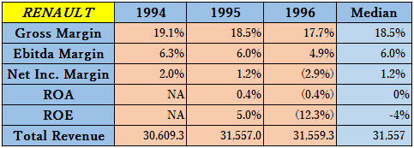
Appendix 9
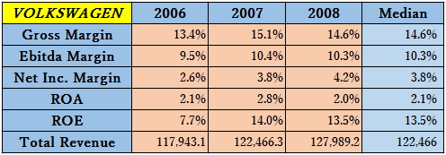
Appendix 10
