The Ministry of Education of Azerbaijan Republic

Azerbaijan State Economic University

The Competitive Analyses of Marketing Strategies of National Mobile Operators

Toghrul Fattahov
Instructor: Leyla Hajiyeva

UNEC SABAH

BAKU 2019
Acknowledgement

I express my sincere gratitude to instructor Leyla Hajiyeva, who has invaluable assistance and care in preparing this dissertation.
Thanks to UNEC management and 24/7 UNEC library, for preparing each condition needed to prepare the dissertation.

Abstract

Mobile communication or Telecommunication is very important in the world. Mobile communication includes internet services, audio, video and etch. We need mobile phones, mobile operators, internet and others for mobile communication. The development of Technology impact to mobile communication. That development helps to create innovation in telecommunication area.
Topic of thesis is Mobile operators of Azerbaijan and Their marketing activities. Mobile operators of Azerbaijan include Bakcell, Azercell, Azerfon LLC (Nar mobile).

Table of Contents

Introduction 5

1.Literature Reviews 8
1.1 Organization of marketing in the mobile communication market 8
1.2 The role of marketing communications in the mobile communication market 14
1.3 Contemporary situation of the conjuncture of the World Mobile Communication Market 16

2.Research and methodology 22
2.1 SWOT analysis and Survey methods 22

3. Analysis 26
3.1. Research of the activity of mobile operators in Azerbaijan...................26
3.2. A Comparative analysis of marketing activity of mobile operators 32
3.3. The results of survey 48

4. Conclusion 55

5. Bibliography 58

Introduction

The telecommunications sector is at the center of the development and prosperity of any country. Continuous innovative events, advanced technologies, scientific developments, global telecommunications market are constantly changing thanks to scientific and technological process. Accelerated changes in the external environment, increasing demand for telecommunications services, internationalization of business, changing consumer positions, the emergence of new requests and new unlimited opportunities for business, the wide availability of modern technologies, the development of information and communication networks that make lightning-fast distribution and information, and most importantly, increased competition, as well as a number of other factors, show the urgent need for marketing in the telecommunications market (Howard & Mazaheri, 2009).
Today, with the development of digital technology, various data (audio, picture, data, video, etc.), different environments (telephone network, wireless access, cable TV network, satellites) has emerged the possibility of transmission / transmission. Beyond this development, it is also possible to receive different information transmitted in different environments with different receiver devices (fixed and mobile phones, computers, televisions, etc.). technology. In this diversity, the emergence of different alternatives for users and enterprises has led to the interaction of different technologies mentioned above.
Human has increased the mobility of mobility thanks to the steam power that realized the industrial revolution. Increased mobility has also led to significant changes in telecommunications. With the use of electromagnetic signals, it became possible to transmit sound and then various information between long distances and without any physical connection between them.
The importance of a marketing approach to the organization of production and commercial activities of an enterprise, which allows an organization to survive in the competition in the long term, has increased dramatically in recent decades. The mobile market, being a part of the telecommunications industry, has its own characteristics, and, accordingly, features of the marketing processes. Market research in the mobile market is becoming increasingly relevant for local enterprises that are in tough competition, both among themselves and with foreign corporations (Lebedeva, O.A 2013).
The most important problem in the telecommunication sector is customer loss. When customers are correctly identified, organizations can predetermine which customers they can lose, so that they can develop strategies to retain their customers, and organize low-cost and effective campaigns. For a customer who is not likely to lose information, it may be costly to inform the customer by sending mail or messages. With the right analysis, these costs can be eliminated.
Using the records in the hands of firms, companies can develop segmented customers (customer segmentation), pricing and promotion strategies that show similar characteristics. Companies that do not have sufficient records of their customers remain in a difficult situation in this competitive environment. Therefore, it is necessary to collect the right data from customers or to analyze and analyze the available data in the best way (Meyer & Schwager, 2007).
“Technology development in telecommunication has enabled telecommunication users to exchange data using cell phones, laptops and other telecommunication devices like the USB Modems or data cards at affordable rates. The word telecommunication is derived from the Greek word tele, which means over a distance, putting the two words together gives telecommunication while communication simply means the sharing of information or messages between two or more entities” (Dean.2003).
Marketing communication systems are the main tool for transmitting information, advertising messages, messages and other communication elements to potential consumers. A limited number of players with almost identical terms of service is participating in the mobile market, so the only thing that makes every mobile operator try to stand out among its competitors in the eyes of customers is the marketing and communication system.
Books on marketing in Azerbaijan are being written. Mammadov A.T, Hajiyeva L.A, Kheirkhabarov IM and others have a great role in the writing of this area.
Subject and object of dissertation. The subject of the research is a complex of theoretical, methodological and practical issues related to the peculiarities of the use of marketing communications in the cellular communications market and the development of communication strategies. The object of the research is the mobile communications market of the Republic of Azerbaijan.
The purpose and objectives of the dissertation. The main goal of the research is to study the characteristics and conditions of the cellular communications market, and to develop proposals for the use of priority components of the marketing communications complex to promote mobile services.
To achieve the planned goal set several tasks. The telecommunications industry should be investigated, its development prospects should be identified, and the mobile communication market should be analyzed, its segmentation peculiarities should be examined and the influence of demand factors determined. It is necessary to determine the role of marketing in the organizational process of the enterprise in the mobile market, to study the role of communications in the marketing process and to consider the main aspects of the modeling of communication processes in the mobile communication market. For completeness, a comparative marketing analysis of local mobile operators is needed. It is important to determine the priority components of the marketing communication complex used to promote the cellular market.

Literature Reviews

  - Organization of marketing in the mobile communication market

Marketing is a very important process in any business, as it makes a significant contribution to the success of an organization. Production and distribution is also largely dependent on marketing. Marketing is a vital component of the prosperity of all organizations. Marketing strategies include getting new customers, branding and public relations. The motivation behind advertising is the acknowledgment or acknowledgment of an item or administration, and promoting supervisors must be innovative and imaginative in showcasing (Sinyaeva I.M., 2005).
The founder of marketing, F. Kotler, in 1998 gave the following definition to the concept of marketing: “Marketing is a social and managerial process by which individuals and groups of individuals satisfy their needs and requirements by creating goods and using consumer values and sharing them with each other " (Fatkhutdinov, 2000).
The term "marketing" covers many different types of activities that are associated with the sale of products - goods or services of the company. Publicizing is the most evident promoting action; numerous organizations burn through a large portion of their showcasing spending plan on this component of interchanges. Promoting incorporates customer investigate, on account of which the item better addresses the issues of purchasers and fulfills them.Product design is also a form of marketing, as it helps to create a bright, memorable image of products in the minds of consumers, highlighting them from the total set of many competitor products. On the other hand, design plays a very important role in the packaging of goods - packaging is responsible for the preservation of the quality of products and is informative in nature.
In general, the importance of marketing is directly reflected in three main areas:
Economy. Making immediate and aberrant occupations (advertising chiefs, economic specialists, distributers, sellers, and so forth.) prompts financial development in organizations, associations, nations and around the globe. According to Richard L. Sandshuen, in free undertaking nations and in a reliant market, promoting forms are a noteworthy power in making mass markets, large scale manufacturing and mass dispersion, and furthermore help make an abnormal state of exchange, incredible venture openings and high work (Richard L.Sandshuen, 2002) .
Improving the way of life. Today, the normal individual has numerous items and administrations that make his life increasingly charming, agreeable and tolerant than individuals 50 years prior. In addition to scientific and technological progress, various marketing processes, for example, marketing research, which are one of the primary stages of marketing, used for the purpose of detailed, more in-depth identification of consumers' needs and desires, and finding the best satisfaction for them, not forgetting This is about getting the most benefit for the company.
Making progressively aggressive organizations. Showcasing urges organizations to concentrate on the client — on what the objective market needs at the value they can and are eager to pay, with limited time exercises, to distribute their offer and through circulation channels that enable you to convey the item to the perfect spot and spot, time.
Considering all the above-described features of marketing, we will provide a more accurate and expanded explanation of the concept of marketing, covering all areas. “Marketing is the concept of targeting consumers of any activity at any stage of the life cycle of managed objects based on forecasting their needs and organizing the promotion of any product” (Fatkhutdinov 2000).
Marketing is relevant everywhere, including in the mobile market. With the rapid development of scientific and technological progress and improvement of the quality of mobile communications, the positioning and promotion of the brands of mobile operators is completely shifting to the marketing side. In created nations, practically all portable administrators have equivalent innovative assets and the capacity to give administrations at a similar dimension, so as to separate among contenders, an association must think of fascinating and favorable ideas for buyers that will plainly emerge from the group. This provides for mandatory marketing participation in the organizational policy of the enterprise, because it is necessary not only to bring relevant offers to the market, but also to first investigate the market in order to identify potential demand, predict a response, and most importantly, calculate everything with minimal risks (Bertrand and Bouchard 2008).
Many entrepreneurs, as a rule, do not consider marketing important, which is the biggest problem, as we live in a globalized world and increasingly deal with extremely strategic and impatient competitors who want to capture as much of the market as possible. Marketing should not be regarded only as a commercial channel of a company engaged only in sales. Advertising is a significant piece of overseeing inside and outside correspondences, making instruments to expand consumer loyalty, making and keeping up the picture of the organization and its brands, guaranteeing great notoriety and acknowledgment, to abstain from losing present and potential clients(Campbell D 2002).
Marketing including deals, publicizing, Public Relations, and Promotion, is a vital piece of the association. "Showcasing is a business switch of an organization, without which even the best key arrangement can't prompt palatable outcomes" (Lambin, 2006). Large and small organizations today compete for the same market, and the most innovative and active become the winners. The global economy has realized the importance of small organizations and more and more often gives them much-needed support to sustain their growth. As a result, the survival of the company depends on their reasonable marketing efforts and financial transactions between other functions in their structure.
For organizations and associations, the significance of promoting is reflected in two fundamental perspectives. To begin with, if the accomplishment of any business is to fulfill the necessities and wants of its clients, the significance of promoting is to lead the business or association to accomplish this objective through different advertising apparatuses. Furthermore, albeit numerous exercises (managerial, money related, creation, and so forth.) are essential for the development of an organization, showcasing is the special case that legitimately produces income ( Baker Michael, 2007).
According to Lamb, Hairu, and McDaniel, the main goals of most business units are survival, profitability, and their growth. “Advertising legitimately influences the accomplishment of these objectives, since it incorporates the accompanying exercises that are imperative for a business association: needs appraisal and fulfillment of existing and potential clients; item structure and the board; valuing and evaluating arrangement; the executives of item offer advancement; improvement of dissemination methodologies; advancement of client interchanges and prospects" (Lamb, Hairu and McDaniel, 2002)
The use of marketing principles allows businesses to provide information based on available information to meet the needs and needs of customers. Once in a while, when a business endeavors to advance merchandise and ventures without considering the requirements of clients, it can make significant issues with the closeout of products that influence the benefit of the organization. Special attention should therefore be given to the importance and importance of the marketing program-targeted approach to the organization of production and commercial activities. Without marketing, brands will not be lit, and organizations will be lifeless. The success of an organization is determined not only by the rational use of funds for various investment portfolios, but also by strong relationships established with customers, which is the main function of marketing.
Another very important task in marketing is an alliance with the commercial department, because it is through marketing that actions to create new sales, potential customers or contracts for a company are determined.
Showcasing program-target way to deal with the association of generation and business exercises of the endeavor depends on the drafting of an authoritative procedure dependent on the promoting methodology." An advertising system is a long haul, forward-looking way to deal with arranging with an essential objective that gives a supportable upper hand" (Al-Fahad, F. N 2009). A marketing strategy is a method of focusing an organization’s energy and resources on a course of action that can lead to an increase in sales and dominance of the target market niche. Marketing strategy combines the development, promotion, distribution, pricing, relationship management and other elements; defines the marketing objectives of the company and explains how they will be achieved, ideally in a timely manner.
Marketing strategy determines the choice of target market segments, positioning, marketing mix and resource allocation. Marketing strategy is most effective when it is an integral component of the overall strategy of the company, determining how the organization will successfully attract potential customers and outperform competitors in the market.
The basis of any marketing strategy is a product - product or service. Below are fourteen rules for product success according to Robert Cooper (Fatkhutdinov, 2000):
- Excellent product: product differentiated, unique in its kind, bringing additional benefits to the buyer.
- Strong marketing orientation: development focus on the market and on the client.
- Global product concept: design and product development from the very beginning focused on the global market.
- Intensive primary analysis: before the start of development, human and financial resources are allocated for an in-depth feasibility study.
- The exact formulation of the concept: a list of specific tasks, the choice of the target market, a set of properties and product positioning.
- Structured development plan: the transition from the planned positioning to the plan of operational (tactical) marketing in terms of price, sales and communication.
- Cross-functional coordination: a new product is the business of the whole company; you need to organize an interface R & D - Production - Marketing (tactical).
- Leadership support: instead of direct intervention, a special support structure for innovation, resources and a correct vision of the process are needed.
- Using synergies: to realize strengths using technological and commercial synergies.
- The attractiveness of the markets.
- Pre-selection of solutions.
- Control over the course of development.
- Access to resources, investments.
- The role of the time factor: quick entry into the market is a source of competitive advantage, but this goal should be achieved not at the expense of quality.
Hence the conclusion: in order to be successful in the long term, a firm must choose only one strategy. Otherwise, having more than one general strategy, the firm “will be stuck in the middle of the road” and will not be able to carry out its plans. Marketing program-target approach to the organization of production and commercial activities of the enterprise deserves special attention when drawing up the overall strategy of the company, aimed at the long term.
  - The role of marketing communications in the mobile communication market

The global telecommunications market is continuously transforming due to constant innovation and events occurring at a consistent and fast pace. If you think of telecommunications as the largest car in the world, then this is a global system united by complex networks, network telephones, mobile telephones and Internet personal computers, which concerns each of us. The world is connected like never before, whether business or personal life, each of us is surrounded by mobile phones and Internet devices to communicate around the world. This allows us to talk, share thoughts and do business with virtually anyone, no matter where we are in the world. All of the above is possible thanks to the coordinated work of telecommunications companies in the mobile market.
“The marketing communications complex is a combination of promotion tools that the company uses to transfer value to customers and build relationships with them” (Kotler 2011).
In 1998, McCarthy characterized a complex of showcasing correspondences as a particular blend of publicizing, individual selling, deals advancement, advertising and direct promoting, which organizations use to understand their showcasing and general objectives. Every one of the components of advertising correspondences can have explicit structures and assume an alternate job in the general program of promoting impetuses. Later, other scientists updated and corrected the list, adding such means as radio advertising, tele-marketing, propaganda, rumors and much more. All of the above types of communications have a place to be in the mobile market (Kotler, 2011).
There are different sorts of promoting, yet on the versatile market the most famous and prevalent are web based publicizing, radio promoting and TV publicizing. Internet advertising is a marketing strategy that began to gain popularity in the early 1990s and included the use of the Internet in order to transmit marketing messages to potential customers. Radio advertising is one of the types of sound advertising, which is the most common and easily digestible method of transmitting information. TV advertising is one of the most popular types of advertising used in the telecommunications sector, since here both visual and sound effects are combined.
“Hearing is a self-propagating communication and conveys a certain story, rather brief or meaningful information, which retains all the signs of truth. True advertising is invisible, so the rumor is often not perceived as someone's advertising or a cunning move. However, often in the process of transmitting and receiving information, there are various barriers that prevent 100% success of communication”(Shpakovskaya 2006):
• technical, related to the quality of equipment;
• geographical, associated with the weakening of the signal passing over the surface of the Earth;
• historical - the farther the event is from us in time, the more difficult it is to understand the actions of its participants and their environment;
• departmental restrictions imposed on the dissemination of information;
• economic: no money to buy information;
• sociocultural: no need to receive information;
• cultural and national specificity associated with different views on the same subject among different peoples, which is the result of upbringing and living in a different natural geographic and cultural environment.
The most significant condition for powerful correspondence is the accomplishment of the greatest fortuitous event of the got message with the sent one, that is, the prohibition of "harmed phone" marvels. So as to stay away from such issues, one ought to pick the correct kind, relating to the first objectives of the correspondence media, of which three are generally recognized:

• presentation - outward appearances, non-verbal communication, voice, for example implies given to him commonly;
• representation - books, publications, photos, artistic creations, and so on .;
• specialized - TV, PC, phone, radio and other electronic and mechanical methods.
In this manner, I need to take note of that considering the attributes of the broadcast communications industry, every correspondence happens in the versatile market, yet an exceptional spot is involved by PR, Internet promoting and radio publicizing. Be that as it may, the most significant thing in the correspondence procedure is to fabricate a right, consistently complete transmission channel, having discovered its unwavering quality, both from the specialized side and from the control side of the showcasing division. "The majority of the above affirms the materiality and high significance of the showcasing correspondences framework in the broadcast communications advertise, just as in the versatile interchanges market"(Al-Fahad, F. N 2009).

1.3 Contemporary situation of the conjuncture of the World Mobile Communication Market

As of late, gossipy tidbits have been coursing the world over that the media communications industry is moving toward a defining moment and enormous business may not endure a breakdown. Be that as it may, in spite of the admonitions and worries of pros in the broadcast communications industry, the pioneers of vast media communications organizations keep on working together and stay above water. Then again, media transmission customers are regularly attached to long haul connections and are steadfast to one organization for a significant lot, which can be considered as a steady condition of the business. For a superior comprehension of client needs, research of the world market circumstance and general qualities of its portions, featuring alluring among them, dissecting different attributes, experienced business visionaries give uncommon consideration to showcasing research (Cricelli, Grimaldi, and Ghiron, 2011).
Research, as a general idea, is a procedure of social affair data, with the objective of getting some answers concerning something that isn't completely known. For advertisers, explore isn't utilized just for research purposes, it is likewise a basic part vital for settling on the correct choice. For instance, great research may offer different open doors for telecom organizations to dispatch new items or enter new markets. By and large, significant choices are less risky when the advertiser has a few potential results. Table 1.1 beneath demonstrates the sorts of research as per different advertising choices.
Table 1.1.
Classification of marketing research
Marketing solutions | Types of research
Target markets | sales, market size; product demand, consumer characteristics, nature of purchase, customer satisfaction, site traffic
Product | new product development; the choice of brand name; brand recognition and loyalty, product location
Distribution | distributor interest; online shopping
Promotion | reviews; free distribution of product samples, the proportion of responding to sales promotion, compensation of sales agents, outdoor advertising research, public relations through the media
Pricing | price elasticity analysis, optimal price regulation, discounts
External factors | competitive analysis; legal environment; social and cultural trends
Other | company image, test marketing

Thus, thanks to research in the mobile communications market, marketers are presented with a picture of what is happening or may occur, and, if successfully completed, alternative alternative choices are offered, in each specific situation, predicted under given circumstances.
The world market of telecommunication services is one of the most rapidly developing and large markets, which accounts for 2.2-2.5% of the GDP of developed countries. In the diagram below (Fig. 1.1), it is possible to analyze the ratio of the average communication costs of key countries on the world market over the past decade ( investopedia.com ).

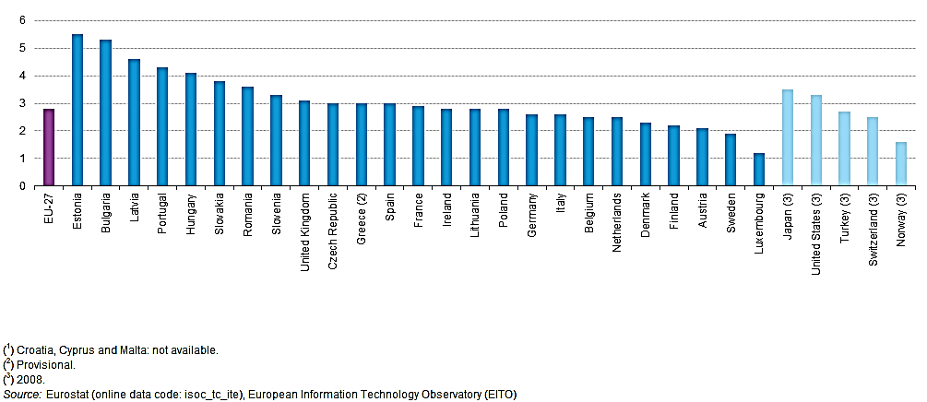

Fig. 1.1 - Telecommunication expenses of the countries of the world for 2007-2017 (investopedia.com).

Figure 1.1 shows the ratio of investments in the telecommunications industry to the total national output of the country. Within the European Union, Estonia, Bulgaria and Latvia occupy leading positions in the ratio of telecommunications investments calculated in relation to GDP. EU-27 reflects the average value of this ratio for the entire group of EU countries. Indicators below the average calculated coefficient are observed in Germany, Italy, Belgium, Holland, Denmark, Finland, Austria, Sweden and closes the group of EU countries - Luxembourg. Among non-European countries in terms of the ratio of telecommunications investments to GDP are leading: Japan, the United States and Turkey.
Based on geographic criteria, the global telecommunications industry can be segmented into: Asia Pacific, North America, Europe, and the rest of the world. The wireless and broadband market in North America is showing healthy growth The gigantic populace base of Asian nations, for example, China and India, is one of the key factors behind the extension of the broadcast communications advertise in the Asia-Pacific district. China, being one of the biggest portable administrators on the planet, speaks to a huge piece of the piece of the pie. Another significant explanation behind the flourishing of the Chinese business is its flourishing universal exchange. Japan is relied upon to turn into an obvious local market as remote venture develops.
Over the past two decades, the telecommunications market in India has been developing by leaps and bounds, thanks to government policies that focus on the wide distribution of communications services in every corner of the country. The monumental growth in the number of smartphone owners and Internet users is just some of the list of drivers that promote the growth of the telecommunications market in a given country.
In addition to the emerging market countries mentioned above, Latin American countries such as Brazil, Mexico and Argentina also plan to present significant opportunities as the penetration of high-speed broadband services, 4G services and the use of smartphones increase.
It is expected that, serving the ever-growing demand for a telephone and wireless connection in the world, the telecommunications industry will continue to expand its operations at the global level. More people in emerging markets are signing on to telephone and Internet contracts, and new telecommunication technologies in developed countries are expanding their existing customer bases of providers (Rossiter, J.R 2005) .
The current state of the world mobile market conjuncture is best displayed when a group of leaders in the industry is identified. Among the many attributes to identify leaders, market value is the determining factor for this list. Let us analyze the top ten largest telecommunications companies in the world with a market value of more than 50 billion dollars (investopedia.com).
1) China Mobile Ltd - a main supplier (by the quantity of endorsers) of media transmission benefits in China - around 849 million clients. China Mobile Ltd is the main media communications organization on the planet. From April 2017, the organization's fairly estimated worth is 215.3 billion dollars, and from January to December 2016, its client base expanded by 2.5%.
2) Verizon Communications Incorporation is the biggest broadcast communications organization in the United States. Its reasonable worth is assessed at $ 191.72 billion as of April 2017, and its business add up to $ 131.8 billion (as indicated by Forbes). Verizon, headquartered in New York, was made in 2000 through the merger of Bell Atlantic Corporation and GTE Corporation. In 2014-2015, Verizon procured shares in AOL and Vodafone. Verizon at present works in 150 nations.
3) AT and T Inc. - This is the second biggest media communications organization in the United States, with a market estimation of 245.58 billion dollars. AT and T gives voice benefits in excess of 200 nations and serves in excess of 34,000 Wi-Fi passageways. As per the organization's site, AT and T covers in excess of 355 million individuals, growing its AT and T GigaPower - a ultra-quick Internet administration, up to 56 megacities in the US, with designs for further enhancement. In May 2014, AT and T gained DirecTV for $ 48.5 billion, which enabled the organization to offer clients the chance to consolidate more administrations into one bundle.
4) Vodafone Group PLC is one of the biggest broadcast communications organizations headquartered in the UK, serving roughly 444 million versatile clients. As of April 2016, the market estimation of Vodafone was 68.41 billion dollars. From 2012 to 2014, Vodafone procured three organizations: Cable and Wireless Worldwide, Kabel Deutschland and Ono. The portable deals bundle represents 42% of the pay of the Vodafone administration gathering, while 27% of the income originates from offers of cell phones outside the bundle. Vodafone is the most important brand in the United Kingdom and is occupied with portable tasks in 26 nations.

2. Research and methodology

In the time of mass interchanges and new versatile innovations, an association must make a satisfactory mix of showcasing correspondences all together not to suffocate in an ocean of data. "To do this, a great connection of items and powers is essential, influencing the administration outside the organization, and in particular, the capacity of advertisers to make effective contacts and keep up great relations with target clients" (Mazilkina, E.I., 2012).
Because of the immense chances of the freshest innovations and increasingly more improved showcasing endeavors, each year the versatile market of the Azerbaijan Republic pulls in an ever increasing number of endorsers. The Ministry of Communications and Information Technologies of the Republic of Azerbaijan, which is the primary controller of the versatile interchanges showcase, together with neighborhood portable administrators affirm the significance of applying the two factors that decide the accommodation of administrations for purchasers. These perspectives add to the acknowledgment of all promoting plans, which at last prompts an expansion in benefits when all is said in done.
The Azerbaijani government gives unique consideration to the advancement of the broadcast communications industry in Azerbaijan and makes all the essential conditions for this. By Decree of the President of the Republic of Azerbaijan number 1897, March 16, 2016, the Strategic Roadmap (Strategic Roadmap, 2016) was set up to satisfy the assigned duties on the "National economy and zones of major monetary areas" for the improvement of media transmission and data advances in Azerbaijan.
Considering the advancements and chances of the media communications division, the "Key Road Map" was imagined with the point of building up the capability of ICT, modernizing and "digitizing" the economy, and fulfilling the need for ICT benefits by inward assets (Strategic Roadmap, 2016).
The fundamental standards in the readiness of the "Vital Road Map" were: support for the advancement of a need non-oil part - the broadcast communications division, the formation of a creative and information based economy; building up viable coordination among on-screen characters in the segment. Significant advances were taken to quickly incorporate Azerbaijan into the worldwide electronic space, structure new types of monetary action, make a business opportunity for data and information, increment proficiency in different divisions of the economy, improve the nature of merchandise and enterprises in the broadcast communications area, and when all is said in done, for ICT advancement.
As of now, there are 4 administrators in the Republic, 3 of which give versatile administrations using 2G, 3G and 4G advancements. In Azerbaijan, 3G innovation started to be connected from 2009, and 4G innovation from 2012, portable administrators give extraordinary consideration to the prerequisites of the system inclusion territory.
The presentation and improvement of ICT grows the scope of broadband administrations in urban communities and rural regions, and gives quicker access to the Internet from wherever. In the wake of leaving the standard recurrence range for versatile and remote innovations, portable administrators ought to put resources into extra systems to make new systems and viably compose specialized approaches in the recurrence range to expand the inclusion and speed of the Internet.
It is anticipated that by 2020 it will require 60 million manat venture to meet the underlying speculation needs of 4G innovation to accomplish the objective.
Technique:
In this piece of the thesis examine is the fundamental objective of portable administrators advertising methodology. We will consider the methodology of versatile administrators by two techniques:
1- SWOT analysis
2- Survey method
Due to the current strengths and capabilities Azerbaijan’s perspective on the telecommunications sector until 2025 is to strengthen the telecommunications and information technology infrastructure in the country and encourage all parties to use these services. In addition to the widespread use of services in everyday life in the period after 2025, the transformation of our republic into a leading country in the region’s technologies is one of its main priorities. The country plans to develop high-speed broadband infrastructure with a wide coverage (Strateji Yol Xəritəsi 2016). To achieve this goal, three main objectives have been set, planned for implementation by 2020:
• improving governance structures and strengthening ICT;
• increase in productivity and operational efficiency in the activities of business entities;
• “digitalization” of state and social networks.
There is an incredible requirement for sorting out the correct advertising approach and making a powerful showcasing technique that will be steady with the general methodology of the endeavor. Advertising correspondences speak to the voice of the organization and its brands; they are the methods by which an organization can set up a discourse and fabricate connections. " According to Mladene Velev, they are an open message and, in contrast to different kinds of correspondence (specialized, natural, transport, and so on.), are described by the way that the sender and beneficiary of data are individuals or gatherings of individuals (Velev 2001).
"Promoting correspondences are the fourth basic component of the advertising blend with which the organization means to serve target markets. Because of the great notoriety of the organization and good social position, business contacts are rearranged and the fundamental speculation reserves are expanded "(Velev 2001).
The marketing communications system is a single complex that unites the participants and the organization’s communication channels aimed at establishing and maintaining certain relationships planned with this organization with the communications recipients in order to achieve its marketing goals. Marketing communications have features peculiar only to them - purposefulness of distribution, complex character, repeatability of influence. The system of marketing communications is one of the main and integral elements of the marketing mix.
The objectives of using marketing communications are:
• informing prospective consumers about their product, services, sales conditions;
• the buyer's conviction to give preference to the goods and services of a particular brand;
• the incentive of the buyer to act - to direct consumer behavior to what the market is offering at the moment, and not to delay the purchase for the future;
• formation of a favorable image of the enterprise in the eyes of potential buyers and other participants in business communication;
• providing comprehensive and accurate information about the product to all interested persons and organizations.
In connection with the rapidly developing technologies and similar conditions of existence of local mobile operators, marketing communications occupy a special place in the cellular communications market.
Survey method
The survey consists of 13 questions. We use the survey method to find out which mobile operators use the most, which encourages customers to use this particular mobile operator. We tried to find out to what extent this mobile operator responded to customers' expectations. Survey has been prepared online form '' Google Form ''. And 210 people participated in this survey.

3. Analysis

3.1. Research of the activity of mobile operators in Azerbaijan

Today, mobile communication is an essential attribute of the daily lives of billions of people. Despite the fact that the mobile market of Azerbaijan is quite dynamic and keeps up with world trends in the mobile market (4G and LTE technologies), the number of players in the market does not change due to large investment requirements for the introduction of new technologies.
Speaking about the mobile market of the Republic of Azerbaijan, we did not consider the offers of CDMA-operators, as well as fixed-telephone operators. The mobile communications market of Azerbaijan is represented by three main players: Azercell Telecom LLC, Bakcell LLC and Azerfon LLC, better known under the Nar brand. After Azerbaijan declared its independence in 1991, in 1994 Bakcell became the first operator in the mobile communications market. Bakcell is one of the largest investors in the economy of Azerbaijan and has an active Corporate Social Responsibility (CSR) program called Bakcell Stars, which serves to support children in need. In 2010, Bakcell was awarded the Technology Leader of the Year and CSR Leader of the Year awards by the Azeri Business Award (Azercell.az). Bakcell offers prepaid (Cin) and postpaid (Klass and Gold) tariffs to its customers.
Main Mobile operators operate in Azerbaijan: Bakcell -1994, Azercell-1996, Nar mobile – 2007
Bakcell. The first and fastest growing mobile network in Azerbaijan Bakcell was established in March 1994 by GTIB Company and the Ministry of Communications of the Republic of Azerbaijan as a Joint Venture. Bakcell is the first mobile communication service provider in Azerbaijan. As one of the first major investors in Azerbaijan, Bakcell continues to invest in the economy through the introduction of cutting-edge technology and staff serving its customers. Thus, the company demonstrates a successful business model in the country. In December 2003, the company's privatization process was completed successfully. As a result, since January 2004, Bakcell operates as a 100% owned subsidiary. Bakcell has SMS and voice roaming agreements with 256 operators in 153 countries around the world, thanks to which Bakcell subscribers can use roaming services in Europe, Asia, North and South America, Australia and Africa.
The company's goal is to become the leading mobile operator in Azerbaijan. Bakcell aims to provide its customers with:
• favorable rates
• simple and easy-to-use products, and all the necessary help and support
• innovative services that help in life and work
• network that meets all requirements
Vision of the future. As the most innovative telecommunication provider in Azerbaijan, it is the country's leading customer-oriented company.
Mission. In order to use telecommunication services, we offer the best customer experience in the field of digital technology wherever there is a superior network, as well as simple and easy solutions. We have set up price plans to make mobile accessible and convenient for everyone and pay for a number of personal and business requirements (bakcell.az).
Bakcell offers you three tariff plans:
-Cin
-Klass
-Business
Azercell
Azercell Telecom LLC is the leading mobile operator in Azerbaijan with a market share of more than 4.5 million subscribers.
The current 100% investor of Azercell is Azertel Telekomünikasyon ve Yatırım Dış Ticaret A.Ş, a Turkish company.
Azercell was founded in January 1996 and has started its commercial activity on December 15 of this year as the first GSM operator in Azerbaijan. In 1998, Azercell became one of the first companies in the world to introduce a pre-paid payment system (SimSim). Azercell has invested $ 1 billion in projects aimed at the development of the country's telecommunication sector and improving social welfare. Has invested more than US $. According to the Ministry of Taxes, Azercell is the largest taxpayer in the non-oil sector.
The first services were offered on the basis of postpay (invoice line), but already in 1998 the SimSim tariff plan was introduced based on a prepaid system. In 2000, Azercell created a quality management system and on December 7, 2000, the company received a certificate of compliance with the international standard ISO 9001. In 2003, the company updated the quality system according to version 2000 of the same Standard and on January 15, 2004, received a certificate of compliance ISO 9001: 2000. Currently, Azercell's coverage area covers about 80% of the territory of Azerbaijan. Azercell has 16 mobile switching centers (MSC), 13 base station controllers (BSC), 2 reserved subscriber bases (HLR) and ~ 2000 base transceiver stations (BTS) in Azerbaijan. Also, all stations of the Baku Metro are included in the service area of ​​the Azercell network.
By 2008, Azercell Telekom has signed roaming agreements with 383 operators from 151 countries of the world. Also in 2008, the joint venture was privatized and became a Limited Liability Company (LLC). On May 15, 2010, Azercell Telekom re-branded and joined TeliaSonera network.
At present, Azercell covers 99.8% of the country's population and 80% of the country's territory (20% of the occupied territories are out of reach). Azercell Telecom LLC has international standards ISO 9001: 2008, ISO 10002: 2014, IIP (Investors In People) - People's Investor (IS) and EN15838 (guarantees high level of customer relationships).
Purpose. Our goal is to bring the company to the next level to become a New Generation Telecommunication Company. To expand our business activities and to work diligently in our everyday work, we really need to serve the interests of our customers (azercell.az).
Azercell carries out Scholarship Program for students demonstrating high academic performance each year. Students who pass all the selection tours become Azercell's pensioners. In addition to their monthly scholarships, students also take part in interesting projects and trainings, get acquainted with our corporate culture, and win the chance to become one of us in the future.
The main purpose of the program is to give students special attention and support for high academic achievement and to help students with a strong potential grow up as a specialist in their education.
The winners of the program receive a unique opportunity to increase their knowledge in the field of telecommunications, participate in corporate events and social activities of Azercell, connect to a number of courses, as well as pass an internship program in Azercell as well as receiving a scholarship of 200 AZN by the end of current academic year.
Nar mobile
Up until 2007, Azercell Telecom and Bakcell competed on the market. In early 2007, Azerfon under the Nar Mobile brand joined the competition and continues to compete to this day. The brand was created as the personification of the rich cultural heritage of Azerbaijan in combination with modernity. Azerfon was the first mobile operator to use local currency AZN to pay for services, instead of contours established throughout the country (conventional unit). It was one of the main innovations introduced in the Azerbaijani mobile market. Azerfon tried to increase its popularity due to low tariffs, flexible prices and consumer-oriented campaigns. In 2009, Azerfon, having entered into a non-equity partnership with Vodafone, presented a new product, Azerfon-Vodafone, to the market, however, this partnership ceased to exist in 2012.
Thus, today there are 3 operators in the market of mobile operators in Azerbaijan with various strategies and methods for their implementation.
The main distinguishing feature of Azerfon’s marketing strategy in the period of the emergence of the mobile communications market in our country was the correct positioning of its brand. The company presented the first mobile operator to the country and its users, whose services were paid not through conventional units (contours), but with the help of the national currency, thanks to which a large number of customers were attracted. The initial tariffs, as compared with competitors, were low and a huge part of the population switched to using the services of the new operator both for reasons of economy and simply out of curiosity, due to which marketing efforts were justified and paid off.
MMC Azerfon, which started its activities in Nar Mobile under its brand name in Azerbaijan on March 21, 2007, is one of the leading telecommunications and mobile companies in the country.
Nar Mobile network covers 80% of the territory of our republic. Due to affordable price policies, high-quality service and ease of use, we have been choosing hundreds of thousands of subscribers over a short period of time. We currently have 2 million subscribers.
To ensure the transparency of payments and convenience of subscribers, Nar Mobile has introduced a manually-paid payment system for mobile communications in Azerbaijan's mobile market for the first time. In addition, for the first time in Azerbaijan, this company has provided services based on 3G (third generation) technologies (video, mobile TV and other services).
One of the innovative projects of Nar Mobile is the provision of mobile communication services at air flights of Azerbaijan Airlines (AZAL). This project is implemented by AZAL and Swiss OnAir. Following the agreement with AZAL, it was decided that the use of these services will be fully available to our subscribers by the end of 2012.
Currently, the company is working on the project Future Lab - Innovative Technology Center. Within the framework of this project, young talents and professionals in the field of information technology will gather in a specially-arranged laboratory for them to work on the development and implementation of promising ideas. For the first time, this kind of center has been opened in the CIS countries and there are only five such centers around the world.
We constantly improve our network so that we can offer our subscribers easy and easy communication. In 2011, the company started large-scale reconstruction and invested more than 72.1 million manat ($ 80 million) to expand network expansion and quality.
Our strategy
Being a telecommunications company offering the most affordable, relevant, simple and digital services for everyone, covering a wider range of communications in Azerbaijan(nar.az).
However, after the lapse of time, cons began to appear. First of all, the difference in the prices of calls within the network and to numbers of other operators became quite noticeable. Secondly, during the transition to Nar Mobile, users could not get rid of the contours and adapted for a long time to the calculation in manats. Therefore, many have returned to the use of the services of old operators. Marketers did not take into account the risks due to the difficulty in adapting subscribers to a new type of payment, thereby losing their customer base. And thirdly, over time, advertising campaigns have waned and began to give way to advertising of competitive companies.
The operator's manual is focused on the continuous development of the company, while not forgetting the traditional values ​​of the family, society and the country as a whole.
Bakcell was the last of the three operators to switch to the manat tariffing system, which weakened its influence and reduced the market share. This happened because Bakcell, in comparison with Azercell, had very cheap contours for contouring tariffing, and due to this, the prices for services were many times cheaper than competitors. When switching to the manat system, the mobile operator significantly increased tariffs, which led to a sharp decline in the customer base. Using the provided information on activity of mobile operators, we will construct the SWOT- analysis of their activity.

Strengths | Weak sides
- basic infrastructure (non-residential areas and telephone drainage) for the installation of telecommunications equipment and conducting fiber-optic cables  - fiber-optic cable infrastructure, created by means of television and internet cables to residential areas  - geographical advantage for the transit of international traffic from East to West | - high rates charged to private providers by telecommunications operators  - low quality of services due to the use of broadband networks through outdated cables  - security dependency on hardware builders  - outdated equipment  - frequency misuse of resources  - insufficient number of information and communication specialists
Opportunities | Threats
- a large number of young people - potential users of telecommunication services  - proximity to large regional markets  - availability of regulatory and legal framework in the field of ICT | - greater competition when entering foreign markets  - increasing confidentiality and network security issues with new technologies

Fig.3.1. SWOT analysis of mobile operators of Azerbaijan

The data provided in this analysis can be used for improvement of strategy of mobile operators.

3.2. A comparative analysis of marketing activity of mobile operators

Marketing activity is very important for mobile operators and in - much predetermines their market success. Azercell’s marketing activities are notable for their high level. The marketing department of the company employs some of the most highly qualified professionals in this field in the whole country. Advertising campaigns often surprise with their creativity and diversity. In the commercials there is a national flavor and music with traditional inserts. However, sometimes the company uses annoying direct mailing, for example, newsletter and SMS advertising. Subscribers complain about too intrusive advertising, that they receive up to 5 SMS messages per day and this does not cause positive feedback from subscribers. In our opinion, the number of such calls should be reduced.
Azercell uses advertising, direct marketing, public relations, sales promotion among the main directions of marketing communications.
Defining a marketing budget is one of the most difficult and demanding tasks. The percentage of the promotion budget with the sales plan primarily depends on the industry: for companies providing cellular services (Azercell, Bakcell, Azerfon), this ratio is approximately 20–25%.
In 2017, the total value of the mobile communication market in Azerbaijan was about 855 million Azerbaijani manat, which is 1.2% of Azerbaijan’s GDP (70.135 million Azerbaijani manat) (marja.az). The share of Azercell Telecom is 48.2% of the market (azercell.com), namely, 411 million Azerbaijani manat, while Bakcell and Azerfon share the remaining 449 million Azerbaijani manat. The share of Bakcell is 36%, 310 million Azeri manats (bakcell.com), and the share of Azerfon is 15.8%, which is equal to 134 million Azerbaijani manats.
Each mobile operator tries to attract the attention of a potential consumer, by all possible means fighting for a place in the market and for increasing its share in it. Each company has developed its own individual marketing strategy, which brings its effectiveness. Marketing departments promoting the services of mobile operators, attract the attention of potential consumers to gain an even greater customer base and profit.
The essence of the marketing of cellular services is to constantly update, improve their services, not to question the ways of their implementation, to focus the company's activities on the existing and hidden requests of both regular and potential consumers. The cellular operator needs to constantly adapt to changing market conditions, not forgetting that only high quality services and expensive equipment without a marketing approach do not guarantee success and their mandatory implementation.
Due to the similarity of lilac color in the Nar Mobile logo with the color of the Azercell logo, Azerfon conducted a rebranding. The importance and popularity of Azercell, as well as the Telia Sonera company, to which Azercell belongs, allowed the operator to make comparisons in their favor and forced the competitor to rebrand. Azerfon has positioned its mission in the following slogan: “Turn into a telecommunications company with affordable, simple, digital and convergent services for each user in an even wider telecommunications space in Azerbaijan” (Nar.az). From the main directions of marketing communications, Nar Mobile mainly uses PR and advertising. In addition, the company uses some marketing tools - souvenirs with proprietary symbols (ribbons and covers for phones, flash drives, etc.), branded packaging, trade incentives that deliver marketing messages directly to the point of sale and thereby increase the likelihood of purchasing goods by buyers.
The corporate style, strategy and mission of the mobile operator Bakcell clearly emphasize the uniqueness of its marketing strategy, while the marketing department positions the mobile operator and tries to distinguish it from competitors with bold statements: “Bakcell has become the brand that offers its customers and their families the best. We will achieve this with the help of constant innovations, always showing exceptional care and paying maximum attention to customers, as well as being the simplest and most convenient in work ” (wikipedia.org/wiki/Azercell_Telekom).
Marketing communications systems should be developed individually for each target market segment. The system of marketing communications contains both information transfer mechanisms for the target audience and feedback between buyers and sellers of goods and services. It is the feedback that gives the opportunity to evaluate the effectiveness of investing funds in a marketing campaign. For a better understanding of the choice and implementation of marketing communications strategy, we will conduct a full marketing analysis of the republic’s mobile communications market based on the 4P marketing model, which characterizes 4 basic marketing coordinates: Product (service or product, features and quality) "(Prices)," Promotion "(promotion and advertising) and" Place "(distribution channels).
We will start with the first “P” - namely, with the services provided by local mobile operators.
1. Product. All local operators provide an identical range of opportunities for using mobile communication: data traffic (to access the global Internet), voice traffic (to make calls inside and outside the network), a platform for sending SMS and MMS messages. The 2G (GSM) network, first introduced by Bakcell in 1994, covers most of the territory (more than 97%). Azerfon, having launched a 3G network in 2009, has remained the only 3G operator on the market for two years.
In 2011, Azercell and Bakcell, having received a license for the 3G network, were able to provide faster and better communication to their users. In 2012, Azercell became a pioneer in Azerbaijan, as well as in the region, on the implementation of the 4G network. In 2015, other market participants received a license to use and implement the 4G network.
Table 3.1
Characteristics of networks of mobile operators (Bakcell.az, Azercell.az, Nar.az)
Network Frequency (MHz) | 2G/GSM | 3G | 4G/LTE
Azercell | 900 | 2,100 | 1,800
Bakcell | 900 | 2,100 | 1,800
Azerfon (Nar) | 1,800 | 2,100 | 1,800

Thus, at the moment, all mobile operators use a technically similar base to provide services to their customers (Table 3.1).
The frequency of the new generation mobile networks (3G and 4G) is identical for all participants, 2,100 MHz for 3G communications and 1,800 MHz for 4G communications. However, in the network of the old generation (2G) there is a difference in the frequencies used. Azerfon, joining the market later than the others, uses the 1,800 MHz frequency, unlike its competitors, using 900 MHz. Mobile operators cover over 90% of the territory of Azerbaijan (with the exception of the occupied territories).
Table 3.2
Technical characteristics of mobile operators (Bakcell.az, Azercell.az, Nar.az)
Operator | Coverage Area | Number of 2G / 3G stations | Number of 4G stations
Azercell | 100% | 4,957 (2017) | 549 (2017)
Bakcell | 92% | More than 6.500 (2017)
Azerfon (Nar) | 93% | More than 5,500 (2017) | 1,000 (2017)

As can be seen from table 3.2, Azercell has 5,506 base transmitting stations on its accounting report. While Bakcell and Azerfon, which join their system foundation, there are in excess of 6,500 telecom stations. In 2012, Bakcell and Azerfon consented to share the capacities of base stations. Specialized combination will enable the two endeavors to lessen their expenses by profiting by economies of scale. The endeavor, which joined the system frameworks of two nearby administrators, was named Azerconnect (Azercell.com).
2. Prices. All local mobile operators offer their customers tariffs, based on both prepay and postpay, popularly known as invoice tariffs. Prepayment implies the use of mobile services only after replenishing the amount of money to the account. Postpay allows the use of mobile communication on credit, and invoicing takes place at the end of the month. While prepaid-based tariffs are open to the public, tariffs based on the post-pay system are offered to legal entities as well as individuals with the possibility of a credit limit. The credit limit depends on the credit history, timeliness of payments and the period during which the user is a subscriber of a particular operator. Azercell, unlike Bakcell, offered the first services only on the basis of the invoice line system (wikipedia.org/wiki/Azercell_Telekom).
However, two years after the creation of the company, in 1998, the SimSim tariff, based on a prepayment system, was presented to the public. Bakcell, under the Cin tariff plan, also offers prepaid services. Azerfon, which appeared on the market in 2007, offers tariffs based on post and prepayments. However, from 2009 to 2012, the company segmented legal entities, as well as post-pay users, through its subsidiary Azerfon-Vodafone.
The first operators (Azercell and Bakcell) used the manat billing system for subscribers of the invoice line, while the tariffication of non-invoice line subscribers (prepayments) took place on the basis of “contour rating”. “Contour” tariffing appeared in Azerbaijan thanks to Turkish operators, who used the “contour” unit of measurement due to the large denominations of Turkish liras (before the denomination, Turkish liras were estimated in millions and billions). In 2007, Azerfon became the first operator to introduce the manat tariff system, both on postpaid and prepaid tariff schemes.
In order to introduce a clear and simple tariffing of the use of mobile communication, in 2011, the Ministry of Communications and Information Technologies of Azerbaijan . recommended that operators abandon “contouring” tariffing and switch to the manat billing system. Starting from the middle of 2011, all local operators switched to a new, manat billing system on all their tariff plans.
Despite the fact that the services offered by the operators are quite identical, the pricing policy between the operators varies. Subscribers are offered tariffs with a fixed price for certain services, prepaid tariffs packages with a certain type of services (mainly Internet packages and voice packages), as well as packages tariffs with different types of prepaid services, better known as “bundles”. Azerfon was a revolutionary in the mobile market, presenting a bundle of prepaid services. Below is a visual comparison of tariff plans and “bundle” s offered by local operators .
Table 3.3
Azercell Prepaid Rates(azercell.az)
Prices in AZN | “Azercell-im” | “Bölgə” | “GəncSim” | “Tələbə 1-liyi”
Calls within the network (1 min) | 0,04 | 0,05 | 0,09 | 0,01
Offline calls (1 min) | 0,06 | 0,05 | 0,09 | 0,05
1 SMS | 0,03 | 0,03 | 0,03 | 0,03

Another mobile operator, Bakcell, offers its subscribers two basic tariff plans, “CIN” and “Klass”. “CIN” tariffs are offered on a prepaid basis, while “Klass” is available on the basis of both prepayment and post-payment.

Table 3.4
Bakcell Prepaid Rates (bakcell.az)
Prices in AZN | “Gəlirli-CIN” | “CIN-eration” | “Əla-CIN” | “Sevimli-CIN” | “Sevin-CIN”
Calls within the network (1 min) | 0.06 | 0.02* | 0.07 / 1 time | 0.03** | 0.08
Offline calls (1 min) | 0.06 | 0.07 | 0.12 | 0.12 | 0.08
1 SMS | 0.05 | 0.02* | 0.05 | 0.05 | 0.05

hour * - Between subscribers «CINeration». Calls and “SMS” within the network (with subscribers who are not users of the CINeration tariff) cost 7 kopecks and 5 kopecks, respectively.
** - This tariff provides the opportunity to talk with 5 favorite numbers of 3 kopecks. The cost of connecting your favorite number is 50 kopecks. Calls to other numbers within the network are 6 kopecks.

As can be seen from the above table 3.4, each of the “CIN” tariffs provides different features to its subscribers. “GəlirliCIN” makes it possible to return half the money spent for the current day on the next day. “CINeration”, which is analogous to “GəncOL”, is aimed at young subscribers, gives them the opportunity to create a subnet and talk cheaper within this subnet.
"ClaCIN" is beneficial for subscribers who spend more than a few minutes on one call within the network. For the same subscribers, the “YeniDoima” and “ÖzÖl” tariffs can also be profitable, making it possible to speak for free within the network after three and two minutes, respectively. Calls outside the network, as well as within the network during the first three and two minutes cost four and six kopecks, respectively.
In addition to these tariffs, there is a “SevinCIN” tariff, which represents the same tariff both inside and outside the network. In addition to this, Bakcell subscribers are given the opportunity to speak for free from one o'clock until six in the evening by connecting to the GÜNBOYU 0 tariff. Klass subscribers are offered four packages: “M”, “XL”, “XXL” and “3XL” (tab. 3.5).
Table 3.5
Bakcell Postpaid Fees (bakcell.az)
Prices in AZN | “M” | “XL” | “XXL” | “3XL”**
Subscription fee | 2* | 10 | 25 | 50
Domestic calls (minutes) | 50 | 250 | 750 | 2,000-3,000***
SMS within the country | - | - | 750 | 2,000-3,000***
Internet within the country (MB) | 100 | 1,000 | 2,000 | 10,000

* - Subscription fee of 2 AZN is charged weekly, and unused minutes and MB are transferred to the next week.
** - The “3XL” tariff also offers subscribers 100 minutes for international calls, 100 minutes for incoming calls in roaming and 1,000 MB for using the Internet in roaming.
*** - “3XL” tariff based on postpay and prepay rates differ in the number of minutes and SMS offered. A postpaid “3XL” provides 3,000 minutes and an SMS-ok, while a prepaid “3XL” offers 2,000 minutes and an SMS-ok.

All tariffs, except for "M", are offered, as well as on the basis of an advance payment, and on the basis of post-payment. Tariff “M” is offered only on a prepaid basis. All subscribers of Klass packages have access to the loyalty platform Ulduzum, as well as free sending / receiving text messages via WhatsApp. The third operator, Azerfon, offers standard subscribers to its subscribers, as well as tariff packages Full, which combine minutes for calls, SMS and megabytes for the Internet (Table 3.9). It is also worth noting that Azerfon, which introduced the Full packages to the market, is the first operator of the country to introduce the Exchange system. This system is the only one among all operators, it allows subscribers to exchange minutes for calls to megabytes for the Internet (or vice versa).

Table 3.6
Azerfon Prepaid Rates (nar.az)
Prices in AZN | Calls within the network (1 min) | Offline calls (1 min) | 1 SMS
«Super 0» | 0.07 – 0.06* | 0.07 – 0.06* | 0.06
"Unique" | 0.04 | 0.04 | 0.04
«Yerlim» | 0.01 – 0.06** | 0.04 – 0.06** | 0.04
"3 in 1" *** | 0.06 | 0.06 | 0.03
"Unlimited" **** | 0.07 | 0.07 | 0.06
"Says Baku" ***** | 0.03 | 0.03 | 0.03
«Cavan-Nar»****** | 0.02 – 0.05 | 0.05 | 0.06
* - This tariff makes it possible to talk within the country for up to four minutes for 7 kopecks. The cost of each minute, starting from the fourth minute, is 6 kopecks.
** - This tariff allows subscribers located in the same region to communicate at favorable rates.
*** - For a subscription fee of 2.80 AZN, the subscriber receives 150 minutes and SMS within the network, 50 minutes and SMS outside the network and 200 MB of Internet traffic. After using the available bonuses in full, the subscriber is charged standard rates indicated in the table.
**** - A subscriber, having paid 33 kopecks in one day, can use 400 minutes within the network and 100 SMS daily.
***** - The subscription fee for this tariff is 3 AZN per month. In return, the subscriber gets the opportunity to talk for 3 kopecks, and free 300 SMS and 300 MB.
****** - People aged 16-25 years old, for only 99 kopecks per month can connect to this tariff. Instead, they get 300 minutes within the network of 2 pennies, 300 SMS and 300 MB.

As can be seen from table 3.6, Azerfon offers its subscribers a wide range of prepaid tariffs. Some of the tariffs imply charging a certain subscription fee in exchange for the provision of packages with mobile communication, SMS and Internet services (CavanNar, Talking Baku, Unlimited and 3 in 1). “Yerlim” is a subnet within the Azerfon network, allowing subscribers within one subnet to communicate on more favorable terms. CavanNar, which is a tariff like CINeration and GəncOl, offers favorable communication rates for young subscribers.
Table 3.7.
“Full” Azerfon Packages (nar.az)
packet | Subscription fee (AZN) | Calls within the network (minutes) | Offline calls (minutes) | SMS | Internet (MB)
«Full 9»* | 9 | 300 |  | - | 1,500
«Full 14»* | 14 | 450 |  | - | 2,000
«Full 19»* | 19 | 600 |  | - | 2,500
«Full 29»** | 29 | unlimited | 1,000 | 1,000 | 3,000
«Full 39»** | 39 | unlimited | 1,500 | 1,500 | 5,000
«Full 49»** | 49 | unlimited | 2,000 | 2,000 | 10,000

* - “Full” packages 9, 14 and 19 provide subscribers with 100 minutes between subscribers of “Full”.
** - “Full” packages 29, 39 and 49, depending on the packages, offer their subscribers 10, 20 and 40 minutes for incoming calls in roaming and additional 1,000, 1,500 and 2,000 MB, respectively.

Unlike “Kombo” packages of other local operators, “Full” packages provide subscribers with the opportunity to transfer unused bonuses (minutes, megabytes and SMS) to the next month, as well as use the Exchange system. Due to technological changes in the Internet sphere over the past decades, the importance of the Internet in our everyday life cannot be disputed. In table 3.11, the Internet packets offered by local operators were compared.
Most of the Internet packages are represented by “Bakcell” (10 packages), while Azerfon subscribers can use 8 packages, and Azercell users - 6 packages. Bakcell has the most packets with par values ​​of up to 10 AZN, thus Bakcell subscribers are offered alternative packets to choose from.
Table 3.8
Internet packages (Bakcell.az, Azercell.az, Nar.az)

Prices in AZN - Number of MB | Azercell | Azerfon | Bakcell
1 AZN | 50 | 60 | 50
2 AZN | - | 200 | 150
3 AZN | 500 | 600 | 500
4 AZN | - | - | 750
5 AZN | 1,000 | - | 1,000
6 AZN | - | 1,500 | -
7 AZN | - | - | 1,500
9 AZN | - | 5,000 | 3,000
10 AZN | 5,000 | - | 5,000
13 AZN | - | 7,000* | -
15 AZN | 10,000 | - | 10,000
22 AZN | - | - | 20,000
25 AZN | - | 20,000* | -
30 AZN | 50,000 | - | -
35 AZN | - | 40,000* | -

* - Internet packages offered by Azerfon with a face value of more than 13 AZN, I provide the opportunity for endless night traffic.

It is also worth considering that the Internet packages costing less than 10 AZN offered by Azerfon are cheaper than the packages offered by competitors. However, packages costing more than 10 AZN are cheaper for Azercell and Bakcell subscribers than Azerfon. Azerfon Internet packages, with a nominal value of more than 13 AZN, provide the subscriber with the possibility of unlimited night use. It is also worth noting that the largest possible traffic, 50,000 MB, is provided to Azercell users .
3. Place
The replenishment of the mobile numbers of local operators is mainly due to the distribution and dealer network, as well as through online / offline payment systems. The implementation of "scratch" cards (providing a 13-digit code for recharge) for all operators occurs through three main distributors, through which further sales to other dealers take place. The three main distributors of “scratch” Azercell cards are “Integral” (integral.az), “ABC Telekom” (bestsoft.az) and “Akhundoff Networks” (akhundoff.com). The main distributors of Azerfon are Aztol Telekom, Logofon and Imperator Telekom. Bakcell produces its sales through the following companies: Mobillon, Caspian GSM and Şahin Telekom. After the appearance of payment systems that provide convenience to subscribers, most of the implementation comes from offline systems such as MilliÖN, E-manat, ExpressPay, EasyPay and Kassam.az. The increase in Internet users contributes to an increase in sales through online payment systems, such as Hesab.az, Portmanat, Epay.az and E-pul.az.
4. Promotion
The last part of the showing blend is "progress". This displaying coordinate is responsible for passing on thing data to the proposed interest gathering. As it ended up obvious from the past "P" isolates, close-by adaptable market managers offer ill defined things (voice traffic, SMS and information traffic) at essentially unclear obligations. In such a market, heads have an essential need to ascend out of various undefined directors.This prominent factor is promoting trades. For this very reason, contention in the compact market of Azerbaijan isn't simply established on the idea of correspondence, yet what's more founded on the ampleness of publicizing trades. In this manner, various sorts of promoting interchanges are effectively actualized by neighborhood portable administrators. The primary sorts of showcasing interchanges incorporate publicizing, advertising ("PR"), marking, dedication programs, exposure, direct advertising, deals advancement, and sponsorship.
a) Advertising. Around the start of the improvement of the versatile exchanges include, in the late 1990s and mid 2000s, Azercell and Bakcell feasibly utilized publicizing to move their brands. Tenacious on TV and radio spun plugs. The entire city was in propelling announcements and lightboxes. After the foundation of the market and the move of TV clients for Internet clients, the dynamic publicizing on TV and radio has changed to ordinarily remarkable progressing on social affiliations. "Sheets", at any rate utilized, are not as standard as heretofore. "Presentations" are basically introduced in the downtown zones, likewise as at the section to the locale focuses. Azercell and Azerfon effectively use sheets to push their obligations expected for the amount of tenants in express zones, Bölgə and Yerlim, solely.
b) Public Relations. Publicizing, as in various markets, is critical for making a perfect image of the relationship as per individuals as a rule. All of the three neighborhood executives are successfully connected with strengthening promoting. Adaptable overseers use social endeavors, for instance, Barama (regarding Azercell) and AppLab (concerning Bakcell), similarly as social tasks for supporting people with impediment and poor people from society to brace their image .
Established in 2009, the development and business focus "Barama" is a social venture of Azercell. The fundamental thoughts of creation were the expansion in inventive business thoughts and the improvement of a computerized and business environment of the republic. The essential target looked for after by the center is to offer assistance to new organizations related with the field of information development (IT). Giving assistance with the sort of an agonizing center is finished at all periods of the improvement of new organizations. Help is given as resources, mechanical assemblies and learning. Since its introduction, 80 new organizations have experienced within's dividers, 20 of which have ended up being free endeavors (barama.az).
c) Branding. The area manager Azercell, an assistant of the Telia communicate correspondences gathering, until March 2018 , winning concerning sustaining its picture through contacts with Telia. Most executives of the Telia gathering, for example, Kcell (Kazakhstan), Telia (Finland, Estonia), Geocell (Georgia), Telia Lietuva (Lithuania), and Moldcell (Moldova), are known by vague logos purple, insinuating a lone focus adventure, Telia. In like manner, the more than 20-year closeness of Azercell and Bakcell in the adaptable market of Azerbaijan decidedly influences the general picture and stamping of the organization.d) Loyalty Programs and Sales Promotion. From nearby administrators, just Azercell and Bakcell propelled their devotion programs. As referenced over, the GəncOl stage was spoken to by Azercell, and the Ulduzum program was presented by Bakcell. GəncOl clients are offered limits and advancements in 165 amusement and instructive outlets. In the meantime, clients of Ulduzum can exploit rebate advancements offered by 250 accomplices in different fields all through the nation. What's more, every once in a while, every single nearby administrator offer extra minutes for conversing with their supporters.
e) Publicity. Because of the way that portable correspondences has turned into an indispensable piece of the life of most natives, any item developments, tax changes, and different changes proposed by administrators are immediately promoted in the media. Administrators effectively utilize these assets to advance their new items, advise clients of potential advancements, and so on.
f) Direct showcasing. Direct advertising is utilized by every single portable administrator. This sort of correspondence is for the most part used to pull in lawful supporters of whom an individual methodology is required (the chance to talk and send SMS inside the organization less expensive). What's more, beginning from 2014, the administration of exchanging a portable number starting with one administrator then onto the next administrator has turned out to be accessible to neighborhood endorsers. Thus, every one of the administrators through direct promoting is endeavoring to draw in endorsers of different administrators, while holding their versatile number for supporters.
g) Sponsorship. Sponsorship is furthermore welcomed by all area adaptable overseers. Flexible managers adequately bolster various general shows and events held in Azerbaijan. For example, Azercell was the official benefactor of BakuTel 2017, a show committed to media interchanges, headways and high advancements (Azercell.az). Azerfon was the official communicated correspondences accessory of the principal European Games, in 2015, similarly as the fourth Islamic Games, in 2017, the year.
Bakcell effectively supports the advancement of football in Azerbaijan. In 2012, they marked a three-year sponsorship manage the English football club Manchester United (manutd.com), went for creating football. Under this understanding, the mid year football school Manchester United was made in Baku, where kids who demonstrated the best outcomes get the chance to go to Manchester and invest some energy in the camp Manchester United (Bakcell.az).
Moreover, around the same time, Bakcell supported the FIFA U-17 Women's World Cup (Bakcell.az). In 2013, Bakcell consented to an arrangement with the Association of Football Federations of Azerbaijan on supporting the national football crew. One of the principle arenas, the eighth kilometer, was renamed Bakcell Arena (Bakcell.az). Also, in 2016, Bakcell supported the UEFA European Under-17 Football Championship.
As can be seen from the examination, the attributes of the administrations offered, estimating strategies and appropriation channels for versatile cell administrations are practically indistinguishable for every one of the three nearby portable administrators. From this we can reason that the challenge in the versatile market of Azerbaijan, and by and large, on the planet showcase, depends on the techniques for conveying the essential and right data to potential buyers, making long haul solid associations with its client base. That is the reason promoting and showcasing correspondences systems are getting to be crucial for cell phone organizations.
The showcasing correspondence procedure depends on the last "P" Promotion. Talking about the promoting correspondence technique, one can't contend that it is all inclusive for all and has some sort of changeless structure reasonable for any versatile administrator. The organization's interchanges procedure centers around a couple of segments of the seven fundamental segments of promoting correspondences. This does not imply that the organization overlooks the remainder of the components - they go about as assistant, and whenever, contingent upon changes in the market, a sharp change in client inclinations, or changes by the administrator of its objective fragment, can assume the fundamental job. Advertising correspondence procedure ought to be adaptable and immediately adjusted to the scarcest changes in the outside condition (Tikhomirov 2013).
The most huge thing in the advancing correspondences process is input. It is basic to set up such contact with customers so they have to make a response on correspondence - share their info, stunning background or a couple of comments. In any case, on the other hand, despite tolerating input, it is basic to have the choice to respond to it viably and, if it isn't sure, by then to settle on brief decisions on reviewing any slip-ups or goofs.
Summing up, I have to observe that publicizing correspondences include a mind-boggling spot in advancing, especially in the flexible trades grandstand. This is a direct result of the brisk headway of the media correspondences industry, steady improvement of advancement, and how the adaptable market is rapidly changing and expanding, thus as to hold its market bit and draw in new potential customers, compact directors need to gather the right exchanges and, in like way, make a reasonable publicizing correspondences system.

3.3. The results of survey

Through the survey method, we tried to find out the attitude of people to the mobile operator and their activities. The survey was shared on social media. And 211 people participated in this survey.
Survey analysis:
- Graph 1.1
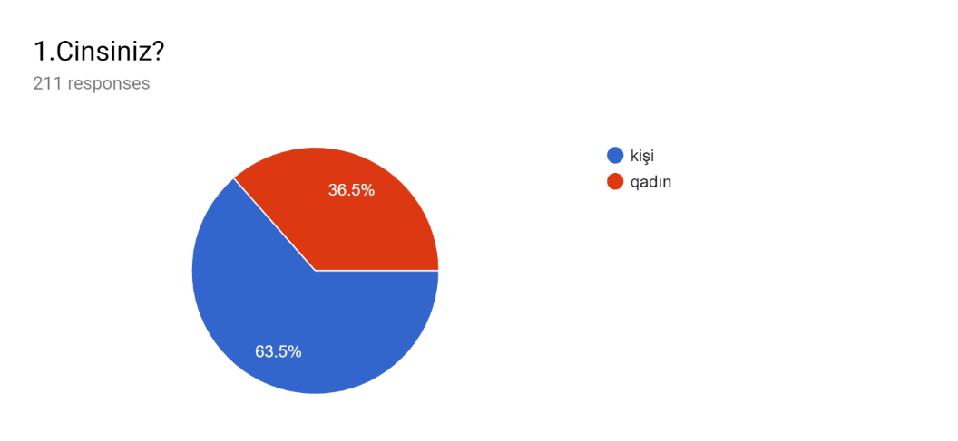

The graph shows that of the 211 people surveyed, 36.5% - women (77 persons) and 63.5% of the men (134 people).
2) Graph 1.2
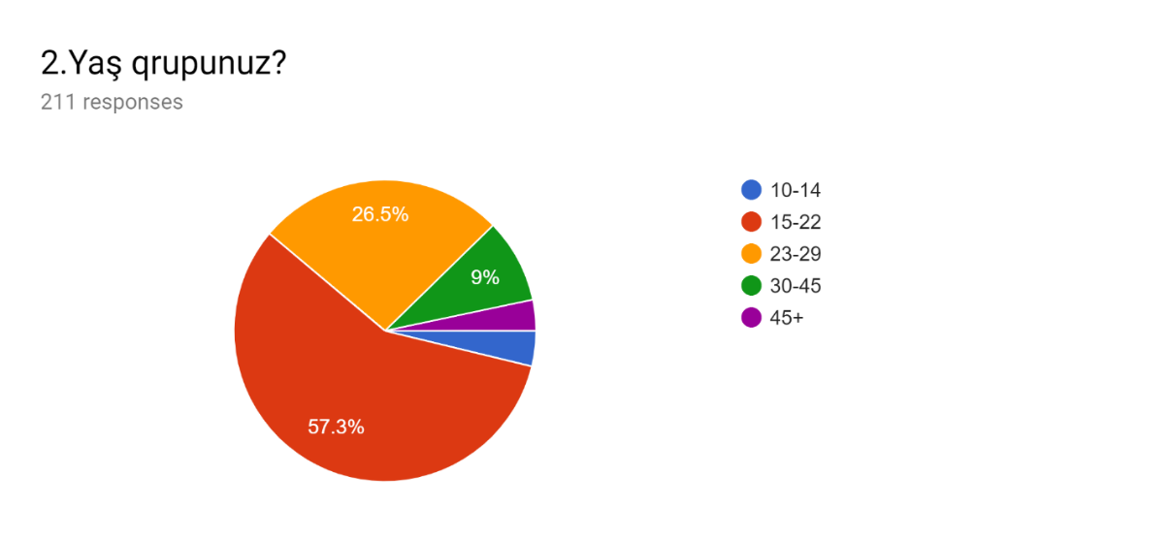
Respondents in the survey:
1. 121 respondents are between 15 and 22 years of age
2. 56 respondents are between the ages of 23-29
3. 19 respondents are between the ages of 30-45
4. 8 respondents are between 10 and 14 years of age
5. 7 respondents are above 45 ages
3)Graph 1.3
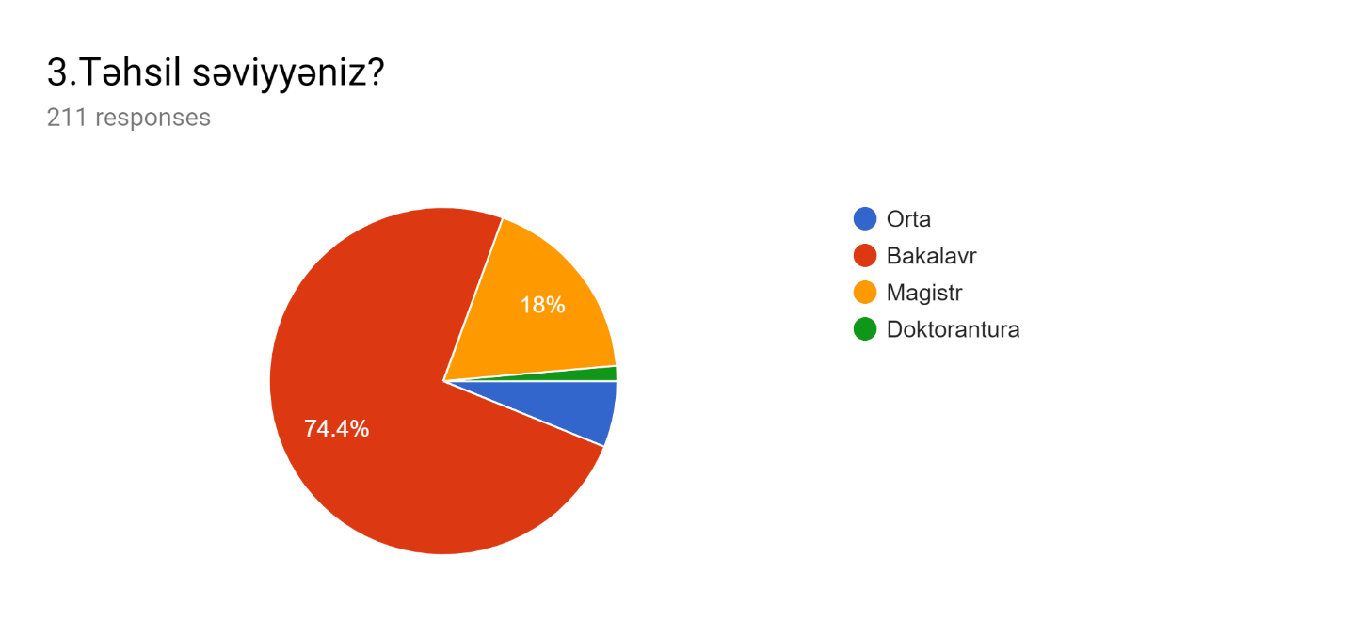
There is a higher degree of Bachelor's degree among respondents than the level of education. They are 157 people. 38 people with Master Degrees. 13 interns with secondary education and 3 doctoral students
4) Graph 1.4
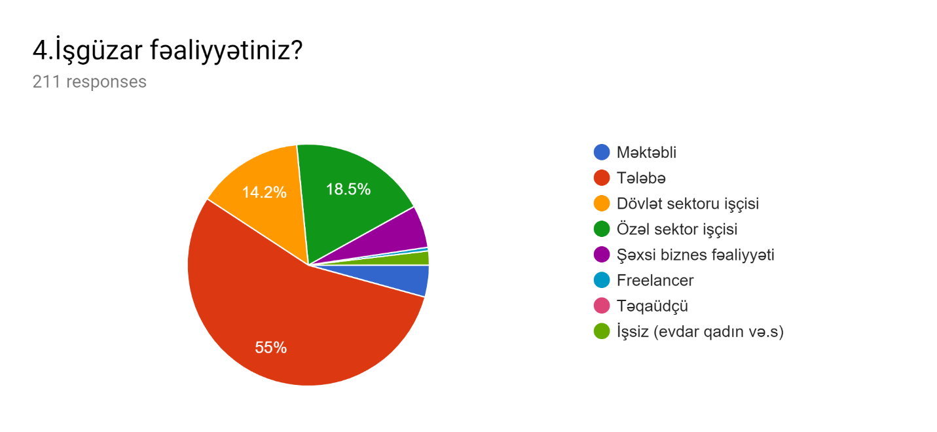
Students are 55% among respondents, which means 116 people. The other participants are 4 people working in the state, private companies, those with their own business activity, and those who are unemployed. There are also schoolchildren among those surveyed. Their number is 9 people.
5)Graph 1.5
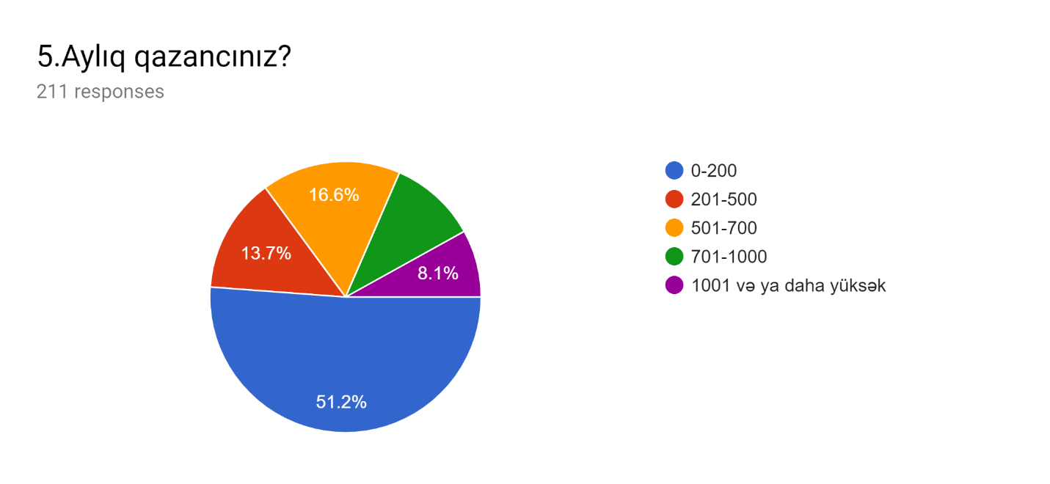

The monthly earnings of respondents are predominantly 0-200 azn because most of the respondents are students. There are 29 people with a salary of up to 500 azn, those with a salary of 501-700 azn and 35 people with monthly income of 701-1000 manat. There are 17 people who earn over 1,000 manats.

6)Graph 1.6
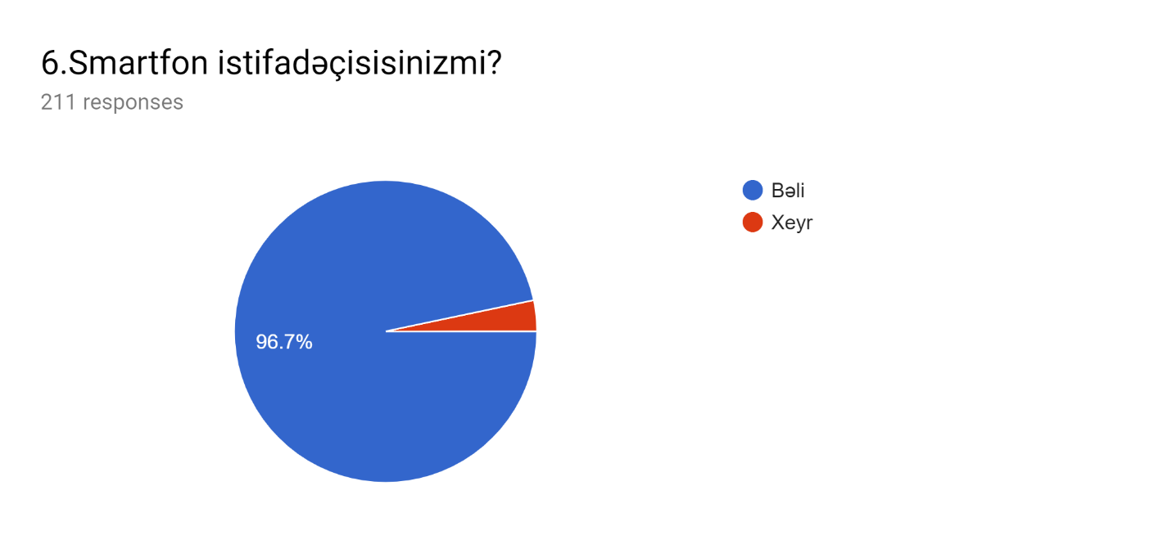
Naturally, the main advantage among mobile phone users is that smartphone users make it as a result of our survey that 204 of 211 people are Smartphone users.

Table1.11 (www.stat.gov.az)

The number of Users of mobile phone in Azerbaijan shown In Table 1.11. In here is increasing dynamics from 1995 years to 2017 years

7)Graph 1.7
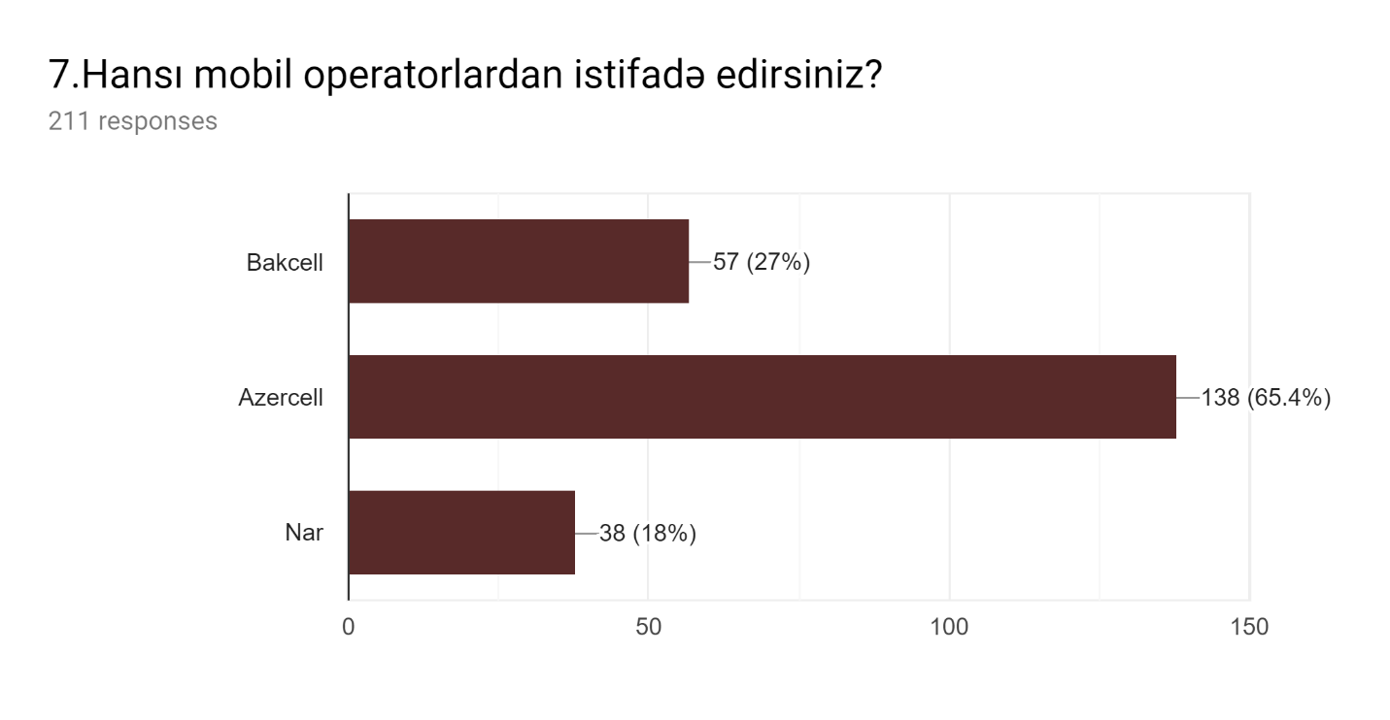
57 people answered Bakcell questions, 138 Azercell subscribers, and 38 respondents answered Nar Mobile's question.
Graph 1.8
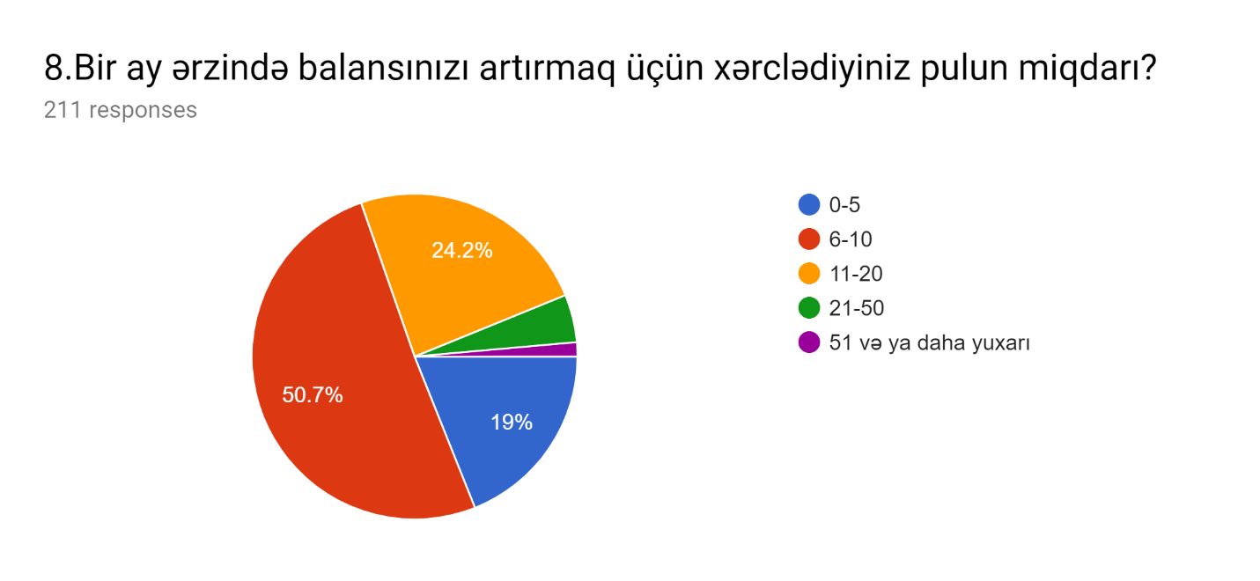
The amount of monthly spent money to increase the balance is as follows:
0-5 azn - 40 people
6-10 azn-107 people
11-20 azn-51 people
21-50 azn-10 people
More than 51 azn - 3 people
9)Graph 1.9
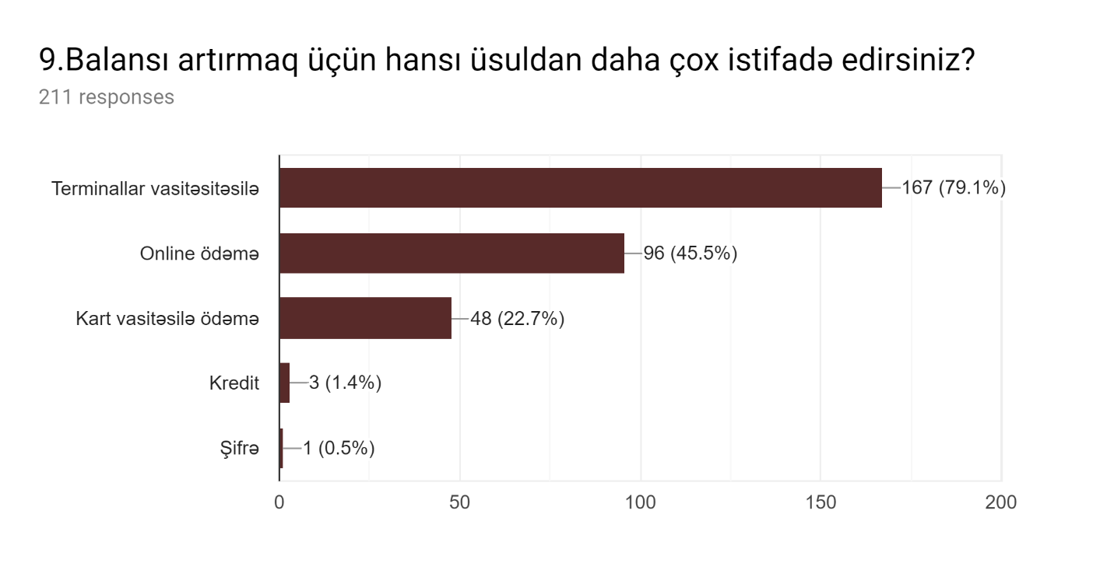
Respondents increase their balance by means of Terminals and online payments. Even though the payment through card is an old method, the number of respondents using this method is small.
10)Graph 1.10
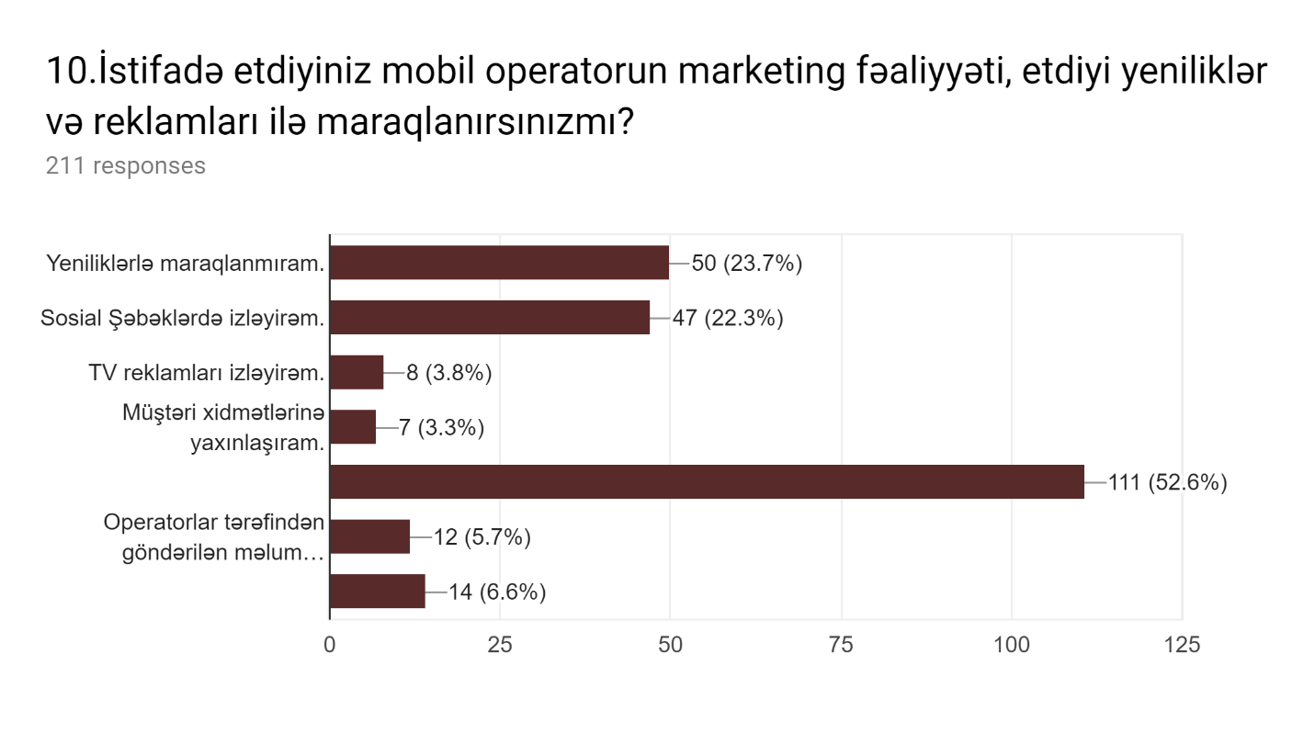
50 people are generally not interested in the activities of mobile operators. 47 people are tracking their pages on their social networks and receiving updates on their updates. The number of respondents watching TV commercials is 8. In the event of any problems, 7 respondents are approaching customer service and solving this problem. There are 14 people who are constantly following the mobile application's mobile applications and receive updates. The number of people receiving information via SMS 12 people.
Graph 1.11
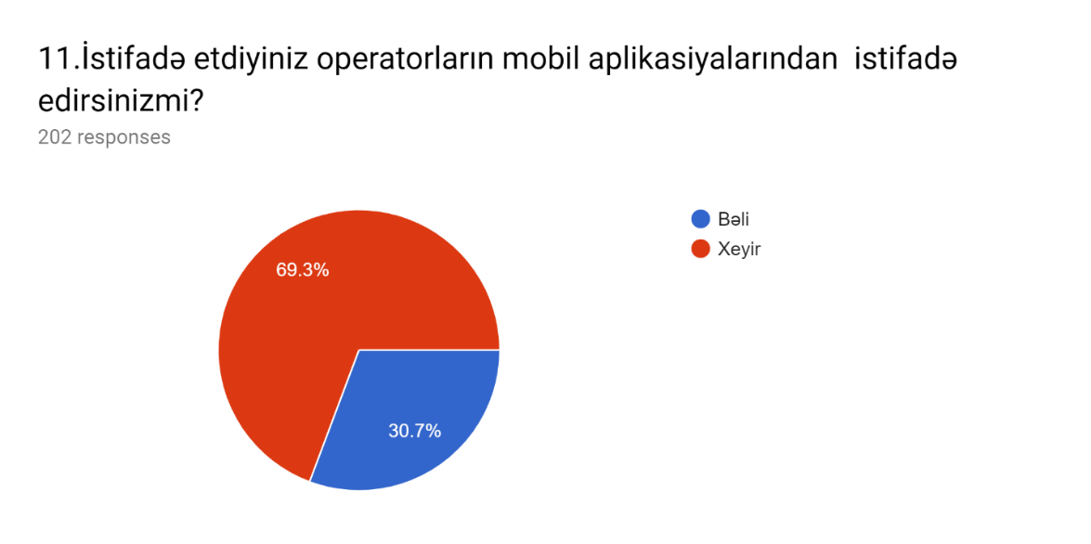
Do you use mobile applications for the operators you use? Only 62 of 211 people answered "yes". 149 people do not use it.
Graph 1.12
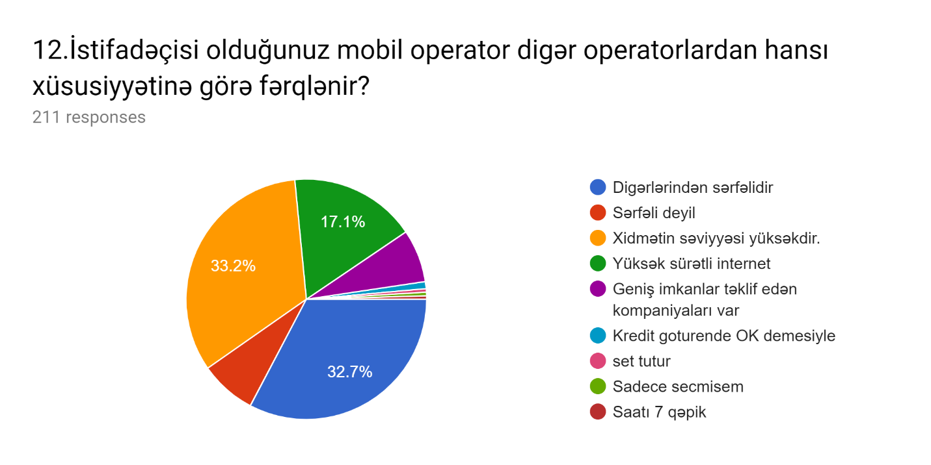
Respondents rated mobile operators as: 70 people think that service is at a high level, 69 people think that their mobile operator is superior to other mobile operators. 16 people think that their mobile operator is not profitable, 36 people think Internet speeds are high. 15 are satisfied with mobile operators' companies.
Conculision

Currently, the technology industry is developing steadily. And it creates conditions for the development of telecommunications. As telecommunications develops, it affects mobile operators' activities. The reason for this is that many innovations are emerging as technology develops. These innovations also lead to new customer demand. Of course, mobile operators play a vital role in our lives. Owes have been hard to establish, and now thanks to mobile phones and technology, we can connect with people from all over the world.
According to the results of the survey, Respondents are mostly satisfied with the services provided by mobile operators. Their expectations are that the internet is faster.
Given the growing volume of information in our daily life, there is a need to find solutions for large-scale data management and new methods for their beneficial use. All this is of great significance in the background of increasing the data not only in terms of volume, but also in terms of content (eg audio and video). More advanced analysis of large-scale data and real-time analysis and allows the process of data processing to go through past events it is important to move forward by distinguishing it from the current model is considered a step. Future predictive analysis is of greater importance it will start to make the decisions in the public and private sectors more accurate and will make it more acceptable to the future. All right these are more opportunities for predictable precautionary measures will create.
States as one of the key players in the telecommunications industry communication technologies, with varying levels of participation development, critical supportive factors for the successful application of technologies plays a major role in ensuring These factors are the telecommunications industry infrastructure, talent and skills, product and service promotion including measures. States are using various financing tools that contribute to the development of infrastructure by investing directly in stocks or indirectly introducing incentive mechanisms for private enterprises. In order to support the development of infrastructure, states focus on a fixed broadband network access and mobile network coverage expansion. Provide social benefits to broadband networks has become an important factor in the country's strategies and this infrastructure is constantly expanding. For this purpose, different alternatives to broadband access are accepted. These alternatives include infrastructure competition, a state-funded operator, and a joint venture with a national fiber optic communications company. In this sense, states have expanded the use of 4G technology through the spectrum distribution and coverage coverage for the broadband network. In addition, measures have been taken to improve telecommunication infrastructure and technology in order to improve the operational base for electronic payments and business activities.
Customer demand changes from day to day. Cellular operators should respond to this demand, and should constantly improve itself. Therefore, they need to implement the marketing strategy correctly. At present, Bakcell, Azercell, Nar mobile are competitors in Azerbaijan mobile operator market. Low competitors in the market of mobile operators create favorable conditions for mobile operators to study the market. Market research is the ultimate objective of promoting procedure. Analyzing competitors here, learning customer demand. When customer satisfaction is met, this will create customer satisfaction and will help to attract new consumers. Here, consumers need to be properly segmented so that they can offer products and services that are appropriate to them. Therefore, it is necessary to know the main expectations of consumers.
It is possible to introduce the product to consumers, to show the quality of their products, as a result of marketing activities. In this dissertation, we tried to find out the activity of mobile operators, the main expectations of consumers from mobile operators. Naturally, the main activity of mobile operators is to arrange customer and domestic interconnection with the country, to serve them in a quality manner.
Consumers' expectations from mobile operators are relatively inexpensive and high-quality, high-speed internet, affordable tariffs, and etch. Today's high expectation that high-speed Internet is an over-Internet use. People invest the greater part of their energy in social media. It means that both social media and the Internet have a great importance in our lives. Mobile operators are paying attention to the requirements of coverage in cities where the population is particularly intense. Therefore, the use of the current broadband network is higher in Baku, where population density is significantly higher than the rest of the country. Here operators are able to provide more customer service and earnings, with less costs. Compared to other countries, Azerbaijan can achieve a 4G implementation in the country by pursuing a better spectrum management policy. Such political approaches are mainly focused on two parameters: improving spectrum and setting coverage requirements for network application.
In this dissertation, we can observe the growth of mobile operators' marketing activities. A lot of funds are allocated for the preparation of advertising, improving the service, developing technology, and solving some problems. Investing in the future indicates that growth rates will grow in the coming years.
For this purpose work is carried out not only in cities, but also in regions. We can be sure that innovations that will take place in the coming years will create more opportunities for us, and all our expectations will be met.

Bibliography
- “Azərbaycan Respublikasında telekommunikasiya və informasiya texnologiyalarının inkişafına dair Strateji Yol Xəritəsi”, 2016
- Azərbaycan Respublikasın Dövlət Statistika Komitəsi, 2018
- Kotler Philip. Fundamentals of marketing. 5th ed. / F. Kotler, A. Gary. - M .: Williams, 2016. 752 p.
- Jean Lambin. Strategic marketing. European perspective. Per. from french. - SPb. : Science, 2006.- XV + 589 p.
- Lebedeva, O.A. Market research: Textbook / O.A. Lebedeva, N.I. Lygina. PH FORUM, SEC INFRA-M, 2013.-192 p.
- Mazilkina, E.I. Marketing communications: Educational and practical guide / E.I. Mazilkina. - M .: Dashkov and K, 2012. - 256 p.
- Maysak O.S. SWOT analysis: object, factors, strategies. The problem of finding relationships between factors // Caspian magazine: management and high technology. - 2013. - № 1 (21). - p. 151–157
- Savinov Yu.A., “World market conjuncture for telecommunication equipment and services” - Telecommunication Herald №2, 2007
- Sinyaeva I.M., Zemlyak S.V., Sinyaev V.V. Marketing Communications: Tutorial / Ed. prof. L.P. Dashkova. - M .: Publishing and trading Corporation "Dashkov and K °", 2005.
- Tikhomirov, V.P. Social Media Marketing. Internet marketing communications: Tutorial - St. Petersburg: Peter, 2013. - 288 p.
- Shpakovskaya S.V., Shpakovsky V.O., “Fundamentals of the Theory of Communication”, 2006
- Baker Michael, The Strategic Marketing Plan Audit, 2008.
- Campbell D., Stonehouse G. & Houston B., Business Strategy: An Introduction. A Butterworth-Heinemann Title, 2002
- Chris Fill, Marketing Communications: Interactivity, Communities and Content (5th Edition)
- Hooley G., Saunders J., Piercy N. & Nicoulaud B. (2007), Marketing Strategy and Competitive Positioning. Financial Times/ Prentice Hall.
- Kotler Philip, Armstrong Gary, Principles of Marketing 14th Edition, 2011
- Krajewski L., Ritzman L., & Malhotra M. (2010), Operations Management and Myomlab: Processes and Supply chains. Pearson Education Global Edition.
- Marketing of Sandhusen L. Richard, First Edition, Continental SA Publishing Company, 2002, p. 12.
- Marketing, Charles Lamb, Hair and Hoseph Carl McDaniel, Sixth Edition, International Thomson Publishing, 2002, p. 19
- Michael E. Porter (2004), Competitive Strategy: Techniques for Analyzing Industries and Competitors. Free Press.
- Mladen Velev, Marketing Communications, 2001
- Dean, T. (2003). Guide to Telecommunications Technology. Thomson.
- Meyer, C., & Schwager, A. (2007). Understanding Customer Experience. Harvard Business Review .
- Bertrand, M., & Bouchard, S. (2008). Applying The Technology Acceptance Model to VR with People Who Are Favorable to Its Use, 200-201.
- Cricelli, L., Grimaldi, M., & Ghiron, N. L. (2011). The competition among mobile network operators in the telecommunication supply chain. Int. J. ProductionEconomics 131 , 22–29.
- Rossiter, J.R (2005) Marketing communications: Theory and applications. Prentice-Hall, Frenchs Forest, N.S.W.
- Okazaki, S., & Taylor, C. R. (2008). What is SMS advertising and why do multinationals adopt it? Answers from an empirical study in European markets. Journal of Business Research 61 , 4–12.
- Al-Fahad, F. N. (2009). Students' Attitudes and Perceptions Towards The Effectiveness of Mobile Learning in King Saudi University, Saudi Arabia. Turkish Online Journal of Educational Technology, Volume 8, Issue 2, Article 10, 111 - 119.
- Bar-Noy, A., & Malewicz, G. (2004). Establishing wireless conference calls unde rdelay constraints. Journal Of Algorithms 51 , 145–169.
- Ou, H. H., Hwang, M. S., & Jan, J. K. (2007). A simple mobile communication billing system among charged parties. Applied Mathematics and Computation 192 , 487–495.
- Kuo, Y.-F., & Yu, C.-W. (2006). 3G telecommunication operators‟ challenges and roles: A perspective of mobile commerce value chain. Technovation 26 , 1347–1356.
- Humphreys, E. (2008). Information security management standards: Compliance, governance and risk management‖, Information Security Technical Report, 13 : 247- 255, 2008
- Park, S. Y. (2009). An Analysis of the Technology Acceptance Model in Understanding University Students' Behavioral Intention to Use e-Learning. Educational Technology & Society , 151.
- Peersman, G., Griffiths, P., Spear, H., Cvetkovic, S., & Smythe, C. (2010). A tutorial overview of the short message service within GSM. Computing and Control Engineering Journal , 79-89.
- Aşurov A.S. Marketinqin kommunikasiya sistemi. Dərs vəsaiti, bakı, “İqtisad Universiteti”, 2008, 168 s.
- Məmmədov A.T., Marketinq. Dərslik, Bakı, 2014, 667 s.
- Hacıyeva L.A. Xidmət sahələrinin marketinqi. Bakı, “Biznes Universiteti”, 2013, 276 с.
- Xeyirxəbərov İ.M. Marketinq tədqiqatları. Bakı, İqtisad Universiteti nəşriyyatı, 2015, 364 s.
- http://akhundoff.com/about/
- http://barama.az/az/barama-innovasiya-ve-sahibkarliq-merkezi
- http://bestsoft.az/az/client/abc-telecom.html
- http://integral.az/about/
- http://www.azercell.com
- http://www.azercell.com/ru/company/
- https://business.bakcell.com/en/why-bakcell
- https://ru.wikipedia.org/wiki/Azercell_Telekom
- https://www.bakcell.com
- https://www.investopedia.com/articles/markets
- https://www.marketing91.com/marketing-mix-vodafone
- https://www.nar.az

Appendix

1.Cinsiniz?
- Kişi
- Qadın

2.Yaş qrupunuz?
- 10-14
- 23-29
- 30-45
- 45+

3.Təhsil səviyyəniz?
- Orta
- Bakalavr
- Magistr
- Doktorantura

4.İşgüzar fəaliyyətiniz?
- Məktəbli
- Tələbə
- Dövlət sektoru işçisi
- Özəl sektor işçisi
- Şəxsi biznes fəaliyyəti
- Freelancer
- Təqaüdçü
- İşsiz (evdar qadın və.s)

5.Aylıq qazancınız?
- 0-200
- 201-500
- 501-700
- 701-1000
- 1001 və ya daha yüksək

6.Smartfon istifadəçisisinizmi?
- Bəli
- Xeyr

7.Hansı mobil operatordan istifadə edirsiniz?
- Azercell
- Bakcell
- Nar

8.Bir ay ərzində balansınızı artırmaq üçün xərclədiyiniz pulun miqdarı?
- 0-5
- 6-10
- 11-20
- 21-50
- 51 və ya daha yuxarı

9.Balansı artırmaq üçün hansı üsuldan daha çox istifadə edirsiniz?
- Terminallar vasitəsitəsilə
- Online ödəmə
- Kart vasitəsilə ödəmə
- Kredit

10.İstifadə etdiyiniz mobil operatorun marketing fəaliyyəti, etdiyi yeniliklər və reklamları ilə maraqlanırsınızmı?
- Yeniliklərlə maraqlanmıram.
- Sosial Şəbəklərdə izləyirəm.
- TV reklamları izləyirəm.
- Müştəri xidmətlərinə yaxınlaşıram.
- Sadəcə Lazım olan məlumatları almaq üçün internetdə axtarış edirəm.
- Operatorlar tərəfindən göndərilən məlumat xaraterli birbaşa SMS'lər.
- Operatorların mobil aplikasiyaları vasitəsilə.

11.İstifadə etdiyiniz operatorların mobil aplikasiyalarından istifadə edirsinizmi?
- Bəli
- Xeyir

12.İstifadəçisi olduğunuz mobil operator digər operatorlardan hansı xüsusiyyətinə görə fərqlənir?
- Digərlərindən sərfəlidir
- Sərfəli deyil
- Xidmətin səviyyəsi yüksəkdir
- Yüksək sürətli internet
- Geniş imkanlar təklif edən kompaniyaları var

