MINISTRY OF EDUCATION OF AZERBAIJAN REPUBLIC

Enhancing Organizational Performance and Business Outcomes Through Employee Engagement Projects

Supervisor: Zulfugar Ibrahimli
Mastura Hasanova

Baku-2019
ACKNOWLEDGEMENT

This thesis began with an idea in my 2nd class of university. Over the successive a few years it sophisticated into this, its ultimate form. I would be regardless not to thank the plurality of people who assist make this possible. Initially, I could not have finished this trial without my advisor PhD. Zulfugar Ibrahimli. You put up with myriad drafts of the thesis proposal and helped lead me through a data-collection process that we both view back on and say “never again” (for university at least).
After all thanks to my family for supporting me through this thesis trial and for the unconditional respect, they have given throughout my life. Mom, Dad, and my brother, they have always been unlikely supportive of me even when I wasn’t academically inclined. You have always demonstrated deep esteem for education and because of that I am several years through university, and now a thesis down.
In addition, I am glad to say that I ascertained so much and was able to develop myself. I would like to give my thanks to UNEC they have given me access to their worthwhile information. I would like to outdoor my thanks to my friends and classmates, who have always stood behind me.
Mastura Hasanova
Baku, July 2019

ABSTRACT
Enhancing Organizational Performance and Business Outcomes Through Employee Engagement Projects
Mastura Hasanova
Bachelor Thesis
Supervisor: PhD. Zulfugar Ibrahimli
April 2019, 55 pages + 5 tables + 8 figures
Employee engagement is valued by achieving within the enterprise when moving to the digital age and the modern world. When talking about a providential and efficient organization, it is vital to consider the competitive advantage and the level of participation as a value proposition. Nowadays, the concept of employee engagement is getting to be progressively prevalent all throughout the world, and Azerbaijan is no exemption.
The potential impact of employee benefits is significant when new products and solutions are introduced to the market. The reason of this paper is to investigate how to have a positive impact on workers and the venture as an entire, and how the organization chooses to report to representatives approximately the sorts of benefits for the offer.
This paper underlines the differences in apprehensions and understandings of the benefits of employer and employee interests and emphasizes whether employees should be blamed if they do not properly recognize the right value of an employer's voluntary employee benefits. There is an opportunity to cultivate benefit communication.

Table of Contents
INTRODUCTION……………………………………………………………….6
HISTORICAL DEVELOPMENT OF EMPLOYEE ENGAGEMENT…………9
1.1 Concept of Employee Engagement 12
1.2 Employee Engagement Conflicts 13
1.3 Attributes Affecting Employee Engagement 15
KEY DRIVERS OF EMPLOYEE ENGAGEMENT…………………………..25
2.1 Models of employee engagement 25
2.2 The Dimensions of Employee Engagement 29
2.3 Employee Engagement Challenge 33
THE IMPACT OF EMPLOYEE ENGAGEMENT ON ORGANIZATIONAL PERFORMANCE……………………………………………………………...36
3.1 Presentation of Company A 36
3.2 Engagement In Organization A 37
RESULT………………………………………………………………………..48
CONCLUSION AND RECOMMENDATION………………………………..51
REFERENCES…………………………………………………………………53

List of figures
Figure 1.1 The big five personality dimensions…………………………..15
Figure 1.2 Open Systems model of teams………………………………...18
Figure 1.3 Diversity- the dilemma of consensus…………………….........19
Figure 1.4 Concept of employee engagement……………………………..22
Figure 2.1 Engagement driving factors……………………………………29
Figure 2.2 Herzberg’s Motivator- Hygiene Theory……………………….31
Figure 4.1 Three types of employees……………………………………...48
Figure 4.2 Characteristics of an employee engagement.………………….49

List of tables
Table 2.1 Strength of employee engagement 33
Table 2.2 Weakness of employee engagement in the production unit 33
Table 3.1 Company A key figures 35
Table 3.2 The category of employee participation 35
Table 3.3 Interviewee details in Company A 36

INTRODUCTION
This chapter introduces research affairs, identifies motives and reasons for doing them, studies research matters, purposes and objectives, and provides a clear overview of the research structure.
The purpose of the research
The main purpose of the study is to understand the concept of employee engagement, the importance of organization building and the effects of employee engagement.
Employee engagement played a key role as a key issue in the corporate success that works better in today's business world (Robinson et al. 2004: 8). When change gets firmer, firms must reinvent themselves and innovate in order to retain their competitive advantage. It is important that an organization acquires knowledge and maintains a competitive advantage. (Argote and Ingram 2000: 154) Companies, therefore, tend to maintain and supply knowledge workers, the most critical determinant of organizational success (Kahumuza and Schlechter 2008: 12).
Many companies now have difficulty motivating their employees. As explained by Gallup (2013), only 13 percent of employees are busy, 63 percent are not engaged, and 24 percent are active. Leadership activities are believed to be highly involved in the organization because they want to share a clear vision of the company's future. As a result, leadership can have a crucial impact on employee engagement, including communicating transparently and caring for staff (Cook 2008: 3-4, Senge et al. 2004). Some research paper about employee participation shows that there is a relationship between employee and organizational productivity, so you should always investigate this relationship and improve the outcome (Towers Perrin-ISR, 2006).
To improve your organization, you need to create value through employee engagement. For this reason, this study thinks about centers on the concept of engagement with esteem benefit chains (Heskett et al. 2003) and suggests that organizations move forward case execution through improved representative engagement.
The objects of the research
The production of the company suffered from the disengagement of the employee in the absence of employee commitment and was unable to achieve its production goals. The aim of this study is therefore to present a proposed improvement of the production for the case company through enhanced staff engagement. This study will help the case company improve its productivity and understand the importance of employee engagement in the development of value in an organization. In its key business strategy, the case enterprise plans to implement the study proposal and use a plan that implements employee involvement. The case company plans to take further steps to improve its productivity and growth based on the results of this study.
The structure of the research
The key concepts of this study are employee engagement projects and organizational performance. Typically the result of the organizations’ collapse found in later company worker studies. The notion of employee participation is taken into account in the context of this study as follows: Positive employee attitudes toward employee values ​​ ​​by working with peers to recognize business context and improve work for the profit of the organization. Organizations should make conditions for employees to supply their representatives with the aptitudes and possibilities that they endeavor to create for cooperation that requires a common relationship between staff member and patrons.
The second concept of this investigate, organizational execution relates to the esteem made by representatives to finish organizational result. The value chain contributes to employee participation by increasing the efficiency of the organization. This enables developers to achieve sustained improvement in the organization (Heskett 2003). The key concept of this study is to perform value through employee engagement to evolve organizational profit and business performance.
The methodology of the research
In this thesis, due to the qualitative nature of this study, the research approach chosen uses interview data collection, group discussion and observation as its primary data. The research design examines the concept of employee involvement in academic literature and merges the data collection results into a proposal validating by the Case Company Representative with best practice of employee engagement.

HISTORICAL DEVELOPMENT OF EMPLOYEE ENGAGEMENT

The first use of the term employee participation happened at the Management Journal Academy, which William A. Kahn published in 1990. Kahn's article on “Psychological Conditions for Personal Participation and Departure from Work” investigated the terms at work that subscribe to participation and departure. He found that meaningful, secure, and available personal and contextual sources have a substantial effect on engagement.
This study of counsellors and individuals of building companies is still a beneficial consider. Some of Khan's works were collected and repackaged by Daniel Pink after 21 years.
The growing interest in employee engagement
In the mid-1990s, Gallup began to improve and expand Q12. Q12 is a copyrighted question with 12 questions. Do you know what to expect at work? And do you have your best friends at work? Gallup has asked hundreds of millions of these questions to create an important database and industry for employee engagement. Gallup's questions were simple, and the containment of the more active workforce was strong.
Speed, depth and breadth came together in 2000. We searched for this term in early 2000 and provided approximately 50,000 results, and currently, the same query yields 47.5 million results. Twitter tweets about employee involvement appear about every 30 minutes five years ago and now occur every minute.
But everything began to change. The growth of global competition and the transition from the manufacturing economy to employers must be more flexible, economical and competitive. Conventional businesses have declined or contracted. Specialists have learned that there's no more work to make strides their careers and learn the difficult way to move to more adaptable and openings. And that's what they did. After living a good life and finishing a good pension, I finished my old contract. People are encouraged to go to work, sell chances and release new employers at the same time. If loyalty did not get in it, then it was a shorter period. So it was used by employees, but soon the employer lost someone who hadn't wanted to lose. This has been costly and has affected the ability to compete effectively.
The last decade also looked like the golden age of the survey. Everyone seemed to have a new definition of new research and participation. High technology and Survey Monkey make you believe that monkeys can write surveys.
In less frivolous notes, more people have developed a very attractive business case for participation in paying attention to employee involvement. The UK is leading the world with employee participation with two prime ministers who support and encourage employee engagement through engage development for success.
The rise of engagement
At this point in history - the early '90s - the concept of participation has been grown up. The core of this engagement article written by the Employment Research Institute (IES) in 1990. It communicates with employees at Employee Profit from Employees - Service Profit Chain Area. Sales figures Based on extensive research, the open linkage between engagement and effectiveness has helped to determine the importance of interaction for HR and business performance. The results of the report were more appropriate and focussed on the interactions between workers and customers as Britain became a service-oriented economy.
The old Mantra is staff the only asset for a service-based business. The employee is your biggest asset. This has resulted in strong incentives for employee investments because of the recognition of employees' involvement, motivation, efficiency, and ultimately revenue (or strategic goals for non-commercial activities).
The economic reasons for participation were backed up in 2002 by another ingenious study showing the linkage between employees and profits. Since it is mainly limited to academia in 1990, it is being debated and implemented at the level of practitioners. Organizations have begun to realize that appointments will have a positive impact on a variety of employees and ways of working, including non-separation of employees, absenteeism, and employee replacement. Profitability and customer service/satisfaction indicators.
HR or business function?
The interaction also began with belonging to the General Managers and Administration. In reality, everybody ought to be included in arrange to be compelling. It must be part of the organization's DNA. Interoperability measures relate to main indicators of performance, such as an administrator's achievement by means of key performance. The importance of work environment and the subtle transfer of people from the human resources department (which ultimately has responsibility for policy implementation) is not only replaced roles such as interaction managers but also places of interaction in the board.
Participation and public sector
Participation also applies to the public sector. Indeed, the impact of overworked, nervous and motivated employees is much more serious in the health sector than in supermarkets or call centers. In a 2011 study conducted by Aston University, the mortality rate for patients with high levels of participation was about 2.5% lower than the average level of participation. Then, you would like to select a healing centers for treatment, inquire your surgeon's involvement, not how the staff is active.

Concept of Employee Engagement

This section discusses employee engagement by explaining the definitions and factors that affect and leverages existing literature resources. At the end of this section has been formed in this study to clarify the concept of employee engagement.
Defining Employee Engagement
The description of employee engagement is defined in several ways and is more difficult to accurately measure (Ferguson 2007). According to Saks (2006: 600), there are many researchers and academics that show the same approach and results that define the illustration of employee engagement and how to improve it. In the past few decades, scientists including Shuck and Wollard (2010:103) have studied employee engagement and believe that employee participation does not just influence employee results, but also financial performance and corporate performance. The organization recognized the importance of employee involvement after participating employees performed more effectively than dismissed employees (SHRM Foundation 2006: 2). The first official study of Kahn (1990: 694) suggested employee involvement described participation as "voluntary participation in the role." He argued that personal involvement "engaged in the role of an organization member," arguing that "hiring and expressing oneself in a physical, cognitive, and emotional role while performing a role." For this reason, participation means high activity at work, knowledge of the workplace, feelings and attitudes toward employers and working conditions carefully. Later, Schaufeli et al. (2002: 74) explained that participation is a "positive, satisfying, work-related mental state characterized by vitality, determination, and absorption". Vigour raises the level of employee energy, commitment means a point of vanity and enthusiasm, and means to concentrate fully on absorption tasks. Employee involvement is therefore explained by the personal emotional and intellectual commitment of many researchers (Croston 2008, Saks 2006, Schaufeli et al. 2002) and the fact that employees speak positively about jobs, organizations and employers. (Aon Hewitt 2011: 1-7, Towers Perrin 2005), focusing on organizational performance (Schuck and Wollard 2010: 99). In addition, to achieve successful business results, organizations can make a logical conclusion that they need to increase employee contributions and contributions to improve employee engagement, which is a positive attitude to employees' organizations and values. This occurs because employees are aware of the business context and working with colleagues in order to improve their efficiency for the increase organization’s performance. As a result, companies ought to be fascinated by creating contracts that require a relationship between workers and bosses. (Macleod and Clark 2009: 5).

1.2 Employee Engagement Conflicts

Over the years there have been different illustrations of employee involvement.
Some studies show that participation is related to other components of organizational behavior, but they are still distinct from engagement. (Kular et al., 2008). The concept of employee participation has been used interchangeably between appointments, general terms of organizational behavior, and organizational citizenship behavior (OCB). (Robinson, Perryman & Hayday, 2004) As seen in many studies and studies, appointments and OCB play an important role in business outcomes and increase participation. However, participation and behavioral terms of both organizations have different characteristics.
Employee engagement is crucial factors contributing to employee participation. One of the reasons many studies are involved in participating by mistake is that the staff is staying because the staff likes the job, but we hope to have unmatched staff.
Non-contract employees choose to stay for a variety of reasons, including money, career opportunities, security, stability, familiarity, pleasant working conditions or resistance to delays and job changes. Without a contract, it is not a shortage of promises, but it helps to prevent wrongdoing and contribute to the company's negative participation rate. (Rice, Marlow & Masarech, 2012) The risk of involving unincorporated employees at the level of participation can be a huge blow to the organization. They don't need to remain, they contribute, and they work diligently for the performance of the company.
OCB(Organizational Citizenship Behavior) is the first main factors of participation. OCB includes several components that enhance the level of commitment to participation. Components can be viewed as helping behavior, organizational loyalty and compliance, initiatives, and self-development. However, these factors seem to be more concerned with individual personality and behavior than the organization itself. (Robinson, Perryman & amp; Hayday, 2004, p.8)
Many people can argue that participation and OCB are different from participation because of individual differences. Individual differences can be seen not only in participation but also in job commitments and OCB. Indeed, Saks (2006) argues that devotion and OCB are different from employee involvement, because commitment refers to individual attitudes and attachment to the firm, and Organizational Citizenship Behavior takes voluntary and informal actions to help others I will. Engagement, any other way, is not about attitudes or actions. (Saks, 2006). Moreover, many researchers predict that participation and OCB are important for participation. Commitment is a positive endeavor to work hard for the success of an organization, to be proud of being an organization, and to identify with the organization. Elseways, OCB is the act of taking the initiative to contribute to the organization. This is important in the concept of employee participation and can not be a complete substitute for participation. (Markos & amp; Sridevi, 2010, 91)

Individual differences affect staff involvement. Individual differences vary from person to person, including self-esteem, level of control, robustness and self-efficacy. In fact, these variables are important at the level of participation because they affect discontinuity. (Saks, 2006, p. 614) Burnout is the opposite of participation due to overly demanding work. On the other hand, relationships with employees are important and encouraging. (Langelaan, 2007). However, individual differences form the personal intervention and resolution of the psychological state, and ultimately form the will of those who want to participate or participate in the workplace. (Kahn, 1990, p. 718)
Another factor that can cause controversy in conceptualizing worker participation is career-related. Vocational participation is considered cognitive behavior and may be the result of an employee's deep involvement in the job. (Markwich & Robertson-Smith, 2009, p.51) This is one of the steps to define participation. Individuals use emotions and behaviors in everyday work with cognitive experiences and performances. (Saks, 2006, p.602)
Participation is more than job satisfaction, "employee involvement, contribution, and personal involvement in ownership." (Robinson, Perryman & amp; Hayday, 2004, p.7)

Attributes Affecting Employee Engagement

The study begins by examining existing literature on attributes that affect employee participation. Some definitions and theories exist in employee involvement. After studying the topics in the available literature, conceptual framework 1 was formed for this study. This conceptual framework also relates to the analysis of the groups used in the company employee survey question format, which was the considerable point of the study. This group is the work, leadership, and organization that affect employee interaction when reviewed below.
Work
Personality change from person to person, for example, when people think of things that others can access from a totally different point of view. Individual differences are combined with the characteristics of the personality of the person who interacts with and interacts with others, and participation is based on these characteristics and is related to the personality dimension described in Figure 1 below (Macey and Schneider 2008: 3- 30p).

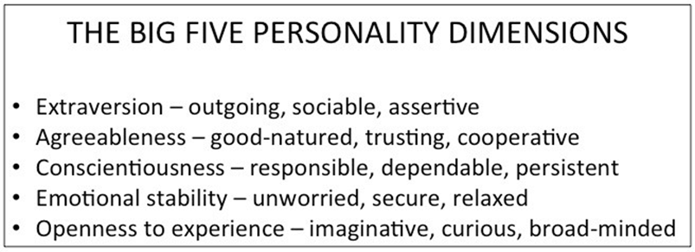
Figure 1.1 The big five personality dimensions (Schermerhorn et al. 2012: 29).

The large five personality dimensions depicted in Figure 1 above include extroversion, equality, conscientiousness, emotional stability, and open to tentative (Schermerhorn et al., 2012: 29). Langelaan et al. (2006: 521-532) measured vulvar and neurosis, where engagement was positively associated with extroversion, but negative with neuroticism. Kim et al. (2009: 96-104), conscientiousness was closely related to participation throughout the study, while neuroticism and extroversion included five major characteristics that showed conflicting information after changing work-related attributes. Schaufeli (2012: 3-14) is incomplete in the study of Wildermuth and Pauken (2008: 208), which states that "participation is a mental rather than a personality" that supports research on worker orientation. Therefore, depending on the personality, participation among different people can vary greatly.
Motivation is characterized as the direction, level and continuity of an individual and the effort spent in the workplace (Armstrong 2014: 182). The direction is chosen when presenting various alternatives to the individual. Levels represent the amount of effort each person exerts, and patience is the time an individual has spent in a particular task. Several sources of theories are studying motivational themes. Reiss (2012: 152-156) categorizes motivation as both intrinsic and extrinsic. The intrinsic thing is that an individual does something and enjoys for his own purposes, whereas an external thing is for a specific goal or goal. The Intrinsic Motivation is closely related to support since it is related to long-term quality of work, and to reach a certain objective quickly and to induce it remunerated. Therefore, the intrinsic motivation is that employees are naturally engaged in their own interests and have fun to work with, so it is possible for employees to engage and concentrate all their strengths and efforts on work and future tasks (Zhang and Bartol 2010: 111 ).
Individual job attributes should be linked to employee participation for motivation. Kahn (1990: 704-705) said that when a work fulfils a meaningful mission, the psychological meaning exists positively and includes a combination of every day and novelty with diversity, originality, challenge and clarity. These job attributes give spontaneity and ownership to their jobs and mark them as engaged. Also, according to Wildermuth and Pauken (2008: 207), continuous learning and progress must also be included in the work.
Another job attribute associated with participation is organizational citizenship that demonstrates that an individual tries to help develop interpersonal relationships or the enterprise as a whole to help peer-to-peer work. (Schermerhorn et al., 2012: 67) Robbins and Judge (2013: 71) argue that motivation for participation is job satisfaction. Typically finished when a person feels positive almost his or her work through organizational commitment, which may be a commitment to work and a commitment to work and organizational dependability. Carrig and Wright (2006: 31) explain that positive attitudes, satisfaction, and commitment drive employee involvement. An organization with a happy and dedicated staff surpasses less motivated employees when the potential for positive outcomes begins to expand in the organization. In conclusion, the combination of job involvement and organizational commitment through personality, motivation, and job characteristics creates a high sense of employee commitment (Gallup 2015).
Leadership
When talking about the elements of leadership, communication and collaboration are tied to concepts as the workplace of modern society becomes more collaborative with new social technologies. Communication is the essence of keeping cooperation and organization together (Schermerhorn et al. 2012: 242). This is an information process between the forwarder and the receiver, in which the communicator is connected with the potential of feedback through various communication channels (Kalla 2005: 302). Ayuso et al. (2006: 475-490) recommend a two-way communication process in which comments and views are shared with each other to enrich the relationship between employees. Sinclair (2010) emphasizes the importance of communication, listening and transparency for open and honest information exchange. Good communication builds cooperative partnerships, including teamwork, to gain employee trust and encourage employee participation (May et al 2004: 16). Two-way communication is part of an organizational environment of trust, accountability and accountability that promotes good relationships, builds teamwork, and promotes collaboration among employees within the organization (Towers Perrin 2003). Employee engagement, therefore, occurs when good communication and collaboration between employees and employers achieve better outcomes and share ideas (Wellins and Concelman 2005: 14). Topics related to communication and collaboration are teamwork. Schermerhorn et al. (2012: 158) show the open system model of the team system in Figure 1.2.
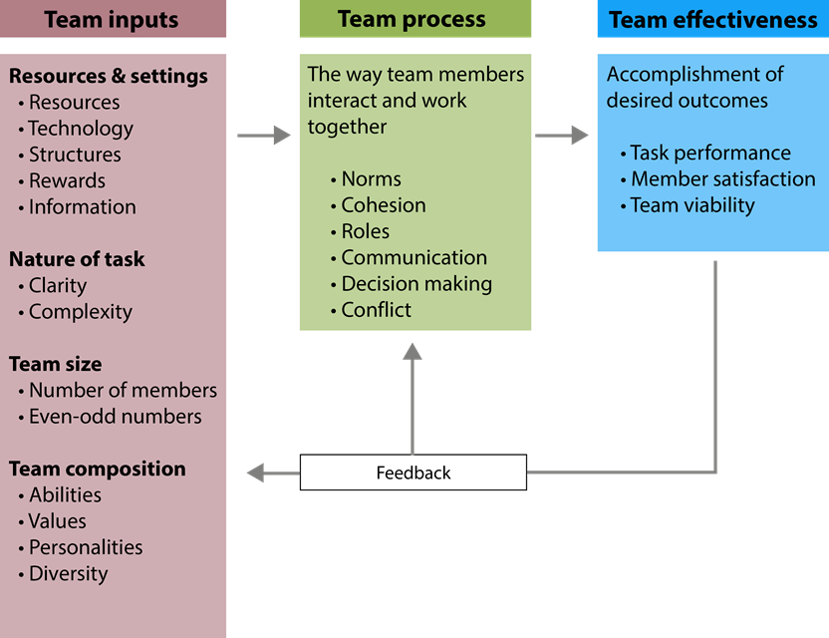
Figure 1.2. Open systems model of teams (Schermerhorn et al. 2012: 158).

Figure 1.2 above shows how team targeting and team effectiveness are targeted for team effectiveness. Team input includes sub-attributes such as (1) resources and preferences, (2) job characteristics, (3) team size, and (4) Team processes are team dynamics that describe (1) norms, (2) cohesion, (3) roles, (4) communication, (5) I headed in the same direction. 'A continuous process in which the team gets the efficiency of the staff affected by the described attributes how the team operates, both internal and external, depending on the quality and style of feedback received from the organization. Team effectiveness depends on team development and performance levels. Schermerhorn et al. (2012: 163) indicate that diversity-consensus dilemma (Schermerhorn et al. 2012: 163) in Figure 1.2 tends to cause difficulties, but a high probability of problem-solving.
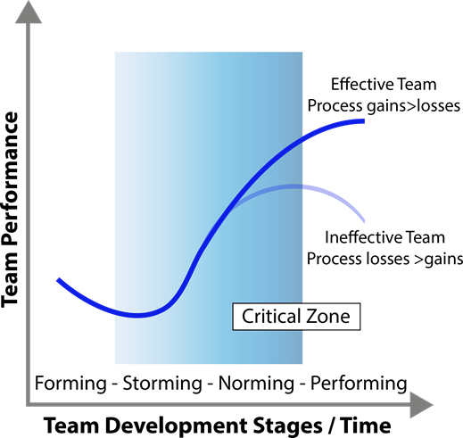

Figure 1.3. Diversity - the dilemma of consensus (Schermerhorn et al. 2012:163).

Figure 1.3 above shows the team's impact on profits and losses. Team development steps affect team performance. The team development stage includes (1) a step with uncertainty about the purpose and structure of the team, (2) a storm at the stage where there is a team identity but a team conflict, (3) (cohesiveness), and (4) the team performs all functions. Schermerhorn et al. (2012: 156-163) Different team development stages may vary from team to team. This dilemma is most noticeable in the critical zone in a storm and normative stages. Schermerhorn et al. (2012: 156-163) explain that although one team can go further, they can be affected by external stress due to poor leadership or the influence of the attributes explained in Figure 1.3 above. As a result, teamwork and team performance can be affected positively or negatively by various levels of attributes that determine the quality of teamwork communication and collaboration.
Leadership itself is defined as an entity in which leadership helps (Castellano 2015: 6) to maintain an organizational environment that is positive for employees to achieve organizational goals and employee engagement through communication and collaboration with work and organizational groups described in this section. It is an important driver of leadership affects employee attitudes, beliefs, behaviours, and emotions (Spector 2003: 313) and plays an important role in defining and delivering the organization's vision, goals and objectives (Castellano 2015:6). This is dependable for the collaboration between workers and organizations and features a critical effect on the capacity of representatives to work, collaborate and organize their enterprise. (MacLeod and Clarke 2009: 88).
The concept of leadership includes leadership that is described as people who urge people do their best to achieve the results they want, what they should do, and then use terminology to manage them using resources (Armstrong 2014: 329). Bridging, Purposeful (Armstrong 2014: Burns 1978), Command, Dreamer, Connected Democracy, Pacesetting, Coaching, Creation, Modification, Change, Information, Participation, Education, Servants, Democracy and Laissez-Faire 641-646). Different styles are needed for different work situations and environments that need to be aware of what type of leadership style to use and how to combine specific leadership approaches. Different leadership styles are different and overlap certain features simultaneously (Armstrong 2014: 641-646). Thus, several researchers have demonstrated the ability to demonstrate trust and resilience (Kahn 1990), to provide opportunities for development and career advancement, and to engage employees when leaders engage and devote to the organization (Welbourne 2007: 45-50) (Harter et al., 2002: 268-279). Leadership has a clear vision of future success, clarifying organizational goals (Towers Perrin 2003), providing staff nursing and support (Kahn 1990), employee participation in providing autonomy for employees, relevant training and systematic feedback sessions Is promoted. Employee Welfare and Recognition (Towers Perrin 2003). Communication and collaboration through open and transparent leadership are therefore a key factor influencing employee participation (Macleod and Clarke 2009).
An organization is one that achieves its purpose through the joint efforts of people working within the organization.' An organizational structure is the foundation of organizational activity, a framework for performing tasks with formal and informal command and communication channel elements (Armstrong 2014: 130). Organizational culture is an action, value, and belief system that develops and guides the behaviour of members within an organization (Schermerhorn et al. 2012: 348). It is a key driver for employee involvement because the organization is dependent on people and wants to be part of the organization, not employees who need to be involved, but staff to do well (Castellano 2015: 3). According to MacLeod and Clarke (2009: 33), good leadership can guarantee a strong, transparent and clear organizational culture. This enables employees to have a high-profile view of employees in a way that understands the organization's strategic goals, contributes to those goals, connects them to the organization, and engages them (Boswell and Boudreaus 2001: 851-860). Employees are entitled to contribute and participate when they participate, to see the essential value of their work, to make decisions, and to be treated with dignity by leading them and by having opportunities for career development and development. Employee participation, therefore, depends on the way leaders shape the organizational culture (Castellano 2015: 3). This allows the shared awareness of organizational members to develop an organizational atmosphere that is an aspect of the organization's culture of its own organization and organizational environment. It is generally known as team spirit (Schermerhorn et al. 2012: 9).
The essence of this study was to establish two conceptual frameworks. This section reviews conceptual framework 1 and looks at the concept of employee engagement to find the purpose of this study, where the results of the survey of company employees were the starting point of the study. Employee engagement is a complex subject, but it can be seen that there is a close relationship between different studies and theories in the various studies and theories of academic literature. Promoting employee engagement requires organizational work to build a system that engages employees. When an employee is committed to his or her work, their work is interesting, and they understand the value and purpose of their organization, a commitment is made to the organization that is engaged in the job (Armstrong 2014: 202). Attributes investigated in this section are divided into three different, interrelated work groups, leadership and organizations that have an impact on employee engagement and detailed attributes.

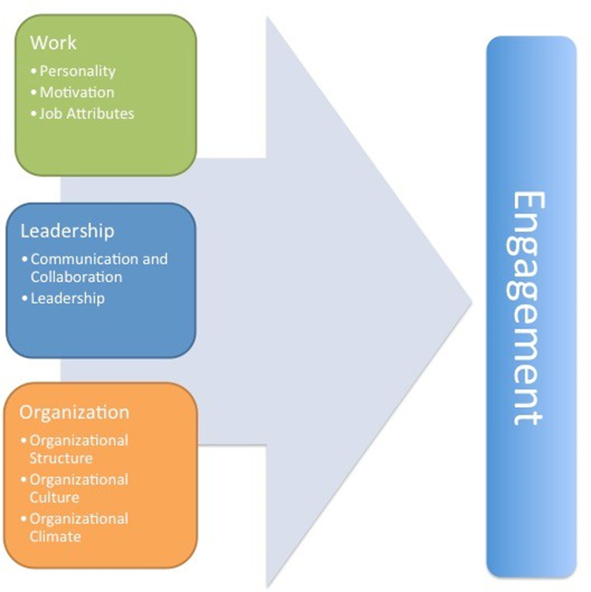
Figure 1.4. Concept of employee engagement.

Figure 1.4 above illustrates the interrelationship of attributes that affect job, leadership, and employee engagement among organizational groups. Workgroups include (1) personality, (2) motivation, and (3) job attributes. Leadership groups include (1) communication and collaboration, (2) leadership and organizational groups include (1) organizational structure, (2) organizational culture, and (3) organizational climate. Conceptual Framework 1 is based on the results of existing academic literature based on the questionnaire survey form and results of the company employees and serves as a theoretical starting point for further research and analysis of this study.

KEY DRIVERS OF EMPLOYEE ENGAGEMENT

Employee involvement is influenced by a variety of factors, including driving factors that increase participation levels and participation factors that challenge participation levels.

Businesses want to increase staff involvement, and fortunately, there is progress. Gallup recently said that in March 2016, 34.1 per cent of American workers were "engaged". This is the highest figure since the research and consulting firm tracked US workplace participation in 2011.

The increase in the number of employees who work for many human resource professionals means that more and more employees are working with enthusiasm and are deeply involved in the company. These workers are helping the organization develop.

2.1 Models of employee engagement
There are various models of engagement, namely the Hierarchy of engagement model, Path-Goal Model, Job demands-resources model, three-dimensional model, Benchmark of Engagement Quotient (BeQ) and Mercer model.

Hierarchy of engagement model
Markos and Sridevi (2010:91) highlighted the importance of the hierarchy of the engagement model, which resembles Maslow’s need hierarchy model. Markos and Sridevi (2010:91) argued that this model illustrated how each level influences employee engagement as well as talent containment. Each level represents a certain need and once these levels of basic needs are realised, employees search for development opportunities and possibilities of promotions. Markos and Sridevi (2010:91) proposed that once all these needs have been satisfied employees search to align themselves with value meaning, displaying a sense of contact.
Path-Goal Model
Oliver (2012:22) argued that the path-goal model, posited by Robert House, indicated that when leaders stimulated their employees, employees were able to reach their targets. Oliver (2012:22) stated that this was based on the assumption that employees were motivated if they were able to perform their jobs, achieve their desired outcomes and felt rewarded for the work done. According to Oliver (2012: 22), this was achieved when leaders provided clarity on employees’ roles, reward performance and provide the necessary support and direction. Otieno, Waiganjo&Njeru (2015:79) highlighted the importance of a leader’s behaviour in ensuring the motivation, satisfaction and performance of their subordinates. Otieno, Waiganjo&Njeru (2015:79) stated that a leader that engages in positive behaviour compliments his/her subordinate’s abilities and compensates for their deficiencies. Malik (2013: 218) argued that dependent on the subordinates and task characteristics, a constructive leader would adopt one of the four leadership behaviours warranted by a given situation. According to Malik (2013: 218), an effective leader provides clear direction where tasks are non-routine, ambiguous and highly unstructured and adopts a supportive role, encouraging reward and recognition for the job well done, where tasks are simple and routine.
Three-dimensional model
Alagaraja and Shuck (2015: 23) proposed that the three-dimensional model, initially proposed by Rich and Crawford, considered cognitive, behavioural and emotional engagement and the effects on organizational climate. Alagaraja and Shuck (2015: 23) drew from previous scholars and expanded this model to establish a parallel agreement across the various studies conducted. The most rational level of engagement, according to Alagaraja and Shuck (2015: 24), cognitive engagement formed the basis in unravelling the phenomenon as well as the psychological state of engagement. Alagaraja et al (2015: 24) focused that employees that are cognitively engaged shared a common purpose with their organization and based on the understanding of that objective, willing to put a personal investment of the resource they influence.
Job demands-resources model
Bakker and Bal (2010:191) addressed the importance of resources in helping employees cope with the emotional demands of their job and how employees attain their work-related goals when using these resources. Bakker and Bal (2010:191) highlighted that a resourceful work environment creates confidence, leading to the accomplishment of goals and the fulfilment of the employee’s need to belong. Remo (2012: 1) shared a similar view, however, indicated that the work environment also played a significant role in improving work engagement. Remo argued that these job resources; related to autonomy, learning opportunities and support of supervisors and colleagues and their positive association with engagement, are embedded in the organization’s culture, and governs the way employees interact at work. Schaufeli and Taris (2014: 45) indicated that the Job demands–resources have initially linked the model to burnout, which focused that when there are long term excessive job demands, employees struggled to recover from these demands, resulting in exhaustion and ultimately burnout. According to Schaufeli and Taris (2014: 46), two factors, namely "mediators of relations between job and health demands, employment resources and intention to sales," have been taken into account in 2004 as part of a revamped job demand-resource model.

Benchmark of Engagement Quotient (BeQ) model
Bisnath (2013: 2) claimed that the Benchmark of Engagement Quotient (BeQ), developed by Viljoen in 2008, is a model used to measure leadership perceptions and engagement which was developed specifically for South African organizations and considers three main constructs namely emotional containment, emotional presence.
Bisnath (2013: 33) further argued that BeQ, with its underlying principal of inclusivity, measures the interaction between perceptions and assumptions present in organizations around constructs that “contribute to the unleashing of individual voices, contributions and gifts”.
Mercer model
Gustomo (2014: 364-365) the Mercer model places emphasis that the drivers of employee engagement are not universal; relates to the geographical, cultural and generational circumstances and therefore categories the drivers of employee engagement into four categories. Gustomo (2014: 364) the first driver, the work itself, includes opportunities for development. Gustomo (2014: 364) many engagement-focused organizations have adopted ways to use work as an effective driver of employee engagement, adopting a strategy of flattening the organization and thus encouraging employees to grow within their jobs. Gustomo (2014: 364) stated that these firms, in highlighting the importance of the job fit into the overall spectrum of functions and activities, enable employees’ to map out and understand how their contributions fit with the enterprise’s vision. Gustomo (2014: 365) the second driver, confidence and trust in leadership, highlights how engaged employees perceive their leader's actions in terms of the organizational values and their strategic allocation of resources to support the organizational strategy. Gustomo (2014: 365) argued that strong leaders, who encourage employee and customer involvement, are transparent and build employee engagement by educating employees on how the strategy relates to the various procedures and processes. According to Pande and Basak (2015: 319), the Mercer model grades engagement of employees along a continuum with four stages namely satisfied, motivated, committed and advocate. Pande and Basak (2015: 319) stated that employees that are satisfied, enjoy their jobs and are satisfied with the terms and conditions of the job however, they do not go the extra. Pande and Basak (2015: 319) further claimed that employees that are motivated contribute energetically, strive to achieve personal goals and place more value in achieving personal goals than the team or organizational goals. Furthermore, Pande and Basak (2015: 319) suggested that committed employees see a wider picture, work with other people to achieve team objectives, be openly ambitious and feel part of the company. Lastly, Pande and Basak (2015: 319) stated that employees who are advocates of the organization proactively seek to serve the mission of the organization, offer discretionary effort and promotes the organization’s name as well its products and services.

2.2 The Dimensions of Employee Engagement

There are a number of factors that influence employee engagement. There are generally eight mentioned elements.
- Trust and Integrity: This driver is concerned with caution and notice. An employer on the employee's well-being and communication skills.
- The nature of the job: This means an opportunity to participate in everyday routines and a certain level of decision making.
- Between personal performance and company performance: This shows the relationship between an employee's understanding of the company's goals and the employee's contribution to the company's performance.
- Career growth opportunity: This represents the path of career development.
- Pride of the company: This driver is proud of our company. It is a desire of the company and a will to develop together with the organization.
- Colleagues/team members: This will affect the level of participation. The contact of employees to their peers.
- Employee Development: This driver is related to the employee's skills.
I want to develop in their work.
- A personal relationship with the manager: This driver is concerned about the relationship between the employee and the director line manager. (Markwich & Robertson-Smith, 2009, page 29)
In 2003, the Institute for Employment Studies (IES) conducted a survey, taking into account the extent to which these factors affect employee commitment. The order of the factors can be seen in Figure 2.1

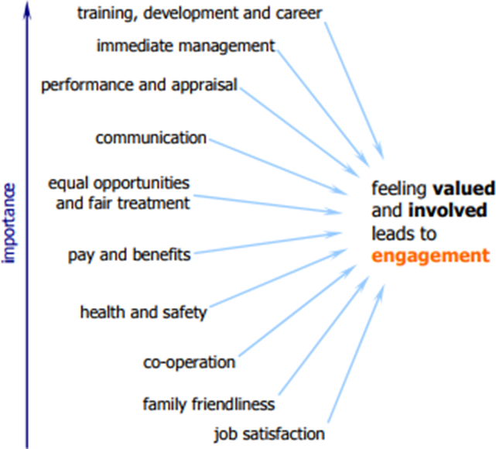
Figure 2.1 Engagement driving factors (Robinson, 2007a, p. 3)

As you can see in Figure 2.1, the most critical demonstration elements for employee involvement include education, relationships, development and performance rather than rational and physical factors. "Career development is one of the best drivers of participation and retention" (Rice, Marlow & Masarech, 2012, p. 183). In fact, emotional drivers are considered to have a fourfold greater impact on employee engagement than rational drivers. (Imandin, Bisschoff & Botha, 2014, p. 523) This discovery seems to be consistent with a study of two-factor theory by Frederick Herzberg 40 years ago.
Two-Factor Theory
Employee involvement is not entirely motivational. The debate about whether motivation and satisfaction conceptualize employee participation is undoubtedly essential. There are various motivational theories about participation and satisfaction, but the two-factor theory developed by Herzberg is most often applied to participatory driving factors.
According to Herzberg, there are types of job characteristics that eventually lead to job satisfaction, and on the other hand, factors that cause job dissatisfaction. These characteristics are grouped into motivational and hygienic factors to form the motivational-hygienic or two-factor theory. (Dartey-Baah & Amoako, 2011)
"What makes people happy and motivate are different from those that cause job dissatisfaction, the Hertzberg study says. Opposition to employment satisfaction is not dissatisfaction but satisfaction with work. Similarly, objection to dissatisfaction with work is not a job. Satisfied, but no job complaints". (Herzberg, 1987) In some situations, motivational factors are satisfactory and hygiene causes dissatisfaction.
The motivating factors are categorized as follows:
- Achievements
- Recognition of achievements
- work itself
- Responsibility
- Growth or development

Hygiene or dissatisfactory elements include the following:
- Company policy and administration
- director
- human relationship
- working conditions
- salary
- condition
- security
- Personal life (Herzberg, 1966)

Herzberg found that 81% of the factors that improve job satisfaction were motivational factors. 69% of all hygiene factors create job dissatisfaction. Hygiene factors "do not cause dissatisfaction with their job, and they can cause dissatisfaction with their absences." It is job satisfaction factors that make people happy and motivate their job "(Herzberg, 1987, p. 15) Motivation is more important to increase job satisfaction and increase participation, negative hygiene factors can lead to job dissatisfaction and lower the level of engagement.

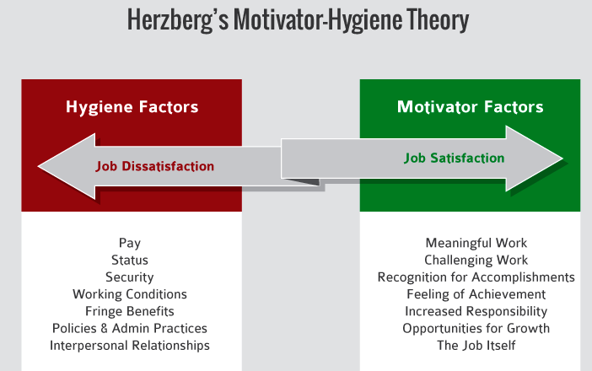
Figure 2.2 Herzberg's Motivator-Hygiene Theory" (Herzberg, 1987, p. 15)

"Herzberg emphasizes that factors that really motivate workers are either 'growth' factors or a personal fulfilment factor for the worker as a challenge to the job itself. Herzberg argues that a situation surrounding a job or an environmental factor (hygiene) causes dissatisfaction when it is in a state of poor health. These dissatisfied people can be classified as deficit needs in that their importance is felt in their absence. "(Onimole, 2015, 203)

2.3 Employee Engagement Challenge

In addition to the driving forces that have a positive impact on employee engagement, there are also a number of obstacles to recruitment and participation. Because participation is a new concept, there are still many problems to apply across the organization.
Some factors contribute to the engagement limit. For example, "job insecurity, unfairness, no space occupation, very stressful occupations with little flexibility or autonomy, poor behavior and harassment, and long breaks without working hours" (Markwich & Robertson-Smith, 2009, )
In addition, age plays an important role in determining the difficulty of participation. The employees with the highest participation are in their 20s, while the 30s-50s experience a lower level. Younger workers are more prosperous than those who settled more in their own way. (Robinson, 2007b) The longer the service period, the lower the participation rate. However, this is irrelevant to the age of the engagement challenge. For example, there are many reasons for frustration, boredom, cynicism, disappointment, etc. (Robinson, Perryman & Hayday, 2004, pp.26-27)
Other factors worthy of mention include lack of security due to accidents or injuries at work, harassment, or other development plans. These challenges can negatively affect organizational performance as well as participation levels.
(Robinson, 2007b) Bad leadership and management style means that when people do not feel that they are worth it, they have a bad influence on the level of participation when they think of leaving the manager. The relationship between employees and employers is based on trust to build a positive direction or two-way engagement. Since difficulties exist, most of the disturbances come from reasonable hygiene factors.
• Tools, work instructions and equipment equivalent for work
• Good communication, support and collaboration between the production unit employees
• Employees possess potential for work improvement and development
• Strong sense of group identity and camaraderie
• Employees have a positive mindset that drives them although many challenges in the current situation

Table 2.1 Strengths of employee engagement

The strengths in the current state of employee participation are shown in Table 2.1 above. Below, the weaknesses of the current state of employee engagement in the production unit are illustrated in Table 2.2
Work | - The employees consider that the work is monotonous, not interesting and not personal  - The employees are unaware of what is expected of them.  - Employees feel exhausted of working too long hours and  overwork with minimal breaks, therefore cannot focus on their work properly with their abilities.  - Motivation is lost and employees do not look forward to going to work  - The employees do not know for what purpose are they  working for
Leadership | - The relationships to the closest supervisor and the rest of the company staff are weak  - Case company and production unit goals not clearly defined  - Information flow within the organization is weak production unit employees not aware of the case company management  - Differences with announcements and reports between closest and senior management  - Production unit employees lack trust and respect due  to lack of support from closest and senior supervisors
Organization | - No recognition for production unit work  - Break facilities minimalistic.  - The stiff atmosphere outside the production area in the rest of the case company  - Lack of training for profession advancement

Table 2.2. Weaknesses of employee engagement in the production unit. (Jukka-Pekka Koskinen’s Master Thesis 18 Dec. 2015)

THE IMPACT OF EMPLOYEE ENGAGEMENT ON ORGANIZATIONAL PERFORMANCE

3.1 Presentation of Company A

Company A has agreed to act as a case company when the author has a six-month internship. Company A is a B2B organization that provides products and services in the areas of financial process automation and outsourcing. Currently, our main business is in almost all regions of Europe, North America and Asia through our network of partners in Latvia, Lithuania, Norway, Poland, Sweden, Germany, Slovakia, Finland, Our head office is in Helsinki, Finland. Details of the operation of Company A can be found in Table 3.1

Key figures | The year 2016
Net sales | 240.1 EUR million
Corporate customers | >11,000
Employees | 1945
Table 3.1. Company A key figures 2016 (Company A, 2016)

In the fall of 2016, A Company utilized external agencies to conduct a participatory survey on the company's credibility, respect, fairness and trust. These factors contributed to employee participation and commitment. The questionnaire contains some statements about participation and ratings on a scale of 1 to 5. 1 is totally opposite, 2 is somewhat opposite, 3 is slightly neutral, 4 is slightly agreed, 5 completely agree.
1 | totally opposite
2 | somewhat opposite
3 | slightly neutral
4 | slightly agree
5 | completely agree
Table 3.2 The category of employee participation (Company A 2016)
The results focus on the proportion of the response content or focus on exactly the same phrase (for example, 4 and 5 on the scale). Results were analyzed by the agency and returned to the average number according to the business unit. 84% of employees participated in the survey and 65% expressed trust and participation in the company. (Company A, 2016)
Over the next few years, Company A has decided to participate in an interview with the authors to achieve more than 70 percent and has decided to contribute to more observations to increase employee engagement. Regardless of existing factors, this paper aims to investigate future or unanticipated factors or challenges that hamper development as much as possible. Interviews with HR Business Partners, Human Resources Development (HRD) experts and Senior Internal Vice President of HR within the company (SVP) take place in two ways, details of which can be found in Table 3.2

Interviewee | Time of working | Interview method
HR Business Partner:  Interviewee A | 9 months | Individual face-to-face meeting
HRD Specialist:  Interviewee B | 1.5 years | Group face-to-face meeting
SVP, HR: Interviewee C | 2 years
Table 3.3 Interviewee details in Company A

3.2 Engagement In Organization A

Based on previous literature, findings, and interviews in the case study, the results have presented that support this theory and contribute to the results of the paper. Interview questions are divided into topics on job expectations, challenges, creativity, problem-solving, decision making, organizational form and hierarchy, social environment, communication, leadership, processes, awareness systems and growth potential. All of these aspects affect every part of your organization to improve engagement and contribute as a motivating factor to your organization's success. Discovery and analysis also aim to explore the actions taken by the case company to improve the levels of participation within the organization.
Company A, which focuses on financial process automation and outsourcing, provides software as a service and customer-centric service product. During the forecast period up to 2020, Company A plans to be one of the leading financial services providers in Northern Europe. Company A plans to expand elsewhere in the world.
Organization and hierarchy
Company A plans to move the company to automate procurement, invoice processing and cash flow management. To achieve this strategy, Company A focuses on the culture and values ​​within the organization. Values ​​are guidelines for working together. Our HR work has defined and built value with employees who adhere to three key areas: customer focus, enthusiasm and collaboration. HR communicates with employees and ensures that employees and leaders meet these values. In the words of Interview A: "The value of a company is a guide to knowing what we are and how we all work together internally. The value of our company is customer-focused, enthusiastic and collaborative. I want to survive alike, but I want to use each other's words to create value. "
According to the company's HR director C interview, customer focus means that all functions of the company are gathered and operated toward customers. Company A constantly meets customer expectations, which play a key role in listening to customer needs and providing the best possible business results. Interviewee C said, "I want to help customers digitize their payment processes and make their business functions easier. They focus on one customer at a time, listen to the customer, care for the customer's attention, and need it."
Passion is motivation and energy to lead people's innovation and inspiration and to succeed in their mission. "We must always be mature about what we are doing and sharing experiences to help others do their jobs ... We must take risks and challenge them to succeed." Interviewee B.
Collaboration is considered the core of Company A's strategy. Company A's collaboration means employees are working together to succeed. They are proactive in presenting ideas and solutions, working to improve and sharing best practices. HR makes all the responsibilities within the company and creates an environment where we can work together and learn from each other. A's collaboration is shared with customers as well as within the organization and is the basis for success.
In addition to strategies that run inside your organization, decision-making and problem-solving strategies contribute to your strategy.
Company A focuses on financial automation. In other words, you must comply with rules and standards in accordance with the rules and rules of your country and global context, as well as your company's local policies. Although it is difficult to meet complexity and standards and company strategy, the HR and leader's duties are communication and training.
Decisions and solutions are based on A's value on cooperation and enthusiasm for customer needs. Interviewee A said, "We have other project teams in the company that perform decision-making processes. The project is not waiting for approval from the CEO but rather waiting to take over ownership and related teams. But that does not mean that the CEO does not intervene, but we always know what projects are going on because of how to project ideas share information from the start to the finish. "
When initiating a new project or task, all information, decisions, and solutions are delivered to all parts of the company. Each team has a team manager and a number of subordinates. In order to maintain a consistent and transparent flow of information and to have responsibilities and ownership of what everyone else does, there is little information kept the secret to employees. This can happen because the structure of the company is possible.
Company A was founded in 1984 and the company's goal to create an organizational structure to date is a flat, slender hierarchy. Headquartered in Helsinki and holding offices in eight countries, the number and scope of leadership remain minimal. This means that the entire organizational group combines international talents from around the world. With an open set of skills and an innovative mindset, people are looking for new ways to work hard and meet their needs.

The value of the company
Business operations are divided into business customers in more than 100 countries across borders, and hierarchies help decision-making and problem-solving processes.
The scope of supervision is considered to be one of the notable aspects of the structure of the company. The scope of supervision is related to the number of people the manager has to report. For Company A, the level is maintained at a maximum of four levels average. Interviewee A noted: "... this means that the person in charge of a department has roughly four levels of supervisory sub-groups, including a line manager, regardless of the number of subordinates." Decreasing the level of reporting increases the flexibility and mobility of the organization and increases the power and willingness to empower and empower employees. However, when too much work and support is needed, the supervisor may be overloaded. Therefore, Company A encourages and carries out inter-team functions to help each other and minimize supervision and control. When the HR department tries to assess the company's capabilities through this solution, 68% of employees in a survey conducted by an external agency in 2016 seek new ways for their peers to do their jobs, not just their own. Interviewee B said, "It's pretty amazing how people enjoy working together. When I first started working here, I also tried to see and understand how everything worked in the first place. Others were willing to help, and lots of advice was really helpful and really appreciative ... "At the same time, in a C interview in a group interview," yes, we consider that a kind of collaboration and cross- And a role model that helps you succeed more quickly. There is a pay team staff who can meet your sales team and customers."
One of the activities that support a thin, flat hierarchy is the open space environment of Company A. According to the author's observation, the office is designed as an open workstation, so no one has his own workspace. The workspace is flexible because no space is available to anyone or there is no fixed cube. This means that CEOs, like everyone else, can be flexible and open when doing business in open spaces or communicating throughout the office. The C interviewer added: "I started here about two months after the new CEO was appointed to the company and I remember sitting down next to the workstation to communicate easily and finish his work. It's really routine to be able to collide with or sit next to you. "The environment promotes team collaboration and helps you interact with your boss. Leaders help people to know each other and help each other. Open spaces, on the other hand, help employees to simply hold their arms and supervisors when they need support. This, in turn, resolves the problem faster, improves real-time evaluation, and develops a more robust flat hierarchy. "Many customers and partners are calling us open, non-serious, unusual places and work, and it's fun to do business with us," said interviewer A.
At the time of this study and observation, A is undergoing a change in the organization. The company is divided into two smaller companies, with half of the company moving to another company, with more than half of the employees moving in early 2018. To change according to organizational reorganization, it is necessary to modify strategy and value in order to maintain a specific structure and working method. We have organized four conferences to announce news and onboarding programs with HR representatives, CEOs and other leaders during the four-month restructuring period. To participate in the decision-making process, six 6-hour discussions were held, including all employees of the company. The author was able to participate and observe the decision.
As a result, all employees and leaders agree to keep strategy and value at the core of customer lead, enthusiasm, and collaboration. A flat, slender hierarchy with an open space environment is a competitive advantage to continue to attract more talents and new employees. Because of the narrower scope of supervision, employees must take action, take initiative without supervisors, and have ownership of what they do.
Instead of relying on your own permission, you can help other teams get help and set up a strategy with your company.
Company A's HR department conducts a survey twice a year to gather feedback and measure the level of satisfaction and dissatisfaction with employees' work and supervisor relationships. Once a year, the evaluation of their performances and their relationship with the first line managers will be included in the development discussions. The result of the development discussions is that the HR and leadership team collects feedback and works on career development plans. Summarize the results of the twice-yearly survey, and the summary will be posted to all employees on multiple communication channels. "At least in our office in Tallinn, we had no negative feedback on the relationship between the staff and the supervisor, and we are confident that it is the same in other offices." Interviewee B said and interviewee C agreed. The same is true for Helsinki. I know I have never had a serious conflict in another office before. "
Business processes
A process can be seen as the most relevant component between an organization and KM, a way to store and access information and knowledge sources. Process A processes business processes as well as managed and informal processes when new ideas are deployed or creativity rises from the inside. An informal process is a self-organizing process and increases the likelihood of "face-to-face conversations and information transfer" with a flat, slender hierarchy of open spaces. (Galbraith 2014, 38 pages)
Unofficial processes are now turning to Enterprise 2.0, which includes e-mail, social media, and other software programs. The social media tools available to businesses are called Yammer for community building, and Wiki and Microsoft Sharepoint are used to communicate and distribute work. (Gall Brace 2014, 38)
Interviewer B, an HRD specialist, claims Yammer is widely used to facilitate informal discussions at work. But A has just started using the Yammer from the end of 2016. Yammer has not been used in all employees. According to interview B, about one-quarter of the users in Yammer is active. "Active users mean sharing information and starting a discussion for everyone to participate. Another 1/4 is a little more active, But do not participate in discussions, and do not use the other half at all, but generally in the old generation.
To address this issue, the HR team encourages other managers to use the Yammer as much as possible with the leadership team. Yammer is used inside the team and throughout the team. They encourage employees to engage everyone by sharing best practices in business, lessons learned from business failures, and even funny information. All results from all projects appear transparent in one shared source. This means that everyone can learn from mistakes, develop best practices and apply them to their work. This allows them to interact with each other in real time and ensure fairness within the company. For example, "An information technology (IT) employee can learn how project management is performed, and later, if you want to try new tasks from another team, you can take on other responsibilities later. If the ability is appropriate for the task, "said interviewer B.
Management processes related to the source of the information needed to perform the task and the information flow within the organization. Company A uses the intranet to share all business information, not just the information store. All the knowledge and information that an employee need is stored on an intranet that is divided into sections and business functions. In addition, it is a dedicated wiki page for all teams and is accessible to everyone. The automation-centric HR team declared that the company handled the information flow fairly well. They can use a software program that can store information according to the needs and characteristics of information so that all employees can do what they need to do when they log in and use their credentials. Along with the HR team's capabilities, the management team also participates in controlling, managing, and updating the information when needed.
One of the problems with the management process is in controlling the software programs you use. As technology and programs are updated frequently, many employees are confused and confused. Occasionally, when the conditions of a laptop are not enough for the required tasks, or if all the necessary software is not available due to licensing, some employees find a lack of emancipation. Human Resources has gathered feedback on this issue, but we can not immediately implement a solution that gives everyone freedom because everyone has access to all the information. Interviewee C says, "We are receiving feedback on the confusion that we have the right to use our technology and the many channels we have for communicating in recent years, mainly because we are updating every channel with a little hassle, It will change as necessary to allow for feedback ".
As part of information flow management, Company A started its training team in early 2017. Our goal is to collect all the information about our products and services on one channel and share knowledge with all our employees. Working with other teams, the training team gathers information, transforms it into a simple and engaging format, such as video or presentation, and encourages employees to learn and learn the site. Increased shared information and knowledge and transparency in the work of each team are provided to better understand the business and collaboration. Interviewees B and C both said, "The training team is one of the best things that happened to this company recently. Information is available in one place, and you can always know about your products, services and how to work." "I agree ... I also have the skills to design, so I am willing to participate with other teams, presentations and videos. We are actively involved".
Business processes arise when new ideas are promoted or encouraged. You can develop new ideas based on all your ideas. Ideas can be discussed through Yammer. You can make suggestions within your office area or directly to your leader or CEO. Ideas must go through trial and error to meet company value and cost-effectiveness. Ideas for success can be implemented in new projects. Ideas that may not be successful can be understood, heard, and discussed as open as possible.
Interviewee A said, "There is no stupid idea, we are trying to spread that view to everyone, even supervisors are sometimes willing to pitch ... because it is useful at some point… "
Rewards system
The majority of the employees who are doing business over 30 years are quite young. Employees are encouraged to rotate within their organization to change to another team to gain new experience and inspiration. From an HR perspective, most employees are thrilled with their responsibilities and challenges. Once a year, HR has a one-hour development discussion session to work with a line manager to assess work and work paths and provide more opportunities for employees if they want. Promotions and recommendations can be done with the approval of the first line manager, so you can shorten your results to the time you wait for the top team to decide. Interviewee C said, "We use management software for HR issues and personal information. Employees can add details about themselves when they change their address or something ... and can clearly see the current vacancy there. Employees play a leading role in finding new challenges in other positions, and employees
Interviewee B also added: "With regard to development discussions, we have a section for further learning, that is, we can find the lessons or topics that employees feel will improve their performance, and they can learn during work hours. I will pay a little. "
It is very important that employees develop new challenges and changes more and more continuously. Interviewee A said: "We are a very young and dynamic organization.
Daily work. It is essential to provide the necessary vocational training not only for starting a job but also for daily business hours. Many employees challenge themselves through new work or new job experiences and strive to make our possibilities possible. As much as we can. "
If someone finishes the project successfully, they can be praised in the Yammer or HR system. Sometimes there is a small bell in the kitchen area of ​​the office and you can ring the bell to praise it. Interviewees B and C both laughed. "We love doing things in the office, it's a kind of motivation factor, people actually use bells to celebrate what they've done to make a small slip chat in the kitchen. I was motivated to say, "Yes, that's right ... I was so special and inspired when Belle was actually ringing. "
At the beginning of 2017, Ambassadors "are issued every six months. This is to praise and commend even the employees and the team. Do a great job with the value of your company. The prize money is determined by the Human Resources department and is generally shared with dinner reservations or team building activities. In the first half, the training team was awarded as the first ambassador. "They highly appreciated it and were motivated much later," Interview A claimed.
Social environment
Due to the flat hierarchy and the open workspace, the communication style is considered to be open at Company A because the CEO or HR head can sit between the employees. HR encourages employees to communicate with other employees.
Share new ideas with team members and share them with others without waiting for approval from the first line manager.
When you join a new employee, you get help and support from the HR department as well as the manager. The induction ceremony is held twice a year, and the CEO and HR department head Company overview Strategies, presentations on products and services. Judo sessions are recorded and shared on the intranet for Yammer and the missing persons. Through collaboration between the HR team and the training team, it is a good idea to learn and become familiar with the new employee as quickly as possible. Interviewee A commented, "The first person in charge of honesty is not the only one who is responsible for the new employee. The HR team's chief and officer as well as everyone's support ... We have all the information, company introduction and mandatory testing We need to create a welcome package to include new people in our culture and values ​​as soon as possible".
As a social life at work, A's HR department chooses bright colors as their color culture. As Interviewee B said: "It is common to maintain a desirable atmosphere in the workplace, not just vigorous and vibrant colors. It emphasizes courage and commitment to change and a passion for a better direction ..." We go out five or six times a year to help employees develop a culture of mutual awareness and mutual understanding. C interviewee added: "We want everyone to feel comfortable and balance their work so that they are not stressed at all. When stressed, they can not work properly, they will affect both the company and others, and we do not recommend it here."
Interviewee C, "As noted in two surveys each year to measure employee satisfaction and dissatisfaction with the organization," For the entire organization and the HR team, people are generally happy inside the workplace.

RESULT
As a result, the employee has a significant impact on the development of the organization. “Employee engagement is a hard-nosed proposition that not only shows results but can be measured in costs of recruitment and employee output”. (Markwich & Robertson-Smith, 2009, p. 16)
As you can see in Figure 6, there are three types of employees that can impact organizational business results. The best scenario for any organization is to increase the number of high-engagement employees and maximize the benefits of employee engagement.

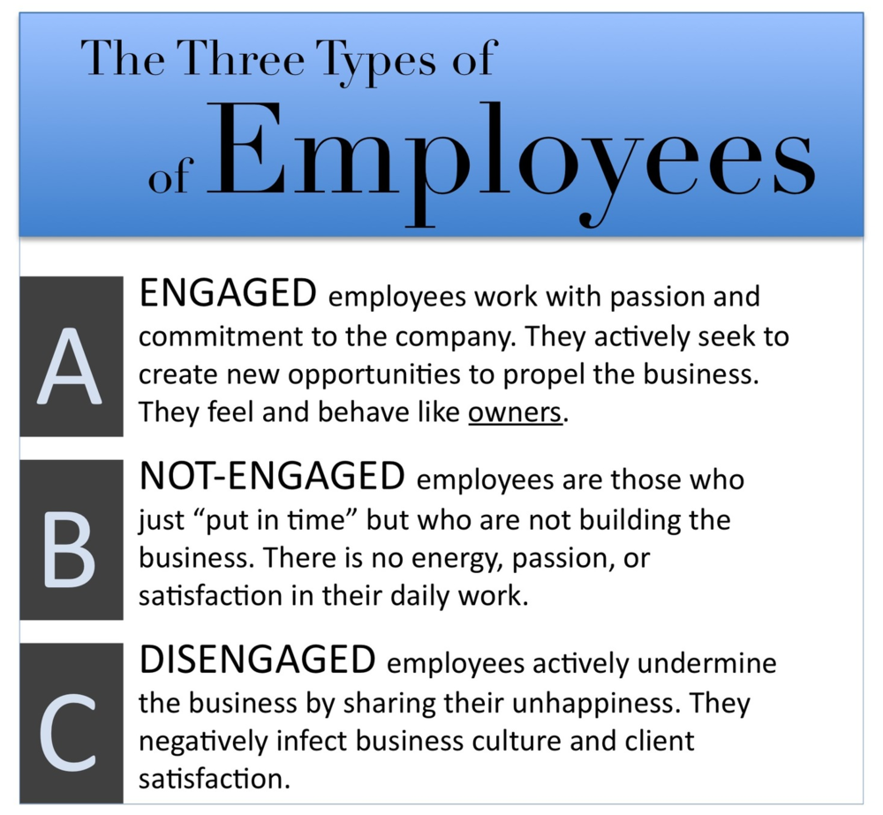
Figure 4.1. Three types of employees (Krueger & Killham, 2006)

Benefits and results of employee engagement are divided into two themes or known in both directions. It is known for its organizational benefits and employee benefits. These benefits are interdependent. The characteristics of engaged employees can be seen in Figure 7.
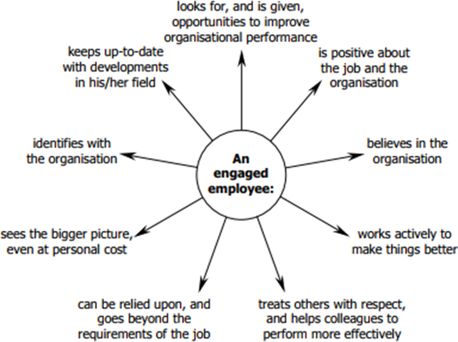
Figure 4.2 Characteristics of an engaged employee (Robinson, Perryman & Hayday, 2004, p.6)

Employee engagement helps organizations grow more effectively in the performance area, from process to results. The employee's performance and performance can affect the organization in a positive way. They believe in the organization, develop it, develop it, identify it with the organization, rely on it when things get tough, and see the importance of the organization in the same way that they see it. In its report on employee involvement in 2010, organizations with more than 65% participation in the economic challenge period outperformed the overall stock market index, with a 22% higher total shareholder return than the average. On the other hand, organizations with low participation rates (less than 45%) had a 28% lower total shareholder return than the average. "(MacPherson, 2013, p. 3) As a result, employee engagement not only helps your organization achieve the best performance in your business, but it also keeps you in the best possible workplace and increases employee retention.
Employee involvement impacts productivity and ultimately leads to customer loyalty to the company. "Engaged employees are more likely to work hard, be loyal, and go" extra miles "for the company." (Markwich & Robertson-Smith, 2009, p.16) Engaged employees stay in the organization, And make customers more loyal to their organizations.
Levinson (2007) states that "Customer loyalty, recurring purchases, and referrals to a friend are twice as likely as average employee involvement in the department where engaged employees are engaged." (Markwich & Robertson-Smith, 2009.)
On the other hand, employee participation is good. In the traditional way of working for many years, employers must create a working environment, set expectations, and ensure that the work itself is attractive and challenging to employees. Recently, this perception has changed in a way that wonders how employees can challenge and evolve in a particular environment. Employees want to participate in the process of developing their own values, goals and career development. (MacPherson, 2013, p. 5) Participation improves your workforce and gives you the opportunity to invest and develop on your own with the value of your organization. "A combination of employing and expressing the preferred self-harvesting behaviour of people who live their roles and relationships" (Markwich & Robertson-Smith, 2009, p.21)
In fact, engaged employees ultimately do three things that help improve organizational performance.
- Say: The employee promotes the organization for his colleagues, supports and identifies the organization by acquiring potential employees and customers.
- Stay: The employee who is involved is more likely, although he can work and change work to somewhere else and/or he / she really wants to remain.
- Strive: The employee spends more time, effort and initiative in supporting and promoting the organization's success and sees the success as important for the company. (Markos & Sridevi, 2010, p. 92)

CONCLUSION AND RECOMMENDATION
The purpose of this study is to explore the driving and obstacles that affect the engagement of employees in enterprises. To achieve this goal, theoretical and empirical frameworks focus on the concept of employee engagement and how employee engagement enables a successful and efficient in organization.
On the theoretical side, the concept of employee participation is studied according to precedence, outcomes and influencing factors. To identify factors, motivation is considered on the assumption that emotional drivers have a greater impact on participation than real drivers. Motivation and factors appear to drive engagement within the organization. References and case objects show that internal feelings or motivations help increase participation levels while hygiene factors are important not to lower participation levels.
We interviewed the case company to test the estimates of the factors and found that the findings based on the discussion analysis helped the company’s development. It is believed that the recommended results will contribute to getting more insight into the topic. Regardless of the industry or size of the company, it is intended to help companies pay more attention to the importance of employee engagement.
Based on the results of the research and the observations, we proposed what to consider when setting up a strategy. To be successful, the case company must evaluate and adjust to better match the modern situation. Factors and situations change as time and industry change, so one-dimensional studies can not.
As mentioned in the thesis section, research is done from the perspective of the HR representative. More research and discovery is recommended for a clear understanding of the employee's perspective. In addition, participation levels and possible influencing factors may change due to differences in personal preference.
The elements of this study will be studied for the time being based on the current situation of the company. When a business changes, the company must also consider changes in the factor of engagement. Depending on industry and business scope, companies must change their research and plan accordingly.

REFERENCES
- Bakker, A.B., & Leiter, M.P. (2010). Work engagement: a handbook of essential theory and research. New York, NY: Psychology Press.
- Bakker, A., & Schaufeli, W. (2008). Positive organizational behaviour: engaged employees in flourishing organizations. Journal of Organizational Behavior.
- Bernardin, John. H. (2003). Human Resource Management – An experiential approach. New Delhi. India: Tata McGraw Hill Publishing Company Limited.
- Buckingham, M., & Coffman, C. (1999). First, break all the rules: What the world’s greatest managers do differently. New York, NY: Simon & Shuster.
- Buckingham M., and Coffman C. (2005). First, break all the rules. London. UK: Pocket Books.
- Coffman, C., & Gonzalez-Molina, G. (2002). Follow this path: How the world’s greatest organizations drive growth by unleashing human potential. New York, NY: Warner Books.
- Hay Group’s survey research division. (2009). Engaging and enabling employees to improve performance outcome. Hay Group Insight.
- Holbeche, L., & Springett, N. (2003). In Search of Meaning in the Workplace. Horsham, Roffey Park.
- Leena, P. Singh, & Binita, P. ( ). Employee Engagement in Indian Scenario - A Case Study of Tata Tele Services Limited (TTSL). DRIEMS Business Review.
- Maslach, C., Schaufelli, W.B., & Leiter, M.P. (2001), Job burnout. Annual Review of Psychology.
- William H. Macey, Benjamin Schneider, Karen M. Barbera and Scott A. Young Employee Engagement Tools for Analysis, Practice and Competitive Advantage (2009 Valtera Corporation)
- Terry Pegg, (2009) “Creating Engagement Through Employee Benefits”, Strategic HR Review
- 2nd International Conference on Managing Human Resources at the Workplace, December 13-14, 2013
- David B.Zenoff(2009) The Soul of the Organization “How to Ignite Employee Engagement and Productivity”
- Research Review of International Journal of Multidisciplinary September 2018
- A Report by Harvard Business Review Analytic Services, The Impact of Employee Engagement on Performance
- Elbruz Erdoğan, İstanbul, Mayıs 2018, Örgütlerde İşçi Motivasyonunun Verimliliğe Etkisi
- Jackson, S. E., & Schuler, R. S. (2003). Managing human resources through strategic partnerships (8th ed.) (p. 286). Cincinnati, OH: South-Western.
- Halbesleben, J. R. B., & Buckley, R. M. (2004). Burnout in organizational life. Journal of Management
- Halbesleben, J. R. B., & Bowler, W. M. (2007). Emotional exhaustion and job performance: The mediating role of motivation. Journal of Applied Psychology
- ArunKumar, K., & Renugadevi, R. (2013). Antecedents and Consequences of Employee Engagement - A Hypothetical Approach. Journal of Business and Management, 9(3), 52-57. Retrieved November 1, 2017, from
http://iosrjournals.org/iosr-jbm/papers/Vol9-issue3/G0935257.pdf
- Baumruk, R. (2006). Why managers are crucial to increasing engagement: Identifying steps managers can take to engage their workforce. Strategic HR Review, 5(2), 24-27. Retrieved October 29, 2017, from https://doi.org/10.1108/14754390680000863
- Bergeron, B. (2003). Essential of Knowledge Management. Hoboken, New Jersey: John Wiley & Sons, Inc. Retrieved November 1, 2017, from http://www.cos.ufrj.br/~jano/LinkedDocuments/_papers/aula06/Wiley% 20-%20Essentials%20of%20Knowledge%20Management.pdf
- Bhojararu, G. (2005). Knowledge Management: Why do we need it for corporates. Malaysian Journal of Library & Information Sciences, 10(2), 37-50. Retrieved November 1, 2017, from
http://eprints.rclis.org/7158/1/KM_why_do_we_need_for_corporate.pdf
- CIPD. (2009). An HR director's guide to employee engagement. Discussion paper, Chartered Institute of Personnel and Development. Retrieved October 26, 2017, from
http://www2.cipd.co.uk/NR/rdonlyres/8DD2561A-D3E3- 4E63-9F63-
- EF74736A17B1/0/hr_director_guide_employee_engagement.pdf Dalkir, K. (2005). Knowledge Management in Theory and Practice. Burlington.
- Elsevier Inc. Retrieved November 2, 2017
- Dartey-Baah, K., & Amoako, G. K. (2011). Application of Frederick Herzberg’s Two- Factor theory in assessing and understanding employee motivation at work: a Ghanaian Perspective. European Journal of Business and Management, 3(9), 1-8. Retrieved November 3, 2017
- Edwards, R., & Holland, J. (2013). What forms can qualitative interviews take? In R. Edwards, & J. Holland, What is Qualitative Interviewing? (pp. 29-42).
- London: Bloomsbury Academic. Retrieved December 27, 2017, from http://dx.doi.org/10.5040/9781472545244

