Republic of Azerbaijan
Ministry of Education

Development of European electricity transmission:
Challenges and opportunities. Nord Pool practice
Name_Ilkin Karimov
UNEC SABAH
University of Economics

Baku 2019
Table of Contents

Abstract 3
Acknowledgement 4
1.Introduction 5
1.1 Research methodology 6
CHAPTER 2. Theoretical analysis 7
2.1 Theoretical and methodological basis of European electricity transmission 7
2.1.1 Role and concept of European electricity transmission 7
2.1.2 Global development of electric power market. 11
2.1.3 Influence of advanced technologies on International electricity grid development in the modern world 16
2.2 Renewable energy policy 20
2.2.1 Institutional composition of energy security and innovations 20
2.2.2 Drivers of renewable energy policy 27
2.2.3 Socio-economic impact of alternative energy on sustainability 30
CHAPTER 3. Challenges and opportunities of development NordPool practice 37
3.1 Global electricity practice 37
3.1.1 Challenges of development of European electricity transmission 37
3.1.2 Opportunities of development of European electricity transmission 42
3.1.3 Long-term forecasts on NordPool practice 48
Conclusion 51
Reference 54

Abstract
During the research, it was proved that when creating an effective methodology for analyzing the importance of NordPool Practice, there is an objective need to take into account all indicators that may affect the mechanism for assessing its activities and making decisions. A current electricity transmission occurred, since the demand rose faster than the generation capacities increased. During the last 10 years, the governments have implemented a variety of mid- and long-term programs and projects to enable further capacities, and to ensure onward sustainable development. Therefore, importance of NordPool Practice is increased.
The framework of the thesis includes a literature research to highlight the current challenges and to justify the need for a sufficient forecast method regarding an increased amount of European energy transmission. Therefore, knowledge about system loads behavior, such as evaluations regarding high demand scenarios and fluctuation bandwidths, is developed. The result contains a variety of information about the prospective supply, which might serve for trendsetting decision-making.

Acknowledgement

The accomplishment of my postulation to a great extent relied upon the support of different key job players. I wish to offer my earnest thanks to my postulation counselor Ms. Parvin Mammadzade, Advisor to Chairman at the State Agency on Alternative Energy, for help and recommendations in research. What's more, I expand my appreciation towards the Dean of SABAH Groups, Mrs. Aida Qulieva. She doesn't know now and presumably will never realize the amount she helped me on my exploration and my point of view.

Thank to my educators, who have been there constantly for me, and to everybody who has added to my advancement amid my examinations.

Introduction
At present, NordPool Practice sources play the instrumental role in stimulation global world economy. Strong demand of energy was necessary to understand the importance of transmission sources, in which the government would be able to accumulate revenues and manage them in favor of the country. Nowadays, the global world depends on petroleum profits and financial management of petroleum countries for preventing domestic Dutch disease. Therefore, states are trying to improve using NordPool Practice to overcome this dependency and maintain economic sustainable balance. The consumption of alternative energy sources can save us money, assure that in next generations will have enough energy, and free us from the uncertainties of depending on foreign energy suppliers.
The purpose of the diploma work is to explain the importance of European energy transmission for economic sustainability and comparable analysis of impacts of NordPool practice to state policies. Then analyze comparably long-term energy plan.
The subject of research is the economic and political sustainability of emerging and emerged countries on development of energy channels.
The objects of research are emerged global energy drivers and flourishing developing states.
Problem statement - this writing assignment analyzes several types of implementation –management of NordPool Practice, positive and negative sides, and the ways of revenue energy for future generations.
The research questions are the followings:
- The role and influence of the NordPool practice on domestic economy of the countries
- The ways of using of energy transmissons and its further implementation
- The ways of increasing of energy security and innovations
- The drivers of renewable energy policy
- Influence of RE policy on economy of European Countries.
- Future vision and forecasts on global and national NordPool practice fields.

1.1 Research methodology
The idea of the examination will be blended, utilizing exploratory and inductive research types. Because of exploratory research, the subjective philosophy will be utilized so as to pick up bits of knowledge in vitality channels. The investigation will utilize one of the basic subjective approach structures. Following structure is proposed for procedure; in the primary stage, different researcher articles will be utilized to discover the structure and the examples in execution and utilization of Nordpool pracitce.

In the second stage, approach will be utilized to gather information through meetings, reports and perceptions of the picked nations. The exploration will concentrate on data and experience of driving NordPool practice client nations, particularly creating nations. Additionally, the methods for vitality security and improvement of elective vitality strategy in European Countries. In the prescient piece of the examination, the estimate of things to come sway on the executives and business culture of these nations will be given by summing up from the investigation of contextual investigations and the expectations.

CHAPTER 2. Theoretical analysis

2.1 Theoretical and methodological basis of European electricity transmission

2.1.1 Role and concept of European electricity transmission
The re-equipment and upgrading of the technical level of transmission and distribution networks is a priority for the European electricity supply system. The existing networks are aging; they are mainly designed for centralized production of high power with weak interconnections. In addition, their reliability is affected by constantly increasing network overloads, the increasing popularity of sustainable power sources (RES) and dispersed vitality assets (DER).
During the recent decade, the state of the electricity grid remained virtually unchanged, despite technological innovations and the development of economic and legislative frameworks. Now, the issue of modernizing networks to ensure safe and uninterrupted power supply has become acute, taking into consideration the tasks of the European energy policy in a changing climate.
Currently, the European power industry is undergoing great changes. Change to a low-carbon economy implies the expanding job of sustainable power sources, increment vitality proficiency and electrification of transport and other sectors. it's the same It involves giving consumers a more meaningful role, allowing them to manage their own actively stimulate, produce electricity for self-consumption and feed the surplus in grid. In this context, there is a need for electricity markets, regulatory requirements and technical infrastructures to adapt to a world in which large utilities no longer dominate the market. In addition, markets should be reworked in a way that energizes interests in low-carbon advancements, while ensuring safety costs of supply and maintenance of control over households and industry. This briefing provides an overview of the operation of electrical networks and major features of the EU electricity markets. The European Parliament the resolution of September 2016 gives a clear position on various aspects of this project.
The EU is in the process of transforming its economy to minimize emissions of greenhouse gases (GHGs). It is expected that electricity will play a important role in this low-carbon transformation. First, more efficient use of electricity and a growing share electricity from renewable sources will help lessen GHG discharges from power age. Secondly, it is expected that the share of electricity in total energy usage will increase, especially in the transport sector (electric vehicles), as well as in heating and cooling (electric heat pumps). Such widespread electrification in combination with low-carbon generation is considered as a key component for the gradual elimination of ozone harming substance outflows from non-renewable energy sources continuously 50% of this century. Fulfillment of all these changes requires significant investments in electricity generation, transport and distribution, as well as in the production of consumer goods. Competition how to secure these investments while retaining affordable electricity for both households furthermore, vitality escalated businesses. Moreover, investment and innovation necessary to ensure the stability of electricity supply in the face of higher demand and an increasingly variable supply from renewable sources, which depends on sunlight, wind and precipitation. Electricity markets should be reconstructed in such a way as to ensure their support for the EU's political goals, by:
- promotion of investment in the production of flexible low-carbon electricity;
- promoting investment in a stable and adaptable network that is suitable for an expanding offer of sustainable power sources and new uses of electricity;
- stimulation of the consume of energy efficient equipment and consumer goods;
- providing affordable energy for industry and households.
This briefing contains background information on current discussions on power showcase plan, for which the European Commission is planning a legislative proposal. It explains how the power grid works, which players are involved and how electricity markets are organized. In addition, it provides an overview of the main trends and problems facing the electricity markets in the coming years.
The electrical system consists of a physical infrastructure for generating electricity, on the one hand, transport and use, and on the other hand, an organized electricity market. The physical grid, that is, the flow of electricity, consists of electricity generators and electric transport systems, which are typically separated into systems for long-range transmission and distribution systems for residential and industrial consumers of electricity. The electricity market, that is, the flow of money, consists of:
- Electricity suppliers who buy electricity from generators and sell it to costumers;
- Consumers who use electricity and pay suppliers through their accounts;
- Transmission system operators (TSOs) who are paid for long distance transport electricity and ensuring system stability;
- distribution network operators (DSOs), who are paid for the delivery of electricity in consumers; and
- Regulators that establish rules and control the functioning of the market.
In addition, we need to describe existence one of the main organization in this direction – ENTSO-E (European Network of Transmission System Operators for Electricity). European system of framework administrators for power transmission - an association that unified in July 2009 the electrical networks of ATSOI, BALTSO, ETSO, NORDEL, UCTE and UKTSOA. An established version of the translation of the name of the organization into Russian is currently not available. In the terminology of JSC "SO UES" ENTSO-E is translated as "European Community of Transmission Network Operators in the Electricity Industry".
The declared goals of the organization are:
- Ensuring the interaction of system operators of the pan-European and regional level
- Promoting the interests of system operators
- Rulemaking in accordance with the legislation of the European Union
ENTSO-E mission is to ensure reliable operation, optimal management and development of the European transmission framework so as to guarantee vitality security and address the issues of the residential vitality advertise. ENTSO-E members are 43 framework administrators from 36 countries.One of the fundamental accomplishment in power strategy of Europe is the synchronous matrix of Continental Europe. The synchronous system of mainland Europe (otherwise called the Continental Synchronous Zone, in the past known as the UCTE lattice) is the biggest synchronous electrical system (by associated limit) on the planet. It is associated as a solitary stage inverter coordinate with a recurrence of 50 Hz, which gives in excess of 400 million clients in 24 nations, including a large portion of the European Union. In 2009, 667 GW of intensity were associated with the system, giving around 80 GW of save saves. Transmission framework administrators working with this matrix have shaped the Union for the Coordination of Transmission of Electric Power (UCTE), which is currently part of the European Transmission Network Operators Network (ENTSO-E).
The synchronous network of continental Europe covers the territory of Europe ENTSO-E Continental Europe and some neighboring countries that do not participate in ENTSO-E. The synchronous grid includes part or all of Austria, Belgium, Bosnia and Herzegovina, Bulgaria, Croatia, Czech Republic, Denmark (western part), France, Germany, Greece, Hungary, Italy, Luxembourg, Macedonia, Montenegro, Netherlands, Portugal, Romania, Serbia , Slovakia, Slovenia, Spain and Switzerland in accordance with the regional groups ENTSO-E Continental Europe. In addition to ENTSO-E members, the small western energy island of Ukraine is synchronized with the network of continental Europe. Albania works with the national network synchronously with the synchronous network of continental Europe. The networks of Morocco, Algeria and Tunisia are synchronized with the European network via the Gibraltar connection line and the SWMB area. In 2015, it was synchronized with the European network.
Although synchronously, some countries work in the regime of a nearby island, with low connectivity with other countries. The European Commission believes that high mobility is beneficial, and listed several projects of accession as "Projects of common interest". However, national networks also need to be modernized to cope with increased energy flows if the energy market values ​​are to be realized in the EU.

2.1.2 Global development of electric power market.
Electricity is the basic infrastructure sector, supplying electricity and heat to all other sectors of the economy. Energy consumption directly relates to the level of social and economic development, and the overall business activity, and the life of each person. Only in the last decade, electricity production in the world has grown by almost 1.5 times. Noticeable changes occur in the ratio of the fuels used and in the geographic structure of the global energy market. The two largest producers of electricity, far ahead of all others, are China and the United States.
Electric power is the basic infrastructure branch in which the processes of production, transmission, and distribution of electricity are realized. It has connections with all sectors of the economy, supplying them with electricity and heat, and receiving from some of them resources for their operation.
The role of the electric power industry in the twenty-first century. Remains extremely important for the social and economic development of any country and the world community as a whole. Energy consumption is closely related to business activity and the standard of living of the population. Scientific and technological progress and the emergence of new sectors and sectors of the economy, improving technology, improving the quality and improving the living conditions of people lead to the expansion of energy use and increasing requirements for reliable and uninterrupted power supply.
The characteristics of the electric power industry as an industry are determined by the specifics of its main product. Electric power is similar in its properties to the service: the time of its production coincides with the time of consumption. Electric power engineering should be ready for generation, transmission and supply of electricity at the time of demand, including in peak volume, having for this purpose the necessary reserve capacity and fuel reserve. The greater the maximum (at least short-term) value of demand, the greater the capacity should be to ensure readiness for service delivery. (The situation will change if there are effective technologies for storing electricity, while these are mainly batteries of different types, as well as pumped storage stations.)
The impossibility of storing electricity on an industrial scale predetermines the technological unity of the whole process of its production, transmission and consumption. Probably, this is the only branch in the modern economy, where the continuity of production must be accompanied by the same continuous consumption of it. Due to this feature in the electric power industry, there are strict technical requirements for each stage of the technological cycle, including the frequency of electric current and voltage.
The basic feature of electric energy as a product that distinguishes it from all other types of goods and services is that its consumer can influence the stability of the manufacturer's work.
The needs of the economy and society in electric power depend significantly on weather factors, time of day, technological regimes of various production processes in consumer industries, household characteristics, even from the program of telecasts. Differences between the maximum and minimum levels of consumption determine the need for so-called reserve capacities, which are included only when the consumption level reaches a certain value.
Economic characteristics of electricity production depend on the type of power plant, the degree of its loading and operating mode, the type of fuel. Other things being equal, the electricity of those stations that generate it at the right time and in the right amount with the lowest costs is most in demand.
In view of all these features, it is common to combine devices that produce energy (generators) into a single energy system, which reduces the total production costs and reduces the need for reserving production capacities. The system needs an operator that performs coordinating functions. It regulates the schedule and volume of both production and consumption of electricity. The system operator makes decisions based on market signals from producers (about the possibilities and cost of electricity production) and from consumers (about the demand for it at certain time intervals). Ultimately, the system operator must ensure reliable and safe operation of the energy system, effectively meeting the demand for electricity. Its activities are reflected in the production and financial results of all participants in the electricity market, as well as on their investment decisions.
The main electricity producers are:
Thermal power plants (TPP), where the thermal energy generated by the combustion of fossil fuels (coal, gas, fuel oil, peat, shale, etc.), is used to rotate the turbines that drive the power generator. The possibility of simultaneous production of heat and electricity led to the spread of district heating in a number of countries to the CHP;
hydroelectric power (HPP), where the mechanical energy of the water flow is transformed into electric power by means of hydraulic turbines rotating electric generators;
nuclear power plants (NPPs), where the thermal energy generated in the nuclear reaction of radioactive elements in the reactor is transformed into electricity.
Three main types of power plants determine the types of energy resources used. They are divided into primary and secondary, renewable and non-renewable.
Primary energy sources are raw materials in their natural form prior to any technological processing, for example, coal, oil, natural gas and uranium ore. In colloquial speech, these materials are simply called primary energy. To such also include solar radiation, wind, water resources. Secondary energy is a product of processing, "ennobling" the primary, for example, gasoline, fuel oil, nuclear fuel.
Some types of resources can be relatively quickly restored in nature, they are called renewable: firewood, reeds, peat and other biofuels, hydro potential of rivers. Resources that do not have this quality are called non-renewable: coal, crude oil, natural gas, oil shale, uranium ore. For the most part, they are minerals. The energy of the sun, wind, sea tides refers to inexhaustible renewable energy resources.
At present, coal is the most widespread type of technological fuel in the world electric power industry. This is explained by the relative cheapness and wide prevalence of stocks of this type of fuel. However, transportation of coal over significant distances leads to high costs, which in many cases makes its use unprofitable. In the production of energy using coal, the level of emission of pollutants into the atmosphere is high, which causes significant harm to the environment.
The expansion of the use of gas in the world electric power industry in recent years is explained by the significant increase in its production, the emergence of highly efficient electricity generation technologies based on the use of this type of fuel, as well as the tightening of environmental protection policies.
The use of uranium is becoming more widespread. This fuel has tremendous efficiency in comparison with other raw energy sources. However, the use of radioactive substances is associated with a risk of large-scale pollution of the environment in the event of an accident. In addition, the construction of nuclear power plants and the utilization of spent fuel is extremely capital intensive. The development of this type of energy is complicated by the fact that so far few countries can provide training for scientific and technical specialists capable of developing technologies and ensuring the qualified operation of nuclear power plants.
Hydro resources are of great importance in the structure of electric power sources, although their share has decreased somewhat in recent decades. The advantages of this source in its renewability and relative cheapness. However, the erection of hydroelectric stations has an irreversible impact on the environment, since it usually requires flooding of significant areas when reservoirs are created. In addition, the uneven distribution of water resources on the planet and the dependence on climatic conditions limit their hydropower potential.
The significant reduction in the use of oil and petroleum products for electricity production over the past thirty years is explained by both the increase in the cost of this type of fuel, its high efficiency in other industries, and the high cost of transporting it over considerable distances, and the increased requirements for environmental safety.
There is an enormous interest in renewable energy sources. In particular, technologies for the use of solar and wind energy are actively being developed, the potential of which is huge. True, to date, the use of solar energy on an industrial scale in most cases is less effective than traditional types of resources. With regard to wind power, in developed countries (primarily under the influence of environmental movements) its use in the electric power industry has significantly increased. We should also mention geothermal energy, which can have serious significance for some states or individual regions (Iceland, New Zealand, Russia - for Kamchatka, Stavropol and Krasnodar regions, Kaliningrad region). The development of electricity production based on renewable resources still requires state subsidies.
In the late XX - early XXI century. Sharply increased interest in bioenergetic resources. In some countries (for example, in Brazil), the production of electricity on biofuel accounted for a significant share in the energy balance. In the US, a special program for subsidizing biofuels was adopted. However, there are also doubts in the prospects of this direction of the electric power industry. They relate primarily to the efficiency of the use of natural resources such as land and water; thus, the withdrawal of vast areas of arable land for biofuel production contributed to the doubling of prices for food grains.

2.1.3 Influence of advanced technologies on International electricity grid development in the modern world
The role of information technology is especially great in strategic sectors of the economy, one of which is energy. After all, the more complex the production, the more acutely it needs more automation of the processes occurring in it. According to experts in the field of electric power industry, the development of this industry currently has a number of serious problems, which precludes the efficient operation of all electric power processes. All generating equipment has undergone aging and wear. This can lead to technological failures, accidents.
The most acute problem of stable operation of power grids is called an excessive increase in the operating voltage to sometimes completely unacceptable values, while the power industry most of all needs continuous, uninterrupted operation. Experts have long been saying about the need for the global introduction of innovative technologies in the energy sector and the full automation of the power grid complex.
In order to proceed to the modernization of power generating companies, the need arises to develop high-tech information solutions. Thus, when upgrading equipment, there is an increase in the degree of its reliable operation, significant fuel savings, as well as reduced consumption of resources for its maintenance. Automation of technological processes increases production efficiency and guarantees the protection of the external environment.
Centralized monitoring of the technical condition of power units and other equipment, as well as observance of industrial safety rules, are indispensable conditions for the stable operation of thermal power plants and hydroelectric power plants (RusHydro’s experience in setting up monitoring centers is quite indicative). Creation of such centralized monitoring systems is possible through the use of modern data exchange protocols (Fiber Channel (FC), iSCSI (based on Gigabit Ethernet and 10G Ethernet), Infiniband) allowing to connect geographically-remote monitoring systems with the main Data Processing Center (DPC). Further development and growth of server capacity based on Intel x86 architecture (for example, Lenovo Thinksystem, HPE Proliant, Dell PowerEdge, Cisco UCS C-series), combined with the use of virtualization technology (Citrix, Microsoft's Hyper-V, VmWare) can significantly reduce the fleet servers in the field, shifting the critical information tasks for processing and reliable data storage to the central data center.
The electricity grid to accommodate higher percentage of renewable energy would need large quantities of conventional back up power and huge energy storage. These would be necessary to compensate for natural variations for power generated depending on the time of day, season and cannot handle this variability, the cost of adopting the renewable energy sources is much more expensive than it should be. This section addresses the definition, benefits and barriers of smart grid renewable energy, role of renewable energy and distributed generation in smart grid, PV smart grid system, and work done in smart grid system.
Smart grid is defined as the electricity networks that intelligently integrates generators and consumers to efficiently deliver electricity, which is sufficient capacity and coverage area accessible, safe, economic, reliable, efficient, and sustainable. Smart grid development tends to be driven by one of the two principal visions for enhancing electric power interactions for both utilities and customers. The growing installations of renewable energy resources require a coordinated effort from the planning stage all the way down to the electronic devices used for power generation, distribution, storage and consumption. The benefits of smart grid renewable energy system are summarized in Table 1.
Table 1: Benefits of smart grid RES system

Source: Prepared by the author accordingly to “Opportunities and Challenges of Integrating Renewable Energy in Smart Grid System”, N. Phuangpornpitak, 2017.
The barrier to smart grid technology adoption is justifying the value preposition by the service provider and the customer, followed by regulatory constraints and technology standard that obstruct the smart grid technologies.
Around the world, a change in electricity generation is desired in order to fight climate change and increase energy security. Consequently, renewable energies and distributed generation are receiving support and their shares in electricity generation are rising. The increasing renewable generation in an inflexible system is the major challenge for developers and practitioners of smart grid system. The addition of distributed generation to the electrical distribution system has been the key driver in the evolution of distributed system; however, distributed generation hardly receives market signals nor participates in system management for two reasons. First, distributed generation is often from renewable sources and therefore prioritized under fixed feed-in tariffs and exempted from market prices. Second, generators in distribution networks are often too small and not equipped with technology and characteristics for system management purposes in balancing markets. Furthermore, one of the problems experienced is that the increasing renewable shares may cause congestion in distribution networks. Other problems may include the intermittency of generation from renewable sources and the lack of dispatch ability. Smart grid delivers electricity from suppliers to consumers using digital technology through control automation, continuous monitoring and optimization of distribution system, in order to save energy, reduce consumer cost and improve reliability. Through cooperation, smart grid technology can provide the flexibility needed to integrate variable generation that is a characteristic of renewable resource such as wind or PV.
PV generates power in a manner that is fundamentally different from the way power has been generated in the past, and requires a power electronics interface to convert the native format of the generation so it becomes grid-compatible. PV energy is the most easily scalable type of renewable energy generation; it can be produced in amounts from a few kilowatts as the residential scale up to multiple megawatts at the utility scale. The intermittency of PV power stems from the diurnal and seasonal cycles of the sun and is deterministic. Its variability because the instantaneous power generation depends on the dimension of episode sun powered radiation.
Because of the developing of power request, expanding cost of oil based goods (presently about US$ 100 a barrel) and the decrease in PV frameworks costs throughout the last numerous years, the open doors for PV keen network framework appear to be increasing.
In end, the power framework administrators organizers still face the test of coordinating sustainable power sources into power framework matrices. Sustainable power source framework is an imaginative alternative for power age, particularly the sun oriented PV framework, as it is a spotless vitality asset. Perceiving the benefits of PV framework, numerous such frameworks have been introduced worldwide as of late. To accomplish the commercialization and boundless use, various issues should be tended to. These issues are identified with the structure and measuring of the framework, the reasonable and viable model that incorporates specialized and budgetary parts of PV savvy matrix to supply power, and the parity power cost for coordinating PV in a shrewd lattice framework. Prior examinations demonstrated that the equalization power cost for coordinating PV in a shrewd network framework managing the truth of utilizing PV savvy lattice frameworks are constrained. Consequently, there is a need to build up a PV brilliant framework model that joins specialized and monetary perspectives. This would be helpful to assess the parity power cost for incorporating PV in a keen framework. Earlier studies showed that the balance electricity price for integrating PV in a smart grid system dealing with the reality of using PV smart grid systems are limited. Therefore, there is a need to develop a PV smart grid system model that incorporates technical and financial aspects. This would be useful to evaluate the balance electricity price for integrating PV in a smart grid system.

2.2 Renewable energy policy

2.2.1 Institutional composition of energy security and innovations
It is obvious that energy security is one of the key factors ensuring the stable functioning and development of any state. Therefore, one of the most crucial policies of European states is the EU’s energy security. Since the EU countries are for the most part among energy importers, the political context of relations with energy suppliers and transit countries becomes a pivotal factor in ensuring energy sustainability.
The use of systemic and structural-functional analysis made it possible not only to draw conclusions regarding the current state of the EU energy security problem, but also to apply prognostic methods in assessing internal and external factors affecting energy security, identify security mechanisms, identify problems and ways to overcome them.
In the last decade, energy security issues have become most significant and relevant for the EU. In the modern world, there are trends of depletion of exhaustible natural resources, especially those that are needed, such as hydrocarbons. In turn, these changes lead to higher energy prices, high demand and higher energy prices; the issue of maintaining the energy balance becomes very significant. For the next two decades, the International Energy Agency forecast not a fall, but a further increase in oil prices, which will be accompanied by a decline in reserve capacity. The problems of energy supply are particularly relevant for EU countries, as there are several reasons for this:
In terms of energy usage, the European Union needs ranks third after the United States and China. A significant source of energy is the North Sea, whose resources, according to experts, at the present rate of vitality generation will be enough for the next eight years, which will lead to an even greater dependence of the EU on foreign energy supplies compared to the US.
Because of active integration processes, EU expansion, an expansion in vitality request is also observed, since the majority of Eastern European countries in the past were part of the USSR energy supply system, which also creates new difficulties in creating a single European energy supply system. If we compare the indicators of energy consumption in the 70s and in the 2000s, the difference increased by 40%.
Relations in the EU-Russia energy discussionsWe focus on the European ultra-high-voltage system are still tense enough. Russia at the present stage is trying to secure the role of an influential actor, actively using energy levers in the sphere of political and economic issues. Russia did not accept the conditions of one of the defining documents in the European energy policy - the EU Energy Charter, also repeatedly entered into energy disputes with Ukraine and Belarus.
Thus, the increase in energy prices and the steady escalation of global energy demand, which is expected to grow by about 60% over the next 20 years, led to a major debate about how to cope with energy needs in the future. In turn, for the EU, with its 27 member states, energy security is also became a priority part of the policy. About 50% of EU imports come from its energy needs. In the process of ongoing changes, experts of the European Commission predict an increase in figures to 65% by 2030.
In terms of quantitative indicators, in the 27 EU member states, states account for about 17% of the total energy consumption in the world. Europe imports about 50% of total energy supplies - just over 80% of oil and about 57% of natural gas. Its dependence on imported energy sources, especially natural gas, is expected to increase significantly in the coming decades. Russia, Norway, the Middle East and North Africa are the largest energy suppliers in the EU.
Europe covered through imports from Russia 40% of its gas needs (as of 2008) and 32% of the demand for oil (as of September 7, 2011). Recent calculations by Deutsche Bank analysts indicate that in 2030 the European Union will import up to 93% of oil and 84% of natural gas.
Experts predict that natural gas consumption in the EU will double in the next 25 years, natural gas, in turn, is a necessary element of energy production in the European market. EU natural gas consumption currently accounts for 18% of global consumption. European gas imports are expected to be at just over 80% of total consumption in 2030.
For the first time, Europe’s concern about its energy security was provoked during the Arab oil embargo in the 1970s. It was the embargo that contributed to the identification of three main issues. First, there was the question of the need to expand cooperation in the field of energy policy between the European countries themselves and between Europe and the world's energy producers. Secondly, it became clear that institutional mechanisms for strengthening coordination in the event of future supply disruptions were necessary. Thirdly, the consensus was manifested in the fact that Europe should develop a strategy that would not allow it to become a victim of attempts by exporters to use energy as a political and economic weapon in the future.
The creation in 1974 of the International Energy Agency, which became Europe’s instrument for monitoring and analyzing energy markets, was the first response to the embargo. In addition, European countries are seeking to develop strategies to diversify energy supplies. After the embargo, European countries began to consider Russia and other Eurasian countries as potential energy suppliers.
In 1991, the EU developed the Energy Charter Declaration as an initiative to encourage cooperation in the field of energy and the diversification of Europe’s energy supply. The declaration was followed by the Energy Charter Treaty in 1994, which entered into force in 1998, establishing a system of rules and agreements to promote international energy cooperation. To date, 51 countries and the EU have signed or acceded to the Treaty. The Treaty aims to create equal rules regarding the promotion of foreign investment in the energy sector, free trade in energy materials, products and equipment; freedom of energy transit through pipelines and networks; increasing energy efficiency in providing dispute resolution mechanisms.
Since the signing of the Energy Charter Treaty, the European Commission has used existing competition and environmental and consumer protection policies to try to shape European energy policies in various ways. These include promoting the domestic energy market, developing alternative sources of energy, and in collaboration with the High Representative Office of the CFSP, in seeking a collective approach to external relations with current and future energy suppliers. In the 2006 Green Paper, the energy relations of the EU were identified as fundamental to the EU's energy security and stability.
Another important goal was to expand the EU's internal energy market to neighboring countries, which resulted in the preparation and signing of multi-level forms of cooperation: partnership and cooperation agreements, memorandums of understanding, association agreements, mechanisms within the European Neighborhood Policy, etc. The EU was considered as a “key actor in the development of international agreements”, which included the expansion of the EU regulatory framework outside the EU. Under the influence of modern challenges, the latest political decisions of EU members focus on increasing energy efficiency, developing renewable sources and using environmentally friendly sources of fuel, as well as reducing the total greenhouse gas emissions. All these trends have contributed to the adoption of a number of important changes in the EU, namely the development of a new energy strategy, which is reflected in a number of regulatory and legislative documents.
Modern technologies in various industries and areas are constantly evolving through the introduction of creative innovations. The energy field is no exception - energy innovations stimulate the development of business, automotive, oil and gas and other industries, and significantly improve the quality of life of the population. Innovations, or innovations, represent the testing and use of technological or other new products aimed at the qualitative development of life processes, industry, etc.
Innovations in the energy plan are being introduced by various countries in the most actively used industries, as well as being borrowed from each other. One of the most significant innovations is:
  - Freckling technology using a shock wave
  - The latest oil extraction technologies
  - The use of bacteria to eliminate oil spills
  - The use of biofuels for cars
Speaking of the first innovation, it is worth noting that the shock wave is the most effective way to dissipate energy. It can be successfully applied at a depth of shale formations up to a thousand or a thousand and a half meters. An Indian company specializing in the study of fracking technology has suggested using a shock wave as a simpler and more cost-effective technology for fracturing, compared to hydraulic fracturing. Such an energy innovation can significantly change the oil and gas industry, since the need to use water in these works will completely disappear. This will significantly reduce the level of water pollution, because fracturing requires at least 4 million gallons per well.
The second interesting innovation in the energy sector is an improved method of oil production. The so-called enhanced oil recovery method involves tertiary formation treatment to extract as much product as possible. This technology is based on the use of carbon dioxide, which increases the flow rate of oil and reduces its viscosity.
Regarding the use of bacteria to eliminate oil spills, this innovation is based on the use of two groups of bacteria - both of them have the ability to oxidize oil and thus reduce the scale of the spill, or prevent it in advance. Now, experts are studying the genus of bacteria Oleispiraantartica, to determine the ability to exist in low temperatures. This innovation will allow developing an effective strategy for the preservation of the environment and the prevention of oil pollution. Finally, another innovation is automotive biofuels derived from plant and animal cells. Biodiesel and ethane (the most popular types of biofuels) will help to stabilize the situation with prices on the world market and reduce research and development costs.
In addition to the above, innovations in the energy sector include other achievements, some of which are already widely used. For example, this is wind energy - the use of wind energy for the operation of various types of engines. Such systems can be found in many foreign countries, we have this technology also finds its application.
Do not deprive attention and heat pumps; they can rightly be called the future of energy. They will significantly improve the environmental situation due to the production of heat, significantly increasing the standard of living of the population, since heat supply is one of the key energy sectors. The principle of operation of heat pumps is based on the transformation of low-temperature renewable energy, it has been known for more than a century, but it is only now that is actively used.
In 2004, the study of such innovations as the use of liquefied petroleum gases (LPG) for thermal power plants started. The use of LPG instead of diesel fuel will improve environmental safety. In addition, this fuel has high consumer properties and lower cost compared to other fuels. Today, this innovation has already passed numerous tests and is distinguished by reliability and efficiency.
The latest energy innovation can be called and LED lamps. They appeared on the market relatively recently, but already managed to win a wide share. In comparison with fluorescent lamps and lamps, LED variants are more practical and economical; they have a long operating life. Practical material allows you to achieve cost reduction, which is very important for a wide consumer circle. Such a novelty is still gaining popularity, the growth of office LED lamps and appliances for shop lighting is particularly noticeable.
The original innovation of the world of energy is the osmotic station, which is based on the use of sea salt water. Osmosis is a physical effect that occurs in the trunks of trees and is designed to transfer nutrient juices to the area where photosynthesis occurs. Scientists have suggested using a similar process to interact with water. If fresh and salt water is placed in a single vessel with a septum, the pressure difference is made to make the osmosis process work. A similar reaction can be used in the operation of hydroelectric power plants. An interesting idea requires improvement - in particular, while scientists cannot solve the problem with the selection of the most suitable membranes for osmotic stations. If this can be done, the novelty will firmly take its place in the field of hydropower and will significantly increase the volume of energy generation, consistently providing a constantly growing population around the world. The reserves of such a process as osmosis can be called quite impressive. This innovation will help to easily use the energy of the depths of the ocean in human life, because the degree of salinity of water depends largely on temperature, and it varies with the level of depth. In this regard, the technology will avoid tying the construction of hydroelectric power stations to the mouths of rivers; they can be placed directly in the waters of the oceans. Therefore, today scientists are actively engaged in the development of this innovation for its early implementation.
Successful and full-fledged development of the conditions of existence, improvement of the quality of life and the ability to save on daily needs depend on how actively innovations are introduced in the energy and other sectors of human life. It is for these reasons that experts around the world study new developments every day and try them in practical terms in order to find truly profitable and useful innovations.

2.2.2 Drivers of renewable energy policy
Policy plays a key role in promoting renewable energy, and were conducted to assess its impact on innovations in renewable energy. The main factors driving corporations to introduce renewable energy sources are the following:
Lower prices: new consumer demand for renewable energy is driven by a steady decline in total wind and solar costs.
Investors: A growing emphasis on “responsible investments” is driven by the recognition that environmental, social and management factors (ESGs) play a key role in determining risk and reward, and support the fiduciary duty of investors to their clients.
Customer and Employee Reliability: Today's customers want to feel good in the companies with which they do business.
Changes in information reporting standards: In accordance with the principles of “true cost accounting,” corporations are invited to identify and quantify the financial implications of climate-related risks in their organization and state potential threats and opportunities for their own stakeholders through proper disclosure of financial information.
Peer pressure from industry: The influence of peer pressure within the industry on supporting renewable energy sources should not be underestimated. We are well aware of the need for greens from the software sector and, in particular, the desire to be associated with additional green power.
Other: many corporations are focused on signing standards such as the UN Principles for Responsible Investment and the UN Sustainable Development Goals. Switching to 100%, renewable energy is an ideal way to help with these programs.
As many countries move from subsidy regimes and take more competitive auction approaches to using renewable energy sources, energy providers have developed two delivery methods for their corporate customers:
- Synthetic PPA, where power is supplied through existing electricity network, but at a price agreed upon with each corporation.
- Direct solutions in which a renewable solution provided on site, resulting in significantly lower transmission costs. These solutions may include roofing or grounding. Solar installations, small wind turbines and solutions involving biomass, combined heat and power (CHP) or batteries.
Other solutions are developed to the extent that some corporations are moving into an environment where they could potentially become completely self-sufficient for their future energy needs. The ones that were successful today, own opportunities are being created, but also open to solutions for future energy needs. Queue, more transparency in future costs and security energy requirements provide a level of control over these corporations climate change risk management.
Corporations are not necessarily experts in the field of renewable energy, but they often have to interact with several renewable suppliers or contractors to develop solutions that suits their needs. The most pressing problem is usually determining the price that works for both the generator and corporate consumer. Simply put, the cost of green energy more in many countries and corporations need to be prepared pay a green premium for renewable energy. However, since number of direct wired solutions based on renewable energy growing steadily (which leads to a significantly lower transmission costs), and the cost of wind and solar energy continues decline, the price differential begins to narrow, and in some countries renewable power can now compete cost-effective.
For utilities, the trend towards renewable energy and more distributed energy solutions are definitely the reason for anxiety. It will be interesting to see how utilities react to this development. They may well become part of high tech energy platforms in the future that include multiple energy sources, manufacturers, distributors and consumers. We see a higher level of corporate interest in switching to low carbon solutions such as renewable energy sources, and we expect this trend to accelerate. Imagine the consequences when retail consumers start to make such demands, and that too will happen. Anyway, we should not underestimate the practical difficulties switching to 100% renewable energy, but at least for now, we have sufficient evidence to prove that this can be done. In any case, the revolving revolution is under way, and with the support of corporate consumers now, there is no return.

2.2.3 Socio-economic impact of alternative energy on sustainability
Sustainable energy solutions, including renewable energy, sometimes judging by the fact that they have too many professions, due to overall socio-economic development. Undoubtedly, as governments around the world seek to set the climate in Paris in 2015 agreements in practice they need to balance the relevance of energy transition from many other considerations that welfare. Fortunately, renewable energy provides climate-friendly solutions that also supports a wide range of socio-economic benefits, including networking creation, health and greater social inclusion.
The International Renewable Energy Agency (IRENA) has analyzed the socio-economic benefits from renewable energy sources since 2011. Initial attention to job creation and skills was subsequently extended to aspects such as gross domestic product (GDP), a broader welfare measures, local economic value creation, livelihood improvement, gender and other benefits. Ratings include contemporary global, regional1 and individual national influences, as well as forecasts for the years 2030 and 2050.
In addition to supporting climate stabilization goals, significant renewable energy and energy efficiency measures are important macroeconomic benefits. In the analysis prepared under the German G20 The IRENA Bureau has determined that the reduction of global carbon dioxide emissions in line with the Paris Agreement will increase GDP by 0.8% in 2050, the relative to the reference case . This leads to cumulative gain. 19 trillion US dollars, which is roughly equivalent to the total market capitalization of all listed companies on the New York Stock Exchange. Stimulated growth in economic activity investments in renewable energy and energy efficiency, and by stimulating policies, including carbon pricing and recycling income from lower income tax.
However, indicators such as GDP do not reflect the full range of human well-being. A fuller consideration of benefits includes measures such as employment, health, education, reducing greenhouse gas emissions and changing material consumption.
Most likely, welfare gains are the result of a reduction in negative external factors, such as pressure on ecosystems (less coal production and less drilling for oil and gas) and impact on human health (lower exposure to air and water pollution due to the use of fossil fuels).
In addition, there are positive social consequences in the form of employment and income. Increasingly, the deployment of renewables is recognized as a huge opportunity, which helps to diversify the country's qualification base, stimulate its industrial development and support common priorities for the development of society. IRENA estimates that the expected increase in the field of human well-being, the deployment of renewable energy sources is approaching 4%, which is much higher than 0.8% GDP improvement rates. Savings from reducing external and external environmental factors, which are not fully reflected in conventional economic accounting systems, far establish the costs energy transition (Diagram 1).

Diagram 1: Global GDP rate for 2015-2040
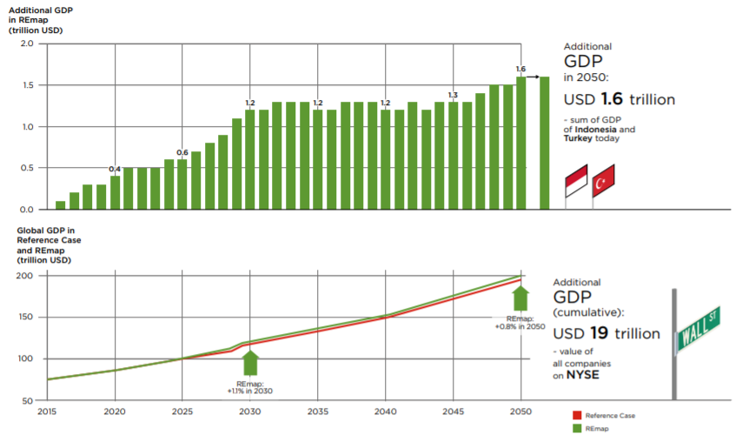
Source: IRENA, 2017a
Since employment is important for the formation of wages and, therefore, for the well-being of individuals and their families creating and maintaining jobs is crucial in any measure socio-economic development. Wage income - especially from well-paid jobs - allows people to make purchases that translate into stable demand for goods and services that promote a healthy local and national economy. Employment rate thus, it goes far beyond direct jobs in the renewable energy sector and indirect jobs in the supply of which also covers the so-called induced jobs in the wider economy (Diagram 2).
Diagram 2: Welfare dimension
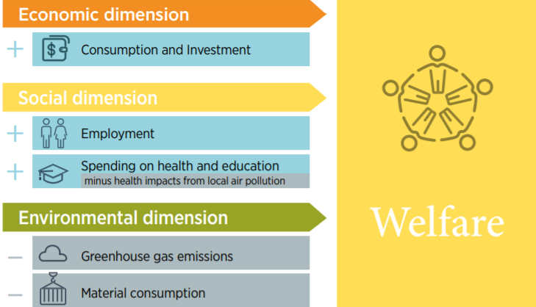
Source: IRENA, 2017a
Renewable energy and jobs IRENA - The annual review conducts annual assessments. Global employment in this sector since year 2013. In the 2017 edition, it is concluded that and indirect renewable energy sources increased to 8.3 million people worldwide. In addition, there are an estimated 1.5 million jobs in large hydropower (direct only), for 9.8 million jobs. Big there is a decrease in hydropower jobs in recent years, reflecting the slower pace of new installations and increase productivity.
In the energy sector as a whole, men are traditionally dominated. IRENA research results show that currently women constitute on average 35% of the workforce in the modern renewable energy sector - the proportion is higher than in the traditional energy sector. Additional online survey conducted with partners at Bloomberg New Energy Finance and The Clean Energy Business Council (BNEF, CEBC and IRENA, 2017) focused on East and North Africa. He confirmed the results of other parts of the world that women still face problems due to a number of factors of attitude and structure. These include lack of experience in the fields of STEM (science, technology, engineering and mathematics) outdated perceptions of gender roles, pay discrimination and a glass ceiling for managerial positions. To remedy the situation will require a number of initiatives, including flexibility in the workplace, policies to promote parenting and greater support for women through mentoring and training.
China, Brazil and the United States are the leading employers in the renewable energy sector. In recent years, there has been a significant shift towards Asian countries, whose share global employment in renewable energy increased from 50% in 2013 to 62% in 2016. This shift the result of two factors. A strong deployment policy has led to the emergence of dynamic Domestic markets and industrial policies have contributed to competitive growth globally. Especially in the solar photovoltaic industry (PV).
China remains the single largest employer with 3.6 million renewable energy sources. In India, record use of solar and wind power was due to both national and state levels political tools. The production of solar photovoltaic (PV) panels and modules also taking in southern Asian countries such as Malaysia. Others in the region, especially Indonesia, Malaysia, the Philippines and Thailand added jobs to the biofuels sector.
Brazil has the largest number of biofuels in any country, but sugar cane mechanization limits employment growth. About 2 million in Latin America people work in the renewable energy sector, and biofuels lead, and then hydropower and the fast-growing wind industry in Brazil and Uruguay. In the US, employment growth is primarily due to wind and solar energy. Both industries benefit from long-term renewals of federal investment and production tax credits, as well as national standards for net accounting and renewable portfolio standards (Figure 1).
Figure 1: Global job numbers in alternative energy sector
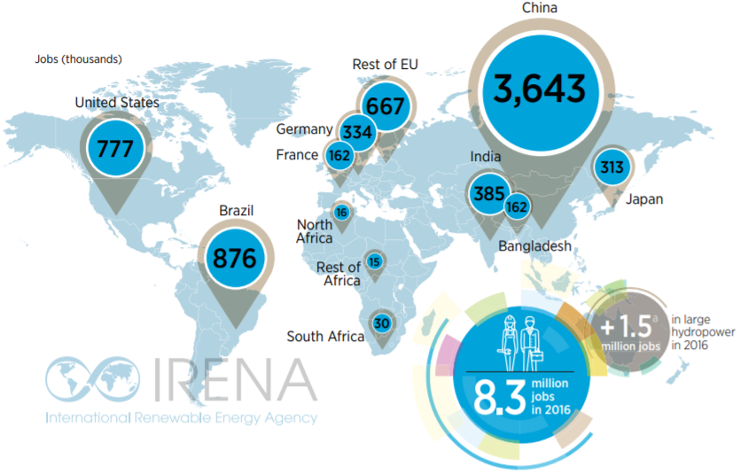
Source: IRENA, 2017c
Several European Union (EU) member states were among the early renewable energy sources. Pioneers of the XXI century. However, competitive pressures and adverse policy change especially since 2008, led to significant job losses in solar PV, while wind power in Europe continues to be the world leader.
In other parts of the world, available employment information remains limited. In Africa, IRENA estimates a conservative 62,000 jobs. South Africa thanks to its successful auctions The largest employer, with Egypt, Kenya and Morocco, has achieved significant success. Expanding access to energy will help increase the number of jobs.
At 3.1 million jobs, PV solar employment increased by 12% in 2016 and more than tripled since then. The industry is followed by a sector of liquid biofuels (growing more slowlymfrom 3% to 1.7 million jobs), and for wind power - by 7% to 1.2 million jobs.
Using IRENA for Local Solar Energy (IRENA, 2017d) analyzed professional samples and skills of a typical 50-megawatt (MW) solar photovoltaic project. In general, some. The value chain requires 230,000 person-days. Operations and maintenance costs are 56%, production by 22%, and construction and installation 17%. Builders (35,500 person-days) and factory workers and equipment (32,000 human days) are among the most famous professions. Many of the professions that may be field-filled — especially in construction — do not require high value-added skills and thus, convenient entry points for work (Figure 2).
Figure 2: Professional occupation division
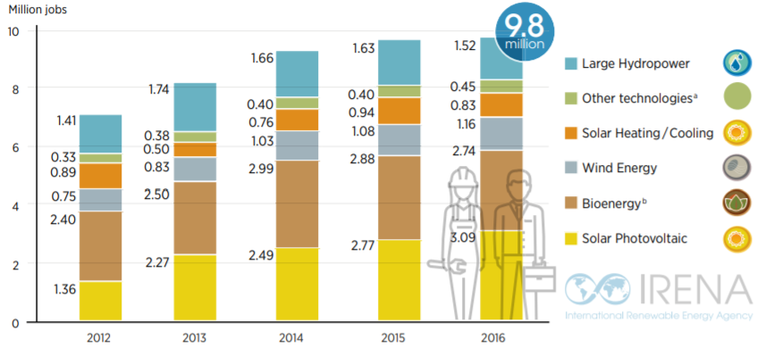
Source: IRENA, 2017c
Wind power has a strong pace of new installations, especially in China, USA and Germany - led to an increase in employment in the world by 7% to 1.2 million. Jobs. IRENA's local coastal wind capacity showed that typical The 50 MW project requires 144,000 person-days, with operations and maintenance accounts for 43%, construction and installation - 30%, and production - 17%. Builders (26,600 person-days) are the largest professional contingent, and then factory workers (about 12,500 person-days).

CHAPTER 3. Challenges and opportunities of development NordPool practice

3.1 Global electricity practice

3.1.1 Challenges of development of European electricity transmission
The European energy system is undergoing a period of profound change. To create sustainability Energy system, the European Commission presented the "Energy Union Package". Motivation after all, the Energy Union is a fundamental shift in the way energy is generated and distributed.
Traditionally, European energy has been based on a centralized supply-side model dominate state fossil fuel utilization and national policies. The vision of the Energy Union included:
International cooperation and harmonization between member states where energy can move freely across the border;
A stable, low-carbon and climate-friendly EU economy;
Competition for encourage firms to innovate and develop low-carbon and energy-efficient technologies;
Increased investor confidence through price signals that reflect the long-term needs and goals of the policy;
Empowering EU citizens to take responsibility for the energy transition. Unfortunately, many of them.
The desired goals have not been achieved to date, and the system is confronted with many must overcome to provide safe, sustainable, affordable and competitive energy for its 503 million citizens.
In the EU energy system there have been major changes in the structure of energy. The current design of the electricity market suggested that high-cost (OPEX) technologies with significant variable costs (such as coal, gas, and oil generators) would supply most of the power. Accordingly, the current market paradigm was designed to create competition between OPEX technologies, and mass support for the production of renewable energy sources (RES) was unexpected. The OPEX model was relatively simple, since the base price of the product determined the cost of energy, and the suppliers charged a premium for the supply of energy. The OPEX model allowed writing off investments with time in a year. Various types of generation also played a certain role in the energy system: large blocks (coal) provided continuous base load power, and flexible blocks (gas) provided peak demand.
Over the past two decades, the energy sector has rapidly shifted toward high capital cost (CAPEX) technologies with high fixed costs (renewable and nuclear) with almost zero marginal operating costs. The rapid expansion is partly due to EU policy incentives aimed at reducing carbon intensity. These technologies with high capital costs affect the wholesale market in three ways:
1) Reducing the amount of electricity produced by conventional utilities,
2) Reducing average prices, and
3) Reducing peak prices.
The latter is a concern because high peak prices are required to stimulate investment in peak capacity. These problems contributed to lower capital returns below the cost of capital, reducing the cost in the energy sector.
The energy-only market is the traditional basis for the wholesale trade in electricity, where producers are paid for the supplied electricity, and market forces determine the cost. As supply and demand fluctuate, electricity is not worth the same either at every point or at every place where it is produced and consumed. High prices during periods of excess demand are called scarce prices and indicate that the system requires more existing capacity. These price signals play an important role in stimulating investment in generation, as they reflect potential rewards to utilities and investors.
Electricity producers can be ranked by their short-term marginal cost (SRMC), which is the marginal cost of producing additional increment (MWh) of energy. In an energy-only market, manufacturers offer in the market and are rewarded in the market. The resulting supply curve is known as the “merit-order” curve. All orders below the clearing price are meritorious, while orders above the clearing price are no good. The limit generator (last shipped) sets the price for other market participants.
The third important issue is the financing of energy transfer. There is a significant gap between the current level of investment and the level required to achieve the goals in 2020 and beyond. Based on the well-known commitments and national policy plans, the IEA predicts that the total investment in the EU energy sector in the period from 2014 to 2035 will amount to 2.227 trillion. Doll. USA. To replace and strengthen obsolete transmission and distribution networks, $ 655 billion is required. US, as well as 180 billion. US dollars. Necessary for the integration of renewable energy sources. The capacity of the new generation will cost 1.6 trillion dollars, Three quarters of which are invested in renewable energy sources, which will increase the share of renewable energy sources in energy production from 24% in 2012 to 44% in 2035. Other estimates of the required investment range from 40-90 billion euros per year. The annual amount of electricity in the EU is 3.1TWh38 at a price of about 55.69 euros / MWh in bulk, 39 with a turnover of 172.6 billion Euros in 2015; thus, the required investment is 23-52% of annual turnover. The ability of the sector to finance these investments depends on their ability to raise capital of existing and new public utilities (Figure 3).

Figure 3: Power generation and infrastructure investments for 1990-2015

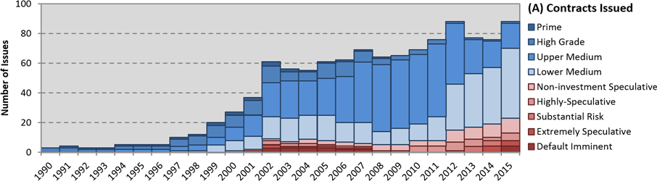

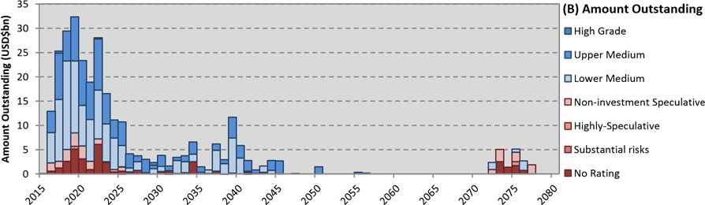
Source:https://www.researchgate.net/publication/303550070_Current_and_Future_Challenges_Facing_the_European_Union's_Energy_System
With a change in nuclear energy perception after the Fukushima incident, some heat may be required to support renewable energy in the short to medium term to ensure supply security.49 In the absence of significant nuclear energy contributions or carbon sequestration and storage, CCGT power plants provide relatively clean, reliable and flexible thermal base load technology.34, 50 The fuel efficiency of the CCGT technology increased to about 57% in 2014 from avneniyu to 49% on 1990 levels. Natural gas plays a potential role in achieving short-term and medium-term emission targets for generating electricity, heating and transportation in
future.
Despite environmental policies requiring high-pollution technologies to improve or close emissions, carbon-intensive installations that meet new standards remain competitive compared to the CCGT due to the low cost of carbon and the insignificant carbon price.34 for 2013, coal provided about 41% of the world's electricity needs and about 32% of the world's primary energy consumption.53.54 This trend is likely to change as you increase standards casts and carbon price increases.
With the exception of widespread early decommissioning or upgrading of existing plants with CCS, inertia dictates that the existing energy infrastructure is “committed” to producing significant CO2 emissions over the next decades, since it is expected that fossil fuel capacity will operate for 40 years old. The strictest global carbon budget, we have already committed ourselves to allocate 89% of the remaining budget for electricity generation for 2014-2018. for a 50% chance of staying below 2 ° C to increase global temperatures. To stay within the carbon budget, all new fossil generation investments must be pure zeroes for at least 2017 or must be modified using negative emission technologies. Failure to achieve a global carbon budget implies one of two results:
A) We accept a greater likelihood that global temperatures may exceed 2 ° C
B) We will early decommission an increasing proportion of generating assets. Any decision on fossil fuel generators depends on the long delivery times, and significant amounts of energy may not be produced until the early 2020s. Investors will be reluctant to invest in the production of heat energy if it is likely that their investments will become premature.
Asset allocation is a significant risk that investors must now consider when making decisions. When generating assets become uneconomical in operation, power plants may be temporarily stopped (mothballed) or permanently decommissioned until the scheduled decommissioning dates. Because of conservation and decommissioning and if capital costs have not been significantly reduced, owners can stay with outstanding expenses. That are unrecoverable and are usually considered non-performing assets.
The impairment charge in 2014 in the 16 largest energy and utility companies in Europe is 22.9 billion Euros, mainly due to persistently low wholesale prices. 58.59 However, this should be balanced with the historical distribution of free carbon allowances until 2013, where the firm's total profit has almost doubled. 60.61 The total windfall is estimated to be between 23 and 63 billion euros between 2008 and 2012.

3.1.2 Opportunities of development of European electricity transmission
In the last decade, several initiatives have been undertaken in the European Union (EU) to harmonize European-wide power grid development with EU policy objectives, especially in the areas of energy and climate change. The creation of new infrastructures, initially driven primarily by the need to expand cross-border trade and the integration of wholesale electricity markets, is also now actively supported by the need to integrate diversified low-carbon energy sources (for example, renewable wind and solar energy sources).
The form of the energy system over the medium and long term (until 2050) largely depends on various potential scenarios for the following elements: the use of renewable energy sources (mainly in terms of technology, performance and geographic location); the expansion of the European power grid in the direction of neighboring electrical networks (for example, North Africa, the Middle East and Russia); and the penetration of distributed energy sources that require the development of a more intelligent power system, especially at lower voltage levels. These factors, determining preferential schemes for cross-continental and intercontinental electricity flows, will determine the basic structural and operational needs of the European energy system of the future.
In conclusion, from all finding aboveWe center around the European ultra-high-voltage framework, which is as of now considered a "shrewd" framework yet is relied upon to develop toward structures offering higher exchange limits (a purported "supergrid"). We address the difficulties of making power appropriation frameworks more brilliant just to the extent that transmission-dissemination interfaces are worried, over the span of representing the strains and complementarities inside the keen matrix and supergrid ideas. In this light, the article shows the fundamental arrangement targets and dreams for power in the European Union, key figures and patterns identifying with the European vitality and power frameworks in an overall setting, and mechanical alternatives and configuration challenges for the skillet European transmission network. The article finishes by outlining different necessities and potential answers for the EU transmission framework in perspective on its long haul evolution.
The EU's vitality and environmental change arrangements aim to concurrently confront challenges related to:
Security of energy supply (by ensuring a reliable and uninterrupted supply of energy and electricity)
Competitiveness as electricity markets are restructured (by reducing the energy bill for households and businesses and maximizing market efficiency)
Sustainability (by limiting the environmental impact of energy production, transport, and use).
In 2009, the third internal energy market package was one of the major EU policy initiatives. It was aimed at accelerating infrastructure investments, with the goal of ensuring the proper functioning of the EU electricity market. The Europe 2020 growth strategy—with its so-called “20/20/20” agenda—is the current starting point for Europe’s energy and climate change policies. It aims to reduce CO2 emissions by 20% compared with 1990 levels, raise the share of renewable sources in the overall EU energy mix to 20%, and increase energy efficiency by 20%. As far as energy grid development is specifically concerned, the medium-term policy was first outlined in the EU’s communication on energy infrastructure priorities for 2020 and beyond and then detailed in the guidelines for trans-European energy networks (TEN-E), which identified three EU infrastructure priority areas (electricity highways, smart grids, and CO2 networks) and nine infrastructure priority corridors (on electricity, gas, and oil). As a first step in the implementation of TEN-E, the European Commission (EC) adopted a list of projects of common interest (PCIs) in electricity, gas, and oil infrastructure. The guidelines provide a new way to identify infrastructure projects of common interest and to accelerate their implementation through enhanced regional cooperation, streamlined permit-granting procedures, adequate regulatory treatment, and through European financial assistance under the proposed Connecting Europe Facility. The list of PCIs is to be reviewed on a regular basis to implement the long-term vision of pan-European market integration and a low-carbon transition. As for the longer-term perspective, the EC has issued the Energy Roadmap 2050, which outlines scenarios leading up to 2050 and following a path toward a low-carbon economy, assuming a greenhouse gas emissions reduction target of at least 80%. All of the scenarios share the following key elements:
- The share of renewables in energy will grow, covering more than 40% of gross final energy consumption in 2050, compared with the 20% expected in 2020.
- Energy savings will be crucial, with a 32–41% reduction in energy demand by 2050, compared with the 2005–2006 peaks.
- The share of electricity in final uses will increase from 22% in 2009 to 37% in 2050.
- Capital investments in infrastructure assets will increase, and the fossil fuel bill will decrease.
- Decentralized power, i.e., power generation connected to medium- and low-voltage distribution systems, will grow, accounting for up to 35% of total generation capacity by 2050.
Electricity consumption increased by 0.2% (7 TWh) in 2018, for the fourth year in a row, the total electricity consumption in Europe increased, albeit by slower pace than in previous years. However, electricity consumption remains 2% lower than in 2010. Despite GDP growth of 13% and population growth of 2% since then. The electrification of the economy is expected to increase electricity consumption. The European Commission’s Long-Term Strategy 2050, published in November 2018, assumes that an increase of 18% by 2030. Electrification transport, heat and industry are considered major drivers. The strategy provides that 10% of European transport will be electrified by 2030. In general, stable power consumption can be
The following trends are attributed in 2018:
→ Economic growth is less “industrial”. While the total EU GDP grew by 2% in 2018, industrial production fell by 2% - a stark contrast compared to the previous 3 years, when industrial production growth exceeded GDP growth. For example, steel production fell 0.5% after rising 4% in 2017.
→ European markets for electric cars and heat pumps expanded in 2018, but from a small base. Step change in the electrification of transport and heat still ahead. Sales of electric vehicles increased by 34% in 2018 as a result, 2.4% of new car sales were electric.
The overall impact of weather on electricity use in 2018 was small. 2018 was a very warm year all of Europe and 0.4 degrees warmer than in 2017. February and March were the only ones. Two cold months when the so-called "beast of "East" swept windy cold air across Europe. Other ten months in 2018 were significantly higher than normal temperature Overall, the winter months were warm. Therefore, a decrease in heating demand compensates for additional demand for air conditioning in the hot summer months. The trend in electricity consumption in 2018 followed a similar pattern in previous years – growth Eastern European countries, and stagnation elsewhere. Polish electricity consumption grew by 1.6% in 2018, which is 12% higher than in 2010 (Diagram 3) and is second only to Lithuania in terms of growth rates. In Western European countries, consumption was below the 2010 level, while the UK lowered electricity consumption the most (Diagram 4). As mentioned above, it is expected that the electrification of heat and transport will increase electricity consumption everywhere coming decade.

Diagram 3. EU-28 Electricity consumption, GPD
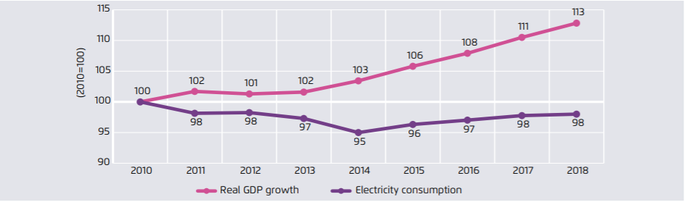
Source:https://www.agoraenergiewende.de/fileadmin2/Projekte/2018/EU-Jahresauswertung_2019/Agora-Energiewende_European-Power-Sector-2018_WEB.pdf
Diagram 4. Surface air temperature anomalies with respect 1981-2018
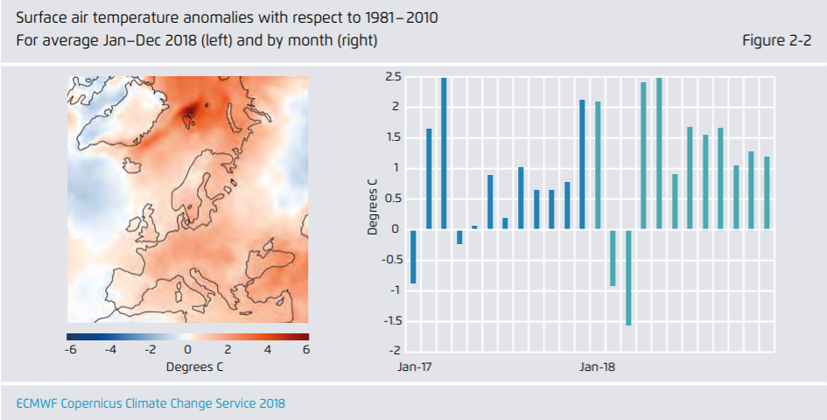
Source:https://www.agoraenergiewende.de/fileadmin2/Projekte/2018/EU-Jahresauswertung_2019/Agora-Energiewende_European-Power-Sector-2018_WEB.pdf
Figure 4. Change in electricity consumption from 2010-2018
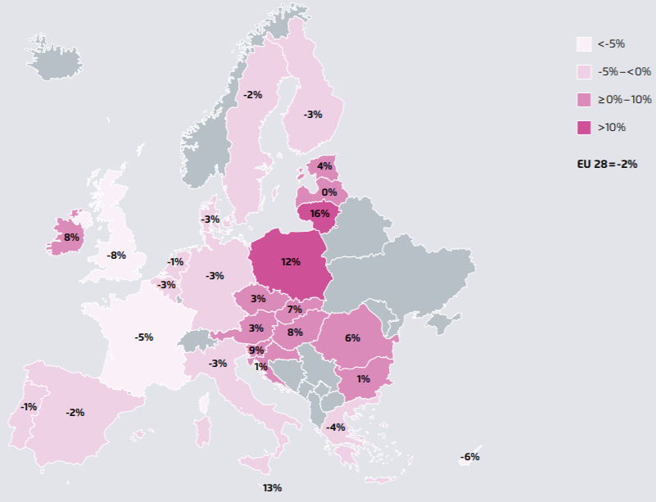
Source:https://www.agoraenergiewende.de/fileadmin2/Projekte/2018/EU-Jahresauswertung_2019/Agora-Energiewende_European-Power-Sector-2018_WEB.pdf
In 2018, renewable energy accounted for 32.3% electricity. Growth by 2.3%, from 30.0% in 2017. Of these, half came to recovery hydropower, and half - from the structural growth of generation of wind, solar energy and biomass. How 2018 wind has the largest share in renewable energy mix, providing 12% of electricity in Europe. Solar contributed 4%, less than biomass and a third of wind generation. Renewable generation increased by 35 TWh in 2018, below the average for 2010–2017 TWh per year. Partly due to less windy conditions compared to the windy year of 2017, although the increase in solar and biomass is less than average.
Over the past four years, 70% growth in renewable sources come from wind, 14% from biomass and 16% from solar. Solar energy produces 4% of electricity in Europe, but this very different countries to country. Italy still the highest proportion, with 8% of its electricity from solar. Germany and Greece go together by 7% (Figure 5). On the other hand, some countries have almost no solar generation: Poland, Finland, Sweden and Ireland are barely recorded and even sunny Croatia and Portugal have <1%. German solar levels increased most in 2018 due to stronger sunlight during the summer. In the UK, 2018 (Figure 5) was second most sunny on the record.
Figure 5. EU-28 renewables share
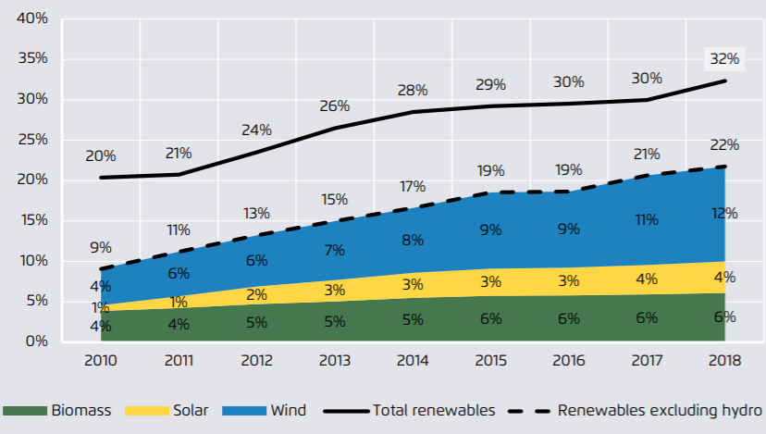
Source:https://www.agoraenergiewende.de/fileadmin2/Projekte/2018/EU-Jahresauswertung_2019/Agora-Energiewende_European-Power-Sector-2018_WEB.pdf
Figure 5. Year-on year changes in EU-28 renewable electricity generation.
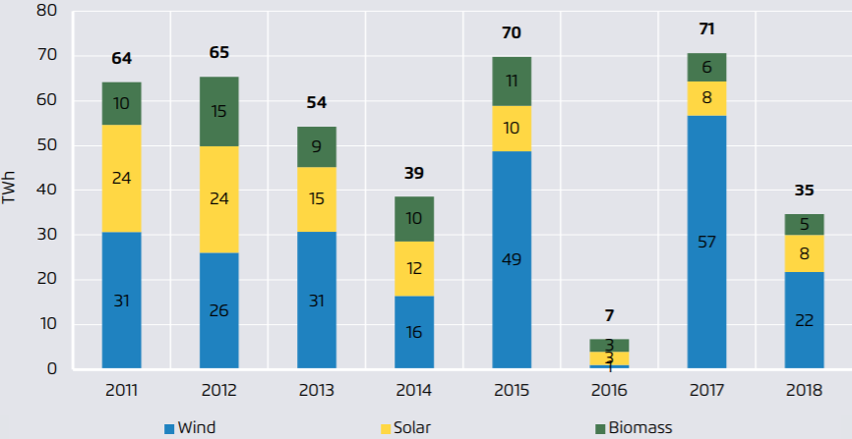
Source:https://www.agoraenergiewende.de/fileadmin2/Projekte/2018/EU-Jahresauswertung_2019/Agora-Energiewende_European-Power-Sector-2018_WEB.pdf

3.1.3 Long-term forecasts on NordPool practice
Nowadays, electricity can be considered as any other product. You can buy, sell, exchange according to the rules of the electricity market. It results of global power liberalization markets. To minimize risks, maximize profits. In addition, making plans is important for the participants the electricity market predicts future prices. Behind For example, using accurate short-term price forecasting, electricity providers can develop trading strategies that will lead to increased profits. However, due to characteristics of the spot price of electricity, such as high volatility, multiply seasonality and surges, this challenging task to accurately predict. Despite a large number of different methods that are applied for spot electricity price forecast, accuracy forecasts are not sufficient, since different approaches work differently with different countries (markets).
In recent literature, there are many electricity prices. Predictive approaches are hybrid solutions that combine two or more different methods. For example, the proposed approach in is a combination fuzzy output system based on adaptive network and particle swarm optimization. Used for forecasting prices next week on the mainland electricity market Spain. For the sake of simplicity and clarity comparison, exogenous variables are not considered.
Prediction accuracy is measured using MAPE an error that is 5.28%. Another example would be in hybrid intelligent algorithm using data filtering Wavelet transform technique an optimization method based on the firefly algorithm, and fuzzy soft computational model ARTMAP network. This method is used to predict the day ahead. Electricity prices in the Ontario market.
Made for 24 and 168-hour short-term horizons. The accuracy of the method is measured using MAPE, MAE errors, as well as the coefficient of determination. MAPE error calculated for the 24-hour horizon varies from 6.24% to 7.67%. Hybrid Wavelet ELM (Extreme Learning Machine) method is used in. Short-term forecasts have been made for Ontario, PJM, Italy and New York electricity markets. MAE, MAPE, MDE errors selected to assess accuracy. In an econometric model for hourly electricity price of the European Energy Exchange for Germany and Austria are presented. The model that can be considered as a periodic var-tarch, this offered in order to grab a specific price movement. Wind power, solar power and load considered as factors that influence price ( Figure 6).
Figure 6: Boxplots of aggregated price data
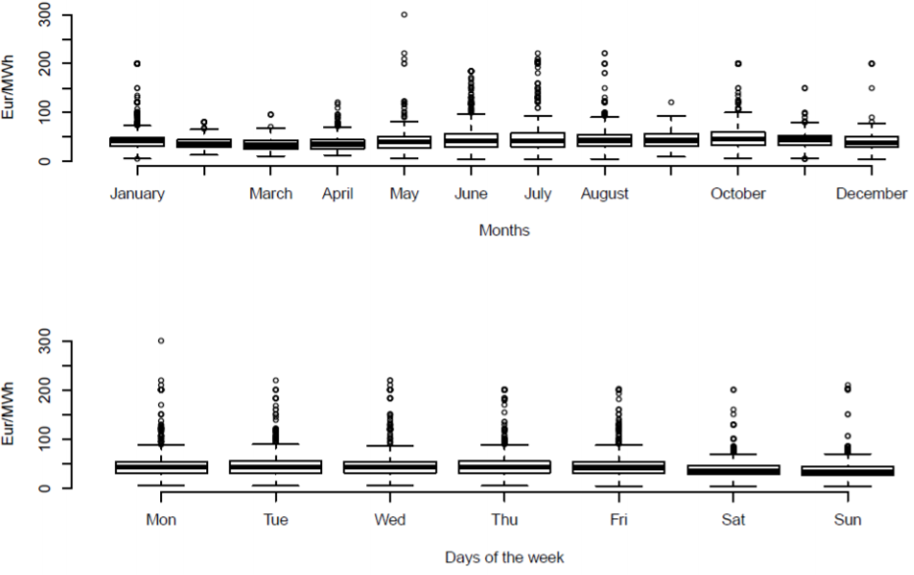
Source:https://www.researchgate.net/publication/327938299_Electricity_Price_Forecasting_for_Nord_Pool_Data
Predictive experiments were conducted for each day of the year 2016. Average, seasonal naive and Seasonal exponential smoothing techniques were used. For short-term forecasting for the day ahead only 24 points. Daily seasonality was chosen as the most important in Seasonal Naive Method. Exponential smoothing was automatically selected using the statistical package R. Accuracy was measured using RMSE, MAE and MAPE errors.
Highest accuracy (considering all three accuracy measures) was achieved by Exponential smoothing method. Lowest MAP the error was 1.76%. However, the average MAPE error year was 16.03% with standard deviation 11.43%. Because there are many emissions in the data, Median MAPE (which is equal to 12.18%) may better present a typical mistake.
Therefore, the forecast was extremely inaccurate. On the other hand, the exponential performance smoothing method was accurate with MAPE the error is 8.54% on that day. Figures 3 and 5 show not how all methods can catch the sudden price Peaks. Only in the winter day off. The accuracy of the average method was highest according to MAPE error, which was equal to 22.13%.
Overall, NordPool practice have many challenges and opportunities. Each challenge need to be good overcome through tested and good grounded options. In case of opportunities, each of them need to be good analyzed with all profits and cost which it will give in future establishment. Most of European countries have big experience on that issue and can share it with other countries to good outcome. However, mostly, this tendency has more good sides, which will develop electricity transmission in Europe, than risks, which will be resulted by not beneficial final.

Conclusion
All in all, from all finding above, unmistakably NordPool practice assumes a job progressively significant as time passes to both people and condition. By wealth, vitality transmission is turning into a significant answer for the European Countries' vitality need. Additionally, NordPool practice likewise conveys numerous positive effects to ensuring condition, lessening impacts of a dangerous atmospheric devation or contaminations. Regardless of certain disadvantages of the vitality, there are additionally motivations to trust the issues will be fathomed before long gratitude to solid venture of government and endeavors' researchers. The misusing and changing over from customary sources into sustainable power source assets is a great defining moment to us. What's to come is to be sure splendid and will be lit by option energy.
It is difficult to live without vitality, yet it is difficult to discover another planet to live in. Vitality is everything. It comes in numerous structures, for example, heat, power, light, mechanical vitality. Ordinary vitality sources, for example, coal and oil are the principle supporters of the an Earth-wide temperature boost. Moreover, these petroleum products are not sustainable, which implies one day we will come up short on them. All things considered, elective wellsprings of vitality can supplant the present advancements we are utilizing. These NordPool practice sources are condition well disposed as they radiate less carbon dioxide, contrasted with petroleum products. There are numerous elective wellsprings of energies that tackle characteristic powers and assets, for example, sun powered power, wind control, and geothermal energy.
NordPool practice division likewise assume an extraordinary job in European nations. Be that as it may, progressive exhaustion, increasing expenses of conventional vitality sources, and eco harm to the earth have expanded the enthusiasm of option (inexhaustible) vitality. With good land area and climatic conditions, European Countries are wealthy in environmentally clean elective vitality sources. It is conceivable to altogether diminish the measure of hurtful emanations to the earth by invigorating those sources and sparing a lot of fuel from the normal capability of the nation at warm power plants. <European Countries are building up its NordPool practice division step by step and "3 Pillar" framework is an outcome. The administration needs to put resources into the vitality transmissions division, to build the viability of open use arranging and, in a word, to actualize a ground breaking strategy to make an interpretation of vitality incomes into better lives for its citizens.
Regarding previously mentioned the accompanying rundown of suggestions is offered:
- Continue to help research, advancement, and exhibition ventures for pre‐ business NordPool practice and transportation fills, with an accentuation on act, emanations decreases and innovation neutrality.
- Provide wind‐powered power age with a smooth progress to a period of unsubsidized aggressiveness by expanding the breeze generation charge credit so the advantage is step by step diminished and at last eliminated.
- Ensure that choices in regards to impose motivators for vitality transmissions are: intended to address well‐documented showcase wasteful aspects; connected just to those powers and advances with a solid way to unsubsidized intensity; and limited in length and in the long run eliminated in an anticipated fashion. Account for territorial varieties in sustainable power source asset accessibility when creating enactment and regulation.
- With regard to the inexhaustible fuel standard, policymakers ought to consider the restrictions of the ebb and flow vehicle armada, fuel conveyance foundation and real generation limit, and receive focused on adjustments as needed. The ebb and flow structure of the development framework has brought about world driving NordPool practice fitness, and ought to be continued.
- Public subsidized elective vitality NordPool practice projects ought to be refreshed to improve this sector.
- Cross-disciplinary R&D, including sociologies, ought to be incorporated into open financed R&D programs. Sociology research ought to add to comprehend, diminish and expel boundaries to innovation advancement and application.
- International joint effort ought to be supported in R&D programs when significant.

Reference
- Annual report of the State Agency on Alternative Energy for 2015-2017
- Annual report of the Department of Energy at IRENA (DoE), 2016.
- Annual report of the Department of Energy (DoE) at IRENA, 2013a. Renewable Energy Independent Power Producer Procurement Programme, formal homepage 2016.
- Annual report of the Department of Energy (DoE) at IRENA, Aug 2017g. Media Statement, Renewable Energy Independent Power Producer Programme, Media & Publications.
- Annual report of the Department of Energy (DoE) at IRENA, August 2017b. Fact sheet for the media briefing session on 31 August 2011. Renewable Energy Independent Power Producer (IPP) Programme.
- Annual report of the Energy for Development at IRENA: The Potential Role of Renewable Energy in Meeting the Millennium Development Goals.
- "Climate Change as a Cultural and Behavioral Issue: Addressing Barriers and Implementing Solutions" (PDF). ScienceDirect. 2010. Retrieved 2016.
- Department database of the State Agency on Alternative Energy
- Eugene Green Energy Standard, Eugene Network. Retrieved 2017.
- Energy Information Agency (EIA), database. 2017.
- Energy for People, Energy for Peace, Results of the 18th World Energy Congress, Buenos Aires, Argentina, October 2001, World Energy Council Statement 2002.
- FS-UNEP Collaborating Centre, Global trends in renewable energy investment, 2016
- Intergovernmental Panel on Climate Change (IPCC). 2016. IPCC Special Report on Renewable Energy Sources and Climate Change Mitigation.
- IRENA (2015a), “Renewable Energy and Jobs”, www.irena.org/rejobs.pdf.
- IRENA (2015b), “Renewable Energy Auctions in Developing Countries”, www.irena.org/DocumentDownloads/ Publications/IRENA_Renewable_energy_auctions_in_developing_countries.pdf.
- IRENA (2016c), “Renewable Energy Innovation Policy: Success Criteria and Strategies”, www.irena.org/ DocumentDownloads/Publications/Renewable _Energy_Innovation_Policy.pdf.
- National Renewable Energy Laboratory (NREL). 2016. Renewable Electricity Futures Study. Volume 1.
- Nuclear Energy in a Sustainable Development Perspective, OECD Nuclear Energy Agency, 2000.
- R. Billinton and R. Karki, “Maintaining supply reliability of small isolated power systems using renewable energy,” IEE Proc.-Gener. Transm. Distrib., vol. 148, no. 6, 2015.
- R. Karki, P. Hu, and R. Billinton, “A simplified wind power generation model for reliability evaluation,” IEEE Transactions on Energy Conversion, vol. 21, no. 2, 2016.
- R. Billinton, H. Chen, and R. Ghajar, “Time-series models for reliability evaluation of power systems including wind energy,” Microelectronics and Reliability, vol. 36, no. 9, 1996.
- R. Karki and P. Hu, “Wind power simulation model for reliability evaluation,” in Electrical and Computer Engineering, 2005. Canadian Conference on, Los Alamitos, CA, 2015.
- R. W. Boom, B. C. Haimson, G. E. McIntosh, H. A. Peterson, and W. C. Young, “Superconductive energy storage for large systems,” IEEE Transactions on Magnetics, vol. MAG-11, no. 2.
- Steurer, R., and A. Martinuzzi (2017). From environmental plans to sustainable development strategies. European Environment, 17(3).
- Stiglitz, J. E., Sen, A. and J.-P. Fitoussi (2016). Report by the Commission on the Measurement of Economic Performance and Social Progress.
- SEIA. 2017. Solar Market Insight Report 2017 Q2.
- The Solar Foundation. 2017. National Solar Jobs Census 2016.
- "The Twin Pillars of Sustainable Energy: Synergies between Energy Efficiency and Renewable Energy Technology and Policy" (PDF), 2017.
- Union of Concerned Scientists (UCS), Clean Power Green Jobs, 2015.
- Y. Gao, “Adequacy assessment of electric power systems incorporating wind and solar energy,” Master’s thesis, University of Saskatchewan, Saskatoon, Canada, January 2016.
- Y. Wang, S. G. Rupani, M. LaBossiere, D. C. Brande, and R. F. Vaz, “Solar energy and photovoltaics education in worcester,” unpublished.
- Zwaan, B. Van der, L. Cameron, and T. Kober (2016), “Potential for Renewable Energy Jobs in the Middle East“, Energy Policy, Vol. 60.
- https://www.researchgate.net/publication/327938299_Electricity_Price_Forecasting_for_Nord_Pool_Data
- https://www.researchgate.net/publication/303550070_Current_and_Future_Challenges_Facing_the_European_Union's_Energy_System

Annual report of the Department of Energy at IRENA (DoE), 2016.
Annual report of the Department of Energy (DoE) at IRENA, Aug 2017g. Media Statement, Renewable Energy Independent Power Producer Programme, Media & Publications
Annual report of the Department of Energy (DoE) at IRENA, August 2017b. Fact sheet for the media briefing session on 31 August 2011. Renewable Energy Independent Power Producer (IPP) Programme.
Annual report of the Energy for Development at IRENA: The Potential Role of Renewable Energy in Meeting the Millennium Development Goals.
R. Karki and P. Hu, “Wind power simulation model for reliability evaluation,” in Electrical and Computer Engineering, 2005. Canadian Conference on, Los Alamitos, CA, 2015.
Steurer, R., and A. Martinuzzi (2017). From environmental plans to sustainable development strategies. European Environment, 17(3).
Intergovernmental Panel on Climate Change (IPCC). 2016. IPCC Special Report on Renewable Energy Sources and Climate Change Mitigation.
Steurer, R., and A. Martinuzzi (2017). From environmental plans to sustainable development strategies. European Environment, 17(3).
https://www.researchgate.net/publication/327938299_Electricity_Price_Forecasting_for_Nord_Pool_Dat
https://www.researchgate.net/publication/303550070_Current_and_Future_Challenges_Facing_the_European_Union's_Energy_System
SEIA. 2017. Solar Market Insight Report 2017 Q2.
Y. Gao, “Adequacy assessment of electric power systems incorporating wind and solar energy,” Master’s thesis, University of Saskatchewan, Saskatoon, Canada, January 2016.
Y. Gao, “Adequacy assessment of electric power systems incorporating wind and solar energy,” Master’s thesis, University of Saskatchewan, Saskatoon, Canada, January 2016.
Union of Concerned Scientists (UCS), Clean Power Green Jobs, 2016.
Union of Concerned Scientists (UCS), Clean Power Green Jobs, 2016.
"The Twin Pillars of Sustainable Energy: Synergies between Energy Efficiency and Renewable Energy Technology and Policy" (PDF), 2017
"The Twin Pillars of Sustainable Energy: Synergies between Energy Efficiency and Renewable Energy Technology and Policy" (PDF), 2017
"The Twin Pillars of Sustainable Energy: Synergies between Energy Efficiency and Renewable Energy Technology and Policy" (PDF), 2017
The Solar Foundation. 2017. National Solar Jobs Census 2016
The Solar Foundation. 2017. National Solar Jobs Census 2016
The Solar Foundation. 2017. National Solar Jobs Census 2016
SEIA. 2017. Solar Market Insight Report 2017 Q2
Stiglitz, J. E., Sen, A. and J.-P. Fitoussi (2016). Report by the Commission on the Measurement of Economic Performance and Social Progress
Stiglitz, J. E., Sen, A. and J.-P. Fitoussi (2016). Report by the Commission on the Measurement of Economic Performance and Social Progress
Stiglitz, J. E., Sen, A. and J.-P. Fitoussi (2016). Report by the Commission on the Measurement of Economic Performance and Social Progress
Steurer, R., and A. Martinuzzi (2017). From environmental plans to sustainable development strategies. European Environment, 17(3)

