**AZERBAIJAN STATE UNIVERSITY OF ECONOMICS - UNEC**

**SABAH CENTER**

**BEHBUD MALİKOV**

**INCREASING THE EFFECTIVENESS OF INVESTMENTS IN NON-OIL SECTOR IN AZERBAIJAN**

**Supervisor: Dr. Of Econ. Rovshan Guliyev**

**JUNE, 2019**

**TABLE OF CONTENTS**

**ABSTRACT...........................................................................................................3**

**ACKNOWLEDGEMENT....................................................................................5**

**INTRODUCTION.................................................................................................6**

**Chapter I. Theoretical and methodological basis of stimulation of investment flows and investments in the modern world economy...................................................................................................................9**

1.1. The place and role of investment in the national economy...................................................................................................................9

1.2. Modern trends in global investment flows........................................................15

1.3 Investment incentive process: methods and world experience................................................................................................................26

**Chapter II.** **Development of non-oil sector's ınvestment opportunity in Azerbaijan..............................................................................................................31**

2.1. Main areas of the non-oil sector and their modern developmental characteristics..........................................................................................................31

2.2. Comprehensive research of investment in non-oil sector........................................................................................................................38

**Chapter III. Stimulation of investment in non-oil sector in Azerbaijan..............................................................................................................43**

3.1. The main targets of the non-oil sector development trend and investment stimulus strategy......................................................................................................43

3.2. The investment climate in the non-oil sector and ways to improve it...............................................................................................................................51

3.3. Directions to improve mechanisms for stimulating investment in the non-oil sector .......................................................................................................................55

**Results.....................................................................................................................58**

**Appendix.................................................................................................................63**

**References...............................................................................................................66**

**ABSTRACT**

**Author of final thesis: Behbud Malikov**

**Full title of final thesis: Increasing the effectiveness of investments in non-oil sector in Azerbaijan**

**Final work supervisor: Dr. Of Econ. Rovshan Guliyev**

**Place and year of final work: Baku, 2019**

**Number of pages: 66**

**Number of Tables:3**

**Number of pictures:9**

**Number of appendixes:3**

**Object and subject of research.** The object of the research is the stimulating policy mechanisms implemented by the state in the direction of investment climate in the non-oil sector of Azerbaijan and its improvement. As the subject of the research, the study of the possibilities of expanding and enhancing the ways of stimulating the non-oil sector investment in Azerbaijan.

**Purpose and tasks of the research.** The main purpose of the research is to prepare proposals for the development and enhancement of investment incentive mechanisms in Azerbaijan's comprehensive non-oil sector investment and investment climate research. In order to achieve the objectives of the dissertation research, the following specific tasks have been identified:

- Investigating the role and place of investments in the development of the national economy;

- Investigating modern trends in global investment flows;

-Investment incentive methods and world practice;

- Studying the main areas of development of the non-oil sector and their modern developmental characteristics;

- Dynamics and structure of investment in non-oil sector investments;

- Development trends and investment of non-oil sector

identifying key objectives of the stimulus strategy;

- Investigating opportunities for investment climate in the non-oil sector and its enhancement;

- Determine directions of improvement of stimulating mechanisms for investment in non-oil sector.

**Scientific novelty of research.** The dissertation has been systematically analyzed for investment in non-oil sector of Azerbaijan and proposed ways to stimulate investment in identified strategic targets.

**Research information base.** Annual reports from local and international researchers, annual reports from the Ministry of Economy, State Statistical Committee, UNCTAD, World Bank and International Monetary Fund have been widely used.

**Practical significance of the research.** The results of the research can be used in the development and implementation of Azerbaijan's investment policy.

**ACKNOWLEDGEMENT**

The dissertational work is given to invigorating the methods for interests in the non-oil segment of Azerbaijan. For this reason, in the exposition work in the principal part been concentrated the spot and the job of interest in the improvement of the national economy, present-day patterns of worldwide venture streams, techniques and global routine with regards to animating the speculations. In the second part were exhaustively contemplated created significant enterprises and present-day qualities, just as the elements and structure of interest in the non-oil division of Azerbaijan. In the third part were examined the fundamental bearings of improvement and the targets of the procedure of putting resources into the non-oil division, ideal states of speculation atmosphere and the likelihood of upgrading and improving systems for animating the venture.

**INTRODUCTION**

**The actuality of the subject.** At present, the world economy is experiencing an increase in uncertainties, weak economic growth, exchange rate instability, sharp slowdown in energy prices, structural deficiencies in the global financial system, condemnation of macroeconomic environment for investors, serious political uncertainty, and so on. It was characteristic of. Naturally, the negative impacts of these processes have not been overlooked by the Azerbaijani economy as an integral part of the world. The drop in oil prices in the world markets over the past few years has led to a significant drop in foreign exchange revenues in Azerbaijan, which accounts for the largest share of oil and oil products, about a decline in the country's national currency for about a year, devaluation of state budget revenues and so on. caused.

One of the strategic tasks facing the Republic of Azerbaijan, which has already overlapping transition period in response to new challenges, is to minimize oil dependence, to accelerate transformation into an export-oriented economy with more robust, high competitiveness, productivity and effectiveness. This task is to improve the structure of the economy, economic development, macroeconomic stability, better business and investment climate, support for the private sector, introduction of advanced technologies and expertise, human capital development, foreign trade and investment.

As it is seen, the formation of the economy in the world requires the rapid development of the non-oil sector as a priority direction of the economic policy of Azerbaijan and increases its relevance. Undoubtedly, the future economic progress of Azerbaijan, in particular the non-oil sector development, and depends heavily on investment activity.

Investing in all countries of the world is one of the key factors in ensuring economic growth. In this regard, investment policy has become a priority in the economic policy of the state in modern times. In the 60s of the last century, the basis for the economic development of countries such as ABS, Japan, Germany, France, and the UK, has been instrumental in investing. the role of attracting foreign investments in the past has been on the cover of the balance of payments, the increase in domestic production, the elimination of uncertainty, rising productivity and so on. with only a few. In the modernization of globalization, modern investment, the creation of healthy competition throughout the country, the introduction of new technologies and know-how in the country, the introduction of liberalization and modern governance in the economy, human resources development, environmental protection, and the support of transnational corporations and their country of origin in terms of importance.

In Azerbaijan, however, these investments are more promoted in the oil and gas sector. In this regard, it is primarily aimed at increasing the export potential of the Azerbaijani economy and reducing the dependence on imports to attract more foreign investment in agriculture, industry and service sectors. is considered one of the tasks.

Today, the world is struggling to oversee foreign investments, and their involvement in attracting more and more states are trying to offer a more accessible investment climate, making use of all possible stimulating tools and thus making greater use of global investment flows. Formation and application of effective stimulus measures that will contribute to the attraction of more investments into the Azerbaijani economy, especially in the non-fiscal sector, are crucial in shaping the global investment market.

**Object and subject of research.** The object of the research is the stimulating policy mechanisms implemented by the state in the direction of investment climate in the non-oil sector of Azerbaijan and its improvement. As the subject of the research, the study of the possibilities of expanding and enhancing the ways of stimulating the non-oil sector investment in Azerbaijan.

**Purpose and tasks of the research.** The main purpose of the research is to prepare proposals for the development and enhancement of investment incentive mechanisms in Azerbaijan's comprehensive non-oil sector investment and investment climate research. In order to achieve the objectives of the dissertation research, the following specific tasks have been identified:

- Investigating the role and place of investments in the development of the national economy;

- Investigating modern trends in global investment flows;

-Investment incentive methods and world practice;

- Studying the main areas of development of the non-oil sector and their modern developmental characteristics;

- Dynamics and structure of investment in non-oil sector investments;

- Development trends and investment of non-oil sector

identifying key objectives of the stimulus strategy;

- Investigating opportunities for investment climate in the non-oil sector and its enhancement;

- Determine directions of improvement of stimulating mechanisms for investment in non-oil sector.

**Scientific novelty of research.** The dissertation has been systematically analyzed for investment in non-oil sector of Azerbaijan and proposed ways to stimulate investment in identified strategic targets.

**Research information base.** Annual reports from local and international researchers, annual reports from the Ministry of Economy, State Statistical Committee, UNCTAD, World Bank and International Monetary Fund have been widely used.

**Practical significance of the research.** The results of the research can be used in the development and implementation of Azerbaijan's investment policy.

**CHAPTER I.**

**THEORETİCAL AND METHODOLOGİCAL BASİS OF STİMULATİON OF İNVESTMENT FLOWS AND İNVESTMENTS İN THE MODERN WORLD ECONOMY**

* 1. **The place and role of investment in the national economy**

One of the main indicators characterizing the country's economic development, its competitiveness and integration into the world is the amount of foreign investment in the country's economy. Investment activity is contributing to the rise of the overall social and economic conditions in the country, the creation of additional jobs, the application of new technologies. At the modern stage of development of economic science and economic relations, the term "Investment" has been widely used. The investment is derived from the Latin word investio, meaning "to groom" or "cover". In English, this term has many meanings, which means "putting capital", "investing in something else". In German, the word "invest" has the same meaning. The terminology interpretation partially explains the meaning of this term. However, in order to understand the meaning of investments in the economy, it is necessary to first understand its essence and structure. Investment - consists of financial means put into objects of entrepreneurship and other types of activity, as well as material and intellectual resources, for the purpose of profit, profit or social benefit. Such funds and resources include:

- Cash, purpose bank deposits, loans, stocks, stocks and other securities;

- movable and immovable property - buildings, fixtures, equipment and other material resources;

- scientifically-experimental and other intellectual resources, which are properly enforced;

 - A set of technical, technological, commercial and other knowledge, such as "know-how", designed as a non-patented, technical documentation, habit and manufacturing experience required for the organization of this or that type of production;

 - rights to use of land, water and other resources, buildings, installations, equipment, as well as other proprietary rights arising from copyright;

 - Other resources.

Modern research shows that investment concept has a wide range of content. It is known that investment in macroeconomics is one of the components of aggregate spending. commodities produced, but not consumed, are regarded as investment.

In microeconomics, investment is understood as the creation of material assets for the production of new capital, as well as the use of a personal factor (human) to acquire the skills and habits. The concept of an investment according to the theory of finance is understood as the acquisition of real and financial assets. Investment is essentially a sacrifice for the future. But it is now clear that the future is always uncertain. Therefore, the investment is a cost-cutting in the current period for the purpose of generating uncertain future benefits. Time factor is one of the key factors determining investment. In general, human activity is interconnected in time. Thus, the means implemented are always carried out at the present time, and the goals that are to be achieved are realized in the future. From this point of view, any choice of market participants has an element of preference over time. Therefore, in the broad sense of the word, the term "investment" is related to the loss of the right to disposal over a certain period of time and on a certain risk basis in order to receive additional income in the future. So it is necessary to give the money in a certain amount now and in a certain amount, if income is obtained, then it is obtained and its quantity is unknown. In this case, in some cases, the key factor (for example, for government bonds), in some cases, is the key factor (for example, options for buying ordinary shares).

In some cases, both factors are both risky and time-consuming (eg ordinary shares). Investments provide an increase in production resources and eventually the rate of economic growth. Investments are capital, with the help of which national wealth is increased. Investment is invested in the morning and is essentially directed to human capital. The investment reflects the processes of long-term capital investments in production and non-production spheres of the economy. Under certain circumstances, investments can be grouped as follows:

- investments in expansion and modernization of production;

- Investments in creation of production infrastructure;

- Investments in creation of inventories;

- Investment in the creation of social infrastructure;

- Investments in the preparation and retraining of staff;

 - Scientific and scientific service.

Large companies in developed countries attach great importance to the training of personnel and increase their proficiency, and consider this as an important aspect of strengthening their position in the global market. It is understood more and more clearly that the intellectual product, which is the main factor of economic development, depends on the investments directed to it.

 In the economic literature a number of terms related to investment activity - investment, investment, investment process, investment activity, etc. terms are being processed more recently. In the system of totalitarian economic relations, administrative power was not used much more than the term of investment. Instead, capital investment was used more frequently.

Looking at the classification of investment-related issues, we see that investment activity is a combination of all the measures taken by entrepreneurs, businessmen, investors in investing in some or all of the national economy. Investment activities are carried out both in the public sector and in the non-governmental sector. Investment activity in the public sector is the investment activity carried out by government agencies, enterprises, institutions and organizations. Investing in a non-public sector is a private investment activity carried out by agencies, enterprises, organizations and other non-governmental organizations. In addition, there is also a foreign investment activity that includes investment activity by foreign citizens, legal entities, states, international organizations and so on.

Joint activities of foreign companies and domestic enterprises in the state or non-governmental sector are joint investment activities. Investment activity is an investment activity within an investment process, between an investor (entity) and an investment object (object) in a closed cycle. This activity takes place in an investment environment. The ultimate outcome of investment activity in the investment environment is the profits or income of an investor, entrepreneur or businessman.

Subjects of investment activity are diverse. This content is as follows

refers to:

- Investors

- Customers

- Business executives

- Users of investment activity objects

- Goods senders

- Legal entities

Legal entities should be mentioned separately in this list. Legal entities include banks,

insurance and intermediary organizations, investment funds.

The following are the objects of investment activity.

- Securities (stocks, bonds, etc.);

- fixed assets and circulation funds newly created and upgraded in all sectors of economy;

- purposeful money savings;

- Scientific and technical products and other objects of property;

- Property right and intellectual property right.

In an open economy, an important investment activity is a foreign investment that does not contradict the country's legislation. Foreign investment enhances its scientific potential by bringing advanced technologies to the national economy. In addition to supporting domestic producers, the state should also create favorable business environment for foreign investors. Naturally, it is necessary to adjust the national economic interest in the interests of foreign capital. In the particular case, the need to evaluate and maneuver the impact of many factors, the main direction is to give preference to the second.

It is necessary to involve partners that will supply raw materials and materials for the implementation of equipment, assembly, assembly and commissioning work, and then provide the property maintenance service. As a rule, the number of contractual partners is expanding: on the one hand, regular access to energy resources, packages, raw materials and supplies for finished products is essential for the realization of the product (s) on the other hand. Thus, the preparation, construction and operation of the facility requires a clear interaction of a large number of organizations and businesses and their interaction is impossible without mutually beneficial co-operation.

As a result of the project's investment attractiveness assessment, the key document should be that this document should unite and encourage the interests of all stakeholders and partners to realize the project.

The major part of investments belongs to equity. Capital investment is a tool for earning profits. In a deeper sense: Capital means the material, financial, and intellectual resources invested by the investor in various fields of entrepreneurial activity for the purpose of earning income, profit or social benefits. Capital may be used for the establishment of an enterprise, acquisition of securities for the purpose of obtaining and managing revenue, and may be credited to a certain interest rate. In commercial practice, the forms of investment are diverse and can be grouped as follows:

Physical / Tangible Assets Group. This group is often called a real asset group. And here's the equipment, semi-finished structures, buildings, fixtures, vices. other movable and immovable property.

Financial Assets Group. This group is also called portfolio asset group. The Group includes all types of financial instruments: cash, bank deposits, loans, stocks, shares, share certificates, etc. referenced.

Intellectual / Intangible Assets Group. It is mainly about inventions, know-how and patents, marketing and management practices, different types of production technology and other intellectual values.

The primary purpose of real investment is to invest in the reconstruction or modernization of the facility intended for provision of capital and resources to capital construction, product or external debt issue and dividend distribution to shareholders. As the foreign debt is repaid, the value of equity capital increases accordingly. In addition, when investing in land, buildings and installations - in real estate objects, it is necessary to envisage world trends in the increase of real estate value.

In general, the experience of developed countries in the market economy shows that those states in the world are developing dynamically and steadily, with a forward-looking and well thought-out investment strategy. In the market economy, it is necessary to fulfill a number of specific tasks in order to achieve the socio-economic development of the country's economy at micro and macro level. These responsibilities depend on the increasing social and economic needs of the society, the full and efficient use of existing production potential, the application of STPs in production, and the effectiveness of others. From this point of view, the importance and role of investments in the life of society is increasing.

**1.2. Modern trends in global investment flows**

In recent years, global investment trends have diminished economic dynamics in the world, particularly with the ongoing global economic crisis that started in 2008. Thus, the flow of direct foreign investments (FDI) in the world has dropped dramatically since 2008 and only reached the mid-2005 level (2005-2007), exceeding 1.4 trillion US dollars in 2013. According to the United Nations Conference on Trade and Development (UNCTAD), in the medium-term, macroeconomic conditions and transformation of trustworthiness of investors can make transnational corporations cash flows to new investments. After that, the CPI flows can reach 1.6 trillion US dollars in 2014 and 1.8 trillion US dollars in 2015. However, there are still significant risks that can prevent this growth. Structural shortcomings in the global financial system, possible deterioration of the macroeconomic environment for investors, serious political uncertainty, and similar factors could lead to a subsequent decline in FDI flows. In 2013, the growth rate of FDI flows reached 11% worldwide, economical groups (developed, emerging and transition economies) were observed. While FDI flows to developed economies increased by 12% in 2013, it accounted for only 39% of global FDI flows.

At the same time, the total volume of FDI in this conventional economic group in 2013 was 44% of the 2007 pre-crisis level. In 2012, global HDI flows in developing countries, which showed a growth rate, also increased in 2013 and amounted to 52% of the total global HDI flows. In transition economies, FDI flows reached a record high growth rate of 45% and accounted for 9% of the total global HDI flows. The results of the previous period of 2015 once again showed that the global economy is not included in the sustainable growth trajectory.

Increase in uncertainties for the world economy in 2015, weak and fragile economic growth on mutual dependent country groups, exchange rate instability, sharp decline in commodity prices, and so on. It has been characteristic. Transformation of soft monetary policy into investments in the real sector was weak in conditions of structural problems in the leading countries.

|  |  |  |  |  |
| --- | --- | --- | --- | --- |
| **Table 1.1. Pace of growth of the world economy, in percent** | | | |  |
|  |  |  |  |  |
|  | 2013 | 2014 | 2015 | 2016 |
| World economy | 3,4 | 3,4 | 3,5 | 3,8 |
| Developed countries | 1,4 | 1,8 | 2,4 | 2,4 |
| USA | 2,2 | 2,4 | 3,1 | 3,1 |
| Eurozone | -0,5 | 0,9 | 1,5 | 1,6 |
| Japan | 1,6 | -0,1 | 1 | 1,2 |
| Developing countries | 5 | 4,6 | 4,3 | 4,7 |
| Central and Eastern Europe | 2,9 | 2,8 | 2,9 | 3,2 |
| CIS | 2,2 | 1 | -2,6 | 0,3 |
| Developing countries of Asia | 7 | 6,8 | 6,6 | 6,4 |
| Latin America and Caribbean | 2,9 | 1,3 | 0,9 | 2 |
|  |  |  |  |  |
| **Source: International Monetary Fund (**[**www.imf.org**](http://www.imf.org)**)** | | | |  |

In 2014, the level of inflation in the developed countries was 1.4% and in the developing countries - 5.1%. According to the WFP forecast, the inflation rate for developing countries was 5.5% and 4.8% in 2015-2016 will. In developed countries, however, inflation is projected to increase by 1.2% by 2016, although inflation does not change in 2015. The downward trend in prices for developed countries in 2015 is explained by the decline in crude oil prices in the world market. In 2014, the energy price index and food price index declined by 7.1%. The decline in commodity prices in the world markets is associated with a relatively low level of economic activity in developing countries. According to the World Bank forecast, the energy price index will drop by 38.7% in 2015 and the food price index will drop by 12.3% in 2015. The decline in the energy price index will largely depend on the crude oil price. Thus, according to the forecast of the bank, crude oil prices will decrease from $ 96.2 to $ 57.5 per barrel in 2015. Experts say the return of Iranian oil to a large volume of the world market may lower prices for crude oil. According to the IMF forecast, crude oil prices in the world market for 2015-2016 will be $ 58.9 and $ 64.2 respectively.

The forecast of the relative weakening of the growth rate of inflation in the developing countries group can be explained by the low fuel prices, as well as the decline in business activity in these countries. However, national currencies should not be attributed to significant devaluation. According to preliminary calculations, world trade grew by 3.4% in 2014. It is projected that the level of world exports will increase by 4.5% in 2015. It is expected that in 2016 the growth rate of world exports will accelerate to 4.9%.

The development of foreign trade relations in the CIS region will depend on the development of the existing geopolitical situation in the region and on the future prices of major commodities in the world market.

In 2014, volatility in the exchange rates of leading countries continued. In the second half of the reporting year, after the tightening of monetary policy in the United States, the US dollar gained value relative to other currencies. Meanwhile, the continuation of the debt problem in the Eurozone resulted in the fall of the euro, crude oil prices in the world market, raw material exporters, and economic sanctions against Russia - the depreciation of the national currencies of the Russian rubles and some other CIS member states.

The correction of the manat rate in February 2015 was aimed at neutralizing the negative effects of recent decline of the national currencies of our foreign trade partners on the competitive advantages of the national economy.

Despite predicting growth in the global economy in 2015-2016, there will be some risks for the realization of these forecasts. According to the IMF experts, the main risks that affect the world economy in the near term are:

- Debt problem in the Eurozone;

- Repeated increase in interest rates in the US may lead to capital inflow from EOM;

- Strengthening of US dollar brings some countries at risk of balance of payments and foreign debt financing;

- Low inflation and even deflation observed in the CFE, in particular, hinder the growth of business activity in countries with large public debt;

- Continuing sanctions against Russia, the ongoing war in the Middle East can pose risks to the unmanned release of fuel products on the world market;

- Risks related to growth in China's economy, existing difficulties in the country's financial market and partial devaluation of national currency.

**Table 1.2. Worldwide GDP, trade, total capital base and employment growth rates, in %**

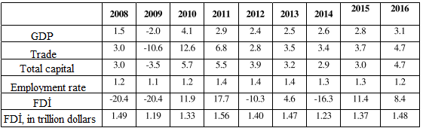

**Source:** UNCTAD, FDİ/MNE database for FDİ in 2008-2014, UNCTAD estimates for FDİ in 2015-2016 ([www.unctad.org](http://www.unctad.org))

Naturally, the ongoing global economic downturn has a negative impact on global investment flows. Global direct foreign investments (FDI) dropped by 16% to $ 1.47 trillion in 2014 from $ 1.23 trillion in 2014. The main reasons for the decline in direct foreign investment were the disruptions in the world economy, the formation of unfavorable conditions for investors and growing geopolitical risks. Despite the increase in GDP, trade, basic capital accumulation (CCA) and employment, a decline in FDI was observed.

UNCTAD predicts that the world's GDP will be 1.4 trillion US dollars in 2015 (1.5 trillion in 2016). The main reasons for the FDI increase are the tendency of growth in the US economy, stimulation of the world's cheap oil demand, and the expansion of the investment liberalization policy. The continuing high profitability of transnational companies (TNCs) will have an impact on the growth of FDI. However, the existence of a number of economic and political risks, uncertainty within the eurozone, and the geopolitical tension may lead to a decline in the probable increase. In addition to the volume of FDI flows, their flow direction has also changed. So, if there was a sharp decline in FDI flows to developed countries, then the historic maximum limit for developing countries has been recorded.

**Figure 1.2. FDI flows to the world and countries group in 1995-2018, in U.S. $**

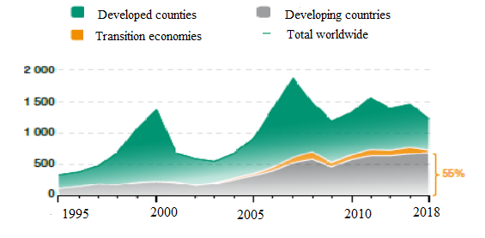

In 2014, 55% of global FDI flows were directed to the economies of emerging economies (Figure 1.2). In emerging Asian countries, FDI imports have increased, while Latin American countries have dropped and stagnation has continued in African countries.

The flow of FDI to developed countries has dropped by 28% to $ 499 billion. The FDI flow to the US economy has dropped by $ 92 billion (40% lower than in 2013). The main reason for the decline is the separation of Vodafone and Verizon companies. Among European countries, Ireland, Belgium, France and Spain, there has been a decline in the UK, Switzerland and Finland.

**Figure 1.3. FDI flows to regions in 2015-2017, in U.S. $ billion**

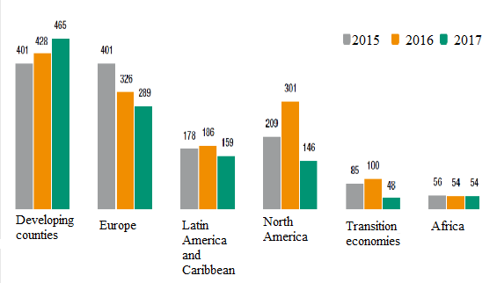

**Source**: UNCTAD, FDI / MNE Database (www.unctad.org/fdistatistics)

In 2014, the flow of FDI to transition economies decreased by 52% to $ 48 billion. The underlying causes of the decline are the aggravation of regional conflicts and the imposition of sanctions on certain countries. The FDI flow to the Russian Federation decreased by 70% to $ 21 billion. The closure of the Rosneft-BP deal in 2013 has led to a rise in this indicator in Russia.

The FDI flow to developing countries has risen by 2% to a historic peak ($ ​​681 billion). While FDI flows to Asian countries increased in 2014, decline in Latin American and Caribbean countries, and stagnation in African countries (Figure 1.3). Developing Asian countries have grown by 9% in the FDI flow of $ 465 billion. East Asia, South East Asia and South Asia have shown an increase in this indicator. As a result of the development of the service sector in China, the FDI flow to the country increased by 4% and amounted to $ 129 billion. There has been an increase in Hong Kong and Singapore FDI flows. In India, the sharp 22% increase in the indicator was 34 billion US dollars. However, the flow of FDI to Western Asian countries has dropped by 4% to $ 43 billion.

 After a 4-year increase, the FDI flow to Latin American and Caribbean countries (excluding offshore financial centers) declined by 14% to $ 159 billion. In Mexico, Venezuela, Argentina, Peru and Colombia, the decline was recorded, and growth was observed in Chile. In Brazil this situation is stable.

FDI flow to Africa remained unchanged at $ 54 billion. The FDI flow to North Africa has dropped by 15% to $ 12 billion. The 5-percent increase in the Sub-Saharan region was $ 42 billion. Due to the Ebola virus, regional conflicts and falling commodity prices, the FDI flow to the West African region has dropped by 10% to $ 13 billion. In South Africa this figure dropped by 2% to $ 11 billion. FDI flows to Central Africa and East Africa have grown by 33% and 11%, respectively, of $ 12 billion and $ 7 billion.

**Figure 1.4. The 20 largest economies for FDI inflows in 2016 and 2017, in billions of US dollars**

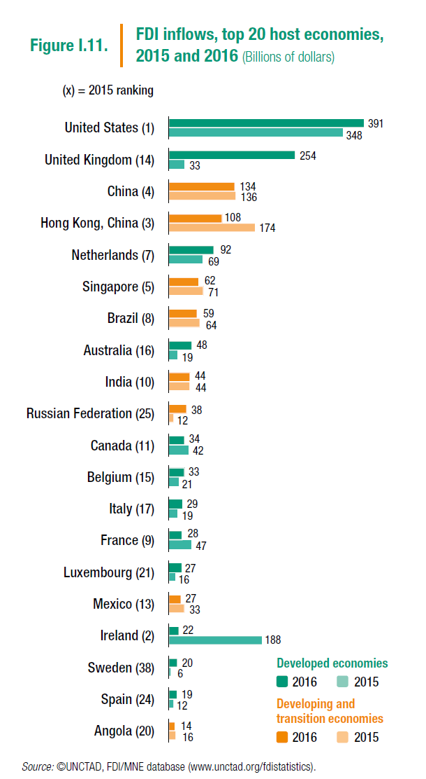

FDI flows to less developed countries increased by 4% to $ 23 billion as a result of the increase in investment in greenhouse projects.

Summarizing, it can be noted that in 2014, China has been the most FDI-receiving country (Figure 1.4). Hong Kong was 2nd and USA third in this ranking. Among the top ten countries, most FDI countries are 5 developing countries.

Transnational companies have seen an increase in FDI flows to emerging economies and developing countries. In 2014, the world's largest investors were emerging Asian countries. In 2014, only 468 billion US dollars have been invested by transnational companies in developing countries, which is 23% more than in 2013. Thus, they have a 35% share of world FDI, which is 13% more than in 2007 (Figure 1.5).

**Figure 1.5. FDI outflows from developing countries and their worldwide share, in billions of US dollars and percentage**

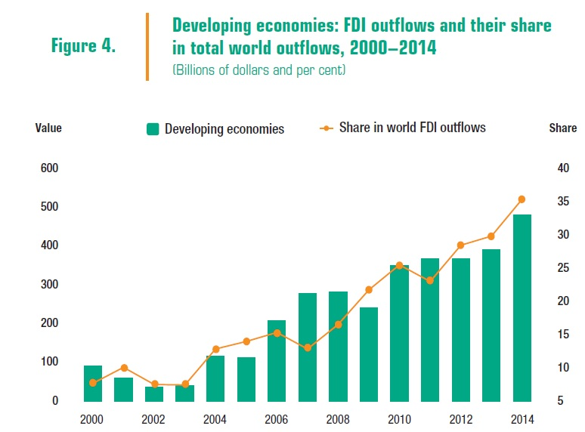

**Source**: UNCTAD, FDI / MNE Database ([www.unctad.org/fdistatistics](http://www.unctad.org/fdistatistics))

Transnational companies in developing countries are focusing on greenhouse projects and creation of trans-boundary companies.

While 81% of transnational companies in emerging economies were invested in recycling projects, while more than half of the transvestite companies invested in major investments accounted for capital.

**Figure 1.6. Top 20 countries for FDI outflows**

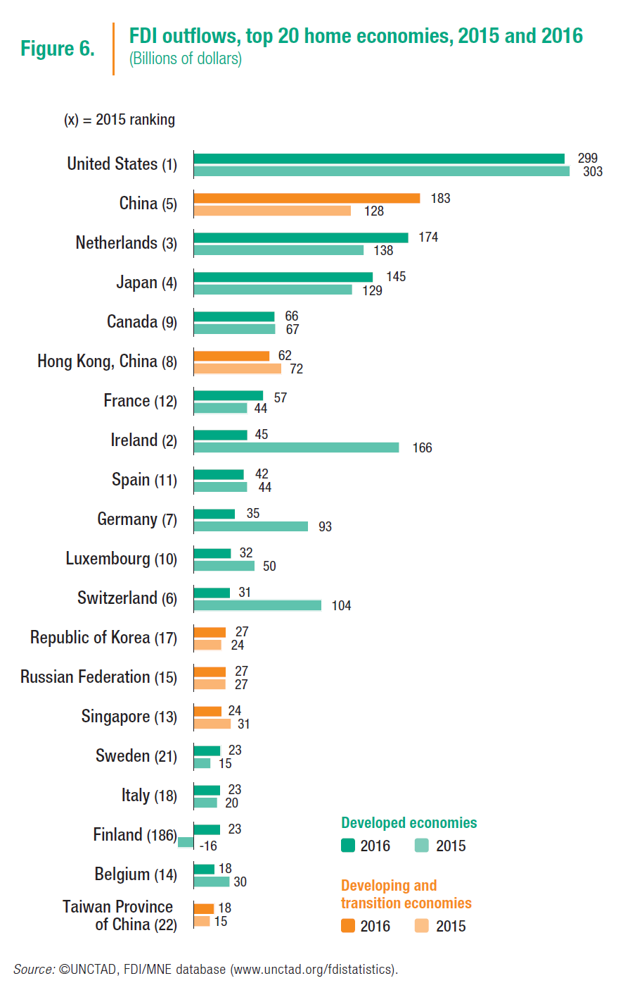

In the modern world, the role of foreign investment in economic life has significantly increased. At present, FDI attracts resources such as acquiring knowledge and skills, transferring new technologies, preparing local cadres, increasing future economic potential, and integrating the country into the global economy. Attracting investment to provide sustainable and balanced development is a key priority for all countries in foreign economic policy. The increasing demand for the economy by attracting investment is one of the factors that enhance the economic potential of the country as a whole. Despite the fact that in recent years, intensive investment policy has been implemented to attract foreign investment from different countries, it seems that they are more selective in this area. Involvement of investments aimed at the development of social welfare and the availability of corporate social responsibility are the basis of the formation of a modern investment policy. Countries prefer investments in the creation of new jobs, increased productivity and efficiency, intellectual property and environmental issues that increase the competitiveness and agility of the economy through innovations. There is a steady and balanced development in the root of such investments. Countries are pursuing their liberalization policy to attract FDI in the face of ongoing global economic crisis. New requirements for investment promotion agencies, as well as incentive and stimulating mechanisms, have also changed the look of the FDI attraction system. The modern investment-oriented system is not only supported by information support (supporting foreign investors, providing support to the registration process), but also providing financial support (discounts and deductions, investment-related costs and special privileges) and continuous support (accompanying investment projects, support for the problems that arise in the work process). In addition to traditional support mechanisms, many countries have started implementing new investment promotion and stimulation programs, adopting new concessional programs, creating a mechanism for direct financial assistance to projects, enhancing the attractiveness of FDI through the securities market, creating private economic zones, attracting and investing in "single window" mechanisms to support investors, lowering the tax burden. Simplification of procedures and requirements related to entrepreneurship activities, improvement of the legislative framework in order to facilitate this activity, and reforming the overall business and investment environment have become an important aspect of public policy in this area. However, given the fact that involvement of foreign investments is largely due to the existence of a system of intellectual property and the reliability of intellectual property protection, attention has also increased to the development of this area. Activities of national investment promotion agencies. The importance of national investment promotion initiatives in attracting investments is significant. According to a study conducted by Oxford University in 124 countries ("Investment Promotion and FDI Inflows: Quality Matters", Univesity of Oxford, June 2012), each US $ 1 spent on investing in the country, as a result, attracts $ 189 USD to FDI, The US dollar creates additional jobs by the foreign investor. 83 percent of foreign investors invest in new markets are primarily targeting investment incentives. For this reason, many countries in the world have created investment incentives that operate in the direction of foreign investment, providing services to foreign investors on a "single window" principle. A World Bank survey of 189 national investment promotion agencies suggests that the introduction of information and communication technologies, modern and interactive processes, management efficiency, professionalism-based incentive system, large international representative and representative network, as well as investment in modern infrastructure organizations have higher results in attracting FDI.

**1.3. Investment incentive process: methods and world experience**

There are a number of measures aimed at attracting foreign investment in world practice.

First of all, it is necessary to note the macroeconomic policy aimed at attracting investments. Meanwhile, the measured monetary policy is being pursued, stability of domestic prices is ensured, and the value of debt capital has a positive impact.

 Fixed tax policy that supports investment: direct tax breaks, extension of tax expense for capital investment, incentives on depreciation charges, customs tax deductions from 2 to 10 years, customs clearance of imported equipment, raw materials and spare parts release of payments, lowering the tax rate for companies implementing capital investment.

There are also financial methods to stimulate capital investment: subsidies, loans, loans, and guarantees to their presentation. Often, financial incentives depend on the fulfillment of certain conditions by the investor (mastering of specific regions, areas, creation of new jobs). For example, since 1982, the UK has a state aid system for more important projects. When foreign investors invest in stagnant regions, they receive large amounts of subsidies. As a result of this policy, structural changes occur in emerging areas with new production. Basic factors of attracting foreign investments are also the liberal foreign exchange policy. This policy allows the investor to easily convert the earnings in national currency to convertible currency.

A number of states generally utilize public programs aimed at meeting the needs of entrepreneurs to stimulate investment.

Many countries also use the means of state guarantee to stimulate foreign investment. In this case, warranty can be issued by both the exporting country and the host country. In accordance with the legislation of many countries, investors wishing to place their own capital abroad may obtain guarantees from their own countries or from a foreign country. Governments interested in promoting capital exports guarantee that their national companies are nationalized, natural disasters, inaccessibility of profits, non-return of local currency, and other unexpectedly funded resources, either partly or in return, by state sources. Investment guarantees are also provided by bilateral and regional agreements on the protection of investments signed by many countries. The Multilateral Investment Guarantee Agency, established under the World Bank's support, is engaged in multilateral investment guarantees. Investment Guarantee Terms are also reflected in the Lomey Convention, signed between the European Union and most developing countries.

For the foreign investors to activate, countries also use foreign investment insurance. This type of insurance, which is considered to be a specific form of insurance, can be implemented both by private and public agencies. The essence of the insurance is that the insurance company must compensate the losses of the investor in cases specified in the insurance contract. Unlike private insurance agencies, national agencies and insurance companies only insure their investors. The State Corporation for Investment Insurance and Guarantee is engaged in direct investments in the United States.

   Removal of double taxation plays an important role in promoting direct investments. if enterprises are operated in several countries, then each of them may have to impose a tax on the enterprise's revenue individually, which ultimately could have a material adverse effect on the company's business. In order to avoid this, the relevant agreements are signed between the two countries. According to these agreements, the company pays the unpaid portion of the capital in the country of export of the capital in the host country.

   Non-financial methods of foreign investment support are aimed at creating a common environment for the effective functioning of foreign capital. Meanwhile, many measures are taken, from the development of transport, from the development of other communications, to the provision of information services to producers.

Regulation of investment disputes also plays a special role in the state support of direct investments. Investment dispute settlement is carried out on the basis of national legislation of countries that accept or export capital, or international arbitration.

   The state often provides its investors with administrative and diplomatic support. Direct Investors are usually sponsored by government agencies that export capital. Governments negotiate with foreign governments to create favorable conditions for their national investors. Representatives of international business are included in international delegations traveling abroad to discuss economic issues.

  The creation of special economic zones is of particular importance during non-financial measures that lead to the activation of foreign investors. In the broadest sense, special economic zones (SEZs) are regions or territories defined by the state where favorable tax, customs, and legislative regimes exist. Provision of these conditions creates favorable conditions for the investor.

Liberalization of the world capital market is one of the key issues in the modern world economy. Nevertheless, some economists believe that liberalization has negatively influenced the conditions for the entry of foreign investors into the domestic market. The following arguments are used to justify this thesis:

• Elimination of direct restrictions does not always result in transparency of investment regimes, and absence of transparency is a significant bar for direct foreign investment.

• Direct restrictions are substituted by hidden restrictions. At present, hidden investment restrictions are more significant barriers to direct constraints.

The most commonly used tools for promoting investment in world practice are:

- application of the tax system with differentiation of taxation subjects and objects, tax rates and privileges;

- implementation of credit and depreciation policy (including through rapid depreciation of fixed assets). Amortization negligible, separate economic areas, variable and differentiable for different types and elements of fixed assets and equipment.);

- granting subsidies, subventions, budget loans for the development of separate regions, industries and industries;

- defining state norms and standards;

- anti-monopoly measures;

- privatization and privatization of property;

- Determine the terms of use of land, water and other natural resources;

- implementation of pricing policy;

- Carrying out examination of investment projects.

The coordination of foreign investment involving Italy is being implemented by the Investments Promotion and Entrepreneurship Development Agency (InvItaly). The agency is a joint stock company for its legal form and its sole shareholder is the Ministry of Economy and Finance. "InvItaly" identifies key priorities for foreign investment: ICT, logistics, renewable energy, tourism, innovation and research and more. The most important directions in the field of investment regulation in Spain are reforms in the financial sector and in the area of ​​labor legislation (increasing the employer rights and recruitment rights). Such measures are also relevant for other developed countries with difficulties in investment. In general, other government-led measures to stimulate investment activities include tax incentives (tax rates reduction, tax contracts with other countries), special (specific) investment projects, financial incentives (preferential loans, investment loans, interest-free loans) provision of necessary land for investment activities or provision of preferential prices), including protective measures. Investment Promotion in Turkey has come into force with the Decision of the Cabinet of Ministers of the Republic of Turkey "On State Support for Investments" of June 19, 2012.

The incentive measures have been divided into six regions depending on the level of socio-economic development of the regions in order to implement the support provided in the Decision on State Support for Investments. Support measures undertaken in Turkey include the following:

- exemption from VAT on import;

- exemption from customs duties;

- Predictability;

- social insurance support;

- Separation of the grass;

- Loan interest support;

- VAT Refund.

Encouraging measures also include industrial zones. In some cases, more favorable stiffness is expected for industrial zones. For example: the amount of discount is increased and the term is extended. Support measures implemented in the system of investment promotion are also divided into 4 groups, depending on the socio-economic development of the regions:

1. General precautionary measures - exemption from VAT on imports; - No exemption from customs duties.

2. Promotion of IOM investments - exemption from VAT on imports; - exemption from customs duties; - tax deduction; - social insurance support; - Land separation.

3. Promoting investment in regions

 The key prerequisite for promoting investment in the regions is to follow a minimum investment requirement in selected sectors and invest in the region (divided by 6 countries according to the level of development of the country and the level of discrimination applied to each region).

4. Promotion of strategic investment

Strong strategic investment incentives are: strict adherence to the minimum investment requirement for defined sectors (50 million liras); the share of imports in the domestic market of goods to be produced should be more than 50%; Value added should be higher (over 40%); minimum $ 50 million in imports for the product to be produced in the last year (this is not required for non-domestic products). - exemption from VAT on import; - exemption from customs duties; - tax deduction; - social insurance support; - Land separation; - Credit interest rate support; - VAT Refund

**Figure 1.7. Turkey's experience in stimulating investments**

**CHAPTER II**

**DEVELOPMENT OF NON-OİL SECTOR'S INVESTMENT OPPORTUNİTY İN AZERBAİJAN**

**2.1. Main areas of the non-oil sector and their modern developmental characteristics**

The rapid price cut in the world market since the end of 2014 played a decisive role in diversifying the economy and promoting the development of the non-oil sector in ensuring the sustainable development of Azerbaijan in the conditions of deepening the financial crisis. Over the past five years, the economy has grown mainly due to the development of the non-oil sector and its share in the gross domestic product has reached 69.9 percent. In general, according to official statistics and macroeconomic indicators, over the past twelve years the country's non-oil sector has grown more than 2.5 times. No doubt, the measures taken to diversify the economy through the oil revenues have played an important role in the development of the non-oil sector. Billions of dollars have been spent on supporting small and medium entrepreneurship based on the development programs to diversify the economy and develop the non-oil sector, allocate preferential loans to those who are caught up in this activity, direct agricultural subsidies, and transport and communications infrastructure throughout the country. All this has caused great revival in the non-oil sector of the economy. At present, non-oil products produced in Azerbaijan, including electrical equipment and their parts, chemical products, construction materials, finished textile products, etc. exported to various regions. As you can see, the most important task that stands in the face of Azerbaijan's transition economy is to diversify the economy economically and minimize its dependence on oil using its natural resources. As a result of this strategy, the trend of sustainable growth in construction, tourism, agriculture, transport, information and communication technologies continues. It is this tendency that over the past twelve years, our country has created about 1 million 400 thousand, the vast majority of which fall into the non-oil sector.

In 2017, the growth rate of non-oil industry totaled 2.1 percentage points in comparison with the corresponding period of 2016. The rise in growth rates affected the growth rates of many leading industries (manufacturing of food products, construction materials, metallurgical industry, chemical industry, machinery and equipments, production of electrical equipment, finished metal products, etc.).

   During January-December 2017, production increased in many sectors of the non-oil refineries, including food products (1.4%), construction materials (22.2%), metallurgy (11.0%), chemicals (32.0% (41.0%), beverage production (8.1%), electrical equipment (12.1%), finished metal products (6.2%), clothing production (59.9%) and other vehicles (3.4%). times), furniture production (8.3%), car and dust production (58.2%), etc. sections have increased.

    In January-December 2017, 66.1% of total investments in the economy or 11.7 billion manats were directed to the non-oil sector. 7.5% of fixed capital investments, 11.4% of investments directed to the non-oil sector or 1325.7 mln. manats were used for the development of the non-oil sector.

   In January-September, 2018, an additional value of 28.0 billion manat was created in the non-oil sector of the country, and overall, more than 60 percent of them fell to the share of social and other services, trade, repair and construction.

**Figure 2.1.**

**Breakdown of added value created in the non-oil sector during January-September 2017**

**Source:** State Statistical Committee of the Republic of Azerbaijan (www.stat.gov.az)

In January-September, 2017, the value added in the non-oil sector of the country's economy increased by 6.4% compared to the same period of the previous year. The share of added value in the non-oil sector in GDP increased by 10.3 percentage points to 68.8% compared to the same period of the previous year. The 3.7% increase in value added in the country's economy during the period from January to September, 2017, has completely diminished by the non-oil sector. Among the sub-sectors of the non-oil sector, the most significant contribution to the country's GDP growth was the repair of trade and transport facilities (0.9 percentage points).

The growth rate of value added in most sectors of the non-oil sector was relatively high compared to the same period of the previous year. The largest contribution to the growth of non-oil GDP was provided by trade and transportation means (1.5 percent).

**Table 2.1. Increase in the value added in non-oil sector, in percent**



**Source:** State Statistical Committee of the Republic of Azerbaijan (www.stat.gov.az)

In January-September 2015, the non-oil industry produced goods worth 5633.8 million manat and increased by 10.2% compared to the same period of the previous year. During the reporting period, the share of non-oil industry products in total industrial products increased by 7.8 percentage points and amounted to 28.6% compared to the same period of the previous year; the industry's 2.1% growth was due to non-oil industry. During the reporting period, the most significant increase in industrial growth was the installation and repair of machinery and equipment (0.9 percentage points), chemical industry (0.8 percentage points), food products (0.3 pp), finished metal products 0.2 percent), construction materials production (0.2 percent) and electrical equipment (0.1 percent). According to the calculations, the non-oil industry increased by 10.6 percent in the non-oil sector in January-September, 0.6 percent in electricity, gas and steam production, distribution and supply, water supply, waste treatment and processing area 0.1 percent contributed. During the reporting period non-oil refineries, which contribute most to non-oil industry growth, were the construction and repair of machinery and equipment (4.1 percent), chemical industry (4.0 percent), food production (1.3 percent), finished metal products (1.0 percentage points), construction materials production (0.8 percentage points), computer and other electronic equipment (0.6 percentage points), electrical equipment production (0.5 percentage points).

The growth rate of the non-oil industry totaled 4.2 percent in January-September 2017 compared to the same period of 2016. The rise in the pace of growth has led to the development of many leading sectors of the processing industry (production of food products, building materials, chemical industry, machinery and equipments, metallurgy, finished metal products, production of electrical equipment, computer, electronic and optical products, ).

  In January-September, 2017, production increased in most non-oil refineries, including food products (3.6%), machinery and equipments (2.1 times), construction materials production (12.2%), , metallurgy industry (5.1%), finished metal products (62.0%), electrical equipments (20.8%), computers, electronic and optical products (71.9%), furniture production (5.2%), leather , leather goods and footwear (74.1%), polygraphy (76.3%), agaculture and wood products production (37.0%) and others. areas have increased.

 In January-September 2017, 54.8% of total investments in the economy or 6479.7 million manat were channeled to the non-oil sector. 7.5% of investments in fixed capital, 13.8% of investments directed to the non-oil sector or 891.3 million manat were used for the development of the non-oil sector.

At present, agriculture, tourism, information and communication technologies, processing industry are the main priority areas in the development of non-oil sector in Azerbaijan. International financial institutions stress the importance of agriculture and tourism in Azerbaijan. About 44 percent of the country's well-educated population is currently working in agriculture. Therefore, implementation of consistent state programs aimed at the development of agriculture in Azerbaijan, accelerating the involvement of some reforms and new technologies is accelerating. It is no coincidence that at the conference dedicated to the results of the first year of implementation of the third regional development program, President Aliyev said: "... The development of agriculture is a priority issue. It is a social, economic sphere and support for the development of the non-oil sector. "

Over the past three years, the growth rate of gross agricultural production in Azerbaijan has been moderate by an average of 2.5%. There are concrete steps to promote the development of agriculture, which is an important part of the country's economy, with the adoption of important state programs and its implementation. As a result, in the first half of 2015, the country's agricultural sector produced 2 billion 648.6 million manat, which is 7.3 percent more than in the same period last year. However, the potential of agriculture in Azerbaijan is quite high, and effective measures are taken by the state to make use of these opportunities. It is enough to note that over the past period of this year, 25 million manats were allocated for the implementation of "State Program on Reliable Provision of Foodstuffs in the Republic of Azerbaijan for 2008-2015" by providing state support to agricultural producers . At the same time, the Decree of the Head of State, Ilham Aliyev, signed on January 12, 2015, also serves this purpose as the Year of Agriculture in Azerbaijan in 2015. A number of effective measures are being taken in our country to ensure rapid development of the agrarian sector. Important work to be done to mobilize the existing potential in the field of agriculture, one of the key areas of economics, will ultimately stimulate the development of the non-oil sector in our country.

One of the priorities of the non-oil sector in Azerbaijan is tourism. The area is very attractive in terms of income. Because of this, large-scale measures are being taken in recent years to fully promote the existing tourism potential of our country, and modern tourism facilities are built and put into operation in Baku as well. , the level of services in this area is gradually improving. The full use of the country's tourism opportunities will lead to an increase in the share of the non-oil sector in the GDP. In the first half of the current year, there has also been a significant increase in transport, information and communication, should be considered a valuable contribution to the development of the oil and gas sector.

   Significant measures are being taken in Azerbaijan in the area of ​​information and communication technologies (ICT) development in recent years. According to the State Statistics Committee, for six months of the current year, information and communication enterprises provided services to population, enterprises and organizations for 771.8 million manat. Compared with the same period last year, the volume of information and communication services increased by 10.7 percent, 72.5 percent of the services were rendered to the population, and 80 percent of the revenue was accounted for non-state sector.

The future economic progress of Azerbaijan, especially the development of the non-oil sector, is largely dependent on the activities of the private sector. The favorable business environment created in Azerbaijan in recent years and the increasing state support to the private sector have led to rapid growth of entrepreneurship in the country. According to the Presidential Decree "On Additional Measures to Improve Entrepreneurship," work was continued last year to further improve the business and investment climate in the country, including simplification of procedures, expanding the scope of electronic services, overcoming unreasonable interventions and other areas. Under the National Fund for Entrepreneurship Support, 2972 ​​entrepreneurs were provided with a graceful loan amounting to 96 million manat in support of entrepreneurship development in six months of this year. In general, many large production, processing and infrastructure facilities have been put into operation in the country thanks to the soft loans financed by the fund.

   As it is known, the development strategy of the regions, which is one of the priority directions of the policy of economic development, in providing sustainable socio-economic development of our country, protection of macroeconomic stability, is of exceptional importance. The socioeconomic development of the regions implemented since 2004 has resulted in an increase in the economic potential of the regions, improved infrastructure, improved utility services, improved business and investment environment, and welfare of the population. From this point of view, significant efforts have been made within the State Program on Socio-Economic Development of the Regions of the Republic of Azerbaijan for 2014-2018, a number of successful projects have been implemented and sufficient funds have been allocated for the development of the regions.

As we have seen, the development of the non-oil sector of Azerbaijan is becoming increasingly urgent as a priority of the state's economic policy. In the background of the socioeconomic development of our country, the share of this division in the GDP has continued in the previous period of 2018. Incidentally, according to economists' forecasts, GDP growth this year will be in the absolute and relative sense of the share of the oil sector, and, respectively, the increase in the non-oil sector's production, according to the forecasts of the state's economic policy. This year, the growth rate of the non-oil sector is expected to be more than 10 percent. This trend will continue in the coming years. Thus, the share of the non-oil sector in GDP will increase from 52.7 percent in 2012 to 72.4 percent in 2021. During this period, the share of the oil sector will decline significantly in the formulation of the state budget revenues, which can be regarded as the result of the large-scale activity of the non-oil sector in the dynamic development of the economy by diversifying the economy by indicating a year-on-year decline in oil dependence.

Having a high share of oil and oil products in export over the past decades has been linked to the traditional structure of the Azerbaijani economy. Nevertheless, the share of the oil sector in the structure of exports is gradually decreasing. For comparison, if the share of the oil sector in exports was 90.3 percent in 2015 and 88.1 in 2016 - 85.4 percent in 2017, last year this figure was 80.1 percent. According to economist experts, this trend will continue in the years to come and will reach 70 per cent in 2020. In the future, the volume of non-oil products will be increased from our country to world markets. This will be possible due to the development of the non-oil sector, which is a logical consequence of the diversification of the economy in Azerbaijan.

**2.2. Comprehensive research of investment in non-oil sector.**

Foreign investment in all the countries of the world is one of the key factors in promoting economic growth. In this regard, investment policy has become a priority in the economic policy of the state in modern times. In the 60s of the last century, the basis for the economic development of countries such as the United States, Japan, Germany, France, and the UK was the investment activity. Previously, the role of attracting foreign investments was to cover the deficit of the balance of payments, increase domestic production, overcome the crisis, increase productivity and so on. but limited to. In the modernization of globalization, modern investment, the creation of healthy competition across the country, the introduction of new technologies and know-how into the country, the introduction of liberalization and modern management practices in the economy, human resource development, environmental protection as well as transnational corporations and their country of origin is important in terms of winning support. From this point of view, the analysis of the structure of foreign investment in the Azerbaijani economy, investigating the factors affecting the investment environment, and determining the investment requirement are of great importance. Starting from 1994, concessions have been made to foreign investors in order to attract investments into the economy of the Republic of Azerbaijan. Important laws have been adopted in the Republic to protect the rights and interests of investors, the inviolability of the property, the creation of favorable conditions for local and foreign entrepreneurs, and the unimpeded use of profits. During this period, the Government of Azerbaijan signed an agreement on the elimination of double taxation and the promotion and protection of investments with a number of sharp countries. Relevant laws, regulations and decisions have been adopted to eliminate factors that hinder foreign investors' activity in Azerbaijan and attract foreign capital to the country's economy. In 1992, the Law of the Republic of Azerbaijan "On Protection of Foreign Investments" (as amended on April 7, 1992 and November 5, 1996) and foreign investment in adoption of the Law of the Republic of Azerbaijan "On Investment Activity" the legal basis of the investment was laid. At present, the legal base of foreign investment in Azerbaijan is defined at 4 levels:

1) in the Constitution of the Republic of Azerbaijan;

2) Laws and other normative-legal acts;

3) bilateral and multilateral intergovernmental agreements;

4) Multilateral international agreements.

Involvement of foreign investments and expansion of foreign trade are among the main priorities of the foreign economic relations of the Republic of Azerbaijan and constitute important factors for strengthening the country's economic potential.

The volume of foreign investments in Azerbaijan's economy during 2003-2013 amounted to $ 74.7 billion. FDI in this period amounted to $ 45.6 billion. During that period, the FDI in the non-oil sector reached $ 1.04 billion (2013) of $ 45.4 million (2003). In 2003-2013, foreign capital invested mainly in the oil and gas sector, and in the non-oil sector, various industries, construction, trade and services.

The number of registered foreign entrepreneurs in Azerbaijan increased from 3252 in 2003 to 6523 in 2013.

The geography of foreign investments is also extensive. Thus, in the top ten of the list of foreign countries investing in Azerbaijan, such countries as Great Britain, USA, Japan, Norway, Turkey, France, Czech Republic, Germany, Saudi Arabia and Russia. Among foreign countries that invest most in the non-oil sector of the country's economy, Turkey, the United States, Great Britain, Germany, the Arab Emirates, France and Russia can be celebrated in 2013. Foreign Trade Relations Growth Rates of Azerbaijan

Azerbaijan has had trade relations with 149 countries around the world. Our country has more intensive trade relations with Italy, Indonesia, Russia, Germany, Turkey, Great Britain, Thailand, France, the USA and Israel. The share of these countries in total trade was 67.8%. the volume of export operations reached $ 23.98 billion. During the reporting period, non-oil exports increased by 6% compared to the previous year and reached $ 1.77 billion. Export of non-oil products per capita was equal to 190.7 US dollars. The number of exported goods was 2111 units.

At the same time, the volume of non-oil service exports in 2017 amounted to $ 4.13 billion, which means an increase of 9.5 times in the last 10 years. The main place is tourism (57.3%), transport (19.1%) and other business services (15.6%). The per capita volume of non-oil service exports is $ 438.

However, despite all the positive factors mentioned above, there are fundamental problems in the area of ​​foreign investment. One of the main risks for foreign investment is the uneven distribution of foreign and joint ventures in regional and industry sectors. Thus, foreign investment enterprises operate mainly in Baku and the extractive industry. According to statistical data, 89.36% (975 enterprises) in 2015 and 88.57% of enterprises with foreign investment in 2016 (938 enterprises) operate in Baku. The volume of services rendered by these enterprises and their services amounted to 23.44 bln. In 2012, 28.61 bln. manat, which is 97.62% and 97.21% respectively of total liabilities. The share of the extractive industries in the total volume of works in the mining industry was 79.3% in 2015 and 83.04% in 2016. Most foreign-owned enterprises in Azerbaijan belong to far foreign countries. Thus, 63 of the foreign enterprises created in 2016 belonged to the CIS countries, which accounts for only 5.9% of the total number of enterprises. The share of these enterprises in total production of goods and services was 0.16%. 79.69% (2012) of foreign and joint ventures carried out by 20 foreign companies in Azerbaijan. An analysis of capital investment in the sector shows that in 2009 77.3% of foreign direct investment (68.6% in 2008) was invested in the oil sector.

Most of the investments directed to the non-oil sector in 2016 are directed to non-profit sectors such as electricity generation, gas and water generation, housing construction, transport, storage and communication, education, health and social services. A small proportion of fixed capital investments is directed to agriculture, manufacturing and processing industries, and trade sectors. Restricted investment in trade and non-oil sectors leads to the lack of modern technologies, innovations and new business opportunities in these sectors, as well as the introduction of new management techniques and the slowdown in enterprises' restructuring. This, in turn, has a negative impact on the competitiveness of these sectors. This fact shows that there is a need to increase the competitiveness of non-oil sectors and attract investment to non-oil sectors. Despite some remarkable achievements in attracting FDI and improving business environment, there are still a number of issues that are yet to be resolved.

There is concentration on the structure of foreign investment in countries. Thus, in 2016, Great Britain has a high share of private investments (33.6%) among foreign countries and international organizations on investment in Azerbaijan. The volume of British residents' capital investments in Azerbaijan amounted to 1096.55 million manat. Britain's share of foreign investments in the economy of Azerbaijan in 2016 was 33.6%, despite the British investor's investment investment decreased by 87.99 million manats or 8.4% compared to the previous year. In addition to Great Britain, the top five of the major foreign investors in the Azerbaijani economy can include US, Japanese, Turkish and Norwegian residents. Capital investments in these five countries totaled about 2469.95 million manat, which is 75.76% of total investment. However, the analysis shows that, despite some positive changes in the system of relations established recently with foreign investors, these advantages and opportunities are not used effectively. In order to achieve a strong foreign investment flow in Azerbaijan, an entire economic system should be formed. Taking into account the experience of the countries taking the lead in the world economy, it can be said that effective foreign economic activity of Azerbaijan and foreign investors should be based on the principles of general liberalization in the economy. Mechanisms of economic regulation in the country should be consistent with international law and world practice; the structure of the economy and foreign trade relations should be shaped in accordance with the country's economic potential, domestic demand and the benefits of the international division of labor. Today, the problems of activating the investment process and increasing its effectiveness are of great importance to the Republic of Azerbaijan. Attraction of foreign investments should primarily mean the irreversible priorities of Azerbaijan's economy, namely the adoption of modern production technologies, innovation decisions, new management systems and renewal of production facilities. However, as practice shows, foreign investors are trying to gain a higher profit, first of all, on the export-oriented raw materials. This often creates the raw material orientation and technical and technological decline of the Azerbaijani economy.

**CHAPTER III**

**STİMULATİON OF İNVESTMENT İN NON-OİL SECTOR İN AZERBAİJAN**

**3.1. The main targets of the non-oil sector development trend and investment stimulus strategy**

Despite the prevailing share of the non-oil sector in GDP, the oil and gas sector has remained dominant in exports, which limits the role of the non-oil sector in accessing our country to foreign exchange. The problems affecting the development of the non-oil industry in the Republic of Azerbaijan are characterized as follows:

Delays in the implementation of the measures taken in the non-oil industry;

- the long-term fuel and energy sector in the economy as a key driving force;

- Remaining a problem of effective and concessional approach to investing in prospective and potentially developing sectors;

- The lack of progressive development of the technical and technological base in the non-oil industry;

- Controversy of modern scientific and intellectual potential in the country;

- Incompleteness of the level of training of highly skilled, professional specialists and intellectuals in this field;

- The lack of regulatory mechanisms and infrastructure to ensure the development of innovation activities;

- lack of inclination to non-oil industry enterprises to produce competitive, innovative products;

- insufficient formation of modern quality standards;

- the presence of differences in the regional development and the tendency of the development of non-oil industrial enterprises to the center;

- Weaknesses of scientific and innovation research in non-oil industries;

- The share of export potential of non-oil industry branches and enterprises, in the balance of payments, the low level of foreign trade;

- the height of production funds, technological equipment amortization, the basis for the application of new and modern equipment;

- The level of material and energy consumption in product production;

 Management system and management's level of professionalism does not meet modern requirements.

State programs and concrete measures to address the aforementioned problems related to the non-oil development in the country should open wide opportunities for diversification of the economy and the development of new industries. That's all

based on positive trends, the priorities of non-oil industry in the Republic of Azerbaijan for 2015-2020 include the following:

- Establishment of enterprises based on modern technologies, producing competitive and export-oriented products in the regions, stimulating exports of products produced in these regions to the regional and world markets;

- Consideration of the non-oil industry development on economic regions as a priority in investment policy;

- Implementation of the necessary measures for the establishment of Special Economic Zones, which is an essential part of industrial policy;

- Creation of industrial parks and complexes for the development of the non-oil industry, the modernization of the economy, the formation of an innovative and elaborated economy, and the expansion of competitive industrial production on the basis of high technology;

- Enhance the application of international standards in non-oil industry sectors in the context of policy making;

- Rebuilding and promoting the chemical industry, which is of great importance to the country's economy, improving the quality of its products, increasing the depth of their processing;

Acceleration of the development of Azerbaijan's mining industry, ensuring export of products to the foreign markets and competitiveness, recovery of the development of the oil and gas industry;

- Expanding black and non-ferrous metallurgy with rich resources;

- conforming light industry development to modern requirements, improving competitiveness of these products in domestic and foreign markets;

- valuable biological material for ensuring competitive products

mastering of products using rich local raw materials, increasing the biological value and quality of these products;

- The development of nanotechnology, the new and modern area in the country

mobilizing all the available space;

- speeding up the creation and development of space industry in the Republic;

- expansion of shipbuilding activities and enhancing the capacity of the field;

- expansion of production of electronic and other equipment, deepening of the specialization in this field;

- Increasing the construction materials industry, increasing the environmental impact of raw materials and resources available in this area.

Modernization of industrial enterprises based on modern technologies, their modernization, creation of industrial complexes with local resources and raw materials, production of export-oriented products, expansion of competitive industrial production are the main priorities of the non-oil industry. Providing sustainable growth in non-oil industry Necessary measures should be taken in the country to do so. First of all, priority is given to the development of high-tech and science-intensive industries; technical and technological restructuring of enterprises, attention should be given to the application of modern management methods; expansion of production of comparable advantageous and competitive competitive products is a crucial issue; will replace imports and stimulate the production of export-oriented products; establishment of industrial clusters and restructuring of the structure of the industry in accordance with the selected progressive directions; stimulation of investment-innovation processes, acceleration of application of ecologically clean technologies of energy and resource saving; identifying investment sources and increasing their effectiveness; ensuring the priority of industrial growth and labor productivity; creation of a marketing system with information on the current and future conjuncture of the world market of industrial goods; Improve the legislative framework in promoting innovation in the non-oil industry and introduce incentive mechanisms in this area; Creation of industrial parks, technoparks, specific economic zones for the non-oil industry development; tax and customs policies, support for exports and strengthening the internal market protection; scientific-technical and design activities, strengthening of patenting activity should be solved.

The emerging non-oil industry in a global competitive environment should also be characterized by the emergence of modern types of new product-based industries.

Competitive development of Azerbaijan's economy and industry requires first of all to shift to knowledge economy, which provides a new quality of economic growth. Its main characteristic is the dynamic development of high-tech industries, intensive growth of investments in research and development, productivity and productivity of products and services, innovation activity of enterprises, innovation gain.

The maximum use of available resources should be ensured by focusing on non-oil industry needs. The realization of this factor should be based on the latest achievements of scientific and technical progress and the intensification of the modernized industrial fields that are thoroughly formulated.

The qualitative changes in the structure of the non-oil industry should become an essential part of economic policy. The main source of sustainable economic growth should be the task of modernizing the new technological base. Gradually reducing the volume of existing old production funds and technologies, and increasing the share of new ones with the help of capital flows should be continued.

Transition from raw-material economy to innovation-driven economy should become one of the key targets in non-oil industry. Competitive production should be achieved by strengthening the link between extracting and processing industries in Azerbaijan. In the development of industrial production, the innovation-driven base of production should be upgraded, and the process of forming a field structure that meets its efficiency and competitiveness should be ensured.

The fuel and energy complex should provide a breakthrough relationship between fuel and energy complex, oil condensation and metallurgical combinations, taking on the role of the principal supplier of products and services. This tendency is also driven by the tendency of recovery and metallurgy to rationalize, maximizing production capacity. the use of expensive equipment and technologies will lead to a decline. Chemical and petrochemical industries are attractive for investment projects and oil and gas production should play an important role in determining the key targets of the country's chemical and petrochemical industries.

The use of domestic raw materials and resources in the non-oil industry will be strengthened in the country. All of this dependence will stimulate the development of raw material, processing and manufacturing industries.

The definite direction of the restructuring of non-oil industrial enterprises is the development of highly technological, high-tech production. This intensified trend will ensure the release of competitive products and its access to foreign markets.

In the regions, local raw materials-based industrial enterprises should be set up at a qualitatively modern level and the establishment of new ventures.

Within the framework of the program, new enterprises will be created in the field of metallurgy, shipbuilding, chemistry and processing industries in the non-oil industry. The introduction of innovation-oriented technologies in industrial enterprises will be stimulated, specialized and specially designated industrial foodstuffs will be created. The country will be preferred to the establishment of special economic zones and construction of industrial markets taking into account the potential of economic regions.

With the development and expansion of export capacities of traditional production areas of the non-oil industry (metallurgy, textile, electrotechnical, light industry, food industry, etc.), the creation of new competitive production areas will also be supported. Attraction of domestic and foreign investments to the country's non-oil splinter stimulating mechanisms will be used to intensify the process, investment cooperation between the public and private sectors will be used to promote the non-oil sector. Particular attention will be paid to the production and processing of agricultural products, as one of the most important areas for food security. Complex measures will be undertaken to increase the production capacity of existing processing facilities and to create new such enterprises through the introduction of modern technologies.

In order to achieve certain targets, measures will be taken to improve the competitiveness of the non-oil sector and to improve the competitiveness of the economy. Enhance competitiveness of the economy, strengthen macroeconomic stability, strengthen co-ordinate of monetary and fiscal policies, improve financial services markets, improve business environment, support for growth targets will boost the development of the non-oil industry. The reformed economic environment and the economic reforms will ensure a more intensive development of non-oil industries in 2014-2020.

The investment activity is the main component of the long-term economic policy line, which is thought to be in line with the requirements of modern integration, globalization, raising the effectiveness of the country's production sectors, the socio-economic outcomes of the service sector, improving the macroeconomic indicators of the national economy. The investment in non-oil industry covers the following:

- Creation of new facilities and the development of enterprises that are based on modern requirements;

- Expansion of certain businesses or existing businesses to increase productive capacities;

technically-technologically armament of the enterprise or separate structural divisions, shops by raising the technical-economical level of production;

- Modernization of the enterprise's main production funds;

- investment support of the entity's working capital;

- investments in an enterprise through securities (stocks, bonds, certificates);

- investments in the production of new and original products;

- investments in the production of new types of products within existing production areas;

- investments aimed at the development of intellectual values ​​(disciplines, know-how, inventions, scientific researches).

The investment scenario will be directed to the improvement of the logistics of the traditional sectors of the non-oil industry, their competitive production, the infrastructure development, and the export potential of the enterprises. This scenario will focus on investing in the chemical, textile, metallurgy, food, light and other industries Increasing the quality of equipment produced in the country and adapting to modern market requirements will be through capital investment.

Taking into account the priorities of the non-oil sector's development, the main purpose of the investment stimulus strategy is to stimulate the flow of import-replacing and export-oriented foreign investments in line with the priorities of the non-oil sector development of the country's economy, increase non-oil export volumes and .

To achieve this goal, the following tasks are essential:

- Continuous development of business and investment environment in the non-oil sector;

- identifying key areas for attracting foreign investment into the non-oil sector;

- Increasing the structure and enhancing the structure of foreign investments with high added value to the non-oil sector of the country's economy;

- Developing a creative (copyrighted) economy that enhances the attractiveness of the investment environment;

- Implementing incentive mechanisms to intensify foreign investment in the non-oil sector and to promote investment cooperation between the public and private sectors;

- Intensification of investment attractiveness through the financial market;

- Involvement of foreign investments into the priority sectors of the non-oil sector and the creation of clusters for the purpose of sustaining the economy;

- Further simplification and continual improvement of foreign trade procedures for the purpose of non-oil export;

- Creating new effective mechanisms to increase public support to exporters;

- Further expanding the scope of information and consulting services to increase the export capacity of entrepreneurship entities;

Branding, promotion of goods and services in foreign markets;

- Enhancement of export geography and product diversification through stimulation of non-oil export to foreign markets;

- Further enhancement of institutional framework for investment and export promotion.

Implementing an effective business environment, identifying the country's investment image and stimulating foreign investment will have a significant impact on achieving the following goals in the medium and long term:

- Azerbaijan will be among the top 30 most competitive countries in terms of business climate and economy competitiveness;

- incentive mechanisms will be introduced to intensify domestic and foreign investment in the country's non-oil sector;

- foreign investments will be attracted to expand the production infrastructure that serves the development of the non-oil sector and meets the modern requirements;

- The non-oil exporter will be delivered to 1000 US dollars;

- investment in public and private sector investment will be promoted to promote the non-oil sector;

- New technologies, know-how, and knowledge will be attracted through foreign investment in the production of import-substituting products, areas of high competitiveness and export potential;

- Promotion of incentive mechanisms to increase non-oil development opportunities will increase the state support to entrepreneurs in increasing access to international markets and increasing competitiveness in foreign markets;

- The quality of the workforce will be improved; highly skilled and competitive staffing potential will be formulated;

- exports will be expanded through stimulation of non-oil exports to foreign markets, and goods diversification will be ensured.

**3.2. The investment climate in the non-oil sector and ways to improve it**

To further improve the investment climate in the country, one of the main objectives is to ensure the required volume and quality of investments. For this purpose, the following steps are taken:

- protection of private property and improvement of corporate governance;

- Creating a more competitive competitive environment for all investors regardless of ownership;

- increasing the role of the state in order to ensure a stable normative-legal regime;

- further improvement of the regulatory and legal basis of investment activity;

- Improvement of the system of informing the investors about the enterprises for the purpose of selecting and analyzing the investment objects;

- Increasing assistance to the process of contributing to the modern institutional infrastructure that ensures efficient transformation of savings into investments;

- improvement of business information, accounting and statistics compliance with international standards.

In terms of protecting the economic interests of foreign investors, it is possible to concentrate on the advantages of the Azerbaijani economy in two groups: Group 1 factors are the advantages of all emerging markets, including Azerbaijan. The advantages of Group 2 are just the advantages of Azerbaijan. The advantages of developing countries, including Azerbaijan, are as follows:

(1) With countries that have a growing potential because of being a registered country

compared to many times. More and more are the means to get more revenue.

This principle encourages transnational corporations around the world to invest in more developing countries.

2) Domestic competition is not strong, as domestic firms are poorly developed.

3) The countries in question have the opportunity to earn more income in high risk situations.

4) In emerging markets, foreign investors have less bureaucratic hurdles than domestic investors.

The following are some of the advantages that are unique to Azerbaijan:

1) Aside from the fact that Azerbaijan has a handicapped geographical location, there is a transport network of international importance (air, water, rail and motor roads, oil and gas pipelines). This makes it easy for you to create intense contacts outside;

2) has a rich natural-economic potential (rich mineral resources, productive land, handicapped natural-climatic conditions, abundant and cheap labor force, etc.);

3) There are a number of industrial enterprises, production areas and infrastructure facilities with a modern technical and economic base;

4) has a strong scientific and technical potential and qualified personnel reserve;

5) adoption of a number of important laws and legal-normative acts on involvement and protection of foreign investments, liberalization and development of foreign economic relations and their

establishment of an organizational and management mechanism for implementation;

6) Establishment of enterprises with economic activity jointly with a number of influential foreign companies around the world;

7) interstate economic agreements with the leading countries of the world, accession to international treaties and agreements, accession to international and regional economic associations and organizations, etc. It is necessary to speed up attraction of foreign investments and eliminate restrictions on business development by using these advantages of our country.

It should be noted that foreign investors estimate the three main risks while investing in transition economies:

a) Macroeconomic stability - economic growth, inflation, exchange rate risk, etc.

b) institutional risk - foreign investment climate, tax regime, legal regulation and corruption;

c) political risks - stability, political freedoms, etc.

While preparing the overall investment policy of Azerbaijan, the risks should be minimized, the investments into the domestic production and consumption market should be encouraged, and the foreign investment in the production area should be encouraged for more than 2 years, giving full information about the attractiveness of the business environment for foreign investors, (regional) agencies should be established to increase the ratings. It should be noted that the rankings of the world's leading organizations are very important for the country, especially in need of foreign investment in the economy. Foreign companies attach great importance to indicators that reflect the investment and business environment assessed by international organizations when investing in any country's economy.

Despite the significant reforms in the field of liberalization, privatization, improvement of the business environment and the granting of foreign investments to the Azerbaijani economy in recent years, there is a possibility to further enhance the position of our country in rating of international organizations. Countries are trying to improve their investment climate by implementing greater liberalization in the economy to attract foreign investors. According to UNCTAD, in 2010, 149 changes have been made to the state regulation in the world. 101 of these changes are due to the liberalization and elimination of restrictions. It should be noted that, due to the financial crisis, the liberalization processes associated with foreign investment have been relatively weakened.

For comparison, in 2004 there were 270 changes in the economic regulation. 234 of these changes relate to decline. Azerbaijan has experienced an unprecedented period of economic development over the past decade. Over the period, industrial production has tripled, while the country's unemployment has declined sharply. Currently, the level of unemployment is around five percent in the country.

In order to further improve the investment climate, the following measures are desirable:

- Enhancing the quality of services provided by state bodies and municipalities to entrepreneurship subjects, including foreign investors, expanding their coverage and enhancing transparency in this field;

- Registration of entrepreneurship entities, including foreign legal entities, registration of construction permits, access to utility networks, state registration of immovable property rights, involvement of labor force, reduction of procedures, time and expenses in other areas of state regulation of foreign trade and entrepreneurship, enhancing the bilateral legal framework in the area of ​​attracting, protecting and promoting investments, improving the legislative acts, including the protection and promotion of investments with foreign countries;

- Expand the types of services provided by the relevant state authorities to entrepreneurship subjects, including foreign investors, on the principle of "single window";

- Strengthening institutional mechanisms to support investments and exporting services to foreign investors and exporters and to upgrade them in accordance with the best international practice;

- Stimulating the involvement of foreign investments through the valuable paper market in the economy of the country, especially for economic entities, for which the institutional development of the securities market, financial intermediation and coordination of the activities of collective investment schemes, support for demand and supply in the securities market, and principles of financial transparency and expanding corporate governance, improving the regulatory framework for the securities market and raising awareness and proficiency in the securities market;

- Acceleration of Azerbaijan's WTO membership;

- To actively engage in regional integration blocs, as well as to obtain mutual concessions on foreign trade by signing a bilateral agreement with the countries of the region.

**3.3. Directions to improve mechanisms for stimulating investment in the non-oil sector**

New challenges and strategic tasks are facing the Republic of Azerbaijan, which has already overlapping the transitional period. In the light of rapid globalization and international economic integration, the expertise in the international market is enhanced, with a science-driven economy model based on innovation-driven and highly added value.

preferably. This leads to a sharp increase in competitiveness at global and regional levels.

The next strategic task facing the Republic of Azerbaijan in such a case is to further diversify, transformation into a highly competitive, productive and efficient export-oriented economy. This task involves the improvement of the structure of the economy, the formation of a science-intensive economy, the protection of macroeconomic stability, the further improvement of business and investment environment, the support of the private sector, the application of cutting-edge technologies and expertise, the advancement of human capital, foreign trade and investment.

Along with the measures taken to improve the investment climate, the investment image of the country should also be important. For this purpose a number of important measures can be taken:

- Organization of business forums and other business events regularly in the country and abroad for the purpose of attracting foreign investment to the priority areas of the country;

- Expanding widespread international investment-oriented events;

- Preparation and dissemination of research materials and electronic resources promoting the country's economic potential, natural resources, investment climate, opportunities and projects, including priority areas in the country;

- Conducting campaigns in the most prestigious international media.

Relevant state agencies operate to stimulate investment in the country:

**"Azerbaijan Investment Company" OJSC**

"Azerbaijan Investment Company" Open Joint Stock Company (AIS) was established under the Order of the President of the Republic of Azerbaijan No 1395 of March 30, 2006 "On Additional Measures to Promote Investment Activities." The main objective of AIS is to support existing and new commercial enterprises with local and foreign investors and the development of the non-oil sector of the economy through Azerbaijan's long-term investment.

**Azerbaijan Export and Investment Promotion Foundation (AZPROMO)**

The Azerbaijan Export and Investment Promotion Foundation (AZPROMO), a joint venture between the public and private sector, was established in 2003 by the Ministry of Economy and Industry of the Republic of Azerbaijan. One of the main activities of the organization is to implement bridges between foreign investors, local producers and the government.

In addition, industrial support measures include the creation of industrial parks and industrial sites in the country and the application of investment stimulus mechanisms. According to the "Model Regulations on Industrial Parks" approved by the Decree of the President of the Republic of Azerbaijan dated April 24, 2013 No. 865 The following stimulus measures can be identified with the industrial park:

- stimulating measures in the field of tax and customs (According to the Tax Code of the Republic of Azerbaijan, the extraneous ones are used for the residents of industrial parks.

According to the legislation, residents are exempt from VAT for property, land, income tax, and equipment imported for the duration of 7 years;

- infrastructure of the industrial park;

- Determination of the leasehold of the land plot;

- granting discretionary loans;

- simplification of administrative procedures;

- organization of services for effective implementation of entrepreneurial activity;

- application of favorable tariffs for the sale of heat and electricity, water and gas, waste water discharge and domestic waste collection.

There is a need to implement and improve stimulus measures in the following areas:

- Development of innovative and high-tech competitive products aimed at sustainable development of the non-oil sector and increase of population employment, as well as creation of favorable conditions for creation of cluster clusters, as well as stimulating foreign investment in production and development; parks, technoparks, business incubators, tourism and recreation zones and other structures;

- Expanding the system of ghosts on investment projects, taking into account the best international practices in direct foreign investment;

- Further enhancement of the necessary infrastructure infrastructure for investment projects in order to stimulate foreign investments in the regions of the country, in particular, the development of competitive production in areas not provided by the infrastructure,

- Establishment of a mechanism of public-private sector support for the implementation of socially important projects on the basis of mutually beneficial hardships, in particular for providing medium and long-term cooperation between public and private businesses in the area of ​​infrastructure provision, attracting foreign investors to these projects;

- Arranging supply development programs for foreign investors and local producers to increase domestic component (domestic raw materials, components and details, services) in products and services produced by foreign investors in the country.

**RESULT AND SUGGESTİONS**

As a result of the research, the following results were achieved:

- Continuous global economic downturn has a negative impact on global investment flows. Global direct foreign investment (FDI) flows decreased by 16%, from 1.47 trillion $ to 1.23 trillion $ in 2015. The main reasons for the decline in foreign direct investment were the disruptions in the world economy, the formation of unfair competition for investors and increasing geopolitical risks. Despite the increase in GDP, trade, mainstream aggregate accumulation (CCA) and employment, a decline in FDI was observed;

- In modern times the role of investments in economic life has significantly increased. At present, FDI attracts financial resources required for the country's economy, such as obtaining knowledge and skills, transferring new technologies, preparing local staff, increasing future economic potential, and integrating the country into the global economy. Attracting investment to provide sustainable and balanced development is a key priority for all countries in foreign economic policy. The increasing demand for the economy by attracting investment is one of the factors that enhance the country's economic potential as a whole;

- In spite of the fact that in recent years the intensive investment policy has been implemented in the direction of attracting foreign investments by different countries of the world, they appear to be more selective in this area. Involvement of investments aimed at the development of social well-being and the existence of corporate social responsibility are the basis of the formation of a modern investment policy. Countries prefer investment into focusing on new ownership, productivity and productivity, intellectual property and environmental issues that increase the competitiveness and agility of the economy through innovations. The sustained and balanced development of the root of such investments is inevitable;

- Countries are pursuing a liberalization policy to attract FDI in the face of ongoing global economic crisis. new requirements for investment promotion agencies, as well as incentives and stimulus mechanisms have changed the way the FDI involvement system is understood. This modern system of attracting investments is not only a matter of information support (providing information to external investors, supporting registration process) but also financial support (discretion and exemption, investment-related costs and special privileges) and continuous support (investment projects, as well as providing support for the problems that arise in the process. In addition to traditional support mechanisms, many countries have started implementing new investment incentives and stimulus programs, adopting new concessions, creating a single financial aid mechanism, enhancing attractiveness of FDI through the valuable paper market, creating special economic zones, attracting and investing in "single window" mechanisms to support investors, lowering the tax burden. Improving the legislative framework to streamline procedures and procedures related to entrepreneurship activities and to facilitate this activity, reforming the overall business and investment environment has become an important aspect of public policy in this area. However, given the fact that the involvement of foreign investments is largely dependent on the availability of the intellectual property system and the reliability of the protection of intellectual property, attention has also increased to the development of this area.

- The sharp decline in oil prices in the world market, diversification of the economy in the provision of sustainable development of Azerbaijan in the context of deepening of the financial crisis and further development of the non-oil sector. Involvement of foreign investments into the non-oil sector and expansion of export are the main priorities of Azerbaijan's foreign economic policy, economic factors.

- Taking into account the priorities of the development of the non-oil sector, the main purpose of the investment stimulus strategy is to stimulate the flow of import-replacing and export-oriented foreign investments in line with the priorities of the non-oil sector's development, increase non-oil exports, is to ensure that To achieve this goal, it is important to implement the following tasks: Continuous development of business and investment environment in the non-oil sector; Identify key areas for attracting foreign investment into the non-oil sector; Increasing the volume of foreign investments and improving the structure of high added value to the non-oil sector of the country's economy; Developing a creative (copyrighted) economy that enhances the attractiveness of the investment environment; Implementing incentive mechanisms to intensify foreign investment in the non-oil sector, and developing investment cooperation between the public and private sectors; Intensification of investment attractiveness through the financial market; Involvement of foreign investments into the priority sectors of the non-oil sector for the diversification of the economy and the creation of clusters; Further simplification and continuous improvement of foreign trade procedures for the purpose of non-oil export; Creation of new effective mechanisms to increase public support to exporters; Further expanding the scope of information and consulting services to increase the export capacity of entrepreneurship entities; Branding, promotion of goods and services in foreign markets; Enhancement of export geography and product diversification through non-oil export promotion to foreign markets; Further improvement of institutional framework for investment and export promotion.

- The advantages of Azerbaijan for attracting foreign investments are as follows: In addition to having a favorable geographical location, Azerbaijan has an advanced international transport network (air, water, rail and motor roads, oil and gas pipelines). This simplifies the possibility of creating intense contacts outside; rich natural-economic potential (rich mineral resources, productive land, favorable natural-climatic conditions, abundant and cheap labor force, etc.); There are a number of industrial enterprises, production areas and infrastructure facilities with a modern technical and economic base; strong scientific and technical potential and qualified staff reserve; establishment of an organizational and management mechanism for the adoption and implementation of a number of important laws and regulations on foreign investment attraction and protection, liberalization and development of foreign economic relations; Establishment of enterprises dealing with economic activity jointly with a number of influential foreign companies around the world; Intergovernmental economic agreements with leading countries of the world, accession to international treaties and agreements, accession to international and regional economic associations and organizations, etc.

- To improve the investment environment, it is desirable to: Improve the quality of services provided by public authorities and municipalities to businesses, including foreign investors, expand their coverage and expand the range of electronic services to increase transparency in this area; Registration of entrepreneurship entities, including legal entities with foreign investments, issuance of permits for construction, access to utility networks, state registration of immovable property rights, recruitment of labor force, reduction of procedures, time and expenses in other areas of state regulation of foreign trade and entrepreneurship, enhancement of legislative acts aimed at involvement, protection and promotion, including the expansion of bilateral contractual legal framework in the field of protection and promotion of investments with foreign countries; Expansion of the types of services provided by the relevant state authorities to entrepreneurship subjects, including foreign investors, on the principle of "single window"; Strengthen institutional mechanisms to support investments and exports that serve foreign investors and exporters and upgrade them to the best international practice; Stimulating the direct involvement of foreign direct investment through the valuable paper market in the country's economy, especially in the economic entities, through institutional development of the securities market, financial intermediation and the organization of collective investment schemes, supporting the demand and supply in the securities market, and the principles of financial transparency and expanding the application of corporate governance, improving the regulatory framework for the securities market and raising awareness and professionalism in the securities market; Acceleration of Azerbaijan's WTO membership; To actively participate in regional integration blocs, as well as to obtain mutual concessions on foreign trade by signing a bilateral agreement with the countries of the region;

- In addition to the measures taken to improve the investment climate, the country's investment image should also be in the focus of attention. For this purpose, a number of important measures can be taken: Organizing business forums and other business events regularly in the country and abroad with a view to promoting the country's investment potential and involving direct foreign investment in priority areas; Expanding leisure activities at investment-oriented international events; Preparation and dissemination of campaign materials and electronic resources promoting the country's economic potential, natural resources, investment climate, opportunities and projects, including priority areas in the country; Conducting campaigns in the prestigious international media.

- In addition to this, there is a need to implement and improve the following measures to stimulate investment in the non-oil sector: the development of innovation and high technology based competitive products focusing on the sustainable development of the non-oil sector and the growth of the population in the production field, Support for the creation and promotion of industrial parks, technology parks, business incubators, tourism and recreation zones and other structures prioritized for the purpose of stimulating foreign investment in the establishment and development of production; Expansion of the system of privileges on investment projects, taking into account the best international experience in direct foreign investment; Further enhancement of the necessary infrastructure infrastructure for investment projects in order to stimulate foreign investments in the regions of the country, in particular, the development of competitive production in areas not provided by the infrastructure, Creating a mechanism for promoting public-private partnerships in the implementation of socially important projects on mutually favorable terms, including medium and long-term cooperation between government and private sector in the field of infrastructure provision, involving foreign investors in these projects; Arrangement of supply development programs for foreign investors and local producers to increase local component (local raw materials, components and details, services) in products and services provided by foreign investors in the country.

**Appendix 1**

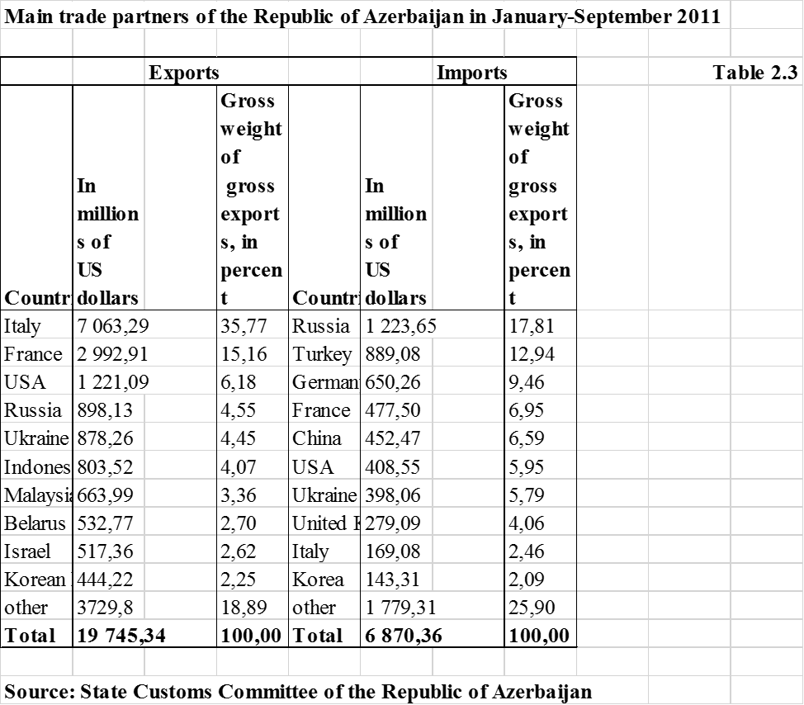

**Appedix 2**

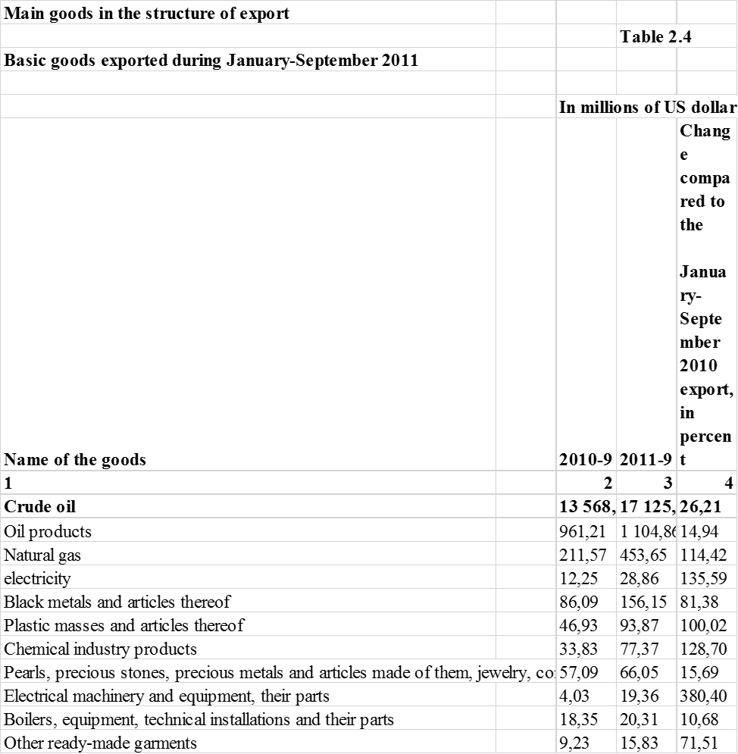

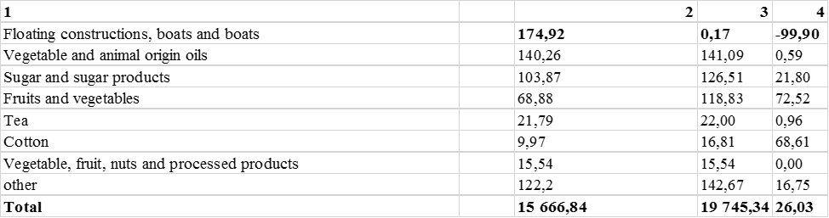

**Appedix 3**



**REFERENCES**

1. Ibrahimov F.M. - "Foreign investment in the economy of Azerbaijan and its role in the national economy's revival" - Baku 2007
2. Yahyaeva A.Y. - "Strategy of attracting foreign investments into the industrial sector and ways to increase its efficiency" - Baku 2009
3. Aliyev A. L. - "Problems of efficient use of foreign and domestic investments in the industry of Azerbaijan" - Baku 2004
4. Mammadov AS - "Investment activity in Azerbaijan industry and its improvement" - Baku, 2005
5. Karimova T.I. - "Investment potential of the economy: Formation and use mechanisms" - Baku 2008
6. Osman Nuri Aras, Elchin Suleymanov - "Azerbaijan Economy" - Baku 2010
7. Mahmudova X. C. - "The main trends of investment in the Azerbaijan industry during transition to market economy" - Baku 2000
8. Pasayev T.N. - "Investments and its role in the development of Azerbaijan's economy in modern times" - Lankaran 2001
9. Zeynalov F.D. - "Investments and their current situation in Azerbaijan" - Baku 2001
10. Joseph E. Stiglitz - Globalization and its Discontents W.W. Norton & Company, 2002
11. Natig Sabiroglu - Globalization and Foreign Investments. Baku, 2006.
12. World Investment Report 2014. New York and Geneva, 2015.

World Investment Report 2015. New York and Geneva, 2016.

1. 2009 Investment Climate Statement Azerbaijan. BUREAU OF ECONOMIC, ENERGY AND BUSINESS AFFAIRS OF U.S. DEPARTMENT OF STATE. 2009
2. State Statistical Committee website - http://www.azstat.org/
3. Ministry of Economy's website - http://www.economy.gov.az/
4. Industrial Portal of Azerbaijan - http://www.senaye.gov.az/
5. World Bank Website - http://www.worldbank.org/
6. International Monetary Fund website - http://www.imf.org
7. UNCTAD's website - http: // www.unctad.org/fdistatistics
8. <http://www.invest.gov.tr/en-US/investmentguide/investorsguide/Pages/Incentives.aspx>