The Ministry of Education of the Republic of Azerbaijan

Comparison of new International Financial Reporting Standard – Revenue from Contracts with Customers with old International Accounting Standards – Construction Contracts and Revenue

Student:
Turan Mammadova

Supervisor:
PhD. Araz Mehdiyev

UNEC SABAH
Azerbaijan State Economic University

JUNE 2019
ACKNOWLEDGEMENTS
This research paper is the last thing I did for my bachelor journey. First of all, I am very honoured and thankful to Azerbaijan State Economic University and to its Directory for creating me lots of opportunities and letting me in order to fulfill my goals during four-years journey.
I would also express my gratitude to the Ministry of Education of the Republic of Azerbaijan for letting me take the advantage of studying in SABAH Groups.
My deepest gratitude is for my supervisor, Araz Mehdiyev. He deserves all gratitude for helping and supporting me during my research period. I would be impossible without his guidance and encouragement.
And finally, I am also thankful to people around me who believed and always inspired me from the starting of the period till the end.

Thanks for everything!

List of abbreviations
IFRS – International Financial Reporting Standards
IAS – International Accounting Standards
IFRIC - International Financial Reporting Interpretations Committee
SIC - Standard Interpretations Committee
IASB – International Accounting Standards Board
FASB – Financial Accounting Standards Board
FPPFS - Framework for the Preparation and Presentation of Financial Statements
BDO – Binder Dijker Otte
FRC – Financial Reporting Council
EY – Ernst&Young
PWC – Pricewaterhousecoopers

ABSTRACT

Revenue is, arguably, one of the most important indicators of an entity’s performance. It may be perceived as an indicator of the desirability of an entity’s products and services, and the growth or decline over time of a business. However, revenue does not represent all income for an entity. Revenue is a subset of income, it is derived from the ordinary activities of an entity and identifying what is revenue and specifying how and when to measure and report it is critical to any accounting framework.
From 2014, Financial Accounting Standards Board (FASB) and International Accounting Standards Board (IASB) together have issued the new standard International Financial Reporting Standards (IFRS) 15 – Revenue from Contracts with Customers which substitutes former revenue standards and interpretations with the inclusion of International Accounting Standards (IAS) 11 – Construction Contracts, International Accounting Standards (IAS) 18 – Revenue and IFRIC/SIC.
This paper is dedicated to review of provisions of IFRS 15 and IAS 11, IAS 18 in point of revenue recognition. The basic foundation of the principles of how to deal with income, how to recognize revenue and other forms of income in the financial statements, the basis of IAS 11 and IAS 18 to help the transition when IFRS 15 replaces it, and how to account for and disclose provisions of grants by government were reviewed in this paper. The study will also reveal the impacts of new standard on diferent companies’ performance and financial statements across many industries.

Table of Contents

Acknowledgements ............................................................................................ 2
List of abbreviations .......................................................................................... 3
Abstract .............................................................................................................. 4
Introduction ....................................................................................................... 6
Methodology ...................................................................................................... 8
- Material .................................................................................................... 8
- Data analysis ............................................................................................ 8
Literature review ............................................................................................... 9
1. Weaknesses and inconsistencies in IAS 11, IAS 18 and reasons behind transition to IFRS 15 ........................................................................................... 9
2. Introduction to IFRS 15: objective, scope and transition ....................... 12
1. Comparative analysis of IFRS 15 and IAS 11 ........................................... 18
1.1 Comparison in terms of Revenue recognition …………………………19
1.2 Comparison in terms of Identification of distinct goods and services
in a contract …………………………………………………………………… 23
1.3 Comparison in terms of Capitalization of Contract Costs …..……….. 25
1.4 Comparison in terms of Impact of time value of money on revenue … 26
1.5 Comparison in terms of Contract modification ………………………. 27
2. Comparative analysis of IFRS 15 and IAS 18 …………………………... 30
2.1 Comparison in terms of Revenue Recognition or type of Revenue Impacted ………………………………………………………………………. 32
2.2 Comparison in terms of Timing of Revenue Recognition …………… 35
2.3 Comparison in terms of Identification and Allocation to Different Goods/Services in a Contract ………………………………………………… 37
2.4 Comparison in terms of Effect of Time Value of Money ……….…... 39
2.5 Comparison in terms of Accounting for Warranties ………………… 40
3. Overview of transition to IFRS 15 …………………………….…………. 43
3.1 General effect of adoption IFRS 15 on Institutions …………………. 43
3.2 1.2 Impact of IFRS 15 on financial statements ……………………… 50
Conclusion …………………………………………………………………… 54
Bibliography …….…………………………………………………………… 55

INTRODUCTION
Today the world is filled with varied kinds of services, products, transactions and lots of different activities that human beings and business do. Businesses' accounting practices varies in terms of revenue, its meaning and definition. Removing of these distinctions, revenue is being obvious and having just one definition is needed. Those who use the financial information need the financial information that is an ability to get a concise answer to the normal periodicity, clear in an international level, comparable and apparent. In terms of eliminating those needs, the preparation of new accounting systems which speak the same language and also apply the same standards became inevitable.
...The principle of income accrual refers to the recognition that revenue should be recognized when the economic benefit of the enterprise is probable in the future and the benefit can be measured reliably (Weygandt, Kimmel and Kieso 2011, s.97). It has been concluded by the financial managers that the management of the revenue accrual process is becoming increasingly complex, error-prone and an important factor in the financial reporting process. This process has a high risk of fraud and the risks or errors in reporting the revenue affect the accuracy of the financial statements. The International Accounting Standards Board (IASB) and the American Financial Accounting Standards Board (FASB) have found insufficient the current process of revenue reporting (Weygandt, Kimmel and Kieso 2011, s.954). In a period of 6 years, in 6 May 2014, the IASB and FASB worked together to publish IFRS 15 - Revenue from Contracts with customers. This standart supersedes IAS 18 – Revenue, IAS 11 – Construction contracts, IFRIC 15, IFRIC 18 and SIC 31. This standard would: move away weaknesses and discrepancies in the revenue recognition literature; increase comparability of revenue recognition applications amongst industries, entities inside of them; ensure more powerful framework in order to address revenue recognition matter; decrease the complication of implementing revenue recognition requirements by lessening the amount of the appropriate standards and interpretations; ensure more beneficial information thru disclosure requirements. Considerable increase in disclosures caused nearly all entities to be affected to some extent. But the modifications extend on the further side of disclosures, and effects on entities differs because of the different industries and accounting policies. All mentioned entities should bear in mind changes that might be vital to IT processes, systems and internal controls in order to seize new data and address modifications in financial reporting. The accounting treatment for the purpose of all revenue from contracts with customers are pointed out in IFRS 15. Together with IFRS 15, the International Financial Reporting Standards (IFRS) and the United States Generally Accepted Accounting Principles (US GAAP) aim to ensure that the revenue reporting process is consistent and of high quality. In addition, IFRS 15 will allow entities to be comparable that prepare their financial statements according to IFRS and to US GAAP (Sukhraj 2014, s.1).
In this researched context, the insufficiency of IAS 18 and IAS 11 that had been previously prepared, required a new study. In this study, the existing IAS 11 and IAS 18 and New Revenue Standard - IFRS 15 shall be explained and commented separately, and the novelteies introduced by the new standard will be explained and commentated with various examples as well.
Section one reviews the investigations regarding with former and new standards by diferent studies and describes general reasons for transition to IFRS 15. Section two analyses differencies between IAS 11 and IFRS 15 and describes general impact of it. Section three differencies between IAS 18 and IFRS 15 and describes general impact of it. Section four focuses on the overview of transition to new standard and effects on and interpretations of financial statements.

METHODOLOGY
- Material
This study is mainly theorotical based and necessary data and information were gathered from both primary and secondary sources. Primary sources used are from websites and publications of offical organizations such as EY, KPMG, ACCA Global. Research method applied is collecting lots of information and analyse them in order to reach appropriate conclusion.

- Data Analysis
This research is descriptive rather than deductive in nature. To explain differences and their effects, I focused on financial statements of a few companies’ which I got from secondary sources.
The main research approach in this study - “comparisons of facts obtained from primary and secondary” is chronical in accordance with analyzing findings of the comparison with the inclusion of results over the review of literature. Comparability or contrasts in irrelevant and primary information are examined as per amplifying handle over principles and the suit study.

LITERATURE REVIEW
1. Weaknesses and inconsistencies in IAS 11, IAS 18 and reasons behind transition to IFRS 15
The term IFRS has both a limited and wide meaning in everyday usage (IASPLUS). Limitedly, IFRS refers to new various series of statements which the IASB is issuing and as separate from the IAS series issued by its ancestor.
“The major objectives (among others) and importance of introducing IFRS are as follows: to develop a single set of high quality understandable and enforceable global accounting standard that require transparent and comparable information in financial statements; to help participants in various capital markets (investors, stockbrokers etc) across the globe to understand financial statements; to work actively with the national standard setter to bring about convergence of national accounting standards; IFRSs are designed for adoption by profit-oriented entities; IFRSs requires that financial statements (FS) give a true and fair view of the financial health of entities” (Fowokan, 2011, Oyedokun, 2014).
Akpan-Essien (2011) argued that financial statements can take many forms. The best known is the profit or loss account and balance sheet of businesses. In the specific case of limited liability companies, financial statements are produced annually and take the form of a Profit and Loss Account (Income Statement), Balance Sheet, Cash Flow Statement, Statement of Changes in Equity and notes to the financial statements.
“Revenues are usually the greatest single item in the financial statements” (FASB, 2002a, p.1). They are considered the most examined thing of financial statements alongside data on net income for term. IAS 18 (2017) states that revenue generally talks about the accounting policies about when to recognize revenue from the sale of goods, rendering of services, and for interest, royalties and dividends. Monetary wellbeing and the evolution of organization's performance can't be handled without examining the source, nature, sum and timing of detailed revenues. Nevertheless, the multifaceted nature of business condition makes recognition of revenue and at what amount.
Information about revenue is very crucial and it is used to assess the financial performance and position of any company’s and used to compare companies with one another. But, former revenue requirements both in IFRS and USA GAAP rough for analysists and investors to understand and compare revenue of company.
In IFRS, substantial diversity in revenue recognition related practices had arisen because earlier revenue standards contained incomplete guidance on many necessary topics, like accounting for arrangements with several elements. Furthermore, the limited direction that was provided was frequently difficult to apply to complicated transactions, particularly because former revenue standards did not comprise any basis for conclusions. Subsequently, some companies supplemented the restricted guidance in IFRS thru selectively applying USA GAAP. In USA GAAP, comprehensive revenue recognition concepts were added by several industry and transaction particular requirements, which often caused in economically alike transactions being accounted for in a different way. Moreover, even with all of mentioned particular requirements, revenue recognition queries continued to rise as new kinds of transactions emerged.
In the research article of IFRS Foundation (2014), it explains the inconsistencies and weaknesses of former revenue standards. Besides issues like accounting for arrangements with several elements, time and amount of revenue recognition and other topics, inadequateness of disclosure requirements in previous standards are also reason for rationale for IFRS 15, according to IFRS Foundation. The disclosure requirements in earlier IFRS and US GAAP frequently resulted in information which was inadequate for investors for understanding a company’s revenue, also the judgements and estimations made by the entity in recognising that revenue. For example, investors were worried that the revenue information that disclosed was often “boilerplate” in nature or was presented in separation and with no explanation how the revenue recognised associated with other information in those financial statements.
Before IFRS 15, inconsistencies and weaknesses regarding with revenue standards often caused companies accounting for assimilated transactions differently, which directed to variety in revenue recognition practices. With replacing those stated requirements with a comprehensive framework, agreements/contracts with customers which are economically alike shall be accounted for on a coherent basis. However, the earlier variety in revenue recognition practices shall mean that the extent and nature of the changes will differ between industries, companies, and capital markets. Subsequently, the requirements in new standard will result in variations in the accounting for just some revenue transactions for sundry companies. Nevertheless, those changes are important to achieve steady accounting for economically alike transactions in the contracts with customers.
In its research, BDO (2017) investigates gaps and inconsistencies in previous revenue related standards and explains rationale for transition to IFRS 15. According to the results of BDO (2017), IFRS 15 addresses those deficiencies by specifying a comprehensive and robust framework for the recognition, measurement and disclosure of revenue; in particular, IFRS 15: improves the comparability of revenue from contracts with customers; reduces the need for interpretive guidance to be developed on a case-by-case basis to address emerging revenue recognition issues; and provides more useful information through improved disclosure requirements.
Another research was conducted by Selim Cengiz, Bushra Tosunoglu in 2018. After detailed research related to former and new standards and impact of the new one, S.Cengiz, B.Tosunoglu (2018) concluded that For many contracts, such as many straightforward retail transactions, IFRS 15 will have little, if any, effect on the amount and timing of revenue recognition. For other contracts, such as long-term service contracts and multiple-element arrangements, IFRS 15 could result in some changes either to the amount or timing of the revenue recognised by a company.

2. Introduction to IFRS 15: objective, scope and transition
A.
The new standard IFRS 15 which was jointly issued by FASB and IASB has been adopted by lots of entities. As we know it already, this standard replaces nearly all heritage requirements for revenue recognition in US GAAP and IFRS, seriatim. “It describes the principles an entity must apply to measure and recognise revenue and the related cash flows” (IFRS 15.1). “The core principle is that an entity recognises revenue at an amount that reflects the consideration to which the entity expects to be entitled in exchange for transferring goods or services to a customer" (IFRS 15.2).
The entities are supposed to apply principles given by IFRS 15 in order to report beneficial information to the financial statements’ users related to timing, nature, amount and ambiguity of cash flow and revenue originating from contracts with customers. It shows effects to merely all entities who go into contracts with customers because of provisions of goods/services, except contracts that are in the scope of the other GAAP or IFRS standards like:
- Lease contracts in scope of the IFRS 16;
- Insurance contracts in scope of the IFRS 4 – insurance Contracts (or, contracts in scope of the IFRS 17 – insurance Contracts – except case when an entity selects to implement IFRS 15 to specific service contracts in agreement with paragraph 8 of IFRS 17);
- Financial instruments and further contractual obligations and rights in scope of the IFRS 9, IFRS 10 – Consolidated Financial Statements, IFRS 11 – Joint Arrangements, IAS 27 –Separate Financial Statements – and IAS 28 – Investments in Joint Ventures and Associates;
and
- Non – monetary exchanges across entities inside the equal line of business that does support sales to customers;
Additionally, in this standard, the way of accounting for costs which incur for entity while obtaining and fulfilling a contract in provision of goods and services is pointed out and it provides a model for the measurement and recognition of gains and losses on the sale of certain non-financial assets, such as property, plant or equipment as well.
What's more, arrangements must meet the criteria set out in IFRS 15.9,
so as to be represented as an income contract under the standard. For specific courses of action, substances should assess their relationship with the counterparty to the agreement so as to decide if a vendor customer relationship exists. Some joint effort game plans, for instance,
are progressively much the same as an organization, while others have a merchant client relationship. Just exchanges that are resolved to be with a client are inside the extent of IFRS 15. See area 2.3 for an exchange on community-oriented game plans.
As noted above, when compelling, IFRS 17 could change the pertinent standard
for certain administration contracts, explicitly fixed-expense administration contracts, which are contracts in which the dimension of administration relies upon an unsure occasion. Models incorporate roadside help projects and upkeep contracts in which the specialist co-op consents to fix determined gear after a glitch for a fixed expense. IFRS 17 demonstrates that these are protection contracts and, in this manner, when it is powerful, that standard would apply.
B.

As I mentioned before, each entity and contract with customers is required to implement IFRS 15 in the provision of goods and services within de regular course of business, but with exception of IFRS 4, IFRS 9, IFRS 10, IFRS 11, IFRS 16 and IFRS 17. Moreover, if an entity wants settlements to be accounted for as a revenue contract under that standard, they must fulfil the criteria mentioned in the paragraph of IFRS 15 which will be viewed later in this study.
“For certain arrangements, entities must evaluate their relationship with the counterparty to the contract in order to determine whether a vendor-customer relationship exists. Some collaboration arrangements, for example, are more akin to a partnership, while others have a vendor-customer relationship. Only transactions that are determined to be with a customer are within the scope of IFRS 15” (IFRS 15, 2017).

C.
The new standard proposals a variety of transition options. An entity can select to implement the new standard to its entire contracts – and retrospectively regulate each comparative period that presented in its 2017-2018 period in financial statements if it waits till the compulsory effective date. On the other hand, a company may recognize the cumulative impact of implementing the new standard at the time of initial application – make no any adjustments to its comparative information. Possible practical expedients make additional alternatives that can chasten the restatements procedure or decrease the number of contracts that essential to be restated. Whereas these expedients can ease the transition load for companies, they decrease comparability that can cause encounters for financial statement users.
The selection of transition option may have a noteworthy effect on revenue tendencies and may also influence cost information. To define the optimal approach, an entity will need to take a wide range of other business matters – from IT application plans to communications with the stakeholders into consideration. Entities may also need to account for the differences in the USA GAAP and IFRS and transition requirements that may result in substantially different outcomes.
Full Retrospective method
Companies recognize the cumulative effect of implementing the new standard at the beginning of the earliest period introduced. They may also select to utilize one or more existing practical expedients. The practical expedients assist to simplify how agreements are restated or decrease the count of contracts to be restated. The entities implementing IFRS, the expedients comprise an option to implement the new standard to just those contracts which are not considered finished contracts under existing GAAP at the beginning of the initial period presented.
Cumulative effect or modified Retrospective method
Unlike first method, here companies recognize the cumulative impact of implementing the new standard in the period of initial application, without restatement of the relative periods presented – that is, the comparative periods are introduced in accordance with existing GAAP. An entity can choose to implement the new standard to its entire contracts or just those contracts which are not considered finished contracts in the initial application. Companies may also select to use the existing applied expedient with respect to contract alterations to make simple their restatement of contracts. Companies, who select that method, are also supposed to disclose the quantitative impact and the description of the significant variations between the reported consequences under IFRS 15 and those which would have been stated under existing GAAP in the period of application.
IFRS 15 launches a comprehensive framework for defining when to recognize revenue and also how much revenue need to be recognized. The core principle in this framework is that an entity should recognize revenue to portray the transfer of promised services and goods to the customer in a sum that mirrors the thought to which the organization hopes to be entitled in return for those goods or services.
To recognize revenue, an entity would implement the following five steps:
1.Identify the contract(s) with the customer
An agreement is an understanding between two or more parties that makes enforceable rights what is more, obligations. An organization would apply IFRS 15 to each agreement with a client that has business substance and meets other specified criteria. One basis requires a organization to survey whether it is plausible that the organization will gather the thought to which it will be entitled in return for the guaranteed goods or services. Now and again, IFRS 15 requires an organization to consolidate contracts and record for them as one contract. IFRS 15 additionally specifies how an organization would represent contract modifications.
2. Identify the performance obligations in the contract
Performance obligations are guarantees in an agreement to exchange to a client goods or services that are particular. In deciding if a goods or services is particular, an organization considers if the client can benefit from the goods or services on its claim or together with different assets that are promptly accessible to the client. An organization likewise thinks about whether the organization's guarantee to exchange the goods or services is independently identificapable from other guarantees in the agreement. For instance, a client could benefit independently from the supply of blocks and the supply of development work. Nonetheless, those things would not be unmistakable if the organization is giving the blocks and development work to the client as a major aspect of its guarantee in the agreement to build a brick wall for the client. All things considered, the organization has a solitary obligation in order to construct a brick wall. The blocks and development work would not be unmistakable merchandise or administrations in light of the fact that those things are utilized as contributions to create the yield for which the client has contracted.
3.Determine the transaction price
The transaction price is the measure of thought to which an organization hopes to be entitled in return for exchanging guaranteed goods or services to a client. Ordinarily, the exchange cost is a fixed sum of client thought. Now and then, the transaction price incorporates assessments of thought that is variable or thought in a structure other than money. A few or the majority of the evaluated measure of variable thought is incorporated into the exchange value just to the degree that it is very plausible that a significant inversion in the measure of combined income perceived won't happen when the vulnerability related with the variable thought is in this way settled. Acclimations to the exchange cost are additionally made for the impacts of financing and for any thought payable to the client.

4. Allocate the transaction price
The transaction price is the measure of thought to which an organization hopes to be entitled in return for exchanging guaranteed products or administrations to a client. Ordinarily, the exchange cost is a fixed sum of client thought. Now and then, the exchange cost incorporates assessments of thought that is variable or thought in a structure other than money. A few or the majority of the evaluated measure of variable thought is incorporated into the exchange value just to the degree that it is very plausible that a significant inversion in the measure of combined income perceived won't happen when the vulnerability related with the variable thought is in this way settled. Acclimations to the exchange cost are additionally made for the impacts of financing and for any thought payable to the client.
5. Recognise revenue when a performance obligation is satisfied
An organization would perceive income when (or as) it satisfies obligation by exchanging a guaranteed goods or services to a client (which is at the point when the client acquires control of that great or administration). An act commitment might be satisfi ed at a point in time (commonly for guarantees to exchange merchandise to a client) or after some time (commonly for guarantees to exchange administrations to a client). For an act commitment satisfi ed after some time, an organization would choose a suitable proportion of advancement to decide how much income ought to be perceived as the obligation is satisfied.

- COMPARATIVE ANALYSIS OF IFRS 15 AND IAS 11
The purpose of IAS 11 - Construction Contracts is to write out prescription about the costs and revenues’ accounting treatment related with construction contracts. Sometimes the date of entering into and completion of contract activity may fall into various accounting periods owing to nature of action in construction contracts. For this reason, the principal matter in this standard is the arrangement of necessities on the designation of construction revenue and expenses to bookkeeping periods in which development work is performed.
With the issuance of IFRS 15, several novelties – amendments and additions were introduced related to construction contracts. These novelties essentially cover issues such as revenue recognition, capitalization of contract costs, contract modification, identification of different goods and services within a contract and time value of money effect on revenue.
In this chapter, I will do comparative analysis and interpretation of IFRS 15 with IAS 11 in terms of all those modifications and describe the effect which it gave.

1.1 Comparison in terms of Revenue recognition
Before the confrontation, it would be better to know what construction contract is under this standard and what it includes. A construction contract is a contract specifically negotiated for the construction of an asset or a group of interrelated assets (IAS 11.3).
Under IAS 11, revenue and cost recognition is done by method of percentage of completion. That is, revenue is coordinated with the agreement costs caused in achieving the phase of finish, bringing about the detailing of income, costs and benefit which can be ascribed to the extent of work finished. The technique mentioned gives valuable data on the degree of agreement movement and execution along a period. Under this method, revenue is perceived as revenue in account of profit or loss in the bookkeeping period in which the work is fulfilled. And costs are generally perceived as a cost in account of profit and loss in the accounting period in which the work to which they relate is performed. However, there may be a case where it is likely that expected total costs surpass total revenue; in this case, anticipated loss should be perceived as an expense right away according to paragraph of IAS 11.
The result of a construction contract may be evaluated dependably when it is likely that the financial advantages related with the agreement will stream to the element. In any case, when a vulnerability emerges about the collectability of a sum effectively incorporated into contract income, and as of now perceived in account, the uncollectible sum or the sum in regard of which recuperation has stopped to be plausible is perceived as a cost as opposed to as a modification of the measure of agreement income.
The completion stage technique may be identified with different ways. The entity utilizes the strategy that measures dependably the work performed. Contingent upon the nature of the agreement, the strategies may include:
(a) the extent that agreement costs caused for work performed to date manage to the evaluated absolute contract costs;
(b) studies of work performed; or
(c) finish of a physical extent of the provisional work.
Advancement payments and advances got from clients regularly don't mirror the work performed.
Under IAS 11, on the off chance that an agreement covers at least two assets, the development of every asset ought to be represented independently if (a) discrete recommendations were submitted for every asset, (b) bits of the agreement identifying with every asset were arranged independently, and (c) expenses and incomes of every asset can be estimated. And again, according to IAS 11, at least two contracts ought to be represented as a solitary contract if they were arranged together, and the work is interrelated.
Revenue from contract ought to incorporate the sum concurred in the underlying contract, in addition to income from variations in the first contract work, in addition to cases and motivation installments that (an) are required to be gathered and (b) that can be estimated dependably.
Costs on contract ought to incorporate costs that relate legitimately to the particular contract, in addition to costs that are owing to the contractual worker's general contracting movement to the degree that they can be sensibly designated to the agreement, in addition to such different costs that can be explicitly charged to the client under the terms of the agreement.
Unlike IAS 11, the main guideline of IFRS 15 is that an element will recognize income to portray the exchange of guaranteed services and products to clients in a sum that mirrors the thought to which the entity hopes to be entitled in return for those services and goods. And an asset is considered transferred when the client acquires control of it. IFRS 15 characterizes asset control as the capacity to coordinate the utilization of and acquire considerably most of the rest of the advantages from the asset. The advantages of an asset are the potential money streams that can be gotten legitimately or by implication. This principle is conveyed in previously explained a five-advance model system.
Cautious evaluation against specific criterion is required to decide whether income and benefit can be perceived dynamically after some time. In contrast to IAS 11, dynamic income acknowledgment isn't the programmed bookkeeping treatment for all development contracts.
An entity exchanges control after some time and, in this way, fulfills an execution commitment and perceives income over the period, on the off chance that one of the accompanying criteria is met:
a) the client all the while gets and expends the advantages given by the obligation of entity as if the entity performs
b) the obligation of entity makes or upgrades an asset that the client controls as the advantage is made or improved; or
c) the obligation of entity makes does not make an asset with an elective use to the entity and it has an enforceable appropriate to payment for execution finished to date.
On the off chance that an obligation isn't fulfilled after some time as mentioned criterions above, an entity fulfills the execution commitment at a point in time. To decide the point in time at which a client gets control of a guaranteed resource and the entity fulfills an obligation, it will consider the prerequisites for control.
Analysis of change and impact
The direction in IFRS 15 is significantly more explicit than that recently incorporated into IAS 11, and a few elements may find that income recently perceived at a point in time should now be recognized after some time, or the other way around. Regardless of whether income ought to be perceived after some time or at a point in time will regularly rely upon a cautious investigation of explicit contract terms.
Where a substance reasons that income ought to be perceived after some time, it should think about how to quantify advance towards complete fulfillment of execution commitments. IFRS 15 determines that the proportion of advancement will prohibit any products or administrations for which the substance does not exchange control to the client. All things considered, the proportion of advancement (and in this manner the level of income to be perceived) might be influenced by whether control of the arrive on which property is being developed is exchanged to the purchaser.
Though there is no programmed right to progressive income acknowledgment, obligation to give service of construction will for the most part be fulfilled after some time. Clients frequently control the assets as they are made or improved. Furthermore, contractors will frequently have authoritative and pragmatic constraints on exchanging the resources for another client and will reserve the privilege to gather costs caused and a sensible profit margin from the client.

1.2 Identification of distinct goods and services in a contract
This is essential point within contracts as it affects revenue allocation and consequently, shows impact on final profit figures. There is no specific guidance for this under IAS 11: it needs explicit direction in recognizing various goods/services inside an agreement.
But IFRS 15 gives a progressively point by point direction, specifically, the new principles on how income is assigned between various things. Thusly entities may need to change their present bookkeeping arrangements.
Elements that show that entity’s guarantee to exchange a services/goods to a client is independently recognizable incorporate, however are not restricted to, the accompanying:
a) An entity does not give a noteworthy administration of coordinating the goods/services with different goods/services guaranteed in the agreement into a heap of goods/services that speak to the joined yield for which the client has contracted. At the end of the day, the substance isn't utilizing the goods/services as a contribution to create or convey the consolidated yield indicated by the client.
b) the goods/services do not fundamentally change or alter other goods/services guaranteed in the agreement.
c) the goods/services are not exceptionally reliant on, or profoundly interrelated with, different goods/services guaranteed in the agreement. For instance, the way that a client could choose to not buy the goods/services without altogether influencing the other guaranteed goods/services in the agreement may show that the goods/services isn't exceedingly reliant on, or exceptionally interrelated with, those other guaranteed goods/services.
Analysis of change and impact
Construction organizations regularly have multi-component contracts and IFRS 15 may influence the assurance of whether certain components of an agreement are perceived independently, which may have critical effect on the profile of income acknowledgment (for example the new standard may influence whether a bundle of land that is sold as a feature of an agreement for the development of a structure is considered to establish an unmistakable decent to be represented independently). It might likewise influence the distinguishing proof of independent obligation of service (and the planning of the acknowledgment of the related income) incorporated into a development contract covering the structure, development, and activity periods of a specific venture.
1.3 Comparison in terms of Capitalization of contract costs
A contractor may have brought about contract costs that identify with future action on the agreement. Such contract costs are perceived as an advantage gave it is likely that they will be recouped. Such costs speak to a sum due from the client and are regularly named contract work in advancement.
An element will perceive as a benefit the steady expenses of acquiring an agreement with a client if the element hopes to recoup those expenses. The steady expenses of acquiring an agreement are those costs that an element causes to get an agreement with a client that it would not have brought about if the agreement had not been gotten (for instance, a business commission).
On the off chance that the expenses brought about in satisfying an agreement with a client are not inside the extent of another Standard (for instance, IAS 2 Inventories, IAS 16 Property, Plant and Equipment or IAS 38 Immaterial Assets), a substance will perceive an advantage from the expenses acquired to satisfy an agreement as it were in the event that those costs meet the majority of the accompanying criteria:
a) the expenses relate straightforwardly to an agreement or to a foreseen contract that the element can explicitly distinguish (for instance, costs identifying with administrations to be given under recharging of a current contract or expenses of structuring an advantage for be exchanged under a particular contract that has not yet been endorsed);
b) the expenses produce or improve assets of the substance that will be utilized in fulfilling (or in proceeding to fulfill) execution commitments later; and
c) the expenses are relied upon to be recuperated.
Analysis of change and impact
Notwithstanding increasingly prescriptive direction on income acknowledgment, the new standard presents explicit criteria for deciding if to underwrite certain expenses, recognizing those costs related with acquiring an agreement (for example deals commissions) and those expense related with satisfying an agreement. Expenses acquired that are legitimately owing to getting contracts with clients will be accounted reliant on the nature (or type) of expenses brought about (for example configuration cost which qualify as an expense of satisfying an agreement will for the most part be promoted in the event that they meet certain criteria, including a desire that the cost will be recuperated, while expenses of getting a contract preceding the agreement being granted, for example, legitimate cost, will for the most part be expensed as they are costs that will have been acquired whether the agreement is gotten.)
As we see from these, both standards have special guidance on expensed contract cost; but just because of guidance specifics they differ from each other. If contractors must define that whether costs must be capitalized or not, they should consider the fulfillment cost guidance.

1.4 Comparison in terms of Impact of time value of money on revenue
The time value of money idea expresses that money got today is more profitable than money gotten sooner or later. The reason is that somebody who consents to get payment in a later period foregoes the capability to contribute that money at this moment. In accounting, this conception is very useful in order to determine transaction price agreed between parties. But in IAS 11, there is no such as a conception to show impact of time value of money on transaction prices. This is another disadvantage of IAS which caused gap in construction contracts.
To eliminate the gap, IFRS 15 introduced time value of money conception. In deciding the price of transaction, the entity will change the guaranteed measure of consideration for the impacts of the time value of cash if the planning of payments consented to by the parties to the agreement furnishes the client or the entity with a huge advantage of financing the exchange of goods/services to the client. In those conditions, the agreement contains a noteworthy financing segment. A noteworthy financing segment may exist paying little mind to whether the guarantee of financing is unequivocally expressed in the agreement or suggested by the payment terms consented to by the parties to the agreement.

Analysis of change and impact
IFRS 15 presents new and progressively broad on financing plan and the effect of time value of money. Under the new standard, the financing part, on the off chance that it is considerable, is accounted for independently from income. This applies to payments ahead of time just as falling behind financially, yet subject to an exclusion where the period among payments and exchange of goods/services will be less than one year. This new direction may change current bookkeeping rehearses sometimes.

1.5 Comparison in terms of Contract modification
Parties to a contract constantly change the contract price or contract scope. These changes are stated to as contract alterations, amendments, differences, or change orders. Contingent upon the conditions, these changes are represented either as a change to the current contract or as a different contract. These changes and the related bookkeeping treatment may influence the timing of revenue. Modification in a contract does not need to be composed; enforceable variations can be the consequence of oral agreements or implied by courtesy of customary business practices. Appropriate accounting for an original agreement is based on each side’s enforceable rights or responsibilities; expectedly, when those primary rights and obligations vary, the parties must assess how to account for those variations. It is done either by regarding changes as discrete, independent contracts or as adjustments to the first contract.
Under IAS 11, the percentage of completion technique is applied on a cumulative base in each accounting date to the current estimations of contract cost and contract revenue. Thus, the effect of an alteration in the estimation of contract revenue or costs, or the impact of a change in the estimation of the result of a contract, is accounted for as a modification in accounting estimate. The changed estimations are used in the fixation of the sum of revenues and expenses recognized in the account of profit or loss in the period in which the modification is made and in consequent periods. In other words, approval of a variation is supposed to be probable for the sum to be included as revenue from contract.
Besides this, a claim is supposed to be at the progressive stage of negotiation for the sum to be included as revenue from contract.
According to IFRS 15, when particular conditions are met, the contractual variations are accounted for as if they are distinct contracts with the customer. One of these conditions is to change the area of the contract with the addition of particular goods or service; the other one is the change in the independent selling price with the changing contract (IFRS 15, 2017). Unlike IAS 11, does not include clear guidance on accounting for claims and variations in contract. It comprises direction for modifications on contract and further variations in the price of transaction, which applies to merely all businesses. This guidance consists of four steps in the case of modifications to contracts:
- First of all, the entity should take into account whether the change is approved or not. The modification could be agreed in writing, by oral contracts or implied by usual business practices. If intended modification is not approved, then the parties remain to account for the current contract under IFRS 15. In the case of approving the change in the scope, but not determining change in price of contract, the entity evaluates the price change in accordance with guiding on flexible consideration.
- The entity takes into account if a modification should be accounted for as a distinct contract. An entity will account for a modification in contract as a separate contract in the case of meeting both of following conditions: a) the scope of contract rises because of the additional promised goods and services that are distinct; and b) the contract price increases by the sum of consideration which reflects to entity’s stand-alone sales prices of the extra promised goods/services and any proper adjustments to that price in order to mirror the circumstances of the specific contract. For instance, an entity may regulate the stand-alone sales price of an additional good and services for a discount which the customer gets, because it is not essential for the entity to incur the sales-related costs that it would create when selling a similar good and/or service to a new client.
- If so, and the construction contract meets all requirements for over time revenue recognition, at that point the entity re-assesses both the total price and completion stage of the contract. The entity may be required to adjust or correct the cumulative revenue recognized to that date.
- The entity keeps on representing the contracts by reference to the phase of completion as changed and also the new contract price. Pay attention that, if that the approved new price is flexible, at that point the entity applies the direction on variable consideration.
Another novelty in IFRS 15 is related to revenue from claims; as such revenue is required to be represented as variable consideration. Those claims are added into revenue just when it is profoundly probable that revenue will not adverse in the future. In the other hand, it is equivalent to in IAS 11 that contract changes are required to be confirmed to be recognized.

Analysis of change and impact
The guidance on account for contract modifications is limited in IAS 11. But it was included to IFRS 15 with detailed guidance if the modification in contract should be accounted for retrospectively or prospectively. Some entities may change of practice because of these requirements. It seems that, requirement for the modification to be approved in IFRS 15 comes in sight to be higher threshold than it is in IAS 11. This mentioned requirement may cause recognition of revenue from modifications being recognized subsequently under IFRS 15 rather than would have been the condition under IAS 11 which is a drawback for IFRS 15. This change in requirement mirrors the general methodology of that standard which an entity does account for the enforceable obligations and rights emerging under contracts. In most cases, the entity may approve a change in scope but may not approve the price change. Then, revenue measurement will be governed by the direction on variable consideration that means even where confirmation for the modification has been got, the change in price will be comprised in revenue just whenever it is “highly probable” that significant revenue reversal will not incur in the future.

- Comparative analysis of IFRS 15 and IAS 18
Income is defined in the Framework for the Preparation and Presentation of Financial Statements as increases in economic benefits during the accounting period in the form of inflows or enhancements of assets or decreases of liabilities that result in increases in equity, other than those relating to contributions from equity participants (IAS 18, 2017). Income includes both revenue and gains. Revenue is income that rises in the course of regular activities of an entity, is stated to by a variety of several names including dividends and royalties, fees, sales, interest. The objective of IAS 18 is to write out a prescription about the revenue’s accounting treatment which arises from certain kinds of transactions and events.
IFRS 15 is going to replace IAS 18 on January 2018, in order to establish the principles that an entity shall apply to report useful information to users of financial statements about the nature, amount, timing, and uncertainty of revenue and cash flows arising from a contract with a customer. The standard is converged with a new U.S. GAAP standard issued at the same time. Below is how the IASB and the FASB sum up the importance of this step:
“Revenue is a vital metric for users of financial statements and is used to assess a company’s financial performance and prospects. However, the previous requirements of both IFRS and U.S. GAAP were different and often resulted in different accounting for transactions that were economically similar. Furthermore, while revenue recognition requirements of IFRS lacked enough detail, the accounting requirements of U.S. GAAP were considered to be overly prescriptive and conflicting in certain areas.
Responding to these challenges, the boards have developed new, fully converged requirements for the recognition of revenue in both IFRS and U.S. GAAP providing substantial enhancements to the quality and consistency of how revenue is reported while also improving comparability in the financial statements of companies reporting using IFRS and U.S. GAAP”.

  - Comparison in terms of Revenue Recognition or type of Revenue Impacted
As per IAS 18 Revenue originates from the normal exercises that an organization does. According to IASB's system, revenues and gains, both are incorporated into income. Incomes from the closeout of products, execution of administrations and utilization by others of element resources yielding interest, eminences and profits is secured by IAS 18. Be that as it may, this standard obtrusively overlooks different surges of incomes: emerging from remarkable and non-working exercises, for example, leases, protection contracts, changes in estimation of money related instruments or other current resources, normal increments in rural resources and mineral metal extraction.
The essential issue in representing income is deciding when to perceive income. Income is perceived when it is likely that future financial advantages will stream to the substance and these advantages can be estimated dependably. This Standard distinguishes the conditions in which these criteria will be met, and, along these lines, income will be perceived. It likewise gives down to earth direction on the use of these criteria. IAS 18 indicates income acknowledgment criteria for 3 essential income creating situations:
- Sale of goods
Revenue from sales is perceived when the majority of the accompanying conditions are fulfilled: the substance has exchanged to the purchaser the noteworthy risk and rewards of responsibility for products; an entity holds neither proceeding with administrative contribution to the degree as a rule related with proprietorship nor compelling authority over the products sold; the measure of income can be estimated dependably; it is likely that the financial advantages related with the exchange will stream to the element; and the expenses caused or to be brought about in regard of the exchange can be estimated dependably.
- Rendering of services
At the point when the result of an exchange can be evaluated dependably, income is perceived by reference to the phase of fulfillment of the exchange at the detailing date. The inquiry to be posed here is, can the result of the exchange be assessed dependably? On the off chance that truly, at that point the income can be perceived by the reference to the phase of culmination of the exchange toward the finish of the detailing time frame; and on the off chance that not, at that point the income can be perceived just to the degree of the costs perceived that are recoverable. The result of the exchange can be evaluated dependably just when: the measure of income can be estimated dependably; it is plausible that the monetary advantages related with the exchange will stream to the element; the phase of finish of the exchange toward the finish of the detailing time frame can be estimated dependably; and the expenses brought about for the exchange and the expenses to finish the exchange can be estimated dependably.
- Interest, Royalties and Dividends
Income emerging from the utilization by others of substance resources yielding interest, eminences and profits will be perceived when: it is likely that the monetary advantages related with the exchange will stream to the element; and the measure of the income can be estimated dependably. Income will be perceived on the accompanying bases: intrigue will be perceived utilizing the viable intrigue strategy as set out in IAS 39; sovereignties will be perceived on an accumulation premise as per the substance of the applicable understanding; and profits will be perceived when the investor's entitlement to get installment is set up.
The center standard of IFRS 15 is that an element perceives income to portray the exchange of guaranteed merchandise or administrations to clients in a sum that mirrors the thought to which the element hopes to be entitled in return for those products or administrations. An element perceives income as per that center guideline by applying the five-advance model which has been clarified previously.
The measure of income perceived is the sum assigned to the fulfilled execution commitment. An exhibition commitment might be fulfilled at a point in time (ordinarily for guarantees to exchange products to a client) or after some time (normally for guarantees to exchange administrations to a client).
For execution commitments fulfilled after some time, an element perceives income after some time by choosing a proper technique for estimating its encouraging towards complete fulfillment of that execution commitment. For certain elements, these five stages may all involve contrasts from existing practices. For instance, the accentuation in stage 5 on recognizing when the client gets control of products varies from the current acknowledgment direction in IAS 18, which centers around whether the huge dangers and prizes of responsibility for merchandise have been exchanged to the purchaser. In numerous regards, for example, the treatment of exchanges containing various components, the new standard gives a lot more prominent detail than IAS 18. The new standard additionally contains increasingly broad exposure necessities, frequently requiring more noteworthy disaggregation of data and more prominent discourse of key decisions and strategy choices, in addition to other things. It likewise addresses representing costs identified with contracts with clients, coordinating that an organization perceives a benefit for the steady expenses of acquiring an agreement if those expenses are relied upon to be recouped.
All substances, different maybe than those obviously not at or moving toward an income producing stage, should consider the effect of IFRS 15. Similarly, as with most new guidelines, a few substances will almost certainly decide generally effectively that the effect on their money related detailing isn't noteworthy. For other people, the standard will fundamentally affect how they report income, expecting changes to announcing frameworks and forms, and maybe making them reassess a few parts of their client contracts. Contrasted with some new gauges, the effect of these progressions might be bound to influence key execution markers and, in this manner, might be of quicker enthusiasm to examiners and different clients.
IFRS 15 just determines how to represent income which emerges because of agreements from clients; besides, certain agreements with clients are investigated on the grounds that they are managed different models. (Intrigue salary and profit pay, which were inside the extent of the past income standard, will currently be inside the extent of the money related instruments standard, yet it isn't normal that this will affect the representing such pay streams.)
  - Comparison in terms of Timing of Revenue Recognition
“Under IAS 18, Revenue from the sale of goods shall be recognized when all the following conditions have been satisfied” (IAS 18.14):
a) the company has transferred to the customer the substantial risks and rewards of possession of the goods;
b) the company retains neither continuing managerial contribution to the degree usually related with possession nor effective control over those goods sold;
c) the amount of revenue should be measured reliably;
d) it is probable that if economic benefits related to the transaction will stream to the entity;
e) the costs incurred with respect to the transaction should be measured reliably.
A company recognizes revenue by applying the 5 stages procedure as demonstrated previously. Under stage 1, one of the criteria to be met is that the gatherings to the agreement have endorsed the agreement (recorded as a hard copy, orally or as per other standard business rehearses) and are resolved to play out their particular obligations. (IFRS 15.9). In spite of the fact that IFRS 15 additionally shown that income can be as yet perceived to the degree of the thought got regardless of whether the criteria demonstrated under section 9 has not been met. These conditions are when: (1) no outstanding commitment are to be performed or contract has been ended; and (2) the thought got is non-refundable (IFRS 15.15). An element will perceive income when (or as) the element fulfills an act commitment by exchanging a guaranteed decent or administration (for example an advantage) to a client. A benefit is exchanged when (or as) the client gets control of that advantage (IFRS 15.31). A substance exchanges control of a decent or administration after some time and, subsequently, fulfills an execution commitment and perceives income over the long run, in the event that one of the accompanying criteria is met: (IFRS 15.35)
a) the client all the while gets and devours the advantages given by the element's execution as the substance performs (see passages B3– B4);
b) the substance's execution makes or upgrades an advantage (for instance, work in advancement) that the client controls as the benefit is made or improved (see passage B5); or
c) the element's execution does not make an advantage with an elective use to the element (see passage 36) and the element has an enforceable appropriate to installment for execution finished to date (see section 37) (IFRS 15.31).
On the off chance that an act commitment isn't fulfilled after some time as per sections 35– 37, a substance fulfills the execution commitment at a point in time. To decide the point in time at which a client acquires control of a guaranteed resource and the element fulfills an exhibition commitment, the element will consider the prerequisites for control in sections 31– 34 (IFRS 15.38).
Analysis of change and impact
Under IAS 18, the planning of income acknowledgment from the clearance of products depends essentially on the exchange of dangers and prizes. IFRS 15, rather, centers around when control of those products has exchanged to the client. This diverse methodology may result in a difference in timing for income acknowledgment for certain elements. For instance, a few companies may supply merchandise on the premise that the title goes to the client at the purpose of shipment at the same time, as an issue of business practice, may repay client for misfortune or harm amid delivery (either through credit or substitution). Already, income may have been perceived just at the purpose of conveyance, on the premise that some presentation to dangers and prizes is held up to that point. Under IFRS 15, companies should evaluate whether control goes to the client at the purpose of shipment or at the purpose of conveyance. This may result in income being perceived at an alternate time. On the off chance that income is perceived at the purpose of shipment, it might be important to assign some portion of the exchange cost to a particular "delivering and hazard inclusion" administration, with that component of income perceived when administration is given.

  - Comparison in terms of Identification and Allocation to Different Goods/Services in a Contract
The acknowledgment criteria in this standard are generally connected independently to every exchange. Be that as it may, in specific conditions, it is important to apply the acknowledgment criteria to the independently recognizable segments of a solitary exchange so as to mirror the substance of the exchange. For instance, when the selling cost of an item incorporates a recognizable sum for resulting adjusting, that sum is conceded and perceived as income over the period amid which the administration is performed. On the other hand, the acknowledgment criteria are connected to at least two exchanges together when they are connected so that the business impact can't be comprehended without reference to the arrangement of exchanges. For instance, an element may sell merchandise and, in the meantime, go into a different consent to repurchase the products sometime in the not too distant future, hence refuting the substantive impact of the exchange; in such a case, the two exchanges are managed together.
Variables that show that a substance's guarantee to exchange a decent or administration to a client is independently recognizable (as per passage 27(b)) incorporate, however are not constrained to, the accompanying: (IFRS 15.29)
a) the element does not give a critical administration of coordinating the great or administration with different products or administrations guaranteed in the agreement into a heap of merchandise or administrations that speak to the joined yield for which the client has contracted. As it were, the substance isn't utilizing the great or administration as a contribution to create or convey the consolidated yield determined by the client.
b) the great or administration does not altogether alter or modify another great or administration guaranteed in the agreement.
c) the great or administration isn't profoundly subject to, or exceptionally interrelated with, different merchandise or administrations guaranteed in the agreement. For instance, the way that a client could choose to not buy the great or administration without fundamentally influencing the other guaranteed merchandise or administrations in the agreement may demonstrate that the great or administration isn't exceptionally subject to, or exceedingly interrelated with, those other guaranteed products or administrations.

Analysis of change and impact
Beforehand, given the absence of explicit direction in IFRSs, there was more noteworthy space for judgment while recognizing the merchandise and enterprises inside an agreement and after that allotting the income to those products and ventures distinguished. Elements may need to change their present bookkeeping approaches because of the more point by point direction in IFRS 15. The new standard requires the income from an agreement to be designated to each unmistakable great or administration gave on a relative independent selling value premise, however a 'leftover' approach is allowed in restricted conditions. This may fundamentally change the profile of income acknowledgment for certain elements where, for instance, they offer a 'free' upkeep period to clients as a feature of an exchange. Where elements have a substantial number of clients with various choices, there might be some noteworthy commonsense difficulties to defeat so as to guarantee frameworks are set up to arrangement with the new prerequisites.

2.4 Comparison in terms of Effect of Time Value of Money
By and large, the thought is as money or money reciprocals and the measure of income is the measure of money or money counterparts got or receivable. In any case, when the inflow of money or money reciprocals is conceded, the reasonable estimation of the thought might be not exactly the ostensible measure of money got or receivable. For instance, an element may give premium free credit to the purchaser or acknowledge a note receivable bearing an underneath market loan fee from the purchaser as thought for the closeout of products. At the point when the course of action viably establishes a financing exchange, the reasonable estimation of the thought is dictated by limiting every future receipt utilizing a credited rate of intrigue. The ascribed rate of premium is the more unmistakably definite of either: a) the predominant rate for a comparable instrument of a guarantor with a comparable FICO assessment; or b) a rate of premium that limits the ostensible measure of the instrument to the present money deals cost of the merchandise or administrations. The contrast between the reasonable esteem and the ostensible measure of the thought is perceived as intrigue income as per passages 29 and 30 and as per IFRS 9.
In deciding the exchange value, a substance will alter the guaranteed measure of thought for the impacts of the time estimation of cash if the planning of installments consented to by the gatherings to the agreement (either expressly or certainly) furnishes the client or the element with a critical advantage of financing the exchange of merchandise or administrations to the client. In those conditions, the agreement contains a critical financing part. A huge financing segment may exist paying little heed to whether the guarantee of financing is unequivocally expressed in the agreement or inferred by the installment terms consented to by the gatherings to the agreement (IFRS 15.60).

Analysis of change and impact
IFRS 15 presents new and progressively broad on financing course of action and the effect of the time estimation of cash. Under the new standard, the financing part, on the off chance that it is critical, is represented independently from income. This applies to installments ahead of time just as falling behind financially, however subject to an exclusion where the period among installment and exchange of products or administrations will be short of what one year. This new direction may change current bookkeeping rehearses now and again.
2.5 Comparison in terms of Accounting for Warranties
In the event that the organization can sensibly appraise the measure of guarantee asserts prone to emerge under the approach, it should accumulate a cost that mirrors the expense of these foreseen cases.
The gathering should occur in a similar detailing period in which the related item deals are recorded. Thusly, the budget reports most precisely speak to all expenses related with item deals, and in this manner demonstrate the genuine gainfulness related with those deals. On the off chance that the period secured by the guarantee is changed by the board, this will adjust the guarantee cost not just for those deals in the present time frame, yet additionally for deals in earlier periods whose guarantees have now been stretched out into the present time frame.
IAS 18 does not have the particular direction identified with bookkeeping of guarantees. So that, in numerous occasions, the Sale of merchandise is joined by inherent guarantees towards adjusting or fixes of specific parts or substitution of the item. Regularly, the warrant is accommodated stipulated period from the date of closeout of the item. In this way, the piece of the income from clearance of item might be owing to such guarantees and the execution commitment to that degree is viewed as not satisfied, accordingly the income to that degree is conceded.
The income perceived must be founded on the thought of these components. Guarantees are for the most part represented as pursues.
a) Initial guarantees – When guarantees are a piece of the agreement of closeout of products
b) Extended guarantees – guarantees sold independently for stretched out timeframe are to be perceived independently from the clearance of products.
In the event that costs identifying with guarantees can be estimated dependably income can be perceived proportional to the estimation of merchandise sold, as just an immaterial hazard is held by the dealer. At the point when the costs can't be estimated dependably, the thought got is perceived as a risk and income acknowledgment is conceded. Substances by and large have chronicled information to appraise the guarantee costs and can accommodate them dependent on the standards of IAS 37.
On the off chance that a client has the choice to buy a guarantee independently (for instance, on the grounds that the guarantee is evaluated or arranged independently), the guarantee is a particular administration in light of the fact that the element guarantees to give the support of the client notwithstanding the item that has the usefulness depicted in the agreement. In those conditions, a substance will represent the guaranteed guarantee as an act commitment as per passages 22– 30 and allot a segment of the exchange cost to that execution commitment as per sections 73– 86 (IFRS 15.B29).
On the off chance that a client does not have the choice to buy a guarantee independently, a substance will represent the guarantee as per IAS 37 Provisions, Contingent Liabilities and Contingent Assets except if the guaranteed guarantee, or a piece of the guaranteed guarantee, gives the client an administration notwithstanding the confirmation that the item agrees to settled upon determinations (IFRS 15.B30). On the off chance that a guarantee, or a piece of a guarantee, furnishes a client with an administration notwithstanding the confirmation that the item consents to settled upon particulars, the guaranteed administration is an exhibition commitment. Accordingly, an element will distribute the exchange cost to the item and the administration. On the off chance that a substance guarantees both an affirmation type guarantee and an administration type guarantee yet can't sensibly represent them independently, the element will represent the two guarantees together as a solitary act commitment (IFRS 15.B32).

Analysis of the Change
The new standard recognizes a guarantee giving confirmation that an item meets settled upon determinations (represented as a cost arrangement) and a guarantee giving an extra administration (for which income will be conceded). Thought of components, for example, regardless of whether the guarantee is legally necessary, the length of the guarantee inclusion period, and the idea of the assignments the substance guarantees to perform will be important to figure out which kind of guarantee exists. On the off chance that a client can pick whether to buy a guarantee or not as a "discretionary additional", that guarantee will dependably be treated as a different administration. Where a guarantee is resolved to incorporate the two components (confirmation and administration), the exchange cost is assigned to the item and the administration in a sensible way (if this is beyond the realm of imagination, the entire guarantee is treated as an administration). Usually for guarantees to incorporate the two components. For instance, a guarantee may both guarantee the nature of the item and give a free support plan to two years. Where a guarantee contains the two components, judgment will be required so as to decide how to assign the exchange cost in a sensible way, and this may result in guarantees being represented uniquely in contrast to at present.
Aside from these real contrasts there are different contrasts. For a model, IFRS 15 requires definite divulgences. In any case, the current fiscal summaries are blamed for having deficient divulgences of income data. As per IFRS 15 budget summaries must unveil adequately point by point data to empower the partners to comprehend the nature, sum, timing, and vulnerability of income and income identified with client contracts. Clients of IFRS 15 will appreciate adaptability to pick different strategies dependent on the standard's standards and targets. The detailing element will have the opportunity to choose any technique that give the most significant and helpful data for its business and the outer clients of their fiscal reports.

- OVERVIEW OF THE TRANSITION TO IFRS 15
3.1 General effect of adoption IFRS 15 on institutions
For entities’ reporting IFRS 15 is applicable from 1 January 2018. It is a complex standard, because it introduces more requirements than former standards which it supersedes. For this reason, some companies were affected by its significant changes to policy of revenue recognition. Even in some areas, it is required to apply substantial judgement, however, it is relatively prescriptive in other fields and allows small room for judgement.
Here, I have collected information which includes statistic data related to adoption and transition methods of IFRS 15 by lots of companies all around the world. We can easily review disclosures of 91 companies within different industries from several countries based on information from Grant Thornton (2018). These industries mainly include construction, telecoms, retail and recruitment, utilities.
As we already know, IFRS permitted the early adoption of new standard from the year of 2014. But what about early adoption and transition approaches?
According to the gathered facts based on those 91 companies, just four of them have early adopted IFRS 15 and only one has mentioned an intention regarding with early adoption. And rest of the companies have chosen the adoption of new standard with the effective date.
After the entities adopted the new standard, they chose whether to apply approach which based on full retrospective, or modified retrospective. The major part of companies has stated their objective to follow the second one, that is, modified retrospective approach.
Across the early adopters, two of them applied implemented the full retrospective approach; these two recorded a decrease in revenue; one of them with recording a reduction of 5% and the other one, a more significant reduction of 20%, compared to former standard. The remaining two early adopters have chosen to apply the modified retrospective method and they have recorded a rise in revenue, which ranges from 6% to 15% compared to previous standard.
Of the entities checked on which were not planning to early implement the standard, 48% presently cannot seem to layout which transition approach they expect to apply. 23% (20 companies) of those that have expressed their objective have picked the full retrospective method, with the rest choosing the modified retrospective method.
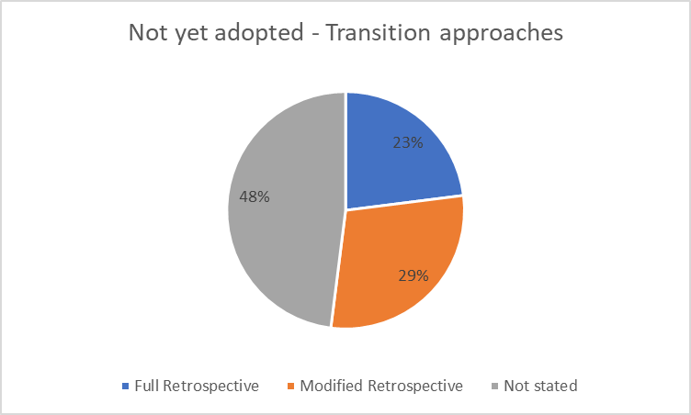
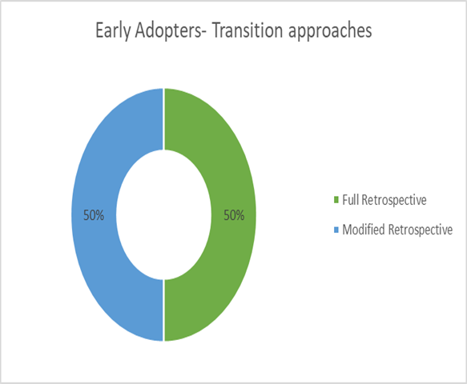
In any case, just 24 entities who have not early implement have measured the foreseen effect of progress; simply over portion of these entities have foreseen that the change alterations are likely not to be material at under 1% of unique revenue.
The remaining entities (62) still cannot seem to quantify the expected effect of IFRS 15 with nine skirting every chance to disclose an estimation in their fiscal reports by any means.
Of the individuals who have made the first assessment however not measured an effect (54 out of the 62 non-early adopters), 83% are not foreseeing a material effect. The rest of that the progress will have a material effect yet presently can't seem to amount it.
Thru the revenue and profit, and thusly distributable reserves influenced, there is likely going to be an effect on dividends paid by organizations. But, just two of the organizations looked into examined their dividend policy; one will postpone paying a dividend again until the following financial year when it is normal that adequate distributable reserves will have been made. The other organization has expressed its goal to keep up a flat dividend, with no ascent expected until the following financial year.
Bank covenants are also a field for organizations to think about when transition to IFRS. Two of the early adopters clarify that agreements have been arrived with lenders with related to covenants, or by testing the covenants if IFRS 15 had not implemented, whether by refreshing the covenants to mirror the modifications under IFRS 15. In the two cases the companies had applied the full retrospective method, however their loan specialists have not required the retesting of the earlier years' covenants.
A on fourth of the entities secured by our examination have made reference to disclosure prerequisites under IFRS 15 and how these are distinctive to the past bookkeeping principles. Various entities have featured these as making the principle contrasts in the transition to IFRS 15.
Besides this, FRC also conducted research (2018) related to impact of IFRS 15 on different industries. In this research, they planned to have a look at the interim financial statements of 17 companies. That sample targeted those areas on which they would expect the adoption of new standard to have the most substantial impact. Consequently, the sample was skewed toward the aerospace & defense, telecommunications and software industries.
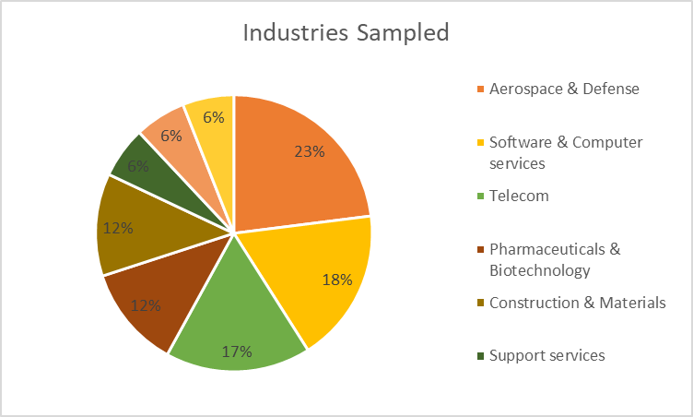
One of the main interim disclosure requirements in initial year of implementing a new accounting standard is a satisfactory clarification of the nature and impact of any variations in accounting approaches or techniques.
The scope of detail given by the organizations examined about the effect of adopting IFRS 15 on past accounting policies and strategies is noticed. Disclosure was for the most part affected by how material the effect of IFRS 15 was esteemed to be. A few organizations' disclosures were useful, yet others were disappointing.
The key issues identified in that area are summarized below:
- Disclosure of the new accounting policies without any comparison with old policies, thus failing to describe changes made
- Inadequate or confusing explanations of changeable consideration and how to account it, including application of the changeable consideration constraint
- Poor descriptions of at what time revenue is recognized, thru reliance on unclear and boilerplate language
- Disclosure of the method of output or input is used to measure transfer of the overtime performance obligations however no clarification of the current method used and wherefore it is appropriate
- No any policies disclosed for agreement assets and liabilities, in spite of material balances presented
Transition disclosures are affected by an organization's decision of transition approach. But, paying little respect to the strategy adopted, there will be a change presented on retained earnings which mirrors the opening effect on net assets– this will happen toward the start of the soonest period displayed for full retrospective adopters; or on transition period(date) for modified retrospective adopters. We trust it is significant this retained earnings alteration is satisfactorily clarified.
Entities implementing the full retrospective approach, which requires rehashing of comparatives, should reveal a third accounting report if the restatement is material (IAS 1.40A), as toward the start of the repeated near period. They should likewise evaluate the effect of the adjustments in their bookkeeping approach on each fiscal report detail and on profit per share ('EPS'). These disclosure necessities should result in a reasonable clarification of the opening change modification, just as the effect on relative figures. Organizations embracing the changed review progress technique, in any case, are not required to repeat comparatives. The effect of changes in bookkeeping arrangement is clarified through revelation of the present year figures under both IFRS 15 and past IFRS. We expect there to be clear clarification of the explanations behind changes in accordance with details in both the present year proclamation of benefit or misfortune and the asset report.
In the interim statements, the most accommodating disclosures were those that, paying little respect to progress strategy received, broke their opening monetary record change down into effect classes and gave suitable linkage to their new income bookkeeping arrangements. It was the altered review adopters whose divulgences we found were commonly poor here. It was not constantly evident why, for instance, the change to IFRS 15 had caused a decrease in an organization's opening retaining earnings.
If we review and consider the impact of IFRS 15 across a number of industries, it will be obvious that one of the mostly impacted industry is Telecommunication sector. With the substance investigation, it is conceivable to locate that 69,23% of the Telecommunications test talked about IFRS 15 in 2016, while the rate experienced an increase in 2017 at 84,62%. This implies while 2016, are 4 the organizations did not give data about the use of IFRS 15 of which 3 having a place with Spanish market while 1 having a place with the Italian market, in 2017 are just two the organizations out of 13 that not managing it, one Spanish and one Italian. This demonstrates following the required selection of the new bookkeeping standard, organizations credit more significance to the data to be given in the disclosures. Every one of the organizations discussing about this new standard debated it just regarding quality in 2016. In 2017, 6 out of 11 moreover given data about the quantitative perspective. Regardless of whether 53,85% of the organizations having a place with the sample given, in 2017, to give quantitative data, the quantity of words held for this last perspective is still not significant. Actually, out of an aggregate of words devoted to IFRS 15 utilized by the organizations of the sample equivalent to 6.530, just 10,98% clarify in quantitative terms the reception of the new standard, while the remaining 89,02% of the words utilized narratively examine this issue. It is critical to feature that, on the sum 717 words used to talk about IFRS 15 in the quantitative terms, 396 (i.e. 47,31%) have been utilized by a solitary organization, which is the Deutsche Telekom AG.
To affirm that the consideration regarding the effect of the new standard grows up step by step considering the approach of the required reception, another component has been broke down; truth be told, it was watched if the organizations gave the more noteworthy importance and more noteworthy detail of the data given. With respect to, all organizations that are within the sample have given more and more noteworthy detail data in 2017 than in 2016. Actually, while in 2016 the organizations utilized, altogether, 2.536 words to talk about IFRS 15, in 2017 the words utilized were 6.530, this demonstrate an increment in the quantity of words utilized, in this manner, the expansion is equivalent to 157,50%. Deutsche Telekom AG, is the organization that has essentially expanded the quantity of words committed to IFRS 15 contrasted with the others, going from 498 out of 2016 to 1.965 in 2017, with a delta of 1.467 words more in the second year broke down.
Besides, in 2016 all organizations talked about the new standard in a section of the disclosure, in 2017 Deutsche Telekom AG manages this theme in two paragraphs.
Taking into account that the investigation done till now could contain general data about the capacity of IFRS 15 and explicit data with respect to the potential effect of this rule on the financial report of each organization, it was chosen to proceed with the examination taking a gander at the last thing clarified. In particular, it was dissected the exposure concentrating on the area which discusses the future effect of IFRS 15 that could contrast from one organization to the next, likewise if all have a place with a similar industry, for example, Telecommunications. The outcome emerges from this action, did utilizing the yearly reports expounded for the year 2017, demonstrates that 10 on 13 organizations gave data about the future unsurprising effect of IFRS 15 on its fiscal summary. As the past results, Deutsche Telekom AG is the organization that gave more accentuation on this thing.

  - Impact of IFRS 15 on financial statements
As previously stated, depending on transition method, IFRS 15 showed its impact on financial statements of different companies’. Generally, who chose the full retrospective method observed positive changes and who chose the modified retrospective method observed negative changes. At all, the new standard caused significant changes and these results were disclosed by them.
In this part of study, I gathered recent and realistic data about companies’ financial statements across different industries in order to show effect of new standard obviously. Because IFRS 15’s impacted mostly to telecommunication and aerospace industries, it is better to show effect on such companies’ statements.
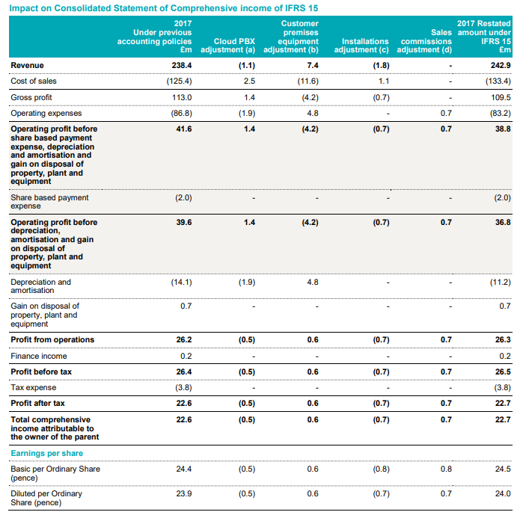
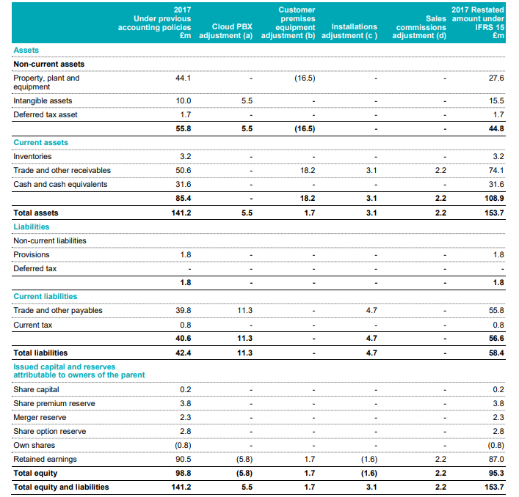
Both financial statements belong to Gamma Communication which significantly affected through changing old standard’s requirements to new ones. Gamma set out an exhaustive investigation which looks at for every revenue stream their present policy versus the IFRS 15’s requirements, clarifies the changes recognized and demonstrates a reconclliation of both the Statement of Financial Position and the Statement of Comprehensive Income and for 2017.
Another extract is from BAE Systems aerospace company. Revenue on most of agreements, as of now being perceived dependent on the finish of achievements or conveyances, will aggregately be perceived before Under IAS 11, revenue under long haul contracts is perceived when an independently recognizable stage has been finished. Under IAS 18, income from the closeout of merchandise not under long haul contracts is perceived when the huge dangers what's more, prizes of proprietorship have been exchanged to the client, for instance, upon conveyance.
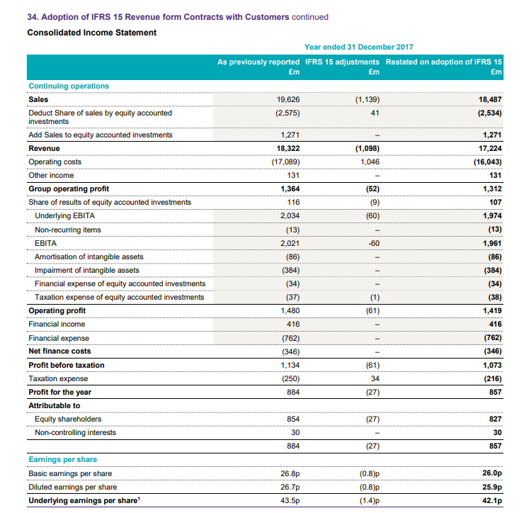
Source: Grant Thornton (2018)
CONCLUSION
IAS 18 and different models such as IAS 11, IFRIC 13 and so on leaves the clients with significant perplexities. These standards are blamed for having a great deal of shortcomings and dubiousness. Likewise, the utilization of these changing principles caused irregularities among the distinctive budget summaries issued by different organizations. This wonder influences the objective of having a practically identical budget summary. This is the reason every single past standard is presently being supplanted by one structure however with numerous potential decisions and estimations. So, every one of the clients of these old principles should overhaul them with the new and far reaching IFRS 15. This revolutionizes the revenue system and brings every one of the clients under one stage. Subsequently there is not so much disarrays but rather more textures.
From this paper, it is apparent that IFRS 15 makes a solitary wellspring of income prerequisites for all substances in all ventures. The new standard is a noteworthy change from current IFRS in that it applies to income revenue contracts with clients and replaces the majority of the income measures and understandings in IFRS, including other related standards.
It is likewise standards based, steady with current revenue requirements, yet gives more application direction. The absence of splendid lines will result in the requirement for expanded judgement. The norms will have little impact on certain substances, however, will require noteworthy changes for other people, particularly those elements for which current IFRS gives little application direction. All the more thus, the standard indicates the accounting treatment for specific things not ordinarily thought of as income, for example, certain expenses related with acquiring and satisfying an agreement and the selling of particular non-financial assets.

BIBLIOGRAPHY
-ACCA Global, https://www.accaglobal.com/lk/en/member/member/accounting-business/2018/11/insights/ifrs15-companies.html
-Ayşe İrem Keskin - Banu Dinçer, (2015). UFRS 15 – Müşteri Sözleşmelerinden Elde Edilen Hasılat Standardının İncelenmesi Ve Telekomünikasyon Sektörüne İlişkin Bir Uygulama
-Dr. Christoph Hütten, (2018). IFRS 15: Implications for SAP’s 2018 Financials
-Ernst & Young LLP, (2017). IAS 11 – Construction Contracts
-Ernst & Young LLP, (2017). IAS 18 – Revenue
-Ernst & Young LLP, (2017). IFRS 15 – Revenue from contracts with customers
-Ernst & Young LLP, (2018). IFRS Update of standards and interpretations in issue at 31 March 2018
-Deloitte & Touche LLP, (2017). International GAAP Holdings Limited Model financial statements for the year ended 31 December 2017 (With early adoption of IFRS 15)
-Deloitte&ToucheLLP, https://www2.deloitte.com/content/dam/Deloitte/ph/Documents/audit/ph-audit-aan-issue-3-s2014-noexp.pdf
-Financial Reporting Council, (2018). IFRS 15 Thematic Review: Review of Interim Disclosures in the First Year of Application
-Giorgia Mattei & Niccolò Paoloni, (2018). Understanding the Potential Impact of IFRS 15 on the Telecommunication Listed Companies, by the Disclosures’ Study
-IFRSBox, https://www.ifrsbox.com/ifrs-15-vs-ias-18/
-IFRS Foundation, (2014). IFRS 15 Revenue from Contracts with Customers
- IASPLUS, https://www.iasplus.com/en/standards/ifrs/ifrs15
-KPMG IFRG Limited, (2014). Impacts on the construction industry of the new revenue standard
-KPMG IFRG Limited, (2017). IFRS 15 Revenue supplement: Guide to annual financial statements
-KPMG IFRG Limited, (2014). Impacts on the construction industry of the new revenue standard
-KPMG IFRG Limited, (2017). IFRS 15 Revenue supplement: Guide to annual financial statements
-KPMG IFRG Limited, (2014). Impacts on the construction industry of the new revenue standard
-KPMG IFRG Limited, (2017). IFRS 15 Revenue supplement: Guide to annual financial statements
-Oyedokun, Godwin Emmanuel, (2016). REVENUE RECOGNITION PARADOX: A REVIEW OF IAS 18 AND IFRS 15
-Patricia McConnell, (2014). Revenue recognition: finally, a Standard approach for all
-Robert Köthner, (2017). Daimler’s transition to IFRS 15
-Selim Cengiz, Büşra Tosunoglu, (2018). TFRS 15, TMS 11 ve VUK kapsamında yıllara yaygın inşaat ve onarım işlemelerinin muhasebe uygulamaları
- https://www.iasplus.com/en/standards/ias/ias11
-https://www.ifrs.org/issued-standards/list-of-standards/ias-11-construction-contracts/
- https://accounting-simplified.com/standard/ias-11-construction-contracts/

