Faculty: “SABAH” Center
Specialty: Business Administration
Thesis
Topic: Dynamic Pricing and the effect of price fairness perception on Customer Loyalty. “Buta Airways”

Student: Toghrul Mirzayev
Supervisor: Galandar Mammadli
Group: S16_01_409
Section: English
Baku 2019

Content
I Chapter
- Introduction………………………………………………………...4
  - Price; Pricing………………………………………………………5
    - Price Strategy…………………………………………………...8
a) Cost Oriented………………………………………………….....8
b) Competitive……………………………………………………...9
c) Value……………………………………………………………9
  - Dynamic Pricing………………………………………………….11
  - Psychological Price……………………………………………….12
  - Perception…………………………………………………………13
  - Price Perception…………………………………………......…....14
  - Price Fairness Perception…………………………………………16
II Chapter
- Customer Loyalty…………………………………………………18
  - The importance of Customer loyalty……………………………...20
  - Levels of Customer loyalty………………………………………..21
  - Dimensions Customer Loyalty……………………………………25
A Cognitive Emotional Behavioral Customer loyalty………………..26
  - Types of Customer Loyalty……………………………………….27
    - Behavior………………………………………………………..29
    - Attitude…………………………………………………………29
  - Customer Loyalty Model………………………………………….31
  - Buta Airways……………………………………………………...32
III Chapter
- Research………………………………………………………...32
  - Purpose of Research…………………………………………….33
  - Measurement of Research……………………………………...34
  - Limitations and Scope…………………………………………..34
  - Hypothesis and Model…………………………………………..35
  - Findings.......................................................................................35
    - Frequency.................................................................................36
    - Factor Analysis.........................................................................38
    - T-Test........................................................................................43
    - Anova........................................................................................43
    - Correlation...............................................................................44
    - Regression................................................................................45
3.6. Discussions....................................................................................46
3.6.1. Revised Model.............................................................................46
3.6.2. Hypothesis...................................................................................46
4 Conculusion.........................................................................................47
5 References …………………………………………………………..49
I Chapter
1 Introduction
Diploma work has been prepared on “Dynamic Pricing and the effect of price fairness perception on Customer Loyalty “Buta Airways” subject. Research consists of 3 main parts.
Price;Pricing section has been explained around price.This section explores various academic themes and different academic web-sites on price strategy, price perception and psyhological price topics and is based on these themes. The objective of this part is to determine the effects of price and types of price topics on the business process.
Loyalty section has been explained around customer loyalty. This section explores various academic themes on customer loyalty,levels of customer loyalty, types of customer loyalty and loyalty model topics and is based on these themes. The objective of this part is to determine the effects of customer loyalty and types of loyalty topics on the business process.
Research section of the Thesis , we have noted research ,the purpose of the research, and research methods. We have surveyed on the “Dynamic Pricing and the effect of price fairness perception on Customer Loyalty - Buta Airways” topic online among people. The objective of this part is to determine the factor analysis, correlations of survey and limitations of survey.

  - . Price, Pricing
Price is the quantity of cash charged for an item (or services). More badly, Price is the total of all value that buyers give up to gain using a product (service). Price has been the important figure influencing to customer’s option. In recent years, non-price parameters have gained growing importance. However, price still remains one of the main components decides company’s capacity and productivity.
Price is sole component in the marketing mix that produces revenue: other components appear for costs. Price is also the main marketing mix components. Different products characteristics and channel commitments, prices can be changed rapidly. Also, pricing is main problem for many marketing managers and many firms do not manage pricing well. Some executives view pricing as a big problem, preferring instead to focus on other marketing mix components. Clever mangers behave pricing as a main strategic figure for creating customer value. Prices have an impact on a main line of companies. A little rate advancement in price can create an expansive rate growth in benefit. as portion of a company large loyalty recommendation, price plays a key factor in making client esteem and building client connections. Rather than running absent from pricing,” says a master, “savvy marketing specialist are cover it. (Kotler & Armstrong)
Pricing Methods
Price Skimming: As a concept, price skimming is nothing modern, but today claiming top-tier prices is not just the business of monopolies. From the base of firms researched, it shows up to be an all or nothing situation, with three of the case companies selecting out, and two very clearly choosing to watch this strategy.
Customized prices: By customizing prices, a company(firm) get the risk of being seen as inequitable by buyers, who may discover they are paying much more for a service than another purchaser who at least appears to be receiving the same service. At the same time, they can capture far more of the value they provide to their customers. There are many ways to go about customizing prices, but it should always be done carefully.
Hourly based billing: Hourly based billing is by far the most general method to sell services, whether it is a bid for a number of hours to complete a special assignment or open-finished billing of hours as work is finished.

Life cycle pricing: Life cycle pricing alludes to the training of planning price for the distinctive stages within the valuable life of an offering. A level of this notion is mentioned in essentially each sale, as few merchandise or services have esteem for as it were a moment and indeed less hold their esteem inconclusively.
Target Return Pricing: As an alternative of arriving at price focuses based on cost and income prognosis, the practice of target return pricing turns the method upside-down by starting with a benefit target, and calculating the price based on the edge required.
Group/ Segment based pricing: One of the easier ways of customizing pricing is to separate a single market into section which have diverse demand. In any case, it is much more troublesome to buy customers to 48 self-select into a better price segment. By part their offering into minimum three diverse levels, Auto-Site offers what each fragment requires, whereas minimizing item level minimize by including client service or other rewards to higher level offerings.
Versioning /Predetermined choices: Versioning as a concept is very analogues to group based pricing in that forms are frequently aimed at a specific section of the showcase. Versions can too be built to suit choice for a single client. All of the case companies other than Multi-Software utilize versioning as a staple of their pricing procedures.
Bundled pricing: By bundling items or services together, the client can be aid along within the obtaining prepare. At the same time, an abatement on the combined items can deliver a sense of getting a great deal. From the firm’s viewpoint, bundling can make weight to offer a rebate, but at the same time it can guarantee a great client experience and the plausibility of additional sales.
Licensing as a craftsmanship or a science could be a wide sufficient subject to warrant a separate consider. Be that as it may, we'll touch on many of the imaginable kind: user, usage-frequency, and time-based licensing. User based licenses are priced in the main to either the number of user with get to an item or the number of user with concurrent get to. (Wuollet, 2013)

1.1.1 Price Strategy
Pricing strategy alludes to way firms utilize to price their items or services. Nearly all companies, great or little, base the price of their items and services on generation, labor and publicizing costs and after that include on a certain rate so they can make a benefit. There is a few various price methodologies, such as penetration
pricing, price skimming, discount pricing, product life cycle pricing and even competitive pricing. (Suttle, 2019)
Pricing strategies habitually change as item passes through its life cycle. The initial organize is particularly challenging. Companies bringing out an unused item confront the challenge of setting prices for the primary time. They can select between two wide strategies: market-skimming estimating and market-penetration estimating. (Kotler & Armstrong)
- Cost-Oriented: Profit fulfillment is the primary pricing objective of industry today. Brooks shows a generally basic, yet appreciable, model for cost-oriented pricing that can help in accomplishing this objective.
Cost-oriented pricing is pragmatic for a few causes:
- It is generally simple
- Businessmen can ordinarily assess the units that will be sold amid a period with tolerable exactness.
3)The coming about price is regularly shockingly near to the profit- maximizing price-at slightest near sufficient so that the extra marginal effort or investigate fundamental to characterize the profit-maximizing price precisely may not be justifiable on a cost/benefit premise. (Brooks, 2015).
An extended cost-oriented pricing approach for proficient service suppliers. The sample included the conventional cost-oriented pricing components of settled costs, variable costs and the firm’s benefit objectives, in conjunction with the variables that make up the expanded show: essentiality – the degree to which the buy of the benefit is postponable, toughness, esteem included, and the rate of performance size, strength, worth included, and the rate of performance size. The components impacting service pricing can be divided into three sections:
unique premium features: essentiality, durability and tangibility percentage of performance size used traditional factors: variable cost, fixed cost and company’s profit goal. (Arnold, 2008)
b) Competitive
Economics specialists have proposed a few hypotheses that allow acknowledgment to the non-price variables of competitive procedure. However, they have not credited the nature of the item and the characteristics of the clients as the prevailing variables in explaining how companies organize to market their items. The prevailing process is customarily supposed to be the market structure of the industry. (competitive, oligopolistic, or monopolistic) (UDELL, 1964)
c)Value
The expanding endorsement of client value-based methodologies among scholastics and specialists is based on a common acknowledgment that the keys to supported productivity lie within the basic highlights of customer value-based pricing, including understanding the sources of value for clients; planning items, services, and arrangements that meet customers’ needs; setting prices as a function of value; and actualizing steady pricing arrangements. (Hinterhuber, 2008)
Table 1 Alternative Approach to pricing
 | Cost-based pricing | Competition-based pricing | Customer value-based pricing
Definition | Cost based-pricing approaches determine prices primarily with data from cost accounting | Competition-based pricing approaches use anticipated or observed price levels of competitors as primary source for setting prices | Customer value-based pricing approaches use the value a product or service delivers to a predefined segment of customers as the main factor for setting prices Perceived value pricing Performance pricing
Examples | Cost-plus pricing, mark-up pricing, target-return pricing | Parallel pricing, umbrella pricing, penetration/skim pricing Pricing according to average market prices
Main strength | Data readily available | Data readily available | Does take customer perspective into account
Main weaknesses | Does not take competition into account Does not take customers (and customer willingness to pay) into account | Does not take customers (and customer willingness to pay) into account | Data are difficult to obtain and to interpret  Customer value-driven pricing approach may lead to relatively high prices – need to take long-term profitability into account  Customer value is not a given, but needs to be communicated
Overall evaluation | Overall weakest approach | Sub-optimal approach for setting prices; appropriate for commodities (if – and only if – products/services in question cannot be differentiated) | Overall best approach, direct  link to customer needs

References: Andreas Hinterhuber (2008); Journal of Business Strategy
  - . Dynamic Pricing
Many industries are using dynamic pricing strategies. These industries: Airline; Hotels; and electric utilities where power is fixed and in short-term.
There has been a developing acceptance of dynamic pricing approaches in retail sectors and other industry sectors, where the retailers have the capacity to shop inventory. We saw a growth adoption of dynamic pricing methods and these methods development in retail and other industry markets.
3 components included to this concept:
1)an expanded accessibility of request information
2)simplicity of alteration prices due to modern innovations
3)a convenience of decision-aid apparatuses for identifying request information and for dynamic pricing.
One can effortlessly imagine that the dynamic pricing problem facing a seller of a steady good, such as a fridge, at the start of its life cycle is unlike that facing a seller selling bathing suits at the end of summer.
While both sellers must decide how to change prices over the remaining selling horizon, the factors that affect their decisions are entirely different. We postulate that there are three important factors of a market environment that impact the type of dynamic pricing problem a seller faces:
Replenishment vs. No Replenishment of Inventory:
Whether or not inventory replenishment is possible during a price planning horizon affects whether a seller needs to make inventory decisions upfront, before the suggestion season starts, or whether she will have access to extra units between the suggestion season.
Dependent vs. Independent Demand Over Time:
Demand of an item over different periods can be subordinate if the product is a stable good or customer’s knowledge almost the product plays a part in their choice to make a buy.
Myopic vs. Strategic Customers:
The purchasing behavior of the clients influences the salesman's pricing choices over time. A myopic client is one who makes a buy instantly in case the cost is underneath his valuation (reservation price), without considering future prices. (Elmaghraby & Keskinocak, 2014)
1.3. Psychological Price
Psychological pricing factors come into play as they can reason price hardness. There is also an interest of industrial firms’ authors in the role of psychological prices for price hardness as psychological prices are an outcome of incomplete markets. The marketing literature differs from the Industrial Firms theory. The pricing factor for the development of firms is a useful tool. The purpose of this section was to show the benefits of psychological pricing factors
A product priced at $2,99, people are thinking of $ 2 for the price of the product. Consumer don’t think $3. Consumer’s reaction to the offered psychological price of $2,99 is that consumers understands appropriate price is $3 to be a `fair' price. (Wedel & Leelang, 1996)
Table 1.1 Psychological Price Example
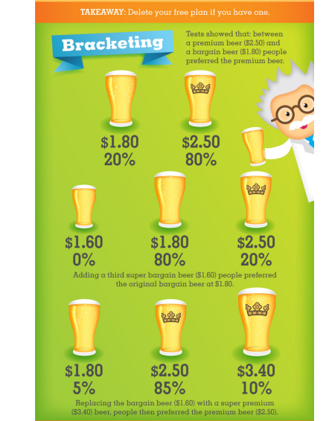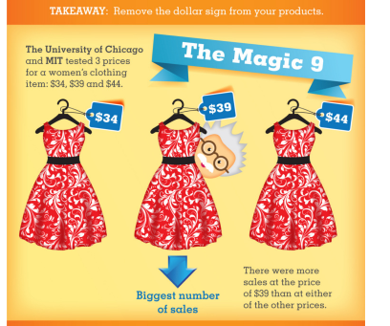
References: Jeff Desjardins (2015); www.visualcapitalist.com
1.4. Perception
Perception is human's fundamental outline of cognitive contact with the world around him. As all conceptual information is based upon or inferred from this essential frame of cleverness, the think about of perception has continuously had a one of a kind noteworthiness for logic and science. The exact nature of perception has never been exhaustively characterized or conceptualized, with the result that those who effort to consider disorders of cognitive work do not persistently know whether an unsettling impact of cognition is due to a distortion in a tactile, perceptual or conceptual handle. The deficiency of the winning concepts of sensation, perception, and conception and the commonsense importance of settling the hypothetical philosophical issues included in characterizing correct definitions of these terms can be importantly outlined out by a concrete neurological issue. Various basic issues inside the history of epistemology are raised by the taking after case history of a 24-year antiquated officer who made a genuine cognitive unsettling impact after a coincidental over-exposure to carbon monoxide. (Efron, 1969).
A few basic philosophers are really persuaded that the world may be a whole of data sur-rounding the subject. What we call the world is nothing else but a set of different perception, senses and concepts. For illustration, phe-nomenalists follow to such a point of see. They accept that as it were our perceptions are the subject of our cognition. What we see are as it were perception and there's nothing else open to us but discernments. What we accept is behind our recognition and what supposedly causes it, is fair a levelheaded build. Other than recognitions, we in this way have pictures, judicious develops and concepts we make ourselves. The address, be that as it may, is what we made them from, on what premise and how we see these thoughts, how we get it them. (Démuth, 2013)
1.5. Price Perception
To identify the number of ways buyers may go to and respond to price and price advancements, we performed a broad survey of the pricing and sales advancement writing. Five develops reliable with a perception of price in its negative part and two develops steady with a perception of price in its positive part were identified.
- Negative Role of Price
Value consciousness: Perception of price cue for a few customers can be characterized by a concern with the proportion of quality gotten to price paid in a buy exchange.
Price consciousness: Perception of the price for a few customers can be characterized more barely as reflecting price consciousness.
Coupon proneness. Perception of the price cue in its negative part may too be related to the frame in which the price cue is displayed.
- Positive Role of Price
Prestige sensitivity similar to perceptions of the price cue based on what it signals to the buyer approximately item quality (i.e., a price-quality construction) are perceptions of the price cue due to inductions around what it signals to other individuals almost the purchaser.
- Price Recall
Both hypothetical and observational prove proposes that the perception of price in its positive part ought to be connected negatively to price recall exactness and the recognition of price The part of the price in influencing buyer’s attitude would be more bulging to the restaurant industry because buyer’s competence will not be identical; high human participation while delivering services provide distinction in experience. (Donald R. Lichtenstein, 1993)
Table 1.2 Price Perception plays an important role for airlines given the spread in positioning of airlines.
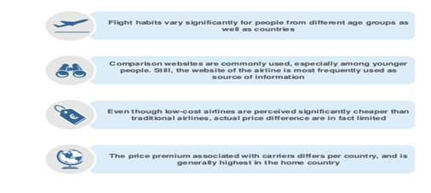
References: Wouter Wincken (2018); www.slideshare.net
Comparison websites are commonly utilized, particularly among youthful individuals. Still, the site of the carrier is most often utilized as source of data. Even through low-cost aircrafts are perceived essentially poor than conventional aircrafts, genuine price distinction are in reality limited. The price premium related with carrier’s contrasts per nation, and is for the most part most in the domestic country. Price perception plays a plays significant part for aircrafts given the spread in situating of aircrafts, and particularly the change of data gathering and booking. Flight propensities change essentially for individuals from diverse age bunches as well as nations. (Wincken, 2018)

1.6. Price Fairness Perception
Price perception investigate picks up significance due to the development of energetic estimating applications all through the trade world, and both promoting analysts and specialists ought to center on finding answers to the questions raised by such differential methods. An understanding that social comparisons bring out higher recognitions of price (un)fairness enlightens the threat of not separating costs accurately for diverse shoppers (e.g., the elderly and the youthful; customary and periodic buyers; understudies and the labor drive). Moreover, consumers may consider expansion when comparing costs over time, in spite of the fact that such comparisons ought to be done between costs disseminated over longer, instead of shorter, periods of time. Both recommendations take after the main finding of the think about, appearing that diverse power of cost fairness perceptions lead to diverse sorts of behavioral responses, extending from complaints to disjoining ties with the dealer or indeed turning to their direct competition. (Malc, Mumel, & Aleksandra, 2015).
Factors are ordinarily considered when studying price fairness perception: distributive fairness, procedural fairness and interactional fairness. In this section, we analyze distributive and procedural fairness. First, we consider definable that impact price fairness perception, such as reference price. Familiarity with Online Hotel Bookings and search for fairness (SF). At the same time, we evaluate the result of Price Fairness Perception over decision confidence, loyalty and satisfaction with price.

Figure 1. Theoretical model proposal

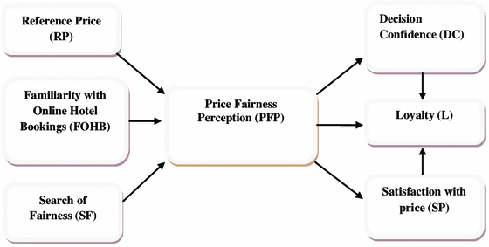
References: María-Encarnación A-M; Miguel-Ángel G-B; Juan-Antonio M-J (2014); Electronic Commerce Research.
II Chapter
2 Customer Loyalty
Firms are wanting to creating relationships with buyers, this process is the primary factor in business environment. Firms set up good results when firms manage their customer base in order to identify, fulfill and hold their most beneficial customers. This is a main objective of Customer Relationship Management strategies. (Buttle, 2004)
Loyalty Program
A loyalty program is a marketing program that is schemed to create customer loyalty by providing stimulus to useful customers. A loyalty program is often based on few opinions such as the following:
1. Customers may want more involving relationships with products that they purchase.
2. A proportion of these customers show a tendency to be loyal.
3. They are a productive bunch
4. It is possible to reinforce these customers' loyalty through the loyalty program (Uncles, 1997).
Customer Loyalty - could be an intentional client arrangement for a long time to construct connections with the company. Loyalty is the user's want for a long time to proceed their relationship with a specific company. Loyal Customers are those who buy goods/services of the company from time to time. Loyalty can be treated as a client crave, readiness to be a normal client for a long time, buying and utilizing the merchandise of the chosen firms by prescribing them to companions and colleagues. Loyalty can be seen as a multi-dimension, covering behavioral and positional components, where positional perspective reflects customers' approach to business, while the behavioral measurement uncovers a visit and customary shopping, buy amount, estimate, run, access (IŠORAITĖ, 2016)
As clients, we love to share our affirmative or negative experiments almost an item or service with companions and family. We are too slanted to believe brands suggested or mentioned by our companions. Word-of-mouth is more successful at driving modern clients than any other class of promoting. The value of catch an existing client is much lower than obtain an unused one a loyal customer may be a valuable brand resource. As a trade, you'll be able pick up a part by concocting techniques to turn your existing client base into loyal customers and brands advocates.
Table 2. Loyalty Rewards to Attract Your Customers
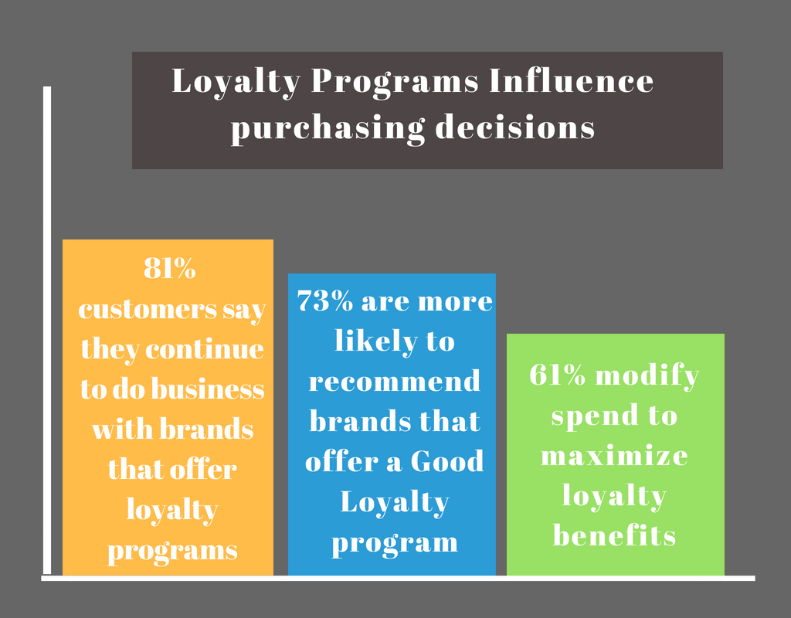
References: RUPALI SINGH (2018); www.foodkonnekt.com
2.1. The Importance of customer loyalty
The purpose of this section is to emphasize the importance of loyalty program. Building a loyalty program permits firms to keep existing clients and to explore for unused clients. Being closely related to the client, in an individual way of caring, passed on a sense of partnership to them, whereas applying a legitimate relationship marketing hip. Importance of loyalty program is an expression of the culture of a firms. One reason that loyalty is developing quickly, is since businesses are realizing the benefits of client loyalty at the time of modern improvement. (Ervin MYFTARAJ, 2014)
Therefore, selecting the proper items and services for present clients or prospects will drive to a potential growth in sales and, as a result, a growth in profits. we cannot dodge the significance of making unused connections with potential clients in arrange to obtain modern salaries. A CRM procedure can offer assistance in both scenarios, working with existing clients and obtain and construct unused ones.
Another case theory from Deloitte said that a current client would spend in our hotel a 67% more than an unused client.
Table: 2.1 The Importance of Customer Loyalty
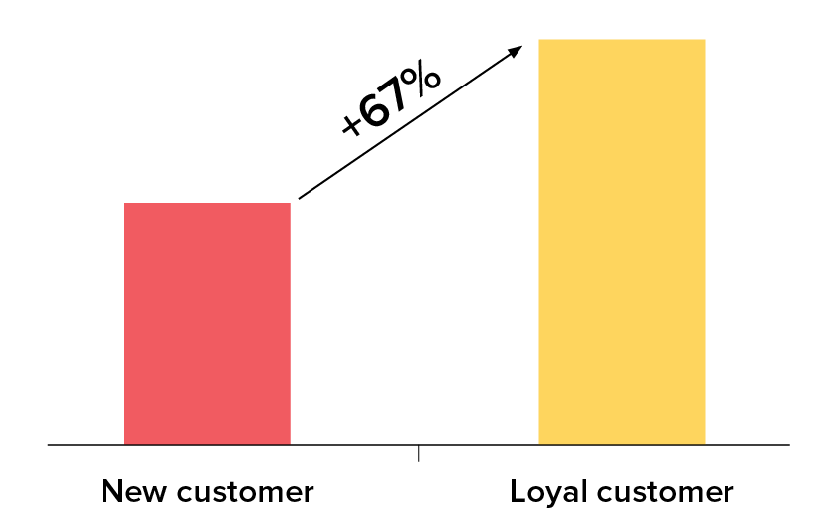
References: www.pasodebooking.com; (2017)
2.2. Levels of Customer Loyalty
The client is the essential focus of our business process and acquire our customer’s loyalty is the dream and target of each action the business process engages in. Not only will this bring you more benefit, but getting clients to remain along with your brand through a long time could be a surefire way for your business process to succeed and proceed within the long term. To do this, you wish to be aware of the distinctive levels of customer loyalty and how you'll be able spur clients to reach the most noteworthy level and become your chief.
Potential customer: The potential client is our target market and anybody who has however to undertake but may be attentive about our item or service. We need to get the word out about our firms to these individuals and how our offerings will advantage them. To attract in intrigued, utilize all shapes of market accessible. Traditionary market such as flyers, booklet and print advertisements can be used. Most significant of all, we got to use the control of the web through digital marketing. Increase your site, make sure search motors discover your location and interface along with your target spectator through social media.
First-time customer: Once the potential customer’s interest is saved and we have persuaded them to buy from our company, they ended up our first-time customers. First-time customers are those attempting us out and waiting to see if they will be pleased sufficient to create a buy once more. We got to make assured that the quality of service or item we provide is at standard or indeed over their desires. Their experience while buying the item, whether it was fast and simple and if agents were appropriately useful, will moreover impact their choice to come back or not.
Repeat customer: First-time clients who were fulfilled with their experience will become repeat clients. To keep these clients, after sales service is main. We ought to appear them that we esteem them and their trade and business process. Inspire clients with service that’s customized and personalized to their wants. Any factors they have with the item or service ought to be managed with appropriately and expeditiously by a friendly and useful client service group. With successively amazing service and best quality items, repeat clients become loyal to your firm.
Brand supporter: Once you’ve earned your customer’s believe and loyalty, your another objective is to construct a passionate association so that clients can distinguish together with your firms. Repeat clients who accept in you and your item will effectively advice your company. This is often your most elevated accomplishment as clients who become advocates will most likely remain together with your firms long dated, additionally they offer assistance bring in other clients through word of mouth. It’s too exceptionally vitally important to form these clients feel how much they are reliable by the firm. In addition to large profit, you wish to have activities in put that know and reward your supporters. (Jayme, 2016)
Table: 2.2 Levels of Customer Loyalty
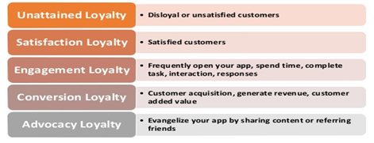
References: www.slideshare.net (2016);
I level - Unattained Loyalty. -Customer who drop into this level are rarely disloyal or unsatisfied. Winning loyalty at this arrange frequently comes down to two components: Building an app clients cherish Humanizing your customers.
II level Satisfaction Loyalty - A fulfilled customer is worth small; a loyal customer is worth a part. Winning customer fulfillment comes down to an iterative handle of collecting and analyzing insights. Utilizing those experiences to construct an app and involvement your customers love.
III Levels – Engagement Loyalty. To win engagement loyalty, construct motivating forces around engagement into construct motivating forces around engagement into the very core of the app. Keep customers coming back with new substance, well-timed pushed notices, peer-to-peer informing, or gamified accomplishments.
IV Level – Conversion Loyalty - Conversion loyalty may be an estimation of the esteem your customers give to your app. Sometime recently including a modern exchange alternative to your app, inquire yourself (or in a perfect world, your customers): Is this something clients would be curious about? And on the off chance that so, how much would they be willing to pay?
V Level –Advocacy Loyalty Coordinated app with social systems and contact books Compensate clients for sharing substance or alluding companions. Make social sharing as hassle-free as conceivable. Incite (pleasantly) for appraisals and audits Advocacy – changing your clients into evangelists. (Technology, 2016).

2.3. Dimensions Customer Loyalty
Air travelers are progressively getting to be more requesting in terms of their desires of the quality of service suggested by airline firms. Thus, Airline firms must progress service transportation to hold their loyalty. This research explores the relationship between airlines firms service quality dimensions and importance of customer loyalty among airline travelers in Lagos state. Causal investigate plan was received to look at the mentioned relationship. Comfort inspecting procedure was utilized to overview 600 air passengers. Data gathered from the defendant were examined by utilizing Pearson relationship examination and Anova. The discoveries uncover that the service quality and its dimensions are positive and importantly related to each other, generally service quality and customer loyalty. The result about of the study demonstrate no important distinction between customers’ travelling for diverse thought processes in their perception of the quality of services. (Ben Akpoyomare, 2016)
Customer loyalty in service industry sector, moreover known as service loyalty, alludes to customers’ adherence to certain brands in the service industry. As a run the show, the degree of customer loyalty to certain service firms shifts with the services they accept embodied as an arrangement of distinctive buy relation or behaviors in market. Analysts hence can degree customers’ loyalty to a certain service firms by looking over these distinctive buy demeanors or behaviors. Be that as it may, as scholars’ understanding of client loyalty changes significantly, there have been a plenty of suppositions on customer loyalty measurement, such as the behavior approach, warmth approach, behavior-affection approach, cognition-affection-behavior approach, and cognition-affection-conation-behavior approach. (LU Juan, 2009)
Figure: 2. A tri-dimensional approach to brand loyalty.

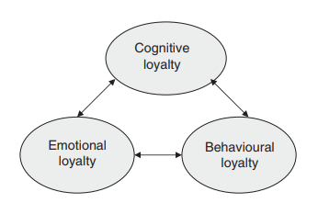
References: Worthington, S., Russell-Bennett, R., & Härtel, C. (2009); Journal of Brand Management,
All human conduct could be a combination of one or more of three distinctive kinds of reactions:
cognitive reactions (I think),
emotive reactions (I feel)
behavioral reactions (I do).
Applying a tri-dimensional theory, brand loyalty is consequently the merger of a buyer’ s contemplations and sentiments about a mark that are at that point communicated as an activity.
we propose a system for a brand loyalty review that utilization a tri-dimensional approach to brand loyalty, which incorporates behavioral loyalty and the two element of attitudinal loyalty: emotional and cognitive loyalty.
In permitting for diverse levels and escalated of brand loyalty, this tri-dimensional theory is imperative from an administrative point of view. It implies that loyalty procedures that emerge from a brand review can be made more viable by focusing on the market fragments that illustrate the foremost fitting combination of brand loyalty elements. We propose a framework with three dimensions (emotional, cognitive and behavioral loyalty) and two levels (top and poor loyalty) to simplify a brand loyalty review. (Worthington, 2009)
2.4. Types of Customer loyalty
Arrangement for customer loyalty programs based on the market characteristics.
- Market based
single industry (coordination of firms within the field of services) –
interbanch (coordination of science organizations, book stores, theaters, traveler transport companies, gas stations, medical centers)
- Function based
economical: (reward, cumulative) -
social (to make working places.) -
respectful (to make respectful society, sound living propensities, etc.)
- Regional based: -
world-wide (exterior the country) -
national (interior the country boundaries) -
between regions - interior districts. (Jokinen, 2014)
Alternative approaches
Table: 2.3 Loyalty typology based on attitude and behavior
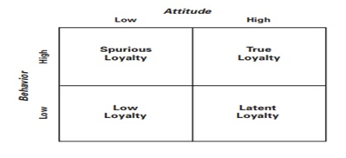
References: Baloglu, S. (2002).; The Cornell Hotel and Restaurant Administration Quarterly,
Both behavioral and attitude
The rationale behind evaluating loyalty on two dimensions (behavior and attitude) is both conceptual and experimental. A few considers have illustrated that customer loyalty could be a multidimensional concept including both behavioral components (repeat buys) and attitudinal components (commitment). Analysts who have checked the two-dimensional theory suggested that centering on behavior alone (i.e., reiterate buys) cannot keep the reasons behind the buys. That’s, by analyzing behavior alone, one doesn’t know whether the reiterate buys stem as it were from, say, consolation or cash related inspirations, or whether the client really keeps up attitudinal loyalty. Analyzing state of attitude alone cannot tell us much nearly competitive influences (e.g., multi-brand or shared devotion), nature, and situational factors. (BALOGLU, 2002)
Figure: 2.1 Elements of two-dimensional loyalty
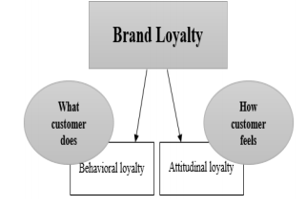 References: Taghi P, Mohammad J; Bakhsh, Mahsa M (2015); International Journal of New Technology and Research.
These are the points of two dimensional loyalties.
2.4.1 Behavior
Behavioral loyalty shows the sum of services that an individual buys or plans to buy more than once what is known through buy behavior and application. This kind of loyalty can be measured on the basis of the share of purchase, frequency of purchase and so on. In this hypothesis, it is expected that the customer’s inclinations show up in their behavior.
2.4.2Attitude
Attitudinal loyalty could be a psychological connection to a firm or selected mark which is frequently within the shape of a permanent and progressing connection with the brand. Inclinations, buy purposeful, provider prioritization, and the willingness to advice are the instruments to degree attitudinal loyalty.
Figure: 2.2 Previous dimensions of loyalty and four-dimensional loyalty
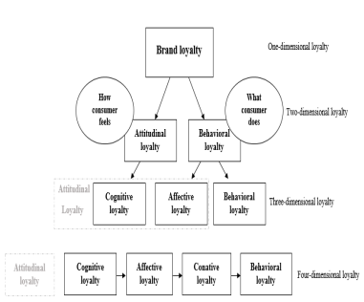
References: Taghi P, Mohammad J; Bakhsh, Mahsa M (2015); International Journal of New Technology and Research.
In this conclusion of figure, diverse conceptualizations of the dimensions of loyalty are showed. (TaghiPourian & Bakhsh, 2015)
Why integrate attitudes and behavior to measure loyalty?
Over the past 20 a long time, observational information, within the form of more and more opportune measures of sales, benefits, trial, and reiterate, have gradually disintegrated the marketer's verifiable dependence on attitudinal measures, such as estimations of mindfulness, review of promoting, or brand symbolism. In this way, analysts have regularly been consigned to the part of contracting for behavioral information one day, and attitudinal information the following, with small thought being given to the gorge that lies between the two. (Rubinson & Baldinger, 1996)
2.5. Customer Loyalty Model
A dynamic model of customer loyalty is inferred from the investigation of the diverse shapes of ‘link’ that the firm can create with its clients amid the connection life cycle.
The administrative suggestions of the dynamic model of customer loyalty concern both the tactics and operations of customer connections. The firm ought to, over all, look at the state of its own connections and after that define the ‘relational’ objectives and the foremost suitable programs for achieving them.
It is evident that the customer loyalty objective ought to be mainly pointed at the highest and most potential esteem client segment, given moreover that not all connections got to be overseen in a developmental viewpoint.
Figure: 2.3 The dynamic model of customer loyalty
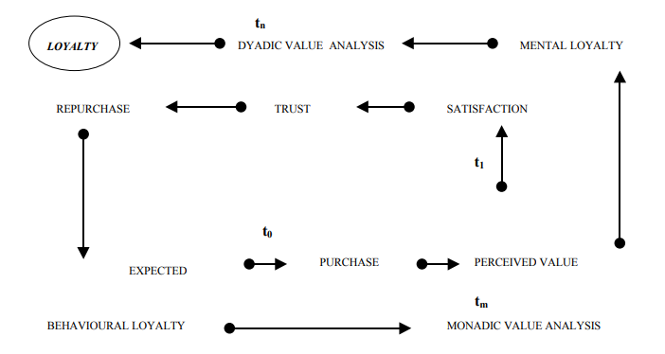
References: Costabile M; A dynamic model of customer loyalty.
2.6. “Buta Airways”
“Buta Airways” airline is a structural section is Azerbaijan Airlines. "Buta airways" airline company was founded in December 2016. Operations of “Buta Airways” airline company began in December 2017. the low-cost airline carries out flights to the close overseas with flights from the air terminals of Baku and Ganja to international station in Russia, Turkey, Ukraine, Georgia, Iran and Bulgaria.
Since the starting of its operation, Buta Airways has been in tall request both among the citizens of Azerbaijan and in other nations. Loading of aircrafts on the larger part of goals isn't less than 85 percent.
The fleet of Buta Airways includes modern comfortable Embraer E190 aircrafts. These new and reliable aircrafts are equipped with comfortable seats, wide legroom and large overhead bins for hand luggage.
As the number of new aims increases, the airline plans to expand its fleet of aircrafts. (ButaAirways/company/about, n.d.)
III. Research
Research is almost obtain information and creating understanding, collecting actualities and translating them to construct up a picture of the world around us, and and even within us. It is decently self-evident then, that we ought to hold a see on what information is and how we are able make sense of our environment. These sees will be based on the philosophical position that we take.
Research Design: There are various kinds of research about plan that are fitting for the distinctive kinds of research projects. Here is a list of a few of the more general research designs, with a brief clarification of the characteristics of each (Walliman, 2011).
- Historical
- Descriptive
- Comparative
- Correlation.
3.1. Purpose of Research
The aim of this research is to measure the impact of price reliability on the price pricing and price integrity of customer loyalty in dynamic pricing. As you know, dynamic evaluation is one of the assessment forms for the student and aims to maximize company revenue for a certain period of time. In this research, both price fairness perception and demographic factors were investigated.
Consumers have been compared with their demographic characteristics (Age, Gender, Marital Status, Number of Children, Education, and income) in terms of price fairness.
Several research questions have been used to prepare a diploma work for the better. Research Questions:
1)How do price fairness perceptions affect customer loyalty?
2)How many differences do you have for demographic features?
3)What strategies can be applied to consumers and firms in the Azerbaijan Airline Sector?
3.2. Research Sample and Measurement.
A questionnaire form was developed to further improve the research and a survey was conducted amongst people.
In this research the sample type is non-coincidental and technic is convenience sample. The survey is consisting of 3 parts: Prices and prices related questions; Customer loyalty related questions and demographics factors related questions;
The survey was applied online and 166 people participated in the survey. The scale type is Likert and evulating criteria is 1 for “Totally Disagree” and 5 for “Totally agree”. Measures of the survey has been adapted from these sources - (Chung, 2015) and (Aydin, Özer, & Arasil, 2005).
3.3. Limitations and Scope
There were some limitations in the survey process. Not everyone has been interviewed according to the time and cost. Survey was carried out only among the users of the airline sector. The survey was conducted only among users of the “Buta Airways” airline company. The survey was designed exclusively on customer loyalty without considering other factors. Azerbaijani users were envisaged.

3.4 Hypotheses and Model
2 hypotheses were determined as the main topic for our research. Then, H1 hypothesis is divided into three sub-headings, H1 hypothesis is divided into five sub-headings.
Table 3. Hypotheses and Model
H₁ | Price Fariness Perception has an impact on Customer Loyalty
H_{1a} | Prosedural factors have an impact on Customer Loyalty
H_{1b} | Distributiv factors have an impact on Customer Loyalty
H_{1c} | Informative factors have an impact on Customer loyalty
H₂ | Demographics Factors have differences in Customer loyalty
H_{2a} | There are Age differences in customer loyalty
H_{2b} | There are Gender differences in customer loyalty
H_{2c} | There are Income differences in customer loyalty
H_{2d} | There are Marital Status differences in customer loyalty
H_{2e} | There are Children differences in customer loyalty
H_{2f} | There are Education differences in customer loyalty

Figure 3.1 Revised Model
Procedural
Informative
Distributive

Loyalty

3.5 Findings
Analyzes for the thesis are described below in sequence. We conducted some studies for the diploma work and analyzed the results.
3.5.1 Frequency
In the research, we conducted an online survey among people around the topic “Dynamic Pricing and the effect of price fairness perception on customer loyalty: Buta Airways ”. 166 people participated in the survey. Survey questions are grouped according to price, customer loyalty and demographic factors. 92 men and 74 women participated in the survey. According to age factors, there were 103 people between the ages of 18-25, 38 people aged 26-35, and 25 people aged 36 and more. The educational factor was divided into 3 criteria. 110 people participated in the high education criterion,48 people participated in Master/Doctorate criterion and 8 people participated in non-higher education criterion. 123 single and 43 married participated in the survey. 23 of the interviewers were employed in the public sector, 37 - in the private sector and 45 - in various sectors. 61 people are students. There are 3 groups on the children factor. 123 people who have no children, 27 people have 1-2 children, 16 people have 2 -3 children. The income of 63 people survey participants is between 0-250 AZN, the income of 31 people survey participants is between 251-500 AZN, the income of 21 people survey participants is between 501-750 AZN, the income of 51 people survey participants is between 751 and more AZN.
Table 3.2 Demographics Factors
Factors |  | Frequency | %
Gender | Man | 92 | 55,4
 | Woman | 74 | 44,5
Age | 18-25 | 103 | 62
 | 26-35 | 38 | 22,8
 | 36 and more | 25 | 15
Marital Status | Single | 123 | 26
 | Married | 43 | 74
Education | High Education | 110 | 66,2
 | Master/Doctorate | 48 | 28,9
 | Non-Higher Education | 8 | 4,8
Work | Other | 45 | 27,1
 | Student | 61 | 36.7
 | Private Sector | 37 | 22.2
 | Government Sector | 23 | 13,8
Children | Non-Child | 123 | 74
 | 1-2 | 27 | 16,2
 | 2-3 | 16 | 9,6
Incomes | 0-250 | 63 | 37,9
 | 251-500 | 31 | 18,6
 | 501-750 | 21 | 12,6
 | 751 and more | 51 | 30,7
Total |  | 166 | 100
Another question is “How many using within 1 year?”. Figure 3.3.1. 145 participants of survey selected 1-2 times variance,21 participants of survey selected 3 and more variance.
Table 3.3 Frequency of Usage
Factors |  | Frequency | %
How many using within 1 year ? | 1-3 | 145 | 87,3
 | 3 and More | 21 | 12,6
Total |  | 166 | 100
3.5.2. Factor Analysis
Table 3.4 KMO Value
KMO Value | Explain
0.00 to 0.49 | unacceptable.
0.50 to 0.59 | miserable
0.60 to 0.69 | mediocre
0.70 to 0.79 | middling
0.80 to 0.89 | meritorious
0.90 to 1.00 | marvelous

References:Stephanie(2016); www.statisticshowto.datasciencecentral.com
The KMO value was determined as 92.5%. KMO value is marvelous because it is higher than 0.90 Sample is appoirntemnt to our research.
Table 3.5 KMO and Bratlett’s Test
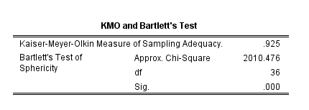
Looking at anti-image correlation table, it can be seen values of anti-image are above 0.50 Therefore it means there is a research correlation among these itmes.
Table 3.6 Anti-image Correlation
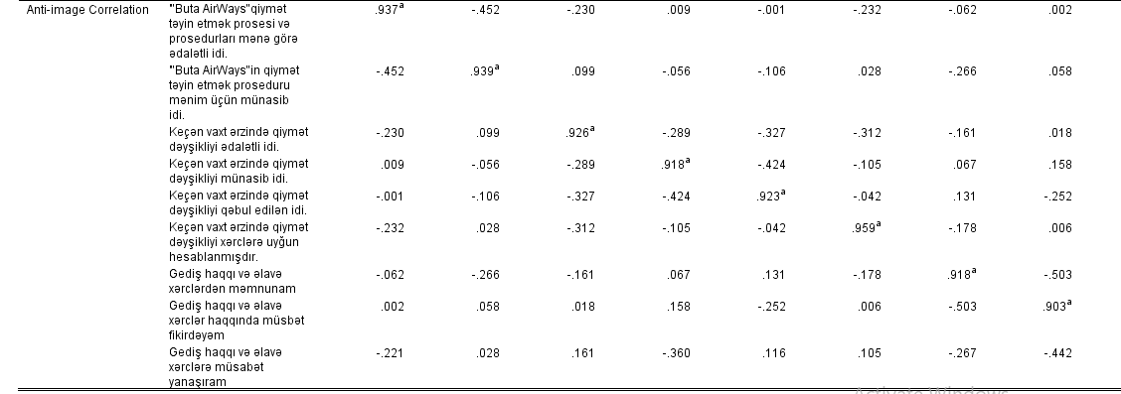
After checking anti-image correlation it is time to reducing items to dimensions, So explanatory factor analysis is eligible, for these research.While the help of explanatory factor analysis it is possible groupping items according with dimensions. Looking Rotated Compananet Matrix it can be seen values of items.
Table 3.7 Rotated Compananet Matrix
Prosedural | Item | Factor load | Total Variance Explained | Cronbach  Alpha
 | I positive think about fare and extra costs  (Gediş haqqı və əlavə xərclər haqqında müsbət fikirdəyəm.) | .859 | 87,7 | 96,4
 | I positively value the about fare and extra costs(Gediş haqqı və əlavə xərclərə müsbət yanaşıram) | .858
 | I am happy with the fare and extra costs(Gediş haqqı və əlavə xərclərdən məmnunam.) | .850
 | The "Buta Airways" price fixation procedure was suitable for me.  ("Buta Airways “in qiymət təyin etmək proseduru mənim üçün münasib idi.) | .730
 | The "Buta Airways" price fixation process and procedures were fair to me.  ("Buta Airways “in qiymət təyin etmək prosesi və prosedurları mənə görə ədalətli idi.) | .708
Distributive | Over the past time the price change was understable  (Keçən vaxt ərzində qiymət dəyşikliyi qəbul edilən idi.) | .847 |  | 95
 | Over the past time the price change was fair(Keçən vaxt ərzində qiymət dəyşikliyi ədalətli idi.) | .845
 | Over the past time the price change was suitable.(Keçən vaxt ərzində qiymət dəyşikliyi, münasib idi.) | .818
 | Over the past time price change have been calculated based on cost.  (Keçən vaxt ərzində qiymət dəyşikliyi xərclərə uyğun hesablanmışdır) | . 756

We grouped elements in 2 factors in this table. According to the “reliability test”, the elements of the procedural factor are 96.4%. According to the reliability test, the elements of the distributive factor are 95%. The “total variance rate” of both factors is 87,7%.
The KMO value was determined as 86.6 %. More than 0.50 and it is meritorious because it is betwen 0.80 and 0.89
Table 3.8 KMO and Bartlett’s Test
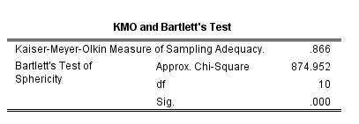
Looking at anti-image correlation table, it can be seen values of anti-image are above 0.50 Therefore it means there is a research correlation among these itmes
Table 3.9 Anti-image Correlation
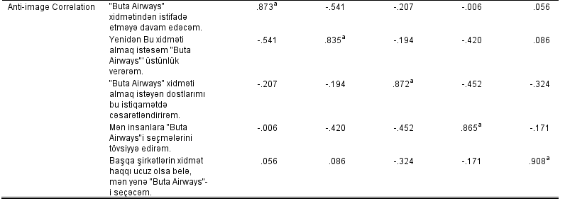
After checking anti-image correlation it is time to reducing items to dimensions, So explanatory factor analysis is eligible, for these research.While the help of explanatory factor analysis it is possible groupping items according with dimensions. Looking Rotated Compananet Matrix it can be seen values of items.
Table 3.10 Rotated Compananet Matrix
Item | Factor Load | Total Variance Explained | Chronbach  Alpha
I encourage friends who want to buy “Buta Airways” service in this direction.  (“Buta Airways” xidməti almaq istəyən dostlarımı,bu istiqamətdə cəsarətləndirirəm) | .950 | 80.6 | 93.8
I recommend people to choose “Buta Airways” service  (Mən insanlar “Buta Airways” seçmələrini tövsiyə edirəm) | .946
If I want to buy this service again, I will choose “Buta Airways “service.  (Yenidən bu xidməti almaq istəsəm “Buta Airways” üstünlük verərəm ) | .940
I will continue to use the “Buta Airways” service. (“Buta Airways” xidmətindən istifadə etməyə davam edəcəm ) | .901
Even though other companies have a low cost of service, I will choose “Buta Airways” service again.(Başqa şirkətlərin xidmət haqqı ucuz olsa beleə mən yenə “Buta Airways” xidmətini seçəcəm” | .734

We grouped elements in factor in this table. The “relability test “ result of the elements is 93,8%. The “total varaince“ result of the elements is 80,6%.
3.5.3 T-test
Levene test results are looked at first, if the value is over 0.05 T test results are looked at in the first line, if it is a value under 0.05, the second line will be looked at and it will be interpreted that there is no difference showbased according to the value there. The Levene test had a result of P = 0.442, ie, greater than 0.05. Therefore it is necessary to look at the first line in the test. Since P = 0,425 there is no significant difference in the intention to purchase by sex and the hypothesis has been rejected.
Table 3.11 T-Test
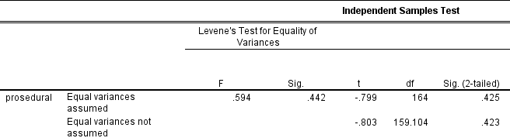
3.5.4. ANOVA
The connection is meaningless because for each factor should be p< 0.05. But here the rule is broken.

Table 3.12 ANOVA
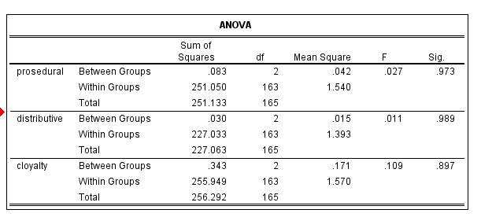
The relationship of each of these factors is meaningless. Because, the percentage of sig. is not correct. Each factor should be p< 0.05. But here the rule is broken.
3.5.5. Correlation
The contact is significant because p <0.05. When you look at the schedule, both are positive. At 99% relaibility level, 87% and 82% are in the same direction relationship.
Table 3.14 Correlations
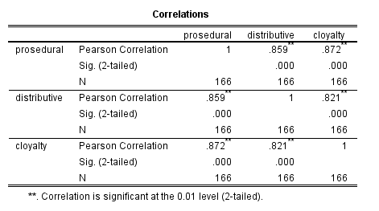

3.5.6. Regression
R.Square is 78%.(Table 3.16 ) Sig. P <0.05 should be. P = 0,000 indicates a significant relationship.
Table 3.16 Model Summary
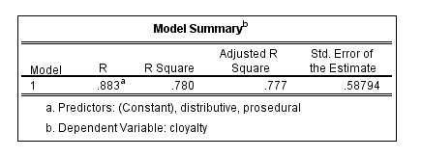
Distributive and Prosedural Justices have 78 % relationship on the Customer Loyalty.
Table 3.17 ANOVA
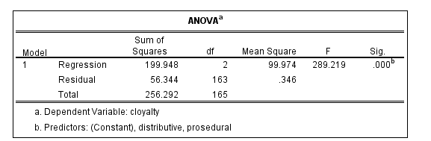

Table 3.18 Coefficients
The B coefficent is 0.64% in the prosedural. B= 0.64 %. The coefficent is 0.29% in the distributive. B= 0.29%. It is determined here that the effectiveness of the procedure is higher than distirbutive.
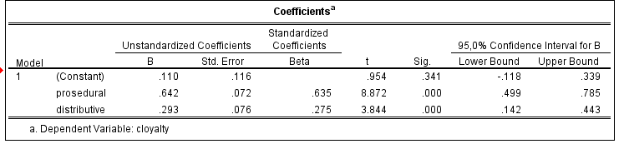
3.6. Discussion
3.6.1. Revised Model
As a result of the analyzes, the informative part was reduced. This is the final result, and we analyze it accordingly.
Loyalty
Procedural
Distributive

Table 3.19 Revised Model

3.6.2. Hypothesis
The first four factors have an impact on customer loyalty. Other factors have differences in customer loyalty.
Table 3.20 Hypothesis Table
H1 | Price Fariness Perception | +
H_{1a} | Procedural | +
H_{1b} | Distributive | +
H_{1c} | Informative | +
H₂ | Demographics Factors | x
H_{2a} | Age | x
H_{2b} | Gender | x
H_{2c} | Income | x
H_{2d} | Marital Status | x
H_{2e} | Children | x
H_{2f} | Education | x

4 Conculusion
Diploma work has been prepared in three main chapters. The first part is price, the second part is loyalty, and the third part is the research. we've reviewed various academic thesis, books, and magazines, explaining each of the cost-oriented, competitive and value types of price strategies in the price and pricing section. we have summarized price strategies in the graph. On the basis of different academic sources, dynamic pricing and psychological price were investigated. Their types and stages were identified. The impact of the dynamic price and psychological price in the modern business environment and their impact on the business process were determined. The final part of the first part was about price perception. Various studies based on perception, price perception and fairness perception were conducted in this section. Their influence on the business development process was determined. The impacts of research in the first part, airline and other sectors were researched.
The second part is customer loyalty. The first part of this section was given information about customer loyalty, and explained in graphics. We've reviewed various academic thesis, books, and magazines, the impact of customer loyalty on business ethics has been identified. The importance of customer loyalty and level of customer loyalty were investigated and explained in graphics. Dimensions customer loyalty and its bottom part, a cognitive emotional behavior customer loyalty were researched and described in figures. Types of customer loyalty and model of customer loyalty were explained in the last part of the loyalty section. The impacts of these elements were investigated in the modern business environment. Behavior and attitude the types of customer loyalty were investigated. The research on “Buta Airways” was conducted in the last part of the second section.
The third part is a research. This section contains notes on the purpose of research and method of research. We have prepared a “Dynamic Pricing and the effect of price fairness perception on customer loyalty: Buta Airways” survey for people.
166 people participated in the survey. Survey questions are grouped according to price, customer loyalty and demographic factors. Based on the results of the survey we have identified descriptive, we calculated the factor analysis and correlation element. As a result of the analysis, there was no difference. However, the factor analysis revealed that one of the three dimensions had dropped and two dimensions.
The effect of two dimensions were taken into consideration and the result was that the price fairness perception had a 78% effect on customer loyalty. The effect of the prosedural factor among these two factors is even more high. Taking into account these factors, it is important to consider the procedural and distributive justice arrangements. However, the procedural factor should be given more consideration. We have analyzed the aviation sector in this thesis. These analyzes can also be analyzed in other sectors. We have looked at the relationship of price perception with customer loyalty in this thesis. Price perception will can with relationship to procurement and brand valuation.

5 References
Andrés-Martínez, M.-E. G.-B.-Á.-J.-A. (2014). A model to evaluate the effects of price fairness. Electron Commer Research, 171-187.
Arnold, K. D. (2008). Professional Services Pricing: An Extended Cost-Oriented Approach. Journal of Professional Services Marketing, 29-40.
Aydin, S., Özer, G., & Arasil, Ö. (2005). A case in Turkish mobile phone market . Customer loyalty and the effect of switching costs as a moderator variable , 89-103.
BALOGLU, S. (2002). Dimensions of Customer Loyalty. The Cornell Hotel and Restaurant Administration Quarterly,, 47-59.
Ben Akpoyomare, O. K. (2016). Airline Service Quality Dimensions and Customer Loyalty: Empirical Evidence from Air Passengers’ in Lagos State. Czech Journal of Tourism , 155-171.
Bolton & Lemon. (1999). Price Perception .
Brooks, D. G. (2015). Cost-Oriented Pricing: A Realistic Solution to a Complicated Problem . Journal of Marketing,, 72-74.
ButaAirways/company/about. (n.d.). Retrieved from https://www.butaairways.az/en/company/about: A dynamic model of customer loyalty
Buttle, F. (2004). Customer Relationship Managment.
Chung, J. Y. (2015). Measuring Price Fairness: Development of a Multidimensional Scale. Journal of Travel & Tourism Marketing, 907-922.
Costabile, M. (n.d.). A dynamic model of customer loyalty.
Démuth, A. (2013). Perception Theories .
Desjardins, J. (2015, Novomber 16). The-psychology-of-prices. Retrieved from www.visualcapitalist.com: https://www.visualcapitalist.com/the-psychology-of-prices/
Dodds, M. &. (1991). Price Perception.
Donald R. Lichtenstein, N. M. (1993). Price Perceptions and Consumer Shopping Behavior: A Field Study. Journal of Marketing Research, 234-245.
Efron, R. (1969). Boston Studies in the Philosophy of Science . Dordrecht, Holland: D. Reidel Publishing Company, .
Elmaghraby, W., & Keskinocak, P. (2014). Dynamic Pricing in the Presence of Inventory Considerations:Research Overview, Current Practices,. Management Science, 1287-1309.
Ervin MYFTARAJ, O. N. (2014). THE IMPORTANCE OF CUSTOMERS LOYALTY IN RELATIONSHIP MARKETING IN THE ONLINE AND OFFLINE MARKET.. THE CASE OF THE ALBANIAN FINANCIAL SECTOR. Interdisplinary Journal of Research and Development, 1-6.
Han, H., & Ryu, K. (2009). Journal of Hospitality & Tourism Research. 487-510.
Hinterhuber, A. (2008). Customer value-based pricing strategies:. Journal of Busuness Strategy, 41-50.
Hinterhuber, A. (2008). Customer value-based pricing strategies: why companies resist. Journal of Business Strategy , 41-50.
IŠORAITĖ, M. (2016). CUSTOMER LOYALTY THEORETICAL ASPECTS. EcoForum, 292-299.
Jayme, D. (2016, December 2). 4-levels-of-customer-loyalty. Retrieved from http://www.takingyouforward.com: http://www.takingyouforward.com/blog/customer-service-blog/4-levels-of-customer-loyalty/
Jokinen, T. (2014). Customer loyalty program. Master's Degree Programme in International Business Management, 1-57.
Kotler, P., & Armstrong, G. (n.d.). Principles of Marketing.
LU Juan, L. Y. (2009). Dimensions and influencing factors of customer loyalty in the intermittent service industry. Frontiers of Business Research in China, 63-78.
Rubinson, J., & Baldinger, A. L. (1996). Brand Loyalty: The Link between Attitude and Behavior. Journal of Advertising Research.
SINGH, R. (2018, July 3). 4-types-of-loyalty-programs-to-attract-customers. Retrieved from www.foodkonnekt.com: https://www.foodkonnekt.com/4-types-of-loyalty-programs-to-attract-customers/
Stephanie. (2016, May 11). kaiser-meyer-olkin. Retrieved from www.statisticshowto.datasciencecentral.com: https://www.statisticshowto.datasciencecentral.com/kaiser-meyer-olkin/
Suttle, R. (2019, February 6). Definition-pricing-strategy. Retrieved from smallbusiness.chron.com: https://smallbusiness.chron.com/definition-pricing-strategy-4686.html
TaghiPourian, M. J., & Bakhsh, M. M. (2015). Loyalty: From Single-Stage Loyalty to Four-Stage Loyalty. International Journal of New Technology and Research, 48-51.
Technology, E. I. (2016, January 25). The-5-tiers-of-mobile-customer-loyalty. Retrieved from /www.slideshare.net: https://www.slideshare.net/Extentia_IT/the-5-tiers-of-mobile-customer-loyalty
UDELL, J. G. (1964). How Important Is Pricing in Competitive Strategy ? Journal of Marketing, 44-48.
Uncles, G. R. (1997). Do Customer Loyalty Programs Really Work ? Centre for Corporate Change , 1-24.
Walliman, N. (2011). Research Methods the basics . New York : Routledge.
Wedel, M., & Leelang, P. S. (1996). Psylogical Price. A model for the eects of psychological pricing in Gabor±Granger price studies, 238-260.
Wincken, W. (2018, December 21). WouterVincken/2018-eyparthenon-price-perception-airlines. Retrieved from www.slideshare.net: https://www.slideshare.net/WouterVincken/2018-eyparthenon-price-perception-airlines
Worthington, S. R.-B. (2009). A tri-dimensional approach for auditing brand loyalty . Journal of Brand Managment, 243-253.
Wuollet, J. (2013). A Multiple Case Study from the IT Service Sector in Finland. Pricing Strategy and Revenue Models, 1-77.

