NAME--Yusif
SURNAME--Najafzade
FACULTY—Business Administration
SUPERVISIOR—Vusal Mammadrzayev
TOPIC-- Financial reserves roles, development perspective and analysis from oil sectors in Republic of Azerbaijan

ABSTRACT
Azerbaijan is one of the most pivotal oil exporters through the XX century. In this time, We were part of the Russian empire( till 1918). While the Russian Revolution in Moscow pushed us to gain independence in 1918 and it was continued to 1920. During these periods,Azerbaijan couldn’t do due to lack of time and high cost on restoring oil sector. We spent remnants of oil money on the military sector and social welfare. After 1920, USSR(United Soviet Socialist Republic) conquered land of Azerbaijan and Azerbaijan was part of this country till 1991. From 1991 to today’s day, we are free Republic in Caucasia.
At the end of XX century, we made many reforms in both governmental as well as the economic level to enhanced Azerbaijan economy. We made many trade agreements to many countries to improve government export, budget, prosperity of society and people, improve workplaces,reduce inflation and so forth.
Oil was Azerbaijan main weapon to achieve those goals which we struggled in early 1990. This is Republic of Azerbaijan main advantage to create a novel economy and strategy in country.Azerbaijan is rich with natural resources such as Iron, Ore, Gold, Lead and so forth. However, the oil deposits are most among them and local people well-experienced in this sector.People of Azerbaijan worked in oil sector more than 2 century which it would create excellent employees in our country.
In both under Russian empire and USSR, Azerbaijan gave them Billions of barrels of oil as a duty. For this oil, USSR filled his tanks, weapons and won the war against Nazi Germany.
In this paperwork, I would explain and analyze Azerbaijan oil price, exports, the tendency of fluctuations, revenue from oil exports and spending monies from oil sales to other countries. I would divide into 3 parts which they are:
1)1837-1990(Azerbaijan part of Russian Empire and USSR)
In this stage, I will give information about Azerbaijan oil industry, their productivity, profitability and so forth. In these periods,Azerbaijan territories started to be famous for its oil. In the early years, we attracted many well-known investors and their investment in oil industry led to the ascension of oil production as well as oil export. I will explain further details of exportation, price, and production of oil in Azerbaijan.
2)1991-2015(Azerbaijan as a free Republic)
Early stage of these periods were suffering for Azerbaijan. We were in the war and civil war which led economy to deep. However, in 1994, Azerbaijan recovered its stability thanks to Heydar Aliyev and his administration. After 1994, Heydar Aliyev created perfect oil strategy in Azerbaijan. Made a contract called a “Contract of the Century”.He attracted multinational companies to our countries. Many oil production facilities to improve oil production and exportation in Azerbaijan. In this paper,manifests that how they improved our economy by using oil resources and its multiplying effect in other sectors.
3)2015-till now what we should do against obstacles and how to avoid it
Azerbaijan improved their oil sectors so well and It generated returns in short-run, yet, Investing in only one sector will not create sustainability in long-run. After 2015, oil prices fall down and not only Azerbaijan and many oil-dependent countries suffered significant economic losses. Prices of assets rose and small businesses could not endure. Price of goods increased and it affected social welfare. I will also explain what happened to our economy and what will be if we rely on oil sectors.In these period what we did in crisis time and what we should do for a better future.

Table Of Contents:
1.INTRODUCTION 5
1.1 Background of Azerbaijan oil History 5
1.2 Statement of the problem 7
1.3 Purpose of Thesis 7
1.4 Research Questions 8
2.AZERBAİJAN OİL SECTOR İN BOTH RUSSİAN EMPİRE AND USSR 9
2.1 Price of oil and entrepreneurship in this period 10
2.2 Oil Production in these period 14
2.3 Exportation of oils in these periods. 22
3-AZERBAIJAN OIL STRATEGY AND PROCESSES FROM 1991 TO 2017 27
3.1 Price of oil and entrepreneurship in this period 28
3.2 State Oil Fund of Azerbaijan and State Budget 32
3.3 Oil production in these period. 36
3.4--Oil output in these periods. 42
3.4.1 Pipelines in Azerbaijan. 43
4-AZERBAIJAN REPUBLIC OIL SITUATIONS AFTER 2017,IMPORTANCE OF OIL AND STRATEGY THAT AZERBAIJAN SHOULD USE TO CREATE A NOVEL ECONOMY. 48
4.1 Importance of crude oil in modern world 49
4.2--Price of oil in future and it’s importance to the world. 51
4.3--Norway economic model and benefits for society 52
4.4--Norway economic model comparing Azerbaijan economy. 54
4.5—Suggestions 55
CONCLUSION 57
BIBLIOGRAPHY 59

CHAPTER 1—INTRODUCTION
If you search about Oil on the internet or some historical papers, you will always meet Azerbaijan name. Azerbaijan is famous for its oil thanks to distinct events in Russian especially in Azerbaijan history. In History, famous big steps took in Azerbaijan where the oil found commonly. In the twentieth century, Azerbaijan Oil Industry improved due to the first features in the world. This process only concentrated in Absheron and neighbor provinces because of the high level of oil deposits and they have emerged nearly surface of the ground.

1-1 BACKGROUND OF AZERBAIJAN OIL HISTORY.
In 1803, Haji Gasimbey Mansurbeyov the entrepreneur in Azerbaijan started oil extraction and production in the sea in Bibi-heybat bay from 2 wells. World first offshore oil well abandoned lately on account of the strong storm in 1825. Another Azerbaijani Cahangir Malikov the technician created the first Oil production factory in Azerbaijan. In the history of Azerbaijan, there was 2 oil company named ‘’Aghai’’ and ‘’Khalafi’’.These companies special for Azerbaijan because they were first who started work in oil well in the world. They started this process in 1844. Even the American richest oil Pennsylvania created first oil well in1859.
Those improvements in oil sectors attracted enormous capital from foreign countries such as England, France, America, Sweden and so forth. Gigantic and influential families like Rothschilds family, Nobels family, Rockfeller family invested the vast number of monies in the Oil sector to obtain a profit and increase their wealth. Oil sectors also created wealthy Azerbaijani Investors and entrepreneurs. Most famous ones are Haji Zeynalabdin Taghiyev, Musa Naghiyev, Shamsi Asadullayev, Seyid Mirbabayev and etc. The most famous one is Haji Zeynalabdin Taghiyev for sure.
Meanwhile the Bolsheviks, They removed the Russian Empire and replaced itself to USSR(United Soviet Socialist Republics). Their main ideology is communism which based on socialism. They Removed whole private entrepreneurship in Russia and converted to the state organization in order to manage the whole financial and accounting procedure in the center.
Meantime, In 1918, Azerbaijan political figures created the Azerbaijan Democratic Republic to create an independent nation for Azerbaijani people. In this time, the Azerbaijan Democratic Republic created its own currency, made many reforms inside of countries and improve the relationship to abroad. Of course, they need to improve their money resources and demonstrate their budget systems. Oil Helped them until 1920. In revolution time, the occupation forces of USSR attacked past Russian Empire territories which they gained independence in 1916-1920. Azerbaijan Democratic Republic government surrendered to Bolshevik forces and USSR inherited this territory and named whole south Caucasia to Transcaucasian Socialist Federative Soviet Republic which contains Armenia, Georgia, and Azerbaijan.
After these occupation plans, USSR created whole new systems in order to rectify their loss in everything. Oils and Natural Resources were rich in Russian territories but there was a problem. Old Russian territories and especially mines were destroyed by citizens and Bolshevik revolution. It was a disaster for USSR economy because their concept created for self-sustain to their people and their economy but under those circumstances, it could be a disaster for USSR.
Azerbaijan oil production grew day by day steadily due to stable government policy but in 1941 Nazi Germany declares war to USSR and as a result, USSR lost huge territories in western Europe.Führer(president) Adolf Hitler main target was Baku itself. He knew that Baku provides high-quality oils for USSR and they fueled their tanks with these oils. Capturing and using Baku oil would affect the whole situation and it would be a catastrophe for the USSR government. Even High power rank officers from Nazi Germany gifted Adolf Hitler a ‘’Baku cake’’ to his birthday in 1942.
USSR drained Azerbaijanian oil as many as possible till 1991. After 1991 Azerbaijan gained independence again after 73 years. However, these action came at a price. Armenian forces occupied Karabagh. Besides, independence of Azerbaijan had new and government should reorganize the whole structure to a new system which before it was adopted to the communist regime.

1-2 STATEMENT OF THE PROBLEM
Oil is one of the biggest tools to support the country’s Economy among all other. High Oil price and its common appearances across all world would boost the economy to the peaks. However, the country should reconsider other threats for its economy due to chance to fall price of oil and other causes. Both in the past and future Azerbaijan and other countries which has the same common environment as Azerbaijan faced many struggles and also opportunities. For example, Norway. They are a wealthy country because they made huge savings in their oil industry and has a good budget for future dangers. Azerbaijan could follow the same trend but past trends is not the same as Norway one. Azerbaijan was under the occupation of both the Russian Empire and USSR more than 2 centuries. This is a very long time and it affected whole political and societal features in Azerbaijan. Both the Russian Empire and USSR rose it's Economy and for Oil production. In 1912, Azerbaijan got 96 % of crude oil export in Russian Natural resources output on oil.Russia had failed with these enormous number of oil due to high corruption and civil war inside of the country.

1-3 PURPOSE OF THE THESIS
In this paper shows discussion about the potential opportunities from oil industry respect to Azerbaijan history and also I would talk about future trends of oil prices and its value for other countries. This paper would show us that not only oil price and also its value to other developed countries.
Azerbaijan is one of the oldest oil industry worker and area for centuries. Azerbaijan attracted many famous investors across the world. It brought huge capital for country and this capital also created job opportunities, the tax benefit for government, potential other oil-related industries and so forth.
This paper also explain how Russia should manage its oil resources to improve his role not only Asia as well as in Europe where he can expand his empire with a different strategy.

1-4 RESEARCH QUESTIONS:
The questions below emerged from this paper which has been helping to answer related problems in the oil industry in Azerbaijan and oil-related activities in Azerbaijan.
Study 1:
Price,extraction and output of oil under Russian Empire and USSR.
Study 2:
Improvement of oil industry in Azerbaijan both public and private sides.
Study 3:
New Oil trends for Azerbaijan and how should it move to dodge risks and improve its economy.
Study 4:
Norway oil model and how people could apply this model in Azerbaijan.

CHAPTER 2—AZERBAİJAN OİL SECTOR İN BOTH RUSSİAN EMPİRE AND USSR
Azerbaijan is one of the most brilliant places for oil industry.Absheron peninsula is rich with oil. Russian Empire made huge industrialization in there. They created many factors and fabrics to improve oil sector further.
In 1837, Russia created the first Oil distillation factory in Baku, by the time their number rose to 23 in 1868. In 1861, Industrialist Kokorev built a kerosene factory In Surakhani with the help of famous Russian alchemist Dmitriy Mendeleyev. Azerbaijanis also affects those process. Another Azerbaijani technician A.Tabrizov created a plan which contains a project to produce an oil continuously in 1873, In the same year June 13 Azerbaijan Oil well pumped into the air. With this process lead an oil enterprises rose significantly. In 1875, oil enterprises rose to 62. With this process also lead the Russian empire to export oil which was made an immense profit. In 1883, Russians established the Transcaucasian railway and they bind this railroad to Black sea railroad corridor. This establishment completed the problem of exportation of Azerbaijan oil to Western countries. In 1872, Azerbaijan extracted 145316 barrel oil and after 22 years, in 1894, this number rose to 35 291 139 barrel oil which it means it had more crude oil production in Azerbaijan than America(141924,4).but in past, world was calculating the places via using kerosene products and many many years world was thinking America is the best crude oil producer in the world.From this reason, Azerbaijan had the best opportunities in the oil industry and how the Russian empire used these opportunities.In the early 20th century, Russia was one of the most oil producers in the world and it occupied 30% of the market where he created those numbers in Absheron peninsula. In 1901, Russia produced 11,9 million ton crude oil where 95 of them is produced in Baku.
From the end of the XIX century, Entrepreneurs and the Russian government used Caspian sea and Transcaucasian railway to transport crude oil to abroad or Russia and its subject states. Only 20% of them transported in railway. Railway transportation was expensive because they used much energy than ships. They used 58 oil carrier ship. The immense number of oil exportation also demand modern technology to improve the exportation process. First motor ship in the world (Vandal) which cost out 800000 German marks and Oil tanker in the world(Zoroastr) made by Nobel brothers for transport Baku oil easily and did not take any severe damage from the oil industry. They knew to invest those enormous numbers on the shipping industry for beneficial for them. In the long term, they will recover the cost of those ships and other ships and twofold their profit.

2.1--Price of oil and entrepreneurship in this period
When technology grew day by day, they consume energy to work properly, the invention of ships, cars, modern weapons, railways demand continuous energy. In 1864, the first time in the world nominal price of oil (the nominal price which is not affected by inflation) is rose to 8 dollars per barrel.
Oil prices in the market in modern time is different, in the past they used basic Supply-Demand Rule to determine the price. If you want to sell more, you should sell cheaper with high quantity. However, decades past and old tradition in the oil market changed and there are some factors I should inform in this paper:
1)Political Factors and Cartels: After the 1970s, Age of Globalization has arrived when the key oil price affectors emerged. It is true that Supply-Demand Rule has still existed but sometimes it is not working properly for government politics. Influential countries on oil such as America, Great Britain, Saudi Arabia, United Arab Emirates, Russia could determine their price if they seek some political vision. There is also Organizations like OPEC where they have 14 members.These members captured 44% of the oil market and 81,5% of oil reserves. With these 2 statistics, Azerbaijan could prove that they could change the whole market situation.

2)Contents of Crude oil: Every country sold out their brand oil which depends on its quality. Normally, it depends on the content of Sulfur and its Density. If the Sulfur’s rate is high, it is difficult to purify them. There is also density which could affect the oil price. If their density is high it means it is not valuable and decreases price as well.

3)High Supply of oil: Normally, In food market high supply of oil, could cause reduce price and a bit later market will stabilize themselves with help of country, yet oil sector is different rather than other sectors.US for example,They had huge oil reserves in Texas, California, Alaska, Louisiana, Pennsylvania which is quite enough to capture 20% of annual government budget. They diminished their Oil consumption between 2005-2012 which leads to rocket up oil prices in these periods.After 2012, they boosted their oil consumption and exportation which lead to 2015 oil crisis. The oversupplied market in oil industry crush whole market situation.price will fall, crude oils would waste and it takes more than decades to recover his normal average price and consumption from countries.

4)Alternative Energy Sources: Today Nuclear, Solar, Wind energy is popular among developed nations because it is less damage to the environment and improve health condition across a country and it affects oil prices and many economists suggest that oil prices would fall deeply.

Capital Saint-Petersburg made many mistakes between 1883-1918. They knew Azerbaijan oil was cheaper than the American oil price. However, they were bought tons of oil from America rather than produce oil in Azerbaijan. It seems they were thinking political rather than economic.In these years, American oil was 2,4 manat per 16kg and Azerbaijan oil was 1,3 manat.
Pricing system for oil also not good. When they transport to other territories, they rose its price ¼ coin per 16kg and then when losing oil due to leaking and evaporation, they rose price ¼ coin per 16kg again but it does not affect its competition to other foreign oil types. In Baku, there was 2 type of lamp oil. In the first type, they used to sell domestic consumer and they sell them in barrels. On the other type, they used to sell foreign consumers and they fill lamp oils to sistern.
Crude Oil Price (Russian Rubl)in Baku per 16kg
 | 1891 | 1892 | 1893 | 1894 | 1895 | 1896 | 1897 | 1898 | 1899 | 1900 | 1901 | 1902 | 1903 | 1904
January | 4 | 1,4 | 2,3 | 2,1 | 4,5 | 7,1 | 8,9 | 9,4 | 12,9 | 16,6 | 11,4 | 4,6 | 7,78 | 16,1
February | 4 | 1,3 | 2,2 | 2 | 4,7 | 7,4 | 8,9 | 6,7 | 12,9 | 16,7 | 10,3 | 4,7 | 6,88 | 16,6
March | 4,5 | 1,2 | 1,4 | 2,3 | 4,3 | 7,5 | 7,6 | 8,9 | 12,8 | 17 | 10,4 | 5,35 | 7,71 | 15,8
April | 3,6 | 1 | 1,2 | 2,6 | 5 | 7,7 | 7,6 | 8,8 | 12,9 | 17,9 | 7,37 | 9,42 | 8,76 | 14,5
May | 3 | 0,7 | 0,6 | 2,6 | 6,9 | 7,1 | 8,5 | 6,5 | 12,1 | 17,8 | 7,88 | 7,54 | 9,6 | 15,1
June | 2,7 | 0,7 | 0,5 | 2,3 | 7,2 | 8,1 | 7,2 | 9 | 12,9 | 17,7 | 9,4 | 7,64 | 7,25 | 14,2
July | 2,5 | 1 | 0,6 | 3,2 | 7,1 | 8,2 | 7,6 | 10,1 | 12 | 17 | 7,5 | 7,03 | 7,6 | 12,7
August | 2,2 | 0,8 | 1 | 3,8 | 8 | 8,1 | 7,5 | 10,2 | 13,2 | 16,6 | 7,5 | 7,44 | 8 | 13,6
September | 2 | 1,2 | 1,6 | 3,7 | 9 | 7,7 | 7,6 | 11,1 | 13,7 | 14,5 | 5,7 | 7,14 | 8,54 | 15,1
October | 1,5 | 1,1 | 1,6 | 3,7 | 8 | 6,2 | 7,9 | 11,1 | 16,1 | 12,5 | 7,3 | 7,98 | 9,41 | 15,2
November | 1,5 | 1,3 | 1,8 | 4 | 6,6 | 6,2 | 7,6 | 11 | 17 | 12,5 | 6,7 | 7,87 | 12,2 | 13,9
December | 1,5 | 1,5 | 1,5 | 4,5 | 7 | 8,6 | 8,5 | 12,1 | 15,5 | 11,5 | 5,4 | 6,94 | 16,9 | 13,7
Average Price | 2,7 | 1,1 | 1,4 | 3,1 | 6,8 | 7,8 | 7,7 | 8,8 | 13,7 | 15,7 | 8,1 | 6,72 | 9,04 | 14,6
The book of ”Azərbaycan nefti Dünya siyasətində”;Azerbaijan publishing
When 1911 began, Private oil companies have had a huge influence in both political systems and markets. They always suggested that they should ascend price month by month due to high demand for oil, less revenue, high cost and so forth. They all were bluff.Systems were not working properly. Many industry fields started to fail.equipment and drilling machines were rusty and they couldn’t prevent the oil spill. Workers suffered mostly. They worked more than 10 hours from the mines without safety suits. They can’t even any insurance or saving when the worst thing happens in mine for them. After 1915, the industry was crushed so badly. Workers couldn’t work properly under bad circumstances, bad equipment and tools, high oil prices, taxes escorted to low exportation and finally when 1917 had arrived Russian Revolution occurred and it was a proper position to take control this territories in 1918.
In 1918 May 28, Azerbaijan declared its independence and rule its nation 23 months.When they gained its freedom, they should create a new system to improve social welfare, economy, army and so forth. They had to face capital and saving related arduous problems. Oil was their only option to stable current circumstances. The early stage of the Azerbaijan Democratic Republic was difficult.nearly all mechanics in the oil sector and other oil-related sector were rusty due to less repair and overworking. They need to repair and modernize old-fashioned remnants items and equipment in the oil sector. Without these upgrades, their oil exportation would have been difficult. However, they could not repair those items and its chain affected whole other sector. In 1919, 25% of government budget spent on the only military sector which includes only 40000 soldier, 3-5 armored trains, vehicles, 4 war planes, and some weapons. Oil production in these years was low due to bad equipment and falling industry, consequently, they should sell superior price to recover their lost and when they rose price, the competitiveness of their oil in the global oil market was fell. In 1918 April 28, Bolshevik Russian Army conquered the Azerbaijan Democratic Republic and end its period.
After occupying forces took Authorities and capital, they started to nationalize all sectors including oil sectors as well. However, they also suffered an early stage of the recovering process. The Azerbaijan Republic didn’t improve the oil industry and it was their job to improve those sectors. Between 1914-1922 there was no Foreign Direct Investment or Governmental Investment to the oil sector. In 1921, they dug up 4 million ton oil which was only 43% of crude oil production in 1913. Subsequently, they improved those sectors year by year because they knew Azerbaijan oil were urgent for USSR and their future plans.
After 1920, the price of oil in global level return its constant level. Below 4$ per barrel.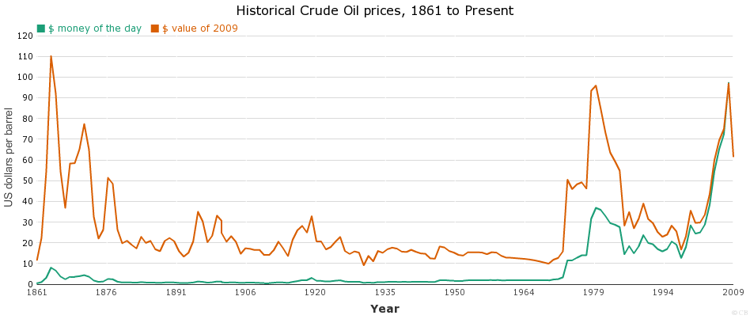
Chartsbin.com/Historicalcrudeoilprice

When 1939 has arrived, II world war has begun. Hitler declares war western border countries such as England, France and so forth. In 1941, they declare war against USSR which is started “Great Homeland War” till 1945. However, the price of oil did not affect.It changed between 10-19 dollar worldwide. Price of Oil was constant till 1973.OPEC countries agreed to make embargo against Us in 1973 which could result in oil shortage in both sides and other countries. It rockets up oil price next years and this event was a start point to increase oil price. Even after embargo against the US could not decrease price because the market was stable and oil buyers were not powerful enough to reduce price in previous levels. In 1973, the average oil price was 3,29 dollar and after the embargo, it goes up to 11,58 dollar where oil suppliers were satisfied with this boost. Yet this price growth was continuous till 1980. In this time oil price intensified to 36,83 dollar. It was a peak point of the oil price for 100 years. after these pumped prices, they saw that oil consumers were not satisfied and they could not be bought further oil for their growing population. After 1980, the price of oil diminished quickly till 1986 when the oil price was nearly the same as 1974 prices, to the 14.43. After 4 years price did not fluctuate economy and market itself and it was stable till 1990.
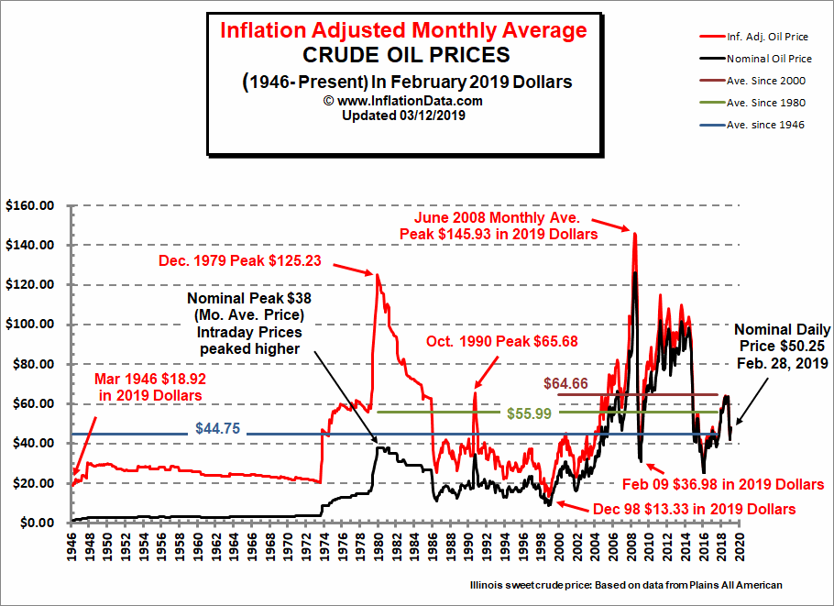
Inflationdata.com/historicaloilpricechart

2.2--Oil Production in these period
Of course, when price grew entrepreneurs eager to export tons of oil to the foreign market to sell. In 1880, there had 195 oil entrepreneurs in Baku and 4 of them were big businesses. 2 of them belong to millioner Mirzayev’s,1 of them belong to Azerbaijan oil company and 1 of them belongs to Sarkisov. However, this number falls into 136 and only 100 of them is working the reason for big businesses. High and middle category businesses reduced their oil price to eliminate competition and in the early stage of marketing suggest that lower price with high quantity always eliminate competition especially in oil and other natural resource markets. This process, unfortunately, affected the whole production level and the number of factories. Their numbers dwindled over time. In 1885, only 12 big factories were produced 80 million kilogram kerosene, 15 middle-sized factories produced between 16-80 million kerosene and other 109 little factories produced less than 16 million kerosene. those 109 factories owners were Iranians and they used little and rusty equipment to production what affects the overall cost of their businesses. There were 6 biggest factory and their owners at this time:
OWNERS OF FACTORIES | THEIR KEROSENEE PRODUCTION(number of sistern which holds 10 ton of kerosene)
Nobel Brothers,Caspian company | 22.200
Batumi Oil company | 5.160
Palashkovski and its company | 4.680
Taghiyev and Sarkisov (partnership) | 3.300
Baku Oil Company | 2.500
Shibayev and its company | 1.700
The book of ”Azərbaycan nefti Dünya siyasətində”;Azerbaijan publishing

This number shows us how the Nobel brothers improved its Oil empire in Azerbaijan. When they first start his business in Baku they owned 10 of sistern in 6.700, nevertheless, those number rose to 17.100 out of 43.000 in 1885.
Exportation and even selling process encountered the worst scenario. In 1881, Russian patriot Ragozin proposed Russian Minister of Finance Aleksandr Abaza a new tax bills on the oil industry in Baku which reduces exportation oil and increase government budget and shifts oil industry to Russian territories. Aleksandr Abaza created a commission under Nikolay Bunge who would be a next minister of finance after a year. They invited 7 or 8 famous owner in Baku with their department managers, Minister of Finance high ranked officers and professors Mendeleyev and Lisenko.Russian patriot Ragozin mentioned in his proposal that the government should put a 1 Russian ruble tax in every 16 kilograms exported crude oil. Mendeleyev suggests that 30 Russian penny would be sufficient, but, both suggestions were rejected by entrepreneurs. This discussion delayed more than a month and after the assassination of II Alexander and without the support of Ragozin, this bill denied and forgotten.
There was 4 main area in Absheron where oil industry pumped up. Thus areas are Balakhani, Sabunchu, Ramana, Bibiheybet. There is statistical information about those oil areas:
1890 | Balakhani | Sabunchu | Ramana | Bibiheybet | Total
Oil production(barrel) | 6413944,3 | 14517022,7 | 156577,2 | 1825529.1 | 22913073.3
The number of oil produced mines | 145 | 190 | 3 | 26 | 264
The number dug mines | - | - | - | - | 231
Average meter of dug wells | - | - | - | - | 103670
The number of oil producer’s company | - | - | - | - | 61
Kerosene Production(kilogram) | - | - | - | - | 117876800
The number of Dried well | 19 | 58 | 4 | 4 | 85
The book of ”Azərbaycan nefti Dünya siyasətində”;Azerbaijan publishing
In the late 1880s, Ramana was used to produce oil by Oil companies. This place was youngest among all territories and it was risky due to unknown place for foreign investors. They used some expertise to invest these areas and they knew there had a huge deposit of oil.between 1885-1890, they have begun to oil production in these areas. In Ramana, there was a mine where they produced 6926582,2 barrel oil and this mine alone passed Bibiheybet and Sabunchu oil mines together sum’s.In 1894, Moscow-Caucasia oil company bought Ramana lake then restored and upgraded mines with special gears. The same year, this company produced 2025316,4 barrel oil in this lake.
Bibiheybet was special among all companies whom they wanted to minimize their cost by using less equipment. Bibiheybet was special because it was an area where had more oil deposits across all others. Moreover, all of founded and remnants of oil deposits in Bibiheybet were mined less than 1050 foot in 1896. There were 9 mines where they produced 6833316,4 barrel oil, while it was 1/3 of 228 mines and thus mines where more than 1050 foot deep.
After 1904, oil reserves start to extinguish. Azerbaijan still had many oils, but, it was in deep and it required modern, costly technologies where they could survive their oil business. Furthermore, there was a protest against oil companies from local workers. They demand novel workplace where they could do their job without any hazardous activities. Companies didn’t give them any proper items to do their job. They always seek to minimize the cost to improve their revenue. Soon they realized that even the days without work in mines could cause a crisis for the companies. Their demand was completed by oil investors to end protest against them.
From 1904-1918 it was a decline period for oil Industry in Azerbaijan. Many oil companies were shut down due to hard competition in the domestic market and only big businesses were alive who are ruling market price and maximize their profit. Meantime, many potential foreign buyers shift their oil demand to other countries because they could not afford high price oils anymore.
Azerbaijan gained independence in 1918 when they use their political power freely. In these years, oil production declined as well. Many investors shut down their businesses in Azerbaijan and moved to other continents to find a suitable oil industry. Investors abandon their place and Azerbaijan authorities had not enough budget to restore the glorious Azerbaijan oil industry. Yet, there still had oil production. However, those process only fed society and supplied militaristic activities where it was not beneficial for the government.
Meantime. Bolshevik forces from Russia seek to find a novel place where they could saturate their oil demand and in their ideology based on communism where they should create a novel society for people but not trading foreign countries such as England, France and so forth. They should find an appropriate place as soon as possible and they realized that there was a city that their oil production exceeds Russia itself. Baku was the answer for USSR. USSR was eager to use Baku oils to create and maintain petrol for their machines and weapons. They also created many Oil factories to devise distinct oil products for citizens.USSR government ordered that they should export harvested raw oil to Russian cities. Baku sent billions of barrels of oil through railway, road and from the sea. They sent oil tankers to Astrakhan where there Russians and local people sent these tankers to the different Russian cities like Moscow, Novgorod, Nizhniy-Novgorod, Kazan and so forth.
When USSR forces conquered lands of Azerbaijan, they started to turn every private business to the public one. They considered the oil industry especially and started with oil businesses. Because in 1921, oil pulled out 2,4 million crude oil which it was it was the lowest level in Azerbaijan economic history. Many of oil millionaires were broken due to these actions.
When these process over, they focused on to improve the oil industry. They dug a new oil mine in Sabunchu in 1922. The same year, Russians created an artificial Island in Bibiheybet buckthorn and in1923, 6 of these well’s in Bibiheybet spit oil and thanks to them, Oil production between 1927-1928 in Azerbaijan passed 1913 oil production rate. Azerbaijan Oil industry had shone year by year. In 1920, oil production was 2,9 million ton. After 8 years,oil production of Azerbaijan expands to 11,6 million ton. In 1940, the Azerbaijan oil industry produced 24,5 million ton of crude oil, in other words,71% crude oil in USSR. At the end of 1941, Azerbaijan twofold its oil production and produced 23,541 million ton oil in USSR.
Azerbaijan had produced 22,4 million ton oil in 1931 and it made USSR second-biggest oil producer in the world. Later on, Russians had found Immense oil reserves in Kur-Araz plains, Neftçala district, Khirovdag, and Mishovdag near in Ganja. In 1937, USSR produced 28,396 thousand ton oil where its 25,706 thousand ton oil produced in Caucasia. It’s 90,5% of overall oil production. Azerbaijan had produced 22,2 million crude oil which holds 71,5% of crude oil extraction in the USSR.
The table below shows us World Crude average oil production per day between 1910-1970: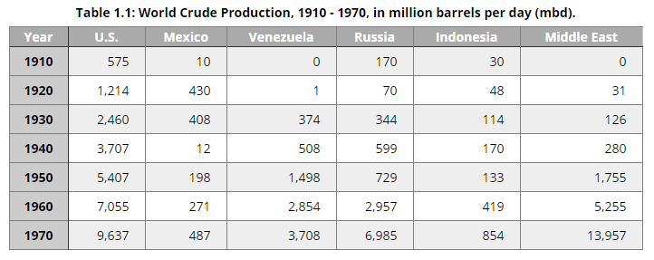Pennstate Energy Department:https://www.e-education.psu.edu/eme801/node/457

Although World War II times(1939-1945), Oil production in Azerbaijan and Caucasia were stable. The oil industry in Azerbaijan attracted Adolf Hitler so much. He believed that capturing Baku would be a significant impact for conquering USSR. At the end of 1945, crude oil production fell to the 11,5 million ton due to the destruction of some oil wells and inactivity in the oil wells. They quickly recovered its nominal oil extraction level within 2 years and after 1947, Azerbaijan oil production grew again more than previous years. In 1949, Azerbaijani people made another historic movement in the oil industry. Azerbaijani people and many expertise found oil reserves.there they created World’s first oil platform in Baku, included pirallahi settlement. It was an artificial city-based district. It was surrounded by black rocks. They named‘’ Oil Rocks’’.The same year, Azerbaijan industrialists found tons of oil there. Between 1950-1960, There were 18 enormous oil mines for Government. Between 1964-1968, stage of oil extraction was rose to the constant level and it was about 21 million tons per year in these periods.From 1969 to 1985, oil extraction started to diminished and overall extraction was 13 million tons per year. There were numerous reasons for that. Essentially, Azerbaijan oil wells dried up and there were no other oil wells on-shore areas in the Caspian Sea. Secondly, there were many oil mines in Central Asia and Sibir where more profitable and low costs. From these reasons, Azerbaijan total crude oil production descended every decade. In 1950’s Azerbaijan oil extraction took 39,1% of the overall share in USSR, in 1960s this number reduced 12% and between 1970-1980 this number corresponded 5,7% to 2,4%. Azerbaijan produced its 1 billionth ton oil in 1971.
There are many statistics and financial reports in oil sectors in USSR gathered by CIA:
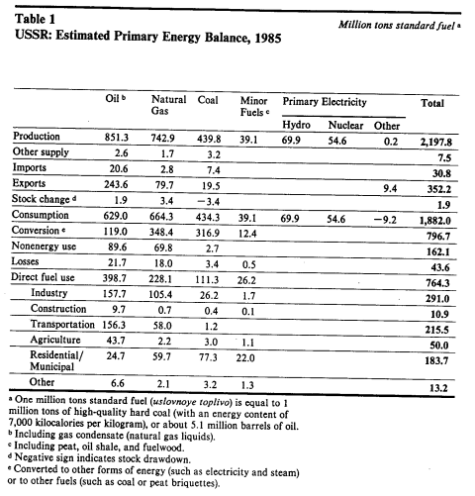
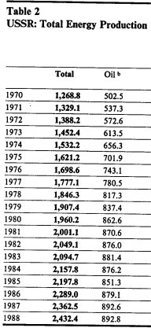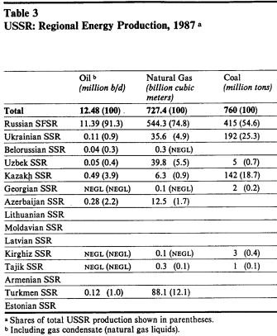

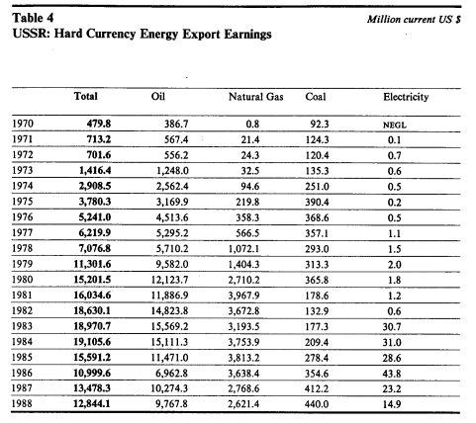
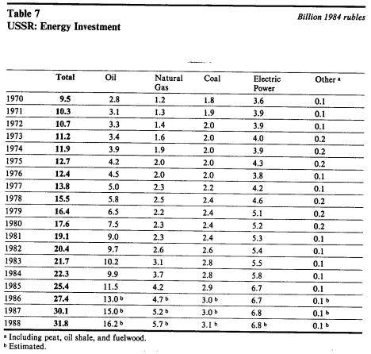
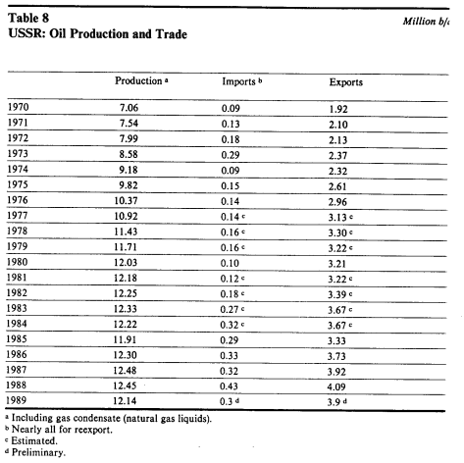
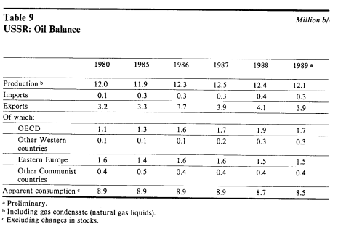
CIA Historical Review Program: ”Soviet Energy Data Resource Notebook”

2.3--Exportation of oils in these periods.
Azerbaijan was one of the crucial territories after 1870. New technologies, modernized machines, weapons demanded oil, kerosene and some oil-based products clean, work itself efficiently. From this point, Russia had eyes on Azerbaijan where he could use crude oil in its industry and especially export tons of oil to neighbor countries where he could defend them in both political and economical.
Between 1877-1882, they exportation of both crude oil and oil-based products 0,96 million kilograms to 4,9 billion kilograms.However, it was merely a tiny number if this numbers would compared from 1883 to1890. In this timespan, the number of crude oil and oil-based goods 3,74 billion kilograms to 2,81 trillion kilograms which this enormous number of exportation passed US oil exportation.
In 1883, they made the first exportation in kerosene where they delivered tons of kerosene to other Russian neighbors and as a result, they squeeze out American kerosene in those markets. They knew the quality of Azerbaijan oil and they wanted to make a huge fortune in oil sectors. Azerbaijan oil attracted huge capital from developed and first world countries where they invested more than a million dollar on oil sectors to make a profit. Russians also obtained profit as well due to taxes on oil sectors and customs.
In 1886, there are used to have 29 oil tanker which they transport Azerbaijan crude oil to Russian cities via using the Caspian sea.11 of these ships belong to Nobel brothers. It means they were one of the crucial persons in Russian. Those ships carried 15760 ton of crude oil. They could do these missions between 28-30 time within 7 months.In 1880, they exported 240000-ton crude oil in the Caspian corridor. However, This number climbs to 3017600-ton crude oil and it is more than 11 times in 1880 result.
The table below shows us exportation with tons via using railway and sea transportation between 1889-1904:
Year | Total export | Sea exportation | Railway exportation | Percentage of with sea % | Percentage of With railway %
1889 | 2521600 | 1763200 | 758400 | 70 | 30
1890 | 2830400 | 1897600 | 932800 | 67,6 | 32,4
1891 | 3110400 | 2121600 | 988800 | 68,3 | 31,7
1892 | 3406400 | 2321600 | 1084800 | 68,2 | 31,8
1893 | 3969600 | 2795200 | 1174400 | 70,4 | 29,6
1894 | 4614400 | 3561600 | 1052800 | 77,2 | 22,8
1895 | 4548800 | 3457600 | 1091200 | 76 | 24
1896 | 4908800 | 3916800 | 992000 | 79,7 | 20,3
1897 | 5537600 | 4268800 | 1268800 | 77,1 | 22,9
1898 | 6288000 | 4948800 | 1339200 | 78,8 | 21,2
1899 | 6164800 | 4827200 | 1337600 | 78,3 | 21,7
1900 | 7089600 | 5646400 | 1443200 | 79,6 | 20,4
1901 | 7809600 | 6140800 | 1668800 | 78,6 | 21,4
1902 | 8214400 | 6550400 | 1664000 | 79,7 | 20,3
1903 | 7904000 | 6180800 | 1723200 | 78,2 | 21,8
1904 | 7868800 | 6076800 | 1792000 | 77,2 | 22,8
The book of ”Azərbaycan nefti Dünya siyasətində”;Azerbaijan publishing

Periods | Tariffs with Azerbaijan coin(per 16kg)
From 1894 December 1 to March 1 | 19 coin
From 1894 March 2 to July 1 | 14 coin
From July 2 to 1895 May 15 | 9 coin
From 1895 May 16 to July 1 | 14 coin
From 1895 July 2 1897 December 3 | 19 coin
From 1897 December 4 to 1900 January 15 | 12 coin
From 1900 January 16 to 1904 April 1 | 16 coin
From 1904 April 2 till the end of Russian empire | 19 coin
The book of ”Azərbaycan nefti Dünya siyasətində”;Azerbaijan publishing
Analyzing the upper table, shows that even the tariffs were not stable due to the fluctuation of oil exports and price of oils.after 1904, they decided to apply constant tariff (with maximum rate) to improve government budget. However, it had affected its price and as a result, Russian exportation diminished year by year.
In the age of Capitalism, Azerbaijan oil dynasty could divide into 3 periods:
First Period (1873-1898)
Azerbaijan discovered from European, American and Russian capitalist and under capitalist-production relation they invested more than 10 million dollars to create oil business in Azerbaijan. With these investments, Azerbaijan reached the American oil industry.
Second Period(1898-1901)
Azerbaijan oil industry and oil production passed American oil industry and became the first place in those areas in 3 years in a row where it event was beneficial both Russian government, Investors, nevertheless the suffering of the Azerbaijanian worker.
Third Period(1901-1920)
After 3 leading year of oil ranks, Investor from foreign countries and Russian authorities started to exploit the Azerbaijan oil industry. Furthermore, a businessman in Azerbaijan oil sector started to create cartel and destroy competitiveness in Domestic market. However, it could not be damaged lethally. Even in these periods,Azerbaijan led one of the major oil production in top ranks.
After 1910, America, Canada and Russia were superior oil exporter in the world. However, Russia was behind them due to excessive war against their neighbors,low governmental investment on oil and oil-related Industry lead to these ranking. Those numbers fell down because of many reasons.
1)War against other neighbors
Excessive wars against other countries bring only bloodshed,money investment for the military where you could not return the same money, overusing natural resources on military equipment and so forth. Russia was in a war nearly every year and they using oil on war.
2)Overpriced crude oil
Azerbaijan faced many overpriced crude oils between 1900-1910 where thus prices were not increased for inflation or some economic disasters. It was critically overpriced by oil cartels and the Russian government where they wanted to improve their profit while they damaged the economy in the future.
3)Continuous investment on American and Middle-east continents
In the early 1860s, Multinational Investors such as Rothschilds, Rockfellers,Nobels came here and invested more than a million dollar. In 1883, Rockfellers opened their Caspian-Black Sea Company in Batum where they could transport Azerbaijan oil in Georgia and there to Europe. Their first charter capital was 800000 Pound-Sterling. However, Oil reserves in here were big and it needed to more than a million dollar. Moreover, they should dig deeper when the oil well dried. In Marginal perspective, they could not achieve maximum profit when this process goes on. Nevertheless, They opened factories and fabrics, created a ship, make tube exportation in these times but none of them were not efficient because they are preferred to invest American and Middle-east continents where they could face no competition in those areas.
4)Technology
In Azerbaijan, Russians created the first tanker and other oil-related inventions. First of his type didn’t mean to not improve those machines. After 1900, A better version of oil drilling machines, ships, tubes and especially workforces and work equipment where they could drill oil without any threat and they could this job very efficiently.Thus factors led Russian plans on oil to the failure where they could be a world biggest oil exporter in these time spans.
After 1918, Azerbaijan gained independence from Russia. The early stage of Azerbaijan Democratic Republic was tough due to the new country for others, lack of practiced expertise and so forth.They wanted to improve relationship neighbors countries via using oil exportation. Azerbaijan oil was a tool for Azerbaijanian Authorities whom they could inform other countries to Azerbaijan exist. However,23 months were not enough to make a pact between countries and government was trying to keep order inside of countries and in 1920 April 28, Bolshevik army conquered Azerbaijan and made part of USSR regime.
On 1920, USSR started to reconstruct the oil industry in Azerbaijan. They knew with old and ruined equipment,dried well’s they could not pass their biggest enemy in the oil industry. Their system was based on to self-sustain their economy and society.That is why they did not need to export oil to Neighbours countries. Instead, we exported oils to other USSR subjects. Between 30 April-May 2 1920, Baku sent 20 tankers what carried 1,3 million poods crude oil to Russia. The same year on May, Baku sent 15 million poods crude oil in total and June it rose to 21,2 million poods crude oil and oil products. Subsequently, these numbers impressed the USSR government and Oil industry in Baku completely nationalized same year.After World War II, Azerbaijan sent 45% of crude oil to other USSR states to produce oil-based materials and ingredients.

CHAPTER 3-AZERBAIJAN OIL STRATEGY AND PROCESSES FROM 1991 TO 2017.
Azerbaijan took his independence after 18 October 1991. After USSR fall apart to 15 different countries, Azerbaijan was one of them. All resources and assets, including factories, oil deposits, wells and all lands which they used to govern decided by USSR.Lands of Azerbaijan in the USSR were divided between Georgian SSR, Armenian SSR, and Azerbaijan SSR itself. After Azerbaijan took independence, all assets, and resources owned by the government. Consequently, this action brought a new development strategy in Azerbaijan. Azerbaijan ought to rebuild every industry in the very beginning. The oil industry was one of them. After independence, Azerbaijan did not have any partners or alliances from foreign countries. foreign affairs were weak due to past Communism theories, actions, and strategies.
When Azerbaijan gain independence, first president was Ayaz Mutallibov and after 1 year later,famous 2nd president Abulfaz Elchibey was president of Azerbaijan. Both in their times, Azerbaijan couldn’t survive in its economic crisis because in both 1st and 2nd presidents period they did the same mistake.Azerbaijan were on war against Armenia. Those wars started in 1988 when Karabagh autonomous province voted that they wanted to union with Armenia. After the independence of both countries, Armenia declared war against us. War brought us expense, lost and especially the blood of Azerbaijan people. Azerbaijan sent both human forces and natural resources to the battlefield to protect homeland of Russia and Azerbaijan itself. Those 2 essential resources were urgent for economy of Azerbaijan to recover it but Azerbaijan should sent those resources to protect homeland. Those tries were not worthy enough and Azerbaijan start to a lost part of Karabagh every year and in 1994, Azerbaijan and Armenia agreed on a ceasefire which essentially,Karabakh stood part of Armenian land.
Azerbaijan was not sufficient alliances and partners in the international world. Repuclic of Azerbaijan need to find alliances to make a business with them. Oil was main tool to attract customers in the international market and oil could improve export and budget. Without export and trade, the wealth of the nation would face inevitable damage in their economy and it would affect society. Azerbaijan was suffered due to lack of foreign diplomacy and trades till 1993. After 1993, there was a replacement in officials ranks and after that, both process and progress had started. Azerbaijan now focused only on one purpose with the help of Heydar Aliyev. Heydar Aliyev and high-rank officials knew that the Azerbaijan economy must be restored in a few time. If the economy were not recovered, Azerbaijan all future plan on its path would be destroyed by the enemies. So, Azerbaijan 3rd president Heydar Aliyev made vital decisions for the country. Essentially, He made a ceasefire against Armenia to take a break of this war and end the bloodshed. He knew that investing in the war brought only pain and loss. Consequently, he deals with famous multinational oil companies and made a contract which called the ‘’Contract of the Century’’.11 multinational companies signed this contract. After 4-5 year, Azerbaijan oil production pumped up and trade balance improved twofold year by year till 2015.

3.1--Price of oil and entrepreneurship in this period
In 1991, When USSR had demolished, Azerbaijan gained independence. However, when Azerbaijan got independence, Azerbaijan had various problems. Firstly, the war had started then unrests from inside of the country and lastly but not least, no diplomatic relations from other countries. Thus problems led Azerbaijan economy into a crisis for more than 5 years. Azerbaijan oil industry was stagnated between 1980-1990 due to stagnation in whole USSR countries. Eventually, that stagnation had chained-effect to other sector and the oil industry itself. by the beginning of 1991, Azerbaijan oil production was low and the country had a tiny amount of crude oil to sell.
Azerbaijan had created ‘’Azerlight’’ oil brand but crude oil price based on ‘’Brent’’ crude oil price which this oil whole ingredients and quality is same as Azerbaijan oil and agreement for different companies. It means, when Brent crude oil price grows, Azerbaijan crude oil price is also growing.
After 1990, Azerbaijan oil price shrank until 1994 due to excessive war and local unrests against the government. Lastly, In 1992, Azerbaijan intelligent persons decided to invite Heydar Aliyev which he will be president in 1993.Those Intelligent persons called ‘’the 91’s’’.those invitation was for only 1 thing which to make a ceasefire and end this war. They also want to improve the Azerbaijan economy into the new stage. They knew Azerbaijan could be ascended with using the proper strategy on oil.
Crude oil price was start fluctuate year by year. However, those fluctuations were little if it compared them for future events. Azerbaijan and whole world oil production start both rise and fall different years because of different consumption rate of every year, inflation rate and other economic struggles which decides the future of trades and imports. When the export of oil falls, the country try to reduce the price to recover it’s cost at least. Oil prices were also decided by oil cartels. Big oil organizations like OPEC could decide the price of oil so easily. They rely on immense supplies, exports, reserves of oil.
The table below, shows us Brent crude oil prices by year(Price per Barrel):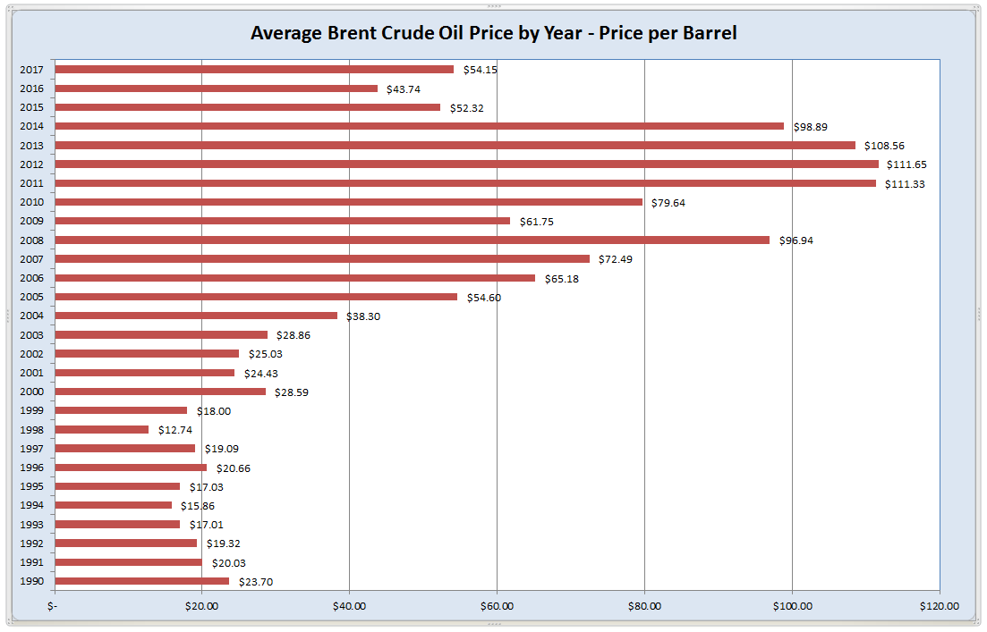
coachmanenergyoperating.com/crude-oil-price-by-year-chart
From 1990 to 2002, Oil price both rose and fell year by year. After 2002, Oil price rose consequently. Price grew year by year till 2009.in these periods, the price was not rose, the price was gouging. In 2003, America invaded Iraq, one of the biggest oil exporters in these times. Thus invasion shifted oil prices at a global level. Supply dropped and demand for crude oil was stable. It was an opportunity for whole oil exporter countries and especially for Azerbaijan. From 2001 to 2009, Azerbaijan oil and gas sector were expressed rapid growth and it was famous information among all oil organizations.GDP growth from 2003 to 2009 averaged 27% due to the increasing rate of oil price and high Foreign Direct Investment from Foreign countries. Price of oil starts to rose consequently to 96,94$. This was the highest price in the world but after the 2008 financial crisis resulted. In 2008, Financial crisis happened in America. Starting in the Subprime mortgage market, it soon affected other markets as well as oil Market. It affected oil prices for one year.Price of oil was decline.OPEC and America want to stabilize oil businesses as soon as possible. Subsequently, they decreased oil exportation to stabilize prices. Meantime, In Azerbaijan, reducing oil prices didn’t affect economy so bad. Azerbaijan were not part of OPEC and its policy doesn’t concern us, when they reduced export. This country could improve oil output year-by-year. Azerbaijan oil revenue boosted after 2004. The government knew Azerbaijan would gain much profit from the oil sector and saving factor was vital for future generations and projects. Government foresaw these possibilities and that is why they created SOFAZ in 1999. Every year profits from the Azerbaijan side transferred there(pure profit after governmental expenses). When 2008 has arrived, diminished oil price also affected Azerbaijan. Azerbaijan national currency could drop abruptly. However, Azerbaijan made transfers from Oil funds which sustained the Azerbaijan economy in 2009.
After 2009 profits from oil industries transferred to SOFAZ and to the budget subsequently. That is why,analyzing the last Line graph above shows many citizens that Azerbaijan governmental budget starts to rose more than expected. However, this growth was not natural. After 2009, oil profits from SOFAZ transferred more than usual. This would a dangerous movement by the government. Because Azerbaijan made vital but also risky decisions to the future. They improved SOFAZ transfer to hasten the process of social projects and stimulate non-oil industry for the future. These decisions for long-run. They believed that after the 2008 financial crisis, oil prices would not drop quickly. It would take more than a decade to drop again and many trends recommended that oil prices after 2009 would rose again. This estimations became real and even passed expertise expectations. Oil prices in the whole world start to ascend till 2013. In 2013, Azerbaijan oil price was a 108,56 US dollar. Azerbaijan oil both oil extraction and exportation rose too which Azerbaijan gained benefit from there too. From these reasons, Azerbaijan relies on these trends and statistics they got. However, after 2014 the first devastating sign has shown itself. Oil price was dropped 10 US dollar within a year. Thus didn’t affect economy so much and Government specialists thought that it would not happen again, yet, it happens again and the oil price falls to the deep second time in XXI century. In 2015, Brent oil price suddenly drops to 52,32 US dollar which plummets nearly twice.In 2016,oil price had reduced again to the 43,74 US dollar which it was it’s lowest price past 10 years of the oil prices.Meantime, Azerbaijan faced recession period when he couldn’t afford it’s expenses due to increasing other products and services price while profit from oil industry starts to decrease as well. Azerbaijan National Currency also suffered from this process. Manat devaluated so quickly and even 1 US dollar could reach 2 manats in 2017. It was could be even worse if SOFAZ treasury has not existed.Azerbaijan recovered it’s lost by using an immense quantity of money from SOFAZ treasury.

The Graphs Below shows us Transfers of State Budget and SOFAZ spending which includes invests, expenditures and so forth: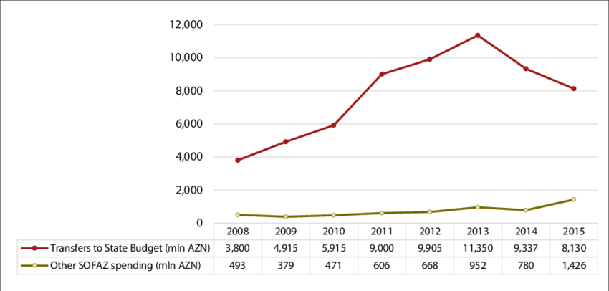
https://www.researchgate.net/figure/SOFAZ-Transfers-to-the-State-Budget-in-million-AZN_fig5_301553594 Uploaded by Farid Guliyev.
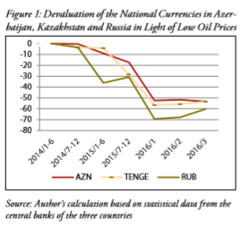

3.2--State Oil Fund of Azerbaijan and State Budget
State budget is one of the main tool for every country.From there,every country collect every state revenues and made decision annualy that where they should invest or which social program invent to satisfy people of their country.State budget decided in first month of every year.State Budget calculated by state comission of budget task in Parliament(In Azerbaijan version it’s Milli Majlis).After confirmation of state budget,it could use to enhance social programs or used to multiply revenue of state owned companies.
Azerbaijan budget mostly,proved from oil revenues from SOFAZ.In,Azerbaijan,only well-developed industry is oil industry where Ministry of Tax could collect tax from foreign companies.Local revenues transferred by SOCAR to the SOFAZ in order to make saving for future.State Budget,in spite of that,is a main problem for Azerbaijan economy.Azerbaijan economy created immense social programs and events which improved their expenses.In order to rectify this deficit,Every year Azerbaijan transferred between 5-10% of oil revenue in 2001-2008 to the state budget to make proficit.This is sufficient amount of transfer for Azerbaijan.Norway did same thing in past and saving from oil industry created a economy which their people nurture themselves.
When 2008 financial crisis occur,Azerbaijan struggle in worse state budget problem.Deficit in 2008 could have been higher than previous years.Consequently,Parliament ascended the amount of transfer to the state budget in order to recover huge portion of deficit.Thanks to the SOFAZ transfer Azerbaijan survived 2008 disaster without damage.However,government didn’t change plethore of transfer to the budget.Instead,Parliament gone to the risk which they increased transfer rate from SOFAZ then created distinct number of government projects and improved army capacity with modernized weapons.Consequently,Azerbaijan made a deal with other countries that Azerbaijan will be host country for many international games such as Europe games,Formula 1,Eurovision,World and European Championships from variable sports field and many other international activities which could cost Azerbaijan more than millions.Subsequently,Azerbaijan invested oil fields to improve their oil production as much as possible.From these expenses,Azerbaijan improved oil transfer from SOFAZ and this transfer between 40-55% which nearly half of oil revenue transferred to the state budget.These actions damaged their first plan which they wanted to be a country like Norway.these risks didn’t go well and after 2015 oil crisis,Azerbaijan suffered tremendous economic damage which reduced value of Manat,social welfare of people.After 2015,Azerbaijan were transferred more than 50% of oil profit from SOFAZ and it made state budget even worse.The Chart below shows us budget revenue,spending and deficit of Azerbaijan:
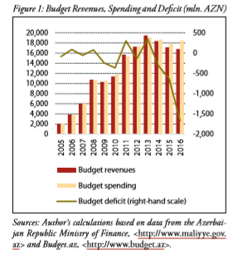
When Azerbaijan authorities attracted sufficient capital from Abroad, they created 2 organizations. On one hand, AIOC(Azerbaijan International Operating Company) who the first conglomerate In Azerbaijan.This state conglomerate created by the Azerbaijan government and 11 companies(6 countries) in 1995. Its main purpose is to divide oil revenues between companies and attract that capital to tax. On the other hand, it’s SOFAZ(State oil fund of Azerbaijan). After the great Oil contract called ‘’Contract of the century’’, In 1999, Heydar Aliyev signs a decree which it was an order to create State Oil Fund of Azerbaijan. State authorities created these fund to achieve these main economic goals:
1)SOFAZ was created to ensure the to manage and collect oil and gas sectors income efficiently and with using these fund to invest non-oil sectors to improve and prosper economic tranquility.
2)Support macroeconomic and microeconomic stability in order to improve social welfare.
3)Funding national projects to improve socio-economic development
4)Using oil wealth to prevent the oil-dependent economy in Azerbaijan.
5)Provide necessary social transactions in recessions times.
6)SOFAZ should check and manage Azerbaijan Republic’s crude oil and gas selling process
SOFAZ only report to the president it is next projects, processes, and progresses.

Structure of oil profit dividing process.Authors Aitor Ciarreta and Shahriyar Nasirov/Analysis of Azerbaijan Oil and Gas Sector.
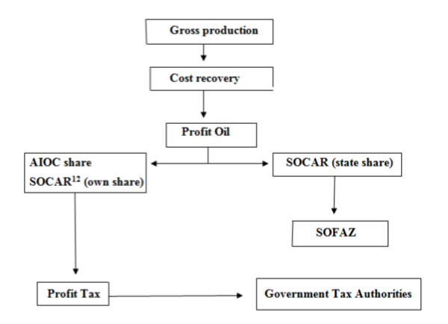
SOFAZ needs some money source to manage and achieve those goals and the President gives it some amount, money to do it. Those sources are:
1)Azerbaijan oil and gas profit(after subtraction cost of government regulations and projects)
2)Acreage fees(start from 2001)
3)Bonus payments from the government
4)Rent from foreign companies using real-estate in Azerbaijan under contract terms and agreements.
5)Revenues from cooperating with multinational companies.
6)Grant and volunteer payments from People and owners.
Those monies collected from Authorized State Authority and SOFAZ itself. After collecting its monies SOFAZ could deposit in Azerbaijan bank who has the highest guarantee and influence. Subsequently, it could deposit those monies in the foreign bank who has the highest rate decided by international rating agents such as Standard and Poor, Moody, Fitch and so forth.
SOFAZ started it is processed in 2001.From 2001-2004 contributed capital were respectfully 2,207,384 million AZN (478 million US Dollar),3,297,064 million AZN(2,637,651 million US Dollar),3,566,607 million AZN (2,853,285 million US Dollar),4,294,713 million AZN(3,435,770 million US Dollar).However, this number was below than their expectation and calculation during 2001-2004. Different Number affected During these periods. The interest rate failed in 2001, oil prices started to downfall between the end of the 2001 and 2004 finally downturn in the stock markets.
The table below shows us Both Azerbaijan State Budget Revenue, SOFAZ Revenue and SOFAZ transfer to State Budget between 2005-2016:
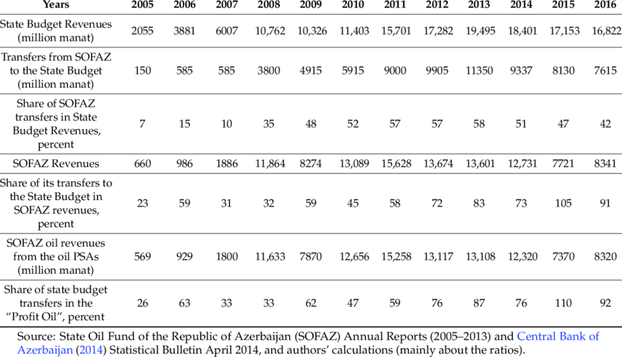
Analyzing the last chart above gives us information that Azerbaijan state started to dependant on oil profits year by year. Everyone thinks that the growing rate of the budget would boost economy and improve social welfare of Azerbaijan, yet it was obvious that State budget of Azerbaijan was balloon exaggerated by oil profits. Oil profits provided an average of 70% of state budget 2005-2015. Till it’s a creation from 2018 July 1, SOFAZ transferred 82,2 billion US dollar.
In my point of view, the government should create production facilities related to oil industries.2 centuries ago, after 1860’s Azerbaijan had immense kerosene production in this time. Furthermore, from oil products,Azerbaijan entrepreneurs could produce wax materials, propane, and other oil-related products. Azerbaijan have fuel oils, diesel production as well. However, today Azerbaijan don’t have any kerosene and other oil-related production now. Moreover,SOCAR enter Romanian, Ukranian, Georgian, Russian markets in early of XX century and SOCAR made billions of revenue from assets and sales process thanks increasing oil price year-by-year.In Figure 2, oil price of oil and assets of SOFAZ in line graph:
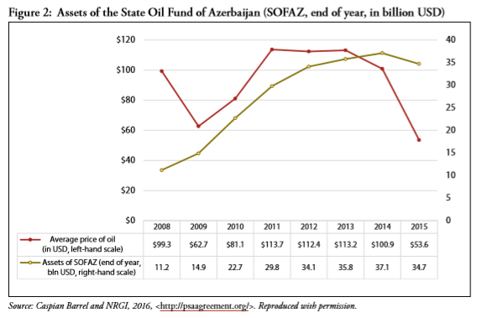
Price of oil is complicated.it has faced its a downturn in 2009 where the financial crisis occurs in Worldwide. After this event, oil price ascended to 110$ and 3 years it
Assets of Oil funds, on the other hand, between 2008-2015 has stable trend.it was effortless prognosis due to the increasing trend of oil price and saving factor from there. There are also some tangible assets like buildings, properties owned by SOFAZ increase it’s value every year.
The Bar chart below shows us investment portfolio of SOFAZ from 2001 to 2017. They made decent movement in investment. They invested oil profits to private equity funds, real estate funds, and other foreign banks and mechanisms. It has an increasing trend each year which is positive news for Azerbaijan. Yet, it didn't replace its main source. Every year, More than 75% of its revenue came from oil profit where SOCAR transfer them. More detail version below shows us the investment and its progress from 2001 to 2017:
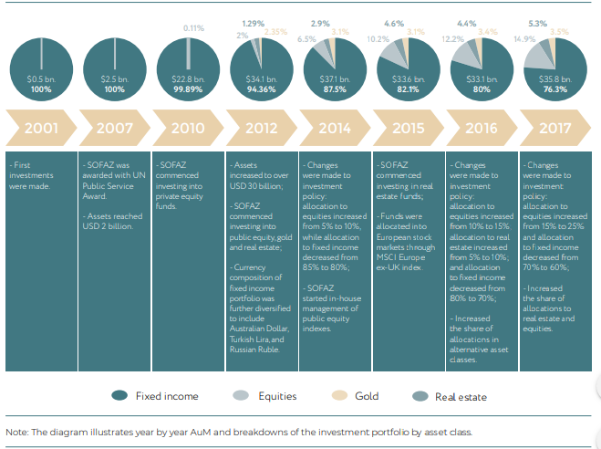
OilFund.az/ReportArchives annual report of 2017

3.3--Oil production in these period.
In 1995 SOCAR extracted 9,161 million ton oil. It was a disaster for Azerbaijan economy because Republic have the potential to extract more than these number, yet it didn’t happen due to low investment and research on the oil industry. That is why government authorities made a revolutionary movement. In 1994, Azerbaijan created a pact called ‘’the Contract of the Century’’.The contract involves SOCAR and foreign 11 multinational oil companies. Azerbaijan and these 11 company will produce and extract oil in Azeri-Chirag-Gunashli. It was not only 1 contract to improve oil production. Government made 7 contracts too in the early stage of Azerbaijan history. Average investment in Azerbaijan between 1991-2004 was 6,7 billion US dollar. There is a list below shows us their investment and their operator during these times. It also shows an estimation of reserves in these periods and government share too: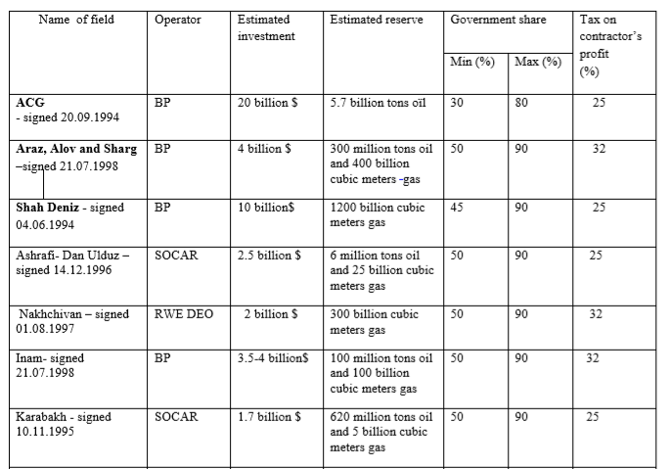
SOURCE: SOCAR(Sabit Bagirov,2007)

Those gigantic reserves were support in early stage which Azerbaijan government suffered mostly from export.Oil production, thanks to these contracts, pumped up every year. There is a certain factor to improve oil production in these periods:
1)Attracting foreign investment from abroad
Deal with famous oil companies such as British Petroleum, Lukoil brought more than 40 billion dollars overall. Thus capital was enough to create oil mines from Caspian shores.
2)Professional workers from abroad
Of course, when these companies do not bring only money capital there. They also invited their specialist in these areas.Their all cost including living cost provided by their company. Their main purpose to live there is explore Caspian sea and Azerbaijan other spots to find oil reserves where they could produce crude oil.
3)Modern Technology
After 1991, Azerbaijan gained independence and take control on their resources to manage it. However, there was a problem.USSR technology was not modernized through decades and they didn’t make any upgrade or recovery on oil platforms. Thus, made difficult to produce crude oil inland and especially in the sea.1994 agreement bring not only capital, as well as modern European technology to Azerbaijan where they could use the oil sector to improve crude oil production.
4)Reasonable Tax and custom rate from oil production and revenue
Government always try to encourage every people to open their small business in their area for taxes. Tax from oil production and custom for oil export is valuable for country. Audit Company Deloitte calculated that Azerbaijan produced 36,7 million ton of oil per year(from 1990 to 2017). Azerbaijan State Tax Ministry could collect Profit tax, VAT(Value Added Tax), Employee tax, Withholding tax with proper rate.
5)No oil restrictions and limitations
Unlike OPEC and other oil countries, Azerbaijan don’t have any oil production restrictions in these periods.Thus encourage Oil companies to maximize their production in Azerbaijan.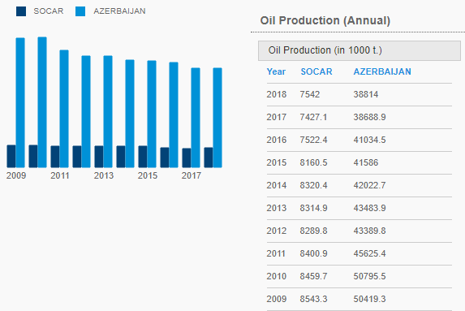
SOCAR.az/Economics & Statistics:Oil production
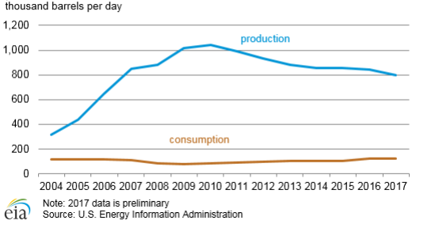
Azerbaijan oil production in early stage(1991-1997) Azerbaijan oil production only sufficient enough to satisfy domestic consumption and some exportation of petroleum products. After 1997, Oil production, thanks to starting new oil mines to produce oil. Overproduction was the best and worst part of nation.
1)Best Part
Production of oil grew every year. However, SOCAR petroleum production was not sufficient enough to produce petroleum production. Meantime, Azerbaijan starts to export instead of produce petroleum products. It was a successful plan for the short-run. Thus, would give us adequate capital to grew Azerbaijan oil industry widely. SOCAR was export crude oil to Europe, thanks to the various pipeline to different places in these periods.Azerbaijan government was not part of OPEC and their oil production, price policy doesn’t consider Azerbaijan policy. Consequently, Azerbaijan output grew more than tradeline and when Azerbaijan improve production, government export ingnearly all of them go abroad to ascend state budget.
2)Worst Part
When analyzing deeply this trend shows that Azerbaijan made the wrong decision in these years, Government could make the different strategy to enhanced economy.Europe and Eastern Asia improved their industries and services to grows their GDP, Budget, Wage per family and other vital features to improve their economy. Azerbaijan should create their plan in their long-run, not in the short-run.Calculating overall expense and revenue from both perspectives reveal that long-run revenue and expense are undeniably superior. Expertises from Azerbaijan government could improve production of petroleum goods as much as possible in 10 years. It would economy more independent rather than relying on the increasing trend of oil prices.
Azeri-Chirag-Gunashli field is one of the main sources of oil production. It was the main reason to sign ‘’Contract of the Century’’ and it was a first Joint Venture contract in Azerbaijan. When this contract signed it contained 11 companies from 7 countries. These companies are AMOCO(United States),BP(Great Britain),McDermott(United States),UNOCAL(United States),SOCAR(Azerbaijan),Lukoil(Russia),Statoil(Norway),TPAO(Turkey),Pennzoil(United States),Ramco(Great Britain) and Delta(Saudi Arabia). They together established the Steering Committee, Azerbaijan International Operating Company(AIOC) first Conglomerate in Azerbaijan and Advisory Council. Initially, in this territory their first elementary evaluation in Azeri-Chirag and deepwater of part of Gunashli had 511 million tons of crude oil, further evaluations discover found out that there was 1,072 billion tons of crude oil. Years later even developed evaluations were wrong. Till 2017,33 billion Dollar were invested and 3,2 billion of barrel crude oil were produced. In 2017, 70% of total crude oil output came from Azeri-Chirag-Gunashli territory where this place is could extend till 2049. On September 14, 2017, New agreement was signed. In this agreement, BP remained the operator of the project and this contract extended to 2050. In this date, there was different partner due to the sudden drop in oil prices in 2015. In this contract, there were 9 companies from 8 countries.These companies are BP(Great Britain),SOCAR(Azerbaijan),Chevron(US),Impex(Japan),Statoil(Norway),ExxonMobil(US),TP(Turkey),Itochu(Japan) and ONGC Videsh(India).Azerbaijan increased their share from 11% to 25% and Azerbaijan direct profitable oil share increased to 75%.
There is a Vertical bar charts below shows us Azeri-Chirag-Gunashli production and their revenue projection per year: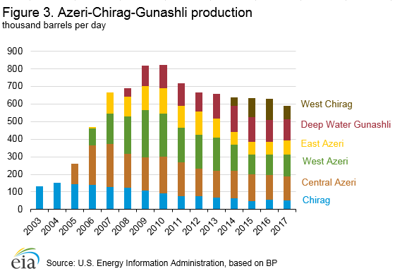
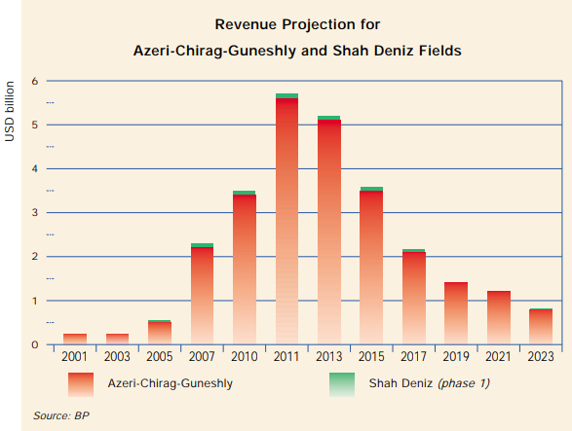
Calculations in 1999 shows that revenue from Azeri-Chirag-Gunashli revenue started to reduce after 2011.Main reason of this trend was oil deposits in Azeri-Chirag-Gunashli were not enough for long-run.Azerbaijan and main operator BP oil extraction each year were much for Azeri-Chirag-Gunashli and after 10 years,ACG deposits start to extinguish.However,Further evaluations and research showed that,ACG potential oil reservers could long-lasted to 2049.
Azerbaijan oil production have advanced growth rate if compare other Turkic countries.The Chart below also shows us piece of time which to compare growth rate in oil industry from another countries.
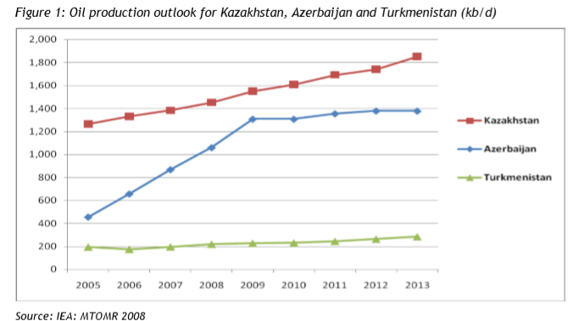

3.4--Oil output in these periods.
Azerbaijan oil output changed after the 1994 event. It was a very foundation of tough oil economy and strategy. Authorities made different contracts from neighbor countries to export state oil to both Western and Eastern Europe.
‘’The Contract of the Century’’ was a first international contract in Azerbaijan history. Authorities from higher ranks made many contracts last 5 years of XX century. Azerbaijan government showed investors that Azerbaijan had overflowed oil reserves for at least 30 years which investors could make benefits both short-run and as well as long-run. In 1994, First oil Contract ‘’Contract of the Century’’.This contract approves that foreign investors could mining process in Azeri-Chirag-Gunashli. Further estimations identified that there has more than 1 trillion ton crude oil which could make a vast fortune for both host country and investors itself. First oil contract lasted till 2017. On 2017, Azerbaijan and chief company CEO’s extended this contract till 2050 due to Azer-Chirag-Gunashli reserves would be exhaust in 2049 if engineers and miners operate and my same rate of crude oil from beneath of the ACG. The volume of investment were 7,4 billion US dollar and operational costs were 5,9 billion US dollar. Oil drilling process would cover 432,4 square kilometers. Oil production stipulated 510 million ton crude oil, yet after 2010 630 million ton crude oil estimated.
On 2017,33 billion US dollar were invested for operation and the same year they extracted 3,2 billion barrel crude oil produced in ACG.State Customs Committee reported that on 2018, Azerbaijan had exported 29,498,337 ton crude oil which worth like 15,719,482,370 US dollar.
Line Area Chart below shows us Azerbaijan consumption, export, and production in Azerbaijan: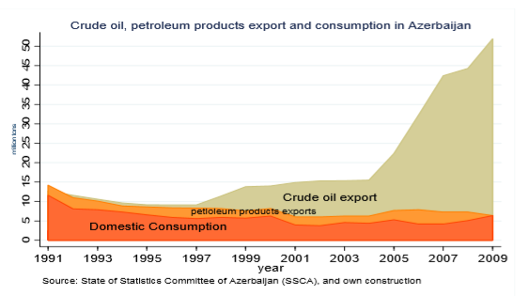

3.4.1--Pipelines in Azerbaijan.
1)Baku-Tbilisi Ceyhan
Azerbaijan government decided to make another astonishing project before Contract of the Century.It called the Baku-Tbilisi-Ceyhan oil pipeline.The initial stage, Azerbaijan could transport it’s oil Georgia and from there to Turkey.The first document signed between Azerbaijan and Turkey on 9 March 1993 in Ankara.Document enhanced and they made Ankara Declaration on 29 October 1998.This declaration showed who is the real supporter of this project.This declaration signed by presidents of Azerbaijan, Turkey, Kazakhstan, Uzbekistan, and Georgia.Subsequently, this declaration witness is United States Secretary of Energy, Bill Richardson who have strong support on this declaration.After this declaration agreement has made.In Istanbul, pipeline project was signed by Turkey, Georgia, and Azerbaijan on 18 November 1999.In 2002 1 August, Baku-Tbilisi-Ceyhan Pipeline Company was established in London.Construction of these Pipeline route starts in April 2003 and at last finished in 2005.This pipeline length is 1,768 km long and it starts from Sangachal Terminal in Karadagh Province.This pipeline passes Georgia and finishes it in Ceyhan Marine Terminal in another name Haydar Aliyev Terminal.this Pipeline has 8-meter width and buried at least 1 meter deep to the ground.This pipeline lifespan projected 40 years.From 2006 to 2009, the pipeline could transport oil at the normal level of 1 million barrel oil per day.After 2009, there was some modification on pipes and now it could transport 1,2 million barrel oil per day.On 11 August 2014, Baku-Tbilisi-Ceyhan pipeline exported it’s 2 billionth barrel crude oil.Between 2006-2018, Azerbaijan exported around 417 million ton crude oil and thus oil carried on the International market.Cost of this pipeline was 3,9 billion US dollar.During construction of this pipeline, it created 10 000 short-run jobs and 1 000 workers to operate it is daily work properly without force majeure.it’s 70% of cost provided by international organizations such as the World Bank, International Finance Corporation and so forth.In this pipeline, Azerbaijan mostly supplied from Azeri-Chirag oils to export to turkey and it could also export Central Asian countries oil brands to the west.In 2015, both Kazakh and Turkman oil were transported 5,2 million ton crude oil via using Baku-Tbilisi-Ceyhan pipeline.
2)Baku–Novorossiysk pipeline
Baku–Novorossiysk pipeline was Northern route for export for Azerbaijan.That is why it also is known as ‘’Northern Route Export pipeline’’ or ‘’Northern early oil pipeline’’.The main reason for this pipeline to deliver Azerbaijan oil to Eastern and Northern Europe with low-cost strategy.If Azerbaijan use Anatolia to connect Northern line, cost would have been higher than the real expenses of Azerbaijan.For this reason, government should make another pipeline from Baku to Russia.It also starts in Sangachal Terminal and Ends up Novorossiysk where located coast of the Black Sea. This pipeline main purpose is to deliver Azerbaijani oil to Northern regions like the Urals.This pipeline length is 1330 km.Under the agreement, In Azerbaijan side, SOCAR will operate Azerbaijan section and In Russian side, Transneft will operate Russian section.In 1996, Contract of Baku-Novorossiysk pipeline has signed and it started its oil transportation on 25 October 1997.Maximum oil export capacity is 105 thousand barrel crude oil per day.On 6 December 2006, Azerbaijan announced that government should not export crude oil to Russia and they will stop to export oil from 2007,1 January.The main reason for this action is conflict on gas delivering system and it’s price, despite the fact that Azerbaijan oil export still remained in small quantities.On 2008, Azerbaijan had stopped completely oil exportation.The reason for that disagreement over the price.Transneft wanted to import in old prices and he gets what he needs.Azerbaijan exported crude oil 15,67 US dollar per ton crude oil.This agreement reduced political relationship with Georgia and they accused us to create conflict between nations.that is why Georgia shut down oil transportation temporarily opponent pipelines Baku-Tbilisi-Ceyhan and Baku-Supsa.Increasing production of crude oil in Russia and conflict between Georgia and Russia had affected exportation as well.Each year,output of Azerbaijan to Russia decreased.In 2012, SOCAR output was 25 million ton of crude oil where 2 ton was exported via Baku-Novorossiysk.
3)Baku-Supsa pipeline
Azerbaijan made another impressive movement in 1996.Although Azerbaijan started to improve its output by exporting oil to Europe, Azerbaijan had wanted to transport it’s oil to its neighbors .one of its a neighbor is Georgia where Baku-Tbilisi-Ceyhan, Baku-Tbilisi-Erzurum, TAP(Trans Adriatic Pipeline) and TANAP(Trans-Anatolian Natural Gas Pipeline) has a pass.That is why government decided to export directly to Georgia for some reasons.Secondly, Azerbaijan wants to improve its political relationship between its neighbor.Azerbaijan also wanted to improve its output by creating various exportation agreement.They also considered that this agreement should be the cheapest one while obtaining a temporarily profit to recover costs of other expenses simultaneously.Georgia was the perfect choice among all other neighbors and options.Lastly but most importantly, Georgia owned territories where we wanted to make and export of crude oils via using pipelines.Authorities from higher ranks should improve relationship to these nations for the fates of other pipelines, though the pipeline was a temporary action for Georgia.After construction of Baku-Tbilisi-Ceyhan, Baku-Supsa oil pipeline overall oil transport start to diminish.On 2012, estimated oil transportation was planned and estimated 4 million ton crude oil, yet, in reality, it was 2,7 million ton crude oil.The construction of the Pipeline had started in 1994.However, the agreement was signed in 1996.Signer of this contract is AIOC, SOCAR, and the Georgian government.Construction completed in 1998.Construction costs were 556 million US dollar.In the early stage, this pipeline could export 145 000 barrel of crude oil per day.On 2006, defections on the pipeline had found.Subsequently, renovating had started and June 2008, Azerbaijan started to export again oil.But, this time the Capacity of oil export was increased to between 300000-600000 barrel crude oil per day.Renovation of this pipeline cost out 53 million US dollar.
Thus contracts had created tremendous advantages in international level:
1)Profit through output, transporting, custom,tax
When operation had started, Azerbaijan had earned a lot of money from the oil sector. Companies from different continent came here to seek profit and wealth. They get it from they want and Azerbaijan also gain benefit from there. Ministry of Tax were the host country in these operations and gained plenty of share of profit in every oil mines.
2)Creating the field for potential oil-related industries
After crude oil production had started, Azerbaijan had the advantage to create other oil-related industries such as in Plastic, Healthcare, Chemicals and other substantial fields which could multiply Azerbaijan economy.
3)Awareness in the international level
Till 1994, Azerbaijan were not famous among nations and only neighbors and nearest countries. After 1994, When Contract of Century has signed and world dominant countries like Great Britain, United States, Japan, Saudi Arabia came here to invest and operate there. Many developed countries today make operations and projects with Azerbaijan thanks to oil reserves and successful oil strategy. 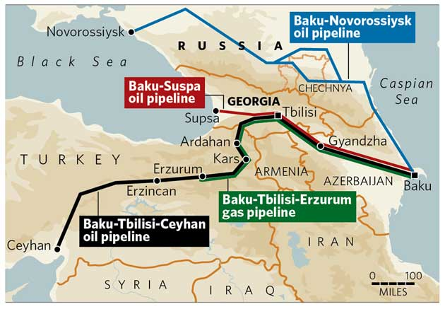
https://www.independent.co.uk/news/world/europe/battle-for-oil-eursquos-hope-to-bypass-russian-energy-may-be-a-pipe-dream-891499.html Author:Claire Soares

CHAPTER 4-AZERBAIJAN REPUBLIC OIL SITUATIONS AFTER 2017,IMPORTANCE OF OIL AND STRATEGY THAT AZERBAIJAN SHOULD USE TO CREATE A NOVEL ECONOMY.
Azerbaijan Republic faced immense problems during shock of oil prices.Essentially,Azerbaijan national currency manat devaluated 2 times which one of them happened in 21 February 2015 and second one happened in 21 December 2015.Second one was most cruel devaluation which created a scar in Azerbaijan economy.Azerbaijan national currency at the end of 2015, 1 dollar equal to 1,55 manat.However,this process continued to the 6 February 2017 when Azerbaijan currency fell into one of the deepest value in the history.1 Dollar equal to 1,91 which it was a disaster for economy.
Devaluation occurs when there has some obstacles in Monetary policy.How Monetary Policy works? Monetary Policy based on 2 feature in economy.1 of them is interest rate and the other one is quantity of national money.When Interest rate rises,Quantity of money in the market will fall and as a result value of the money will increase due to low supply and high demand lead to increase value of the money in the market.When quantity of money rises,interest rate will fall due to high supply in the market and as a result,high supply lead to low demand and it reduces the value of the money in the market.This basic rule also apply in our situation.
It is simple actually. Azerbaijan had been collecting US dollars from oil business and after the crisis it had damaged revenue of SOFAZ which it gained from oil industry.SOFAZ had been using US dollars to convert manat in Central Bank through years and and Central Banks using these dollars to saturate demand of US dollar in order to make a balance in the money market.Thus,make Azerbaijan manat valuable against Dollar and other sustainable currencies for a long-run.However,relying on oil revenues reversed situation of Azerbaijan so quickly.When oil prices fall to the deep,SOFAZ had not able to transfer sufficient number of US dollar to the Central Bank to make proper operations.In Azerbaijan,US Dollar had stable demand since people of Azerbaijan take independence and when Central Bank couldn’t satisfy demand of US dollar,value of US dollar had rose against Manat.When Manat value reduced and US dollar rise,price of final goods and commodities from abroad had rose too.Azerbaijan had weakness in the economy.Azerbaijan economy were dependent on oil and it wasn’t a good sign for sustainable economy.Ministry of Economy were importing nearly all type of final goods from different places of the world,but,only exporting oil which is not final goods.middle-sized entrepreneurs are buying nearly all type of goods with US dollar.That is why,when oil prices reduced,Azerbaijan economy damaged so violently.
After 2017,Azerbaijan economy started to turn the tides with us.There is some reasons which affected economy:
1)Central Bank involves money market
Central Bank made it’s strategy on Fixed-Floating exchange rate.They are not influence Manat value directly in order to manage Floating exchange rate.
2)Increasing oil price trends after 2016 and shares in oil mines
Deepest oil prices in past 10 years,oil prices start to increase again.This was a good sign for economy and SOFAZ revenue start to rise again.Consequently,September 14,2017 Azerbaijan and top oil industry companies from the world re-signed again.This time SOCAR share increase from 11% to the 25%.
3)Support with subsidies to the Society
Azerbaijan government had aware that after this crisis Azerbaijan both Small businesses and citizens in low category.Azerbaijan had decided that return amount of money when citizens took credits who took credits in US dollars from bank before 2015 devaluation.
4)Tax changes for both entities and as well as Entrepreneurs
Azerbaijan Ministry of Tax and Azerbaijan Ministry of Economy had decided to reduce tax rate both physical and legal entities.Subsequently,Azerbaijan changed tax rates for entities in order to ensure competitiveness in the market.

4.1--Importance of crude oil in modern world
After 2015 financial crisis,Azerbaijan very weaknesses appeared so easily.Both goverrnment and society knew that relying on oil would be disastor for the economy of the country.Today,most developed countries shift their energy supplies from renewable energies.First and foremost Great Britain,Germany,developed US states,France starting to use nuclear,wind and solar energy which is not scarce resource in the nature.In Britain,they will start to ban sales of both diesel and petrol automobiles and vans from 2040 which it would be encouragement to shift consumer demand environment friendly vehicles.How is this related into oil industry? It is very simple actually.Today vehicles is one of major products in the world and this vehicles consume petrol and diesel.These ingredients produced from crude oil.In modern world,the number of transport services,private vehicles starts rise so much due to increasing population of world.When number of cars rise,demand for petrol and diesel will rise as well and it affect crude oil demand in the world.Oil is not only used for energy but also used in medicine.Oil compositions also used for medicine products.Developed countries demand for pills and drugs has been increasing every year.They are providing expensive and distinct range of drugs and pills to their people in order to ensure their safety and health.Furthermore,producing these drugs and pills demands some amount of crude oil as well.Today,developed countries wants to import crude oil as much as he could to improve their production in medicine sector.They also want to export this drugs to other countries to gain a profit and medicine sector is one of the profitable sectors in the world.From Crude oil producer could also create Refinery gas,plastics,kerosene,Lubricants and other commodities which people use in their daily life.Picture below shows us basic information about Crude oil and it’s usage in production:
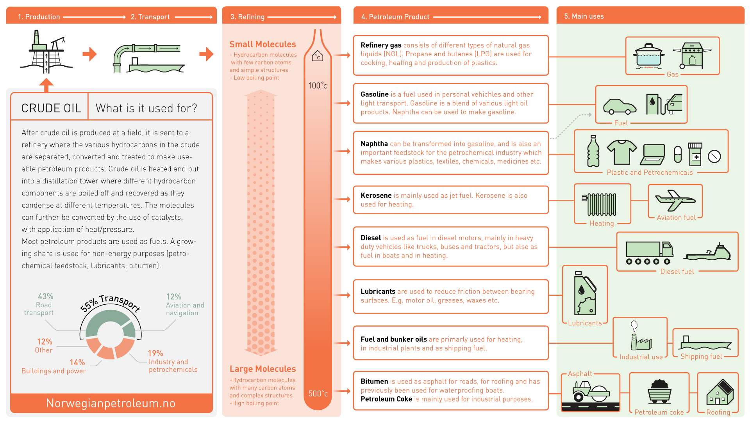

4.2--Price of oil in future and it’s importance to the world.
From 2014 to 2016 Oil crisis happened and there was some reasons triggered this event:
1)Supply-Demand
Oil market based on supply-demand curve.If supply increase and demand would stay same,price of oil would fall quickly.In 2014,United States started to produce crude oil in their states which shifted whole market situation so easily.Consequently,US started to sell it’s brand oil below the average market price and as a result,it affected other countries economy as well.Many countries start to bought millions of barrel oil with ships.exporting through ships is not costly for short-run and you could gain sufficient amount of oil for your oil-related products.
2)Value of US Dollar
Price of oil were affected from US dollar itself.Global accepts that oil prices based on US dollar itself.Every nations use US dollar to evaluate their oil price.When 2 nation make oil trade between themselves,oil exporter convert it’s currency to the US dollar and sell it to another country.Countries currency make huge factor for trading policy.2008,financial crisis is one of the most famous example for this section.After money market was crashed,FED start to print new US dollars in order to rectify the market.It was the beginning of rising of oil prices after 2009.By the end of 2015,the value of US dollar has sustained it’s place in world and it reduced price of oil sharply.
After 2016,oil prices start to rise again.Expertises from EIA(Energy Information Administration) forecasts Brent of crude oil to the 2050.They forecasts that Brent crude oil would 81,73 US dollar per barrel.By 2030, demand for crude oil will lead Brent oil price to 92,98 US dollar per barrel.By 2040 and 2050 105,16 US dollar and 107,94 US dollar respectively.This calculation based on 2018 US dollar value.The graph below shows us detailed versions of Brent oil price.
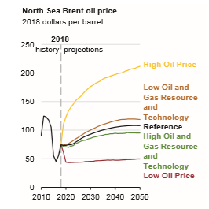
EIA/Annual Energy Outlook 2019 with projections to 2050.

Price of oil for future could be rise again due to many factors:
1)Reserves
Crude oil one of the non-renewable energy in the world and it affects it is price as well.Today world,depend on crude oil day-by-day and if reserves become less it will be a precious material for both owners and buyers.
2)Growing population
World population still increasing especially in Asia and South America.When population grows,demand will grow either and high demand leads high price.Today,oil-related products still one of the most vital aspect for both machnery and human life.
3)No substitute
World still try to replace oil demand by shifting renewable energy in vehicles and energies.However,oil industry is not simply replaced in short-run.Medicine,Plastic industry still depend on oil sector and thus lead oil prices even higher for future.
4)Stable US dollar value
US dollar one of the biggest impact of oil price and it will have same influence for a while.

4.3--Norway economic model and benefits for society
Norway economic model is one of the famous model in the world.This country is the best example for others who are highly dependent on crude oil.
So what they did during 50 year? Firstly,they declare a bill in 1962 that all lands belongs to the government if there has oil.With this bill Norway start to centralized all oil industry into one safety hand which means into government.In other countries if you buy land from government and if you find a oil beneath,you could use this oil as your property.This is the first movement in Norway.They also need to operate oil starting to extraction to the export.That is why they created a company called StatOil.When they created StatOil,government awarded 50% of oil industry including wells,stations,terminals,profits from selling and so forth to the StatOil in order to centralized oil industry in one hand and improve both efficiency and effectiveness in oil sector.After this actions they started oil business in Europe and quickly they rose their production and now they are 14th most crude oil exporter in the world.There have some reasons they achieve their goal so quickly:
1)Geopolitical positions
Norway geopolitical positions one of the sufficient positions in the world.Essentially,they are close to one of the biggest oil company in the world called BP.Secondly,Border countries like Sweden,Denmark and from sea Germany.This countries demand high portion of crude oil due to high demand on fuel and refinery gas.This also affects their price as well.Norway created a pipeline web in Scandinavia to sell it’s oil this countries.Oil transportation through tankers also Norway exportation which made Norway not to make costly contracts between nations.There wasn’t any proper oil saler which could sale to Central Europe and Scandinavia.
2)Huge Tax rates
Norway tax policy is harsh among all else.They are taxing 78% of oil profit which contains corporate tax(23%) and special tax in Norway(55%).Thanks to it’s geopolitical positioning Europe and oil deposits in Barents,North, and Norwegian sea.
3)Second highest oil reserves in Europe
Norway owns second biggest oil wells in the Europe.However,excessive extraction of crude oil left 6,6 billion barrel crude oil in Norway.Their plan was to produce crude oil as much as they could because of collecting capital in short-run.
4)Sovereign Oil Fund
World largest Sovereign Oil Fund is Petroleum Fund of Norway.Today they are managing assets worth more than 1 trillion US dollar and they are improving their assets annually.From it’s establishment (1990),Norway had been collecting whole profits and oil taxes there and today they invested 9158 companies in 73 countries in order to make profit from non-oil sector continuous.They are investing 3 major areas which are equities in ownership,bonds from multinational companies and finally in real-estate sector.From these sectors Fund recover it’s governmental expenses and also obtains sufficient amount of profit where they could save in Norway.For these fund Norway have 0 debt foreign countries and education is free for improving human abilities by investing them.Today for both Norwegian and foreign citizens in order to improve human intelligience.
5)Both physical and economical risks are minimized
When Norway gained independence in 1945,they were joined NATO in order to make reconstruction under governmental plans.They discovered oil deposits in North Sea on 1966 and after 3 year of analysis and researchs in sea they found richest oil wells in Northern Europe.They need to attract foreign investors from other countries in order to start oil extraction in there.However,they knew intelligient investor would not invest gigantic capital with high risks.That is why economical risks including their monetary and fiscal policy were stable during years.They also built one of the secure oil terminals and stations in the world which built for only 1 purpose.To protect lives of Norwegian and foreign workers in the oil extraction.

4.4--Norway economic model comparing Azerbaijan economy.
Norway economic model sometimes called Nordic model is one of the succesful model for oil-dependent countries.Azerbaijan is one of the country where state budget make proficit for 7,78 billion manat(48,3% of state budget) transfer to the budget in 2018.Unlike Norway,Azerbaijan don’t have that Norway have:
1)Geopolitical factors
Geopolitic positions of Azerbaijan is complex.Border countries of Azerbaijan mainly neutral but most of times they would do against any actions if they find opportunity.Azerbaijan main enemy Armenia holds Nagorno-Karabakh to bluff other developed countries that Nagorno-Karabakh was part of their land through centuries.this conflict could cause war which afraids many investors.Norway,on the other hand,is placed in northern region of Scandinavia where their neighbours has same cutural,national relations.
2)Budget depends on oil profits
Azerbaijan state budget mostly based on oil profits from SOFAZ and it is dangerous fact for Azerbaijan economy.Azerbaijan had been using SOFAZ revenue through years which it didn’t let SOFAZ to collect a plethora of oil profit.the rest of state budget were based on through taxation of big businesses and customs which is not enough to remove SOFAZ transfer to state budget.Azerbaijan had been suffering lack of exporting due to lack of production in Azerbaijan.Norway,also half dependant on their funds.However,these funds mechanism were different than SOFAZ.In early stage,Norway stacked every oil profit there and used only 4% of assets in order to recover budget expenses.Every year,Norway collected cash and Fund didn’t stop there.Government gave power to Petroleum fund of Norway to make investment and proper operations both domestically and internationally in order to generate money as much as it possible.SOFAZ also has it’s right,but,immense number of transfer to the budget do not let him to make investment and operations in the markets and as a result,generations of money in SOFAZ would be delay.
3)Education and people
Unlike Azerbaijan,Norway have free education system to educate it’s people.Norway had created a novel social welfare where non of the country could achieve it so far.They were aware that investment on human could be the best investment on the world.Educating people means,creating a better worker who could attract multinational companies and also it could create many small businesses which they could make big businesses and government could be beneficial through taxation.Meantime,In Azerbaijan suffering from lack of high-skilled workers who could manage and improve the company.
4)Better economic standarts
Norway listed as developed countries due to it’s high rate in all economic category.Norway national currency Norwegian Krone is one of the reliable currency in the world.It is reliable because this currency is stable thanks to effective monetary policy of Central Bank of Norway.Average Gross Salary of Norwegian people is more than 85,355 US dollar which makes Norwegian people richer than other countries.Corruption Perception rate in Norway is 100 out of 84 and it helps Norway to make 7th place out of 184 country.Thus statistics created by Norwegian petroleum fund led by Norwegian government.They are modifying every gap of economic obstacles in order to assemble superior economy in the region.These figures and situations attracts influental investors to the Norway to make Foreign Direct Investment rather than exporting.These statistics make Norway more safer than other countries and it shows that Norway have minimum risks in their country.When Foreign Direct Investment made it creates job opportunities and products which they could buy cheaper and also export to other countries.

4.5—Suggestions
Azerbaijan needs to take some steps and movements which stated down below:
1)Create a field which owners could produce oil-related products
Azerbaijan had been exporting through decades.However,if Azerbaijan would compared to other wealthy countries,it is obviously seen that Azerbaijan output is based on crude oil which is not a way to maximize profit of SOFAZ via transporting oil to other countries.Azerbaijan had been suffering from lack of supply-chain management.Azerbaijan is a home of oil reserves which worlds 20th largest oil deposit in the world.However,Azerbaijan had lack of production.Main strategy of crude oil exportation is to obtain a profit in short-run.While,long-run this profit even higher than short-run.This actions also have admirable impact to the market.Firstly,average price of these products would reduce and it also creates a workplaces where Azerbaijan citizens could work here with nearly first-rate salary.
2)Improve Human capital in order to create a more desirable society.
Human capital is one of the pivotal requirement for every country.Azerbaijan needs to invest their profit from oil industry to the it’s people.Azerbaijan should create a practice field to encourage youth people of Azerbaijan to improve their knowledge about work conditions.Azerbaijan also needs to create a internship in multinational companies to aware youth people of Azerbaijan a work conditions in foreign countries.Apart from that,Azerbaijan should reorganized education system to improve society knowledge.Azerbaijan would improve knowledge of Azerbaijani children by creating a field which these children could see and learn process of their potential profession in the future.If Azerbaijan wants to create a specialist in different sectors,they should do appropriate activities in early stage of their lifetimes.
3)Minimize risks.
Azerbaijan,nowadays,suffering from distinct number of risks past 5 year.Devaluation of manat,corruption in local organizations rises risk of investors.Azerbaijan should eliminate this problems as soon as possible.In order to revaluate manat,Azerbaijan should attract suitable investment from foreign country.Eliminating corruption is a complex feature for every country.Azerbaijan had created Comission on combating corruption for remove extortion from local ranks.
4)Improve Social welfare.
Many developed countries wants to improve their social welfare to satisfy local citizens.Azerbaijan wants to achieve it either and needs to make some actions. Azerbaijan needs to improve average salary of citizens to affect some features.Essentially,rising salary of people improve their welfare.On economic side,value of all market in Azerbaijan start to rise simultaneously.When salary rise,Purchaser Power Index will rise which affects market value either.This process attracts potential investors from abroad.
5)Monetary Policy and Fiscal Policy.
Every country nations economic success based on 2 policy which they are Monetary Policy and Fiscal Policy.On one hand,in Monetary Policy,Central Bank should find out a balance between interest rate and quantity of money to make Manat more stable against other currencies.On the other hand,Fiscal Policy which works with tax and budget.Azerbaijan should use expansionary fiscal policy to attract entrepreneurs from abroad.Expansionary fiscal policy claims that government should reduce taxes or improve government expenditure.Reducing taxes would damage budget policy in short-run.However,reducing taxes would attract potential investors from abroad and creating a better market place and taxation system would encourage them to make investment there.
If government do these sections properly,Azerbaijan could achieve everlasting economic growth in long-run.

CONCLUSION:
In conclusion,Azerbaijan oil industry start to rose in 1803 when Azerbaijan entrepreneur Haji Gasimbey found world first offshore oil extraction in the world. First and second crude oil extractor companies created there. Azerbaijan earliest oil potential attracted foreign investors from Europe which most of wealthy persons in XIX century in Europe.Investors from different countries such as Sweden,Great Britain,France and Germany came here to create their oil industry and grows their oil empire in these period.One of the famous investors are Nobel brothers and Rockfeller who have invested more than a million dollar there to create a oil company and make profit there.By the end of XIX century Azerbaijan boosted it’s oil industry to the highest ever and Russia gained benefit from this.Early of XX century started make things difficult for Russia and especially Azerbaijan.Oil entrepreneurs eliminated small oil producers in Baku and started to create a monopoly which cause rose of oil prices.From there, industrialization of oil sector had stagnated for a long time due to russian government and owners misbehaviours.
In Azerbaijan Democratic Republic time,this misbehaviours was fatal damage to oil industry.Azerbaijan didnt’t have enough capital to repair oil industry in short-run and they didn’t have partners for a while.By the 1920,April 28,Bolshevik forces conquered the land of Azerbaijan and by using rightful land of Russian Empire lies.USSR saw that Azerbaijan oil production were small due to 0 modifications.After 1921,Russian expertises and specialists came here to repair and modify every Oil well and terminals to produce oil like the end of 1890.Azerbaijan oil reserves fed USSR very people through decades.In World War II,Azerbaijan were main target of Nazi Germany who believed that capturing Baku oil would cause tremendous damage to USSR.After 1950,Azerbaijan oil production stagnated again.Not because of modifications,but extinction of oil reserves in Baku and very foundation of new oil reserves in Central Asia and Sibiria.
On 1991,Azerbaijan finally gained independence.From there oil industry start to rise again.On 1994,Azerbaijan signed a contract which called “Contract of the Century”.This contract were starting point of Azerbaijan Industry.Growing extraction of crude oil improve government output.Azerbaijan wanted to create a fund where they could save their profits from crude oil.After a while,they could make transfers and operations to generate money or provide sufficient amount of money to improve budget.These reasons created SOFAZ(State Oil Fund of Azerbaijan) in 1999.Another reason of this actions to create an economy which could same as Norway economy.
However,they couldn’r carry on due to state budgets depends on oil profits.Most of SOFAZ profits were transfering to the state budget.Azerbaijan couldn’t create oil-related industries there to free Azerbaijan economy bound to the crude oil.After 2015,Azerbaijan took economic damage due to fall of oil prices.Manat was devaluated and many foreign companies abandoned there for increasing economic risks.
Azerbaijan after 2015,saw it’s weaknesses which could rectify it through future 10 years.Azerbaijan should create a novel economy like Norway which they created within 40 years.Norway created sustainable economy through decades which essentially,affected social welfare and domestic market.Azerbaijn trying to achieve what Norway previous achievements.Azerbaijan still have potential to improve their social welfare and create sustainable economy in future.

BIBLIOGRAPHY
Center For Eastern Studies: The resource wealth burden-oil and gas sectors in the former USSR. Russia, 2003.
International Energy Agency Directorate of Global Energy Dialogue: Perspectives on Caspian oil and gas development. IAE working paper series. December 2008.
Eurasia extractive Industries Knowledge Hub (Khazar University) and Jeronim Perovic: Low oil prices Economic and Social Implications for Azerbaijan. 21 April 2016.
Israfil Z. Ismailov:AZERBAIJANIAN OIL IN THE XX CENTURY (imilitary-political aspect).Azerbaijan state oil academy,2007.
EIA:Annual Energy Outlook 2019 with projections to 2050. January,2019.
Rovshan Camalov & Tahmasib Alizada:Energy Security and Energy Union perspectives for Azerbaijan.CESD press
Dan Breban and Elmir Mukhtarov:The 2018 State Budget Project of Azerbaijan: From Consolidation to high spending?CESD press Baku,November 2017.
CESD Research group:How Much Does Azerbaijan Really Earn from Higher Oil Prices?CESD Press Baku,April 2018.
Mushviq Atakishiyev:Azerbaijan New Oil Strategy and Economic Growth. Azerbaijan Press; Baku-2004.
International Energy Agency Directorate of Global Energy Dialogue: Perspectives on Caspian oil and gas development. IAE working paper series. December 2008.
Nazim Ibrahimov:Azerbaijan oil in World policy. Azerbaijan press; Baku 1997
E.M.Hajizade: Azerbaijan economic reforms onoil-gas drilling stations in land and efficiency problem. ‘’Elm’’press; Baku,1998.
Eurasia extractive Industries Knowledge Hub (Khazar University) and Jeronim Perovic: Low oil prices Economic and Social Implications for Azerbaijan. 21 April 2016.
M.M.Sadiqov:Finance.Azerbaijan State AgriCultural University press. Ganja, 2010.
Aitor Ciaretta and Shahriyar Nasirov:Analysis of Azerbaijan oil and gas sector article.
http://sam.gov.tr/wp-content/uploads/2012/01/1.-AZERBAIJANI-OIL-GLIMPSES-OF-A-LONG-HISTORY.pdf
http://cesd.az/new/?tag=oil-money-in-azerbaijan
https://www.rbth.com/business/326217-black-gold-how-russian-oil
https://www.e-education.psu.edu/eme801/node/457
https://www.omv.com/en/blog/the-price-of-oil-how-is-it-determined
https://www.quora.com/How-is-oil-price-determined
https://www.cia.gov/library/readingroom/docs/DOC_0000292332.pdf
http://www.oil150.com/about-oil/early-crude-oil-production/
https://www.businessinsider.com/timeline-155-year-history-of-oil-prices-2016-12
https://www.thebalance.com/opec-oil-embargo-causes-and-effects-of-the-crisis-3305806
https://www.e-education.psu.edu/eme801/node/457
http://www.visions.az/en/news/206/1ee04b7e/
https://www.usaee.org/usaee2011/submissions/OnlineProceedings/Ciarreta_Nasirov-Article1.pdf
https://www.coachmanenergyoperating.com/crude-oil-price-by-year-chart/
http://jbepnet.com/journals/Vol_2_No_2_June_2015/5.pdf
http://www.iteca.az/__subdomains/caspianoilgas/2013/img-project/mm/mm6en.pdf
http://www.socar.az/socar/az/home/
https://www.bp.com/en_az/caspian.html
https://azertag.az/xeber/Bakida_Azeri_CHiraq_ve_Gunesli_yataqlari_uzre_yeni_Sazisin_imzalanmasi_merasimi_kechirilib_YENILANIB___4_VIDEO-1093389
https://www.brookings.edu/wp-content/uploads/2009/03/2009a_bpea_hamilton.pdf
https://www.oilfund.az/
http://files.preslib.az/site/10il/gl4.pdf
http://country.eiu.com/article.aspx?articleid=1414728325&Country=Azerbaijan&topic=Economy&subtopic=Forecast&subsubtopic=Fiscal+policy+outlook&u=1&pid=1113860895&oid=1113860895
https://www.eia.gov/beta/international/analysis_includes/countries_long/Azerbaijan/azerbaijan_exe.pdf
https://en.president.az/azerbaijan/contract
https://www.independent.co.uk/news/world/europe/battle-for-oil-eursquos-hope-to-bypass-russian-energy-may-be-a-pipe-dream-891499.html
https://www.norskpetroleum.no/en/production-and-exports/exports-of-oil-and-gas/
http://credbc.ca/norways-oil-gas-policy/
https://www.nbim.no/
https://www.weforum.org/agenda/2016/03/what-s-behind-the-drop-in-oil-prices/
https://eurasianet.org/is-bigger-better-for-azerbaijans-budget

