The Ministry of Education of Azerbaijan Republic

RESOURCE CURSE PHENOMENON. DIVERSIFICATION OF AZERBAIJANI ECONOMY AS A WAY TO OVERCOME THE PROBLEM

Rehim Qocazade
UNEC SABAH
Azerbaijan State Economics University

JUNE 2019
Acknowledgement
To begin with of all, I would like to thank to my supervisor Matin Firuzi who helped me a lot. As a result of his direction, his steady inspiration and exhortation, I could effectively finish my diploma work. He always gave me amazing support, feedbacks, new ideas for my thesis.
I also want to thank to dean of SABAH Groups Aida Guliyeva for her support. I want to thank to my family, my friends for their valuable support while I tried to complete my thesis. They always made me more productive and brave.

ABSTRACT

Author of final thesis: Rehim Qocazade
Full title of final thesis: Resource curse phenomenon. Diversification of Azerbaijani economy as a way to overcome the problem
Final work supervisor: Matin Firuzi
Place and year of final work: UNEC SABAH, 2019
Number of pages: 55
Number of tables: 3
Number of figures: 12

This diploma work was related to resource curse phenomenon and its problems. Thus, these issue how to affect economy, also how to affect Azerbaijan’s economy and how to relieve from these problems.
This work comprises of 3 segments which are divide into 5 sections.
First section is about Natural Resource curse, this accident how to affect countries, examples of natural resource curse.
The second is about Dutch disease, examples of Dutch disease, effects of Dutch disease.
The third section is about Azerbaijan oil and gas reserves, how Azerbaijan economy depends on oil and oil prices.
The forth section is about sectorial analysis of Azerbaijan such as tourism, agriculture, construction, education and health and so on.
The last section is about strategic map of Azerbaijan, decreasing ways of depending on oil.
TABLE OF CONTENTS
Acknowledgement……………………………………………………..2
Abstract………………………………………………………………...3
Introduction…………………………………………………………….5
- RESOURCE CURSE PHENOMENON……………………….7
  - Definition of natural resource curse……………………………..7
  - Examples of natural resource curse……………………………….9
  - Dutch Disease………………………….......................................22
- AZERBAIJAN AND NATURAL RESOURCES…………….26
  - Oil and gas reserves in Azerbaijan………………………………26
  - Sectorial analysis of Azerbaijan…………………………………36
- STRATEGIC WAY MAP OF AZERBAIJAN………………46
- CONCLUSION…………………………………………………52
- REFERENCES…………………………………………………54

INTRODUCTION

Natural resources play an important role in economy of country, poverty reduction or welfare of people where these resources could be discovered and extracted. Thereby, natural resources are assumed to be a blessing not a curse.
Resource curse syndrome is a situation that in some countries with an abundance of non-extensile natural resources calm economic growth or even economic shrinkage. It happens when a country begins to focus its entire production base on a single industry such as oil industry and it results carelessness of other industries.
As a result of natural resource abundance a country begins extremely depend on price of commodities and revenue of country become more volatile. Volatility in Gross Domestic Product of a country has a negative impact on performance of the economy.
The Resource Curse usually observed in less-developed countries cause their undiversified economy. It means that big share of their revenues come from only one sector and country don’t want to invest and develop other sectors of economy. If country want to develop well and become a strong country at that time country must have diversified and strong economy because diversified economy is always better than undiversified economy.
One of the examples of natural resource curse is Dutch Disease. The Dutch Disease is a situation that- when one sector of economy develops rapidly but other sectors don’t develop. This case occur at that time when a country find one natural resource reserves, begins to focus and tries to develop only one sector. Capital and skilled labor begins to move from other sectors to the resource sector, it creates channel to Dutch disease.
Dutch Disease is the case that it can mostly result from intrusion of foreign currency into a country, involve in foreign aids, foreign investment and etc. In the long run, this phenomenon can contribute to increase level of unemployment, because manufacturing jobs begin to move to lower-cost countries. This model also suggests that the negative relationship between economic growth and natural abundance. Dutch disease usually happened in developing countries. Because they have not diversified economies. But developed countries have diversified economies it means that they have strong economies.
Azerbaijan is also suffer from Dutch Disease. Because Azerbaijan economy mostly depends on only one factor. This factor for Azerbaijan economy is oil. Any changes in oil and oil prices can affect to the Azerbaijan economy so negatively. According to information of State Statistical Committee, the most part of GDP comes from oil.
Azerbaijan tries to decrease depending on only one sector-oil. The way for it is diversification of the economy- development of non-oil sector. Agriculture, tourism, construction, service sector, communication sector have a great opportunity for development in Azerbaijan. Foreign investors is another way for decreasing of depending on oil.

1.1. Resource curse phenomenon
Natural resources play an important role in economy of country, poverty reduction or welfare of people where these resources could be discovered and extracted. Thereby, natural resources are assumed to be a blessing not a curse.
The Resource curse syndrome is a situation which in some countries with an abundance of non-extensile natural resources calm economic development or even economic shrinkage. This has been looked for a couple of decades that the possession oil, flammable gas, or other significant mineral stores or regular assets does not basically present budgetary advancement. The Resource Curse usually observed in less-developed countries cause their undiversified economy. It means that big share of their revenues come from only one sector and country don’t want to invest and develop other sectors of economy. If country want to develop well and become a strong country at that time country must have diversified and strong economy because diversified economy is always better than undiversified economy.
The most part of African countries like Nigeria, Angola, are wealthy in oil, jewels, or other minerals, and however their people groups proceed to encounter moo per capita pay and moo quality of life. Auty (2001) is clearly the person who minted the indicated “natural asset curse” to depict this astounding marvel. It’s used distribute speedily.
Graph 1, replicated from Manzano and Rigobon (2001), outlines for a cross segment of nations. Sends out of essential items as a division of GDP show up on the flat hub and financial development on the vertical hub. The relationship on normal is marginally negative. The negative relationship isn’t exceptionally solid, veiling nearly as disappointments. Nevertheless, it surely advices no positive relationship between natural resource wealth and economic development.
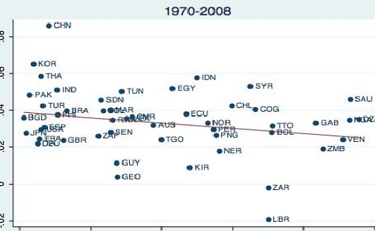
Figure 1: Relationship between natural resource and economic growth

Natural resource curse ought to be caught on that in case a nation encompasses a noteworthy asset assignment, it ought to utilize them to their advantage. In any case, this has not continuously been the case in numerous nations with expansive saves of assets. In reality, a few ponders uncover that such asset plenitude has been malignant to nations who claim them. It is the meaning of what is the name of natural resource curse.
The term might appear to show that the assets themselves are generating the curse, for case, that the products were not of great quality, or that utilizing them intrinsically makes hurt. Be that as it may considers appear that the curse comes not within the good as such, but within the utilize made of them and the conditions of the nation, its individuals, teach, and specialists that have gotten bounty of assets.
These are two definitions of the “natural resource curse” to use phrase:
Karabegovic (2010) said that: In the past, natural assets were thought to make financial development and success. Be that as it may, in later a long time, talk about has flared over whether characteristic assets, such as minerals and metals, oil, rural assets and so on, fortify economic growth or act as a prevention to development. The thought that characteristic resources really ruin growth is known as the curse of natural resources.
Kronenberg (2004) demonstrated that: The curse of characteristic resources may be a well-documented marvel for creating nations. Economies that are luxuriously invested with characteristic resources tend to develop gradually. Various analysts have found a critical negative relationship between natural resources wealth and economic growth. This finding appeared astounding at to begin with, since classical financial hypothesis would foresee that inexhaustible natural resources ought to be great for the economy.
Prove collected over the final 15 a long time clears out small room for questioning the presence of a ‘resource curse’. Nations intensely subordinate on natural resources-topographically concentrated resources such as hard-rock minerals, oil, and gas-have performed more awful, in both economic and political terms, than nations without the clear ‘benefit’ of such natural blessings.(Arellano-Yanguas,2008)
Examples of Natural resource curse:
This case is related to Asian tiger economies. None of South Korea, Hong-Kong, Singapore, and Taiwan, the Asian tiger economies, has noteworthy natural resource gifts, but their average growth rates amid the moment half of the twentieth century have been higher than anyplace else within the world. South Korea and Taiwan accomplished this indeed with troublesome political circumstances (Kronenberg, 2004).
One imperative finding in advancement financial matters is that normal asset plenteous economies frequently develop more gradually than economies without considerable resources. For occurrence, development failures, like Nigeria, Sierra Leone, Saudi Arabia, Zambia, Angola and Venezuela, are all resource-rich, whereas the Asian tigers:Korea,Hong-Kong,Taiwan and Singapore,are all resource-poor. On normal asset, copious nations slack behind nations with less resources. However we ought to not bounce to the conclusion that all resource wealthy nations are reviled. Numerous growth winners like Canada, Australia,Botswana and Norway are wealthy in assets. Besides,of the 82 nations included in a World Bank consider,five nations have a place both to the beat eight countries agreeing to their characteristic capital riches and to the best 15 countries agreeing to per capita salary (World Bank,1994).
In the blow was examined two differentiating cases of resource curse:
Venezuela. Venezuela is favored with oil in plenitude. Concurring to the World Factbook,Venezuela is the primary of a list of nations with rough oil-demonstrated saves,and is one of the beat makers and exporters of oil within the world. Oil trades account for over 95% of Venezuela’s trades, 50% of government income,and 30% of GDP(Rossi,2011). Clearly,the oil speaks to the food of life in Venezuela. The government,legislative issues and economy rotate around these natural resources. However,as of this composing (summer 2014), Venezuela is living through maybe its most troublesome period since its independence. In the mid-2010’s challenges in Venezuela are characterized by a destitute financial execution, the most noticeably awful in South America,combined with a need of steady political educate,and emergency of authority.
With regard to political institution, whereas there’s a equitable government,this has not implied the renewal or alter within the political party that administers the nation. Both the perished President Hugo Chavez and Nicolas Maduro, Chavez’ successor,speak to coherence in control which has endured fifteen a long time.
The Natural Resource curse took place in Venezuela within the 1970s when the government,utilizing the cash coming from oil trades, made the choice to cancel all agribusiness related obligation with the trust of disposing of this money related burden and expanding rural generation. Be that as it may,the inverse impact took place; most landowners of huge ranches sold or closed their latifundios(expansive cultivate bequests) and moved to urban situations where they built up other businesses not related to farming. Subsequently Venezuela(such as Nigeria) misplaced much of its rural division due to its asset riches. The drop of the agrarian segment and the rise of the oil industry and other benefit segments have made tall levels of movement and inner relocations from country zones to guideline cities. These convergences of modern entries over the a long time have made tall levels of wrongdoing,viciousness,unemployment and destitution in these cities(Egoavil,2011)
Chile. The nation of Chile has had exceptional financial execution, taking advantage of the natural assets it possesses. Chile produces a third of the copper utilized within the world. Within the past 40 a long time,Chile has ably taken care of and channeled incomes from the deal of copper. Chile has provoked the improvement of other financial activities. Similarly,choices that specialists have taken over this time have permitted Chile to effectively lead the move from destitution to improvement. In expansion,these same choices have anticipated Chile from being influenced by asset curse.
At to begin with,given that the mining division was basic for Chile,the government passed measures to reinforce the division. The measures looked for to make an alluring environment for speculation in mining in specific for capital coming from overseas. In any case,they were not the as it were measures that were taken. The government of Chile received an economic structure with four columns. The primary was the appropriation of an unsurprising and mindful monetary arrangement, adjusting charge incomes and government investing. The moment column was the selection of a financial approach guided by an unequivocal swelling target. The third reason was the continuous opening up of financial and exchange divisions. At long fast, the fourth column was to form a strong monetary framework, private banks and fitting administrative approaches.
Encounter appears that economies with moo supply of natural resources have had to bargain with constrained assets and this circumstance has pushed them to look for elective advancement ways. Those courses to development and improvement were based in profitable exercises instead of in extractive exercises. So,having seen those encounters,is it conceivable that economies favored with assets can utilize this source as component of leveraging their development and improvement?(for instance,can resources be utilized for development?) In expansion,whereas the reply must be yes,such a way is likely to be more complex and troublesome than one might anticipate. The complexity and challenges are due to the many undesirable impacts that are included where there’s plenitude of resources.
Maybe one reason is that where there are bounties of assets and things appear to be going well for a nation, specialists, and populace, educate, etc., ended up smug. So, a country’s society does not think it ought to consider more than the extraction and export of the resources. They don’t have to think in terms of the long-run, of a objective of making more advanced economy activities. Therefore, the asset curse isn’t a way economies must take after. A society can take a full of advantage of an asset riches. Taking this way,be that as it may,depends on the choices society makes.
The Resource curse and possible channels. The natural resource curse isn’t kept to personal accounts or case thinks about, but has been borne out in a few factual tests of the determinants of financial execution over a comprehensive test of nations. The Warner and Sachs (1995) commenced the econometric composition, finding that monetary dependence on oil and mineral is connected with moderate budgetary advancement, controlling for other assistant characteristics of the country. Sachs and Warner(2001) summarized and amplified past investigate appearing prove that nations with incredible normal asset riches tend to develop more gradually than resource-poor nations.
They say their result effortlessly clarified by other factors, or by elective ways to degree resource wealth. The papers of these scientists requisition that there’s small coordinate prove that excluded geological or climate variables explain the curse or that there’s a inclination in their gauges coming about from a few other in secret development obstacle. Other ponders that discover a negative impact of oil, inspecific, on financial execution, incorporate Ross (2001), Sala-i-martin and Subramanian (2003) and Smith (2004)
The result is in no way, shape or form widespread, particularly when one sums up past oil. Norway is obvious as an oil-maker that is at the highest point of the worldwide class tables for administration and financial execution. The same number of have brought up, Botswana and Congo are both inexhaustible in precious stones; yet Botswana is the best entertainer in mainland Africa as far as majority rule government, security, and quick development of salary, while Congo is among the worst.11 Among the measurable investigations, Delacroix (1977), Davis (1995), and Herb (2005) all discover no proof of the common resource revile. Sometimes, particularly if the information don't return to a period before oil was found, the reason various investigations come to various outcomes is that oil riches may raise the dimension of per capita salary, while diminishing or neglecting to raise the development rate of pay (or the finish of-test dimension of pay, if the condition conditions on starting income).12 It isn't that nations with oil riches will fundamentally accomplish more terrible execution than those outside. Maybe a couple would exhort a nation with oil or other normal assets that it would be in an ideal situation decimating them or shunning creating them. Oil-rich nations can succeed. The inquiry is the means by which to utilize the asset. The objective is to be a Norway as opposed to a Nigeria. A similar point applies to different valuable minerals: the objective is to be a Botswana instead of a Bolivia, a Chile as opposed to a Congo. Give us a chance to come back to a thought of different channels whereby oil riches could prompt poor execution. In light of the factual proof, we have as of now to a great extent dismissed the speculation of a long haul negative pattern in world costs, while tolerating the theory of high instability. Be that as it may, we presently can't seem to explain precisely how high value unpredictability may prompt slower financial development. What's more we presently can't seem to consider in detail the speculations as indicated by which oil riches prompts poor foundations – including military clash and dictatorship – which thusly may prompt poor financial execution.
Which are the conceivable negative externalities to specialization in regular assets, past unpredictability? What are the positive externalities to broadening into assembling? Outside of traditional financial aspects, enhancement out of essential items into assembling in many circles is viewed as self-clearly attractive. A couple of false conflicts have been made for this. One is the Prebisch speculation of commonly declining product costs, which we made a decision to need merit in Part I of this paper. Another is the mixed up "payload religion" derivation, in light of the perception that exceptional nations have improvement. However, one ought not reject progressively substantial contemplations, in light of the fact that less legitimate contentions for enhancement overwhelming enterprises like steel factories and auto plants, that these noticeable landmarks are essentially the course to monetary into assembling are at times made. Is industrialization the sine qua non of financial improvement? Is support of assembling important to accomplish high pay? Established financial hypothesis says "no:" nations are best off delivering whatever is their similar bit of leeway, regardless of whether that is characteristic assets or assembling. In 19th century see, tries by Brazil to industrialize were as inept as it would have been for Great Britain to endeavor to create coffee and oranges in crèches. In any case, the structuralizes referenced right off the bat in this part were never alone in their inclination that nations possibly get reasonably rich on the off chance that they industrialize (oil-rich sheikdoms in any case). Nor were they ever alone in inclination that industrialization thusly requires an additional push from the legislature, frequently known as industrial approach (in any event for mavericks). The suggestion is that purposeful arrangement instigated enhancement out of essential items into assembling is advocated, and that a perpetual ware blast that swarms out assembling can for sure be unsafe. Does mineral wealth bullet to fighting? 13 Domestic clashes are positively awful for financial advancement, particularly when fierce. Where a profitable asset, for example, oil or precious stones is ready for whoever gets there first, instead of requiring generous contributions of work and capital speculation, groups are bound to battle about it. Ceaseless clash in such oil-rich nations as Angola and Sudan rings a bell. The end isn't consistent: Brunnschweiler and Bulte (2009) contend that the traditional proportion of asset reliance is endogenous as for struggle, and that incrementing for reliance takes out its essentialness in strife relapses. They discover struggle builds reliance on asset extraction, instead of the different way.
Growth and corporation. A noticeable pattern in intuition in regards to monetary improvement is that the nature of establishments is the profound key factor that figures out which nations experience great execution and which don't, and that it is worthless to suggest great macroeconomic or microeconomic approaches if the institutional structure isn't there to help them (for instance., Barro, 1991; North, 1994). Acemoglu, Johnson, and Robinson (2001) utilize a proportion of confiscation hazard to financial specialists. Acemoglu, Johnson, Robinson, and Thaicharoen (2003) measure the nature of a nation's "bunch of foundations" by the degree of imperatives on the official. The hypothesis is that powerless foundations lead to disparity, discontinuous tyranny, and absence of any imperatives to keep elites and government officials from pillaging the nation. Foundations can be endogenous: the consequence of financial development as opposed to the reason. (A similar issue is experienced with other proposed crucial determinants of development, for example, opportunity from jungle fever and receptiveness to exchange.) Many organizations -, for example, the structure of money related markets, instruments of salary redistribution and social wellbeing nets, charge frameworks, and protected innovation rules - will in general advance endogenously, in light of the dimension of pay. Econometricians address the issue of endogeneity by methods for the system of instrumental factors. What is a decent instrumental variable for organizations, an exogenous determinant? Acemoglu, Johnson, Robinson, and Thaicharoen (2002) and Acemoglu, Johnson, and Robinson (2001) present the death rates of provincial pilgrims. The hypothesis is that, out of the considerable number of terrains that Europeans colonized, just those where Europeans really settled were given great European organizations. Acemoglu et al picked their instrument on the thinking that underlying pilgrim death rates decided if Europeans along these lines settled in huge numbers.14 The main thing to indicate out legitimize this generally eccentric sounding instrumental variable, is that there need not be a solid connection between's the ailments that slaughtered pioneers and the sicknesses that burden locals, and that both are autonomous of the nations' geological reasonableness for exchange. The finish of Rodrik is that organizations trump everything else - the impacts of both tropical topography and exchange pale the blinding light of foundations. No one precludes the significant job from claiming macroeconomic steadiness; yet the case is that macroeconomic approaches are simply the result of organizations. This is basically a similar outcome was found by Acemoglu et al (2002), Easterly and Levine (2002) and Hall and Jones (1999): organizations drives out the impact of arrangements, and geology matters fundamentally as a determinant of institutions.15 It doesn't make a difference much whether the impact of foundations is only one of a few significant profound components or if, as these papers appear guarantee, it is the main significant profound factor. Institutions are so significant.
The different potential channels through which normal assets could be a revile to long-run advancement, the nature of establishments and administration is maybe the most broadly conjectured. Leite and Weidmann (1999) locate that characteristic asset reliance has a generous factual impact on proportions of debasement specifically. Gylfason and Zoega (2002) find a negative effect running by methods for unevenness. Gylfason (2001) finds a negative contact with guidance, 2002) in regards to why industrialization recently happened in American countries. Terrains invested with extractive businesses and manor crops (mining, sugar, cotton) created establishments of bondage, disparity, tyranny, and state control, while those atmospheres fit to angling and little homesteads (foods grown from the ground, grain and animals) created foundations dependent on independence, majority rule government, populism, and private enterprise. At the point when the modern insurgency tagged along, the last regions were appropriate to benefit as much as possible from it. Those that had practical experience in extractive businesses were not, on the grounds that society had come to rely upon class structure and dictatorship, instead of on individual motivator and decentralized basic leadership. The hypothesis was thought to fit Middle Eastern countries. It isn't really self-evident, from the earlier, that gifts of oil should prompt disparity or dictatorship or terrible foundations by and large. As Humphreys, Sachs and Stiglitz (2007, p.2) bring up, an administration wishing to decrease disparity ought to in principle have a simpler time of it in a nation where much riches originates from a non-inexhaustible asset in fixed supply, on the grounds that burdening it runs less danger of inspiring a fall in yield. This is in contrast with the more versatile supplies of fabricates and different merchandise or administrations, including horticultural products, which are created with a higher work part. In any case, the standard elucidation is that most governments in asset rich nations have verifiably not been keen on advancing uniformity. The "lease cycling hypothesis" as articulated by Auty (1990, 2001, 2007, and 2009) holds that financial development requires reusing rents by means of business sectors as opposed to by means of support. In high-lease nations the characteristic asset inspires a political challenge to catch proprietorship, while in low-lease nations the legislature must spur individuals to make riches, for instance by seeking after relative preferred position, advancing uniformity, and cultivating common society. This thesis was related to the explanation of economic historians Engerman and Sokoloff (1997, 2000, 2002) as to why industrialization first took place in North America and not Latin America (and why in the Northeastern United States rather than the South). Lands endowed with extractive industries and plantation crops (mining, sugar, cotton) developed institutions of slavery, inequality, dictatorship, and state control, whereas those climates suited to fishing and small farms (fruits and vegetables, grain and livestock) developed institutions based on individualism, democracy, egalitarianism, and capitalism. When the industrial revolution came along, the latter areas were well-suited to make the most of it. Those that had specialized in extractive industries were not, because society had come to depend on class structure and authoritarianism, rather than on individual incentive and decentralized decision making. The hypothesis is thought to fit Middle Eastern oil exporters particularly well. 17 Isham, (2005) find that the things that are hurting to institutional progression, which they call "point source" resources, are, despite oil: various minerals, bequest yields, and coffee and cocoa (versus a comparative little scale farm things perceived by Engerman and Sokoloff). Sala-I-Martin and Subramanian (2003) and Bulte, Damania, and Deacon (2005) also find that point-source resources, for instance, oil and some particular minerals undermine institutional quality and consequently advancement, yet not cultivating resources. Mehlum, Moene, and Torvik (2006) watch the capability by appointing them "lootable" resources. Arezki and Brückner (2009) find that oil rents worsen pollution (in the meantime, inquisitively, that they furthermore improve basic opportunities). A few researchers have investigated the doubt that oil revelations are exogenous and establishments endogenous, all things considered the supposition that oil wealth is basically the reason and foundations the effect, instead of the diverse way. Norman (2009) out that the revelation and progression of oil isn't totally exogenous, yet rather is endogenous worried, notwithstanding different things, the profitability of the economy. Mehlum, Moene, and Torvik (2006), Robinson, Torvik and Verdier (2006), McSherry (2006) and Smith (2007) suggest that the critical request is whether the country starting at now has incredible establishments at the time that oil is found, in which case it is bound to be put to use for the national welfare as opposed to the welfare of a world class. Notwithstanding, Alexeev and Conrad (2009) find no confirmation that oil or mineral wealth discusses quite with institutional quality.18 d. Oil and Democracy Mahdavy (1970) was obviously the first to propose—trailed by Luciani (1987), Vandewalle (1998) and numerous others - that Middle Eastern governments' entrance to rents, as oil income, may have liberated them from the requirement for tax assessment of their people groups, and that this thus liberated them from the requirement for majority rule government. The requirement for duty income is accepted to require popular government under the hypothesis "no tax imposition without any political benefit." Huntington (1991) summed up the rule past Middle Eastern oil makers to states with common assets in different pieces of the creating scene. Measurable investigations crosswise over huge cross-segments of nations pursued. In 2001 years discovered by Ross that fiscal dependence on oil and mineral is related with despot government. In 2000 years it discovered by Barro, in 2002 years discovered by Wantchekon, in 2004 years discovered by Jensonand Wantchekon, and in 2006 years discovered by Ross. In 2004 and 2007 years by Smith, in 2007 years by Ulfelder and others overall find that despot schedules have persevered through longer in countries with oil wealth. In any case, Karl (1997) points out that Venezuela had just been tyrant when oil was created, and in reality progressed to majority rule government at the tallness of its oil riches. Neither of the Central Asian governments are well known governments, regardless of the way that Kazakhstan is the only a single one of them with genuine oil age. In this way propelled, Haber and Menaldo (2009) take a gander at authentic time arrangement information for a connection to majority rules system from the offer of oil or minerals in the economy and neglect to discover the factually huge proof that is common of cross segment and board studies.19 Similarly, when Dunning (2008) acquaints fixed impacts with consider nation explicit contrasts inside Latin America, he finds that the relationship between's oil benefits and vote based system turns positive. The inquiry whether oil reliance will in general retard popular government ought to most likely not be viewed as a segment of the causal connection among oil and monetary execution. A few associates of majority rule government – principle of law, political steadiness, receptiveness to universal exchange, introductory fairness of financial gifts and openings – do will in general be useful for monetary development. In any case, every one of these different factors can likewise exist without majority rule government. Precedents incorporate pre-fair Asian economies, for example, Korea or Taiwan. Some scientists trust that Lee Kwan Yew in Singapore and Augusto Pinochet in Chile couldn't have accomplished their monetary changes without dictator controls (the one surely more moderate and kindhearted than the other). On a greater scale, it is said that China has become such a great amount of quicker than Russia since 1990 in light of the fact that Deng Xiao Peng choseto seek after financial change before political change while Michel Gorbachev did it the a different way. The factual proof is, best case scenario blended regarding whether majority rules system essentially is useful for financial execution. Barro (1996) finds that it is the standard of law, free markets, instruction, and little government utilization that are useful for development, not vote based system as such. Tavares and Wacziarg (2001) find that it is instruction, not majority rule government in essence. In 1996 years it discovered by Alinas that it was political capacity. 20 Some even locate that, subsequent to controlling for significant factors, for example, the standard of law and political solidness, popular government has on the off chance that anything a feeble negative impact on development. One can guarantee great proof for the turnaround causation, that financial development prompts popular government, frequently helped by the production of a white collar class, considerably more dependably than the other way around.21 Examples incorporate Korea and Taiwan. Obviously majority rule government is regularly viewed as an end in itself, beside whether it advances monetary development. In reality, even if here, the one should annotation that the benefits of the shows of races could be over-focused. For a certain something, races can be a trick. Western style or limited one-vote races should likely get less need in creating nations than the basic standards of principle of law, human rights, opportunity of articulation, monetary opportunity, minority rights, and some type of prevalent portrayal.
1.3. Dutch disease
Dutch disease means that country economy depends on only one sector.
Developed countries have usually good diversified economies, but developing and underdeveloped countries have usually undiversified economies. That’s why developed countries have strong economies and have good position in the world. This accident - Dutch disease can happen for different reasons, example of these reasons:
- an expansion in spending (particularly by the administration, which for political economy reasons expands spending in light of the expanded accessibility of assessment receipts or eminences – examined beneath);
- an expansion in the cost of nontrade products (merchandise and enterprises, for example, lodging that are not globally exchanged), with respect to exchanged products (universally exchanged merchandise other than the fare ware);
- a conclusion move of job and land out of non-convey thing traded items (pulled by the all the more appealing returns in the passage product and in non-traded items and adventures);
- a present record deficiency. At the point when swarmed out non-product tradable merchandise are in the assembling area, the dreaded impact is deindustrialization. In a certifiable model, the reallocation of advantages across over tradable fragments, e.g., from produces to oil, may be inevitable.
However, the improvement into non-traded items is macroeconomic in beginning stage. What makes this an "infection?" One understanding, especially pertinent if the total cycle isn't satisfactorily predicted, is that it is all horrendously turned around when the world cost of the fare product returns down. A second understanding is that, regardless of whether the apparent life span of the expansion in world value ends up being precise, that the swarming out of non-product sends out is bothersome, maybe in light of the fact that the assembling part has more noteworthy externalities for long-run development (as in Matsuyama, 1992). Be that as it may, the last view is actually simply one more name for the Natural Resource Curse, talked about in the previous area; it has nothing to do with repeating changes as such. The Dutch Disease could rise up out of sources other than a rising in the thing cost. Different models emerge from product blasts because of the disclosure of new stores or some other extension in supply, prompting an exchange surplus by means of fares or a capital record surplus by means of internal speculation to build up the new asset. What's more, the term is additionally utilized by similarity for different sorts of inflows, for example, the receipt of exchanges (remote guide or settlements) or an adjustment instigated capital inflow. In all cases, the outcome is genuine gratefulness and a move into no tradable, and far from (non-blasting) tradable. Once more, the genuine thankfulness appears as an ostensible gratefulness if the conversion scale is adaptable, and if exchange rate is scheduled.
Unpredictability in creating nations emerges both from outside stuns, for example, the variances in the cost of the fare item talked about above and furthermore from local macroeconomic and political precariousness. Albeit most creating nations during the 1990s brought leveled out the constant runaway spending shortages, cash creation, and swelling, that they encountered in the former two decades, most are as yet subject to money related and financial approach that is procyclical instead of countercyclical: they will in general be expansionary in blasts and contractionary in retreats, in this way fueling the extents of the swings. (The dot should be to guide them - the countercyclical plan that the models and perusing material of the decades following the Great Depression at first believed discretionary methodology would receive). Frequently pay imbalance and populist political economy are profound crucial powers basic the procyclicality. That creating nations will in general experience bigger repeating vacillations than industrialized nations is just halfway owing to items. It was moreover somewhat on account of the activity of components that "must" moderate the cycle, anyway before long just all over worked that way: procyclical capital streams, procyclical cash related and monetary procedure, and the related Dutch Disease. In the event that anything, they will in general compound blasts and busts as opposed to directing them. The expectation that improved approaches or establishments may lessen this procyclicality makes this a standout amongst the most possibly productive roads of research in developing business sector macroeconomics.
The procyclicality of capital streams to developing nations. As per the hypothesis of intertemporal improvement, nations ought to obtain amid impermanent downturns, to continue utilization and venture, and ought to reimburse or amass net outside resources amid transitory upturns. By and by, it doesn't will in general work along these lines. Capital streams are more regularly procyclical than countercyclical. Most speculations to clarify this include blemishes in capital markets, for example, awry data or the requirement for guarantee. As creating nations develop more market-situated budgetary frameworks, the capital inflows amid the blast stage show up progressively in costs for land and structures, and furthermore in costs of money related resources. Costs of values and securities (or the proportional or interest rate) are synopsis proportions of the degree of theoretical excitement, regularly helpful for foreseeing which nations are defenseless against emergencies in the future.26 In the product and developing business sector blast of 2003-2008, net capital streams normally went to nations with current record surpluses, particularly Asians and commodity makers in the Middle East and Latin America, where they appeared in record amassing of outside trade saves. This is rather than the two past cycles, 1975-1981 and 1990-97, where the capital streams to creating nations essentially went to fund current record shortages. The capital flows of countries which have undiversified economies can relate to only one sector or only one resource. If any problem happened in this sector or this resource it means that the capital flow of country can decrease sharply and it can affect to the country economy so negatively. In the most of developing countries, the capital flow comes from only one sector, especially, comes from oil sector. Any changes in oil and oil prices or unexpected accident relate to oil can decrease the capital flow of developing countries so badly. It can affect the whole economy so negatively, not only economic situation in country, it can also affect political and social situation in the country; it can also affect welfare of people in the country. Capital flow is the most important one for economy of country. That’s why decreasing of capital flows can affect to the whole economy.

2. ENERGY RESOURCES IN AZERBAIJAN ECONOMY
2.1. Natural resources and Azerbaijan economy
Natural resources play an important role in all of the world countries economy. Energy resources are the factors that contribute the economies to move forward. Development of non-energy resources is also so important that it contribute to development of energy resources to produce goods and services.
The production of oil in Azerbaijan has increased sharply in the following years Countries which can produce energy resources always differ from countries which can’t produce energy resources. It is a real fact that energy resources don’t affect only the economic indicators of economy such as GDP, GNP and so on. It also affects political and social indicators in countries which they are oil producers.
The history of oil production in Azerbaijan was related to ancient periods. The first information about oil in Azerbaijan was related to BC 331. Historical sources said that The Great Alexander had used the oil that extracted from the Caspian Sea during the blockade of Persia (Aliyev, 1994). In 8th century the information about oil in Azerbaijan has increased during the occupation of Arabians because Arabian scientists have noted so important information about oil which produced in Azerbaijan, since oil production in Absheron peninsula has increased at the end of 19th century. (Mirbabayev, 2010). During the 19th century Azerbaijan has achieved many innovations in oil sector and its transportation like “Baku Oil Society” which was first pipeline in the world owned by the “Nobel brothers” in 1877 (Ciaretta and Nasirov, 2012). Growth of oil production in Azerbaijan has maintained for a long term until the last decade of 20th century in that period Azerbaijan was part of the Soviet Union. But in that period Azerbaijan couldn’t control over its oil and oil production independently. Azerbaijan won its independence in 1991. After that, Azerbaijan could begin to control its oil, oil production, oil strategy and so on.
Nevertheless, in the first years of independence, Azerbaijan had strict economic, political and social problems which were related to lack of strong tax system, lack of foreign trade, the Nagorno- Karabahk war with Armenia and so on. During the first years of independence, approximately 60% reduction was contemplated in Azerbaijan. But after 1994 Azerbaijan economic situation began to improve. Toreveal these bad situations, the oil reserve of the country was the best option to restore economy of the Azebaijan.
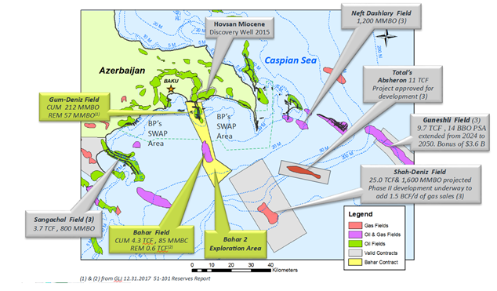
Figure 2. Oil and gas reserves in Azerbaijan
Source: GLI Reserves Report

The richest natural resource in Azerbaijan was oil. But Azerbaijan also counted as a rich country with its other natural resources. Figure 2.1 shows oil and gas reserves in Azerbaijan. Figure represents that oil and gas reserves in Azerbaijan are mainly situated in Absheron peninsula. The most economic activities in Azerbaijan are centralized in this region.
In 1994 years, the most important agreement for Azerbaijan was signed. This agreement was called “Contract of Century” (Bayulgen, 2003). This contract was multilateral contract which 33 oil companies from different countries participated in this agreement.
In 1995 years, the Gross Domestic Product for Azerbaijan was 11, 8% (State Statistical Committee of the Republic of the Azerbaijan, 2016). After these years, The Gross Domestic Product in country began to increase sharply. It was related to rising prices in oil sector and foreign investments in oil sector.
Table 1.
The Gross Domestic Product of Azerbaijan for years
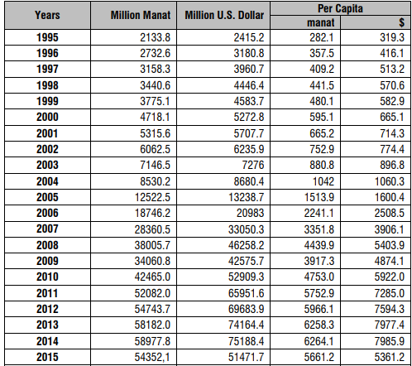
Source: Azerbaijan State Statistical Committee

Oil was always played an important role for the development of the Azerbaijan and most important part of the GDP always came from oil.
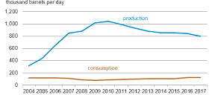
Figure 3. Azerbaijan petroleum and other liquids consumption and production
Source: U. S. Energy Information Administration
New oil reserves have been discovered, in order to this, daily oil production of Azerbaijan also began to increase. Oil production increased from 195.000 barrels per day (Lenczowski, 1997) to 14 million tons in 2000 years and it reached to 22.4 million tons in 2005. The highest level of oil production in the Republic of the Azerbaijan reaches to 44.3 million tons in 2008 years and in 2009 years, it reached to 50 million tons (Nasirov, 2013). Figure 2.3 shows that Azerbaijan petroleum production. Azerbaijan oil production began to increase 2004 and it continued until 2008-2009. This graph shows that Azerbaijan oil production reached its highest level in 2009.
This level of oil production is too much for small country such as Azerbaijan. That’s why Azerbaijan decided to export most of the oil which country produced to the international market.
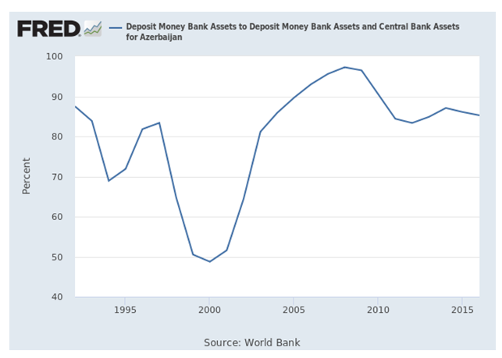
Figure 4. Azerbaijan’s oil production
Source: World Bank Data
Figure 4. shows that Azerbaijan’s oil export from 1995 to 2005. Azerbaijan has become one of the main oil exporters in the region in which Azerbaijan situated (Caspian Sea), for the world export of oil began from 1997 but specially, export of oil for the world began to increase after 2005. The big part of the Gross Domestic Product of Azerbaijan began to come from oil. It began to create a problem. Gross Domestic Product of Azerbaijan began to depend on only one sector-oil sector. It means that any changes in oil prices mostly affected to the country economy. Increasing in oil prices can affect to the country economy positively and can increase Gross Domestic Product but decreasing in oil prices can affect to the country economy so negatively and GDP of the Republic of the Azerbaijan can decrease so badly. It can bring country to the bad results. That’s why depending on only one sector is not good situation for the country.

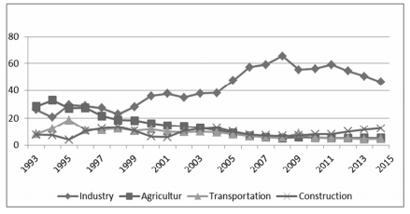
Figure 5. Sectorial distribution of GDP (%)
Source: Azerbaijan State Statistical Committee
Figure 5. shows that sectorial distribution of GDP which consist of industry, agriculture, transportation, and construction. As graph shows that industry was the main part of the GDP for Azerbaijan. Especially, after 1997, industry became the main part of the GDP. The second one was agriculture, the third and the forth one is transportation and construction. This graph compromised between 1993-2015 years.
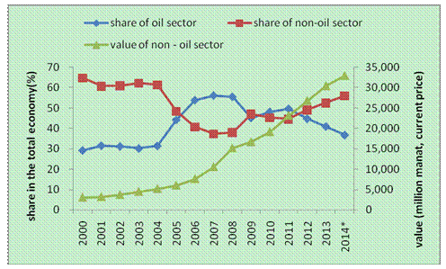
Figure 6. Oil and non oil share in GDP
Source: Azerbaijan State Statistical Committee
Figure 6. shows that oil share in GDP for the Republic of Azerbaijan was more than non-oil share in GDP. This graph comprised between 2000-2014 years. The blue line was share of oil sector, the red one was the share of non-oil sector, and green one was the value of non-oil sector. It shows how Gross Domestic Product of our country depends on oil sector. If country wants to escape from this situation, the best way is diversification of economy. Diversification is that improvement of non oil sector.
If one sector develops more than other sectors, domestic and foreign investments begin to move from other sectors to developing sector. For Azerbaijan, this sector is oil sector which domestic and foreign investors want to invest in. In this case, interests in other sectors begin to decrease and these sectors begin to decline.
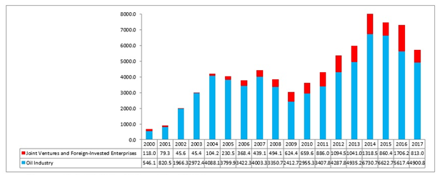
Figure 7. Foreign Direct Investments in Azerbaijan
Source: State Statistical Committee (SSC)
Figure 7. shows that foreign direct investment in Azerbaijan for oil and non-oil sector. The blue color is oil industry. The graph shows big interest for oil industry by foreign investors.
Depending only one sector can bring country to the devaluation. Any changes in oil prices can bring country to this result. Example of this-2015 devaluation:
The present currency of the nation was in power since 2006 and in that year the exchange rate for the country was AZN 0.87 per $. Starting from 2006 manat acknowledged to 0.78 and after this it remained to some degree stable until 2015 as the accompanying figure appears:
Currency of Azerbaijan faced 2 devaluations during 2015 years.The one, occurred in the February 2015, exchange rate 1.05 AZN = 1USD, which was 0.7850 AZN = 1 USD previously. It was 33.86 percent more than the conversion standard set before the start of the debilitating procedure of the rate. Despite the fact that Azerbaijan Central Bank guaranteed a continuous debasement, it happened forcefully. Afterward, on December 16, 2015, FED raised loan costs by 25 premise focuses, which was the principal ascend since 2006. Following this choice, on December 21, 2015, the Central Bank of Azerbaijan changed to a coasting rate routine. Unmistakably moving to gliding rate hydro happen sometime, however the issue is tied in with timing. Changing to flexible rate made manat lose half of its incentive against dollar (1 dollar=1.55 manat). Thus, the currency of Azerbaijan began to lose its value around 98 percent.
Why the government of Azerbaijan devalued its national currency-manat?
1.Financial reasons for that;
Sparing State
Cash of Oil fund of Azerbaijan:
As per Azerbaijan Statistics Agency, oil and oil items industry formed65 percent of the spending income in 2015. Since the oil costs began to diminish on the planet advertise, Azerbaijani State Oil Fund incomes diminished to USD 8636 billion. By means of deterioration of manat around 34%, the SOFAZ salary becomes AZN 9067 billion in home cash which was the monetary objective of the SOFAZ. (oilfund.az) -
Sparing the Central Bank's diminishing stores:
After expanded oil costs, Azerbaijan Central bank had been utilizing its stores to keep up the fixed rate of manat. Henceforth, debasement of the national money was a security against Central Bank’s diminishing stores.
- Enlarging the nation's GDP in Manat terms:
According to World Bank information,Gross Domestic Product of Azerbaijan fallen from USD 75 billion to USD 53 billion during 2014. Humiliations of manat enlarge the Gross Domestic Product of the country inmanat terms.
2.Empowering non-oil segment:
Neighbor nations of Azerbaijan Russia, Turkey and Georgia have encountered money debasements as of late. Be that as it may, Manat had been acknowledging since 2006 and this made Azerbaijani items progressively costly in dollar terms. Henceforth, through deterioration Azerbaijan items may appear to be progressively alluring to its accomplices and it will improve non-oil segment.
3.Expanding of inflation rate/advancing remote speculation:
Downgrading of Manat caused import costs to rise and expanded expansion. Along these lines, Azerbaijani government was expecting to support both remote and neighborhood speculation.
The figure shows that inflation rate has increased from 4 percent at the end of 2015 years to 13.6 percent in January, 2016. Especially food prices in Azerbaijan has risen contiguous %14 from 2015 to 2016.
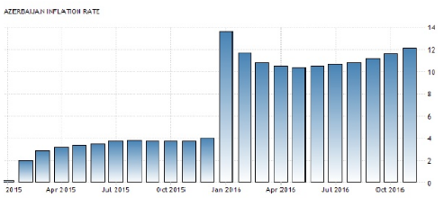
Figure 8. Azerbaijan inflation rate
Source: Azerbaijan State Statistical Committee

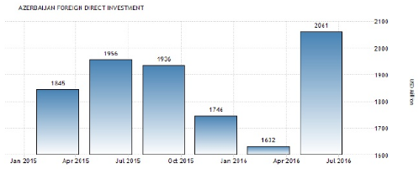
Figure 9. Azerbaijan foreign direct investments
Source: Azerbaijan State Statistical Committee
When we consider imports and exports of the country, we expect imports to decrease
– As foreign products will be harder to afford, and exports to increase - as national products will be cheaper in dollar terms
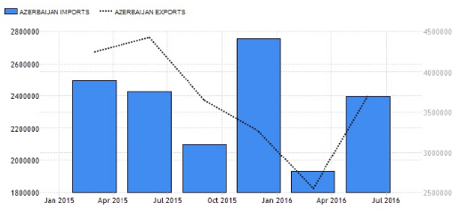
Figure 10. Azerbaijan import and export
Source: Azerbaijan State Statistical Committee
Figure 10. show that the import and export of Azerbaijan from the beginning of 2015 years until mid 2016 years. It depicts that imports have fallen sharply from January to April, however after that we again see imports increasing. Considering exports, consequences of devaluation did not emerge right after devaluation (December, 2015), rather we see increasing exports starting from April, 2016. Now the exchange rate is AZN 1.80 per dollar. In spite of two devaluations there is still extensive demand for foreign currency. Some banks declared bankruptcy including Bank of Standard and Bank of Azerbaijan. Other banks have completely stopped foreign currency sale or limited it to special amount per person. (Like $100 per person and $500 for the ones who has a ticket abroad).Above discussion shows that the some expectations of Azeri government have not realized yet and after current devaluations Azeri population no longer trust national currency.

2.2. Sectorial analysis of Azerbaijan
Agriculture and cattle breeding are the most important sectors among the non-oil sectors in socio-economic development of Azerbaijan. Azerbaijan’s rich agriculture areas and regions with different climate zones make possible to grow quality and wide range products. 9 out of 11 climatic zones of the world are available in Azerbaijan. This diversity extends from subtropical climate to tundra climate. It is possible to get a product more than once in a season. The variety of climate makes possible to grow various sorts of harvest. In short, being favorable for agriculture Azerbaijan’s main agricultural products are wheat, tobacco, tea, olive oil, fruit and vegetables. The country has enough potential to produce grain and satisfy internal demand.
Areas of private property came to an end in the agricultural sector after invasion of the Soviet Union in 1920 and managed by cooperatives named collective farmsand state farms which were state properties. During this period, the central government was planning where any product should be manufactured and where should be sold.
Table 2.
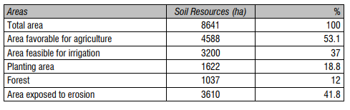
Source: Azerbaijan State Statistical Committee

During 2014-2015s, quite impressive processes taking place in Azerbaijan's economy. Thus more than ninety percent of exports were oil products. Improvement of agriculture and agricultural goods and services and diversification of export of the Republic of Azerbaijan increased its significance due to significant decrease in oil prices in the world market. 55.1% of the country's territory is arable land. 30.1% of this area is used as pastures and hayfields. In 2014 the total sown area of agricultural crops was 1, 6 million hectares. In the context of the economic division, the distribution of the arable lands is listed below; 0.2% of Absheron economic region, 12.07% of Ganja-Kazakh economic region, 11.9% of the Sheki-Zagatala economic region, 7.2% of the Lankaran economic region, 7.8% of the Guba-Khachmaz economic region, 42.8% of the Aran economic region, 7.4% of the Mountanous Karabakh economic region, 0.2% of Kalbajar-Lachin economic region, 6.5% of the Shirvan economic region, 3.93% of the Nakhchivan region. Gas and oil in mining industry of the Republic of Azerbaijan of production takes the important place, the share of agriculture in GDP is not so high. In 2014 total agricultural products were 5.2 billion AZN or 5.3% of the country's GDP. Cattle-breeding goods are also so important for Gross Domestic Product of Azerbaijan. Considering the economic factors, 92.3 percent of agricultural products produced by individual entrepreneurs, family and households, 7.7 percent of them were produced by agricultural enterprises and other organizations. Although the share of agriculture in Gross Domestic Product is little, it plays an important role in ensuring employment in the country. According to official statistics, 37.1% of the employed population works in the agricultural sector. Out of the major factors of production, the small number of officially registered, specialized individuals and legal entities who can act as a coordinator or direct executor in export and foreign trade are one of the main obstacles in front of the growth of international trade of agricultural products. In general, the country's total exports in 2014 were $ 21.83 billion, and imports - $ 9.19 billion, for the period from January to June 2015, export outputs were $ 6.23 billion and $4.52 billion, respectively. The following table shows foreign trade statistics for agricultural products of the Republic of Azerbaijan for 2014. The main agricultural goods groups in the country’s export are vegetables, roots and tubers, edible fruits and nuts, citrus fruits, animal or vegetable fats and oils make $ 481.4 million together (89.3%). Cereals (52.7%), animal and vegetable fats and oils (13.7%), live cattle (8.1%) and dairy products, poultry, eggs, natural honey and other food products of animal origin (10.7%) goods groups have more weight in import.
Table 3.
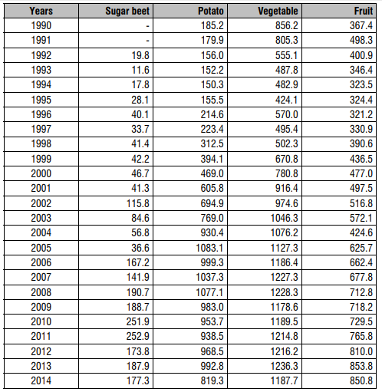
Source: Azerbaijan State Statistical Committee
In 2014 years, the trade of agricultural products accounted for 2.5 percent of exports and 7 percent of imports.
STOCK-BREEDING -The animals (99.8% cattle, and 98% small animals) belonged to the state and after 1996 distributed to the private sector. Other animals are used by government as a pedigree. One of the most profitable businesses was the cattle-breeding after the independence. The cattle-breeding met the domestic demand after the independence. However some decreasing was observed in the cattle-breeding until 1998. On the other hand, the increase was observed in the meat and milk production in comparison with the previous years. The huge amount of the production was provided by the farmers. As a result of the privatization policy which realized in 1998, the cattle-breeding increased. Furthermore the quality of the milk products improved. Azerbaijan companies produced more than 15 types of the products (sour clotted milk, cheese, milk and etc.,).
SERVICE SECTOR- The share of the service sector in GDP was 52.4 percent in 1998, 48.0 percent in 1999, 41.7 percent in 2004, 40.8 percent in 2006, 36 percent in 2008 and finally 33 percent in 2015.Important sub-sectors of the service sector will be elaborated on below.
MINING INDUSTRY- Azerbaijan has rich underground resources. The most important resources are; oil, natural gas, copper, zinc, lead, sulfate, gunpowder, ore, mercury, molybdenum, cobalt, arsenic, marble, limestone, salt mine and rock-salt. The use of the natural resources was planned according to the short and long term demands. Several important mineral deposits were not used conveniently. Azerbaijan has 200-250 million tons iron reserves. The extraction of the iron ore was suspended after the collapse of the Soviet Union. The reason was the refusal to buy and general decrease in world market consumption of ore products, which stipulated by switch of industry to aluminum and plastics. However the German and English companies are interested in the restoration of the deposits. The agreement with the “RV Investment «company of the United States was attained in accordance with the using the gold resources. The agreement was signed for 25 years. According to the agreement the U.S. Company will invest $620 million dollars for 6 gold reserves($500 million dollars for operation and 120 million dollars for development). The gold reserves are located in Gedebey, Dashkesen and Kalbajar, which is invaded by the Armenian troops. “RV” company is planning to start operations based on the price of the gold in the world market34. The mining sector needs urgent modernization. Consequently the mining sector is confronted with the significant problems. The lack of the modern technology is the most important problem of this area.
Electricity. There are 8 thermal power stations and 6 hydroelectric power stations in Azerbaijan, which utilized for 85% of their capabilities. These electricity power centers were built during the soviet period, and they have not been used relevantly after the independence. 82% of the electricity is produced in thermal power stations, and the other 18% is produced in hydroelectric power stations. The liberalization of the prices also affected the price of the electricity. The electricity which is produced in Azerbaijanwas not enough to meet the domestic demands. The problem displayed itself in the winter months especially. The reason of the problem was the old technology, which was used in the electricity production.
On the other hands the production loss increases gradually because of the inconvenient distribution of the electricity. Azerbaijan imports energy from Russia, Turkey and Iran. Azerbaijan joined European Union program in order to establish united energy system with Azerbaijan, Turkey and Georgia. On the other hand Azerbaijan implements privatization program in order to abolish the loss in energy sector. In 1996 the president Heydar Aliyev signed decree on the privatization of the “Azərenerji” for 5 years. Azerbaijan was consisted of 5 regions in 2000, in terms of the energy issues; Baku, Nakhchivan, North (Sumgayit), South (Shirvan) and West (Ganja). The establishment of the joint-stock companies was planned in for those regions. There is a fuel problem in line with the electricity production in Azerbaijan. The electricity networks of Baku, Sumgayit, Shirvan and Minghachevir were given to private sector in order to meet the oil and gas demands of the country35. The distribution of the electricity was given to Turkish company “Barmek Holding” with the decree of the president in the 1st January, 2002. The electric networks of Baku and North were managed by “Barmek holding” while other regions were managed by the “Bayva” company. Then the BayvaCompany rejected the management of these regions. As a result the authority was given to “Azərenerji” back. The electricity systems of Baku have been managed by “Bakı Elektrik Şəbəkə” and the electricity systems of Sumgayit has been managed by “Sumgayit Elektrik Şəbəkə” since 2007. The reconstruction of the electricity system of Azerbaijan was discussed in several projects. Recently President Ilham Aliyev signed decree on the “Establishment of Azerisig Open Joints Stock Company” and this company took the rights of “Baki Elektrik Shebeke” and partly electricity producer Azerenerji for Absheron peninsula. The foreign investors are interested in electricity, but no more than the oil sector. In 2002 the construction of the Yenikənd Hydroelectric Power Station was completed. The completion of the reconstruction of the Minghachevir Hydroelectric Power Station increased energy potential of Azerbaijan. In 2000, the construction of the “North” electricity station was started near Baku (The value of it was $201 million dollars). The Japanese companies such as Mitsui and Mitsubishi, the Turkish companies TML Borova and the Swedish company ABB were the subcontractors in this project in order to increase the operational capability of the station.
Tourism. For the tourism sector, there are natural, historical and cultural resources, namely, climate, natural beauty, historical and archeological potential available in the country. 9 out of 11 climate zones exist in Azerbaijan, as well as the coasts of the Caspian Sea, wooded area in Khachmaz-Lankaran-Astara regions and springs for treatment purposes attract attention. All-union and international tourist routes functioned in Azerbaijan were cancelled since 1st quarter of 1990. The war and instable situation on borders led to occurrence of other problems in the system of tourism. For example, 2 of 10 tourism centers in the system of the trade unions left in the occupied territories and other places were accommodated with internally displaced persons. In September 1991 the department on foreign tourism wasliquated and Foreign Tourism Council was established in its place under the auspices of the Cabinet of Ministers of the Republic of Azerbaijan. Only at the end of the 90-es the trends of tourism development were reflected in the legislative acts of the country. Already at the beginning of the XXI century in Baku, Ganja, Nakhchivan and other regions of the country modern hotels that can accommodate foreign guests operated. More than 500 tourism companies covering all regions of the republic are engaged in accommodation of foreign tourists and servicing local population with tourist services, and 540 hotels have been officially registered. The total amount of beds in those hotels is more than 50000. Private treatment and resort centers with modern level were given for use in the regions suitable for tourism and recreation. The number of foreign tourists visited the republic passed the 2,5 million people. Owing to the favorable climatic conditions, significant number of tourists was attracted to the country during the Soviet Union. Hotels and beaches back at those years indicated that
The areas forming the tourism sector in Azerbaijan can be focused on under the following subheadings; Holiday Tourism: The most appropriate regions to rest, especially, during summer months are Zagatala, Sheki, Guba, Ganja, Gazakh and Lankaran. Plateau and Mountain tourism: The suitable areas in Azerbaijan for plateau and mountain tourism are Zagatala forests, Shaki Gelersen-Gorersen tower, Basdasagil, Guba, Ismayilli, Lahij, Gabala, Agdash forests, Ganja, Hajikend, Goygol. Bath and Health Tourism: Azerbaijan is rich in drinkable and treatment-purpose mineral water resources. There are nearly 2000 mineral water sources providing 200 million liters of water. In addition, the muddy water with mixture of oil in “Naftalan” is good for nervous system, skin, and gynecological and other diseases. Many of the specific therapeutic sanatoriums are located in the Absheron peninsula. Beach Tourism: Azerbaijan surrounded by the Caspian Sea, is favorable in terms of beach tourism. Bilgah and its surrounding have beaches stretching kilometers. Hunting Tourism: There are 97 species of mammals, 346 species of birds and 95 species of fish in Azerbaijan. In the country, different regions of which have favorable conditions for hunting tourism, permission should be given to use shotgun. At the same time, membership of every gun owner is mandatory in the society of hunters. Cultural Tourism: Azerbaijan owns very rich cultural and historical treasure. Various organizations have been set up to protect and restore ancient monuments, graves, tombs, building and other historical works. Owing to natural wealth, the development of tourism in Guba-Khachmaz, Astara-Lankaran, Shaki-Zagatala, Ganja-Khanlar, Shamkir-Ismayilli, and Siyazan-Khizi is more appropriate. Considering the number of tourists entering the country, it is observed that very few of them come from developed countries. Tourists from the CIS countries are prevalent.
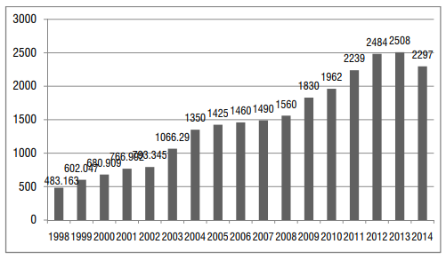
Figure 11.
Source: Azerbaijan State Statistical Committee
Transport and communications. Communication and transport division has an offer of over 7 percent of GDP. In 2014, the volume of transport administrations decreased 1.6% contrasted and a past, services of communication expanded 4.4%. A segment of the oil transported from Turkmenistan and Kazakhstan within Iran and Russia, negatively affects the volume of freight travel within Azerbaijan.
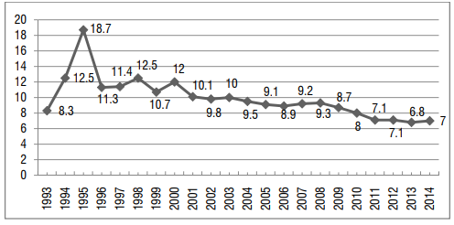
Figure 12.
Source: Azerbaijan State Statistical Committee

In 2008 years, 56.5 percent of the freight conveyed as transported by street. 15.4% of loads are transported by pipelines, 17.8 percent by rail, and 11.2% via ocean. 57.8% of freight, 84.7% of travelers was completed by exclusive vehicles. 57.9% of payload was transported by street in 2015. 27.7% of the payload transported pipeline, 9.8% by railroad and 4.5% via ocean. The private division share in the zone of correspondence administrations has developed every year. At last, the offer of private division in 2009 was 71.3%. 74.2% of correspondence administrations were done by the private division. In the coming years, the offer of the private division will keep on ascending in the zone of correspondence administrations. The restricted access to untamed oceans and streets don't fulfill the needs of worldwide principles are the most significant issues. Communication division is developing because of coordination through the world.

3. STRATEGIC REVIEW FOR AZERBAIJAN ECONOMY

The main aims and future plans of Azerbaijan can be divided into 3 groups;
- Plans till 2020
- Plans between 2020-2025
- Plans after 2025

Plans till 2020. Till 2020, strategic review for Azerbaijan economy to protect exogenous shocks, to relieve negative effects, to stabilize economy for short term, to diversify economy for medium term and for long term, through integration to the world market to achieve to increase competitiveness of the country in the world.
Azerbaijan economy faced two big devaluations such as 2008 and 2015 devaluations. These devaluations affected to the economy so negatively; high prices, high inflation rate and so on. The effects of devaluations are still remaining on the economy. The main target of the country must be relieved from these situations. For long term, some economic factors must be solved for the economy for example inflation rate must be kept under control. High inflation rate affect to the economy negatively. High inflation rate bring to the economy to high prices. That’s why inflation rate cannot be so high.
The main target of the Azerbaijan is to decrease depending on oil. One of the main goals of Azerbaijan is to develop non-oil sector, to increase value of the non-oil sector through diversification of the economy. For a long period, Azerbaijan economy depends on oil. Benefits from oil are to increase welfare of people and to increase employment level of people. People who work in oil sector constitute little percent of general employed people in Azerbaijan. Benefits which gaining from natural resources is to increase employment level in construction sector. Development of infrastructure and development of business environment will help to attract investments (foreign and domestic investments) to the economy and will help to create new job places in the service sector.
Strategic review for 2020 compromise increase the ways which can integrate to the world market. One of the goals for till 2020 is development of trade infrastructure but at the same time protecting of domestic market.
For increase durability of development of economy, the main goal should be decreased depending on oil of state budget and state currency. Benefits which gaining from oil mostly affects to the goods and services in the economy. Any changes that happen in oil prices disrupt of the stabilization of economy. Profits which gaining from oil is the main source of the foreign currency for Azerbaijan. Changes in oil prices cause to loss value of national currency.
To decrease depending on oil, “Gold Rule” should be applied. According to this rule, profits of oil should be distributed between generations through fairways. Money policy will increase stabilization of currency. Regulated fiscal policy will be created and it will affect to economic growth in positive ways. The target of monetary policy, regulated fiscal policy, the aim of economic growth will support each other. Deepness of financial market, kind and quality of service sector will increase.
For 2020 strategic review, social effects will be appreciated. New job places will be created, range guarantee will be improved. Education and health sector will be developed according modern ways. Communication sector will be also improved. Another aim for 2020 strategic review is improvement of welfare of people.
Plans till 2025. The main goal for 2025 strategic review is to achieve durability of long term development and to create ability of competitiveness in the world market.
Till 2025, free competitive environment will be improved. One of the main goals of this strategic review is to attract many investors to the economy and expand integration ways to the world market. Protecting of macroeconomic stability, improvement of business infrastructure and investments on private sector are the main targets for 2025 strategic review.
To achieve diversified economy country must be kept macroeconomic stability. For next 10 years, diversified profit structure will be created. Regulated fiscal policy, using from “gold rule”, diversified profit structure are to protect economy from changes in oil prices. It will also help keep state debts in low level.
Another target for 2025 strategic review is for effective fiscal and monetary management, financial stability and liquidity will be provided. It will help to macroeconomic environment and will also help to attract international investments and trade movement to the country. Beside, international investments, foreign investors, domestic investors will be attracted to the economy. It will help diversification of capital markets and will help to decrease volatility in the economy. Until 2025 in the financial sector short-term stability will be provided. Until 2025 financial sector will be prepared for rivalry at the global level. For development of business environment, infrastructure of private sector will be provided. The Republic of Azerbaijan government will help to domestic organizations for development of business environment.
Non-oil goods and services will integrate more to the world market and will begin to increase its share in the GDP. Azerbaijan will try to improve its non-oil sector for decreasing of depending on oil. First of all, Azerbaijan has a great opportunity for development of agricultural sector. Agricultural goods and services will be produce more and will be sent more to the world market. These goods and services will be sent to European countries and will increase their capability to reach to world market.
Domestic brand of Azerbaijan- “Made in Azerbaijan” will be held its own place at the global level for 2025 strategic review. Export of non-oil sector will be increased according to 2025 strategic review.
For improvement of trade and quality, international standards and certificates will be applied. These standards will help exports of goods and services for competitiveness in the world market. The level of consumption will be increased. Domestic organizations will be able to improve their quality of goods and services for domestic and foreign markets according to 2025 strategic review.
New investment agreements will be prepared and new foreign investors will be attracted to the economy. New suggestions and privileges will be prepared for investors and it will attract more investors to the economy of country. Services for available and potential investors will be increased such as new technologies, more available construction environment; new construction firms will be provided for investors. Such investments will increase demand in the economy and increase variety in the economy. These investments will also help to development of education sector. New technologies and new methods will be applied to the education sector of the country.
Strategic review for after 2025. The aim of strategic review for after 2025 is that increasing welfare of people, development of human index through new technologies and optimal economic structure. Another aim of strategic review for after 2025 is to create strong competitive environment.
The first condition for good quality of life is welfare, medicine, and education. Level of education, medicine will be developed in the Republic of Azerbaijan. Level of poverty in Azerbaijan will be declined according to strategic review for after 2025. The good environment for good quality of education, medicine will be created.
The minimum wage of people will bring to closer to 60 percent of average wage of Azerbaijan Republic. This movement will increase social welfare between people in Azerbaijan.
According to development of economic perspectives strong urbanization process will be held and it will increase social welfare of middle level of people, it will also increase financial welfare of middle level of people; it will also increase purchasing power and productivity between people. Through these ways, index of economic development will be kept at highest level.
According to strategic review for after 2025, the young people and women will be attracted to the employment. It will increase productivity in the economy of The Republic of Azerbaijan. The employment level in Azerbaijan will be increased through opening of new job places, attracting of foreign direct investments or other type of investments. The unemployment level in Azerbaijan will be declined. Strong and innovative employee power will increase position of The Republic of Azerbaijan at global competitive level.
Development of new technologies will help to development of service sector in Azerbaijan. It will also increase to expand of communication system in Azerbaijan.
Azerbaijan has a great opportunity for development of tourism sector. According to after 2025 strategic review, profits which gain from tourism sector will be increased. The Republic of Azerbaijan will try to increase the number of tourists who come to visit Azerbaijan. Through strong marketing strategy, good advitersement can be attracted the tourists to the Azerbaijan. Through these ways Azerbaijan can decrease depending on oil and can diversify its economy. Diversification of Azerbaijan economy means that Azerbaijan will has more strong economy. Developed countries have diversified economy, but developing countries have undiversified economies. Diversification of Azerbaijan economy means that Azerbaijan can reach to the level of developed countries and it will increase the position of Azerbaijan in the world and it will also increase the position of Azerbaijan in the world market.

CONCLUSION

So, there are some countries that suffer from having resource-based economies. Although having natural resources such as oil, gas, etc. can be considered as an advantage, however, experiences depict that countries which possess those resources are not inclined to develop other fields of the economy and they mainly focus on one sector. As a result people welfare becomes dependent on one field. This situation leads to many problems especially when those resources exhaust or demand for them goes down.
Azerbaijan is also one of these countries and its economy is oil-based. After the independence of the country, the government paid attention basically to the oil-sector and foreign investments were attracted to that field. This caused some problems and in recent years it became more obvious. After the sharp fall on the oil price (2014) in the economy were clarified. Having an undiversified economy affected people’s welfare. So, the country’s currency, the manat, devaluated two times which this accident happened in 2008 and 2015 and lost its value in 2015. In fact, the government could handle this problem without severe impacts on society, if there would be a diversified economy. That means, if Azerbaijan could export products that are not related to oil, then devaluation would bring positive results. So, the product which Azerbaijan would export would become cheaper and it would bring a comparative advantage.
However, after the oil price fall, the governmenttook a number of steps in order to support the non-oil sector. “Strategic Road Map” was designed to eliminate the problems related to depending on the oil sector. In fact, this road map can help to diversify the economy if the requirements are implemented continuously. The diversification of the economy is the only way to decrease depending on oil.
The agriculture sector can be thought of as one of the alternatives to the oil sector. Because in the near past, during the USSR, this field had been developed. Azerbaijan has a great opportunity for development of agricultural sector. However, after the independence of Azerbaijan, all attention was paid to the oil sector. As a result agriculture sphere was left behind the improvement. Nevertheless, this area has great potential to be improved. This is the only one way to diversify economy.
Tourism is also a very profitable area for the country. In order to improve this sector, the government should try to simplify the Visa procedures. The number of tourists who come to visit Azerbaijan should be increased.
The construction sector is also good alternative for the diversification of the economy. Azerbaijan has a great opportunity for development of this sector.
Education and medicine is also good alternative for development of non-oil sector. Through new technologies, increasing of capability of employees will affect Azerbaijan economy in good ways.
In conclusion, it has to be stated that foreign investments have to be attracted and directed to the non-oil fields in order to avoid suffering from the resource curse.

REFERENCES

- Azərbaycan Respublikasının milli iqtisadiyyat perspektivi üzrə Strateji Yol Xəritəsi - https://static.president.az , (accessed May 21 2019).
- Development concept “Azerbaijan – 2020: The vision of the future” -https://www.undp.org/content/dam/azerbaijan/docs/sustain_development/AZ_Vision2020_government_draft_en.pdf , (accessed May 21 2019).
- Economic analysis (summary) https://www.adb.org/sites/default/files/linked-documents/cps-aze-2014-2018-ea.pdf , (accessed May 21 2019).
- http://www.azerbaijan.az/_Economy/_Reforms/_reforms_e.html#top , (accessed May 21 2019).
- https://www.azerbaijan.com/v/economy/ , (accessed May 21 2019).
- https://www.imf.org/external/pubs/ft/fandd/basics/dutch.htm , (accessed May 21 2019).
- Statistical Committee of Republic of Azerbaijan https://www.stat.gov.az/?lang=en , (accessed May 21 2019).
- World Data Bank https://data.worldbank.org/ , (accessed May 21 2019).
- https://www.economy.gov.az/en/article/non-oil-industry , (accessed May 21 2019).
- http://cesd.az/new/wp-content/uploads/2018/04/CESD_Paper_Oil_Price_and_Azerbaijan_Economy.pdf , (accessed May 21 2019).
- https://www.azernews.az/business/127199.html , (accessed May 21 2019).
- https://www.academia.edu/4919635/The_Role_Of_The_Fiscal_Policy_In_The_Development_Of_The_Non-Oil_Sector_In_Azerbaijan , (accessed May 21 2019).
- https://bakuresearchinstitute.org/analysis-of-main-problems-facing-azerbaijans-non-oil-exports/ , (accessed May 21 2019).
- https://www.researchgate.net/publication/320840500_APPROACH_TO_THE_AZERBAIJAN_ECONOMIC_STRUCTURE_NON-OIL_SECTOR , (accessed May 21 2019).
- https://www.azerbaijan.com/v/economy/ , (accessed May 21 2019).
- http://www.azerbaijan.az/_Economy/_Reforms/_reforms_e.htm , (accessed May 21 2019).
- http://files.preslib.az/projects/azerbaijan/eng/gl4.pdf , (accessed May 21 2019).
- http://www.applet-magic.com/azerbaijan.htm, (accessed May 21 2019).
- https://heep.hks.harvard.edu/files/heep/files/dp21_frankel.pdf , (accessed May 21 2019).
- https://hal.archives-ouvertes.fr/hal-01217075/document , (accessed May 21 2019).
- https://www.theatlantic.com/international/archive/2012/04/why-natural-resources-are-a-curse-on-developing-countries-and-how-to-fix-it/256508/ , (accessed May 21 2019).
- https://www.nber.org/papers/w15836.pdf , (accessed May 21 2019).
- https://bakuresearchinstitute.org/analysis-of-main-problems-facing-azerbaijans-non-oil-exports/ , (accessed May 21 2019).
- https://www.export.gov/ , (accessed May 21 2019).
- http://www.worldstopexports.com/azerbaijans-top-10-exports/ , (accessed May 21 2019).

