The Ministry of Education of Azerbaijan Republic

International economic cooperation of global petroleum energy sector
Fidan Guluzade

UNEC SABAH
University of Economics
JUNE 2019

Table of Contents
Abstract 2
Acknowledgement 3
Introduction 4
Research methodology 5
Chapter 2. Theoretical analysis 6
2.1 Theoretical and methodological basis of International economic cooperation of global petroleum energy sector 6
2.1.1. The concept of International economic cooperation 6
2.1.2. Institutional composition of energy security and innovations 11
2.1.3 Energy sector problems in developing countries and in developing countries 18
2.2 Global petroleum policy 26
2.2.1 Drivers of international petroleum energy policy 26
2.2.2 Influence of worldwide international petroleum corporations on economy 32
Chapter 3. Challenges of alternative energy for petroleum sector 38
3.1 Future vision and forecasts on petroleum energy 38
3.1.1Socio-economic impact of alternative energy 38
3.1.2 Global forecast on energy sector 43
Conclusion 48
Reference 50

Abstract
The objective of an effective methodology is to create an evaluation mechanism for the global oil and gas sector's activity, which can influence the global oil industry for the purpose of analyzing the importance of international economic cooperation. Current energy supply was required, as production capacity increased. Over the past decade, international cooperation has succeeded in broader opportunities and long-term sustainability to implement various medium and long-term programs. Therefore, the importance of international cooperation is growing.
Thesis includes a justification for the need for a fairly accurate prediction methodology for reflecting existing problems in literature research and the increased cooperation in the field of petroleum energy. As a result, information on system load behaviors such as high demand scenarios and wavelength bandwidth assessments is developed. As a result, there are various information about perspective equipment that may be inclined to make decisions.

Acknowledgement
The success of my thesis was largely due to the promotion of players who played a major role. I express my gratitude to the Deputy Chairman of the State Agency for Alternative Energy Parvin Mammadzadeh for his gratitude and support. In addition, I express my gratitude to Aida Gulieva, Dean of the SABAH Group. Probably she does not know, and will never know how much she has contributed me in my academic research and my life.
I would like to thank the professors who are constantly standing for me and thanking everyone who has made progress in my research.

Introduction
Currently, international economic co-operations for petroleum sector play the instrumental role in stimulation global world economy. Strong energy demand was crucial for international companies to collect revenue and manage them in the country to understand the importance of the oil company's resources. At present, the global world depends on oil revenues and the financial management of oil countries to prevent the Dutch disease. Therefore, states are trying to improve joining international cooperation for global petroleum sector to overcome this dependency and maintain economic sustainability. Using energy sources can make sure that we will have enough energy and future generations to be relieved of uncertainties that depend on foreign energy suppliers.
The purpose of the diploma work is to explain the importance of international energy cooperation for energy sector sustainability and comparable analysis of impacts of international cooperation to state policies. Then analyze long-term comparative energy scenarios.
The subject of the research is the economic and political stability of the emerging and emerging countries for the development of international energy cooperation for the oil and gas sector.
Research objects are emerging from emerging emerging economies and global energy carriers. Problem statement - this writing assignment analyzes several types of implementation –management of international energy cooperation for petroleum energy sector, positive and negative factors, and the ways of revenue energy for future generations.
The research questions are the followings:
- The role and influence of the international energy cooperation on domestic economy of the countries
- The ways of joining international economic cooperation and its further implementation
- The ways of increasing of energy security and innovations
- The drivers of petroleum energy policy
- Future vision and forecasts on global and international economic cooperation for global petroleum energy sector

Research methodology
The nature of the study will be mixed, employing exploratory and inductive research types. Through intelligence research, a quality methodology will be used to study PUs in international cooperation. The research will use one of the commonly used methodological designs. The following structure is proposed for the methodology; Various scientific articles will be used to determine the structure and examples to be applied in the first stage.
At the second stage, an approach will be used to gather information through selected countries' interviews, documents and observations. The research will focus on information and experience of leading countries, which joined international energy cooperation, especially developing countries. In addition, energy security and development of energy policy in the world. In the forecasted part of the study, it is summarized from the analysis of future impacts, case studies and projections for management and business culture of these countries.

Chapter 2. Theoretical analysis
2.1 Theoretical and methodological basis of International economic cooperation of global petroleum energy sector
2.1.1. The concept of International economic cooperation
Although some economic cooperation structures have been a part of international political relations during recent century, nearly all of the countries are involved and concerned in international economic cooperation. Furthermore, the importance of economic cooperation has significantly improved. The leading reasons behind to develop social-economic policies and to ensure stability in the world. These issues are: there is sharp fluctuations in exchange rates, and in trade balance there is enormous shifts, and the quick-tempered growth of debt between many of the developing countries.
Figure 1: Increased international trade
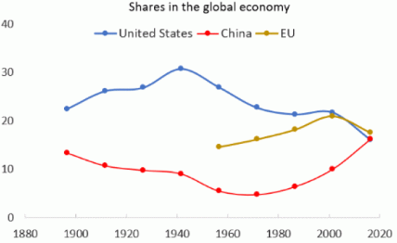
Source: Steering the world toward more cooperation https://textile-future.com/archives/14318
The enlarged interest in international economic cooperation also reflects the extra elementary changes in the world economy that have been growing over a longer period. The world economy has become additional interdependent: international trade has amplified relative to production for domestic markets and international capital markets have become bigger and more dynamic. In adding together, the United States has gone the main economic position, so as to it enjoyed in the untimely postwar years. Japan Economic Community and the European Economic Community (EEC) have become most important economic powers that try to win successfully in trade and finance.
The modern global economic system is a product of the complex evolution of the system of international economic relations. In search of effective forms of interaction between them and self-improvement within the framework of the system of interaction between regions.
International cooperation is irregular in content, their role in the process of replenishing and scaling entrepreneurs, while the structure of the global economic system itself is irregular. They form a certain hierarchy in accordance with the stage of involvement of individual segments of the economic system in the processes of international cooperation, creating conditions for macro-cooperation (i.e. Interactions between countries), meso-cooperation (for interaction between regions, divided into countries) and micro cooperation (that is, cooperative interaction between enterprises in the region).
Enterprises involved in free relations, as a rule, have higher levels of production development, competitiveness and transparency, etc. International cooperation is usually associated with blue chips, which have sufficient export potential, excellent business development scaling and international dynamics. economic relations. Cooperation is a powerful factor in growth in the region, because it contributes to raising awareness of the specifics of production and international labor, in more efficient use of economic resources (i.e. Justice, labor, environmental assets), technically progressive, improving labor efficiency and, as a result , a gain in social productivity.

Figure2: Share of World economy
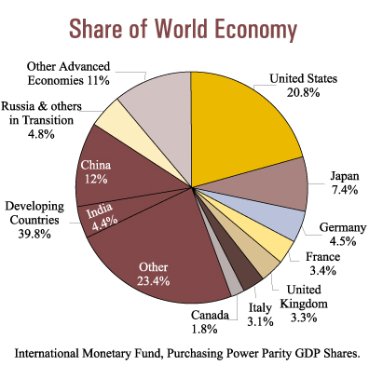
Source: https://www.budget.gov.nl.ca/budget2000/economy/international.htm
International production cooperation occupies a leading position among other forms of business cooperation due to its objective advantages: increased production through joint cooperation with economic actors, its efficiency, sales, service, maintenance and management of R & D means the competitiveness of companies, regions and countries.
International production cooperation provides a range of opportunities to create new or modernized markets with the help of competing production technologies with less own investments, as well as improving industrial management and marketing methods. The analysis of economic and social systems shows that international-interregional activities (in accordance with the Russian classification of types of economic activity) is the most effective way of working.

Figure3: Global Economic Growth Outlook
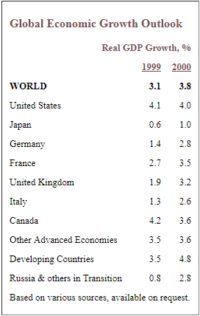
Source:https://www.budget.gov.nl.ca/budget2000/economy/international.htm
Global trends make it compulsory to create international organizations for cooperation, and of them is OECD. The Organization for Economic Co-operation and Development is a kind of association in which the 30 governments’ market democracies work together to solve and address the economic, social and governance problems that arise in the context of globalization, and explore the opportunities that it provides.
It is an association in which this organization has ability to put the pressure to member countries, in order to stabilize policy in governments and drive international tools, solution and recommendation in those areas where multilateral treaty is needed for individual governments to improve progress in the context of economic globalization. Countries that are not members of the OECD are invited to join these agreements and treaties.
Over the last decade, the OECD has addressed a wide range of social-economic and environmental problems while further expansion of interaction with trade unions, business and the others’ representatives of civil community.
For example, the negotiations on taxation and transfer pricing conducted by the OECD triggered bilateral tax treaties around the world.
Figure 4: Real GDP, year on year change, %, selected OECD and G20 countries
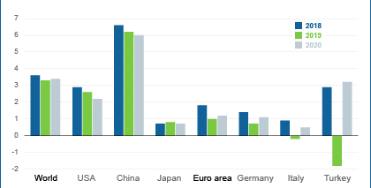
Source: OECD International Economic Outlook, March 2019
Another organization which is acting on a global area is IMF. The association that named International Monetary Fund (IMF) seeks global financial stability and cooperation in the monetary and financial sphere. IMF supports international finance and its stability and co-operation in the field of monetary and finance. It also emphasis on the development of international trade, higher employment rate, sustainable economic development and reduction in the rate of poverty.
The IMF is managed and accountable to 189 member states of the organization. The idea of ​​creating the IMF, also known as the "Foundation," originated at the UN conference in Bretton Woods, New Hampshire, USA, in July 1944. The 44 countries represented at this conference aimed to form the basis for economic cooperation in order to avoid the recurrence of devaluations in order to obtain competitive advantages, which became one of the causes of the Great Depression of the 1930s.
Obligations of the IMF: The main task of the IMF is to ensure the stability of the international monetary and financial system, the system of exchange rates and international settlements, which allows countries (and their citizens) to conduct operations with each other.
Goals and objectives of the IMF:
- To promote the development of international monetary and financial cooperation.
- Promote the process of expansion and stabilized growth of international worldwide trade
- To promote the stability of currencies.
- Provide assistance in the creation of a multilateral settlement system.
- Provide resources (subject to adequate safeguards) to Member States experiencing difficulties in financing the balance of payments.
The main object of IMF is to protect stability in the international monetary and financial system and to prevent crises; the IMF oversees the countries, regions, and the official system known as observing the world's economic and financial changes. The IMF advises and develops policies mainly aimed, reducing vulnerability to financial and economic crisis, promoting economic stability, and improving living standards. It regularly assesses the global outlook in the World Economic Outlook, the financial markets in the Global Financial Stability Report and changes in public finances in his Budget Gazette, and publishes a number of publications on the prospects for the development of the regional economy.
Figure 5: Real GDP growth in annual percentage for 2017
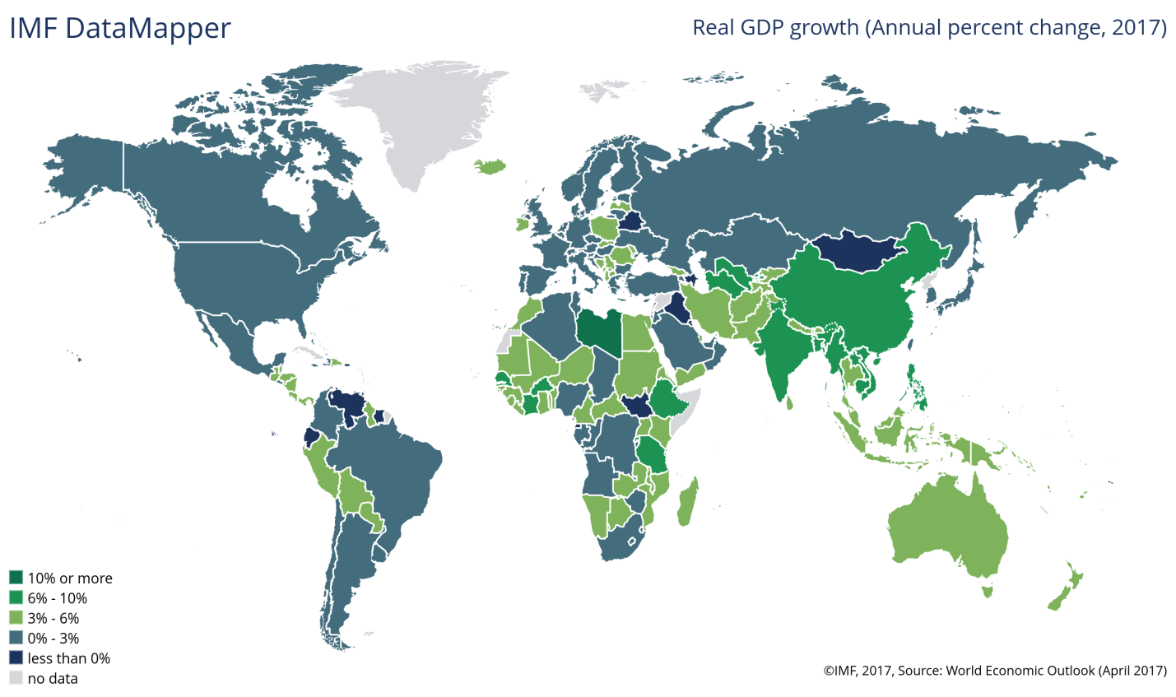
Source: World economic outlook, April 2017
Financing of the IMF gives the members of the organization the necessary breathing, emphasis to overcome problems with the balance of payments. Individual countries adjust programs that are closely collaborated with the IMF ongoing monetary support depends on the efficient implementation of these amendments. After reacting to the global economic crisis, the IMF strengthened its credit capacity and in April 2009 approved a significant revision of its financial assistance mechanisms, and in 2010 and 2011 adopted further reforms.
Figure 6: IMF Office of Budget and Planning, Analytic Costing and Estimation System
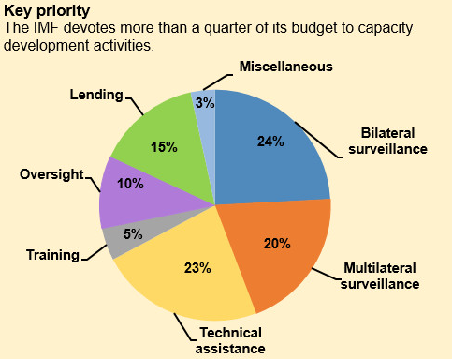Source:https://www.imf.org/en/News/Articles/2016/09/23/NA092616-IMF-Expert-Advice-Responds-to-Worldwide-Demand
These reforms were aimed at strengthening instruments to prevent crises, reducing the chain reaction during systemic crises, and adapting instruments taking into account economic indicators and the conditions of Member States. After the introduction of the increase in quotas under the Fourteenth General Review of Quotas, the access limits under the non-concessional arrangements for the IMF were revised and increased in early 2016. In order to increase financial support for the world's poorest countries, these concessional resources available to low-income countries under the Poverty Reduction and Growth Facility were significantly increased in 2009, while the average access limits under the IMF concessional financing mechanisms doubled. In addition, in 2015, the norms and limits of access were increased by 50 percent. Finally, measures are now being taken to secure additional credit resources of about $ 15 billion (11 billion SDRs) to support concessional lending by the IMF.
2.1.2. Institutional composition of energy security and innovations
Despite the frequent use of the energy security concept, there is no consensus on how energy security can be identified and understood. How much understanding of the energy source, pointing to the existence of energy security, i.e consistent production and / or supply, composite and complex definitions; energy efficiency and energy prices. IEA determines energy security, in order to provide energy resources at affordable price. Moreover, the responsible body try to provide energy security on the long-term period. As we know, it directly leads to economic boost and growth. On the contrary, short-term energy security focuses on the immediate intervention of sudden changes in the supply and demand balance of the power system.
Figure 7: IEA Total Oil Stocks at end-January 2019
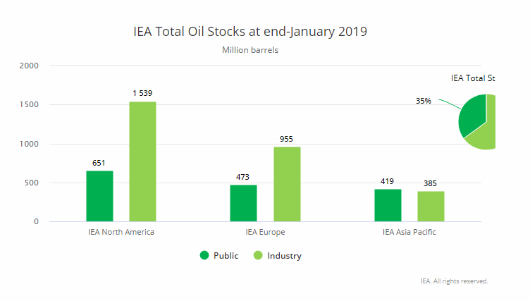
Source: https://www.iea.org/topics/energysecurity/

Figure 8: Energy consumption prediction till 2040
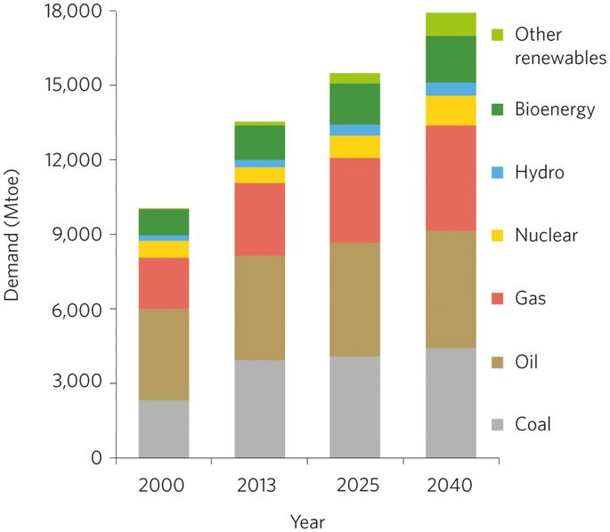
Source: Global World Outlook
The simplest praise, the energy security of a country means energy; ie, the amount required at the time of energy availability. Here, we do not take into account the energy price, and we do not take into account the legality and requirements of the proposal, the higher the price, the lower the amount of consumption. We call a security energy is characterized by complete inelasticity. From an economic point of view, total inelasticity does not have an impact on the amount of consumption. Therefore, in our situation, we should not ignore the aspects of energy resources, and we think that energy is at least suitable for the industry, and does not affect the price of production and export competitiveness.
Despite the assumption, we have here, it must be related to category of research restrictions, and there is a research that confirms this scientifically limited hypothesis. Once, the energy security has been identified, the idea adopted in this article has allowed us to proceed to sustainable industrial development discussions.
With sustainable industrial development, the economic expansion of economic activities of the industrial sector at the International level means that it does not increase the level of environmental degradation and remains in long-term competition due to gradual reduction of energy intensity.
Figure 9: The energy trilemma: Meeting the requirements for reducing CO2 emissions, competitive energy costs, and securing the energy supply
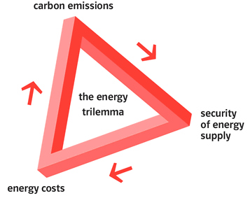
Source: https://www.eng.ed.ac.uk/research/themes/energy-policy-economics-and-innovation
Energy security is an important political objective for many countries. In particular, the public dependence on the import dependence and commercialization reflects the specific energy context in countries with dependency on energy and electricity costs. Higher concerns about energy resources, vulnerability and reliability are due to higher fossil fuel consumption. It looks like more general national contexts outside of energy; energy security challenges in countries with better economic and human well-being. These findings show that a wider energy, social and economic context affects the sensitivity and security of the public, which can provide information on the development of effective energy security strategies that provide public concern
We need to pay attention to these main areas of sustainable development and especially the elimination of poverty, both in rich and poor countries;
-all consumers should be directed to provide modern energy services;
-It should be applied to all supply chains. Lower flows are as important as upstream;
-all anticipated time horizons should be covered. Security is as important as future’s security;
-new technologies must be sustainable, economically and environmentally oriented;
-we need to be encouraged to extend support and cooperation.
Alternative energy sources play an indispensable role in ensuring energy security. Innovations, especially in recent years, play an indispensable role in strengthening energy security of countries dependent on oil importing.
Renewable energy is used for sustainable, substitute and never-ending natural resources. As with many natural sources of energy, there are many renewable energy technologies. The Sun and wind energy is the most common energy source and hydroelectric is one of the oldest one. Other renewable technologies use geothermal energy, bio energy and ocean energy to produce heat or electricity.
Again, new technologies that help to manage renewable energy are equally equitable. It can be produced day and night when it is powered by electricity. These allowing technologies include battery retention, supply estimates, and intelligent grid technologies.
The definition of alternative energy is alternative another way to the consumption of the energy. Generally speaking, we can call it as non-traditional and environment-inactive energy. The alternate energy compared with fossil fuels and some other sources which have detrimental impact on the environment. In most concepts, alternative energy does not harm the environment, it separates it from the renewable energy that can or may not affect the significant environment.
The definition of renewable energy is that energy is clean source of energy, it does not have negative impact on the environment. Instead of renewable energy, fossil fuels produce harmful greenhouse gas emission, and it leads to global warming and climate change.

Figure 10: The prediction of conventional energy consumption until 2030
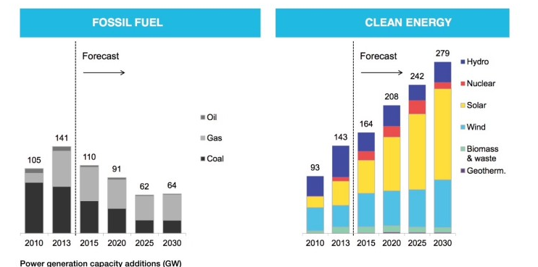
Source:https://www.researchgate.net/figure/Fossil-fuel-vs-Renewable-energy_fig1_310810054
Technology innovation process is complex and nonlinear; The complexity takes place through multiple dynamic feedbacks between the stages of the process of technology innovation because it includes a number of actors and factors and is not linear. In addition, the innovation system of technology consists of many institutions such as universities, large corporations, beginners, federal government, states and other international and foreign institutions and the relations between them. The complication of the innovation procedure is particularly exceptional for a number of reasons in the field of energy technologies:
• There are limited and uncertain market signals for energy research, development and promotion (R & D) and distribution. The externalities of greenhouse gas emissions and energy security are not well represented in the market, for example, and therefore there is a common belief that the distribution with RD & D will not face the challenges and technical opportunities faced by the energy sector available.
- The large scale of many energy technologies, such as clean coal processes and nuclear energy, and the long periods of development have further hampered the participation of the private sector in the development of these technologies.
- At each stage, energy technologies are very heterogeneous - especially R & D, early deployment, and widespread - different structures, early posture and subsequent expansion issues.
- As a result, energy technologies must compete in the market with powerful technology and network and infrastructure impacts should be integrated into a larger technological system that can eliminate the technology of the technology.
Therefore, the public nature of energy technologies requires the attention of the government: to achieve future technology variables, to reduce the risk of probability, to develop more relevant market signals, and even to help create a marketplace. Consequently, the federal government is an important player in the energy market that makes R & D only a significant boost and not an investment, but also facilitates the introduction of technology on the market. The given the scope and scale of the energy field, the design of energy innovation and the management of energy innovation institutions and their connection with the energy system and other components are quite complex.
The processing of specific details for each of the energy-related innovation activities will require more effort, but the innovation organizations' design and management, and their personal experiences in literature, new successes, and initiatives to enhance the renewal of US energy technology.
2.1.3 Energy sector problems in developing countries and in developing countries
It is estimated by World Energy Outlook 2002 that, global primary energy demand will increase by 1.7% annually from 2000 to 2030 and reach an annual equivalent of 15.3 billion tons of oil. The current trends predict that, total energy consumption will be double or even triple until 2050. The projected growth, however, is slower than growth, which was 2.1% per annum in the last thirty years.
Almost 70% of the primary energy demand of world increased and nearly all of the enlargement in energy production between 2001-2030 will be realized in developing countries and economic transition, energy investment requests will be highest and will increase in these regions in the fastest way.
It was predicted that, by the 2030, the global energy supply infrastructure needs to be invested more than $ 16 trillion or more than $ 550 billion per year, equal to 1% of the projected gross domestic product. This investment is required to increase the supply capability and to change the existing and potential procurement facilities that will be pooped or not used through the projection period. More than half of the investment in energy production will only be necessary to change or maintain existing and future capacity. The annual average investment rate is estimated to increase from $ 455 billion to $ 632 billion in a decade. This corresponds to an estimated investment of energy of $ 413 billion in 2000. Nearly half of the total investment of energy will take place in developing countries, where production and demand are expected to increase the most.
Annual energy usage is hardly stable in OECD countries, but it is increasing by approximately 5% . In the rest of the world, economic growth and population growth is moving. However, the usage of energy per capita in non-OECD member countries is around 30% on average. It is fact that about 1.3 billion people have no access to electricity, and about 3 billion people are using biomass (wood, animal dirt and crop waste) and using open fires and simple stoves for cook and heat their homes. Every year more than 4 million people die early due to diseases caused by solid-fueled foods due to domestic air pollution.

Figure 11: World Energy Consumption between 2015-2040
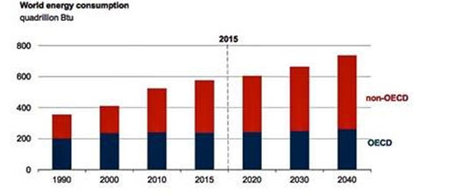
Source:https://wattsupwiththat.com/2017/12/30/despite-green-dreams-eia-report-projects-fossil-and-nuclear-fuels-provide-83-of-total-world-energy-in-2040/
But nowadays humanity faces a tremendous amount of energy challange. The intense dependence on fossil fuels threatens to change the Earth's climate and it releases billions of tons of harmful substances, especially CO2 into the atmosphere in a way that it will have serious consequences for both the natural systems and the integrity of the vital man. Globally, most of the world's population approximately more than two billion people, - still have lack electricity, clean ventilation and ventilation.
Numerous reports on sustainable energy have been written, but few have approached it from a developing country perspective. There are still countries that have less access to energy. In other words, the ability of advanced and developing countries to manage the results of increased consumption and demand for commercial energy forms depends on whether it is possible to significantly accelerate progress for higher efficiency, more carbon removal, and more fuel diversificaton and less pollutant emissions.
Environmental concerns have made us aware of the importance of using energy resources much more efficiently. Over the recent two decades, attention has been given to the development of technical elements and technologies from existing resources to energy conservation and rational use and energy generation from renewable energy sources. Today's energy saving use is becoming a way of life in a part of the world. It is just a matter of eliminating wastes and managing energy consumption simply by using what's needed.
Furthermore, the world economy is growing rapidly, so the demand for energy has increased significantly. Today, we are faced with the problems of energy resources depletion and energy supply, and despite the fact that the demand is more problematic, the outcome of sustainable development has not yet happened. Increased energy demand in the industrialized, at the same time developing countries, puts us in a state of shortage of energy shortage. Increased demand for the oil is the primarily issue for both developed and developing countries.
Another problem directly related to the shortage of workforce in the field of energy industry. Moreover, the primary cause of this that the people who work in energy industry, decide to go to retirement. The average age for those working in the oil and gas sector is approximately 47 years old, while the average pension age is 55 years. Certainly, industry needs to be more active in the traning and recruitment of potential engineers, geologists, technicinical managers. Furthermore, NOCs should cooperation with different governments to encourage education and mobility of citizens. Members of OPEC and NOCs undertake some actions, in order to eliminate this shortage. These co-operations take the steps to establish well trained workforce by the help of developing new programs and training.
This is an area where -IOC and NOC- co-operate a lot. For example, the US Government has launched the "Seven Ten" initiative aimed at reducing gasoline consumption in the United States, by 20% over the next decade. While these sovereign nations have full rights, OPEC member countries have spent a great deal of finance, so far to provide broader opportunities for the future. However, due to these uncertainties and concerns about reducing upward investment, OPEC member countries should consider plans to expand their future capabilities.
Oil is leading commodity in lots of field, it takes the very serious weight at the industry. The NOC has been active in combating local pollution - for example, initiatives that hinder oil spill and reduce gas flares, as well as to deal with a larger issue of global warming.
OPEC is committed to a compromise with a cleaner and safer global environment. Industry encountered long history of developing environmental guarantees in either production or use. This will remain a right way for our NOCs. This is also very important for NOC-IOC cooperation.
Instead of this, there is emerging call for energy security based on the expectations of stakeholders that the global economy will continue to expand and will need much more oil.
Another challenge faced by NOCs is directly related to demand uncertainties. Recently, the issue of energy (supply) security has been fundamentally from the point of view of the need for safe and affordable supply for economic energy consumers. The oil and gas industry is beginning to perceived that energy security has need
a more comprehensive accession; In developing countries, many poor households and governments have no immediate financial resources to get energy. In these countries energy consumption levels are very low compared to industrial consumers. Restriction of access to energy for poor households and different governments in developing countries due to lack of funds.
In other words, it is possible to significantly increase the quality of living standards of poor households with an energy consumption below the average of those living in an industrialized country. Less than half of developing and developing countries account for around 75% of the world's population, however, consuming about 30% of the total global energy. Both the industry and the living requirement increase power generation capacity and have electricity and fuel shortage. This affects the productivity of different sectors. For example, in India, economic losses associated with energy shortage make up 8 percent of national income.
Developing countries confront with serious energy problems. In the developing world, energy consumers fall into two groups with different energy sources and needs. Those who use modern commercial fuels such as coal, petroleum products, natural gas and electricity are mostly urban residents, where there are important areas, utility networks and fuel systems. Fuel-wood disappears and people burn more fossils and animal fertilizers. On the other hand - people living in rural areas are naturally biomass fuels, such as trees, plant wastes and animal seeds. Typical agricultural economics depend on living conditions and allow very little commercial fuels and services. In the non-profit sector, along with high population pressure, environmental degradation has created a chronic failure of traditional fuels.
In addition to the need to expand access, lots of developing countries are facing at least 2 other emergencies.
For many countries that import oil, the first and most urgent problem is economic. The increased price of global oil prices led to increased cost of imported oil. For instance, the value of India's oil imports rose to more than 20 percent in one year, from $ 33 billion in 2006 to about $ 40 billion in 2007.
In developing countries the cost of petroleum imports reached $137 billion in 2005, later it exceeded $84 billion according to US Department of Economic Research. Furthermore, since 2005, the prices of oil have sustained to increase substantially, and this has further boosted their financial burden. For many small and poor countries, rapidly increasing energy prices, and the rise in global food prices in recent years have raised concerns about domestic economic and political stability. Furthermore, to get rid of this problem, countries should diversify their energy resource by introducing alternative energy into practice. So, it also leads to ensure the long-term energy security of for developing countries.
A second, important difficulty with energy is circumferential. As we know, the consumption of the energy is the main cause for environmental pollution into atmosphere. Energy-related emissions from automobiles, industrial equipments, plants, machines are mainly responsible for the air pollution, especially in the industrialized countries.
In the world, the use of conventional fuels for both cooking and heating reveals the death of billion people. In most cases, adverse environmental impacts start thoroughly at the end of energy use. Conventional fuels are a big danger for ecosystem and main cause of polluting water and land. Meanwhile, relying on conventional fuels like wood can produce its own negative effects. Long-term climate change, generated by energy-related emissions, poses great risks for emerging economies. While emissions produced in a developed country are heavily responsible for the current level of thermal emissions in the atmosphere, many analyzes have shown that the burden of global warming will decline relative to emerging economies. Developing countries are much more sensitive to such effects of fuels on their agriculture industry and productivity. They may also be deprived of financial and institutional arrangements for effective adaptation measures.
Fortunately, greenhouse gas emissions reduction can be substantially aligned with the monitoring of other energy-related targets, such as the development of local renewable sources and the reduction of local pollution patterns. Nevertheless, there will be pressure in the close future. This seems to contradict with the goal of expanding access to basic energy services for the poor, or the development of economic development or both, in particular the policies designed to prevent the use of carbon-intensive conventional fuels, many of which have the effect of indirectly or indirectly increasing energy prices. Therefore, pursuing a sustainable energy agenda for developing countries requires minimizing potential conflicts between different public targets, while benefiting from the positive synergy of efforts to achieve other social and economic goals. In many developing countries, there is plenty of renewable energy potential and may benefit from positive economic crises, particularly with the development of the energy sector, which is expected to have the ability to deal with traditional alternatives, especially small-scale renewable energy technologies.
However, in most cases, public policies and public support are needed to use these opportunities.
The World Bank should promote privileges in the private sector to serve the poor and underdeveloped regions where the poor live. Equitable, simple, competitive and time-consuming ways (G8 RETF, 2001) have a situation in which they provide intelligent incentives and / or incentives for the development and utilization of relevant technologies.
While energy subsidies have declined over the last decade, subsidies for fossil fuels are still tens of billions of US dollars in developing countries. Cumulatively, these subsidies are less than taxes on fossil fuels such as gasoline (G-8 RETF, 2001). However, instead of supporting sustainable energy targets, there are several effects that undermine them.
Firstly, by artificially reducing the price of some fuels, they distort the market and encourage inefficient consumption levels (ie, if they need to pay a market-based or market-based price, the consumption is more than the community uses. Second, fossil fuel subsidies make it difficult to compete with energy efficiency and cleaner energy resources
The increase in industrial activity in these countries will be beneficial in terms of revenue and employment generation. It also reflects potential increases in industry involvement in global, regional and local environmental problems, by increasing greenhouse gas emissions, liquid and solid waste, local air and water pollution and the use of resources. In 2001, an act of energy conservation was adopted.
They can examine the previous experiences of developed countries, keep away from some political problems in the last half century, and find an opportunity to jump straight to cleaner, more proficient technologies. Fortunately, many key elements of the transition to sustainable energy are expected to develop in good relations with other important development goals, such as improving public health, expanding employment opportunities, developing local industry, increasing confidence in local sources and improving the trade balance.

2.2 Global petroleum policy
2.2.1 Drivers of international petroleum energy policy
A number of macro and micro structural changes accelerate the demand increase; affect the lower carbon future, changes in consumer behavior, and the technological innovation that affects the fuel mix and the renewable energy sources. At the essentially level, the population, economic growth and energy efficiency are the major impacts of energy demand. Despite the slower growth compared to previous estimates, GDP per capita will double. However, on the surface, these two drivers show a steady increase in demand for energy, in fact, slows down.
Figure 12: Center for Strategic and International Studies and national Security
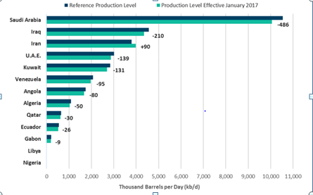
Source: https://www.csis.org/features/us-oil-global-economy
Most of the population growth will result in longer human life, which will in turn pressure on employment and on GDP. However, GDP will generally increase, though we witness a global change to the economy based on a service that is far from the energy-oriented heavy industry. The energy intensity of economic growth will be reduced if both demand and supply side of technology and this process improve productivity and energy efficiency in individual sectors.
In general, the main demand for energy will slow down to about 0.7% by 2050, lower than the general base and 30% slower than 2015.
These sectors control the basic energy needs:
- The demand for raw materials and energy in the chemical industry will provide more than two-fold increase in the overall demand, 1.8% of CAGR,
- Industry, power and heating and buildings, about 0.6-0.7%
- Energy for light vehicles decreased by 0.2%, after a peak of about 2023
- Electricity, mainly due to the construction and industrial electrification in China and India, will increase the demand for other types by increasing the energy demand in terms of more than two. Approximately 80% of opportunities for this growth will come from the sun and the wind; It reflects long-term changes to renewed goods.
The blend will depend, particularly in the electrical industry, at a reduced rate of fossil fuel up to 2050. The spaces will be refilled by upgrading 74% of the total primary confusion by 82% from the current highs. Solar and wind will grow up to 7%. A true change to green energy production will be adapted to electric motors and more efficient engines, which will reduce energy-related CO2 emissions by 2035.
Figure 13: Top 250 companies
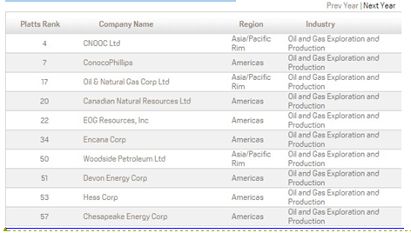
Source: http://top250.platts.com/Top250Rankings/2015/Region/OilandGasExplorationandProduction
The low gas consumption will continue to rise with an estimated CAGR of around 1.2% between 2013 and 2050. On the contrary, the oil ratio is corrected, while in general it will only increase by 0.4%, and coal will peak by 2025. We should go beyond the expected growth in the chemicals industry because products that accelerate growth on the shore of the industry are usually not made of raw or recyclable.
There is less dynamic appearance for the oil, can we answer that question and see the pinnacle of demand? Certainly, this can be done as a usual case; Changes in GDP, volatility of oil prices, technological innovations and regulatory changes. Sector players are also encouraged to keep track of growth forecasts and take into account the results of long-term investment.
If we analyze the share of fossil fuels in global consumption, it is clear that they play an important role in a modern society, and management of energy sources is a strategic issue. The complex market system and various types of comprehensive monopolies can create market and economy instability, which can result in global crises. Therefore, regulation of the energy market is an international tendency to achieve a higher level of supply security. In the past, electricity, gas production, transmission and distribution dominated the goats. Creating the only energy market based on open and competitive markets is Europe's biggest problem. The full implementation of competition in energy supply is a matter of the past, traditional monopoly suppliers.
Establishing energy prices reflecting the true costs of energy is essential for effective energy use and further use of renewable energy sources. It is also important that carbon and carbon tax is further applied to transfer fuel content to non-fossil sources to ensure compatibility between energy and financial policy subsidies between economic and environmental goals.
The burden on the environment has increased dramatically because of the massive consumption, mass consumption and mass emissions, as well as the increased socio-economic activity in recent years, with increasing resource and energy consumption in emerging economies. The environmental tensions of these tendencies have finally reached global proportions. Measures to achieve sustainable development at the local level are particularly important. These issues should be resolved by all humanity through international cooperation, reflecting the lives of every human being, through the life and lifestyle of every person and the socioeconomic activity. Thus, the mission of the human society is to strive for the protection of the global environment by an attempt to build a society that can be involved in sustainable development. That's why some of the community's main activities should be:
- Energy conservation, waste reduction and recycling
- Protection of water and promotion of efficient water use
- Promoting practical ecological education and conservation activities
- New energy application and energy efficient use
- Encouraging energy-saving homes and buildings
- Promoting efficient road traffic and goods distribution systems
- Creating regional areas with green energy and nature-rich areas
- Development of agriculture, forestry and fishing industry that cares for the environment
- Encouraging greenhouse gases collection
- Encourage international environmental co-operation

The conditions for achieving sustainable development policy can be summarized as follows:
- Conservation and rational utilization of conventional energy resources. Non-renewable resources, such as coal, oil, gas or uranium, should not be utilized at a higher level than the installation of substitutes in the form of energy savings or renewable energy delivery systems
- Management of the parties
- Strategic planning in the energy sector
- Use of renewable resources such as hydropower, wind energy, solar energy, biomass, geothermal energy, wave energy or wave energy
- Stabilized population growth
- Development and use of new technologies for more efficient use of energy
Among other factors affecting global crude oil prices include political events, economic moods, and even illicit opportunities. Political events can affect global crude oil prices in a long and short time and have led to the good oil shock in the past. Similarly, economic decisions may have an impact on crude oil prices for a long and short term but more on the 'demand' side. With the slowdown in China's economy and the decline in industrial production, China imports fewer diesel engines and thus reduces the market demand. As a result, the overall demand is above demand, and the crude oil prices have dropped dramatically.
Other intangible assets, such as weather, have more regional impact on oil prices and affect specific products. For example, when the Japanese winter is very cold, people burn more heat to keep the heat and cause a short break in the regional price of this product.
OPEC emphasizes the importance of energy for the social and economic development of the world, especially for developing countries. We know that societies cannot develop without energy: roads and bridges cannot be built, large-scale agricultural projects cannot be implemented, and communication infrastructure that is so important for citizens to participate in the global economy and ensure competitiveness cannot be resolved without energy. As a lucrative affiliate to developing natural resources from developing countries, we support the wishes of poor countries to pursue economic growth goals. Founded in 1976, OPEC's International Development Fund has extended $ 8.5 billion in aid to developing non-OPEC member countries.
The main goal of OPEC is to coordinate and unify the oil policies of affiliate countries and to determine the best ways of protecting their interests, individually and cooperatively. This is achieved by developing ways and means to ensure the stabilization of prices on international oil markets in order to eliminate harmful and unnecessary fluctuations. For this reason, OPEC is described as a “cartel” of large oil-producing developing countries that controls the production of oil from its member countries in order to influence world oil markets and prices.
The impact of OPEC could be felt as early as the 1970s and early 1980s, during the nationalization of resources in the Middle East, which excluded the IOC - although the actions were carried out by individual states, OPEC had a certain degree of coordination. Following the informal agreement of OPEC in September 2016 on the reduction of oil production (for the first time since 2008), world oil prices rose by more than 5%.
The value of OPEC to the NOC of the member states is that after the transaction is agreed at the OPEC level, the member states are obliged to fulfill the transaction, despite their individual interests or ambitions. Sometimes the direction may be strongly influenced by the interest of stronger and more powerful members. Article 3 of the OPEC Charter recognizes the sovereign equality of member countries. However, media reports and analysis show that the OPEC deal to reduce production in November 2016 was mainly carried out by Saudi Arabia, which has ambitions for living outside oil, and was the only member who voluntarily agreed to reduce production . All other oil-producing countries were forced to reduce their production due to technical, political or natural factors.
Questions were raised about the impact of OPEC in the future, while commentators point out that: a deal to reduce oil production in November 2016 took place after 2 years of fruitless negotiations; regional rivalry, for example, between Saudi Arabia, Iran and Iraq; and competition from US shale and non-OPEC producers.

Figure 14: OPEC share of world crude oil reserves, 2015
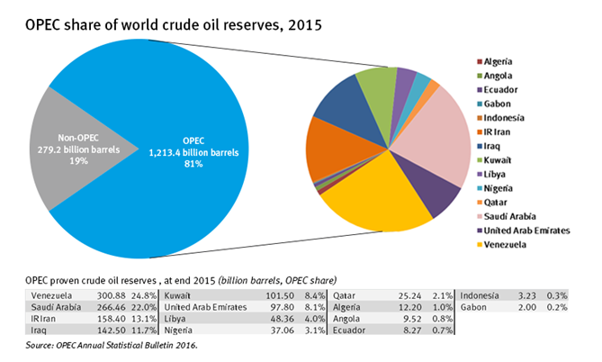
Source: https://www.extractiveshub.org/topic/view/id/26/chapterId/354
As for supply, we predict that OPEC's role as the world's oil supplier will increase in the first quarter of the 21st century. We expect exactly the demand for oil industry to meet these requirements. What is the predicted change in the origin of the supply? OPEC is responsible not only for OPEC countries in the shortest possible period of time, but also for OPEC's long-term global oil supplies. NOCs of the OPEC member countries are currently expanding their capacity to reach crude oil in 2010, with a capacity of up to 40 mbpd, up to 5 billion barrels, supported by more than 100 projects currently under $ 100 billion.
Significant Progress, our analysis, is the result of density in the processing sector and the density of refineries across all of the major functions. The OPEC MOK carries the burden of low flow investments both in its own countries and in consumer countries. OPEC NOCs are planning to expand their capacity at a 5 mbpd oil refinery alone.
These two aspects - the increase in supply and demand from the OPEC member countries play a major role in the NOCs in the global oil industry. NOCs will continue to be called to ensure safe energy sources, as it is in industry history. While discussing how much risks the NOC reserves in the industry are to control, it is likely that the NOCs are always reminded of the need for each oil barrel. Nevertheless, we believe that MACs are a part of a larger part, and we will not be able to meet problems without cooperating with CIO and other key players. Together, national or international oil companies are the key tool in the oil industry, throughout the supply chain, through intelligence and manufacturing, processing and transportation, marketing, sales and transportation. Given the challenges facing the oil industry, a strong partnership between the public and the private sector should be encouraged.
2.2.2 Influence of worldwide international petroleum corporations on economy
Big corporations are political, economical, cultural and environmental forces and are inevitable in today's globalizing and changing world. Large corporations are affecting the lives of billions of people every day, often in complex and invisible ways. The growth of these companies is usually estimated economically - profit, assets, number of employees and share prices.
The industry covers companies operating in the fields of oil extraction and extraction from oil and shale and recovery of hydrocarbon liquids, specializing in crude oil production. It also involve all natural gas producers and those who recover sulfur from natural gas. It doesn't include companies that carry, refine or market oil and natural gas. For companies that perform transactions that are included and excluded, only estimated revenues from operations are considered to be 2 trillion dollar.
State-controlled national oil companies (NOCs), which were once criticized for excessive spending, low investments and political means, transform themselves into lean, professionally managed enterprises. Now, with national and international oil companies (IOCs), they are competing in oil and gas research, development and production in the country and abroad. Malaysia PETRONA operates in more than 35 countries. China and India are negotiating NOCs in Africa, Middle East, Latin America and Central Asia. Simultaneously, they have more impact on the domestic market: they employ more local suppliers, develop entrepreneurship in energy-related sectors, and share their assets. Norway has collaborated with the Norwegian administration, research institutes and universities to create a dynamic and growing oil and gas industry. Despite the decline in Norway's oil production, the country's oil service companies are already competing internationally.
First, successful NOCs bring world-class management and operating standards. Malaysia's PETRONAS could restrict the first charter of the Malaysian oil and gas sector. Instead, she worked closely with ExxonMobil and Shell-Malaysia to develop the capabilities of an independent operator. Today, PETRONAS revenues are over $ 75 billion and are a global mark for many IOCs.
Brazil's Petrobras are a better example. Over time, Brazil has developed advanced technology for the discovery, development and production of deep water oil reserves. Petrobras is the largest company in Brazil with revenues of $ 146 billion in 2011.
Leading NOCs also put together world-class providers. They usually insist on not supporting local companies, but also for developing global competitive suppliers. For example, in order to improve R & D capabilities among local suppliers, Norwegian companies have lobbied Statoil to increase their investment by favoring new oil discounts for oil companies that have invested heavily in Norwegian ventures with Norwegian researchers. The more serious technology and /the bigger the investment, the more new blocks to go.
In the context of local content, the NGPC directive also provided Shell with a comprehensive and gradual development of the country's oil industry capabilities. The company has made a great effort to justify the NNPC directive on a simple basis: Nigeria suppliers have been able to provide more contracts because they have more capabilities. Shell provides these companies with knowledge transfer, training, tender proposals and funding. Over time, these steps have passed to Nigerian companies about 90% of all Shell contracts.
Finally, NOCs work with their national governments to promote geographic groups of companies in the industry, such as oil and gas services, machine building, oil chemistry, and automobile, which can be synergies with oil and gas. A successful multi-strategy strategy can help balance the three outcomes: building sustainable local business and wealth, improving public accounts, and creating attractive returns for investors.
Brazil, the cluster leader, realizes the economic development rewards. Presently, the country benefiting from its ultra-deep pre-salt oil fields, not only from companies such as Schlumberger, Halliburton and Baker Hughes, but also attracts local R & D investments, primarily from Petrobras, BG Group, Shell, ExxonMobil and Chevron. - Deep discounts. In the outlook, like Norway, Brazil can form a strong macro group of strong local oil service teams.Today, the world is coming to Brazil to participate in the development of deep waters; tomorrow Brazilian companies will travel to the world as a competitive player on the new intelligence borders.
Leadership of NOCs not only translates into the country of capital, technological and operational knowledge, but also preserves the wealth of its people. Ideally, they help to isolate themselves from the socio-economic development strategy and pressure and protect the integrity of the country as it passes through the economic era. Most importantly, they take a durable course to look for global competitiveness. The best NOCs serve the most national interests when fitted to national standards.
Saudi Arabia Aramco is the largest and most advanced world oil company in Zahran, Saudi Arabia. The company was founded in 1933 as the California-Arab Standard Oil Company and was a state-owned company called Saudi Aramco in 1988. Saudi Arabia has the largest oil reserves in the world and the largest oil per day in the world, the world's leading oil company with revenue of approximately $ 478 billion. The company produces oil, natural gas and petroleum products. The company is available worldwide for discovery, distribution and marketing. It has the biggest carbon emissions that the company has to offer and reduce some environmental policies.
Sinopec, the owner of a state in Beijing, has earned $ 455.499 billion from the Chinese oil company and the world's second largest oil company. Sinopec is also engaged in oil and gas exploration, production, sale and distribution of petrochemical products. The company is expanding its presence with other oil companies, as well as drilling operations in untested Africa. The company has been criticized for using Gabbon's harmful methods for exploring oil in the Loango National Park, causing the environment to be destroyed and burying the animals in the area where they are prone to illegal plains. Sinopec is responsible for the mass contamination of water objects.
The China National Petroleum Corporation corporation was established in 1988 by the headquarters in Beijing. The company reaches $ 428.62 billion in the world's largest oil company list and is a major employer of more than a million people. The company is involved in the processing, extraction, oil exploration and marketing of natural gas and petrochemical products. The company participates in investments and subsidiaries in other Asian and African countries and other petroleum companies in the world. The company has played a major role in the exploration process by contaminating water and air pollution and environmental pollution by drilling.
Petro China is the establishment of the China National Petroleum Corporation, established in 1999. As a parent company, Petro China is owned by a government headquartered in Beijing. The company is engaged in exploration, production and sale of oil products. The company is the fourth largest oil company in the world with revenues of 367.982 billion dollars per a year. Like other oil companies, petro China has faced various charges for environmental pollution in the exploration area.
ExxonMobil is an American oil company, headquartered in Texas. It ranks fifth among the world's largest oil companies. The company was established in 1999 by the combination of Exxon (formerly the Standard Oil Company) and Mobile (formerly New York's Standard Oil Company) and earned $ 268.9 billion. world and thousands of employers. ExxonMobil is engaged in oil, natural gas, petroleum products and other petroleum products. The company has been criticized for its slow response to environmental pollution, including oil spills.

Chapter 3. Challenges of alternative energy for petroleum sector
3.1 Future vision and forecasts on petroleum energy
3.1.1Socio-economic impact of alternative energy
Energy is the foundation of modern economics and constitutes the necessity of modern life. It is a prerequisite for economic growth, improvement of living conditions and poverty reduction. Therefore, getting energy is an important development objective. Obstacles such as high-energy costs, unfavorable energy network infrastructure and destructive populations make it difficult to reach the majority of the world's population in developing countries. Again, renewable energy technologies are a unique opportunity to provide millions of people with affordable and sustainable energy. Renewable energy technologies offer different and economically attractive options, especially for rural electricity. This section assesses the economic and social impact of community-based renewable energy (CRE) projects in cities and communities. In the initial research, there are strong indications that renewable energy projects are linked to the improvement of the economic situation of the two pilot cities; but also in urban and home levels. This chapter shows that the economic effects of the CRE projects are quite modest as they lead to the creation of jobs and business development. Finally, the CRE projects are responsible for providing energy security to targeted communities.
Figure 15: Sustainability as the intersection of its three key parts, and examples of features at the intersection of any two parts
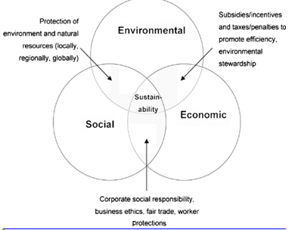
Source : https://www.researchgate.net/figure/Sustainability-as-the-intersection-of-its-three-key-parts-and-examples-of-features-at_fig2_328235389
At the same time, renewable energy sources have the potential to meet the current global demand for energy several times. Renewable energy sources play an important role in increasing energy diversity, long-term energy security, and environmental protection. Renewable energy, in particular, offers attractive and varied options for rural areas and developing countries to gain sustainable energy services. As technology is mature and markets are expanding, it is likely that initial costs will be reduced by reaching the scale of the economy. Today, it is incapable of competing with conventional fuels, except the biggest barrier markets for the broader use of renewable technologies (UNDP 2000).
New renewable energy sources (small hydropower, modern biomass, wind, solar energy, geothermal and biofuels) make up 3% and are developing rapidly.d biofuels) make up 3% and are rapidly developing. The share of renewable energy sources in electricity generation is about 19%, which is 16% of global electricity, and 3% of renewable energy sources.
Four key areas that affected CRE projects: 1) political; 2) social; 3) economic; and 4) the environment. In two cases, together with official and informal talks, work was undertaken to gather information and achieve results. They led to social benefits for the public in order to create public bonds, communicate with communities, and share common problems and collective responses. This led to a reduction in negative ideas for CRE projects and participatory processes, enhancing the credibility and the power of society. The study also revealed that CREs, using local people, materials and materials, have brought significant economic benefits to the community; Dividends paid to local shareholders and service to local banks. In addition, CREs have increased the community's solidarity by creating a fund that invests in electricity from the sale of electricity in the local economy. This has allowed some communities to invest in the major economic priorities they have chosen. From a environmental standpoint, CREs, in a modest way, has helped society reduce carbon emissions and increase environmental awareness. Hicks and Ison (2011) are also more sensitive to the local environment and environment, and planning and execution involve more local information than projects implemented by organizations outside the community. These, in turn, lead to less severe impacts on wildlife, less adverse hydrological impacts and less erosion, noise and shadow shocks (Hicks and Ison 2011).
The impacts on the use of CREs are positive. Although direct employment is relatively modest, it is relatively large compared to the size of the society indirectly for the creation of employment. Despite the fact that at least the solar-powered workplace has been created, biofuels have created many direct and indirect jobs. In one case, a biofuels project created 200 (in direct and indirect) jobs in a tens of thousands of communities. Projects also resulted in the diversification of employment and income sources as well as the creation of temporary jobs (Rio and Burguillo 2009).
In the age of diminishing economic growth and decreasing public financing for infrastructure projects (often renewable energy projects), researchers have to compete with more pressing government priorities. Moreover, governments across the world face increasing environmental challenges and diminishing traditional fossil fuel resources. The time to promote and invest in sustainable energy solutions has never been better. Therefore, it is critical to have a comprehensive understanding of the benefits of renewable energy technologies and their impacts both economically and socially to make the case for these projects.
The advantages of renewable energy projects are focused on environmental and economic benefits, and are designed for cost measurement, financial savings and environmental improvements. Some of these studies have improved in areas such as sustainability and social development. In addition, renewable energy projects appear to be a tool for decision makers to reduce the effects of reduced energy resources and pollution problems. The combined socio-economic benefits of these projects are not widely considered. Therefore, the socioeconomic developments emerging in this document are identified and approved. The goal is to present existing literature to sustainability and renewable energy while demonstrating how CRE projects can lead to sustainable solutions for immediate social and economic needs.
At the community-level CSOs have resulted in "progressive improvements" in the development of communities by providing social and economic benefits. On average, 45.5% of the research participants have led to the development of the community of CRE. The most significant improvements were in the provision of services such as health services (59% of the participants agreed), as other clinics were provided with solar powered wells, but other government agencies did not have this facility, followed by education services (57.5%) and public services (50%). Economic indicators, ie the creation of jobs (38%) and enterprises (32%) have provided the best development. The reason for this is that the energy generated by renewable energy systems was mainly used for lighting and home appliances. None of the societies utilized the power generated in these plants for industrial purposes. Limited power generation and high demand in households are one of the main reasons preventing the use of electricity for productive purposes. Therefore, the CRE projects have led to the progressive improvement of social benefits at the community level. Similarly, projects have provided "small economic improvements" at community level, largely due to lack of access to industry for these communities.
Sustainable development is an important aspect of CRE projects. Although renewable energy is an essential element of sustainable development, their use does not provide community-based sustainable electricity.
The United Nations Environment and Development Report describes sustainable development as “development that meets the needs of today without sacrificing the ability of future generations to meet their own needs”. (UNDP 2000).
Sustainable development has three directions: 1) economic; 2) social; and 3) ecology that establishes three bases for sustainable development. The economic sustainability of CRE projects is largely dependent on financial sustainability. It involves sustainability in terms of investment, subsidy, financial management and electricity supply acceptance. Secondly, social sustainability is related to the access to electricity services, improvement of living conditions and equality of socio-economic benefits. At the same time, environmental sustainability requires minimal environmental impacts that will allow for the protection of natural resources.
Renewable energy effects on the environment arise from external influences of individual projects that accept such technology. Foreign layers may be positive (benefits) or negative (expenses), but they are not a regular market mechanism. These externals refer to the use of non-functional resources and public goods of all economic entities as valuable carriers, and not all the economic agents have complete information. This situation is called a market failure. However, there is no specific proprietary right in all entries and products from production and consumer activities.
3.1.2 Global forecast on energy sector
Another notion from this year's prospect is the strengthening of competition pressure on global energy markets. Demand will continue with global energy consumption by about three or more by 2040. Nevertheless, technological advancements, our ability to produce energy, are increasing - unconventional oil and gas or wind and solar energy. Indeed, the continuous growth of renewable energy leads to the most different combustion of fuel. Rich and diversified energy supply will be a difficult marketplace.
Most importantly, this year's energy forecast for cooperation is the need for lower emissions of carbon emissions. Global forecast ongoing transition scenario shows that the ongoing development and acceleration of technology and technology can lead to more slowdowns of carbon-free emissions than in the past. However, this slowdown falls short of the sharp decline in carbon emissions that Paris seeks to achieve its climatic goals. We need a more decisive story than the past.
In the past, one of the biggest obstacles to decarbonization has been the lack of commitment at the global level. However, in December 2015, COP21 in Paris, 198 countries signed a direct contract to limit the increase in temperature to 2 ° C. This was surprising because global energy demand predicted an increase of 48% between 2012 and 2040. Non-OECD countries showed an increase of 71%, and rapid economic growth was associated with population growth.

Figure 16: Energy demand and energy intensity growth
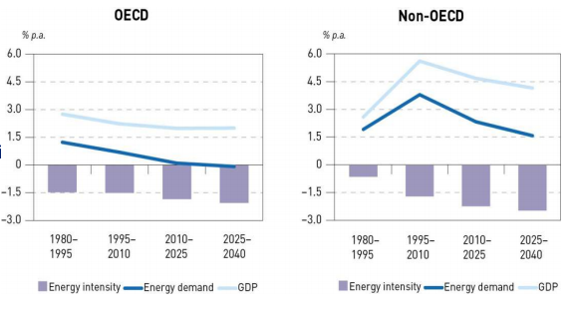
Source: https://www.ief.org/_resources/files/events/ief-lecture---world-energy-outlook-weo-2017-and-world-oil-outlook-woo-2017/opec---world-oil-outlook-2040.compressed.pdf
Excluded fuels remain the cheapest energy systems. Natural gas will be the world's largest consumers until 2040, as it transfers from coal to the world.
By 2040, tight emission sources will account for 60% of the generation installed, with the next 25 years being wind and sun protection of 64% of the 8.6 TW growth. The pace of this change is particularly unbelievable; For example, in the UK, forecasts for the solar level of 2030 in 2012 exceeded 15 years ago.
The tendency to build smaller generation plants in the energy and utilities sector will support the spread of more green technologies, along with increased economies, government subsidies. The rate of falling costs for these technologies (dry wind costs fall by 41% and solar PV costs will drop by about 60%). It predicts up to 49% of the potential in the UK, up to 1630 by 2030.
This tendency is also widened by companies such as MKOPA in Kenya, beyond developed countries. Provides the solar power market with commercial offers at cheap rates. This leads to projections that by 2030, up to 49% of the potential in the UK will be in the distribution network. Now with a developed Kenyan company MKOPA solar energy Cheap commercial offers for markets
This change in energy supply will require substantial, sustainable investments in traditional sources to address the intermediate situation with renewable energy sources.
This change in energy supply will require substantial, sustained investment in conventional sources to address the interim situation of renewable energy sources. This will lead to a supply portfolio that requires the exploitation of flexible centralized power stations, allowing for the replacement of renewable renewable equipment. There will be pressures for a more flexible delivery method for these major infrastructure investments.
New developments make it possible to eliminate potential power in the energy sector, to quickly adapt and measure. That is, it is important to take into consideration that innovation is necessarily new technology; a new approach to a problem that leads to a new business model or operating procedure in many cases.
Worldwide, it is now engaged in various industrial processes in the industrial sector, such as fuel oil (RFO), sea transport, electricity generation, commercial furnaces and boilers. In addition, in some areas, RFO is used as a relatively inexpensive fuel for space heating. RFO is one of the few residues that remain after crude oil distillation, including gasoline and distillate. RFO holds large quantities of contaminants, including sulfur, nitrogen and heavy metals. Because of the high viscosity, RFO is usually either mixed with lighter flows or heated to allow it to flow.
RFO plays an important role in the global fuel market, as the price is lower than other liquids. However, health and environmental issues related to the high sulfur content in RFOs have resulted in new rules and regulations that significantly reduce the future utilization expectations (Figure 2-5). As demand for RFOs declines, the need to convert materials to lighter and cleaner products is needed.
Reduced demand for RFOs could be related to the decline in electricity generation and space heating. Measures to mitigate impacts in the energy sector, storage and use of R & Ds compensate for lower RFO values compared to natural gas and other precious fuels. The demand for RFOs is likely to be significantly reduced due to the reduction in the use of electricity and space heat. Reducing RFO costs, storage and heating costs in the energy sector pays low RFO prices compared to natural gas and other fuels. Consequently, it is expected that demand in the Russian Federation for the electricity sector, especially in industrialized countries, will decrease, although it may continue to serve as a transitional fuel in the energy sectors of non-OECD countries, which may be more price-sensitive and less sensitive to environment and the environment. health effects. Additional significant reductions in demand for RFOs may occur as a result of the application of the rules established by Annex VI of the International Maritime Organization through the International Convention on Pollution from Ships (Marpol) .27 Since 2012, Marpol regulations require measures to control emissions of sulfur and nitrogen oxides worldwide. The rules are based on emissions from fuel combustion, not on the fuels themselves. As a result, some carrier operators are considering using alternative fuels such as liquefied natural gas (LNG) for vessels operating on LNG routes.
Since several oil refineries are capable of producing sulfur from RFO, the Marpol compliance is likely to be achieved by two approaches: use of smaller sulfur-containing fuels (seawater oil and intermediate vegetable oils) and the use of cleaning or other technologies to remove sulfur from used gases make. The levels provided by the Marpol rules can be achieved by using RFO with sulfur levels of no more than 3.5%. More stringent requirements - more than 0.1% RFO sulfur levels - assigned emission control areas (ECAs) covering the North Sea, the Baltic Sea, and the North American and Caribbean seas. The 2016 study is designed to assess the likely availability and pricing of various compliance options for the use of RFO in non-ECA areas. 28 The study should make a decision no later than 2018 when the introduction of RFO reduction standards setting sulfur emissions levels of no more than 0.5% will come into force, either in 2020 or in 2025.
All proposals, including new telecommunication and technology companies, have attracted new players to the energy sector, as well as a gradual rise in the associated home, as well as a number of new proposals for utility services. In addition to other technologies, from 2022 to 2026, the parity of electric vehicles, which will lead to the destruction of traditional roles of the electric power chain with new possibilities, needs to be filled.
For most OECD countries, the consumption of oil and other liquid fuels remains unchanged or decreases in the IEO2016 reference case (see Figure 2-7). With 20 million barrels per day in 2040, the total consumption of liquid fuel in the OECD will be only 0.6 million barrels per day higher than in 2012. In most OECD countries, slow economic growth and a constant or declining population level contribute to a reduction in fluid consumption. In addition, many OECD governments have adopted policies to improve vehicle efficiency, and consumers are turning to more economical transportation options as high oil prices return in the long run. Improving efficiency can also reduce the demand for energy associated with freight. The US Environmental Protection Agency recently proposed a significant increase in fuel economy standards for trucks. If these proposed standards are adopted as final rules, they will significantly reduce the prediction of diesel fuel use in trucks. To the extent that these standards apply and affect trucks sold worldwide, the reduction in fuel usage for freight traffic can be significantly increased.
The share of non-OECD countries in the global consumption of liquid fuels increases from 50% in 2012 to 54% in 2020 and to 62% in 2040. In non-OECD countries, there is the largest increase in liquid fuel consumption in the world in the IEO2016 reference case — 17.4 million b / d from 2012 to 2040, with China accounting for 6.2 million b / d increment. As China's economy shifts from dependence on energy-intensive industrial production to services, the transport sector is becoming the most significant source of growth in the use of liquid fuels. During the forecast period, the consumption of liquid fuels in the country increases by 61%.
New proposals are being made that allow for full advantage of asset management, machine learning, analytical and advanced care methods. With the help of remote sensors and control systems for monitoring and data collection (SCADA), you can more accurately manage assets, optimally manage components between available and damaged assets.. The rise of drones and artificial intelligence will also reduce significant costs in light activities and endanger the operations in hazardous environments.
In terms of energy efficiency, it is even more important for the driver to work less when we grow out of the planet's destruction. Energy efficiency improves, and potential is still great. Improvement of energy efficiency from the IEA member countries in the 1970s from the 1970s brought the value of 1.4 billion tons of oil to $ 743 billion in 2011. Energy Efficiency is the key investment area of ​​around $ 221 billion in capital investment in 2015, up to 6% from 2014
In the world of infrastructure, productivity of the workforce and the maintenance of effective assets may be combined with the design of a lightweight asset. Often assets were "golden coated" and ordered. By focusing on standard designs, more productivity can be established.
The use of the oil and gas infrastructure increases the agenda of the staff as it is exposed to substantial costs from advanced deposits. The cost estimate for the UK Continental Shelf Basin (UKCS) is growing steadily and now stands at over £ 50 billion. Costs should be available to “expert experts”; these companies need to gain experience, develop innovative methods and use portfolio effects to manage economies of scalend use portfolio effects to manage scale economies. It is a new industry and can be combined with a suitable commercial model to significantly reduce costs.
As the system becomes more intelligent, users can efficiently integrate a safe, sustainable, and cost-effective power supply. In the US, LO3 Energy uses a system that allows microgenerators to sell their electricity directly to home consumers. This initiative uses intelligent contracts with permission to trade without a central purchasing mechanism. These new technologies are based on the digital network.
In future energy scenarios, the national grid forecasts up to 80 percent of natural gas in the UK by 2030.England would be dependent on the retention of the highest demand period. With the advent of more renewable electricity via the Internet, it is necessary to increase flows from areas with low demand for areas with high demand with our continental neighbors. So far, from 3.95GW to 2040, up to 23.25 GW will be invested in more intermediate devices to avoid the expected signal. Energy companies to adapt to the changing world:
- See where they are on the market, their roles, and future business models
- Re-evaluate how they operate and their next operating models
- Correctly adapt the mid-term path to change
About 60% of the management teams assessed the violations of leadership as a threat, not an opportunity. There is something in the process of this uncertainty: inaction is not an option. In the future, companies that are moving forward and changing will develop and develop in the new world to create value for new participants, employees and extensive stakeholders. Industry knowledge, combined with our growth strategy and customer growth opportunities, will help you understand your greatest opportunities and risks and can develop thinking for a sustainable future.

Conclusion
In conclusion, it is clear from the above that oil energy plays a more important role every day, both for people and for the environment. In abundance, cooperation in the field of petroleum energy is becoming an important decision of world energy needs. In addition, the international energy cooperation sector also has many positive effects on environmental protection, reducing the effects of global warming or pollution. Despite some shortcomings of energy, there is also reason to believe that the problems will be solved in the near future thanks to the active investments of the government and the efforts of scientists. The use and transformation of traditional sources into world energy resources is a favorable turning point for us. The future is really bright and will be highlighted by international economic energy cooperation for the oil sector.
It is difficult to live without energy, but it is impossible to find another planet for life. Energy is everything. It comes in many forms such as heat, electricity, light, mechanical energy. Conventional energy sources such as coal and oil are the main contributors to the global warming. In addition, these fossil fuels are not subject to renewal, which means that one day we will exhaust them. Nevertheless, alternative sources of energy can replace the current technologies we are using. There are many alternative energy sources that use natural forces and resources, such as solar, wind, and geothermal energy.
Regarding above-mentioned the following list of recommendations is offered:
- Continue to support research, development, and demonstration projects for pre‐commercial international economic cooperation for global petroleum energy sector generation and transportation fuels, with an emphasis on performance, emissions reductions and technology neutrality.
- Take into account regional differences in the availability of renewable energy sources when developing legislation and regulations.
- With regard to the renewable fuel standard, policymakers should take into account the limitations of the current vehicle fleet, fuel distribution infrastructure and actual production capacity, and also adopt targeted modifications as needed.The current design of the innovation system has resulted in world leading International economic cooperation of global petroleum energy sector competence, and should be continued.
- State R & D programs in the field of alternative energy should be updated to improve the oil sector.
- Interdisciplinary research and development, including social studies, should be included in publicly funded research and development programs. Research in the social sciences should promote the understanding, reduction and elimination of barriers to the development and application of technology.
International cooperation should be encouraged in R & D programs, where appropriate.

Reference
- R.Dani and R.Mark, 2010 “International Trade, Foreign Direct Investment, and Policy of Indsutry
- H.Ricardo and R.Dani. 2003. “Development of Economy as Discovery of Trade
- W.M.Stephen 2002. “Failed Opportunities: Innovation Based on Growth in World
- A.Melon and R. Andres. 2006. “Productive Development of Policies and Supporting of Institutions in the World.”
- N.Oddny, H.Vetna and H.Stefan. 2003. “The Upstream of Petroleum Industry and Inhabitant of Industrial Development.
- “Industrial Development: Stylized Facts and Policies.” 2007. In Industrial Development for the 21st Century.
- R. Stuart and Willian C. Strange. 2004. “Evidence of the Nature and Resources of Agglomeration Economies.”
- Globalization of Development: The Trade of International Perspective.
- United Nations Conference on Trade and Development 2008WTO (World Trade Organization). 1998. S/C/W/58 20 October
- IEA, World Outlook of Energy 2018, International Agency of Energy, 2018
- IEA, Outlook for Producer Economies, in World Energy Outlook 2018
- OECD/IEA, IRENA, 2018 Policies of Renewable Energy in a Time of Transition, Agency of International Renewable Energy, Organization for Economic Cooperation and The Development of International Energy Agency
- IEA, Outlook of World Energy 2018, New Policies related Scenario, Agency of International Energy
- IEA, Global Energy and Status Report, 2018 Agency of International Energy, March 2018. The Statistics of Renewable Energy 2018.
- IRENA, Statistics of Renewable Energy 2018, Agency of International Renewable Energy, 2018.
- IRENA, Statistics of Renewable Energy 2018, Agency of International Renewable Energy. Outlook of World Energy 2018
- BNEF, Outlook New Energy 2018, Finance Bloomberg New Energy
- IRENA, Transformation of Global Energy: Roadmap till 2050, Agency of International Renewable Energy, 2018.
- John R. Baldwin. 1997 ' The Statistics of International Financial’
- R.N.Cooper,. 1968, Interdependence of Economics: Economical Policy in Atlantic Community.
- Kenneth L. Dixonand, 2000, ' The Problem of Collective Action and The Clauses of Collective Action’.
- F. Jeffrey and R. Kerry, 1988. ' Policymakers of International Macroeconomical Coordination
- H.Hammada 1976, 'The Interdepence of Strategic Analysis of Monetary, Journal related Political Economy
- International Monetary Fund 2003a, 'A Guide to Committees, Groups,
- International Monetary Fund 2003b, 'IMF Borrowing Arrangements: GA Band NAB',
- Rodrik, D. (2000), 'How long should International Economic Integration Go?', Perspectives of Economic journal.
- Williamson, J. (2000), 'The Role of the IMF: A Guide to the Reports', International Economic Policy Briefs
- Fischhendler, I., L. Herman, J. Anderman, “Crosses-border of electricity grids.
- European Union, “Synchronisation of the Baltic States’ electricity grid with the continental European system”,
- IEA, Electricity security across borders, International Energy Agency, 2016.
- L. Amory “Clean resources of energy and rare earths: why do not to worry about environment”, Scientists and Bulletin of the Atomic, 23 May 2017

