The Ministry of Education of Azerbaijan Republic

University of Economics – UNEC

Faculty:“SABAH”center
Specialty: Business Administration

Thesis
Topic: “Manipulating Consumers through Graphic Design:
A Project about The Effects of Graphic Design
on Branding and Consumer Perceptions”

Supervisor : Galandar Mammadli
Student: Rustamli Aytaj
Section: English
Group: S_16_01_409

Baku 2019
Acknowledgment

First of all, I would like to thank my supervisor Galandar Mammadli for his encouragement and support. I am very fortunate to have a supervisor responsible for answering my all questions at any time. These feedback was very important for the thesis. Thanks to his guidance, I chose the most appropriate subject and researched and finished this license thesis in time and in the best way.

CONTENT

I Chapter: Introduction 4
1. Background 4
2. Research aim 5
II Chapter. Graphic Design 6
1. Graphic Design 6
2. Design History 7
3. Design types 13
III Chapter: Brand Elements 18
1. Logos 18
2. Typography 18
3. Colors and Patterns 20
4. Illustrations 20
5. Menu Design 21
6. Truck Design 22
7. Promotions 22
8. Web sites 23
IV Chapter: Branding 24
1. Brand Equity 24
2. Brand Awareness 25
3. Brand Loyalty 26
4. Brand Associtation 28
5. Brand Perception 30
V Chapter: Consumer Perceptions 32
1. Consumer Behaviour 32
2. Consumer Intention 33
3. Consumer Attitude 35
VI Chapter: Conclusion 37
1. Corporate Identities 37
2. Packaging 38
3. Magazine Advertisements 41
4. Conclusion and suggestion 42
5. Literature 44
6. The Survey 46
7. The Survey Results 59

I Chapter: Introduction

1. Background
''There are professions more harmful than industrial design, but only a very few of them. And possibly only one profession is phonier. Advertising design, in persuading people to buy things they don't need, with money they don't have, in order to impress others who don't care, is probably the phoniest field in existence today… And the skills needed in these activities are taught carefully to young people." (Papanek, 1972) Design is getting more and more important, as Victor Papanek claims above. So when is design important? When do we start dealing with the appearance of a product? Sometimes we only buy products by looking at their packages, sometimes we don't pay attention to how they look. In the usual shopping in a supermarket, we face 40 000 plus products with almost 300 products per minute. (Napotalino, 11 Nov 2002) How do we choose? We create our own traditions and habits for some products and some of the products we consume for our feelings. Most of the time we like to buy and buy a product, but we realize that its benefits and functions are no different than the others. We are usually affected by the package of a product, maybe the logo. Sometimes it's just color. Every day, we become consumers who buy our feelings rather than our needs. The factors that attract our attention in a product are primarily based on visual elements as mentioned above; packages, colors, web sites, corporate identities touching our feelings, magazine advertisements, etc. And the fact that the consumer does not see only one logo while looking at the product, can touch the consumer's feelings and summarize the basic goal of a brand. De Mozota refers to the grand opening as the sum of the perceptions acquired by communication and experience. And he says that the brand gives an identity, a meaning and a story to a product. This is reflected in the visual elements of the consumer. It is the social symbolism created by the brand, which affects and directs the decisions of consumers. Graphic Design and Product Design is now the primary responsibility for creating meaning, identity, a background, a story for a product. The design has now become one of the decisive elements of branding.
This license thesis tries to understand whether brands can manipulate consumers using graphic design. First, it focuses on the relationship between branding and graphic design. The terms related to graphic design and market and the relationship between them will be summarized briefly. Then different design concepts for a product, information about creating different identities will be given. The project will be summarized step by step and will be explained in detail with the help of the questionnaire. These surveys and analyzes will evaluate the results of the creative process. This thesis is made to understand whether the perception of consumers can be shaped by the help of graphic design.

2. Research aim

This thesis explores how graphic design can be understood as a brand. The use of visuals has been accepted in various areas. But researchers in sciences tend to position graphic design as a means of communication rather than a research strategy. This thesis aims to explain the information in the graphic design process and to understand the term “graphic design Bu as a research strategy. In doing so, the methodological foundations are the analytical materials of articles, books, websites that investigate this problem. The thesis study is conducted as an online survey. The innovation of the research is the attempt to consider the importance of graphic design in all aspects of the manifestation of alcohol-free beverage in Azerbaijan, its role and the rationales and approvals of its effectiveness in shaping the image of companies.
The first research aspect is graphic design research, which is directly related to visuals and graphic design applications. The second research aspect is the use of visual data for the brand. Such research covers a wide range of topics, from design to operation. For the repositioning of graphic design in all areas of research, it is important to clarify the difference between these two research directions. This will reveal the potential of being one of the most important brand tools of graphic design.

II Chapter. Graphic Design

1. Graphic Design
Another name of graphic design is communication design. Graphic design conveys ideas to images and texts, then plans and reflects. This design can be physical or virtual and may contain images, words, or graphics. Experience can take place immediately or for a long time. Keller interprets a brand as a product, which puts in other aspects to distinguish it some way from other products designed to fulfill the same need. (Keller, 1998) The business can be performed anywhere from any postage stamp design to the national postal mail system. Graphic design can be limited to a limited number of people and can be targeted for very few people and can be seen by millions of people, including the digital content of a news organization. Although graphic design is often a commercial purpose, it can be for any purpose, including educational, cultural or political.
Graphic design is the art of creating visual content to convey messages. Graphic design is an art, in which the need of going to a museum is excluded as people are always in contact with it in their daily life. (Landa, 2001) Graphic designers who apply visual design hierarchy and page layout techniques use typography and illustrations to meet the specific needs of users and focus on the logic of showing elements in interactive designs to optimize the user experience.
Graphic design is a tool for the purpose of the art of digitalization to keep up with the modern era. Pictures, symbols, and even solve a problem through the use of words or provides a creative and systematic plan to achieve specific goals. Various graphic elements and visual communication is an expression of aesthetic ideas and concepts and using tools.
Graphic design is a tool that can reflect emotions in the simplest way and in a short time. Although the digital age requires and interactive design also with writing, the graphic design still revolves around the principles of ancient times. At first glance, it is very important to hit the right chord with users. As a graphic designer, what color theory and the correct choice of color scheme is so vital, you must have a solid understanding. Graphic design uses a combination of image-based design, type-based designs or both techniques, including photos, images, logos, and symbols.

2. Design History

Graphic design has become a part of our modern world. And even though visual communication itself was an old method, it took a long journey from stone tools to digital tablets. In short, the history of graphic design, covering the whole of human existence and modern graphic designers even have a story to inform and inspire strength.
Before the Printing Press: Prehistory to the Renaissance
- Cave paintings
- Sumerian written language
- Chinese printing
- Medieval calligraphy
- European heraldry
- Storefronts
The birth of graphic design: Renaissance and Industrial Era
- Gutenberg press
- First logos
- First Print Advertisements
- Chromolithography
Graphic design in the modern era
- The Wiener Werkstätte
- Paul Rand
A glimpse into the digital era
Before the printing press: Prehistory to the Renaissance
The graphic design began literally in 1440 after the invention of the printing press, but the roots of visual communication go back to the time of the caveman. In this section, we are talking about historical events that are leading the way to graphic design.
Cave paintings - 38,000 BCE
People have always been concerned with art, as cave paintings in prehistoric times show. The subjects are made with the handprints of animals such as fruits, hunting, and a lot of symbols, and examples are found all over the world. Historians argue about the fine details of who to communicate (whether they are one or the other gods), but the only thing that is clear is that humanity has shown a knack for communicating with images from the very beginning.
Sumerian written language - 3300 - 3000 BCE
It is easy to forget that alphabets are a man-made invention by interpreting all these small, abstract signs of the Latin alphabet as words and sentences. In order to ensure that couriers do not steal anything from deliveries, the Sumerians have created one of the first written languages to register merchant stocks. This was the logographic one of the oldest languages - the symbols represented all the words. This shows that the idea of using visuals to convey ideas that underlie modern graphic design has long been in use. And in the last few thousand years technology has developed, but the main idea has hardly changed.
Advancements in Chinese printing - 200 CE - 1040 CE
China holds most of the records on its exploration discoveries. These include non-papyrus papermaking, wood printing, and moving type. Up to 200 CE, China began using wood reliefs to print and stamp silk embossed designs. Later, the paper went into use. In 1040, Bi Sheng invented the world's first porcelain-type portable printing press 400 years ago when Gutenberg brought technology similar to Europe.
Medieval calligraphy - 700s
In the Middle Ages, as humanity began to expand its aesthetic horizon to letters and words spontaneously, typography began to rise. As the texts in this period were reproduced by hand, the small artwork books became valuable and distinguished certain scientists from others. Typography in Islamic culture was much more important. Because they used figurative art even in sacred books. Therefore, typography was one of the few art expressions in this environment.
European heraldry - 1100
In fact, a group of people from which to indicate the region to draw them from these symbols. While technically the world's first logo was used as a symbol to represent homes or region. Researchers make the theory of application popularized during the Crusades where soldiers from different countries mixed together, especially when they developed a tool to separate everyone from armor and war flags.
The symbol of a house or region, such as logos, represents the values, characteristics and even clothing styles of the people who live there. These symbols and emblems were then used for more practical purposes with wax.
Storefront signage - 1389
In the 14th century, alternatives for drinking water became preferred because most water sources were contaminated. King of England II. Richard has made a law stating that there should be signs in front of the brewery so people can find it more easily.
These are not only the first signs, symbols representing houses or companies, but also the origins of a beautiful tradition that continues and continues until today.
The birth of graphic design: Renaissance and Industrial Era
After the European printing press, printing has become much easier. People can now recreate text, art and design at a much larger and relatively inexpensive cost. People soon realized that all of these designs and prints affected their shopping habits and increased their profits, so modern graphic design was born.
The invention of the Gutenberg press - 1439
Gutenberg was the first European to use a moving type. Among the many contributions to printing, it produces series invented a process for movable type, books, adjustable molds, oil-based ink used for mechanical movable type prints, and the period also had the use of a similar wood printing machine to the agricultural screw presses. At the same time, mass communication with Western culture brought about the ever-changing civilization. With the Gutenberg press, people no longer had to ensure the scientific reproduction of books, to make the literature available to the masses and to make it cost-effective. The Gutenberg press, as we know, prepared the ground for the more commercial use of the design used in the graphic design era.
First print advertisements - 1620s
Printing led to the pioneer of the newspaper "coranto". At the beginning of 1600, this coranto has published the first printed ads. To be fair, written ads are based on ancient Egypt.
Chromolithography - 1837
Technological developments continued to pioneer discoveries that supported the development of graphic design, such as color printing or chromolithography. Primarily used to recreate home decor paintings, the chromolithography opened new doors for advertising.
Brands can now use many familiar marketing tools that we know now, for example, to create emotional connections with characteristic color schemes and scenes of life. Any connection that the consumer has with the brand can shape and leverage these opinions and associations. (Plummer, 1985) Previously, visuals were shaped according to the technique of time, and the basic clarity was prioritized instead of touching complex emotions. However, chromolithography has provided realism for the commercial to be depended on the beautiful and attractive models, fashion and the artistic use of colors.
Graphic design in the modern era
The graphic design that is used and defined today is in the modern age. It was beginning to develop until the end of World War II. In the nineteenth century, technological advances and new talents were greater, and modern-day people were trying to learn how to benefit from these developments for more artistic purposes. With widespread technology and pressure, fueling innovation, artists and designers were quickly forced to discover new styles and techniques that enter advertising and branding.
The Wiener Werkstätte (first graphic design agency) - 1903
It was only a matter of time before the first graphic design agency to find out more than any other company after meeting the benefits of graphic design. This honor belongs to the Austrian Wiener Werkstätte, an organization that contributes to both design and business.
The Wiener Werkstätte (Vienna Atelier), which operates in graphic arts and in many sectors, was the production community of visual artists who brought together architects, artists and designers. This workshop is considered the pioneer of modern design, and its influence can then be seen in the Bauhaus and Art Deco styles. Organizationally, it has set a precedent for the monitoring of all other collaborative institutions.
Perhaps the greatest legacy from ancient times was stylistic innovations such as cubism. A group of professional artists working together had a great impact on creating design standards for new generation artists. Especially after World War I, at a time when cultural attitudes are changing in the world.
Staatliches Bauhaus founded – 1919
The Staatliches Bauhaus, or simply the 19 Bauhaus ya, opened its doors in 1919 in Weimar, Germany. It had an ambitious goal: creating a Gesamtkunstwerk, or one that combines excellent work from the existing art form of expressing an artistic ideal. Interestingly, the Bauhaus was one of the main driving forces behind the popular modernist style.
The term “graphic design” appears for the first time - 1922
In his essay “New Kind of Printing Calls for New Design”, Book Designer William Addison Dwiggins originally intended to explain what his role was when he first used the term "graphic design “. So how to manage images in book design. From day one, designers had difficulty explaining exactly what they were doing to designers.
Paul Rand publishes Thoughts on Design - 1947
Paul Rand, the legendary designer of modernism and postmodernism, is one of the people who helped graphic design to survive. Paul wrote the future of the entire graphic design industry largely shaped the seminal work on the theory Thoughts on Design and ideologies. He describes the book as a call for “functional-aesthetic perfection” the ideal balance between the design philosophies that he used during the second half of the twentieth century, a logo that effectively conveyed the points seen in popular and popular logo designs. According to the logos of famous brands such as Ford, Westinghouse, Yale, ABC, UPS, and IBM, it is known for his popular designs.
A glimpse into the digital era
The world and design sector began to approach the current digital age from the 1950s. Mass adoption of home computers is comparable to the invention of the printing press, a technological development used in a new era of mass communication and providing access to digital software for esoteric art styles and new art creation methods.
Adobe Photoshop was first released in 1990, and graphic design changed on its own. It created a completely new graphic design subcategory, combining photography manipulation, photography, drawing and CGI elements.
At the same time, the quality of branding has evolved to meet changing times. In part, we would like to thank MTV - in particular, they have brought a new approach to the use of the ever-changing logo, particularly by preserving recognizable features.
When the Internet emerged at the turn of the century, designers made young, energetic and sometimes edgy designs to attract the young generation to the worldwide network. This can be seen in online trends such as the flat design with bright colors and cartoonish figures. Colors appeal differently to each person and can cause diverse associations or remind the observer diverse feelings. (Rivers, 2003)

3. Design Types

While each type of graphic design is interconnected, they all require a certain skill and design technique. Many designers are specialized in one type; others focus on similar types. Design is an ever-changing industry. That's why designers have to learn lifelong. In this way, designers can change or add their expertise at any point in their career.
1. Visual identity graphic design
A brand is a relationship between the audience with a business or organization. The brand identity reflects the personality, memories, emotions, and experiences of the organization. This is also known as graphic design of visual identity. The visual identity is to use the visuals and shapes to convey the intangible qualities of the brand and to show the visual elements of brand identity. Visual identity is collaborating with professional graphic designers, brand shareholders to create entities such as logos, typography, color palettes and images that reflect the personality of the brand. Apart from the standard design elements, business cards, and corporate stationery products, designers often develop a guide that provides visual marking examples that are applied in a variety of environments. This is called a visual brand guide or style guide. This guide will help to ensure brand consistency in future business practices.
Visual identity graphic designers should have a general knowledge of all branches of graphic design to dominate the entire media and create an appropriate design. In addition, designers need a passion to explore robust communication and creative skills, industries, sectors, organizations, competitors, and trends.
2. Marketing & advertising graphic design
Most people think of graphic design and think about designs created for marketing and advertising. Companies want to dominate the decision-making process of their target audience. In this case, marketing techniques recover the situation. The right marketing technique creates a sense of need for a product, service or brand in people and attracts them according to their satisfaction. Graphic design enables organizations to more effectively promote and communicate, as people will always find visual content more engaging.
Marketing designers often create designs for specific marketing strategies. But for this, the company's managers and marketing experts must consult. Because every brand has a certain concept. But they can work alone or as part of the creative team. Designers can also specialize in media types, such as graphic design types. Media types such as vehicle overlays or magazine ads require additional design knowledge. Some designers also choose to work in other branches that are trendy, like print, digital. In general, the designs are print-centered and feature more digital design. In content marketing, brands prefer digital design.
For marketing graphic design: brochures, signage and trade show displays, PowerPoint presentations, social media ads, banners, and graphics, magazine and newspaper ads, postcards and flyers, infographics, images for websites and blogs, email marketing templates, vehicle wraps, menus, posters, banners, and billboards, and social media ads, banners, and graphics can show as an example.
3. User interface graphic design
The UI design is the process of designing interfaces to provide an easy-to-use and user-friendly experience. The UI includes everything the user interacts with the screen, keyboard, and mouse, but in the context of graphic design, the UI design focuses on the user's visual experience and the design of screen graphics elements such as buttons, menus, micro interactions, and more. Balancing the technical side of the content with its aesthetic appearance is the work of the UI designer. UI designers are familiar with their work in mobile applications, web applications, and all games.
For user interface graphic design: game interfaces, theme design, app design and web page design can show as an example.
4. Publication graphic design
Publications are used to make the content public. Print publishing has been used until today. However, with recent innovations, digital publishing has begun to push print publishing.
Graphic designers who work in publishing houses or specialized in publications try to create an order with typography and artworks specially selected for each content, along with illustrations and graphics. For this, they work with publishers and editors. Generally, publishing designers are freelancers within the organization. They can also work as a publishing company or as a creative agency member.
For publication graphic design: newspapers, magazines, books, directories, catalogs, newsletters and annual reports can show as an example.
5. Packaging graphic design
Most of the products need packaging for storage and sale. Packaging design is also an important part of the marketing technique and connects directly with consumers. Especially in fashion and arts, aesthetic values are considered as product features by many consumer experiences. But aesthetics also started to have significant importance in other products, such as cars, packaging, home appliances. (Mel Yamamoto, September 1994) Other design elements such as boxes, bottles, and bags can also be used to tell the story of the brand. Because packaging is the first thing consumers see when looking at the product.
Packaging designers create a specific concept for the brand and prepare a few examples for these concepts, these examples are a page designed to tell a story. Expert knowledge of industrial design and production understanding is required for such printing operations. Since the packaging design is a very detailed and labor-intensive business, designers can sometimes find themselves doing the work for design creation, or doing other work that is not the area of expertise.
6. Motion graphic design
Simply put, motion graphics are motion graphics. Effects used in television and movies often include effects such as sound, image, video, animation, typography. With the development of technology in recent years, the contents of the videos have also been diversified and they have been further elaborated by the designers. This increased the media's popularity.
"Motion graphics designer" is a new feature for designers. Officially, technological developments devoted to TV and film made the art form more accessible and affordable by reducing production time and costs. It can now be found on all digital platforms that create motion graphics, all kinds of new spaces and opportunities.
For motion graphic design: advertisements, presentations, video games, trailers, promotional videos, websites, title sequences and end credits, banners, tutorial videos, animated logos and GIFs can show as an example.
7. Environmental graphic design
Environmental graphic design is used to emotionally connect and inform people about places reserved for excursions. Linking people to a place visually makes the rate unforgettable for them, and it becomes meaningful if a plus becomes a place. A simple place with an environmental graphic design makes it interesting for people to mind. Orientation is a specific type of environmental graphic design, consisting of strategic signs and visual cues that will help people determine where they are and where to go.
It is a multidisciplinary application that combines environmental graphic design, graphics, architecture, interior space, landscape, and industrial design. These designers have to work with other designers and architects to plan and implement designs. Therefore, environmental graphic designers often have education and experience in the field of architecture. They are familiar with industrial design concepts and can read and draw architectural plans.
For environmental graphic design: event and conference spaces, office branding, wall murals, stadium branding, museum exhibitions, signage, public transportation navigation and retail store interiors can show as an example.
8. Art and illustration for graphic design
Graphic design is often confused with drawing and graphic art. But they are very different. Graphic artists and illustrators also create works of art, but graphic designers create compositions. Of course, there are similar sides. Both are used for storytelling, but graphic design is also a tool for problem-solving.
Graphic art and drawing is not a branch of graphic design. But when it comes to commercial use, there is no one without others.
For art and illustration for graphic design: motion graphics, comic books, t-shirt design, technical illustration, book covers, concept art, stock images, infographics, video games, picture books, stock images and graphic novels can show as an example.

III Chapter: Brand Elements

Logos
The features to categorize and separate a brand from others can be summed up as brand elements. (Keller, 1998) Logos are a combination of images, text, figures, or three showing the name and purpose of a business. However, a logo is more than an identity symbol. If it is well designed, the brand will also tell the story of a company by transmitting your message to help your audience engage in an emotional connection. In addition to limiting your business, a good logo also gives your customer very important information about your company: it can deliver your industry, the service you provide, your target demographic information and your brand values. For example, a company can use circuit images in their logos to show that they are working in the software industry. Or they can use a certain color to indicate that they are committed to becoming green/environmental. Or they can use a stylish font to emphasize their luxury. “A logo must be designed appropriately in terms of style”. (Landa, 2001)
There are many reasons why the logo is important:
• The first impression. Invites customers to interact with your brand.
• Helps create a brand identity.
• Gives your company a symbol. This symbol allows people to remember you better.
• It makes you different from competitors.
• Increases brand loyalty.

Typography
Monograms and word marks are based on words (typically the initials or names of the organization) rather than pictures to graphically illustrate an organization, but many typographic games blur this line. Context and conditions should direct decisions about whether to use a typographic logo. During the logo design, a significant visual feature of branding that can exploit emotional associations is the composition of the letters transmitting the message. (Gobé, 2001) A typographic logo offers more possibilities than a descriptive symbol. Choosing the right typeface for a brand logo was also decisive since the font selection also expresses a “nonverbal” meaning. (Zisman, December 2001)
The thickness and thinness of the serif fonts developed from the pressure points created by the calligrapher. Serif fonts often match tradition. In contrast, relatively small sans serif fonts match modernity. Sans serif fonts are used for signage systems all over the world. As a result, what is once seen as modern in the most modern state can now be seen as institutional. Personality is an important consideration when choosing a font, but it should not be the only thought. Readability, flexibility, and consistency are important factors to consider for an identity program.
Typeface: The general style of a font group. For example, Helvetica, Arial or Times New Roman. Each font has distinctive features represented in fonts.
Font: A specific variation. For example, Helvetica Bold 12pt.
Type family: A comprehensive collection of all sizes and styles of a single font (bold, italic, middle, etc.).
As in imagination, typography often suggests an alternative meaning or cultural context for a brand identity. A writing style, referring to the classic print advertisements of the 1950s, a brand identity inspired by graffiti tags on New York City subway trains from the 1980s, pushes the industry in a very different direction.
Typestyles always carry their own history; this often shades the meaning of the post. Brand identities created with typographic elements that are compatible with pictures often create deeper and more lasting memories in the viewer. Some of the most effective campaigns and promotions are based on a title and a picture. The readability, understanding of the words can be affected through the use of diverse typefaces and they can influence the represented concepts. (Tangaraj, June 2004) Therefore, the authors of advertising companies continue to be partners with designers.

Colors and Patterns
Owens-Corning is the only glass fiber insulation brand that can be pink. UPS's unique brown trucks and uniforms became trademarks. The Sephora cashier is wearing only one black glove to handle the products before handing them over to the customers. When they get used to their full potential, consumers can instantly recognize a brand according to their color. This is the reason why Tiffany & Co. branded robin egg blue in 1998. The “subjective characteristics”, the qualitative features such as a comfortable use or a professional look of a product, have an essential impact on consumers’ product evaluations; therefore they are considered important by marketing researchers and designers. (Lan Luo Kannan, April 2008) Research has ensured that colors are 60% easier for people to decide if they are interested in the brand. Colors have a great impact on brand awareness.
Our brain is programmed to respond to colors. For example, we stop the cars for the red light, we see the green light. Brands and color are unrelated to each other, because color, meaning, and the message provide an instant method to communicate without words. The most memorable element of a brand is color. Then other visual elements, symbols, numbers and words are remarkable. Most of the world's most recognizable brands are based on color as an important factor in their immediate recognition.
Another example is the laundry detergent, which is a household product used by everyone. Note that most detergents are blue or orange. Blue represents cleanliness and orange represents dynamic. Therefore, a blue and orange package communicates clearly with "industrial power, cleaning power". A light shade of purple, black and white luxury class products by customers. (Olga Ampuero, 2006)

Illustrations
The brand illustration system is an image collection with a harmonious mood and style, which clarifies the promise of a brand, often attracting attention to human experience (humor, hope, irony, etc.). It is important to note that the demonstration should be an integral part of the overall framework of a brand unless there is a specific strategy to the contrary. If the brand that a brand wants to give to customers and the brand identity it wants to show is serious, an example of a fun and loose style design will not be appropriate and can create confusion, especially when creating the brand's style guide.
It has the ability to modify and redefine drawing reality. In design, this feature is used to describe a complex message in a simple, but also meaningful and complete way. It is a powerful way of interrupting distractions and quickly associating complex emotions. A sampling system is a way of enriching the visual language of a brand, and a logo, color scheme, typeface, and even a way of saying more nuanced things that words cannot communicate on their own. One of the most effective ways for a brand to get a place in people's memory is the brand story. Creating a brand story and telling people about it is sometimes complicated. The system of inclusion is the means to tell the story in a coherent, but at the same time simple manner.

Menu Design

One of the most important internal marketing tools is the menu. The menu is used to educate the guests about the experiences that customers will experience, the faster and faster the ads in mind. The menu should have an attractive and clean image. Every guest who arrives at the restaurant should be able to understand what they read in the menu. Only in this time, a snapshot of ads placed in the menu also contributes to internal marketing. Typically a menu is a bill fee and the list of dishes offered either. However, knowledgeable restaurant owners and chefs use a well-designed menu for larger purposes. An effectively designed menu reflects the restaurant's vision, the feeling it wants to spend on customers, the experience the customers want to live and the atmosphere of the restaurant.
The driving force behind a good menu is not the chef of the restaurant or the owner of the restaurant. The elements that fully represent the brand experience are a well-designed menu, robust vision and creative brain.
Once established, the aim is to influence and encourage guests in a creative way. This comes to the actual menu design, fonts, color typewriters, white space or photos, descriptive content, even the type of paper used, or the presentation folder in which it is contained.

Truck Design

The advantage of the truck design is that it can affect thousands of customers every day at an affordable cost. The tools are the best mobile advertising board that runs your branding for you 24/7. Therefore, when designing graphics for vehicles, it is not only intended to improve the appearance of a car, a van or a truck. These tools are used as a media channel. It is the most convenient way to send a clear message to a specific audience. Vehicle marking can come in the form of a complete vehicle cover, half vehicle cover or vehicle graphics. The type of brand you choose depends on the type of potential customers you want to reach, your company's budget, and your marketing strategy.

Promotions

Marketing is essential for every company, but the most important factor that distinguishes the company from its competitors is the brand. While the brand creates a long-term customer base and loyalty, marketing encourages the customer to use a service and purchase a product. When done correctly, the brand can lead to a specific product or service. People remember the brand name through ads, promotions, and marketing strategies. Although most companies will not reach this brand recognition level, brand promotion is vital for business.
The brand is made through social media, a mission statement, a website, a logo and even customer service marketing. Creating a strong brand requires you to be consistent with your product or service, your interactions with customers, your message, and s. Customers need to rely on your company to ensure exactly what they need.
Brand promotion strategies include:
• Magazine and newspaper ads
• Social media marketing on Facebook, Instagram, and other platforms
• Informative and viral videos.
• Online advertising through backlinks, Google ads and banner ads.
• Promotional items including mugs, reusable bags, t-shirts, pens and other giveaways.
• Customer-focused strategies such as loyalty incentives and discounts.

Web Sites

A website where most conversions take place is certainly one of the most important brand elements reflecting the general idea behind a company. What a company needs to take care of is the smooth running and visual impact of all the critical aspects of the website. Color is the biggest factor in visual brand elements to evoke a sense of emotion. The more dominant color of a product on the website has a surprising effect on people's buying behavior.
Not only the items on the website but also the color of other main items, such as the logo, can significantly change the attitude of the consumer about a company. However, another important aspect of web design is the ability to select a color that perfectly reflects the story of the company, as well as triggering higher conversions such as logos and other elements. That is heat maps and different eye tracking studies have long defined how a person's attention changes across the screen. Since most people focus on the top left corner or the center of the screen, there are two places to position the most important page items. A logo is connected to the homepage and a logo on the top left allows consumers to navigate through the pages easily. This should be set as a central location for a noticeable call-to-action button that counts conversions and receives clicks.

IV Chapter: Branding

1. Brand Equity
The brand represents much more than a logo, and this is especially true for your users. The long-term success of the brand depends on brand value, but developing a dynamic and strong brand is a solid foundation for the company. The brand equity is the value-added or high-level brand recognition that a product has from a well-known brand. It is the price difference that a consumer pays when buying a product from a lesser known general version of the same product. Brand value gives the company more sales and higher revenue at lower costs. This is a significant advantage in a competitive environment. The company must have a brand value in order to distinguish itself from its competitors. Blind test researches show that two groups of customers have different reactions after consuming exactly the same product, based on whether or not the group had been informed about the brand name beforehand. (Keller, 1998)
Creating brand value has many advantages for a company. Brands with this competitive advantage may have a larger customer base as well as higher revenue for their customers because they pay more than others for their products. In addition, the expansion of companies with strong brands to different product groups is generally easier because the brand's consumer confidence will track every new product that a company creates. Robust brand equity not only increases sales and revenues of a company but also reduces costs. Marketing costs are actually lower than consumers think about the marketing costs of well-known brands. They don't have to bother to educate the people about their products.
The model created by marketing professor Kevin Lane Keller in his book Strategic Brand Management is the most common model for customer-centric brand value. Keller's model consists of a four-level pyramid and the middle two layers are equally divided between two factors: brand awareness and brand image.
Brand recognition is an element that plays an important role in consumer purchasing decisions and determines whether a product will be seriously evaluated by the consumer. It is the outcome of a relationship between the producer and the consumer of a brand, depending on the coherence between the intended image created during the branding and the perceived image by the consumer. (Pavitt, 2000) Brand image is related to the effect of differentiation on the consumer's situation when it is necessary to choose between two different products from two different brands. The brand's brand preference and brand knowledge also play an important role. So as Keller always emphasizes: “Brand meaning is what helps produce brand responses, or what customers think or feel about the brand.” (Keller, 1998)

2. Brand Awareness

Brand awareness is the level of consumer awareness of a company. It measures not only the ability of a potential customer to recognize a brand image, but also the ability to associate a particular company with a product or service. When competition in a sector is high, brand awareness can be one of the biggest assets of a business. All marketing campaigns can be created to promote brand awareness. Promoting brand awareness is especially important when they try to make a name for themselves in the first few years of a company. When consumers are aware of the product offered by a company, they will go directly to that company if they need this product instead of looking for other places to buy it. Enterprises with strong brands are seen as accepted by the market. Therefore, consumers who want to buy a new product rely more on upon.
It is likely that if brand awareness is higher in the products and services, it will bring more sales. Consumers facing elections are more likely to buy a branded product than an unknown product. The soft drink industry is a good example. Many soft drinks cannot be distinguished by consumers without packaging. For this reason, Coca-Cola and Pepsi, one of the major beverage brands in the sector, rely on brand awareness. Because it makes these brands a brand that consumers can access. For years, these big brands have used marketing strategies and advertising ideas that have turned into high direct sales among consumers and increased brand awareness.
As of 2019, internet users spent 27 minutes on Instagram, 43 minutes on Facebook and 28 minutes on Snapchat. Unsurprisingly, companies are now spending a lot of energy on these platforms to increase brand awareness. This led them to find new forms of promotion. Now, consumers are constantly making discussions about the products and services they love and use. Of course, consumers share their negative experiences. Inevitably, marketers have begun to adapt to this reality. It has become very important for a company to respond to negative comments and to offer a solution in real time to the customer's problem. However, in order to increase brand awareness, consumers need to see and interact with social media updates and publications. In order for brand recognition to be the most productive, consumers need to be able to connect seamlessly from the social media platform to the company's website.
Targeted publications, such as industry-published journals or radio ads, focus on the listener's or viewer's attention to what makes the brand memorable. Significant in-store indicators, which combine the logo of the brand with special pricing, allow for concrete brand recognition, especially when indicators are placed near end caps or placed in the chassis to increase impulse sales.

3. Brand Loyalty
Brand loyalty has traditionally been conceived as a behavioral construct relating to intentions towards repeat purchase. (Nam, 2011) Brand loyalty is a positive relationship between consumers and a certain product, even if they are chosen as opposing alternatives. The first-class success for marketing professionals is to ensure and maintain a brand's loyalty. Most of the built-in brand products are in a highly competitive market. In a competitive market, products cannot be distinguished by the consumer because they are sometimes drowned with new and old competitive products. When a loyal customer base is formed, the customer gets the brand's product, regardless of the price. If they find a product that meets their needs, they don't want to experiment with another brand. Loyal customers are more likely to give up their purchases if they do not search for more than one store for the brands they prefer. This purchase decision may be consciously or unconsciously, but it is based on the trust that the brand carries out. Brand loyalty is based on the emotional relationship between brand and consumer.
Companies use many tactics to build and maintain brand loyalty. Marketing departments try to connect with their customers through active customer service. From this point onwards, the consumer closely monitors the buying trends. They spend advertising budgets for targeted messages. This target audience usually includes people who are similar to loyal customers in the market segment, ie potential customers. One of the most successful of a brand loyalty campaign is to reach and achieve the qualities that are crucial to the market segment. Must consider their implications for both measurement and the search for brand loyalty correlates and determinants. It would probably be impossible to understand the psychological dynamics and causative factors underlying brand loyalty using data collected on purchasers who are not the decision makers. (Jacob Jacoby, February 1973)
Before the Internet, the most common way to create brand loyalty was the interaction of the customer with a salesperson. Today, the consumer is able to access thousands of products and services that are not Internet sales representatives. The latest trend is to conduct research on new ways of communicating on the internet. Brand loyalty is provided when a customer uses a company's product or service and is satisfied with their offer. On the other hand, customer loyalty is achieved through coupons, extended warranties, incentive programs and free offers to make customers happy, and by convincing them to make return purchases. Customer loyalty is primarily related to consumers' overall spending power and budget, and this is the main difference between customer loyalty and brand loyalty. This is related to what they can offer for normal prices and money-saving offers. Also, brand loyalty is not about price or money. Brand loyalty is about how consumers perceive your brand correctly or incorrectly. These promotional activities and perceptions about the company may have previous experience and reputation in the industry. In other words, customer loyalty is about consumers who continue to return to your store. This is about discounting the products that consumers are searching for most, or offering lower prices than competitors. The reason why consumers are loyal to a brand is that the service provided is always convinced that it is better than other brands. This loyalty is not related to price or other financial reasons. Such loyal customers usually try other products of the same brand without any hesitation for their trust in the brand. These products may be a little more expensive.
Customer loyalty can be promoted and improved by maintaining low prices in general, and by offering regular loyalty discounts, special offers or multiple purchase opportunities. People who are regular customers of a brand are psychologically convinced that the brand is always the cheapest dealer on the market. This method takes away consumers from another brand. Once the loyal customer base is created, it becomes easier to maintain brand loyalty.
Loyal customers and happy employees play an important role in controlling competition. Families also play a powerful role in loyalty. In many cases, an employee’s spouse and cousins, nephews, uncles, the whole clan also represent prospects, customers, and people who advocate (or don’t advocate) a brand. (Michael Moon, 2000) As long as your service level and product quality remain the same, it becomes easier for customers. Therefore, customer loyalty is riskier than brand loyalty. Loyal customers are less inclined to purchase products. But the profit margins in the products they buy are much larger. As a result, brand and customer loyalty is equally important for the brand. Therefore, enterprises should try different types of products and take care of product development. The two strategies should be combined with the marketing strategy.

4. Brand Association

The concepts that are at the forefront in trade today are customer loyalty, perceived value, and association. (Yıldırım, 2018) The brand association union is something that deeply sees the customer's thoughts about the brand. Brand associations are the features that come to mind when consumers talk about the brand. It relates to clear meanings that a consumer has associated with a particular brand name. Associates the perceived properties of a brand with a known organization. For example, BMW is remembered for exceptional engineering, sophisticated and fun driving, while the Hyatt Hotel has been associated with comfort and luxury. The brand union can also be defined as a specific product, service class, degree of recognition in the category. The name chosen for a brand should reinforce the benefit unity that constitutes the product positioning, or another important feature.
Positive brand relations, brand products are durable, marketable and developed if desired. Customers should be convinced that they have the features that meet the brand's needs. Thus customers will have a positive impression of the product. Creating a positive brand union in the minds of customers prevents the market competitors from entering the market and helps an organization gain goodwill.
Brands live in people's minds. The mind is a network, not a data set. The concepts are interdependent, so when you think about something, you can think about other things, even if it's just the subconscious. For example, if you think about your aunt, you can think of her name, her home, how she feels you, her hobby she knows, and other people related to her, maybe your uncle and cousins. The brain behaves in the same way as brands. The mental link between a brand and the concept is the brand association. Brand connotations come to mind when a person thinks about a brand. Brand relationships are the mental connections between a brand and people, places, things, and emotions. Also, experiments made by Heath and Brandt in order to test Watzlawick’s suggestion show that the emotional content is responsible for maintaining brand relationships and they suggest focusing on the creative side in advertisements to establish strong relationships. (Robert Heath, December 2006) When a brand and another thought come together in someone's mind, they are neurologically connected and are more likely to be considered together in the future. A careful and strategic brand manager or entrepreneur can create brand associations that will be useful for their purposes. The brands that want to sell makeup work to connect with the most beautiful women in the world. Sephora does this.
Most businesses operate for years to create brand relationships, but they don't choose a specific place or object, and then they have to identify what people associate with their brands and change them slowly. That is why experienced brand managers focus on all strategies to remind people, places, things and desired emotions associated with the brand on a billboard or anywhere.

5. Brand Perception
The result of the brand's experience with a brand is brand perception. It is extremely important for a marketing strategy that raises a simple product or company to a brand. Being a successful brand requires many stages starting with brand awareness and ending with brand loyalty. If true experiences occur, it can create a brand value for life. In addition, the company should be able to position itself strategically when it comes to brand perception. Offering increased variety can enhance the quality perceptions of a brand. (Jonah Berger, 2007) And so brand loyalty is emerging. But before entering this challenge, it is important to understand what brand perception is and why it is so important.
Participants, in general, can not appear to be able to discern the taste differences among the various drink brands, but labels and their associations can influence their evaluations. In other words, product distinctions or differences, in the minds of the participants, arose primarily through their receptiveness to the various firms' marketing efforts rather than through perceived physical product differences. (Ralph I. Allison, August 1964)
There are many stages of brand loyalty. Brand perception first. If you are a company, strategic loyalty can arise. But before that, very important perceptions emerge. There may be quite a variety of interactions in brand perception. For example, brand perception may require everything from an interview with a friend to watching an ad, reading a review. This sensory information determines the value, reputation and quality of the brand, how the consumer is perceived and translated into the mental impression of a brand. It identifies how brand perception occurs or the perception that is gathered on the brand: positive, negative and neutral.
If there is an understanding of consumer perceptions for a target audience in a sector, the same data can be used for another brand in the sector. Nevertheless, brands need to understand brand perception by perceiving how consumers perceive it without asking them and understand the reality of brand perception. It can be very difficult for consumers to catch and measure their first sensations about a brand, but brand perception provides the possibilities for doing so. Many brands do not spend much effort to measure brand perception. This leads to false marketing strategies. In addition, although brands think they can control brand perception, in reality, power and control are completely consumers. However, brands can take some steps to use brand perception more effectively.
Because consumers have long time spent on social networking sites, natural traceability is now available, so you can create your brand from scratch and create a complete picture of your brand's image and perception. By analyzing social conversations, brands can now understand what has affected and contributed to consumer perceptions. These views can then be used to help support branding reshaping and increasing initiatives. Social listening platforms allow you to measure the sensitivity of speech in brands, products, and campaigns. By analyzing the conversations, it is possible to identify customer problems that could harm the brand perception and help to produce solutions to avoid the same problems in the future. Looking at these metrics over time, it is possible to calculate what has led to an increase in the brand's speech and how perception has changed over time.
Recently, the ability to share information instantly democratized brand perception. Customer opinion is more effective than ever to determine brand perception.

V Chapter: Consumer Perceptions
1.Consumer Behaviour
In order to determine the marketing strategy correctly, you must first understand the behavior of the consumer. Consumer behavior is a study of how people make a decision about what they buy, want, need, or act in relation to a product, service or company. Knowing how potential customers will respond to a new product or service is critical to understanding consumer behavior.
A recent example of the change in consumer behavior is the eating habits of consumers, who significantly increase the demand for gluten-free products. Companies following changes in consumer eating habits created gluten-free products to fill the gap in the market. However, many companies have not tracked consumer behavior and are left behind to release these products. Understanding consumer behavior allows proactive companies to increase their market share by predicting changes in consumer wishes.
Consumer behavior has three factors that affect marketing: psychological, personal and social. In daily life, consumers are affected by many problems specific to their thought processes. Psychological factors may include a need or situation perception, the ability to learn or understand information, and the individual's attitude. Each person will respond to a marketing message based on their perception and attitudes. For this reason, marketers should consider these psychological factors to ensure that their campaigns address their target audience when creating campaigns. Turkish company Docteur Renauld Paris in 1999, caused a misunderstanding via its brand elements and formulated the subjective characteristics incorrectly, which led to unintended consumers’ perceptions and eventually to a failure in the market. (Coşkun, 2007)
Personal factors are features that are specific to a person and cannot be related to other people in the same group. These features may include how a person decides, specific habits and interests and views. Considering personal factors, decisions are influenced by age, gender, history, culture, and other personal issues. For example, an older person will probably exhibit different consumer behavior from a young person, meaning that they will spend on different items to choose from and differentiate their money on items that do not concern the younger generation.
The third important factor that has an impact on consumer behavior is social characteristics. Social influences are quite diverse and may include a person's family, social interaction, business or school communities, or any group of people to whom a person is attached. It may also include a social class that includes a person's income, living conditions and level of education. Social factors are very diverse and may be difficult to analyze when developing marketing plans. However, it is very important to consider the social factors in consumer behavior, as they greatly affect how people react to marketing messages and influence purchasing decisions. For example, how using a famous spokesperson can affect buyers.
2. Consumer Intention
Consumer intention is defined as thoughts that direct customers' decisions or actions to a specific purchase event. This is their current goal: for example “I'll buy a jacket". The customer's intention in the field of e-commerce is considered the holy grail of digital traders. Consumer intention can be the most powerful data that any business can access to increase sales and create popularity in its industry. An online user shows the consumer intent when he or she makes a call using a keyword or phrase that shows an item or service that she is interested in. For example, if someone searches for "black leather boots", you can probably assume that they are thinking about buying a pair in the near future.
Specifies data points, such as color and size, shared by a digital client during a specific session. Demographic and geographic information is also very helpful in establishing the individual profile of customers, but not in understanding the customer's intentions. Some marketers rely solely on demographic data to reach consumers. In this case, the probability of losing a potential mobile customer is more than 70%. Because the demographic structure doesn't usually tell the whole story.
This means that when the customer searches for products in the digital domain, it is on the way to purchase. It is therefore important that each session in the digital domain responds immediately to the customer. So customer intention includes sessions as well. Therefore, category pages have a page so high in e-commerce sites. If a customer wants to buy a jacket, he doesn't spend much time on entry or home page, directs to the category of directories and hopes to find what he's looking for in the jacket category. The first statement that the customer is a buyer is to go to the category page. This is the first signal captured by digital vendors. This digital movement is similar to a customer entering a store and making a beeline for jackets.
An individual with high ﬁnancial resources might have higher perceived ease of use, perceived usefulness and behavioral intention to use m-service than an individual with lower ﬁnancial resources. Indeed, perceived money resource was found to have a signiﬁcant inﬂuence on perceived usefulness, perceived ease of use and behavioral intention. (Yi-Shun Wang, 2006)
In recent years, mobile shopping has changed the face of the typical consumer journey. The way in which we decided to buy products as we were using smartphones and tablets to search for more people than ever before was divided into dozens of important decision-making moments. Following the intent of the consumer, companies fully understand what your buyer is looking for and what stage they are in. However, building successful strategies for the mobile marketplace unquestionably begins by understanding the factors affecting consumer intentions to use m-service systems. (Yi-Shun Wang, 2006)
Search retargeting is a popular and effective targeting technique in recent years. Search targets have been reused to make successful display campaigns based on leading brand search behavior around the world. This not only helps you stay on the good side of your potential buyers by reducing your chances of disturbing them with unrelated ads during their online experience but also helps to optimize budget spending.

3. Consumer Attitude
Consumer attitude means a positive or negative feeling that an individual has against an object. An individual with a positive attitude is more likely to buy the product, which will then cause the product to be liked or not liked. Consumer attitude consists mainly of beliefs towards certain objects, counter-feelings, and behavioral intentions. Belief is very important to consumers and can be positive or negative to an object. For example, some consumers say that tea is good and reduces tension, while others say that too much tea is unhealthy. Human beliefs vary according to situations. Attitude valence may take a cognitive form in terms of favorable/unfavorable associations or an effective form of liking/disliking the extension. Attitude toward the extension may alter the consumer’s original attitude toward the parent brand or the extension category. (Czellar, 2003) Consumers have certain feelings about certain products or brands. Sometimes the consumer's thoughts about these objects are based on some beliefs, sometimes not. For example, a person feels uneasy because the cheese is a large amount of cheese or fat in the pizza explosion. Behavioral intention to indicate their plans for products. Sometimes these beliefs or emotions are based on experience or logic, but not always. For example, an individual does not go to a restaurant itself, but it is appropriate for a meeting with friends and it can be either a traditional meeting place.
It is important to understand consumer attitudes toward mobile advertising in the hopes of utilizing mobile advertising campaigns to supplement mobile usage fees and startup costs. Furthermore, understanding consumer attitudes toward mobile marketing in emerging mobile markets is highly relevant. (Humayun Kabir Chowdhury, December 2006)
Attitudes have many functions. Attitudes help people to adapt to different situations and conditions. Attitudes are also created to protect the ego. We are all very sorry for our self-esteem and image, so the product that increases our ego is the target of such an attitude. Attitudes are generally related to the values of an individual. We gain value through education and training. Our value system encourages us to purchase certain products. For example, our value system is smoking, alcohol, drugs, etc. allow or not to buy products. Individuals constantly look for information.
Three models are usually mentioned. According to the three-component model: cognitive component, the emotional component, traditional component.
Components include the information or perception about some product or service that contains information about a variety of sources from personal experience or cognitive individuals. This information often leads to consumer beliefs and special behaviors. Emotional component, a feeling that people have for a particular brand or product, consists of feelings and emotions. They see them as the primary criterion for evaluation. Mental status, also affects the attitude of consumers sadness, happiness, anger or stress plays an important role. The conative component is the traditional component that contains the intent or probability of a person for a particular product. This usually means the person's actual behavior or intent.

VI Chapter: Conclusion

1. Corporate Identities
Corporate identity covers all sensory and visual aspects of a company. Stationery, brochure, logo design, web site design, radio, e-mail, advertising board, social media, magazine, display advertising, uniform design, vehicle design, corporate signage and so on. A corporate identity program causes the lowest brand perception when applied incorrectly or inconsistently. It should, therefore, cover all these potential impressions created by the company. A Style and User Guide is prepared to explain all these applications. And if the company follows these guides, it makes a good impression on the public. The tone, style, and appearance chosen for the corporate identity support the brand and deliver the sense that the brand wants to give. The product had to be appropriate to create “image advertising” and must be able to give the sense of a “desirable lifestyle or spirit” formed with the consumption of this product through its brand elements. (Landa, 2001)
The concept of corporate identity is similar to what we refer to when we talk about characteristics that distinguish one person from the other. What we are dressed, what we talk about and how we behave express our character. Similarly, the image that a brand presents with business cards, brochures, and other visual elements makes a business different. These are a physical expression of the brand. In order to preserve the image of the company, the business considers the communication style and the manner in which it is exhibited. Because they are seen as an extension of the corporate culture.
The entity needs a strategy to create a solid asset in the market and a market share. Because the market is now offering consumers numerous choices and the market has become fast and competitive. It is possible to achieve this goal with the right corporate identity.
When we first meet someone, the first impression is what has the most effect. We gather clues from what we see and feel, and we create our views about the person. This also applies to products and companies. To stand out of the competition, each company must have a unique brand image. As added brand elements, visual aesthetics started to matter more, in fact, today, having a low brand image and appeal started to be considered more harmful than low perceived quality. (Homer, 2008)
When an enterprise identity is consistently designed in accordance with the objectives of the business, it reflects and protects the business principles, culture, ethos, future or visionary targets. The brand develops loyalty towards the business by using the feelings of the customers that are related to this philosophy.
Corporate identity affects consumers' purchasing decisions. Corporate identity, leaving a positive impression, creates a positive visual image in the consumer's mind. A strategically robust identity provides a good return.
Businesses need occasional updates. When the world changes, if there is an ideological change in the target group, they may need to update their corporate identity. Design experts can help with impressive business cards, elegant letterheads, striking brochures, eye-catching logos, inviting envelopes, and other identity elements. Corporate identity is needed to build a lasting connection with the value, trust, and customer base.

2. Packaging
The packaging is an important part of brand design. The first thing that reflects the brand's messages is packaging, considering that the consumers see the first package. A package should transmit the intended note to the consumer, should gain his attention in order to complete a purchase. It represents a brand’s main principles physically. (Delia Vazquez, 2002) Before the packaging design is made, the brand investigates what is more attractive than the consumer's tastes and desires. The packaging is a very effective tool for consumers not to want to spend time with details, to get bored quickly, and to tell the short story about the brand. The package can tell a story about a brand or let the consumer imagine their own experiences. (Gobé, 2001)
The first impression of a product is always of great importance. Therefore, the difficult part of the packaging design is to tell the story of the brand, while at the same time affecting the emotional side of the product and the consumer and not neglecting to communicate its functional benefits to the consumer. The more difficult one is to do all this in a very short time. In other words, in general, the package design should provide the consumer with information about the product, to help the product to use and to make the consumer decide in order to receive the product in seconds.
The objectives of a brand's packaging design:
• To inform about the product
• Inform legal issues
• Briefly describe the proposal of the brand
• Helping to consume the product correctly
• Creating impulse
• To highlight the keywords that the brand wants to keep in mind
• Keeping in mind
• Protect content
• To re-sell an old product
• Emotional communication with the consumer
• Don't forget to support environmental and social responsibilities
Proper brand packaging design provides both tangible and intangible benefits and helps in sustaining sales profitably.
Consumers often cannot distinguish products without packaging and find it too pointless. For example, it is almost impossible to shop by simply looking at the tea choices without the packaging. For this reason, we understand how the packaging design helps the selection. Besides functionality, it is the best way to design an emotional connection and design a packaging to leave a crowded storyteller from the crowd. In branding, as Gobé states, realizing influential ideas through design is the most excellent technique to create a strong connection between the consumer and the company. (Gobé, 2001)
Today, we see that the market has become a highly competitive environment. Therefore, brand packaging is also a very variable business. Now there are too many product options for the consumer, so consumers are also more selective. Most of the products listed on the shelves are locked with consumer loyalty. Brands are virtually in the battle for visibility into market share and shelf space. The brands work hard on the packaging so that the product is immediately recognized in the markets.
There are thousands of products that attract consumers' attention in the stores, and according to research, a product has less than three seconds to catch the consumer's attention. That doesn't necessarily mean that the product package should be something very flashy. Only the target of the packaging is determined by the brand to convey the message in a clear and brief way.
Now, a product has only months, sometimes even weeks, not years of creation and recognition. Therefore, the packaging is a point to be emphasized.
The packaging of a product conveys the feeling that the brand promises to the consumer not only by the appearance but also by the smell, flavor, touch and sometimes by sound. The consumer often trusts that the packaging of the product can and will sufficiently inform the product as it takes only the packaging.
Good packaging is the balance of functionality and equality, which will not only cost the producer more than the production requirements but also consider the needs of the target audience. Things to create packaging are color palettes, painting, classic typography tools, photography, sensory hints, and quality. Product design is not enough, even if it is effective. This must not be interpreted as a consideration of the product quality’s unimportance, but for some categories, researches show that performance and quality features are not efficient enough to improve brand image. (Homer, 2008) The product must retain its contents and bear the weight of the content. Furthermore, the product packaging ensures that a product is protected against contamination and deterioration. In addition, the package must also be environmentally friendly. Another issue that consumers are challenged is that the product package is not opened easily. Therefore, the package should be designed for easy tampering. At home or on the shelf in the market aesthetically, the eye should not worry.
Supermarket product retailing is one of the most aggressive retail sectors. Supermarkets are the most violent competition. This is where innovation and package design are most valuable. In other words, packaging in markets is generally more important than the product. Packaging means a kind of self-proving. The primary packaging, the one that is in straight touch with the product. (Olga Ampuero, 2006)
There are a lot of pitfalls that can lead to the wrong response of the consumer. No matter how much money is spent on the package design, the more beautiful it looks, the more it presents the product incorrectly and does not deliver the content. It is only possible to deceive consumers. The result is that consumers never buy your products and affect your brand image by reporting it on social media. This leads to greater costs for the brand. It is therefore important to be careful not to fool and not to send the wrong message.
The brand should consider the differences in cultures and languages when carrying out the packaging process. A product sold on the European market cannot be sold in Islamic countries with the same packaging, or worse, it can cause big reactions. The big reaction is the boycott of that brand in the country.

3. Magazine Advertisement
Newspapers and magazines are written media used by advertisers to reach targeted audiences. Magazine advertisements often include large brands, because it can be expensive for small businesses. However, it is the most efficient and most effective advertising tool for the targeted audience. The main feature of magazine ads is that they are printed and therefore fixed.
Magazine ads contain visual images and written copies. Written text, unlike other brand tools, can easily present the content and proposition of the brand or product. First, the visual images and images draw the attention of the reader and help you draw attention to the advantages of the product. In some magazine ads, a large number of texts are used to describe complex products, and sometimes very little or no use and are reliable for images.
Magazine ads are often published in journals, not in newspapers. Advertisers recommend 2 positions for advertising: preferred and placement position. Preferred positions include blanks near the front side, or near the front cover, close to the foregoing stories. These ads are more expensive than placement ads. The cost of placement ads is more cost-effective because of the flexibility and flexibility of the location.
Magazine ads have a more powerful and effective presentation compared to ads in newspapers and other print media formats due to glossy pages and colors.
Advantages of magazine ads:
Readership: People share their magazines with family and friends, which helps to get to know more.
Target group: Journals can reach better audiences than newspapers.
Situation: Some journals are respected in their respective fields, which in turn raises the prestige of the brands that are placed in the magazine together with the magazines.
Long life: Journals are kept longer than newspapers due to collectors and waiting rooms.

Disadvantages of magazine ads:

Cost: It is more expensive than newspapers due to color pictures.

Deadline: Journals generally demand ads for weeks or months before the brand. That's why you need to make sure that you choose the right marketing strategy.

Cemetery: If there is no payment for premium positioning, the ad is at risk of being ignored along with the ads behind the magazine.

4. Conclusion and suggestion

The main purpose of this thesis was to demonstrate the relationship between graphic design and consumer perceptions and the importance of graphic design in brand design. In other words, the perception of the consumer can be manipulated by decisions in the graphic design process. A questionnaire was prepared with price ranges, target groups and various product options to learn about the demands of consumers. In this survey, participants are asked to explain in what area of graphic design life is important, and how different designs evoke a sense for them.
The results of the survey show that graphic design elements such as logo, website, printed advertising, and packaging can create certain associations in the consumers' head. These associations are created by the correct use of colors, shapes, images, and fonts. Choosing the color and font of a logo will probably trigger the initial connotations that a brand wants to create, or cause complexity and conflict in the perceptions of customers. The use of images in commercials also has an impact on target positioning. Consumers create a quick connection between the people in the ad and the target group of the product. If young people are used in an advertisement, customers think that these products are more appealing to young people. Therefore, the images we select and use in the ad are also important in order not to create a false image.
In particular, conveying an emotional message has always been important. This is a valid factor for each product. For this reason, considering the perception of graphic design by consumers, we understand the importance of graphic design for emotional factors. This thesis successfully demonstrated that graphic design is necessary to shape consumers' observations, perceptions, and thoughts. A company can correct the condition of a product in poor condition with the support of graphic design and increase sales or, on the contrary, make it worse with poorly applied graphic design. Although a product is cheap, it is possible to create associations such as da fashion da and o energetic ”in the perceptions about that product with graphic design. Therefore, the design is one of the main objectives of a company to shape and advance the image of a brand.
All graphic design elements and components in the brand's design set should be considered as a whole and the whole design set should be applied when a decision is made, in order for the design to be consistent and to create the right relationships. Thinking independently of each design and brand element causes interruptions between the links in the story the brand wants to create and creates uncertainty in the minds of consumers. Design is probably responsible for creating an image, a situation and a background for a brand. The results of this thesis show the process of creating the design, how to make the right decisions in this process and how it can be shaped according to the demands of the consumers. As a result, this thesis shows that it is possible to manipulate consumers with graphic design.
An insufficiency of the thesis was that the answers to the questionnaire were insufficient. Therefore, it is not right to use these results as evidence. But it can be used as additional supporting information for a previously mentioned idea. These results created an environment for future research on the relationship between brand management and graphic design and can be used to create a hypothesis.
The development of technology has made the products' specifications almost identical. That's why brands have become more and more interested in the brand image to create a distinction in their products. It was stated that graphic design was an effective tool and therefore it should be implemented correctly. If the design knows how to influence a brand in a good direction, unfortunately, it has the power to influence it in a bad way. Choosing colors, effects, and fonts when creating a design shapes the fate of a product. Therefore, graphic design should be considered as a key tool, especially when a brand is newly created and when it is under construction. The role of graphic design in brand management and marketing should be considered and implemented consciously and clearly.

5. Literature

- Coşkun, A. (2007). Docteur Renaud Paris geri dönüyor. Para Dergi.
- Czellar, S. (2003). Consumer attitude toward brand extensions: an integrative model and research propositions. Intern. Journal of Research in Marketing , 97-115.
- Delia Vazquez, M. B. (2002). Design Management - the unexplored retail marketing competence. International Journal of Retail & Distribution Managemenet, 202-210.
- DeMozota, B. B. (2005). Tasarım Yönetimi. Istanbul: Kapital Medya Hizmetleri A.Ş.
- Gobé, M. (2001). Emotional Branding. New York: Allworth Press.
- Homer, P. M. (2008). Perceived Quality and Image: When all is not “rosy”. Journal of Business Research, 715-723.
- Humayun Kabir Chowdhury, N. P. (December 2006). Consumer Attitude Toward Mobile Advertising in An Emerging Market: An Empirical Study. International Journal of Mobile Marketing, 33-41.
- Jacob Jacoby, D. B. (February 1973). Brand Loyalty Vs. Repeat Purchasing Behavior. Journal of Marketing Research, 1-9.
- Jonah Berger, M. D. (2007). The Inﬂuence of Product Variety on Brand Perception and Choice. Marketing Science, 460-472.
- Keller, K. L. (1998). Strategic Brand Management: Building, Measuring, and Managing Brand Equity. New Jersey: Prentice Hall.
- Lan Luo Kannan, B. T. (April 2008). Incorporating Subjective Characteristics in Product Design and Evaluations. Journal of Marketing Research, 182-194.
- Landa, R. (2001). Graphic Design Solutions. New York: OnWord Press, Thomson Learning.
- Mel Yamamoto, D. R. ( September 1994). The Impact of Product Aesthetics on the Evaluation of Industrial Products. Journal of Product Innovation Management, 309-324.
- Michael Moon, D. M. (2000). Firebrands: Building Brand Loyalty in the Internet Age. USA: The McGraw-Hill Companies.
- Nam, J. (2011). Brand Equity, Brand Loyalty and Consumer Satisfaction. UK: Elsevier Ltd.
- Napotalino, R. (11 Nov 2002). Wrap products up in creativity,equity. Marketing News.
- Olga Ampuero, N. V. (2006). Consumer Perceptions of Product Packaging. Journal of Business Research, 110-112.
- Papanek, V. (1972). Design for the Real World. London: Thames & Hudson.
- Pavitt, J. (2000). Brand.new. London: V&A Publications.
- Plummer, J. (1985). How personality makes a difference. Journal of Advertising research, 27-31.
- Ralph I. Allison, K. P. (August 1964). Influence of Beer Brand Identification on Taste Perception. Journal of Marketing Research, 36-39.
- Rivers, C. (2003). Identify: Building Brand through Letterheads, Logos and Business Cards. Switzerland: RotoVision SA.
- Robert Heath, D. B. (December 2006). Brand Relationships: Strengthened by Emotion, Weakened by Attention. Journal of Advertising Research, 410 - 419.
- Tangaraj, J. (June 2004). Fascinating Fonts: Is the power of typography a marketing myth? Prism.
- Yıldırım, A. (2018). The relationship between perceived value, customer loyalty, and brand association i̇n b2c websites.
- Yi-Shun Wang, H.-H. L. (2006). Predicting consumer intention to use mobile service. Info Systems Journal, 157-179.
- Zisman, A. (December 2001). The font you choose says as much as the words you write. Business in Vancouver, 4-10.

6. The Survey

1) Hansı yaş aralığındasınız?
□ 18-25
□ 26-35
□ 36-45
□ 46 və daha çox

2) Cinsiyyətiniz?
□ Kişi
□ Qadın

3) Ailə vəziyyətiniz?
□ Subay
□ Evli

4) Təhsil dərəcəniz?
□ Orta təhsil
□ Orta ixtisas
□ Bakalavr
□ Magistr və doktorantura

5) Aşağıdakılardan hansı aylıq gəlirinizi ən yaxşı şəkildə ifadə edir?
□ 250 manatdan az
□ 250 man - 500 man
□ 500 man – 1000 man
□ 1000 manat və daha çox

- Qazlı içkiləri nə qədər müddətdən bir içirsiniz?
□ Gündə bir dəfə
□ Gündə bir dəfədən çox
□ Həftədə bir dəfə
□ Həftədə bir dəfədən çox
□ Yalnız xüsusi hallarda
□ Heç vaxt
- Gündəlik içkinizi dəyişməyə nə səbəb ola bilər?
□ Hazırda istifadə etdiyim içkidən sıxılmaq
□ Sağlamlığa zərərlidir
□ Yeni dadlar axtarmaq
□ Kampaniyalardan təsirlənmək
□ Şüşə dizaynından təsirlənmək
□ Qiymət
□ Diğər

- Aşağıdakı dizayn elementlərinə nəzər salın, içkini almaq üçün sizi cəlb etmələrinin nə qədər əhəmiyyətli olduğunu düşünürsüz? (1- Əhəmiyyətsiz, 2-Biraz əhəmiyyətsiz, 3- Orta əhəmiyyətli, 4-Biraz əhəmiyyətli, 5-Çox əhəmiyyətli)

1 2 3 4 5
İçkinin adı □ □ □ □ □
İçkinin loqosu □ □ □ □ □
Şüşə dizaynı □ □ □ □ □
Qablaşdırma □ □ □ □ □
Web səhifəsi □ □ □ □ □
Media reklamları □ □ □ □ □

- Aşağıdakı dizayn elementlərini nəzər salın, içkini aldıqda nə qədər diqqət yetirirsiniz? (1-heç, 2-az, 3- orta, 4-çox, 5-həddindən artıq)
1 2 3 4 5
İçkinin adı □ □ □ □ □
İçkinin loqosu □ □ □ □ □
Şüşə dizaynı □ □ □ □ □
Qablaşdırma □ □ □ □ □
Web səhifəsi □ □ □ □ □
Media reklamları □ □ □ □ □

- Aşağıdakı ifadələr şəxsiyyət özəlliklərini və xüsusiyyətlərini təsvir etmək üçün istifadə olunur. Xahiş edirik, nə qədər razı olduğunuzu və ya razı olmadığınızı göstərin. Bunu etmək üçün, 1-dən 5-ə qədər bir ölçü istifadə edin; Burada 1, tamamilə razı deyilsiniz və 5 tamamilə razılaşdığınız mənasına gəlir.

Tamamilə Razı Nə razıyam, Tamamilə razı deyiləm deyiləm nə razı deyiləm Razıyam razıyam
I_______________I_______________I________________I______________I 1 2 3 4 5

10.1) Yeni dadlara şans verməyi sevirəm.
1 2 3 4 5
□ □ □ □ □

10.2) Bir şeyi yeni üsullarla sınaqdan eçirməyi sevirəm.
1 2 3 4 5
□ □ □ □ □

10.3) Mən adətən detallara nəzər yetirirəm.
1 2 3 4 5
□ □ □ □ □

10.4) Həmişəkindən bir qədər fərqli bir məhsul gördükdə onu yoxlayıram.
1 2 3 4 5
□ □ □ □ □

10.5) Maddi vəziyyətimə diqqət edirəm.
1 2 3 4 5
□ □ □ □ □

10.6) Yeni və fərqli şeylər yoxlamağı sevirəm.
1 2 3 4 5
□ □ □ □ □

10.7) Mən dəyişikliklər barədə çox mühafizəkar bir şəxsəm.
1 2 3 4 5
□ □ □ □ □

10.8) Özümü mühafizəkar biri hesab edirəm.
1 2 3 4 5
□ □ □ □ □

10.9) Bəzən bir reklamdan çox təsirlənirəm.
1 2 3 4 5
□ □ □ □ □

10.10) Bəzən ehtiyacım olmasa da, bir şey alıram.
1 2 3 4 5
□ □ □ □ □

10.11) Bəzən bir şeyi qablaşdırmasına görə alıram.
1 2 3 4 5
□ □ □ □ □

10.12) Reklamlara diqqət edirəm.
1 2 3 4 5
□ □ □ □ □

- Xahiş edirik, dizaynın içki almağınız üçün nə qədər təsir etdiyini göstərin. Xahiş edirik, nə qədər razı olduğunuzu və ya razı olmadığınızı göstərin. Bunu etmək üçün, 1-dən 4-ə qədər bir ölçü istifadə edin; Burada 1, tamamilə razı deyilsiniz və 4 tamamilə razılaşdığınız mənasına gəlir.

Tamamilə Razı Nə razıyam, Tamamilə razı deyiləm deyiləm nə razı deyiləm Razıyam razıyam
I_______________I_______________I________________I______________I 1 2 3 4 5

11.1) İçkinin loqo dizaynının önəmli olduğunu düşünürəm.
1 2 3 4 5
□ □ □ □ □

11.2) İçkinin qablaşdırmasının önəmli olduğunu düşünürəm.
1 2 3 4 5
□ □ □ □ □

11.3) Məncə, içkinin web səhifəsi istifadəyə yararlı və yaxşı dizayn olunmuş olmalıdı.
1 2 3 4 5
□ □ □ □ □

11.4) Qrafik dizaynın içkini almağıma heç bir təsiri olduğunu düşünmürəm.
1 2 3 4 5
□ □ □ □ □

11.5) İçki dadlı olsa da, xoşagəlməz və ucuz qablaşdırmada bir içkini almaq istəməzdim.
1 2 3 4 5
□ □ □ □ □

11.6) Reklamlarda yaxşı bir içki görən kimi marketə gedib onu yoxlayıram.
1 2 3 4 5
□ □ □ □ □

11.7) Bir içkinin qiymət aralığını dizaynına baxaraq deyə bilərəm.
1 2 3 4 5
□ □ □ □ □

12) İndi isə bir içkini almaqla qrafik dizayn arasındakı münasibətlər barədə razılaşıb razılaşmadığınız nüansları qeyd edin(hə/yox).
İçkinin dizaynı dadından daha önəmlidi.
□ Hə □ Yox

İçkinin dizaynı dadı qədər önəmlidi.
□ Hə □ Yox

İçkinin dadı dizaynından daha önəmlidi.
□ Hə □ Yox

13) Loqo dizaynına nəzər saldıqda, hər dizayn üçün aşağıda verilən uyğun açar sözdən istifadə edin.

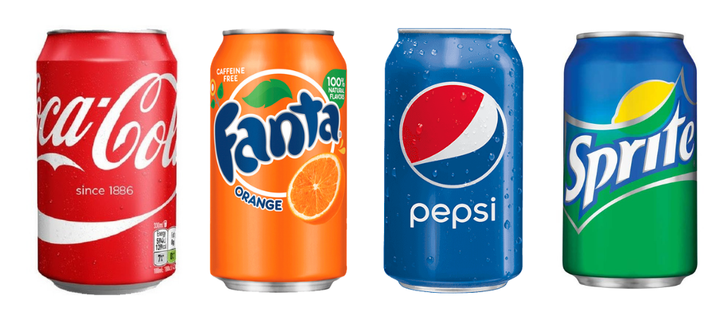

1 2 3 4

Gözəl □ □ □ □

Sadə □ □ □ □

Enerjik □ □ □ □

Sakit □ □ □ □

Lüks □ □ □ □

Gündəlik □ □ □ □

Baha □ □ □ □

Əlçatan □ □ □ □

Ucuz □ □ □ □

Yetkin □ □ □ □

Gənc □ □ □ □

Uşaq □ □ □ □

Trend □ □ □ □

Klassik □ □ □ □

14) Qablaşdırma dizaynına nəzər saldıqda, hər dizayn üçün aşağıda verilən uyğun açar sözdən istifadə edin.
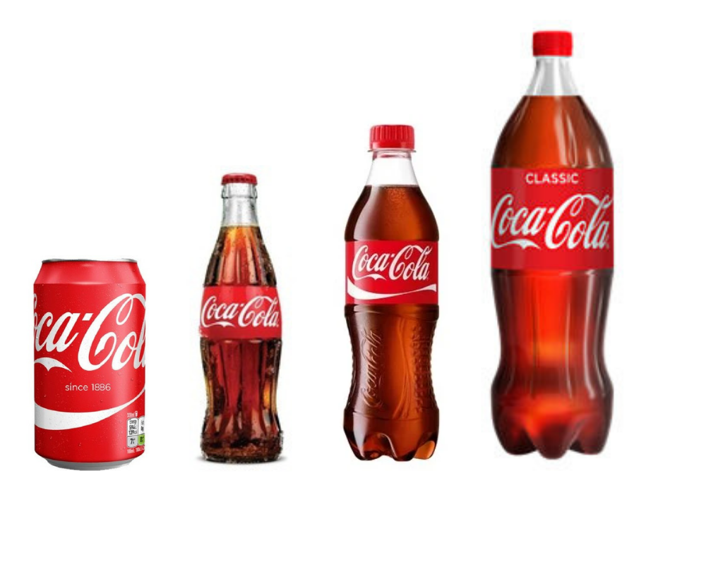
1 2 3 4

Gözəl □ □ □ □

Sadə □ □ □ □

Enerjik □ □ □ □

Sakit □ □ □ □

Lüks □ □ □ □

Gündəlik □ □ □ □

Baha □ □ □ □

Əlçatan □ □ □ □

Ucuz □ □ □ □

Yetkin □ □ □ □

Gənc □ □ □ □

Uşaq □ □ □ □

Trend □ □ □ □

Klassik □ □ □ □

15) İçkilərin web səhifəsinə nəzər saldıqda, hər dizayn üçün aşağıda verilən uyğun açar sözdən istifadə edin.
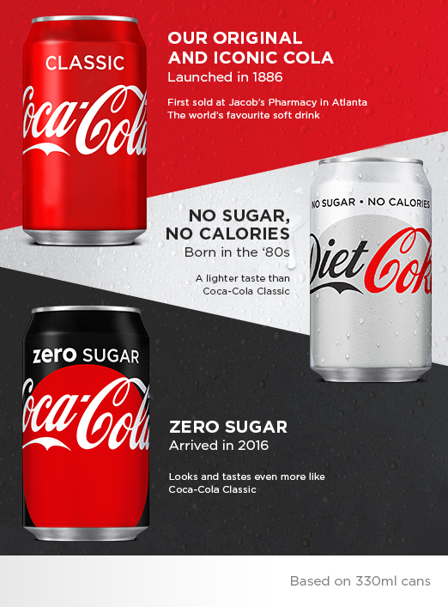
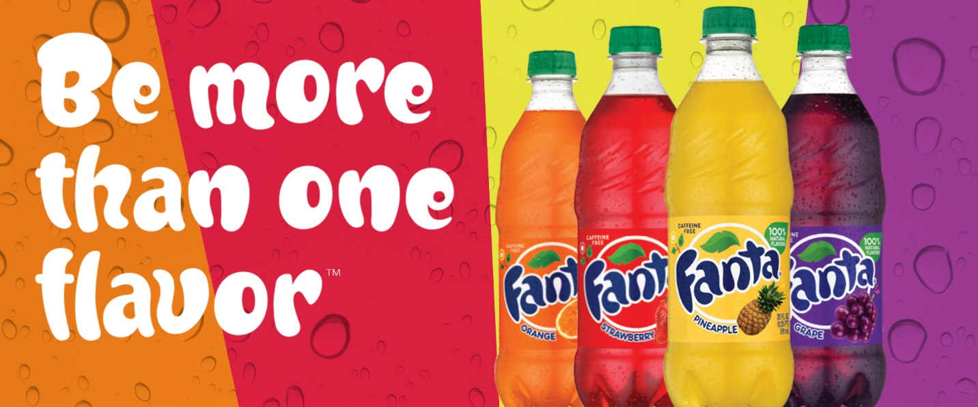
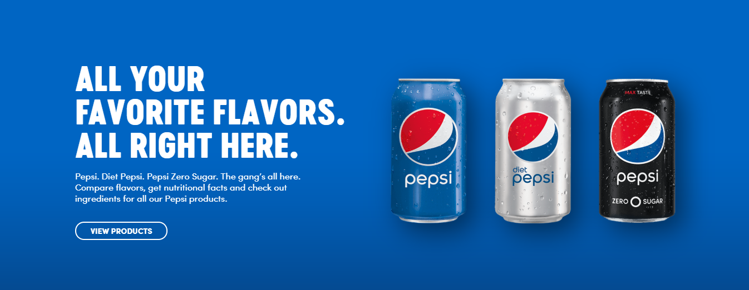

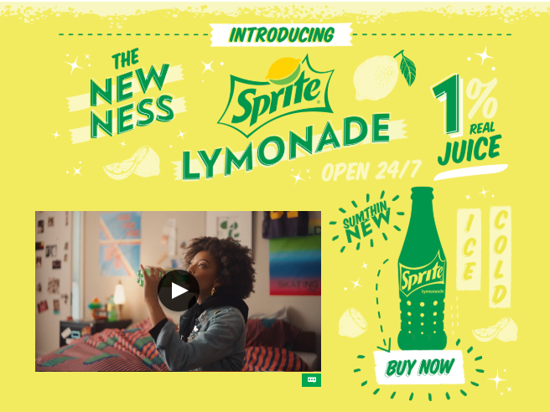

1 2 3 4

Gözəl □ □ □ □

Sadə □ □ □ □

Enerjik □ □ □ □

Sakit □ □ □ □

Lüks □ □ □ □

Gündəlik □ □ □ □

Baha □ □ □ □

Əlçatan □ □ □ □

Ucuz □ □ □ □

Yetkin □ □ □ □

Gənc □ □ □ □

Uşaq □ □ □ □

Trend □ □ □ □

Klassik □ □ □ □

7. The Survey Results

Frequency Tables
F – Frequency
P – Precent

Logo design
Answers | Valid |  |  |  |  |  |  |  | Total
 | Pepsi |  | Coca Cola |  | Fanta |  | Sprite
 | F | P | F | P | F | P | F | P | F | P
Gözəl | 47 | 27.0 | 65 | 37.4 | 46 | 26.4 | 14 | 8.0 | 174 | 100
Sadə | 95 | 54.6 | 25 | 14.4 | 18 | 10.3 | 34 | 19.5 | 174 | 100
Enerjik | 26 | 14.9 | 45 | 25.9 | 77 | 44.3 | 24 | 13.8 | 174 | 100
Sakit | 70 | 40.2 | 18 | 10.3 | 22 | 12.6 | 62 | 35.6 | 174 | 100
Lüks | 62 | 35.6 | 79 | 45.4 | 17 | 9.8 | 14 | 8.0 | 174 | 100
Gündəlik | 43 | 24.7 | 64 | 36.8 | 28 | 16.1 | 37 | 21.3 | 174 | 100
Baha | 65 | 37.4 | 78 | 44.8 | 18 | 10.3 | 11 | 6.3 | 174 | 100
Əlçatan | 24 | 13.8 | 72 | 41.4 | 44 | 25.3 | 32 | 18.4 | 174 | 100
Ucuz | 30 | 17.2 | 38 | 21.8 | 52 | 29.9 | 52 | 29.9 | 174 | 100
Yetkin | 57 | 32.8 | 62 | 35.6 | 27 | 15.5 | 26 | 14.9 | 174 | 100
Gənc | 33 | 19.0 | 50 | 28.7 | 56 | 32.2 | 33 | 19.0 | 174 | 100
Uşaq | 16 | 9.2 | 17 | 9.8 | 101 | 58.0 | 38 | 21.8 | 174 | 100
Trend | 34 | 19.5 | 109 | 62.6 | 17 | 9.8 | 12 | 6.9 | 174 | 100
Klassik | 32 | 18.4 | 109 | 62.6 | 17 | 9.8 | 14 | 8.0 | 174 | 100
Packaging design
Answers | Valid |  |  |  |  |  |  |  | Total
 | Qutu |  | Şüşə |  | 0.5l plastik |  | 1l plastik
 | F | P | F | P | F | P | F | P | F | P
Gözəl | 46 | 26.4 | 115 | 66.1 | 7 | 4.0 | 4 | 2.3 | 174 | 100
Sadə | 31 | 17.8 | 46 | 26.4 | 71 | 40.8 | 24 | 13.8 | 174 | 100
Enerjik | 86 | 49.4 | 67 | 38.5 | 16 | 9.2 | 3 | 1.7 | 174 | 100
Sakit | 26 | 14.9 | 40 | 23.0 | 68 | 39.1 | 38 | 21.8 | 174 | 100
Lüks | 45 | 25.9 | 112 | 64.4 | 7 | 4.0 | 8 | 4.6 | 174 | 100
Gündəlik | 40 | 23.0 | 31 | 17.8 | 84 | 48.3 | 17 | 9.8 | 174 | 100
Baha | 58 | 33.3 | 78 | 44.8 | 7 | 4.0 | 29 | 16.7 | 174 | 100
Əlçatan | 30 | 17.2 | 20 | 11.5 | 97 | 55.7 | 25 | 14.4 | 174 | 100
Ucuz | 22 | 12.6 | 18 | 10.3 | 83 | 47.7 | 49 | 28.2 | 174 | 100
Yetkin | 32 | 18.4 | 51 | 29.3 | 31 | 17.8 | 58 | 33.3 | 174 | 100
Gənc | 73 | 42.0 | 64 | 36.8 | 27 | 15.5 | 8 | 4.6 | 174 | 100
Uşaq | 47 | 27.0 | 37 | 21.3 | 72 | 41.4 | 16 | 9.2 | 174 | 100
Trend | 60 | 34.5 | 71 | 40.8 | 25 | 14.4 | 16 | 9.2 | 174 | 100
Klassik | 38 | 21.8 | 71 | 40.8 | 29 | 16.7 | 34 | 19.5 | 174 | 100
Web design
Answers | Valid |  |  |  |  |  |  |  | Total
 | Pepsi |  | Coca Cola |  | Fanta |  | Sprite
 | F | P | F | P | F | P | F | P | F | P
Gözəl | 27 | 15.5 | 100 | 57.5 | 22 | 12.6 | 23 | 13.2 | 174 | 100
Sadə | 108 | 62.1 | 21 | 12.1 | 3 | 17.8 | 12 | 6.9 | 174 | 100
Enerjik | 16 | 9.2 | 48 | 27.6 | 51 | 29.3 | 57 | 32.8 | 174 | 100
Sakit | 98 | 56.3 | 25 | 14.4 | 16 | 9.2 | 33 | 19.0 | 174 | 100
Lüks | 42 | 24.1 | 111 | 63.8 | 13 | 7.5 | 6 | 3.4 | 174 | 100
Gündəlik | 31 | 17.8 | 59 | 33.9 | 45 | 25.9 | 37 | 21.3 | 174 | 100
Baha | 34 | 19.5 | 111 | 63.8 | 17 | 9.8 | 10 | 5.7 | 174 | 100
Əlçatan | 33 | 19.0 | 53 | 30.5 | 55 | 31.6 | 31 | 17.8 | 174 | 100
Ucuz | 35 | 20.1 | 21 | 12.1 | 68 | 39.1 | 48 | 27.6 | 174 | 100
Yetkin | 57 | 32.8 | 73 | 42.0 | 25 | 14.4 | 17 | 9.8 | 174 | 100
Gənc | 28 | 16.1 | 51 | 29.3 | 49 | 28.2 | 43 | 24.7 | 174 | 100
Uşaq | 20 | 11.5 | 26 | 14.9 | 93 | 53.4 | 33 | 19.0 | 174 | 100
Trend | 29 | 16.7 | 110 | 63.2 | 19 | 10.9 | 14 | 8.0 | 174 | 100
Klassik | 45 | 25.9 | 94 | 54.0 | 20 | 11.5 | 13 | 7.5 | 174 | 100
Brands set specific specifications for each design set. Although the masses decided for soda drinks cover all ages, the target audience of the campaigns is usually young people. As the price range, hanging from the size of the bottle is determined as low and medium price. If we look at the results of the surveys, the participants' perceptions of the logo design are "simple" and "calm" for Pepsi, "trend" and "classic" for Coca Cola, "energetic" and "child" for Fanta, "calm" and "cheap" for Sprite. They described it as. If the correct keywords for this cluster are "young", "cheap" and "energetic", the effect of the logo design on the participants is not very successful. But other drinks have created a certain amount of correct perception.
If you pay attention to the packaging design of Coca-cola, the participants are "energetic" and "young" in the glass bottle, the size of the glass bottle is "nice" and "luxurious", the size of the small plastic is "accessible" and "cheap", the larger plastic size is "cheap" and "adults." If we come to a conclusion, we can understand that young person like the box and glass bottle, that the large drink should be drunk together with adults, that is, they perceive the concept of the family being constantly shown in the advertisements. As we have seen, brand advertising and packaging have achieved a great deal of success.
As for the publicity posters on the websites, Pepsi's "understated" and "calm", Coca Cola's "luxury" and "expensive", Fanta's "cheap" and "child", Sprite's "energetic" and "cheap" We see that you create your perception. Sprite is more successful in web design. As Pepsi moves away from the perception he wants to create, Fanta gets even closer.
With these results, we know how graphic design really affects the brand's marketing strategy. Sometimes it conveys the message that the brand wants to give correctly, sometimes it may cause the opposite.

