The Ministry of Education of Azerbaijan Republic

Effects of Digital Finance on Financial Inclusion

Author: Fidan Sultanova
Supervisor: Asif Azizov

UNEC SABAH
Azerbaijan State University of Economics

JUNE 2019

ACKNOWLEDGEMENTS

This thesis is the final step in obtaining bachelor degree. Nevertheless, the research demonstrated in next sections and thesis defense are my first scientific experiences. For this reason, I would like to express my sincere gratitude to my supervisor, Asif Azizov, for his patience and adequate guidance through this short though quite productive journey, special thanks to my family and beloved ones for their endless encouragement and constant motivation.
Particularly, I would like to thank PwC Azerbaijan team, whom I got to know during my work experience, for their contribution to my self-development, proper organization of my thoughts and eternal inspiration.

ABSTRACT

Effects of Digital Finance on Financial Inclusion
Fidan Sultanova
SABAH, Finance, S_16_01_403
Supervisor: Asif Azizov

The subject of this scientific work was found by chancing upon the report of McKinsey Global Institute while searching for appealing topic for Diploma Work. The report was about the opportunities risen by Digital Finance for emerging economies. That is the exact point from where everything has started. The term “digital” by nature looked very attractive, so that extensive research on this topic had started. The next step was acknowledgement of financial inclusion, its features and benefits.
The key and prior purpose of this study is to demonstrate how financial inclusion is a vital indicator of sustainability for all economies globally. The research will focus on examining current and previous situations of target economies through a determined period by observing ups and downs, evaluating them, presenting findings and proposing potential resolutions for them.

Key words: Digital Finance, Financial Inclusion in Azerbaijan, Technology, Financial Inclusion

Table of Contents

ACKNOWLEDGEMENTS 2
ABSTRACT 3
1 INTRODUCTION 5
2 LITERATURE REVIEW 7
2.1 Basic understanding of financial inclusion 7
2.2 Common limitations and restraints that impede financial inclusion 9
2.2.1 Supply-side barriers of financial inclusion 11
2.2.2 Demand-side limitations of the unbanked 12
2.2.3 Voluntary financial exclusion and its reasons 14
2.3 Recommendations given by various scholars 15
2.4 Technology towards extreme poverty – Digital Finance 17
2.4.1 Digital Finance – benefits and future prospects 18
2.5 M-PESA as the most successful derivative of Digital Finance 21
2.5.1 History and development of M-PESA 21
2.5.2 “Rails” of M-PESA – More “rails” means more services 23
2.5.3 How M-PESA influenced the “unbanked” communities 25
2.6 Digital Finance in Azerbaijan 27
3 METHODOLOGY 31
3.1 Materials 31
3.2 Data analysis 31
3.3 Expected results 32
4 EVALUATION 33
4.1 General overview of financial inclusion over the World 33
4.1.1 Financial account ownership 33
4.1.2 Classification of digital financial payments 34
4.1.3 Global saving and borrowing behavior 36
4.2 Overview of financial inclusion across countries 38
4.2.1 Financial account ownership 39
4.2.2 Classification of digital payments 40
4.2.3 Saving and borrowing 45
4.3 Azerbaijan in 2019 47
4.3.1 Updated indicators of financial inclusion 47
4.3.2 State Programme on Expansion of Digital Payments in Azerbaijan Republic in 2018-2020 51
5 RESULTS AND FINDINGS 53
BIBLIOGPRAPHY 54

1 INTRODUCTION

As the indication of the Era of Technology, financial services will in general move to digitalization by substituting conventional ones so as to fulfill complex needs of globalization challenges. Advanced financial services are conveyed through computerized systems, including web and mobile, with the usage of low money sums and conventional bank workplaces. PCs, cell phones and Visas utilized over POS (purpose of-sell) gadgets interface people and endeavors through a digitalized system, encouraging to help number of exchanges amongst gatherings.
Digital Financial Services concentrate all types of financial services, including credit, insurance, saving accounts; every type of users – starting with governmental authorities and ending with business of all sizes and individuals at all income levels, as well as involving all kinds of financial service providers: banks, insurance companies, telecommunications companies, fin-tech providers and so forth.
Financial services help to drive improvement. Accordingly, individuals are empowered to escape destitution by putting resources into education, health and business. The investigations demonstrate that basically individuals with low salary level are experiencing the absence of financial services, as bank account or online payments. They give more consideration to cash, which is very perilous to save and oversee.
As indicated by late investigation of Suri and Jack (2016), directed in Kenya, access to mobile money services brought various advantages, especially to ladies: in excess of 180,000 ladies got an opportunity to leave agrarian area and dispatch their very own business, and the dimension of outrageous destitution amongst female-headed families was permitted to diminish by 22%. Since 2011 World Bank Group has explained on the Global Findex Database, which includes the world's most far reaching information on how grown-ups from in excess of 140 economies spare, acquire, make installments and deal with their dangers. Through of all the time International Organizations have urged countries to build the dimensions of financial inclusion, since it conveys advantages to each member.
This examination will look at the improvement of financial inclusion, the open doors ascended by expanding the quantity of financially included people and organizations. Particularly, there will be researched the impacts and effects of computerized money on financial inclusion, which angles support the positive consequences of interests in advanced financial services area. Regardless of the way that nearly in all aspects of the world there is working somewhere around one bank, roughly 1.7 billion of grown-up populace still don't get an opportunity to be a player of financial services fragment: they don't hold any bank account nor through a mobile money supplier. Furthermore, it is exceptionally evident that the greatest offer of these individuals lives in rising nations (World Bank Group, Findex Database, 2018).
Our goal is to uncover and characterize what the causes are for such low dimensions of financial inclusion specifically areas, what sort of drivers of financial inclusion are existing, propose explanations for goals of it and analyze particularly the impact of digitalized financial services on the dimensions of progress of financial inclusion.
Also, there will be inspected different markers of financial commitment stages for a foreordained nations list, for example, account proprietorship levels, how much individuals are included into financial division, for which purposes they utilize their accounts, how every now and again individuals utilize their account. Also, there will be explored the offer of advanced installments related exchanges – kinds of computerized installments that have been made through a year, recurrence of these exchanges. Sparing and obtaining practices will take a huge piece of the assessment of this exploration paper also, since those ones are firmly associated with having a bank or mobile money account and are one of the primary locators of settled and created financial framework.

2 LITERATURE REVIEW

2.1 Basic understanding of financial inclusion

The nearness of banking abilities and solid banking system are considered as real assistants of formative exercises. An amazing and sound financial framework is a balance of monetary development, improvement and movement of an economy. A financial framework, which is generously strong, practically broadened and exhibits profitability and adaptability, is basic to any national objectives of making a focused, productive and advertise driven economy. A created framework supports venture and contributes development in the economy with its assurance. Financial delegates are those monetary operators who aid advance and are the main and very significant pilots heading to Financial Inclusion (Damodaran, 2013).
As an idea itself, financial inclusion shows that individuals and businesses have been given an entrance to advantageous and reasonable financial items and services which can meet their most essential needs – exchanges, installments, reserve funds, credits and protection services – moved in a dependable and manageable manner. Getting an opportunity to approach an exchange account is a forward advance toward a huge range of financial inclusion because of the way that the account licenses people to protect reserves, send and get installments. An exchange account assumes a job of a passageway to other financial services (The World Bank Group, 2018).
Another meaning of "financial inclusion" is given in the paper on the subject of advancement of government arrangements to extend financial inclusion (Shilpa Aggarwal, 2013) as the ownership and utilization of a checking or investment account at an authority financial establishment like a business bank, microfinance association, credit association or a mail station. So these services offer a safe spot to spare paper money, instead of significantly more hazardous exercises of keeping cash in the house or with unregulated informal foundations. As a rule, formal banks give an agreeable method for accepting wages or government installments. Moreover, aggregating money in an account may improve a progressively dependable spending frame of mind. As one of the main Big Four organizations, at the Banking the "Unbankable" Challenge (PwC Global, 2018) referenced that financial inclusion may support people and organizations to put resources into future, control their financial dangers and even turn away them from falling into neediness right off the bat. Nations which have greater and better created financial frameworks grade to develop quickly. Not exclusively do banks and other financial establishments and middle people offer more services to family units and organizations as their financial needs develop, in the meantime better access to reserves is one reason why firms and nations rise quicker, as an extensive collection of proof shows (Thorsten Beck, 2012).The chance to hold accounts with dependable banks duplicates investment funds, which thus the banks can move into business advances and credits. Thus, the subsequent lift in speculation builds development by decreasing destitution in locales that have suffered from financial avoidance in earlier occasions (EBRD, 2017).

Inadequate access to financial services is an issue experiencing a considerable part of the populace over the globe. All things considered, the attributes of the issues differ extensively amongst created and creating nations, and even amongst different gatherings of the populace in a similar nation or locale (Anju Patwardhan, 2018).

Financial services can extend monetary development. They permit individuals salvage from destitution by advancing interests in their wellbeing, training, and organizations. What's more, they encourage to control financial inconveniences, for example, an occupation misfortune — that can push families into destitution. An extensive number of individuals with low pay the world over miss the financial services that may keep up capacities, for example, bank accounts and advanced installments. Rather, they rely on cash — which is conniving and hard to oversee (Asli Demirguc-Kunt et la, 2017).
Association for Economic Co-task and Development advocates that financial instruction is one of the real powers to accomplish financial inclusion, and characterizes financial training as the system by which financial shoppers/speculators improve their comprehension and learning of financial items, ideas, highlights and hazards and, through data, direction or target exhortation, make capacities and assurance to be progressively aware of financial dangers and openings, to settle on educated choices, realize where to go for help, to take other convincing methods for exercises to assemble their financial flourishing (Adele Atkinson, 2013).
The topic of financial prohibition contacts not just poor people – most of the building up world's devouring or working class is underserved too. Individuals who utilize financial services experience significant wasteful aspects, citing to high costs and limiting their entrance to the wide scope of investment funds, protection, and credit items that is detail in cutting edge economies (McKinsey Global Institute, 2016). By and large, financial inclusion implies diminishing various casual money lenders and assistance of the available approaches to get reserves.

2.2 Common limitations and restraints that impede financial inclusion

Roughly 1.7 billion grown-up populace stays without having a formal account at a financial organization or through an e-money supplier, as announced by Global Findex. As owning an account is about typical in rich economies, in truth this unbanked populace lives in the creating economies. In actuality, practically half live in only seven creating nations: China, India, Mexico, Bangladesh, Indonesia, Nigeria, and Pakistan (See Figure 1).
Figure 1. Adults without an account
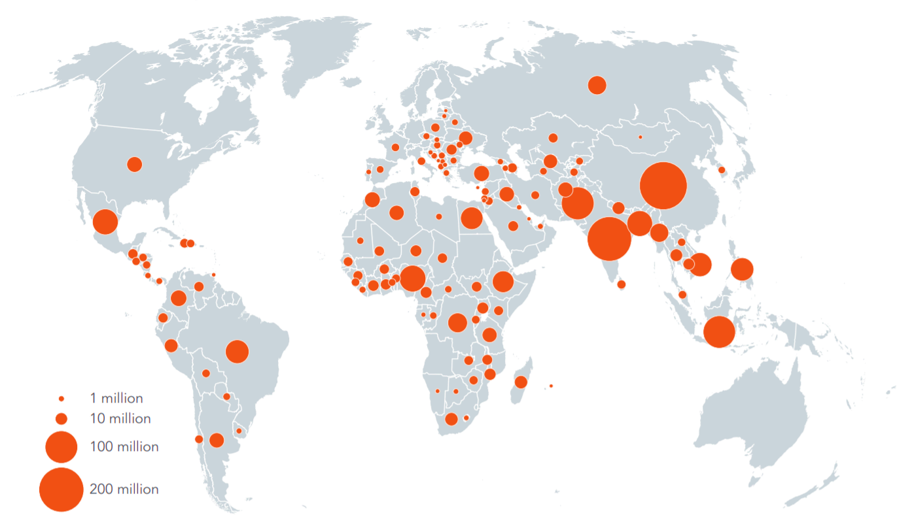
Source: Global Findex Database, 2017

Around 60% of all unbanked grown-ups establishes by ladies. Unbanked individuals are bound to have low instructive foundation. In creating economies generally 50% surprisingly matured over 15 have an essential training or less. What's more, around 66% of unbanked has basic training. Somewhat more than 33% of the financially prohibited has completed secondary school or postsecondary instruction. Those ones who are dynamic in the work advertise are less inclined to be unbanked. In light of led reviews, amongst unbanked, females have more opportunities to be out of the work power than guys. Looks into of Global Findex 2017 overview asked unbanked grown-ups for what valid reason as they would see it they are financially avoided. The vast majority noted two reasons. The most incessant one was lack of money to manage the cost of and utilize an account. 66% referenced this in nature of not having a financial organization account, and around a fifth said it as the outstanding reason. A quarter noted they don't claim an account on the grounds that a relative as of now holds one. Absence of documentation and doubt in the entire financial framework were both alluded by about a fifth of unbanked grown-ups, and religious issues by 6 percent.
As per the Global Findex, around a fourth of financially avoided grown-ups in creating nations notice that staggering expenses of services given by banks are one reason of not having an account. The vast majority may discover it too expensive to even think about sustaining a bank account for a few reasons. Numerous banks in various nations charge month to month account support expenses, explicitly in Africa, where normal account upkeep charges are about $4 (World Bank, 2009). Most banks additionally charge an expense for opening first account. What's more, some business banks control least parity prerequisites, which are not valuable for people of low-pay class.

2.2.1 Supply-side barriers of financial inclusion

Atkinson, A. and F. Chaotic (2013) in their investigation of "Advancing Financial Inclusion through Financial Education" which was directed for OECD, referenced that “financial exclusion is an indicator of market failure”, consisting of both supply- and demand-side factors. As indicated by this investigation, one of the supply-side segments is administrative imperatives. Some national administrative experts may restrict the chances of financial suppliers to charm new customers, implementing costs that would not be recuperated in the momentary period. Unwise and opposing Know Your Customer (KYC) commitments and hazard unwilling routine with regards to such standards can likewise repress access in certain circumstances. Principles, for example, KYC may generously effect on the supply of items and services to specific gatherings of the populace, for example, youngsters or transient laborers.
Another boundary is considered as presence of financial services with no any, or constrained, financial client assurance prerequisites, which make extra challenge. The accessibility of services, for example, registration, doorstep moneylenders and investment funds and advances clubs may pull in barred clients, and yet they can counteract any move to increasingly sufficient items as shoppers stall out in the cycle of turning credit, or impact reimbursements that are excessively huge and difficult to oversee.
Besides, there are roundabout costs which are for the most part ordered because of time and travel costs. It very well may be exemplified when required to be designated to venture out to the bank or the time taken to set up every single fundamental report for opening an account (Shilpa Aggarwal and Leora Klapper, 2013)
Atkinson, A. and F. Chaotic (2013) consider this reality as a land and foundation obstruction. Generally, banks and other financial foundations convey their services in physical branches. Albeit, a few nations various branches are shut as a result of remoteness or low productivity of the zone. By and by, financial services suppliers have attempted to convey answer for this issue, with the goal that they began conveying their services through utilization of data advances. In any case, a few gatherings are as yet remaining avoided, since equipment is hard to find or there is an absence of power. Accordingly, these elements decline the viability of the provided financial services.
As per Anju Patwardhan (2018), there are three principle factors that counteract the extension of financial services crosswise over states at various improvement stages and differing bunches amongst the populace: "Access, Product Market fit and Affordability". One of the huge viewpoints is the absence of services which are conveyed through branches, and the explanation behind that is the remoteness of a given territory or a district. In increasingly thorough markets services might be available physically yet be hampered with “complex terms, poor transparency and low usability”.

2.2.2 Demand-side limitations of the unbanked

Demand side impediments, as per Atkinson, A. also, F. Muddled (2013), are close to personal, educational and cultural hindrances. Absence of financial assets, joblessness or not having a credit score rating may push individuals to work with informal money lenders, and along these lines compound current circumstance. Various individuals probably won't know financial terminology and how financial items work, and therefore, will have poor certainty and no trust in banks. There can likewise be planned a few demeanors toward financial services suppliers: if an individual have encountered a few issues and issues a few times, the person in question would not depend on those services later on.
T. Beck and others (2012) in their work notice that high data hindrances make credit process increasingly hard for "opaque borrowers". Family units for the most part need to acquire little measures of credit and the accessible data about their reimbursement plans is principally restricted. Despite tough customer merchandise like autos, lofts or houses on account of home loans are normally given as security, it is very costly for banks to force their recuperation if there should arise an occurrence of disappointment of obligation reimbursement.
Another generally spread issue, as substantiated by Anju Patwardhan and others (2018), is that financial items which are accessible at the commercial center don't address the issues of expansive segments of purchaser socioeconomics. This can be since the structure of the items or services or the manner in which they are conveyed. For example, in instances of the prerequisites as credit rating assessments, negligible adjusts or different limits that can't be met by an expansive piece of the populace. In a large portion of the events, the value itself turns into a boundary when evaluating terms don't address the capacities of potential purchasers, either “due to the fact that prices are too high or prices are determined and charged in such a way that is too rigid to be affordable for them”. The circumstance is comparable for little and medium undertakings. They need items and services that are satisfactory for them yet their financial needs are regularly portrayed as high in multifaceted nature and low in scale.
So as to make financial services comprehensively accessible, costs must be reasonable and along these lines the expense offered to the suppliers ought to be adequately low with the goal that the services can be given at a benefit regardless of the limited incomes. On the off chance that the suppliers are unfit to create benefits, they have no any motivating force to offer the services.

2.2.3 Voluntary financial exclusion and its reasons

Notwithstanding, not constantly financial inclusion faces the hindrances, for example, the absence of access to essential financial services. Much of the time individuals are prohibited from the formal financial framework because of willful financial avoidance. A portion of the destitute individuals in the unbanked populace may willfully reject to participate in the formal financial framework because of a few reasons. P. K. Ozili (2017) outlines them in the accompanying manner:

- People don't wish to participate straightforwardly with banks and web organizations
- They don't know about the advantages which advanced financial services would present to them
- These people don't have a decent financial assessment rating so as to get an advance at lower loan cost offices from either banks or formal credit establishments
- Lack of financial proficiency and instruction about how to utilize computerized financial stages, points of interest and dangers of advanced fund.

Individuals are just reluctant to utilize an item or administration that they don't see. Therefore, such circumstances happen when individuals with low pay deliberately don't wish to have the utilization of the formal part despite the fact that they understand the monetary preferences and accommodation it prompts them.
“If you don’t understand the language of money, and you don’t have a bank account, then you’re just an economic slave” – John Hope Bryant, CEO, Operation HOPE.
Researchers consistently avow that improving the dimensions of general and financial proficiency can take care of the issue of deliberate financial rejection. “Developed financial literacy could bring to increased wish for financial services amongst the voluntarily unbanked people” (S. Aggarwal and L. Klapper, 2013). Investigation of the pattern in mobile banking demonstrates that having improved innovation, better items and services are not adequate. The potential client of these applications ought to see rudimentary financial instruction and ability to utilize innovation. Individuals ought to be taught why long haul speculations are basic for them and their family (A. Damodaran, 2013).

2.3 Recommendations given by various scholars

Anju Patwardhan and others (2018) and A. Damodaran (2013) bring a few answers for both willful and automatic financial rejection. As a matter of first importance, diminishing exchange costs is considerable to build up installment systems which are comprehensively utilized by all areas of the populace. The fast increment of mobile gadgets has conceded another class of installment specialist co-ops and arrangements that gauge a lot faster than ordinary installment services and are given at much lower exchange costs. These installment systems and the information produced from the installment exchanges can be utilized to rapidly take off other financial services, specifically credit. Likewise, different client sections have distinctive financial needs.

Financial inclusion is frequently examined from perspective expanding access of conventional financial items to the unbanked part of populace. Be that as it may, the instances of M-PESA (Kenya), AliPay (China) and other mechanical developments call attention to that the clients don't really require a formal bank account and just wish a methods for directing installment exchanges. Computerized validness and advancements help excuse the difficult account opening procedure and bolster financial conditions. Aadhar in India has permitted opening an account with low expenses for many clients and empowered them with financial access.
Enlistment at Aadhaar is deliberate yet it enables Indian residents to get to not exclusively to banking services yet in addition to get stipends and national wellbeing welfare securities, quicker movement work areas (at the U.K.), quicker registration in Indian air terminals, even twofold confirmation for high esteem exchanges and E-trade ID (PwC, 2018).
The job of government is additionally basic somewhat. Neighborhood specialists should build number of banks backups in remote zones. Business banks should give more consideration to items which would be straightforward and moderate for their clients with high effectiveness. Financial organizations should lead persistent overviews in communities and towns so as to comprehend what sort of the financial services individuals need, and gather inputs about existing items and services. NGOs and not revenue driven associations may work together with financial organizations and individuals to announce the financial services to less available regions.

2.4 Technology towards extreme poverty – Digital Finance

The favorable circumstances originating from financial inclusion can be a heap. For example, ongoing inquires about have demonstrated that mobile money services — which allow to clients to spare and exchange assets through a mobile telephone — can help advance individuals' capability to win salary and subsequently decrease destitution. As per an exploration directed by Suri (2016), it was discovered that computerized financial services conveyed by mobile telephones brought immense advantages, particularly for ladies, as “It enabled female-headed households to grow their savings by more than 20%; permitted 185,000 women to quit farming and establish business or retail activities; and it helped decrease extreme poverty amongst households headed by ladies by 22 percent” (T. Suri, 2016).
As indicated by the examination led by P. K. Ozili (2017), computerized account can be a main impetus to more noteworthy financial inclusion, widening of financial services to non-financial areas, and the extension of essential standard services to people, since about portion of individuals in the creating scene as of now has a mobile telephone. By the by, advanced money certifications to help the total national output of digitalized economies by acquainting agreeable access with differentiated scope of financial items and services (and acknowledge offices) for people just as for SMEs, which can support total consumption in this manner redesigning GDP levels. As an intention control, computerized account can likewise foreordain to more noteworthy monetary dependability and expanded financial intermediation, both for clients and for the economy where they and their families live. In addition, advancements in computerized money innovation can have long-term constructive outcomes for banking industry. In their examination Scott and different researchers of Warwick University (Scott, 2017) inspected the effect of appropriation of the SWIFT framework on bank execution, a system based innovative foundation and set of principles for overall interbank media transmission. They examined in excess of six thousands banks in very nearly 30 nations in Europe and the U.S. what's more, discovered that the appropriation of SWIFT affects gainfulness in the long haul; these benefit results are more noteworthy for little banks than for substantial banks.
Computerized financial services can likewise encourage individuals' administration of financial hazard — by making it advantageous for them to get assets from companions and relatives, who live in far off and remote zones, when challenges are out of hand. In Kenya specialists saw that when there was a hit with an unpredicted drop in pay, mobile money clients did not diminish their family going through — while clients with poor access to the mobile money arrange and those ones who did not have any account limited their buys of nourishment and different items by 7– 10 percent (Asli Demirguc-Kunt et la, 2017).
Therefore, advanced fund is meant to boost the prosperity of people and businesses that have formal bank account and have money in their formal bank accounts to complete various financial exchanges. By the by, the foreseen points of interest of computerized money can be completely acknowledged on the off chance that if the expense of giving advanced financial services is unimportant or zero, as expressed by P. K. Ozili (2017).

2.4.1 Digital Finance – benefits and future prospects

McKinsey Global Institute conducted a microeconomic analysis of the impact that digital finance may have on saving, investment, and productivity, by building a model for seven countries which constitute more than half of the GDP and population of all developing economies: China, India, Mexico, Brazil, Ethiopia, Nigeria and Pakistan. Afterwards, they extended application of the same model to the rest of countries. The findings are more just promising: digital finance can lead to GDP growth via three important paths:
1. The productivity of financial and non-financial enterprises and governmental authorities can be increased through digital payments;
2. As a result of increased digital payments, extended financial inclusion of individuals and businesses allows formal financial system to cover more of the saving in the economy and in turn expand more credit and boost investment;
3. Digital finance saves time for people, enabling them to set aside time for other activities.
As a product of digital finance, mobile money is becoming successful since it is substantially cheaper than other options of cash. McKay and Pickens (2010) in their comparison of about 25 banks have observed that branchless banking (including mobile money) services were nearly 20 percent cheaper on average than other alternative services.
Other key advantages of mobile money – liquidity and speed. Low-income participants of the society usually own a limited range of assets, which are quite illiquid in their nature, such as gold and livestock. During crisis times, it is difficult to exchange those assets into cash indeed. Moreover, the value of these assets may decline as a result of situation when many people will try to convert them into cash. People also send cash and gold jewelry to their family or friends in need, and this can be really risky. But mobile money services can offer an accessible and comfortable medium for the transfer of financial services and more secure than informal conventional methods (K. Donovan, 2012).
Another positive side of digital finance is that it can increase the motivation to save, through automatic deposits, default options or text reminders. Texted reminders raised savings in Bolivia, Philippines and Peru by nearly 16 percent (World Bank, 2014).
Moreover, digital financial inclusion approves 10 of the 16 United Nations’ Sustainable Development Goals (see Figure 2)
Figure 2 United Nations’ Sustainable Development Goals
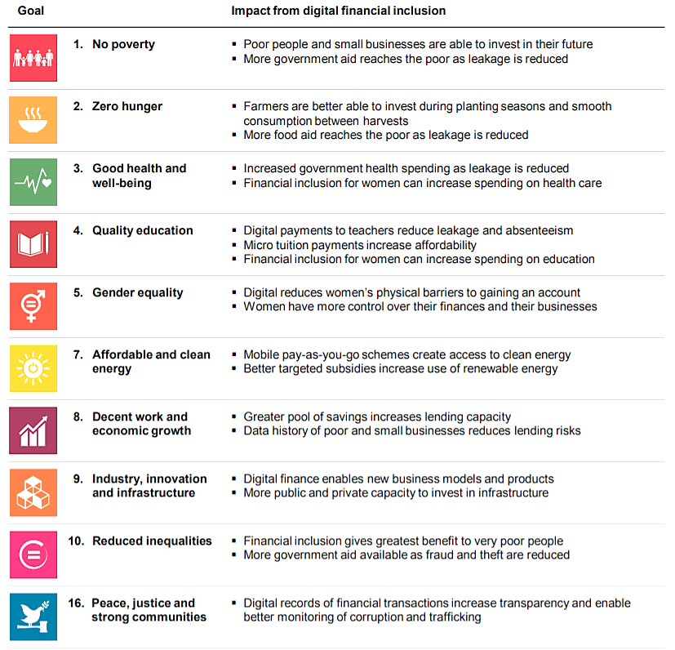 Source: UN Sustainable Development Goals, McKinsey Global Institute, 2016

Computerized money can likewise build ladies' financial contribution. Indeed, this is on the grounds that computerized installments may all the more basically be covered by the recipient as opposed to money; at any rate for some period, it alters monetary basic leadership for females. Approaching reserve funds instruments likewise fortifies ladies strengthening and the utilization and productive speculation of business women. There is an extensively self-assured connection between female work power interest and ladies' bank account possession. Online installments assemble an unmistakable computerized record and can be effectively followed, with the goal that the odds of assets not achieving the beneficiary, probabilities of copied installments or installments to "phantom" payees – those ones who don't exist in genuine world – will be significantly much less. Proof from India additionally demonstrates that utilizing smart cards rather than cash for standardized savings installments diminished the incidence of demands for bribes by about half (World Bank, 2016).

2.5 M-PESA as the most successful derivative of Digital Finance

2.5.1 History and development of M-PESA

Computerized financial services are amongst the most growing mobile applications in creating economies. These services may develop to a one of a kind stage that transmutes strong economies, as it is coordinated by means of trade, human services framework, rural and instructive segments, and so forth. Today many mobile money applications with a great many dynamic clients have been created and initiated (Mobile Money for Financial Inclusion, 2012).
Over 10 years prior mobile money was right off the bat presented in Sub-Saharan Africa and the Philippines (Suri and Jack, 2016). The most prominent and regularly acknowledged one, M-PESA, was right off the bat presented on the 6th of March 2007 by Vodafone's Kenyan accomplice, Safaricom. In its logo, "M" means "mobile" and "PESA" signifies "money" in Swahili. Until this point, Vodafone gives M-Pesa services in 10 nations: Kenya, India, Albania, Lesotho, the Democratic Republic of Congo, Romania, Egypt, Tanzania, Ghana and Mozambique. As of the finish of December 2017, M-Pesa helped around 27 million dynamic clients by means of a system of in excess of 130,000 operators (Vodafone Annual Report, 2017).
Clients right off the bat register at an approved operator, generally this is a retailer or smaller than normal mobile telephone store, and afterward clients get electronic money which they can exchange to their family in return for keeping money. When they have recorded all exchanges, they are finished by entering a PIN number for security and the two sides get a SMS message that affirms the sum exchanged. On the off chance that the beneficiary does not enlisted in a similar system, the person in question gets mobile money continuously and after that recovers it for money by setting off to another specialist. The administration is created so that empowers clients to send, get and set aside some cash and protected and secure route through a fundamental mobile telephone and in certain business sectors by utilizing a cell phone (M-PESA, Vodafone, 2017). One of the inspirations of embracing this remarkable stage was its motto. Vodafone advanced its services by focusing on residential settlements advertise with the motto "send money home".
Kenya has the most astounding offer utilizing an account: amongst grown-ups sending or getting residential settlements in the previous year, 89 percent revealed having utilized an account to do as such, much of the time a mobile money account (Global Findex Database, 2017).
Mobile money can make an unrest in financial inclusion. Mas and Radcliffe (2011) in their investigation recognized that “Where most financial inclusion samples have executed either ‘credit-led’ or ‘savings-led’ approaches, the M-PESA experience affirms that there might be a third method as well — focusing on building the payment ‘rails’ on which a broader series of financial services may ride”. Computerized account frameworks may fill in as a stage for additional developments, regardless of whether they are charge installment services that assistance to escape long line times or increasingly brilliant models like viable contingent money exchanges for drouth help or remuneration.

2.5.2 “Rails” of M-PESA – More “rails” means more services

Mobile money enables individuals to make exchanges in little sums. This implies the rate of appropriation is a lot quicker than if there should arise an occurrence of conventional accounts (which is fundamentally going to increment with pay levels). This circumstance makes the ground for new organizations, for example, small scale installments (McKinsey, 2016). There are various items which were created in temperance of M-PESA, and will be talked about in this area.

• M-Kopa Solar
This is IT-empowered installment framework which spoken to by pay-as-you-go sunlight based boards and can control lighting, radio, computerized TV and mobile telephone charging. It is used by means of mobile-money application M-Pesa. In this model, clients register a little store for the sun oriented board and pay per use through a mobile telephone each time they utilize the power amassed. Suppliers can kill the administration if the client does not pays his or her obligations opportune. This reality builds possibility of reimbursement and lessens costs related with gathering. Without the ability to gather installments for each utilization, providers would not have the capacity to guarantee that utilization coordinated installment. Explicitly in rustic and remote territories this will in general be off-lattice, accumulation expenses would be high (Website of M-Kopa Solar). Despite the fact that advanced gathering of installments is moment and modest. Starting at July 2016, M-Kopa Solar had associated in excess of 380,000 homes to cheap sun oriented power in East Africa, and working buyers are estimated to spare $280 million throughout the following four years by utilizing M-Kopa Solar instead of purchasing lamp fuel (McKinsey, 2016).

• Kilimo Salama
In Swahili its name signifies "safe farming" and is an association inside Syngenta Foundation for Sustainable Agriculture, Safaricom and UAP Insurance. This is a smaller scale protection item created to guarantee smallholder ranchers (McKay and Pickens, 2010). Kilimo-Salama safeguarded in excess of 10,000 ranchers, and in excess of 10 percent of them got payouts of around 50 percent of guaranteed components. In addition, the system gathers information on climate and deals with ranchers' receivables from insurance agency through M-PESA. And the majority of this procedure was done in second year of activity of Kilimo-Salama (Sen and Choudhary, 2011).

• M-Kesho
The item was propelled in May 2010 by an organization of Safaricom and Equity Bank. The Bank offers credit, miniaturized scale sparing accounts and protection. Since clients get enlisted through this system, their financial narratives are beginning creating. Thus, other financial foundations will almost certainly make an investigation of their accounts and plan a credit scoring model for them (K. Donovan, 2012). What's more, M-Kesho offers basic financial records, yet enthusiasm bearing bank accounts. These accounts might be gotten by enrolling at M-PESA specialists or by having an account at Equity Bank which will be associated with M-PESA. Sum additionally can be exchanged amongst M-PESA wallets, M-Kesho accounts and Equity Bank accounts, which makes significantly more accommodation for its clients (McKay and Pickens, 2010).

• Academy in a box
This task was propelled in Kenya, by Bridge International Academies 10 years back in 2009. The center administration is advancing reasonable minimal effort tuition based schools for underserved networks. School organization is overseen completely on cell phones and tablets, which dispenses with the requirement for accounting and money divisions and their related expenses. M-PESA assumes a job of stage to may school charges. Expenses can paid in month to month micropayments, and it underpins educator compensations, supplies and furthermore other authoritative expenses. Scaffold International Academies was extended to very nearly 400 schools and in excess of 100,000 understudies by 2014. Since 2014 they began working in India, Nigeria, Uganda and Liberia also (Website of Bridge International Academies).

2.5.3 How M-PESA influenced the “unbanked” communities

By bringing down the costs suppliers of mobile money can reach and serve perpetually individuals gainfully, and more people will be incorporated. With such system activities, acknowledgment can be quick for sure. The quantity of Kenyan clients of M-Pesa mobile-money arrange supported up from zero to about 40 percent of grown-ups in just three years succeeding its 2007 dispatch and before the finish of 2015 remained at very nearly 70 percent (Mas and Radcliffe, 2011 and McKinsey, 2016).
The investigation in Kenya additionally has discovered that families which approach M-Pesa had the capacity to stand up to significant financial stuns, for example ailment, without cutting the dimension of the utilization; rather than it, they had the capacity to get household settlements from specific individuals, their loved ones. In any case, the individuals who didn't have an account at M-Pesa mobile money framework decreased their utilization by 7 percent in comparative events (Suri and Jack, 2016).
Safaricom in Kenya affirms that about 50 percent of M-PESA clients spare a normal of three hours of transport time and 3 USD of transport costs per every exchange. In Kenya, 75 percent of customers state they keep their money in M-PESA wallet (McKay and Pickens, 2010).
Development of new advances that utilization a wide scope of handsets, for example, cell phones for sellers can lessen the expenses and expand the easement of tolerating computerized installments. At the most essential dimension, mobile-money frameworks like M-Pesa help to make it reachable for traders to get installments by content. For cell phones, the presence of mobile purpose of-offer (mPOS) innovations help vendors to interface their telephones to a card and contactless per user at reasonable costs which are underneath than normal POS terminals. In India, for example, merchants can procure an Ezetap mobile telephone card per user for around 50 USD (McKinsey, 2016).
Disregarding low expenses charged by mobile money suppliers, this business can be essentially gainful for them while the quantity of account proprietors is expanding by showing significant income figures. Safaricom, the mobile administrator that gives M-PESA, detailed its incomes on mobile money for the FY 2011 of K Sh 11.78 billion (USD 141.4 million; at the swapping scale of 1 K Sh = 0.012 USD) and for the FY 2018 that figure was equivalent to K Sh 62.9 billion (USD 6 billion; at the conversion scale of 1 K Sh = 0.098 USD) (Website of Safaricom, Annual Reports). The dependability of the figures is very high, since the financial explanations of Safaricom are continually evaluated by one of Big Four organizations - PwC (PricewaterhouseCoopers) from its initially working year.

2.6 Digital Finance in Azerbaijan

Regardless of challenges identified with absence of researcher articles in this theme for Azerbaijani market, there are still some incredible assets which helped in the readiness of this area.
Azerbaijani researcher Gubad Ibadoghlu, who is an educator at the Rutgers University (the USA) and earlier teacher of the UNEC – University of Economics (Azerbaijan), arranged an extensive working paper in a joint effort with Asian Development Bank Institute on the point of "Financial Inclusion, Financial Literacy and Financial Education in Azerbaijan". Financial division of Azerbaijan chiefly comprises of banks, generally 88% in the all-out resources of the financial framework. Beginning from 2015, licenses of 15 banks were proclaimed invalid since they had lost their capacity to meet capital necessities in three resulting years. Also, this event was because of the two debasements of Azerbaijani manat in February and December 2015, brought about by fast fall of oil costs (G. Ibadoghlu, 2018).
Azerbaijani policymakers since those occasions are centered on recovering financial dependability, reestablishing shopper and speculator certainty, limiting dollarization and putting resources into non-oil segments. This is demonstrated by Strategic Road Map on Development of Financial Services in the Republic of Azerbaijan Approved by the Decree of the President of the Republic of Azerbaijan dated December 6, 2016.
The key guide on improvement of financial services features a few methodologies:
- The first goal is to shape a financial framework which comprises of dynamic and solid establishments. In the protection division, it covers vital objectives that reflect measures to underwrite insurance agencies, upgrade resources, build up the protection advertise, and fortify financial inclusion towards the goals of new difficulties.
- The second methodology is identified with the advancement of focused financial markets, the movement of speculators and guarantors in financial markets. The uninformed dimension about potential speculators and guarantors about the capital market and financial instruments, similar to data asymmetry and conventional devotion, restrains the advancement of the securities advertise, which prompts the wasteful dissemination of financial assets in the economy. Key focuses for advancement of capital and money showcase, formation of ideal condition for market members were characterized so as to take out prohibitive variables.
- The third procedure is to reinforce foundation, for example, framework, law authorization and implementation components, just as the foundation of credit data trade framework, advancement of credit data sharing framework to improve framework, making successful instruments for ensuring loan bosses' rights, institutionalizing and requirement of court choices key objectives went for improving order.
- The fourth vital target is to improve the administrative and control system. Expanded hazard affectability of financial organizations in the current monetary condition and the development of new hazard zones require the improvement of hazard the executives rehearses in the division. Financial establishments have distinguished vital targets for the arrangement of another administrative and control design that advances sound hazard the board forms and computerized change.
- Finally, the fifth target is to raise financial proficiency. Improving the information and abilities of workers in the financial framework to a subjectively new dimension, just as expanding the financial education of financial services buyers can prompt the development of a sound, dependable, tough and viable financial framework. So as to accomplish this, key targets have been distinguished gone for developing the monetary framework's mastery and expanding financial proficiency.

The Strategic Roadmap particularly features issues identified with financial inclusion and proposes a few arrangements, for example, improving channels interfacing financial specialist co-ops and focused on networks, and structuring useful and dynamic administrative framework for establishments which add to national financial inclusion level.
Gubad Ibadoghlu in his exploration makes reference to different obstructions to financial inclusion in Azerbaijani market. The absolute initial one is the quantity of banks, NBCO and their backups. He additionally makes reference to high financing costs and non-appropriate credit scoring frameworks, since many SME's don't have straightforward activities, which makes snags for banks to assess reliability and survey potential advance issuance. This point is from financial organizations viewpoint. Be that as it may, there are additionally difficulties amongst individuals and organizations towards financial services suppliers. More often than not there is common misconstruing amongst organizations and banks: business people have uninformed about services offered by banks, and banks don't have any goal to clarify them the entire procedure. Notwithstanding these, clients lost their trust to credit organizations (G. Ibadoghlu, 2016).
There are made into move a few endeavors for improving financial education dimensions of the populace by CBAR (Central Bank of Azerbaijan Republic) and other neighborhood financial associations, as referenced by Jh. Hajiyeva (2016).
As indicated by Jh. Hajiyeva (2016), there is working Department of Development at the Center for Research and Development. The focused on group of onlookers of the tasks identified with financial proficiency are secondary school understudies, workers of the business banks, understudies who are studying banking, and individuals with low financial instruction foundation. Likewise, there are various sound associations which remain as accomplices of the Development Department on Financial Literacy: the World Bank (WB), the International Federation of Library Associations (IFLA), the Organization for Economic Cooperation and Development (OECD), the American Resource Center (ARC), the Germany International Cooperation Society, PricewaterhouseCoopers (PWC) and the Ministry of Education of Azerbaijan Republic.
So as to increment financial proficiency dimensions of the populace CBAR led various classes and workshops, summer schools, different rivalries and promotion crusades. The latest ventures executed by CBAR are Financial Literacy Portal (www.bizimpullar.az) which propelled in 2015 and Virtual Education Platform (www.edu.e-cbar.az) propelled in 2017 (Website of CBAR, Financial proficiency).
Bizimpullar.az causes people to get fundamental thing materials about financial aspects and account, banking services. There are likewise a virtual exhibition hall, a few recreations and adding machines, including tests to decide financial information of a client.
By enlisting at the Virtual Education Platform individuals can get free access to the online courses arranged by CBAR. Here they can watch recordings, utilize extra materials and evaluate their insight after each scholarly section. Toward the finish of each course fruitful understudies who pass the test can get a testament of consummation from CBAR.
The further measurable confirmations will be exhibited in the following area, as per the figures acquired from Global Findex Database of World Bank Group, just as indicated by the discoveries of overview led by Author.

METHODOLOGY

3.1 Materials

The informational background of theoretical review and evaluation of data for this research is based on the secondary data which are obtained from publicly available sources and reports published by sound national and globally international organizations such as World Bank Group, McKinsey Global, International Finance Corporation, PwC Global (PriceWaterhouseCoopers), EY Global, Asian Development Bank, as well as Central Bank of Azerbaijan Republic, etc.

Data analysis

This research is conducted in a deductive approach, so that the Author is analyzing the existing theories and assumptions given by various scholars from a number of countries through a period of 2009-2018, by focusing mainly on recently conducted academic works. There will be investigated a number of lower- and higher middle income economies, by observing several variables (account ownership, digital payments, saving and credit patterns) during three different periods: 2011, 2014 and 2017. Countries were classified according to their GNI (Gross national income) per capita by the World Bank Group. Thus countries with $1,004 and less GNI per capital are classified as low income economies, from $1,005 to $3,954 – lower-middle income, from $3,955 to $12,236 – upper-middle income, and countries with GNI per capita of $12,337 and more are considered as high income economies. The figures, demonstrated in charts, will be indicated in percentage of the adult population (people at the age of over 15).
The research will challenge the hypotheses of whether introducing and expanding digital financial services has a positive effect on financial inclusion and poverty as well. Since the aim of broadening financial inclusion is to maximize access to affordable and not expensive financial products and services to meet any daily basic needs.

Expected results

The purpose and main goal of this work is to reveal the effects of the implementation of Digital Finance over the levels of financial inclusion across various community segments. It is also contemplated that the application of various financial awareness campaigns and seminars for people with low financial literacy will have a positive impact on decreasing the portions of unbanked individuals. The obtained final results will be disclosed in Conclusion.

4 EVALUATION

4.1 General overview of financial inclusion over the World
Having a financial account shown that an individual has a financial instrument. It encourages a protected and secure approach to save money and make investment funds for the following years. Accounts additionally empower individuals to pay their bills, send and get money just as make buys. Therefore these lines World Bank Group utilizes it as a primary pointer of financial inclusion. Internationally, almost 1.8 billion of individuals stay without having any account – neither at formal financial organization nor at mobile money administrator. Since having an account is a principle normal for created economies, the greatest segment of unbanked represents low-salary countries.

4.1.1 Financial account ownership

According to the Figure 3 below, it is promising that there are developing patterns amongst creating nations in financial inclusion dimensions of the populace, as obviously if the level of individuals having any account in 2011 was 41%, following 6 years in 2017 this figures in moved to 63%. Be that as it may, as we see natives of high-pay economies had been financially included since 2011.
Figure 3 Percentage of adults with an account
Note: The chart has been created by the Author based on the data obtained from The Global Findex Database (2018)

Globally, 53% of grown-up populace — or 75% of account proprietors — announced that they have gotten or made somewhere around one advanced installment exchange by utilizing their account in the previous year. In created economies the segment was 90% of grown-ups (96% of account proprietors), in low and center pay economies 45% of grown-ups (69% of account proprietors), and see Figure 4.
Figure 4 More people who owns an account are using it for digital financial transactions, in percentage
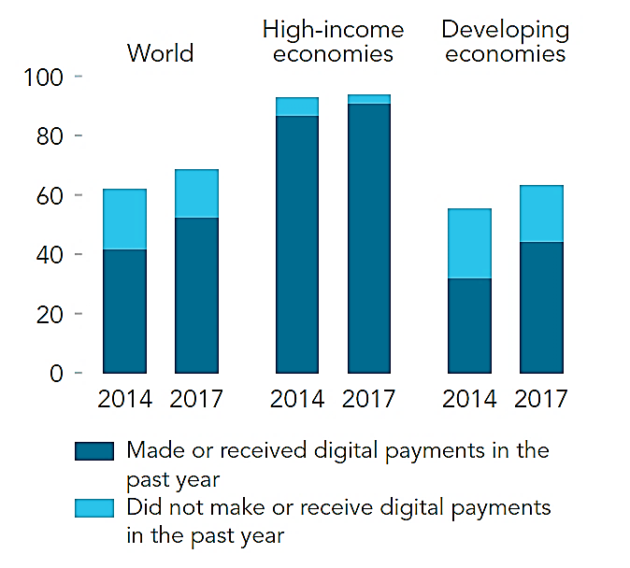
Source: Global Findex Database (2018)

4.1.2 Classification of digital financial payments

The World Bank Group has ordered principle classifications by which individuals ordinarily include in advanced installments: paying service bills, tolerating compensation from private division ventures, accepting government installments, utilizing web to do web based shopping or pay any bills, utilizing charge or Visa to make an exchange and utilizing a mobile telephone to execute an exchange. In figure 5 there is portrayed how and for which purposes individuals everywhere throughout the globe utilize their accounts.
As per the information shared by the World Bank Group, individuals living in high salary economies announced that amongst all advanced financial exchanges the for the most part (almost 80%) utilize their credit and check cards to pay for their buys. Interestingly, the least rate is of use of digitalized installments represents getting government installments. Individuals additionally pay for their utilities and web based shopping buys in all respects effectively with the rates of 59% and 68% separately.
Figure 5 Percentage of how adults use their accounts
Note: The chart has been created by the Author based on the data obtained from The Global Findex Database (2018)

Interestingly, natives of creating world are less occupied with advanced financial services. For instance, just 20% of them have utilized web association with do web based shopping, and utilities are paid through accounts by 14% of populace. In general, the rate figures for utilizing the account for the given services fluctuates from 10% (for accepting wages in private division) to 23% (for utilizing charge and Master cards for their installments). While financial inclusion starts with owning an account, the points of interest originate from dynamic use of that account — for putting away money, overseeing dangers, for making or tolerating installments. Worldwide Findex Database have pointed that around the world, a billion of grown-ups who as of now claims an account still use money to pay their service charges (see figure 6). In the event that greater utility suppliers gave an engaging option in contrast to paying bills over computerized advancements, the two sides would probably get profited by more noteworthy proficiency. The vast majority of grown-ups who are as of now utilized and have an account at a financial establishment still get paid in real money. Almost 300 million of account proprietors all-inclusive work in the private area businesses and get their compensations and wages in real money, while approximately 278 million of account proprietors acknowledge money installments for the selling of rural items.
Figure 6 Adults with an account paying utility bills in cash only
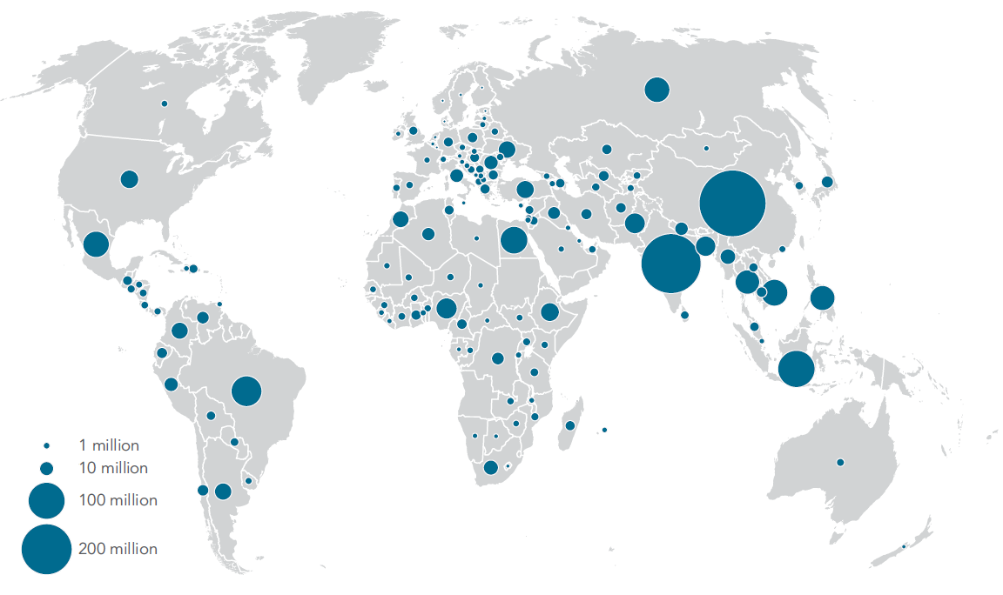
Source: Global Findex Database, 2017

4.1.3 Global saving and borrowing behavior

As per the report arranged by the World Bank Group, universally individuals spare the greatest bit of their assets all alone, which establishes about half of all talked with people, as opposed to store their money at the financial organization (see Figure 7). It was seen that just 43% of people living in creating economies spared any money in the previous year. While 1/5 of reviewed ones referenced about sparing at a financial foundation. The figures are very higher for high-salary nations. For example, over 70% of watched individuals detailed being occupied with any sparing exercises, and in excess of a half of populace affirmed utilizing a financial account for saving their assets.
Generally, there is almost similar patterns about investment funds for both low-and high-salary economies. Individuals are for the most part engaged with sparing their assets all alone, and less individuals spare at a financial association. In any case, minimal piece of interrogated people referenced regarding putting something aside for their oldness, 43% of created countries and just 15% of creating nations.

Figure 7 Saving behavior of adult population
Note: The chart has been created by the Author based on the data obtained from The Global Findex Database (2018)

As per the information gathered by World Bank Group, practices in high and low salary nations fluctuate a ton. As it is observed from the outline beneath (see Figure 8), in high salary economies a typical mean of acquiring is moving toward a formal financial organization (55.1%), while in developing ones individuals will in general obtain from their family and companions (28.5%).
Figure 8 Borrowing behavior of adult population
Note: The chart has been created by the Author based on the data obtained from The Global Findex Database (2018)

4.2 Overview of financial inclusion across countries

For nation assessment segment there were focused on a few economies from lower-and upper-center pay gatherings of nations so as to get sensible examination, depict openings and future prospects for intensification of methods for reasonable access to fundamental financial services by execution of computerized installments framework, too we by elaboration of administrative structure.
There will be inspected four lower-center salary nations (Georgia, Kenya, India, and Pakistan), four upper-center pay (Azerbaijan, Turkey, Russia, Kazakhstan) and one high pay economy (Estonia).
The explanation behind missing any information about a specific nation is expected to either no probability to gather information or a figure which speaks to a significant little digit.

4.2.1 Financial account ownership

Account possession is acknowledged as the principle instrument demonstrating the dimension of financial inclusion. Beneath there is displayed an outline which demonstrates financial account possession in rate by people more than 15. Financial account possession rate figures have been secured by three unique periods: 2011, 2014 and 2017. By and large, there is seen that all nations have an expanding pattern of having a financial account beginning from the given first year (see Figure 9). By considering every nation separately clearly there are different patterns: some of them have lower dimensions of account proprietorship, however broadly they have risen this figure since 2014. Some of them have higher rates however through the given time frame there was less jumps, and there are those nations which begun with very low sizes of owning and account, and made a colossal bounce amid watched period. We should glance through some of them.
Azerbaijan has made an incredible improvement since 2011, from 14.9% in 2011 to 29.2% in 2014. Be that as it may, this figure somewhat fell in 2017 to 28.6%. The explanation behind that was twofold debasement of Azerbaijani Manat in 2015, and debilitating of open trust in the financial market (G. Ibadoghlu, 2018).
In India the part of grown-ups with a financial account has dramatically increased since 2011, lifting to 80 percent. The most grounded factor propelling this expansion was an arrangement propelled by government in 2014 to advance account possession amongst unbanked individuals through biometric distinguishing proof cards. The executed strategy advantaged generally barred networks and permitted guarantee feasible development in account possession. Between most recent two years, 2014 and 2017, account possession expanded by in excess of 30 rate focuses amongst females just as amongst individuals in the most desperate 40 percent of families (Global Findex Database, 2018).
Figure 9 Account ownership by adult population
Note: The chart has been created by the Author based on the data obtained from The Global Findex Database (2018)

There has been made a critical development by Georgians since 2014. As indicated by information acquired for 2011, the dimension of account proprietorship was 33 rate. All things considered, the figure multiplied in 2017, and as per the most recent information, 61.2% of Georgian grown-up populace possesses an account. This reality may be because of the fiery development of executing advancements in financial division, for example, mobile money and mobile banking, e-money, e-wallets, just as electronic mark services (Y. Babych et la., 2018).

4.2.2 Classification of digital payments

There are various focal points of utilizing computerized installment frameworks. For governments it implies higher straightforwardness and lower costs, for people – notwithstanding diminishing costs, digitalization of installments permits to have command over exchanges, since individuals don't send physical money to their family; it additionally advances the impetus for sparing. Besides, advanced installments are acknowledged as progressively secure route for money exchanges and can upgrade speed and practicality of conveyance (World Bank Group, 2014). As needs be, in the overview led for gathering Global Findex Database there were posed a few inquiries about kinds of digitalized installments by World Bank group. Generally speaking, it is unmistakable that the greater part of the focused on economies have very high rates of utilizing advanced installment frameworks (see Figure 10). Six out of nine nations have encountered in excess of 50 level of populace paying in computerized route amid the time of 2017. Amongst higher-center pay economies – Turkey (64%) and Russia (70%), lower-center salary nations – Kenya (79%), and Estonia (96.8%), as an agent of high pay economies, are top entertainers regarding use of computerized installments.
Figure 10 Adult population who made or received digital payments Note: The chart has been created by the Author based on the data obtained from The Global Findex Database (2018)
All-inclusive 52 percent of grown-up populace affirmed having made installments for service charges on advanced stages, with the offer of 14 percent figure for low and center pay economies, and approximately 60 percent figure representing high salary countries amid 2017 (Global Findex Database, 2018).

As indicated by the perception led by World Bank Group, amongst focused nations, the top entertainer for paying service bills by means of computerized stages is Estonia (with the offer of 72%), while amongst nations with the most reduced outcomes for 2017 are India, Azerbaijan and Pakistan with rates of 6.5, 3.9 and 8.4 individually (see Figure 11). The explanation behind such low figure of Azerbaijan is because of the way that the nation over there are in excess of 5,000 installment POS terminals of Milliön, which give an advantageous method to paying different bills (Website of Milliön). In any case, as of late there have been advanced different computerized installment stages, for example, Hesab.az, E-Pul, epay and numerous others.
If there should arise an occurrence of buys made through charge or Mastercard Turkey and Russia take higher positions with the offer of 47% and 45% separately. Interestingly, generally 20% of Turkish individuals have had a charge/Mastercard yet without making an immediate buy.
Figure 11 Adult population who used an account to pay utility bills and make purchases
Note: The chart has been created by the Author based on the data obtained from The Global Findex Database (2018)

If there should arise an occurrence of accepting pay rates (see Figure 12) from private area, Turkey and Russia once again take the heavenly positions with 27% and 26% separately, after Estonia (about 48%). As per World Bank Group, these figures are because of the way that individuals get their wages generally in real money, and just 24% of grown-ups in creating economies detailed about accepting one pay installment from a business in private segment amid 2017.
As per the reactions given by Russian, Georgian and Kazakh interviewees, the installments from government for the most part comprises of annuity installments and open area pay rates.

Figure 12 Adult population who used an account to receive wages from private and public sector
Note: The chart has been created by the Author based on the data obtained from The Global Findex Database (2018)

Money which is moved in outskirts of one nation – sent or got reserves – residential settlements – assume a significant job in economy. In the outline underneath there is displayed information gathered by World Bank Group about residential settlements made through an account or by means of money.
Here Kenya is the top entertainer with the offer of 59% installments sent or got by means of account and just 1.3% through money exchanges (see Figure 13). This astounding actuality is the aftereffect of executing "M-PESA" – SMS based framework which enables individuals to spare, send and get their installments however a mobile telephone (Findex Database, 2018; IMF, 2009; Suri and Jack, 2016). Also, even the motto of this stage offered by Vodafone was "send money home".
Figure 13 Adult population who sent or received domestic remittances through an account and cash
Note: The chart has been created by the Author based on the data obtained from The Global Findex Database (2018)

4.2.3 Saving and borrowing

Individuals by and large put something aside for future: for interests in possess business or training, for making extensive buys, for old ages and crisis events. Individuals likewise can get money to meet present moment or surprising costs. That is the reason Global Findex information demonstrates how and why individuals everywhere throughout the world save and get their financial assets.
Clearly the greater part of focused nations' populace favored store their reserve at a formal financial organization as opposed to semi formally - at an investment funds club or somebody outside the family (see Figure 14). The exemptions are accounted for Kenya and Pakistan with the offer of 34.7% and 21% individually.
By and by, having an account does not really mean having a motivating force to utilize it for sparing purposes (green segments were included for correlation of offer of account possession and sparing conduct).
Figure 14 Adult population who saved at financial institution or at saving club and person outside the family
Note: The chart has been created by the Author based on the data obtained from The Global Findex Database (2018)
In a matter of acquiring practices (see Figure 15), as it was referenced previously, individuals living in creating economies as a rule get from their companions or family as opposed to at an authority financial association. Notwithstanding, Turkey, Georgia and Kazakhstan have demonstrated an encounter of emulating high salary economies, with the goal that the offer of getting from financial establishment is considerably more as opposed to obtaining semi formally. As per Global Findex Database, Turkish individuals will in general obtain by means of a charge card more probable than a formal credit.
Figure 15 Adult population who borrowed from a financial institution or used a credit card, and borrowed from family or friends
Note: The chart has been created by the Author based on the data obtained from The Global Findex Database (2018)

4.3 Azerbaijan in 2019

In order to get more realistic view about Azerbaijani market, there was conducted a survey by Author amongst Baku city population in order to get understanding about current situation of the financial inclusion levels.
There were participated about 300 respondents, from age groups starting from 15 and at all income levels. The questions were targeted to obtain knowledge about people’s account ownership, their attitudes towards banks and digital financial payment systems, as well as their saving and borrowing behaviors. Below there will be presented several charts as a result of the implemented observation.

4.3.1 Updated indicators of financial inclusion

Figure 16 Demographic indicators of surveyed

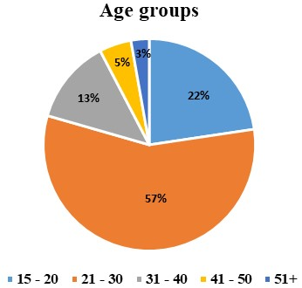

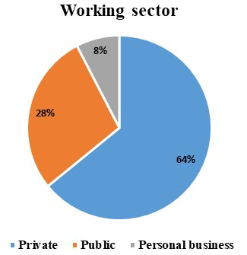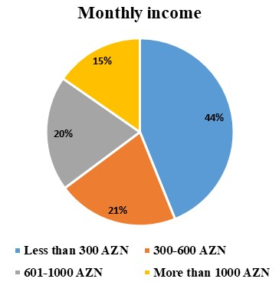
Source: Author

From demographics point of view, about 60% of the participated people were at the age between 21 and 30. This fact was due to the online survey promoted mainly in social media networks. Since the biggest share of users of social media network is young generation, they took the main part of the research. A bit more than 60% of participated individuals have reported about having a job, which is a good indicator for having a financial account. Only 8% of respondents has confirmed not having a job, and the rest were university students.
More than 40% of the respondents reported having monthly income of 300 AZN or less. This group may account for unemployed people and students who took part in the study. Share of people with monthly income in range of 301-600 AZN and 601-1000 AZN is almost the same – 20 percent each of them. And nearly 65% answered that they are hired by a private sector employer, rather than public sector one, which figure accounts for 28%. In addition, 8% affirmed being in entrepreneurship activities, and this factor confirms about improvement of conditions for developing personal business.

Figure 17 Indicators of financial inclusion of surveyed
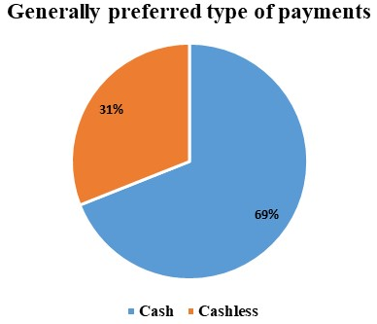
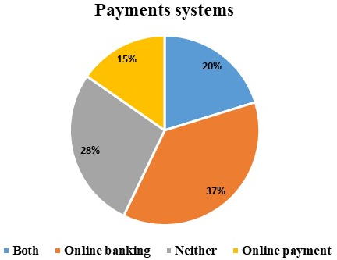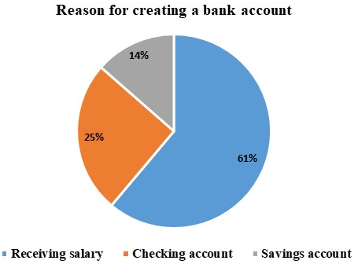
Source: Author

According to the results above, more than 80% of participants are owners of a formal financial account. This is quite a good figure for such number of total respondents. And it was observed that most part of the population, roughly 2/3, bank accounts have been created for receiving salaries and wages. Other portions are for savings and cheking accounts with the percentages of 14% and 25% respectively. However, less than a third of respondents are active users of cashless payment systems and they use both online banking and online payments applications.

Figure 18 How surveyed use their account
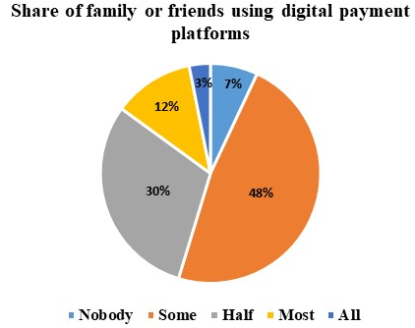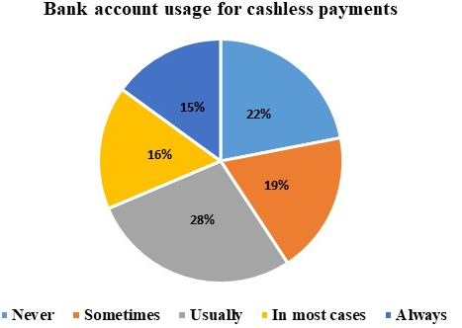
Source: Author

For the question about the attitudes of close friends, collegues or family members about using digital payment platforms, only 7% answered that nobody had used it. Nearly a third of people around, as reported by participants, use a digital payment platform for their transaction. So this is the next positive evidence of improving digital financial services.
According to the results of study, amongst those ones who already own a bank account, only 15% have never used it for making a cashless transaction. The rest of the population confirmed that the the uage of an account for making digital payment varies.
Figure 19 Reasons for not owning of bank account and saving behavior
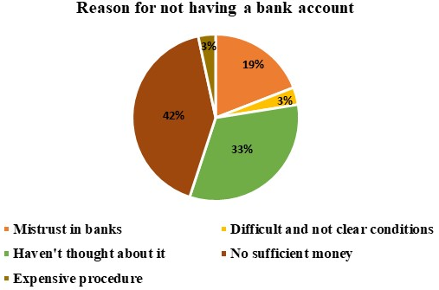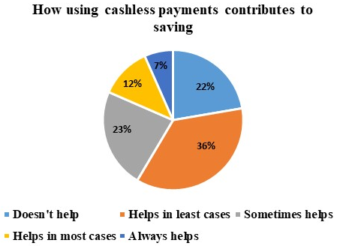
Source: Author

The answers for a cause of not having a formal account were various. A fifth of people affirmed that they do not believe into banking sector. Almost a half of the repondents think that they do not have enough money to maintain an account, and even more than a third of participants claimed that they haven’t thought about opening an account since there is no any need for owning it.
Overall, the results of survey are considered as positive, as the level of financial inclusion and usage of digital financial payment platforms have risen in comparison with the results of study conducted in 2017 by World Bank Group. Such a positive fact is due to the State Programme which have started being implemented since 2018 after the approval of Strategic Road Map on Development of Financial Services in the Republic of Azerbaijan by the Decree of the President of the Republic of Azerbaijan dated December 6, 2016.

4.3.2 State Programme on Expansion of Digital Payments in Azerbaijan Republic in 2018-2020

The State Programme has been endorsed with the Order of the President of the Azerbaijan republic dated 26 September 2018. The objectives of the given Programme consist of the following features:
  - To maximize the volume of cashless and innovative payments;
  - To minimize the significance of cash in the economy;
  - To pull cash flows into banking sector;
  - To enhance investment capacity of Azerbaijani banks;
  - To extend the usage of digital payment systems by commercial subjects.
The measures taken under this Programme will give positive results in a growth of the transparency of economy, reduction in tax avoidance, restoration of banking sector, financial transparency in a relationship between a worker and employer, accelerate in size of social insurance allocations, augment of types and volumes of e-banking transactions, increase in the number of financially included people using e-banking, as well as progress in the scale of e-trading. All of these will boost the noncash operations across Azerbaijani economy and will significantly contribute to the maximization of real GDP and revenues of the state budget in addition to improvement of living standards of the nation.
There are also mentioned leading digital payment technologies in the State Programme. Moreover, development and implementation of the “POS” and “mPOS” based on the Fast payments, Cloud technologies as well as Quick Response. Instant payments, Blockchain technologies and cryptocurrencies have been also referred amongst the globally accepted trends and routes under the State Programme.

5 RESULTS AND FINDINGS

The first and foremost goal of this study was examining financial inclusion – its indicators and variables, as well as revealing any impact of digital financial services on the levels of financially included population. There were proposed supply as well as demand side barriers which create numerous obstacles for improvement of the financial environment. Those ones were obtained through a review of various statements mentioned by scholars globally. From the supply side point – geographical location, regulatory framework, indirect cost and other point were given. While, during considering demand side of the case, it was disclosed that main reasons for such situation are unemployment, low income levels and levels of financial literacy. However, the most interesting fact was that some portion of global population remain excluded from financial environment due to their voluntary desire. People do not wish to communicate with workers of banking or fintech sector, or they do not have any aspiration to improve their financial knowledge and even how to use financial applications.
The results also show that Digital Finance may boost the levels of financially included people indeed. There were proposed and implemented myriad of digital payment and mobile money systems, which give a ground for enhancing the standard of living as well. The main fact was that the most successful platform was developed in order to meet daily needs of people, such as domestic remittances. In some countries people do not have sufficient funds, and the only thing that they need is to have the ability to send money to their friends and family members, as well as to have a possibility to save for future expenses. Additionally, in line with enriching the types of financial services and improving regulatory framework there should be involvement of financial awareness-raising activities by targeting women, people with low income level, disabled people, as well as children from very early childhood.

BIBLIOGPRAPHY

- Asli Demirgüç-Kunt, Leora Klapper, Dorothe Singer, Saniya Ansar, Jake Hess (2018) – The global Findex Database, World Bank Group
URL:https://globalfindex.worldbank.org/sites/globalfindex/files/2018-04/2017%20Findex%20full%20report_0.pdf
- Asli Demirgüç-Kunt, Leora Klapper, Dorothe Singer, Saniya Ansar, Jake Hess (2018) – The Little Data Book on Financial Inclusion, World Bank Group
URL: https://openknowledge.worldbank.org/handle/10986/29654
- Anju Patwardhan, Ken Singleton, Kai Schmitz (2018) – Financial inclusion in the digital age
URL:https://www.ifc.org/wps/wcm/connect/f5784538-6812-4e06-b4db-699e86a0b2f2/Financial+Inclusion+in+the+Digital+Age.pdf?MOD=AJPERES
- Peterson K. Ozili (2017) – Impact of digital finance on financial inclusion and stability
URL: https://www.sciencedirect.com/science/article/pii/S2214845017301503
- Tavneet Suri and William Jack (2016) – The long-run poverty and gender impacts of mobile money
URL: http://science.sciencemag.org/content/354/6317/1288
- James Manyika, Susan Lund, Marc Singer, Olivia White, Chris Berry – McKinsey Global Institute (2016) – Digital Finance For All: Powering Inclusive Growth In Emerging Economies
URL:https://www.mckinsey.com/~/media/McKinsey/Featured%20Insights/Employment%20and%20Growth/How%20digital%20finance%20could%20boost%20growth%20in%20emerging%20economies/MG-Digital-Finance-For-All-Full-report-September-2016.ashx
- Agufa Midika Michelle (2016) – The Effect of Digital Finance on Financial Inclusion in the Banking Industry in Kenya
URL:http://erepository.uonbi.ac.ke/bitstream/handle/11295/98616/Midika%20_The%20Effect%20Of%20Digital%20Finance%20On%20Financial%20Inclusion%20In%20The%20Banking%20Industry%20In%20Kenya.pdf?sequence=1&isAllowed=y
- Tariq Abbasi and Hans Weigand (2017) – The Impact of Digital Financial Services on Firm’s Performance
URL: https://arxiv.org/pdf/1705.10294.pdf
- M-Money Channel Distribution Case Kenya (2009) – International Finance Corporation
URL:http://documents.worldbank.org/curated/en/832831500443778267/pdf/117403-WP-KE-Tool-6-7-Case-Study-M-PESA-Kenya-Series-IFC-mobile-money-toolkit-PUBLIC.pdf
- Enabling Digital Development, Digital finance (2016) - World Development Report
URL:http://documents.worldbank.org/curated/en/896971468194972881/310436360_20160263021313/additional/102725-PUB-Replacement-PUBLIC.pdf
- Susan V. Scott, John Van Reenen, Markos Zachariadis (2017) – The long-term effect of digital innovation on bank performance: An empirical study of SWIFT adoption in financial services
URL:http://wrap.warwick.ac.uk/88927/1/WRAP-long-term-digital-bank-empirical-adoption-Zachariadis-2017.pdf
- Shilpa Aggarwal and Leora Klapper (2013) – Designing Government Policies to Expand Financial Inclusion: Evidence from Around the World
URL:https://www.isb.edu/faculty/shilpa_aggarwal/files/shilpa-aggarwal-leora-klapper.pdf
- Innovation in financial inclusion (2017) – EY Global
URL: https://www.ey.com/Publication/vwLUAssets/EY-innovation-in-financial-inclusion/%24FILE/EY-innovation-in-financial-inclusion.pdf
- Akhil Damodaran (2013) – Financial Inclusion: Issues and Challenges
URL:https://www.researchgate.net/profile/Akhil_Damodaran/publication/309194840_Financial_Inclusion_Issues_and_Challenges/links/5852655808ae7d33e01a803c/Financial-Inclusion-Issues-and-Challenges.pdf?origin=publication_detail
- Kevin Donovan 2012 – Mobile Money for Financial Inclusion
URL:http://siteresources.worldbank.org/EXTINFORMATIONANDCOMMUNICATIONANDTECHNOLOGIES/Resources/IC4D-2012-Chapter-4.pdf
- Adele Atkinson, Flore-Anne Messy (2013) – Promoting Financial Inclusion through Financial Education
URL:https://www.wsbi-esbg.org/SiteCollectionDocuments/OECD%20Promoting%20financial%20inclusion%20through%20financial%20education.pdf
- Financial Services Technology 2020 and Beyond: Embracing disruption (2016) – PwC Global
URL: https://www.pwc.com/gx/en/financial-services/assets/pdf/technology2020-and-beyond.pdf
- The PwC Challenge: Banking the “Unbankable” Financial Inclusion Puzzle (2018) – PwC Global
URL:https://www.pwc.com/mx/es/archivo/pwc-mx-bankingtheunbankable-basesf1.pdf
- Transition Report 2016-17 - Transition For All: Equal Opportunities In An Unequal World (2017) – Financial Inclusion, European Bank for Reconstruction and Development
URL: https://www.ebrd.com/news/publications/transition-report/transition-report-201617.html
- Thorsten Beck, Berrak Buyukkarabacak, Felix K. Rioja, Neven T. Valev (2012) – Who Gets the Credit? And Does It Matter? Household vs. Firm Lending Across Countries
URL: http://www2.gsu.edu/~ecofkr/papers/published_version_BEJM.pdf
- Banking the poor : measuring banking access in 54 economies (2009) – World Bank Group
URL:http://documents.worldbank.org/curated/en/608761468157765351/Banking-the-poor-measuring-banking-access-in-54-economies
- Claudia McKay and Mark Pickens (2010) – Branchless Banking 2010: Who’s served? At what price? What’s next?
URL:http://documents.worldbank.org/curated/en/641141468159325589/pdf/826200BRI0ENGL00Box379853B00PUBLIC0.pdf
- State of the Industry Report on Mobile Money (2018) – GSM Association
URL:https://www.gsma.com/r/wp-content/uploads/2019/02/2018-State-of-the-Industry-Report-on-Mobile-Money.pdf
- The Opportunities Of Digitizing Payments (2014) – World Bank Group
URL:http://documents.worldbank.org/curated/en/188451468336589650/pdf/903050WP0REPLACEMENT0Box385358B00PUBLIC0.pdf
- Ignacio Mas and Dan Radcliffe (2011) – Mobile Payments Go Viral M-PESA in Kenya
URL:http://siteresources.worldbank.org/AFRICAEXT/Resources/258643-1271798012256/YAC_chpt_20.pdf
- Gubad Ibadoghlu (2018) – Financial Inclusion, Financial Literacy And Financial Education In Azerbaijan, Asian Development Bank
URL: https://www.adb.org/sites/default/files/publication/421611/adbi-wp842.pdf
- Strategic Roadmap for Financial Services Development in the Republic of Azerbaijan (2016) – Decree of the President of the Republic of Azerbaijan dated December 6, 2016
URL: https://static.president.az/pdf/38542.pdf
- RIF (Responsible Inclusive Finance) Regulation Mapping: Azerbaijan (2016) – The Social Performance Task Force (SPTF)
URL: https://sptf.info/images/RIF-regulation-mapping-Azerbaijan-June2016.docx
- State Program on Expansion of Digital Payments in Azerbaijan 2018-2020
URL:https://static.president.az/media/W1siZiIsIjIwMTgvMDkvMjcvNGp3Njkyc2J6d19BTEFWQV9ZRU5JLnBkZiJdXQ?sha=daaeec64cc5ce312
- Yaroslava Babych, Maya Grigolia, and Davit Keshelava (2018) – Financial Inclusion, Financial Literacy And Financial Education In Georgia, Asian Development Bank
URL: https://www.adb.org/sites/default/files/publication/428771/adbi-wp849.pdf

Websites:
- http://www.worldbank.org/en/topic/financialinclusion/overview
- https://www.vodafone.com/content/index/what/m-pesa.html#
- https://www.safaricom.co.ke/investor-relation/financials/reports/annual-reports
- https://www.bridgeinternationalacademies.com/teachers/teacher-guides/
- https://tradingeconomics.com/kenya/currency
- https://www.cbar.az/press-release-2106/central-bank-holds-awareness-events-in-a-number-of-pre-school-and-general-education-institutions?language=en
- https://www.cbar.az/page-67/financial-literacy
- www.bizimpullar.az
- www.edu.e-cbar.az
- https://newzoo.com/insights/rankings/top-50-countries-by-smartphone-penetration-and-users/

