AZERBAIJAN STATE UNIVERSITY OF ECONOMICS - UNEC
SABAH CENTER

Islam Taghiyev

Asset Pricing Models. Implications for Portfolio and Expected Returns.

Summary

Author of final thesis: Islam Taghiyev

Full title of final thesis: Asset Pricing Models. Implications for Portfolio and Expected Returns.

Final work supervisor: Faig Nuriyev

Place and year of final work: Baku, Azerbaijan 2019

Number of pages: 58 pages

Number of Tables: 15 Tables

Number of pictures: 13 Figures

Number of appendixes: 1

The aim of this dissertation is the analysis and research on the models, which are used in estimation of expected rate of equity return by investors. These models are widely used by asset managers and companies that tries to estimated the cost of equity in calculation of various model. The methodology part and empirical part of this dissertation, then estimate the differences between the rates of required return by investors to exactly calculate the deviation from correct measure of required rate of return. Such measures lead to misleading while conducting researches and, thus, the analysis and research on this topic is relevant in terms making assumptions and forecasting. Then, the conclusions of this research is presented, to describe the limitations and findings.

TABLE OF CONTENTS

- Introduction……….............................…………………………………...5 p.
- Theoretical Analysis……………...............................................................6 p.
2.1 Markowitz Portfolio Theory…………………………………………..6 p.
2.1.1 Risk and Return trade-off……………………………………………8 p.
2.1.2 Diversification…………………………………………………….…9 p.
2.1.3 Efficient Frontier……………………………………………………10 p.
2.2 Capital Asset Pricing Model……………………………………..….11 p.
2.3 Market Model...........................………………..…………..……..….11 p.
2.3.1 Capital Allocation Line............................………………………...14 p.
2.4 Two mutual fund theorem..................................……………....…..….22 p.
2.4.1 Tobin’s Separation theorem...........................…………….……..….22 p.
2.4.2 Sharpe Linter Capital Asset Pricing Model....... ……..………….…23 p.
2.4.3 Black’s version...............................………………….……………..24 p.
2.4.4 Black Jensen Scholes Study............. …..…..…..…..…………...….25 p.
2.4.5 Fama Macbeth Study ...........……...…..………………..………..…25 p.
2.5 CAPM Debate..........................……………..………...………….….26 p.
2.6 Early Tests..........................……………..…………...…………..….26 p.
2.7 Challenges..........................……………..………………………..….27 p.
2.7.1 Responses..........................……………..…………………….…….28 p.
2.7.2 Banz Study on size effect..........................…….…………..……….28 p.
2.8 . Conclusions................................…………………………………….28 p.
- Methodology…………………………………..……....…………..........29 p.
- Model Analysis..............................................………………....…..32 p.
- CAPM Estimation Methodology...............................................…..34 p.
- Data Selection..............................................………………..... …..35 p.
- Selected Stocks..............................................………………....…..35 p.
- Selected Benchmark..........................................………………… ..38 p.
- Research Method................................................…….……….……39 p.
- Data Analysis ….............................………………...….……….…40 p.
- Beta Estimation….............................……………………….….… 41 p.
- Testing hypothesis …............................………...…………..……..42 p.
- MCPM …............................………………...……………….…..…43 p.
- Critiques…............................…………...….…………………...… 44 p.
- Empirical................................………………...….……………….....…. 44 p.
- Normality…............................……………...…………………...… 49 p.
- Heteroscedasticity…............................………….…………….....…50 p.
- OLS Results …............................……………….........………………………..…50 p.
- MCPM …............................………………...…………..………………..…52 p.
- Conclusion…………..……………………….……..………………..55 p.
- References………………..…………………………………………..56 p.
- Appendixes…………………………………………………………...57 p.

- Introduction

There are various models in estimating the rate of return on a variety of securities and assets. These models include CAPM, APT (Arbitrage Pricing Theory), MCPM and Fama French Model and etc. that will be discussed. The Capital Asset Pricing Model is crucial in the financial industry as it estimates the variations in required rate for securities by investors through calculating it by changes in the required rate of some index or portfolio that consists of all securities traded in some industry or market. This calculation is done through an understanding of risk that is inherent to the portfolio by the term beta that indicates the sensitivity of some asset to index or portfolio. This calculation is done by adding this risk factor to the risk-free rate of return as U.S T-bills. Risk premium that is the difference between market return and risk-free rate generally known as the risk premium. This model was developed by Sharpe and Lintner in order to estimate the rate of return on equities.
The core for calculation of Capital Asset Pricing Model is the theory of portfolio. While calculating not the aim of the one investor is taken, rather from market sentiment and overall investor attitude.
However, there are some assumptions that CAPM takes that will be discussed. These assumptions that are inherent to this model leads to variations in calculating the rate of return that is required by investors and gives different rates for CAPM and other models.
This topic is relevant among institutional investors and corporations for determining the correct rate in financial modeling and statistical calculations, empirical research. The aim of this research is to understand the differences in rates that are calculated by using different models and see factors that effect to such variations.
This difference may lead to uncertainties among investor groups and corporations, as in order to make investment decisions investors should precisely know the discount rate that will be applied in the calculation of asset values, while corporation should know this indicator for capital budgeting purposes in the derivation of the weighted average cost of capital. This measure is widely used by companies in calculations of net present values of investment decisions or taking the right project for investing in.
Calculation of interest rate by MCPM through giving coefficient to factors that effect to an equity rate of return most of the time can lead to interest rates that are significantly different from discount rates that are derived from Capital asset pricing model due to differences in models and calculation models. This research will indicate this difference and show factors that affect such variations in rates of return.
Financial models used by corporations or valuation models are highly sensitive to discount rates used in modeling and valuation as minor changes in this assumption could lead to high discount factors that in turn will substantially decrease or increase our outputs. Such outputs can be capital budgeting models such as NPV calculations or simple valuation models. Financial modelers, statisticians, and economists are highly interested in determining the right approach to estimate this rate, however, modern techniques have different assumptions and approaches that make these calculations complicated and researchers, statisticians trying to incorporate right assumptions and inputs to find out real discount rate that will be used in valuing equity or any other asset.
These differences make this research reasonable, necessary, and relevant as such differences between required rates of return can lead to misinterpretations and false decisions made by corporations or equity investors. While investing in securities or companies, the analyst uses these models for obtaining the value of the underlying asset by examining free cash flow to equity or dividends, etc. any cash flows that could be used to give value to the asset. On the other hand, corporations use these inputs in calculations of its weighted average cost of capital that is used in discounting the expected cash flows of the project that the company invests in.
While conducting research, the objective and aim of this research are to find out the differences in the required rate of return calculated by the different models. The research will find out the reasons and underlying factors that lead to these differences and assumptions that are used in each of the models. After the research paper depicts the theoretical analysis of the problem, the empirical research and conclusion will be given based on showing differences between the MCPM and CAPM.

II Theoretical analysis

There are various models in finance that are used in estimating the rate of return that is required by investors. The most well-known ones are CAPM and APT (Arbitrage Pricing theory), that is mostly used by institutional investors and individual analysts who are analyzing portfolio investment and search for the equity rate that is required by investors.

2.1 Markowitz Portfolio Theory

According to Markowitz investors try to increase return while diversifying portfolio so that their portfolio generated a maximum return with the given lowest risk. This risk is measured by the standard deviation of the portfolio and comes from the correlation between securities. Securities that have the highest correlation with each o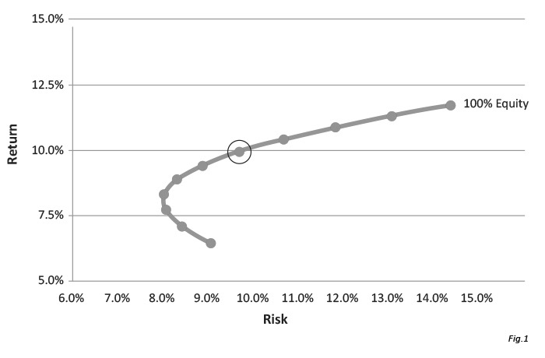
Source: Damodaran (2019) Corporate Finance
Figure 1: Efficient Frontier

there can be interpreted as the highest risk, and the risk-averse investor will try to avoid such circumstances while constructing a portfolio. There is always a trade-off between risk and return that investors want to obtain, so portfolio managers that want to reduce their exposure to risk, construct a portfolio that has the lowest variance and thereby decreasing return that is expected.
Markowitz has some assumptions that are used in the construction of the portfolio. These assumptions include:
1) Int-1 investors select a portfolio that produces given return in time t
2)The amount of all assets is given and short sales are not allowed
3)Portfolio managers are risk-averse, as they don't want excess risk with the given rate of return
4)All securities in the market can be divided and there are not any transaction costs in the market
5)Markets are perfectly liquid. It means that all securities in the market can be readily sold without constraints.
6)There are no taxes and no corporation or investors pay taxes
While solving function and efficient frontiers in order to find out what is the return that corresponds to the given risk, Markowitz uses two variables: variance (standard deviation) and return. Modern portfolio theory and mean standard deviation analysis, is the model used by the portfolio managers, investors and financial analysts that is quantitative model indicates the return that can be gained through risk that these finance specialists are taking. This is just another approach to the idea that holding and investing to a number of securities that have correlations that are less than 1 creates the portfolio which gives higher return with given risk rather than investing in single security. The main idea behind this approach is that the risk of the security should not be estimated itself, rather it has to be calculated how much risk does it contributes to pour investment portfolio. In 1952 Harry Markowitz analyzed this topic and received Nobel prize for his findings.
Mathematical model

2.1.1 Risk and Return Trade-off

According to Markowitz theory, all portfolio managers investors in the market are risk averse and with the same level of return these investors will chose the security that offer lower risk. Therefore, the investor will take the addition risk if this risk is associated with the higher level of return and this return justifies this risk. On the other hand, all investors who want to earn higher return should accept the risk relevant to this. The tradeoff between risk and return is the similar for all portfolio managers and investors but this trade off can be different in terms of these finance specialist’s characteristics of being risk averse. The conclusion of this idea that no investor will invest in portfolio that provides the same return as the second portfolio with lower risk. All investors try to construct portfolio of securities that has the highest return with lowest standard deviation.
1)The return of the portfolio is the weighted average of returns in portfolio
2)Portfolio risk is the function of standard deviations of underlying assets in portfolio with correlation and covariance

Expected return is
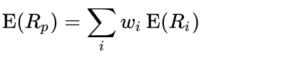
R is the portfolio return, w is the weights of assets and R is the single asset in portfolio
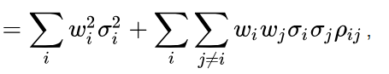

Which indicates the variances of the single securities in the portfolio and correlations, that gives covariance to us.
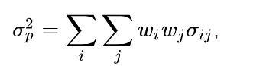
Which is the covariance indicator in our equation and,

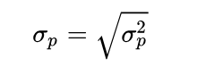
Is the standard deviation of assets in our example.

For two assets

For three assets

2.1.2 Diversification

In order to reduce the overall risk that portfolio is exposed to, investor can purchase securities that are not correlated with each other with perfect positive correlation. It means that when portfolio manager holds portfolio that is diversified can reduce its risk to specific factors. Through diversification of portfolio, portfolio managers can earn the same return with lower risk that is related to lower standard deviation. The model that describes the returns and standard deviation as a tradeoff that shows how many risks you have to undertake in order to get some measure of return is firstly constructed by Markowitz and afterwards was analyzed and improved by mathematicians and economists. The correlation in calculation of the variance of the portfolio is very important in calculation of the risk that portfolio managers and investors take. This risk can be increased when the correlation is perfect between two assets and eliminated when there is perfect negative correlation between assets. The correlation can be 0 when the asset is perfectly uncorrelated and they don’t affect each other in terms of change in price. When the correlation between these assets are 0 it means that risk of the portfolio that is calculated by the standard deviation is equal to the weighted standard deviation squares and square root. The case that the correlation between assets are 1 is the case when the upward change in the price of any security is repeated by the change of other security that equally change to up and down. It increases the probability of having loss in portfolio and this case is tried to be eliminated by most portfolio managers and specialists. When the correlation between securities are positive 1 the portfolio gets highest risk (standard deviation that it could get).
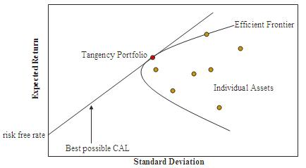
Source: Damodaran (2019) Corporate Finance
Figure 2: Capital Asset Line

2.1.3 Efficient frontier

Portfolio theory described in the last decades that is called modern portfolio theory or efficient frontier is a portfolio that indicates the relation between risk and return and describes the trade of the portfolio managers face when constructing efficient portfolio. This model was introduced by Harry Markowitz and shows a number of portfolios that that lies in the curve with the intersection of return and risk. In this combination of the assets wen can call the portfolio efficient portfolio when the portfolio gives the high return with the risk that is equal to the same standard deviation. Each combination of different assets can be gathered to formulate portfolio that will give different returns with the different levels of risk. While calculation of the efficient frontier, the matrixes are generally widely used for obtaining results.

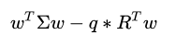
While calculating matrix for relevant risk, this formula is used generally
Which includes,
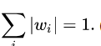
W portfolio weights’s vector, some times these wights are negative that indicates the asset managers ability to short the security.

Is the asset portfolio returns covariance matrix?
is the point where risk is equal to its minimum amount
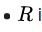
Is the expected returns vector?

2.2 Capital Asset Pricing Model

Capital Asset Pricing Model (CAPM) shows how sensitive is an asset to systematic risk that lies behind the portfolio. This risk is generally non-diversifiable and investors try to see how many percentages will the asset price change after the decrease or increase in the market. This sensitivity is shown by the beta coefficient that indicates the sensitivity of asset to the portfolio. CAPM thinks of a special form of a function where only first and second factors matter, that is a risk is estimated by standard deviation, or in other words equity returns whose probability distributions are totally shown by the first two factors such as the normal distribution and zero transaction costs. If these conditions hold, we can see that asset prices are only affected by the beta coefficient that shows the sensitivity of equity to underlying portfolio risk that is not diversifiable. Although it falls some empirical tests, and the existence of more modern ways to estimate asset prices and portfolio selection, including arbitrage pricing theory, the CAPM is still popular because of its simplicity. Capital Asset pricing model is a formula for giving value to some securities or portfolio. For single securities, we use the security market line (SML) and its sensitivity to return and systematic risk to see how the market will give a value to an individual asset.

2.3 Market model

Withdraw generation models were used to calculate dangerous equities anticipated yields on both the subject of particular factors. We should calculate the responsiveness of the yields for each particular component of each security. Macroeconomic, basic and qualitative variables could be categorized in variables that explain safety returns. Multifactor modeling uses economic and financial variables like Economic growth, interest rates or business confidence as well as basic factors, like income, income growth, corporate size and development costs most commonly. Quantitative variables sometimes have no foundation throughout the principle of financial services but are suspected that they could only reflect interactions over a certain duration recognized by data collection.

Brokers that accept likewise that industry value levels are instructively profitable once in a while seek after a customary venture approach (for example putting resources into an unstable stock record that gives as only an intermediary to the market speculations just as distributing a level of their investable advantages for either a hazard free resource like momentary government securities). Of hypothesis, a few investors just as reserve chiefs accept that their security criticalness figures were correct and that stock costs aren't right. These partners don't utilize industry resource distribution loads, and will spend more than in bonds which they believe are undervalued yet not exactly the values business loads which we believe are oversold than the business loads. It is connected to it as powerful riches the board to recognize from a customary speculation approach utilizing a stock list for both the ideal hazardous arrangement of benefits.

E(Ri) − Rf = βi1 × E(Factor 1) + βi2 × E(Factor 2) + ....+ β× E(Factor k)
The above model predicts that perhaps the anticipated surplus returns for Resource I is the amount for each element responsiveness or capacity factor (βs) for Resource I increased by an average value for both the time period. Fama and French are among the multifactor models that is sometimes used. A responsiveness of safety rates was assessed on three variables: firm size, the book value-to-market value ratio as well as industry return except for the risk-free rate (excess market return). Around each other, such four variables explain the relationship in yields of us investment assets over most of the timespan for the model. Designing a one factor cause is the clearest factor. A measurable statistic model with such an expected return, Rm, since its just factor could be written when:

E(Ri) − Rf = βi ×[E(Rm) − Rf]

When stated above, you must mix all accessible resources in order to establish the industry portfolio. Knowing the causal links between these resources permits us all to calculate the threat of the portfolio. You often discovered that certain classrooms or basically all resources are part of a completely diverse portfolio. An alternative way is faster and easier to enforce to build an ideal portfolio. An shareholder starts with either a recognized investments, like the S&P 500, as well as contributes certain investments another in one based on the default, anticipated move closer on the investment as well as the threat and return effect of both the portfolio. This cycle will continue till a valuable contribution to equity quality is not affected by the relation of some other asset. The method just involves a systemically important calculation of each resource even though the shareholders are not offset against the non-systematic risk.
As discussed in this section, anticipated yields could be computed utilizing purchase producing models. We also break down the total deviation into systemic variability as well as nonsystematic variance, or create a financial relationship around systemic risk and return, in contrast to the use of retour generation models. Throughout the following paragraph, we can broaden the conversation and present the CAPM as both the preferred solution for return generation. The whole method has a simple explanation which results in a simple outcome. Its model suggests because the only possible explanation for a shareholder to receive on average through investment in one price is because one stock is much riskier. Not seem unexpectedly, modern economic hypothesis is dominated by the model.

E is expected return of portfolio, s 2 is risk of the portfolio shown by the variance, x is the number of the investor's securities that are given to the ith security, xj is the percentage of the investor's asset which is given to the jth security, and mi is the expected return of its security. sij is covariance between ith and jth security. Covariance is the major component of portfolio selection as is describes the co-movement (standard deviation) of security and market and is describes defined in this way
The negative correlation between securities or very low correlation leads to a decrease in the risk of the portfolio. This is defined as the subtracting component of the portfolio and it decreases the standard deviation of the portfolio. +1 describes perfectly positive correlation and is not desirable by investors because correlation leads to a decrease in the price of the second security when first decreases. This means that there is a higher risk of loss and the value invested in the portfolio has a higher probability of having negative returns. -1 is a perfectly negative correlation between two securities and also is not desirable because the gain in one of the securities is accompanied by the loss in the second one and portfolio manager doesn't receive any good returns. 0 is the case when there is not any correlation between securities at all.
While there is not a perfect correlation between securities, the diversification will benefit the portfolio. This benefit comes from higher return with lower risk, that is standard deviation that is as a result diversification is decreased and this is due to correlation. This diversification comes from weights that are given to individual securities and such weights result in different standard deviation from an ordinary security investment.

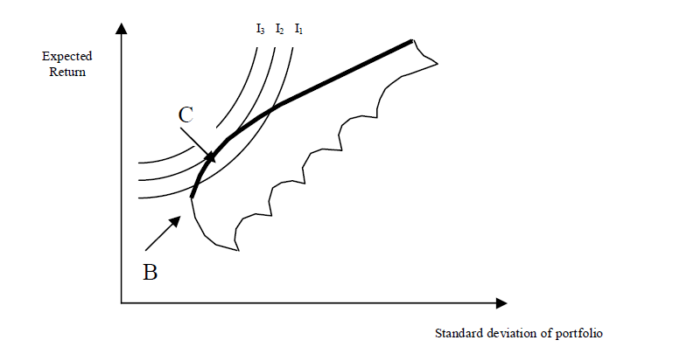
Source: Damodaran (2019) Corporate Finance
Figure 8: Markowitz efficiency set

As it is seen from figure 1 efficient portfolio is the portfolio that is above point B and investors will not choose a portfolio that lies below point B. However optimal portfolio is the portfolio that lies in the interaction of the indifference curve and efficient frontier. The point where the indifference curve touches the frontier, investors will maximize its utility and will invest in the portfolio with a given combination of risk and return.

2.3.1 Capital Allocation Line

If there is an asset that pays hypothetical risk-free rate, will can this asset risk free asset. US t bills are generally used as risk free assets, as the fixed rate are paid by these investments and these securities do not have any default risk. The standard deviations of these assets are zero, that is why they are risk free, and these assets do not have correlation with market portfolio, and pay fixed rate of interest. It means that, while combining it with other investment securities, return changes are related in line with differences in risk with varying combinations. After the introduction of the risk-free rate, the modern effect frontier is the line in the graph. This is the hyperbolas tangent with the lowest risk that has the Sharpe ratio that is maximum. These intercept that is vertical and which indicates the combination of assets, portfolio that has all of its holdings in the asset that is risk free asset, and all assets in the asset combinations that lies in the point of the tangent/. These points are the asset combinations with different expected returns and different risks. The Capital Allocation line is the efficient line

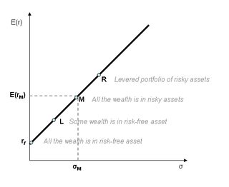
Source: Damodaran (2019) Corporate Finance
Figure 3: Modern Portfolio

Previously, we have seen the market sentiment and how investors and portfolio managers, who try to maximize wealth, react to market based on risk and return. Asset pricing theory is based on this analysis in the way that this research will explain. As every investor invest in assets with risks so that the proportions are identical in terms of the portfolio tangency and in the equilibrium that market has, all asset’s risk adjusted prices with returns that are expected by holders of these assets will change in the way that the tangency portfolio’s ratios are identical to the ratios of risk asset supply to market. So, supplies will be equal to demand and Modern portfolio theory says that the return that is expected by investors is adjusted to the asset prices based on their risk.
• one can't dismiss the speculation (H1-H3) that the evaluating of securities is in accordance with the ramifications of the two-parameter model for anticipated returns. Also, given a two-parameter estimating model, the conduct of profits through time is reliable with a productive capital market" (F-M 2017, pp. 625)

Specific risk is the risk that is inherent to specific security or asset, as these assets has the risks that is associated with the security itself and its characteristics. This risk is generally estimated by the standard deviation of the portfolio and these risks can be eliminated if the investors wants to diversify its portfolio. When the portfolio is diversified, portfolio managers and investors reduce their exposure to the specific risk and they encounter unspecific risk that is the general risk of the portfolio. When the portfolio managers try to diversify maximum its portfolio with eliminating the specific risk that is equal to the risk inherent to the asset, they get market portfolio that has systematic risk. Systematic risk is inherent to all market and can be affected by the factors such economic shocks including devaluations, inflations, change in interest rates that was conducted by monetary authorities, increase in the price of the input costs and etc. As investors and portfolio managers invest in assets and securities that decrease the overall risk of the portfolio and the overall risk of investment is improved, the good indicator of the security is the amount that it contributes to the overall portfolio and not unique risk that this security has. Historically researched observed the total correlation of the security and market portfolio has and it is considered a good measure in terms of volatility. Investors and asset managers sometimes use short and long positions to manage the risk that they take from market exposure and in this way, they balance the portfolio. Such portfolio that are considered neutral are not correlated with the most of indices that are used as measure of market portfolio for determining the correlation.

"the information of these impacts is of no assistance to the speculator since the coefficients themselves carry on as a reasonable amusement through time. Hence, the speculator can obviously do no better to go about as though the two-factor model, recommended by BJS, is legitimate." (Jensen 2015, pp. 24)
When the correlation of the securities decreases the overall standard deviation of the portfolio decreases as well. That is the crucial factor in determining the risk of the portfolio and analyzing it: When the correlation is low, the less the risk and higher the diversification of the portfolio. This reduction of the risk that is called the diversification affect the portfolio the most when the assets are combined. This relation can be seen in the graph presented by plotting the risk and returns two assets portfolio with different expected correlations. We can see from this research that investing in securities that has the lowest correlation with each other. The idea of investing to not just equity but also fixed-income securities, real estate, alternative investment asset classes come from this idea. To reduce the overall risk. When we have the fixed expected return, we can change the weights of each investment securities to see the portfolio that has the lowest risk. In this case as researcher the lowest of the standard deviation that is inherent to the specific combination of assets can be chosen to invest and construct the portfolio that is consists of these assets. The portfolio that has the lowest risk, in our case lowest standard deviation and variance with specific return can be called minimum variance portfolio. Such portfolio constructed together are called minimum variance frontier.

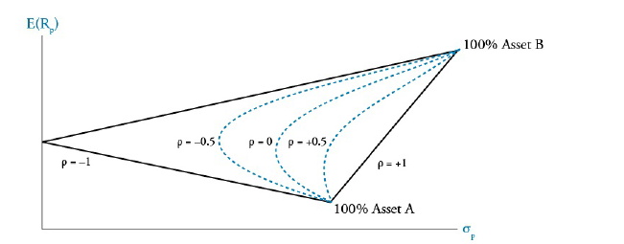
Source: CFA Curriculum 2018
Figure 4: Risk and Return for Different Values

If we assume that all investors and asset managers are risk averse and try to avoid risk, in that case we can conclude that those investors will prefer the portfolio with the lowest risk, which is the lowest standard deviation and variance and invest in portfolio that has highest expected return. All those assets that is included in the portfolio with different risks and different expected returns make the efficient frontier. The investors that wants to avoid risk will invest in portfolio that is in efficient frontier, as other investments that are not in efficient frontier will have lower Sharpe ratio as their risk is high relative to the return of the investor that invests to specific combination of risk and return. The combination of assets and securities that has the lowest standard deviation is called global minimum variance portfolio. Each investor has its own utility curve that indicates what is the combination of risk and return that this investor wants to revive after investing in securities. There is an indifference curve that is known from economics that shows the return and risk combinations that are indifferent to investor. While constructing of such curves that are indifferent for investors, the assumption that only these characteristics is cared about investors. The expected utility of the investor is equivalent in all points within curve. All risk-averse investors see indifference curve as upward sloping, as the greater risk will be taken if it gives additional value for higher risk with higher return that is expected by investors. As Risk, adverse investors try to eliminate risk that is inherent to the portfolio, by increasing risk try to obtain more return based on these risks and expect higher return increase with the same increase in risk. It means that, Indifference curve that risk adverse investors have are steeper in terms of their slope, by indicating their coefficient of being risk averse.

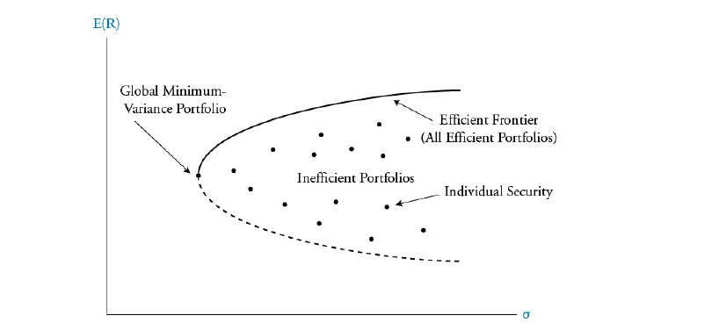
Source: CFA Curriculum 2018
Figure 5: Global Minimum-Variance Portfolio

Combination of the portfolio that has the risk inherent to it, and risk-free asset, the theory about two fund separations can be supported, what says that the optimal combination of assets that lead to risky portfolio and risk free asset combination will generate all investors optimal portfolio. Capital Allocation Line (CAL) is the line that indicates different risk-free asset and diversified portfolio’s combinations.

After construction of this efficient frontier that is the combination of different risky assets and risk-free asset which are invested by investors and portfolio managers in order to improve the risk of their portfolio without affecting to the expected return ad keeping the expected return high, these indifference curves can be combined in order to see what is the desire of the investor and logic when these investors trying to select the portfolio that is optimal. After making such analysis, the conclusions that investors that less risk averse will select more risky portfolios in order increase expected return that they can receive after investment. However, more risk averse investors will have curves that are flatter in terms of their slope. These investors, who want to maximize their wealth through investing to risky portfolios, should construct portfolio that has most of assets in risky assets and less of the portfolio in risk free assets.
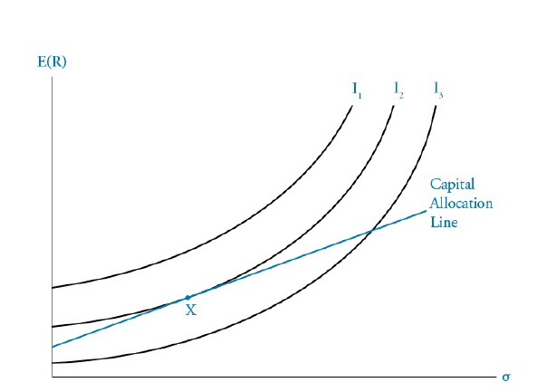

Source: CFA Curriculum 2018
Figure 6: Capital Allocation Line

The line of necessary investment risk and return mixtures is referenced to as the Capital Allocation Line (CAL) based on the risk-free rate as well as risk and returns of a investments of risky assets. On an active manager, the greatest CAL provides the optimum range of risk and return portfolios. The ideal dangerous investment strategy for this asset manager seems to be Portfolio A, as the consequence of merging risk-free asset with the high-risk holdings is the most favored portfolio of investments built. The fund manager provides the largest anticipated value of all investments at the disposal of the asset manager, combining risk-free assets with dangerous Portfolio A. Each investment company will also have a different, optimal, liquid asset investment strategy and a distinct CAL when they have different priorities regarding assumption of gains, variance or relation among volatile stock returns. A complicating presumption behind contemporary portfolio allocation is that investment companies have homogenous perceptions (that is, all share the same danger, return and relation figures for all risky investments with the other volatile stocks). Keep in mind that the ideal CAL to any shareholder is only digression with the effective frontier, within this assumption. Investors may select distinct investment weights for even a cost-free investment and the dangerous (efficient frontier) cash position depending on their choices of threat and returns (their indifference curve). However, each investment company uses the about the same highly risky investment portfolio. If so, the investment strategy has to be the industry portfolio among all risky investments because all hedge funds holding riskier assets keep a certain risky assets portfolio.

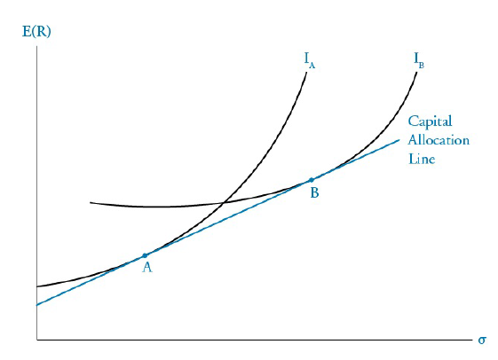
Source: CFA Curriculum 2018
Figure 7: Capital Allocation Line

Traders that believe also that industry price levels are informatively productive sometimes pursue a traditional investment approach (i.e. investing in a volatile stock index that provides as just a proxy for the market investments as well as allocating a percentage of their investable assets to either a risk-free asset like short-term government bonds). Of theory, several shareholders as well as fund managers assume that their safety significance forecasts were right and that stock prices are wrong. These stakeholders do not use industry asset allocation weights, and will spend more than in bonds which they think are underpriced but less than the equities business weights which we think are oversold than the industry weights. It is linked to it as effective wealth management to distinguish from a traditional investment approach using a stock index for both the optimum dangerous portfolio of assets. If an fund manager broadens through resources which are not completely associated, the danger of the holdings is lower than the total average threat of the portfolio's individual securities. The threat which consolidation eliminates is named unsystematic threat (also known as distinctive, diversifiable, or company-specific risk). That may have been consolidated away. Its remaining threat could not be distinguished but is named the widespread threat (often known as no diversifiable danger or risk of the market). The widespread risk logic applies to both individual bonds and investments. Its financial market hypothesis suggests crucially which equilibrium-security yields rely on the systematic risk of the stock or a portfolio, not on its complete threat calculated by variance. Diversification is one of the presumptions of the model. This is reasoned that the threat to be removed without costs could not be offset to investors. In comparison to a purchasing of individual inventories, if you factor in the cost of a non-load mutual fund, diversifying is quite small if not really free. The effects for investment valuations (anticipated yields) are quite essential for this conclusion. With the danger as standard deviation from the yields, the least risky stock may not simply have the average expected yield. In order to identify its effectiveness, consider a biopharmaceutical stock with such a drug item being clinically examined. When the medication proves efficient and secure, inventory yields are quite substantial. Unless the topics are murdered and/or hurt by medication, at the other side, then the inventory will fell to around nil as well as the returns will be very poor. It defines a stock with such a higher level of transfer variance (i.e., a relatively high threat).

The line of vital venture hazard and return blends is referenced to as the Capital Allocation Line (CAL) in view of the hazard free rate just as hazard and returns of a speculations of hazardous resources. On a functioning administrator, the best CAL gives the ideal scope of hazard and return portfolios. The perfect risky venture procedure for this benefit director is by all accounts Portfolio An, as the result of combining hazard free resource with the high-chance possessions is the most supported arrangement of speculations constructed. The store supervisor gives the biggest foreseen estimation of all speculations at the transfer of the advantage administrator, joining hazard free resources with hazardous Portfolio A. Every speculation organization will likewise have an alternate, ideal, fluid resource venture system and an unmistakable CAL when they have various needs with respect to suspicion of additions, fluctuation or connection among unpredictable stock returns. A confusing assumption behind contemporary portfolio designation is that speculation organizations have homogenous discernments (that is, all offer a similar threat, return and connection figures for every hazardous venture with the other unstable stocks). Inside this supposition. Speculators may choose unmistakable venture loads for even a without cost speculation and the hazardous money position contingent upon their decisions of danger and returns (their lack of concern bend). Be that as it may, every speculation organization utilizes the about the equivalent exceedingly unsafe venture portfolio. Provided that this is true, the venture methodology must be the business portfolio among every single dangerous speculation since all flexible investments holding less secure resources keep a specific hazardous resources portfolio.

2.4 Two mutual fund theorem.

One of the main conclusions that lead to the analysis that was conducted before is the two-mutual fund theorem. According to this theory all portfolios that lies in the efficient frontier is the result of the mutual use different combination of the 2 portfolios and with standard deviation relevant to expected return. These portfolios are those mutual funds that is in the name of the theory. If there is not any risk-free rate like T-bills, portfolio managers and investors can make all combinations of the efficient frontier even if the all mutual funds that contribute to portfolio are invested in positive amount. When the portfolio that is should be constructed in the mind of investors is between these two portfolios in the mutual fund theory, these portfolios will be invested long and all this portfolio will be in hands positively. However, if investors want to develop portfolio that is not in the range of these mutual fund portfolios then investor should short one of these so that the desired portfolio is constructed.

2.4.1 Tobin’s separation theorem
Tobin's paper Liquidity preference as behavior towards risk, where the writer talks about the liquidity preference of investors in terms of mean and standard deviation is the next indicator of the evaluation of capital asset pricing model.
It lets portfolio managers to think of trade-off whether to hold their investment in cash or consoles, which are in the absence of inflation risk-free in nominal sense, and further shows that given these two assets, different investors, with regard to their risk awareness, choose a different optimum point of investment on the investment opportunity line (0, C) different portions in the two assets.

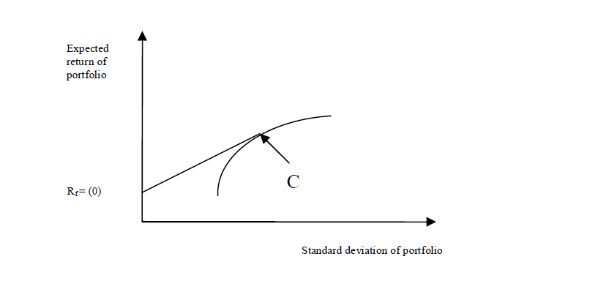
Source: Damodaran (2019) Corporate Finance
Figure 9: Tobin’s Capital Market Line
In order to simplify the Markowitz efficiency, set, we add risk-free borrowing and lending.
Think of a portfolio that invests some amount of portfolio funds in risk-free security and (1-this amount) in portfolio g.

2.4.2 Sharpe-Linter’s CAPM

Sharpe and Linter had research based on the risks and their effect on asset prices. They wanted to answer to one question that cited: what is the relation between high risk(variance) and return, and how to derive the risk that comes from the market, as the risks that are incorporated in the portfolio, which was diversified, some of the risks come from individual security rather than overall market. They have published the assumptions that were added to assumptions of the Markowitz model and they include:
1)Every participant of the market can lend and borrow without restriction at a given risk-free rate and unlike Markowitz's assumptions, there are not any short sale restrictions.
2)markets are perfect
3)All market participants have the same estimates of mean, standard deviation and covariance for assets.
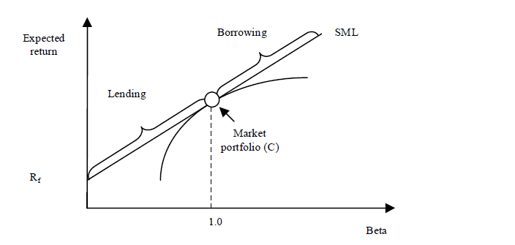
Source: Brealey, Myers (2019) Principles of Corporate Finance
Figure 10: Security Market Line

Considering the return distribution, portfolio managers and all market participants from the same tangency portfolio C risk Rf. For the market to stabilize assets in the market portfolio c should be valued that its weight is equal to the total market value divided by the market value of every single security with high standard deviation.

Where beta is equal to covariance divided by var. In order to interpret this equation, we can see the numerator as the covariance between market and security, which is equal to start deviations of market and security that is multiplied by the correlation between them. The enumerator of the equation is just the variance of the market.
Accordingly, covariance is the good measure of the risk as Jensen cite: As the standard deviation(variance) is taken by portfolio managers as the right estimate of the risk, the covariance between market and single security is the right estimate for measuring the risk of the market and market portfolio.

2.4.3 Black’s version of the model

The critics were made to the assumption that any borrower can lend and borrow the amount that he wants at a risk-free rate is very limited and this formula would have changed significantly if this assumption was rejected. As well, the empiric studies show that this model that incorporates risk-free rate does not estimate equity return precisely.

While discussing such topics, Black published research where he proved that any portfolio of portfolio managers consists of a combination of two portfolios extrapolated by the linear curve.
Although this factor was found earlier, Black proved that, if there is not any risk-free rate and lending(short-sales are allowed), any portfolio consists of a sum of the portfolio of market and portfolio with the minimum risk(or with the lowest variance). ERz is the return that is expected for the portfolio with null beta. Thus, the return that is expected for all securities is a linear function of their market risk and equation resembles the Sharpe-Linter, although ERz is replaced the role of Rf.

2.4.4 Black Jensen and Scholes study.

In 1972 Black Jensen and Scholes analyzed and made some research on the Sharpe Linter asset pricing model. While analyzing the Sharpe Linter model the came to the conclusion that some variables such as risk-free rate does not fit into the model while conducting some empirical research.
The conclusion was made that these mean returns of the market are not truly represented by the formula 2.7 general CAPM. Calculations of the expected returns are significantly higher than forecasted return calculated by the CAPM when there are lower betas, and their calculations of the returns were significantly lower than forecasted returns when betas are higher.
They came to the conclusion that two factor model for forecasting equity returns are more precise for estimating the risk-return relation of stocks.

2.4.5 Fama and Macbeth study

This regression was used by Fama and Macbeth in his research on Risk, Return and Equilibrium: Empirical test,
Which indicates that r is the return that is expected by the portfolio managers and investors on asset, the return on the portfolio that has zero portfolio, the market premium expected by the asset managers, the mean of the all assets in portfolio, and the disturbance or error term. These tests were done on a number of portfolios that were constructed based on all stocks on the New York Stock Exchange from 1935 to 1968. While constructing these portfolios, the idea behind was eliminating the disturbances in cross-sectional estimates for coefficients. Stock betas were first calculated based on one period firstly, and then formed a portfolio based on these betas. After, these betas were calculated again through the calculation of return in the previous year. It was done in order to assure that these calculations are free from error and don’t contain any bias.

The test done by Fama is executed in order to test coefficients of equation 2.1, calculated from the cross-sectional analysis within the year. The analysis was based on the tests of major implications of the properties of the model.

- The relation between risk and return should be linear
- There are no other risks except Beta that is related to returns systematically
The trade-off between risk and return should be positive

2.5 CAPM Debate

During the last 50 years, Camp was tested many times and have got substantial attention from the side of investors and portfolio managers. In this section, I will discuss the 50-year discussion on the topic camp that analyzed the truthiness of the model. A lot of research papers were publicized that analyzed the validity of the model, while in this section I will discuss substantial ones that played a major role in analyzing CAPM.
Methodology

CAPM equation has three implications:

- For any efficient portfolio, the line of the relation between risk and expected return is upward sloping and linear.
- The only measure of the risk in the portfolio is Beta
- For rational investors, if the investors expose himself to higher risk, the associated return should be higher.
Capital Asset Pricing model describes risk and returns, from the point of return, however it have to be tested from one period to another for security and portfolios.

While conducting such a regression equation, we have to know which variables are significant and we have to look for t statistics of the coefficient used in our model. It allows to see the significance of the variables and know which variables are significant
Coefficient estimated in model, are examined from the regression and compared to the risk-free rate of return and return on zero beta security._ is the return on market portfolio, which is often used for evaluation of excess return over a risk-free rate(risk premium)

2.6 Early Tests.

In 1969 Douglas published early tests of Capital Asset Pricing Model. The regression based on the risk and some other factors that affect the return was made by Douglas in order to see the coefficients of their effects. This regression was made based on the very large cross-sectional data set on stock returns and their standard deviation with covariance’s, that incorporates correlation coefficient and variances of two variable. The results obtained were the same as the results of the Linter. He found out that the average return on securities was positively correlated to their risk(variances) After a while, Miller and Scholes analyzed this research and came to the conclusion that this was because of the heteroscedasticity and omitted variables in the regression.

2.7 Challenges

Capital Asset pricing model was tested firstly in70’s. Whereas, some ideas that CAPM misses some elements in calculations of return that is required by portfolio managers and investors, Fama and French in 1992 said that Capital Asset Pricing Model misses not just one element but everything.

Fama and French

Fama and French calculated the relationship between the variables of formula 2.9 in their research of The Cross-Section of Return within period of 1963 to 1990. While calculating this coefficients they estimated the relation between size, p/e ratio, leverage, and other valuation multiples which influence to market beta.
The stocks were grouped for firms which are listed on the NYSE, NASDAQ and AMEX by grouping into 10 classes of beta within 100 portfolios. While researching, they received the coefficients of y=-0.37 and the t-stat of -1.21 with y=-0.17 and t stat of -3.41.

The returns that are obtained for regression has the slope of -0.15% and t stat of -2.58. Such a negative relation does not depend on which variables in regression. Fama and French Conclude: Although there is power of size in explaining the beta and returns, from the regression we can see that the beta is not able to explain the returns consistently, no matter which factors we include like size, leverage, valuation multiples and etc.

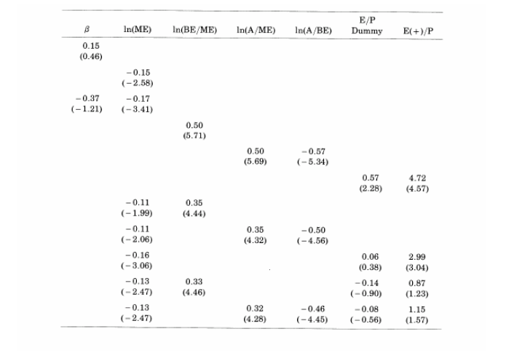
Source: Damodaran (2019) Corporate Finance
Table 1: Regression of Stock Returns
2.7.1 Responses

Other researchers challenged the findings of Fama French that beta is not able to predict the cross sectional return variations and the valuation multiples has the same role as the size of company. Other questions were the fact that whether the NYSE, Amex is the good indicator of portfolio in estimating the beta and whether the assumption that beta is constant is correct.

2.7.2 Banz study on size effect
Differences between actual returns obtained by CAPM was tested by Banz in 1981 to see whether these differences can be calculated by the size of company.
Which includes r as a return that is expected by investors and asset managers, y is the rate return that is expected to portfolio that has zero beta

2.8 Conclusions

The CAPM developed by the Sharpe Linter was the focus of main criticizers within 40 years and these criticizers tried to estimate whether this model is valid or not. These models were researched was reshaped into numerus versions of original CAPM:

- CAPM developed by Linter as heterogeneous-expectations version 1969
- Brennan’s tax application CAPM 1970
- The CAPM developed by black as zero-beta assuming that borrowing without risk not possible
- Mayer’s CAPM variations that is non-marketable 1972
- The CAPM developed by Merton that is intertemporal in order to include investor preference of liquidity
- Kraus and Lichtenberger CAPM with preference of skewness
- Breeden CAPM with consumption that is based on the real consumption rate that is in aggregate
- Brown and Gibbons CAPM that is based on utility in order to test the model of Breeden
- Lo CAPM that is based the analysis of contingent claims
- CAPM by Statman and Shiffrin that incorporates the belief of the noise traders

Although these models that are listed above are different forms of the same theory Markowitz that is about efficient frontier and portfolio selection with different levels of risk and return. However, these models provide vey god indicator, as we can obtain information whether these assets were valued properly or not with their different rate that are required by investors under different models.

III Methodology.

Throughout this dissertation our study explores the motion in stock prices at Stock exchange and includes a timespan of 30 months within October 2010 and March 2013. As our survey data base, we have selected 72 shares from multiple companies and most of them are selected as well from four different S&P 500 industries. We require additional them and for at least usually two long years to be on the NYSE in order to select these stocks. In addition, stocks with purely negative book-to-market coefficients will also be removed and substituted by certain equities. We suggest that the return graph be used as a substitute for both the normal price ranking. Because the near cost for dividend payments and divides had already been adjusted, we don't need to recognize dividend payments and dividend payments if estimating yields. The S&P 500 index has been used as a industry agent in the Capital Asset Pricing Model to measure beta at both the default risk for the intended compensation on individual stocks. Throughout the measurement system, we can measure the accuracy of two designs using the OLS method and the normal quantitative and inferential statistics tests. The two-pass regression method is used to test the CAPM. That first-pass regression has the object of estimating betas from each investment using OLS methods and instead sorting assets to create investments predicated on their betas.
• average return on little stocks are too high given their b gauges, and normal profits for vast stocks are excessively low." (Fama and French 2014, pp. 427)
Previous-pass regression is a cross-sectional regression, and that we have to use second-pass regression theory trials as well as other quantitative tests. Following the analysis of the CAPM model, we are replicating quantitative tests with the same information as our CAPM model. Last, in comparison with both the measurable statistic model, we examine the two additional factors. The safety business dimensions as well as the BE / ME determinant were two complicating factors. Secondly, the FF three-factor model provides a beta-factor for stock in the Regression Equation.

Then we perform the linear regression to compare the 1-factor regression and the 2-factor regression. We separate the Fama model from the French three determinant model into three levels: the one factor (market factor), the two determinant level ( ME) and the three determinant degree (business / ME with business factor). In particular we split the three element models. Eventually we may check in the traditional stock industry the relevance of the CAPM and the FF 3-factor models; (2) we equate the predictive power between the one and two element models and the 3-factor models for the Fama and the French three factor model; and we evaluate the reliability of these outcomes on both the basis of both the results.
We have used the time-series regression analysis, which is the equal in 1972 as that of the study of Black, Jensen and Scholes, for analyzing the relevance of the FF three-factor model. On the surplus stock exchange yield and imitation size yields (SMB) as well as the book-to-market (HML) factors, monthly surplus yields on equities or investments are regressed.
• "the normal overabundance return (from holding exceptionally little firms long and vast firms short) is, by and large 1.52 percent every month or 19.8 percent on a yearly premise." (Banz 2014, pp. 15-16)

There are different models in evaluating the rate of profit for an assortment of securities and resources. These models incorporate CAPM, APT( Arbitrage Pricing Theory), MCPM and Fama French Model and so on that will be examined. The Capital Asset Pricing Model is critical in the monetary business as it appraises the varieties in required rate for securities by financial specialists through ascertaining it by changes in the required rate of some record or portfolio that comprises of all securities exchanged some industry or market. This figuring is done through a comprehension of hazard that is inborn to the portfolio by the term beta that shows the affectability of some advantage for file or portfolio. This figuring is finished by adding this hazard factor to the hazard free rate of return as U.S T-bills. Hazard premium that is the contrast between market return and hazard free rate commonly known as the hazard premium. This model was created by Sharpe and Linter so as to appraise the rate of profit for values.

The center for computation of Capital Asset Pricing Model is the hypothesis of portfolio. While ascertaining not the point of the one speculator is taken, rather from market slant and by and large financial specialist frame of mind.

In any case, there are a few suspicions that CAPM takes that will be talked about beneath. These suspicions that are natural to this model prompts varieties in ascertaining the rate of return that is required by financial specialists and gives various rates for CAPM and different models.

This point is applicable among institutional speculators and organizations for deciding the right rate in money related displaying and measurable computations, exact research. The point of this exploration is to comprehend the distinctions in rates that are determined by utilizing various models and see factors that impact to such varieties.

This distinctions may prompt vulnerabilities among speculator gatherings and enterprises, as so as to settle on venture choices financial specialists ought to absolutely know to limit rate that will be connected in the estimation of advantage esteems, while partnership should know this pointer for capital planning purposes in the determination of the weighted normal expense of capital. This measures are generally utilized by organizations in counts of net present estimations of venture choices or taking the correct task for putting resources into.

Computation of loan cost by Arbitrage valuing models through offering coefficient to factors that impact to a value rate of return more often than not can prompt financing costs that are fundamentally unique in relation to limit rates that are gotten from Capital resource evaluating models because of contrasts in models and figuring models. This examination will demonstrate this distinction and show factors that influence such varieties in rates of return.

Monetary models utilized by enterprises or valuation models are exceedingly delicate to limit rates utilized in demonstrating and valuation as minor changes in this suspicion could prompt high limit calculates that turn will considerably diminish or build our yields.

The exposition went for mapping the usage of CAPM just as Asset Pricing Theory, just as building up a troublesome model dependent on securities exchange information. We cautiously researched both CAPM just as APT models and featured the difficulties that can be knowledgeable about the translation of the results and while the calculations. We at that point removed speculation returns of 4 firms traded in the United States utilizing the two models. Be that as it may, the discoveries of this thesis are not as basic as we need them to be, on the grounds that the results of 2 models are not comparative, in spite of the fact that they are planned to be equivalent as far as return they create. We do not have a strategy to figure out which model furnishes us with all the exact and significant gauges of the rates of ventures. Experts overall utilizing their valuing techniques, and furthermore the insight, impulse and learning, must convey a ultimate choice. This issue can't be replied without these info however it doesn't clarify why we can't stay nonpartisan. Of in light of the fact that my own feeling, CAPM depends on slightly foundations itself and its monetary hazard and return gauges appear to be either enduring consummately substantial.

Similarly as with the Arbitrage Pricing Theory, I think it merits demonstrating its structure given the todays share advertise flood over the world. Adept offers us with an exceptionally energizing alternative to significant resource valuing models, because of the way that there are heaps of postponements as noted out amid one subsection. More examination around there with respect to the analysis offered must be permitted.

3.1 Model Analysis

In this area, we will clarify the hypothesis of the Sharp-Linter CAPM model, to demonstrate the entire image of the model. We will likewise investigate the Fama and French three-factor model completely, and analyze the one-factor (advertise factor), two-factor (measure and BE/ME) and three-factor forms of the Fama and French three-factor model.

CAPM

There are a few essential assumptions in the capital asset pricing model, which are:

- All investment companies are unwilling to sacrifice and also have consistent risk and yield expectations (investment companies are reasonable). Fund manager investments are assessed exclusively for their forecast returns and the variance in returns calculated during the equal hold period.
- Investors get a specific time and choose the very same return-to-risk selection criteria; in certain other words, all other private investors also have the same business opportunities for investment.
- Financial markets seem to be ideal in a number of ways: each investment is infinitely scalable and anticipated revenues are distributed in normal way; trading costs are absent, selling short or levy; data is free and accessible to anyone; and that every investment company can lend and take out a loan at risk-free rates.
- almost all institutional investors guess the investment returns, standard variance and the hypotheses of variances of investment yields on their individual assets in a certain way. As our industry investments, we use the S&P 500 index, but not the only one real market investment; practically each single asset is inappropriate. Only 72 businesses are included in our sample data, asserted in the 30 months period.

Although we attempt to prevent survival biases, there can still be mistakes through the use of businesses from various markets and specific market sizes.
We may change the equation (1) to its comparable equation by moving to a different knowledge of the model. The surplus yield as a predictor variable to a left of both the equation. The following variables are explained: We collect daily discount rates in our paper for 30 days, then weigh them equally in order to obtain the monthly bill for treasuries. We obtain everyday cost of capital in our article for 30 days, then weigh them similarly in order to obtain the monthly payment for treasuries. The premium that investors get from additional risk is the distinction among the anticipated investment return as well as the threat-free rate. Because the CAPM is a model of balance! This is a security market line pitch, with that kind of line being an line which slopes upward and a asset beta as when the horizontal line (SML) shows the connection between such a security (or investment portfolios ) anticipated return and its beta.

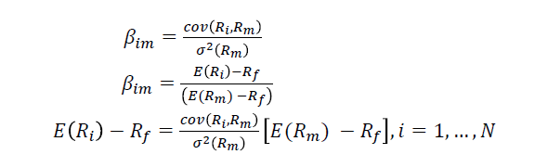

Investors require greater yields for higher risk. which they take for gaining additional return and the premium of taking additional risk compensates the difference among market yield and risk-free return. The anticipated asset return rate i. The Formula clarifies the connection among the surplus stock yield as well as the safety beta and, to determine the relation between them, the descriptive input of the calculation must be calculated. Therefore, the beta should be calculated:
The risk that is inherent to market, which is not a risk that could be diversified. This is the risk inherent in the market as a whole or in the whole market sector. The asset managers need remuneration for the surplus portion of the risk-free rate and, as a remuneration for the having taken of surplus risk, the price of risk is the surplus yield for the investment sector.

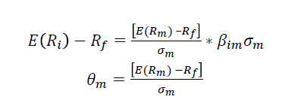

3.2 CAPM Estimation Methodology

Throughout this segment, our primary method for testing the efficiency of the CAPM model are economy-based estimates. Using our dataset, for example, we investigate if quantitative outcomes conform to theory of economics. A two-pass regression is perhaps the most popular method to check the CAPM model: 1. First-pass regression: The formula we use is the beta calculation of the asset for the 72 companies, ranking it accordingly and creating investment funds predicated on the beta value.
"on occasion, just by some coincidence, a procedure will appear to have worked reliably previously. The analyst who discovers it reviews it, and we have another irregularity. Be that as it may, it by and large disappears when it's found" (Black 2014, pp. 9)
In order to formulation of the regression equation, we simultaneously calculate the rate of return of each asset that corresponds to the inventory beta. The anticipated return on every asset shall be calculated by the mean of the 30-month yield on each stock.
Second-pass regression: because the beta is classified and the investments is established in the preceding segment, the first step that we have to take is the beta and the anticipated return of this second-pass regression. The beta of each investments are calculated by calculating an mean beta of the four investments stock, and the anticipated returns on the four shares are equally weighted to achieve the anticipated return of the portfolio. The risk-free rate is calculated as the mean of 30 months. It is worth mentioning. U.S. bill of the finance. Finally, the formula can be used to perform transversal regression and to examine and evaluate its quantitative characteristics. To draw the conclusion, the CAPM model technique would be to use the ordinary least-fourth method for estimating beta and, then, to test this hypothesis deriving from the CAPM structure by using bend-sectional regression. The preceding regression is calculated.

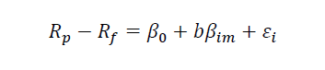
We understand that even the average return on even a asset investments is, on the basis of the CAPM model hypothesis in the equation, the amount of the free risk and the associated risk of this industry portfolio. Investors need a better profit to offset the risk if they are to be higher. You should find the following: 1. The connection between both the surplus return as well as the predictor variables must be in line; non-linear variables should also not differ substantially from 0.

Security beta, which has substantial predictive value in this structure, must be an only factor that is applicable in the CAPM.

This section is aimed at gaining further perspectives into the way the assumptions were tested. The first step will be to clarify the variety of samples such as chosen phases, economic publications and chosen stocks. This segment will then examine the method of research by investigating some otherwise employed methods for the CAPM precision.

3.3 Data Selection

The objective of this study is to build a relationship among the importance of beta as well as the real return on a Nasdaq investment market between 2008 and 2018 of individual stocks. This 10-year period is similarly divided into two periods for five years. Two important justifications are the choice of these two particular sub periods. One reason is that in equity market of Nasdaq there really is limited history study on CAPM. Moreover, many of these scientific studies discussed only the timespan to 2018, whereas in recent decades these tests in the share industry of Nasdaq have not been concentrated. Therefore, it is important to focus on the period from 2015 to present useful results for implementations by investors. In addition, splitting ten years into 2 sub periods enables scientists to easily and effectively analyze data and monitor results at every particular stage.
Moreover, many of these scientific studies discussed only the timespan to 2018, whereas in recent decades these tests in the share industry of Nasdaq have not been concentrated. Therefore, it is important to focus on the period from 2015 to present useful results for implementations by investors. In addition, splitting ten years into 2 sub periods enables scientists to easily and effectively analyze data and monitor results at every particular stage.

3.4 Selected stocks

AT&T
AT&T is a diverse worldwide telecoms, media, recreation and innovations leader. The Center covers 4 segments: HBO & Turner division, Warner division, AT&T communications division, AT&T international division and AT&T ad and big data division. AT&T Communications offers recreation and interaction perspectives for over 100 million U.S. customers through TV, phone and telecom services. More than 3 million business customers have a elevated-speed, high security connectivity. Across 11 states and territory in Latin America as well as the Caribbean, AT&T Worldwide offers pay-tv and services without wire for businesses and consumers. Warner Media’s HBO, Turner and Warner Bros are industry leaders in the creation of digital content as well as the world's biggest TV and movie studio. AT&T advertisements and big data offers advertisers creative, focused and information-driven marketing alternatives for high price online content. The fusion with Time Warner (TWX) resulted in a diagonal fusion of a content creator with such a content creator. AT&T is a corporation that is totally different from its history. The unbelievable amount of cash spending in this sector helps to keep rivals away from debt This is a weapon with 2 edges.

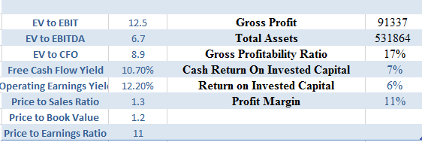

Source: Finance Yahoo
Table 2: Financials

Citigroup
Citigroup Inc. as well as Citi is a New York City-based US-based transnational investment and banking firm. The corporation came into being through the acquisition of the company gigantic Citicorp with the Travelers Group finance conglomerate in 1998. Travelers were later spun out of the corporation in 2002. In addition to several global subsidiaries, Citigroup does own Citicorp, the standing firm in favor of Citibank. Citigroup ranks third among the biggest finance corporations in the US, which is one of the big-four financial institutions of the U.s, along with JPMorgan Chase, BOFA , as well as Wells Fargo.
FedEx
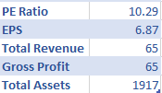
Source: Finance Yahoo
Table 3: Financials

General Motors

General Motors is indeed a transnational US company based in Detroit which crafts, manufacturing companies, industries and transmits cars and trucks and sells financial institutions through its international offices at the Detroit Renaissance Centre. Corporation General Motors is collectively called as General Motors (GM) Company. It has been initially established as a corporation through William C. Durant on 16 September 1908. It is the greatest automotive producer in the United States one of the world's biggest worldwide. Since 2018, General Motors listed #10 for total sales in the Fortune 500 of the highest US companies.

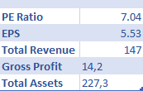
Source: Finance Yahoo
Table 4: Financials

McDonalds
McDonald's is the biggest food provider company in the world. Statewide revenues produce over $40 billion. In further of 100 states on six regions McDonalds function in more than 30 000 restaurants. We have the advantages, which are large as well as financially strong. They own some of the many regarded and well-known companies in the world. Their national infrastructure as well as skills are unmatched.
The McDonald's company not became the biggest fast-service restaurant company in the world since it was incorporated in 1955, but it also literally transformed International habits–including more and more non-American habits. From one of the over 31,000 eateries of the company, situated on six regions in 119 countries, further than 46 million individuals per day average eat. Some of these eateries are operated and managed by companies; the majority are managed by franchises or enterprises with regional businessmen. In 2003 the widespread system revenues of over $46 billion (including net revenues from any and all three types of businesses).
In 2004, McDonald's persisted to cut shop opportunities and to focus on the construction of current eateries. Many of the capital spending of over $1.5 billion planned to renovate current eateries in 2004 is intended to be used. McDonald's often targeted to charge off $400 million of debt to € 700 million as well as repay stakeholders by earnings and sales of share amounts of roughly $1 billion. has already hit a number of lengthy-term targets, including the continued system wide annual turnover as well as income increase rates of 3-5 %. Simplifying the list of foods and decreasing the calorie dense of all its offers.

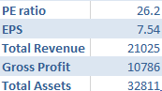

Source: Finance Yahoo
Table 5: Financials

3.5 Selected Benchmark

With regard with the above study, assessing the return of the market is of the utmost importance throughout the calculation of the correct beta values. Though, the use of a proxy is far more important and suitable for the overall market because it is difficult to determine the natural market rate of return. A market index is therefore widely chosen and seen as a proxy, a baseline for a industry. Nguyen (2015) were using standard and poverty 500 (also known as S&P 500) as the ranking when examining the flexibility of beta significance throughout the European market. Two asset indexes are used for security markets in the US context: Nasdaq and SP500. The Sp500 benchmark is a measure that shows the market trends across all equities exchanged at the NYSE(New York Stock Exchange) The choice of such 2 measures is appropriate for scientific purposes since they involve both assets that are exchanged on the industry of US. The S&P 500 has been created through Dow Jones Index, the significant proportion-owned subsidiary of S&P International. This is still maintained. S&P 500 is a Capitalizing Index, of several related signs, like GSPC,INX, SPY and SPX, based upon the industry or the Website’s 500 is different from either the Dow Industrial Average although it covers all 30 businesses of DJIA, as well as the Blitzer’s, respectively. David M. Blitzer tends to lead the committee, which has the complete accountability for selecting Index Securities.
The S&P 500 utilizes a market-cap weight technique, while allocating more rate distribution to organizations which has more market cap in terms of their size. The capitalization of specific organization in market is estimated through calculating the stock value and duplicating it by the remarkable offers.

The S&P just utilizes shares, which means the offers that the open can exchange. The S&P modifies each organization's market top to make up for new offer issues or organization mergers. The estimation of the file is determined by totaling the balanced market tops of each organization and isolating the outcome by a divisor. Tragically, the divisor is restrictive data of the S&P and isn't discharged to general society.

In any case, we can compute an organization's weights in the record, which can give financial specialists good data. In the event that a stock ascents or falls, we can get a sense about whether it may affect the general file. For instance, an organization with a 10% weighting will greater affect the estimation of the list than an organization with a 2% weighting.

3.6 Research Method:

This subsection can represent as the start of the segment to examine commonly used techniques used in prior empirical research. This segment also tries to explain carefully the useful process used for this dissertation, that makes it much easier for viewers to read the study. With regard to the deliberations of the current exams mentioned earlier in this thread, the technique used primarily to determine the connection between risk and return seems to be easy regression. In factual demonstrating, relapse investigation is a lot of measurable procedures for evaluating the connections among factors. It incorporates numerous systems for demonstrating and investigating a few factors, when the emphasis is on the connection between a needy variable and at least one free factors. All the more explicitly, relapse investigation causes one see how the regular estimation of the reliant variable changes when any of the free factors is differed, while the other autonomous factors are held fixed.

Most normally, relapse examination assesses the contingent desire for the needy variable given the autonomous factors – that is, the normal estimation of the reliant variable when the free factors are fixed. Less usually, the emphasis is on a quantile, or other area parameter of the contingent dispersion of the reliant variable given the autonomous factors. In all cases, a component of the free factors called the relapse work is to be assessed. In relapse examination, it is likewise important to describe the variety of the reliant variable around the forecast of the relapse work utilizing a likelihood circulation. A related yet unmistakable methodology is Necessary Condition Analysis, which gauges the greatest estimation of the reliant variable for a given estimation of the free factor so as to recognize what estimation of the autonomous variable is vital yet not adequate for a given estimation of the needy variable.

• "obtained an essentially positive coefficient of normal profit for b . An extra improvement in factual essentialness was gotten when GLS was connected to represent heteroscedasticity after some time and crosswise over portfolios just as cross-portfolio relationships." (Amihud, Christensen and Mendelson 2016, pp. 16)

- First of all the daily prices of these stocks should be collected from the data sources that provide such information
- Then the daily return should be calculated
- The beta of these stocks will be estimated
- The hypothesis regarding this research will be examined

3.7 Data Analysis

Return Estimation

The formula for calculation of the daily returns is the following

RS, t = (Ps, t - Ps, t-1) x 100/Ps, t-1

Which includes:

RS, t: return of the stock in terms of daily calculation
Ps, t: the price of the stock based on the mean value at time t
Ps, t-1: the price that stock has at time t-1

As well, the rate that investors earned by investing in these securities is estimated through:

Rm, t = (Pm, t – Pm, t-1) x 100/Pm, t-1

In which:
Rm, t: the rate of return that is estimated daily
Pm, t: the value of the index based on the mean value at t time
Ps, t-1: the value that index has at t-1 time

3.8 Beta estimation

Beta of the individual stock is calculated through excel function that utilizes the regression with Covariance/Variance to see what sit eh beta of the stock.
The study utilizes the linear regression developed by Galton in 1885 to evaluate the hypotheses. In this statistical model, the sequential connection around two factors is investigated: one is input and the other separate. This linear connection is anticipated in specific by representing the input variable as exponential function. You can write this type as follows:

Beta is significant in light of the fact that it gauges the danger of a venture that can't be decreased by broadening. It doesn't gauge the danger of a speculation hung on an independent premise, yet the measure of hazard the venture adds to an effectively broadened portfolio. In the (CAPM), beta hazard is the main sort of hazard for which financial specialists ought to get a normal return higher than the hazard free rate of intrigue.

The definition above spreads just hypothetical beta. The term is utilized from multiple points of view in account. For instance, the betas ordinarily cited in common reserve investigations for the most part measure the danger of the store emerging from introduction to a benchmark for the store, as opposed to from presentation to the whole market portfolio. In this manner they measure the measure of hazard the reserve adds to an enhanced arrangement of assets of a similar kind, instead of to a portfolio differentiated among all store types.

Beta rot alludes to the propensity for an organization with a high beta coefficient to have its beta coefficient decrease to the market beta. It is a case of relapse toward the mean.

The beta is the protection or risk of the investments risk for the remainder of the industry. A method of assessing how well a asset or securities can move in contrast with the economy is also known as a beta-coefficient. The beta on the economy is 1.0. If an inventory keeps moving less than the market, the beta is less than 1.0 for the investments. When a stock keeps moving beyond the usual market, the beta of the asset will be over 1.0. The fundamental idea is that the more your beta is, the more threat you take in order to gain return.

Time horizons are very essential and must be adapted to your particular business surface. You must use a bigger duration to compute beta, perhaps five or indeed ten years if you are a buy-and-hold investor. If you are a investment manager, purchase often, use beta for a considerably shorter period of time, maybe just a few months or years or maybe less. Finally, there are a variety of different beta calculation techniques— from both the oversimplified and efficient methodology we use nowadays to rigorous academic features that use calculations, interest rates, and anticipated return estimates. Most estimators use these more advanced technologies that I believe are useful.

Where the beta as well as return rate are significantly positive, the calculation slope is not identical or less 0. Excel is used to calculate the curve of the calculation.

3.9 Testing hypotheses
H1: There is a strong geometric connection between the regular real rate of return as well as the daily beta of each stock.

H2: The true every week return on investment as well as the every week beta of each security are significantly linear.

H3: There is an important linear connection between the every month true return as well as the month beta of each stock.

When forming linear regression upper with 5% significance, the research focusses on the numbers of calculated slopes and the value of P Of illustration, the zero theory of an important positive association around everyday beta yields and actual stock yields is of 5 percent importance with the H1 hypothesis. Unless the hypothesis is accurate the P-value should be equal to or below 5 %. As a result, the actual daily level of yields and risks has a meaningful relationship. At the other side, the 0 hypothesis is denied whether the value of p of the study is higher than 5 %. With each of the testable theories the method will be repeated.

3.10 Market Derived Capital Asset Pricing Model

As we have determined similar results – anticipated returns – utilizing two unique models we would normally need to analyze them. Shockingly on account of CAPM and MCPM isn't direct. Creators of MCPM put as an undisputable favorable position of their model the likelihood to infer various rates as per the timespan of the venture, contrasted with a "fit-for-all" beta, anyway this ruins our capacity to make an examination.

• Stable more than five-year (60 months) time range" (Berndt 2014, pp. 35)

CAPM utilizes just the recorded information to accomplish a hazard premium and changes gradually over the time. MCPM infers distinctive a hazard premium as indicated by the length of the venture them two come basically to a similar outcome – resource cost. The way that we don't get an opportunity to contrast the models head-with head does not make both of them less accommodating. As I would see it the two models ought to be utilized and the supervisors' official conclusion ought to be founded on the data that the two models are giving. Since the two of them have their interesting perspective and spotlight on marginally various viewpoints joining them is by all accounts sensible.

For our situation the main thing we may close from the correlation of the two outcomes we have is the way that MCPM gives higher expected rates and subsequently greater expense of capital versus CAPM. Different ends are lamentably incomprehensible.

Assumption of risk

MCPM wants to define and offer an attractive price tag threat prices which shareholders respect. MCPM divides the general danger into three pieces in order to achieve the risk premium shareholders need for asset.

Political risk
The political uncertainties may lead to the loss of investment.

Default risk of company

this risk is associated with the risk that company may default in the future.

Equity return risk

The return may be less that anticipated.

Black Scholes formula

In order to value the security and incorporate the factors that mentioned above: the formula of black Scholes should be used for estimation of the value of the option.

Forward break even price will be calculated

Calculation of the future volatility f stock

Equity return that is excess of risk free rate should calculated in annual nomination

3.11 Critique

Although MCPM is one of the main models to determine information on the benefit estimate that the subsidiary ads give, it is not invincible and causes a couple of gaps, as compared to a post hoc market implementation.
• "rather than the predictable illustrative intensity of size, the relapse demonstrate that advertise b does not help clarify normal stock returns for 1963-1990" and "we can likewise report that demonstrates no capacity to clarify normal returns in relapse that utilization different blends of b with size, book-to-showcase value, influence, and E/P." (Fama and French 2016, pp. 438)

Obviously, MCPM is not on a strong hypothesis as CAPM, but only many formulas have been established in conjunction to achieve an appealing outcome. In either case, it is hard to check whether some of the hazards were not evident, which the designers unknowingly prevent and thus do not refer. The designers focus on three hazards and provide a sensible technique for evaluating these hazards. The lack of formal verification of both the system is essential and it is not enough for us to discard CAPM by stating from the makers that the MCPM produces "sensitive' and" useful "results compared to various models. This includes CAPM, that has soon been tested over the last pair, as discovered in the last segment, with a huge specificity.

IV Empirical

The return rate of 4 individual stocks exchanged on New York equity markets is calculated as well as discussed in the sheets below.

Date | T | C | GM | MCD
1/2/2015
1/6/2015 | 0.15% | -3.52% | 1.51% | 0.18%
1/7/2015 | -1.28% | 0.93% | 2.84% | 1.74%
1/8/2015 | 0.99% | 1.50% | 1.00% | 0.37%
1/9/2015 | -0.30% | -2.23% | -1.69% | -1.22%
1/12/2015 | 0.27% | -0.79% | 0.70% | -0.21%
1/13/2015 | 0.00% | -0.71% | -1.65% | -0.19%
1/14/2015 | -0.48% | -1.94% | -2.70% | -1.39%
1/15/2015 | -0.21% | -3.71% | -2.54% | -0.17%
1/16/2015 | 1.62% | 0.80% | 0.75% | 0.12%
1/20/2015 | 0.44% | -0.74% | 0.74% | -0.75%
1/21/2015 | 0.15% | 1.02% | -0.12% | -0.51%

Source: Finance Yahoo
Table 6: Stock returns

From these graph the volatility of these stocks can be seen. These volatility are mostly affected by the deviations in the price of the stocks with different values. The main purpose in estimating the price changes of the stocks with their change in terms of the percentage is the estimation of the their beta and estimation of the covariance variance of these stocks with market index in order to see how are they correlated with the market.
• compensation for the danger of longer ventures stay more noteworthy than that of shorter ones ... in any case, the extra remuneration for the hazard that organization takes on every year diminishes after some time" (McNulty, Yeh, Schulze and Lubatkin 2014, pp.119)
These beta estimations therefore will be used in estimating the cost of equity and investors expectations about the return that they will earn after investing to these stocks. On the other hand, these cost of equity is the cost that company pays to equity investors through investing to the companies equity capital. The graph shown below indicates the changes in the price of these stocks

Date | T | C | GM | MCD
1/2/2015 | 33.87 | 54.26 | 34.84 | 93.26
1/5/2015 | 33.55 | 52.55 | 34.33 | 92.23
1/6/2015 | 33.6 | 50.7 | 34.85 | 92.4
1/7/2015 | 33.17 | 51.17 | 35.84 | 94.01
1/8/2015 | 33.5 | 51.94 | 36.2 | 94.36
1/9/2015 | 33.4 | 50.78 | 35.59 | 93.21
1/12/2015 | 33.49 | 50.38 | 35.84 | 93.01
1/13/2015 | 33.49 | 50.02 | 35.25 | 92.83
1/14/2015 | 33.33 | 49.05 | 34.3 | 91.54
1/15/2015 | 33.26 | 47.23 | 33.43 | 91.38
1/16/2015 | 33.8 | 47.61 | 33.68 | 91.49
1/20/2015 | 33.95 | 47.26 | 33.93 | 90.8
1/21/2015 | 34 | 47.74 | 33.89 | 90.34
1/22/2015 | 33.79 | 49.57 | 33.82 | 90.89

Source: Finance Yahoo
Table 7: Stock returns

Based on these returns that was calculated through use of stock prices which were given above, the beta of each stock is calculated accordingly. These betas that are indications of how responsive is stock prices to changes in the market index, that is SP500in our calculation. As a prime example, we can say that when the market goes down by 1% the price of MCD will decrease by 0.6%. These calculation will be used in estimation cost of equity based on the Capital Asset Pricing Model. As well, this indication will be broadly utilized in our APT model for calculation of cost of equity with various multifactor that affect to the price of the security that we want to determine price for. We can see that McDonalds has the beta of 0.6, General Motors has beta of 1.03, Citigroup has beta of 1.35 and the beta of ATT is 0.64. It means that relative tp General Motors and Citigroup, ATT and McDonalds are less volatile and less sensitive to the market changes.

 | Beta
MCD | 0.6
GM | 1.03
Citi | 1.35
T | 0.56

Source: Own estimate
Table 8: Beta coefficients

Source: Own estimate
Figure 11: Stock returns

The risk free rate we will use in our calculation is T-Bills of US that is commonly used in calculation of risk-free rate. Similarly market return assumption for our model of CAPM is based on the SP500 index that is mix of the 500 largest corporations that operate in US and mostly referred as market index for calculation of required return of investors. The risk free rate for our model is 2.4% and market return that was determined by the return of SP500 is 12% .

 | Market Return | Risk-free rate | Beta | Cost of Equity
ATT | 12% | 2.40% | 0.64 | 8.54400%
MCD | 12% | 2.40% | 0.6 | 8.16000%
Citi | 12% | 2.40% | 1.35 | 15.36000%
GM | 12% | 2.40% | 1.03 | 12.28800%

Source: Own estimate
Table 9: Cost of Equity

Based on our Capital Asset Pricing Model, the return for ATT is 8.54%, MCD is 8.16%, Citi is 15.4%, GM is 12,28%. The same calculation for these companies based Arbitrage pricing theory can give other results that will lead to different approaches by different investor groups, as such changes will affect to Weighted Average Cost of Capital and all inputs that companies utilize. Changes in WACC can lead different NPV results and all valuations of company that is affected by the changes in WACC.

Source: Own estimate
Figure 12: Cost of Equity

 | ATT | change in % | SP500
 |  |  |  |  | Beta
6/1/2015 | 35.52 |  | 2063.110107
7/1/2015 | 34.74 | -2% | 2103.840088 | 2% | 0.564
8/1/2015 | 33.44 | -4% | 1972.180054 | -6% | 0.564
9/1/2015 | 32.58 | -3% | 1920.030029 | -3% | 0.564
10/1/2015 | 33.51 | 3% | 2079.360107 | 8% | 0.564
11/1/2015 | 33.67 | 0% | 2080.409912 | 0% | 0.564
12/1/2015 | 34.41 | 2% | 2043.939941 | -2% | 0.564
1/1/2016 | 36.06 | 5% | 1940.23999 | -5% | 0.564
2/1/2016 | 36.95 | 2% | 1932.22998 | 0% | 0.564
3/1/2016 | 39.17 | 6% | 2059.73999 | 7% | 0.564
4/1/2016 | 38.82 | -1% | 2065.300049 | 0% | 0.564
5/1/2016 | 39.15 | 1% | 2096.949951 | 2% | 0.564
6/1/2016 | 43.21 | 10% | 2098.860107 | 0% | 0.564
Source: Yahoo Finance
Table 10: Stock returns

While conducting regression equation based on OLS estimation the following assumption were followed:

- The parameters in linear while conducting regression
- There are non-random which are independent
- The distribution of variables are distributed normally
- The 0 is the anticipated values of residuals
- There is not any anticipated dependence among one another
- Homoscedasticity
- Covariance between variables are zero
- The amount of expected parameters is lower than number of sample
- There is finite standard deviation that is variable
- There is not any specific variance and error
- Multicollinearity between these variables does not exist

4.1 Normality

Jarque-Bera test has been utilized for the study of normality. This study showed problem of normality as shown in Table 2. This could take place because the amount of findings is constrained.
The statistics from Jarque-Bera are allocated such as two df underneath the 0 hypothesis of normal curve. The likelihood recorded is that the figure of Jarque-Bera surpasses the observable importance below zero (in exponential function), a tiny likelihood price leading to the refusal of a probability distribution theory.

The first exchange compulsive exam seems to be Durbin Watson DW statistics. The DW stat analysis the sequential connection around neighboring residuals of a multivariate regression much more actually formal way even if a serial positive correlation was not established. the DW statistics should be available. When relatively relation exists and in bad case almost 0, the DW statistics actually fall below. The statistics continue to lie out somewhere among two and four when there is an unfavorable strong correlation. Because the BW statistics simply questions normality.

Company | Jarque-Bera statistic | P-value
GM | 0,68987 | 0,024
ATT | 2,06144 | 0,06
Citi | 12,53360 | 0,002
MCD | 5,27808 | 0,03

Source: Own Estimate
Table 11: Normality

4.2 Homoscedasticity

Experiment of the presumption that almost all the determinant parameter principles ( homoscedasticity holds) are comparable to the deviation around the line of the regression was performed with both the White exam. Homoscedasticity has been identified across all datasets. Such conclusions were relevant across all 4 stocks, as when the White measure may not presume rationality.

Company | Durbin-Watson statistics
GM | 1.958800
ATT | 1.516365
Citi | 1.290931
MCD | 1.662800

Source: Own Estimate
Table 12: Heteroscedasticity

4.3 OLS Results

Many of the presumptions of OLS aren't really satisfied in prior post-chapters. This would also be appropriate to apply ARCH as well as GARCH features, taking formed heteroscedasticity in and out of consideration, to achieve more dramatic results, however this dissertation will not be able to provide information in this step, given the growing difficulty of using all of them to.
Although OLS is used, readers should take into consideration that it is not really possible to meet all false presumptions and thus also estimates are not as effective as those of the models referred to above. Of accordance with either the Alpha measurement principle, it is mathematically insignificant for each four firms. Table 5 provides as well as alpha and beta calculate results. At 5 percent stage, beta is mathematically significant. The easy presumption that special and IT or biotechnology businesses that have short maximum revenue have more risk rather than corporations that have cash flow that deviates less from average appears to resist values. Values. ⠀

⠀

Company | Alpha | Standard | t-Statistic | Standard | t-Statistic
 | estimate | Error |  | Error
GM | -0.000743 | 0.009958 | -0.074605 | 0.300267 | 2.777261
ATT | 0.022515 | 0.015422 | 1.459969 | 0.334956 | 4.260684
Citi | 0.055271 | 0.030811 | 1.793850 | 0.746953 | 2.711481
MCD | 0.006435 | 0.007106 | 0.905549 | 0.133397 | 5.249018
Source: Own Estimate
Table 13: Regression analysis

Company | Expected return
GM | 12.22%
ATT | 8.54 %
Citi | 15.36%
MCD | 8.16%
Source: Own Estimate
Table 14: Expected Returns

4.4 MCPM

MCPM is a theory which looks forward that collects bond as well as option market data. The timescale will be determined by the accessibility of information instead of the selection of the assessed timespan. The preceding information should be used to estimate asset prices utilizing MCPM: corporation bills, option quotations and risk-free rates. Data on the debt costs for certain businesses is required for the reasons of the estimate. As stated in the last chapter, these data often isn't accessible and must be derived from similar securities. It also applies to eBay and Myriad Genetics, in which equity rates will be acquired in this way. As stated previously, the effects of this choice could be severe, and our projections could be partial. If evaluating the outcomes, this must be taken into consideration.

Although MCPM is a template which can anticipate asset values over various long periods, its accessibility is actually limited. In fact, information is available. When option industries may not give references in the long term. Its preceding anticipated yields have been computed using process described in length. The results correspond to the perceptions of the theory writers. As we have determined similar results – anticipated returns – utilizing two unique models we would normally need to analyze them. Shockingly on account of CAPM and MCPM isn't direct. Creators of MCPM put as an undisputable favorable position of their model the likelihood to infer various rates as per the timespan of the venture, contrasted with a "fit-for-all" beta, anyway this ruins our capacity to make an examination.

"the run of the mill proportion of a hazard free rate is something like the 30-day U.S. Treasury charge rate" (Berndt 2016, pp. 37).

CAPM utilizes just the recorded information to accomplish a hazard premium and changes gradually over the time. MCPM infers distinctive a hazard premium as indicated by the length of the venture them two come basically to a similar outcome – resource cost. The way that we don't get an opportunity to contrast the models head-with head does not make both of them less accommodating. As I would see it the two models ought to be utilized and the supervisors' official conclusion ought to be founded on the data that the two models are giving. Since the two of them have their interesting perspective and spotlight on marginally various viewpoints joining them is by all accounts sensible.

For our situation the main thing we may close from the correlation of the two outcomes we have is the way that MCPM gives higher expected rates and subsequently greater expense of capital versus CAPM. Different ends are incomprehensible.
Company | Expected return
GM | 13.%
ATT | 9 %
Citi | 16%
MCD | 8%

Source: Own Estimate
Table 15: Expected Returns

Source: Own Estimate
Figure 13: Cost of Equity

• The parameters in straight while directing relapse
• There are non-arbitrary which are free
• The appropriation of factors are dispersed ordinarily
• The 0 is the foreseen estimations of residuals
• There isn't any foreseen reliance among each other
• Homoscedasticity
• Covariance between factors are zero
• The measure of expected parameters is lower than number of test
• There is limited standard deviation that is variable
• There isn't a particular fluctuation and blunder
• Multicollinearity between these factors does not exist
• The parameters in direct while leading relapse
• There are non-irregular which are autonomous
• The dissemination of factors are appropriated regularly
• The 0 is the foreseen estimations of residuals
• There isn't any foreseen reliance among each other
• Homoscedasticity
• Covariance between factors are zero
• The measure of expected parameters is lower than number of test
• There is limited standard deviation that is variable
• There isn't a particular change and blunder
• Multicollinearity between these factors does not exist

Our examination shows the differences between the cost of equity and required return by asset managers how changes as per two distinctive value return estimations. From the examination, we can presume that from the CAPM estimation the required rate of return by value investors were 12,22%,8,54%,15,36% and 8,16% for organizations GM ATT CITI and MCD. Anyway multifactor model of Arbitrage Pricing Theory that estimated GDP growth rate, inflation and so forth macroeconomic factors in count of the model lead to various outcomes. These outcomes are the aftereffects of the various models that utilized various contributions for estimation of a similar result. The speculation and specialists refer to that we can not no which of the outcomes is the most exact as far as the exactness of count of the cost of equity.
• "obtained an essentially positive coefficient of normal profit for b . An extra improvement in factual essentialness was gotten when GLS was connected to represent heteroscedasticity after some time and crosswise over portfolios just as cross-portfolio relationships." (Amihud, Christensen and Mendelson 2014, pp. 16)
For accurately estimation if these outcomes we need to had involvement and experience approach. The greater part of the examiners while settling on choice utilize their instinct and related knowledge to recognize which of the value returns are most precise as the cost of equity.

V Conclusion

The dissertation aimed at mapping the implementation of CAPM as well as Market Derived Capital Asset Pricing Model (MCPM), as well as establishing a model based on stock market data. The research on both CAPM as well as MCPM models and highlighted the challenges that can be experienced in the interpretation of the outcomes and while the computations. The expected returns of the 4 firms exchanged in the United States were extracted using both models. But the findings of this dissertation are not as simple as we need them to be, because the outcomes of 2 models are not similar, although they are intended to be equal in terms of return they generate. We lack a method to determine which model provides us with all the precise and important forecasts of the rates of investments. Professionals worldwide using their pricing strategies, and also the intelligence, instinct and knowledge, must deliver the final decision. This issue can not be answered without these input but it doesn't explain why we can't remain neutral. Because of my own opinion, CAPM is based on slightly foundations itself and its financial risk and return forecasts appear to be perfectly valid.
As with the MDCP, it is worth showing its structure given the todays share market surge across the world. MDCP offers us with a very exciting option to major asset pricing models, due to the fact that there are lots of delays as noted out during one subsection. More study in this area with regard to the criticism offered must be allowed.
Though, they must understand, throughout the final stages of criticizing all models, that while we now have very sufficient scientific evidence to safely dismiss the majority of the research done over the past 40 years, a dismiss must not result us to turn away from the hypothesis of investments as such. Each economist and portfolio manager must be viewed as the necessary basis for starting with, just not for embracing, contemporary equity hypothesis.
According to Damodaran (2015) : While the overall significance of different components changes after some time, as do the inclinations of financial specialists, we need not totally desert an important system inside which we can approach venture choice efficiently. We have built up a helpful arrangement of apparatuses and ought to absolutely keep on creating them. In the mean time, we can utilize the devices we have, as long as we use them keenly, warily, and unassumingly."
Our analysis indicates the differences between the cost of equity and required return by investors how changes according to two different equity return calculations. From the research we can conclude that from the CAPM estimation the required rate of return by equity investors were 12,22%,8,54%,15,36% and 8,16% for companies GM ATT CITI and MCD. However multifactor model of MCPM that incorporated option volatility, stock prices and etc. macroeconomic factors in calculation of the model lead to different results. These results are the results of the different models that used different inputs for estimation of the same outcome. The hypothesis and researchers cite that we can not know which of the results is the most accurate in terms of the preciseness of calculation of the cost of equity. For precisely estimation if these results we have to had experience and investor approach. Most of the analysts while making decision use their intuition and prior experience to identify which of the equity returns are most accurate in terms of the cost of equity when they value some asset or just estimate the discount rate for their purposes.
Estimation of rate of return by MCPM model through estimating coefficient factors that impact to a rate of return often can prompt costs that are not same as rates that are estimated from Capital Asset Pricing models because of contrasts in models and computation models. This examination will demonstrate this distinction and show factors that influence such varieties in rates of return.
According to research these differences between results of the model was mainly affected by the factors such incorporated in research which was included in model. On the other hand, Capital Asset Pricing Model used only beta to estimate the cost of equity from the multiplication of the beta to excess return that index market generated from the risk free rate which was U.S T-bill in our estimation. This distinctions may prompt uncertainties among finance specialist researchers and organizations, as so as to settle on investment choices portfolio managers ought to correctly know to rate that will be used in the estimation of price, while enterprise should know this rate for capital planning purposes in the determination of the WACC. The main recommendation in this research is to utilize factors that are inherent to asset managers and investors including their prior experience while choosing among costs of equities that was calculated with different models. The reason is that, there is not any perfect model for estimation of return that is expected by investors.

VI References

Books

- R. Brealey and S. Myers (2019) Fundamentals of Corporate Finance
- Cornett and T. Adair (2019) Finance: Application and Theory
- S. Ross and R. Westerfield (2019) Essentials of Corporate Finance
- S. Block and G. Hirt(2018) Foundations of Financial Management
- C. Hilmer (2014) Practical Econometrics
- D. Gujarati (2009) Essentials of Econometrics
- R. Melicher (2013) Introduction to Finance
- R. Frank and B. Bernanke (2018) Principles of Macroeconomics
- C. McConnell (2018) Macroeconomics
- L. Chincarini(2007) Quantitative Equity Portfolio Management
- A. Saunders (2019) Financial Markets and Institutions
- Saunders (2018) Financial Institutions Management: A Risk Management Approach

Articles

From a book/ collection of books
- A. Damodaran (2012) Investment Valuation
- M. Pompian (2012) Behavioral Finance and Wealth Management
- J. Rosenbaum (2009) Investment Banking: Valuation, Leveraged Buyout
- P. Kaplan (2011) Frontiers of Modern Asset Allocation
- T. Coleman (2012) Quantitative Risk Management
- K. Butler (2012) Multinational Finance
- A. Schmidt (2011) Financial Markets and Trading
- D. Colander (2019) Macroeconomics
- M. Crouhy (2014) The Essentials of Risk Management
- R. Jarrow (2016) Economic Foundations of Risk Management
- A. McNeil (2015) Quantitative Risk Management
- M. Corrent (2017) Financial Institutions Management
- D. Rubens (2019) Strategic Risk and Crisis Management
- P. Hopkin (2017) Fundamentals of Risk Management
- J. Hull (2018) Risk Management and Financial Institutions
- G. Rejda (2013) Principles of Risk Management
- D. Chance (2015) Introduction to Derivatives and Risk Management
- M. Miller (2013) Mathematics for Financial Risk Management

Appendixes

Date | MCD | Citi | ATT | GM
1/1/15 | 98.90 | 46.95 | 32.92 | 32.62
2/1/15 | 97.44 | 52.42 | 34.56 | 37.31
3/1/15 | 96.55 | 51.52 | 32.65 | 37.50
4/1/15 | 95.93 | 53.32 | 34.64 | 35.06
5/1/15 | 95.07 | 54.08 | 34.54 | 35.97
6/1/15 | 99.86 | 55.24 | 35.52 | 33.33
7/1/15 | 97.33 | 58.46 | 34.74 | 31.51
8/1/15 | 98.53 | 53.48 | 33.44 | 29.44
9/1/15 | 112.25 | 49.61 | 32.58 | 30.02
10/1/15 | 114.16 | 53.17 | 33.51 | 34.91
11/1/15 | 118.14 | 54.09 | 33.67 | 36.20
12/1/15 | 123.78 | 51.75 | 34.41 | 34.01
1/1/16 | 117.19 | 42.58 | 36.06 | 29.64
2/1/16 | 125.68 | 38.85 | 36.95 | 29.44
3/1/16 | 126.49 | 41.75 | 39.17 | 31.43
4/1/16 | 122.06 | 46.28 | 38.82 | 31.80
5/1/16 | 120.34 | 46.57 | 39.15 | 31.28
6/1/16 | 117.65 | 42.39 | 43.21 | 28.30
7/1/16 | 115.66 | 43.81 | 43.29 | 31.54
8/1/16 | 115.36 | 47.74 | 40.88 | 31.92
9/1/16 | 112.57 | 47.23 | 40.61 | 31.77
10/1/16 | 119.27 | 49.15 | 36.79 | 31.60
11/1/16 | 121.72 | 56.39 | 38.63 | 34.53
12/1/16 | 122.57 | 59.43 | 40.38 | 34.84
1/1/17 | 127.65 | 55.83 | 42.16 | 36.61
2/1/17 | 129.61 | 59.81 | 41.79 | 36.84
3/1/17 | 139.93 | 59.82 | 41.55 | 35.36
4/1/17 | 150.89 | 59.12 | 39.63 | 34.64
5/1/17 | 153.16 | 60.54 | 38.53 | 33.93
6/1/17 | 155.14 | 66.88 | 37.73 | 34.93
7/1/17 | 159.97 | 68.45 | 39.00 | 35.98
8/1/17 | 156.68 | 68.03 | 37.46 | 36.54
9/1/17 | 166.91 | 72.74 | 39.17 | 40.38
10/1/17 | 171.97 | 73.50 | 33.65 | 42.98
11/1/17 | 172.12 | 75.50 | 36.38 | 43.09
12/1/17 | 171.14 | 74.41 | 38.88 | 40.99
1/1/18 | 157.74 | 78.48 | 37.45 | 42.41
2/1/18 | 156.38 | 75.49 | 36.30 | 39.35
3/1/18 | 167.44 | 67.50 | 35.65 | 36.34
4/1/18 | 160.01 | 68.27 | 32.70 | 36.74
5/1/18 | 156.69 | 66.69 | 32.32 | 42.70
6/1/18 | 157.54 | 66.92 | 32.11 | 39.40
7/1/18 | 162.23 | 71.89 | 31.97 | 37.91
8/1/18 | 167.29 | 71.24 | 31.94 | 36.05
9/1/18 | 176.90 | 71.74 | 33.58 | 33.67
10/1/18 | 188.51 | 65.46 | 30.68 | 36.59
11/1/18 | 177.57 | 64.79 | 31.24 | 37.95
12/1/18 | 178.78 | 52.06 | 28.54 | 33.45

Appendix 1: Closing Prices for Equity
Source: Yahoo Finance

