The Ministry of Education of Azerbaijan Republic

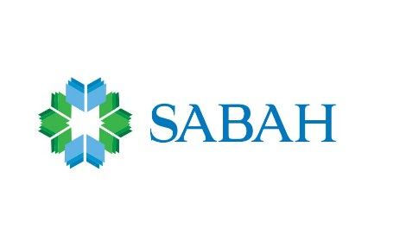
University of Economics – UNEC

Faculty:“SABAH”center
Specialty: Business Administration

Thesis
Topic: “Impact of Sponsorship Activity on Brand Image: Energy Drink Sector”

Supervisor : Galandar Mammadli
Student: Taghiyeva Nazila
Section: English
Group: S_16_01_409

Baku 2019
Acknowledgment

I would like to first say a very big thank you to my supervisor Galandar Mammadli all the support and encouragement he gave me. I have been extremely lucky to have a supervisor who cared so much about my thesis, and who responded to my questions and queries so punctually. Outwardly his constant feedback and guidance, this bachelor thesis would not have been achievable.

CONTENT

CONTENT 3
I Chapter: Introduction 5
1. Background 5
2. Research aim 6
II Chapter. Sponsorship as a Marketing Tool 7
1. Objectives for Energy Drinks Sector Sponsorship 7
2. Effect of Cultural Differences on Energy Drink Consumption 9
3. Energy Drinks Sponsorship as a Market Tool 10
III Chapter: Sponsorship 12
1. History 12
2. Types of Sponsorship 13
3. Sponsorship from the Sponsors Perspective 16
3.1 Create Exclusivity 16
3.2 Building Goodwill 16
3.3 Secure Entitlements or Naming Rights 16
3.4 Sales Increment 17
3.5 Competition 17
3.6 Legislation 17
4. From Organizer perspective 17
5. The Effect of Sponsorship Activity on Energy Drink Consumption 18
6. The Seven Keys of Effective Sponsorship 19
7. Why Companies Sponsor 22
IV Chapter: Brand Image 24
1. Image 24
2. Branding 27
2.1 Brand Identity 30
2.2 Brand Personality 32
2.3 Brand Image 33
2.4 Corporate Image 34
3. Brand Building 35
3.1 Definition 35
3.2 Brand Building by Sponsorship 38
4. Brand Image and Sponsorship 39
V Chapter: Analysis of Research Data 41
3. Research Results 42
3.1Demographic features 42
4. Factor Analysis 48
4.1 Sponsorship Scale 48
4.2 Brand Image Scale 51
4.3 Correlation analysis 52
4.4 Regression Analysis 53
5. T-TEST AND ANOVA 54
6. Conclusion and Suggestion 56
7. Literature 57

I Chapter: Introduction

1. Background
Historically, the vital and appropriate to the perception of the target audience in terms of price/quality ratio, any product or service practically does not require representation or presentation. Examples are bread, water, cleaning services, babysitters, etc.
When the question arises of creating demand for a new product, service, or packaged old one, but which needs to be sold at a higher price, there is often a very difficult task: How to gather the right audience and under what pretext should they inform about the “new” opportunity?
We all know well about such a tool as the presentation of a product or service. When important events take place in society, the most difficult task is to attract the target audience, to whom this could potentially be sold. Naturally, the most ingenious technologies and versatile methods of PR are developed for this. More about presentations - the more expensive and more difficult to sell a product, the more sellers, of course, with great pathos and mystery, draw up their presentation, often putting pressure on all sorts of supposedly chips - “this is only for the elect”, “only for people of your circle”, “only for own people, “only for company employees ...”, “only for lawyers”, etc.
So, the advantages of direct selling to the target audience are obvious - everything can be laid out slowly on the shelves, in the correct order, answering all the questions so that nothing distracts potential buyers. In the successful version, completing the presentation, good salespeople are switching to direct individual sales on the spot.
Why do we need sponsorship as a tool of marketing? The simplest and most obvious answer is that sponsorship can significantly reduce the costs of finding and attracting the target audience to company's presentation. On the other hand, the most obvious advantage is saving time.
Particular relevance in modern conditions acquires the social image of the enterprise. Social image of company forms the opinion of consumers about goods in different groups of the corporate audience (employees, authorities, competitors, business partners, society as a whole).
In the 21st century, the largest companies are seeking to acquire a reputation as an organization that cares for society and the planet. For example, on many packages, especially imported products, you can see the emblem, meaning the company's involvement in environmental programs; there are also a huge number of charity events supported by companies whose activities do not overlap with the social sphere.
At the present stage, there is a real struggle between companies for the right to be a sponsor of a large-scale event. After all, this is an incredible opportunity for the implementation of company tasks and the possibility of an advertising campaign. Such organizations immediately reach a new level, consumers recognize them and trust them, they are respected in the business community, it is easier for them to interact with different bodies of society.
The problem is that in order to achieve a positive effect, it is necessary to properly plan and apply the considered image tools. According to the study by IEG research, sponsorship for festivals, fairs and annual events was $ 878 million by the end of 2017, which is 2.1% more than last year. This huge amount shows that the topic of event sponsorship is now very relevant for all organizers.

2. Research aim

There are many nuances and subtleties of the use of sponsorship, as a way of forming an image, on which the whole result of the company entity depends. For this reason, the aim of this research is to develop proposals for improving the sponsorship activities of the company in the energy drinks sector in order to improve their image.
To achieve this aim it is necessary to perform the following tasks:
- to investigate the origin of the phenomena of sponsorship;
- to characterize the concept of the image of a commercial organization and its structure;
- determine the place and role of sponsorship in the technology of image formation;
- to analyze the practice of the implementation of sponsorship by large corporations in order to form and improve the brand image;
- to analyze energy drink sector in Azerbaijan and determine opinions of costumers about sponsorship activity on brand image in energy drink sector.
The object of the research is the impact of sponsorship activity on brand image.
The subject of the research is sponsorship as a tool for shaping the image of a company in the energy drink sector. The methodological bases of the study are articles, books, analytical materials of internet sites, which investigate this problem.
The study of the thesis is implemented as an online survey.
The novelty of the research is an attempt to take into account the importance, role of sponsorship in all aspects of its manifestation in the energy drink sector, as well as the justification and confirmation of their effectiveness in shaping the image of the energy drink companies in Azerbaijan.

II Chapter. Sponsorship as a Marketing Tool

Objectives for Energy Drinks Sector Sponsorship

Sponsorship is defined as a strategic activity by many researchers. This is strategic, because Slack and Bentz (1996) said that the organization relies on the decision to allocate resources to achieve its goals and is also used to align it with the requirements and pressures of the environment."
Global energy drink brands have used sponsorship, branded content and endorsements to create a unique brand that generally covers the different sphere of human life. In these actions companies, which produce energy drinks have several objectives. Possible objectives for energy drinks sector sponsorship are classified below:
1. Stimulate the recognition of energy drinks brand.
2. Change or improve the image of the energy drinks companies.
3. Increase sales. Frequently, there is an obscure relation between sponsorship and sales. The recognition of the brand, the image of the company and its publicity (achieved through sponsorship) lead to an increase in sales.
4. To conduct marketing in the field of relations with the business world. The sponsors invite their business partners to attend events sponsored by energy drinks companies (film premiere, football match).
5. Conduct internal PR.
6. Conduct corporate PR. By sponsoring, for example, charity events, a company can demonstrate the social orientation of its policies and appear in a more attractive from the public's point of view.
An important advantage is that energy drinks sponsorship allows to reduce the level of “advertising noise”, which is inevitable when using classical advertising tools. Nowadays, most of the techniques of direct advertising are already fed up with the consumer, while with the proper conduct of a sponsorship policy; a company may indirectly receive much more dividends than if it uses direct advertising to work with the media.

2. Effect of Cultural Differences on Energy Drink Consumption

Faced with local culture, brands use the strategy of product localization, taking into account not only regional linguistic, but also social, as well as gastronomic features. Traveling around the world can be found on the shelves of shops many familiar brands, but with an unusual taste. Famous brands adapt their product to the preferences of people in different countries.
For example, currently, around 70 different types of Fanta are produced around the world: Fanta-Shokata with elderberry is sold in Serbia, Montenegro and Croatia, Fanta with pear in Azerbaijan, Fanta with black currant flavor is sold in Switzerland and the Netherlands.
Before entering different specific markets, the possibility of each individual will taste the product, all small details must be studied, and then, solutions will be given. In Russia, for example, DietCoke was not pulled out, finding that the Coca-ColaLight brand is stronger. Coca-Cola is trying to conquer the Russian market by offering consumers new products, such as citrus-flavored energy drinks, iced tea, juices, and their own version of the traditional sparkling brown kvass drink. Thus, the company takes into account the characteristics of local consumers, who “quickly became selective in their tastes” and often refuse sugary carbonated drinks, considering them harmful.
In those markets where traditions, cultural and geographical features play an important role, there are special technical standards for corporation products. Their goal is to increase profitability, and in some cases, the attractiveness of the parent brand. Therefore, along with the use of global brands, corporations still retain local brands, established strong ties with customers. For example, after Coca-Cola purchased the Indian brand Thumb'sUp (brand № 1 among energy drinks in India), it was decided to keep the Thumb'sUp brand name, mentioning only that it now belongs to Coca-Cola. Buying in Ukraine the water "Yurskezhelolo" or "Fruktime", the consumer may not suspect that the brand belongs to Coca-Cola.

3. Energy Drinks Sponsorship as a Market Tool

Marketing these days has become one of the most important tools for many companies in the economy. The increased competition in the market led to the fact that in order to increase sales and profit, it is sometimes not enough to have high-quality goods, companies also need to convey to consumers the benefits of using them, create a certain image for these goods and define a special place for them in the market. A successful marketing strategy for a company can create high-level demand for goods.
Energy drinks provide an attractive margin for dealers and retailers. In addition, these drinks do not require a lot of shelf space. Energy drinks are distributed to gas stores, supermarkets and other stores. Most sales of energy drinks are convenient and take place in the destinations with urgent needs such as gas shops. Between 47-54 percent of the energy drinks are sold throughout 2010 and 2015 years in convenience and gas stores. About 10 percent of sales were made from supermarkets and about 13 percent of sales were made at food service points. Energy drinks showcasing are customarily based on the utilize of non-traditional outlets, such as celebrity supports, extraordinary sports, and NASCAR. Less is done with television, radio, and print advertising.
The main idea of ​​energy drinks sponsorship is that the sponsor begins to associate itself with the consumers and thus tries to project onto itself all its positive characteristics and positive feelings associated with it. In fact, we are talking about transferring the image.
Energy drinks sponsorship is most effective in the early stages of creating a firm's fame, because it cannot change the established opinion of consumers, but it can influence the formation of a new opinion about an organization due to the following factors.
Firstly, one of the main conditions determining the effectiveness of energy drinks sponsorship is duration. Creating stable positive fame takes time. The novelty of a “one-time” energy drinks sponsorship may attract more attention, but the strength of the sponsor’s association with the object in this case is small. While ongoing sponsorship is perceived as an indicator of the company's serious intentions.
Secondly, the obligatory success factor of a sponsorship project is the coincidence of the target audience of the sponsored object with the target audience of the energy drinks sponsoring company. The greater this intersection, the more likely it is to reach potential customers. In the process of perception of energy drinks sponsorship, consumers appreciate not only the sponsor and the object of sponsorship, but also the extent to which they logically correspond to each other. The less obvious is the link between the energy drinks sponsor and the object of sponsorship, the more effort must be made first to substantiate its connection with the object.
Thus, sponsorship at the stage of entering the company on the market can have a significant impact on the formation of an organization’s fame along with the well-established public relations specialist’s toolkit. Sponsorship is also an effective way to make energy drinks company known, as well as a constant opportunity to support public opinion.

III Chapter: Sponsorship

History

According to Dolphin (2003), the concept of sponsorship comes from the Greek and Roman periods, and the word comes from the Greek word "Horigia", which means guarantor.
The origins of sponsorship could be traced back to Ancient Greece. Popular and still ongoing Olympic Games was financed by rich citizens, and the winners received money, food provided by the city, tax exemptions, and so on. The government also sponsored these games in ancient Greece. Various presents allowed the athletes to hire coaches and the same time better prepare for the next game. Thus, the Olympic Games spread out a good image of city and country.
The origins of modern sponsorship as supporting in exchange for privileges can be found in the features of patronage. In other words, sponsorship in the sense of providing financial support for deserving events and individuals is rooted in patronage, which in the past was provided to artists and musicians by royal families and aristocrats. For example, Beethoven and Mozart without such protection simply would not have survived. Later, rich industrialists and financiers Tate, Carnegie, Ford, Morris founded many of the funds of this kind.
Sponsorship has been successful in getting rid of the confusion of traditional forms of communication, such as television advertising, radio advertising, and magazine advertising.
Lagae (2005) mentions that sponsorship is a new compared to other marketing concepts. The earliest modern commercial use of sponsorship may be investigated to Kodak's advertisement deployment in the official program of the Olympic Games in Athens in 1896. He adds that sponsorship is the only promotional tool that allows company to associate the desire and passion of the target audience with certain events.

Types of Sponsorship

Currently, we have various types of sponsorship, which in turn can be used for different purposes (advertising, marketing or public relations). Sponsorship exists in the form of advertising, when a company sponsors a radio or television show. It all started with soap operas (so named, because soap was advertised at that time) broadcast on American radio in the 1920s and 1930s. In Europe, the programs were also sponsored by Luxembourg’s radio (the first popular entertainment programs run in the UK on Sundays). It was, and in many parts of the world still remains the primary means of obtaining funds for radio and television companies
For many years, marketers have developed new advertising tools for entering consumer markets, such as public relations, sales promotion, direct marketing, sponsorship and product placement. It means, sponsorship can be associated with other advertising tools, as shown in Figure 1.

Figure 1. Linking sponsorship with other promotional tools

Source: Buhler, Andre&Nufer, Gerd. (2010) Relationship Marketing in Sports. Oxford: Butterworth-Heinemann, cop. 2010. p. 99.

In most literature, sponsorship is described as a strategic activity. As a main reason, Slack and Bentz (1996) noted that it makes decisions about the distribution of resources for achieving an organization’s goals, and the same time it is used to bring an organization into compliance with the demands and requirements of its environment.
Therefore, all sponsorships are not the same and various types of sponsorships can be seen in the practice (Figure 2).

Figure 2. Types of Sponsorships

Source: Jagre, E., Watson, J. (2010). Sponsorship and Congruity Theory: a Theoretical Framework For Explaining Consumer Attitude and Recall of Event Sponsorship//Advances in Consumer Research Volume 28, 2010

Most sponsorship discussions focus on first type of sponsors (financial sponsors). Most sponsorship discussions focus on financial sponsors. These sponsors pay money directly to the producer or the company to finance the events.
Second type of sponsors (media sponsors) guarantees advertising of an event. This may mean to buy a space on a local newspaper or in a local TV, create a blog post about the event, and publish content related to the event on the channels.
In-kind sponsorship is the third type of sponsorship. In-kind sponsorship is a contract where the sponsor delivers goods or services instead of direct financial support. For example, a company may provide energy drinks for a fundraising event.
The promotion partnership is very similar to the media sponsors. The main difference between them is that promotional partner is usually separate individual, not companies and media. The promotional partners advertise its activity or cause on the network.

Sponsorship from the Sponsors Perspective

When companies seek to sponsor specific activities, they will always have clear reasons and goals for these actions. Sponsorship objectives should always be associated with ad targets and, more generally, with the organization's marketing objectives.
Shank differentiates direct and indirect sponsorship goals. The goal of direct sponsorship is expected to have a direct impact on the level of sales and consumer behavior. The goal of indirect sponsorship is a long-term commitment that requires a high level of awareness and builds the company's image before the company reaches its indirect goals.

Create Exclusivity

Generally, companies enter into a licensing agreement, which makes it an exclusive sponsor of the event. The advantage of this sponsorship is a high rate of exposure without worrying about certain competitors and confusion that are synonymous with the classic advertising style. Sponsorship tends to convey the company’s messages in a more various and less commercial ways.

Building Goodwill

Sponsorship is an excellent way to do business personally to create a high level of goodwill. With hospitality and entertainment, the energy drinks company can create a friendly business environment that can increase this company's image positively.

Secure Entitlements or Naming Rights

Naming rights & entitlement may be acquired by companies participating in sponsorship agreements in various organizations or events. They may either be part of an organization or the whole organization that may include the different facilities at the same time. Naming rights are the most expensive investment in the current market and are also accepted as a less-used sponsorship method.

Sales Increment

The purpose of the sponsorship agreement is to increase the sales o company. While organizations are considering investing in sponsorship agreements, they must first evaluate their organizational goals and marketing objectives and then decide which type of sponsorship may help them achieve all these goals.

Competition

Sometimes companies make sponsorship agreements because of the threat from their competitors. Many sponsors claimed it was the main reason for sponsorship. Put it differently, if the company will not interested and does not invest in sponsorship, some of the competitors of the company will do it. This, in turn, will lead to a loss of market for big events such as the Olympics.

Legislation

Many countries of the world have legislation against some goods namely alcohol and tobacco, where sponsorship is used as an alternative to prohibited advertising campaigns. For this reason, the sectors which produce these type of products generally use so-called ‘surrogate advertising’ by promoting different events and organizations through non-tobacco or non-alcohol making subsidiaries.

From Organizer perspective

Nowadays, a lot of money is required for realized the various activities. To extend the scope of these activities, or to rent/buy the items for these events, the used money may force the organization's budget. For this reason, organizations find sponsors, and get the cash or receive in-kind assistance from sponsors, and they could meet their expenses and may reduce their expenses. On the other hand, sponsors share their experiences and strength.

The Effect of Sponsorship Activity on Energy Drink Consumption

Energy drinks sponsorship can be done on different sectors of life. For example, sports, culture, science, social care, etc. Supporting a variety of socially acceptable sectors of our life gives them a chance to be seen by customers as energy drink companies whose products are
reliable, as well as worth to buy.
Generally, energy drink companies have set themselves up in the extreme sports sub-culture as sponsors of athletes and competitions. For example, The X Games, Nitro Circus and Formula 1. As a result, people who regularly watch sports or do sports are subject to advertising for these products over and over again. This sponsorship increases the demand for energy drink products and raises the profits of the company. However, there are limited researches on effects of energy drinks on human health. The various questions about the effects of sugar and caffeine, which contains these drinks remain unanswered. At the same time, there are a few data about consumption rate of energy drinks in the scientific literature. This process is systematized in Figure 3.

Figure 3. Connection Between Sponsorship Activities and Energy Drink Consumption (in social media example)
Source: Лавров С.Н., Злобин С.Ю. Основы маркетинга промышленных объектов. – М. 2005

The Seven Keys of Effective Sponsorship

Sponsorship is a voluntary investment of financial resources, implying financial gain. It should be noted that the sponsorship of events is a tool for PR, through the transfer of information through the media to sponsor a project or event quickly reaches the general public.
The effective sponsorship can positively affect to the image and income of the company include the associativity of the sponsor and the sponsored object. In other words, the image of the event is projected onto the sponsor of the event. In his book “The War of Brands”, David D'Alessandro said: “By making a contribution to a certain event that is valuable to consumers, you can cause them interest and respect, or even gratitude. Ideally, the public perceives the charm, excitement and emotions that arise during the event you sponsored as a distinctive feature of company brand. The process of transferring emotions from an event or person to a sponsor company is often called the “halo effect”.
Efficiency of sponsorships can be assessed by two parameters: what benefits have been achieved for society (social effect) and business effect, i.e. the benefits that the organization received.
Performance analysis is to account for all available information. Reliable are polls at the venue and interviews immediately after it. When analyzing the effectiveness, it is necessary to evaluate what the participants of the event specifically remembered, how many people and how their attitude towards the organization, its products changed.
To optimize sponsorship, it is important to be well aware of how it can be turned into an effective marketing tool. The most important keys of effective sponsorship are shown in Figure 4.
The first key in effective sponsorship deal is about clear communication. The company should have clear communication goals for the brand. Strategies of sponsorship must take into account the brand's communication goals. Usually, there are three types of goals. They are (a) visibility (awareness), (b) association development and (b) relationship development. Each of these types can be the main driving force behind the strategy of sponsorship.

Figure 4. Keys of Effective Sponsorship
Source: Aaker, David A. & Joachimsthaler, Erich (2000) Brand Leadership. Free Press, 2002, p.223

The second key to effective sponsorship is proactivity. The selection of sponsorship should proactively manage by developing a set of criteria for effective sponsorship. The possible choices should list and the best criteria determine after evaluation. Being proactive raises the likelihood that sponsorship will become original and not cause confusion.
Look for an exceptional fit is another important key of effective sponsorship. The extraordinary harmony between the event and the sponsor company is much better than a good fit, and lack of fit or obedience fit is an important obstacle.
Own sponsorship. The main task in successful sponsorship is to link the brand to the event associations. This task is much easier and less costly if the brand is an integral part of the event. Event ownerships have some implications. Instead of building a loose relationship with many events, consider focusing on one or more. Go for long-term relationships and agreements; if it gives good results, pay attention to the situations in which competitors could be moved into company’s place. The companies should pay attention to the complexity of sponsorship. Think about the threat of ambush marketing and make a plan to deal with it.
Effective sponsorship has different signs. The general rule is that the budget cost of effective sponsorship should be 3-4 times higher than the cost of sponsorship; This additional budget is needed to help link the company to the event and make full use of the potential of the event.
To create and strengthen a favorable image by effective sponsorship, takes a long time, so the use of such a tool as sponsorship must be firmly established with the object of sponsorship and be permanent. Such a long activity is perceived by society as an indicator of the organization’s serious intentions. Since sponsorship is a successful means of creating advantages over its competitors, it is not the one who makes one-time, albeit grandiose, cash contributions, but the one who systematically and consistently acts in a particular direction.

Why Companies Sponsor

The most valuable asset for the company is regular customers. The absence of certain differences among all categories products are simple but inevitable result: emotional logic is the most important driving force of business. Without emotion, the product or service is the same as any other products or services. Whether it is sports or entertainment, art or business, companies create loyalty by combining problems, actions and organizations that excite their products and services to their customers. Intensive exposure in electronic and print media offers sponsors wide advertising opportunities. However, the cost of television and print exposure sometimes are very expensive for many sponsors. Sponsorship could create, change or improve brand image. For instance, Mountain Dew sponsors the Dew Tour and this way strengthens ties with young people. Although imagery may be reflected through advertising, the paid media lacks the reliability of sponsorship.

Figure 5. Objects for Sponsorship

Source: Prepared by author based on IEG’s Guide to Sponsorship, Everything You Need to Know About Sports, arts: Event: Entertaiment and Cause Marketing, IEG LLC, 2017, p.13-19.

Customers generally are speaking and emphasize that they want to reward and punish organizations with their corporate citizenship wallets. In a millennium survey conducted in Canada, people answered that social responsibility was the first factor, which influenced their impressions on the company more than the quality of the brand or business fundamentals. Organizations use sponsorship as hooks to increase sales. For instance, Listerine used Chicago Tasting sponsorship for $ 20,000 to increase shelf space, retail advertising and sales. The brand scored a 238% annual growth in regional types of equipment for its 48-ounce extension. This growth was gained during the mentioned sponsorship. Shipments in the second quarter of that year also increased by 193%, while sales of 48 ounces remained one share point more after sponsorship. On the other hand, in the history of this brand, the number of storefronts displays reached double digits. Sales of company may also be made directly from the copyright holder. Sponsorship permit brands to demonstrate the benefits of the product. Bell Canada seeks opportunities to underline the strength of telecommunications services and products. For instance, the company sponsored ticket ordering and reconciliation phone line at the festivals (Shaw and Stratford festivals). Festivals websites are also protected by sponsorship. Components of properties' hospitality could be very important for organizations, which offer the opportunity to spend several hours with customers and potential clients, and at the same time to strengthen their business relationship. Sponsorship is also being studied for their ability to stimulate company employees. Sponsorship provides the opportunity to reach more than one goal at the same time. For instance, Jack In The Box in Seattle had five goals to sponsor the Western Washington's Puyallup Fair:
1) create awareness and test new products
2) strengthen its position as a fast food chain where consumers can try new products
3) increase sales with aggressive coupon
4) provide employees with the opportunity to explore and participate in local marketing techniques
5) increasing network awareness with broadcast support.

IV Chapter: Brand Image

Image

Image is a declared statement or position that formulated for further reporting to the consciousness of the target groups to which the activity is oriented. The image in the context of the organization’s activity is a certain foundation, the starting point on which the further development of the organization will be based.
Image is considered to be a landmark substitute for the properties of a real person, a subject of politics or economics. Image sets the essence of the organization itself, depending on this, communication with the target audience will be built.
Existing in the real and the symbolic world, a person evaluates everything through this “filter”. In this case, the image is exactly part of the symbolic world. Image can be called a combination of form and content, where external characteristics refer us to content under the influence of established stereotypes.
It is important to understand that the formulation of the image should optimally represent the subject in the outside world, create conditions for positive fame among potential and real partners and be aimed at the dominant perception by target audiences in comparison with competitors - these are its main tasks.
Such terms as reputation and brand are inextricably linked with the image. Reputation is the perception of a formulated image by target audiences. The image is undergoing a transformation in reputation. Awareness about the organization, its activities and the compliance of its activities with the image and target audience called publicity. A set of stable symbols and characteristics associated with an organization or its activity is the organization's publicity capital.
Each company needs its own image, and clearly formulated for communication with customers, and internal interaction in the company.
The study of the structure of the image of the organization led to the development of two main structural models. They are specially organized information about the organization.
The first model contains seven components:
- external attributes (organization name, corporate identity, emblem, symbols, location, etc.);
- financial well-being;
- the identity of the manager and his “team”;
- staff image;
- quality of activity, product or service image;
- design of office space;
- business communications of the organization and personnel.
The second model consists of ten components:
- external attributes;
- organization history, traditions;
- financial position;
- product image, quality of activity;
- image of the manager and his team;
- staff image, corporate culture;
- business communications, features of organization management;
- cost of goods or services (comparative data over time);
- publicity, advertising fame;
- design of office space, products.
The significance of the components on which the image is built is determined in each specific case, the image of the organization can be dominated by information that enhances the image of the manager, or the quality of the activity and the cost of production, the history of the organization’s formation, and so on.
Prioritization in the criteria for creating an image should be based on the analysis of the company itself and the external situation.

2. Branding

The word "brand" comes from the English "brand" (brand), which, in turn, comes from the ancient Scandinavian "brandr", which means "burn." In the distant past, in order to distinguish their cows from the livestock of other owners, shepherds began to put a distinctive mark on animals. They just took the stigma, glowed and made an imprint.
Of course, now, speaking of the brand or branding, no one remembers cows, but this does not prevent us from having an erroneous idea about the brand or branding in general. The saddest thing is that the wrong idea is not only among people who have nothing to do with branding or business, but in professional circles one can often hear the wrong interpretation of these words.
As mentioned above, the word "brand" denotes a name, mark or symbol that identifies the products and services of the seller. Branding is the actual process of creating and developing a brand, the main way to differentiate products, a tool to promote products to the market and create long-term relationships with consumers based on the values ​​that are relevant to consumers that are embedded in the brand. If we say shorter, then branding is a set of consecutive events aimed at creating a holistic and popular image of a product or service. Quite briefly: branding is brand management.
The consumer is faced with a brand in a variety of circumstances. For example, energy drinks get their contact with the consumer through many channels, some of which can hardly be called favorable:
- notes and articles in newspapers, news in other media;
- signage on buildings;
- product;
- personal consumption experience;
- advertising;
- rumor;
- fairy characters and playgrounds;
- employees;
That is why, in addition to purely communication tools, great attention must be paid to the practice of consumers using the brand image. As Schulz and Barnes note, “brand communication programs can only reinforce or supplement brand information already accumulated by consumers. "The history of the brand determines most of its future value."
So, manufacturers of various consumer goods make extensive use of brands in world markets for the following reasons:
• the popularity of brands allows their owners to receive additional profits in the form of
the so-called premium - prices for a well-known name;
• the brand simplifies the process of choosing a product by the consumer and making a decision on the purchase of a product: knowing the products of a well-known manufacturer, the buyer does not spend time searching for information about the product and comparing competing products, but chooses a familiar product, works well;
• the brand helps the company to identify itself and its products from a number of competing products;
• the brand allows the manufacturer to extend its influence to related industries;
• the brand creates favorable conditions for the manufacturer to cooperate with partners, strengthens the position of the manufacturer.
As practice shows, to achieve the necessary state of corporate culture, when it corresponds to the brand values, is extremely difficult. Traditional means such as mission and corporate media are not always effective. The principles of remuneration and compliance of brand values ​​with values ​​of local culture and mentality play a big role. For example, in the developing countries, the most common corporate culture is different shades of collectivism, while in the West, individualism is the basis of intercorporate behavior. In the developing countries, informal relationships at work are the rule rather than the exception, while at multinational companies they try to strictly follow formal instructions and regulations.
So, the brand determines the constancy of demand and its independence from many market factors, including the general level of prices in the market. We can say that the brand insures the manufacturer and creates the willingness of the buyer to pay more.
There are different stages of branding. The main stages of branding are shown in the Figure 6.

Figure 6. Main Stages of Branding

Source: Дуэйн Нэпп, Политика бренда. М.- 2004, p.96.

In the process of branding can occur stretching and expanding the brand. Stretching happens when, with the appearance of a new product under the same name, the product category, destination, target audience, brand identity remains unchanged, and only the benefit for the consumer changes.
Brand extension is the distribution of a brand to a new consumer segment or a related product category. For example, Nivea cosmetics was originally female, but it began to develop the male direction, releasing Nivea for man.

2.1 Brand Identity

In marketing literature, brand content is called brand identity, because one of the main functions of the brand is the identification of goods or services.
Identification is the process of comparing the perceived object with the standard stored in memory and establishing their identity or coincidence in essential features. Synonym of identification is recognition.
During the identification process, we get answers to the questions: who is it? or what is it? The word identity is derived from the late Latin ‘identicus’, which means "identical". The concept of brand identity was proposed in 1986 by J.N. Kapferer,
Model ‘Brand Identity Prism’
The concept of brand identity was proposed in 1986 by J.N. Kapfer and proliferated as the "Brand Identity Prism" model. The author proposed a model from different elements.

Figure 7. Kapferer’s Brand-Identity Prism Model

Source: Kapferer, J. N. The new strategic brand management - creating and sustaining brand equity long term. London: Kogan Page. 2008, p.183

In this model the main elements, which affect brand identity explained below:
Physical data. The appearance of the product and its physical features, the external manifestations of the brand. What exactly is this brand? What is he doing? What does he look like?
Personality. Description of the characteristic features of the brand in the categories of personality traits. This could be a celebrity, a personifying brand, a company leader, a fictional character, a hero, an opinion leader in advertising, or a stable set of brand associations.
Culture. The image of the country, the history of the company or product, traditions, corporate values, national characteristics, etc.
Relationship. A certain type of relationship and interactions between the consumer and the brand, “a type of behavior that mostly identifies brands”. The boundary of relationships determines the way brands operate, the supply of services, the nature of relationships with consumers.
Reflection. What does the consumer want to look like in the perception of others? What is the impression when using the brand? The edge of reflection is expressed in the statements of consumers "this is for young people", "this is for the older generation", etc.
Self-image. What does the consumer think and feel and how does he identify himself/herself when using the brand?
Apéria & Back (2004) highlight that the prism of brand identity could be used if identity and brand image have a gap.

2.2 Brand Personality

The classic definition of a brand describes it as a means of identification and distinction, therefore the brand personality is a system of characteristics that determines its uniqueness. All brand properties are divided into three categories.
The first category includes the advertised characteristics of the brand, which are clearly offered or promised to the consumer. The second category includes such characteristics that require specific actions (facts) confirming their presence, they can be called confirmations. The second group of brand features is formed gradually, in the process of interaction between the consumer and the brand. The second category includes the character of the brand, trustful, friendly and respectful attitude to the brand. The third category includes implied, or implicit, promises; it’s consumer expectations — what brand buyers would like to see. Expectations consist of the experience of consumption of goods in this category, as well as of the features of contacts with a particular brand. In developing the brand and its identity, they deal only with promises, i.e. with those characteristics of the brand, which apply to potential consumers and by which the consumer will be able to identify this brand. Confirmations are determined mainly by the communicative quality of the brand and its ability to maintain contact with the target audience, organize and direct communications and thus build and strengthen consumer-brand relationships. Expectations are most important at the stage of studying consumer perception of a brand, since the difference between the offered and expected can significantly distort the brand image and reduce consumer activity.

2.3 Brand Image

Brand image means a visual image of the brand, formed by advertising media. It can be said in a different way: a brand image is an image of a brand that is reflected by brand-related associations that remain in the memory of the consumer. According to KL Keller, these associations can vary in strength (availability of information), adequacy (compliance of the generated information to customer needs) and uniqueness (an indicator that this association is not characteristic of competing brands).
The brand image helps consumers to process information, distinguish a brand from a number of others, create intangible advantages, and induce it to purchase, communicate positive feelings, and provide the basis for product distribution.
When creating a brand image, the physical properties of the product, the feelings that it causes on the consumer should be taken into account. There is an appeal not only to the consciousness, but also to the emotions, to the subconscious.
Brand image depends on the qualifications of sales staff, level of service, design of points of sale, content of information in the media, etc. For the formation of a brand image, the duration of presence and brand awareness in the market is important. Forexample, global cosmetics companies prefer to use the faces of famous actors, top models and show business stars as a brand image.

2.4 Corporate Image

Corporate image is a holistic perception (understanding and evaluation) of the organization by various groups of the public, formed on the basis of information stored in their memory about various aspects of the organization's activities.
The corporate image structure may include several components depending on the company profile. Some authors identify eight groups of corporate image components:
1. Image of goods (services).
2. Image of the consumer of the goods (service).
3. Internal image of the company.
4. Image of the management of the company.
5. Image of the staff.
6. The visual image of the organization.
7. Social image of the organization.
8. Business image of the organization.
Each component requires careful study and management, as well as the corporate image as a whole.
Creating the image of the company should carry out with a strategic approach, using integrated marketing communications to achieve a synergistic effect.
Management of corporate image begins with the formulation of the vision of the company's business processes and, as a consequence, the mission, declaring the socially significant status of the organization. The corporate image can re-created for a new organization, it can transformed, and it can managed if the organization moves to a new stage of its life cycle, rebrands, renames, repositions in the market.

Brand Building

3.1 Definition

It is known that marketing can be effective only when the product meets the needs of the market. A similar situation observed with branding: if the product cannot satisfy the consumer, it will be doomed to failure.
Creating a brand is creativity based on deep market knowledge. The process of creating a brand is quite complicated, and the cost of a mistake can be huge, therefore many large companies prefer not to do it themselves, but transfer the creation of the brand to a professional company in this field.
Brand Institute Inc. and other well-known brand development agencies offer the following brand development scheme.

Figure 8. Brand development scheme
In order to form a brand, the brand-maker must ask himself/herself four questions:
- for whom? - definition of the target consumer group for which the brand is created
- what for? - the benefit of the consumer, which will be received as a result of the acquisition of this particular brand
- for what purpose (for what use?) need this particular brand
- against which competitor?
Along with the use of an integrated approach, it is necessary to choose the right brand communication campaign strategy for building brand. The problem is that many companies incorrectly assess their role in the market (most often, exaggerating it), choose the wrong brand promotion strategy. Al Ries and Jack Trout in the book "Marketing Warfare" describe four possible strategies for a brand’s communication campaign:
- defensive;
- offensive;
- flank;
- partisan.
Defensive strategy is the lot of the leading brands that occupy the largest share in a particular market segment. A tragic mistake for such brands would be a communication campaign aimed at proving superiority over other market participants. A good example is the fate of the beer "Solod" and the famous slogan "Perhaps the best beer." All other market participants will unite and must find flaws in the products of this brand. Therefore, market leaders should choose a calm and defensive strategy, reminding consumers of who is the market leader, but not proving that this brand is the best. Moreover, company should choose its own brand, or rather the previous versions of the product, as a target for attack. That is why even very good products are being replaced by new, even better ones.
Flank strategy is available to those brands that occupy a small market share, and produce products that can withstand the leaders in one segment of products. Partisan strategy is a strategy, which some companies occupy niches that are not accessible to market leaders, in principle, because of their size and slowness. Usually - these are narrow-specialized brands, designed for sophisticated users.
There are five standards of compelling brand communications:
1. To implement the corporate strategy and brand vision, use all possible communication strategies.
2. The choice of the right communication strategy should be determined by the portrait and the positions of company brand.
3. For maximum return on investment, use integrated marketing communications.
4. The communication strategy should cover the whole organization.
5. The conditions for successful communication are internal interest, training and metrics.
From the point of view of time parameters, the recommended timeframe for the effects of vintage communications are as follows:
For building brand consistency of the message is very important. Company cannot lose contact with consumers and it cannot lose the constancy of the brand, that is, the ability of the brand to offer the consumer the main idea or the main promise for a long time. The abrupt change of the company's strategy causes much more serious damage to the brand than the not always accurate positioning within the communication campaign.
In recent years, it is PR technologies that are the main means of creating new brands, whereas advertising in essence only reinforces the progress achieved. According to Al Ries and Laura Ries, argued in the book “The Fall of Advertising and the Rise of PR” most of the recent marketing success was achieved using PR technologies, not advertising. For example, Anita Roddick didn’t need any advertising to create the world-famous “Body Shop” brand. She simply traveled around the world in search of ingredients for natural cosmetics, and her research attracted the interest of the general public. In addition, company can recall the experience of promoting such well-known brands like Starbacks, Amazon.com, Yahoo !, eBay, Palm, Google, Linus, PlayStation, Harry Potter, Red Bull, Microsoft, Intel, BlackBerry, etc.

3.2 Brand Building by Sponsorship

To stand out among competitors, a company needs to be one-step ahead from others. This also applies to advertising tools: the more unusual methods used, the greater the chance of success. Sponsorship is the perfect solution. It characterized by a deep involvement of the audience in advertising communication. Sponsorship allows the company to create a stable corporate image and contributes to increasing brand awareness.
In brand building, the choice of matching the sponsor and the sponsored object can be divided into two types: functional and image.
Functional matching - sponsor and sponsored are related by purpose. For example, the sponsor of a football team is a company that sews sports shoes and clothing.
Image matching - when the image of the sponsor is similar to the image of the sponsor. For example, the organization that manufactures Rolex watches is the main sponsor of major tennis tournaments. Famous people present at the event, other sponsors who provide support, also have an impact on the image of the sponsor.
In the case of sponsoring a project by a well-known large company or the availability of state support, the image of other sponsors is strengthened, so that when drawing up a sponsorship package, the remaining sponsors should be indicated.
When companies sponsor an event or venue, it opens various opportunities for brand recognition. Here is a brief list of what sponsorship packages offer, depending on the level of sponsorship or the type of event:

Figure 9. Sponsorship packages

Source: https://www.seroka.com/using-strategic-sponsorships-build-brand/

4. Brand Image and Sponsorship

In recent decades, the concept of integrated communications has been the leading concept of a brand communication campaign. It replaced the concept of communications based on sponsorship. The fact is that from the point of view of a customer or a consumer, a brand image is a combination of many forms, factors, functions and contexts that give it value in the market. Therefore, if a brand is really a mixture of all the elements shown, then this implies
that brand communications should be managed integrated.
The combination of various means of communication can achieve a synergistic effect. This allows company to reduce the cost of communication through the use of more simple, but close to the consumer means. For example, packaging is paramount importance for consumers, since it is from this that familiarity with the product. Another important communication tool is the conditions and circumstances of consumption. Everything must be done so that the consumer can enjoy the process of using the brand.
This is a two-way street for both the event and the sponsoring organization, through which the latter seeks to associate itself or its brands with positive images achieved by the unique personality of the events. It means, events sponsored by companies have a big impact on the brand image. Sponsorship can improve the brand image as well as destroy it. In general, we are simply talking about how sponsorship has a positive effect on the brand image. Sometimes it can be the other way around, and sponsorship can negatively affect it. For instance, this type of situation can be discussed in the case of Tiger Woods. In this incident, many Tiger Woods sponsors (Accenture; Gillette; AT&T; General Motors) ended their sponsorship with him after news of his numerous infidelities surfaced. Most companies believed that these scandals could have a negative impact on their brand image, and did not want their brands to be associated with Tiger Woods scandals. This case shows that sponsorship is a very important marketing tool for creating the company's brand image.
With regard to the role of sponsorship on the brand image of the organization on the basis of the above, we can conclude that sponsor advertising has a much more positive effect on the image of the organization than conventional advertising. This is due to the fact that participation in sponsorship demonstrates to the general public the viability of the organization and its involvement in various social projects, demonstrating social significance.

V Chapter: Analysis of Research Data

- Purpose and model of research
This research aims to determine the impact of sponsorship activities on brand image components. For this purpose, the effect of sponsorship activities in the energy drinks sector on the brand image of the consumer has been tried to be determined. The study of the thesis is implemented as an online survey. In the research, it was assumed that the participants gave realistic and sincere answers to the questions asked in the survey. The survey is analyzed through the 21st and 23th editions of the SPSS (Statistical Package for the Social Sciences) program. We used the T-test in 2 variable questions (gender, marital status etc) and the ANOVA analysis in questions with more than 2 variables. Research is restricted to the energy sector, though it can be applied and expanded to other sectors.
312 respondents participated in this survey, however, 17 people who do not drink energy drink during the survey of the data are excluded from the questionnaire, and therefore, the responses of only 295 respondents remain.
2. Hypotheses of research
Young people constitute the main mass of the research. The following hypotheses were developed to be tested in the study.
1) H1: Sponsorship has an impact on brand image.
- H1a: Goodwill has an impact on brand image.
- H1b: Corporate sponsors have an impact on brand image.

2) H2: Demographic factors have differences in brand image.
- H2a: There are differences in brand image by gender.
- H2b: There are differences in brand image by age.
- H2c: There are differences in brand image according to marital status.
- H2d: There are differences in brand image according to education.
- H2e: There are differences in brand image according to income level.

3. Research Results

3.1Demographic features

Table 1: Distribution by Demographic Characteristics
 |  | Frequency | Percentage
Distribution by Gender | Female | 91 | 30,8%
 | Male | 204 | 69.2%
Distribution by Age | Between 18-25 years | 181 | 61.3%
 | Between 26-35 years | 83 | 28.2%
 | 36 years and older | 31 | 10.5%
Distribution by Marital Status | Single | 231 | 78.3%
 | Married | 64 | 21.7%
Distribution by Education | Who do not have higher education | 22 | 7.5%
 | People with higher education | 232 | 78.6%
 | Master and PhD | 41 | 13.9%
Distribution by Income Levels | Less than 250 AZN | 89 | 30.2%
 | 251- 500 AZN | 92 | 31.1%
 | 501-1000 AZN | 69 | 23.4%
 | 1001 AZN and above | 45 | 15.3%

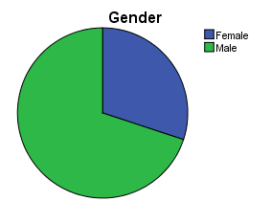
When the distribution of the participants according to their gender is examined (Figure 10) , it is seen that 204 participants are male (69,2%) and 91 are female (30,8%).

Figure 10: Distribution by Gender

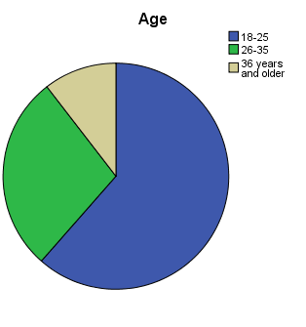
When the distribution of the participants according to their age is examined (Figure 11) , it is seen that more than half of the participants (61.3%) are in the 18-25 age range. This is followed by 28.2% of the participants in the 26-35 age group. The ratio of the participants in the 36 years and over age group was 10.5%.

Figure 11 : Distribution by Age

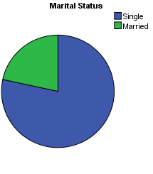
When the distribution of the participants according to their marital status is examined (Figure 12), more than half of the participants (78.3%) are single. The ratio of married participants in the sample was 21.7%.

Figure 12: Distribution by Marital Status

When the distribution of the participants according to their level of education is examined (Figure 13), it is seen that more than half of the participants (78.6%)are higher education. While the ratio of the master and Ph.D. graduates in the sample was 13.9% the ratio of who do not have higher education in the sample was 7.5%.
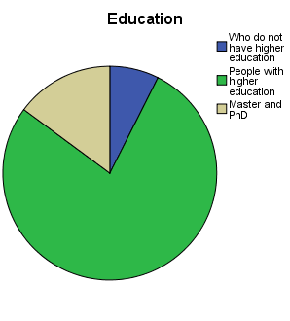

Figure 13: Distribution by Education

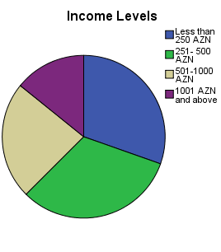
When the distribution of the participants according to their income levels is examined (Figure 14), almost half of the participants (31.1%) are followed by the participants with income between 251 and 500 AZN. It is seen that it has less than 250 AZN income with 30.2%.The ratio of the participants with income of 1001 AZN and above was 15.3%. The percentage of participants with income between 501 and 1000 AZN was 23.4%.
Figure 14: Distribution by Income Levels

Table 2: Distribution of Energy Drinks by Consumption
 |  | Frequency | Percentage
Which energy drink do you consume most? | Redbull | 90 | 30.5%
 | Bizon | 53 | 18%
 | Hell | 108 | 36.6%
 | Others | 44 | 14.9%
How many energy drinks per month do you consume? | 1-5 pieces | 182 | 61.7%
 | 6-10 pieces | 48 | 16.3%
 | 11 and more pieces | 65 | 22%
How much do you spend on energy drinks monthly? | 1-10 AZN | 173 | 58.6%
 | 11-20 AZN | 59 | 20%
 | 21 AZN and above | 63 | 21.4%

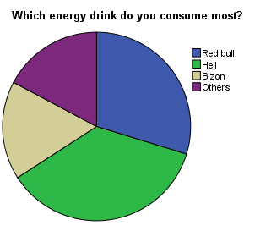
When the distribution of the participants according to the consumption of energy drinks (Figure 15) is examined, it is seen that most consumers (36.6%) choose Hell. This is followed by participants using Red Bull with 30.5%. The proportion of the participants who consumed Bizon was 18% in the sample. The other participants (14.9%) consume energy drink other than what we count.

Figure 15: The Consumption of Energy Drinks
When the distribution of the monthly drink according to the energy drinks (Figure 16) was examined, it was seen that more than half of the participants (61.7%) were in the range of 1-5. People who consumed 6-10 people were shown with 16.3% of participants. The rate of participants in the group of 11 and over was 22%.

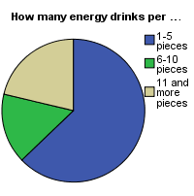
Figure 16: Distribution Of The Participants According To The Monthly Energy Drinks

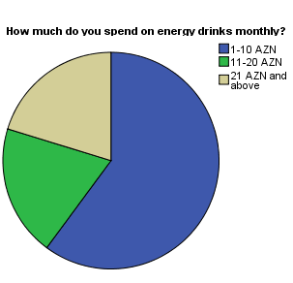
When the distribution of the participants according to the money they spend on energy drink in a month (Figure 17), it is seen that more than half of the participants (58.6%) spend between 1 AZN and 10 AZN. The ratio of participants who spent 21 AZN and above in the sample was 21.4%. Participants with 20% pointer are those who spend between 11 AZN and 20 AZN.
Figure 17: Distribution of participants by the money spent on energy drink in a month

4. Factor Analysis

4.1 Sponsorship Scale
Factor analysis is a statistical technique utilized to describe variability between observed, correlated variables in terms of a conceivably lower number of unobserved variables described factors. First, we created the analysis with 1 factor. Suddenly, when we look at the Total Variance Explained Figure (Figure 18) , cumulative percentage is 51%.
Figure: 18 Total Variance Explained (with 1 factor)

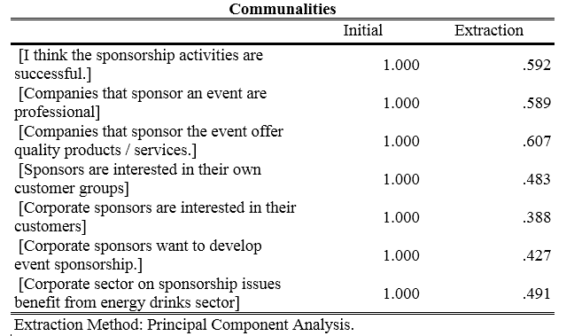
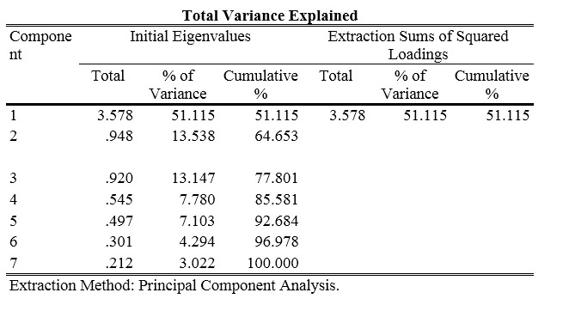
However, we require cumulative percentage to be over 60% and above. As our conditions admit, we know that we can do the analysis with two factors. After choosing 2 factors, cumulative percentage increased from 51 to 65%. ( Figure 19)

Figure 19: Total Variance Explained (with 2 factors)
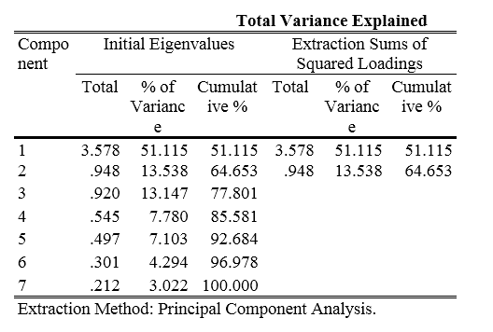

As a result, two factors have been divided into: the attitude towards the company and the company's activity. (Figure 20)
Figure 20 : Rotated Component Matrix
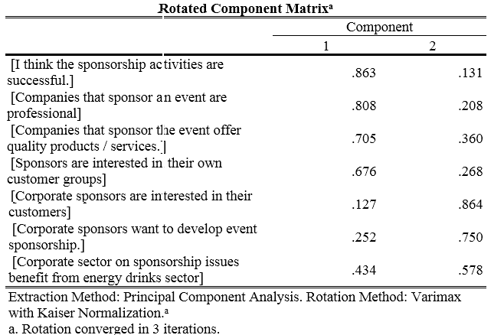
To verify the reliability of these 2 factors, reliability analysis was performed and the first factor was 82% (Figure 21) , the second factor showed 60%(Figure 22) reliability. It corresponds to the references used.
Figure 21: Reliability Statistics of first factor
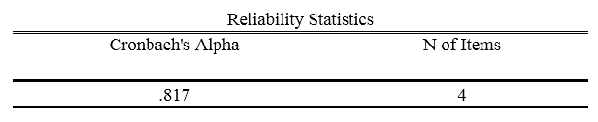
Figure 22: Reliability Statistics of second factor
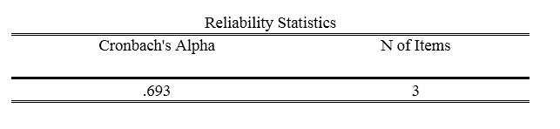

4.2 Brand Image Scale

When we look at the reliability analysis of the brand image, 86% of the questions were found to be reliable.(Figure 23)
"I use this product because it is a brand." - question removed because it could not be understood and after that the percentage of reliability increased from 86 to 88. (Figure 24)

Figure 23: Reliability Statistics (with all questions)
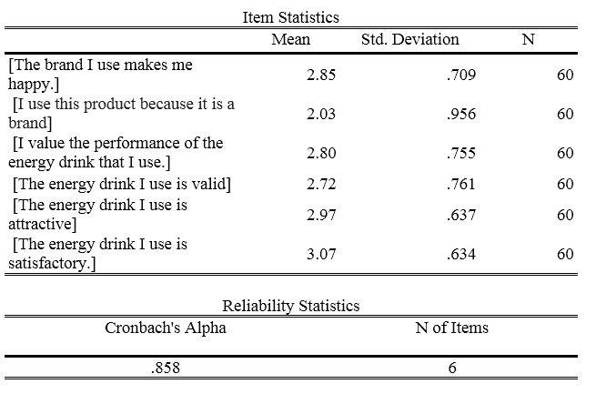

Figure 24: Reliability Statistics (except one question)
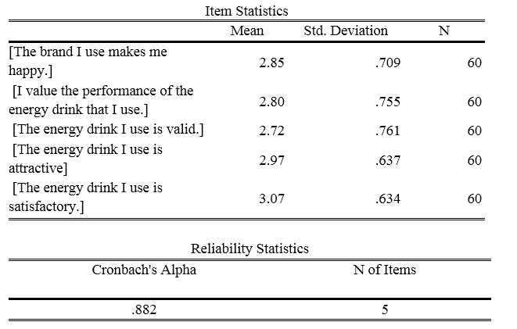

4.3 Correlation analysis
Figure 25 shows that there is a relationship between the brand image and goodwill, but also an inverse relationship with the attitude towards sponsorship.
Figure 25: Correlations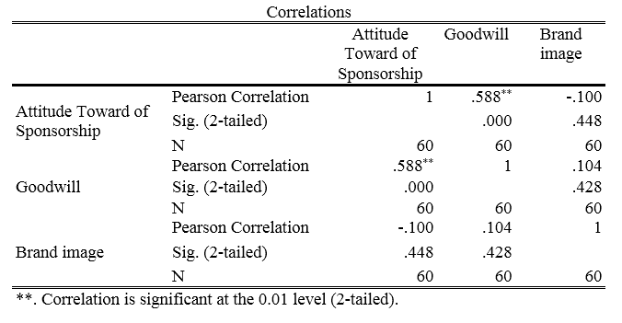

4.4 Regression Analysis

In regression analysis, although this relationship has no positive effect on brand image, it is found that there is 0.5 explanations. (Figure 26)
Figure 26: Regression Analysis

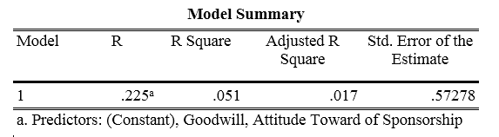

5. T-TEST AND ANOVA

To achieve a result, 2 variables (gender, marital status and b) were used and the analysis was done by T-test. In addition, ANOVA statistical analysis was used to investigate the brand image.

Figure 27: T-Test analysis between brand image and gender

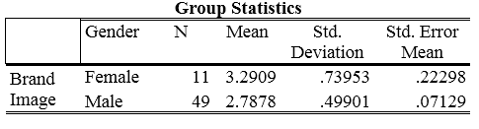
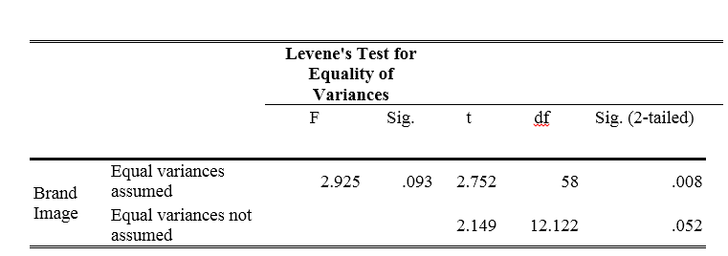

According to the results of T-test analysis, there is a clear difference between the male and female consumers in brand image.

Figure 28: Effect of Education Level on Sponsorship Activities
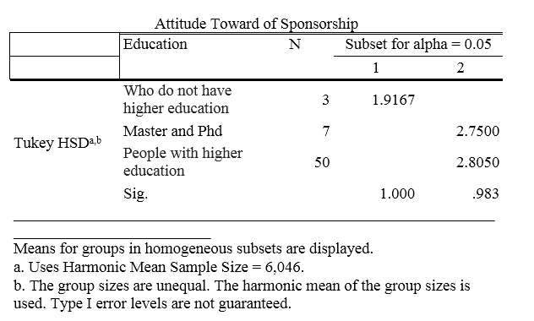
Figure 28 shows that those with higher education are estimated more positive about the sponsorship than those who do not have higher education.
Figure 29: 1-5 Product Consumers' Opinion on Brand Image.
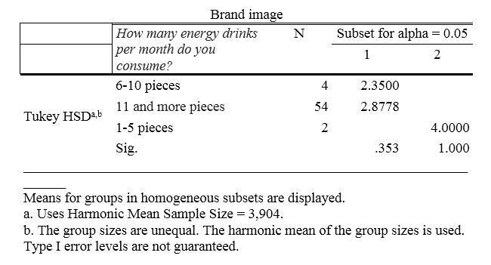

Figure 29 shows that those who drink 1-15 energy drinks have positive opinions about the brand image.
Consequently, attitude towards the sponsorship and goodwill have a positive impact on brand image. However, in the case of demographic factors, these effects differ.

6. Conclusion and Suggestion

Sponsorship is a very major tool for organizations that have a positive impact on their brand image and enable them to reach their target audience effectively and to realize their brand management goals. One of the most significant goals of the sponsorship is to make positive contributions to the brand image. Sponsorship increases brand identification and makes the brand's other promotions remarkable. In other words, as a result of the sponsorship, there will be a connotation of the consumer against the brand and a relationship with the brand is shown and can be said to create brand loyalty. Sponsors should first recognize the target audience of the brand and measure the sponsoring activities of competing organizations. As a consequence of these examinations, a report should be prepared for the impact on the brand before and during the sponsorship. In this thesis, the effect of sponsorship activities on the brand image components is attempted to be determined. As a result of the research, we realized that those who drink 1-15 energy drinks have positive opinions about brand image and sponsorship. We may include these people in various sponsorship activities. But the rate of awareness about sponsorship is low. That's why sponsors should realize their sponsorship activities to the forefront. Sponsors need to pay more attention to the strategies they use to increase their budgets. For instance, it is appropriate to take more consideration of the persons who are sensitive to sponsorship and to place more advertisements in the communities where they are.
According to the findings of the study; there is a relationship between the brand image and goodwill, but also an inverse relationship with the attitude towards sponsorship The hypothesis 1a was confirmed from here. Also, those with higher education are estimated more positive about the sponsorship than those who do not have higher education. As a result, H2d was verified.

7. Literature
- Aaker, David A. & Joachimsthaler, Erich (2000) Brand Leadership. Free Press, 2002.
- Barten, A. P. 1993. “Consumer Allocation Models: Choice of Functional Form.” Empirical Economics 18(1):129-158.
- Buhler, Andre & Nufer, Gerd. (2010) Relationship Marketing in Sports. Oxford: Butterworth-Heinemann, cop. 2010.
- Cornwell, TB, Clinton S. Weeks, and Donald P. Roy (2005), “Sponsorship-linked Marketing: Opening the Black Box,” Journal of Advertising, 34 (2), 21–42.
- http://www.brandinstitute.com/
- http://www.rediff.com/sports/2001/feb/07tobac.htm accessed on September 2, 2010
- https://www.seroka.com/using-strategic-sponsorships-build-brand/
- IEG’s Guide to Sponsorship, Everything You Need to Know About Sports, arts: Event: Entertaiment and Cause Marketing, IEG LLC, 2017, p.13-19.
- Jagre, E., Watson, J., Sponsorship and Congruity Theory: a Theoretical Framework For Explaining Consumer Attitude and Recall of Event Sponsorship//Advances in Consumer Research Volume 28, 2010.
- Levin AM, Joiner C, Cameron G. The impact of sports sponsorship on consumers' brand attitudes and recall: the case of NASCAR fans. Journal of Current Issues & Research in Advertising 2001;23(2):23-31.
- Loudon, D. Stevens, R. & Wrenn, B. (2005). Marketing Management. Binghampton: The Haworth Press Inc.
- McDonald, C, (1991) Sponsorship and the image of the sponsor. European Journal of Marketing, 25(11), 31-48.
- Meenaghan, T. (1991) The role of sponsorship in the marketing communications mix. International Journal of Advertising, 10, 35-47
- Moore, M. (2009). Does brand image or taste have more influence on consumer preference for energy drinks? The Honors Program, Senior Capstone Project. http://digitalcommons.bryant.edu/cgi/viewcontent.cgi?article=1004&context=honors_marketing
- Mullin, B., Hardy, S. and Sutton, W. 2007. Sport marketing. Third edition. USA: Human Kinetics.
- Muntinga, D. G. Moorman, M. &. Smit, E. D. (2011). Introducing COBR as Exploring Motivations for Brand-Related
- Olson, EL., Thjomoe, HM, (2011), Explaining and Articulating the Fit Construct in
Sponsorship, Journal of Advertising, Vol. 40, No. 1.
- Penalty, J. 2006. “A Brief History of Energy Drinks.” SWINDLE Magazine. http://swindlemagazine.com/issue06/a-brief-history-of-energy-drinks/
- Sandler, D.M., Shani, D. (2011). Sponsorship and the Olympic Games: the consumer perspective// “Sport Marketing Quaterly”, t. 11, nr 3.
- Shank, Matthew D., Sports Marketing: A Strategic Perspective. 4Th ed. Upper Saddle River (NJ): Pearson Prentice Hall: Pearson Education International cop. 2009.
- The Beverage Network. http://www.bevnet.com, “Energy Drinks Market.”
- Дуэйн Нэпп, Политика бренда. М.- 2004.
- Чумиков А. Н. Имидж – репутация – бренд, Издательство: ДиректМедиа, 2015.
- Капферер Ж.-Н. Бренд навсегда: создание, развитие, поддержка ценности бренда / Пер. с англ., 3-е изд. М.: Вершина, 2006.
- Шейнов В.П. Пиар белый и черный: Технология скрытого управления людьми. Мн.: Харвест, 2011.
- Anne-Marie Grey and Kim Skildum-Reid, The Sponsorship Seeker's Toolkit, Mcgraw-Hill, 1999.
- Kim Skildum-Reid, The Corporate Sponsorship Toolkit, Sydney : Freya
- Пылаев Игорь, В объятиях маркетинга, или когда клиент скупает все, 2015
- Митчелл Джек, Обнимите своих клиентов. Практика выдающегося обслуживания, 2013
- Мельников Илья, Цена и ценовая политика предприятия, 2014.
- Сиськов В.И., Ларин В.М., Иванова Н.В., Екшенбиев С.Х. Межотраслевой маркетинг. – Саратов: Саратовский экономический институт, 1994.
- Сиськов В.И., Зайцев В.Д., Кормильчикова З.М., Зиненко В.Г., Гришина Г.П., Ищенко М.М. – Маркетинг (учебное пособие) – МАСИ и Академия проблем качества, Москва, 1994.
- Котлер Ф. Основы маркетинга. – М. 1990 г.
- Лавров С.Н., Злобин С.Ю. Основы маркетинга промышленных объектов. – М. 2005
- Эванс Дж.Р., Берман Б. Маркетинг. – М., 2006.
- Kapferer, J. N. The new strategic brand management - creating and sustaining brand equity long term. London: Kogan Page. 2008. Press, 2012.
- Apéria, T. & Back, R. (2004). Brand relations management: bridging the gap between brand promise and brand delivery. Stockholm: Liber.
- Slack T, Bentz L (1996). The involvement of small businesses in sport sponsorship, Managing Leisure, 1: 175-184
- Lagae, W (2005). Sports sponsorship and marketing communications: - a European perspective. Prentice Hall
- Gardner, M. P. and Philip S. (1998). "Sponsorship and Small Business," Journal of Small Business Management, 26(4), 44-52.
- Гэд Т. Брэндинг: Взламывая корпоративный код сетевой экономики. – СПб.: Стокгольмская школа экономики в Санкт-Петербурге, 2001.
- Прингл Х., Томпсон М. Энергия торговой марки. – СПб.: Питер, 2003.
- Al Ries and Jack Trout, Marketing Warfare, New York, 1986
- Д'Алессандро Д. Войны брендов / Пер. с англ, под ред. Ю. Н. Каптеревского. - СПб.: Питер, 2002.
- Ахтямов Т.М., Шкардун В.Д. Оценка и формирование корпоративного имиджа предприятия // Маркетинг в России и за рубежом. - 2001

Пылаев Игорь, В объятиях маркетинга, или когда клиент скупает все, 2015, p.3
Лавров С.Н., Злобин С.Ю. Основы маркетинга промышленных объектов. – М. 2005, p.5
Riezebos, R. Brand management: a theoretical and practical approach. Harlow: Financial Times Prentice Hall, 2003, p.6.
www.sponsorship.com/
Slack T, Bentz L (1996). The involvement of small businesses in sport sponsorship, Managing Leisure, 1: 175-184
Penalty, J. 2006. “A Brief History of Energy Drinks.” SWINDLE Magazine. http://swindlemagazine.com/issue06/a-brief-history-of-energy-drinks/
Лавров С.Н., Злобин С.Ю.М. 2005, p.24
Шейнов В.П. Пиар белый и черный: Технология скрытого управления людьми. Мн.: Харвест, 2011.
Penalty, J. 2006. “A Brief History of Energy Drinks.” SWINDLE Magazine. http://swindlemagazine.com/issue06/a-brief-history-of-energy-drinks/
Пылаев Игорь, 2015, p.76
The Beverage Network. http://www.bevnet.com, “Energy Drinks Market.”
Пылаев Игорь, 2015, p.24
The Beverage Network. http://www.bevnet.com, “Energy Drinks Market.”
Levin AM, Joiner C, Cameron G. The impact of sports sponsorship on consumers' brand attitudes and recall: the case of NASCAR fans. Journal of Current Issues & Research in Advertising 2001;23(2):23-31.
Пылаев Игорь, 2015, p.26
Mullin, B., Hardy, S. and Sutton, W. 2007. Sport marketing. Third edition. USA: Human Kinetics.p.15
Dolphin, Richard R. (2003). Sponsorship: Perspectives on its Strategic Role, an International Journal Vol. 8 No.3 pp.173-186
Mullin, B., Hardy, S. and Sutton, W. 2007., p.51
Sandler, D.M., Shani, D. (2011). Sponsorship and the Olympic Games: the consumer perspective// “Sport Marketing Quaterly”, t. 11, nr 3.
Gardner, M. P. and Philip S. (1998). "Sponsorship and Small Business," Journal of Small Business Management, 26(4), 44-52.
Lagae, W (2005). Sports sponsorship and marketing communications: - a European perspective. Prentice Hall.
Buhler, Andre & Nufer, Gerd. (2010) Relationship Marketing in Sports. Oxford: Butterworth-Heinemann, cop. 2010. p. 98
Slack T, Bentz L 1996, 175-184
Jagre, E., Watson, J. (2010). Sponsorship and Congruity Theory: a Theoretical Framework For Explaining Consumer Attitude and Recall of Event Sponsorship//Advances in Consumer Research Volume 28, 2010.
Лавров С.Н., Злобин С.Ю. М. 2005, p.5
Сиськов В.И., Ларин В.М., Иванова Н.В., Екшенбиев С.Х. Межотраслевой маркетинг. – Саратов: Саратовский экономический институт, 1994, p.62
Пылаев Игорь, 2015
Shank, Matthew D. (2009) Sports Marketing: A Strategic Perspective. 4Th ed. Upper Saddle River (NJ): Pearson Prentice Hall: Pearson Education International cop. 2009. p. 333
Mullin, B., Hardy, S. and Sutton, W. 2007, p. 322
Mullin, B., Hardy, S. and Sutton, W. 2007, p. 328
Shank 2009, p. 344
Shank 2009, p. 334
http://www.rediff.com/sports/2001/feb/07tobac.htm accessed on September 2, 2010
Пылаев Игорь, 2015, p.88
Moore, M. (2009). Does brand image or taste have more influence on consumer preference for energy drinks? The Honors Program, Senior Capstone Project. http://digitalcommons.bryant.edu/cgi/viewcontent.cgi?article=1004&context=honors_marketing
Д'Алессандро Д. Войны брендов / Пер. с англ, под ред. Ю. Н. Каптеревского. - СПб.: Питер, 2002, p.17
Slack T, Bentz L., 1996, 175-184
Aaker, David A. & Joachimsthaler, Erich (2000) Brand Leadership. Free Press, 2002, p. 223
Лавров С.Н., Злобин С.Ю. М. 2005, p.31
Пылаев Игорь, 2015, p.45
Kim Skildum-Reid, The Corporate Sponsorship Toolkit, Sydney: Freya Press, 2012, p.27.
Anne-Marie Grey and Kim Skildum-Reid, The Sponsorship Seeker's Toolkit, Mcgraw-Hill, 1999, p.51
IEG, 2017; Anne-Marie Grey and Kim Skildum-Reid, The Sponsorship Seeker's Toolkit, Mcgraw-Hill, 1999
IEG, 2017, p.18
Пылаев Игорь, 2015, p.79
Имидж – репутация – бренд, Чумиков А. Н., Издательство: ДиректМедиа, 2015 г. P.11-13
Шейнов В.П., 2011, p.44
Loudon, D. Stevens, R. & Wrenn, B. (2005). Marketing Management. Binghampton: The Haworth Press Inc.
Шейнов В.П., 2011, p.45
Kapferer, J. N. The new strategic brand management - creating and sustaining brand equity long term. London: Kogan Page. 2008, p.152
Эванс Дж.Р., Берман Б. Маркетинг. – М., 2006, p.91
Чумиков А. Н. Имидж – репутация – бренд, Издательство: ДиректМедиа, 2015, p.22
Kapferer, J. N. 2008, p.160
Loudon, D. Stevens, R. & Wrenn, B.,2005, p.95
Гэд Т. Брэндинг: Взламывая корпоративный код сетевой экономики. – СПб.: Стокгольмская школа экономики в Санкт-Петербурге, 2001.
Moore, M. 2009, p.7
Дуэйн Нэпп, Политика бренда. М.- 2004.
Пылаев Игорь, 2015, p.83
Loudon, D. Stevens, R. & Wrenn, B., 2005, p.101.
Loudon, D. Stevens, R. & Wrenn, B. 2005, p.102
Капферер Ж.-Н. Бренд навсегда: создание, развитие, поддержка ценности бренда / Пер. с англ., 3-е изд. М.: Вершина, 2006.
Apéria, T. & Back, R. (2004). Brand relations management: bridging the gap between brand promise and brand delivery. Stockholm: Liber.
Пылаев Игорь, 2015, p.36
Дуэйн Нэпп, 2004, p.101
McDonald, C, (1991) Sponsorship and the image of the sponsor. European Journal of Marketing, 25(11), 31-8
Loudon, D. Stevens, R. & Wrenn, B.2005, p.103
Пылаев Игорь, 2015, p.89
Barten, A. P. 1993. “Consumer Allocation Models: Choice of Functional Form.” Empirical Economics 18(1):129-158.
Muntinga, D. G. Moorman, M. &. Smit, E. D. (2011). Introducing COBR as Exploring Motivations for Brand-Related Social Media Use. International Journal of Advertising, 30(1), 13–46.
Apéria, T. & Back, R. 2004, p.33.
Meenaghan, T. (1991) The role of sponsorship in the marketing communications mix. International Journal of Advertising, 10, 35-47
Cornwell, TB, Clinton S. Weeks, and Donald P. Roy (2005), “Sponsorship-linked Marketing: Opening the Black Box,” Journal of Advertising, 34 (2), 21–42.
http://www.brandinstitute.com/
Al Ries and Jack Trout, Marketing Warfare, New York, 1986
Гэд Т., 2001, p.51.
Apéria, T. & Back, R., 2004, p.86
Прингл Х., Томпсон М. Энергия торговой марки. – СПб.: Питер, 2003.
Apéria, T. & Back, R. 2004, p.35.
Ахтямов Т.М., Шкардун В.Д. Оценка и формирование корпоративного имиджа предприятия // Маркетинг в России и за рубежом. – 2001, p.63
https://www.seroka.com/using-strategic-sponsorships-build-brand/
Apéria, T. & Back, R., 2004, p.80
Эванс Дж.Р., Берман Б. Маркетинг. – М., 2006.
Riezebos, R.2003, p.26
Olson, EL., Thjomoe, HM, (2011), Explaining and Articulating the Fit Construct in Sponsorship, Journal of Advertising, Vol. 40, No. 1, pp. 57–70

