Brand Identity and Its Effect on Consumer Behaviour in FMCG sector

Ughur Yusif ALASGARLI
Student Number: 1611211001111009

Supervisor: Seymur Malik Guliyev

A project presented in partial fulfillment of the requirements for a degree of B.Sc. in Marketing,
University of Economics

University of Economics
2019
ACKNOWLEDGMENTS
Writing this thesis has been an exceptional journey that I have finished in my life. This journey might never have been completed without the guide and support of the special people that has a place in my heart.
Firstly, I would like to show gratitude to my supervisor Mr. Seymur Quliyev for helping me to write this thesis. Without his guide and support, I would not be able to finish my work.
Special thanks goes to my mother, Yasemen Abdinova. You've got given me so many opportunities in life. I owe you so much, now I can offer you is my unrestricted adore and appreciation.
To my dear groupmates, Asya & Sevil, I always appreciate your fellowship and support . You two will continuously have a special place in my heart.
I hope that my thesis will help the reader to learn more about branding and especially in the FMCG sector.

UNEC, Baku, Azerbaijan 2019

Ughur Yusif ALASGARLI
ABSTRACT
Modern day marketing has enormously advanced. Companies presently utilize consumer-centered approaches to encourage their capacities to fulfill the incalculable developing needs and needs of the advanced customer. Among these consumer driven approaches, branding has risen as one of the vital activities required within the building of a faithful client base and the creation of a compelling brand image.
Branding is the method by which a marketer tries to construct long term relationship with the clients by learning their needs and needs so that the offering (brand) may fulfill their shared goals. It can be utilized as a separate methodology when the item cannot be effectively recognized in terms of substantial highlights (which constantly happens in case of numerous administrations, durables, etc.) or in items which are seen as a product (e.g. cement, fertilizers, salt, potato chips, etc.).The brand building may be a cognizant client fulfillment introduction prepare. The brand proprietor tries to hold clients to its overlay over its competitors by a mix of hardware-software since when a client feels fulfilled he she creates a kind of devotion for the same.
The aim of this thesis is to understand brand identity and its effect on consumer behaviour in FMCG sector. So as to reach to aim, the author the quantitive research. With the help of survey, author analyzed results from data collection. In the end, it could be understood that reasons and demographic indicators influence consumers’ loyalty to brand which they are selling FMCG products.

Table of contents
1. INTRODUCTION 6
1.1 Background 6
1.2 Research objectives 7
1.3 Research methodology 7
1.4 Problem discussion 9
2 LITERATURE REVIEW 9
2.1 Background 9
2.2 Understanding Brand Identity 13
2.3 Brand Identity building framework 18
2.4 Brand Identity building elements 19
2.5 Brand Building 20
2.5.1 Brandbuilding by taking advantage of world famous events like cricket 20
2.5.2 Brandbuilding though move in advertisement procedure 21
2.5.3 Reinforcing the brand image 21
2.5.4 Branding an industrial HI-TECH product 22
2.5.5 Emotions in brandbuilding 22
2.6 Characteristics of the FMCG from consumers’ perspective 22
2.7 Characteristics of the FMCG from marketers angle 24
2.8 Growth strategies for FMCG 25
2.9 Definitions of Brand Loyalty 38
3. RESEARCH METHODOLOGY 40
3.1 Research purpose 40
3.2 Research approach 41
3.3 Research strategies 42
3.4 Data collection methods 42
3.5 Data analyses 44

4. DATA ANALYSIS and FINDINGS 45
4.1 Background 45
4.2 Descriptive results 49
4.3 Validity and Reliability test 56
4.4 Regression analysis 57
5. Conclusion 60

6. References 63
7. APPENDIX A – MÜSAHİBƏ SUALLARI 67
8. APPENDİX B - QUESTİONNAİRE 69

1. Introduction
This chapter is going to provide an introduction of the topic. Firstly,the background and research objectives are presented, continuing the problem discussion where the research area is discussed . At the end, limitations and outline of the research report are described. Then the research aim and the research questions will be presented. At the end, limitations and summary of the thesis are described.
1.1 Background
The brand is a resource of the company that has picked up expanding significance and in this way has progressively captured of the attention of managers. The American Marketing Association characterizes a brand as the title, term, sign, size, image or plan that distinguishes the products or administrations of one dealer.
According to Morgan and Rego (2009), the role of brands is to assist guarantee the company’s identity. The recognizable proof of a brand, may be an acknowledgment factor and learning, which can interpret to certain buyer behavior. Consumers will together their past encounter in brand mindfulness, securing brands meeting their needs and wants.
Sonnier and Ainslie (2011) argues, in order to get it the impact that the brand identity has on buyers, the consistency of brand concept has got to be emphasized through the company’s strategic alternatives. This will encourage the acknowledgment and brand review by customers in an environment where there are numerous competitive options.
The management literature characterizes brand identity as the set of implications by which a society permits itself to be known, and through which permits individuals to portray, keep in mind and relate to it (Melewar et., al., 2005).
As Faus and Eilertson (1994) states, brand identity is much more than a symbol – is the title, is the personality, is the picture and an entirety have of other attributes that characterize the company and its items.

1.2 Research objectives
This study aims to survey consumers from different income and age groups in Azerbaijan, to investigate 1) Brand Identity and its effect on consumer behavior in FMCG sector, 2) Whether consumers can be loyal to FMCG brands, 3) how the utilitarian and hedonic values or benefits they appreciate from chosen FMCG brands influence their brand trust, brand influence, satisfaction with the brand, and how that satisfaction in turn influence behavioral and attitudinal brand loyalty.

1.3 Research Methodology
Quantitive research method were utilized to gather and examine this study’s examination. Quantitive methods were suitable because of the nature of investigation (testing connections between different factors) and the reality that institutionalized instruments which have been tested and demonstrated reliable and valid were accessible to this study’s factors.

1.4 Problem discussion
In this work, the brand identity is operationalized as the brand image in the consumers’ thoughts, which permits the company to get faithful and willing to pay a premium for the brand. The personality and brand picture must be well characterized, with the point to recognized the customer to know and select the item that meets their needs in full. It was created an expansive number of studies on brand image. (Dutton et.al., 1994; Batra and Homer, 2004; Birtwistle et. al., 1999; Martinez et. at., 2005; Martínez and Chernatony, 2004; Chowdhury et. al., 1998; Nandan, 2005).
In order to construct and keep up brand loyalty, it is basic that the identity and brand image are consistent in order to interpret esteem for the company as well as for buyers. The links between the brand and the shopper must be set up through interactions that relate to customer needs and inspirations, based on the benefits given by brand. (Kabiraj and Shanmugan, 2011; Amraoui et. al., 2006; Johnson et. al., 2006; Chaudhuri and Holbrook, 2001; Punniyamoorthy and Raj, 2007;).
This study varies from most other investigations in that it reveals drivers of brand devotion for low involvement items brands classified as FMCGs. Retailers and FMCG brand owners will be interested to know that they can adjust their brand communication and publicizing techniques to request both utilitarian benefits and passionate security of their branded FMCG products. This strategy can construct trust within the brands, which emphatically predicts satisfaction, which in turn can unequivocally secure attitudinal brand devotion and a greater probability of repurchasing of the brand within the future.

2. Literature Review
2.1 Background
Modern times reflect key changes within the marketing strategies utilized by companies looking for to maintain competitive advantage. The financial wellbeing of these companies is presently subordinate on the amount of data that is collected in regards to consumer purchasing habits. These companies have turn to the selection of behavioral and sociological studies in order to gather these germane information and to advance the corporate understanding of buyer purchasing patterns.
Companies moving their focus from a market/product driven line of attack to buyer driven marketing activities reflect this advancement of marketing. As a direct result of this move, companies are presently ascribing much more significance on the response buyer display in respects to the 4Ps ( Product, promote, place and price) and have advance implemented three extra Ps, people, process and physical layout (Kotler,1999).
Current market patterns appear that the homogeneity of product has expanded, meaning that few functional contrast between key competitors currently exists in most exceedingly competitive markets. This diminish in product differentiation is considered to be the coordinate result of high levels of competition that exists inside today’s markets, as well as the innovative advances of production and distribution strategies. Because these advances have lessened the capacity of innovative developments to offer sustainable competitive advantage and have made product differentiation amazingly troublesome (Kotler, 2000; Levitt, 1983)
As a direct result, branding has risen as a critical feature of modern marketing techniques and is presently considered a key organizational resource(Kotler, 2000). The symbolic values related to brand names have ended up the premise for product differentiation, with driving methodologies attempting to imitate key variables that are conductive to key practices that are related to buyer purchasing patterns.
An instance of the influence branding has on the client shopping for decision process, is how branding is utilized to the criminal track downloads industry. With nearly 230 vendors online, it is a fairly competitive agency that is nevertheless increasing at a furious pace. With over 180 million tune tracks bought online in the first quarter of 2005 alone. With over 180 million track tracks sold online in the first quarter of 2005 alone, (IFPI National Groups, 2005) web primarily based giants such as Apple’s iTunes Music Store, Napster, Tesco, Emusic and Kazaa are all competing for domination in this digital marketplace. Only one, however, the iTunes Music Store, has performed near domination with 8o% market share in the UK in 2005 (OCC, 2005).
With the advent of the iPod digital track participant and the iTunes Music Store, Apple has emerge as one of the most observed companies of the twenty first century. Steve Jobs, CEO of Apple, is considered as being a key contributor to Apple success story, by means of skill of transforming and in addition growing Apple’s company image, with the aid of the usage of making it higher available to a wider target market and extending the Apple enterprise into the prison tune download industry. Spotting a gap in the market and thinking about that document organizations had been dropping an estimated 4.6 billion dollars yearly (RIAA, 2005) with illegally pirated track archives being downloaded with the aid of skill of file-sharing servers, Apple pioneered the sale of prison music on the Internet, by way of the usage of their iTunes Music Stores. This has earned Apple 240 million greenbacks in earnings from music sales in the 2nd quarter of 2005 by myself and has lead to the sale of an estimated 30 million iPods on the grounds that its launch in 2001. By the beginning of 2006, it is estimated that Apple will promote its 1 billionth tune (Smith, 2005)
According to Pashandi(2013), Fast moving consumer goods (FMCG) or Consumer Packaged Goods (CPG) are items that are sold fast and at moderately low cost. Examples incorporate non-durable products such as soft drinks, toiletries, and basic supply things. In spite of the fact that the outright benefit made on FMCG items is generally little, they generally offer in huge amounts, so the aggregate benefit on such items can be considerable. The term FMCG alludes to those retail merchandise that is generally supplanted or completely utilized up over a short period of days, weeks, or months, and inside one year. This contrasts with durable merchandise or major apparatuses such as kitchen apparatuses, which are generally supplanted over a period of a few years. It is found that the instability of the stock market may influence consumers’ purchasing mood, not tomention the growth or declines of retail sales.
According to Blackwell(2012), supported this contention by the fact that brand value depends on the number of individuals with standard purchasing. The seriously discourse within the literature so distant has shade light on the values of brand value for both customers and the firm. For the customers, the brand value might give them inside arrangement around the brand which impacts their certainty amid the obtaining process. And it is observed from such thinks about that there's a tall affinity for customers with great discernment to purchase from the same shop once more than those with destitute discernments.
According to Tauseef(2011), the impulse buying behavior of consumes for FMCG, in a research impulse buying was characterized as a spontaneous buy and this definition can also be found within the investigate of Kollat and Willett (1967). In another research detailed that drive buying more often than not takes place, when a customer feels a powerful inspiration that turns into a craving to buy a product immediately.
Beatty and Ferrell (1998) characterized impulse buying as a momentary purchase having no past point or objective to buy the product. Strict (1962) found that items bought on impulse are usually cheap.
It clearly demonstrates that there exists a powerless affiliation between customer way of life, fashion association and post-decision stage of consumer's purchasing behavior with the motivation buying behavior counting the attitudinal as well as behavioral viewpoints of the buyers buying behavior. Pre-decision stage of consumer‟s purchasing behavior built up a solid affiliation with the motivation buying behavior of the customers. So, it is set up through this investigation that customers obtaining items within the zone of arranging their buys, having shopping way of life-related to arranged buys and their post-decisions are too not blameworthy. The pre-decision organize of the purchasing associate these buyers with spontaneous or impulse buying since these days stores are full of an assortment of products and a buyer can effortlessly get inquisitive about acquiring an item which requests him or her whereas shopping the arranged list of items and here delight rule comes into play.
Kulkarni S.H. (2001), has identified study of consumer behaviour towards FMCG products in rural areas. According to him, things are changing fast presently. The expanding literacy level and media blast, individuals are getting to be cognizant almost their ways of life and around their rights to live a better. Brand awareness is on the rise. This clubbed with expanding expendable salary of provincial family units, has made the rural customer more requesting and choosier in his buy behavior than ever sometime recently. And the dusky town maid has presently learned to pine for glossy silk rose.
His findings were as takes after: Without a question, FMCG companies must focus on product accessibility in provincial focuses. POS (both within the essential & secondary) must be included prolifuratiously to foster visibility as there's a prepared market for branded items. Organizations must focus on TV advertisements keeping the rural markets in intellect since a huge chunk of the audience is affected by the same. Organizations can no more be smug about their provincial positions and must work on brand maintenance since greatest individuals have an “average life” within the same. People are getting to be increasingly mindful of the different brands accessible. They want to undertake modern products. They are getting to be brand cognizant. Rural India contains a potential of $500-bn. Companies ought to attempt to investigate the provincial advertise. There's a gigantic development opportunity out there.
Chandra Sekhar(2004) has identified, consumer buying behavior and brand loyalty and according to him, Marketers on provincial marketing have two understanding (i) The urban metro items and marketing products can be implemented in country markets with a few or no alter. (ii) The rural marketing required the partitioned abilities and methods from its urban partner. The Marketers have following offices to create them accept in tolerating the truth that provincial markets are diverse in so numerous terms.
His findings were as follows: Within the study majority of the respondents are male categories. Male individuals of the family are alone getting to purchase consumer items. Women are not inquisitive about shopping and don't come out from their houses frequently. Most of the families come beneath the horticulture category. Family pay is exceptionally low. Item planning is exceptionally imperative to advertiser to enter into provincial market. Non-Availability of brands is another reason which influences acquiring choice. Packaging ought to be solid sufficient to stand unpleasant taking care of since of poor foundation facilities and pack ought to be small. Brand names ought to be basic, little and simple to keep in mind and articulate Viable IMC is required to reach farther towns.
2.2 Understanding Brand Identity
To pick up a clear knowledge into brand definition, to begin with clarify what this scholarly survey alludes to as “products”. Person who can consider a product as being anything that can fulfill the financial, mental or utilitarian needs of a potential customer(Baker, 2000). Baker (2000) assists this definition by expresing that the degree of which a product meets the above mentioned needs, is decides the product’s value.
The often-complex process of branding may be a requirement that has been motivated by the profoundly competitive nature of most modern day businesses. In arrange to address this issue, branding has gotten to be a far-reaching instrument utilized by corporations to drive their products in progressively soaked markets. In doing so, companies empower themselves to exhibit the center competencies that they feel are required by consumers (Prahalad and Hamed, 1994).
In today’s marketing, it has presently ended up the brand itself that separates a company’s products accessible to buy (Levitt, 1983). If we looks at Apple Computers, as an illustration, many claims that a move towards brand orientated promoting procedures have permitted them to break into the advanced music showcase and encourage their presence within the IT market. However, others believe that this is often by no implies an unused “shift” but or maybe the productive encouraging of an as of now viable brand picture. Considering that Apple has continuously been at the bleeding edge of creative promoting and brand asociative strategies, with reputation stunts such as the “1984” commercial, the “Think Different. Think Apple”, publicizing campaign or the later “iPod+iTunes” commercials including celebrity supports.
So far, the above-mentioned writing confines the impacts of branding on a consumer’s translation of how a particular brand relates to his or her identity-based characteristics. Macrae (1996) in any case, explains by presenting the extra component of “Brand Essence”, which he characterizes as being the soul or exceptionally reasons for being of a company. Macrae (1996) encourages this definition, by expressing that a company should consider its claim representatives with the same significance as its targeted customers since both are of rising to significance. He legitimizes this by shedding light on the reality that it is the workers that advance the items or administrations in coordinate deals circumstances, not the company. This concept of branding builds up a clear connection between a company’s inner working with the exterior world of customers, by means of their brand.
In modern-day branding, the creation of unmistakable values, as well as intangible values, is essential in permitting the client the implies to recognize one brand from another (Cowing and Hankinson, 1993). The reader will appreciate that it is this capacity in specific, that isolates a “brand” from an insignificant “product”er. King (1991) proceeds with his qualification by clarifying that a brand is an intangible resource that is special and immortal. This simple however effective definition insinuates that a brand is the center personality of an item. Kotler (1999) extends on the concept of identity by expressing that a brand is able to pass on up to six diverse levels of meaning to a focused on the audience. Typically known as the “Six Dimensions of The Brand”.
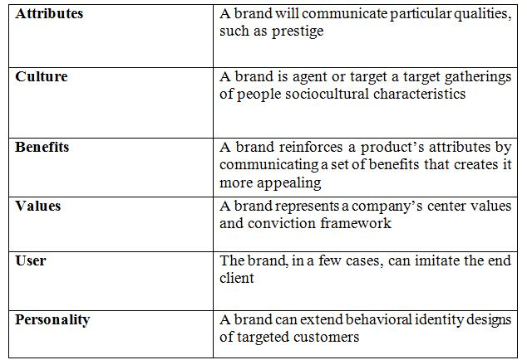
Kotler’s (1999) hard work on the perception of branding can be seen as the center ground between Feldwick’s (1995) and Macrae(1996) colleges of thought. In spite of Kotler’s introductory definition appearing excessively oversimplified, his extended definitions and sees on the different measurements of brands, give a more profound understanding of how branding can be so much more than basically images, plans, and catchy trademarks. Kotler builds up branding as the creation of a deep bond between the company and the buyer.
From the consumers’ point of view, brand names are as crucial as the product itself within the sense that they rearrange the purchasing process, ensure quality and at times frame as a premise of self-expression. Subsequently, ought to a company showcase a brand title as nothing more than “just a name”, it would be lost the complete reason of item branding. The challenge lies in creating a profound set of implications for the brand. Once a target market segment can visualize all six measurements of the brand, it will have set up a solid affinity inside the consumers’ purchase decision-making process.
If we look into know what is brand character , it is critical to get it the indication of personality and brand characteristics. The etymology of “identity” demonstrates that “a substance has a character if it remains the same over a certain period” and “repetition, progression and consistency” over the time are essential characteristics of “identity” (Franzen and Moriarty, 2009). In expansion, dictionary.com characterizes identity as (1) the state or truth of remaining the same or ones, as beneath changing angle or conditions, (2) the condition of being oneself or itself, and not the another. Equivalent words of “identity” are distinction, peculiarity, uniqueness ((APA), 2015). This advanced definition of character deduces that other than being reliably the same over time, being particular and unmistakable is another critical include of “identity”. Several analysts have connected this concept of identity to brand whereas highlighting its characteristics of being reliable, nonstop, person, special and unmistakable. For example, Aaker characterizes brand personality as an interesting set of brand affiliations that the brand strategist yearning to make or maintain (Aaker, 1996). In the expansion, “the brand personality must express the specific vision and uniqueness of the brand, and the brand personality must be of a long-lasting or permanent nature (Heding, et al., 2009). The concept of brand identity with its one of a kind, reliable, long-lasting characteristics is reflected in numerous the speculations and framework of Aaker (1996), Signorelli (2014), Kapferer (Kapferer, 1992), de Chernatony (1999), etc. For example, Aaker’s brand personality arranging model (BIPM) and Signorelli’s StoryBranding process both concur that brand has internal layer & external layer, and it is the inner layer (which contains the core meaning, values, purposes, identity of a brand) that drive the consistency, the uniqueness, particular, long-lasting characteristics of the brand.
In addition, comparable to the arrangement of a brand’s concept, numerous creators have wrangled about over whether the brand character is of inside or outside viewpoints. Whereas “most of the literature on brands see brand identity as an inside construct, constructed by the brand manager” (Franzen & Moriarty, 2009), there's an understanding that “identity ought to start among insiders (e.g. the organization’ s individuals, in the event that an organization; the brand directors, on the off chance that a brand) and untouchables (e.g. consumers can participate within the creation, support, and alter of brand personality (Bring forth & Schultz, 2004; Silveira, et al., 2011)). For example, whereas Aaker’s BIPM propose that brand identity exudes from brand managers’ idea – what they need the brand to be, which is shown through their system BIPM (Aaker, 2012), Signorelli’s StoryBranding emphasizes that brand identity ought to be driven from the insiders’ experiences conjointly the untouchable by taking in to thought the customers’ perception and conviction).
2.3 Brand identity building framework
Since the conception of brand identity used to be to commence with specified by using Kapferer in 1986, manufacturer identification has been rapidly grasped as a the necessary concept, at that factor being utilized and created with the aid of severa students and experts in their conceptual system, e.g Kapferer with his BrandIdentity Prism (1992), Aaker with his B I M P(1996), de Chernatony with his IdentityReputation Gap mannequin in Brand management (1999), Signorelli with his Story Branding model (2014), and many more. In any case, now not all those systems are about the brand identity building process, a few systems center of attention on introducing/describing the build and building-elements of company identity whereas a few system focus on clarifying comprehensively what steps to be taken to assemble a company identity procedure. In details, Kapferer’s BrandIdentity Prism focuses on inspecting the structure of a company identity and de Chernatony’s IdentityReputation hole display focuses on depicting the internal and outside components of company identity, as properly as the interaction and common, strengthen amongst the components. In the meantime, Signorelli’s StoryBranding and Aaker’s BIMP systems comprehensively focal point on performing the steps of a company identification advent process.
2.4 Brand identity building elements
According to Franzen & Moriarity (2009), the understanding of brand identity cannot be isolated from the frameworks, which indicate brand identity’s building components and building handle as well as the viewpoints that those frameworks build on. Above, BIPM and StoryBranding model are displayed as two pertinent brand identity building system. Be that as it may, these models don't unequivocally point out the building components of brand identity. Therefore, the author should review different systems to firmly decide what components constitute the brand identity by making the taking after table, which gives a comprehensive outline of the assortment in development of brand literature.

Table: Brand identity frameworks & building elements
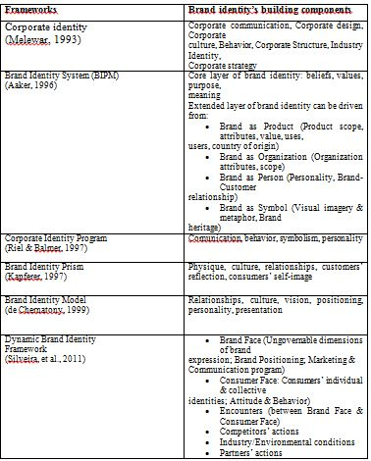
As ones can see from the table that in spite of the fact that the systems change in approaches (corporate, product or benefit branding), brand identity building squares, terminology, they share comparative vital building-blocks of brand identity, which are the reason of presence, core values, culture, vision, mission, identity, physiques, and connections.
2.5 Brand Building
2.5.1 BRANDBUILDING BY TAKING ADVANTAGE OF WORLD FAMOUS EVENTS LIKE WORLD CUP (CRICKET)
Surf Excel’s promoting during the world cup was talked about. The brief was to connect Surf Excel expectations with cricket and at the same time bring out the brand‟s capacities and benefits like stain evacuating. “The promotion highlighted the core advantage of the brand – removal of stains”, says an HLL representative. “That is why the client bought the thought promptly, indeed in spite of the fact that the thought was not regularly lever.”
This advertisement campaign is a case of how a company can construct its brand image by keeping a near observe on occasions taking put all around the world.

2.5.2 BRAND BUILDING Though Move IN Advertisement Procedure
Onida's brand image was being undermined by umpteen brands. It needed a publicizing technique, which may communicate its modern, energetic premium brand image with a point of cheeky pomposity. This pomposity stems from the truth that their TV is the best. This time they changed their recognizable and fruitful devil, as they accepted that the core of the brand is more imperative than images just like the devil. So the unused advertisement with the plane came up. This is often. the case of changing the brand image through publicizing.
2.5.3 Reinforcing the brand image
Kelvinator has strengthened it is „the coolest one‟ picture with arrangement of advertisements. For example, in one of its promotions, a man sings attuned but picks up appreciation when he feels cold and sings in his shuddering voice once the fridge is opened.
In spite of Kelvinator's possession being moved from whirlpool to Electrolux, the customers still relate Kelvinator with „the coolest one.‟ The advertisements were essentially implied to bring Kelvinator back o beat of mind consciousness. The thought came from rural thinking and the advertisements are being publicized on star sports and sony.
This case supports the truth that advertising can play a crucial part in settling the brand's image in people's minds.
2.5.4 BRANDING AN INDUSTRIAL HI – TECH PRODUCT
INTEL (the third line) it is the world's tenth most important brand. It is focusing on the standard market, with an uncommon emphasize on the domestic pc showcase, together with office use. Its global advertising sees the blue entryway opening- the watcher is sucked down a streak spin, virtual town. The sheer technical wizardry of the advertisement spots gelds the atmosphere of a really hi-tech item and in this case, well gets to be the message itself. It moreover joins it to the energy of surfing the web. It has situated the brand as the web dream machine
2.5.5 Emotions in Brandbuilding
Maggi tomato ketchup is outlined as, „sauce a big boss‟. The tag line of Tomchi is „not too hot, not too sweet, tastes fair right.‟ It shows up to be a coordinate hit at Maggi‟s „its different‟ hot and sweet sauce. The communication is based on situating of „tomchi‟ as a sauce, which incorporates a idealize adjust of tomatoes for sweetness and zest of chillies. The maggi sauce campaign with its celebrated Ajit jokes-„Lilly don‟t be silly‟ or „boss has gone for a toss‟, was path-breaking. It has made the brand memorable.
There's a modern advertisement presently, which clarifies the development promoting procedure. Maggi is persistently taking after upon.
But whatever be the item, maggi has remained and will stay carved within the customer’s mind as a reliable and a quality brand.
2.6 Characteristics of An FMCG from Consumers’ Perspective
An FMCG is characterized by some particular variables. By its exceptional title on is able to create out the truth that an FMCG encompasses a low shelf life. There are a host of other characteristics which have impressive suggestions for any advertiser. These are presently briefly described.
1) Frequency purchase. As is apparent from the title itself, these merchandise loan themselves to frequent purchases by the buyers. A item like salt is bought exceptionally frequently. It is a reasonably item, costing anyplace between Rs. 2.00. to Rs. 5.00 kg and is additionally accessible in nearly all the corner shops which cater to their individual neighborhoods. It is never supplied at domestic past a level because it is effectively available thus making it all the more appealing to purchase at all times and indeed at odd hours!
2) Low involvement. FMCGs are by their exceptionally nature low inclusion products. When a customer strolls into a shop to buy a packet of salt or a bottle of tomato ketchup, the shopper once in a while makes an exertion to select the thing. Indeed in the event that the shopper is mindful of the different brands of that specific item, ought to be brand he or she inquire for not be accessible, the shopper will, in most cases, take anything is advertised in its put. Another figure which works in this course is that there's advertised in its put. Another figure which works in this direction is that there's ordinarily an awfully expansive assortment of choices available in these item classes. So if the brand inquired for is not accessible the shopper still incorporates a large choice.
There are some exemptions to this rule. Products like cigarettes, individual cleanliness items, in spite of the fact that fulfilling all the other criteria of FMCFs, are found to command a high level of brand devotion. Once a shopper gets utilized to a specific brand of cleanser, customers don't effortlessly acknowledge any other brand. Within the case of individual cleanliness items, like shampoos or sterile towels, customers do not like to alter brands since it may be a matter of earlier propensity or personal enjoying and as such those bunches of shape a really brand steadfast showcase. They indeed go to distinctive shops if the favored brand is not found within the to begin with the shop.
3) Low Price. FMCGs are ordinarily low priced. In any case, a buyer may see a choice to be high estimated when implicitly compared to prevalent brands. For case, the foremost costly latrine cleanser may taken a toll Rs. 50-00. Great like soaps, detergents, tea, potato wafers, etc., are high volume items within the low inclusion category. This is often another reason why customers appear restricted intrigued in selecting these.
2.7 Characteristics of the FMCG from Marketers Angle
1) High volumes. The advertise for FMCGs is characterized by high volumes. A medium sizes family, for example, may utilize two the three cakes of cleanser in a month. On the off chance that that number is increased by the number of such families all through the nation, one arrives at a really large number. The phenomenon is taken note for toothpaste, chips, rolls, cleansers, chewing gums and so on. These products are, in this manner, made in millions of tones. As a result, in the event that marketers cannot guarantee large volume deals, the operations may not be reasonable.
2) Low margins. Since of the high volume and as a result of serious competition, these items are more often than not sold at costs which are exceptionally near to their generation costs and the margins advertised to dealers/distributors on these items are or maybe low. So, marketers set costs as low as conceivable and guarantee turnover through large volumes. Essentially, wholesalers and merchants work in low margins which they oversee with high volume deals and quick transfer of stock.
3) Extensive distribution systems. Customer inclination within the FMCG item is not inflexible. A buyer may inquire for a brand whose notice he or she has seen as of late, much appreciated to simple review. More often than not, a buyer will inquire for an item and acknowledge anything brand is given by the businessperson. Indeed within the improbable occasion that the consumer does inquire for a particular brand-name, in case the brand is not accessible, he or she will settle for a few another one. In other words, the idea of brand devotion is not exceptionally predominant among an expansive area of the showcase. Within the case of the drive, great customers will generally require the item as it were on locate. The customer permits the businessperson to choose for him. In view of such client behavior and low devotion on the portion of the dealers; it gets to be essential for companies to create beyond any doubt that their item is well disseminated. With this in intellect, most FMCG companies have built up exceedingly broad dissemination systems all over the nation. It is since of this reason that a remote company at first tries to procure another Indian company to have got to its conveyance organize.
4) High stock turnover. A characteristic include of FMCGs is that they have a really high stock turnover. This can be a result of the reality that these items are bought regularly and at customary interims. In other words, the products have a brief shelf life. Businesspeople, subsequently, a readiness to exchange in these products more promptly since they discover a tall stock turnover, which subsequently permits them to turn his capital a number of times in a month or so. A pouch retailer, for example, can turn his capital over nearly every day. He buys his stocks within the morning and by the time he close at night, he has recaptured his speculation and more. Another day, the same cash is reinvested.
2.8 Growth strategies for FMCG
We have as of now highlighted the fundamental characteristics of fast moving customer goods and their markets. We might presently consider the different development methodologies taken after by FMCG companies.
Regularly, the success of an FMCG depends incredibly on its promoting methodology. Typically, an advertiser handbags a wide combination of techniques. For occurrence, when costs are competitive the company would utilize a broad distribution organize, plan appropriate publicizing, and deals advancement plans from time to time. In any case, what is it that can make an FMCG brand offer more than its competitor? What makes a few exceptional brands? How does a advertiser change over a client from buying a bland washing powder to buying a specific brand, say Surf? Or what makes Lifebuoy a symbol of wellbeing for over a century? Let us presently talk about different strategies utilized by the companies in an FMCG showcase.
1) Multi-brand Technique. A company frequently sustains a number of the brand within the same category. There are different motives for doing this. The most basis behind this methodology is to capture as much of the market share as possible by attempting to cover as numerous portions as possible because it is not conceivable for one brand to cater to the complete market. This too empowers the company to bolt up more merchant shelf space.
Take, for case, the procedure received by Hindustan Lever. They have presented numerous brands within the cleansers and cleansers showcase so that no fragment is left untouched. It has Dove within the Ultra-premium fragment, Lifebuoy for the economy fragment and brands like Rexona, Liril, Lux and Le Sancy for the mediating portions. Within the cleansers markets moreover, Surf itself is accessible in several shapes- Surf Ultra, Surf Easywash, separated from the bland item. It has the Surf run within the premium portion, and Wheel for the economy fragment. It has hence secured itself against any shape of attack and captured advertise offers in each conceivable fragment.
Another reason to adopt different brand procedure is to ensure its major brand by setting up flanked brands. Now and then the company acquires distinctive brand names within the handle of procuring other companies and each brand title contains a steadfast taking after. A case of this technique within the Indian setting would be that of Coca Cola which procured Thums Up, earlier to its passage into the showcase. Nowadays they have a portfolio of delicate drinks, each with a significant showcase share.
2) Product flanking. Item flanking alludes to the presentation of distinctive combinations of items at distinctive costs, to cover as numerous showcase fragments as conceivable. It is fundamentally advertising the same item in numerous sizes and process combinations to tap differing advertise openings. The presentation of shampoos in little sachet has, for a case, made them reasonable to the lower fragment of shoppers who already seem not bear to spend anyplace between Rs. 30 and Rs. 40 for a guidelines bottle of great cleanser. In spite of the fact that the sachets were at first propelled to protect the most brand shockingly, they have presently gotten to be a big success among unused and little amount clients.
The thought behind this concept is to flank the core item by advertising diverse varieties of estimate and cost so that the customer finds a few brands to select from. Stayfree has presented so numerous varieties of its item where customers can presently purchase Stayfree singles, pairs, compacts, Stayfree Customary, bundles of 10 or 20 sterile towels. Vicks, the hack and cold diminishing medication are presently accessible in little holders conjointly as inhalers, hack drops and hack syrups. They have advertised a entire run of the same item in numerous sizes and costs to flank their primary brand, Vicks Vaporub.
3) Brand extensions. Markets like to have a faithful buyer base so that those specific brands appreciate high brand value within the market. In such cases, companies make brand expansions within the trust that the expansions will be able to ride on the value of the fruitful brands, which the unused brand will stand in its possess right within the course of time. At times, the thought does not work and the result is that the solid inclination for the initial brand itself gets weakened within the deal. In any case, in case this procedure works, it has been of colossal esteem driving to the arrangement of a number of umbrella brands in a assortment of items. Brand extension procedure offers a number of points of interest. A well-respected brand title gives the new item moment acknowledgment and simpler acknowledgment. It empowers the company to enter unused item categories more effortlessly. A classic case of this is often Lifebuoy and its brand expansions. Nowadays this brand encompasses a number of expansions like Lifebuoy Furthermore, Lifebuoy Fluid and life.
4) Building product line. A few companies include related modern item lines to provide the buyer all the items he/she would like to purchase beneath one umbrella. Revlon and Britannia have done absolutely this. The previous company included related items within the makeup extend so as to offer their clients a one-stop shop for all the restorative they may conceivably require, extending from moisturizing creams to confront cleans and carefully shaded eye colors. Revlon nowadays is related not fair with nail colors and lipsticks, but moreover with the complete run of make-up and hair-care.
Britannia has adopted a comparable technique. It has presented distinctive sorts of rolls and prepared nourishments within the past few a long time. By including a number of flavors in each item line the company developed within the industry. Building-related item lines are nowadays the market pioneer within the rolls and related prepared nourishment items industry.
5) New product improvement. Given the strongly competition in most items nowadays, companies that come up short to create unused items are uncovering themselves to extraordinary chance. Their existing items are helpless to changing customer needs and tastes, modern innovations, abbreviated item life cycles and expanded residential and outside competition.
A company can include modern products through the acquisitions of other companies or by giving one's possess endeavors on new product development. With the assistance of new products, a company can enter a growing advertise for the primary time, and supplement its existing item lines. Unused items might too cruel advertising moved forward execution like dark & white TVs to color sets or more prominent seen esteem and supplanting existing items or relaunching ancient items which are focused on at unused advertise portions. For occasion, transistthe or sets may be relaunched with a see to drawing in the country showcase or clients who wish to capture FM programs.
6) Innovations in core products. Within the FMCG advertise, the life of a item is brief, Marketers, subsequently, persistently attempt to present unused brands to offer something modern and meet the changing prerequisites of the customer. A customer is additionally open to attempting out new alternatives and, on the other hand, the brand loyal fragment is convinced to update their choice. Consequently, it is judicious for an advertiser to improve from time to time both by innovative skill as well as from the consumers or dealers criticism. Such developments are attempted out around the center items of a company.
7) Long term outlook. Many companies receive a long term view towards development in an FMCG advertise. Within the prepare, brief term picks up which might antagonistically influence the long term prospects of the company are yielded. The memorable case of this was the methodology received by Kelloggs‟ in Mexico. The concept of cornflakes for breakfast advanced by Kelloggs‟ is totally American in nature. A nation like Mexico, which is socially and ideologically so distinctive from America, seem not to acknowledge the Kelloggs‟ offer. Be that as it may, Kelloggs‟ with its long term viewpoint took 28 a long time sometime recently at last breaking indeed. Nowadays it is the market pioneer within the breakfast cereals markets, getting a charge out of an unparalleled restraining infrastructure.
8) Wide distribution network. A very straightforward way of expanding an FMCG company's market share is by creating a solid conveyance organize, ideally in term of more areas. One of reach of the item has been amplified, it is likely to pick up in market share got to be of its profound entrance. As a broad distribution framework can be created over time, or the company may secure another company which has a broad dispersion arrange. As expressed prior, Brooke Bond, Asian Paints, Hindustan Lever, Union Carbide have created great dissemination arrange. This stands as the prime reason behind their market administration in individual businesses.
9) Checking the pulse of the customers. Companies spend impressive exertion to discover out the whats, wheres, hows, and when of their buyers. They figure out all sorts of things approximately them that at last mentioned are not indeed mindful of. Well-known companies as often as possible attempt marketing investigate to discover out more approximately their buyers and how to fulfill their needs and needs in an improved way. It makes a difference them to screen the beat of their buyers so that they are able to identify and/or expect the requirements of the customers and be able to fulfill them in a better way than competitors.
10) Promoting and media coverage. Promoting is required to construct mindfulness approximately an FMCG or brand which is accessible within the showcase but not numerous individuals might know approximately it. Information advertising figures intensely within the spearheading state of an item category, where the objective is to construct an essential request.
Powerful promoting gotten to be vital within the competitive stage, where the company's objective is to construct particular request for a specific brand. Most advertising falls into this category. For example, Pantene cleanser endeavors to influence customers that it conveys more benefits than any other brand of shampoo. Marketers attempt to set up the prevalence of its brand through particular comparisons with one or more brands within the item course.
Reminder advertising is very common with developing products. Costly four color Coco-Cola advertisements in magazines do not have the destinations of advising or inducing buyers. Maybe it tires to remind individuals to buy Coca-Cola. A related frame of advertising is fortification advertising, which looks for to console current buyers that they have made the proper choice.
The fundamental idea approximately development through adverting by a company is to extend market share through more share of intellect as more data approximately the company and its items will actuate the watcher at the time of the real demand.
11) Sales promotion. Sales promotions offer a coordinate motivation to purchase more within the short term. They are outlined to fortify the faster and/or more prominent buy of specific items by buyers or the trade. In any case, a number of focuses need to be kept in mind. They abdicate speedier and more quantifiable reactions in sales than advertising does. They primarily draw in the bargain inclined customers who switch brands as bargains ended up accessible. Faithful buyers regularly do not alter their brand as a result of competitive promotion.
A classic case of sales promotion is that of the Maruti car filled with Nescafe coffee packets. The customers were given forms to fill in and among other things were inquired to figure the number of parcels of coffee stuffed within the car. The car was at long last granted to the individual whose figure was closet to the real.
Pepsi has been doing a large number of promotions since the time it entered India. Pepsi cassettes and T-Shirts have been advertised to youthful individuals of over the nation. The Pepcard was the primary of its kind within the nation. Promotions like “Aishwarya is coming to your home” and “You might be the 13th man” with Sachin Tendulkar have all been a portion of the numerous imaginative campaigns carried out by this company.
Employees as a brand ambassador: how to create a strong network of employee ambassador?
The part of the worker inside the modern workforce is presently more critical than ever some time recently. Whereas they still must take on conventional parts anything their portion is, the worker too ought to become a brand ambassador to communicate the esteem of a benefit or item of the company to the client (Frank M. Waechter, 2017).
The Edelman Trust Barometer and Nielsen report found that the clients are 77 percent more likely to buy a great or a benefit in case they are educated of its presence by a trusted agent. The essential address is subsequently how an representative can use the benefits related with this persuasive part.
Proactive advocacy and Brand ambassador
Proactive advocacy is another term which for the most part relates to the worker sharing his or her individual stories with the bigger customer community. Which is additionally one of the essential assignments of an envoy; to punctuate the ethics of a brand through customized engagement. Each company ought to, therefore, encourage its staff to assist construct a capable brand title by utilizing present day communication channels (Waechter, 2017).
Not each worker has the aptitudes or the want to “take the following step” and to start adopting the part of an official ambassador. Many will got to learn how to associate with their statistic in a proactive and however locks in the way. To put this another way, a fundamental understanding of promoting and social media aptitudes is frequently urgent in deciding the extreme viability of any envoy program. More experienced co-workers will at that point be able to educate amateurs approximately the significance of measurements such as branding, social media and client engagement.
Important new ideas and viewpoints can emerge through a social media brand ambassador program. A LEWIS study among representatives appeared that nearly half of the respondents would like to be included in making content for their companies’ social media channels and suggest their company to have more video substance.
One basic point frequently related with the advanced office is the utilize of social media portals such as Facebook during working hours. Numerous companies still boycott these sites during the normal day. The central preface is the conviction that such intuitive obstruct efficiency. But this approach may result in more hurt than great within the long run (Waechter, 2017).
The LEWIS survey moreover appears that 78% of workers share company related substance at least once a week. Nearly three-quarters of them share substance on their individual social media channels. This is often noteworthy, but here are two indeed more essential insights: More than half do so due to a feeling of giving, whereas more than one third have a want to be an advocate! Do companies make ideal utilize of employees’ commitment to share important company substance? No! 73% of respondents feel that their company ought to be more dynamic on social media.
Of the individuals who do not share, nearly half state that their social media channels are private which therefore they do not need to share commerce upgrades. This is often a reasonable point, in spite of the fact that companies can make a part of progress in the event that they effectively make common values among all workers (Waechter, 2017).
It has been appeared that inserted media such as photographs, memes and recordings get up to 94% more sees than campaigns related with other substance. This can be moreover exceptionally vital from the point of see of a brand ambassador, as specialists will be more likely to share such substance with companions and contacts (Waechter, 2017).
Within the LEWIS study inquired workers what kind of company content they share the foremost. 59% of the respondents are likely to share news related overhauls; 56% of the respondents are likely to share video and photo substance. One third offers HR substance such as work opening. Interests, fun-related substance is less likely to be shared. Numerous moreover famous that they would suggest their company to share more video and photography substance.
Eventually, the part of the branding ambassador will ended up indeed more prominent as companies proceed to confront expanded competition from inside the advanced environment. Leveraging the control of any workforce to make strides peer-to-peer intelligent may be a basic determinant of energy. Supervisors and bosses who appreciate this observation ought to appreciate success well into long-standing time. Still, preparing and the correct direction are both basic to create dynamic and proficient workers as brand ambassadors (Waechter, 2017).
What should a company consider before change its identity?
There are a number of substantial reasons a company might need to rebrand itself. For case, its commerce may have advanced since the company begun and they require their branding to reflect its development. Possibly brand now not reverberates with clients and company require a revive to drum up intrigued. Or maybe they've chosen to totally turn its business model and need an overhauled see to coordinate their new approach.
Alternately, there is moreover a part of bad reasons to rebrand your company. Changing things up without a strong technique or reason could be a squander of time and cash, and more awful, it seems to confound and estrange customers. In case you're considering almost making a critical alter to your brand personality, to begin with inquire yourself these 13 questions (Forbes Agency Council).
1) Why am I changing brand’s identity?
Know who or what you're rebranding for. Rebranding for a new gathering of people? For modern services? Or essentially attempting to keep up with the times? Rotating to undertake and pick up a modern market can be risky. In any case, on the off chance that this market is evident, you are distant closer to an effective rebranding procedure. Watch out not to distance your existing target market (unless that's the objective). Know your "why" and go from there (Bernard May, 2018)
2) What company could lose?
Will a rebrand imperil the brand value you've built up over the a long time? On the off chance that the changes you make are extreme, will your current clients embrace them? Is the potential draw of modern clients solid sufficient to chance distancing or befuddling your current base? On the off chance that not, at that point what? Is it conceivable that cleaning up your current brand components would provide you the most excellent of ancient and new? (Scott Greggory, 2018).
3) What do my customers want?
It's ordinary for companies to unequivocally accept they know precisely what their clients' got to listen and see in their brand. Speculating what clients need is unsafe and leads to off base suspicions. All rebrands must incorporate a organized disclosure handle that incorporates client interviews to dispense with speculating, and inside interviews to bring the complete company together in one message (John Gumas, 2018).
4) How Does Brand Feed The Identities People Want To Create?
Brands play a crucial part in fortifying the identities individuals develop for themselves — multi-dimensional personalities. By translating what spurs individuals to construct a specific character and understanding your brand's part in supporting it, you'll construct brands that gotten to be, in a few little way, portion of how somebody characterizes themselves, and eventually, portion of the social texture (Meggan Wood, 2018).
5) Are We Ready To Do This?
Rebranding could be a great idea when sales are level, the company's focus has changed or notoriety has been tarnished. But a modern brand could be a modern guarantee. As such, a genuine rebrand requires commitment from workers at each level to really bolster the reexamined position. Frequently, companies squander cash going through a rebrand as it were to keep doing things the same way. On the off chance that you are not planning to alter, save your cash (Jacquelyn LaMar, 2018).
6. Can Our Marketing Campaigns Compensate For The Rebrand?
Rebranding is inconceivably costly and requires a total organizational rebuilding of the way you communicate your commerce over existing showcasing channels. Everything from your brand's voice to the substance you make will alter. Can you keep up consistency and coherence over your channels? And can existing clients keep you above water meanwhile? Decide costs some time recently moving forward (Kristopher Jones, 2018).
7) Will This Rebrand Deliver Significant Changes Or Consumer Benefits?
As a PR organization, we are frequently entrusted with promoting a rebrand as huge company news. From our viewpoint, on the off chance that producing buzz around a tired brand is one of the rebrand's objectives, it must convey noteworthy changes or customer benefits past a modern symbol, bundling or tagline to urge media and customer consideration (Suzanne Miller, 2018)
8) Do the Company Have The Budget To Make A Real Impact?
Companies rebrand all the time since they've ended up tired or have a modern, sparkly situating to thrust out. The moment address you would like to inquire, particularly on the off chance that there's a mass group of onlookers, is: Have I set aside sufficient budget to create an effect? Brands can't go out in open half-naked. In the event that you've got a built up brand and ought to alter your target's intellect, you've got to contribute more overall comms ( Sean Looney, 2018).
9) How Will It Impact Existing Customers?
When rebranding, the company ought to continuously consider how to alter will affect existing clients. Now and then a rebrand is essential, but many of today’s businesses are looking to rebrand to draw in more youthful socioeconomics. In this case, it’s vital to inquire whether the center components of your trade will alter and, on the off chance that so, how that will affect the steadfast clients you’ve as of now earned (Matthew Jonas, 2018).
10) How Will the Company Track The Results Of The Rebrand?
How do you arrange on following the rebrand's success and ROI? Figuring out the why is simple — possibly it's keeping up with competition, requiring a plan revive or modernizing your brand. But in case you're not following the results a short time later, it'll be difficult to tell how effective your endeavors have been (David Kley, 2018).
11) Will the Company See A Real ROI?
Will your new brand open up sufficient revenue-generating openings to legitimize the cost, time, assets and disturbance that will happen sometime recently the rebrand is done and effectively executed? Be clear on how the rebrand will assist you to pull in modern clients, develop existing connections, command more for your advertising and draw in a new ability. Think carefully sometime recently taking the plunge (Michelle Pittman, 2018).
12) How Well Do the Company Know its Audience?
In case you have a profound and vital understanding of your audience's interface, needs, and computerized preferences, your rebrand is more likely to reverberate with the gatherings of people that matter most to your trade (Paula Chiocchi, 2018)
13) What Problem Will This Rebrand Solve?
Rebranding for the sake of rebranding may be a squander of time and energy. Get it what issue you are attempting to solve and figure out in the event that rebranding will fix it. On the off chance that your client base has changed, new clients are coming back and you are changing your whole trade, at that point yes, rebrand. But in the event that you are basically having a marginally off year, do not spend the time (Aidan Cole, 2018)

2.9 Definitions of Brand Loyalty
Loyalty is one of the most investigated subjects (Moolla and Bisschoff, 2013) and characterized in different ways (see Moisescu, 2014; Moolla, 2010; and Pillay, 2007 for the different definitions). For case, Jacoby and Kyner (1973:2) characterize brand loyalty as the one-sided behavioral reaction communicated over time by a few choice making unit with regard to one or more elective brands out of a set of such brands. They depict brand dependability as a work of mental choice making as an evaluative forms. Along the same line of considering, brand devotion is characterized by Oliver (1999:34) as a profoundly held commitment to rebuy a favored product or benefit reliably within the future, subsequently causing repetitive purchasing of the same brand or brand set in spite of situational impacts and promoting endeavors being able to cause exchanging conduct.
The most expansive and commonly referenced definition of brand loyalty is displayed by Jacoby and Kyner (1973), and is suitable in this think about since the FMCG industry consists of numerous elective brands. Whether or not the one-sided repurchase of a specific FMCG brand over time may be a work of a few mental forms as the definition suggests, is one of the questions this ponder points to reply.
Since Day (1969) proposed a composite definition of loyalty, analysts (Jacoby and Kyner, 1973; Dick and Basu, 1994; Assael, 1998, Jensen and Hansen, 2006) have viewed loyalty in terms of two measurements – behavioral and attitudinal. The core of this composite definition is the expansion of mental forms This implies that repeat purchase isn't only a subjective reaction, but the result of a few going before variables (for illustration mental, passionate or situational variables). Dick and Basu (1994) point out that indeed a generally critical rehash buy may not reflect genuine devotion to an item but may just result from situational conditions such as brands supplied by the retailer.
Agreeing to Moolla (2010), brand loyalty is built over time through a collection of positive encounters that requires reliable exertion and consideration to detail. Faithful customers are rehash clients who select a brand or company without indeed considering other choices. They purchase more, they purchase more frequently, and they habitually prescribe the brand to others.

3. Research Methodology
Research methodology is the particular methods or strategies used to distinguish, select, prepare, and analyze data almost a subject. In a research paper, the strategy area permits the reader to basically assess a study’s in general validity and reliability. The technique segment answers two primary questions: How was the information collected or created? How was it analyzed?
3.1 Research purpose
Research can be characterized as “an action that includes finding out, in a more or less precise way, things you did not know” (Walliman, 2011).
“Methodology is the philosophical system inside which the investigate is conducted or the establishment upon which the investigate is based” (Brown, 2006).
Research Methodology chapter of research portrays inquire about strategies, approaches, and plans in detail highlighting those utilized all through the study, advocating my choice through portraying points of interest and impediments of each approach and plan taking under consideration their commonsense appropriateness to our research.
O’Leary (2004, p.85) depicts methodology as the system which is related to a specific set of paradigmatic presumptions that we will utilize to conduct our research. Allan and Randy (2005) demand that when conducting a inquire about technique ought to meet the taking after two criteria:
Firstly, the strategy ought to be the foremost fitting to attain the goals of the research.
Secondly, it ought to be made conceivable to duplicate the strategy utilized in other inquiries about of the same nature.
3.2 Research approach
The scientific method—i.e., the strategy utilized in dissertations—is based, in portion, on the capacity of others to duplicate your study. Particularly, in arrange to steadfastly reproduce your study, other analysts must know the Who, What, Where, When, and How of your consideration. Whereas there are nuanced contrast within the subtle elements between subjective and quantitative ponders, the techniques to both are comparable. In brief, a strategy gives a diagram for other analysts to take after, permitting them to conduct their claim ponder while using your strategy to reach at comparable discoveries. The taking after portions give a brief diagram of how the two approaches to methodology formation vary.
Quantitative Research Methodology
Whereas the plan and method of reasoning of a quantitative study require a composed area, the nuts, and bolts of the quantitative strategy comprise of depicting the members within the think about, the rebellious used, the strategy utilized to manage the disobedient to the members, and the treatment of the information, or the information analysis plan. Within the sampling procedure, the researcher must portray the method utilized to choose members from the population. Within the instrument area, the analyst must cite the unwavering quality and legitimacy of the instrument utilized, ordinarily from past inquire about considers that have used the instrument. Of course, the analyst must also base their test size—typically much bigger than in subjective studies—on the measurable tests chosen within the information examination arrange. Besides, the analyst points of interest within the information examination arrange any pre-analysis information screening, unwavering quality of the scales, and the suspicions that will be tried for based upon the particular measurements.
Qualitative Research Methodology
Research plan and method of reasoning are the how and why of information collection and investigation in subjective approaches (Yin, 2009). Regularly understudies utilize a phenomenological, grounded hypothesis, or case consider, for their inquire about. As such, the analyst plays a fundamentally portion when it comes to subjective inquire about strategy plan. Particularly, how the tests are chosen, counting the last choice of test sizes utilized, and how the information is collected are all parts of the strategy. On a related note, the information arrange ought to clarify everything in a step-by-step process— from characterizing units of meaning to the extricating of topics and summarizing of interviews. Issues of reliability (i.e., validity, steadfastness, and transferability) are too depicted and can be encouraged by looking at Creswell (2014) or Merriam (2009). Moral strategies, repercussions for choices that are made, the well-being of members, and any dangers to members are depicted here, as well.
3.3 RESEARCH STRATEGY
Sarantakos characterized research strategy as “the hypothesis of methods” (Sarantakos 2012; p. 465), or the way through which an analyst makes sense of the question of the request. Inside research methodology, research strategy accept as the “general arrange of how the analyst will go around replying the research questions” (Saunders et al. 2009; p. 90).
3.4 Data Collection method
Data collection is a process of collecting data from all the pertinent sources to discover answers to the research issue, test the speculation and assess the results. Data collection strategies can be partitioned into two categories: secondary strategies of information collection and primary strategies of information collection (Dudovsky, 2018)
Secondary Data Collection method
Secondary information is a sort of information that has as of now been distributed in books, newspapers, magazines, diaries, online entries, etc. there is a plenitude of information accessible in these sources approximately your inquire about the range in trade considers, nearly notwithstanding of the nature of the research area. Therefore, the application of a fitting set of criteria to choose secondary information to be utilized within the ponder plays a critical part in terms of expanding the levels of investigate legitimacy and reliability. These criteria incorporate, but not restricted to date of distribution, the credential of the creator, the unwavering quality of the source, quality of dialogs, profundity of examinations, the degree of the commitment of the content to the improvement of the research area, etc. (Dudovsky, 2018)
Primary Data Collection Method
Primary data collection methods can be divided into two groups: quantitative and qualitative.
Quantitative data collection strategies are based on numerical calculations in different groups. Strategies of quantitative information collection and investigation incorporate surveys with closed-ended questions, strategies of relationship and relapse, cruel, mode and middle and others. Quantitative strategies are cheaper to apply and they can be connected inside shorter term of time compared to subjective strategies. In addition, due to a tall level of institutionalization of quantitative strategies, it is simple to create comparisons of discoveries (Dudovsky, 2018).
Qualitative research strategies, on the opposite, do not include numbers or numerical calculations. Qualitative research is closely related with words, sounds, feeling, feelings, colors and other components that are non-quantifiable. Qualitative studies point to guarantee a more prominent level of profundity of understanding and subjective information collection strategies incorporate interviews, surveys with open-ended questions, center bunches, perception, amusement or role-playing, case considers, etc. (Dudovsky, 2018).
3.5 Data Analaysis
Data Analysis is the method of efficiently applying measurable and/or coherent methods to depict and illustrate, condense and recap, and assess information. According to Shamoo and Resnik (2003) different explanatory strategies “provide a way of drawing inductive inductions from information and recognizing the flag (the marvel of intrigued) from the noise (statistical changes) display within the data”.
While data analysis in subjective research can incorporate measurable strategies, numerous times examination gets to be a continuous iterative process where information is ceaselessly collected and analyzed nearly at the same time. In fact, analysts for the most part analyze for designs in perceptions through the complete information collection stage (Savenye, Robinson, 2004). The shape of the investigation is decided by the particular subjective approach taken (field consider, ethnography substance examination, verbal history, history, inconspicuous inquire about) and the shape of the information (field notes, archives, audiotape, tape).
An essential component of guaranteeing information integrity is the precise and suitable investigation of research discoveries. Improper factual analyses mutilate logical discoveries, deceive casual readers (Shepard, 2002), and may adversely impact the open discernment of inquiring about. Keenness issues are fair as important to the analysis of non-statistical information as well.

4. Data Analysis and Findings
The analysis of the accumulated information with the assistance of the survey is planning to be displayed in this part of the thesis. The fourth chapter involves comparing the accumulated information to the speculations and the author needs to explore for similarities and contrasts between them. Firstly, background data around the collected data will be displayed. The charts and tables are utilized to appear the gathered information and create the speculation with the assistance of the obtained data.
4.1 Background
The survey had a runtime of seven days and it was conveyed to respondents with social media platforms, such as WhatsApp, Facebook, Instagram and Twitter. At the conclusion of the survey, a total of 412 people had joined. But concurring to analyses, most of the answers came from the people who aged among 19-39 years.
The starting questions of the survey were arranged for learning common data about respondents. For this reason, it is significant to know the age, sex, education level, marital status and occupation of the members to figure out their behaviors to the brand.
In this research, figure 4.1 shows that 322 respondents (78.2%) are aged between 19 to 39 years and the second group of participants is aged among 40-55 years which stands for 41 respondents (10%). The significant amount of the respondents are women (253 respondents, 61.4 %) and 159 respondents, 38.6 % of them are male (Figure 4.2). In expansion, the unbalanced dissemination of sexual orientation is related to that females are more supportive than males and they are more conceivable to express their thought.

Figure 4.1
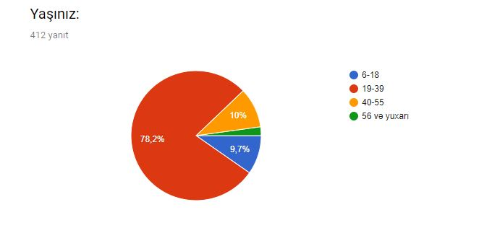
Figure 4.2
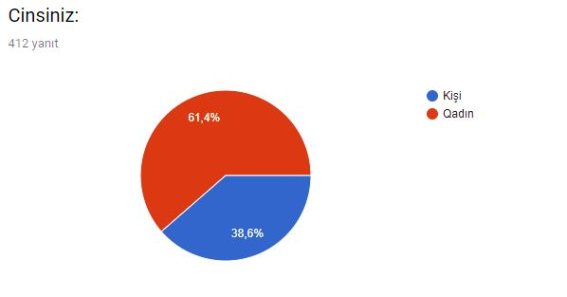

The next questions asked for the occupation, marital status and education level of respondents . The majority are students (34.2%, 141 respondents), people who work for the private sector (28.2%, 116 respondents) and who work for the governmental sector (19.7%, 81 respondents). And also according to results, 10.9% of respondents are unemployed. Finally individuals who have their own business stands for 7%, 29 respondents.
When talking about the respondent’s marital status, we can say that 285 respondents (69.2%) are single. The reason for that, a large number of respondents who are participating in the survey are students. According to survey, 118 respondents (28.6%) are married, and just a few of them 9 respondents (2.2%) are divorced.

Figure 4.3
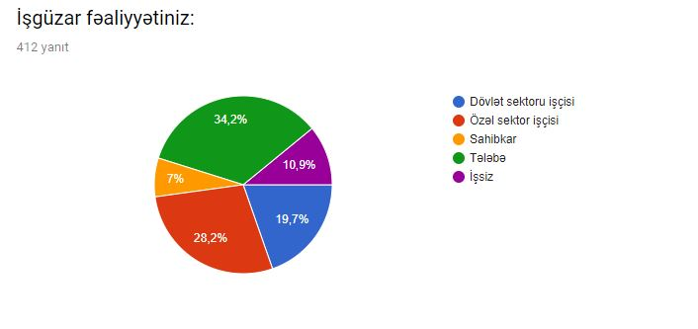

Figure 4.4
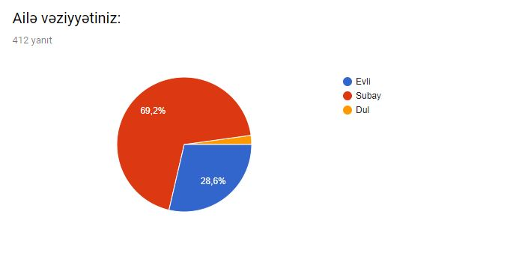

Figure 4.5
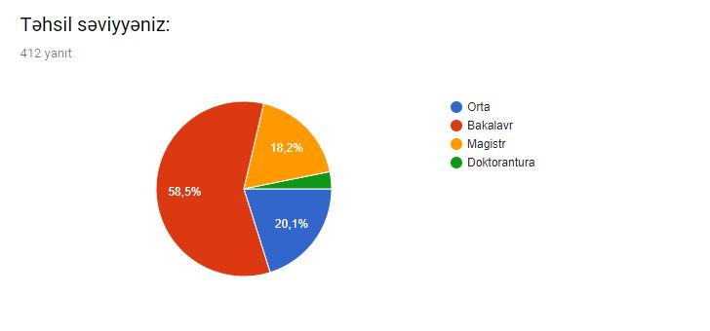

In the following part of the survey, the respondents were asked what types of stores would they prefer to buy. On the whole, larger amount of participant select Super Market (298, 72.3%), 77 respondents chose Hyper Market (18.7%) and finally, convenient stores were placed in third stage with 37 respondents (9%).

4.2 Descriptive results
Figure 4.6
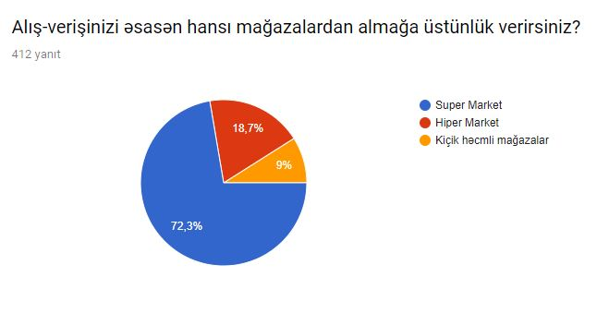

In the next question, respondents were asked which shopping stores they are using when they buying FMCG products. Participants had to rank from 1 to 6 which it shows that how frequently they use these stores. 1- at least used, 6- most commonly used.

Figure 4.7
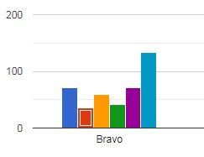
Bravo supermarkets are the most commonly used among other shopping stores and significant number of people gave 6 point (134 respondents). 71 respondents gave 1 point which it shows Bravo is not their preference. 72 participant gave 5 point and it is slightly different from the people who gave 1 point. 41 respondents gave 4 point, while 59 individuals gave 3 point. Finally, 35 person gave 2 point to Bravo supermarkets.

Figure 4.8
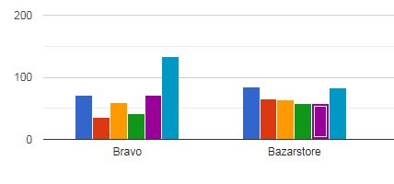
Bazarstore is the only supermarket has almost same amount of people who gave 1 point and 6 point ( 84 respondents -1 and 83 respondents – 6). We can see that there slightly different amount of people gave different point to Bazarstore. 58 respondents gave 4 and 5 point, while similar number of people gave 2 and 3, respectively.

Figure 4.9
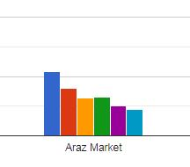
Figure 4.9 shows that Araz market placed third stage after Bravo and Bazarstore. People who gave 1 point are more than other points. 108 respondents gave 1 point, whereas 44 individuals gave 6 points. From the left to the right statistics like this: 2 point - 81, 3 point – 64, 4 – 65, 5 – 50 respondents.

Figure 5
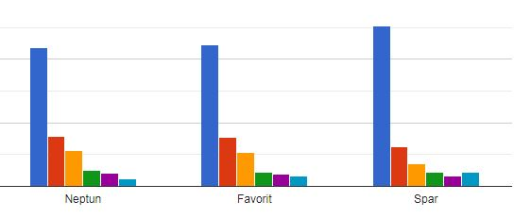

In this figure 5, we can see that 3 supermarkets: Neptun, Favorit and Spar are the least chosen among customers for buying FMCG products. People who gave 1 point to these markets are significantly differ from individuals who gave other points. From 12 individuals to 22 gave 6 points to Neptun, Favorit and Spar. 252 respondents to Spar, 223 person to Favorit, and 219 people to Neptun gave 1 point. People who gave 2 point are almost same: 79, 78 and 63, respectvely. Therefore, it is obvious that other statistics are similar among these three supermarkets.

Figure 5.1
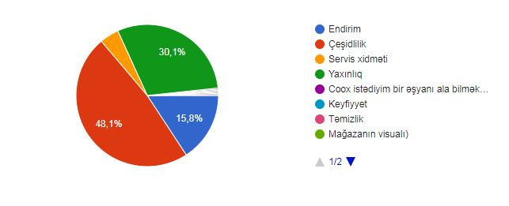
The diagram 5.1 illustrates that there are several reasons influence consumer preference to which they choose shopping stores for buying FMCG products. The main reason is variety. 48.1% respondents wants from stores to offer various products, in order to find most valuable one among them.
With 30.1% percentage proximity is the second reason that affect customer preference. 124 participants choose their markets by closeness.
The third reason that influence shoppers’ mind is discount. 15.8% respondents agreed with this reason and they accept that discounts play a major role when they go to markets.
18 respondents choose service is the most important reason when they buying FMCG products from markets.
There are also some reasons customer wrote their options by themselves. This include: cleannes, view of the store, wide capacity. These all have same percentage (0.1%).

Figure 5.2
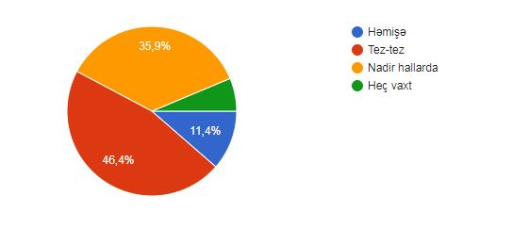
Then respondents were asked how often they offered discounts and coupons on the stores they used. We can clearly see that 46.4% of respondents chose often. 35.9% of people answered this question rarely, while 11.4% respondents chose always. In the end, minority of respondents select never (6.3%).

Figure 5.3
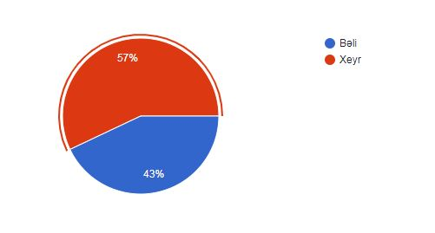
The next question were asked from respondents that will they switch their brand preference if they get some promotional scheme with another brand. As we can see from the diagram, most of the respondents remained loyal to their brands, they chose no (57%, 235 respondents). 43% of survey participant select yes.

Figure 5.4
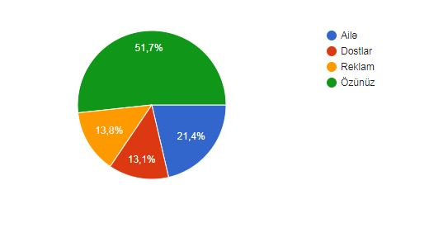

In the part of the following survey, respondents answered question that who most influence their preference for brands. More than half of respondents answered they chose brands by themselves and no one has any influence (51.7%).
21.4% respondents told that they affected for their brand choice by their family members.
Advertisements and friends have similar influence on customer’s brand preference (13.8% and 13.1%, respectively).
In the end, respondents were asked that does advertisement has any influence on customers’ brand choice, or not. 275 respondents said yes, 137 participant answered no.

4.3 Validity and Reliability

Figure 5.5
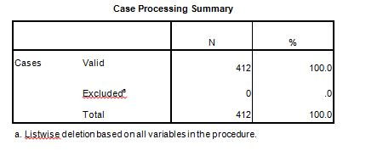
According to SPSS validity test result, total 412 respondents participate in the survey and sample is 100% valid to test.

Figure 5.6
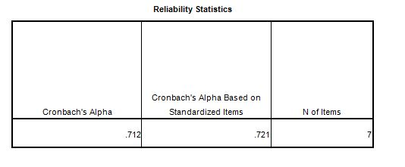
According to Cronbach’s Apha test, this dataset has 71.2% reliability. Considering the level of reliability requirement is 70%, we can say that this datasaet is reliable.
Figure 5.7
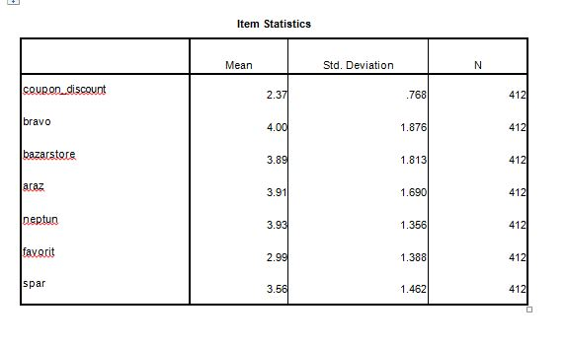
According to the factor analysis, coupon_discount (always, often, rarely, never) and Favorit questions cannot be understood or not clear to the respondents. Because the gap between these questions are higher than other questions.

4.4 Regression analyses
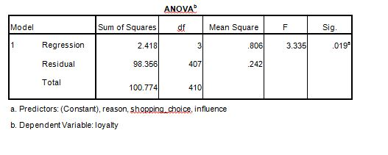
H1: Reason (Discount, Variety, Service, Proximity), shopping_choice ( Super Market, Hyper Market, Convenient stores) and influence (family, friends, advertisements, Self) influence Azerbaijani consumers’ loyalty. Hypothesis is accepted.

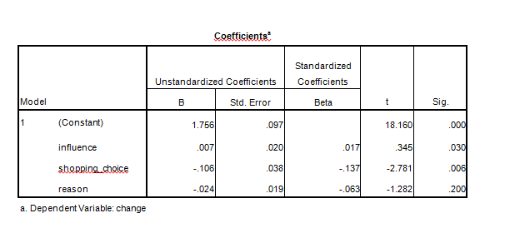
The coefficient table of the regression (Loyalty=Family + Friends + Advertisements + Self + SuperMarket + HyperMarket + ConvenientStores + Discounts + Variety + Proximity + Service) illustrates that all variables are significant and it means there is association between these variables and cunsomers’ loyalty.

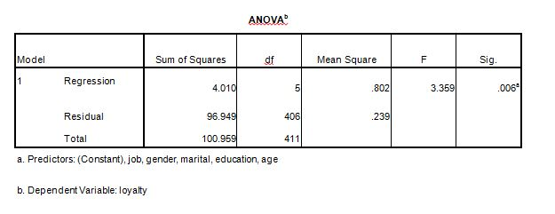
H2: Demographic indicators (job, gender, marital status, education, age) influence consumers’ loyalty to brands. Hypothesis is accepted, because significance level is below 5%.
According to Anova test from SPSS, we can understand that demographic indicators affect customers’ preference to brands.

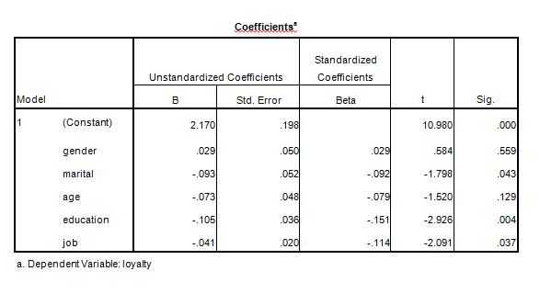
In general, we can see from the coefficient table all variables have significant impact on customers’ loyalty, but if we look separately, gender has 55.9% significance level and do not directly influence to loyalty.

5. Conclusion
The nature of the FMCG market with high volume deals, expansive numbers of clients and low benefit margins, makes it exceptionally costly to hold and build up long-term relationships with buyers. Since customers appreciate a few benefits from the utilization of FMCGs, marketers, and retailers ought to get it the benefits shoppers pick up from them. With this information, marketers can utilize relationship administration instruments such as the creating of trust and commitment techniques to create devotion to their items. Loyalty programmes and devotion cards can assist help this methodology (Zineldin et al., 2014:3)
The goals of this study were to evaluate whether, in expansion to utilitarian values, customers determine hedonic values from FMCGs. The consider too evaluated whether customers can be loyal to FMCGs, and how the utilitarian and hedonic values they hold for a few chosen FMCG brands influence their brand belief, brand impact, and fulfillment with the brand. The evaluation included a assurance of how fulfillment, in turn, influences behavioral and attitudinal brand dependability. The discoveries of this ponder can be compared with comparable discoveries like Chitturi et al. (2008), Chaudhuri and Holbrook (2001), Musa (2005) and Moolla and Bisschoff (2013) who have conducted related studies.
Considering that the definition of brand loyalty stresses inclination (one-sided), buy recurrence (over time) and demeanor (mental), and considers buyer reaction over a set of brands instead of fair a single brand, it was addressed whether shoppers would create both behavioral and attitudinal devotion to FMCG brands which are low inclusion items (Joghee and Pillai, 2013,) and are for the most part supplanted over a brief period of time (Fouladivanda et al. 2013:946).
Chaudhuri and Holbrook (2001: 90) affirmed, in a consider performed over a assortment of categories (counting FMCGs) expended within The U.S.A., that both buy loyalty and attitudinal loyalty impact outcomes-related viewpoints like market share and relative cost, though through the directing impacts of brand believe and brand impact. This was moreover affirmed by Knox and Walker’s (2001:120) comes about which appeared that among four buyer acquiring styles ('loyal', 'habitual', 'variety seekers' and 'switchers') within the U.K., there were a few buyers who were behaviourally (labeled ‘habitual’) and attitudinally (labeled ‘loyals’) steadfast to the basic need brands they bought.
FMCG brands are for the most part the risk-averse customers but when they, in the long run, believe a brand, they behaviourally and attitudinally adhere to it. In Sweden, Zineldin et al. (2014:6) found that customers can be faithful to FMCG brands but the finest cost and quality features a solid affecting part in this showcase.
The findings of this examination show that there's a positive relationship between brand trust and customer satisfaction in FMCG brands. This happens to be the most grounded of all the variable intelligent considered in this think about. Brand trust is appeared to contribute 99% within the clarification of the buyer satisfaction variable.
This finding is in agreement with a study conducted in Sweden by Ismail et al. (2012:42) which demonstrates that brand satisfaction features a solid relationship with brand trust. This finding also concurs with a study performed by Kiyani et al. (2012:497).
Marketers of branded washing powders, cleansers, milk, juices and cereals can have a communication methodology which outlines that these trusted brands keep clients fulfilled, subsequently guaranteeing that more customers remain brand loyal.
This study appeared that customers appreciate utilitarian benefits in expansion to hedonic benefits from FMCG brands and can create dependability to these brands. The study also investigated the components which drive loyalty to FMCGs.

List of References
- Aaker, D. (2012). Building strong brands. New York: The Free Press.
- Aaker, D.A. (1996). Measuring Brand Equity Across Products and Markets. California Management Review, Spring 1996, 38 (3): 102-120.
- Anselmsson, J. and Bondesson, N. (2015). Brand value chain in practise; the relationship between mindset and market performance metrics: A study of the Swedish market for FMCG. Journal of Retailing and Consumer Services, 25(2015): 58-70
- Bandyopadhyay S. and Martell, M. (2007). Does attitudinal loyalty influence behavioural loyalty? A theoretical and empirical study. Journal of Retailing and Consumer Services, 14: 35-44.
- Bass, F.M. (1974). The Theory of Stochastic Preferences and Brand Switching. Journal of
Marketing Research, XI (February 1974): 1-20
- Baumann, C., Hamin, H. and Chong, A. (2014). The role of brand exposure and experience on brand recall – Product durables vis-à-vis FMCG. Journal of Retailing and Consumer
Services, 23: 21-31
- Brijball, S. (1993). A study of the attitudinal and Behavioural dimensions of Indian
consumers to brand loyalty, submitted in fulfilment of the requirement for the degree of Masters of Administration (Industrial Psychology). Durban: Faculty of Commerce and Administration at the University of Durban-Westville, South Africa. Available at
http://researchspace.ukzn.ac.za/xmlui/handle/10413/7849
- Chaudhuri, A. and Holbrook, M.B. (2002). Product-class effects on brand commitments and brand outcomes: The role of brand trust and brand affect. Brand Management, 10(1): 33-58.
- Chaudhuri, A., and Holbrook, M.B. (2001). The Chain of Effects from Brand Trust and Brand Affect to Brand Performance: The Role of Brand Loyalty. Journal of Marketing, 65: 81-93.
- David, E.M. (2013). Re-Branding Fast Moving Consumer Goods: The Case of Nestlé
South Africa, a dissertation submitted in fulfilment of the requirements for the degree of Master of Commerce at The School of Management, IT and Governance, College of Law and Management Studies. Kwazulu-Natal: University of Kwazulu-Natal, South Africa. Available at http://researchspace.ukzn.ac.za/xmlui/handle/10413/10880.
- Davis, S. (2002). Brand Asset Management: How businesses can profit from the power of brand. Journal of Consumer Marketing,
- David, E.M. and Govender, K.K. (2014). Re-Branding Fast Moving Consumer Goods in an International Company in South Africa. Journal of Economics, 5(2): 153-164, Available at
http://www.krepublishers.com/02-Journals/JE/JE-05-0-000-14-Web/JE-05-2-000-14-AbstPDF/JE-5-2-153-14-179-Govender-K-K/JE-5-2-153-14-179-Govender-K-K-Tx[3].pdf.
- Day, G.S. (1969). A two-dimensional concept of brand loyalty. Journal of Advertising
Research, 9(3): 29-35.
- Delgado-Ballester, E. (2011). Development and validation of a brand trust scale,
ResearchGate. 3-58. Available at
http://citeseerx.ist.psu.edu/viewdoc/download?doi=10.1.1.201.5789&rep=rep1&type=pdf.
- Delgado-Ballester, E., Luis Munuera-Alemán, J. and Yagüe-Guillén, M.J. (2003). Development and validation of a brand trust scale. International Journal of Market
Research, 45(Quarter 1): 35-53.
- Delgado-Ballester, E. and Munuera-Alemán, J.L. (1999). Brand trust in the context of consumer loyalty. European Journal of Marketing, 35(11/12): 1238-1258.
- Deng, Z., Lu, Y., Wei, K. K., & Zhang, J. (2010). Understanding customer satisfaction and loyalty: An empirical study of mobile instant messages in China. International Journal of
Information Management
- Dick, A.S. & Basu, K. (1994). Customer Loyalty: toward an Integrated Conceptual Framework. Journal of the Academy of Marketing Science
- Forsido, M.Z. (2012). Brand loyalty in Smartphone, Masters Thesis. Uppsala: Universitet, Uppsala, Sweden. Available at http://www.divaportal.org/smash/get/diva2:545415/fulltext02
- Fouladivanda, F. et al. (2013). The effect of Brand Equity on Consumer Buying Behavior in term of FMCG in Iran. INTERDISCIPLINARY JOURNAL OF CONTEMPORARY
RESEARCH IN BUSINESS [ejournal], 4(9): 51-68. Available at http://journalarchieves27.webs.com/945-957.pdf.
- Fournier, S. and Yao, J.L. (1997). Reviving Brand Loyalty: A Reconceptualization within the Framework of Consumer-Brand Relationships. International Journal of Research in
Marketing, 14: 451-472
- Lacey, R. (2007). Relationship drivers of Customer Commitment, Journal of Marketing
Theory & Practice, Fall2007, 15(4): 315-333.
- Liu, C. T., Guo, Y. M., and Lee, C. H. (2011). The effects of relationship quality and switching barriers on customer loyalty. International Journal of Information Management, 31(1): 71-79.
- Hawkins, D.I. and Mothersbaugh, D.L. (2010). Consumer Behavior: Building Marketing
Strategy, Eleventh edition. New York: McGraw-Hill Irwin.
- Hofmeyr, J. and Rice, B. (2000). Commitment-Led Marketing. Chichester: John Wiley & Sons Ltd.
- Hoyer, D.H. and Stokburger-Sauer, N.E. (2012). The role of aesthetic taste in consumer behavior. Journal of the Academy of Marketing Science, 40: 167-180.
- Seymur M. Guliyev, AZƏRBAYCANIN QİDA İSTEHSAL MÜƏSSİSƏLƏRİNDƏ BRENDİNQ FƏALİYYƏTİNİN TƏKMİLLƏŞDİRİLMƏSİ, Ipek Yolu jurnali, No 2, 2014
- Seymur Guliyev, An emerging consumer experience: emotional branding, Modernlesme seraitinde milli iqtisadiyyatin inkisafinin aktual problemleri ve perspektiv istiqametleri, Azerbaycan Universiteti, 2018
- Seymur Guliyev, Private Label in marketing and its importance, 3rd international scientific conference of Young researchers, Qafqaz University, 2015
- Seymur Guliyev, Effects of brand on emotional decision making process of consumer: a research in food industry of Azerbaijan, Scientific News Summary, No 2/2018, Ganja Technology University, 2018
- Seymur Guliyev, Effect of Social Factors on Consumer Behaviour, International Scientific Conference “Sustainable development in Economy and Management: problems and perspectives”, Baku Engineering University, 2018
- Seymur M. Guliyev, Improvement Directions of Branding Processes in the Food Industrial Companies of Azerbaijan, Scientific News Summary, No 1/2018 by Ganja Technology University, 2018.
- Seymur M.G., Rasim A., Qualitative Research and the process of constructing qualitative data, Journal of Qafqaz University, volume 1, number 1, ISSN 2310-9076, 2013
- Prof. Joanna Scwacka, Assoc.Prof. Rasim Abutalibov, PhD.c. Seymur M. Guliyev, Globalization process in the food industry - European Experience, Qafqaz University, 2014
- Seymur M. Guliyev, Rasim Abutalibov, Factors affecting consumer behaviours of Azerbaijani youths, Marketing Management International conference, Warsaw University of Life Sciences (SGGW), Warsaw, Poland, 2015
- Seymur M.G., Rasim A., Qualitative Research and the process of constructing qualitative data, Journal of Qafqaz University, volume 1, number 1, ISSN 2310-9076, 2013
- Seymur M. Guliyev, Improvement Directions of Branding Processes in the Food Industrial Companies of Azerbaijan, Scientific News Summary, No 1/2018 by Ganja Technology University, 2018.
- Seymur Guliyev, Effects of brand on emotional decision making process of consumer: a research in food industry of Azerbaijan, Scientific News Summary, No 2/2018, Ganja Technology University, 2018
- Seymur Guliyev, An emerging consumer experience: emotional branding, Modernlesme seraitinde milli iqtisadiyyatin inkisafinin aktual problemleri ve perspektiv istiqametleri, Azerbaycan Universiteti, 2018
- Seymur M. Guliyev, AZƏRBAYCANIN QİDA İSTEHSAL MÜƏSSİSƏLƏRİNDƏ BRENDİNQ FƏALİYYƏTİNİN TƏKMİLLƏŞDİRİLMƏSİ, Ipek Yolu jurnali, No 2, 2014
- Ismail, R., Boye, C.L. and Muth, A. (2012). Customer Brand Relationship - An empirical
study of customers’ perception of brand experience, brand satisfaction, brand trust and
how they affect brand loyalty, Bachelor thesis, Spring 2012. Växjö: Linnaeus University – School of Business and Economics, Växjö, Sweden. Available at http://www.divaportal.org/smash/get/diva2:530408/FULLTEXT01.pdf.
- Jacoby, J. and Chestnut, R. W. (1978). Brand Loyalty Measurement and Management. New York: Wiley.
- Jensen, M. and Hansen, J.T. (2006). An empirical examination of brand loyalty. Journal of
Product & Brand Management, 15(7): 442-449. Available at
http://dx.doi.org/10.1108/10610420610712829. [Accessed 18 October 2015].
- Joghee, S. and Pillai, P.K. (2013). Brand Influence on Buying FMCG Products in UAE: An empirical Study. European Journal of Business and Management
- https://www.forbes.com/sites/forbesagencycouncil/2018/03/02/13-questions-to-ask-yourself-before-you-start-rebranding/#573f500f130e
- https://research-methodology.net/research-methodology/)
- https://ori.hhs.gov/education/products/n_illinois_u/datamanagement/datopic.html
- https://research-methodology.net/research-methods/data-collection/
- Kabiraj, S. and Shanmugan, J. (2011). Development of a conceptual framework for brand loyalty: A Euro-Mediterranean perspective. Brand Management, 18(4/5): 285-299.
- Kiyani, T.M. et al. (2012). THE RELATIONSHIP BETWEEN BRAND TRUST, CUSTOMER SATISFACTION AND CUSTOMER LOYALTY. (EVIDENCE FROM AUTOMOBILE SECTOR OF PAKISTAN). INTERDISCIPLINARY JOURNAL OF
CONTEMPORARY RESEARCH IN BUSINESS [ejournal], 4(1): 489-502. Available at
http://journal-archieves18.webs.com/489-502.pdf.
- KPMG Sector Report. (2015). Fast-Moving Consumer Goods in Africa [online]. Available at https://www.kpmg.com/Africa/en/IssuesAndInsights/Articles-Publications/GeneralIndustries-Publications/Documents/FastMoving%20Consumer%20Goods%20sector%20report%202015.pdf.
- Kwong, M.Z. and Candinegara, I. (2014). Relationship between Brand Experience, Brand Personality, consumer Satisfaction, and consumer Loyalty of DSSMF Brand. iBuss
Management [ejournal], 18(2): 89-98, Available at
http://studentjournal.petra.ac.id/index.php/ibm/article/view/2411/2190.

Appendix A – Questionnaire
Cinsiniz:
- Kişi
- Qadın

Ailə vəziyyətiniz:
- Evli
- Subay
- Dul

Yaşınız:
- 6-18
- 19-39
- 40-55
- 56 və yuxarı

Təhsil səviyyəniz:
- Orta
- Bakalavr
- Magistr
- Doktorantura

İşgüzar fəaliyyətiniz:
- Dövlət sektoru işçisi
- Özəl sektor işçisi
- Sahibkar
- Tələbə
- İşsiz

Alış-verişinizi əsasən hansı mağazalardan almağa üstünlük verirsiniz?
- Super Market
- Hiper Market
- Kiçik həcmli mağazalar

Aşağıdakı mağazalardan hansına gündəlik tələbat malları alışı zamanı daha çox üstünlük verirsiniz?( Sıralayın: 1-ən az istifadə, 6- ən çox istifadə)
Bravo
Bazarstore
Araz Market
Neptun
Favorit
Spar
Bravo
Bazarstore
Araz Market
Neptun
Favorit
Spar

Hansı səbəb sizin mağazadan alış-veriş etməyinizə daha çox təsir edir?
- Endirim
- Çeşidlilik
- Servis xidməti
- Yaxınlıq

Gündəlik tələbat malları aldığınız mağaza hansı tezlikdə endirim və kuponlar tətbiq edir?
- Həmişə
- Tez-tez
- Nadir hallarda
- Heç vaxt

Başqa brendin həvəsləndirici satış kampaniyasına görə hər zaman üstün tutduğunuz brendi dəyişərsiniz?
- Bəli
- Xeyr

Aşağıdakılardan hansı sizin brend seçiminizdə daha çox təsir gücünə malikdir?
- Ailə
- Dostlar
- Reklam
- Özünüz
Reklamın sizin brend seçiminizdə rolu var mı?
- Bəli
- Xeyr

Appendix B- Questionnaire
Gender:
- Male
- Female
Marital status:
- Married
- Single
- Widow

Age:
- 6-18
- 19-39
- 40-55
- 56 and up

Education:
- High School
- Bachelor
- Master
- Phd

Profession:
- Public sector employee
- Private sector employee
- Business owner
- Student
- Jobless
Which of the following format you prefer to make purchase?
- Super Market
- Hyper Market
- Convenient store

Which of the following Retail stores do you prefer most for buying FMCG`s? (Rank from 1 to 6. 6-Most Prefered 1-Least Prefered)

Select the reason for making purchase in your preferred store?
- Discount
- Variety
- Service quality
- Proximity

Will you like to switch your brand preference if you get some promotional scheme withanother brand?
- Yes
- No

Who influence your preference for brands?
- Family
- Friends
- Advertisements
- Self

Does the advertising play any role towards brand preference?
- Yes
- No

