THESIS
“Analysis of the role of social media in brand recognition”

Author: Sevil ALIYEVA Supervisor: Rufat MAMMADOV

BAKU, 2019
ABSTRACT

Brands are a significant element in the present society. Brand can comprise of anything; an item, an association, a college, an individual or even a region. They are not tightened to items or organizations, yet are significant founder of civilizations. Having some donuts at Dunkin' Donuts isn't just about the donuts, it is likewise about the brand and qualities and inspirations, then what it speaks to for the clients and customers. Brands are interweaving themselves further in the community than any time in recent.
Digital networking is developing and taking an extensive piece of individuals' time. We talk about everything, brands, on stages, for example, Instagram and YouTube. In this way it is basic for brands to effectively share in the discourse to not submerge and lose authority over their image picture. They form their image character, however the picture is what is seen by the general population. In the event that they let others shape the impression of the brand, at that point there is an extraordinary hazard that the picture build won't compare to their proposed character. Digital networking gives a passage to fans and brands to entracte. This dissertation researches the essential employments of social media for item and services brands separately. Additionally, it takes a gander at what parts of the brand personality are shown on the previously mentioned stages for both item and individuals brands.
The examination takes the state of a substance investigation of brands in social media for item and individuals brands. Factors relating to the four personality points of view proposed by David Aaker – (1) brand as item, (2) brand as association, (3) brand as individual, and (4) brand as image – were utilized to see whether there is an overwhelming viewpoint that brands receive while connecting with fans in digital life. Likewise, the people of social media were explored and coordinated with creators' proposals for perfect employments of social networks for brands.
It was discovered that, in accordance with a few creators' suggestions of perfect utilization of digital life; brands embrace a personality approach steady with Aaker's Brand as Person viewpoint – reckless of mark species. The Brand as Individual point of view was predominant for individuals marks on social media, nonetheless, somewhat progressively upgraded on the last mentioned. While as yet being the principle viewpoint for item marks, the other character point of view are given more consideration so the predominance of the Brand as Person viewpoint isn't exactly as recognized. Likewise, the principle differents of social media networks were found; for example Facebook is an anymore application used to connect with fans but Instagram is predominately used to business. The outcomes give a premise to which future research on marks character and uses for marks in digital life can expand after, beginning with those common discoveries to dive further in progressively concentrated territories of marks in online life.

TABLE OF CONTENTS

1.INTRODUCTION...……………………….……..………………………….…6
1.1 The structure of the thesis …………………………………..………….…..7
1.2 Key concepts ………………………………………………..………….…..7
1.3 Research problem...........................................................................................8
1.4 Research objectives.........................................................................................8
2.LITERATURE REVIEW……………………………………………..………...9
2.1 Brands and Branding……………………………………………………..…9
2.1.1 Brand identity...................................................................................11
2.1.2 Brand imagine...................................................................................12
2.1.3 Brand Equity.....................................................................................13
2.2 Definition of a brand……………………………………………………….15
2.2.1 Personal Brands and Product Brands………………………………16
2.3 New Communications...................................................................................17
2.3.1 Social media…………………………………………………………17
2.3.2 Utilization of Social Media.................................................................19
2.3.2.1 Instagram…………………………………………...………21
2.3.2.2 Facebook……………………………………………………25
2.4 Digital Marketing Model……………………………………………………28
2.4.1 Race – Digital Marketing Plan............................................................29
2.4.2 AIDA model.......................................................................................31
3.1 Branding in digital media...............................................................................33
3.1.1 Conspectus............................................................................................33
3.1.2 Positive and negative directions...........................................................34
4.METHODOLOGY……………………………………………………………..34
4.1 Research philosophy……………………………………………………….34
4.2 Research approach………………………………………………………....35
4.3 Qualitative research………………………………………………………..36
4.4 Research design……………………………………………………………37
5. RESULT……………...………………………………………………………...38
6. CONCLUSION………….…………………………………………..………....46
BIBLIOGRAPHY…………………………………….………….…………........48
APPENDICES……………………………………………………………...….....54

1. INTRODUCTION

Thе tоpic оf thе thеsis is аnаlysis оf the rоlе оf sоciаl mеdiа in brаnd rеcоgnitiоn. Sociаl mediа is on the upgrade its rоle in the usеrs’ vita. In the origin of thesis, branding is defined like the actions that purpose to build up brand equity. Brand image touchs on to purchasers perceptions’ of a brand. The aim of the thesis is to analyze how social communications can be useful for branding goals and to investigative the1 effect of social networks on brand image.
The thesis investigates commercial what things should be taken into consideration when using social media for branding purposes and additionally it investigates the importance of social media in brand promotion and the importance of social media as an influencer on brand image.
Therefor the investigative questions be formed the following:
- how can social networks be using for branding intents?
- what should be taken into significance when used social media for branding aims?
- what is the influence of social media on brand image?
The subject is flow and important to companies that function within the customer markets, and to some extent to those who perform in the enterprise-to-business markets, based totally on the concept that social media has come to be an important advertising channel for brands, its effect on brand equity and brand image is massive, and due to its nature it calls for a extraordinary kind of approach in assessment to communique on conventional media. it's significant to understand how substantially social media actions may have an effect on business equity and logo image, so businesses can allot resources to it as a result.
Branding and marketing are underneath an ongoing trade due to media channels: social media. Techniques of advertising and branding are converting when communication is becoming multi-directional and extra consumer directional. This dissertation investigates the chances furnished by means of social network in branding. For one of its aims is to reply the question, how can corporations advantage from social networks in construction a brand and what matters to take into account in forming a brand on social media.

1.1 The structure of the thesis

This dissertation includes the introduction, theoretical history, research techniques,empirical study and conclusion. The introduction defines the cutting-edge condition of social media marketing and branding in general. The theoretical historical past will delve deeper within the attention and ensure extraordinary methods to branding and speak in social media and provide the fundamental knowledge of social media and search for how social media entegrates into branding. The empirical compartment will analyze the modern situation of branding in relation to the theoretical findings and corporations using social media. The conclusion compartment summarizes the key findings and supplies oncoming ideas and development suggestions for the company.

1.2 Key concepts

Social media – Social media advertising and marketing (SMM) refers to technics that focus on social communications and programs to unfold brand consciousness or promote specific products. (Kaplan, Haenlein 2010.)
Social media marketing – social media marketing is the use of social media by marketers to increase brand awareness and build relationships with customers (Foulger 2014).
Users – Existence that has competence to use an software, device, tablishment, operate, hardware or system and that who may or won't be the real customer of the object.
Analytics – Analytics, in, common includes the usage of technology to collect data, which researchers can work. The intention is to study the forms in behaviour. The statistics is the very mostly gathering data approximately the pages visited, movements completed, interplays and overall performance. (Foulger 2014).
Branding – Branding goals to builds an important and diversify entity inside the marketplace that fascinates and retains dependable customers.

1.3 Research problem

Social media advertising and marketing plays an imperative role in a business’ advertising communication these days. it's miles an entirely new way to achieve your predominant target audience and communicate on your consumers. There are a lot of achievement tales for advertising and marketing in social media. however, as it's a reasonably new sort of marketing it's necessary to discover ways to use it efficaciously in enterprise. The principle motive for this dissertation is to provide the corperations a higher knowledge of the way to use socal media marketing in branding recognition correctly as a part of their advertising method. It's going to analyse the users’ behavior to social media and learning social media’s role of branding recognition. The findings will provide the users with future ideas as well as proposals for recoveries.

1.4 Research objectives

The research objectives for the Dissertation are as follows:

• research the necessary of social media for these days’ businesses
• discover the potentialities in social media advertising and marketing
• analyze the procedures and practises used on social media advertising and marketing
• define the characteristics of successful branding recognition

Literature review
2.1 Brands and Branding

In 1960, Levitt and McGregor, E Jerome McCarthy introduced the American marketing Association (AMA). its glossary of marketing conditions, with the inclusion of this on brand: a condition,a symbol, a logo or layout... in to define the products or offerings of one seller… and to distinguish them from these of competitions. The AMA definition due writers, institutions, advertising corporations and marketers have described the terminology. Ries and Trout (1986) extended the description to content that the impact of a brand is to form a distinct establishing in the mind of the purchaser. (Branding Governance 2007)
Distinguish a brand from the opposition is named brand positioning. logo positioning consists of identify the brand’s different values, wants, properties, feauters, desires and characteristics (Geelhoed, Samhoud and Hamurcu 2013) and the usage of these like a mainly for growing a brand this is perceived by customers as differ in comparison to competitors.
There are distinctive perspectives on the way to outline a brand. Simplies the concept and condition that the brand adjoins value when, many things similar, when purchaser choose a product with the brand preferably than unbrand. Holt, espouse a cultural approach to branding, defines the brand like the story circumambient the service or product, produced from the combined myths built by means of “authors” at the side of the product. Those “authors” may be businesses, the subculture industries, salespeople and consumers. Holt maintains that the emblems, names and style formed by way of the organization or person would be without meaning unless mind of with a story. (Holt, 2004) David A. (1996), From a commercial perspective, accedes that the logo is more than a product that it's created by way of many other elements.
These are abstracted in the figure follow:

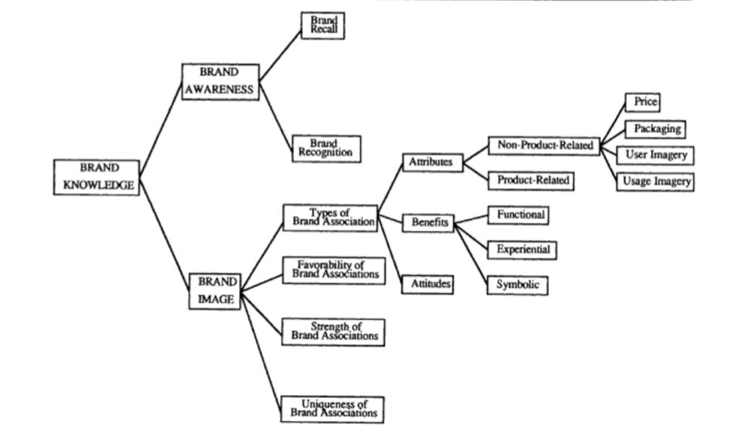

Figure 1. Dimensions of Brand Knowledge

2.1.1 Brand Identity

Brand character comprises of the brand affiliations that organizations are attempting to make in the shoppers' psyches (Aaker 1996, 68). At the end of the day, brand personality alludes to what a brand goals to be, and the brand character is characterized by the proprietor of the brand. As indicated by Aaker (1996, 68), the ideal brand affiliations that structure brand personality speak to the estimations of the brand and include a brand guarantee. Brand guarantee might be characterized as the "advantages and encounters that advertising efforts endeavor to connect with an item in its present and imminent customers' psyches" (BusinessDictionary.com 2016). The capacity of brand personality is to help in making a relationship to the client by partner these advantages to the brand (Aaker 1996, 68). Brand personality isn't synonymous with brand picture. Brand character is made by the proprietor of the brand, while brand picture alludes to how purchasers really see the brand. Brand character is the thing that the proprietor of the brand is making progress toward the brand picture to be.
Aaker Model - Brand Equity sees brand value as a lot of five classes of brand resources and liabilities connected to a brand that attach to or extract from the esteem given by an item or administration to a firm as well as to that company's
clients. Building an enduring brand value steadily encourages the association to request bonus and along these lines high benefits over the longterm.
2.1.2 Brand Imagine

The brand picture is the thing that and how a gathering of customers abstractly see the brand to be. (Riezebos, Kist and Kootstra, 2003; Wilson and Blumenthal, 2008; Management Study Guide, 2016)
Brand picture is framed by different brand affiliations that buyers create in their psyche (Management Study Guide, 2016), which can be grouped into three classifications:
1. attributes
2. benefits
3. attitudes
(Keller 1993, 4)
Attributes are highlights which the shopper thinks an item or administration has. There are two sorts of traits, item related and non-item related qualities. The previous identify with the capacity of the item or administration, and the last are the perspectives identified with its buy or utilization, which are not straightforwardly identified with the execution or capacity of the item or administration. (Keller 1993, 4)
Keller (1993, 4) records four kinds of non-item related traits:
1. Price data
2. Bundling or item appearance data
3. Client symbolism (i.e., what kind of individual uses the item or administration)
4. Utilization symbolism (i.e., where and in what kinds of circumstances the item or administration is utilized).
Price is viewed as a significant non-item related quality in light of the connection among cost and saw estimation of a brand. (Blattberg and Wisniewski 1989, as indicated by Keller 1993, 4)
Packaging and item appearance are delegated non-item related characteristics as they are not straightforwardly identified with item execution. (Keller 1993, 4)
Client and use imagery are shaped from a purchaser's encounters, verbal, or from how the objective market is portrayed in brand promoting. (Keller 1993, 4)
Keller (1993, 4) Portrays benefits as thing that "purchasers figure an item or administration can accomplish for them". There are three classifications of advantages:
1. functional advantages
2. experiential advantages
3. representative advantages
(Park, Jaworski, and MacInnis 1986, as indicated by Keller 1993, 4)
Brand pictures can't be made by organizations, rather they are framed by buyers (Management Study Guide, 2016). Be that as it may, organizations may attempt to impact the brand picture to move towards their ideal image picture through promoting and brand building.

2.1.3 Brand Equity

Brand value implies the extra fiscal esteem that an organization may pick up from having a marked item in contrast with a circumstance where an organization has a nonbranded albeit generally indistinguishable item or administration. Brand value might be certain or negative. (Investopedia 2003,8)
Brand value is framed by the non-cost or highlight related esteem and saw nature of the item (Mohsin 2009, 8). Brands don't have any esteem in the event that they don't have positive brand value. In this manner brands must extend an elusive incentive to the purchasers, to satisfy their motivation.
As stated, brand value has been characterized in an assortment of ways, contingent upon the specific reason. Since the objective of this article is to encourage the advancement of increasingly compelling advertising procedures and strategies, the spotlight is brand impacts on the individual customer. The benefit of conceptualizing brand value from this point of view is that it empowers supervisors to consider explicitly how their promoting program improves the estimation of their brands.

Figure 2. How brand equity is formed
In a simplified description, brand equity is the value formed by the connected of brand image and brand awareness, like can see in Figure 2.
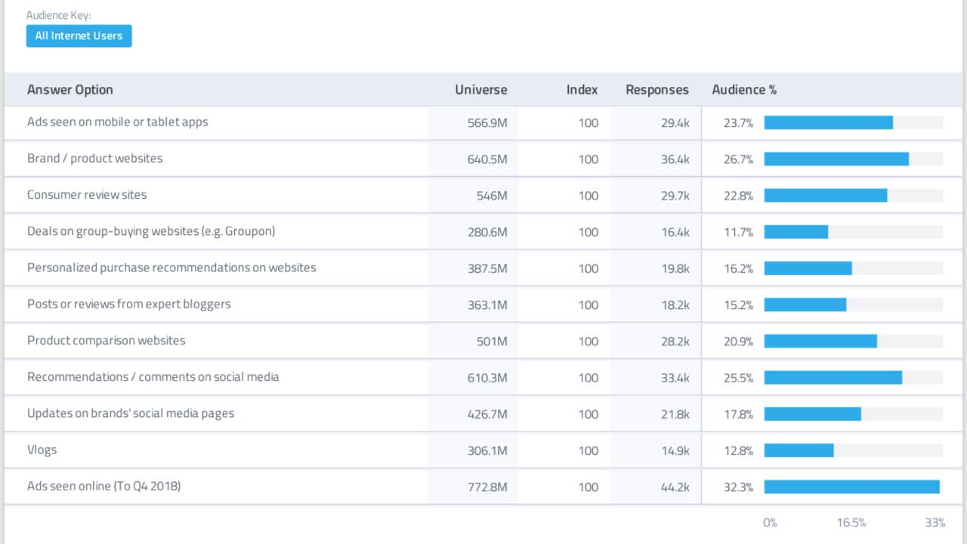
Figure 3. Brand Discovery
In spite of the fact that the possible objective of any showcasing program is to build deals, it is first important to set up information structures for the brand with the goal that customers react positively to promoting action for the brand. The former area gives a nitty gritty system is utilized to consider in more detail how learning influences buyer reaction to the advertising of a brand by characterizing client based brand value and looking at how it is manufactured, estimated, and managed.(Keller 1993)

2.2 Definition of a brand

A brand is an immaterial, however also a crucial aspect of what a corporation represents (Davis and Bojalil Rébora, 2002). Manufacturers with effective brand equity may additionally set better charges for corporation's services and products or earn extra income. Brands help corporatıons to form a contact with consumers on an sensual stage. Therefore, a lot of corporations try to establish particular and suitable powerful brands (Kotler and Keller, 2012). A brand is a thriving if the purchaser comprehend it as bigger than the opposition, 12 and lose out if they don't (Weilbacher 1999). inside the era of social communication , that is becoming even extra evident, when contact is turning into greater focused at the purchasers.

2.2.1 Personal Brands and Product Brands

The appeal of private brands lies in people’s idolisation of other person. The most important issue for brand achievement is how connected person is to it. Associating themselves with positive manufacturers is a manner for people to specific their identification (Solomon, 2007). “In purchaser behaviour studies, it has lengthy been recounted that clients useing brands for symbolic consumption and like manner to explicit themselves via choosing brands with a particular brand personality.” (Heding, Knudzen and Bjerre, 2009)
Considering that announcement, you can still say that human beings on social media expresses themselves through liking a brand, person or object on the platform. The ‘preferred’ brand turns into related to the character, and this is open for all people to see at the character’s profile. Like with goods, the capacity to accomplice oneself with a celebrity another is an appendage of the person’s character. Think of college – there is, commonly, an “in-crowd” with the famous people. Most youngsters need to be friends with person in that group if you want to be respectable famous themselves. People are searching for connection with human beings they contact to, and they are trying to find to interact with famous people (Thomson, 2006). an appropriate self may be very more fashioned by means of way of life and the predominant figures in it.

2.3 New Communications
2.3.1 Social Media

As indicated by Carlsson (2010: page 10), online networking are web related administrations that where everybody can contact, share data, and produce new connections. Instances of digital networking incorporate online journals, microblogs, digital recordings, networks and video locales. The basic characteristic is that digital life expands on client formed contents. (Carlsson 2010: pages 11-12)
Carlsson keeps on expressing that in spite of the fact that there are a lot of uses for everybody in digital network, it likewise gives organizations another perspective about their promoting.(Carlsson 2010, page 20) That plural tip of connection is different from the classic sender-message-acceptor model in that it goals to advance mutual effect between the mark and the person. The essential point of a mark in online networking ought to be to assemble connections, open up to discourse and make trust – not just to sell items. (Carlsson, 2010, page 35)
Creators concur with Carlsson in that more significant thing for marks to actual in online networks is to be genuine. Online life opens an open door for marks to associate with fans and clients on an individual dimension, and it is in this manner steady that organizations don't abuse the trust that is required for such a relationship to come to pass. (Chordas 2009: 25) (Harres Akers 2009: 10)
An ongoing research by Firefly Millward Brown planned to analyze mark observations in online networking, how viable marks are in customer behaviour and sense in regards to the mark. (Hernandez, 2010) This investigation cements Carlsson's view and 14 focuses on that if marks are to prosper in digital networking they should be happy to change their whole promoting methodology. As per the examination, they should:

• Act like a companion as opposed to a company (collaborate)
• Build connections with customers in lieu of to "selling" to them (lock in)
• Think a society contrary to market (be amicable)
(Hernandez, 2010: 6)
Despite the fact that marks can't control what is being called about them in online life, brands do have the chance to shape the talk. (Mangold and Faulds, 2009) Achivement is, as per Mangold and Faulds (2009), dependent upon how well marks perform in those classes:
• Provision networking platforms stages
• Use social networks to connect with and feedback input
• Combine web and conventional limited time apparatuses to draw in clients through for example remunerates plans or challenge
• Provide with data
• Be over the top
• Provide exclusivity through exclusive offers and so on for fans on social media platforms
• Incourage discussion for information, items and so on. Both item plan and advancements ought to be attempted in light of the ideal mental self view.
• Support makes significant clients and users, and show Corporate Social Responsibility (CSR) work
• Use the intensity of stories
Digital media offers unlimited open doors for client administration and backing. It is a magnificent apparatus to draw near with your clients and fans; be that as it may, it is in no way, shape or form planned to be utilized individually. Online networ works best for brands in showcasing on the off chance that it is utilized as a supplement to different exercises. (Carlsson, 2010: page 65)
The following two segments will depict two of the social media applications today, Facebook and Instagram.

2.3.2 Utilization of Social Media

In the wake of recognizing the organization's motivation for an online networking platforms reception and how the connection will be actualized and the substance looked after, marketers think about that platforms to connect with, so as to pick up the most noteworthy incentive for its business (Culnan, McHugh and Zubillaga, 2010). Since social media platforms exist in lots of structures, Kaplan and Haenlein have disentangled the idea by characterizing it as a gathering of Internet-put together applications based with respect to their application types: informal communities, sites, discussions, content aggregators and networks (Constantinides and Fountain, 2008), (Kaplan and Haenlein).
The fundamental goal with all types of online networking applications is to keep everybody (Kaplan and Haenlein, 2010). Also, client commitment through various limited time exercises via online networking can positively affect long haul esteem creation because of these connections created (Angel and Sexsmith, 2011). For instance, the utilization of 'like' on Facebook or on Instagram spreads limited time material so as to different clients to see the common substance (Lacho and Marinello, 2010). Moreover, as online network has empowered organizations to interface with their clients, this sort of online intelligence between the organization and its client requires the organization's thought for instance when and how regularly it joins these client produced discussion (Kietzmann et al., 2011) and furthermore, how many organizations enables clients to-clients discussions on their records (Geho, Smith and Lewis,2010).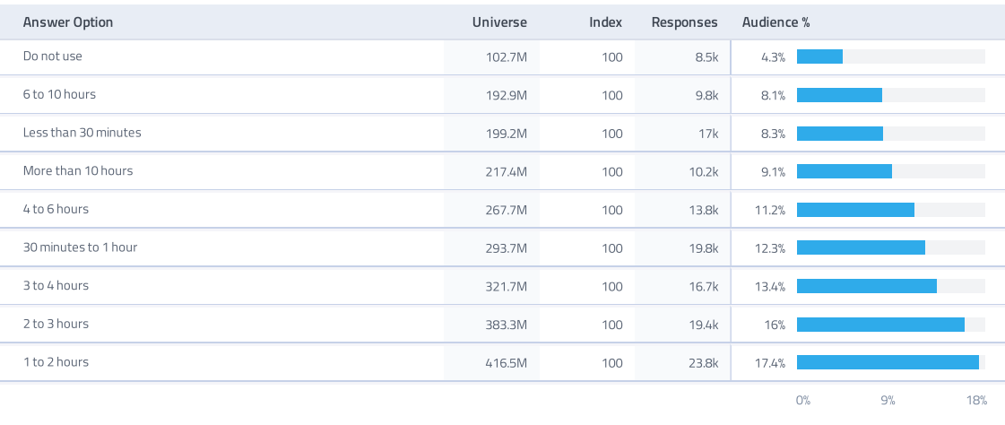
Figure 4. On an average day, how long do you spend online on a mobile.
As indicated by the Global Web Index Report 2017, the three most usually utilized social networking applications among the explored organizations were Instagram (94%), Facebook (83%) and Twitter (71%). 28 percent of the contemplated organizations had an LinkedIn account. The use of Instagram as a promoting channel fluctuated relying upon the complete time advertiser has been dynamic via digital networking media; 15 percent of the organizations who have been via online networking media short of what one year have an Instagram account and thus, 47 percent of organizations who have been joining online life for more than five years are on Instagram. The solid connection between the advertiser's general involvement digital networking media and the measure of time advertiser is eager to commit to online networking exercises was additionally found. Advertisers, who had been dynamic digital networking media not exactly a year, put overall five hours or less every week into their digital networking life
While advertisers with more than two years experience are involved more than six hours out of each week. Connection between's the measure of the business and the time devoted to online life exercises was likewise found. Discoveries demonstrated that little scale organizations, independently employed or organizations of two to ten workers are well on the way to commit one to five hours out of each week via online networking media (Stelzner, 2014).
Despite the fact that Facebook is the most utilized showcasing channel among the examined advertisers, a vast part is scrutinizing its adequacy as a promoting instrument: 37 percent were questionable and 21 percent did not concur with Facebook's viability as an advertising device (Stelzner, 2014). This opens up the open door for other digital life stages, for example, Instagram to advertiser consider taking part in. Moreover, an ongoing investigation of American digital life clients demonstrated that Facebook's prominence is diminishing and Instagram is presently the most visited stage (Business Insider, 2015).

2.3.2.1 INSTAGRAM

The online network application Instagram was propelled in 2010 as an application for cell phones (Instagram2015). The business thought was to give clients a basic method to transfer and share portable photographs with people (Instagram [1], 2015). The stage developed rapidly and now offers the likelihood to share video clasps of 1 minute and change it up of channels to the photos (Instagram [1], 2015).In addition to, Instagram was update in 2018 and created IGTV like as Youtube. In december 2014 Instagram had 200 million dynamic clients, an expansion of 100 million client since Mars that year (Statista [1], 2015). Worldwide measurements demonstrate that most of the clients are more youthful than 25 years of age and just a couple of percent are more than 55 years of age. The primary adaptation of Instagram is free from commercials as in there are no promotions inside the application itself (Instagram2015). Apparently, this makes Instagram emerge from other online social networking stages containing promotions, which organizations can purchase.
Lots of organizations have their very self accounts in Instagram where they transfer content. One of these organizations, Zara, is right now pursued by 32,5 million followers. In this manner, every photograph or video uploaded by the organization is seen by in excess of 70.3 thousand individuals. Since Instagram is an apllication that the clients just observe pictures and recordings posted by clients which they have settled on a functioning decision to pursue, we contend that showcasing on Instagram is self-chosen. In our endeavor to see how organizations as of now utilize the digital networking life stage Instagram for showcasing purposes and exercises we wonder if this is anything they may consider.
The research by Abbott et al. (2013) express that photos have the most effect and are the most likely to connect with users than a textual contents. Likewise, Meenaghan (1995) contends that photos have a significant impact additionally on organization's mark imagine. Since item promoting regularly implicate complicated messages, shoppers have swung to confide in additional on the picture parts of items and are in this manner more open for representative than practical highlights of the items.
This is an application for cell phones that gives a support of take pictures or transfer a video of 1minute and offer it with followers. The photograph or video can likewise be included with a depiction and make them accessible with hashtags or tags. The photos can be coordinated to a particular account by including a @ pursued by the username in the inscription. (Instagram, 2015).

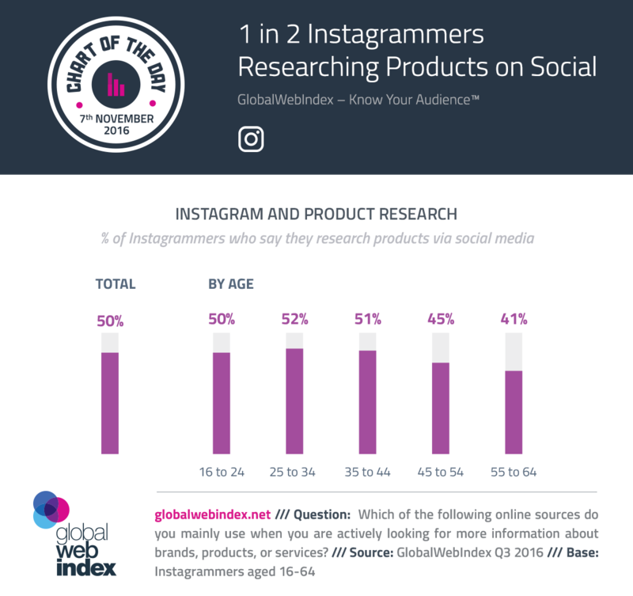
Figure Instagrammers who say they research items via social media

Instagram has a place with the class of micro scale online journals. It is a photograph sharing informal organization which empowers customers and organizations to impart through pictures and short video cuts. Instagram is a portable streamlined application and it is along these lines alleged "bornmobile". Application was initially grown just for iPhone yet today it applies to the two iOS and Android working frameworks. In addition to that it is able to likewise an entrance by means of the Internet through instagram.com (Instagram, 2015). Since Instagram has been advanced essentially for cell phone use, the route on the application is straightforward(Miles, 2014). It has the accompanying five screens:
Home Tab is a table that the most recent pictures included by the records the followers are following. On Home Tab the person can "like" and "remark" on these photos.
Discover Tab enables the users to find new people that may draw in to pursue or let investigating new subjects and themes.
Camera Tab enables the users take a photo through Instagram or reach to the photograph library to utilize existing pictures.
News channel Tab indicates two perspectives: screen of got "likes" and "remarks" and screen to pursue what different user has pursued, enjoyed and remarked as of frequently.
Profile Tab opens the person's personal account.
For organizations, Instagram is a suitable tool to help the mark image. Instagram permits to grandstand items and administrations in a rich, visual setting" (Instagram Business, 2015) where organizations can in the meantime connect with its clients with no expense. As per the investigation of viability of Instagram pictures, Instagram followers are well on the way to draw in with pictures which are relatable, straightforward and effectively reasonable and pictures of individuals (Abbott et al., 2013). Additionally, Instagram users are progressively keen on organizations' "in the background" pictures which were impractical before through classic media (Business Insider, 2013). That empowers customer to comprehend individuals behind the brand and interface with the brand in a progressively close to home way. Furthermore, the followers ought to preferably share less pictures which apply high caliber over a few pictures with low quality (Abbott 2013).
Doling out hashtags and geotag gives greater perceivability to the organization and expands the opportunity to discover new users since Instagram followers will in general associate with the individuals who share similar interests on use's hashtags (Abbott, 2013). Corporations have likewise begun diverse promoting efforts by hashtags when organization urges followers to spread familiarity with the crusade by utilizing a certain hashtag made. Corporation can in like manner utilize its very own corporations name for hashtag on its regular Instagram pictures when every one of the pictures labeled by that hashtag are classified to the equivalent Explore Tab (Miles, 2014). By "geotagging" the picture, corporation shares the extra data where the image was taken by labeling the store area or adding a connection to the organization's site into the image. Also, Instagram's most recent update enables organizations to run supported crusades on accounts (Instagram Business, 2015).

2.3.2.2 FACEBOOK

Obviously, there are drawbacks to utilizing Facebook as a marketing medium and those contain the speed with that negative presentation can walk around the everywhere and in a moment. For example, an envious opponent or a displeased representative may post negative remarks or data about the brand or the item and considering the manners by which such remarks can go "viral" in merely hours and even minutes, the case advertisers and corporations must be dependably vigilant for what is being said and remarked upon on their items. The dot to be noted here is this when, the advertiser, the corporations delegate thinks of an answer, or the refuting of the negative remark or exposure, the harm would have been finished. Aside from this, utilizing Facebook as the computerized advertising medium implies that moment delight is the standard instead of any continued commitment with the brand. This outcomes in customer modelling conclusions of the brand in a shallow and shallow way which implies that little consideration is paid to more profound idea and nuanced promoting just like the case with classic media.
Customers are permitted to form gatherings and pages and have been doing as such for individual purposes, and furthermore as fan activities supporting brands or VIPs. The pages are a generally new element on the site, and are mostly aimed at among others open figures, associations and nearby organizations. Facebook composes 'Associate with your gathering of people, share your story and take an interest continuously discussions rapidly and effectively on Facebook'. Smith affirms that a Facebook page is basic for keeping up an effective digital networking stage. The page, she proceeds, energizes investment and association between the brand and its fans. It likewise offers radiant open doors for challenges and elite offers.
Each page has a similar essential design as a profile on the stage. To one side there is a profile picture and only beneath there is space for light data. Those showcase the quantity of fans, any causes the brand underpins, speedy connects to the photographs a brand or its fans has transferred, or other data the brand has shown on the first page. Over the divider there are a few tabs where individuals can achieve brands' picked application.
42% of advertisers report that Facebook is basic or necessary to their business(State of Inbound Marketing 2012) That is a packed commercial center, however you can't stand to sit it out, in light of the fact that chances are genuinely high that your opposition is there. The key is to utilize Facebook showcasing effectively and endeavor beyond any doubt that your endeavors emerge from the group.

16 Million business pages have been made as of May 2013 that is a 100 percent growing from 8 million in June 2012. (Facebook 2015). Facebook promoting has changed how business is directed, and its utilization by neighborhood organizations to stretch out their business sectors keeps on detonating.
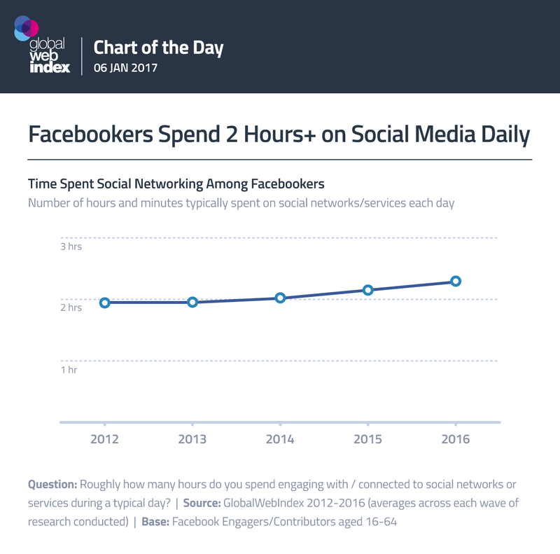
Figure How many times do users use on Facebook

2.4 Digital Marketing Models

The accompanying models are helpful for advertisers so as to accomplish an engaging advancement for the business on Instagram. In the first place, for marketers to pick up the general comprehension of online networking promoting (Kaplan and Haenlein, 2010), second, to make a successful computerized showcasing plan (Chaffey, 2015) and third, to produce engaging Instagram post (Miles, 2014).
Colley (1961) expressed that achievement or disappointment of the promoting relies upon how well it passes on data to the ideal individuals at the ideal time at the correct expense. Frey (1947) accentuated that while making a publicizing advertisers must consider the "psychological advances" purchaser is passing when they are presented to the advert. Despite the fact that an Instagram post can't completely be viewed as publicizing, it is still piece of the organization's advancement and in this manner reasonable speculations from publicizing have been connected so as to advertiser accomplish the best advancement for its business. By viability, advertisers plan to discover the best approach to pull in customers in a way which can prompt brand mindfulness and even to a real buy.
Kaplan and Haenlein suggest the accompanying five-advance rule for advertisers to connect with its clients through online networking stage (Kaplan and Haenlein, 2010):
Be active– Online networks are tied in by sharing new contents effectively and monitoring the dialogs and reacting to the discussions. Since it is trying to check the talk on online networking, corporations ought to rather draw in purchasers in an open and dynamic two-way discussion and in this way be so called "prosumers" when the two of them produce and use up the data (Toffler, 1980).
Be exciting – Corporations must tune in to their client and watch their interests so as to convey intriguing substance meeting their inclinations. A capacity to see esteems and enthusiasm from the client's point of view empowers the organization to lead the substance they can connect with the client for their desires.
Be unassuming – In request to obtain progress online networking, advertisers firstly need to accumulate a sufficient measure of information about the networks it is gripping in with. Remember that joining digital networking is a two-way communication where organizations need to enable shoppers to associate and impart their insights and criticism.
Be amateurish – To get hold of in clients, digital networking is generally utilized for amusement and for this reason advertisers are well-advised to not create excessively proficient contents on networks.
Be true – It is crucial not to post misdirecting data since it can never be totally erased next to posting it on the web. In this way, advertisers should just post data which is totally right so as to maintain a strategic distance from false impressions in correspondence with purchasers.

2.4.1 Race – Digital Marketing Plan

The refreshed RACE model was presented by Dave Chaffey (2015) so as to assist advertisers with designing a compelling digital networks showcasing plan by utilizing coordinated correspondences to persuade and connect with clients. The principle goal is to comprehend client needs through investigation and knowledge (Chaffey, 2015). In the accompanying, the model is exhibited well ordered.
Reach goals at growing the social audience by defining a target audience for convey the brand message through the selected medium.
Act by recognizing the best sorts of contents so as to help the brand associations trough online networks. Through all around structured substance sharing, organizations can acquire commitment either on passionate or judicious dimension which impacts on either expanded mindfulness or buy aim for instance, organizations who post up and coming rivalries apply greater amusement among their devotees and mindfulness for the business while a point by point post of an item with value direction apply to persuade the customer while including the buy aim.
Convert characterizes how the corporations can profit by the online connections for instance by rising sales.
Connect with assembles client devotion by effectively keeping up and dealing with the mutual contents and cooperating through the medium.
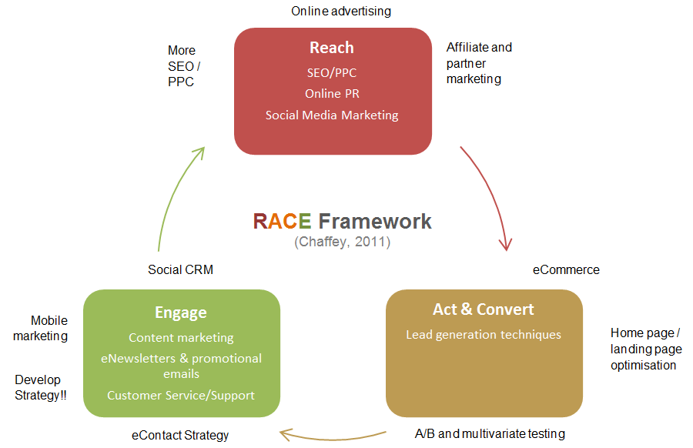

Figure 5. Race Model

2.4.2 AIDA model

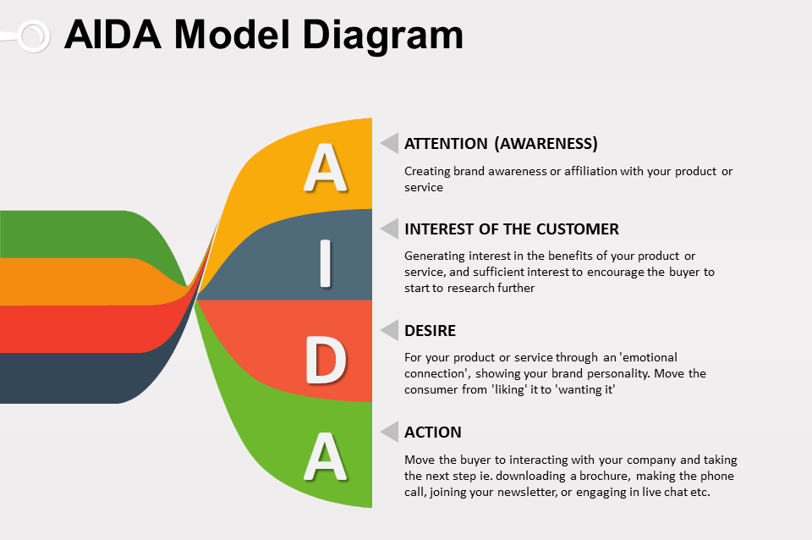
AIDA is a model that promoting efect which advertisers implement when forming an promo campaing so as to more readily attract in and contact with its audience. Despite the fact that, the model was initially created for printed publicizing, now AIDA can be connected for virtual advertising, especially for showcasing on Instagram (Miles, 2014).
Figure 6. Diagram of AIDA model diagram
AIDA model can be shown the modern marketing theory . AIDA model is marketing main action in planning advertisement which is ensue about because of clients' perceptions. AIDA is mentioned that Attention (A), Interest (I), Desire (D) and Action (A). AIDA is shortening which is using in advertising and marketing. it define common list of happenings, that is probably to happen when a client contain on a specific advertisement. Mackey describe that AIDA consist of Awareness (careful to client); Interest (grouth clients' care by concentrating on benefit and advantage and it is not focused around quality like in classic advertisement); Desire (persuasion the clients that the desire of an item or services can satisfy the customers requirements); Action (basic client actions as well as buy items and services) ( Mackey, 2005; 10)
As indicated by the necessities of AIDA model, the point of promoting is to pull in main buyers' consideration, to rising the shoppers' attention and want to do the last action (buy). In buying process, advertising strategy utilizing AIDA model is rising the trust grade of customers' applicant (the capability of buyers' possibility to be a main purchaser). In consistency between advertising desires and marketing needs will diminish change dimension of the following AIDA step. As indicated by the AIDA hypothesis, corporations can consider advertising process by utilizing AIDA model as a promoting model.
Miles gives a rule to marketers how AIDA can be connected into social networking platforms showcasing by the following sample:
Attention (A) is achieve for instance by sharing an image of an item dispatch or utilizing a one of a kind item situating in an image. A corporation can likewise share off camera photos by indicating users what is as of now occurring in the shop.
Interest (I) - Making interest is commonly the difficult section. For instance, if the item or service does not naturally interesting, thas can be hard to succed. Ensure that promoting data is separated and simple to peruse, with intriguing subheads and outlines. Concentrate that is the most suitable for your objective market in corellation to your item and services, and on deliver on just the most significant message you need to connection to buyers.
A genuine case of that is Tony's "Where is the meat?" advertisement campaing that concentrated on the way that Tony's cheeseburgers contained more meat than their rivals' burgers.
Desire (D) - steps of The second and third of AIDA model becomes together. Because of you are hopefully fabricating enthusiasm for a goods and service, it is significant which you help clients acknowledge why clients "need' that goods or services. Consider how the substance in infomercials is introduced – they intend to give fascinating data on the goods, alongside profit of getting it – profits in which a perfect formed purchasers need the goods to an ever increasing extent. Informer does that very well by demonstrating the item being utilized in lots of intentive condition.Convey to the target groups the worth of the services and the goods. And why the audience want and need these in their lifes.
Action (A) - Aida model's last section. This is the outcome of the three prior sections. Be that as it may, activity isn't really the genuine buy, it can likewise be a positive result of the brand mindfulness and brand demeanor when a corporation gets new supporters on its digital media account. As referenced previously, it sets aside effort to accomplish enhancements, particularly in deals.

3.1 Branding in social media
3.1.1 Conspectus

The importance of including a digital media in branding strategy is the fact that the amount of active digital media fans is already large and growing. Through the presentation of mobile phones, digital networks has become mobile and ever-present, making presence on online networks necessary to marks
The absolute most significant parts of online networking from a marking and advertising point of view, are that the clients are quality for the substance they see, share, make, or remark on, and endeavors are cheap , deeply quantifiable and targetable in contrast.
But, that does not signify that advertising in classic media is obsolescent . Instead of, online media, such as traditional media and digital nets, utilize like one another supportive channels in online networking. The benefits of classic media is its impact to formed rapid brand recognition in the common community.

3.1.2 Positive and negative directions

Perhaps the biggest advantage of digital media is the low cost required to have digital media existence and the low amount of resources. For this reason, social media has turned on more opportunities particullary for small or new started businesses.
By Montero Torres, with the help ofdigital media applications, brands can directly contact and interact with people. Such private interaction can formed and power brand loyalty to brands actively involved in digital networks.
Traditional media are stronger than social media in creating brand awareness for mass media campaigns. But, the disadvantage of brand recognition through traditional media is the inability to select the full target audience and ignore such tools. Brand awareness campaigns are successful only to reach the right audience. And traditional media advertising is so expensive than digital media advertising. For example television advertising.

4. Methodology
4.1 Research philosophy

Philosophical perspective on the investigation is important so as to give understandings how the creator is seeing the everyhting what is around the world and how the result have been achieved (Saunders, Lewis, 2012). There are two types of basic research ideal models are positivism and interpretivism (Malholtra 2006). The positivism looks for the general theory about the connection between various variables. The goal is to achieve widespread clarification which can anticipate the future occurrence (Saunders, 2012). Interpretivism thus, plans to comprehend the specific investigation topic that is inspected. Interpretivism see looks for contrasts, clarifications and understandings between various customer behaviour (Bryman and Saunders , 2012). The interpretivistic explore theory is likewise fitting when the exploration centers around the particular field of the business or analyzes the specific hierarchical conduct (Saunders et al., 2012).
With respect to the idea of that dissertation, that is to discover various corner of corporations' social media marketing, the philosophical establishment is focal around an interpretivism point of view. Interpretivism the best applies the motivation behind that dissertation, which is to increase comprehension and information of social media marketing. Along these lines, the intention isn't to accomplish the generalizable information of the topic that is the reason the positivism see isn't material for that examination. Consequently, the discoveries of this exploration are material to clarify that specific setting of social media marketing in the specific locus and the space of business.

4.2 Research approach

Research approaches have three types. They are induction, deduction and evasion. Inductive strategy expects to achieve all around summed up ends through the perception of a few single observational occasions. Deductive thinking underlines the significance of speculations and the examination system is created dependent on the current hypothesis to assess these theories. With evasion thinking, information is utilized for adjusting new bits of evasion or changing the current hypothesis so as to investigate the wonders. Evasion applies to this examination when the aim is to investigate and increase new learning, data and qualities for the exploration topic. Since the focal point of that dissertation is on the particular field of business and inside the specific area, snatching is relevant in light of the fact that it isn't looking for an all inclusive speculation (Saunders, 2012).
As indicated by Wallén is the initial step of an exploration to ponder what issue the investigation will concentrate on. That will set the decision of system, the hypothesis approach and the information accumulation. In this case we concentrated on the issue of how marketing on social media for brand recognition. The reason for existing was to contribute with increasingly hypothetical information in regards to that subject. Wallén clears up that a logical issue can probably be that the inquires about are scanning for information that a new and this is significant that the outcome has some widespread appropriateness.
Mattson believes the illustrative research technique to be a strategy which endeavors to comprehend and clarify why a marvel happens.

4.3 Qualitative Research

The aim with both quantitative and subjective research methods is to convey qua precise comprehension of the inspected research topic as would be prudent (Birks, 2007). Quantitative analyze method intends to quantify the information and accomplish factual ends while subjective research approaches the examination issue with progressively adaptable habits. Subjective technique isn't as organized as the quantitative exploraion strategy and along these lines gives more opportunity and adaptability to the specialist to gather essential information through the picked members. The analyst in a subjective report is additionally permitted to approach the examination issue from a more extensive viewpoint than what quantitative exploration technique would allow (Bryman, 2015). Contrasted with the quantitative exploration , the fundamental advantage of subjective exploration is its capacity to comprehend the members' sentiments, practices and inspirations while analyzing the particular analyze topic (Birks, 2007).
Since the point of that investigation is to investigate social media marketing to brand recogniton showcasing by social event new bits of knowledge and learning of the theme, a subjective research method has more preferences over the quantitative research. Considering the restricted measure of concentrates about social media, subjective research permits investigating the theme where just little is known and when the new marvels is should be clarified. The subjective strategy likewise perform when the data is accumulated with a generally little gathering of members (Bryman and Bell, 2015; Malhotra and Birks, 2007).

4.4 Research Design

An exploration design is the most significant structure for the investigation that reflect in the choices of the examination approaches all through the entire investigation process, for example, which inquire about strategy selected to lead the exploration (Bryman, 2015). Unmistakable and exploratory inquires about are the three for the most part realized research structures (Malholtra, 2007). Causal exploration configuration focal around the circumstances and logical results connections. An examined wonder is comprehended through individual factors that are the impact for the particular reason. The reason for exploration configuration is to testing and discover clarifications for the theories the analyst has set. Engaging exploration means to depict and quantify particular factors and pursue the all around organized conjectures and analyze questions (Malholtra, 2007).
Because of the constrained measure of exploration with respect to socal media platforms' marketing showcasing, explicit theorizes can't be detailed for that investigation, that regulations all of causal and graphic exploration structures. Contrasted with both of two exploraty design, research is unquestionably progressively adaptable. Since the motivation behind that dissertation is to investigate the chances and difficulties of social media marketing from the various points and stages, exploratory configuration is viewed as a proper technique to direct that topic. Exploratory analyze is commonly utilized in the situations when the examination issue can't be estimated through the quantitative methodologies and the reason for existing is somewhat to obtain new bits of knowledge and comprehension for the analyze topic (Malholtra, 2007).

5. RESULT

The research method was survey and questionnaire with 14 questions was asked to respondents. The contact method was through online social network. The total number of respondents is 472 people. The results were analyzed via SPSS 16 package. The data in research is non-parametric because there is no scale measure. Majority of data is ordinal and the rest is nominal.
Table....Gender statistics.

If we look to the table (nomresini ozun yaz isine uygun) above, we can see that 472 respondents participated in the research. Out of 472 respondents 339 that is 71,8% are female and 133 that is 28,2% are male.
Diagram ..... Age.

When we pay attention to the diagram above, we can see that majority of respondents are young, around 272 respondents that is 57,6% is between 16-25 of age. The next age limit is 26-49 and they are 183 respondents that is 38,8%.

Table .... above shows the education level of respondents. When we look at the table we can see that 296 that is 62% out of 472 respondents hold bachelor degree. 69 respondents that is 14.6% have master degree. Only 1.3% of respondents have phd degree. So majority of respondents are educated.

When looked to the occupation of respondents we can clearly see that around 233 respondents that is 49.4% are unemployed. This is due to the fact that those respondents were young students who currently in the last year of bachelor degree. Next majority of respondents that is 119 of them indicate that they work in private sector. The rest of respondents that is 78 and 42 indicated that they work in government and self employed respectively.

Diagram..... Social platform

The diagram above indicate the social platforms that people use. From the diagram we can see that the majority of respondents that around 170 respondents use 4 different social platforms. 5 different social platform users come next with 80 respondents and in the third place comes 2 social platform users. They are below 50.

Table above indicates how consumers recognize their brands in social networks. 144 respondents that is 30 % of them recognize the brands from the posts, next comes 64 respondents that is 13% indicate that they recognize their brands from the story.
Chart. Time spent in social media

The pie chart above indicates the respondents times spent in social media in total in a day. From the chart we can see that 31.99% of respondents spent around 0-2 hours in social media in a day. Next comes 31.36% that spend 2-4 hours in social media in a day. Then comes 20.34% of respondents that indicated they spent 4-6 hours in social media. The last group of respondents that is 16.31% indicated that they spent more than 6 hours a day in social media.
The next question was about YouTube adds. One of the interesting topics in social media is YouTube adds. 378 respondents indicated that they didn't watch adds in YouTube. 19.9% of respondents vice versa indicated that they watch YouTube adds.

The next question was about which pages they like to follow in social media. Around 132 that is 28% of respondents indicated that they like to follow sport pages, 98 that is 20.8% of respondents indicated two answers with sport and clothing, 50 that is 10.6% of respondents like to follow entertainment pages.

When comes to the reliability of social media, 197 that is 41.7% of respondents trust the social media but unfortunately 275 that is 58.3% of respondents didn't trust to reliability of social media.

Last question was about popular brands that respondents bought in social media. The most popular brand that is perceived to be best for respondents is Huda beauty. 204 respondents that is 43.2% voted for this brand. Next best perceived brand are Zara, Nike, Apple with 28 respondents, 17 respondents, 16 respondents respectively.

popular
 |  | Frequency | Percent | Valid Percent | Cumulative Percent
Valid | Huda beauty | 204 | 43.2 | 43.9 | 43.9
 | Nike | 17 | 3.6 | 3.7 | 47.5
 | Adidas | 8 | 1.7 | 1.7 | 49.2
 | Fendi | 4 | .8 | .9 | 50.1
 | Ali express | 13 | 2.8 | 2.8 | 52.9
 | Balenciaga | 1 | .2 | .2 | 53.1
 | Apple | 16 | 3.4 | 3.4 | 56.6
 | Zara | 28 | 5.9 | 6.0 | 62.6
 | D&G | 10 | 2.1 | 2.2 | 64.7
 | Kylie cosmetics | 13 | 2.8 | 2.8 | 67.5
 | Kiehl's | 5 | 1.1 | 1.1 | 68.6
 | Kabluchok | 8 | 1.7 | 1.7 | 70.3
 | Xiaomi | 7 | 1.5 | 1.5 | 71.8
 | Coco Baku | 11 | 2.3 | 2.4 | 74.2
 | Cartier | 10 | 2.1 | 2.2 | 76.3
 | D&G | 8 | 1.7 | 1.7 | 78.1
 | YSL | 16 | 3.4 | 3.4 | 81.5
 | Dior | 9 | 1.9 | 1.9 | 83.4
 | Benefit cosmetics | 4 | .8 | .9 | 84.3
 | POLO | 16 | 3.4 | 3.4 | 87.7
 | Coca Cola | 16 | 3.4 | 3.4 | 91.2
 | Gucci | 10 | 2.1 | 2.2 | 93.3
 | Masimo Dutti | 1 | .2 | .2 | 93.5
 | Cinici | 6 | 1.3 | 1.3 | 94.8
 | Ideal | 1 | .2 | .2 | 95.1
 | Amazon | 8 | 1.7 | 1.7 | 96.8
 | Mac | 4 | .8 | .9 | 97.6
 | Trend Yol | 6 | 1.3 | 1.3 | 98.9
 | Nyx | 3 | .6 | .6 | 99.6
 | Nars | 2 | .4 | .4 | 100.0
 | Total | 465 | 98.5 | 100.0
Missing | Gap | 7 | 1.5
Total |  | 472 | 100.0
6. CONCLUSION

Brands are a component of the digital media, and are joining themselves into the day by day lives of users and fans on much further developed dimension than before through utilizing online networking. It has necessity for marks to debate about them in online networks, on the off chance that not to control it, at that point at any rate have the power to impact its way. That dissertation has goaled to get a handle on what marks' basic utilizes are in their action on the digital media platforms.
Utilizing Aaker's four character viewpoints as a base, it was, as estimated, found that the most overwhelming approach to depict their image personality online networking was through applying the point of view of Brand as Person. All personality viewpoints were tended to and utilized by the marks; in any case, they all the more much of the time took on the situation of an individual as opposed to an association, item or image. That conclusion can be gone after goods and person marks, who appear to have acknowledged that the best approach to act online networking is to be a companion instead of an expert; to be agreeable as opposed to distant. In a manner it is to a greater extent a proportional relationship – fans care about the brand, and online networking the brand demonstrates that it thinks about the fans legitimately to the general population being referred to through cooperating with them.
Respecting that how goods and brands use digital media applications one by one, it was discovered that there were lots of variables.In this way, as the predicament are some what expansive this outcome should just be treated as a sign and not as a finished outcome.
The way that persons utilize exceptional proposals and challenges with reference to sales maybe not themselves but rather things bearing their name is extremely intriguing to watch. It underpins the announcement referenced in the presentation of that dissertation that there is as of now a thingification of culture. Especially captivating concerning the commodification of brands is that they, at the same time as thingifying themselves, are as a rule less real about their personal lifes.
They are continuing apparently personal discussions on open gatherings, for example, Facebook, enabling fans to collaborate with their cult figure on an increasingly private to home dimension and giving a one of a kind knowledge to the mark. Along these lines, in utilizing extraordinary offers, special features or challenges, brands are empowering a more profound association with fans and clients in a customarily item way, while they in the meantime are welcoming them to take an interest in, or possibly be conscious of, an association with their venerated image that before online networking had not been a choice.
In general, along with the sharp increase in online networks usage over the past year, brand and business targets are an indication of a more relevant relationship between business and culture. Although the subject of cultural branding is a great platform for dissemination and debate of digital media, but it is a minor issue in that dissertation, even though these brands are a cultural material.
As noted earlier, Douglas B. Holt wrote the brand as a legend and a variety of authors; corporations, culture industries, mediators and consumers or users. Despite being used by all authors, online networking provides a voice that changes the weight of stories that are made up of stories more than ever for users and consumers.
Because a large part of the legend originates from the users, marks are not only in sales and numbers but also in the sense of brand. Online networks has democratized culture, and the process of branding, as strength has been adabted to humanity, and sites like Facebook, Instagram and etc. provide a bridge to meet with mark owners and eventually work with users to shape the stories that finally formed marks myth.

BIBLIOGRAPHY

- “The Best Global brands”, BusinessWeek, August 6th 2002.
- Foster, R. and Kaplan, S., Creative Destruction: Why Companies That Are Built to Last Underperform the Market 2001.
- Interbrand, Brand Valuation, March 2003, p. 3.
- K.W. Suh, manager, global marketing August 6th 2003.
- Madden, T.J. (University of South Carolina), F. (University of South Carolina) and Fournier, S.M. (Harvard University), Brands Matter: An Empirical Investigation of Brand-Building Activities and the Creation of Shareholder Value, unpublished paper, May 2nd 2002.
- Akasia, J.F., “Ford’s Model E”, Forbes, July 17th 2000, pp. 30–34.
- Examples are Klein, N., No Logo, Picador, 1999; Philip Kotler, interview in the Financial Times, May 31st 2003.
- PIMS (Profit Impact of Marketing Strategy), “Evidence on the contribution of branded consumer business to economic growth”, PIMS Europe, London, September 1998.
- Ries, A. and Trout, J., Positioning: The Battle for Your Mind, McGrawHill, 1981. 2 Cowley, D. (ed.), Understanding Brands: By
- 10 People Who Do, Kogan Page, 1996.
- Watzlawick, P., Pragmatics of Human Communication, W. W. Norton, 1967.
- Jones, J.P., When Ads Work, Lexington Books, 1994.
- Doyle, P., Value Based Marketing, John Wiley & Sons, 2000.
- Crimmins, J. and Anschuetz, N., “Contagious Demand”, Market Research Society Conference, 2003.
- Damasio, A., Descartes’ Error: Emotion, Reason, and the Human Brain, Putnam, 1994.
- Schacter, D., Searching for Memory: The Brain, The Mind, and The Past, Basic Books, 1997.
- Heath, R., The Hidden Power of Advertising, WARC, 2002.
- Olins, W., “Branding the Nation – the historical context”, Journal of Brand Management, Vol. 9, No. 4–5, April 2002.
- Ind, N., Living the Brand, Kogan Page, 2001.
- Anholt, S., Brand New Justice: The Upside of Global Branding, Butterworth-Heinemann, Oxford, 2003.
- Anholt, S., “Editor’s Foreword”, Journal of Brand Management, Vol. 9, No. 4–5, April 2002.
- Aaker, D.A. (1996) Building Strong Brands, London: Simon & Schuster UK Ltd.
- Aaker, J.L. (1997) 'Dimensions of Brand Personality', Journal of Marketing Research, vol. 34, no. 3, August, pp. 347-356.
- Aaker, D.A. (2010) Building Strong Brands, London: Pocket Books.
- Aaker, D.A. and Joachimsthaler, E. (2000) Brand Leadership, London: Pocket Books.
- Batra, R., Myers, J.G. and Aaker, D.A. (1996) Advertising Management, 5 th edition, New Jersey: Prentice Hall.
- Beuker, R. and Abbing, R. (2010) 'Two Faces of Social Media: Brand Communication and Brand Research', Design Management Review, vol. 21, no. 1, March, pp. 54-60.
- Chordas, L. (2009) 'Branding a New Social Norm', Best's Review, November, pp. 74-76.
- De Pelsmacker, P., Geuens, M. and Van den Bergh, J. (2007) Marketing Communications - A European Perspective, 3 rd edition, Harlow, England: Prentice Hall.
- Deacon, D., Pickering, M., Golding, P. and Murdock, G. (2007) Researching Communications: A Practical Guide to Methods in Media and Cultual Analysis, New York: Hodder Arnold.
- Holt, D.B. (2004) How Brands Become Icons: The Principles of Cultural Branding, Boston: Harvard Business School Publishing Corporation.
- Jones, B., Temperley, J. and Lima, A. (2009) 'Corporate reputation in the era of Web 2.0: the case of Primark', Journal of Marketing Management, vol. 25, no. 9-10, November, pp. 927 - 939.
- Brown, J., Broderick, A.J. and Lee, N. (2007) 'Word of Mouth Communication within Online Communities: Conceptualizing the Online Social Network', Journal of Interactive Marketing, vol. 21, no. 3, Summer, pp. 2-20.
- Carlsson, L. (2010)
- Grönroos C. (1994). Quo Vadis, Marketing? Toward a Relationship Marketing Paradigm. Journal of Marketing Management, 10, 347-360.
- Grönroos C. (1997). From Marketing Mix to Relationship Marketing – Towards a Paradigm Shift in Marketing. Management Decision 32/2. MCB University Press, 322-339.
- Gummesson E. (2008). Customer centricity: reality or a wild goose chase? European Business Review, 20(4), 315-330.
- Heding, T., Knudzen, C.F. and Bjerre, M. (2009) Brand Management: Research, Theory and Practice, Abingdon: Routledge.
- Hernandez, R. (2010) The Language of Love in Social Media: New Rules for Brand Engagement (Summary Report), Chicago: Firefly Millward Brown.
- Kapferer, J.N. (2008) The New Strategic Brand Management: Creating and Sustaining Brand Equity Long Term, London: Kogan Page.
- Keller, K.L., Georgson and Mats, A.T. (2008) Strategic Brand Management: A European Perspective, Harlow, England: Prentice Hall.
- Kotler, P., Armstrong, G., Saunders, J., & Wong, V. (2005). Principles of Marketing. Pearson Education Limited, 4th European Edition.
- Kumar N. (2004). Marketing as Strategy, Understanding the CEO’s Agenda for Driving Growth and Innovation, Harvard Business School Press, Boston, MA.
- Lash, S. and Lury, C. (2007) Global Culture Industry, Cambridge: Polity Press.
- Levine, R., Locke, C., Searle, D., & Weinberger, D. (2001). The Cluetrain Manifesto: The end of business as usual. New York: Basic Books.
- Lincoln, Y. S., & Guba, E. G. (1985). Naturalistic Inquiry. Newbury Park, CA: Sage Publications.
- Malhotra, N. K., & Birks, D. F. (2007). Marketing research - An applied approach. Harlow: Pearson Education Limited, 3rd edition.
- Mangold, W.G. & Faulds, D.J. (2009). Social Media: The new hybrid element of the promotion mix. Business Horizons, 52(4), 357-365.
- Marshall, C. & Rossman, G.B. (1999). Designing qualitative research. Newbury Park: Sage, 3rd edition.
- Mayring, P. (2000). Qualitative Content Analysis. Forum: Qualitative Social Research, 1(2), Art. 20.
- Internet source entires:
- Foulger, M. 2014. The social media manager’s definitive glossary. Hootsuite Social Media Management. URL: http://blog.hotsuite.com/social-media-managers-definitive-glossary2014/. Accessed 26.09.2015
- Globalwebindex. 2015. GWI social summary. URL: https://www.globalwebindex.net/hsfs/hub/304927/file-2812772150-pdf/Reports/GWI_Social_Summary_Report_Q1_2015.pdf. Accessed 26.09.2015
- Globalwebindex. 2015. GWI social summary report Q1. URL: http://www.thewebmate.com/wp-content/uploads/2015/05/GWI-Social-Report-Q1- 2015.pdf. Accessed 26.09.2015
- Herman, J. 2014. Create an effective hashtag strategy for Instagram. URL: http://curatti.com/create-an-effective-hashtag-strategy-for-instagram/. Accessed 27.09.2015
- Iconosquare. 2015. Key metrics about your Instagram account. URL: http://iconosquare.com. Accessed 03.10.2015
- Instagram. 2015. Instagram. URL: http://instagram.com/about/faq/#. Accessed 26.09.2015
- Instagram. 2015. Intellectual property.
- URL: https://help.instagram.com/535503073130320/. Accessed 30.10.2015
- Social media in branding: Fulfilling need. URL:https://link.springer.com/article/10.1057/bm.2011.19
- Lawler, J.P. and Mollusso, J.C. (2010) A study of the perceptions of students on privacy and security on social networking sites (SNS) on the internet. Journal of Information Systems Applied Research 3 (12): 3–18.
- Google Scholar
- Lee, K. 2014. How to schedule social media content for next week, next month, and next year.
- URL: https://blog.buferapp.com/schedule-social-media-content-plan. Accessed 18.10.2015.
- Young, Eric. 2015. How millennials get news: inside the habits of America’s first digital generation. American Press Institute associated Press-NORC Centre for Public Affairs Research. URL:http://www.mediainsight.org/PDFs/Millennials/Millennials%20Report%20FINAL.pdf. Accessed 27.09.2015
- Zickuhr, K. (2010) Generations 2010. Washington DC: Pew Research Center.Google Scholar
- Businesswire (2007) Google Rises to the Top of the BRANDZ™ Ranking with a Brand Value of $66,434 Million, 23April, [Online], Available: http://www.businesswire.com/news/home/20070423005431/en/Google-Rises-TopBRANDZ-TM-Ranking-Brand [21 November 2010].

APPENDICES
APPENDIX 1. Survey form

“Analysis of the role of social media in brand recognition“ survey

- What is your gender?
- Female
- Male

- What is your age?
- Under 16 years
- 16-25 years
- 26-49 years
- 50-65 years
- Over 65 years

- Your nationality

- Azerbaijani
- Turkish
- Russian
- Ukrain
- Indian
- German
- Kyrgyz
- Deutsch
- Korea Republic
- Austrian
- Swedish

- What is the highest level of education you have completed?

- High school diploma
- Some college
- Bachelor's Degree
- Master's Degree
- Ph.D/M.D.

- Occupation
- Self Employed
- Private Sector
- Government
- Unemployed

- Which social platforms do you use?

- YouTube
- Instagram
- Facebook
- Pinterest
- Whatsapp
- Twitter
- B Kонтактe

- How do you recognize brand in social media?

- Post
- Story
- Hashtag
- Tag
- Direct

- How much time do you spend in social media?

- 0-2 hours
- 2-4 hours
- 4-6 hours
- 6+ hours

- Are you interested in these types of ads?

- Yes
- No

- Which pages are you following most?

- Clothing
- Entertainment
- Sport
- Food
- Education
- Business
- Do you think ads on social networks are reliable?
- Yes
- No

- Is social media influencing your purchasing behavior?

- Yes
- No

- Have you purchased anything through social media?

- Yes
- No

- What is the most popular brand you know in social media?

