The Ministry of Education of Azerbaijan Republic

The Fourth Industrial Revolution and Global Changes in Modern Management System

Aynur Alizada

UNEC SABAH
Azerbaijan State University of Economics

BAKU - 2019

Acknowledgements

First and foremost, I would like to offer my gratitude to Mr. Khalid Javadov, who teaches me main subjects about my specialty since the 3rd course. What I have been taught and supported by the industrial revolution and modern management has been the main help in writing this thesis and collecting and continuing control of the material. I also offer my appreciation for the learning and studying opportunities provided by my Dean, a Cand. of Econ., Assoc. Prof. Aida Aydin Guliyeva; Head of SABAH groups at Azerbaijan State University of Economics (UNEC).
Thank to my professors, who have been there continuously for me, and to everyone who has contributed to my progress during my studies.

Abstract

The Fourth Industrial Revolution is a mixture of physical, digital and biological world technologies, which creates new opportunities and affects political, social, and economic systems. The Industry 4.0 is the basis of modern production, including digitalization and robotics, artificial intelligence and Internet of things (IOT), new materials and biotechnology. Due to these changes in production in developed countries, it is becoming increasingly important source of well-being and creation of new jobs. Industry 4.0 in every aspect of production is revived, and this continuous process shows itself in increasing product and service choices. Also, modern management and the use of human resources within the organization, modern management and integration of technology with these indicators are key factors for our contemporary era. The 21st century is based primarily on the growth of digital economy, technology and innovation in the world economy and emphasizes the superiority of certain states by applying it in all other areas.
Thesis reflects some of the challenges and advantages of the modern world economy and the role of the Industry 4.0 in the implementation of their solution. Due to the digital economy and the world's upholding innovation and innovation in modern times, it is expedient to use the innovations of the Industry 4.0 in chains of different industries.

Contents
Acknowledgements i
Abstract ii
1. INTRODUCTION 1
1.1 BACKGROUND OF STUDY 1
1.2 PURPOSE OF THE STUDY 1
1.3 RESEARCH QUESTIONS 1
1.4 SIGNIFICANCE OF THE STUDY 2
2: THEORETICAL ANALYSIS OF STUDY 3
2.1 THEORETICAL VIEWS OF INDUSTRIAL REVOLUTIONS 3
2.2 CAUSES FOR THE FORMATION OF INDUSTRY REVOLUTIONS AND THE CHANGES THEY MAKE IN THE ECONOMIC SYSTEM. 7
2.3 THE FOURTH INDUSTRIAL REVOLUTION AND ITS BASIC CONCEPT 14
3: MODERN INDUSTRY MANAGEMENT SYSTEMS AND GLOBAL TRENDS OF THE 4TH INDUSTRIAL REVOLUTION. 22
3.1 MODERN INDUSTRY MANAGEMENT SYSTEMS AND THEIR KEY FEATURES 22
3.2 GLOBAL TRENDS OF THE 4TH INDUSTRIAL REVOLUTION 31
3.3 CHANGES IN THE INDUSTRIAL MANAGEMENT SYSTEM AS A RESULT OF THE INDUSTRY 4.0 42
4: THE MAIN DIRECTIONS OF THE PERCEPTIVE CHANGES IN THE 4TH INDUSTRIAL REVOLUTION IN INDUSTRIAL MANAGEMENT. 48
4.1 NEW MANAGEMENT SYSTEMS AND NEW LEADERSHIP PHILOSOPHY. 48
4.2 MODERN ORGANIZATIONAL AND MANAGEMENT MODELS IN INDUSTRY 56
4.3 MODERN HUMAN RESOURCES MANAGEMENT MODELS AND KNOWLEDGE ECONOMY. 63
5.CONCLUSION 70
5.1 RECOMMENDATIONS 72
6. REFERENCES 73

1. Introduction
  - Background of Study
The 4th industrial revolution today has led to a new angle of vision and innovation in the economy. This revolution played an important role in boosting economic growth and managed to maximize the use of technology with its innovations. In the modern world, an industry action plan has been compiled for each sector of the economy by utilizing the 4th industry revolution innovations.
4th industrial revolution in each sector of the economy can redefine its strategic plan in a more innovative way. These innovations are widely used by both developed and developing countries in the world. Many developing countries are acquainted with the features of this revolution and try to apply it to their own countries. For this, they use the experience methods of developed countries. This is the most innovative way to get an important market share on the entire world market.

Purpose of the study

The purpose of the study is to investigate the use of modern technologies and innovations and to examine their positive aspects and ways by examining the experience of different countries and organizations. Since the main requirement of the modern era is high technology and innovation, it is important to apply projects in this direction and to allocate them a certain amount of investment.

Research Questions

To measure the impact of the 4th industrial revolution on each sector of the economy, I try to answer the following questions in my research:
1. Determining the growing role of the 4th industrial revolution in the economy
2. Study of international experience and comprehensive provision of its application
3. Creating perfect organizational structure in the modern management system using the 4th industrial revolution innovations.
4. Measurement of the benefits derived from human capital and the 4th industrial revolution

1.4 Significance of the Study
The main focus of my research is to apply the technology and innovation experience throughout the world during a sustainable development period. One of the other important aspects of this field is the development of modern management systems with the innovations of the 4th industrial revolution and the removal of the old system and the application of profitable business environment. In this case, the economy of the country will become stronger and prove itself in the international market.

2: Theoretical Analysis of Study

2.1 Theoretical Views of Industrial Revolutions

The revealing 'industrial revolution', as a generic conception, direct to the origin, in the course of the passage-way between a pre-industrial and an industrial community, of contemporary economic surplus, i.e. a durable and significant growth of GDP per capita in reality. When economy refer to the 'revolution', it does not mean that this trial would properly be instantaneous and speedy. At the beginning, it illustrate that it was profound and influential. Here the transition in Britain include years between 1750s and 1850s. Real GDP per capita profit only actually began increasing after in the year 1840s, when it go up to more than 1 percent in a year. Different modern industrial sectors had already been indicating significant development in productivity in former times. But musty harvests, hastily wars, a elevated population growth, and in fact, structural economic variation always, however, particularly in a pioneer country, takes period, had the jointed effect of dampening whole surplus figures. Post-industrialized countries, overall, had a speedy step of development and a superior rate of up growth.
Industrialization is a durable process. Literature often comes from the first "classic" in England, industrial revolution, coal, iron and cotton, and then steam and railways; From the 1870s, steel, chemicals and electricity have become even stronger, and the third is probably in the twentieth century, including cars and motorcycles. For a good reason, it is claimed that the Western world has now consist a post-industrial cycle. Particular references will be to the British circumstance. Because Early Industrializing countries were not simply retyping Britain. Now historians admit that, there was not one model of industrialization. Whole of industrializing countries, nevertheless, in spite of their special circumstance, meet several essential, similar problems. The British case claim an example of what these problems are and how they can be solved. Whole pre-industrial economies were topic to what has become known as 'Malthusian' trap. Malthus illustrated that in all well-known history, the maintenance of the essential needs of the society, such as food, shelter, clothing and energy had referred almost completely both quantity and quality of the accessible land.
This case is suitable for first 3 necessity. From energy perspective, the essential part of it was provided by man and animal muscle force and by warmth produced by fire catching wood. On top of that, there was the partnership of wind and water force. And these were not straight depend on the land. Pay attention to the technological opportunities of time period and the particular constraints of those two types of energy resources, their collaboration, whereas, could only be comparatively not major. In some areas, peat was burned by people. This called 'semi-fossil', but its provisions were considerable limited, drilling has created enormous environmental problems and has created much heat compared to coal. Coal using process was known from society. So far, industrial consumption has been very important in the UK. In 1700 it was known to 3 million ton - the world's highest consumption. However, problems releated with drainage were increasing.
Development was not totally impossible: it could be comprehended by, for example, growing capital input, working severe and longer or by presenting a more effective division of labor. Whereas it had its constraints and was a steady increase in population is compelled to decline and even disappear when accompanied. In comparison, the pre-suppositions refer to Malthus started-the quantity of land is limited, technological variation is not major and production is in its declining terms - as the world knows, it is unrealistic for the world.
The drama and centralization of the Industrial Revolution ensured the continuation of new or repeated theories in this great transition. These theories fall into a number of separate categories. The theory of "false balance" tries to explain that Maltese stagnation is a product of a system of self-sustaining economic incentives. In all human societies, people's desires and rationality are basically the same. In Europe, medieval peasant, elevated Indian, height of light, general willpower and ability to act to fulfill these wishes. What is the difference between societies but organizations that manage economic life.
There is a cartoon of pre-industrial world, which many economists have intuitive, and this is a mix of all the bad movies about early societies. The Vancouver is to bring looters into the loot without burying long boats and burn and burn monasteries libraries. The Mongolian troops cross the river from the horseman to throw out the Chinese cities. Classic fanatics burn on those who dare to drive religious doctrines. The villagers only commit suicide and fight. The Aztec priest cut off his heart with obsidian knives from screaming screams. In this brutal and chaotic world that promotes time, energy, or new technology?
The advantage of a theory based on some exogenous shocks in the economic system is that it can cause a sudden change in the rate of increase in measured efficacy measured around 1800. Organizations can change dramatically and dramatically - The Theories of Institutional Changes, the Revolution of the Revolution of the French Revolution, the Revolution and the Salt of Salt, face two major difficulties, but one conceptual empirical. Conceptual difficulty, if modern economic growth can be generated by a simple institutional change, then why the world has nothing in all different and different societies since 10,000 years ago and in the past knowledge of property? The societies were distinguished by the transfer of property between the owners and owners. For example, in 1066, in the civilian jurisdictions of the Norman system in medieval England, a land disputed party may choose to prove his title to fight an opponent with an opponent! This may seem like a bare way to settle property disputes, but point shows that societies have made all kinds of choices about institutional forms. Here we cannot rely on imagination in the selection of institutions. There must be something in the "evil" position in the industry.

Table 1. Industrial Revolutions and their key features

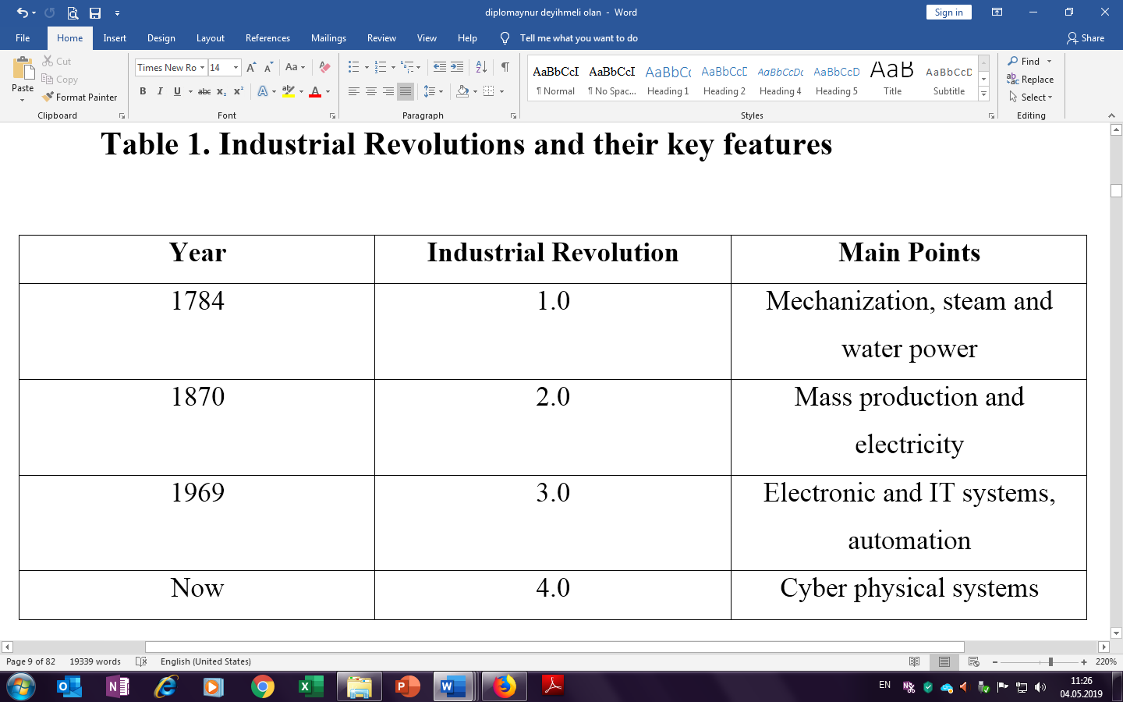

Source: Klaus Schwab “The fourth industrial revolution”, 2016

Key characteristics of revolution were been technology, socio and economic and culture. Technological variation include:
1. use of modern fundamental materials, mainly steel, iron;
2. fuel and coal, steam, electric, oil, internal burning engine,
3. power loop, allowing for modern cars, yarn jenny and energy production with less human energy,
4. a new job known like plant
Non-agricultural areas have had many improvements in non-production areas, including:
1. agricultural improvements that provide food for more non-farming people,
2. economic changes that lead to more widespread wealth, land degradation
3. the development of towns, growth of working class operation and the emergence modern force patterns and
4. extensive cultural change. Employees have gained new and diverse skills and have been relocated to their duties; Despite being handicraftsmen, machine operators were subject to factory discipline. Finally, there was a psychological change: relying on resource utilization and the essence of nature.

2.2 Causes for the Formation of Industry Revolutions and the Changes They Make in the Economic System.

In XVIII-XIX Industrial Revolution basically in horticulture was business both city of farming in America also Europe. Refer to the Industrial Revolution, started in England around the 1700s, fabricate was executed in individuals' homes, utilizing hand devices or straightforward machines. Industrialization was evaluated with a change to solid, remarkable hardware, manufacturing plants and chains creation. The business of material and iron assumed a noteworthy job in the mechanical transformation, nearby with the improvement of the steam motor, and saw the advancement of transportation, data and interchanges and banking frameworks. Inspite of the volume and blend of industrialization, the assortment of creation merchandise and the great standard for living, poor people and the working society normally manhandled and prompted living conditions. Preceding the Industrial Revolution, the vast majority lived in little, laborer networks that pivoted day by day cultivating. Life for the normal individual was troublesome, in light of the fact that the pay was little and the ailment and sickness were normal. Individuals assembled their nourishment, dress, furnishings and apparatuses. Most produces were made at home or little, in country shops, utilizing hand instruments or straightforward machines.
Various elements have helped the job of the British Industrial Revolution as a position of birth. To start with, the coal and iron minerals required for industrialization were expansive. Also, Britain was a free legislator society and the autonomous pioneer intensity of the world. It made pioneer settlements as a hotspot for crude materials, just as a market of fabricated products. As interest for English merchandise expanded, shippers required progressively beneficial generation techniques, which prompted an expansion in automation and an industrial facility framework.
Specifically, the material business was changed into industrialization. Automation and material creation prompted the generation of home-made merchandise (which prompted the improvement of the rent business), alongside traders giving progressively crude materials and essential gear. Workers have distinguished their arrangements in this framework, demonstrating that it is extremely hard for shippers to manage and has brought about various wasteful outcomes. Various developments during the 1700s prompted expanded proficiency while requesting less human vitality. For instance, in 1764, British James Hargreaves (1722-1778) developed the yarn jenny (an early shortened form of "jenny"), enabling one to deliver more than one spools in the meantime. At the season of Hargreaves' passing, there were excess of 20,000 turning jenny in the UK. Yarn pants have been overhauled by ingrown fixings from English creator Samuel Compto (1753-1827) and resulting machines. Another significant advancement that motorized the material procedure was made by the English creator Edmund Cartwright (1743-1823) during the 1780s.
Amid the mechanical upset, the vehicle business has additionally experienced critical changes. Before the entry of the steam motor, crude materials and completed items were transported and sent by ponies and trenches and streams along the waterways. In the middle 1800s, American Robert Fulton (1765-1815) set up the main monetarily fruitful steam motor, and by the center of the nineteenth century, the steam courses were stacked in the Atlantic region. Steam trains were additionally put into task since steamers were debuts.
In the middle 1800s, English specialist Richard Trevitik (1771-1833) manufactured the main railroad steam train. In 1830, England's Liverpool and Manchester Railways were the first to offer standard traveler administrations. Moreover, in 1820 Scotland engineer John McAdam (1756-1836) arranged another procedure for street development. The procedure known as Macadam has prompted progressively smooth, increasingly steady and less elusive streets.
Transmitted developments have made correspondence considerably simpler amid the Industrial Revolution. In 1837 two Brits, William Cooke (1806-1879) and Charles Wheatstone (1802-1875) licensed the main business electrical broadcast. Until 1840, the railroads were a Cooke-Wheatstone framework, and in 1866 a message link was effectively laid on the Atlantic. The Industrial Revolution additionally observed an ascent in banks and modern lenders and a processing plant subordinate arrangement of proprietors and chiefs. A stock trade was set up in London during the 1770s; The New York Stock Exchange was set up in the middle 1790s. In 1776, the Scottish social thinker Adam Smith (1723-1790), the originator of current financial matters, distributed the "National Wealth". Smith is a free venture based financial framework, the administration's absence of obstruction with property possession.
The Industrial Revolution prompted bigger volumes and different plant-delivering items, and raised the way of life for some, particularly center and high societies. In the meantime, life was hard for poor people and the average workers. Wages for specialists in production lines were low, and working conditions could be perilous and dreary. Untalented laborers had little security at work and were effectively supplanted. Kids were a piece of the workforce and regularly worked for quite a while and were utilized for such high-chance undertakings when cleaning the vehicles. Toward the start of the 1860s, around one-fifth of laborers in the UK material industry were younger than 15. Industrialization additionally implied supplanting a few craftsmen with machines. Also, the city couldn't stay aware of the progression of laborers from the town, and industrialized zones brought about insufficient, various settlements and contamination, and illicit living conditions that prompted the spread of the malady. The conditions for the British average workers step by step started to develop, as the administration in the nineteenth century set up different work changes and the specialists picked up the privilege to shape worker's organizations.
Albeit European states met each other for a long time, most of them maintained the pioneer control until the center of the eighteenth century. Presently, what was the challenge for a worldwide super power? Toward the start of the eighteenth century, Britain's populace was around 33%, 66%, in France and Spain. Therefore, it was a steady battle against these lasting and greater foes. The British were occupied with various significant wars, for example, the Austrian War of Struggle (1740-48), the Seven Years War (1756-63), the American Revolutionary War (1775-83) and the Napoleonic Wars (1803-15). The need to remain with the adversary was an extraordinary weight on the nation to create more. This urgent need fortified the creation of work sparing gadgets that assumed a key job in the transformation.
In the eighteen century Britain had for some time been a sacred government, and the country was moderately steady contrasted with opponents like France and Spain. This took into account better approach plan and execution. The administration has kept up its patent framework for trailblazers for a set number of years. This has helped subsidize new thoughts. The assurance framework initially permitted private responsibility for terrains generally used to elevate free enterprise and to shape a future mechanical class. Another significant arrangement prompted the progression of workers to expand the abilities and improvement of the business, which prompted the debilitating of the societies. Rather than other European nations, approaches are the principle explanation behind late industrialization.
Most students of history don't concur with the definite time of the Scientific Revolution in Europe. Many portray it amid the time of Nicolaus Copernicus (1473-1543) and Isaac Newton (1642-1727). Logical Revolution alludes to European improvements that change applied, social, social and institutional connections that spread nature, learning and conviction. Toward the start of the sixteenth century Copernicus introduced a straightforward heliocentric theory. The gutsy case that the earth moves around the sun challenged the Copernican custom, the notoriety of the books, and the thoughts made at colleges and the congregation.
In the coming decades, the Europeans were Galileo Galilei (1564-1642), René Descartes (1596-1650), Christiaan Huygens (1629-1695) and, obviously, Isaac Newton. The logical component of development and the liberal network made a gainful spot for advancements and new thoughts.
Advancement and new innovations were key factors in the accomplishment of the Industrial Revolution. In 1700, England was known for its woolen industry, yet the cotton weaving was better than different kinds of generation. Moderately shoddy, solid and simple to paint and washed from fleece or material. But since of the UK's absence of cotton, there were two challenges: cold atmosphere; there was insufficient work power to fulfill the need. Consequently, they are extremely occupied with satellite producers, for example, India and the United States. Be that as it may, there were developments in material strategies, taking into consideration the business. In 1733, James Kay made a straightforward flying administration, which used to twofold specialist profitability. The principle issue was to make a delicate automated gadget just in the appropriate add up to dismantle and bend cotton fiber to make a solid yarn. Turning Jenny's innovation by James Hargreaves in 1764 tackled this issue multiple times the profitability. In 1769, Richard Arkwright took a shot at John Kay's thoughts and built up a technique to ensure a water line to the Jenni water line. This development drove the crude material to the main manufacturing plant that finished the procedure at one point. This is the processing plant framework that is the way to modern upheaval. The imaginative creation of the mechanical unrest was James Watt's Steam Engine toward the finish of the 1760s, for the most part intended to draw water from coal mineshafts. Likewise, the material business is additionally furnished with advancements, for example, control bend and power fragment. Steam-driven motors let the ventures move far from the water (utilizing water-outlines). In particular, it has prompted a transporter furnished with steam, which had never been, to transport products.
Britain had monetary establishments since the mid eighteenth century; national bank, local banks and stock trades for financing new organizations. In 1760, Britain's rising political and business impact and the subsequent gains in cotton and trade enterprises permitted the production of riches. The ascent of industrialists expanded the requirement for cash security; speculation and development openings; accessibility of working capital for day by day business. Specific keeps money with specific enterprises and fields have grown up to exploit this circumstance. Banks picked up advantages by paying them to acquire something known as money save upkeep and the present continuous reinforcement framework. Early business visionaries were industrialists, lenders, innovators, brokers and shippers; ventures were discrete and little. After some time, investors and stock organizations that have changed the fate of the business.

Figure 1. Economic Growth in Major World Regions

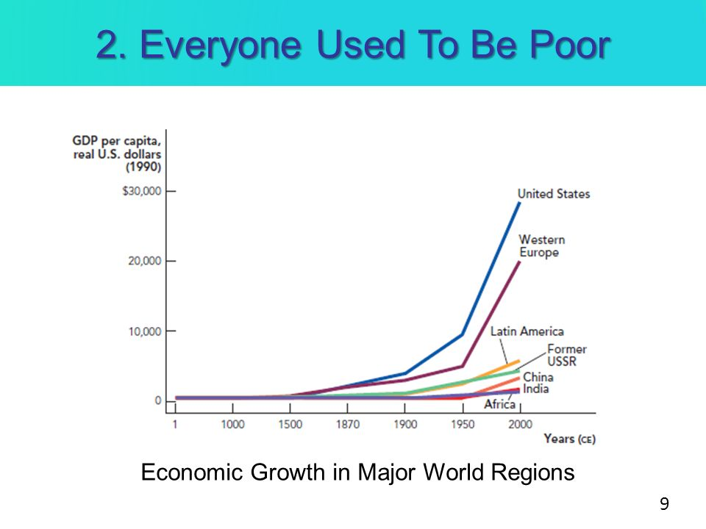

Source: 2. A. Maddison “Contours of the World Economy 1-2030 AD: Essays in Macro-Economic History” September, 2007

The given figure indicate the economic growth due to the industrial revolutions. It is clear from the line graph that, between 1500-1879 the first industrial revolution had happened and its impact had been experienced. Around 1900 years, the second industrial revolution had happened and GDP for given major regions had increased. After 1950, digital revolution had happened and all major regions had experienced fast growth of GDP per capita. And we understand from this line graph, digital revolution has a great impact for world economy and its indicators. Using technological challenges impact economy positively and create succesfull opportunities for both developed and developing countries.
Results of the Industrial Revolutions had created different key points:
Economic changes
It include expansion of world trade, factory system, mass production of goods, industrial capitalism, increased standard of living, unemployment. There are four producers of land, labor, capital and economic growth. Today, the world's entrepreneurial potential reaches 52% and this figure declines over the years. Smaller companies have a significant advantage over the future of the business because of the ability of large enterprises to adapt to technological changes. But this is not a formula for long-term, sustainable economic success. The world should be in the center of attention to support independent entrepreneurs, because small and medium-sized businesses are fueling the world's economy today.
Social changes
Development and growth of cities, improved status and earning power of women, increase in leisure time, population increase, economic insecurity and wars and urban slums were solved and science research stimulated in social changes. Technology will continue to change community values. Today, more than 36% of US workforce is freelance, including autonomy, flexibility and extra income. Together, it increases popularity and is often fully subscribed before opening doors. Technology has enabled people to work anywhere, at any time. Until 2027, more than half of American workers will be released.
Technological Changes
AI, robotics, 3D printing, and the development of the Internet for the global industry (logistics, finance, production, aerospace, etc.) will show greater pressure on automation to compete with companies. This will require firms to see how companies affect the technology of these technologies and how they can provide organizational flexibility to adapt to these changes. Increased global competitiveness will accelerate the cost burden, which will result in a substantial reduction or re-assignment of a large portion of its employees. McKinsey believes that more than 800 million people can be automated by 2030.

2.3 The Fourth Industrial Revolution and its Basic Concept

Industry 4.0 is a standout amongst the most usually utilized terms. Industry 4.0, the fourth era of modern transformation, was first recorded in Germany amid a reasonable period. What is Industrial 4.0 and I don't get it is meaning? There are a few insights regarding the development and significance of this term, which is characterized as the meaning of another period industrialist.
Industry 4.0 will enable the business to pick up another measurement. The principal segment of Industry 4.0 that joins data innovation and industry exercises, in contrast to the present great types of gear, is ease, earth-sparing, low vitality, low warmth, yet very dependable. working equipment and working frameworks and programming frameworks to guarantee that this equipment is fit for being utilized in a way that is steady with memory use. The second and potentially the most significant part is the (Internet) that associates the Internet and the world to trade data and data.
Digital Physical Systems. In the creation procedure, the utilization of digital physical frameworks on machines in processing plants is, in practically any sense, "keen manufacturing plants" for the coordination and improvement of items themselves.
At the point when the Industrial Strategy 4.0 is executed, the measure of vitality required for generation time, expenses and creation will be decreased, the amount and nature of generation will increase. This month, Global Competitiveness Report 2018, arranged by the World Economic Forum, presented another challenge file dependent on the Fourth Industrial Revolution. The report takes note of that the unpredictability, extension and size of the Industrial Revolution of the fourth Plan expresses that the living conditions, expectations for everyday comforts and considering humanity will change by and large. A few researchers even case that this transformation will change the meaning of mankind and human discourse.
The author and leader of the World Economic Form, Klaus Schwab, noticed that the potential for another mechanical upset is horrible, and transformation is a remarkable danger to extraordinary karma and humankind. However, what are the fundamental highlights that recognize the fourth modern transformation, the world's consideration, its primary viewpoints, and its risky highlights?
To discover the meaning of the fourth modern upheaval, above all else, it is important to come back to history and perceive how different unrests occur. The main progressive mechanical upset made the motorization of creation utilizing water and steam. Amid the second mechanical insurgency, humankind got to know power and started large scale manufacturing. At long last, the third Revolution of the Industrial Revolution (advanced insurgency) occurred amidst the only remaining century and computerized the creation of individuals through hardware and innovation. The fourth Industrial Revolution robotizes all territories where the third unrest cannot mechanize the utilization of wise innovations in the work environment. The principle highlight of this modern transformation is its speed, scale and methodical impact. There are a few guides to all the more likely comprehend the fourth modern upheaval. The new age, Siri, is a striking case of the Fourth Revolution, with the voice of the iPhone. Or on the other hand, at the end of the week in Sofia, the robot said the world would change drastically. It isn't hard for these robots who can address individuals' inquiries and attempt to rehash in the generation procedure. The primary any desire for the fourth upset is to improve the personal satisfaction and improve the nature of living for mankind. With the presentation of new keen gadgets, individuals can beat the death toll by telling the idea of the occasions in advance. The most encouraging potential is to quicken PC frameworks with the presentation of new quantum PCs and gather data as right on time as could be expected under the circumstances. Access to a more extensive database will prompt the association of another workforce in the economy by expanding individuals' training and viewpoint.
Notwithstanding the new upset, the normal period of individuals will increment and the arrangement of past disappointments will be conceivable with the presentation of new innovation. As a rule, with the presentation of new advances, there will be remarkable computerized improvements in all zones, and this will diminish the job of human factor underway and economy. The debilitating of the human factor can prompt mass joblessness in the work showcase. Before applying innovation, organizations with interest for a large number of specialists will most likely produce a similar measure of innovation as a few laborers. A few occupations and strengths will typically vanish. In his book The Zero Marginal Cost Society, Jeremy Rifkin gives the most ideal clarification for such a suspicion and henceforth absence of private enterprise. Capacity to quantify individuals utilizing just innovation application. Nearly the work request in the work advertise shapes the mechanical capacities. It ought to be noticed that, with the presentation of quantum PCs, our PCs will be increasingly viable with a couple of standard projects, much the same as the one used to get to the Internet. Be that as it may, specialists have recommended that with the presentation of quantum PCs, there will be no digital security around the globe and any close to home data on the Internet will be in peril. Every one of our exercises can be watched by individuals with a quantum PC. Moreover, the utilization of robots and advances in the working environment and in the network will prompt the loss of "individuals' way of life" on the planet. The presentation of new advances can be frightening to the point that even individuals can lose their soul and individual characteristics.
In the event that we focus on the world's monetary guide, we see that economies in created nations are far more prominent than creating nations. This distinction shows itself in all divisions of the economy, and created nations need economies of rising economies to satisfy the financial needs of improvement. Creating nations are ending up progressively represented considerable authority in getting a similar preferred standpoint more than one zone of the economy.
In any case, this pattern may vanish with the use of the fourth mechanical transformation. Since the mechanical advancements delivered by the Fourth Revolution will be more costly than the other three insurgencies, and, obviously, it is important to have an ordinary foundation first. The mind-boggling expense of innovation will make it hard for them to apply around the world. Created nations, which are subject to creating nations in any field of economy up until now, can conquer reliance on new innovation and produce all the more viably. Nations that have not completely aced the third modern upset will in any case have the capacity to start in the fourth year after the transformation. Along these lines, the monetary hole among created and creating nations will develop.
Mechanical transformations are generally unique, dangerous, or totally ruinous. The fourth mechanical upheaval might be supplanted by a couple of lines of code, instead of fortifying and creating individuals, rather than different insurgencies. The new mechanical insurgency opens boundless open doors for the individuals who apply it on schedule. Financially, more unfortunate nations will turn out to be considerably less fortunate, more extravagant and progressively created. Regardless, science and innovation have ventured into the new phase of advancement, and these progressions can change the meaning of material and otherworldly things.

Figure 2. Essential indicators of Industry 4.0
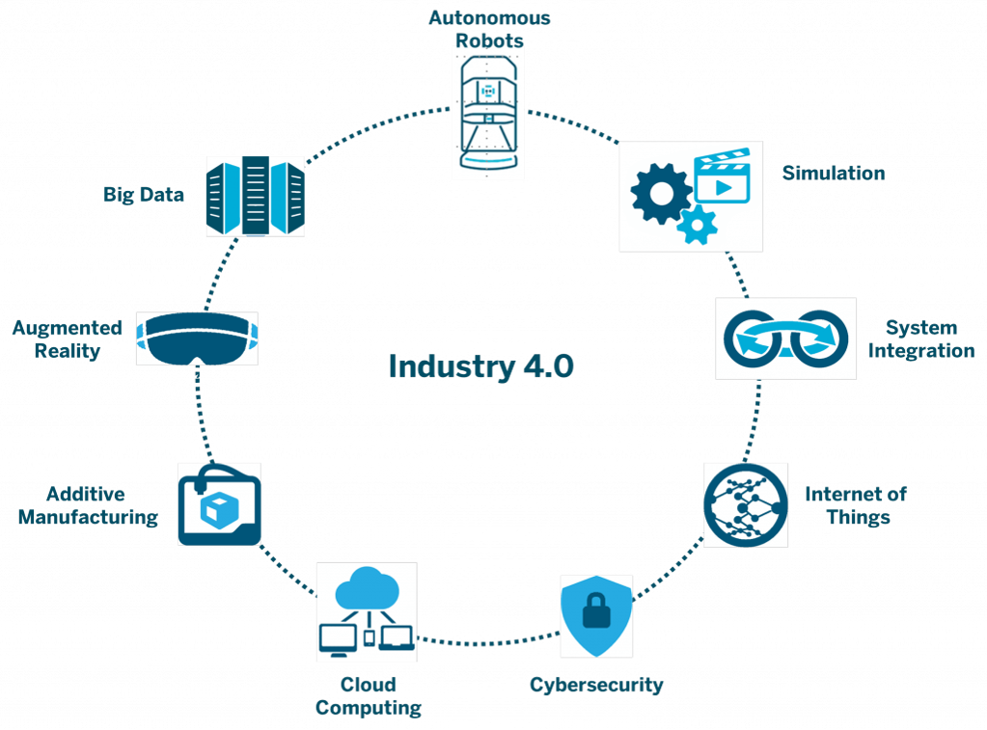

Source: World Economic Forum - www.weforum.org

Four modern transformation and human progress have a closeness between five years: seeker and age, farming age, mechanical age, time of data laborer, and period of insight. Subsequently, we can consolidate the conceivable outcomes of the fourth modern upheaval with the highlights of the five-year-old human advancement exhibited by Steven Covey in the eighth Habit book. (2011, 12-17) Fertility develops by multiple times when contrasted with past age after all ages. For instance, think about an expansion in efficiency amid the mechanical time. Also, each ensuing age demolishes numerous occupations of the past period. Data age substitutes the working environment made in the mechanical time. The greater part of the modern mistakes in working environments are identified with state arrangement and unhindered commerce understandings that significantly change the data laborers in our economy. Thirdly, in the initial three centuries of human advancement, science laborers delivered the best of their bodies and administrations, yet over the most recent two centuries, information specialists produce their products and enterprises with their own thoughts. Learning laborers are another organization's venture. They ensure consideration, inventiveness and influence to utilize ventures to accomplish the objectives of the association all the more productively. At the end of the day, learning is a basic piece of generally speaking administration and is the break between practical limits.
Amid modern period significant resources and real drivers were machine and capital. Individuals were essential however could be changed. Mechanical style the board basically does not work in the new economy. The board staff are propelled to play out the physical work required to create items and administrations. In the fourth modern time, the issue is the means by which and which organizations center their insight laborers around liberating human potential. Principle specialists fight that the fourth insurgency has molded the future with the impacts of government and business. Individuals did not control the disintegration of the two innovations or the fourth modern insurgency. Notwithstanding, we can appraise the potential outcomes of the fourth modern unrest:
lower barriers between inventors and markets, active part for the artificial intelligence (AI), integration of different techniques and domains (fusion), quality of people's lives (robot) and connected life with Internet
As even US Vice President Joe Biden says we may not be prepared, brilliant gadgets, man-made brainpower, and human-good robots are getting to be broad. Mechanization is the dread of the loss of mid-level occupations in this present reality where people in the upper expertise bunch are much increasingly significant so as to require a base dimension of human reconnaissance in certain kinds of generation, which merits genuine word meaning. We are now observing that transnational organizations are starting to return their generation toward the West. This proposes Asian nations, which offer shabby work, may have issues in the fourth Industrial period. At the end of the day, both social polarization inside the nation and post-monetary holes between nations are dreaded.
In Turkey, albeit high efficiency in the material and car, instructed and talented workers has the effect with the group of onlookers, notwithstanding when we might not have these favorable circumstances can be continued in the medium term. Not just the assembling segment will transform into an entire society.
Until further notice, the change that is symbolized by digital physical her innovations is one reason that will legitimize the term upset Improvements in the fields of bio and material sciences, thinks about in fields, for example, quantum registering, and right now working in regular daily existence, far reaching driverless vehicles, 3D printing, for instance, relational correspondence collaborator, basic leadership calculations that supplant our budgetary portfolio director, are separated in the work advertise.
At the end of the day, we are not simply looking at assembling occupations like Industry 4.0, we are going to leave to calculations that learn numerous employments in territories, for example, law and banking. Advancements in figuring force and capacity limit will make it simpler for calculations to settle on choices in Big Data as everybody moves into the pocket of supercomputers. Wearable advances, Internet of Things, Transfer of Matter to some sort of coded
Something else, this unrest can prompt incredible sharing wars as much as it was previously. We need to adjust the propelling innovation to our business forms, else we can't contend with our rivals. Since 2000, we have seen that half of the 500 organizations with the most noteworthy turnover on the planet today can't discover a spot in that rundown. We should oversee change great, realizing that change is troublesome and we will confront various hindrances.
When we take a gander at the historical backdrop of the first modern unrest, steam motors were delivered and utilized in the weaving and ship industry and changed the course of the world. second modern insurgency was begun in large scale manufacturing and now we are in the third mechanical upset. Presently we have the fourth modern transformation. Around 4 years prior, Germany announced that it had started this change and we realize that genuine work has been finished. At the point when the breezes of change are blown, some are walling, while others are windmills.
When it says computerized change, promoting on the web rather than paper commercial is very missing to see our site to be progressively dynamic, to make it portable good and to be increasingly dynamic in internet based life. So as to completely comprehend the computerized change, the world should be perused well. Since the most recent innovation advances to meet another age of uses that will make our lives simpler step by step, Internet speeds are rising. Brilliant gadgets in our home, contact with the general store for the absence of organic product in the pantry, the fridge can comprehend the request and call the administration combi boilers, rambles, driverless vehicles, working gadgets, robots, wearable innovations demonstrate to us that innovation is no longer in our lives, not our lives.
Vast organizations never again keep their advantages on their system links, not in their bank vaults, however in PC cases. Organizations additionally need to change their plans of action. Just the world's biggest media organization with no created substance with the product they claim, and the world's biggest, no single taxi uber or a solitary room isn't even the world's biggest lodging and home booking site. Rather than losing muscle quality or machine control, the innovation is flourishing. 15-20 years back to tune in to music from the principal phase of the in front of the rest of the competition where we need to take the opportunity of music, yet then we would think about an assortment of gadgets turned out, and afterward we turned out badly. The equivalent is the situation for the cameras and the route gadgets are unavailable for general use. Advanced mobile phones that come into our lives as an incredible change have joined our camera, route gadget and the opportunity to take every one of our activities and music to the spot we need. Presently the procedure isn't associated with the equipment dimension of use, we have the opportunity to utilize our favored programming as opposed to getting diverse equipment for every item. The advancements that will comprehend and react to mind waves that we can give directions with eye developments as opposed to squeezing the catches that will be supplanted by cell phones after a specific timeframe will be put into our lives. Together with the computerized advancement, it is normal that the productivity will increment profoundly, the upper hand will be utilized all the more viably, the intensity of web based life will be used all the more successfully, the separation will be simpler, the quick come back with the clients won't have any separation issues and the fast increment in the piece of the overall industry will be given. The procedure of progress ought to be incorporated among the organization arrangements, not only an advancement that can be acknowledged by the solicitation of a couple of administrators who can't be finished by certain individuals or offices. This developmental unrest isn't just a spot for the older in the new modern upheaval, which must be acknowledged gratitude to frameworks who completely comprehend and receive this change. In past mechanical insurgencies we have pursued a long ways behind. We have seen the first modern unrest around 200 years 2. modern transformation 70-80 years and the third mechanical insurgency 30 years behind, however we see that it won't be the fourth mechanical unrest. Truly, we can do it. On the off chance that just among Germany and different nations, we will just have a couple of years. In our nation, different leaps forward are made about advanced change.

3: Modern Industry Management Systems and Global Trends of the 4th Industrial Revolution.

3.1 Modern industry management systems and their key features

The Modern Period, after 1960 administration thought has been dismissing to some degree from the outrageous human relations thoughts especially with respect to the immediate connection among resolve and efficiency. Present administration thinking wishes equivalent accentuation on man and machine.
The cutting edge business ideologists have perceived the social duties of business exercises and thinking on comparative lines. Amid the period, the standards of the executives achieved a phase of refinement and flawlessness. The arrangement of huge organizations brought about the detachment of possession and the executives.
This adjustment in proprietorship design definitely got 'salaried and proficient administrators' instead of proprietor supervisors'. The giving of control to the contracted administration brought about the more extensive utilization of logical techniques for the board. And yet the expert administration has turned out to be socially capable to different segments of society, for example, clients, investors, providers, workers, worker's guilds and other Government organizations.
Under current administration thought three floods of reasoning have lagers seen since 1960:
- Quantitative or Mathematical Approach
- Systems Approach.
- Contingency Approach.

Quantitative or Mathematical Approach or Management Science Approach:
Science has made advances into all controls. It has been all around perceived as a significant instrument of investigation and a language for exact articulation of idea and relationship.
It very well may be communicated as far as numerical images and connections or models. Diverse numerical and quantitative systems or apparatuses, for example, straight programming, recreation and lining, are as a rule progressively utilized in practically every one of the zones of the board for contemplating a wide scope of issues.
The types of this school trust that every one of the periods of the executives can be communicated in quantitative terms for examination. In any case, it is to be noticed that numerical models do help in the efficient investigation of issues, however models are not a viable alternative for sound judgment.
Additionally, arithmetic quantitative procedures give devices to examination yet they can't be dealt with an autonomous arrangement of the board thought. A great deal of arithmetic is utilized in the field of physical sciences and building yet arithmetic has never been considered as independent school even in these fields.
The commitments of mathematicians in the field of the executives are noteworthy. This has contributed stunningly in growing deliberate reasoning among supervisors. It has offered precision to the administration discipline. Its commitments and convenience could scarcely be over-stressed. Be that as it may, it must be treated as an apparatus in administrative practice.
System Approach:
This methodology is normally known as 'Frameworks Approach'. Its initial donors incorporate Ludwig Von Bertalanffy, W.G. Scott, Daniel Katz, Robert L. Kahn.
They saw association as a natural and open framework, which is made out of communicating and related parts, called subsystems. The framework approach is to view the board as a framework or as "a sorted out entire" made up of subsystems coordinated into a solidarity or methodical totality.
Framework approach depends on the speculation that everything is between related and between ward. A framework is essentially a collection or mix of things or parts shaping a mind boggling entirety.
A standout amongst its most significant trademark is that it is made out of progressive system of sub-frameworks. That is the parts framing the real frameworks, etc. For instance, the world can be viewed as a framework in which different national economies are sub-frameworks.
Thus, every national economy is made out of its different businesses, every industry is made out of firms; and obviously, a firm can be viewed as a framework made out of sub-frameworks, for example, creation, advertising, money, bookkeeping, etc.
Contingency or Situational Approach:
The possibility approach is the most recent way to deal with the current administration approaches. Amid the 1970's, possibility hypothesis was created by J.Lorsch and P.R. Lawrence , who were incredulous of different methodologies surmising one most ideal approach to oversee. The board issues are diverse under various circumstances and require to be handled according to the interest of the circumstance.
One most ideal method for doing might be valuable for redundant things however not for administrative issues. The possibility hypothesis goes for incorporating hypothesis with training in frameworks structure. The conduct of an association is said to be dependent upon powers of condition. Subsequently conduct inside an association is dependent upon condition, and if a basic needs to change the conduct of any piece of the association, he should endeavor to change the circumstance impacting it. Tosi and Hammer tell that association framework doesn't involve administrative decision, however dependent upon its outside condition.
Possibility approach is an improvement over the frameworks approach. The cooperation between the sub-frameworks of an association have for quite some time been perceived by the frameworks approach. Possibility approach additionally perceives that authoritative framework is the result of the association of the sub frameworks and the earth. Additionally, it tries to distinguish definite nature of between activities and between connections. This methodology requires a distinguishing proof of the inner and outside factors that basically impact administrative transformation and authoritative execution. As indicated by this, interior and outer condition of the association is comprised of the hierarchical sub-frameworks. In this way, the possibility approach gives a down to business technique for examining authoritative sub-frameworks and endeavors to coordinate these with the earth. Possibility sees are at last coordinated towards proposing authoritative structures circumstances. Along these lines, this methodology is additionally called situational approach. This methodology encourages us to advance useful responses to the issues remanding arrangements. Kast and Rosenzweig give a more extensive perspective on the possibility approach. They state, “The possibility see looks to comprehend the between connections inside and among sub-frameworks just as between the association and its condition and to characterize examples of connections or arrangements of factors possibility sees are at last coordinated toward proposing association plans and administrative activities most proper for explicit circumstances”.

Features of Contingency Approach:
Initially, the possibility approach does not acknowledge the comprehensiveness of the executive hypothesis. It focuses on that there is nobody most ideal method for getting things done. The board is circumstance, and administrators ought to clarify goals, structure associations and get ready techniques, arrangements and plans as indicated by winning conditions. Also, administrative strategies and practices to be compelling, must acclimate to changes in condition. Thirdly, it ought to improve symptomatic abilities in order to envision and prepared for natural changes. Fourthly, supervisors ought to have adequate human relations expertise to oblige and settle change.
At last, it ought to apply the possibility model in structuring the association, building up its data and correspondence framework, following appropriate authority styles and getting ready reasonable targets, arrangements, techniques, projects and practices. Hence, possibility approach hopes to hold a lot of guarantee for the future improvement of the board hypothesis and practice. Current Management framework allude to the hierarchical structure. Every association ought to oversee and lead their creation cycle and tasks. That is the reason they generally monitor their group. Current Management framework direct running methodology and bring advantage for the two bosses and representatives. We partition 4 fundamental Organization structure and endeavor to discover their connection between present day the board framework.
- Functional Structure
- Matrix Structure
- Divisional Structure
- Flatarchy Structure

The practical structure depends on the division of an association into little gatherings of errands or jobs. For instance, an organization can fund a gathering of data innovation organizations, other advertising, and others. Every division has a chief or executive in charge of abnormal state of execution in a pecking order that can lead a few offices. A case of this is the promoting division in charge of the advertising office and the VP in charge of showcasing, money and IT. The upside of this structure is that the laborers are gathered into a range of abilities and capacity that enables aggregate energies to manage their jobs as a division.
One of the difficulties confronting this structure is the absence of interagency correspondence and the most well-known issues and question between individual divisions at administrative dimensions. For instance, a division that works with a venture may have various desires or subtleties for a particular business, which can prompt issues.
What's more, there is a probability to build up the "exclusive focus" of the representatives with the groups that interface with the business work - to direct the organization just through the viewpoint of the worker's work.
Figure 3. Functional Organization Structure
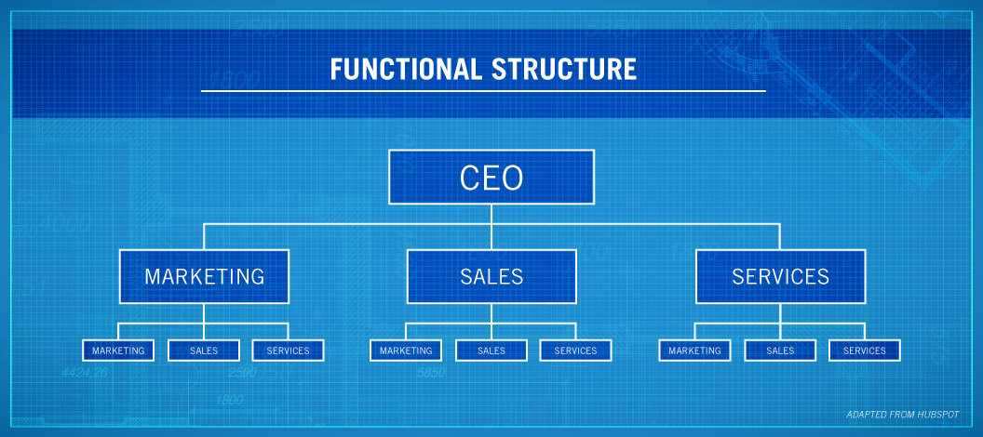
Source: P.G. Aquinas “Organization Structure & Design : Applications And Challenges” September, 2009
Matrix
Cross breed hierarchical structure, framework structure is an utilitarian authoritative structure and an anticipated hierarchical structure.
In the scientific structure, representatives may answer to at least two directors relying upon the circumstance or the venture. For instance, in an ordinary workplace, an architect can work for a director in a noteworthy designing firm, however there might be another task where building ability is required. For the length of the undertaking, the representative will likewise advise the venture chief, just as his/her other day by day errands.
The structure of the network is testing in light of the fact that numerous chiefs can report troublesome and convey. It is subsequently significant for workers to know their jobs, duties and occupation needs.
The benefits of this structure can be that representatives can isolate their insight into various useful segments, and that the job of each capacity can be better conveyed and comprehended. By taking a shot at the highlights, representatives can grow their aptitudes and learning and make proficient advancement inside the organization.
Then again, reports to more than one supervisors may include perplexity and disarray about what's going on between organizations. What's more, if the needs are not obviously characterized, representatives can likewise be confounded about their jobs.
Figure 4. Matrix Organizational Structure
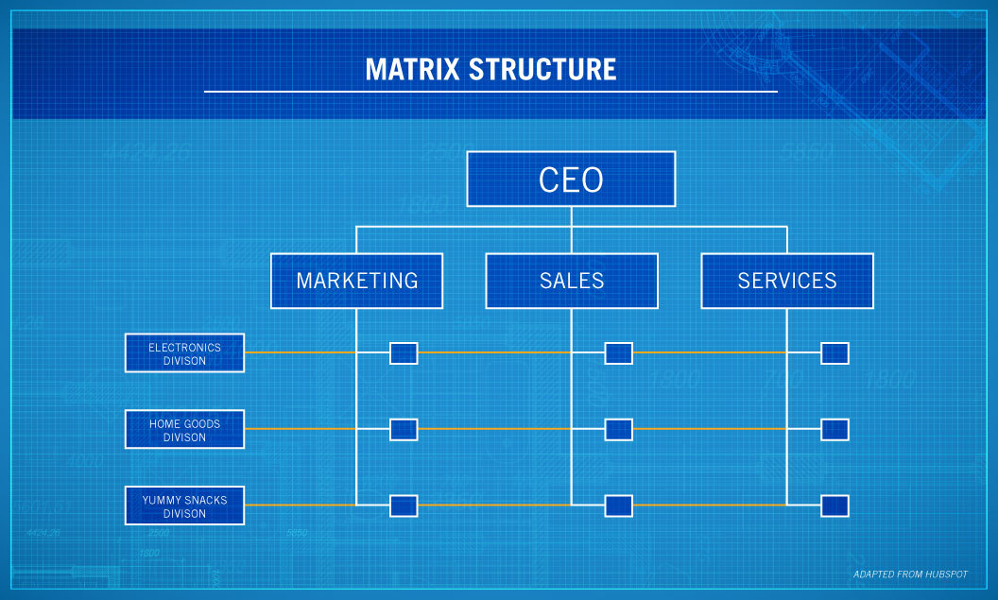
Source: P.G. Aquinas “Organization Structure & Design : Applications And Challenges” September, 2009

Divisional
Bigger organizations working among a few even targets now and then utilize the sectional hierarchical structure.
This structure takes into account more noteworthy self-sufficiency among gatherings inside the association. A case of this is General Electric. GE has a wide range of segments, including aeronautics, transport, streams, advanced and sustainable power source.
Under this structure, each area works principally as its own organizations, controls its assets, and is spent on specific ventures and parts of the unit. Likewise, segments can be made topographically in North America, Europe, East Asia, etc.
This sort of structure offers more accommodation to an extensive organization with numerous organizations and is a couple of those answering to a CEO or overseeing executive of an organization that enables every one of them to work as their very own organization. Rather than tolerating all projects at the most abnormal amount, these inquiries can be replied at the area level.
Decrease of such hierarchical structure might be because of the way that representatives who work in a similar office can not discuss well with divisions, focusing on the areas. This structure can likewise expand issues with bookkeeping rehearses and may have charge outcomes.
Figure 5. Divisional Organization Structure
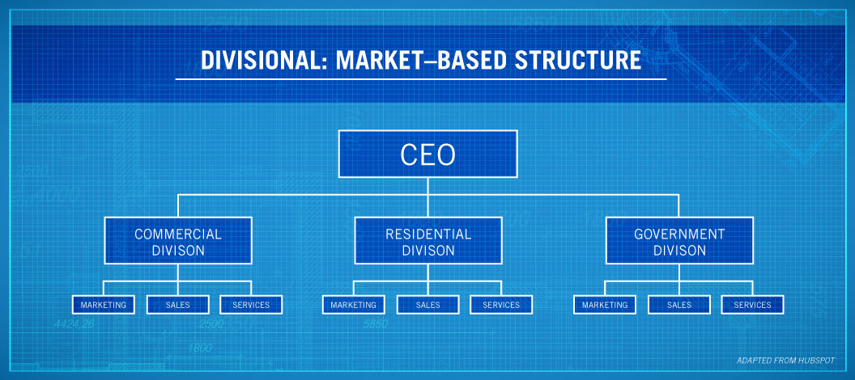
Source: P.G. Aquinas “Organization Structure & Design : Applications And Challenges” September, 2009

Flatarchy
Despite the fact that the past three sorts of authoritative structures work for certain associations, the crossover hierarchical structure for amateur or littler organizations might be better.
Blending an utilitarian structure and a straight structure results in a flatarchial authoritative structure that takes into consideration more basic leadership between an association's dimension and by and large a vertical look of a chain of importance.
A standout amongst the best instances of this structure inside an organization is that it has an inward hatchery or development program. Inside this framework, the organization can work in a current structure, however at each dimension, representatives can offer thoughts and team up, possibly making new level gatherings. As indicated by Forbes, Lockheed Martin was well known for the Skankin venture, which created spy flying machine plan.
Google, Adobe, LinkedIn, and numerous different organizations have inner hatcheries that urge workers to be imaginative and inventive to advance the organization's general improvement.
The advantages of this framework take into account more noteworthy advancement of the organization, just as disposal of red strips causing the spread of developments in the utilitarian structure. Concerning the negative ones, if the structure does not concur on how the structure will be framed, the structure might be satisfactory and badly designed.

3.2 Global trends of the 4th industrial revolution

The 4th industrial revolution is an essential part on the agenda with its own differences and innovations. In fact, the current situation is still the beginning of the 4th industrial revolution, and technological innovations in the future show that this revolution will reach a peak. Naturally, the influence of the three other industrial revolutions on society, as well as on the economic and political situation, was considerably greater. Each of these revolutions took on a pivotal agenda, taking the power within their own time. But since every step and decision of our time can be related to technology, this work has become our lifestyle rather than the agenda. Therefore, the effects of the 4th industrial revolution are already reflected in all spheres globally. We can first talk about the positive and negative aspects of the revolution.
Positive impacts:
Power and variety of digital devices, computing devices and networks are rapidly developing day by day to advance the latest technological innovations. This is an excellent tool for developing both education and information easier.
Gradual development of technology and scientific innovation lead to the emergence of new educational disciplines, which leads to a more comprehensive range of opportunities for better opportunities. The development of the Fourth Revolution, along with the development of new skills, also increases opportunities for development. The Development of the Fourth Revolution highlights the increase in knowledge and thirst for learning. The program-oriented courses and innovative trainings are more preferable than books.
For continued technological advancement such as Twitter, LinkedIn, Facebook and other social media platforms are existed and reach peak nowadays. Online Social Media Channels are activated. Everyone can easily express their views on any modern event or event in the world through these social media platforms.
Communication becomes even easier. Both WhatsApp and IMO also Messenger and others. people can easily communicate with relatives, friends or anyone else. Video helps to make the call or chat distances and make people happy.
Territories are not important for markets. Online shopping websites and fast delivery services help households get home and boost economic benefits. Customer service share agents which are online also offer smart advice to their customers.
The world has become so much a place that every person and every product is more accessible and have a stronger relationships.
Due to the Fourth Industrial Revolution, medical sciences, neurology, and etc. progress leads to a healthy lifestyle; advanced intellectual and mental abilities and longevity.
Agriculture has also influence to the Fourth Industrial Revolution. Bioengineering can be used in more quantities of herbal products. With the assistance of machines furnished with man-made reasoning, estimation of item populaces and recognition of weeds or plant nuisances can likewise be encouraged. Mechanical sprayers are additionally accessible for the utilization of herbicides.
Based on the improvement of digital technologies, employees are freed themselves from automative jobs and can involve themselves for solution complex business problems. This makes them more autonomous.
The Fourth Industrial Revolution has been minimizing carbon emissions, road deaths, and insurance costs due to improvements in car safety due to emerging technologies.
There is no need to stand on the road and to keep in traffic. People have demand cars and vehicles with online and purchase them in their private area. Thanks to the grace of the Fourth Revolution, autonomous or non-driver vehicles can be put into use soon.
With the help of online banking, people are not required to go to banks for operations or other important business operations. Bank's work can be done at home.
E-Governance is additionally conceivable amid the Fourth Revolution through new mechanical advancements. The new innovation additionally enables the legislature to modernize the official and its capacities. E-administration gives responsibility and straightforwardness, just as improves correspondence among government and residents.
Online jobs allow people to work and earn a living. The Industry 4.0 underline self-employment.
Apparently, technological innovations and revolutions have taken quite a place in people's lives and we cannot think of a world without them. In addition, these innovations have given us ease and comfort with our positive effects. However, the 4th industrial revolution has some negative effects.
Negative impacts:
Advancements in technology reduces the person’s ability to use his own intelligence and physical strength.
Social media increases the distance between individuals and family members and the physical community. The virtual world is superior to the physical world, and it creates a social division.
Social media is not always beneficial, because many people use it as a means of spreading news that can be lying; false news creates anxiety.
Personal protection of individuals through the grace of technological developments in the tracking system is not entirely individual in the Fourth Revolution. Every activity of a person is connected to CCTV cameras, smartphones and so on. Some digital devices can be monitored. Facebook, Twitter and so on. Like social media platforms, as well as Flipkart, Amazon, and so on information about a credit card or person's bank information from the name and date of birth before creating a profile or account.
Cyber insults and hate speech are the negative effects of gradually increasing social media during the Fourth Revolution. Cyber attacks are also impossible due to gradual improvements on the Internet. We do not forget that hacking is not a good move. It can also undermine the overall security of people and companies.
Excessive use of data and contacts is the download of network services.
Individuals are less keen on heading off to the market, going outside, or visiting somebody's home in light of the fact that the mechanical development enables them to shop on the web, move in running groups and associate with internet based life. With the help of intelligent technologies, children are more interested in mobile games than open games. It affects the health of the person, the physical and mental effects of the human body and the use of fresh air. Unreasonable use of phones and digital games avoids children both physical and mental improvement.
Due to improvements in automotive and robotic technology, employment is in danger. Human abilities are invaluable in the face of artificial intelligence. Cars are superior to people.
The attentiveness of wealth between smaller groups is continuously growing. It creates economic and social imbalance between people. Thus, social breakdown, political division and lack of confidence in administrations are inevitable.
The competitive environment of the Fourth Revolution sometimes causes emotional frustration and also affects the mental balance. It can cause miserable tendencies, nervousness, insomnia and other neurological and heart diseases.
Bioengineering, 3D models, artificial intelligence, cyber security, programming tools, robotics and other factors can be used for negative purposes.
Due to biotechnology, controversial innovations such as gene drivers or implants to increase productivity of a person, and designer babies can not be overlooked.
Environmental change is a negative effect of the Fourth Industrial Revolution. Gigantic industrialization, fast advancement of innovations, urbanization, pulverization of outrageous timberlands, desertification, desertification, quick populace development, water deficiencies, sustenance security, etc. it counteracts the regular natural equalization of the earth.
Sending people to a quicker place for the better occasion and clustering, leaving another separation puts pressure on the world, and the improvement of another side is behind. This leads to ecological inequality and uneven global development, and this causes social inequality in the world. Development in discrimination can invite fights, social pressure and forceful extremism.
As a result we see that the development of technology, along with positive effects, also has negative effects. The transition to the modern era of robotics is very dangerous for society. Because there is no longer need for a growing population and labor force. This is one of the biggest negative in my opinion. The Industry 4.0 is changing the method we live, work, imagine. This technology, in addition to advanced robots, artificial intelligence and the rapid development of technology related to machine learning. As innovation winds up undetectable, it shapes the lives of youthful grown-ups and laborers everywhere throughout the world, deleting fringes and enabling individuals to work from anyplace. Work is never again a spot to go and requires interdisciplinary masterminds who can be inventive, fundamentally considering and taking care of issues. These are the best 10 abilities the World Economic Forum has observed to be the way to accomplishment in the coming decade. The fourth modern upheaval stays here. To be successful with an innovation-based strategy, a firm must make and implement a number of key decisions in its strategic process (Margaret A. White, Garry D. Bruton, 2011). Together with Cloud computing, technological facilities such as smartphones, 3G / 4G / wifi and high-speed internet have facilitated the organization of various cross-functional groups that collaborate in different parts of the world. By 2020, the idea of innovation organizations will vanish as innovation moves toward becoming as an indispensable piece of each effective association's DNA. On the off chance that your information, readiness, proficiency and extended knowledge are a piece of your incentive for your clients and clients, at that point your opportunity will fall behind the following rush of enhancements inside your industry. It is necessary to apply an analysis of how many of the technologies that will develop brand-consumer relationships can be used (İrfan ERTUĞRUL, 2018).
Manufacturing technology is developing more rapidly. In such a rapidly moving and engaging environment, it can be difficult to cut down the information and sounds that are really important and to win something really different.
In other words, the market will increase your competitiveness and downward line.
Technology related to Industrial 4.0 manages the majority of changes in production. It is applied in all sectors, but is particularly important in high-precision and highly regulated industries such as pharmaceutical production and medical device production.
Factory Automation
This implies that product lines are more efficient, more efficient use of resources and increased productivity. Recruitment problems are also factor that solves the problem of technology manufacturers. Staying competitive in fast-changing markets is also an accelerating factor for increasing the number of Factory Automation solutions. It isn't hard to coordinate past frameworks and stages with new hardware and innovations. Nonetheless, these troubles are not settled on the grounds that Factory Automation will be an element underway in 2019, yet in addition in numerous years.
Virtual, expanded and mixed reality
The virtual, expanded and mixed reality can be applied in several production environments. These technologies make them more efficient while helping businesses to function more efficiently. Their application suggests a virtual world of real-world prototypes or virtual worlds before the production begins, using a virtual or realistic reality to create a new production line or product.
Digital Twin Technologies
Digital Twins is modern technology that will develop a progressively vital tool in manufacturing accommodations. A Digital Twin is a virtual physical copy of a physical object, process, or product that is updated in real time.
The introduction of this technology in production is very far from. One sample equipment can run on a single Twin - or all production line - engineer simulations and can predict machine learning technologies faults, repair scheduling schedules, improve OEE, and more.
Of course, there are problems, including dealing with compliance issues and ensuring security. Nevertheless, eliminating these challenges offers manufacturers a great deal of opportunity.
Move to digitization
Digitalization is named digital transformation. Purchasing digital technologies to familiarize or change your commercial activity to the digital business.
In production, this includes most of the points mentioned above that systems and installations are integrated into each process, chain, unit, branch, and device.
Increase the use of cobots
Some estimates suggest that the cobot market will increase from $ 710 million in 2018 to $ 12.3 billion by 2025. One of the reasons is that today's cobots are more affordable, more affordable and more compact.
Cobots manufacturers will be able to improve product lines, improve productivity while ensuring employee safety.
Table 2. Largest Global Companies in 2018 and 2008

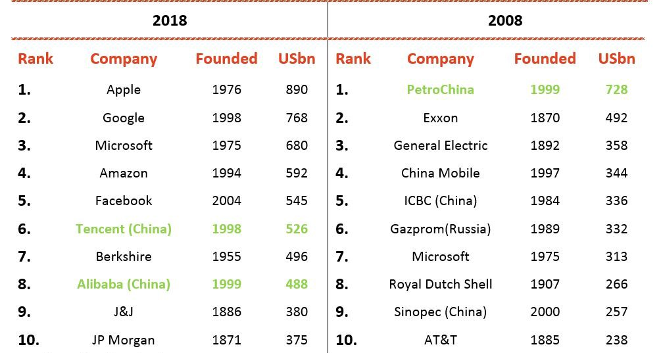

Source: Bloomberg, Google – www.bloomberg.com

The given table show us the global ranking of companies between 2008 and 2018. In 2008, companies who use natural resources such as oil and gas are at the top of rank. But in 2018, some changes were happened. Companies who use high technological innovations and 4th industrial challenges were at the top of global ranking. This show us modern era focus on technology and innovation and digital economy. Because only with using this way companies reach their goal and attain high market share in global market.
The global economy has improved dramatically over the past decade. Compared with the past decades, developing countries are doing better and are helping global products substantially. The US still estimates the world's largest economy as $ 18 trillion, while China is worth $ 11 trillion and the second is Japan at $ 4.4 trillion. Three countries account for about 45% of the global economy. The Chinese economy is rapidly growing, and the Economic and Commercial Studies Center (CEBR) predicts that China will overtake the United States as the world's largest economy by 2029. The rise of the Chinese economy can be directly linked to the country's production growth.
Table 3. 10 Countries with The Highest Industrial Outputs In The World

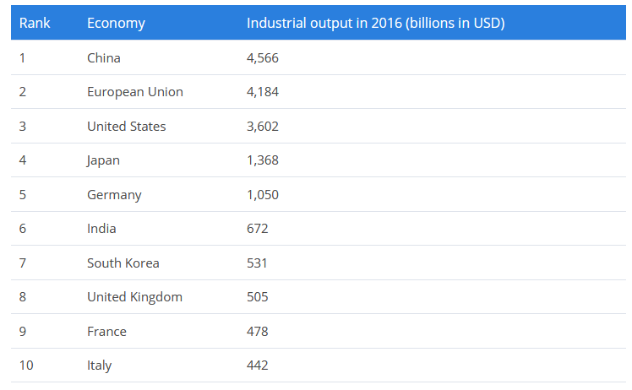
Source: World Atlas - www.worldatlas.com
Table show us the industrial output for major regions of world. Countries who use high technology and innovation are included in this statistical data. They are implement 4th industrial revolution challenges and modern management system in their business environment. Countires have already passed to the 4th industrial revolution and use challenges.
Figure 3. Included papers number by public policies.
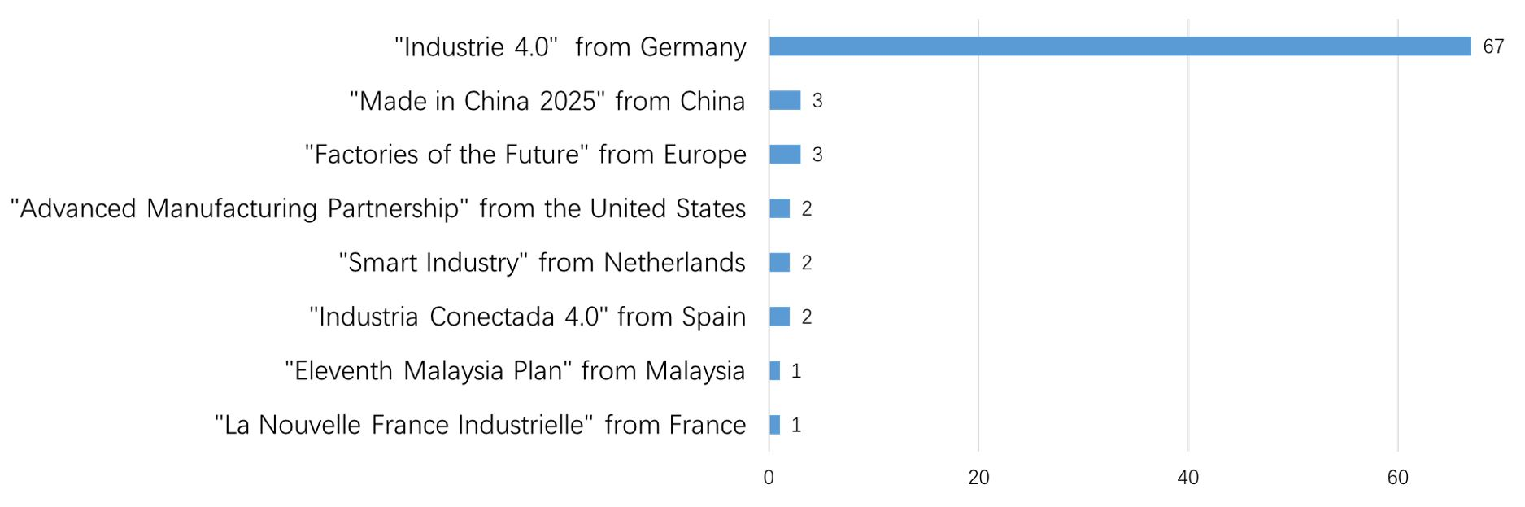
Source: Scientific Electronic Library Online - www.scielo.org

Different countries both developing and developed also have investment rate for the industrial revolution challenges. They try to use these factors for all sector of economy and implement for successful future. Here, some of countries invest to economic sphere in figure 9.
Figure 6. Annual investments related Industry 4.0 in billion euros.
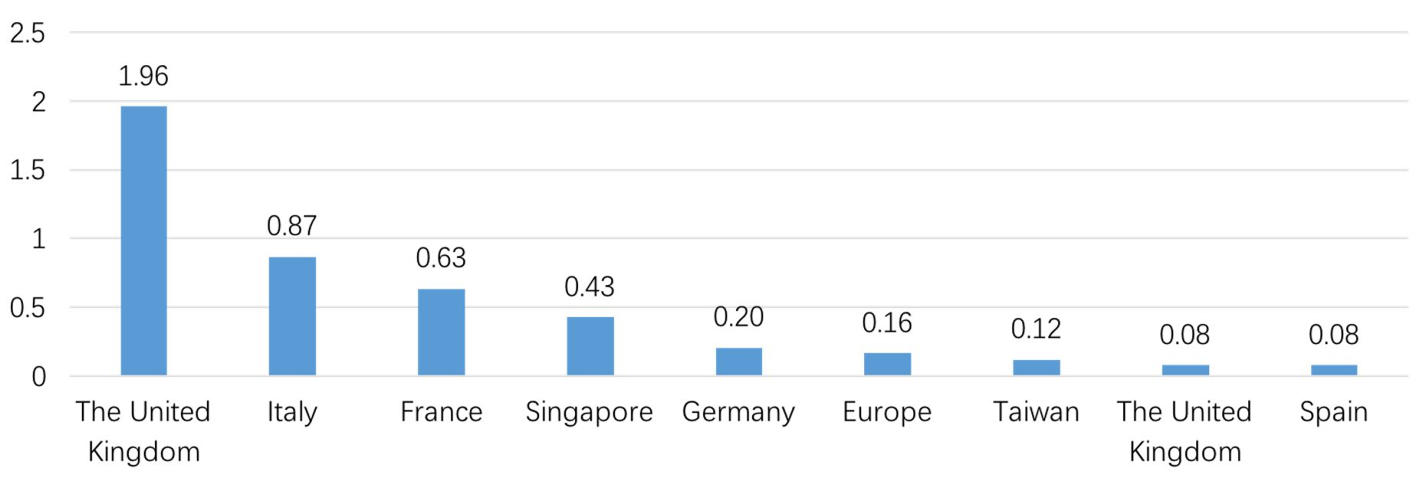
Source: Scientific Electronic Library Online - www.scielo.org

Figure 9 shows the amount spent by each of the seven countries and 2 regions according to the data collected in the years in which the data were available. Except for the United States, all countries and regions have invested more than € 1 billion annually, with six (Singapore, Germany, Europe, Taiwan, United Kingdom and Spain) investing less than € 500 million a year, Italy and France) respectively, investing 870 and 630 million Euros annually. United States is the only state to invest around 2 billion euros annually. It should be renowned that even though the Industry 4.0 plan is more than any other European country.

3.3 Changes in the industrial management system as a result of the Industry 4.0

Simple product innovations are increasing. Intelligent and modern automation and technology enhance this modern revolution. And this unprecedented, exponential variation of change is gaining more and more reliance on partner platforms: the more fundamental innovations.
Organizations face a turning point in everywhere to go through product-oriented business models for modern products aimed at making and catching various sources of modern product. As a result, technological innovation becomes even more complicated.
This is the 4th industrial revolution in the center of that transformation. Here the production becomes a very rapid digital manufacturing enterprise facility. This is designed to diminish the answer rate and run it more efficiently, effectively and effectively. Everything must be related to bringing a different perspective to a global response to a comprehensive answer and to closest customer wants.
How company affect digital reality? We are building real connections as we work, partnership and manage. Companies try to "keep" various technologies in order to run the current physical world contrarily and prepare for joint relations among the physical and computer-generated world - it's time to bring us together. Investing in IT infrastructure is investing. In the future, the nature of our search for innovation results varies.
The 4th Industrial Revolution gains new modern and innovative knowledge and understanding. Modern business models offer a very various potential for building goods, services and public solutions. Producers are at the initial stages of this revolution, but there is a sensation that we continue to disrupt the whole thing we know.
If we go back to the production world, the technological revolution will drown us. Scales, scope, and complexity are, of course, what they've never experienced. Such speeds, coverage and systems are visible in the exposed aspect of rapidly changing rates. Companies are fundamentally controlling systems of manufacture, management on a enduring basis. We have unmatched processing power, storage capacity and various information capabilities. They are jointed with progressive technology in areas such as artificial intelligence, robotics, 3D printing, nanotechnology, biotechnology, logistics and quantum computing. It creates modern and new challenges and opportunities for innovation.
Figure 7. Industry 4.0 is a journey towards a complete value chain transformation driven by new technologies and new collaborative business models

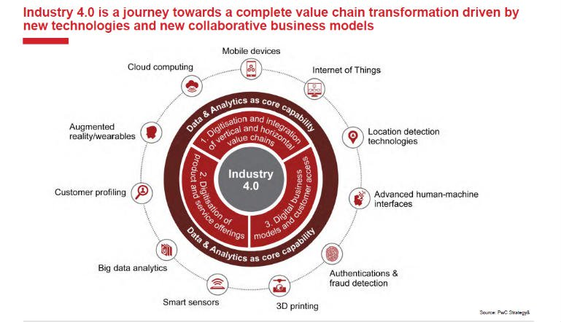

Source: Scott Shane “Handbook of Technology and Innovation Management” July, 2009
Manufacturing is in a massive transformation
Production has been gradually created around cyber-physical product systems (CPPS), which seamlessly integrates our real and virtual worlds. The program is optimized for each process and task, even if implemented by people or machines.
These are online nets of technologies that are parallel to our social networks, which are connected to technology, digital infrastructure. The revolution interconnects all parts in progress: Internet of Things “(IoT), data, services and people.
Our creation offices are winding up progressively coordinated - nearly incorporated. We make industry-standard open norms with the goal that we can make more associations between environments underway, in order to diminish intrusions or give more noteworthy adaptability. We are examining information examination for learning and determining, and this puts more accentuation on cooperation, experimentation, investigation and coordination from every one of these connections.
We should mirror all these immediate results of the fourth modern insurgency. Where innovation has converged with the physical to additionally expand our client desires, it has empowered us to create various items that are progressively reasonable for our lives, that we can contribute more and work together.
The client is progressively at the focal point of financial aspects. Items and administrations are created with advanced capacities that expansion their qualities and qualities. New materials make our advantages stronger and adaptable, and information and examination give profitable input to make better administrations and execution for what's to come. This association and response requires new types of collaboration, and we see new sorts of associations rising. They are substantially more subject to stages and biological systems. Development is the opening component. In light of this fourth insurgency, we have to change our comprehension of Innovation.
The results of the fourth mechanical upset can be seen by moving our accentuation on advancement. We are concentrating more on our development spending on mechanical advancements. To mirror these changes, we continually take a gander at the adjustments in our current plans of action and coordinate our advancement frameworks to find totally new plans of action.
We should value the new advanced plans of action and their effect. We are increasingly more positive about computerized designing and science. Our tasks give more advancement expanding potential to start to finish the executives, have a computerized production line to reply, are increasingly dependent on numerous things carefully, and can prompt drastically unique development openings.
The items have numerous item development minor departure from how to position the items and how to work them in more than one working model. There are fundamentally extraordinary item improvement and procedures to oversee them. These are increased by the rate of mechanical change. In like manner, the customary store network has an altogether different potential when processing plants and activities are interconnected and begin to work as Industry 4.0 ventures; along these lines, they can be worked, responsive, while reacting through supply systems and strategic incorporation openings and through various dimensions of mechanized arranging and stock administration. They all require diverse administration. When we make more associations, client encounters can profit incredibly.
We can target, sell and market more connection information. As we can better understand the channel selection and connectivity, and continue to build the connected industry 4.0 environment, we can provide pre- and post-sales support to manage the entire life cycle.
The main point of the discussion was what people call the Fourth Industrial Revolution (although there are some discussions about whether we are in third place anyway). The WEF has prepared a long report with a large number of statistics to help you understand change and scare you into mobilizing the world - with statistics stating that robots will play about 5.1 million jobs by 2020.
Digital transformation is about people as much as technology. I interviewed two private CEOs focusing on the digital transformation of industries, and in both of them human challenges were overcoming technological problems. Companies have difficulty creating cultures that adopt rapid technological change, and governments are struggling to respond to future risks, which are more likely to focus on future benefits.
An important difference is the constant rate of change. In our own research, we see that the average organization has made five institutional changes over the last three years, such as cultural change, restructuring, market expansion, leadership transition or merger / acquisition. Change is undoubtedly accelerating.
Another important difference is the importance of changing new skills and knowledge. We're in the middle of collecting data for a new study on labor and change, but what we've found so far is something we've found so often, where employees say new skills and knowledge are needed in this developing environment. if you are an administrator, what do you need to do about the ability to avoid this new world of instability? First, it will require a new approach to change management from major distortion. This means a flexible, agile and business-friendly HR department rather than focusing on their specific areas of expertise. Second, the change needs to be more guided by the employees than the foundation. Leaders do not have complete knowledge of everything that needs to be fast enough for the change to be successful. Third, talent applications need to be updated to reflect a constantly changing environment. Your task and performance management systems must move in real time. Your sequential management system needs to create a portfolio of leaders instead of putting people on a static pipeline.
New business models and opportunities
So far, consumers have won the most from digital developments: technology has provided new products and services that increase individual productivity and enjoyment. You can make a taxi or plane reservation, buy products, pay, listen to music, watch movies or play games remotely.
In the future, technological innovations are expected to emerge in new business models that will open up new, global platforms, business opportunities and markets and provide economic growth. As a result, you will need to redefine concepts such as talent, culture and organization. Quite simply, companies will have to reevaluate their way of doing business. Companies that have the capacity to understand the change in business environments and to follow the processes of continuous change will be the winners.
New ways to work
This new technology will enable companies to work remotely, through teleconference and in new ways with people who share their work spaces. In addition, it is expected that colleagues in other countries will have full-time employee bases, which are supported by external consultants on specific tasks, and have continuous functions.
One of the greatest features of the revolution is the massive use of robots and the application of robotics in production.

Figure 8. Number of installed industrial robots per 10.000 employees in the manufacturing industry

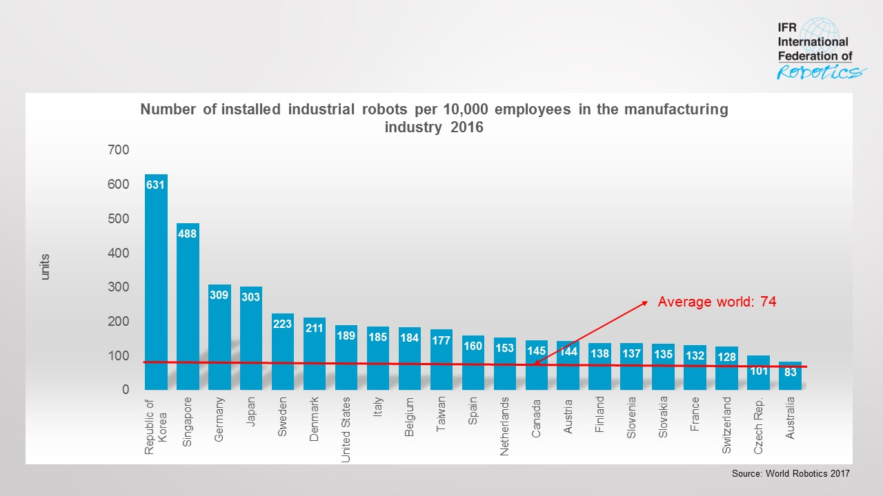
Source: Executive Summary World Robotics Industrial Robots, 2017
The 4th industrial revolution and, most importantly, the list of countries most using industry without robotics is as follows: Republic of Korea, Singapore, Germany, Japan, Sweden, Denmark, USA, Italy, Belgium and Taiwan.
President of the International Robotics Federation, Junji Tsuda, said that knowing these figures and the robotization rates in the countries tells us about the countries' core potential and industrial power. Based on these indicators, the power of each country can be compared. High indicators in Asia in recent years are indicative of the region's growth. The robotization in Asia grew by 9% between 2010 and 2016. It is 7% in America and 5% in Europe. This figure is based on the fact that the 4th industrial revolution continues to grow in Asia, and those countries and Asian tigers, it will keep its potential in the near future.

4: The Main Directions of the Perceptive Changes in the 4th Industrial Revolution in Industrial Management.

4.1New Management Systems and New Leadership Philosophy.

Modern business ideologists have recognized social responsibilities and similar ideas of business activity. During the period, the principles of management have reached the phase of delicacy and perfection. Formation of large companies resulted in the division of property and management.
This change in the model of entrepreneurship has resulted in any 'owner-manager' instead of 'salary and professional managers'. Controlled recruitment led to more widespread use of management methods. But at the same time, professional management is socially responsible for different parts of society, such as customers, stockholders, suppliers, employees, trade unions and other government agencies.
Although it is difficult to see the stage of evolution or stage-by-stage evolution, leadership's "imagination theories" have succeeded and largely "behavioral theories."
In addition, in this sequence of theoretical schemes, theories of "reserve theories" and "transformation leadership" emerged. This continued to make efforts for fresh and useful explanations of the primary questionnaire by researchers as "What is leader, what is leadership and what it means".
It was accepted among academic circles, as well as practitioners in business and organization, that all the elements of the above-mentioned theory existed in the last century. This is true in the twentieth century, though "basic theories" gradually and gradually disappeared from the center of the current dialogue, despite some of the creative attempts of meta-analysis of their main buildings.
"Democratic Leader"
An antithesis between one of the first "departures" from the casual theories and the autocratic leader, so that they can be explicitly put in place, not to follow his subordinates but to the democratic leader who takes into consideration his people. Tannenbaum and Schmidt (1958).
Tannenbaum and Schmidt, as an article titled "Selecting a Leadership Example," offered the continuity of leadership behavior from the decision makers to the type of employee engagement in the theoretical mindset published in the Harvard Business Review magazine. Their sustainability implies 7 different approaches through a degree allowing the manager-manager to make his decisions and announce them to the people, and the manager of the management trusts his subordination and works independently, but remains in the defined limitations.
"Leadership Network"
Blake and Mouton (1964), two elements of anxiety, are the "management network" (later called the "Leadership Network") that disturbs people concerned with the production or performance of certain enterprise goals or organizations, submitted by.
"Management-Leadership Network" has been widely used in many private and public institutions and organizations for training and personnel development. According to its creators, 'grid' takes into account a number of entrepreneurial-organizational activities and goals for workers who work to limit manufacturing quota and human relations and production quota ranging from working conditions to wages and promotions.
In a transparent way, 'management-leadership rays' are the axis of the vertical axis of the leaders and the horizontal axis that represents the worry about the leader's outcome. Each of the two axes has a number of grades from 1 to 9, the leader is at least worried and the biggest concern of leader number 9 is number one.
Blake and Mouton's model creates provisions for each leader to calculate scores ranging from 1 to 9 in each of the two intersecting vertical and horizontal axes. The authors have proposed five key leadership styles for each studied leader score (at least 1 to a maximum of 9). Leadership in the 'competent compliance' style with the result and with minimal people.
Leadership in 'Country Club Management' style is basically with its own people and, ultimately, at a minimum. In the "weak management" style, the leader has minimal care for his own population and outcome. In the midst of road management, the leader represents moderate concerns about people and outcomes, and finally, the leader of the team leadership represents a matter of concern for both his own people and their endeavors.
"Situation Leadership"
Hershey and Blanchard (1969) draw attention to their leadership theories, mainly Blake and Mouto's leadership-leadership network, and personality attributes of a successful leader's abilities, and the ability to adapt to each situation, giving a prominent position and context.
This theory, as before, is of two dimensions: behavioral behaviors and relationship behaviors. Task behavior refers to the amount of direction that the leader has to fulfill his / her responsibilities, and the relationships they hold provide support, encouragement and recognition.
The name of the event is explicitly stated and the situation management, as mentioned above, focuses on the situation and essence, and effective leaders are able to adapt individual styles to different requirements from different situations. The choice of the manager-leader's style calls for three different factors, namely the leader identity and the "modus operandi", the features of the subordinate, personality, motivation and abilities, and leadership-leaders and followers.
In general, considering that modern administrators should motivate their employees more motivated and give them an innovative approach, where there is a difference between managers and modern leaders. It gives itself to all sectors of the business environment.
The world is seeing progressive advances in science and innovation – man-made brainpower, quality altering, apply autonomy, etc. – that have together been named the "Fourth Industrial Revolution". Accomplishment in this new time – regardless of whether that implies corporate benefits, macroeconomic development, human welfare or taking care of the most immovable issues confronting the world – will in this manner require overseeing groups of very specific specialized specialists: "learning laborers, for example, researchers, engineers, information examiners.
In parallel, the world's expanding interconnectivity is giving us another type of globalization in which always assorted and universal groups of individuals are cooperating.
Dealing with these groups of universal information specialists requires an altogether different attitude to "standard" administration and persuasive models – it needs a methodology that perceives the heterogeneity, desire and refinement of such staff.
The worldwide law office I lead is worked around our exceedingly particular information specialists – legal counselors and the associates supporting them – based everywhere throughout the world. In the course of the most recent two years, we've put in another way to deal with spur and oversee them. It is early days, however we have effectively taken in a great deal.
There are three big ideas in order to be a good leader in organization in Industry 4.0.
Development of the following strategy
Firstly, we developed a revived methodology from information got over the firm and from our customers, as opposed to from a lot of top-down professions. We asked our kin what they thought by means of a lot of reviews and up close and personal discussions. Almost 50% of the firm, over all dimensions, added to the discussion. The community procedure made a feeling of shared qualities, possession and fervor – yet in addition mirrored our customers' shifting needs and the decent variety of societies and attitudes over the firm.
A community oriented methodology is extraordinary, however it is additionally significant that the final result supposedly reflects the yields from the discourses. Anyway great the system is on paper, it won't prevail in an organization domain if there is deficient help for what is proposed. The group needs to feel energized by what is being asked of it. In that regard, the initiative ought to believe itself to be bound to the firm by an elastic band. In the event that you pull excessively hard, or go toward a path that the remainder of the firm wouldn't like to go, the elastic band snaps. In any case, building procedure cooperatively with every one of your kin encourages you pull them alongside you.
Holistic measurement of contribution
Learning laborers are masters. In any case, our customers have numerous requirements crosswise over a wide range of specializations. Our customers are additionally regularly global: they should almost certainly converse with individuals in numerous nations to take care of their issues. Taking care of our customers' issues requires a really community oriented methodology crosswise over geologies and specialisms that rises above a specific person's mastery.
However, the need to take care of issues in a community oriented manner, and carry various experts into the group, isn't helped by the manner in which that law offices ordinarily measure staff commitment: by taking a gander at individual use and charging insights. Estimating these individual measurements can support limited personal responsibility as opposed to firm intrigue or customer fulfillment.
Servant Leadership
Learning specialists are specialists in their general vicinity of center, and they are additionally exceptionally energetic. Individuals like this needn't bother with the board to instruct them. They need their initiative group to make a workplace that is strong of their accomplishing their desire.
As the firm overseeing accomplice, I feel that I am a worker of the organization, looking to give a workplace that is strong of its aspirations and which empowers us to beat. Furthermore, this administration mentality helps set the tone: it is an interminable update that my accomplices and partners are at the administration of our customers.
Creating methodology cooperatively is a piece of this "hireling authority" approach: it requires sympathy, lowliness, receptiveness and tuning in. It additionally requires, and creates, trust, cooperation and purchase in over the association.
Leadership in the Fourth Industrial Revolution: Faces of advancement, again asked officials how they are empowering their associations to prevail in four regions: society, procedure, innovation and ability. Notwithstanding our look for year-to-year patterns, however, we additionally expected to reveal how pioneers are pushing ahead, where they are gaining the most ground, and what separates the best heads.
While numerous officials keep on battling with exploring the intricacy of Industry 4.0, certain pioneers gave off an impression of being "hitting the nail on the head". We discovered four unmistakable administration personas that, we accept, can give guideposts to officials and fill in as models for pioneers the world over as they handle the difficulties related with computerized change.
The aptitudes challenge has progressed toward becoming more clear. The expansiveness of the aptitudes hole is progressively obvious to pioneers, similar to a calming mindfulness that present instruction frameworks will be insufficient to address the difficulty. About twice the same number of pioneers said their associations will endeavor to prepare existing workers instead of hope to procure new ones. We have grouped the four leaders into the right direction:
Social Supers. Certain pioneers emerge for their capacity to do well by doing great. These Social Supers consider social activities major to their organizations, and their hopefulness about making societal effect impacts their viewpoint in a few different ways. They were bound to state their workforce synthesis is set up for computerized change, and unquestionably all the more ready to prepare their specialists. Organizations with pioneers who recognize as Social Supers are likewise developing more than the individuals who haven't effectively discovered the harmony between doing great and making a benefit.
Data-Driven Decision. Some C-level administrators are defeating difficulties by taking efficient, information centered ways to deal with key basic leadership. These Data-Driven decision are twice as liable to state they're set up to gain by Industry 4.0 chances, and their associations are as of now receiving the monetary rewards of grasping Industry 4.0. In the previous year, practically 50% of such associations produced yearly income development of 5% or more while just a fourth of different associations saw such outcomes.
Disruption Drivers. These pioneers comprehend that interests in troublesome advancements set their associations apart from contenders. They are sure, which gives them preference when adapting to the questions of Industry 4.0 on the grounds that progressively guaranteed associations will be better arranged to actualize troublesome advances. Disturbance Drivers' associations regularly have increasingly characterized basic leadership procedures, and they are bound to settle on information driven choices with contribution from various arrangements of partners.
Talent Champions. These officials are getting ready workers for advanced change. They are almost certain than others to put resources into worker retraining for the eventual fate of work. And keeping in mind that doing as such, the Talent Champions are additionally dedicated to societal effect and are seeing early comes back from their dynamic endeavors - and 64% have just created new income streams for their associations through socially determined activities.
Numerous leaders comprehend what it will take to prevail in Industry 4.0, yet authoritative barricades are constraining the improvement of compelling methodologies, and numerous pioneers are proceeding to modest far from strong innovation speculations that will drive advancement and interruption," says Michele Parmelee, worldwide boss ability officer at Deloitte. Ongoing examination from Deloitte found that there are four sorts of pioneers who prevail in the Fourth Industrial Revolution, or Industry 4.0:
The Social Supers, who "are organizing societal effect activities and have had the capacity to create new income streams from socially useful items or administrations"
The Data-driven decision, who use "a fastidious, information driven way to deal with system advancement and are sure about their capacity to underwrite in Industry 4.0"
The Disruption Drivers, who illustrate "a readiness to put resources into problematic advances that overturn their business sectors and [who] have officially made speculations that have accomplished or surpassed planned business results"
The Talent Champions, who "are on top of things at setting up their workforces for the future and making forceful moves to proceed with this advancement"
There are "general essentials that all directors need," says Tom Griffiths, fellow benefactor and CEO of Hone, and they haven't changed after some time. "It's more the medium through which individuals need to work" that is changed. For instance, as of late has instructing "been grasped" as a significant piece of initiative. "The standards are general, yet how they get connected has changed, in view of the innovation dissemination and the manner in which that individuals work."
So also, "The immense full scale pattern that we're endeavoring to fathom for is the conveyed workforce," he includes. Between the innovations that empower remote work and "the genuine ability crunch that we see in customary center points like New York and San Francisco," it's significant that pioneers have the capacity to oversee representatives who don't work in a similar office or even a similar city, state or nation.
Figure 9. Industrial business leaders’ expectations for industry 4.0

Source: Patrick Lencioni “The Five Dysfunctions of a Team: A Leadership Fable”, 2002

Modern Organizational and Management Models in Industry

Organization of production or is in the center of the enterprises covering production process. As shown in the timeline, production is simply the way you organize your products and services in your business. It comprises of assembling associations that can successfully co-ordinate generation factors, including crude materials, work and capital. Therefore, you will increase considerable advantages from the creation procedure.
The family economy is the most straightforward creation association of land, work and capital, which is possessed and constrained by a similar individual. For instance, you can enter this dimension of generation association by sorting out your family to give work and specialized guidance to give family and family sustenance and specialized exhortation to create agrarian items. The generation of merchandise and the arrangement of administrations at the network level reason the generation association to ascend with the production of different ideas, for example, division of work and ability.Industry 4.0 has changed its way to the Enterprise 4.0 and most developed countries try to implement all these challenges to their production cycle in order to create value and return on investment.
Despite the popular belief that new digital businesses are best placed to succeed in the next revolution, Enterprise 4.0 mentioned this situation. Enterprise 4.0 has revealed that, in all sectors, factories that are likely to be well-positioned for the next industrial revolution have actually identified the second industrial revolution. Australian experience show us the digital transformation and average exponential score in 3 revolutions.
When different differences are discovered between the responsibilities of enterprises established in the First, Second, and Third Industrial Revolutions, the enterprise shows that the enterprise is at a level equal to 4.0 enterprises' changing expectations and capitalization to emerging technologies, which indicates the possibility of a transition. There was a performance range between digital businesses and their investment transformation and digital technologies and strategies are still applying to those who compete in traditional ways.
Figure 10. Idea of industry 4.0 production style
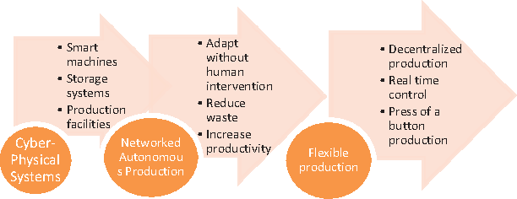
Source : Saqib Shamim, Shuang Cang “Management Approaches for Industry 4.0” 2016
The focal thought of industry 4.0 is to execute the Cyber Physical Systems (CPS) for generation, for example installed actuators and sensors, systems of microcomputers, connecting the machines to the esteem chain. It further thinks about the computerized upgrade and reengineering of items. Figure 2 is displaying a condensed thought of industry 4.0 creation style. It is additionally described by profoundly separated tweaked items, and well-organized blend of item and administrations, and furthermore the esteem included administrations with the genuine item or administration. In straightforward words industry 4.0 should have shrewd machines, stockpiling framework, and generation office. It limits the human intercessions and increment profitability. It accentuations on decentralized and very mechanized creation, as appeared in figure.
Modern industry management begins with the point of view of the leaders in the manufacturing enterprise. The main goal here is to switch from the old and standard management system to a new and innovative system. This type of product and service will take up a significant part of the market share through a strong marketing strategy. The 4th industrial revolution we have just mentioned is bringing innovations to the industry through these innovations. The brightest examples of the procedure are the example of Japan, Germany and the Silicon Valley. Each space has made world-class changes with its own management system and innovative strategies, and has been able to reach the forefront in production by applying updates.
While Japan's industrial development stage, the Japanese market had little to win in the rising domestic production. Japan needed world market to further develop. By creating an export market, Japan could transform its economy dramatically and thus have achieved the technology needed to develop.
Japan's goal was to become a full-fledged businessman through industrialization. It called for the market to dominate the many selected product areas. They carefully selected places where they prefer to spend more than watch their efforts in many areas.
A number of tactics have been used to support this strategy. First of all, the Japanese imports their technology, thereby eliminating the risks of large R & D costs. Instead, they discussed the licensing agreements to prepare new products. Later, the best engineering ability is directed to the factory floor, not to the product design department, so their inventions are cheaper than high productivity and innovative designs. Finally, the quality and reliability have been steadily strengthened to the highest possible level and then to be overthrown; said competitors would be able to reach the levels and not provide them. The implementation of these tactics is based on a strong sense of respect for people and the elimination of waste (these two areas are deepened down below).
The success of Japan as an economic superpower casts doubt on whether the West can lose the world's dominance as a technology leader. For the success of Japan, they began to follow the example of other Pacific countries, thereby accelerating the spread of innovative technologies through the industry. As a result, new industrial preference centers were created.
- Management technology is a high-tech technology.
- Just-in-time production problems are largely hidden by inventory and staff.
- Quality starts with production and requires a "habit of improvement" in the company.
- Culture is no obstacle; methods may change the behavior.
- Simplify and the goods flow like water.
- Flexibility opens doors.
- To make trips such as travel light and water bugs.
- More self-improvement, fewer programs, fewer specialist interventions.
- Simplicity is a natural state.
For many American business executives, this was his first encounter with timely, only the concepts of Kanban, Total Quality Management, and quality circles (even just terms).
A number of reasons to explain Japan's success have been announced. When the market position of Japanese automakers began to grow stronger in the 1970s, it was easy to imagine the advance of the Arab oil embargo and gas prices in advance in 1973. Customers are looking for smaller fuel-efficient vehicles. The Japanese has already had a natural competitive advantage, since it has already joined the smaller car market. Nevertheless, it was expected that this greatness would decline as the Big Three car makers reacted with their small products into their products and the oil prices declined.
Modern Management and new leadership philosophy refer to several factors. As Steve Jobs said, “It doesn’t make sense to hire smart people and then tell them what to do; we hire smart people so they can tell us what to do”.
Figure 11. Organizational dilemmas faced by Netflix.

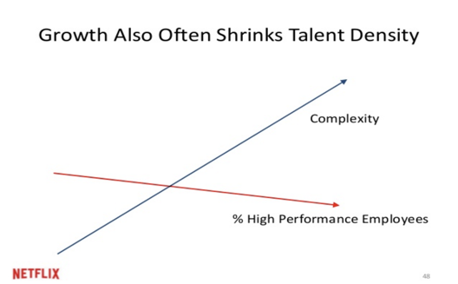
Source: World Economic Forum – www.weforum.com
An issue that seems clear everything considered: as organizations develop, so does their unpredictability. In any case, that includes some significant downfalls of contracting ability thickness: the extent of superior workers inside an organistion. What charmed everybody's creative ability were the strange arrangements that she offered: "Throughout the years we discovered that on the off chance that we requested that individuals depend on rationale and sound judgment rather than on formal approaches, more often than not we would show signs of improvement results, and at lower cost."
New organization Management teach us avoid old and standard factors in order to follow innovative challenges.

Figure 12. Differences between old and modern organization management system

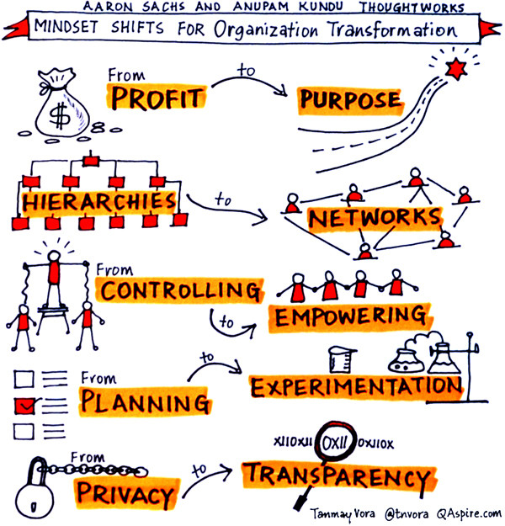
Source: World Economic Forum – www.weforum.com
As we can see, new organization system implement various factors: from profit to purpose, from hierarchies to netwokrs, from controlling to empowering, from planning to ecperimentation and from privacy to transperancy. Because wit using this way they reach their organizational goal and get succes in long term.
The Fourth Industrial Revolution additionally impacts the coordinations segment. Creative plans of action in the field of store network the board can result from the advancement of existing items and administrations however can likewise speak to an essential change in the manner coordinations administrations are delivered and conveyed. The four measurements "client", "execution", "esteem creation" and "benefit model" are key components of plans of action and support the way that an imaginative or new plan of action must not be restricted to item advancement and novel administrations. The new plans of action, as of now under talk and improvement, would have been inconceivable without digitalization. Two highlights that are normal for new plans of action in coordinations are the serious utilization of information and the computerized interconnection of all accomplices along the esteem chain.

4.3 Modern Human Resources Management Models and Knowledge Economy.

Knowledge Economy is an intellectual capital based consumer and production system. Less developed countries have a farming and production-based economy. In developing countries, there is an economy based on production and service, and developed countries have an economy-driven economy. The economies of many countries are different from each of these three main types of economic activity, with the wealth of that country.
In addition, knowledge sources, such as knowledge-based factors, human experience and trade secrets, are important factors in economic growth and are considered to be important economic sources that link to each other and create a global economy.
The knowledge economy can serve as a productive asset or business product for education and knowledge, "human capital", to be sold and exported to profit for individuals, businesses, and the economy.
In fact, unlike industry and agriculture, it does not have a privileged partnership with the industry. In every industry, knowledge-intensive services and sensitivity appear in the scientific industry as well as in the high-tech industry. Nevertheless, in every sector, it looks like an outsider, with the exception of the vast majority of the workforce. Operation is managed by a small number of large firms, increasing their presence worldwide.
We do not want to identify it with the most familiar form, as it is carried out by a high-tech industry, especially a few global meta-firms and start-up businesses. However, we do not alter what they are doing to organize complex information and increase their performance, unless they use their products on any scale, especially on computers and other information technology products and services. Such use indicates that only a small part of the potential for new production practices is that the effect can give a boost to quickly depleted productivity. From 1994 to 2005, there has been a change in reporting in the United States on a temporary increase in productivity: the wave of digital technology adoption has increased by one-time increase in the efficiency of data management. as well as advanced production practice, should be radically alienated and disseminated or disseminated. It does not want to be another way of producing goods and services with different technological equipment. He wants to be a production paradigm that continues to rebuild. This ideal is now immediately visible on the three levels of management, coordination and narrow production, and then on deeper features. It describes these features as existing, not as they are now, but as they spread and radicalize. These achievements can be very few or many, depending on how long they have been extended.
An important and well-known driver of information economy is innovation, process, and careful research not only by academics but also by companies. Open innovation is a special innovation, involving customers, stakeholders and third parties (Wallin & Von Krogh, 2010). The open innovation process is based on five state processes based on data from Wallin and von Krogh (2010):

Figure 13. Open innovation states process

Source: Samuel C. Certo, S. Trevis Certo “Modern Management”, 2013
In the Smart Manufacturing and Industry 4.0 Revolution, human capital administration faculty are plainly characterized and give proceeded with execution desires. In the Smart Manufacturing and Industry 4.0 Revolution, directors are in charge of surveying the execution of their workers. This evaluation considers the reasonable rating, prizes, and representative answering to accomplish certain business objectives. The sole objective of this assessment is to support innovation and sustainable development. In the Intelligent Manufacturing and Industry 4.0 revolution, human capital management is seen as an approach to organizations that evaluate the asset value of workers. Such an entity recognizes human capital as assets that can measure its current value and can be increased through future investment. Human capital acts as a catalyst for increasing productivity in Smart Manufacturing Industrial 4.0 Revolution. The Smart Manufacturing and Industry 4.0 Revolution will not survive if there is no human capital with the skills, knowledge and abilities needed to transform it.
In fact, they start issuing documents for bankruptcy early or in the evening, even though they do not want to get the best of their organizational staff. Similarly, if organizations employ and hire only employers and easy-to-manage employees, these organizations will be the best mediocre. The reason for this is the harmful organizational growth of suppressed or drowning creativity.
Directors, encompassing them considerably wonderful individuals, don't locate the most noticeably awful of themselves by compelling an imaginative laborer. With somebody like them. Such activities can be flops since laborers will go after thoughts, they will end up extraordinary in the cerebrum always or will never observe one another. It is stated, directors they ought not cover their innovative laborer with their truly exhausting or ordinary partners, they won't comprehend or fall. At long last, late investigations demonstrate that groups are made out of various individuals who are available to the thoughts of one another and are most inventive in discourse.The answer is to support creative workers with their colleagues who are in a position to challenge their views, but they are quite non-traditional to co-operate with them. These colleagues to pay attention to details, to secular execution processes, and to do an ugly job.
Involve them in meaningful work:
Innovations are naturally more visionary. The most inconvenience is that it won't simply merit the exertion. All or no way to deal with this work is a bipolar character of imaginative craftsmen. This methodology can likewise be connected to different representatives since everybody is increasingly innovative while dealing with their legit advantages and craving minds.
Removing pressure from workers:
The Smart Manufacturing and Industry 4.0 revolution requires more freedom and flexibility in the workforce, as it usually enhances creativity that is a cutting-edge innovation. Leads leaders against the Smart Manufacturing and Industry 4.0 Revolution
structure, order, and forecast, for example, evaluating managers like non-creativity. The reason for this is that employees are more creative and unexpectedly more creative. Managers should not limit the creative staff or follow the processes, rules, procedures or structures. Smart Manufacturing and Industry 4.0 requires employees to work remotely and out of normal hours; It should be emphasized that managers do not ask the employees where they are, what they are doing, or how they do it. Employees are the caliber of the workers required in the Smart Manufacturing and Industry 4.0 revolution, when and when and how to perform a specific task.
Do not pay most of the employees:
There is evidence that links between internal and real motivation. Over the past two decades, psychologists have provided convincing support for the so-called "reasoning" effect, ie high external rewards, in which the performance has been weakened by reducing the true or intrinsic interest of a person . In particular, when two major meta-analyzes are of natural significance (and creative positions are in this case), foreign debt burden is weakened. Nevertheless, providing positive feedback does not hurt internal motivation during the time the feedback is honest.
More importantly, those who have the talent for innovation are not funded. The evidence is clear that more creative and bizarre workers are more likely to value more than commercial needs and provide absolute logic.
There are four HRM models are:
The Fombrun
The Harvard
The Guest
The Warwick
The first model (until 1984) highlights only four features and their commitment to each other. There are 4 functions existed: selection, evaluation, development and rewards. It is expected that human resource management will contribute to these four components and organizational effectiveness.
The Fombrun model focuses on only four functions of the ICM and is incomplete despite all environmental and defective factors that affect the HR functions.
The Harvard model cases that HRM is altogether up to its six basic parts. The measurements incorporated into the model are: partners, interests, situational certainties, HRM arrangement decisions, HR results, long haul results, and an input circle. Discourses run straightforwardly to associations and partners. In 1997, another human asset the board model was created by David Guest and is better than different models. The introduction legitimizes the case. This model cases that there are sure systems for the HR supervisor to begin, which will result if certain practices are required and actualized. These outcomes incorporate conduct, execution, and budgetary prizes.
The model underlines the consistent arrangement of six segments: HR technique, HR rehearses, HR results, conduct results, execution results and monetary outcomes. Whenever switched, the monetary results are subject to the representatives' exercises, and this, thusly, is the outcome of their social conduct. The consequence of conduct is the aftereffect of representatives' responsibility, quality and adaptability, which thusly influences HR rehearses. HR practices ought to be steady with HR systems that are continually adjusted to hierarchical procedures.
Human capital is viewed as basic for the achievement of associations in this day and age, how-ever in Smart Manufacturing and Industry 4.0 upset, analysts and the board prac-titioners are as of now foreseeing this situation to take an alternate shape, given the qualities of the progressions foreseen. The attributes of human capital that are vital to progress are training, background and learning that associations need to take advantage of to make progress in the focused world. Human capital hypothesis thinks about that information conveys more prominent cognitive abilities to people, in this manner inciting their profitability and proficiency potential to create exercises.
There is sufficient proof that a nation's training framework assumes a significant job in its social, financial and political advancement. Best nations are fruitful on account of their instruction framework, for instance, Japan training framework requires that from class one to three, youngsters are just shown Japanese good qualities and that's it. This is to guarantee that they are guzzled with the Japanese's way of life and instruction framework that is strong of Japanese's workplace morals. Homerooms should cultivate quality condition equipped for innovative reasoning and unique perspectives among youngsters independent of their ages and phases of their training. Grasping advances at an early age make such youngsters progressively versatile to the requirements of Smart Manufacturing and Industry 4.0 transformation rather than appropriations and disseminations of such innovations at a later stage.
Training for Smart Manufacturing and Industry 4.0 revolu-tion is characterized by innovation proficiency, data education, media imagination, social ability and duty, work environment aptitudes and urban commitment. This is on the grounds that the data made accessible drastically increment, consequently expecting individuals to have new abilities to fundamentally access and process substance to guarantee the best social correspondence and connection. Shrewd Manufacturing and Industry 4.0 unrest present an open door just as difficulties to countries' instruction frameworks and just those countries whose training frameworks are tied down in comprehensiveness and advances goals will stay focused. It is clear that, Smart Manufacturing and Industry 4.0 insurgency depend more on the assembly of systems and gadgets to construct connects among individuals and nations. From one perspective, countries are as of now moving towards computerized vote based system to make their residents beneficial and connected with members in majority rule government. While then again, in the working environment, more individuals are required with mechanical aptitudes to satisfy the need of advanced work environment around the world. To fulfill every one of these needs for Smart Manufacturing and Industry 4.0 transformation, long lasting learning is important to guarantee that everybody can remain educated. Colleges need to lead look into endeavors not exclusively to distinguish the aptitudes yet in addition to master duce gauge of workforce that have the right stuff required in the Smart Manufacturing and Industry 4.0 insurgency.
Figure 14. A model of human capital for Smart Manufacturing and Industry 4.0 revolution. Source: Author’s own illustration.
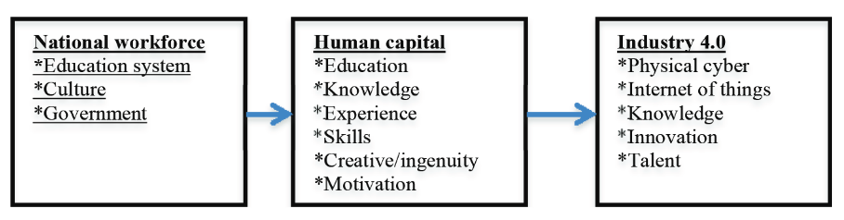
Source: Joseph Evans Agolla “Human Capital in the Smart Manufacturing and Industry 4.0 Revolution”, 2018
Human Capital Investments increase day by day and reach to the Industry 4.0. It different from physical capital with its long term. Because we use human capital in long term and education is the best method for solving issues. Different states try to invest human capital, increase their education degree, create brain drain and develop their economy in order to penetrate into global scale. The adequacy of advanced education framework focuses on the component of human capital (researchers, advanced education directors, teachers, scholastics, understudies, and so forth.): the general viability assessment framework depends on the human capabilities, guaranteeing the execution of advanced education organizations, its assessment, quality confirmation structures, potential interest or ultimate results. This is the place most creating nations should center to reform their training for information and imaginative society that outcomes in the national intensity. Great and focused training framework guarantees a nation of inventive and learned populace that contributes enormously at national advancement frameworks as individual or association.

- CONCLUSION
First of all, I have examined industrial revolutions and their theoretical and methodological aspects. I have analyzed the reasons of industrial revolution in the economy and the changes they have made in the economic system. I have come up with some of the latest innovations in this industrial revolution that have been linked to each other. Then I explored the innovations of the 4th Industrial Revolution, one of the issues of our contemporary era, and explored the countries and projects in which they were implemented. In my research, I devoted myself to information about the 4th industrial revolution, its changes in leadership, and how world standards are applied to these innovations.
The use of innovations in the 4th industrial revolution in this era where technology and innovation has developed and transitioned to the digital world means an important market share for each state. Developing countries need to gain experience from some developed countries and apply these innovations to their own economic systems and lay the foundation for an innovative strategy. With the use of robotics, internet of things, artificial intelligence, biotechnology, and nanotechnology, we can say that this revolution is globally increasing its development.
In my research I also explored modern management systems. The 4th industrial revolution has a great impact on the modern business environment. The use of existing enterprise structures has already been abolished almost globally. Instead, modern innovations and strategies that promote employee motivation and better business coexistence are put forward. Significant changes have taken place in management. Managers have already focused on the goal, but not the revenue, and has contributed to the growth of the network among employees. Instead of a previously planned and implemented system, modern methods of experiments have been introduced. Transparency has already been increased in the affiliates and has been the focus of brainstorming managers.
Countries have invested in various innovations in the 4th industrial revolution and have seen that the top three are the United Kingdom, Italy and France. Meanwhile, investments in human capital have increased. Because investing in human capital will become a profitable part of the country for a long period of time and use of human resources will increase market share in the international regime. Knowledge management and subsequent projects involve well-trained human resources - the use of human resources is crucial.
The best way to globally introduce the 4th industrial revolution is to ensure that other countries, including China, the United States, Finland, Canada, Russia, use the system.

5.1 RECOMMENDATIONS
After completing this research, I realized that there were a number of problems related to the 4th industrial revolution. First of all, if we talk about the global economy, technology and innovation should be reflected in each country. The first solution I propose for this is to apply the experience of developed and backward economies from developed countries. They can also be a developed and developed country with new world standards. Also, in order to ensure the application of the 4th industrial revolution in countries, their potential and current economic conditions should be examined first. Technology and innovation orientation, systematic action and investment are the most important points for this. For example, Africa has the potential for alternative energy with its geographical location. China, which wants to become a leader in the alternative energy market, is continuously investing in Africa.
In my research, I have shown companies that are leaders in 2008 and 2018. In 2008 we see the leadership of more oil and gas producing countries. But in 2018, we are witnessing new technology and innovation leadership. This indicates that we have already transitioned to alternative energy. I propose that countries invest in global projects on alternative energy and increase their market share and release the environment from contamination.
There is a certain potential for each country, and the main purpose of the state is to identify it and scrutinize the plan. State support is crucial for this. Each country wants a citizen to be recognized internationally. Various startups and state innovations that have been disclosed can bring realities.
All states should be ready for the change in the modern governance system to the 4th industrial revolution. Therefore, it is necessary to investigate their potential in advance and apply appropriate strategy. Managers need to develop a plan that is relevant to the employee in their systems and increase brainstorming. Leadership philosophy should be applied to the modern standards and innovations of the industrial revolution, not as in the previous period.

6. REFERENCES

- A. Bogdanov and L. Von Bertalanffy “The systems approach” August
  - 1985
- Maddison “Contours of the World Economy 1-2030 AD: Essays in Macro-Economic History” September, 2007
- W.G. Scott “Organization Theory: A Behavioral Analysis for Management” 1967
- Daniel Katz “The Study of Organizations” 1980
- Robert L. Kahn “Organizational Stress: Studies in Role Conflict and Ambiguity” 1964
- J.Lorsch “Organizations and Their Members: A Contingency Approach” 1974
- J.Lorsch “Organization Planning; Cases and Concepts” 1972
- Lawrence, Paul R, and Jay W. Lorsch “Organization and Environment: Managing Differentiation and Integration” Harvard Business School Classics 1986
- James Rosenzweig; Fremont Kast “Organization and Management : A Systems and Contingency Approach” February, 1985
- Scott Shane “Handbook of Technology and Innovation Management” July, 2009
- P. G. Aquinas “Organization Structure & Design: Applications and Challenges” September, 2009
- Joseph Evans Agolla “Human Capital in the Smart Manufacturing and Industry 4.0 Revolution”, 2018
- Tannenbaum, R. and Schmidt, W.H. “How to Choose a Leadership Pattern” Harvard Business Review, 1958
- Blake, R., & Mouton, J “The Managerial Grid: The Key to Leadership Excellence”, 1964
- Paul Hersey, Kenneth H. Blanchard, Dewey E. Johnson “Management of Organizational Behavior”, 1969
- W. Edwards Deming “The Essential Deming: Leadership Principles from the Father of Quality” December, 2012
- W. Edwards Deming “The Deming Management Method” November, 1988
- Wallin, M.W. and Von Krogh, G “Organizing for Open Innovation: Focus on the Integration of Knowledge” Organizational Dynamics, 2010
- Margaret A. White, Garry D. Bruton “The Management of Technology and Innovation”, 2011
- Klaus Schwab “The Fourth Industrial Revolution”, 2016
- Senate of the Italian Republic – 11th Labour and Social Security Committee “ The Impact of the Fourth Industrial Revolution on the Jobs Market” , 2017
- World Economic Forum “ The Global Human Capital Report2017”, 2017
- İrfan ERTUĞRUL, Gözde DENİZ “4.0 Dünyası: Pazarlama 4.0 ve Endüstri 4.0”, June, 2018
- Julfikar Ali, Akash Saha “Contemporary Theory of Management: A Comparative Study on Quantitative Approach, System Approach and Contingency Approach” May, 2016
- Gregory Clark “The Industrial Revolution”, 2007
- Chikere, Cornell C. and Nwoka, Jude “ The Systems Theory of Management in Modern Day Organizations - A Study of Aldgate Congress Resort Limited Port Harcourt” September, 2015
- Dr. Yasin Olum “Modern Management Theories and Practices” July, 2004
- World Economic Forum – www.weforum.com
- Bloomberg – www.bloomberg.com
- World Atlas – www.worldatlas.com
- Statistics time - statisticstimes.com
- Scientific Electronic Library Online - www.scielo.org
- Freightera – www.freghtera.com
- Patrick Lencioni “The Five Dysfunctions of a Team: A Leadership Fable”, 2002
- BVL International - www.bvl.de
- Samuel C. Certo, S. Trevis Certo “Modern Management” January, 2013
- Executive Summary World Robotics Industrial Robots, 2017
- Saqib Shamim, Shuang Cang “Management Approaches for Industry 4.0”, 2016
- Stephen R. Covey “The 8th Habit: From Effectiveness to Greatness” November, 2004

