THE GROWTH OF INTERNET AFFECT CONSUMER BEHAVIOR IN ONLINE CLOTHING INDUSTRY IN AZERBAIJAN

Javid Ehtimal Asadli

Supervisor: Seymur Malik GULIYEV

Project presented in partial fulfilment of the requirements for the
Degree of B.Sc. in Marketing,
University of Economics

University of Economics
2019

ACKNOWLEDGEMENT

Working on this thesis was an interesting experience and I researched and learned a lot about my topic. During these period, Mr Seymur Guliyev supported me as a supervisor. I would like to send my deep thanks to him for his human qualities and supportive manner. Without shadow of doubt, his theoretical support during this period made me to complete this research easily.
Also I would like to thank to Miss. Aida Guliyeva, as a dean of faculty she encouraged us to science and learning. My deepest gratitude belongs to her.
My beloved supporters – my parents, I would like to thank them, because of their patience and mental support these years.
I hope this thesis is going to help people to find out about factors which influence online clothing industry and its effect on consumer purchasing decision in Azerbaijan.

ABSTRACT

In recent year internet have been popular in Azerbaijan which many people spend time on any kind of platform such website, Instagram, Facebook and etc. Internet have affected marketplace which is known as e-commerce or online shopping. That is the reason why, this research project tries to find consumer behavior in online shopping and which factor influence their decision. What is main goal is to identify consumer behavior during online shopping and some factor which have impact on consumer decision on online clothing shopping. Some data were collected from 308 of respondent who have experience on online apparel shopping to identify and analysis this research. Some tests such as regression, anova and correlation were used by SPSS to analyze data to obtain some results which help online retailer to meet consumers’ needs and desires. According to result, it seems clearly that increasing of Online shopping depends on security of internet customer service and etc.

TABLE OF CONTENTS

ACKNOWLEDGEMENT 2
ABSTRACT 3
Table Content 6
1. INTRODUCTION 8
1.1. BACKGROUND OF STUDY 8
1.1.1. Review of Online purchasing definitions 9
1.1.2. Problem Statement 11
1.1.3. Research object 13
1.1.4. Research question 13
1.2. LITERATURE REVIEW 14
1.2.1. Customer service 14
1.2.2. E-Shopping Satisfaction 16
1.2.3. Factors influence online consumer’s behavior 18
1.2.4. Online retailing. 25
1.2.6. E-shopping intention 28
1.2.7. Online purchasing behavior 30
2. RESEARCH METHODOLOGY 32
2.1. METHODOLOGY OF TYPES 32
2.1.1. Research philosophy 32
2.1.2. Research approach 32
2.1.3. Research strategy 33
2.1.4. Research Design 33
2.1.5. Questionnaire design 34
2.1.6. Sampling Design 36
2.1.7. Sampling Technique 36
2.2. DATA ANALYSIS 37
2.2.1. Introduction 37
2.2.2. Descriptive Analysis 37
2.2.3. Gender of respondents. 37
2.2.4. Age group of respondents 39
2.2.5. Marital status 40
2.2.6. Graph based on education level. 41
2.2.7. Graph based on occupation 42
2.2.8. Graph based on income status 43
2.2.9. Graph based on income status 44
2.2.10. Graph based on type of online shopping 45
2.2.11. Graph based on type of online shopping 46
2.2.12. Graph based on attractiveness 47
2.2.13. Graph based on platform 48
2.2.14. Descriptive results 49
2.2.15. Validity and Reliability test 53
2.2.16. Multiple regression analysis 54
2.2.17. Anova Test 57
2.2.18. Correlations 59
3. CONCLUSION 61
REFERENCES 62
APPENDIX 1. 69

TABLE CONTENT

Figure 1: Retail e-commerce sales worldwide from 2014 to 2021……….…...…..10
Figure 2: Dissatisfied customer complaint behavior………………………………18
Figure 3: Gender group................................................................…………………39

Figure 4: Age group ...........................................………........…………….......…..40
Figure 5: Marital status …………………...…………………........………………41
Figure 6: Education …………………………..………….....……..................……42
Figure7: Occupation……………………...…………………...............................43
Figure 8: Income level ……………………………..………………...................... 44
Figure 9: Credit card ...............................................................................................45
Figure 10: Type of online shopping……………………………………………….46
Figure 11: Frequency…………………………...………………………………....47
Figure 12: Attractiveness ………………………………………..……..................48
Figure 13: Platform ….............................................................................................49
Figure 14: Factors …………………………………………………………………50
Figure 15: Customer satisfaction level…………………………….………………51
Figure 16: Afraid of people......................................................................................53
Table1: valid test……………………………………………………………….….54
Table2: Reliability test……………..……………………………………...………54
Table 3: Variables ...................................................................................................55
Table 4: Model Summary for Independent Variables………..................................55
Table 5: ANOVA test...............................................................................................56
Table 6: Coefficients................................................................................................57
Table 7......................................................................................................................58

Table 8 .....................................................................................................................58
Table 9……………………………………………………………………………..59
Table 10………………………………………………………………..…………..59
Table 11…………………………………………………………………..………..60
Table 12……………………………………………………………..……………..60

INTRODUCTION

This chapter consist of background of the study, problem statement, research objectives and research question which will be debated. In the end of chapter, brief information are given about this chapter.

1.1. BACKGROUND OF STUDY
Customer conduct of each individual is not quite the same as other relying upon purchasing decisions which is impacted by conduct of shopping and decisions that are turn altered by mental and social drivers that influence buy choice procedure. (Brassington, F. and Pettitt, S., 2000) Web based business can be characterized as business exchanges behaviored electronically on the web (Kotler &Keller, 2012). Numerous organizations are attempting to increase upper hands by utilizing internet business as business stage (Lee and Lin, 2005). By looking at the enormous amount of social media campaigns, e-commerce websites, online sales, forums, etc., it appears that companies of all sizes have been translating their marketing approaches to the Internet because it is accessibility to have impact on their target audience and the money required to do so. (Chui and Manyika 2012.)
As per Hou (2005), the improvement innovation of web has made boundless changes for internet business because of the convincing points of interest that recommends over regular blocks and mortar stores, for example, more noteworthy adaptability and market outreach more extensive, product offering, smoother exchange, lower cost structures, accommodation and customization. According to Bitner (2001, p.376) states, supports that new technology, like internet, provides a new suitable and productive way to service customer as well as an easy way for customers to learn and get information about goods .
Cox and Dale (2001) states that However, without a legitimate quality administration from its frameworks, staff and provider, it is exceptionally hard to fulfill purchaser because of retailers unfit to convey the suitable dimension of administration. Adequately overseeing on the web stores that have sway on consumer loyalty for online retailer as well as critical for multichannel retailer on account of the equal impacts over the channel (Venkatesan, Kumar and Ravishanker, 2007). As indicated by Finn before concentrate in 2008 (as refered to in Ha and Stoel, 2012) guarantee that those clients who have an awful web based acquiring background seem to oppose shop through the retailer's different channels.
In this manner, it is extremely fundamental for clothing retailers to choose the determinants of web based shopping quality and noteworthy variables that influence purchaser shopping result, for example, e-shopping fulfillment and e-shopping aim (Lee and Lin, 2005; Ha and Stoel, 2012)

1.1.1. Review of Online purchasing definitions
Today, Online shopping in the world is very popular among consumers who want to save time. In additional, online shopping give a chance consumer to make purchase decision easily.

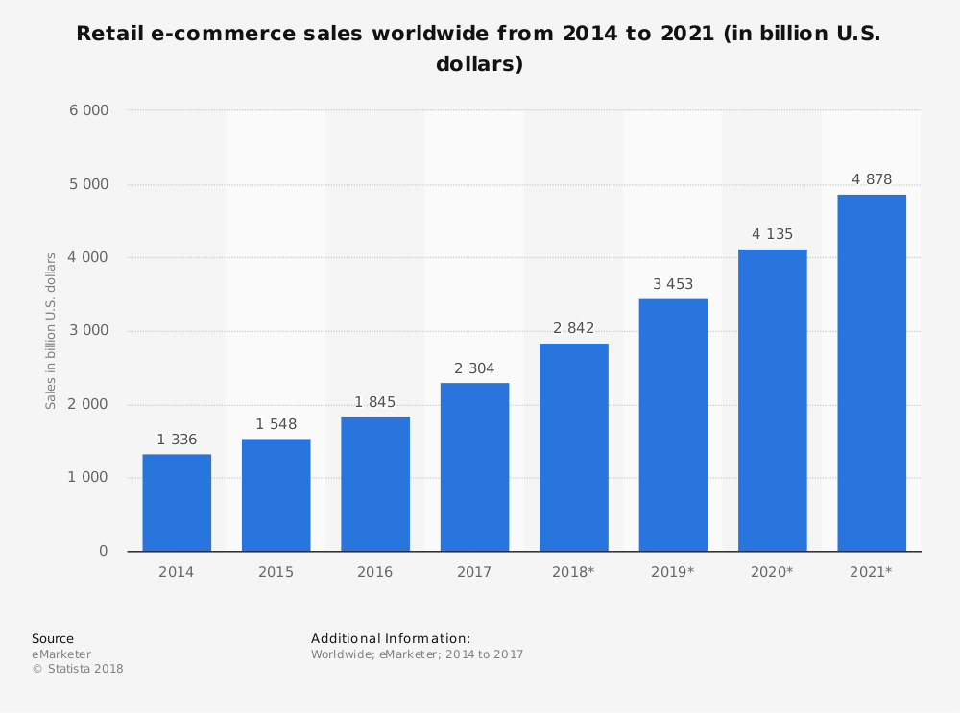Figure 1. Retail e-commerce sales worldwide from 2014 to 2021
When it comes to e-shopping sales, we can see that there are a significant increase from 2014 to 2018. It is predicted that It will continue to increase to until 2021. Online purchase providee people some opportunity. Today, there are many companies which offer same products to consumer. If consumer want to compare product they can do it easily and do not need to go every market examine products. Aad Weening (2012) states that The online shopping is a crucial part of an economy and country and give trust and confidence to consumer to buy products via internet.
Before said that A great deal of creator and analyst show that internet acquiring are utilized by numerous buyer. As of late, internet buying has been well known in Azerbaijan. Online commercial center can offer advantage to both shopper and retailer. In this manner, it gives savvy channel to retailers to achieve their objective buyers. Likewise, advantage purchasers on the grounds that internet shopping help client to spare time and cash while giving more item decisions (Alba, Lynch, Weitz, Janiszewski, Lutz and Wood, 1997)
Lee (2014) states that some consumers prefer to buy products via internet because they can compare different types of products or services and find new products or services that are exclusive for them.
Consumer behavior can be more difficult in electronics environment than traditional environment because some people who prefer to buy product traditional way want to examine product before purchasing. Sometimes, consumer fear to use online shopping because they cannot touch physical product which are wanted to buy via internet That is reason why, Sajjad (2012) noted that consumer purchase decision which use online shopping can differ from other consumer who prefer to buy product face to face.

1.1.2. Problem Statement
Online shopping is one of the important factors to enhance market share and gaining positive competitive advantages for businesses. As Tung (2012) claims, modern traditional retailers have admitted that internet is going to become crucial marketing tools with the dynamic growth of market size.
According to Santos (2003), Online service quality play vital role for consumers who anticipate high standard of online service quality since it is much easier to compare price online. That is why increasing competitiveness of online stores, in understanding of factors or online service quality that affect consumer’s decision making process should be given priority (Seymur M.G, 2015)
Sharma and Sheth (2004) states that protection and security has been a basic issue in web based buying on the grounds that there are a few dangers that one of them identified with abuse of individual data and cause individuals reluctant to buy items through web. Along these lines, protection and security is one of the cirucal factors that have sway on buyers' shopping results.
Website design is very essential factor for customer who are presented by company (Than & Grandon, 2002). The quality of website and features always play key role to affect consumers to buy product via internet. Kim, Kim and Lennon (2011) stated that lack of relevant product information in the website is very big problem that customer may exit the website without any purchase for company.
Im and Ha (2011) noted that purchase intention is one of variable which is very crucial factor to predict future behavior of consumers. Based on earlier study of Schlosser in the year 2003 (as cited in Im & Ha, 2011) suggested that purchase intention can be identified to predict available consumers purchase behavior. If retailers do not into consideration purchase intention or consumer shopping behavior, they cannot extend their market share. As result, purchase will be decreased. However, some companies which to increase rate of sales can predict consumer intention.
Chua, khatibi and Ismail (2006) and Tung (2012) stated that there are limited studies and online shopping quality dimensions which zeroed in on focused on online clothing industry. Although online market which is high potential play a vital role in clothing industry however many companies cannot comprehend that consumer satisfaction and purchase intention are effected by potential market (Chua, Khatibi & Ismail, 2006). That is why, If company wants to structure e-shopping quality measurement with satisfaction and intention, it need a framework.

1.1.3. Research object
Aim of this study is to evaluate the connection among some factors whic are very important for our research. There are e-shopping quality dimensions, e-shopping satisfaction and e-shopping intention about clothing retailing in Azerbaijan.
- To examine customer service and e-shopping satisfaction on online clothing retailing.
- To examine e-shopping quality dimensions and e-shopping intention on online clothing retailing.
- To examine some factors which is preferred on online clothing retailing.
- To examine fear of Azerbaijan consumer toward online clothing shopping.

1.1.4. Research question
There are four question for my research which they is very important to get result.
- Does customer service influence e-shopping satisfaction on online apparel retailing?
- Does satisfaction mediate e-shopping quality dimensions (privacy/ security, website design, customer service and atmospheric/ experiential) and shopping intention?
- Which factors are preferred by Azerbaijan consumer during online purchasing?
- Do Azerbaijani consumers have fear towards online shopping and why?

1.2. LITERATURE REVIEW
In this chapter literature review focus on debate which is about past study. Literature review will start about customer service, followed by e-shopping satisfaction. It is going to continue with describing factors which include financial risk, Delivery risk, Security risk. After that, it is presented online retailing, e-shopping and e-shopping intention.

1.2.1. Customer service
According to Kim (2011), there is not shop assistant and there is not connection between consumer and retailer in online store that is the reason why retailer should provide customer service through multiple channels which give satisfaction to consumer. As Seymur M.G (2018) stated Customer service is crucial factor which it helps to solve problem, to provide consumer to choose something and to respond inquiries quickly. In addition, Customer service should be ready to support customer’s needs and be willing to answer customers’ question. Zeithaml, Parasaraman & Berry (1990) noted that customer service is to provide information and respond question. What is more, it can be very hard which company need to predict consumers’ needs and follow consumer habits.
There is strategic importance for customer service and companies need to improve consumer satisfaction and experience to gain consumer attention in competitive market. Kotler (2000) said that processes and actions are made easier to do business with a company by customer service.
Client administration has key significance (Dean& Terziovski, 2000) and expects organizations to ceaselessly improve client experience and fulfillment, to convey quality in a focused commercial center (Schneider and Bowen, 1999).
Customers’ expectation should be always met with service which are provided by websites management that helps customer to complete transaction, product delivered on time and respond question quickly by email (Cristobal et al. 2007). Francis (2009) pointed out that customer service has strong predictor ability to provide many kinds of internet offer such as offline services and goods.
Francis (2009) noted that Customer service should give a chance which consumers’ mail are responded quickly, problem is sold and information which is about company are obtained easily. According to Jun, Yang and Kim (2004) , what is very important for companies Is that companies need staffs who should have some abilities to enhance their customer service to attract consumer attention and give them satisfaction. In addition, there are not external and internal collaboration which it cause to lose effective communication amount different departments. That is the reason why it can have negative impact on shopping quality which are not enhanced ( Jedd 200).
Disend (1991) noted that some authors believe that customer service are all activities which help company to make good relationship with consumer in the future. However, some authors claim that customer service provides utility to consumer which is known as measurable activities. Customer service consist of five factors which help consumer to appreciate services (Dr. Leonard Berry 1999).
Factors which influence satisfaction of customers are in accordance with Zeithaml et al. (1990).
- Reliability – ability to provision of what was pledged exactly and dependably
- Assurance – ability to carry competence, trust and confidence to your customer and courtesy and knowledge that is shown to them.
- Tangibles - your appearance, equipment and physical facilities.
- Empathy – to what extent you have individual attention that you show to customers.
- Responsiveness - The readiness to help customers quickly.

According to Jedd(2000),Companies need to enhance their consumer service which is very important to attract consumer attention and be leader in the marketplace. If consumer face any problem during purchasing or after sales, consumer service can be more useful to solve problem (Zeithaml et al. 2002). However, according to Ha and Stoel (2012), customer service does not play important role to affect consumer satisfaction but e-shopping intention can be affected by it. To sum up, it can be see that customer service can be crucial factor to be successful in the market (Zeithaml et al., 2002; Kim et al., 2011 ;Ha & Stoel, 2012; Francis, 2009).

1.2.2. E-Shopping Satisfaction
E-shopping satisfaction is a way to measure online consumer response that online products are provided some consumption which is a pleasurable (Oliver, 1997 as cited in Ha & Stoel, 2012; Cronin, Brady & Hult, 2000). Chang & Wang (2011) that Customer satisfaction plays vital role in the marketing which it helps to consumer intention which is desired satisfying consumer. According to Oliver (1997) and Woodruff (1997), consumer satisfaction relate to consumer reaction and gives chance to show feeling which is negative or positive about product’ value from retailer. Kotler (2000) said that Consumer satisfaction is known as person feeling which consist of two sense such as pleasure and disappointment. That is why this feeling can be resulted from service or product performance which relates consumer expectations. Satisfaction is revealed during purchasing stages which are need something, getting information, evaluation of alternative purchase, purchase intention and post purchase behavior (Schaupp and Belanger 2005). Satisfaction of consumers is a result of experience which consumer gets during different stages of purchasing process which are information being aware of need, collecting information, evaluation of product alternatives, purchase alternatives and behavior that show consumer after purchase (ibid.)
Customer service is crucial factor for company which it shows difference between physical present business and business which is located in the online world. Sometimes, some orders which do not exist are accepted during online purchasing. Consumer cannot these items which later come they know that product is out of stock and it cause dissatisfaction feeling. (Carroll & Broadhead 2001)
Profitability of a business depends on both customer satisfaction and customer retention (Best 2005). Hill and Alexander (2003) noted that if company convinces people to stay committed to product and service,It ensure that consumer will not seek alternative product or companies. According to best (2005), measuring consumer satisfaction Is very important to success in competitive marketplace.
Lin and Sun (2009) pointed out that measuring consumer satisfaction is very important for retailer to have positive impact on consumer decision which are influenced by satisfaction during purchasing. Consumer satisfaction is very essential to start relationship with client for a long term can bring some benefit such as sustaining business (Schaupp and Belanger 2005). That is the reason why products or service should be met expectation of consumer by retailers. If they do it, they can make repetitive purchase which increase e-commerce firm of sales (Jiradilok, Malisuwan, Madan & Sivaraks, 2014). However, many factors can affect consumer e-shopping satisfaction such as quality dimensions.
Market-driven business associations place uncommon accentuation on consumer loyalty. Edosomwan (1993) in (Grigoroudis and Siskos 2010) characterizes these associations as pursues:
A client and market-driven undertaking is one that I resolved to give magnificent uality and aggressive items and administrations to fulfill the requirements and needs of client in a well-characterized showcase portion… Such an endeavor examine its market capacities and gives items and administrations to fulfill advertise needs. It considers its clients as the last judges who decide item and administration fulfillment level, conveyance, cost and execution
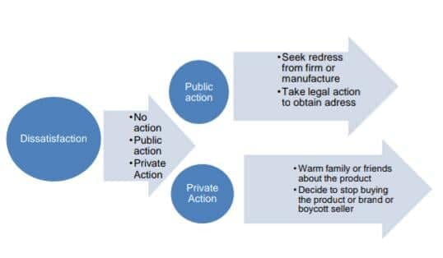
Figure 2: Dissatisfied customer complaint behavior (Day and Landon, 1977) in (Grigoroudis & Siskos 2010).

1.2.3. Factors influence online consumer’s behavior
Kumar and Dange (2014) referenced that there are two segments of seen chance that are associated with web based shopping which are vulnerability and the importance of the outcomes of specific buy. According to Seymur M.G (2013) ,Vulnerability is identified with the conceivable results of positive or negative behavior and undesired aftereffects of these outcomes. Vulnerability is additionally connected with the conceivable loss of cash while making a monetary exchange for a specific item on the web (Kumar and Dange, 2014). Monetary exchanges on the web are connected to different risk factors (Adnan, 2014). Moreover, Adnan (2014) referenced that the clients see diverse risk factors before exchanging cash to online trader. These components could be monetary misfortune, security and protection. Naiyi (2004) asserted that diverse elements of saw risk, for example, e-retailer source chance, obtaining process and time misfortune chance, conveyance chance, money related risk, item execution chance, awry data risk, and protection chance with respect to web based shopping goals have contrarily affected buyer's internet shopping behavior.
It is referenced above about the determination of five online variables that have been picked subsequent to perusing the applicable writing in the field of purchaser's behavior in web based shopping. These components are additionally portrayed in the accompanying segment.

1.2.3.1. Financial risk
An ongoing report was led by Kumar and Dange (2014) where the point have been to examine distinctive components of saw chance that impact the buyer's internet shopping behavior. The consequences of study uncovered that web based shopping sees chance with respect to monetary risk, time chance, social risk, and security chance as they affected progressively online buyer's demeanor towards internet shopping. Then again, a similar two web based purchasing risk factors are monetary risk, and security chance that have affected on non-online customers (Seymur M.G., 2014). Besides, their investigation has discovered two extra obstructions of mental risk and physical risk among non-buyer.
In this examination ''Saw chance in attire internet shopping'' Almousa (2011) explored the effect of apparent risk measurements in clothing web based shopping. In view of the data of an online overview and gathered exact information from 300 respondents, the examination uncovered apparent risk measurements which did not have a similar effect on clothing web based shopping behavior. Significantly, performance risk, and time have more extensive effect than security and social risk interestingly money related risk and mental risk have no critical impact on buyers' web based shopping behavior.
Samadi and Nejadi (2009) directed an investigation and found the impact of apparent risk level among online customers and store purchasers. In this investigation, the relationship was estimated among past positive shopping encounters, saw risk, and future goal to buy inside web based shopping condition.
According to Seymur M.G (2015) stated that The discoveries of study showed that online customer saw higher risk rather than store purchasers. They found that monetary risk, physical risk, accommodation chance, and utilitarian risk had all the more altogether influenced customer's behavior in web based shopping condition. Among them, money related risk had a negative impact to impact shopper's aim to shop on the web. Customer had a dread to lose cash over the web shopping. Further investigation showed that high seen risk prompted limit expectation to shop online in future when contrasted with less seen risk that lead to higher aims to purchase on the web(ibid.).

1.2.3.2. Product performance risk
Masoud (2013) led an investigation on Jordan's online customers. The point of this investigation has been to look at the apparent risk (money related, item, time, conveyance, and data security) on web based acquiring behavior in Jordan. The examination directed a review of 395 online purchasers and clients to explore the theory of research. He chose the clients that had past involvement of web based shopping, and the examination picked the most famous online stores in Jordan. The examination result demonstrated that four saw chance (monetary, item, conveyance and data) had adversely influenced web based obtaining behavior. Additionally, the examination demonstrated that there was no critical impact of time and social risk on internet acquiring among Jordanian shoppers.
Yeniçeri and Associated (2013) contended that item chance is identified with the poor execution of an item or brand particularly when the execution of an item or brand does not meet the ideal desires. It is because of customer's wastefulness to evaluate the great nature of item or brand in online stores. Moreover, they clarified that the purchaser's aptitudes to evaluate the item or brand are constrained in online website due to non-accessibility of physical examination of an item including contacting, brand hues, mistaken data of item includes which results in an expansion of the item execution risk. Ji et al. (2012) considered the purchaser frame of mind towards the web based shopping condition and concentrated on the effect of various saw risk to various items. In the wake of creating the outcomes from relapse coefficient, the examination found that there is a negative impact of item execution when the purchaser purchases not institutionalized items like attire while there is a constructive outcome when the customer shops standard items like PDAs.

1.2.3.3. Delivery risk
Hong (2015) proposed that the item conveyance risk had a beneficial outcome if shopper requested the item from a solid online vendor, in this way clients discover approaches to approach dependable online dealers to decrease the item conveyance chance. Amid buying from solid online vendor, the buyer feels protected and safe from undesired item conveyance issues. Adnan (2014) demonstrated that the item conveyance negatively affected purchaser's purchasing behavior. Besides, Adnan (2014) recommended that online shippers ought to give protection inclusion to online purchasers if a thing isn't conveyed to the shopper in time. Customers dread not to get items in time or postponement in conveyance which prompts a high item conveyance risk (Yeniçeri and Associated 2013).
Moshref et al. (2012) planned to look at ''An examination of elements influencing on web based shopping behavior of customers'' in an Iranian point of view and decided the effect of different saw risk factors (budgetary risk, item chance, accommodation chance and non-conveyance chance) in web based buying behavior. To look at the speculation of this investigation, they chose distinctive online stores in Iran and conveyed 200 polls among hapriskly chosen online buyers. Their examination inferred that two saw risk (money related, and non-conveyance) had contrarily influenced internet shopping behavior of Iranian purchasers while other saw chance (space explicit ingenuity and abstract standards) positively affected web based shopping behavior of Iranian customers. As indicated by Koyuncu and Bhattacharya (2004), numerous clients had less aim to shop online in light of the inclusion of conveyance chance. The consequence of the examination found that people who purchase online once per week or make a few online buys in a month had contrary effect of item conveyance risk, rather than the individuals who do web based shopping not exactly once every month - they had a constructive effect of item conveyance.

1.2.3.4. Trust & Security factor
As per Ariff et al. (2013), mental factor like trust identified with the degree of the assurance a site gives and protects client's close to home data. Besides, Ariff et al. (2013) referenced that trust and security had a vital and constructive outcome on customer's frame of mind in web based shopping. Yörük et al. (2011) led an investigation among Turkey and Romanian purchasers' web based shopping behavior and found that in web based shopping condition, trust and security factors were the real snags for customers not to shop on the web. They liked to circumvent markets to shop items through physical assessments particularly Turkey's buyer are increasingly mingled and appreciate to go to bazaars and invest hours in the shopping centers.
Roman (2007) contended that the security factor shows shopper's conviction viewing internet shopping just as the security of purchaser's money related data which ought not be undermined or imparted to an outsider in web based shopping setting. Ahuja et al. (2007) inquire about asserted that the trust and security are principle snags for buyers not to shop on the web. As per Elliott and Spot (2005), trust is a critical factor and comprehensively influences the web based shopping mentality because of online promotion and online website that sets aside effort to download pages identified with shopper's worry towards online security which may take individual data.
Monsuwe' et al. (2004) investigate asserted that the break of buyer's trust prompts negative demeanor toward web based shopping. Then again, keeping purchaser's close to home data protected and secure prompts progressively uplifting demeanor toward web based shopping. Hence, the trust was an essential mental factor which influences the aims of buyer to shop on the web. An investigation by Grabner-Kraeuter (2002) recognized two components of trust related issues: ''Framework subordinate vulnerability and Exchange explicit vulnerability'' in web based shopping condition, the examination utilized monetary model of trust and reasoned that the trust is increasingly critical and fundamental factor for the decrease of vulnerability and multifaceted nature of budgetary exchanges and relationship.

1.2.3.5. Website design factor
Suwunniponth (2014) analyzed the variables that determined customers' expectation in web based shopping. The idea of the examination was subjective and quantitative. He decided the diverse online components like web composition, saw convenience, saw value, and trust impact buyers' goals to shop on the web. The information was gathered through poll and inside and out meetings. It was gathered as a survey through 350 experienced online customers in Baku and Ganca afterward expressive examination and way investigation were utilized to investigate the information. The investigation uncovered that the site apparent usability and value. The trust had noteworthy impact on the shoppers' aim to shop on the web. The outcomes found that the site had noteworthy impact on the purchaser's internet shopping demeanor and online shopper wants to have an easy to understand site in web based shopping condition. The examination finished up innovation acknowledgment factors and trust that had huge association with goals towards various items and administrations and furthermore towards proposed conduct to shop.
Adnan (2014) expected to explore the impact of various components of saw hazard, saw favorable circumstances, mental elements, decadent inspirations, and web composition on web based shopping conduct. The examination conveyed 100 polls to online purchasers in Pakistan. The examination found that apparent favorable circumstances and mental components affected the purchasers' expectations to shop on the web while saw hazard negatively affected the customers' disposition toward internet shopping. Different elements like web architecture and indulgent inspirations had no huge effect on the shoppers' expectations to shop on the web. Hassan and Abdullah (2010) attempted to decide the impact of free factors web composition, trust, web information, and web based promoting shopper's web based shopping conduct. He utilized a poll study and it was filled in by online clients and test the speculation. The consequence of the examination demonstrated four autonomous (web composition, trust, web learning, and internet promoting) factors where web based shopping had a positive relationship. Besides, the exploration asserted that site quality had noteworthy effect on web based shopping. The examination proposed that the structure of sites ought to be anything but difficult to utilize, helpful, efficient, simple to stack site page, basic route. The solace of utilizing a site page will expand the likelihood of returning to increment (ibid.)
Li and Zhang (2002) directed an investigation dependent on 20 experimental articles. The reason for the investigation was to examine the effect of site quality on internet business. In light of substance examination of these investigations their exploration discoveries demonstrated that web composition had decidedly and fundamentally affected shopper's demeanor towards internet shopping. Then again, they likewise discovered that web composition had two distinct fragments which buyer saw in web architecture that were cleanliness and inspiration. Besides, they referenced protection and security, simple route of site, and complete data identified with cleanliness fragment. The nonappearance of cleanliness prompts disappointment of buyer's need when contrasted with pleasure, quality, subjective result, client strengthening, and e-retailer data that is connected to inspiration section in web composition. These elements of inspiration section increment the estimation of web architecture and fulfilled purchaser's need. So, a great and engaging web architecture can be useful for customers to make their e-shopping simple and smooth. Then again, a low quality web composition could be a hindrance for shoppers not to shop on the web.

1.2.4. Online retailing.
Barua et al (2001) noted that online retailing gives a chance to companies to generate their revenue rather than traditional channels. Revenue can be gotten to use online retailing by selling product in online which it can have positive impact on financial status. If product are sold through online retailing they can reduce staff of company which helps to save additional cost.Webb, k.l (2002:96) defined e –commerce as technologies of information and tools which relate computer to do business task. Ecommerce plays vital role in changed business world. According afuah and Tucci (2001), E commerce and internet are used to create value and do business which give some opportunities to consumer to save time and cost effectiveness. Information and electronic trading of physical goods plays main role in e-commerce.
What is main aspect of the online retailing is using online channel for exchanging services money and information (Madlberger M., 2004:297). Dubsson- Torbay (2002) stated that framework of online retailing model which is developed helps to company to define target groups and consumer needs, Intention. What is more, Company can be successful if it learns and study about consumer behavior.
There is some different business model which are used in E-commerce (P. Timmers 1998:4-5).
- E-shop: Companies are given chance to sell their product via internet to customer.
- E-procurement: suppliers are connected with each other by this model while they do some transaction
- E-auction: this model is part of auction which helps to sell product via online.
- E-mall: there are any types of e-shops which are collected under common umbrella.
As it is said, Companies depend on industry type which have impact on chosen such as electronic model. E-shop and E-malls plays significantly role in this field.

1.2.5. E-shopping
Online shopping is known as business-to-customer ecommerce. Online has shopping become part of consumer daily life which it can help to consumer to save time and energy. According to Zhou et al., (2007), many people tend to buy difference product from internet that is the reason why, online shopping has become more popular among people since the late 1990s.online shopping can bring benefit to both consumer and retailer.
There was significantly increase for e-shopping, going up from $172 billion to $329 billion during 5 years (Johnson 2005, cited by Zhou et al., 2007). Zhou et al., (2007) noted that there are many kind of benefit for consumer such as convenience, various selection, natural service, personal attention. According to Park and kim (2003), online store has four categories of attributes: merchandise, customer service and promotions, navigation and convenience, and security. Product-related characteristics belong to merchandising which it means that consumer can be more satisfied with product assortment which is very rich. As Seymur M.G (2018) said that What is second attribute is customer service and promotion which includes various online discount information, return and payment policy and answer to frequently asked question. Navigation and convenience are the third attribute category which it about the user interface of an online store (Szymanski and Hise 2000, cited by Park and Kim, 2003). This help consumer to search and purchase through providing product such as search engine, site map and navigation sequence. The final is keeping of online transaction which it ensures consumer that their private information is protected by company (Elliot and Fowell 2000, cited by Park and Kim, 2003).

1.2.6. E-shopping intention
E-shopping helps companies to force and stimulate consumer to buy products via internet (Thamizhvanan and Xavier, 2013). Earlier study of Schlosser in the year 2003 (as cited in Im & Ha, 2011) pointed out that consumers’ purchase intention should be measured to predict actual consumers’ purchase behavior. If company measure online purchase intention correctly on website, it is given chance to assess consumer behavior (Pavlou, 2003).
According to Jiradilok et al. (2014), it is very hard to measure actual consumer behavior which is not practical that is the reason why it is suggested that purchase intention is seen as the representative to help company to predict consumer behavior. Purchase intention is very important for company which it helps to predict future consumer behavior (Im and Ha, 2011). What is more, according to Thamizhvanan and Xavier (2013), if online retailers want to gain market share and force consumer to buy product, they should focus on some details which are able to have impact purchase intention among consumers.
According to Seymur M.G (2015), E-shopping intention is about purchasing product which some elements such as brands, its perceptions and its motivations can have impact on consumers. Online shopping intention plays vital role to show actual purchasing and help retailer to predict consumers’ action (Kim et al., 2008; Lee et al., 2015; Pavlou, 2003).
Conduct aims are factors that see how individuals are happy to make a specific conduct and conduct goals likewise impact the forecast of a specific conduct (Azjen, 1991).
The hypothesis of contemplated activity has been utilized to anticipate somebody's conduct as per its dispositions towards abstract standards and gatherings of persuasive individuals in his or her’s life (Azjen et al., 1980). These emotional standards likewise impact electronic buyers' online buy aim through the demeanors purchasers when all is said in done have against internet shopping (Hansen et al., 2004). Web based retailing is a significant channel for some, organizations, having continued its deals amid the emergency on account of it. As internet business turns out to be increasingly more aggressive e-retailers are concentrating in inspiring shoppers to receive online channels to buy and repurchase its items (Chiu et al., 2014). So as to increment online buy expectation, organizations need to fulfill the wants and needs of the online purchasers (Fortsythe et al., 2003). For this, it is critical to profoundly investigate the impact of online inspirations as a determinant of procurement expectation and which measurements of online inspirations may have more impact in the buy goal.
Wan (2009, p. 219) There are three main studies in the process of online shopping which are called as Human computer interaction (HCI), behavior and consumerist orientations Wan, 2009, p. 219).

1.2.6.1. Human Computer Interaction (HCI)
HCI incorporates web architecture, client's effortlessness to learn, cooperation, productive, show and lovely which fundamentally impact shopper conduct. Wan, (2009, p. 219) said that There are a few attributes, for example, enhanced visualizations and engaging quality, simplicity of route, less tedious, data accessible on site, and procedure exchange which isn't long and troublesome structure, by and large nearness of site with security affirmation.

1.2.6.2. Customer concerns in online shopping (CCOS)
Next group is Customer concern in web based shopping which human conduct and its credits are researched to figure out what influence web based shopping choice. Trust is significant factor among buyer and online retailers which it animates shopper to purchase items by means of web. As indicated by Wan (2009, p.220), there are three components to expand trust among buyer and online retailer which it incorporates Safety and protection of data, security and conveyance and profit for time.

1.2.6.3. Consumer characteristics
The third group of study is consumer characteristics which this study helps to company to find some individual characteristics such as his tradition and culture, demographics, profile and personality is very important during online shopping. There are other variables which are able to influence consumer purchasing behavior and online consumer depend on these elements such as computer literacy, technology awareness, past experience and his comfort level in online shopping.

1.2.7. Online purchasing behavior
Online shopping behavior is very important for company which it is consumer’s idea about product or service which can be good or bad. According to Li and Zhang (2002), Past investigations have characterized that conduct is a multi-dimensional develop and has been conceptualized in various ways. Web based shopping behavior is vital for organization which it is purchaser's thought regarding item or administration which can be positive or negative. Li & Zhang (2002) states, past investigations have characterized that behavior is a multi-dimensional build and has been conceptualized in various ways.
Numerous researchers define consumer behavior from different dimensions. Gozukara et al. (2014) defines consumer behavior according to the first dimension towards a utilitarian motivation (variety seeking, convenience, cost benefit, time effectiveness and quality of merchandise). The second dimension is about hedonic motivation (fantasy, awakening, happiness, escapism, enjoyment & sensuality), and Baber et al. (2014) state that the third dimension is about perception of ease of use, and usefulness. Another measurement covers apparent risk which decide customer behavior towards internet shopping.
There are two different types of perceived risk entailed in identifying consumer behavior in the process of internet shopping (Li & Zhang, 2002). It is additionally depicted as the principal classification of saw risk associated with online item and administration for example budgetary risk, time risk, and item chance while the other class of perceived risk associated with e-exchanges including protection and security (ibid.).
Numerous scholars (Samadi & Nejadi, 2009; Kumar & Dange, 2014; Subhalakshami & Ravi, 2015 Hassan et al. 2006) say that perceived risk including product risk, time risk, financial risk, non-delivery risk, privacy risk, social risk, information risk, and personal risk have a bad and substantial impact on online shopping behavior of consumers. Trust and security are dimension of consumer’s behavior on internet retailers, positive online shopping experience reduces the perceived risk and establish consumer’s trust on e-retailers (Monsuwe et al., 2004)
- RESEARCH METHODOLOGY

Methodology Of Types

2.1.1. Research philosophy
The ''term reasoning is identified with the advancement of learning and the idea of that information'' (Saunders et al. 2009. p. 107). Most explores depend on specific suppositions about the idea of the real world and the information is created. This exploration depends on presumptions of purchaser's web based shopping behavior. Managing philosophical suspicions is a significant advance in scholastic research (Saunders et al. 2009). This segment will give a review of elements of philosophical suppositions. Buyer's web based shopping behavior is framed by various online variables like money related risk, item execution risk, trust and security, and web architecture towards internet shopping. Because of this reality, the buyer internet shopping behavior is changed after some time. In this manner, the theory depends on subjectivism, which signifies "that social wonders are made from the observations and resulting activities of social performing artists" (Saunders et al., 2009, p. 110). As this exploration investigates the variables which impact purchaser's internet shopping behavior, this examination requires quantitative research strategy to research the impact of various online components. Accordingly, a positivism epistemology is utilized. Positivism is "working with the perception of social reality and final products of research can be summed up to similar items by physical and common researchers" (Saunders et al., 2009, p. 113). Accordingly, existing hypothesis is tried and diverse theory created (Saunders et al., 2009)

2.1.2. Research approach
As this examination depends on existing speculations of purchaser's behavior, it has been utilized a deductive methodology, since it is more appropriate to this exploration than an inductive methodology, which is principally used to apply a hypothetical structure upon experimental information (Saunders et al., 2009).

2.1.3. Research strategy
The idea of this investigation is an illustrative kind, and the point of the examination draws an image of the examination's subject, along these lines a quantitative research technique is utilized in this examination. Creswell (2003) referenced that time is imperative factor for settling on any decision of choosing research strategy. Saunders et al. (2009) thought about that quantitative examination is quicker than subjective investigation since it is conceivable to appraise contemplate time period albeit subjective investigation can take similarly additional time. Research ventures are by and large directed for scholastic purposes and are constrained to time, hence, this examination is additionally for scholarly reason that must picked and pursues quantitative methodology.

2.1.4. Research Design
As per Saunders, Lewis and Thornhill (2009), investigate configuration will be the general arrangement of how to respond to explore question. In addition, inquire about structure contain goals got from research question, determine the sources from which plan to gather information, moral issues and thought of the imperatives, for example, access to information, time, area and cash.
This examination think about is configuration dependent on quantitative methodology which is created through the calculated structure from past writing and tried information investigation (Zikmund, 2003). Descriptive and illustrative investigation will be utilized in this exploration contemplate. As indicated by Saunders et al. (2009), engaging examination is portraying the qualities of the populace or marvel.This examination consider is design reliant on quantitative approach which is made through the determined structure from past composition and attempted data examination (Zikmund, 2003).Descriptive and illustrative examination will be used in this investigation think about.
Bryman (2012) suggested that there are five nonexclusive research structures in particular; cross-sectional, longitudinal, contextual investigation, near, and trial. In light of the writing looked into, the examination report utilized a cross sectional research configuration so as to manage the exploration movement. Cross sectional structure is characterized by different analysts as "An exploration plan that involves the accumulation of information on more than one case at a solitary point in time so as to gather an assortment of quantitative or quantifiable information regarding at least two factors which are then inspected to distinguish examples of affiliation" (Bryman, 2012). Seymur M.G (2018) characterizes a cross sectional plan as "the investigation of a specific marvel at a specific time" Robson (2012) alludes to cross sectional structure as "An examination plan where information is gathered at a solitary point in time (by and by over a brief timeframe)". The method of reasoning for utilizing cross sectional plan in this report was that it allowed the specialist to break down a wide scope of factors in the meantime. The point was to endeavor to comprehend the inspirations driving individuals' choices to connect via web-based networking media stages and what advises their buy choices.

2.1.5. Questionnaire design
According to Hayes (2008), there are some consumers’ satisfaction dimensions which need to be valued such as timeliness, completeness, availability, responsiveness, convenience by questionnaire. Time is very important satisfaction forms which helps retailer to delivery products to consumer at time. What is more, consumer should be satisfied by firm to make sure that it is good products and task should be done by firm to gain respect from consumers. Availability should help company to contact with consumers. Responsiveness plays vital role which help give a feedback from website about product or purchase and help companies to response questions of consumers. Some elements such as professional behavior and manners need to be improved by firm to extend their share, target and to keep consumer satisfied.
SERVQUAL scale was published in 1998 which it was first attempt to measure consumer satisfaction. Nowadays, this scale is used to measure consumer satisfaction by many companies. There are some types of scale such as Tangible Scale, Reliability scale, responsiveness scale, assurance scale and empathy scale. As we said, Many companies design questions which base on consumer satisfaction dimension. It is better way to measure consumer satisfaction.
Design of questionnaire plays vital role in survey ( Hays, 2008). According to (ivb)
Companies need to take into consideration questions forms which should be biref and unambiguous. Survey questions should be prepared in a understandable and easy language.
Primary sources which are developed some questions to obtain are used some research such as descriptive and explanatory (Zikmund, 2003; Saunders et al., 2009). Questionnaires design are paid into consideration to collect precise data from respondent in order to achieve research objectives and answer questions. It very important process because it can have impact response rate, reliability and validity of the data (Zikmund, 2003; Saunders et al., 2009).
There are 3 parts: (A) demographic information (B) e-shopping satisfaction and e-shopping intention (C) factors affecting e-shopping satisfaction on online apparel retailing. There are five point which are used to measure satisfaction and it is called as Likert-type scale (1=strongly disagree, 5=strongly agree)

2.1.6. Sampling Design
According to Saunders et al (2009), Inspecting is the information accumulation process from a whole populace of a sensible size and whole populace is alluded as the gatherings that share some basic arrangement of attributes. Companies need sampling if they cannot collect data from population because they can face some problems such as money, restriction of time and open access. Saunders et al. (2009) likewise expressed that testing to give a scope of techniques that empower to lessen the measure of information that need to gather and test acquired is considered as sub-aggregate from vast populace.

2.1.6.1. Target Population
As per Zikmund (2003), populace is shown to the particular and complete gathering that identified with the examination ponder. The examination objective is to inspect the connection between e-shopping quality measurements and e-shopping result (e-shopping fulfillment and e shopping expectation) on online attire retailing in Azerbaijan.

2.1.6.2. Sampling Elements
The respondents of this investigation were the online clothing customers who had buy and shop attire through online store and can give assessment of e-shopping quality measurements on online attire stores.

2.1.7. Sampling Technique
Accommodation inspecting is chosen for this investigation which is under the classification of non-probability testing system. In view of Saunders et al. (2009), non-likelihood testing procedure is characterized as examining system that give a scope of strategies to choose tests as indicated by close to home claim abstract decisions. In the time, accommodation inspecting system is included choosing erratically those cases that are most effortless to get for the example and test determination process is proceeded until required example has been achieved (Saunders et al., 2009). By utilizing the comfort testing strategy, specialist ready to acquire the example sizes rapidly with the least demanding way.

2.2. DATA ANALYSIS

2.2.1. Introduction
Information investigation aftereffects of this examination are exhibited in this part. Information gathered from target respondents were broke down by utilizing Statistical Package for Society Science (SPSS) Version 20.0. The objective respondents are Azerbaijan who experienced online attire shopping. Descriptive analysis, multiple regressions are used to find out some information about some details which can have impact on consumer decision making during online shopping.

2.2.2. Descriptive Analysis
There were 308 respondents who have online shopping experience participated in this poll overview. The complete respondents will be 384 for further examination. In this segment, a few profile of target respondents who experienced online clothing shopping are introduced, for example, statistic data of target respondents which included gender, age, income status and education level.

2.2.3. Gender of respondents.

According to the table 1, it seems that female respondent is 48.7% of total 308 respondents and 51.3% male shoppers were engaged with this examination ponder.
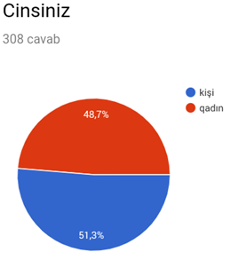

Figure 3: Gender group
2.2.4. Age group of respondents 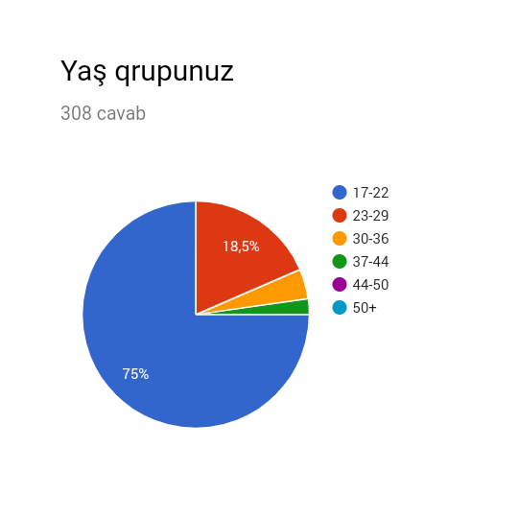

Figure 4: Age group
Figure 4 are demonstrated that among the objective respondents which greater part age falls into the scopes of 17-22 year of age (75%), followed by 23-29 of age which is 18.5%. Rest of respondents belong to old people who do not use internet frequently in Azerbaijan which respondents consist of 4.2% and 2.3%.

2.2.5. Marital status

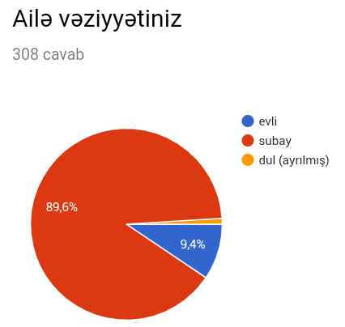

Figure 5: Marital status
Figure 5 shows marital status which consist of 3 part. 89.6% of respondents are single in terms of survey, followed by married people and divorced people which is 9.4% and 1% respectively.

2.2.6. Graph based on education level.
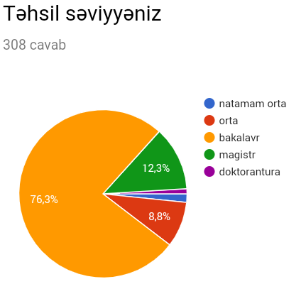

Figure 6: Education

Most of respondent belong to bachelor group which is 76.3%, followed by master degree and high school is 12.3% and 8.8% respectively. Minority of respondents have doctoral degree in terms of survey.
.

2.2.7. Graph based on occupation
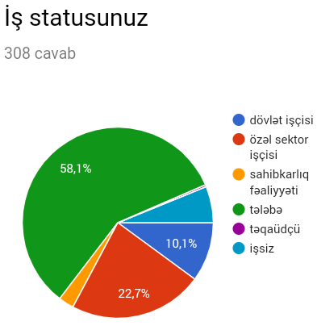

Figure7:Occupation

Respondents were divided into 6 groups in terms of their occupation. Most of respondent belong to students by 58.1%, followed by 22.7% of respondents who work private sector. Respondents who work public sector is 10.1%, followed by unemployment which is 6.2%. Percentage of entrepreneurs are 2.6% in survey.

2.2.8. Graph based on income status

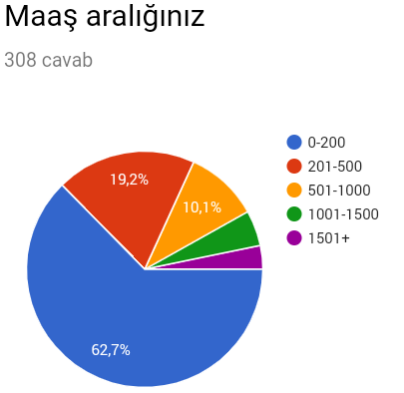

Figure 8: Income level

Most of respondent of income is 0-200 which is leader with 62.7% in survey, followed by 19.2% of respondent who can earn 201-500 Azn in a month. Percentage of respondent who earn between 501-1000 Azn and between 1001-1500 Azn are 10.1% and 4.9% respectively. End group is respondents who receive income above 1500 Azn which is 3.2%.

2.2.9. Graph based on income status
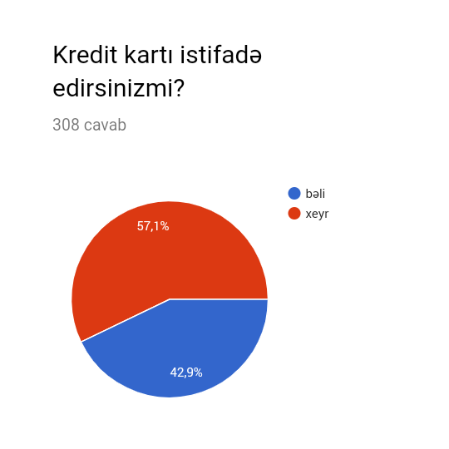
Figure 9: Credit card

Nowadays, Credit card have been popular among people in online market. Figure 9 shows that many respondents do not prefer to use credit card which these respondents are 57.1% in survey. 42.9% of respondent use credit card during online shopping.

2.2.10. Graph based on type of online shopping
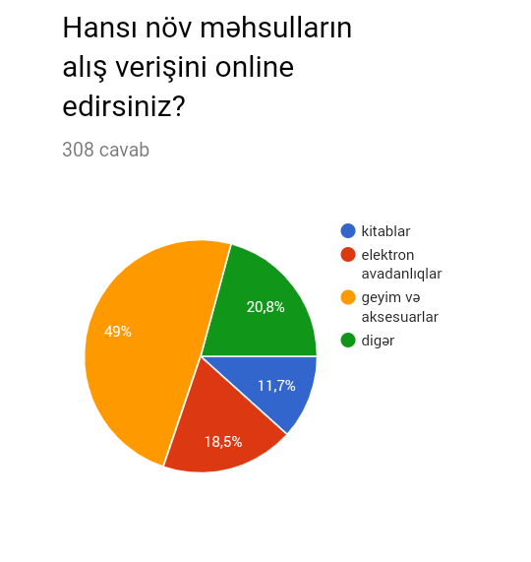

Figure 10: Type of online shopping
Most of respondent prefer to buy clothing and accessories which is a leader with 49%. Percentage of respondents who buy other things and electronic devices are 20.8% and 18.5% respectively, followed by books which is 11.7% in survey.

2.2.11. Graph based on type of online shopping

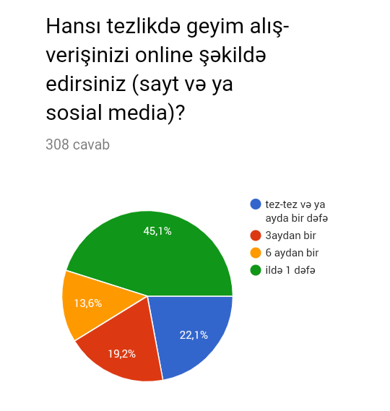
Figure 11: Frequency

Most of people prefer to buy products via internet once a year which it is 45.1%, followed by respondent who buy one times a year is 22.1%. Percentage of respondent who doing online shopping 4 times o year and 2 times a year are 19.2% and 13.6% respectively.

2.2.12. Graph based on attractiveness

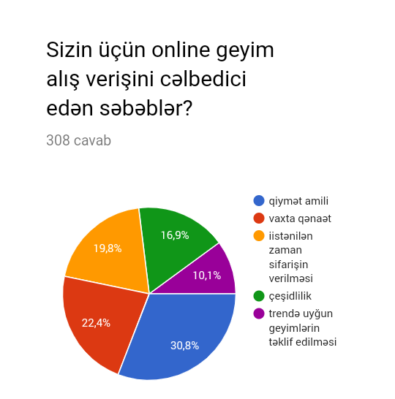Figure 12: Attractiveness
There are many reasons to attract consumer intention to buy product via internet for online retailer. Reasons are dived 5 group to find out about effects. Price can be stay main reason for consumer which price is leader with 30.8%, followed by saving time which is 22.4%. Some respondents were affected by detail which consumer can order product when they want. Variety and trend have not necessary effect consumer decision which are 16.9 and 10.1 respectively.

2.2.13. Graph based on platform
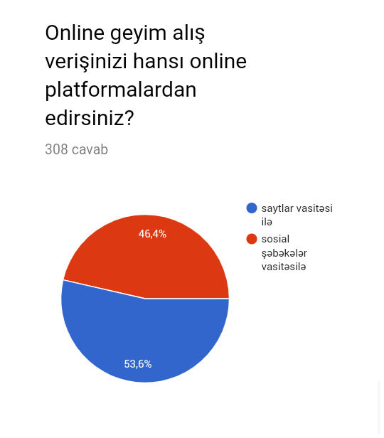
Figure 13: Platform
Nowadays, there are two ways to buy product via internet which one of them is social network which is 46.4% such as Facebook, Instagram and etc. which have been popular in recent years. However, Web site is very popular among people which is 53.6%.

2.2.14. Descriptive results
In this chapter, it will be talked about respondents thinks which can have impact on their decision during online shopping

2.2.14.1. Factors.
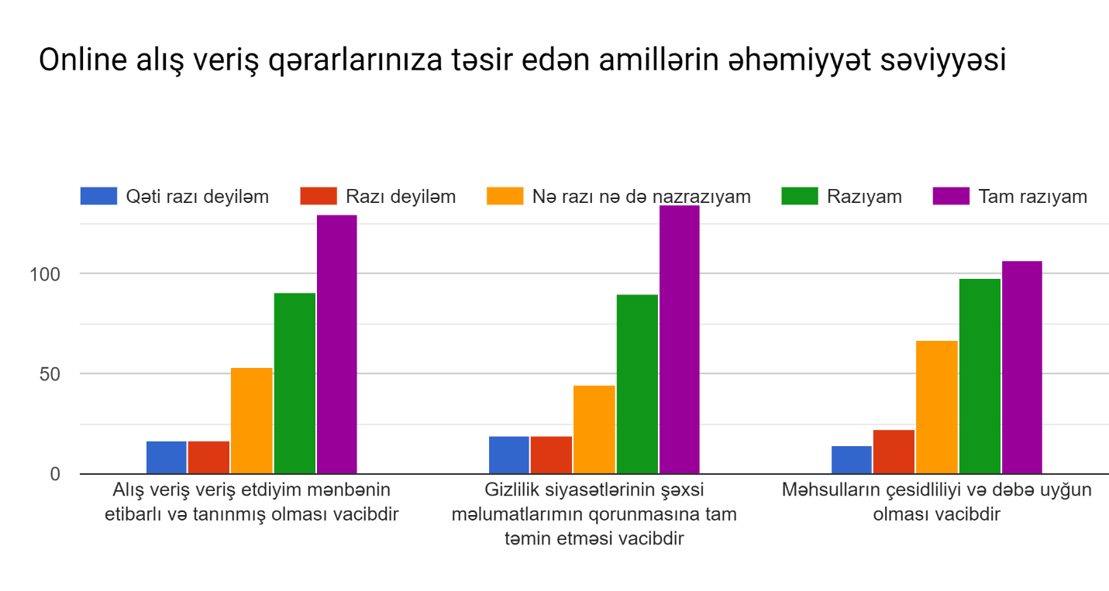
Figure 14: Factors

Figure14 demonstrate that some elements which can influence consumer decision making.

“Online shopping source which is reliable and famous is very important“ 42.2% of respondents agree absolutely with given statement, followed by agreed respondents are 29.5%.Percentage of respondents who do not have idea, so they are neutral are 12.2% in survey. Respondents who disagree and absolutely disagree fluctuate same level which is 5.5%
“Ensuring full protection of privacy policies' personal information” most of respondents agree absolutely with given statement (43.8%). Some respondents just agree this idea (29.2%), however, 14.6% of people are neutral about protection of privacy policies’, followed by disagreed and absolutely disagreed respondents which both of them are same level (6.1%).
”It is very important that product should be variety and trend” it seems clearly that most of respondent agree with this idea which 34.7% of respondent agree absolutely and 31.8% of respondents just agree with given idea, followed by neutral respondents is 21.7%.Minority of respondent disagree with this idea. Absolutely disagreed respondents are 4.5% and disagreed respondent is 7.1%.

2.2.14.2. Customer satisfaction level
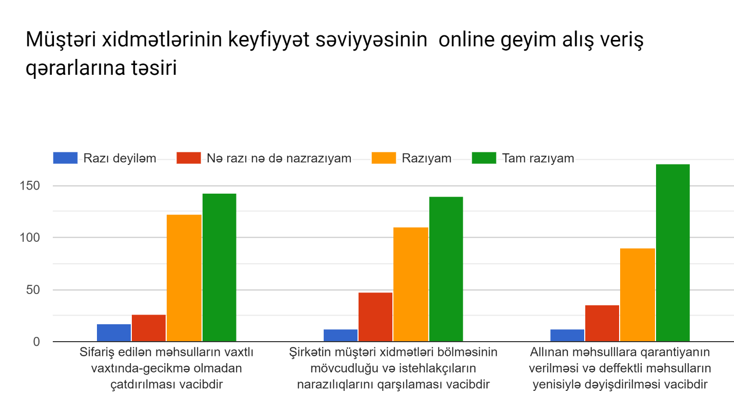
Figure 15: Customer satisfaction level
“Delivery of the ordered product in time and without delays” Most of respondents agree with given idea which absolutely agreed people is 46.2% and agreed people is 39.6%. Some people are neutral which is 8.4%, followed by disagreed people is 5.5% which they do not care about it.
“It is important for the company to have a customer service department and answer consumers' dissatisfaction” Some people believe and strongly agree that Companies should answer customer question and solve their problem which is consist of 45.1% of total respondents, followed by agreed people which is 35.7%. There are 15.2% of respondents who are neutral. Percentage of respondents who do nort agree with given statement is minority group (3.8%).
“Guarantee and refund of purchased goods” Most of people strong agree that guarantee can have impact on consumer shopping decision (55.5%), followed by respondents who agree with this idea is 29.2%. Percentage of respondent who are neutral is 11.3%. There are some kind of respondents who think that this type of elements cannot affect their decision (3.8%).

2.2.14.3. What is main Afraid of people
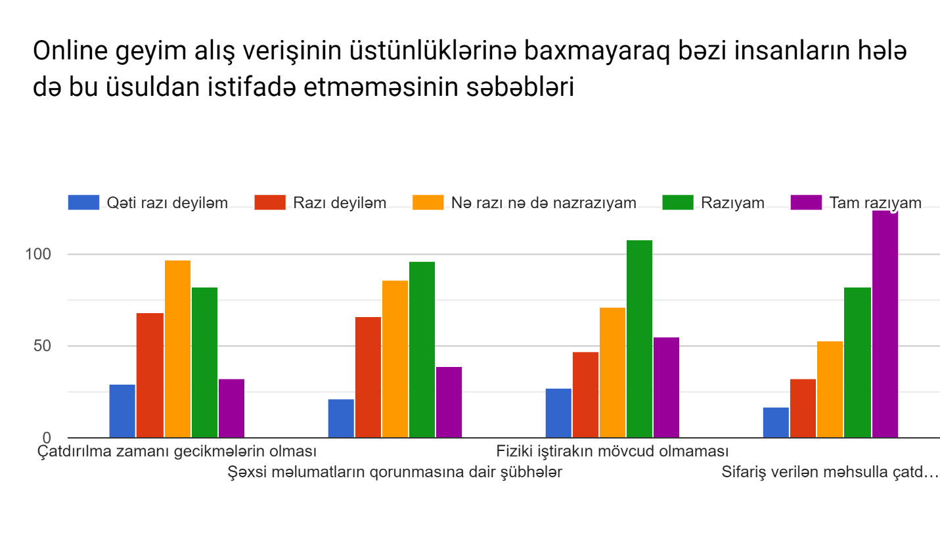
Figure 16: Afraid of people
“Delayed delivery time” Minority of people agree strongly that this is main reasons to afraid of doing shopping via internet (10.3%), followed by agreed respondents and neutral people which is 26.6% and 31.4% respectively. Percentage of respondent who do not agree strongly is 9.4%, followed by disagreed people is 22%.
”Doubts about personal data protection” 12.6 of respondent agree strongly that this reason can have impact their decision, followed by 31.1% of respondent who agree with given statement. Percentage of respondents who are neutral, strongly disagree and disagree is 27.4%, 6.8% and 21.4% respectively.
“Product cannot be touched” Most of people agree that this is main reason to afraid of doing online sopping which are divided two group which one of them is strongly agreed people (17.8%) and agreed respondents which is leader with 35%. There are some neutral respondents (23%) followed by respondents who disagree and strongly disagree which is 15.2% and 8.7% respectively.
“Different product can be delivered instead of order” There are 40.2% of respondents who strongly agree with given idea, followed by agreed respondent which is 26.6%. Some people are neutral which is consist of 17.2% of total respondents. Percentage of respondents who strongly disagree and agree is 8.7 and 10.3% respectively.

2.2.15. Validity and Reliability test
Case Processing Summary
 |  | N | %
Cases | Valid | 308 | 100.0
 | Excludedª | 0 | .0
 | Total | 308 | 100.0
a. Listwise deletion based on all variables in the procedure.

Table1: valid test
All of respondents’ answer are used to find out consumer behavior in online clothing industry that is reason why test is 100% of valid
Reliability Statistics
Cronbach's Alpha | Cronbach's Alpha Based on Standardized Items | N of Items
.897 | .912 | 10

Table2: Reliability test
Cronbach’s Alpha should be 70% above to be acceptable. According to 89.7% of Cronbach’s Alpha, this is acceptable in this survey.

2.2.16. Multiple regression analysis

Variables Entered/Removed^{b}
Model | Variables Entered | Variables Removed | Method
1 | CRM3, credit_card, age_group, education, gender, used_platfom, frequency, attractiveness, job, FACTOR3, income, CRM1, marital_status, FACTOR2, FACTOR1, CRM2ª | . | Enter
a. All requested variables entered.
b. Dependent Variable: negative

Table 3: Variables
Multiple regression analysis is used to find out effect how independents variable affect dependent variable. Dependent variable is negative which people use online shopping. Independent variables are rest of data.
Model Summary
Model | R | R Square | Adjusted R Square | Std. Error of the Estimate
1 | .690ª | .477 | .438 | 2.27305
- Predictors: (Constant), CRM3, credit_card, age_group, education, gender, used_platfom, frequency, attractiveness, job, FACTOR3, income, CRM1, marital_status, FACTOR2, FACTOR1, CRM2

Table 4: Model Summary for Independent Variables

In this table, it is showed that R square is 0.477, meaning that 47.7% of dependent variable is explained by independent variables such as CRM3, credit_card, age_group, education, gender, used_platfom, frequency, attractiveness, job, FACTOR3, income, CRM1, marital_status, FACTOR2, FACTOR1, CRM2
ANOVA^{b}
Model |  | Sum of Squares | df | Mean Square | F | Sig.
1 | Regression | 1030.290 | 16 | 64.393 | 12.463 | .000ª
 | Residual | 1131.519 | 219 | 5.167
 | Total | 2161.809 | 235
a. Predictors: (Constant), CRM3, credit_card, age_group, education, gender, used_platfom, frequency, attractiveness, job, FACTOR3, income, CRM1, marital_status, FACTOR2, FACTOR1, CRM2
b. Dependent Variable: negative

Table 5: ANOVA test
According to Anova test, it seems that it is significant which significant level should be less than 0.05 (p=0.000 <0.05).
Coefficientsª
Model |  | Unstandardized Coefficients |  | Standardized Coefficients | T | Sig.
 |  | B | Std. Error | Beta
1 | (Constant) | -.668 | 2.113 |  | -.316 | .752
 | gender | .622 | .309 | .103 | 2.012 | .045
 | marital_status | -.288 | .592 | -.034 | -.486 | .627
 | age_group | -.182 | .319 | -.039 | -.570 | .569
 | education | .170 | .313 | .029 | .543 | .588
 | job | -.024 | .138 | -.010 | -.172 | .864
 | income | .009 | .209 | .003 | .042 | .967
 | credit_card | -.301 | .322 | -.049 | -.935 | .351
 | frequency | .274 | .132 | .109 | 2.081 | .039
 | attractiveness | -.135 | .118 | -.060 | -1.144 | .254
 | used_platfom | -.113 | .322 | -.019 | -.350 | .727
 | FACTOR1 | .967 | .324 | .270 | 2.985 | .003
 | FACTOR2 | .315 | .295 | .090 | 1.068 | .287
 | FACTOR3 | .339 | .277 | .092 | 1.222 | .223
 | CRM1 | .817 | .440 | .146 | 1.857 | .065
 | CRM2 | .700 | .558 | .117 | 1.254 | .211
 | CRM3 | .331 | .534 | .054 | .620 | .536
a. Dependent Variable: negative

Tabel 6: Coefficients.

There are many types of elements in this table which they are independent variable for regression. For-example coefficient 0.622 for gender, age_group is -0.182, factor1 is 0.967 and etc. it seems clearly that most of element of p value is higher than 0.05. Factor1 just is less than 0.05.

2.2.17. Anova Test
An ANOVA test is an approach to see whether overview or trial results are significant. As it were, they help you to make sense of in the event that you have to dismiss the invalid speculation or acknowledge the substitute theory. Essentially, you're trying gatherings to check whether there's a contrast between them.

Table 7
ANOVA^{b}
Model |  | Sum of Squares | df | Mean Square | F | Sig.
1 | Regression | 779.319 | 1 | 779.319 | 113.192 | .000ª
 | Residual | 2106.794 | 306 | 6.885
 | Total | 2886.114 | 307
a. Predictors: (Constant), CRM1
b. Dependent Variable: NEGATIVE

H1: Delivery of the ordered product in time and without delays affect consumer online shopping decision. Null hypothesis is accepted.
According to acceptable of null hypothesis, there is relationship between Delivery in time and Azerbaijan’s consumer shopping decision.
Table 8
ANOVA^{b}
Model |  | Sum of Squares | df | Mean Square | F | Sig.
1 | Regression | 744.915 | 1 | 744.915 | 106.456 | .000ª
 | Residual | 2141.198 | 306 | 6.997
 | Total | 2886.114 | 307
a. Predictors: (Constant), CRM2
b. Dependent Variable: NEGATIVE

H2: Existing customer service department and answer consumers' dissatisfaction influence consumer purchasing decision during online shopping. Null hypothesis is accepted.
According to SPSS result, it seems clearly there is association between exiting customer service department and purchasing decision.
Table 9
ANOVA^{b}
Model |  | Sum of Squares | df | Mean Square | F | Sig.
1 | Regression | 1077.921 | 1 | 1077.921 | 182.416 | .000ª
 | Residual | 1808.192 | 306 | 5.909
 | Total | 2886.114 | 307
a. Predictors: (Constant), FACTOR1
b. Dependent Variable: NEGATIVE

H3: Reliable source for online clothing shopping have impact on consumer decision. Null hypothesis is accepted.
According to significant level, there is relationship between reliable source and consumer decision which p value is less than 0.05.

Table 10
ANOVA^{b}
Model |  | Sum of Squares | df | Mean Square | F | Sig.
1 | Regression | .413 | 1 | .413 | .044 | .834ª
 | Residual | 2885.701 | 306 | 9.430
 | Total | 2886.114 | 307
a. Predictors: (Constant), attractiveness
b. Dependent Variable: NEGATIVE

H4: attractiveness affect consumer decision in Azerbaijan online market. Null hypothesis is rejected, because significant level is above 5%.

Table 11
ANOVA^{b}
Model |  | Sum of Squares | df | Mean Square | F | Sig.
1 | Regression | 815.848 | 1 | 815.848 | 120.588 | .000ª
 | Residual | 2070.266 | 306 | 6.766
 | Total | 2886.114 | 307
a. Predictors: (Constant), FACTOR2
b. Dependent Variable: NEGATIVE
H5: Full protection of privacy policies' personal information influence consumer decision during online shopping. Null hypothesis is accepted, because p value is less than 0.05 which there is association between both of them.

2.2.18. Correlations
Correlation is a statistical measure that demonstrates the degree to which at least two factors vary together. A positive correlation shows the degree to which those factors increment or diminishing in parallel; a negative correlation demonstrates the degree to which one variable increments as different reductions.

Table 12:
Correlations
 |  | factor | Crm | negative
factor | Pearson Correlation | 1 | .723** | .622**
 | Sig. (2-tailed) |  | .000 | .000
 | N | 308 | 308 | 308
crm | Pearson Correlation | .723** | 1 | .568**
 | Sig. (2-tailed) | .000 |  | .000
 | N | 308 | 308 | 308
negative | Pearson Correlation | .622** | .568** | 1
 | Sig. (2-tailed) | .000 | .000
 | N | 308 | 308 | 308
**. Correlation is significant at the 0.01 level (2-tailed).

According to Table 11, Correlation is significant with 0.01 such as CRM, Factor, Negative. All of variable are positive correlation which there are strongly positive relationship between CRM and Factor (72.3%), followed by Negative/factor and Negative/CRM is 62.2% and 56.8% respectively.

3. CONCLUSION
In this part finish of the examination will be presented. Three research questions will be replied and examined in this part so as to give end to the exploration. Clarification of these inquiries dependent on information investigation through SPSS and it is applicable to the writing survey of the examination and system.
Q1. Does customer service influence e-shopping satisfaction on online apparel retailing?
According to SPSS result and answer to questionnaire, it seems clearly that most of people can be influenced by customer service which is very important for consumer during online clothing shopping. Meaning that if online retailer can suggest offer which is wanted by consumer, they can obtain e-shopping satisfaction. (factor1 and Factor2)
Q3. Which factors are preferred by Azerbaijan consumer during online purchasing?
According to survey, most of people prefer to use website if they want to buy product via internet which it is very easy and privacy for them. In addition, saving time can influence significantly consumer online shopping decision in Azerbaijan clothing market. People do not want to waste time going shops to do shopping.
Q3. Do Azerbaijani consumers have fear towards online shopping and why?
Based on result of regression in SPPS, it seems clearly that many people do not ready to use internet for shopping completely which there are any kinds of risk for them. As result of questionnaire, most of respondent are afraid of protection their private information which are stolen by other people. What is more, Azerbaijan consumer want to touch products and examine them with hand, however, it is impossible during online shopping which consumer just see product design or forms.

REFERENCES

- Adnan, H. (2014). An Analysis of the Factors Affecting Online Purchasing Behavior of Pakistani Consumers. International Journal of Marketing Studies. Vol. 6(5), p.133-148.
- Afuah, A., & Tucci, C. L. (2000). Internet business models and strategies: Text and cases. McGraw-Hill Higher Education.
- Ahuja, M., Gupta, B., Raman, P. (2007). An Empirical Investigation of Online Consumer Purchasing Behavior. COMMUNICATIONS OF THE ACM. Vol. 46(12), pp. 145-151.
- Ajzen, I. (1991). The theory of planned behavior. Organizational Behavior and Human Decision Processes, 50(2), 179–211. doi:10.1016/0749-5978(91)90020-T
- Almousa, M. (2011). Perceived Risk in Apparel Online Shopping: A Multi-Dimensional Perspective. Canadian Social Science. Vol. 7(2), pp. 23-31.
- Ariff, M.S.M., Yan, N.S., Zakuan, N., Bahari, A.Z., Jusoh, A. (2013). Web-based Factors Affecting Online Purchasing Behavior. IOP Conf. Series: Materials Science and Engineering. Vol. 46, pp. 1-10.
- Barua, A. et al. (2001), ‘Driving e-business excellence’, copyright by the MIT (Massachusetts Institute of Technology) Sloan Management Review; Fall 2001:36-44
- Berry, L. (1999) Discovering the Soul of Service: The Nine Drivers of Sustainable Business Success. New York: The Free Press.
- Berry, L.L., Zeithaml, V.A., & Parasuraman, A. (1990) Five Imperatives for Improving Service Quality. Sloan Management Review, Summer 1990, pp. 29-38
- Best,RJ (2005), Market-based management: Strategies for Growing customer value and profitability, Pearson Prentice Hall, New Jersey, P 7-20
- Carroll, J &Broadhead, R 2001, Selling online: how to become a successful e-commerce merchant, Dearborn Trade, Canada.
- Chang, H. H., & Wang, H. W. (2011). The moderating effect of customer perceived value on online shopping behavior. Online Information Review, 35(3), 333- 359.
- Chiu, C.-M., Wang, E. T. G., Fang, Y.-H., & Huang, H.-Y. (2014). Understanding customers’ repeat purchase intentions in B2C e-commerce: The roles of utilitarian value, hedonic value and perceived risk. , 24(1), . doi:http//dx..org/10.1111/j.1365-2575.2012.00407.x
- Cristobal, E., Flavian, C., & Guinaliu, M. (2007). Perceived e-service quality (PeSQ) measurement validation and effects on consumer satisfaction and web site loyalty. Managing Service Quality, 17(3), 317-340.
- Cristobal, E., Flavian, C., & Guinaliu, M. (2007). Perceived e-service quality (PeSQ) measurement validation and effects on consumer satisfaction and web site loyalty. Managing Service Quality, 17(3), 317-340.
- Dean, A., & Terziovski, M. (2000). Quality practices and customer/supplier management in Australian service organizations: Untapped potential. Working Paper Series: Monash University Department of Management.
- Dean, A., & Terziovski, M. (2000). Quality practices and customer/supplier management in Australian service organizations: Untapped potential. Working Paper Series: Monash University Department of Management.
- Disend, J. E. (1991) How to Provide Excellent Service in Any Organization. Pensylvania: Chilton Book Company
- Dubosson‐Torbay, M., Osterwalder, A., & Pigneur, Y. (2002). E‐business model design, classification, and measurements. Thunderbird International Business Review, 44(1), 5-23.
- edd, M. (2000). Sizing up home delivery. Logistics Management and Distribution Report, 39(2), 51-56.
- Elliot, S. and Fowell, S. (2000), ‘Expectations versus reality: a snapshot of consumer experiences with internet retailing’, International Journal of Information Management, 20:323-336.
- Eroglu, S., Machleit, K. and Davis, L. 2001. Atmospheric qualities of online retailing. Journal of Business Research, 54(2), pp.177-184. Available through: Science Direct. [Accessed 10 April 2016].
- Forsythe, S. M., & Shi, B. (2003). Consumer patronage and risk perceptions in Internet shopping. Journal of Business Research, 56(11), 867–875. doi:10.1016/s0148- 2963(01)00273-9
- Francis, J.E. (2009). Category-specific RECIPEs for internet retailing quality. Journal of Service Marketing, 23(7), 450-461.
- Francis, J.E. (2009). Category-specific RECIPEs for internet retailing quality. Journal of Service Marketing, 23(7), 450-461.
- Grabner-Kraeuter, S. (2002). The Role of Consumers' Trust in Online-Shopping. Journal of Business Ethics, Vol. 39(½), pp. 43-50. Fourteenth Annual Conference of the European Business Ethics Network (EBEN) (Aug., 2002).
- Ha, S., and Stoel, L. (2009). Consumer e-shopping acceptance: antecedents in a technology acceptance model. Journal of Business Research, 62, 565-57
- Ha, S., and Stoel, L. (2012). Online apparel retailing: roles of e-shopping quality and experiential e-shopping motives. Journal of Service Management, 23(2), 197- 215
- Hansen, B., Rose, J., & Tjørnehøj, G. (2004). Prescription, description, reflection: The shape of the software process improvement field. International Journal of Information Management, 24(6), 457–472. doi:10.1016/j.ijinfomgt.2004.08.007
- Hill, N & Alexander, J 2006, Handbook of customer satisfaction and loyalty measurement, Gower Publishing, England
- Hong, I. B. (2015). Understanding the consumer’s online merchant selection process: The roles of product involvement, perceived risk, and trust expectation. International Journal of Information Management. Vol. 35, pp. 322-336.
- Ji, Shu-xian., Zheng, X., & Chen, D. (2012). Perceived Risk and Its Impact on Customer Intention to Online Shopping Based-on Different Products. Advances in information Sciences and Service Sciences (AISS). Vol 4, pp. 1-11.
- Jiradilok, T., Malisuwan, S., Madan, N., & Sivaraks, J. (2014). The impact of customer satisfaction on online purchasing: a case study analysis in Thailand. Journal of Econimics,Business and Management, 2(1), 5-11.
- Johnson, C.A. and Tesch, B. (2005), US Ecommerce: 2005 to 2010, Forrester Research, Cambridge, MA.
- Kapsalis, V., Charatsis, K., Georgoudakis, M., Nikoloutsos, E., & Papadopoulos, G. (2004). A SOAP based system for the provision of e-services. Computer Standard & Interfaces, 26, 527-541
- Kim, B.Y. (2008), Mediated Effects of Customer Orientation on Customer Relationship Management Performance. International Journal of Hospitality and Tourism Administration, 9(2), 192-218
- Kim, J. H., & Kim, C. (2010). E-service quality perceptions: a cross-cultural comparison of American and Korean consumers. Journal of Research in Interactive Marketing, 4(3), 257-275.
- Kim, M., Kim, J. H., & Lennon, S. J. (2011). E-service attributes available on men’s and women’s apparel web sites. Managing Service Quality, 21(1), 25-45
- Kim, S., & Stoel, L. (2004). Apparel retailers: website quality dimensions and satisfaction. Journal of Retailing and Consumer Services, 11, 109-117.
- Kotler, P. (2000) Marketing Management. New Jersey: Prentice-Hall..
- Koyuncu, C., Bhattacharya, G. (2004). The Impacts of Quickness, Price, and Payment Risk, and Delivery Issues on Online Shopping. Journal of Socio-Economics. Vol. 33, pp. 241-251.
- Kumar, Mr. V., Dange, Dr. U. (2014). A study on perceived risk in online shopping of youth in Pune: A factor analysis. Acme Intellects International Journal of Research in Management, Social Sciences & Technology. Vol. 8(8), pp. 1-9.
- Lin, G. T. R., & Sun, C. C. (2009). Factors influencing satisfaction and loyalty in online shopping: an integrated model. Online Information Review, 33(3), 458- 475.
- Loonam, M., & Loughlin, D. O. (2008). Exploring e-service quality: a study of Irish online banking. Marketing Intelligence & Planning, 26(7), 759-780.
- Madlberger, M. (2004, March). Strategies and Business Models in Electronic Retailing: Indications from the US and the UK. In Proceedings of the 6th international conference on Electronic commerce (pp. 296-303). ACM
- Madu, C. N., & Madu, A. A. (2002). Dimensions of e-quality. International Journal of Quality & Reliability Management, 19(3), 246-258.
- Masoud, E. Y. (2013). The Effect of Perceived Risk on Online Shopping in Jordan. European Journal of Business and Management. Vol. 5(6), p.76-87.
- McCormick, H. & Livett, C. 2012. Analysing the influence of the presentation of fashion garments on young consumers’ online behavior. Journal of Fashion Marketing and Management 16(1): 21-41
- Miyazaki, A. D., & Fernandez, A. (2001). Consumer perceptions of privacy and security risks for online shopping. Journal of Consumer Affairs, 35(1), 27-44.
- Monsuwe´, T. P. Y., Dellaert, B.G. C., Ruyter, K. D. (2004). What drives consumers to shop online? A literature review. International Journal of Service Industry Management. Vol. 15 (1), pp. 102-121
- Moshref Javadi, M. H., Dolatabadi, H. R., Nourbakhsh, M., Poursaeedi, A., & Asadollahi, A. R. (2012). An Analysis of Factors Affecting on Online Shopping Behavior of Consumers. International Journal of Marketing Studies. Vol. 4(5), pp. 81-98.
- Naiyi, Y. (2004). Dimensions of Consumer’s Perceived Risk in Online Shopping. Journal of Electronic Science and Technology of China. Vol. 2(3), pp. 177-182.
- Oliver, R. L. (1997). Satisfaction: A Behavioral Perspective on the Consumer, McGraw-Hill, New York, NY
- Park, C.H. and Kim, Y.G. (2003), ‘Identifying key factors affecting consumer purchase behavior in an online shopping context’, International Journal of Retail & Distribution Management, 31(1):16-29.
- Prof. Joanna Scwacka, Assoc.Prof. Rasim Abutalibov, PhD.c. Seymur M. Guliyev, Globalization process in the food industry - European Experience, Qafqaz University, 2014
- Ranganathan, C., and Ganapathy, S. (2002). Key dimensions of business to consumer web sites. Information and Management, 30, 457-465.
- Román, S. (2007). The Ethics of Online Retailing: A Scale Development and Validation from the Consumers' Perspective. Journal of Business Ethics, Vol. 72 (2), pp. 131-148.
- Salonen S., Närvänen E., Saarijärvi, H. 2014. How do consumers consume fashion online? A practice-theoretical inquiry. International Journal of Marketing Studies 6(3) : 87-96
- Samadi, M., Yaghoob-Nejadi, A. (2009). A Survey of the Effect of Consumers’ Perceived Risk on Purchase Intention in E Shopping. Business Intelligence Journal. Vol. 2(2), pp. 261-275
- Santouridis, I., Trivellas, P., & Tsimonis, G. (2012). Using E-S-QUAL to measure internet service quality of e-commerce web sites in Greece. International Journal of Quality and Service Sciences, 4(1), 86-98.
- Saunders, M., Lewis, P., & Thornhill, A. (2009). Research methods for business students (5th ed.). Prentice Hall: Financial Times.Zeithaml, V. A., Parasuraman, A., & Malhotra, A. (2002). Service quality deliverythrough web sites: a critical review of extant knowledge. Journal of theAcademy of Marketing Science, 39, 362-410.
- Schaupp, L. C., & Belanger, F. (2005). A conjoint analysis of online consumer satisfaction. Journal of Electronic Commerce Research, 6(2), 95-111.
- Seymur Guliyev, Effects of brand on emotional decision making process of consumer: a research in food industry of Azerbaijan, Scientific News Summary, No 2/2018, Ganja Technology University, 2018
- Seymur Guliyev, Effects of brand on emotional decision making process of consumer: a research in food industry of Azerbaijan, Scientific News Summary, No 2/2018, Ganja Technology University, 2018
- Seymur Guliyev, Private Label in marketing and its importance, 3rd international scientific conference of Young researchers, Qafqaz University, 2015
- Seymur M. Guliyev, AZƏRBAYCANIN QİDA İSTEHSAL MÜƏSSİSƏLƏRİNDƏ BRENDİNQ FƏALİYYƏTİNİN TƏKMİLLƏŞDİRİLMƏSİ, Ipek Yolu jurnali, 2015
- Seymur M. Guliyev, Improvement Directions of Branding Processes in the Food Industrial Companies of Azerbaijan, Scientific News Summary, No 1/2018 by Ganja Technology University, 2018.
- Seymur M. Guliyev, Rasim Abutalibov, Factors affecting consumer behaviours of Azerbaijani youths, Marketing Management International conference, Warsaw University of Life Sciences (SGGW), Warsaw, Poland, 2015
- Seymur M.G., Rasim A., Qualitative Research and the process of constructing qualitative data, Journal of Qafqaz University, volume 1, number 1, ISSN 2310-9076, 2013
- Suwunniponth, W. (2014). Factor Driving Consumer Intention in Online Shopping. International Journal of Social, Education, Economics and Management Engineering. Vol. 8(6), pp. 1927-1931.
- Szymanski, D.M. and Hise, R.T. (2000), ‘e-satisfaction: an initial examination’, Journal of Retailing, 76(3):309-322.
- Timmers, P. (1998). Business models for electronic markets. Electronic markets, 8(2), 3-8.
- Trocchia, P. J., & Janda, S. (2003). How do customers evaluate internet retail service quality. Journal of Service Marketing, 17(3), 243-253.
- Webb, K. L. (2002), ‘Managing channels of distribution in the age of electronic commerce.’ Industrial Marketing Management. 31, 295-102
- Yeniçeri, T., Akin, E. (2013). Determining Risk Perception Differences between Online Shoppers and Non-Shoppers in Turkey. INTERNATIONAL JOURNAL OF SOCIAL SCIENCES. Vol. 11(3), pp. 135-143.
- Yörük, D., Dündar, S., Moga, L.M., Neculita, M. (2011). Drivers and attitudes towards online shoppin0g: Comparison of Turkey with Romania. BIMA Publishing, communication of the IBIMA. Vol. 2011, pp.1-13.
- Zeithaml, V. A., Parasuraman, A., & Malhotra, A. (2002). Service quality delivery through web sites: a critical review of extant knowledge. Journal of the Academy of Marketing Science, 39, 362-410.
- Zhou, L. et al. (2007), ‘Online shopping acceptance model – a critical survey of consumer factors in online shopping’, Journal of Electronic Commerce Research, 8(1):41-62.

APPENDIX 1.

- Choose your gender
- Male
- Female
- Choose your marital status
- Single
- Married
- Divorced
- Choose your age group
- 17-22
- 23-29
- 30-36
- 37-44
- 50+
- Choose your qualification
- Pre-High school
- High school
- Bachelor’s degree
- Master’s degree
- Doctoral degree
- Choose your occupation
- Public section worker
- Privat section worker
- Entrepreneur
- Student
- Pensioner
- Unemployed (housewife etc.)
- Choose your income status
- 0-200
- 201-500
- 501-1000
- 1001-1500
- 1501+

- Do you use credit card?
- Yes
- No
- How frequently do you buy online?

- Frequently or at least once a month
- Once in three month
- Once in six month
- Once a year

- What products do you normally online?

- Books
- Mobile / computer / Camera (Electronics Products
- Clothes
- Other

- What is Main Reason to do online Shopping for you?
- Price
- Convenience & time saving
- Fast Shipping
- Brand conscious
- Variety of products

- Choose platform which is used by you

- Social network
- Website

Please indicate to what extent do you agree with the statements?
Strongly disagree | Disagree | Neutral | Agree | Strongly agree

- Factors which affect consumer purchase decision

- Online shopping source which is reliable and famous is very important
- Ensuring full protection of privacy policies' personal information”
- It is very important that product should be variety and trend

- Customer service’s level which have impact on consumer online shopping decision.

- Delivery of the ordered product in time and without delays”
- It is important for the company to have a customer service department and answer consumers' dissatisfaction
- Guarantee and refund of purchased goods

- Some people are afraid of using online shopping what is main reason?

- Delayed delivery time
- Doubts about personal data protection
- Product cannot be touched”
- Different product can be delivered instead of order

Intentionally left blank!

