- The cost function of competitive firm is TC=20+0,2Q² . The product's market price is 20 AZN. Please find the firm's profit.
- The price elasticity of a product that monopoly produces equals to -2. The price of a good is 6 AZN. MC= 2+2Q. Find output level at which the firm maximizes its profits.
- If the inverse demand curve a monopoly faces is p = 100 - Q, and MC is constant at 10, then the deadweight loss from monopoly equals
- If the price of a slice of pizza rises from $2.50 to $3, and quantity demanded falls from 10,000 slices to 7,400 slices, using the formula for arc price elasticity what is the percentage change in quantity?
- Suppose the demand function for a good is expressed as Q = 100 - 4p. If the good currently sells for $10, then the point price elasticity of demand equals
- The demand function of a good is Q=60-P. If the price elasticity of this good is -2, find the price of the good.
- The price elasticity of a product that monopoly produces equals to -3. The price of a good is 15 AZN. MC= 2+2Q. Find output level at which the firm maximizes its profits.
- The demand function of monopoly in the market is P=10-0,1Q. Short run total cost function SRTC=2Q+0,1Q² .Find the market power of this firm.
- A monopoly sets a price of $40 per unit for an item that has a marginal cost of $5. Assuming profit maximization, the implicit demand elasticity is.
- Total cost function in competitive firm is TC = 24+ 6Q². If firm gets normal profit please find the average total cost of this firm.
- The demand function of X good Q_{D} = 80 – 2P + 4M. M is consumer income and equals 30 AZN. P(price of X good) and equal 25 AZN. Please find the income elasticity of demand.
- Consumer utility function is, U_{xy} = 10x^{0.5}y^{0.5}. The price of X good 10 AZN and Y good 20AZN. If consumer income is 500 AZN, find how much consumer can buy X good.
- Q_{D} = 20 - P , Q_{S} = 10 + P if the government impose 6 AZN tax per unit of good, please find the tax income of government gained from consumer.
- If the price of X good decreased from 12 to 9 AZN. Consumer’s demand for good X increased from Q_{D} = 30 to Q_{D} = 40. Find change in consumer surplus.
- Price elasticity of demand which monopoly faces in market equals – 2. Marginal cost equal 40, find monopoly’s good’s price.
- Demand function which monopoly face in the market is Q_{D} = 100 – P. Firm’s marginal cost is 10 AZN. Find the market power of this firm.
- If the demand curve for slices of pizza is given as Q = 300 - 16p, then the point elasticity of demand when price is $1.50 is?
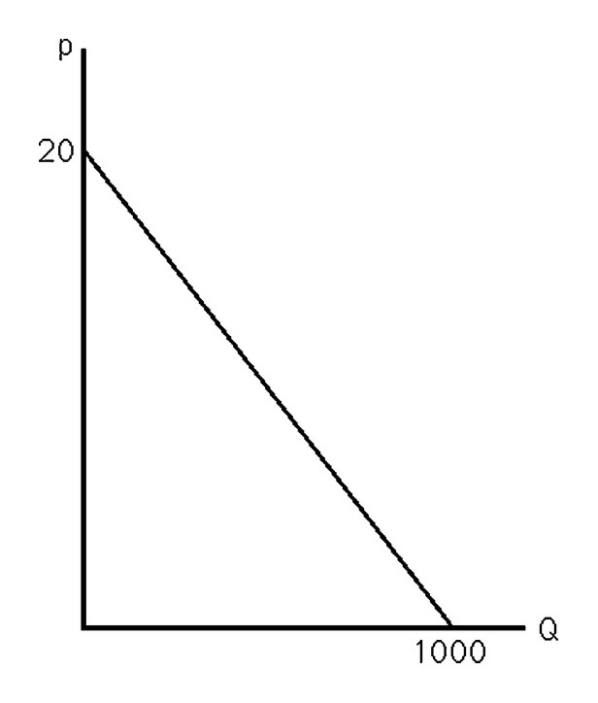
- The above figure shows the demand curve for crude oil. If the market price is $10 a barrel, what is the price elasticity of demand?
- If the inverse demand curve a monopoly faces is p = 100 - 2Q, and MC is constant at 16, then profit maximization is achieved when the monopoly sets price equal to?
- Suppose a monopolist has TC = 100 + 10Q + 2Q2, and the demand curve it faces is p = 90 - 2Q. What will be the price, quantity, and profit for this firm?
- A monopoly incurs a marginal cost of $1 for each unit produced. If the price elasticity of demand equals -2.0, the monopoly maximizes profit by charging a price of?
- If the inverse demand curve a monopoly faces is p = 100 - 2Q, and MC is constant at 16, then the deadweight loss from monopoly equals?
- A weapons producer sells guns to two countries that are at war with each other. The guns can be produced at a constant marginal cost of $10. The demand for guns from the two countries can be represented as:
QA = 100 - 2p
QB = 80 - 4p
Why is the weapons producer able to price discriminate?
What price will it charge to each country?
- Suppose the demand for pizza in a small isolated town is p = 10 - Q. There are only two firms, A and B, and each has a cost function TC = 2 + q. Determine the Cournot equilibrium.
- Joe's budget constraint equals 500 = 2F + 100S, where $500 is Joe's income, $2 is the price of food (F, y-axis) and $100 is the price of shelter (S, x-axis). How much food can Joe buy if he buys one unit of shelter?
- Manisha could work for another firm making $10,000 per month, but she decides to open her own gourmet cheese store and pay herself $2,000 per month. In her first month of operations, she spends $6,000 on cheese, $1,000 on other items, and $2,500 on rent. She had a great opening month, and brought in revenues of $14,500. According to her accountant, what are Manisha's profits?
- Tom is going to quit his job to pursue his PhD in economics, which will take him 6 years to complete. He currently makes $55,000 per year as a high school teacher. While going to school, he will receive a stipend of $24,000 per year plus $6,000 per year to help cover food and rent. His living expenses are the same regardless of what he does. What is Tom's opportunity cost of pursuing his PhD?
- Suppose there are 1000 identical wheat farmers. For each, TC = 10 + q2. Market demand is Q = 600,000 - 100p. Derive the short-run equilibrium Q, q, and p. Does the typical firm earn a short-run profit?
- A monopoly sets a price of $50 per unit for an item that has a marginal cost of $10. Assuming profit maximization, the implicit demand elasticity is?
- If the price of a slice of pizza rises from $2.50 to $3, and quantity demanded falls from 10,000 slices to 7,400 slices, using the formula for arc price elasticity what is the percentage change in price?

Open Questions

- Explain why managerial economics relies on microeconomics and industrial organization to analyze business practices and design business strategies.
- Describe the separation of ownership and control of the Firm
- Describe the market structure and managerial decision making
- Describe the direct and inverse demand functions
- Describe the direct and inverse supply functions
- Explain the market clearing price
- Describe the finding optimal activity levels with marginal analysis
- Explain why sunk costs, fixed costs, and average costs are irrelevant in discussion of optimization problems
- Explain the Simple Linear regression model
- Explain the Quadratic and Log-Linear regression models
- Explain the concept of utility and the basic assumptions underlying consumer preferences.
- Define the concept of indifference curves and explain the properties of indifference curves and indifference maps.
- Construct a consumer’s budget line and explain how to rotate or shift the budget line when either prices or income change.
- Define a corner solution and explain the condition that creates a corner solution.
- Use indifference curves to derive a demand curve for an individual consumer
- Derive and interpret the equilibrium conditions for an individual consumer to be maximizing utility subject to a budget constraint.
- Explain the difference between Private, Public, and Nonprofit Firms
- Define market power and describe how own-price elasticity, cross-price elasticity, and the Lerner index are used to measure market power.
- Explain why barriers to entry are necessary for market power in the long run and discuss the major types of entry barriers.
- Show the relation between long-run and short-run cost curves using long-run and short-run expansion paths.
- Explain the characteristics of long-run competitive equilibrium for a firm, derive long-run industry supply curves, and identify economic rent and producer surplus.
- Explain why the demand curve facing a perfectly competitive firm is perfectly elastic and serves as the firm’s marginal revenue curve.
- Graph a typical production isoquant and discuss the properties of isoquants.
- Construct the firm’s expansion path and show how it relates to the firm’s longrun cost structure.
- Explain how a variety of forces affects long-run costs: scale, scope, learning, and purchasing economies
- Explain why uniform pricing does not generate the maximum possible total revenue and how price discrimination can generate more revenue.
- Explain how to practice first-degree price discrimination to earn greater revenue and profit than charging a uniform price.
- Explain how to practice second-degree price discrimination by using either two-part pricing or declining block pricing.
- Explain how to practice third-degree price discrimination.
- Explain the difference between decision making under risk and under uncertainty.
- Identify deadweight loss associated with market power and discuss ways antitrust policy, second-best pricing, and two-part pricing can reduce the cost of market power.
- Explain why common property resources and public goods are underproduced and how government can reduce market failure created by nonexcludability.
- Explain why imperfect information about product price and quality can lead to market failure.
- Explain Why Cartels Succeed or Fail
- Explain the Cournot Oligopoly model
- Explain the Bertrand Oligopoly model

