AZƏRBAYCAN DÖVLƏT İQTİSAD UNİVERSİTETİ
BEYNƏLXALQ İQTİSADİYYAT MƏKTƏBİ
BEYNƏLXALQ İQTİSADİYYAT (İNGİLİS DİLLİ) KAFEDRASI

Fənn: Layihə menecmenti
Müəllim: Nail Tahirov
Qrup: 1081

İMTAHAN SUALLARI

- Define a project. What are five characteristics that help differentiate projects from other functions carried out in the daily operations of the organization?
- Describe project life cycle via diagram.
- Explain projects in terms of compliance, strategic, and operational.
- Two new software projects are proposed to a young, start-up company. The Alpha project will cost
$150,000 to develop and is expected to have annual net cash flow of $40,000. The Beta project will cost
$200,000 to develop and is expected to have annual net cash flow of $50,000. The company is very concerned about their cash flow. Using the payback period, which project is better from a cash flow standpoint? Why?
- A five-year project has a projected net cash flow of $15,000, $25,000, $30,000, $20,000, and $15,000 in the next five years. It will cost $50,000 to implement the project. If the required rate of return is 20 percent, conduct a discounted cash flow calculation to determine the NPV.
- You are the head of the project selection team at Broken Arrow records. Your team is considering three different recording projects. Based on past history, Broken Arrow expects at least a rate of return of 20 percent. Your financial advisors predict inflation to remain at 2 percent into the foreseeable future. Given the following information for each project, which one should be Broken Arrow’s first priority? Should Broken Arrow fund any of the other projects? If so, what should be the order of priority based on return on investment?
Recording project: Time Fades away

Year | Investment | Revenue stream
0 | $ 600,000 | 0
1 |  | 600,000
2 |  | 75,000
3 |  | 20,000
4 |  | 15,000
5 |  | 10,000

Recording project: On the Beach

Year | Investment | Revenue stream
0 | $ 400,000 | 0
1 |  | 400,000
2 |  | 100,000
3 |  | 25,000
4 |  | 20,000
5 |  | 10,000
- The Custom Bike Company has set up a weighted scoring matrix for evaluation of potential projects. Below are three projects under consideration.
- Using the scoring matrix below, which project would you rate highest? Lowest?
- If the weight for “Strong Sponsor” is changed from 2.0 to 5.0, will the project selection change? What are the three highest weighted project scores with this new weight?
- Why is it important that the weights mirror critical strategic factors?

Criteria | strong sponsor | supports business strategy | urgency | 10 % of sales from new products | competition | fill market gap | Total
Weight | 2 | 5 | 4 | 3 | 1 | 3
Project 1 | 9 | 5 | 2 | 0 | 2 | 5
Project 2 | 3 | 7 | 2 | 0 | 5 | 1
Project 3 | 6 | 8 | 2 | 3 | 6 | 8
Project 4 | 1 | 0 | 5 | 10 | 6 | 9
Project 5 | 3 | 10 | 10 | 1 | 8 | 0

- A local project being analyzed by PERT has 42 activities, 13 of which are on the critical path. If the estimated time along the critical path is 105 days with a project variance of 25, the probability that the project will be completed in 95 days or less is?

- A project being analyzed by PERT has 38 activities, 16 of which are on the critical path. If the estimated time along the critical path is 90 days with a project variance of 25, the probability that the project will be completed in 88 days or less is ?

- A PERT project has 45 activities, 19 of which are on the critical path. The estimated time for the critical path is 120 days. The sum of all activity variances is 64, while the sum of variances along the critical path is 36. The probability that the project can be completed between days 108 and 120 is ?

- A project whose critical path has an estimated time of 120 days with a variance of 100 has a 20% chance that the project will be completed before day (rounded to nearest day).

- Contract requirements state that a project must be completed within 180 working days, or it will incur penalties for late completion. Analysis of the activity network reveals an estimated project time of 145 working days with a project variance of 400. What is the probability that the project will be completed before the late-payment deadline?

- Identify the responsibilities of project managers?

- Identify and describe briefly each of the purposes of project scheduling.

- What is the objective of critical path analysis?

- Identify, in order, the six steps basic to both PERT and CPM.

- Briefly describe the concept of cost/time trade-off and how it is used.

- What are the advantages of using PERT and CPM?

- Consider the network described in the table below.

Activity | Predecessors | Pessimistic | Most likely | Optimistic
A | -- | 15 | 10 | 8
B | -- | 9 | 8 | 7
C | A | 10 | 6 | 5
D | A | 3 | 3 | 3
E | B,D | 9 | 5 | 1
F | B,D | 10 | 7 | 4
G | L,E | 10 | 8 | 3

- Calculate the expected duration of each activity.
- Calculate the expected duration and variance of the critical path.
- Calculate the probability that the project will be completed in fewer than 30 time units.

- Given the activities described by the following table:
Activity | Expected Time | Standard Deviation of Time Estimate | Immediate Predecessor(s)
A | 7 | 2 | —
B | 3 | 1 | A
C | 9 | 3 | A
D | 4 | 1 | B, C
E | 5 | 1 | B, C
F | 8 | 2 | E
G | 8 | 1 | D, F
H | 6 | 2 | G

  - Draw the appropriate PERT diagram.
  - Find the critical path and project completion time.
  - Find the probability that the project will take more than 49 time periods to complete.

- What is the minimum cost of crashing the following project by 4 days?

Activity | Normal Time (days) | Crash Time  (days) | Normal Cost | Crash Cost | Immediate Predecessor(s)
A | 6 | 5 | $ 900 | $1,000 | —
B | 8 | 6 | 300 | 400 | —
C | 4 | 3 | 500 | 600 | —
D | 5 | 3 | 900 | 1,200 | A, B
E | 8 | 5 | 1,000 | 1,600 | C

The following represent activities in a major construction project. Draw the network to represent this project.

Activity | Immediate Predecessor
A | -
B | -
C | A
D | B
E | B
F | C, E
G | D
H | F, G

- A project has an expected completion time of 40 weeks and a standard deviation of 5 weeks. It is assumed that the project completion time is normally distributed.
- What is the probability of finishing the project in 50 weeks or less?
- What is the probability of finishing the project in 38 weeks or less?
- The due date for the project is set so that there is a 90% chance that the project will be finished by this date. What is the date?

- Development of a new deluxe version of a particular software product is being considered. The activities necessary for the completion of this project are listed in the table below along with their costs and completion times in weeks.

Activity | Normal Time | Crash Time | Normal Cost | Crash Cost | Immediate Predecessor
A | 4 | 3 | 2,000 | 2,600 | -
B | 2 | 1 | 2,200 | 2,800 | A
C | 3 | 3 | 500 | 500 | A
D | 8 | 4 | 2,300 | 2,600 | A
E | 6 | 3 | 900 | 1,200 | B, D
F | 3 | 2 | 3,000 | 4,200 | C, E
G | 4 | 2 | 1,400 | 2,000 | F

- What is the project expected completion date?
- What is the total cost required for completing this project on normal time?
- If you wish to reduce the time required to complete this project by 1 week, which activity should be crashed, and how much will this increase the total cost?

- How does resource scheduling tie to project priority? And what is a resource levelling?
- How does resource scheduling tie to project priority?
- How does resource scheduling reduce flexibility in managing projects?
- Present six reasons scheduling resources is an important task.
- Why is it critical to develop a time-phased baseline?
- Given the network plan that follows, compute the early, late, and slack times. What is the project duration? Using any approach you wish (e.g., trial and error), develop a loading chart for resources Carpenters (C) and Electricians (E). Assume only one Carpenter is available and two Electricians are available.
- Given your resource schedule, compute the early, late, and slack times for your project. Which activities are now critical? What is the project duration now?

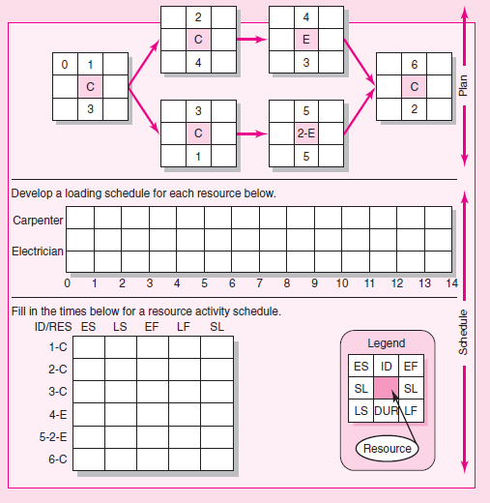

- You have prepared the following schedule for a project in which the key resources is a tractor. There are three tractors available to the project. Activities A and D require one tractor to complete while activities B, C, E and F require 2 tractors. Develop a resource-constrained schedule in the loading chart that follows. Use the parallel method and heuristics given. Be sure to update each period as the computer would do. Record the early start (ES), late finish (LF) and slack SL) for the new schedule.
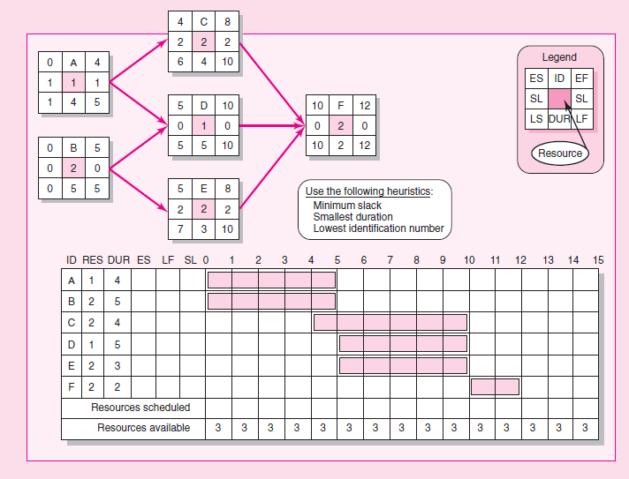

- Given the time-phased work packages and network, complete the baseline budget form for the project.
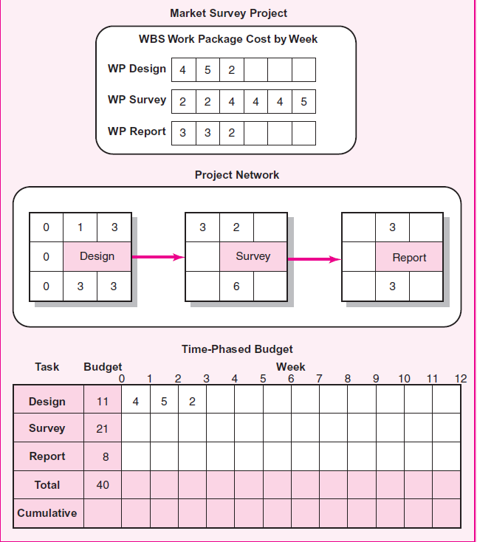
- Given the time-phased work packages and network, complete the baseline budget form for the project.
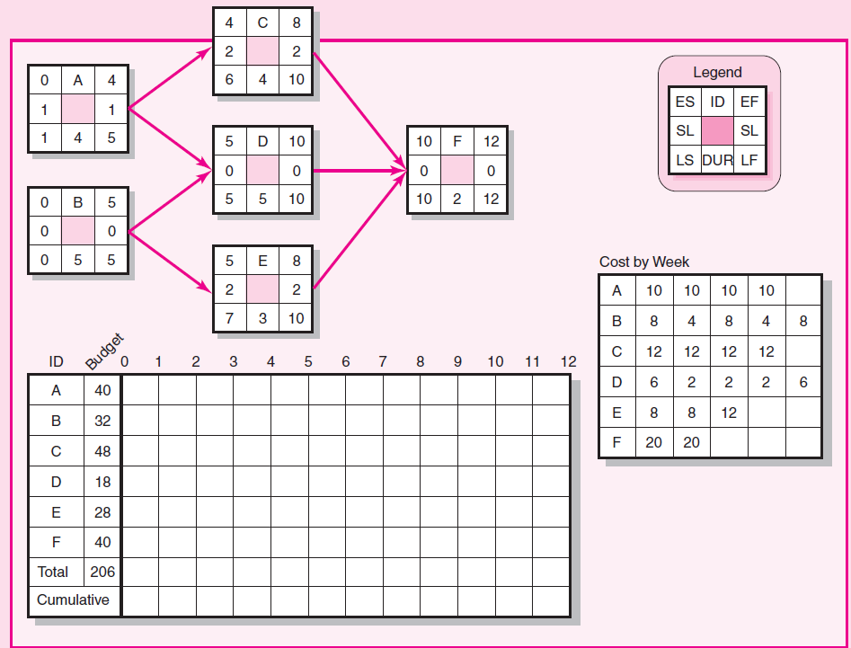

- What are five common reasons for crashing a project?
- What are the advantages and disadvantages of reducing project scope to accelerate a project? What can be done to reduce the disadvantages?
- Why is scheduling overtime a popular choice for getting projects back on schedule? What are the potential problems for relying on this option?
- Identify four indirect costs you might find on a moderately complex project. Why are these costs classified as indirect?
- How can a cost–duration graph be used by the project manager? Explain.
- Reducing the project duration increases the risk of being late. Explain.
- It is possible to shorten the critical path and save money. Explain how.

- In month 9 the following project information is available: actual cost is $2,000, earned value is
$2,100, and planned cost is $2,400. Compute the SV and CV for the project.
- On day 51 a project has an earned value of $600, an actual cost of $650, and a planned cost of
$560. Compute the SV, CV, and CPI for the project. What is your assessment of the project on day 51?
- How does a Tracking Gantt chart help communicate project progress?
- How does earned value give a clearer picture of project schedule and cost status than a simple plan versus actual system?
- Schedule variance (SV) is in dollars and does not directly represent time. Why is it still useful?
- How would a project manager use the CPI?
- What are the differences between BAC and EAC?
- Why is it important for project managers to resist changes to the project baseline? Under what conditions would a project manager make changes to a baseline? When would a project manager not allow changes to a baseline?
- You are managing a project to add a new kitchen onto an older home. The Plumber owns the task of Install Plumbing. The Electrician owns the task of Install Electric. Both tasks span a duration of 5 days each. The initial plan was to have all the plumbing complete before installing the electric. However, you would like to compress the overall duration of these two tasks, so you talk to both the Electrician and the Plumber. It is decided that the Electrician could begin his work 2 days before the Plumber is complete. How would you alter your schedule?
- Given the project network and baseline information below, complete the form to develop a status report for the project at the end of period 4 and the end of period 8. From the data you have collected and computed for periods 4 and 8, what information are you prepared to tell the customer about the status of the project at the end of period 8?
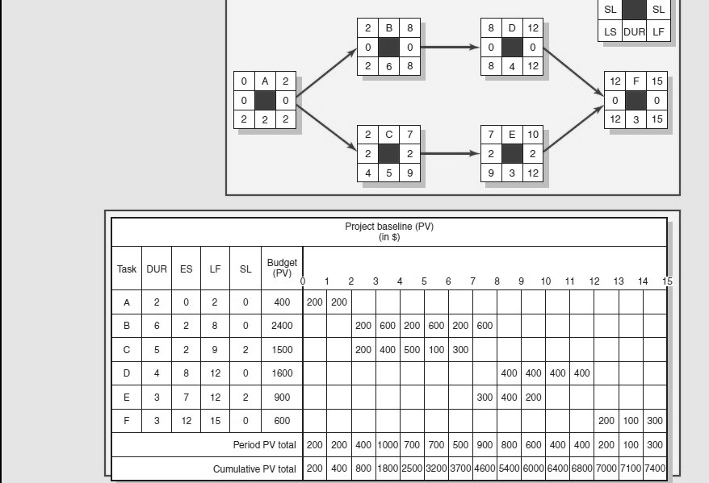

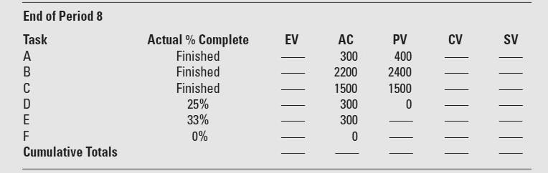

- You have a task that spans 5 days in Duration, has only one Resource assigned, and consists of 40 hours of planned Work. Due to a change in a delivery date, you discover that you now need to complete this task in 3 days or less. You have an additional resource on the team who could help with this task. How should you configure this task before adding the second resource?

- You have a resource on your team who is only available 50% of the time. She is responsible for working on only one task next week. The original estimate of Work for this task was 20 hours. She just informed you that based upon some new found information, the task is really going to take 30 hours worth of Work to complete. There is no one else that can assist with this task. How should you configure this task before updating the Work?

- You were just asked to take over a project. The previous project manager had developed a schedule in Microsoft Excel. It has 262 tasks, each with Duration in days and Resource Names assigned. You prefer to manage your projects using Microsoft Project. What’s the best way to get the information out of Excel and into Microsoft Project?

- Working with your project sponsor, you determine that a few tasks are out of scope for your project. You would like to somehow adjust your schedule to eliminate those tasks, but you don’t want to simply delete them just in case they may be needed in the future. What should you do?

- What is resource over- allocation and how should you solve it via MS Project?

- You just updated your schedule. You need a graphical view that shows how your current schedule compares to the Baseline. Which view should you use?

- The PMO manager comes to you because she realizes you have good experience with Microsoft Project 2013. She is wondering if there is an out of the box view or report that shows Actual Work, Remaining Work and Baseline Work. Which do you recommend?

- What kind of resources are available in Project Management?

- You are in the process of updating your schedule. You notice that one task has 3 days of Remaining Duration. You speak with the person assigned to this task and they state that the work is complete. What should you do?

- What is the function of Team Planner?

- The following labor hour’s data have been collected for a nanotechnology project for periods 1 through
- Using the relevant information compute estimated cost at completion (EACf) of the project at the end of
period 2?

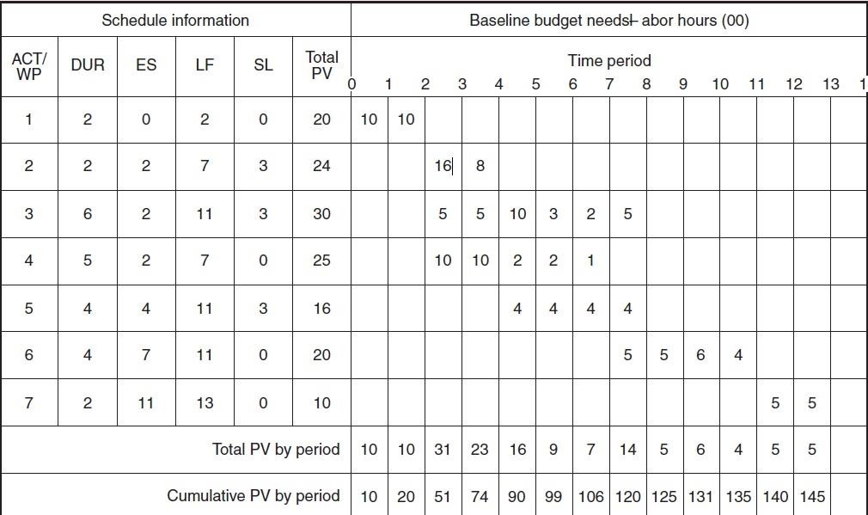

Status Report: Ending Period 2
Task | % complete | EV | AC | PV | CV | SV
1 | Finished |  | 15
Cumulative Totals |  |  | 15

  - The following labor hours data have been collected for a nanotechnology project for periods 1 through 6. Using the relevant information compute estimated cost at completion (EACf) of the project at the end of period 3?

Status Report: Ending Period 3
Task | % complete | EV | AC | PV | CV | SV
1 | Finished |  | 15
2 | 0% |  | 0
3 | 10% |  | 2
4 | 20% |  | 5
Cumulative Totals

  - You are one of three carpenters assigned to complete a short construction project. Right before the start of the project, one of your fellow carpenters was hospitalized and will not be available to work on the project. Develop a resource-constrained schedule in the loading chart that follows to see how long the project will take with only 2 carpenters. Be sure to record the order in which you schedule the activities using the scheduling heuristics. Activities A, B, C, D, E, G, and H require 2 carpenters to complete. Activity F requires only 1 carpenter. No splitting of activities is possible. You will receive a bonus if the project is completed within 15 days. Should you start planning how you will spend your bonus?

A
2

B
2

D
2

E
2

G
2

H
2

Legend
C
2

F
1

ES | ID | EF
SL | RES | SL
LS | DUR | LF

 | RES | DUR | VAR |  | SL | 0 | 1 | 2 | 3 | 4 | 5 | 6 | 7 | 8 | 9 | 10 | 11 | 12 | 13 | 14 | 15 | 16 | 17 | 18
A | 2 | 2 | 0
B | 2 | 1 | 3
C | 2 | 3 | 2
D | 2 | 1 | 3
E | 2 | 2 | 2
F | 1 | 3 | 4
G | 2 | 2 | 1
H | 2 | 2 | 0
Resource scheduled
Resource available |  |  |  |  |  | 2 | 2 | 2 | 2 | 2 | 2 | 2 | 2 | 2 | 2 | 2 | 2 | 2 | 2 | 2 | 2 | 2 | 2 | 2

  - What are the driving forces behind the increasing demand for project management?

  - Why should a project manager emphasize group rewards over individual rewards?

  - What is the difference between functional and dysfunctional conflict on a project?
  - When would it be appropriate to hold a formal team-building session on a project?
  - What are the unique challenges to managing a virtual project team?
  - What can a project manager do to avoid some of the pitfalls of a highly cohesive project team?
  - The following activities are based on a current or recently completed group project that you have been involved in. This project may be a student project, a work project, or an extracurricular project.
- How strong is the team identity on this project and why?
- What could participants do to strengthen team identity?
- What kind of informal activities could be used to rejuvenate the team? Why would these activities work?

  - What are the best practices used by firms to outsource project work?

  - Why is the principled negotiation approach recommended for negotiating agreements on projects?

  - How can a project manager influence customer expectations and perceptions?

  - Explain To To Complete Performance Index (TCPI).

