Tural Qasımov
Maliyyə Təhlili - 1044
- Determineg project's payback period and net present value (NPV).
- Determine the project's net present value (NPV) and whether or not to accept it.
- Determine after-tax cost of debt capital and after-tax cost of preferred stock
- Weighted-average cost of capital
- Investment Decision (NPV rule)
- Arbitrage Opportunities
- Arbitrage Opportunities
- Explain the difference between a long position in a forward and a long position in a call.
- „Options and futures are a zero-sum game “. Please discuss!
- Explain carefully the difference between hedging, speculation and arbitrage
- Explain two Perspectives on Economic Performance Measurement (Accrual vs cash basis)
- Financial Statement Analysis
- Cash Flow Statement Analysis?
- Complete the T-account Worksheet.
- Explain payoffs on long call contracts
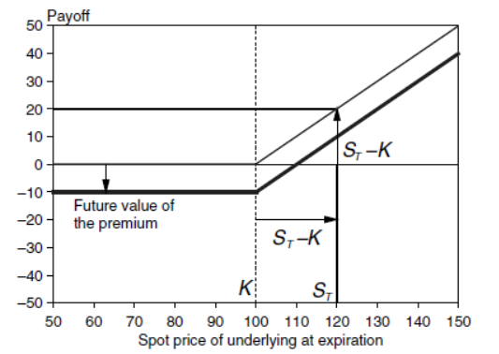
- Explain the payoffs of profits on Long forward contracts

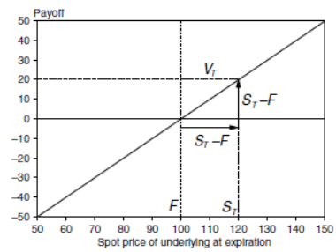

- Explain the payoffs of profits on Short forward contracts
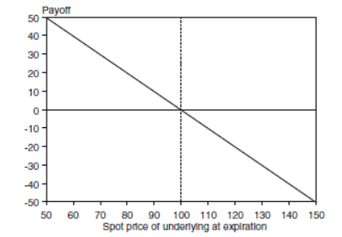

- Explain Operating efficiency ratios.
- Explain Equity valuation ratios
- Explain Common-Size Analysis
- Balance Sheet Preparation
- Revenue recognition
- Expense recognition
- Complete the Balance Sheet
- Cash Flow Statement Analysis
- NOPLAT, ROIC Calculation
- Valuation (Equity/Debt Valuation)
- Valuation (Performance Analysis)
- Valuation (Tax Issues)
- ROIC decomposition, ROIC determination
- Valuation (Performance Analysis)
- Valuation (Performance Analysis)
- Which interest coverage ratio, EBITDA to interest or EBITA to interest, will lead to a higher number? When is the EBITDA interest ratio more appropriate than EBITA ratio? When is the EBITA interest coverage ratio more appropriate than the EBITDA ratio?
- Valuation (Depreciation forecast, Interest forecast)
- Valuation (YTM Analysis)
- Valuation (Cost of Capital)
- Valuation (ROIC vs Cost of capital analysis)
- Valuation (Cost of Capital)
- Valuation (Cost of Capital, Enterprise Value)
- Valuation (Forecast methods)
- Valuation (EBITA, EBITDA)
- Valuation (EBITA, EBITDA)
- Valuation (Enterprise-value-EBITA multiples)
- Valuation (Enterprise-value-EBITA multiples)
- Valuation (Enterprise-value-EBITA multiples)
- Valuation (P/E Ratio analysis)
- Valuation (Key Value drivers)
- Valuation (Key Value drivers)
- Valuation (Bond Analysis)
- WACC Calculation
- CAPM Calculation, Analysis
- Valuation (ROE Analysis)
- Valuation (Future and spot prices analysis)
- Valuation (Project Valuation- decision making)
- Portfolio Analysis (Risk and Return)
- Valuation (Future and spot prices analysis)
- Investment Decision making (Interest rate issue)
- Portfolio Analysis (Risk and Return)
- When a company incorporated in a country with a high tax rates does business in countries with lower tax rates, it will report an effective tax rate below its statutory rate. Is the difference sustainable into the future? What occurs if the company decides to repatriate earnings? How operating taxes should be computed in the year of repatriation? How is ROIC distorted by local taxation and repatriation?

- Valuation (ROIC issue)

- Valuation (ROE Analysis)

- Company’s in highly competitive industries often see a number of consecutive restructuring charges. In these cases, should restructuring be treated as operating or non-operating? Form a valuation perspective, what are the important issues that should be considered?

- Valuation (tax reconciliation issues)

- Many financial analysts estimate the value of operating leases by discounting rental payments provided in the annual report at the cost of debt. Is this method likely to overestimate or underestimate the value of leased assets? Why?

- Many companies securitize their accounts receivable. Name two ways the cost for securitizing receivables is recognized. If you decide to recapitalize securitized receivable, when for which method is an expense adjustment required?

- When can I use the regression beta as my estimate of beta in a valuation?

- Why is the marginal investor assumed to be diversified?

- Is there an easy way to tell if a cash-flow is an equity cash-flow or a firm cash-flow?

- What is the cost of having more detail in valuations?

- Should I use the government bond rate of the country where my firm is located as my riskfree rate?

- Can I use book value of debt as a proxy for market value of debt?

- When would you include cash in working capital to compute cash flows?

- Can I use a growth rate higher than the growth rate of the economy as my stable growth rate if my firm is a well-managed firm or if it has other stellar qualities?

- Can you value stocks that do not pay dividends with the dividend discount model?

- Valuation (ROE, P/E Issues)

