University: Azerbaijan State University of Economics
Faculty: UNEC SABAH Center
Specialization: Finance
Author: Turgay Huseynli
Supervisor: Asif Azizov

How did the Financial Crisis 2008 affect the global financial markets and economy - An analysis from the Governments' role view perspective?

Baku 2019

Acknowledgements

Firstly, I would like to express my huge gratitude to my scientific supervisor, Asif Azizov for his advice, inspiration, motivation and tolerant direction. I am blissfully happy to have a supervisor who cared so much about my work and answered my problems and questions so punctually.
Abstract

Although ten years are passed from the 21st century’s economic recession, it is still one of most controversial and interesting topic for us. To prevent 2008 financial crisis, governments spent a massive amount of money in the name of bailouts and government support programs. Most of the programs were quite successful, as we can see their impacts today. However, some politicians and economists still have worries about these programs.
According to some analytics, the costs of the programs are greater than their benefits, and they are in favour of neoliberal economic principles. That is the key idea of my study.
In my dissertation, firstly I try to explain what is neoliberal principles and rules and how it works. Then economic and financial condition prior to 2008 are analysed properly and major factors behind crisis were defined and explained.
After that, intervention programs of the USA and EU nations are explained and the net effects of these programs are analysed.
To conclude, I think neither full restrictions to government intervention, nor less limitation to government will effect on economy and financial sector negatively, as it is obvious from TARP and Lehman Brother cases.

Table of Contents
1 Introduction 4
2 Literature Review 9
2.1 The main causes of the global crisis. 9
2.2 Economic and financial conditions before the 2008 financial crisis in the USA and Europe. 14
2.3 Estimated costs of the 2008 financial crisis and unfairness in the government interventions. 17
3 Methodology and Results 25
3.1 Details of government’s intervention strategy during the 2008 financial crisis 25
3.2 Types of state support and stimulus programs of the U.S government and their effects on the national economy. 28
3.3 Types of state support and stimulus programs of the EU governments and their effects on the national economy. 33
3.4 Net effects of government intervention and stimulus programs on economy and financial sector in the USA. 34
3.5 Net effects of government intervention and stimulus programs on economy and financial sector in Europe. 41
4 Conclusion and Implications 47
4.1 Summary of Findings 47
5 References 50

Introduction

Starting from the year of 2007, the world was forced to face the financial crisis. August 9th, 2007 was designated as the start of the credit crunch, defined as an economic condition in which investment capital is very difficult to obtain. According to BBC News, the most famous bank of France Republic, BNP Paribas, observed a dramatic increase in the cost of credits in 2007. By the negative effects of the US sub-prime mortgage market, this process caused to decline in the world financial markets. The reason behind the 2008 financial crisis was the USA economic policy, regulation of the financial system, and certain issues in the real estate market. So that, in the US, plenty of sub-prime mortgages and collateralized debt obligations (CDO) were purchased before the financial crisis by the citizens and this is the important fact that the major part of the population who took mortgage loans were the low-income households. Therefore, people with poor budgets faced with a lot of difficulties to pay their debts and were forced to sell their houses. In turn, this action upset the demand-supply equilibrium in the real estate market and led to a huge drop in the market prices and banks witnessed excessive losses on these defaulting loans. One of the most unusual events during the mortgage crunch is the bankruptcy of Lehman Brothers. So that, on September 9th, 2008 Lehman Brothers lost 40 percent of its market value in one day. On September 15th Lehman Brothers went bankrupt, and this date is considered to be the start of the worldwide financial crisis. This crisis affected not the only USA, but also almost all countries, especially Western Europe adversely.

Prior to the 2008 financial crisis, most of the economies were established on neoliberal principles. The basis of the neoliberal economic order is market competition. The latter is supposed to guarantee both economic efficiency and the realization of economic freedom (Mullis, 2009). As the independent government is the main nature of neoliberalism, within these concepts, government interventions are rejected, since unplanned side effects may occur. Interventions, however, are legalized as long as they meet the conditions of market conformity and as long as they satisfy the rule of law (Willke, 2003).
Despite above-mentioned principles, throughout the 2008 financial catastrophe to stabilize the economy and avoid upcoming negative effects of the crisis, most of the economies were intervened by the governments, including the USA and Germany. A significant part of interventions was carried out by the bail-out packages (USA, Germany, the UK) and economic stimulus packages (USA). The bail-out of unsuccessful banks is controversial in terms of market discipline, and a well functioning competition mechanism (Zimmer & Fuchs, 2010). An investigation directed by Anderson, Cavanagh and Redman (2008) for the Institute for Policy Studies (IPS) uncovers that as of November 13, 2008, the key parts of the U.S. budgetary division bailout added up to $1.3 trillion, while the European money related segment bailouts added up to $2.8 trillion. Together, the bailouts by the western countries added up to $4.1 trillion in certifications. Tables 1 and 2 demonstrate the subtleties of the United States and Western European nations focused on the budgetary division bailouts as of November 13, 2008. In the United States alone, as showed in Table 1, $700 billion was endorsed for the disturbed resource help program (TARP) and another $243 billion for business paper financing office, $200 billion in real money infusions to keep Fannie Mae and Freddie Mac above water, $112.5 billion to save AIG, $29 billion to ensure Bear Stearns' misfortunes on speculation portfolio, and $13.2 billion for FDIC takeovers (Anderson, Cavanagh and Redman, 2008).

Table 1: US Commitment to Financial Sector Bailout as of November 13, 2008) ($ Billions Unless Otherwise Stated)

Program | Amount | Description
Troubled Asset Relief Program (TARP)  Commercial Paper Funding Facility | 700.0  243.00 | The interesting plan was to use the advantages essentially to purchase bothered home credit-related assets. The Treasury Secretary has since chosen to utilize the assets for money injections for banks.  By the help of this task, the Fed buys business paper (transient obligations) from banks to help account day-by-day business activities.
Fannie Mae/Freddie Mac  AIG | 200.00  112.5 | Government authorities expected control of the home loan firms and are giving money infusions to keep them above water.  Does exclude $40 billion drawn from the $700 billion bailout support. After an underlying bailout in October, AIG arranged a bigger salvage bundle with simpler terms.
Bear Stearns  FDIC Bank Takeovers  Total U.S | 29.0  13.2  $1.3  Trillion | Special lending facility to guarantee losses on the investment bank’s portfolio; encouraged buyout by JPMorgan.  The Federal Deposit Insurance Corporation has set up to cover stores on fizzled banks.

Source: Anderson, Cavanagh and Redman (Instituted for Policy Studies, November2008)

Table 2 likewise uncovered that the United Kingdom burned through $734 billion for interbank loaning and transient advances, Germany $637 billion to ensure medium-term loaning and recapitalization, and France $483 billion to ensure bank obligation and recapitalization.
Nation | Volume | Explanation
United Kingdom | 743.0 | The UK bailout was the principal declared and largely filled in as the model for other European salvages. Half of the bundle is for ensuring between bank loaning, 40% for momentary advances and 10% for recapitalization.
Germany  France | 636.5  458.3 | The mass is to ensure medium-term bank loaning, with 20% for recapitalization.  The mass is to ensure bank obligation, with about $50 billion for recapitalization.
Netherlands  Sweden | 346.0  200.0 | To ensure bank advances.  For credit ensures.
Austria  Spain | 127.3  127.3 | For bank buyouts, interbank lending, and bank bond issuance guarantees.  For bank buyouts, interbank lending, and bank bond issuance guarantees.
Italy  Other European Countries  Total European | 51.0  110.6  $2.8 trillion | To purchase bank debts.

Source: Anderson, Cavanagh and Redman (Instituted for Policy Studies, November 2008)

As you see from abovementioned information, the main point of this research is the results of crisis and the interventions carried out by governments to prevent further negative outcomes. During the study research, the economic policies of determined governments, such as the USA, the UK will be analysed, those countries’ stimulus and bail out programs will be analysed, and then pros and cons of these programs will be explained deeply.
In the next part, current state of literature will be discussed. Previous studies will be reviewed, the different phases of government interventions will be explained, approaches of several governments will be analyzed, and additionally factors and causes behind crisis will be explained. Methodology and results part of study research will deliver an exact information about the different types of government bailout packages and analyze their effects on economy based on real data. Chapter 4 includes descriptive and summary statistics of the data, and discusses the. Finally, the last stage of my dissertation will consist of the conclusion and recommendations for further researches.

Literature Review

The main causes of the global crisis.
As I mentioned before, this credit crunch had a negative impacts on not only the USA, but also on the leading nations of European continent, for example Germany, France, the UK and so on. Generally, it is accepted thought that the starting point of subprime mortgage crisis was the bubble in the housing market of the US; however, we can list several reasons, which led the world to enter global financial shock. The reasons of crisis was a topic to debate between policymakers and economists and as a result, we can see several dimensions. As far as government arrangement, Taylor (2009) stresses that the exorbitantly free US money related strategy energized the credit blast, while others, for example, Elmendorf (2007) infer that loan costs were not very low. Notwithstanding these measurements, the discussion has considered both the association of neighborhood issues (US money related guideline and financial arrangement) and worldwide disparities (the overabundance of reserve funds spilling out of surplus nations to shortfall economies). Overall, we conclude that government policies, insufficient external statistics, and inadequate evaluation of systematic risk by investors and managers can be identified as the major factors behind crisis. Here is summary of the key reasons:
- The inadequate and biased analysis from the rating agencies.
It merits expressing that credit offices like Moody's, Fitch, Standard and Poor's, and so forth gave AAA+ appraisals implies that evaluations of least hazard, in a large number of administrations. Thus, numerous speculators put their cash in nearly "riskless" ventures, which swung out to be harmful items. No office thought about the noteworthy fundamental hazard. In addition, it is not amazing to underline that the backers of the securities were the individuals who paid for the rating!
- The absolute faith in neoclassical theories.
“The invisible hand” of Adam Smith, the agents’ rational expectations of Robert Lucas, the efficient market hypothesis by Eugene Fama and similar theories.

- The asymmetric information and the principal-agent problem.
The asymmetry in data in all the collateralized commitments (e.g. CDOs, CMOs, CDS, CBS…) driven to the undertaking of tall chance. At the same time within the environment of venture banks and support stores there was not compatibility within the motivations between the supervisors and the shareholders, the well-known principal-agent issue, which driven to less secure choices from those who would not cause the fetched of their choices.
- The excessive role of leverage
The role of leverage for the past 30 years in the US and in other developed countries has been extremely high. Leverage has caused financial instability and exposed the whole economy to severe systemic risk.

- Easy monetary policy
Low authentic and foreseen strategy loan costs in a couple OECD nations moreover had any kind of effect in resource costs and the look for surrender. There were various purposes behind game plan captivated rates being moo, a couple of which were gotten in Taylor-rule type associations (Figure 1) though others can be viewed as supporting deviations from such guidelines. The powerlessness related with Taylor-type drives should be underlined in the meantime, regardless, they may enable an obliging benchmark to talk and, likewise, the examination has recommended that various closes drawn dependent on these standards are invariant to slighter instabilities in numerical doubts.
Figure 1. Monetary policy has been accommodative
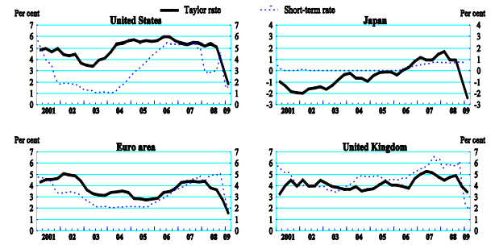
Note: The Taylor rule rate is a component of the harmony genuine financing cost (present moment), the (certain) expansion focus on, the normal yield hole and the hole between real center swelling and the verifiable swelling target. Equivalent weight is given to the expansion hole and the yield hole. For the United States, the expected value strength target is for expansion of 1.9% and the accepted harmony genuine financing cost is 2.85%. For Japan, the accepted value steadiness target is for expansion of 1.9% and the expected balance genuine loan fee is 2.1%. For the euro zone, the accepted value soundness target is for swelling of 1.9% and the expected balance genuine financing cost is 2.1%. For the United Kingdom, the accepted value dependability target is for swelling of 2.0% and the expected harmony genuine loan fee is 3.0%.Source: OECD.
Since the mid-1990s, expansion results in OECD nations have been critically influenced by globalization. Lower costs of fabricated imports came about both from falling fare costs in developing advertise maker nations and from more prominent entrance of makers with minimal effort bases (suggesting a move in sourcing towards developing business sector economies). OECD estimations recommend that amid the initial segment of the present decade, these impacts decreased yearly swelling by a few .2-.4 rate focuses. Some balance originated from the way that fast and item serious development in rising economies put upward weight on product costs however the net outcome was as yet a dis-inflationary impact in OECD nations. Well beyond these impacts, more prominent challenge in item showcases and auxiliary change in work markets may likewise have put some transient descending weight on swelling. Thus, the approach financing costs required to accomplish a given target expansion rate were diminished. While some level of undershooting of swelling focuses for quite a while could have been shielded, it would have been politically difficult for central banks, in the prevailing regime, not to pass through this favorable supply shock in lower interest rates.
In the meantime, two variables militated for loan costs beneath those anticipated by Taylor rules. To begin with, the blasting of the website bubble prompted lower share costs with negative riches consequences for development, something which a Taylor rule does not get. This impact was aggravated for some time by corporate outrages, which incidentally expanded hazard premium. Second, and at any rate in the United States, the collapse was viewed as a significant hazard. Given the zero stories on financing costs, this was viewed as inferring an unbalanced dispersion of dangers and, henceforth, a different purpose behind keeping up loan fees beneath Taylor-rule levels. Whatever the value of these contentions on an ex risk premise, plainly rates appear to have been excessively low when surveyed on an ex-post premise. In fact, even on an ex bet premise rates may have been raised at too ―measured‖ a pace amid 2004-5. Cross-country proof proposes that contract loaning, lodging speculation, development venture, and house costs all are related to deviations from a Taylor rule (Figure 2) (Ahrendts et al., 2008).

Figure 2. Housing and construction investment are correlated with low interest rates

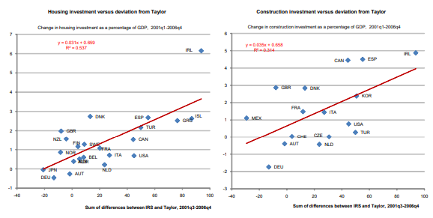
Note: The Taylor rule rate is an element of balance genuine financing cost (present moment), the (verifiable) swelling focus on, the normal yield hole and the hole between real centre expansion and the understood expansion target. Equivalent weight is given to the swelling hole and the yield hole. For the United States, the accepted value strength target is for swelling of 1.9% and the expected harmony genuine loan fee is 2.85%. For Japan, the expected value security target is for expansion of 1.9% and the accepted balance genuine loan cost is 2.1%. For the euro zone, the expected value security target is for swelling of 1.9% and the accepted harmony genuine financing cost is 2.1%. For the United Kingdom, the expected value dependability target is for expansion of 2.0% and the accepted balance genuine financing cost is 3.0%.
Source: OECD.

Economic and financial conditions before the 2008 financial crisis in the USA and Europe.
The starting point of the emergency plainly lay in OECD nations. Various improvements in these nations over the previous decade can, with the advantage of knowing the past, be believed to have had a bubble character. In a few cases, the potential bubble character of technological and financial advancements into economy was even talked about and cautioned against in open time. Although it was not quite easy to call these actions as reasons for the crisis, however, plenty of improvements are worth to be mentioned.

- Security yields in numerous nations plunged to abnormally low proportions in historical analysis, both in nominal and real terms (Figure 3). While a considerable piece of the fall appears to have gotten from desires that short-term interest rates were to remain moderately low, some part moreover epitomise a diminished term premium. . Concern was expressed about the risk of a back-up in bond yields and its potential implications for financial institutions (e.g. Brook, 2003; Ahrendts et al., 2006). In the event, however, the commencement of the catastrophe, budgetary strategy facilitation and the flight to wellbeing have resulted in even inferior government bond earnings.

Figure 3. Government bond yields fell to low levels
(10-year maturity)
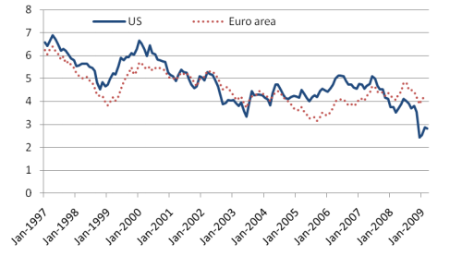
Source: OECD.

- Mirroring the low loan cost condition, genuine house costs shot up in most OECD nations (Figure 4). While desires for all time lower contract-financing costs could legitimize a few run-up in house costs, the advancement went well past what could be legitimized on this premise. Again, warnings of over-valuation were given and, in this case, proved accurate (e.g. OECD, 2005). Rising house costs in nations with liberal and focused home loan markets offered ascend to contract value withdrawal, fuelling utilization well beyond any riches type impacts. Money related advancement permitted the market for sub-prime advances to develop, fundamentally in the United States, with a large number of the home loan holders unfit to support their obligation except if house costs kept on expanding.

Figure 4. OECD house price and economic cycles became desynchronised
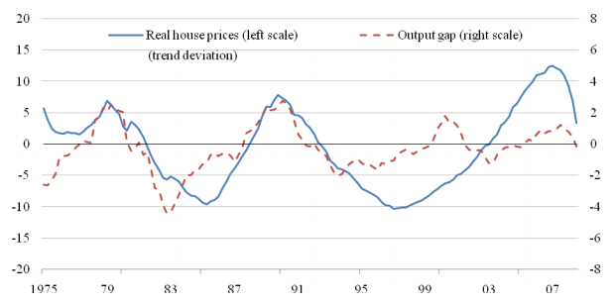
Note: Real house costs have been descended utilizing a direct pattern. The OECD real house value index is total of the 17 nations for which time arrangement begin in the mid-1970s. Computed using purchasing power parity-adjusted GDP weights.
Source: OECD.

- Share prices in OECD nations expanded from their troughs in mid-2003, however at the pinnacle were at most reasonably over the magnitudes came to amid the dot-com bubble. As income had fundamentally extended meanwhile, price-earnings ratios were as a rule well beneath the pinnacles of the dot-com bubble and not out of line with historical arithmetic means (Figure 5). This does not bar a rise to the degree profit themselves may have been complimented by bubble related profit in the monetary segment and, in any occasion, share costs conciliator after the beginning of the money related emergency.
Figure 5. Price-to-earning ratios were below those of the dot-com years
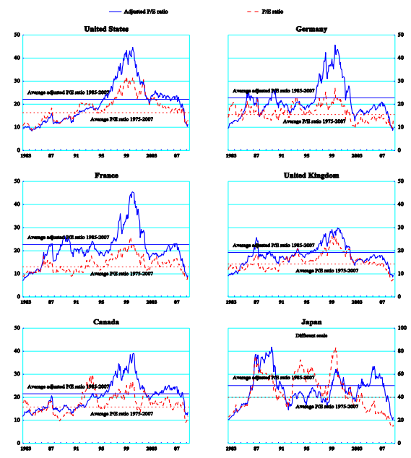

Note: Adjusted P/E ratios are calculated as the ratio of stock prices to the moving average of the previous 10 years’ earnings, adjusted for nominal trend growth.

Source: DataStream, OECD calculations

Estimated costs of the 2008 financial crisis and unfairness in the government interventions.
By certain estimates, the U.S. economy is progressing commendably, because being without a job at an 18-year was at the low level and second-quarter monetary development soaring at its quickest clasp in excess of twelve years. In any case, that does not mean that American population have completely escaped from the 2008 money related emergency.
According to the study of the Federal Reserve Bank of San Fransisco, it was estimated that the housing crash and ongoing recession caused to loss of $70,000 in incomes by each person averagely.
After the 2008 financial emergency period, several agencies, analytics, economists tried to measure the costs of the misfortune. One of these reports is called "Cost of the Crisis" indicates that the financial and economic emergency costs the USA $12.8 trillion and European Union $8.4 trillion approximately. According to statistics, between the period of 2008 and 2018, actual gross domestic product of the USA dropped by $7.6 trillion. However, as the CEO of Better Markets said that, this numbers are a old-fashioned assessment. It is also highlighted that:
- After the crisis almost 15% of the US population and 8% of EU population became unemployed person;
- 3% of the USA residents have lost their medical coverage;
- 11 million property holders, very nearly 1 of every 4, are incumbered with home loans higher than the worth of their homes. Homeownership has for quite some time been an image of the American dream and the single biggest venture and wellspring of riches for American families. Be that as it may, in the years prior to the emergency, Wall Street transformed America's lodging market into a club, with banks hawking subprime contracts and giving them to Wall Street to be cut, diced, and bundled into hazardous securities that were sold and disseminated to speculators around the globe. At the point when the U.S. lodging market fallen, it took the remainder of the worldwide economy down with it. Millions of (some time ago) working class American families were the blow-back, their fantasies and monetary security annihilated by a lodging market that, for a period, appeared as though it could fall constantly. The fall in housing prices was so steep that it touched virtually every corner of the country. According to David Blitzer, Chairman of the Index Committee for S&P, prices in 2011 dipped to 2001 levels:
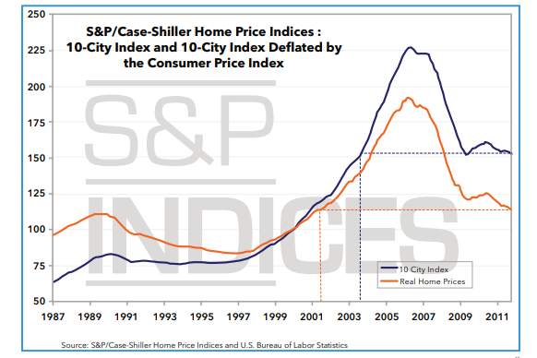
Numerous areas networks still haven't recuperated:
- Between January 2007 and December 2011, there were in excess of four million finished dispossessions and over 8.2 million abandonment starts.
- Since 2007, there have been in excess of 16 million dispossessions altogether.
- Between 2007 and 2009, housing prices fell by a third (in the largest metropolitan areas), and the Dow Jones Index lost half its value. Unfortunately for the struggling middle class, the housing market has been much slower to rebound than the stock market. By mid-2013, the stock market returned to pre-recession levels, but home prices were still 20% below their value prior to the crisis.
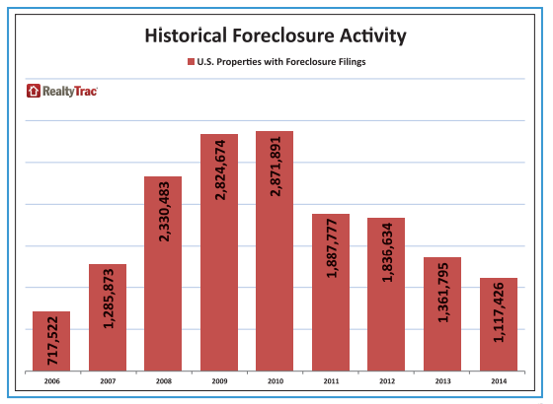
- Because of the money related emergency, the central government spent, loaned, ensured, vowed, submitted, or on the other hand generally utilized trillions of dollars to safeguard Wall Street, prop up the budgetary framework, and balance out the economy through many crisis programs. The estimation of the administration's all out duty of help is evaluated at no under $23.7 trillion.These gigantic government uses and responsibilities corresponded with emotional abatements in duty incomes at the government and state levels, too as soaring social costs when the budgetary emergency constrained millions out of work and out of their homes. These variables added to gigantic deficiencies in the years following the money related emergency. The government shortfall hit an incredible $1.4 trillion out of 2009 at the stature of the Great Recession, due both to the monetary boost went for balancing out the economy and to a drop in duty incomes. Making matters more awful, as the shortfall swelled in the years following the emergency, backers of severity won the political contention. What pursued were endeavors to bring spending shortfalls somewhere near diminishing spending, be that as it may fundamental it may be to react to the financial catastrophe brought about by the accident. This not just starved the projects expected to battle the monetary conditions, yet in addition hampered financial development. While these measures balanced out the quickly breaking down condition of numerous American families and the money related framework—on terms that were exceedingly positive to the financiers that had destroyed it in any case. The trillions of dollars that the legislature needed to spend to safeguard the budgetary framework were reserves that it couldn't spend on other fundamental needs and priorities. But then, as much as the legislature was compelled to spend, despite everything it consumed significantly less on a rate premise than it had in the past to battle earlier retreats, which were considerably less extreme. As appeared in the following outline, not at all like other ongoing subsidences in which the administration significantly extended spending to restore a decaying economy, government contributed moderately little to the extremely powerless financial development that pursued the 2008 budgetary emergency. This iron deficient reaction was inferable, to some degree, to the preoccupation of those assets to prop up the budgetary framework, which did not accelerate and was not at the focal point of earlier subsidences.
- The decrease in tax income was much more sharpened at the government level, because of lower salary and business profits just as the tax reductions made under the ARRA and different projects. Individual income taxes diminished especially, bottoming out about two rate focuses beneath their 1974-2013 normal of 7.9% of GDP. Corporate revenue taxes dropped from 2.6% of GDP in 2007 to only 1% of GDP in 2009. Social protection charges that help Social Security and Medicare declined by 0.8% of GDP, in extensive part because of falling payments.
- The country witnesses long-term debt challenges, today and in the future.
The debt to-GDP ratio is a symbol of a country's capacity to pay back its obligations and an indication of monetary wellbeing. The debt-to-GDP ratio is the ratio between the government’s debt and the nation’s gross domestic product. A low debt to-GDP ratio demonstrates an economy that creates adequate incomes to pay back its obligations without bringing about further obligations. On the other hand, a greater debt-to-GDP ratio is a red flag, indicating a country’s lack of ability to deal with its obligations due to disproportionate debt and/or lagging GDP. In the early 1980s the U.S. debt-to-GDP ratio was 35.4%. As can obviously be perceived in the next chart, although the ratio of debt-to-GDP increased from 2002 to 2008, it has gone through the ceiling in the past seven years owing to the financial predicament. At the end of the first quarter in 2015, it accounted for 102.6%. In absolute numbers the debt has risen to $18.2 trillion.
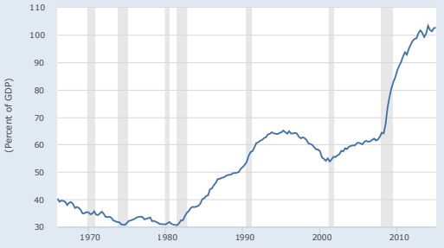
Source: Federal Reserve Bank of St. Louis, US. Office of Management and Budget
Shaded areas indicate US recessions - 2015 research.stlouisfed.org
- Innovation that never comes to be.
Another important field which devastated by this financial crisis was research and development sector. At the point when Congress started cutting optional spending in 2011 (after the boost of the ARRA), R&D consumed a huge spending cut. As of late, the nation's R&D spending plan has shrunk by more than $24 billion or 15.4%. This figure incorporates diminishes in R&D spending for protection and non military personnel science, as well as innovation. The sequestration in 2013 additionally had an essential job in the decrease, bringing about generally speaking decreases in 2013 that were more noteworthy than some other three-year time frame since the finish of the space race in the mid-seventies.
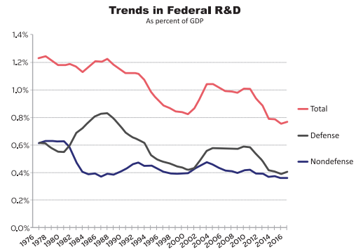
Source: Till 1994 – National Science Foundation, Survey of Federal Funds of Research and Development; 1995-2016 – AAAS data. GDP indicators were compiled by annual budgetary reports of the U.S Government

As it is clearly realised from the reports that 2008 financial and economic collapse almost destroyed the world economy and finance sector, and certain measures should be taken into consideration to prevent nations from another financial shock. That was a big issue for all governments which obliged them to intervene economic cycle. As a result, governments truly needed good and strong financial reforms to support companies. Troubled Asset Relief Program (TARP) of the USA and bailout packages of EU countries was considered as an successful instances. However, these type reformations and supports were not liked by the all parts of politicians and economists. So that the debates for the administration's reaction to the budgetary emergency — extending from TARP, to the nationalization of AIG, to permitting safeguarded banks to keep on paying rewards to their employers — all relied on the rationale of equity as the salvage of the American economy at the most minimal conceivable money related expense. These disagreements, be that as it may, completely disregard the incredible and undeniably increasingly normal conviction that equity is fairness. Productivity may have required compensating individuals who had acted seriously and rebuffing the irreproachable — however that did not make it rational. One approach to highlight this unfairness is to analyze the discrepancies between bailed-out banks or financial institutions and automative companies. So that at the point when the administration saved significant American banks, it didn't fire even one of their CEOs. The bailouts did not keep the banks from liberally paying their administrators, and paying profits to investors, as opposed to holding money to build soundness. At the point when the administration ransomed AIG, it didn't force a solitary penny of misfortune on any of AIG's loan bosses. On the off chance that you were a player in the American budgetary framework, the legislature did everything conceivable to ensure that you didn't experience the ill effects of the accident your industry had caused.
Whenever GM and Chrysler were safeguarded, then again, their CEOs were terminated and their unionized workforces were compelled to acknowledge significant pay cuts, despite the fact that they don't had anything to do with the reasons for the emergency. Every individual choice may, in some sense, have been the correct one when estimated simply regarding financial productivity. In total, be that as it may, they gave the presence of an administration willing to save no cost to protect Wall Street from the outcomes of its own errors, while to a great extent reluctant to try comparable endeavors for other people.

Methodology and Results

Details of government’s intervention strategy during the 2008 financial crisis
The main idea of my dissertation topic is to analyse the performances of governments during and after the 2008 financial crisis. Therefore, I researched for the countries’ economies and financial sectors including banks, investment corporations, and insurance companies to explain the crisis clearer. However, my focus is about the governments’ bailouts and stimulus programs. In the methodology part of my dissertation, the core financial and economic rescue programs will be explained based on their origin country and then the results of these programs will be evaluated. The centre of this part of dissertation is about the actions of the U.S government and European Union countries’ governments including Germany, the United Kingdom, and France and so on. Nevertheless, it is worth to say that most of government’s assurances and bailouts programs led to an enormous budgetary deficit in countries. Let us begin analyse with the leading and resilient economy, the USA.
The USA: Recovery efforts made in direct response to the financial crisis were a substantial quota of government outlay, as the federal administration endorsed procedures to deal with the calamity beginning in 2008. Many recognised government actions, which contributed to extraordinary shortages from 2009 to 2012, include:
- Economic Stimulus Act of 2008;
- Troubled Asset Relief Program (TARP);
- Supplemental Appropriations Act of 2008;
- American Recovery and Reinvestment Act of 2009 (ARRA);
- Worker, Homeownership, and Business Assistance Act of 2009.
In the initial few years succeeding the emergency, the government devoted roughly $12.2 trillion to get the economy back on its feet. Of that immense total, $9 trillion was distributed to direct investments in financial organisations, purchases of superior corporate debt, and purchases of mortgage-backed securities; $1.7 trillion was allocated to covering debt issued by financial institutions and guaranteeing ailing performing assets; and $1.4 trillion went to a noteworthy extension of the government’s old-fashioned overnight lending to banks.
On top of all this, starting in 2009, the Fed executed a program to purchase massive amounts of bonds in an unprecedented exertion to stop the monetary freefall, settle the economy, and help stimulus financial development. Overall, the bond-purchasing program, called "quantitative easing" or QE, pushed the FED's monetary balance to more than $4 trillion.
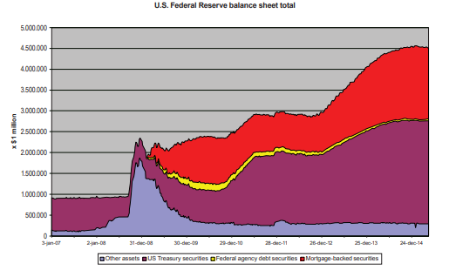

In a further attempt to help the financial recuperation, the U.S. national bank cut loan costs to zero in 2008. In mid-June 2015, the Fed casted a vote to keep rates enduring almost zero, testing seven years of outstanding low financing costs.
The economic hypothesis holds that low loan costs are commonly useful for the economy, as they invigorate development. Nevertheless, constant and verifiably low financing costs hurt savers, including the individuals who depend on premium pay and a wide range of financial specialists.
While borrowers pay less on credits, savers winless on their cash—giving them less to spend. Since individual spending drives the U.S. economy, it cannot develop under delayed states of brought down utilization. What's more, low financing costs add to the underfunding of annuity plans, which will force hardships on retirees. In conclusion, the positive effects of low financing costs are prompt yet transitory: “most benefits of low U.S. rates have already occurred. Individuals who possessed U.S. Treasuries and different securities in 2011, 2012, thus far in 2014 received gigantic rewards as financing costs fell and bond costs rose. While falling loan fees produce an extraordinary one-time advantage, the future for bond speculators is sombre.”
The transformation of every one of these components forsakes us badly prepared to satisfactorily react to an encumbered economy that is scarcely developing or to a future budgetary emergency. For instance, there is succeeding to no limit to do extra financial or money related enhancement, and the legislature does not have the resources to deal with any extra monetary insecurity. Congress cannot do it, in light of the fact that the monetary misfortune caused shortages and coming about obligation constrain its capacity to spend. The Fed cannot do it, in light of the fact that the Fed finances rate is as of now at zero and cannot be cut further, while its statement of financial position is surrounding at $4.5 trillion.

Types of state support and stimulus programs of the U.S government and their effects on the national economy.

Economic Stimulus Act of 2008:
President Bush signed it on February 13, 2008, the stimulus act provided individuals with tax rebates and businesses with tax breaks, but cost American taxpayers $152 billion in 2008. The desire for policymakers was that by returning cash straightforwardly to the hands of US families, they would expand spending levels and maintain a strategic distance from (or possibly relieve) the seriousness of the slowdown.
Doubters contended that families would not spend their expense refunds. Individuals will in general aversion swings in their utilization levels, persuading that the one-time improvement instalment would be spent just systematically over numerous years. This would imply that the spending effect of the rebate would be modest at best, rendering fiscal policy ineffective. (Martin Feldstein, 2014). Others contended that since the cash to pay for financial projects must be acquired and settled back in government obligations, it is a wash for the economy overall, and in this manner utilizing monetary strategy to get the economy moving resembles “taking a can of water from the profound end of a pool and dumping it into the shallow end."
Following information is worth highlighting:
- An individual taxpayer is allowed to get a maximum $600 tax refund, but it can be $1200 when taxpayer is married. Furthermore, an extra $300 tax can be refunded for each child.
- Taxpayers must record their 2007 returns by October 15, 2008, to be qualified for the discount. The IRS may apply instalments (to some degree or in full) to back assessments and certain obligations.
With financial experts and monetary pointers anticipating a subsidence for 2008, and amidst the subprime loaning emergency, the Economic Stimulus Act of 2008, P.L. 110-185 (ESA), was marked into law on February 13, 2008. The demonstration is proposed to support alleviate or forecast the downturn. It gives two tax reductions: recovery refunds for individuals and incentives for business investment. Rebate checks are being sent to citizens in the expectations that individuals will spend the cash and in this way animate the economy. The business arrangements incorporate motivating forces for speculation just as some arranging chances that ought to be exploited before the year's end.
Investigations of the 2001 US charge discounts demonstrated a considerable utilization impact, so how usable has the 2008 financial boost program been at getting individuals to spend. This question will be answered in the next part.

Troubled Asset Relief Program (TARP):
The Troubled Asset Relief Program (TARP) was an activity made and kept running by the U.S. Treasury to balance out the nation's money related framework, re-establish monetary development, and relieve abandonments in the wake of the 2008 budgetary emergency. TARP looked to accomplish these objectives by obtaining disturbed corporations’ assets and stock. To help counteract the total breakdown of the money related framework in 2008, Congress approved and President Bush marked the $700 billion TARP to stop the budgetary accident and re-establish steadiness to the framework. Until now, the legislature has distributed near $430 billion. As of April 2014, the Congressional Budget Office (CBO) revealed a complete net expense of $27 billion identified with TARP and estimated the final cost between $20 and $30 billion. Here is the summary on key findings of TARP:
- The Troubled Asset Relief Program (TARP) made and kept running by the U.S. Treasury following the 2008 money related emergency, comprised of endeavours to settle the monetary framework by having the administration purchase contract sponsored securities and bank stocks.
- Running from 2008 to 2010, TARP ended up capitalising $426.4 billion in businesses and regained $441.7 billion in yield.
- TARP was questionable at the time, and its adequacy keeps on being discussed: Advocates state it spared the U.S. money related framework and abbreviated the emergency, while commentators charge just gave Wall Street a superfluous, no-strings support.
Supplemental Appropriations Act of 2008:
Title IV of the Supplemental Appropriations Act of 2008 generated the Emergency Unemployment Compensation program, a short-term unemployment insurance package to lengthen joblessness insurance for an extra 13 weeks for those who dissipate their regular benefits. The Act increased estimated disbursements by $13 billion through 2009. The law is a push to pay for veterans' school costs to a comparative degree that the first G.I. Bill did after World War II. The primary arrangements of the demonstration incorporate financing 100% of an open four-year undergrad instruction to a veteran who has served three years on dynamic obligation since September 11, 2001. The demonstration additionally gives the capacity to the veteran to exchange advantages to a companion or kids subsequent to serving (or consenting to serve) ten years.

American Recovery and Reinvestment Act of 2009 (ARRA):
In reaction to a deteriorating monetary catastrophe triggered by the financial crash, ARRA, signed into law on February 17, 2009, delivered a stimulus package and tax assistance for $787 billion. ARRA was an indispensable supplement to President Bush's plan, the Troubled Asset Recovery Program. TARP ended the 2008 financial crisis by bailing out large banks. When we analyse ARRA, we have to mention each of the seven components of this stimulus program. Here are the details of components:
Immediate Relief for Families:
ARRA invigorated interest by sending $260 billion to families. They got the assets through tax breaks, charge credits, and joblessness benefits. The greater part of the assets were conveyed in the initial two years. Following statistics was created by the first component:
- By decreasing of withholding tax, an amount of $400 per citizen and $800 per families were cut.
- $70 billion to extend the Alternative Minimum Tax shelter. Congress extends it each year.
- A payment of an additional $250 each to recipients of Social Security, veterans' pensions or Supplemental Security Income benefits.
Modernize Federal Infrastructure
ARRA additionally made occupations by financing scoop prepared open works ventures:
- $46 billion for transportation and bulk shipment assignments.
- $31 billion to revolutionize centralised constructions.
- $6 billion in water ventures

Increase Alternative Energy Production
This financing kicked off the alternative energy industry in America. It exhibited that the national government bolstered clean energy by:
- Applying $17 billion tax reduction in renewable energy and,
- Weatherizing homes in the amount of $5 billion.

Expand Health Care
This component financed the huge amount of medical costs that crisis created. Here is the summary of ARRA’s contribution on health care industry:
- $24 billion to finance 65 percent of the Consolidated Omnibus Budget Reconciliation Act premiums for as long as 9 months for laid-off specialists.
- $87 billion in coordinating assets for a long time to help states pay for the extra Medicaid needs that generally happen in a retreat.
- $10 billion to National Institute for Health.
- $17 billion to modernize health data innovation frameworks.
Improve Education
Here is what ARRA spent on education:
- $54 billion to graduate school areas and federations to remuneration for tutor incomes and educational programs.
- $21 billion for school facility modernization and construction.
- $17 billion to boost Pell Grants by increasing the maximum to $5,350 in 2009 and $5,550 in 2010.
- $13 billion for Head Start.
- $12 billion for special education programs, including job training for those with disabilities.
Invest in Science Research and Technology
Financing broadband arrangement in pastoral regions also facilitated cover the way for high-tech health records needed for the ACA.
- $10 billion to modernize science facilities and fund research jobs that investigate disease cures.
- $4 billion to increase broadband infrastructure in rural and inner city areas. That made their businesses more competitive.
- $4 billion for physics and science research.
Help Small Businesses

Independent ventures drive 70 percent of every single new employment. ARRA distributed $54 billion to assist independent ventures with tax deductions, credits, and loan guarantees. These included:
- Permitting a distinctive depreciation deduction for 2008.
- In the Fiscal Year 2011 spending plan, an extra $64 billion in improvement cash was assigned to broaden a significant number of the ARRA programs. It included duty credits for any new contracts, and increment the Small Business Administration advance cut-off points from $3 million to $5 million. (Source: Recovery.gov presently outdated.)
- Cutting capital additions charges for independent company financial specialists who hold their stock for over five years.

Types of state support and stimulus programs of the EU governments and their effects on the national economy.

Significant approach activities have been taken in the EU quest for emergency control and alleviation. Money related salvage strategies have concentrated on re-establishing liquidity what's more, capital of banks and the arrangement of ensures in order to get the monetary framework working once more. Store ensures were raised. National banks slice strategy loan fees to remarkable lows and gave monetary organizations access to essentially boundless loan specialist after all other options have run out offices. Governments gave liquidity offices to money related organizations in trouble also, along with state ensures on their liabilities, soon pursued by capital infusions and weakened resource help. Unhindered financial boost was discharged to hold up request and ease social hardship over and past the programmed financial stabilizers. These emergency resistor and relief strategies are generally accomplishing their goals. Financial withdrawal has been confined and the number of work misfortunes contained relative to the estimate of the financial withdrawal. This chapter talks about and surveys the arrangement activities in these regions in a few detail. Here is the summary of EU programs:
- Monetary policy
- Regulation
- Government policies

Net effects of government intervention and stimulus programs on economy and financial sector in the USA.

In the first part of methodology and results stage, types of bailouts and stimulus programs was explained totally. In addition to this, economic and financial contribution of these strategies was analysed. Nevertheless, question is that how will these rescue plans and strategies effect on economy and help it to back its normal cycle?
Therefore, in this part of my dissertation, results of government interventions will be evaluated whether it is negative or positive, special comparison will be carried out between pros and cons of each program.

Results of Economic Stimulus Act of 2008 on the economy, how did it change the situation?
In exceptionally ongoing research, I answer this inquiry by recording the weekly expenditures of more than 30000 family units who have gotten or will get refunds, and relating their spending levels to the planning of the receipt of their rebate. The main point is to compare between two types of spending of citizen; the first one, which happened before the tax rebate, and the second one happened after the rebate. I use detailed statistics of expenditures, which compiled from ACNielsen’s Homescan database.
The table provided below demonstrates the main results of my analysis on Economic Stimulus Act of 2008. The first column shows the number of households who received a tax rebate or will receive soon. According to my analysis, as it is shown in table purchasing of goods increased approximately 3.5% on average, however this percentage reached a peak with almost 6% when tax rebate was gained. However, it is not possible to find out any results before receipt of rebate. Additionally, as it is obvious that, people with low income spend more money than their counterparts do. As it can be seen from the table, average consumption of low-income family increased 6% when they received a tax refund from government based on the stimulus act.
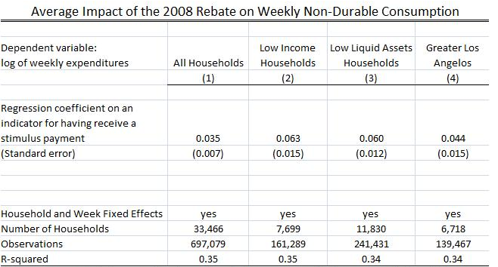

Although the regression analysis consists of daily expenditures of people based on the time of a tax rebate, in my next analysis, I investigate which gained more from this rescue program. For this purpose, I used the sales statistics of 30000 consumers of Walmart after the rebate.
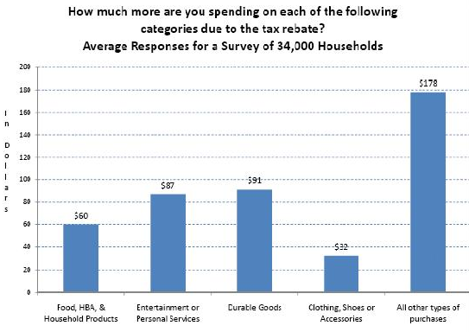
According to the table, after the tax rebate consumer directed to purchase durable goods, such as home appliances, furniture.
As a result, Economic Stimulus Act of 2008 was aimed to increase the money of people by cutting tax expenses, in turn, to increase spending for breathing economy and I found out that this was carried out very well.

Results of (Troubled Asset Relief Program) TARP on the economy, was it profitable?
In addition to the long-term costs it inflicted on the U.S. economy, in the form of lost GDP, foregone investment, and exploding government deficits, the financial crisis galvanized the government into deploying trillions of dollars to keep the financial system from imploding. Unlike the lasting damage that the financial crisis inflicted on the economy, the effects of which will linger for decades to come, much of the money spent to rescue the financial system has been returned to the Treasury and the Fed. But the fact that the government got “repaid” for saving the financial system has given rise to the myth that the bailouts turned a profit for the American taxpayer.
A standout amongst the most deceptive professes to leave the money related accident is that the U.S. Furthermore, citizens profited on the bailouts. That is just false. Being reimbursed is not equivalent to profiting. This key error has been made more than once to propose that the emergency was not as harming as it genuinely was and that the bailouts were not as exorbitant as they truly were.
It means that if government give $1 million to any company and to get $100000 interest at the end of period does not mean that government made money, because risk-adjusted rate of return, the time value of money theory must be taken into consideration.
A precise evaluation of whether the U.S. government profited on the bailout of the monetary division must begin with some key inquiries: What was loaned; what was the risk-free rate of return; what was the actual rate of return; and what might have been the risk-adjusted rate acquired by the administration?
To start with, this ridiculous case shrouds the enormous and mystery endowment that citizens gave Wall Street banks, which is the contrast between the risk-adjusted rate the administration ought to have charged and the actual rate got. Second, it immensely downplays the harm of the accident and emergency, quieting individuals into supposing it wasn't as awful as it truly might have been, which thus ingrains an incorrect conviction that all is well with the world and lack of concern—which adversaries of money related change use to minimize the requirement for budgetary change to guarantee that such an emergency never happens again.
The benchmark for considering the genuine expense of the bailouts and the citizen gave sponsorship they presented on the banks is the unquestionable certainty that the dangers of the whole money related framework were moved from the private division to the American government. The bailouts utilized trillions of dollars in government what is more, citizen cash to prop up the monetary framework. One of the most noteworthy profile moves made (in spite of the fact that not even close to the biggest) was TARP, which initially approved $700 billion in spending, a figure later diminished to $475 billion by the Dodd-Frank Financial Reform and Consumer Protection Act. Until this point in time, the administration has dispensed near $430 billion.
Covering's bearishness had both an expectant viewpoint and a trailing impact; terrible as conditions may have been heretofore, they is no uncertainty that they deteriorated a short time later. It is essentially false that business sectors would have been more regrettable off without TARP; actually, they would have been exceptional off without it. In the five months before TARP was embraced (i.e., May 3, 2008 to October 3, 2008), the S&P 500 fell by 22%, while U.S. bank stocks dropped by 21%. Interestingly, in the five months after TARP was established (i.e., October 3, 2008 to March 9, 2009), the S&P 500 declined by 38% while bank stock costs dove by 72%.

So, advertises in the five months after TARP's selection were much more regrettable off than in the past five months, and they performed most noticeably terrible of all accurately in the segment (banks) that TARP should "help." These empirics are evident. The individuals who guarantee TARP was a great to approach need to trust bank stocks would have dove 90-95%, aside from TARP topping the misfortune at 72%. Such a case would be silly.

American Recovery and Reinvestment Act of 2009 (ARRA); it has more advantage or disadvantage?
According my analysis, Economic stimulus act of 2008 was in favour of both the U.S government and people; however, as it is mentioned above, TARP was one of the main reason for budget deficit in the USA, therefore TARP criticized by economist all the time. For example, “Instead of U.S. banks shedding bad assets, merging and raising private capital, TARP compelled them to take unwanted, high-cost capital injections with "strings attached" that became a noose around their necks. Similarly, the problem with Europe’s shakier banks today is not they’re "under-capitalized" but that they hold shaky government bonds (issued by Greece, Portugal, Italy, Spain, etc.), assets which bank regulators insisted were the safest things they could possibly own, and thus required little or no capital.” (Richard M. Salsman, Forbes, Oct 9, 2011). However, in contrast to TARP, ARRA is considered as a good and measured strategy by the most of the economist and politicians.
The American Recovery and Reinvestment Act had something for everyone. In any case, it was excessively muddled. Numerous individuals were uncertain whether they, actually, got a tax reduction. Surveys demonstrated that numerous people thought their duties had expanded rather than diminished. Small companies protested that credit guarantees and tax suppositions did not benefit them.
Nevertheless, the triumph of ARRA is in the facts. The stagnation finished in July 2009, five months after Congress passed the Act. Economic growth instantaneously upgraded. It extended 1.5 percent in the third quarter of 2009 after lessening 4.4 percent in Q1 2009. In the initial year and a half after ARRA passed, the economy included 2.4 million private part and 1.7 million government occupations. That was in the wake of losing in excess of 500,000 occupations every month amid the retreat.
The tables provided below demonstrate economic growth stream and unemployment rate, accordingly.
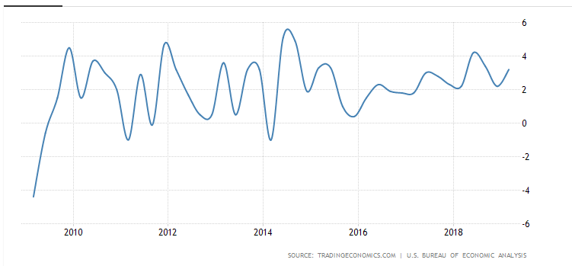
Economic growth in the USA
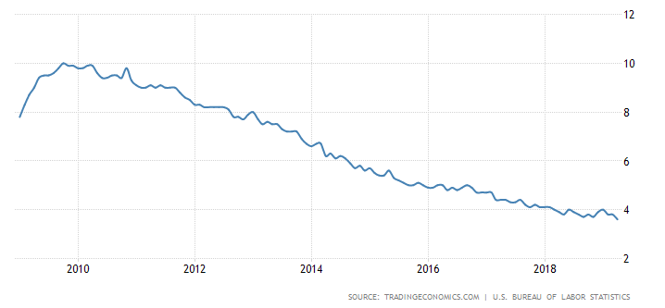
Unemployment rate in the USA
As it is clearly seen from the second graph, due to ARRA the unemployment rate began to decrease from 2009, and currently stand at 4%

Net effects of government intervention and stimulus programs on economy and financial sector in Europe.
As you know , the collapse of Lehman Brothers caused to the most difficult and terrible economic catastrophe since the 1930s Great Recession. All the governments which affected by the crisis took some initiative and responsible measures to prevent this calamity. However, these were different based on their implemention forms and origins.
We confront comparable challenges on both sides of the Atlantic. But there have been a few contrasts within the approach reactions within the US and the euro region. The choice and plan of measures are affected by the regulation highlights of the central banks, such as their degree of autonomy. They are too impacted by basic financial and budgetary characteristics, such as the relative importance of monetary markets and commercial banks within the subsidizing of businesses and family units.
You have already had information and thoughts about the policy responses of the U.S governments to the 2008 money related emergency which I wrote about it in the previous part. Therefore, in this stage of my dissertation I try to analyze the responses of the European Central Bank (ECB), EU governments and so on.

- Monetary policy
Between October 2008 and May 2009, the ECB brought down its fundamental policy interest rate, the rate on the most renegotiating operations, by 325 premise focuses. The current rate of 1% is the least since the dispatch of the euro in 1999, which could be a reflection of quickly receding inflationary weights since the summer of 2008. Typically in line with our essential objective at the ECB, to preserve cost steadiness within the eurozone within the medium term. In expansion to bringing down the approach intrigued rate, we have taken a number of measures to bolster the smooth functioning of the euro region interbred showcase. These measures have bolstered the stream of credit to family units and endeavors in a way that goes over and past what may well be accomplished through rate diminishments alone. Additionally, the European Central Bank took other measures to strengh daily operations of eurozone interbank market. These type of supports made the loans and credit easier for households. Therefore, this measures were named as “enhanced credit support”. As the main point of stimulus package is to improve the credit capacity of people, the ECB main focused on commercial banks, such as Commerzbank, and it accounted for 70% of all government bailout package. However, in contrast to EU, 25% of money aid came from banking sector. As a result, we can conclude that monetary policy was priority for EU governments in period of 2008-2009.
Role of banks in the funding of corporations & households
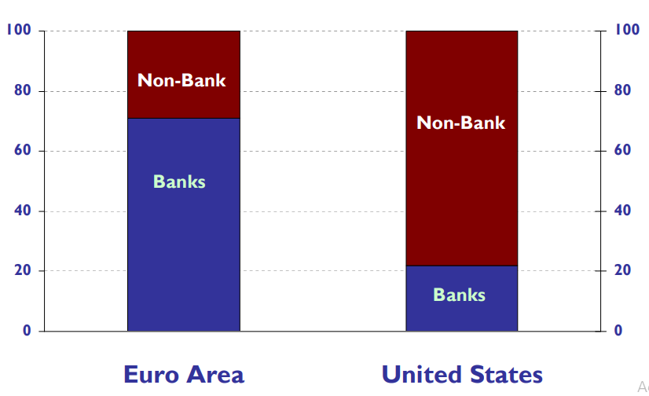
Note: Breakdown of the sources of external financing of non-financial corporations, in percent, average 2004 – 2008 Source: ECB Monthly Bulletin, April 2009
ECB response: strong decline in ECB interest rates
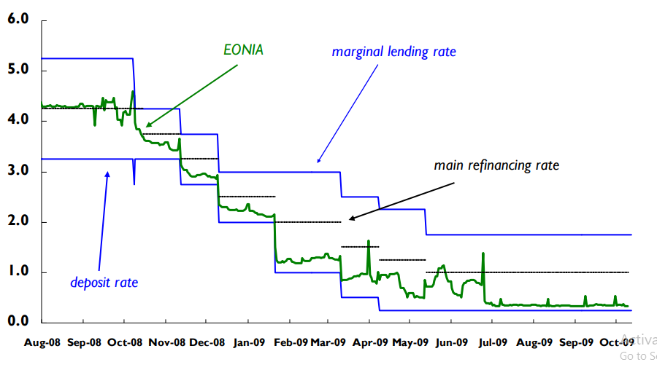

Here is the details of “enhanced credit support”:
- All the liquidity of the banks must be at fixed interest rate;
- Assets are allowed to be extended as a collateral;
- The enlargement of the ripeness of our refinancing actions, up to 1 year;
- The preparation of liquidness in outside monetary standards, eminently the US dollar;
- Entire acquisitions of euro-denominated covered bonds allotted in the euro area.

The secured bond advertise is customarily an imperative source of subsidizing for banks within the euro zone. This showcase portion endured intensely from the monetary emergency. With EUR 60 billion, we have chosen a volume noteworthy sufficient to bolster showcase working but not so expansive as to overwhelm advertise advancements. Still, compared with bond buy programs in a few other major nations, the sum spent by the ECB within the setting of its secured bond program is decently unassuming. In any case, this reflects the reality that the essential part of the ECB is to act as a catalyst for this advertising, not as a showcase maker. The through and through the buy of secured bonds is the as it were a genuinely modern component in our financial approach system. All other non-standard measures have been actualized by utilizing the adaptability of our financial approach system. The usage of our improved credit bolster has been accomplished by alterations in a few parameters of the framework. For illustration, sometime recently the emergency began the ECB as of now acknowledged private securities and asset-backed securities as collateral in our renegotiating operations, with suitable risk-control measures in put. Extension of the list of qualified collateral was essentially accomplished by bringing down the rating edge from “A-“ to “BBB-“, with the special case of asset-backed securities.
Generally, if we look at the effectiveness of enhanced credit support, it is clear that this injection of money to the economy made a positive impact on money market, which decreased interest to the 0.25%.
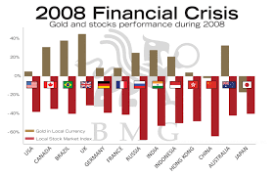
- Government policies
Our evaluation of the adequacy of the back measures is generally positive. The measures were required for deflecting a advance heightening of the emergency in late 2008. Starting experimental prove recommends that government bolster measures have been successful in diminishing banks’ default hazard. Here it appears that capital infusions have been compelling as well as obligation ensures and resource buys. The three-month euro and dollar Libor spreads over showcase overnight intrigued rates, a degree of credit hazard, have as of late fallen to their most reduced levels since the collapse of Lehman Brothers.
Other than these measures to back the monetary division, the government reaction to the emergency moreover incorporates the financial response to decrease the fall-out of the budgetary emergency on the rest of the economy. This is often a combination of the operation of so-called programmed stabilizers (the programmed decrease in charge receipts and the rise in government welfare installments as financial movement decays) and particular optional financial measures, such as extra open speculation, assess alleviation and appropriations for part-time work.
The size and timing of the upgrade measures, obviously, varied impressively between nations. For the entire euro territory, be that as it may, the European Commission assesses the upgrade measures to add up to 1 percent of GDP throughout the years 2009-2010. At the point when all is said and done, the administration reaction has been dynamic and we have invited it. Be that as it may, it includes some significant downfalls also. As per the European Commission's spring gauge, the euro territory shortage is set to increment to 6.5 percent of GDP in 2010 with the obligation expanding to 84 percent of GDP, from 69% in 2008. The financial releasing ought to be as it were transitory and we ought to make beyond any doubt that it is deserted as before long as the fundamental method of reasoning blurs absent and the financial environment makes strides. The governments ought to guarantee that financial combination does not begin afterward than the financial recuperation when private request can substitute the open request. As it were a portion of the monetary combination will happen through the programmed stabilizers and the brief nature of a few financial boost measures. Extra and more driven financial alteration will be required as well. Monetary arrangement can as it were be a effective macroeconomic instrument in case it is economical within the long term.

- Regulation
The crisis showed us that monetary and fiscal policy tools and instruments was not a good strategy to overcome crash completely. Therefore, two major procedures, proper regulatory change, macroprudential supervision and moral hazard of systemically important financial institutions were carried out by European Countries.
The first procedure: Prudential supervision – In this procedure, banks and other institutions and organizations will be supposed to obtain more and high quality capital and asset, which enable them to take corrective measures against unwanted cases. A leverage ratiowill be introduced as an integral amount to the Basel II system to check extreme monetary record development, and a liquidity essential will be perceived, obliging banks to hold satisfactory excellent fluid resources. These measures, to be issued by year-end, will fundamentally expand the capacity of money related organizations to oppose stuns and hence the flexibility of the budgetary framework. Give me a chance to feature, in any case, that these measures will be staged in as the economy recoups, to warrant they don't hinder the credit stream to the economy. Following three matters were important:
- Within the borders of European Union, all banks must extend their cooperation and create transparent information transmission system to enable them to analyse systematic risk beforehand.
- Effective monitoring and regulating mechanism must be created for the issues of the European Systemic Risk Board (ESRB).
- Banks and other financial corporations must ensure their international cooperation with the global organizations, such as IMF, FSB and so on.
The second procedure: Proper regulatory change – Credit Rating Agencies will now take part in monitoring and operating banks to have more tranparent bank sector. Furthermore, to increase effectiveness and transparency of over-the-counter market EU will enlarge its negotiations with the USA.
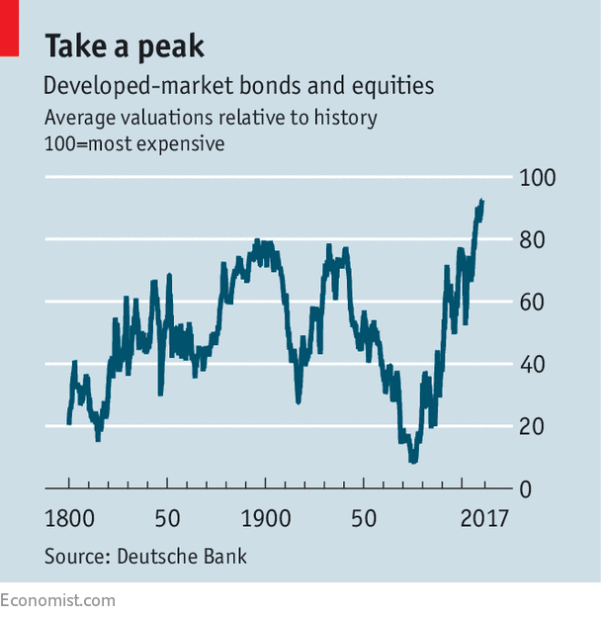

Conclusion and Implications

Summary of Findings

Through my research, my main point is to analyze whether governments responses to the crisis had positive results or negative results. Therefore, I explained analyzed each of the government programs and strategies to define their advantages and disadvantage and for the purpose I took the USA and the EU as a sample.
According to my analysis, EU showed great performance during the 2008 financial shock, as they carried out two governmental support programs, namely regulatory enhancement and credit support program. However, we must divide strategies into monetary and fiscal policy.
As far as a financial strategy, in the euro region, the noteworthiness has been to fix the working of the currency advertise. This mirrors the critical job that business banks in the euro region play in financing organizations and families, and the significance of the currency showcase for these banks.
In terms of fiscal policy which mainly used by the USA, it was carried by increasing amount of government spending or by cutting taxes to back economy to its cycle.
However, in contrast to Europe, the USA’s support program did not meet our expectations and requirements fully. The majority of U.S. banks were dreamily strong in 2008-2009 and should have been left permitted of TARP. Instead, they were subjugated by Washington – and unintentionally by U.S. taxpayers – not the other way around.

The commentators of bank bailouts are all in all correct to restrict bailouts essentially, yet the vast majority of them disregard the undeniable truth that in 2008-2009 generally U.S. banks were compelled to take TARP reserves, forced into paying above-showcase rates on favored profits, and constrained to run their tasks as Washington likes (the wellspring of the money related emergency in any case). Truly, most banks at this point have reimbursed TARP reserves, however, the Dodd-Frank "change" bill (sanctioned July 2010) proceeds or increases its disasters while further regulating government impedance in banking. Despite the fact that U.S. bank benefits have bounced back as of late, bank stocks today stay 47% beneath where they exchanged when TARP was sanctioned in October 2008, and 23% underneath where they exchanged when the Dodd-Frank bill was established in July 2010. It is politically dangerous to put resources into the banks.
The majority of U.S. banks were perfectly healthy in 2008-2009 and should have been left free of TARP. Instead, they were exploited by Washington – and unwittingly by U.S. taxpayers – not the other way around. However, it is doubtful fact that, ARRA was one of the best government program in the USA history.
As a result, I recommend that although modern lifestyle and economic environment require neoliberal principles and rules, which restrict governments to intervene economy in downturn, governments must fill partially free to intervene economy.

References

Assessing TARP, Dinara Bayazitova – Anil Shivdasanari, University of North Carolina
Broda, C. and J. Parker, (2008). "The Impact of the 2008 Tax Rebate on Consumer Spending: Preliminary Evidence ", mimeo University of Chicago, GSB, July 2008.
Johnson, D., N. Souleles and J. Parker, "Household Expenditure and the Income Tax Rebates of 2001" American Economic Review, Vol 96 No 5, (December 2006) 1589-1610.
Bruegel, A.Ahearne,J.Dlgado, J von Weizsaecker, “A tail of two countries» Policy Brief April 2008
Costello, D., A. Hobza, G.-J. Koopman, K. Mc Morrow, G. Mourre and I. P. Székely (2009), “The negative impact of the financial crisis on potential output necessitates an EU-led policy response”, VoxEU.org, 15 July.
Dennis M. Patterson (2010), "A great financial history book"
Dr.Nantawan Noi Kwanjai, “ Anatomy of financial crisis, past, present and future”
Dr.Nantawan Noi Kwanjai, “ Anatomy of financial crisis, past, present and future”
Dwight M.Jafee “ The U.S Subprime Mortgage crisis: Issues Raised and Lessons
Elina Bantavani. (2012), “The global financial crisis (2007- to date), the U.S policy response and lessons for the European debt crisis”. Athens University of Economics and Business.
Elul Ronel, “Liquidity Crises”, Business Review Federal Bank of Philadelphia Q2 2008
Emergency Capital Injections provided to support the viability of Bank of America,other major banks and the U.S financial system, October 2009, Office of the Special Inspector General for the TARP
Erik Bergloef,Yevgeniya Korniyenko,Alexander Plekhanov and Jeromin Zettelmeyer,”Underestanding the crisis in emerging Europe”, European Bank
Escaping TARP, Linus Wilson, University of Luisiana and Lafayette and Yan Wendy Wu, Wilfrid Laurier University
European banking authority 2011 EU-wide stress test aggregate report
European Central Bank, Paper 101, March 2009
European Commission (2008), “A European Economic Recovery Plan”, Communication from the Commission to the European Council COM(2008) 800 final.
European Commission (2009), “Economic Crisis in Europe: Causes, Consequences and Responses”, European Economy 7.
Federal Reserve Lending to Troubled banks during the financial crisis 2007-2010,Working Paper 2012-006A, March 2012
Happened, and What to Do about It
http://www.earth.columbia.edu/sitefiles/File/Fortune%20May%202008%20-
implications and policy directions”
Karen Weaver, Deutsche Bank “ The subprime mortgage crisis: a synopsis”
L.Pandall Wray “ Financial Markets Meltdown”, Public Policy Brief No.94 2008, Levy Economics Institute of Bard College
Laurence Boone, Barc lays “European integration and financial crisis: causes,
Learnt”, Commission on Growth and development, working paper no.28
OECD, J.Elmeskov, “The general background of the crisis”, May 2009
Robert J.Schiller,”The Subprime Solution” How Today's Global Financial Crisis
Sachs, J. D. (2008). Stagflation is back. Here is how to beat it.
Shazia Ghani. (2014), “Global financial crisis of 2007 : analysis of origin assessment of contagion to emerging economies : lessons challenges for financial regulation. Economies and finances”. Université de Grenoble, 2013. English.
Stephen K. Aikins (2011), “Global financial crisis and government intervention: a case for effective regulatory governance”
Ulrich Volz, Asian Development Bank Institute,» Lessons from the European Crisis for Regional Monetary and Financial Integration in East Asia
Yoichiro Ishihara, “Quantitave analysis of crisis: Crisis Identification and causality”
Zandi Mark “ Financial Shock”, NJ : FT Press 2008

Online resources:
- https://www.forbes.com/sites/richardsalsman/2011/10/09/tarp-after-three-years-it-made-things-worse-not-better
- https://www.thebalance.com/arra-details
- https://www.usatoday.com/story/money/business/2013/09/14/impact-on-states-of-2008-financial-crisis/2812691/
- https://www.ecb.europa.eu/press/key/date/2009/html/sp091016_1.en.html
- Inside Mortgage Finance, www.insidemortgagefinance.com
- IMF, http://www.imf.org/external/pubs/ft/gfsr/2009/02/pdf/chap3.pdf

