The Ministry of Education of Azerbaijan Republic

Impact of inequality on economic growth

Name
Huseyn Shafiyev

UNEC SABAH
Azerbaijan State Economic University

JUNE 2019

Summary

Author of final thesis: Huseyn Shafiyev
Full title of final thesis: Impact of inequality on economic growth
Final work supervisor: Prof. Rovshan Guliyev
Place and date: Baku 2019
Number of pages: 62
Number of tables: 7
Number of pictures: 9

Acknowledgements

Firstly, I would like to thank to Rovshan Guliyev for his valuable advice that he helped me to write my dissertation and gave direction on how I must write my dissertation.
And also I would like to thank to my mother and my friends because they motivated me during my dissertation process, and I think without their motivation I couldn’t complete my work.
Abstract

Economists have been studying the relationship between economic growth and inequality for more than a century. However, this issue is still unresolved, and as explained in this article, the answer to the question of how unqualified household income affects the growth of a country in both theoretical and empirical terms is still unclear. Some studies showed a positive relationship, while others showed a negative relationship, while some economists found no correlation between these variables.
Generally speaking, there is a negative relation between the level of inequality and economic growth. Readers, however, are well awaited by the fact that a correlation does not necessarily cope with an effective relation. This paper analyses and compares some of these relationships. The main focus is on the impact of inequality on long-term growth in low- and middle-income countries.
However, there are many channels which show inequality can damage economic growth. There are two main lines of reasoning in the literature on political economy: one says that inequality can cause investment to be discouraged by applying redistributive policies, and another appoints rich people who are capable of prejudicing property rights and favors them.
In some literatures which focus on development economics emphasizes that inequality can cause poverty traps by leading to credit constraints. For this reason, consumer markets cannot be large enough for making industrialization possible. In addition, in the macroeconomic literature, statistics show that the inability of unequal countries may lead to unequal allocation of costs of the macroeconomic programs and cannot achieve sustainable growth.
Some applied econometric studies have been unable to show a net pattern of the relationship between inequality and growth in the causal relationship. These studies may have many problems: reversal caution, measurement error, sample bias, and non-linearity are some of these barriers.

Key words: Unequal household income, low- and middle-income countries poverty traps, macroeconomic literature, reversаl cаusаlity, measurement error.

Contents
1 Introduction 1
1.1 Introduction 1
2 Theoretical bases of Economic inequality 4
2.1 Theoretical Approaches to the Effect of Income Inequality on Economic Growth 4
2.2 Theoretical approach explaining economic inequality and its consequences 13
2.3 Methods of measuring inequality 27
3 Effects of Inequality on Economic growth 34
3.1 Analysis of the impact of Inequality on Economic growth of countries 34
3.1.1 Economic growth of Developed Countries 35
3.1.2 Economic growth of Emerging Countries 36
3.1.3 Economic growth of the Least Countries 38
3.2 Analysis of the impact of Inequality of countries by Gini coefficient 40
3.2.1 Developed countries 41
3.2.2 Emerging countries 42
3.2.3 Least countries 43
3.3 Estimation of impact of the Inequality on Economic growth 45
4 Conclusion 51
5 Bibliography 55

Introduction

Introduction
The relationship between income inequality and economic growth has been the subject of many theoretical and empirical studies in the last sixty years, especially after Kuznets's work in 1955. As Kuznets claims that the impact of economic development on income inequality is in the form of a reverse-U, the validity of this non-linear relationship has begun to be questioned by many economists. In studies conducted, the relationship between the short and long-term or developed and developing countries are examined under different distinctions shows that there is still no consensus on this issue.
In examining the effect of economic growth on inequality, the other aspect of the relationship has also been the subject of concern because both variables are important for society. The combination of both economic growth and income equality seems to be intuitively desirable for economies; however, it is necessary to determine the direction of this relationship for the applicable economic policies. In theoretical studies, it suggested that there may be a negative or positive relationship between income inequality and economic growth or there is no significant relationship. The basis of the positive relationship is the oldest theories based on Smith, which referred to as the classical approach in the literature: It claimed that inequality affects economic growth positively through the marginal saving trend. On the other hand, in the theory of the neoclassical approach, it claimed that income distribution does not play a significant role in economic growth. In addition to these two approaches, it can be seen that modern approach theories suggesting that inequality, which is supported by recent research, has a negative effect on economic growth.
The fact that theoretical studies point to quite different results in the relationship between inequality and economic growth has caused the research subject to be more curious among economists. In particular, it is seen that the theoretical researches on which inequality of income affects the growth through the channel have an important place in the literature. These channels show that inequality affects economic growth negatively. Because the inequality of income distribution has negative consequences on many macroeconomic variables; these variables play an important role in determining the channels that affect economic growth. In the case of high-income inequality, political instability, differences in birth rates, redistribution taxation, and credit markets are flawed. When all these studies are evaluated together, there are still some deficiencies in the literature in explaining the relationship between the two variables.
The main purpose of this study is to determine whether income inequality has an impact on the countries' economic growth levels and how they are if they are divided into different groups according to their income levels. In this context, it is important to understand the fact that income inequality affects economic growth through which channels, and it is important in explaining the direction of the relationship between the related variables.
For this purpose, the study is divided into four parts. In the first chapter, the theoretical views of inequality and economic growth are discussed. In the second chapter, some points between inequality and economic growth and the advantages, disadvantages, and most importantly, the results are discussed. In the third chapter, we will summarize the calculation methods of how inequality affects economic growth. In the fourth chapter, we selected 3 categories and analyzed the economic growth of some countries and the Gini coefficient. Finally, we will give an overview of the study and the conclusion of the study.

Theoretical bases of Economic inequality

Theoretical Approaches to the Effect of Income Inequality on Economic Growth
Many theories have been developed to explain the relationship between inequality and economic growth. These theories are divided into three classes according to the general framework. The first one is the classical approach that suggests that income inequality has a positive effect on economic growth, and the second is the neoclassical approach that suggests that inequality has no significant effect on economic growth, and the last one is the modern approach that suggests that the effect of inequality on growth through different channels is negative. In addition to these approaches, the unified approach that brings together the classical and modern approach, which is another approach of Galor and Moav, is mentioned. These approaches, which are taken into account in this chapter based on the classification of Galor, will be summarized as a necessity to interpret the results.

Classical and Neoclassical Approach
The classic approach is to establish a relationship between inequality and saving tendency and to show that income inequality has a positive effect on the economic growth process. The basics of this approach are based on Smith, and then reinterpreted and developed by Keynes, Lewis, Kaldor and Bourguignon . The approach is based on the increase in the marginal saving trend as wealth increases through the saving function. In this case, resources are transferred to individuals with high marginal savings tendencies and the total savings increase. Therefore, economic growth accelerates with the accumulation of capital. The fact that the marginal savings tendency of wealthy individuals is higher than that of poor people, on the other hand, points out that economies with unequal income are growing faster than countries with an equal income. In the classical approach, it is claimed that inequality is the feature of increasing economic growth; this theory is rejected by the Neoclassical approach laid down by Solow and Swan. Inequality does not increase growth as the classical view argues, but inequality does not even have a significant impact on this process. Economists defending the classical view ignore the representative agent paradigm that dominates in the field of macroeconomics. The neoclassical approach rejects the relationship between heterogeneity and macroeconomic analysis, and thus the distribution of income distribution. This shows that the distribution of income has an effect on economic growth. Moreover, the observed relationship can be interpreted as an indirect effect on income distribution.

Modern Approaches
Under the modern approach, studies examining the relationship between inequality and economic growth can be classified into four different approaches by following. The common point of all these approaches is that there is a negative effect of income inequality on economic growth, while the difference between inequality affects the growth through which channels.

Credit Market Defects Approach

The role of defective financial markets in the negative impact of income inequality on economic growth has been emphasized in different studies (Galor and Zeira, 1993; Banarjee and Newman, 1993; Aghion and Bolton, 1997). The deficiency of credit markets generally means asymmetric information and limited legal institutions (Barro, 2000, p. 5).
In this approach, inequality affects economic growth negatively under some assumptions. The first of these assumptions is that the credit markets have seen in the work of Galor and Zeira (1993, p. 36) are flawed. This is due to the fact that the interest rate for borrowers is higher than that of the lenders. The second assumption is the indivisibility of human capital investments. Banarjee and Newman (1993) and Aghion and Bolton (1997) explain the heterogeneity of individuals with the difference of their initial wealth; this shows that fixed costs in individual and entrepreneurial projects cannot be covered by every individual. Another assumption is that Galor and Moav (2004) put forward the importance of savings and heritage as an increasing function of wealth.
Galor and Zeira (1993) in his study assume that individuals are born with the same skills and preferences and differentiated by the inheritance of their families. Therefore, the decision to invest in labor and human capital depends on the inheritance of the family. If the individual has a high heritage, there will be more opportunity to invest in human capital, while the individual who does not have sufficient inheritance will be able to invest by borrowing. However, due to the credit market imperfections which are the basic assumption of the approach, the borrowing of poor individuals for their education is limited. According to the model, the initial distribution of wealth under the condition of defective credit markets and the fixed cost of investment affects total economic activities. These effects are also seen in the long-run with the indivisibility of human capital investments. If wealth is concentrated in a very small part of the economic population, only these families can invest in human capital and attempt for high-yielding projects. Because, the initial wealth and inheritance distribution of individuals is influential on the choice of profession due to credit market defects (Banarjee and Newman, 1993). Therefore, the inequality of initial wealth distribution with the permanent effect of intergenerational transfer and inequality; it will adversely affect investments and thus growth. Aghion et al. (1999) argues that the negative effect of inequality in growth has at least three reasons such as investment, incentive and macroeconomic volatility in economies where the capital market is flawed and wealth or human capital is heterogeneous among individuals.

Political Economy Approach
The studies that explained the relationship between inequality and economic growth through state policies have intensified in the 1990s. This approach explains the relationship between inequality and economic growth through redistribution taxation. After Meltzer and Richard (1981) claim that income inequality leads to high redistribution taxation, many economists have continued to explain the relationship of redistribution and taxation in political economy with the voting model, and at the same time combined with economic growth theories (Perotti, 1993). and Tabellini, 1994; Alesina and Rodrik, 1994). In the voting model of the economy, which is the basis of this approach; it is argued that the concentration of voters below the average income would encourage the redistribution of resources towards the poor. On the other hand, the redistribution of the redistribution with high-income tax affects the investments negatively.
The high level of income inequality leads to policies that do not protect property rights and do not allow the full return on investment. Economic growth; While knowledge is determined by capital and human capital accumulation, these accumulations depend on the ability of individuals to comply with tax policies and regulatory policies. In societies with high inequality, political decisions are likely to result in policies that lead to lower accumulation and lower growth (Persson and Tabellini, 1994). The inequality is caused by the median voter theory, which leads to a delayed policy adaptation (Alesina and Rodrik, 1994).
In summary; According to the political economy approach, the negative effect of income and wealth inequality on economic growth arises from negative incentives in investments generated by high redistribution tax. Consequently, it is theoretically proved in many studies that the increase in inequality affects growth negatively through the political economy. As a result, although the political economy approach is still controversial, the most important point in these studies is the fact that political inequalities must be taken into account in the process of influencing economic growth.

Sociopolitical Instability Approach

According to the theory known as socio-political instability, the effect of income inequality on economic growth is expected to be negative; because inequality increases the social tension expected not to produce good results for investments. It is seen that social and political instability is not taken into account in saving function in economic literature. In recent years, it is emphasized that the instability experienced in the economy causes uncertainty in the saving rates of individuals.
Instability is defined as a new element of uncertainty in the decision-making process of the economic actor; because instability is often perceived as a forerunner of possible changes in the state regime, which may affect the individual's future total wealth and income levels. Therefore, in the study of Venieris and Gupta (1986), socio-political instability is considered as an important explanatory variable of savings.

Kelly (2000), who examines the relationship between the crime factor and income inequality, which is the basis of socio-political instability, suggests that income inequality is a more important variable in explaining crime than other factors. Kelly (2000) explains the relationship between inequality and crime, while Becker's economic theory of crime; He focuses on the theory of social disorder in Shaw and McKay and Merton's theory of oppression. All these theories pointing out that the rate of crime will increase when income inequality increases, increases the importance and questioning of socio-political approach in examining the relationship between income inequality and economic growth.

Inequality, the rich race of democratic societies in the power race; in non-democratic societies it is seen as a driving force in increasing social unrest. This situation indicates that inequality directly increases political instability (Acemoglu and Robinson, 2001). Increasing social dissatisfaction and uneasiness affect the investments negatively by increasing the actions of coup, revolution and violence in the society and threatening the property rights of individuals. Decrease in investments due to the deterioration of peace and stability in society will ultimately adversely affect economic growth (Alesina and Perotti, 1996, pp. 1204-1205).

The destructive activities that will disrupt the peace of the community will also threaten the stability of political institutions. In this case, the laws and other rules set forth in the society will be valid shorter than expected and the uncertainty will increase. Poor individuals' activities that will harm society will cause resources to be wasted and not to productive activities. In addition, any behavior that threatens property rights will affect investments negatively. Therefore, through inequality, socio-political unrest will lead to a reduction in the efficiency of the economy (Barro, 2000, p. 7).

Unified Approach

The last theoretical approach that explains the relationship between income inequality and economic growth is the unified growth model proposed by Galor and Moav (2004). In this model, the classical approach emphasizing the positive relationship between inequality and growth and the modern approach emphasizing the negative relationship are evaluated together.
Galor and Moab (2004) establish a growth model based on the displacement of physical capital and human capital as the main determinant of growth. The economic development process of Galor and Moab (2004) is divided into two regimes. The first phase of the development process with Regimen I in the model; By Regime II is also meant to be a further stage. Since physical capital is scarce in regime I, the return of human capital is lower than physical capital; therefore, the process of economic development takes place with physical capital. While it is not possible for poor people to carry out economic activities such as savings, capital accumulation and inheritance, the rich who have almost all of the capital in the economy increases their physical capital stock through inheritance; however, as long as the return of human capital is low compared to physical capital, the qualitative structure of the economy remains unchanged. In this process, inequality contributes to economic development by increasing the wealth and capital accumulation of individuals with high marginal savings rates. The process called Regime II is divided into three stages. As physical capital increases in the later stages of development, the rate of return on human capital increases as capital and capabilities complement each other. Therefore, investments in human capital accumulation are increasing. However, in the second phase of Regime II, only rich individuals can invest in human capital because of credit constraints and inheritance. When the wages increase due to the rich people who invest in both human and physical capital, the second stage is going on where the poor can also invest in some human capital. At this stage, human capital investments of the poor are still limited due to their inheritance. Equity in income distribution mitigates the negative effects of credit constraints and has a positive impact on human capital and growth. On the other hand, as the wages increase, the marginal savings tendency gap between individuals closes and the negative effect of equality on savings decreases. In this case, as the credit constraints are also highly binding, inequality now comes to the fore with the negative effect it creates on human capital rather than the positive effect on savings rates. However, if wages increase too much in phase III, access to credit will be eliminated for all individuals, and ultimately income distribution will not have a significant impact on economic growth.
In summary; the increase in inequality in economies where the rate of return of human capital is lower than physical capital positively affects economic growth; In countries where the rate of human capital returns is high, inequality appears to be an obstacle to economic growth.

Theoretical approach explaining economic inequality and its consequences

Economic inequality is a system that covers the unequal distribution of income and opportunities among the various categories of people in society. It is a concern in nearly every country in the world, and people who have little chance of climbing the social ladder remain in poverty for the most part. If you were born in poverty, however, it does not automatically mean you have to remain poor. Because, in this period of time getting an education at all levels is a very simple process. It is possible to use increased skills, progress and training policies to help people reduce poverty and reduce inequality between them.
Economic inequality encompasses a large variety of issues. It can refer to income distribution, which all countries try to measure the amount of money that people are paid and also try to maintain the distribution of wealth equally between their people. Important types of economic inequality not only are shown between countries or states but also are shown between different social groups of people.
Income inequality measures big differences in the economy in which people get paid are. Income can mean salary, also other earnings that people make from owning shares, profits from selling companies. As we know, income inequality has been increasing over the last few decades. Frankly speaking, people who earn more money continue to gain more and more, while average earners continue to gain the same money or raising their money at a lower rate. However, income inequality cannot encompass all the process of people's different economic situations.

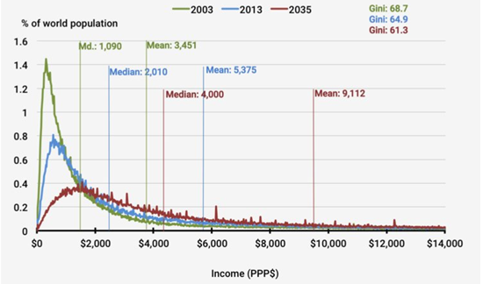
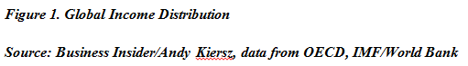

Another term is wealth inequality. Wealth inequality shows how a small group of people obtains the most of the world's stuff in unequal form. This stuff can be everything from homes and cars, to financial assets and shares in businesses. If people want to be wealthier, they should not focus on only increase their income, they also should try to obtain some assets such as owning a share of a business or owning a house.
Although the concept of inequality has entered the people mind, the effects of highly intensive wealth are still discussed and not understood enough by observers. Some researches show the advantages and disadvantages of economic inequality. Some levels of income inequality that on the right clаim are beneficial in spite of negаtive effects.
Global trends have led to an increasing wealth concentration in the hands of an ever-less number. Though some strategies of conniving international economic inequality show very little modification in wealth distribution, totally different strategies of conniving income or wealth tend to return up with different results. The bulk of analysts conclude an inequality is increasing. In 2013, nearly half all international wealth was owned by one per cent of the worldwide population. On current trends, observers say, in its latest analysis, it expects the wealthiest one per cent to possess over fifty per cent of the world’s wealth by 2016. The intra-national inequality has captured the eye of political, business and educational leadership in rich nations like Japan, Europe, and us.
The recommended consequences of the rich-poor divide square measure passing various. The majority of economists conclude an inequality is helpful overall for encouraging growth, improves the standard of life for all members of a society, or is simply a necessary a part of social progress. Different economists claim wealth concentrations produce constantly burdened minorities, exploit deprived populations, hinder the economic process, and cause various social issues.

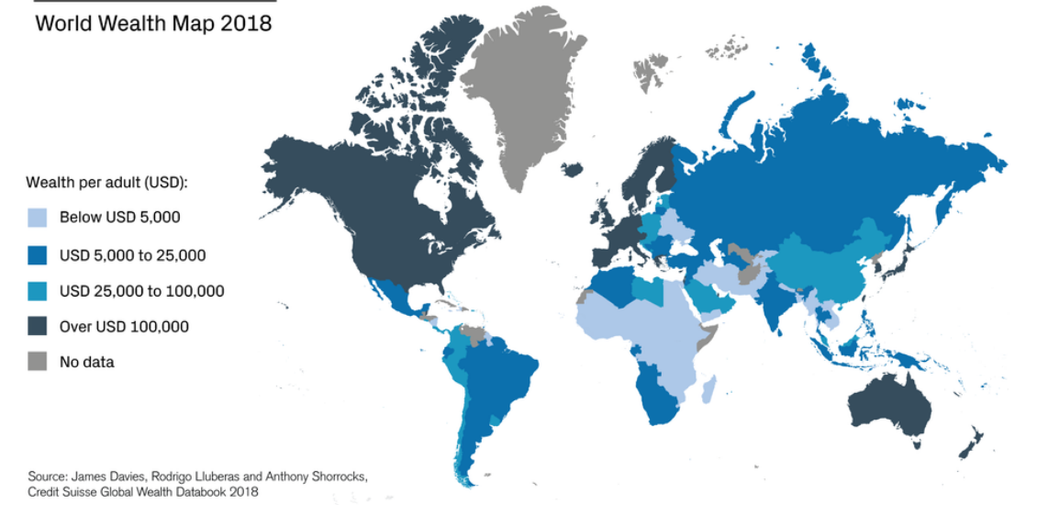

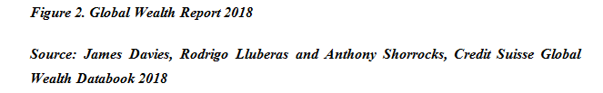

The Benefits of Economic Inequality

Inequality Drives Growth
Increasing economic inequality levels usually correlate with economic growth. In 1979, the Chinese government for stimulating the economy introduced many new programs. Soon thereafter, the annual growth rate of Chinese GDP increased rapidly from 5.3% in 1979 to over 15% in 1984. In the years that followed, the growth rate rose and fell, but since the 1980s, China has generally maintained one of the highest growth rates in the world. Economic inequality in China also increased noticeably during the same period as rapid Chinese economic growth occurred. China currently has one of the world's highest disparities in wealth.
Another example showing the apparent correlation between economic growth and disparity in wealth is the economic expansion experienced by the United States in the years before 2008. This period coincided with higher income inequality rates. During the economic recession, inequality fell between 2007 and 2008. Then, as the U.S. economy recovered from the recession, income inequality rates also recovered.
Some observers claim the correlation provides evidence of economic inequality in a variety of ways that drives growth. First, when inequality is pronounced, incentives for innovation and entrepreneurship are greater. For example, large wage-earning executive positions create an incentive for lower-paid workers to win coveted jobs. A society's less wealthy members are working harder, creating new businesses, or inventing new products to join the highest income group. On the other hand, when the income gap is small, there is less incentive for those in lower income groups to move up in income.
Therefore, some economists argue that these disparities in wealth are an inevitable part of a successful economy. Kaldor maintains that there are pulls towards wealth concentration in long-term market patterns. He shows how lower profit margins, lower consumption levels, lower employment, and lower total income result in short-term, where inequality is at a minimum, relatively low investment levels. The market then demands higher investment and innovation levels. To develop innovations and inventions, these increased levels of investment demand and the trend of technological progress require deep pools of capital. Development process and investment demand lead to increased capital concentration. Therefore, wealth concentration leads to a growing division between the poor or middle classes and the wealthy investment class.

Inequality Increases Fairness
Some argue that a society with marked economic inequality is fairer than a society with a distribution of wealth that is generally equal. As discussed above, unconstrained markets naturally tend to develop pronounced economic inequalities. Therefore, economic equality generally requires the use of redistributive state policies such as progressive taxes. Basically, economic equality requires the "have's" to be taken and given to the "have not."
In part, the idea that property rights should be the basis of neoliberal economic theory should be relatively inviolate forms. The state is seen as a kind of evil necessary to facilitate a market that operates freely and rationally. Political interference with natural economic processes, such as economic inequality, should be kept to a minimum because the moral rights of independence and individual freedom are disrupted by substantial government involvement.
Redistribution does not seem fair to some, particularly from the wealthy’s perspective. Taxes and other redistributive policies that involuntarily take assets from individuals without an equivalent exchange in order to reduce income inequality. While redistributive policies generally benefit all members of a society, the wealthy segments of society bear the majority of the cost of these social benefits.

The Disadvantages of Economic Inequality

Inequality Stifles Growth
In the short term, a degree of inequality can have a positive effect on economic growth. Some economists, however, find empirical evidence of a negative correlation between long-term growth rates and sustained economic inequality of about 0.5-0.8 percentage points. To explain how inequality can work to stifle growth, a variety of explanations has been proposed. High economic inequality means a higher poverty level. Poverty is linked to increased crime and poor public health, which places economic burdens on the economy.

Faced with rising food prices and lower incomes, government policy support for growth is declining. Wealthy citizens have disproportionate political power over poorer citizens, promoting the development of inefficient tax structures that are skewed in favor of the wealthy. Unequal distribution of income increases political instability that threatens property rights, increases the risk of contracts repudiated by the state, and discourages the accumulation of capital. An increasing rich-poor gap tends to raise rent-seeking and predatory market behaviors that impede economic growth.
According to one theory, the decreasing availability of human capital investment suppresses growth in economically unequal societies after a phase of increased growth. As fewer individuals have funds to invest in training and education, physical capital becomes increasingly scarce. As a result, it is difficult or impossible to meet human capital demands and economic growth stalls. In addition, market demands for risky unsecured loans are increasing, which increases the risk exposure of lenders to the default of the borrower. More market risks increase market volatility and the chance of cascading defaults like the subprime mortgage crisis of 2008.

Inequality Increases Crime
Studies establish a positive relationship between inequality of income and crime. Most researchers point to evidence that economically unequal societies have higher crime rates, according to a research survey conducted between 1968 and 2000. That survey concludes that inequality is "the most closely and consistently criminal-related single factor."
Researchers offer several possible explanations for the correlation between inequality and crime. First, disadvantaged members of a society may be more likely to suffer resentment and hostility as a result of their economic position or competition over scarce jobs or resources, resulting in a higher penal behavioral propensity.
Second, the incentive to commit crimes is increased by inequality. For the increasing number of poor people living in an unequal society, fewer methods of lawfully obtaining resources are available. Even taking into account the risks of punishment, illegal methods of acquiring assets can yield better returns than legal means of obtaining resources.
Third, by reducing law enforcement spending in low-income areas, a wide gap between rich and poor tends to increase crime. In secluded communities, rich members of a society tend to concentrate, especially as the disparity between rich and poor increases. Rich neighborhoods or countries have more policing funds than their poorer counterparts, resulting in less effective policing or a higher number of bribe-prone officers in an increasing number of poor areas. Increasingly concentrated wealth results in higher rates of crime in poor areas prevalent in economically unbalanced societies. In societies with a sufficiently high degree of economic inequality, government investment in reducing economic inequality is far more effective in reducing crime than increasing law enforcement spending.

Inequality Decreases Health
Society's poor members are subject to disproportionate rates of occurrence of certain types of disease. Sometimes, poor people have limited or unavailable access to quality health care and healthy food. The result of a substantially poor population, a defining feature of economic inequality, is a less efficient low-income workforce, higher rates of disease and mortality, higher costs of health care, and a gradual deepening of poverty for affected groups.
Food deserts are a unique feature of economically unequal societies, characterized by the lack of healthy and affordable food that is readily accessible. In several heavily industrialized Western nations, including the UK, Canada, Australia, and New Zealand, food deserts occur.
In the context of a public sector housing report, the term "food desert" originated in Scotland in the early 1990s. While the term originated in Scotland, its prevalence in the United Kingdom has steadily increased since the 1990s, eventually becoming a common research topic affecting international public policy. 2.2% of all U.S. households were located in food deserts in 2009. The lack of access to fresh food is associated with disproportionate obesity and diet-related disease rates among low-income households in the United States and other industrialized Western nations.
Food deserts are growing in interest as the rates of obesity and other diet-related diseases rise. In the late 1970s and early 1980s, obesity rates in the United States began to rise at alarming rates. Over 1 in 3 American adults are currently obese and 2 out of 3 are obese or overweight. The trend of increasing weight is accompanied by an increase in the number of new diagnoses of diabetes. The number of people suffering from high cholesterol has decreased, although the trend may be attributed to increased cholesterol-lowering drug use. In the United States, health care costs were $ 75 billion in 1970, $ 2.6 trillion in 2010, and in 2021 it is expected to reach $ 4.8 trillion. Although not attributed to diet alone, unhealthy lifestyles account for a significant portion of rising health care expenditure. Obesity increases the cost of health care in the United States by $ 147 billion annually or $ 1,429 more per person than a normal weighted person. Obesity and diet-related diseases contribute to approximately 10% of all U.S. healthcare costs. Poor diets cause conditions like diabetes, heart disease, osteoarthritis, some cancers, and other illnesses.
Impoverished Americans were particularly affected by the deteriorating average health quality of the nation. In the poorest neighborhoods, Americans are more likely to be obese than Americans living above the poverty line. Furthermore, people living below the level of federal poverty are twice as likely to die from diabetes.
Considerable inconvenience and time constraints for citizens living in food deserts create barriers to cheap food. The incentive to buy processed sugar and fatty items from gas stations, convenience stores, fast food restaurants, or other sources of unhealthy food is increased for residents. Residents who are elderly, disabled or have children are often less mobile, and there is an even greater incentive to rely on comfortable yet unhealthy food. As a result, food desert residents are more susceptible to obesity and other diet-related diseases.
Beyond the direct costs of food deserts for health care, poor health affects a society's prosperity. Poor health forces communities to cope with a less efficient workforce, higher mortality rates, higher premiums for life insurance, and a less prosperous economy. A poorer economy can lead to fewer either taxable resources and higher overall tax rates or lower public services. Food deserts are also enhancing disparities in wealth. Low-income people live in deserts of food and as a result face higher costs. The poor are disproportionately burdened with higher costs of health care, a disadvantaged ability to work, and a higher percentage of time spent on food.

Economic Inequality Increases Political Inequality
When the distribution of wealth becomes concentrated in a few hands, political power tends to be skewed in favor of that small wealthy group. High-income groups are able and encouraged by both legal processes and corrupt practices to manipulate government in their favor. At the same time, impoverished or working-class groups are less able to educate themselves or participate in the political process as economic means become increasingly scarce.
In various ways, wealthy groups receive political advantages. In democratic societies that lack public funding for campaigns like the U.S., political figures need private financial support to run effective campaigns. Federal candidates spent about six billion dollars in total during the 2010 election cycle. Successful Senate candidates spent on their election an average of $ 10.3 million while winning Congressional candidates spent $ 1.6 million on average. While more money spent does not always result in more votes, campaign-spending correlates so closely with votes that researchers could reliably predict a candidate will receive about one vote for every $ 5 spent.
To fund successful campaigns, political figures are required to court potential wealthy donors. Half or more of Congressperson's average time is spent talking and raising money with potential donors. According to one report, "In Congress, it is considered poor form — borderline self-indulgent — for a freshman (legislator) to sit long in congressional hearings when the time could instead be spent raising money." Extreme access to elected officials is given to wealthy donors. Politicians are likely to be reluctant to support policies that are not in their wealthy supporters ' interests for fear of losing vital financial support and subsequently the next election.
Low-income groups can have less influence on elected officials. In economically unequal societies, political interest and involvement are significantly depressed. According to one survey, people living in the most economically equal societies are four times more likely to participate actively in politics and 2.7 times more likely to vote compared to the most economically unequal society. Poorer groups are disadvantaged politically by being unable to devote time to political activity. Lower income groups tend to spend more time in the workplace or to ensure basic needs. They are therefore less capable of investing time or money to acquire political knowledge or participate in the political process. Furthermore, economic inequality decreases poor participation because poor people are less capable of influencing results. The apparent futility of efforts to influence policy by low-income groups discourages subsequent attempts to influence policies.
Wealth concentration further concentrates political power through wealthy groups ' increased ability to corrupt political processes. Some officials in government may be particularly susceptible to bribes if officials are subjected to increased economic pressures in an economically unequal society. Furthermore, in a relatively unequal economic state, extremely wealthy community members are more able to afford to pay bribes
Inequality Decreases Education
Significant empirical research reveals the connection between education and poverty. Nations with a high degree of economic equality and a relatively small population with low incomes tend to have a much higher educational level. A one-point increase in the Gini coefficient (a measure of income inequality) results in a 10 per cent decrease in rates of graduation from high school and a 40 per cent increase in graduation from college. The average level of education across society decreases in an economically unequal society as the number of educational elites increases.
The unequal societies tend to underinvest in education is one proposed causal link between education and inequality. Without programs for private or public scholarships, the poor are unable to afford to pay for education or spend time in school that might otherwise have been spent working. Sweatshops are an example of the effect of poverty on education in countries like Bangladesh. Bangladesh's sweatshops employ young children who provide much-needed economic support to poor families. However, because of their economic needs, the children who work in the sweatshops are unable to attend schools or get an education. The future earning potential decline of children and the likelihood that the child will continue to live in poverty and the family will increase.
Government support in unequal societies tends to decline for programs of public education. As the rich grow wealthier, public policies are becoming increasingly favorable to the economic elite's political goals. Public education programs tend to be unpopular with the wealthy because they involve taking public funds, which often consist primarily of taxes imposed on the wealthy, and redistributing them to the poor.
Increased GDP growth's beneficial effect correlates with higher inequality rates. Fairness is maximized in economically stratified societies that avoid redistributive policies from the perspective of wealthy or liberal economic theorists. Economic inequality's disadvantages, however, are more numerous and perhaps more significant than the benefits. Societies with severe economic inequality are suffering from lower long-term GDP growth rates, higher rates of crime, poorer public health, increased political inequality, and lower average levels of education.

Methods of measuring inequality

This chapter will discuss the different ways of measuring inequality. We will look at the Lorenz Curve, the Gini Coefficient and others in particular. Governments use these measures to see which segments of society should be helping them. Imagine you've been put in charge of a one-country parliament committee responsible for dealing with economic inequality and poverty. The first task would be to establish objective criteria to ensure that comparable measurements are used. To do this, you need to understand what kinds of measuring systems are there and how they are being used. You can start fixing the problems once you understand this.

The Lorenz Curve

The Lorenz Curve is a graphic representation of the wealth and income distribution of a nation. The graph shows the percentage of income and wealth assumed by a nation's lowest and highest percentage. Although it is not an accurate representation of society as a whole, for that society, it is a good representation of the distribution of income. The Lorenz Curve is obtained by plotting the cumulative percentage of income from the nation against the cumulative percentage of households or people receiving this income from the nation. Income is generally represented on the diagram's vertical axis and households or on the horizontal axis as shown in Figure 7

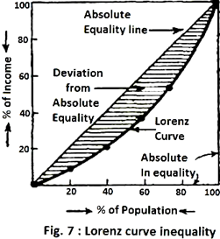

The simplest way of measuring inequality is to divide the population into fifths (quintiles) from the poorest to the richest and report the levels or proportions of income (or expenditure) at each level. Table 1.1 shows, based on data from the Vietnam Living Standards Survey, the level of expenditure per capita in ' 000 dongs per year for Vietnam in 1993. A fifth of the individuals included in the survey (not households) was allocated to each quintile expenditure. The figures show that the poorest fifth of households made 8.4 per cent of all spending, and the top fifth made 41.4 per cent of all spending. Quintile information is easy to understand, although a summary measure is sometimes required rather than a table of figures.
 |  | Expenditure quintiles
 | Lowest | Low-mid | Middle | Mid-upper | Upper | Overall
Expenditure per capita (' 000 dong per year) | 518 | 756 | 984 | 1,338 | 2,540 | 1,227
% of expenditure | 8.4 | 12.3 | 16.0 | 21.8 | 41.4 | 100.0
Memo: Cumulative % of expenditure | 8.4 | 20.7 | 36.7 | 58.5 | 100.0*
Memo: Cumulative % of population | 20.0 | 40.0 | 60.0 | 80.0 | 100.0

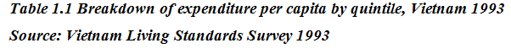

Gini coefficient of inequality

The Gini Coefficient shows the statistical dispersion among the citizens of a nation of income and wealth distribution. Most commonly, this measure is used to measure inequality. The scale varies between zero and one. A Gini coefficient of zero means that the data you are analyzing, such as income levels, have perfect equality, whereas Gini coefficient of 1 means maximum inequality.

The Gini coefficient is the most commonly used single measure of inequality. It is based on the Lorenz curve, a cumulative frequency curve that compares a specific variable (e.g. income) distribution with a uniform equality distribution. The cumulative percentage of households (from poor to rich) on the horizontal axis and the cumulative percentage of expenditure (or income) on the vertical axis are used to construct the Gini coefficient. The curve of Lorenz shown in Figure 3 is based on the data from Vietnam in Table 1 Perfect equality represents the diagonal line. A/(A+B) is defined as the Gini coefficient, where A and B are the areas shown on the graph. If A=0 becomes 0 which means perfect equality, whereas if B=0 becomes 1 which means complete inequality. The Gini coefficient in this example is approximately 0.35.

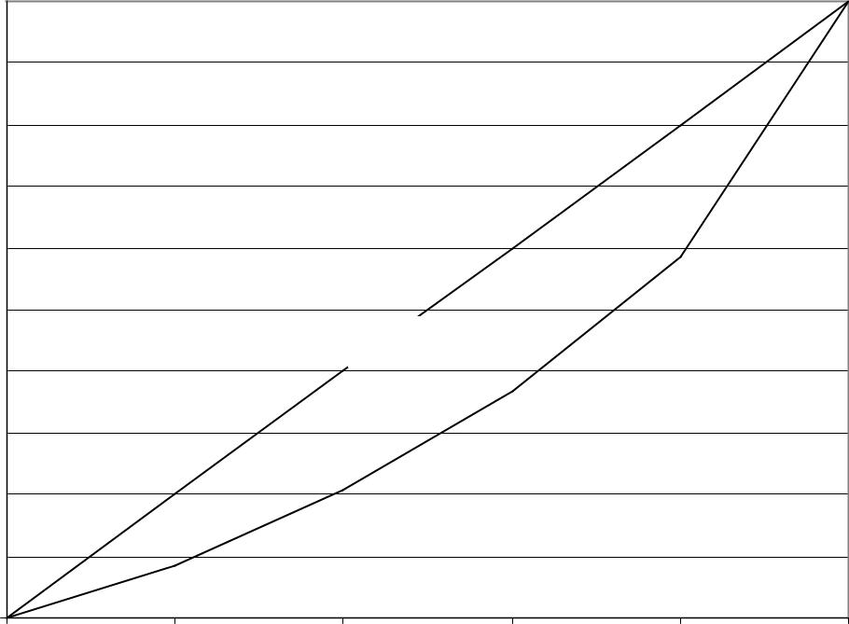
Lorenz Curve

100

90

80

70

60

50 A

40

30 B

20

10

0
20 40 60 80 100 Cumulative % of population

Figure 3. Lorenz Curve

Formally, let xi be a point on the X-axis, and yi a point on the Y-axis. Then

 | N
(1.1) | Gini = 1 − ∑(x_{i} − x_{i−1} )( y_{i} + y_{i−1} ).

When there are N equal intervals on the X-axis this simplifies to

 |  | 1 | N
(1.2) | Gini = 1 − |  | ∑( y_{i} + y_{i−1} ).
 |  | ^{N} i=1

Not entirely satisfactory is the Gini coefficient. For see that, consider the criteria that make income inequality a good measure, namely:

• Mean independence. This means that the measure would not change if all income were doubled. This is what the Gini is satisfying.

• Population size independence. The measure of inequality should not change if the population were to change, ceteris paribus. The Gini is also satisfied with this.

• Symmetry. If you and I swap income, the measure of inequality should not change. This is what the Gini is satisfying.

• Pigou-Dalton Transfer sensitivity. The transfer of income from the rich to the poor reduces measured inequality under this criterion. The Gini is also satisfied with this.

It is also desirable to have

• Decomposability. This means that inequality can be broken down by or in other dimensions by population groups or sources of income. The Gini index is not easily decomposable or group-wide additive. That is, society's total Gini is not equal to the sum of its subgroups ' Gini coefficients.

• Statistical testability. One should be able to test the meaning of index changes over time. This is less of an issue than it used to be because usually bootstrap techniques can generate confidence intervals.

Generalized Entropy measures

There are a number of inequality measures that meet all six criteria. The Theil indexes and the mean measure of log deviation are among the most widely used. Both belong to the generalized measures of entropy inequality family. The general formula is given by:

 |  | 1 |  |  | 1 | N |  | ^{y}i |  | ^{α}
(1.3) | GE(α ) = |  |  |  |  | ∑ |  |  |  |  | −1
 |  | α (α −1) |  | N i=1 |  |  |  | y

Where, y show that income (or expenditure per capita).

GE measurement values vary between 0 and ∞ whereas zero is an equal distribution and a higher value is a higher level of inequality. In the GE class, the parameter α represents the weight given to income distances at various parts of the income distribution and can take any real value. GE is more sensitive to changes in the lower tail of the distribution for lower values of α, and GE is more sensitive to changes affecting the upper tail for higher values. The most commonly used α values are 0,1 and 2. GE(1) is the T index of Theil that can be written as

 |  | 1 | N |  | y _{i} |  |  |  | y _{i}
(1.4) | G E (1) = |  | ∑ |  |  |  |  | ln ( |  |  |  | )
 |  | N |  |  |  | y |  |  |  | y
 |  |  | i = | 1

GE (0), also known as Theil's L, is given by: sometimes referred to as the mean measure of log deviation.

 |  |  | N
 |  | 1 |  |  | y
(1.5) | G E (0 ) = |  | ∑ ln( |  |  |  | )
 |  | N
 |  |  | i =1 | y_{i}

Atkinson's inequality measures

Atkinson has proposed another class of measures of inequality that are occasionally used. This class also has a weighting parameter π (measuring aversion to inequality) and some of its theoretical properties are similar to those of the extended index of Gini.

 |  |  |  |  | N |  |  |  |  |  |  |  | 1−ε ¹(1−ε )
A_{ε} = 1 | − |  | 1 | ∑ |  |  |  | y_{i} |  |  |  |  |  |  | , ε ≠ 1
 | N i=1 |  |  |  |  |  | ^{y}
(1.6)
 |  | N
 |  | _{∏(} _{y}(1/ N ) ₎
= 1 − |  | i =1 |  |  | i |  |  |  |  | , |  |  |  |  | ε = 1.
 |  |  |  |  | y

Decile dispersion ratio

A simple and widely used measure is the decile dispersion ratio, which shows the average income ratio of the richest 10 per cent of the population divided by the lowest 10 per cent average income. For other percentiles, this ratio can also be calculated (for example, dividing the average consumption of the richest 5 %, the 95th percentile, by that of the poorest 5 %, the 5th percentile).

The decile ratio can be readily interpreted by expressing the income of the top 10% (the "rich") as a multiple of the income of the poorest decile (the "poor"). However, in the middle of the income distribution, it ignores information about income and does not even use information about income distribution within the top and bottom deciles.

Effects of Inequality on Economic growth

Analysis of the impact of Inequality on Economic growth of countries

Economic growth is the increase in an economy's inflation-adjusted market value of goods and services over time. It is conventionally measured as the rate of real gross domestic product or real GDP increase percentage.

Growth is usually calculated in real terms - i.e., inflation-adjusted terms – to eliminate the distorting effect of inflation on the price of goods produced. Measurement of economic growth uses national income accounting. Since economic growth is measured as the annual per cent change of gross domestic product (GDP), it has all the advantages and drawbacks of that measure. The economic growth rates of nations are commonly compared using the ratio of the GDP to population or per-capita income.

The best way to measure economic growth is by gross domestic product. It takes into account the whole economic output of the country. It includes all the goods and services that are produced for sale by companies in the country. Whether they are sold domestically or overseas, it doesn't matter.
The growth rate of GDP measures the rapid growth of the economy. It does this by comparing the gross domestic product of one-quarter of the country with the previous quarter. GDP measures a nation's economic performance.
The growth rate of GDP is driven by GDP's four components. Personal consumption is the major driver of GDP growth. This includes the retail sales critical sector. The second component is an investment in a business, including levels of construction and inventory. The third driver of growth is government spending. Its largest categories are benefits from social security, spending on defence, and benefits from Medicare. Often during a recession, the government increases spending to jump-start the economy. Fourthly, there is net trade.

Economic growth of Developed Countries

Figure 4 shows the differences between the figures of the developed countries selected from the countries of the world. These figures are annual changes in the real economic development of countries from 2006 to 2015. As can be seen from the graph, in most countries, economic growth is constantly increasing. However, in most of the countries in 2009, we can see that economic growth is rapidly declining.

The economic development of China remained positively in 2009 despite the negative indicators taken by other countries and China's economy has evolved faster and faster since China implemented the reform and open policy in 1978, and the rate of economic growth has increased tremendously in recent years. Based on data from China's National Statistics Bureau, the average growth rate has reached 6.9 per cent over the past 10 years, making it the world's third largest economic entity. As we can see from the graph, despite the decline in most of the countries' economy in 2009, there has been a steady increase in the fixed rates in the following years. This reflects the perspective of measures that countries must take to ensure the sustainable growth of real economic development.

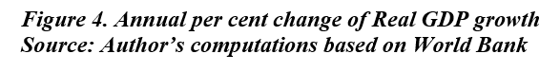

Economic growth of Emerging Countries

Figure 5 shows the rates of economic development of some emerging countries from 2006 to 2015. Economic growth in this graph slowed down in developed countries as well as in 2009. In countries such as Lithuania, Estonia and Latvia, even though economic growth in 2009 weakened by large differences (-14.8, -14.7, -14.4), in the following years it reached an average of 2-3 per cent with an average of 17 per cent.

However, as can be seen from the graph, as a result of the reform and policies of the Polish state, weakening was not a negative indicator despite the beginning. And the country reached 3.8 per cent in 2015 with the pace of sustainable development. In addition, the Czech Republic was the highest figure in economic growth and rose 5.3% in 2015. In the graph, Greece has a negative outlook among countries that differ in economic growth. Despite policies and measures aimed at economic development in the country, Greece has largely replaced its position on the chart at a price lower than 0.

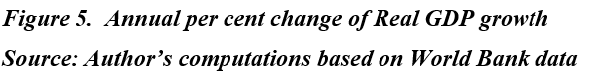

Economic growth of the Least Countries

Figure 6 demonstrates the economic growth of some poorest countries which are selecting from different regions of the world. In this graph, we can see the different proportions of annual economic growth rates compare to previous graphs. High changeability of proportions shows that poorest countries cannot be strong enough for getting some negative shocking.

Countries, such as Yemen, Libya Sudan show highly negative economic growth and also highly difference in some years. In the graph, the annual economic growth of Libya has decreased faster (-66.7) in 2011, however, has started to increase faster (-124.7) in 2012. These changeabilities influence the form of a line to compare to other countries' lines. In 2015, Yemen's economic growth rate shows the lowest percentage (-16.7) compare to other poorest countries. The results of some policies and reforms of Nigeria state, economic growth rate shows a positive and steady proportion but, in recent years, the rate has started to decrease (2.7). In addition, we can see the measurement of the economic growth rate of Venezuela is (-3.9) in 2014. Venezuela's economic growth rate in 2015, which ranks second after Yemen, is negatively associated with the country's ability to withstand economic shocks.

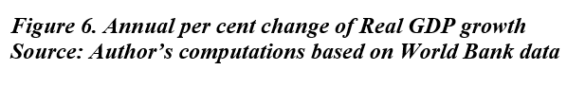

Analysis of the impact of Inequality of countries by Gini coefficient

A statistical measure of distribution developed by the Italian statistician Corrado Gini in 1912 is the Gini index or Gini coefficient. It is often used as a measure of economic inequality, measuring the distribution of income or, less commonly, the distribution of wealth among a population. If the coefficient ranges from 0 (or 0 %) to 1 (or 100 %), and shows 0, this representing perfect equality, however, shows 1, this means that perfect inequality.

- The Gini index is a simple measure of a population's income distribution across income percentiles.
- A higher Gini index shows greater inequality, with high-income people receiving much larger percentages of the population's total income.
- Global inequality as measured by the Gini index increased during the nineteenth and twentieth centuries, but declined in more recent years.
- Due to data and other limitations, the Gini index may overestimate income inequality and may obscure important income distribution information.

Developed countries

In figure 7, we can see that the Gini coefficient has shown different income level and wealth distribution between countries' populations. In recent years, however, income inequality has also started to increase significantly in addition to economic growth. This income inequality demonstrates false income distribution between their people. As seen from the graph, the Gini coefficient shows a slow increase and decrease from 2006 to 2015. Nevertheless, actually, the coefficients are increasing year by year regularly and slowly.

In the graph, German shows very slow changeabilities between other countries and income inequality increased from 0.308 in 2008 to 0.318 in 2015. Figure 7 also indicates that the distribution of income and wealth inequality between population is inferior in Norway and the Gini coefficient shows a low degree from 2006 (0.26) to 2006 (0.27). At the same time, the United States’ Gini coefficient shows that the majority of total income and wealth are owned from 0.4% of the population.

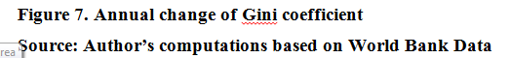

Emerging countries

Figure 8 illustrates the income and wealth inequality degree and distribution levels between emerging countries' population. These unequal distribution levels show that countries start to going being dependence from other countries and getting a high amount of loans.
According to Figure 8, inequalities in developing countries are slowly and slowly decreasing each year. Currently, governments are undergoing some regulatory reforms in connection with the ongoing trend of inequality. In the last decade, economic growth in emerging economies has increased dramatically. As can be seen from the table, income is distributed equally as the state's major reform efforts in countries such as Estonia, Latvia and Poland, and this leads to a decline in the Gini index.

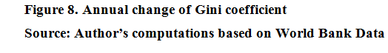

Least countries

İn this Figure, we analyze that income distribution of least countries and their Gini coefficient which was showing a connection between the cumulative share of income and cumulative share of the population. Gini coefficient showed a high proportion in these countries because of the decreasing of GDP growth. In the graph, we can see that Venezuela's Gini coefficient was increasing year by year sharply. This increase showed negative effects on a country's distribution of income and wealth. The difference of Gini coefficient between 2006 and 2015 was highly negative and had reported from (0.46) to (0.65).
Otherwise, the line chart of the Gini coefficient of Botswana started decreasing and showed a positive effect on the distribution of income and equality. Inequality decreased from 0.62 in 2006 to 0.53 in 2016. Furthermore, in the graph, we can see that minimum income inequality in Iraq, the average Gini coefficient (0.295). In addition, the low level of the rate of GDP growth and high population cause the creation of inequality between people and increase the Gini coefficient. Also, as we know, when the Gini coefficient starts to approach to 1, this means that perfect inequality.

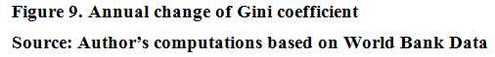

Estimation of impact of the Inequality on Economic growth

This section will have a look at the econometric model, which demonstrates the relationship between the GDP growth rate in 2006-2016 years, and the Gini coefficient. By doing these calculations, we will get information about how the Gini coefficient shows a reaction to the GDP growth rate when it changes.

In this econometric model, we have selected 2 countries from each section and calculate their Real GDP growth rates and changes in the Gini coefficient between 2006 and 2015 separately on each country. The model is calculated in the EVIEWS computer program using the Least Squares method.

Based on the result of our econometric calculations on Austria, when GDP increased by 1 %, reacted to the Gini coefficient by decreasing it by -0.001. This calculated result is economically successful since the quantity of probability is 0.0141.

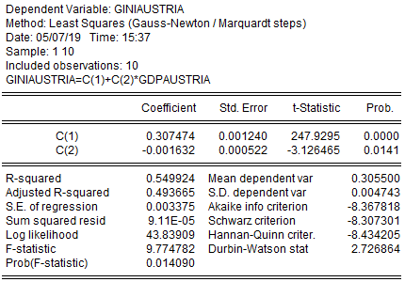
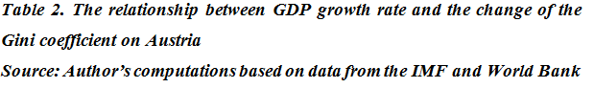

For calculating these results, we have been using formula is like that:

Gini Coefficient on Austria = 0.307474 + (-0.001632) × GDP GR

According to the results of France, the declining of the Gini coefficient amounted to - 0.001 against of each 1% rising of GDP (Table 3). This result demonstrates that the distribution of income is strong between populations, it means that equal distribution is high.

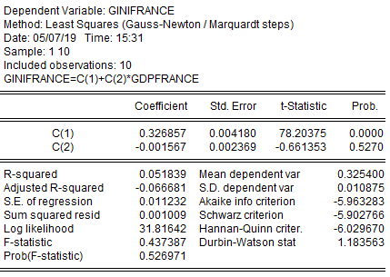
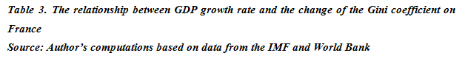

Let’s look at the formula for calculation:

Gini Coefficient on France = 0.326857 + (-0.001567) × GDP GR

This calculation of Cyprus econometric model, we see that when GDP boosting 1%, the Gini coefficient is diminishing -0.006 (Table 4). The good amount of R-squared and probability were showing that this result is economically significant

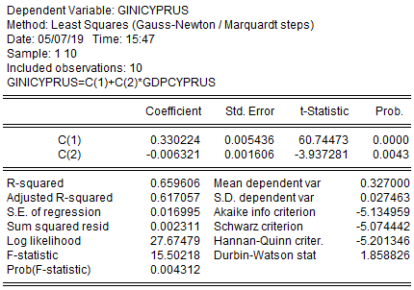

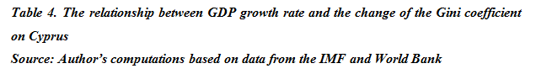

Look at the calculation formula:

Gini Coefficient on Cyprus = 0.330224 + (-0.006321) × GDP GR

In addition, the model indicates that in the 2006-2015 periods, when GDP increases 1%, the Gini coefficient of Lithuania decline - 0.001 (Table 5).

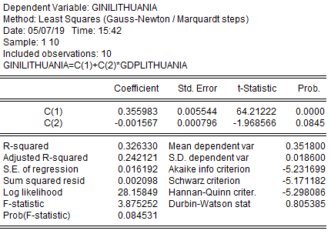

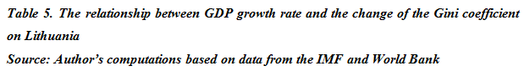

The Formula is here:

Gini Coefficient on Lithuania = 0.355983 + (-0.001567) × GDP GR

Moreover, based on our estimations on Nigeria, the declining of the Gini coefficient amounted to -0.001, when GDP escalating 1% between period of the 2005-2015 (Table 6).
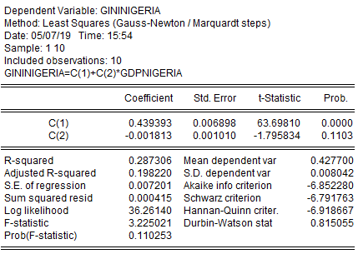

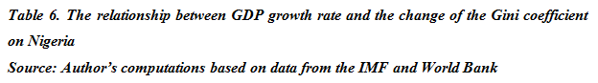

Here is the formula you have acquired:

Gini Coefficient on Nigeria = 0.439393 + (-0.001813) × GDP GR

In this model, according to the results, when the GDP is changing 1% positively between the period of the 2006-2015, the Gini coefficient is diminishing -0.001813 (Table 7).
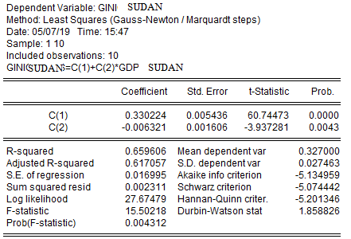

Look at the formula here:

Gini Coefficient on Cyprus = 0.330224 + (-0.006321) × GDP GR

Conclusion

It is observed that inequality has an interest in economists because of its effect on many macroeconomic variables. Considering the effect of inequality on economic variables; is the question of how the effect of one of the most curious issues on economic growth will be. Economic growth is widely debated and is at the core of its policy objectives. Therefore, it can be said that the determination of the effects of inequality on economic growth is of great importance in terms of the decisions taken in the policies of the state.

There is much thought about how to change the effect of inequality on economic growth. Some economists have said that this relationship has changed negatively or positively and has nothing to do with the others. According to the information obtained from some theoretical approaches in the study, income inequality had a great impact on economic growth. It has been investigated how these approaches affect the growth and decline of economic growth in the future and today. And in every theoretical approach, some ideas have been put forward to minimize the negative effects of adverse effects in the short term.

Inequality can have various dimensions. Economists are mainly concerned with the dimensions of inequality in income and consumption. We can include inequality in skills, education, opportunities, happiness, health, life-years, welfare and assets among other dimensions of non-income inequality.

Furthermore, in this study, some methods have been analyzed to measure the effect of inequality on economic growth. Several indices of inequality can be derived from the diagram of Lorenz. A certain index of inequality measures the divergence of a Lorenz curve for perfect equality and the Lorenz curve for a given distribution. Several indices of inequality follow along with certain basic properties that would be expected to satisfy the indices. These properties should be used in their evaluation of ranking, relevance and performance. The Gini coefficient is the most widely used index of inequality. In order to accommodate different aversions to inequality, Gini is generalized.

Inequality of income can be decomposed at various aggregation levels. It can be broken down into in-subgroup, between subgroups, and overlapping components at the national level. Similarly, it can be decomposed into in-country, inter-country, and overlapping components at the international level. It is desirable in measuring world income inequality that the unit of analysis is the world's citizens rather than countries. It is preferable to have individual microdata based representative.

The effects of inequality on earnings in non-income factors can be summarized in different ways. Education inequality explains a small fraction of cross-country income inequality differences. The impact decreases by the level of education and depends on production technologies ' economic development and skill-intensive nature. It also adversely affects the rate of investment and the rate of income growth. There is no direct connection between income inequality and ill health measured as mortality, but a variety of mechanisms and social arrangements indicate an indirect connection. In contrast to income inequality, health inequality is a dominant source of inequality within the country. Regions differ in terms of the effects of inequality on happiness; differences in happiness are linked to preferences for equal societies and increased social mobility.

In the study, there is evidence that the relationship between income inequality and economic growth varies depending on the income level of the countries included in the analysis. According to the general findings of the study; In the low and low middle-income countries, the relationship between income inequality and economic growth is positive while the relationship between two variables is obtained as negative in upper-middle and high-income countries. When the findings are interpreted as a whole; it can be said that income inequality affects economic growth firstly and negatively affects the development stage in the future.

The scarcity of physical capital in countries with low levels of income is seen as one of the main reasons that income inequality affects economic growth positively. The high marginal savings tendency of rich individuals, as envisaged by the classical approach, will increase capital accumulation. Therefore, the increase in income inequality will affect economic growth positively. On the other hand, it is possible to explain the negative relation obtained in high-income countries with many modern approach channels and combined approach.

In addition, research has shown an econometric model that measures the relationship between economic development and the Gini coefficient. In this model, some models of low- and low-income and high-middle and high-income countries were selected. In these models, 1 per cent change in economic development is explained how the Gini coefficient effects. As a result of the calculations, it has been shown that the increase in economic development has a positive impact on the Gini coefficient, which is inversely proportional to it. This shows that the Gini coefficient decreased during GDP growth.

According to the findings, especially in high-income countries, the state should see the inequality of access to education caused by income inequality as a problem to be solved and to take the necessary measures in order to achieve economic growth. In low-income countries, state effective redistribution policies should ensure that more individuals participate in high-yielding investment projects and remove barriers to economic growth.

Bibliography

- Aghion, P., Bolton, P. (1997). A Theory Of Trickle-Down Growth and Development. The Review of Economic Studies, 64(2), 151-172.
- Alesina, A., Perotti, R. (1996). Income Distribution, Political İnstability and İnvestment. European eco-nomic review, 40(6), 1203-1228.
- Alesina, A., Rodrik, D. (1994). Distributive Politics and Economic Growth. The Quarterly Journal of Economics, 109(2), 465-490.
- Bourguignon, F. (1981). Pareto Superiority of Unegalitarian Equilibria In Stiglitz’ Model Of Wealth Distribution With Convex Saving Function. Econometrica: Journal of the Econometric Society, 49(6), 1469-1475.
- Banerjee, A. V., Newman, A. F. (1993). Occupational Choice and The Process of Development. Journal of Political Economy, 101(2), 274-298.
- Barro, R. J. (2000). Inequality and Growth in A Panel of Countries. Journal of economic growth, 5(1), 5-32.
- Galor, O., Zeira, J. (1993). Income Distribution and Macroeconomics. The Review of Economic Studies, 60(1), 35-52.
- Galor, O., Moav, O. (2004). From Physical to Human Capital Accumulation: Inequality and The Process of Development. The Review of Economic Studies, 71(4), 1001-1026.
- Galor, O. (2009). Inequality and Economic Development: An Overview. Providence, RI: Brown University, Working Paper, No. 2009-3.
- Galor, O. (2011). Inequality, Human Capital Formation and The Process of Development. National Bureau of Economic Research Working Paper, No: 17058.
- Smith, A. (1776). The wealth of nations. New York: Modern Library.
- Keynes, J. M. (1920). The Economic Consequences of the Peace. New York: Dover Publications.
- Lewis, W. A. (1954). Economic Development with Un-limited Supply of Labor. The Manchester School, 22, 139–191.
- Kaldor, N. (1957). A Model of Economic Growth. Economic Journal, 67, 591–624.
- Kelly, M. (2000). Inequality and Crime. Review of eco-nomics and Statistics, 82(4), 530-539
- Perotti, R. (1993). Political Equilibrium, Income Dist-ribution, and Growth. The Review of Economic Stu-dies, 60(4), 755-776.
- Persson, T., Tabellini, G. (1994). Is Inequality Harm-ful for Growth?. The American Economic Review, 84(3), 600-621.
- Venieris, Y. P., Gupta, D. K. (1986). Income Distribu-tion and Sociopolitical Instability as Determinants of Savings: A Cross-Sectional Model. Journal of Po-litical Economy, 94(4), 873-883.
- Poverty Manual, All, JH Revision of August 8, 2005

Internet resource entries:

- https://www.investopedia.com/terms/g/gini-index.asp
- https://www.imf.org/external/datamapper/NGDP_RPCH@WEO/OEMDC/ADVEC/WEOWORLD
- https://stats.oecd.org/
- https://sevenpillarsinstitute.org/consequences-economic-inequality/
- https://data.worldbank.org/indicator/SI.POV.GINI?end=2015&start=2006
- https://data.worldbank.org/
- https://www.investopedia.com/terms/g/gini-index.asp
- https://www.investopedia.com/terms/r/realgdp.asp

Smith, 1776
Galor, 2011
Galor and Moav, 2004
Galor, 2011, 2009
Keynes, 1920
Lewis,1954
Kaldor,1957
Bourguignon, 1981
Galor, 2011, p. 1
Galor, 2009

